|  |
| --- |
| **THE IRISH OF TOURMAKEADY,**  **CO. MAYO**  **A PHONEMIC STUDY** |

**BY**

**SEAN DE BURCA**

|  |  |
| --- | --- |
|  | **DUBLIN INSTITUTE FOR ADVANCED STUDIES  10 BURLINGTON ROAD, DUBLIN 4  1970** |

PART I

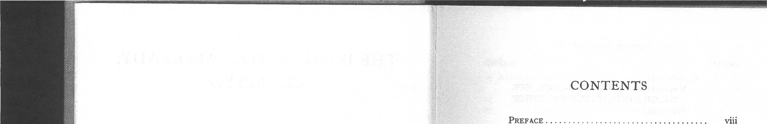

CONTENTS

PREFACE Viii

PHONEMIC ANALYSIS AND TEXTS

Chapter Page

V

I. PROLEGOMENA

Transcription

Organs of Speech 2

Reprinted 1970

Phonemes 2

Description of Vowels 3

Description of Consonants 4

PRINTED IN THE REPUBLIC OF IRELAND
  
BY PHOTOLITHOGRAPHY AT IRISH UNIVERSITY PRESS SHANNON

|  |  |  |
| --- | --- | --- |
| **II.** VOWELS AND DIPHTHONGS  Stressed Vowels  Unstressed Vowels |  | 7  S  9 |
| Pure Vowels (i:, 1, **e:, e, a, a:, o, o:, u, u:)** |  | 10 |
| Diphthongs **(io, no, al, au)** |  | **17** |
| III. CONSONANT PHONEMES |  | 22 |
| Plosives **(b', b, p', p, d', d, t', t, g', g, k', k) ..** |  | 22 |
| Fricatives (v', **v, f', f, s', s, j, y, x', x, . . .** | **.** | 28 |
| Nasals **(m', m, n', n, N, 1)', 1])** |  | 34 |
| Laterals (1', **1, L', L)** |  | 38 |
| Vibrants **(r', r)** |  | 40 |
| Marginal Phonemes & Affricates |  | 41 |
| IV. PHONEME DISTRIBUTION |  | 45 |
| Vowels and Diphthongs (V(:), V:V(:) ) • • • | • | 45 |
| Consonants **(C, CC, CCC, CCM & 00000) ..** |  | 46 |
| Quality |  | 5o |

|  |  |  |  |
| --- | --- | --- | --- |
| **Vi THE IRISH OF TOURMAKEADY**  Chapter   1. **THE SYLLABLE**   Monosyllables **(V, VC, VCC, CV, CCV, CCCV, CVC, CVCC, CCVC, CCVCC, CCCVC, CCCVCC)** Polysyllables   1. **EXTRA-PHONEMIC ELEMENTS ,**   Nasalization  Transitions (Vocalic Transitions, Conson-  antal Transitions)  Further Instances   1. **PHONEMES IN SANDHI**   Similitude  Assimilation (Vowels and Consonants) . . .  Elision  Waning Vowels   1. **NON-SEGMENTAL FEATURES**   Length  Stress (Word Stress, Utterance Stress,  Clitics) Intonation (Free Contours, Linked Contours) Emphasis   1. **TEXTS** | Page  **52**  52  56  58  58  59  61  62  62  63  69  7o  **72  72**  74  78  8o  82 | **CONTENTS**  Chapter   1. **CONSONANTS**   Plosives  Fricatives  Nasals  Laterals  Short Vowels before Nasals/Laterals  Vibrants  Short Vowels before Vibrants  Intrusive Consonants   1. **METATHESIS**   **INFORMANTS**  **BIBLIOGRAPHY**  **INDEX**  **ADDENDA** | Vii **Page**  123  123  124  131  132  132  133  134  134  **136**  **138**  **139  141  170** |

PART **II**HISTORICAL SURVEY

|  |  |
| --- | --- |
| 1. **INTRODUCTORY** | **112** |
| 1. **VOWELS AND DIPHTHONGS** | **114** |
| Long Vowels | 114 |
| Diphthongs | 116 |
| Short Stressed Vowels | 116 |
| Short Unstressed Vowels | 120 |
| Additional Unstressed Vowels ..... | **121** |
| The Epenthetic Vowel | **122** |

**PREFACE ix**

dialect and containing variations recorded from fellow-students **in** the Irish College in Paris, appeared in 1867. At length, towards the close of the century Ireland began to come within the scope of European dialectology, and two distinguished continental scholars, F. N. Finck and l'Abbe Rousselot, made investigations of Western Irish.5 The latter made a palatogram study of the Irish of South Mayo in 1895 ; his informant being Rev. Stephen Walsh, a native of the Neale, who was then a student at the Irish College in Paris. The results of the inquiry were published four years later, in a lengthy article including upwards of eighty palatograms. Subsequent students of our dialect included Prof. Tomas 0 Maine, whose *Urlabhraidheacht,* published in 1927, contains the name of Padraig 0 Meadhraigh— a native of Glensaul—among the list of informants.

PREFACE

The present work deals with the spoken Irish of a narrow tract extending along the west side of Lough Mask, between it and the mountains, from its northern tip to the border of Co. Galway. Part of the area was included in Co. Galway until the boundary was adjusted in 1898.

In a somewhat wider sense, this dialect belongs to what may be termed the Irish of Middle Connacht.' It may be added that Middle Connacht is the only major region relatively unaffected by one or other of those two great linguistic movements—spreading respectively from the North-East and from the South—that have largely moulded the history of spoken Irish since the 13th century.2 Indeed, observers have been struck by the apparent closeness of the dialect to the classical form of Modern Irish ; a fidelity that is all the more remarkable because, unlike Northern or Southern Irish, that of Middle Connacht has depended almost solely on oral tradition ever since the fall of the classical order, over three centuries ago. Evidently the old tradition was transmitted orally with considerable success.3

Among previous investigators of Middle Connacht Irish, mention must be made of John Molloy, a native of the Tuam area, who ' is worthy of special mention as being the author of the first Grammar of Irish based for the most part on the language of the people **'.4** His grammar, based on his own

1 Cf. *Urlabhraidheacht, §* 472.

**2** See *Irish Dialects,* pp. 189, 246, 263 ; *Clare Island Survey,* **III, p. 7** *; Urlabhraidheacht,* p. 135.

**3** In his well-known anthology of Irish poetry, published in 1831, Hardiman gives portion of a Fenian poem, the Lay of Ben Bulben, taken with several others, from the recital of a native of Partry. He writes : These metrical fragments, to the number of several thousand verses, had been committed to memory by the reciter in his early youth, amidst his native hills, where they have been transmitted from sire to son through countless generations '. See *Irish Minstrelsy,* II, p. 385.

*Irish Dialects,* p. 13.

viii

The present century has seen the diffusion of the phoneme theory, together with its further development by linguists such as Trubetzkoy in Europe and Bloomfield in America. In this, as in the wider fields of language and communication, progress continues on both sides of the Atlantic : a voluminous literature exists. As compared with phonetics, phonemics involves the further step of sorting the sounds, of identifying the relevant units into which phonetic material is organized in a particular dialect or language. In this study an attempt is made to provide a phonemic inventory of the dialect of Tourinakeady ; to examine its structure in the light of modern phonemics on the one hand, and by comparison with early modern Irish on the other. The method of treatment is based, to a large extent, on the one already successfully used in the monographs on Irish dialects published by the School of Celtic Studies in the Dublin Institute for Advanced Studies ; in the present work, however, attention is devoted to such matters as phoneme distribution and syllabic structure, while extensive use is made of the commutation test in proving the status of phonemes.

It need hardly be said that no investigator of a living dialect can expect to exhaust his subject : dialectologists are familiar with such variables as the rate of speech, the style of speech, the

Noteworthy also in this connection is the name of C. Dottin, who was, moreover, a pioneer in the comparative study of Irish dialects. See *Revue Celtique, xiv, xvi, xx, xxi.*

x THE IRISH OF TOURMAKEADY

speech of different age-groups, the realization of phonemes in relation to strong or weak stress, in relation to word or utterance, etc. Problems such as those await further study.

Tourmakeady itself, although the scene of strong anglicizing efforts by landlords and others in the Igth century, was entirely Irish-speaking at the beginning of this century, when an Irish college was established there. Irish is still a living language there, though the circumstances accompanying its use are changing at an ominous rate : many customs, pastimes, and beliefs, that were once part and parcel of the Irish speaker's world, are now moribund ; and the innovations that replace them frequently involve foreign phrases and an alien vocabulary. The fact that it remains an economically under-developed area, with a high rate of emigration, has the twofold effect of reducing the number of speakers and increasing the import of English.

I should like to thank Prof. M. A. O'Brien, Director of the School of Celtic Studies, Prof. Heinrich Wagner, of the University of Basle and Dr. Brian 0 Cuiv, of University College, Dublin for their helpful comments and advice. Prof. Myles Dillon kindly read the proofs, and made several useful suggestions. I am grateful also to the speakers, to whom much is due for their attachment to a time-honoured heritage in the domain of *Partraighe an tSleibhe.*

S. de B.

PART I

PHONEMIC ANALYSIS AND TEXTS

CHAPTER I

PROLEGOMENA TRANSCRIPTION

i. In the type of transcription here used each phoneme is represented by a separate symbol, which is taken as a rule from the alphabet of the *Association Phonetique Internationale.'* Nevertheless, in order to secure some uniformity of procedure with previous investigators of western Irish dialects, special symbols are used for certain consonant phonemes ; while, for the sake of simplicity and the maximum typographical con­venience, ordinary Roman letters are introduced in a few other instances where no ambiguity can result. These symbols, with their respective international equivalents in brackets, are as follows : **d (a), t (3), g (g), s' (I), x' (9), N (a), N' (p), L (1),** and **L' (A).**

Digraphs are used to denote diphthongs and affricate sounds. In the distribution of spaces the usual orthographical practice is followed as far as possible.

Regarding diacritics, a colon indicates that the sound re­presented by the preceding letter is long, e.g. **e: ;** an acute accent placed after a consonant denotes palatalization, e.g. **m' ;** where a tilde is used over a letter it denotes nasalization, e.g. **a;** and a stressed syllable in other than word-initial position is preceded by the vertical stroke, e.g. **a'n'is'** *anois.* The capitals C and V denote unspecified consonants and vowels, and the sign a is used for a number of short vowel types, as set forth in §21.

For a description of this alphabet, see *Principles of the International Phonetic Association,* pp. z ff.

**2 THE IRISH OF TOURMAKEADY PROLEGOMENA 3**

**ORGANS OF SPEECH**

1. **Reference is made to parts of the speech mechanism, as follows : the lips ; the teeth ; the teeth-ridge, namely, that part of the roof of the mouth immediately behind the teeth, which is convex to the tongue ; the hard palate and the soft palate, both concave to the tongue ; the tongue itself, comprising the tip, the blade which normally lies opposite the teeth-ridge, the front which normally lies opposite the hard palate, and the back which is normally opposite the soft palate ; the uvula ; the vocal cords ; and the glottis.2**

**PHONEMES**

1. **The phonemes of the dialect are those features of speech occurring in it as minimum functional units, being utilized for communication between one speaker and another. As used by one speaker, the phonetic quality of a phoneme may vary within limits, since its nature is more or less conditioned by that of the particular sequence in which it occurs within the speech continuum. A number of these sub-phonemic variations can be detected by auditory investigation, and still more by instrumental methods ; but they are not sufficiently marked to render a phoneme unrecognizable as such : for the native listener they remain, as it were, one and the same sound. These are the allophones or submembers of the phoneme, and that member which appears least limited in distribution and least modified by its environment is regarded as the norm.3**

**Languages differ considerably in the phonemic use they make of phonetic distinctions. Comparing our dialect with ' received ' English, for instance, we observe that the phonetic difference between the initial element in the word mi:1** *meal* **and that in**

**2 Wall-charts showing these include that prepared by Prof. D. Jones and published by Cambridge University Press.**

**3 See Pike, *Phonetics, 42, 115; Dieth, §§ 424 ff. ;* Jones, *The Phoneme,* Chap. XXIX. the word moul** *mole* **is without semantic significance in English, where both elements belong to the same phoneme ; while in the dialect a parallel difference in consonant quality marks a distinction of meaning in such words as m'i:n'** *min* **and mi:n'** *maoin,* **where the initial elements belong to separate phonemes.**

**On the other hand, in the English words mid** *meal* **and mil *mill,* vowel differences are used in a manner similar to that of the dialect in such words as m'i:n' *min* and m'in'** *min.*

1. **The word, a minimum isolatable form, is used by phon­emicists generally as the basis of reference in phonemic analysis. Most of the examples given in the following paragraphs consist of single words. At the same time, an attempt has been made to consider the larger sequences, and some of the phenomena and variations observed therein are noted below. See Chapter VII.**

**DESCRIPTION OF VOWELS**

1. **In vowel articulation the air-stream passes through the mouth by an opening, of which the size and shape determine the nature of the vowel : size and shape are in turn determined mainly by the height of the tongue, which can vary from close to open, by the part of the tongue that is highest, which varies from front to back, and by the position of the lips, which may vary from spread to rounded.**

**Standard degrees of these factors are provided in the scale of cardinal ' vowels, consisting of eight vowels of known quality, denoted in the alphabet of the** *Association Phonetique* ***Inter­nationale* by the symbols i, e, E, a, a, 0, o, u.**

**The first four of these are front vowels, made by the front of the tongue and separated by approximately equal acoustic distances, cardinal ' i being the highest or closest possible front vowel ; while the remainder are back vowels separated in like manner by equal acoustic distances, ` cardinal ' a being the lowest or openest possible back vowel.**

**The positional relationship between these vowels may be**

4 **THE IRISH OF TOURMAKEADY PROLEGOMENA** 5

shown diagrammatically by trapezoidal figures, such as the following

As regards the soft palate, which can be more or less lowered to admit the air-stream into the nasal cavity and cause various degrees of nasalization, its position is not of primary import in the vowel system of the dialect. Sees 297.

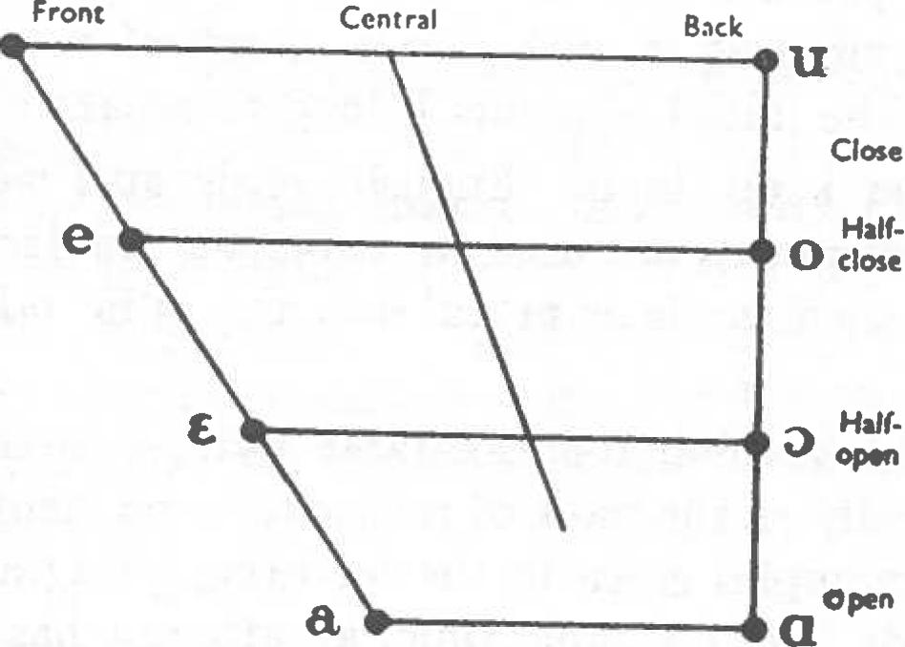

**Front**

**Central**

**Back**

**Close**

**Half-0 close**

**Half-**
  
**oPon**

**Open**

1. A vowel may be long or short, according to the time during which the articulating organs are retained in position for such a vowel. As a rule, there are concomitant differences of quality between long and short vowels. Indeed, the types might be distinguished on the basis of quality rather than length, using a separate symbol for each phoneme.2 The use of the length criterion has, however, been sanctioned by usage ; moreover, the length-mark effects a considerable economy of symbols.

**DESCRIPTION OF CONSONANTS**

1. According to its primary point of articulation, a consonant is described as either bi-labial, labio-dental, dental, alveolar, alveo-palatal, palatal, velar, or glottal ; involving respectively

**1 See** *Outline,* **pp. 36, 37. A record of these vowels, numbered DA JO 1-2, has been made by Prof. D. Jones and published by the Linguaphone Institute, London.**

**2 So for example, by taking account of the relevant conventions regarding vowel length, and using capitals and lower case letters to distinguish ' short ' and long ' vowels respectively, the words in § 25 infra could be**

**transcribed as In'in', ri, bor'hi, Umi, etc.**

the lips, the lower lip and upper teeth, the backs of the upper teeth, the teeth-ridge, the hard palate, the soft palate, or the glottis.

1. As to type of articulation, those consonants entailing stoppage and subsequent sudden release of the air-stream are called plosives ; those made by constriction of the air-stream are described as fricatives ; affricates are made by stoppage followed by relatively slow fricative release of the air-stream ; nasals entail the diversion of the air-stream through the nasal cavity ; laterals are made by arresting the air-stream in the centre while it escapes at one or both sides of the tongue ; and vibrants are produced by vibrating or rapidly tapping the tip of the tongue against the teeth-ridge.
2. A consonant is said to be voiced when its articulation is accompanied by vibration of the vocal cords : if such a vibration is absent the consonant is described as voiceless. The degree of actual voicing is rather variable, voiced consonants being most completely so when flanked by vowels or other voiced consonants, while voicing is reduced—with consequent overlapping of voiced and voiceless consonant allophones—in the neighbourhood of voiceless consonants, especially **s', s, x,** and **h.**

1o. A consonant becomes palatalized when its articulation is accompanied by simultaneous secondary raising of the front of the tongue towards the hard palate : this modifies the shape of the oral cavity, and gives the consonant the resonance of a close or half-close front vowel. Conversely, with regard to a consonant of which the primary point of articulation is other than velar, the back of the tongue may be raised so as to effect secondary modification of the quality of the consonant, giving it the resonance quality of a close or half-close back vowel. This development is known as velarization, and the consonant **is** said to be velarized.

1. For convenience in description, both true palatal con­sonants and palatalized consonants may be referred to henceforth as ' palatals ' ; while the term ' non-palatals ' may be used to include true velars, velarized consonants, and consonants **which,**

6 **THE IRISH OF TOURMAKEADY**

7

though rather of neutral quality, occur with these in phonemic contrast to the palatals. Such ' neutral ' consonants include the dentals **d, t, *N,*** which are distinguished from their palatal counterparts by point of articulation rather than difference in quality ; and s, which is characterized chiefly by its particular sibilance.

CHAPTER II

VOWELS AND DIPHTHONGS

1. While the afore-mentioned counterpoise of palatals and non-palatals is an essential rule in the consonantal system of the dialects it cannot be regarded as an absolute one : exceptions include the phoneme **h** (cf. § 134) and the marginal phonemes (§§ **224** ff.). Juxtaposition of palatal and non-palatal consonants occurs in a small number of clusters containing **s, s', x,** or **r.** See §§ 258 ff.
2. Because of their open character, vowels and diphthongs are often liable to be influenced by their flanking sounds, especially by consonants, of which the articulation generally demands a greater degree of oral closure.'

One important modifying factor is the place of articulation of a vowel in relation to the articulatory position of an adjacent consonant. Thus, for a front vowel in interpalatal position, the movement of the speech organs and their consequent transitional sounds or glides are reduced to a minimum, giving such a vowel maximum freedom from modification by adjacent consonant phonemes, e.g. **m'i:n'** *min,* where a close front vowel is flanked by palatal consonants. The opposite extreme is reached when the vowel occurs in a velarized context, in which case it tends to be retracted, while the transitions become more prominent, [e.g.](http://e.g.ki:1) **ki:1** *caol.*

1. Stress exercises a far-reaching influence on the vowel system. The quantity of long vowels in unstressed position is reduced, while unstressed short vowels tend to be centralized, and to vary in quality according to environment and the vagaries

of the speaker.2

1. In this dialect there are ten pure vowel phonemes, namely, i:, i, **e:, e, a, a:, o, o:, u,** and The phonemic norm of each of these is shown on the following figure :
2. Consonant length, a non-significant feature in the system, is influenced by position, stress, and mode of articulation, e.g. ***N,* L, *,* L',** and **a'** are long finally after short stressed vowels.

**3** Russian, of course, is the most widely-spoken language with such a system ; compare **rat 'glad r'at 'row,** range ', **rat' '** army, troop '. See Boyanus, ***A*** *Manual of Russian Pronunciation, §15.*

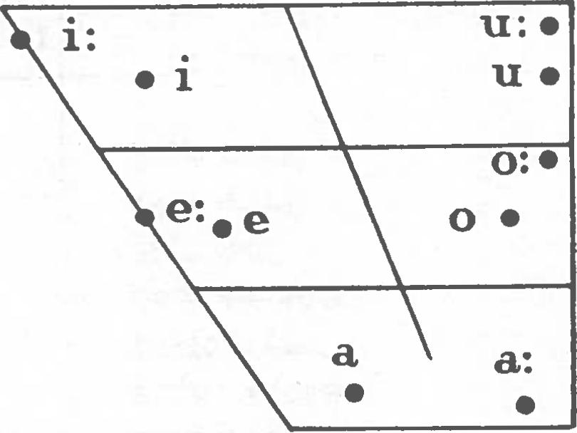

1 See Rousselot, *Articulations* p. 252.

**2** A similar obscuration of unstressed short vowels is found in other languages with potent stress, **e.g. Danish, English, Russian ; giving rise to conflicting theories as to the phonemic status** of such vowels.

8 THE IRISH OF TOURMAKEADY VOWELS AND DIPHTHONGS 9

STRESSED VOWELS

17. Here the pure vowels are listed in contrasting illustrations,, demonstrating the status of each phoneme and its significant function in stressed position :

i:, *min, taos, fior, caol, buidhe, taomadh ; i, min, fir, ruic, stuic, fuil, sil ;* **e:,** *fear, feir, seid, eating, aer, Eabha ;* **e,** *tomhas, reic, seid, eite, ceil, sail ;* **a,** *fear, staic, raic, call, fail, mac, cairt ;* **a:,** *fearr, faghdil, kite, carr, lir ; o, col, olann, coil, cor, toirt ; 0:, b6, seOil, 6r, ce6il, f6ill, tabhairt, pas ; u, tomadh, ogh, muc, cur, pus ;* **u** *siobhail, ur, still, a:art, cubhar.*

They may be tabulated as follows :

|  |  |  |  |  |  |  |  |  |  |  |
| --- | --- | --- | --- | --- | --- | --- | --- | --- | --- | --- |
| **i:** | **i** | **e:** | **e** | **a** | **a:** | **o** | **o:** | **u** | **II:** |  |
| — | **•**   * **• 5 5** | **f'i:r  re :r** | **tits tes** | **f'i:r f'ar** | **f'i:r f'a:r** | **ki :1 kol** | **.. • •** |  |  | * • |
|  | **--** | * **b.,.**   **•**   * **•**   **014 C4.1** | **rik'  rek** |  | • | **\*** | **s'il' s'o :I'** | **\*** | **s'il' s'u :I'** | **i** |
|  | **--** | **s'e :d' s'ed'** | **re :r rar** | **re :r  f'a:r** | **e auN oluN** | **0 0** | **e :v uv** | **a) 0** | * **•** |
|  | **—** | **rek'  rak'** | **ere a :t' a** | **\*** | **k'el' k'o :1'** | **\*** | **ser su 1'** | **e** |
|  | **—** | **rar f'a:r** | **kai,  koL** | **fail fo :Li** |  | **kart' ku:rt'** | **a** |
|  | **—** | **ka:r kor** | **O** | **ka:r kur** | **0** |  |
|  | **—** | **tort' to :rt'** | **kor  kur** | **kor ku :r** | **o** |
|  | **—** | **po :s pus** | **rl**  **o** |  |
|  |  | pu | **.0** |
|  |  | **O** |

Of the possible contrasts, o v. i on the one hand, and **u** v. **e** on the other, are not observed. Overlapping of i and u, and of **e** and o, tends to occur between consonants of opposing quality, e.g. **b'eg/b'og** *beag,* **g'uru:/g'iru:** *giorrughadh.*

But the variety of vowel in almost every case agrees with the consonant immediately following it : a back variety before C, and a front type before C', e.g. **keL' *coill,* g'uLa** *giolla,* **ger'** *goir,* **p'uko:d' *piocOid.3***

UNSTRESSED VOWELS

i8. The short vowels **i, e, o,** and u, are found before consonants in unstressed position, e.g. **arum** *anon, ainm,* **L'ehed** *leithead,* **L'ahor** *leathar,* **e :drum** *eadtrom.* They can occur with long vowels as V v. **V:,** e.g. **Lorin'** *luchain, v.* **Loxa:n'** *lochain;* although, as between the short vowels, quality is not a distinctive feature and has no significant function in the dialect at the present stage. The identity of V in such cases is determined by its environment.

19. But the relative laxness and instability of unstressed short vowels become still greater in word-final position. Unchecked by following consonants, they are further centralized towards the neutral position. Substitution of one short vowel quality for another would here cause no change of reaction in the listener : what matters is that a short vowel should be present. This V is commonly commutable with V: and with zero :

**V** v. zero, e.g. **bal'** *bail* V. **bare** *baile,*

**baL** *ball* v. **haul** *balla,*

*int* v. *im'a ime,*

*V v.* V:, e.g. **im'a** *ime* v. im'i: *imthigh,*

**baLe** *balla* v. **bath** *ballai,*

**a:t'a** *kite* v. **a:t'u:** *diteamh,***made** *maide* v. **mad'i:** *maidi.*

**8** Similar to the foregoing effect is that of two neutral ' consonants on an interjacent vowel, e.g. **du N/di N** *donn.* On overlapping of phonemes, see Jones : *The Phoneme §§* 3o2

**I0 THE IRISH OF TOTTRMAKEADY VOWELS AND DIPHTHONGS II**

1. **Obviously, each occurrence of V can be identified and allocated to that phoneme to which it is phonetically most similar, e.g. the words in § 19 can be written bare, bald% im'e, a:t'e, mad'e. Indeed, it is no more necessary to posit an extra phoneme here than it is for instance, in the case of nasals, where phonetic identity is sometimes determined by the environment, while nasalization remains as the significant quality, e.g. maxt (mat) *mannt, bank* (bail) *bangc.* See_ § 35o.**
2. **Clearly, El or another appropriate sign could be used to denote V in all positions where its quality is non-distinctive as such, being determined by the environment. But some environ­ments are comparatively stable, e.g. the interior of a word. In the present work a is used as a sign of V variation in diphthongs, and in unstressed initial and word-final positions, e.g. Wigan' *bliadhain,* a' }lost *anocht,* ma:la *mdla.***

**PURE VOWELS
  
1:**

1. **The norm is a relatively long front close spread vowel, lowered about a third of the way towards the half-close position.**
2. **When the phoneme occurs between palatals, as in the words** b'i:m' ***bim,* L'i:n'a *line,* it is virtually as close as cardinal i, but has rather less lip-spreading.**
3. **Between non-palatals, or in an open syllable next to a non-palatal, it is about midway towards the half-close line and retracted considerably towards the centre,** [**e.g.**](http://e.g.gi:1) **gi:1 *gaol,* kri: *croidhe.***
4. **Further illustrations are in'i:n' *inghean,* ri: *ri,* b'r'is't'i: *briste,* bo:r'hi: *baithre,* k'r'ed'i: *creidimh, umi: iomdha,* vari: *inharbh, aol,* si:hor *saothar, m'i: mi,* f'i:a:n' fiadhdin***,* **ti:ska:n**

***taosgdn, briste,* hri:d' *t(h)rid,* ki:ra *caora.***

1. **The norm is a short front spread vowel, made while the blade of the tongue is in a position intermediate between close and half-close and retracted about a third of the distance from the front to the centre line. It resembles the vowel used in such words as lip *li p ,* hil *hill,* in received English.**
2. **In the interpalatal positions the phoneme is realized as a front spread vowel, rather closer than the norm, e.g. m'in' *min,* k'is' *cis,* g'r'im' *greim.***
3. **After non-palatals, it is a short spread vowel, about midway between the normal position and the half-close line and retracted to the centre area, e.g. Ida' *cuisle.***

**20. Between palatals in unstressed position, it is a very short vowel, slightly spread, rather more than half-close, and just inside the centre area, e.g. Lad'in' *Laidin,* d'en'im' *(a)deirim.***

**3o. Unstressed before palatals in word initial or medial positions, its quality is similar to that of the previous variety, though the lip-spreading is further reduced, e.g. alr'i:sT *aris,* gavin' *gamhain,* kouir' *cabhair.***

1. **Illustrations are m'isu:r *miosgr, ,* bin'e N *baineann,* in'hi N' *inchinn,* N'iv'n'ux *neimhneach, m'iL't' meilt,* kil'a:n** kid'u: ***cuidiughadh, sNim' snaidhm,* brit'i:n'ux *bruithtineach ,***

**b'rrisru: *briseadh.***

**e:**

1. **The norm here is a front spread vowel, relatively long and lowered nearly midway to the half-open position.**
2. **When stressed between palatals, it is virtually half-close in quality, e.g. L'e *Mine,* :r' *feir.***