OpenRTB

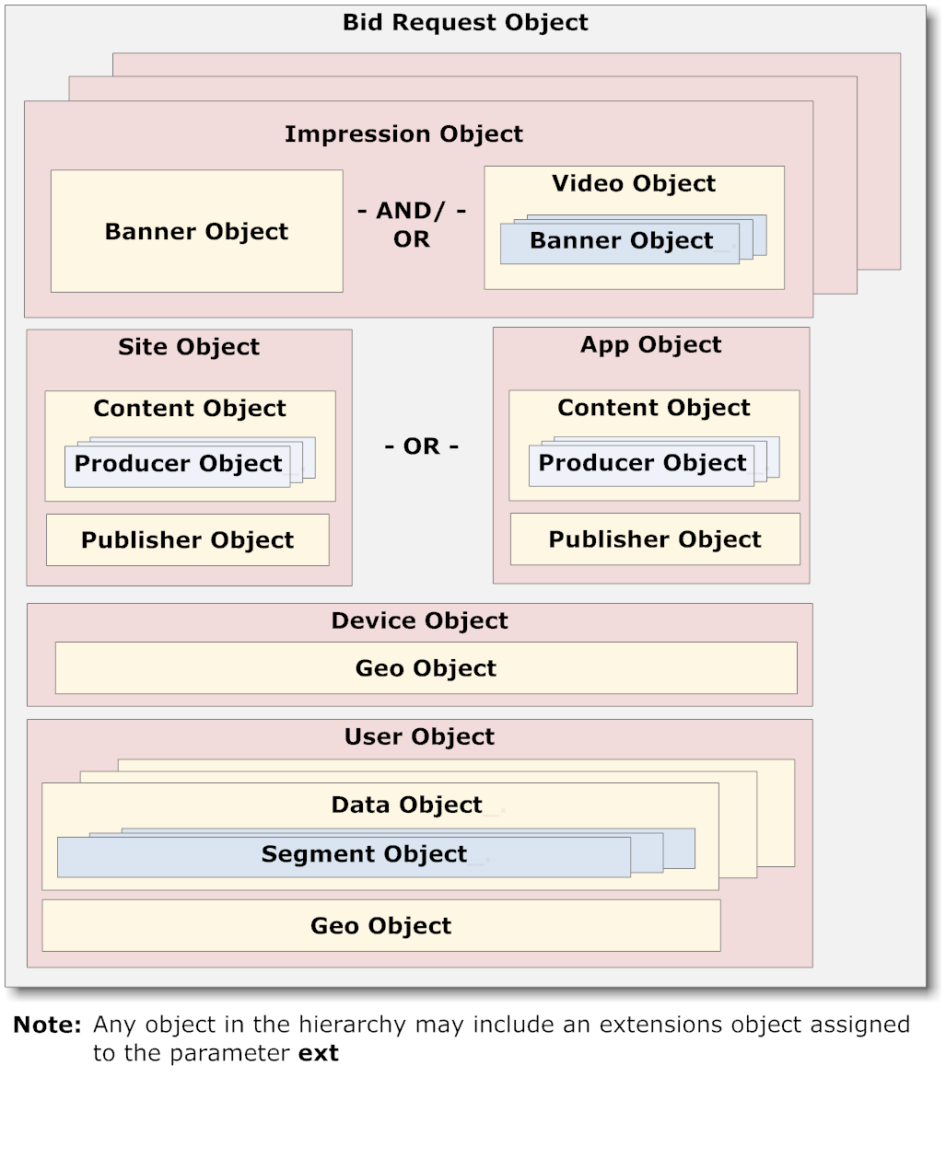

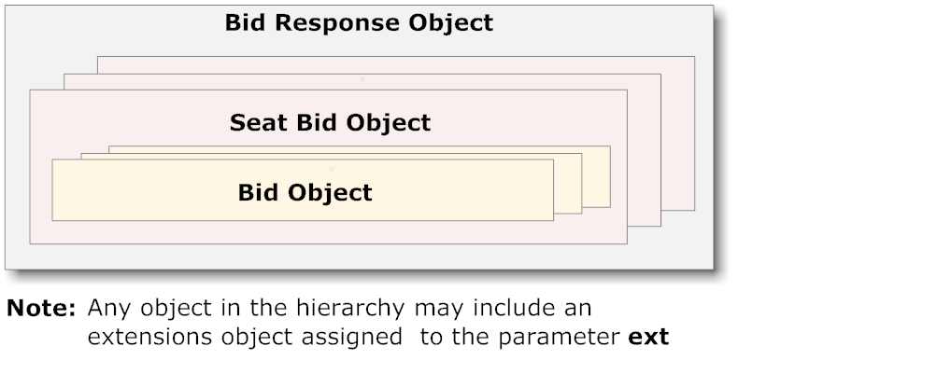

Note: Any object in the hierarchy may include an extensions object assigned to the parameter ext

User Object
Segment Object
Data Object
Geo Object
Geo Object
Device Object
Regulations Object
Content Object
Producer Object
App Object
Publisher Object
OR
Site Object
Publisher Object
Producer Object
Content Object
PMP Object
Banner Object
Bid Request Object
Direct Deals Object
AND/
OR
Video Object
Banner Object
Impression Object

