CS 262 - Advanced Concepts in Web Development

Week 2 Assignment

Name : **Seakmeng Chheang**

Section : **1**

**Arrow function feature in PHP 7.4**

Basically, ***arrow function*** is just being called in PHP instead of anonymous function in other programming languages. Yeah, as the name suggests, these functions are created without name to resolve a tiny function inline (mostly one-line functions). Doing so, reduce code complexity and more human readability. That being said, let’s dive into the code.

* Life before PHP 7.4

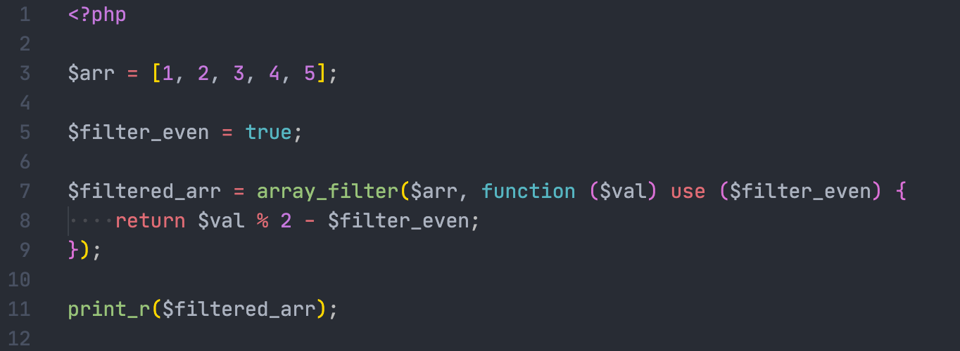

* Life after PHP 7.4

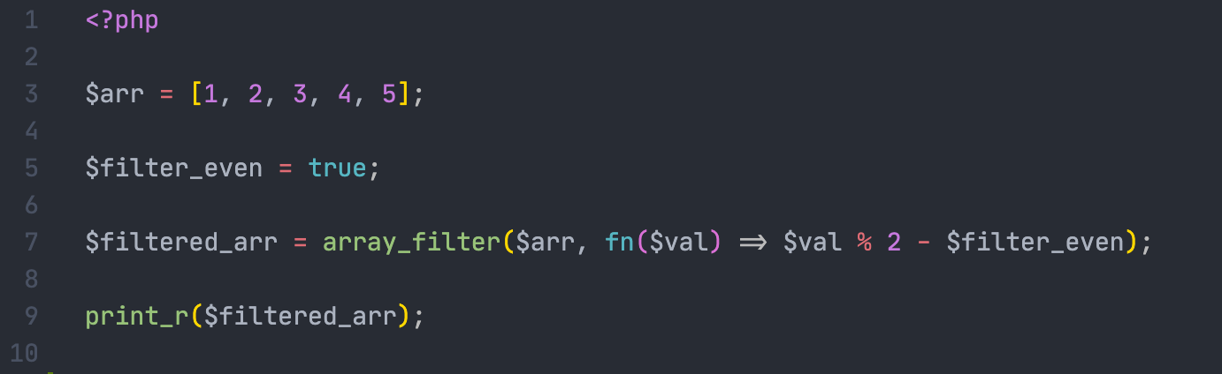

I guess you also have an eye on how *arrow functions* in PHP 7.4 can use local variable without the keyword *use*. Additionally, *arrow functions* also can use *$this* variable as local scope.