Your name _ _ _ _ _ _ _ _ _ _ _

191st FIDE ARBITERS’ SEMINAR – Online

EXAMINATION – July 27th 2025

Pass mark 80%
The number of marks awarded for each question is given in column 2 Time allowed: 4 hours

All questions are based on Standard games (40 moves in 90 minutes with an additional 30 minutes and with 30 sec increments from the start) unless indicated otherwise. The special rules for Rapid and Blitz apply unless the information given in the question indicates otherwise. Any illegal move is the first one unless stated otherwise.
You may type your answers into the document in the space provided under each question. Save the document
as “(Your name) FA Exam”

If you use a separate document, please number all the pages and put your name in the header of each page. Please number each answer correctly.
Any notes, working out or examples can be scanned or photographed and sent with your paper.

Answer all questions in accordance with the FIDE Laws and Regulations, unless the question expressly states otherwise.

When finished please email your completed paper to: lara.barnes68@gmail.com and ger@bertagnolli.com (both together in one e-mail!)

Questions on Laws of Chess (55)

No. | Marks
1 | 2 marks | 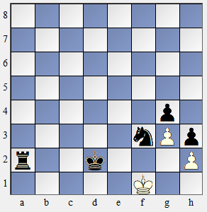  In the position given Black has plays his king from d2 to e3. White resigns immediately. Both players write 0-1 on their scoresheets and start to sign them. An arbiter has been watching. What should the arbiter do? Explain your answer.
 |  | Answer:
2 | 2 marks | 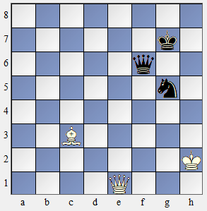  Black plays 1 … Nf3. Before he can complete the move his flag falls. Black claims a draw as after the White king moves 2 … Nxe1 and Black cannot lose. What is the result and why?
 |  | Answer:
3 | 4 marks | 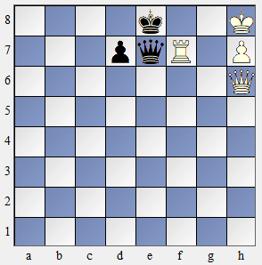  White makes the move 40. Rf8. His flag falls. Black claims a win on time. White claims that he has made the time control and the game should continue.  - Is White correct?  - Is Black correct? Explain your answers fully.
 |  | Answer:
4 | 4 marks | 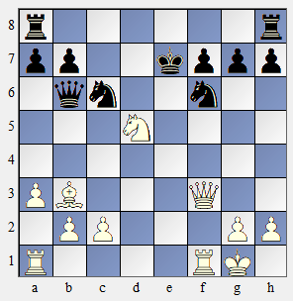  The arbiter arrives at a Blitz game where the position is given in the diagram.  - What action does the arbiter take? Explain your answer.  - If the game continued with 1 … Nxd5 2 Qxf7 what  action should the arbiter take?
 |  | Answer:

5 | 2 marks | A player promotes his pawn and the arbiter that is present gives him the requested piece that will deliver immediate mate, but the flag falls. The arbiter assigns him the victory.  - Is this decision correct?  - Why?
 |  | Answer:
6 | 4 marks | 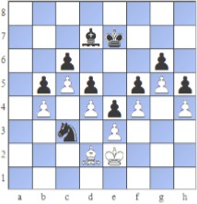  In the position shown White plays Bxc3 and starts Black’s clock. Black’s flag falls immediately.  - What is the result of the game and why?  - Would the result have been different if White had played Ke1? If so, why?
 |  | Answer:
7 | 2 marks | In a team competition the player on board 1 who played with white pieces offered his opponent a draw under the condition that the two players on board 4 should do the same. The players on board 4 did not agree. After a few minutes Black on board 1 accepted the draw, but White went to the arbiter and told him that he had offered the draw under the condition that the players on board 4 also agreed to a  draw. What is the arbiter’s decision? Explain your answer.
 |  | Answer:
8 | 4 marks | 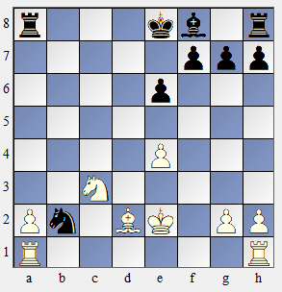  The following moves were played in a game.  1.d4 Nf6 2.c4 c5 3.d5 b5 4.cxb5 a6 5.e3 Bb7  6.Nc3 Qa5 7.Bd2 axb5 8.Bxb5 Qb6 9.Qb3 e6 10.e4 Nxe4 11.Nxe4 Bxd5 12.Qd3 Qb7 13.f3 c4  14.Bxc4 Bxc4 15.Qxc4 d5 16.Qc2 dxe4 17.Qxe4 Qxe4+ 18.fxe4 Nd7 19.Ne2 Nc5 20.Nc3 Nd3+  21.Ke2 Nxb2 22.Nb5 Ra4 23.Nc3 Ra8 24.Nb5 Ra4 25.Nc3 Ra8  After 25…Ra8 move White wrote on his scoresheet 26. Nb5, stopped the chess clock summoned the arbiter and claimed a draw because of three times the same position. He  had even underlined the moves which produced the same position. The arbiter investigated the position and took the right decision to reject the claim. Can you  explain fully why he rejected the claim? How should the game be restarted?
 |  | Answer:
9 | 2 marks | White makes a move which is checkmate. Black correctly states that White’s move  was the 50th without a capture or a pawn move and therefore the game is drawn.  Explain the decision you make.

 |  | Answer:
10 | 4 marks | 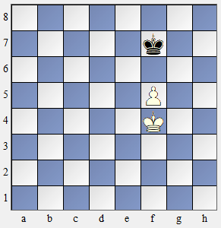  In the position shown, Black is very short of time and unsure which move to make. He lifts up his king and without letting go of it, he moves it to f6, then to f8, and then to e7 before finally placing it on f7 where he releases it and presses the clock. What should the arbiter do and why?
 |  | Answer:
11 | 3 marks | The arbiter is watching a game. The move counter is not being used. Both scoresheets shows 38 moves have been played by the White player. Black makes a move and the chess clock shows  0:00.35 0:05.12  White makes his reply and now the chess clock shows 0:30.35 0:35.12  Why is the White clock showing 0:30.35? What should the arbiter do?
 |  | Answer:
12 | 2 marks | In a Blitz tournament Black, who was left-handed, moved the chess clock so that it was at his left-hand side. This suited both players. All the other clocks faced in the  opposite direction. Should the arbiter allow this? Explain your answer
 |  | Answer:
13 | 2 marks | White has K+R. Black has K+N. White’s flag falls. What is the result of the game?  Give an explanation for your decision.
 |  | Answer:
14 | 3 marks | In a tournament a blind player and a deaf player are due to play each other. What  special arrangement should an arbiter make?
 |  | Answer:
15 | 2 marks | Name four places which are part of the playing venue.
 |  | Answer:
16 | 2 marks | Name four things an assistant can do for the disabled player

 |  | Answer:
17 | 3 marks | 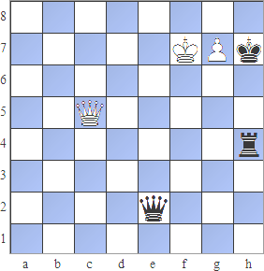  White plays g8. There is no spare queen at his board so he puts an upturned rook on in place of the pawn and announces check. The opponent calls over the arbiter. The arbiter states that White has played an illegal move and decreases two minutes from  White’s time. He then replaces the upturned rook with a queen. What mistakes if any has the arbiter made?
 |  | Answer:
18 | 2 marks | Game played with 90 minutes plus 30 seconds increment a move: after 30' a clock  shows: W 1:10 - B 1:12 after Whites 12th move. Is it correct? Why?
 |  | Answer:
19 | 3 marks | In which of the following situations must an arbiter intervene? Explain why.  - A player makes an illegal move in a Blitz tournament with one arbiter overseeing 20 players.  - A player places their king in check and presses the clock in a game with a time control of 90 minutes plus a 30-second increment.  - A player's flag falls in a Rapid game with one arbiter responsible for three boards.
 |  | Answer:
20 | 2 marks | Player A offers a draw before moving. Player B asks to see the move first. Player A states that he no longer wants to offer a draw and completes his move. Player B tries to accept the draw. What is correct arbiter’s decision?  - The game should continue as Player B did not accept the original offer. No penalty applied to either player.  - The game should continue with Player A penalised for making an illegal draw offer  - The game ends in a draw  - Both players are defaulted for having a disagreement
 |  | Answer:
21 | 1 mark | When can a player leave the playing area when it is his move?
 |  | Answer:

Questions on Tournaments (6 marks)

22 | 3 marks | A player wishes to appeal the decision of an arbiter. What three conditions must the appeal satisfy in  order to be heard?
 |  | Answer:
23 | 3 marks | Questions about round-robin tournaments (all-play-all):  - In a 7 player round-robin-tournament which player gets the bye in round 5?  - In a 12 player round-robin-tournament in which two rounds does player 8 get consecutive blacks?  - Why should the draw for a round-robin-tournament always be random?
 |  | Answer:

Questions on Tie-Breaks (6 marks)
nr | Name | tot | R1 | R2 | R3 | R4 | R5
1 | Player 1 | 4 | 6w1 | 4b1 | 2w½ | 3b½ | 5w1
2 | Player 2 | 4 | 7b1 | 3w½ | 1b½ | 4w1 | 8b1
3 | Player 3 | 3.5 | 8w1 | 2b½ | 5w1 | 1w½ | 4b½
4 | Player 4 | 2.5 | 9b1 | 1w0 | 7b1 | 2b0 | 3w½
5 | Player 5 | 2.5 | 10w1 | 6b½ | 3b0 | 7w1 | 1b0
6 | Player 6 | 2.5 | 1b0 | 5w½ | 9b1 | 8w½ | 10b½
7 | Player 7 | 1.5 | 2w0 | 10b1 | 4w0 | 5b0 | 9w½
8 | Player 8 | 1.5 | 3b0 | 9w½ | 10b½ | 6b½ | 2w0
9 | Player 9 | 1.5 | 4w0 | 8b½ | 6w0 | 10w½ | 7b½
10 | Player 10 | 1.5 | 5b0 | 7w0 | 8w½ | 9b½ | 6w½

24 | 2 marks | What is meant by Buchholz Cut 1 and Median Buchholz?
 |  | Answer:
25 | 2 marks | International Open  Which player wins if the tie break is Buchholz? Show working.
 |  | Answer:
26 | 1 mark | Is it true, that in an Armageddon play-off White will qualify if the game ends in a draw?
 |  | Answer:
27 | 1 mark | Does a virtual opponent be used in calculating of tie break?
 |  | Answer:

Questions on Swiss Pairing (10 marks)

28 | 2 marks | Player A was due to play Player B in round 2 but defaulted because he took ill. He returned and was  paired against Player B in round 5. Could this be correct? Explain your answer.
 |  | Answer:
29 | 1 mark | Why is it important that an arbiter knows how to do a pairing when it has been done by computer?
 |  | Answer:
30 | 3 marks | In a Swiss system tournament with 9 rounds, after the 4th round we have the following scorebracket: Pairing number Colour history  8 BWBB  10 WBBW  11 WBWB  19 WBWW  20 WWBW  25 BWWB  29 BWWB  31 WBWB  45 WBBW  Following pairings have already been played in previous rounds: 10-25 and 19-45  Non of these players have been up-floated or down-floated last 2 rounds. What are the pairings of the  5th round?
 |  | Answer:
31 | 3 marks | 50 players take part in a tournament. There are 21 winners in the first round. 15 of them had white. How many of these players will get a second white in round 2? Explain why  A. 6  B. 5  C. 4  D. 3
 |  | Answer:
32 | 1 mark | How many rounds would be required to ensure that in a normal 54 player Swiss tournament only one player could have a 100% score?  A. 5  B. 6
 |  | Answer:

Questions on Titles & Rating (15 marks)

33 | 8 marks | A Swiss event in England had 80 players of whom 19 are foreign (non ENG) rated. A local player named McDonalds meets the following opponents with the results as shown:  R1. Andrews ENG 2363 1  R2. Bradshaw AUS GM 2528 ½  R3. Cooper ENG 2295 1  R4. Drew WLS 1925 1  R5. Edwards SCO IM 2460 1  R6. Fryer ESP GM 2548 0  R7. Green ENG CM 2023 1  R8. Harris ENG IM 2487 1  R9. Innes ENG 2373 ½  R10. Johnson ENG GM 2484 1  R11. McNab ENG GM 2464 ½  Has McDonalds fulfilled the requirements for a GM norm? Explain your answer fully showing all working.
 |  | Answer:
34 | 2 marks | In his first rated tournament a player scores 1 point from 5 games against rated opponents. However, in the next rating list his name does not appear. Which of these is the most likely reason?  - He did not score enough points as 25% needed  - He did not play enough rated opponents  - His rating was below 1400  - You must wait 60 days before a rating is published  Explain why you think your decision is correct.
 |  | Answer:
35 | 3 marks | In a 7 rounds Swiss System Tournament a player whose rating is 2556, played against the following opponents and had the following results:  Opponent's rating Player's score  2075 1  2134 1  2395 1  2468 0  2290 1  2550 ½  2653 ½  Calculate his rating change from this tournament. (Show full work)
 |  | Answer:
36 | 2 marks | In a 5 rounds Swiss System Tournament a player without rating scored following results:  Opponent's rating Player's score  2075 1  2100 0  1933 1  2010 0  1919 1

Calculate his rating entry in FIDE rating list (Show full work)
Answer:

Questions on Arbiters (3 marks)

37 | 3 marks | An application for a FIDE arbiter title was rejected. The candidate submitted five ‘norms’ as follows:  3 national championships with 40 players and 9 rounds  1 rapid tournament with 50 players and 9 rounds  1 blitz tournament with 60 players and 7 rounds  Explain fully why the application was rejected.
 |  | Answer:

Questions on Anti-Cheating (Fair Play) (5 marks)

38 | 2 marks | A player approaches the arbiter and says that he thinks his opponent has a phone in his pocket as he heard a noise. He insists that the arbiter should immediately scan his opponent. Why should the  arbiter refuse? If the opponent is scanned suggest when it should be done.
 |  | Answer:
39 | 3 marks | Players at an event are allowed to have their mobile phones but they must be switched off and, in a bag, supplied by the organiser. A ‘beep’ makes you suspect that a player has not switched his phone off. On the board he has king and rook. The opponent only has a king. You ask to see the phone but  the player refuses. Would your decision be different if he continues to refuse?
 |  | Answer:

