Assignment 1

Name: Haiyue Wang

Email: wanhy149@mymail.unisa.edu.au

Contents

Abstract 3

1. Research 4

1.1 Big Data Applications in Meituan 4

1.2 Suggestions 5

1.3 The Advantages 5

1.4 Challenges 6

2. Naïve Bayes Model 7

2.1. Numerical variables. 7

2.1.1. Distribution of Variables 7

2.1.2. Classifier model with full training set 8

2.1.3. Explanation for one record 9

2.1.4. Cross validation using 10-fold approach 10

2.2. Categorical variables 10

2.2.1. Distribution of Discretized Dataset 11

2.2.2. Model and Cross Validation 11

2.2.3. Explanation 14

3. References 16

4. Appendix 17

4.1 Full Training Set 17

4.2 Cross Validation using 10-fold approach (Numerical variables) 20

4.3 Cross Validation using 5-fold approach (Categorical variables) 23

# Abstract

This paper is the assignment 1 for Advanced Analytics 2 of SP5 2023 in Unisa. Two components consist of the whole content. The first one is research on a big data platform of a specific company, analyze and give some suggestions on optimization, which will show on change 1. Another component is to build Naïve Bayes Model with UCI cancer dataset, show the clear understanding on different variables, which will show on chapter 2.

# Research

## Big Data Applications in Meituan

For a company that need to process big data, all they will come across the problems because of characters of big data. There are several ways to describe the characters of big data, such as the most famous V3 and V10. Next, will explore how the Meituan, which is a comprehensive internet company in China, to process big data for their business.

Here will use the V3 to show the characters that Meituan come across. Firstly, describe the huge volume of data, there are 42P+ volume data exist in company and around 16 thousand tables; for the variety, there are kinds of business data, log, and comments, etc. need to process; for the velocity, there are 150 thousand tasks on MapReduce and Spark per day, the log data with a peak value of one million per second. There are 2500+ nodes are deployed in 3 computer rooms to process all the tasks (2022).

It’s obviously that it impossible to process using a normal application. They established application based on Hadoop software to support all the service. The structure of their application like ***Image 1.1.1***.

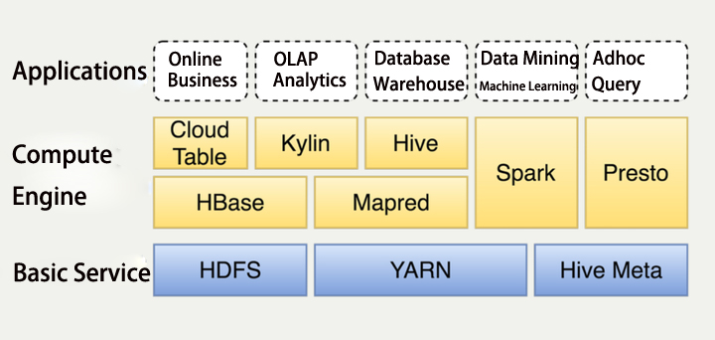

***1.1.1*** ***Structure of Big Data Platform***

The applications layer is the business layer, they are all business related, the compute engine layer and basic service layer construct the big data platform, which are what we need to focus on. All the components on the two layers will be described below.

HDFS stands for Hadoop Distributed File System, which is a distributed file system (*HDFS Architecture Guide*, no date). Apache Hadoop YARN (Yet Another Resource Negotiator) is a novel resource orchestrator within the Hadoop framework, and a versatile resource governance infrastructure capable of furnishing cohesive resource allocation and scheduling functionalities for superjacent application strata (*Apache Hadoop 3.3.6 – Apache Hadoop YARN*, no date). The fullname of Hive Meta is Hive Metastore (HMS), which is the paramount depository, it houses the metadata pertaining to Hive tables and partitions within a relational database, affording diverse clients (comprising Hive, Impala, and Spark) the capability to retrieve said information through the utilization of the Metastore service API. (*Apache Hive*, no date). HBase is [Apache](https://www.apache.org/) HBase™ is the [Hadoop](https://hadoop.apache.org/) database, a distributed, scalable, big data store (*Apache HBase – Apache HBaseTM Home*, no date). Mapred is a package, which describes how to read and write ORC files from Hadoop’s older org.apache.hadoop.mapred MapReduce APIs (*Using in MapRed*, no date). Cloud Table is a HBase interface make by Meituan (2022). Apache Kylin stands as an open source, distributed Analytical Data Warehouse; its conception was geared towards furnishing OLAP (Online Analytical Processing) proficiency within the milieu of extensive data landscapes. (*Apache Kylin | Analytical Data Warehouse for Big Data*, no date). Apache Hive is a distributed and resilient data warehousing system, which empowers extensive-scale analytics, querying, manipulation, and governance of petabytes of data stored across distributed repositories through the SQL. (*Apache Hive*, no date). Apache Spark is a multi-language engine for executing data engineering, data science, and machine learning on single-node machines or clusters (*Apache SparkTM - Unified Engine for large-scale data analytics*, no date). Presto is an open-source SQL query engine that's fast, reliable, and efficient at scale (*Presto: Free, Open-Source SQL Query Engine for any Data*, no date).

After having a glace of each component, next step will give some advice on how to optimize the big data platform.

## Suggestions

The platform structure formed around 2012, ten years past, there are lots of components have made a great progress, and there are replacement components emerged. The structure of Meituan’s platform is well organized, but still have several components can be optimized. I will propose one suggestion on the structure, which is using K8 that is an open-source system for automating deployment, scaling, and management of containerized applications, to replace yarn for a more flexible capability (*Production-Grade Container Orchestration* n.d.).

## The Advantages

This part will show the advantages for the suggestions proposed on chapter 1.2. For replacement using K8 for YARN, the first thing is to understand the details of the two components, and the limitations of YARN and advantage of K8.

For understanding the limitations of YARN, it’s necessary to know how YARN works. A YARN cluster consists of nodes, some of them are Master nodes, and the most Worker nodes. Two resource managers to manage resource at different levels. The ResourceManager handles resources at the cluster level, while NodeManager manages resources at the individual host level. They track vcores and memory at the cluster and localhost level. When an application runs on YARN, the two managers will evaluate the available resources, then assign each container to a host. In this way, the key work of YARN is to manage resources and schedule tasks on the cluster.

YARN exhibits limitations like version control, job isolation, and resource allocation. Running diverse workloads mandates separate clusters, escalating complexity and inefficiency. Especially for demanding tasks like real-time processing, YARN's lack of job isolation necessitates frequent cluster setup, causing costs and resource wastage (*Kubernetes vs YARN for scheduling Apache Spark* n.d.).

The next is to understand how K8 works and the benefits from using K8.

Kubernetes could use pod to manage different tasks as an isolated container, a pod is a group of containers, and all the tasks run in an isolated environment, no matter which task failed will not influence the whole cluster (*Sensu | How Kubernetes works* n.d.).

After comparation between the YARN and Kubernetes, several benefits will get after using Kubernetes. Such as, containerize applications and dependencies to prevent dependency issues; Kubernetes' Resource Quota and Namespaces enhance control over resource utilization; portable hybrid cloud compatibility achieved with swappable backends for Spark applications; Kubernetes Role and ClusterRole features enable precise permissions based on API groups; Tag container images for version control, aiding auditing and rollback of deployments; flourishing Kubernetes ecosystem offers robust open-source management add-ons like Prometheus, Fluentd, and Grafana.

All the benefits are the reasons for the suggestion.

## Challenges

The Kubernetes is a great component for dealing with big data. There still have lots of challenges to overcome. The initial hurdle in adopting Kubernetes lies in the requisite expertise, which often lacking in data teams. Proficiency in Kubernetes, Helm, Docker, and networking basics is essential. Despite Kubernetes' prowess in scaling apps, addressing infrastructure scalability remains a task. Efficient cost management amid the need for adaptable infrastructure supporting dynamic applications is another significant challenge. Given the resource-intensive nature of big data tasks involving research, testing, modeling, and experimentation, costs can escalate if not vigilantly managed (*Kubernetes vs YARN for scheduling Apache Spark* n.d.).

# Naïve Bayes Model

In this part, the Naïve Bayes Model will be used to make a classifier on the UCI Breast Cancer Wisconsin dataset. The Weka will be selected as the tool for implementation.

## Numerical variables.



### Distribution of Variables

The dataset has 10 valid variables, one of the variables is class variable. The distribution for all the variables like the ***Image 2.1.1***.

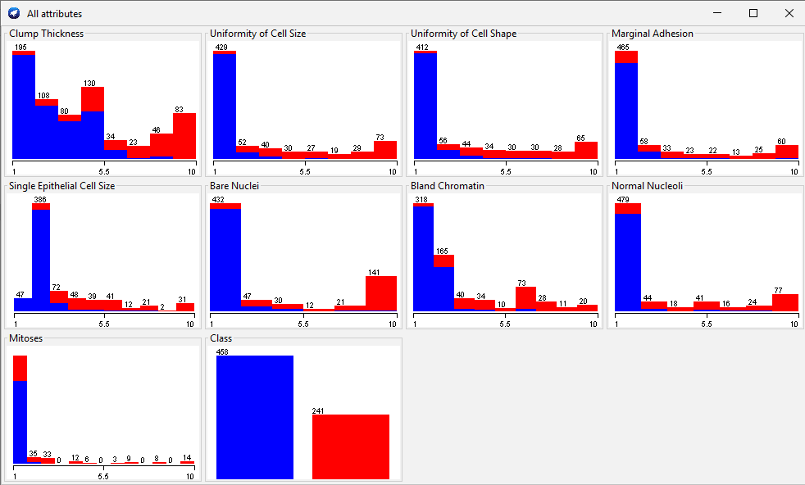

***Image 2.1.1: Distribution for numerical input variables and class***

### Classifier model with full training set

In this part, the whole dataset will be used for training the Naïve Bayes model. A Naïve Bayes Model gets after training like the ***Image 2.1.2***. More details for the model please refer to 4.1 Full Training Set.

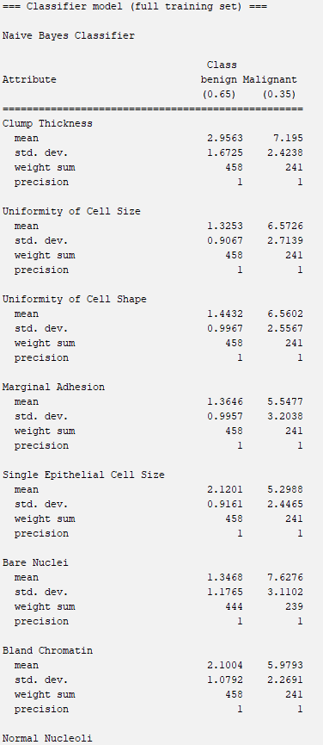

***Image 2.1.2: Part of Naïve Bayes Model***

### Explanation for one record

Select one record like the ***Image 2.1.3*** as the test record, and show how the model works on this record.



***Image 2.1.3.1: One test record***

According to ***Image 2.1.3.1***, it’s easy to know the value of each variable. The variables need to rename for easy using, like ***Image 2.1.4.2***.

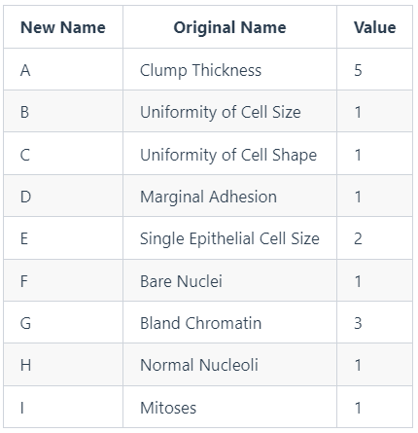

***Image 2.1.4.2: Rename table***

Now, assign ***Input = (A,B,C,D,E,F,G,H,I)***, then need to calculate ***P(Class= benign | Input)*** and ***P(Class= malignant | Input)*** , finally use MAP rule to select a bigger probability as the final result.

The target formulas could be transformed to the formulas below.

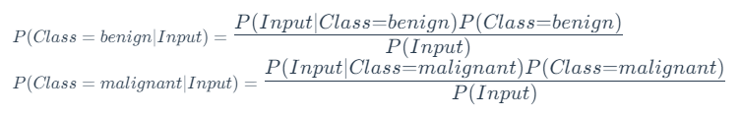

Because of ***Input=(A,B,C,D,E,F,G,H,I)***, so



The conditional probability for continuous-valued features equals to

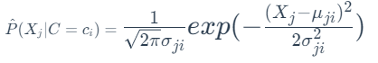

According to the model, it could easily to know the mean and standard deviation for each variable, then to calculate the conditional probabilities, a table could be got like ***Image 2.1.4.3***.

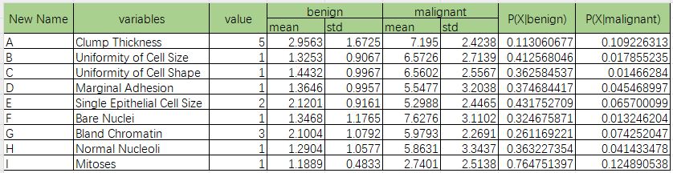

***Image 2.1.4.3: Conditional probabilities***

According to model, ***P(Class=benign) = 0.65, P(Class=malignant) = 0.35***, it could easily calculate that



**It's obviously that

According to MAP rule, the result for this record is benign, which has been classified correctly.

### Cross validation using 10-fold approach

Using 10-fold approach with Weka, a cross validation summary will get, like ***Image 2.1.4.1***.

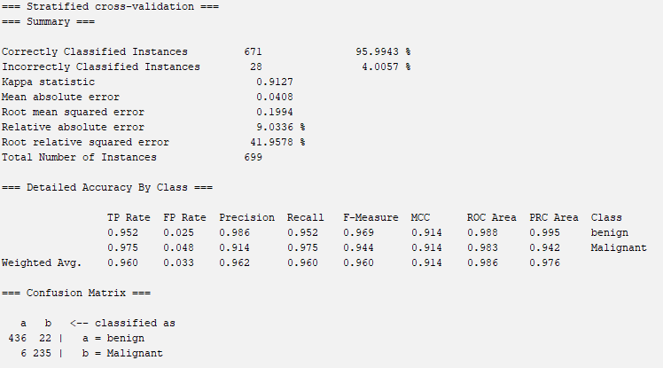

***Image 2.1.4.1: The summary for 10-fold approach***

According to the summary, it is easy to get the confusion matrix and other performance indicators.

The accuracy of the model is about 95.9943%.

***Precision(benign) = 98.6%*** means there is 98.6% benign predication cases are correct.

***Precision(malignant) = 91.4%*** means there is 91.4% malignant predication cases are correct.

***Recall(benign)=95.52%*** means there is 95.52% benign data has been classified correctly.

***Recall(malignant)=97.5%*** means there is 97.5% malignant data has been classified correctly.

## Categorical variables

In this part, the numerical data will be discretized using equal-frequency technique to split data into 3 bins. Then to train a Naïve Bayes Model and test the performance.



### Distribution of Discretized Dataset

After discretization, the data distribution will like the ***Image 2.2.1.1***.

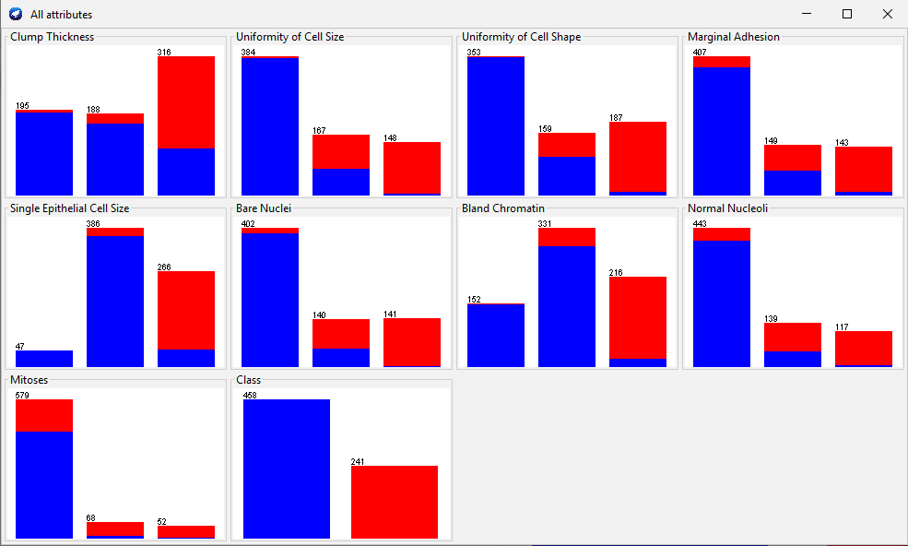

***Image 2.2.1.1: Distribution for Discretized Dataset***

### Model and Cross Validation

In this part, the discretized dataset will be used for training a Naïve Bayes model, then using 5-fold approach to evaluate it. For the part of the model please refer to ***Image 2.2.2.1***, more details please refer to chapter 4.3.

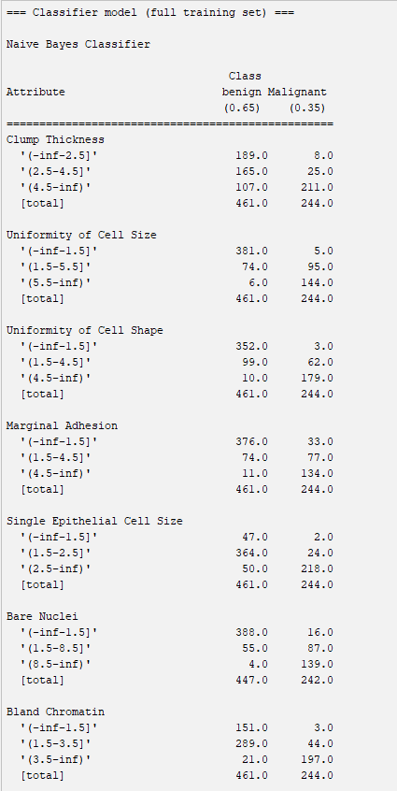

***Image 2.2.2.1: Part of Naïve Bayes Model (Model details refer to*** ***Chapter 4.3******)***

After evaluation using 5-fold approach, a summary will get, like ***Image 2.2.2.2***.

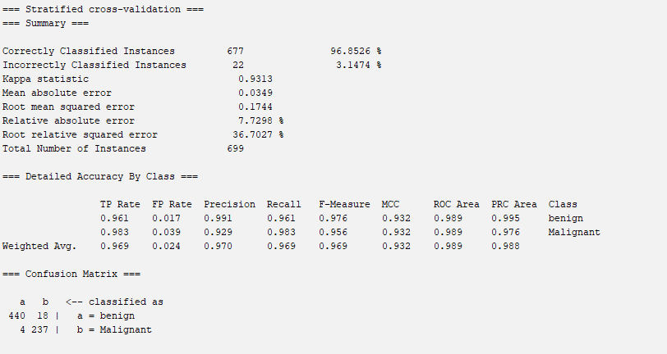

***Image 2.2.2.2: Summary for 5-fold approach***

It’s easy to get the confusion matrix and other performance indicators for the model. According to ***Image 2.2.2.2***, the accuracy is 96.8526%. The four numbers of confusion matrix are 440, 18, 4, 237. 440 means that there are 440 real benign cases are classified as benign class correctly. 18 means there are 18 benign cases are classified into malignant class incorrectly. 237 means that there are 237 real malignant cases are classified as malignant class correctly. 4 means there are 4 malignant cases are classified into benign class incorrectly.

### Explanation

This part will explain how the model works using one record, here select the same record with 2.1.3, like ***Image 2.2.3.1***.

Test Record

***Image 2.2.3.1: The record for explanation***

The 3 bins of the discretized dataset will be renamed as x, y, z, then a table will ge, like ***Image 2.2.3.2***.

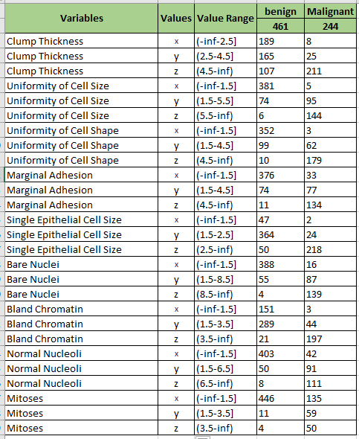According to ***Image 2.2.3.1*** and ***Image 2.2.3.2***, we could know the value of each variable. For easily to use, the variables need to rename. Another table will get, like Image 2.2.3.3, rename table.

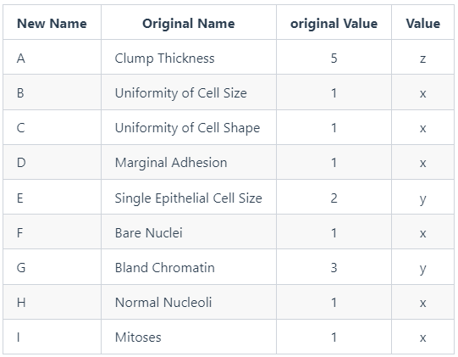

***Image 2.2.3.3: Value table***

***Image 2.2.3.2: Discretized dataset table***

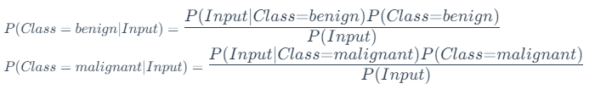Next, we need to do some steps. Firstly, assign ***Input = (A,B,C,D,E,F,G,H,I)***, then to calculate ***P(Class=benign|Input)*** and  ***P(Class=malignant| Input)***, finally use MAP rule to select a bigger probability as the final result.

Transform the formulas above, then get the formulas on the right.

Because of ***Input=(A,B,C,D,E,F,G,H,I)***, so



According to the data above we could get the probability table for each variable, like ***Image 2.2.3.4***.

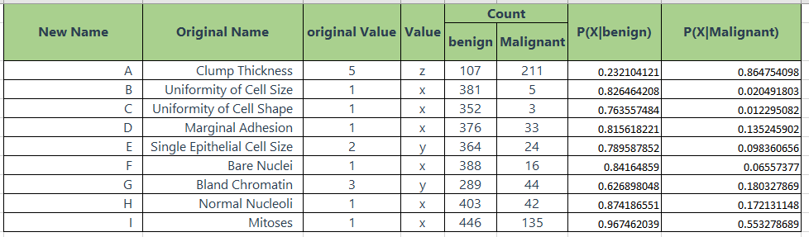

***Image 2.2.3.4: Probability Table***

It’s easy to get other possibilities from the model.

***P(Class=benign) = 0.65***  
***P(Class=malignant) = 0.35***

Finally, calculate the probabilities are 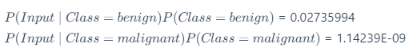

It's obviously that

So, the final result for this record is benign, it has been classified correctly.

# References

*Apache Flink® — Stateful Computations over Data Streams* n.d., viewed 20 August 2023, <<https://flink.apache.org/>>.

*Apache Hadoop 3.3.6 – Apache Hadoop YARN* n.d., viewed 20 August 2023, <<https://hadoop.apache.org/docs/stable/hadoop-yarn/hadoop-yarn-site/YARN.html>>.

*Apache HBase – Apache HBaseTM Home* n.d., viewed 20 August 2023, <<https://hbase.apache.org/>>.

*Apache Hive* n.d., viewed 20 August 2023, <<https://hive.apache.org/>>.

*Apache Kylin | Analytical Data Warehouse for Big Data* n.d., viewed 20 August 2023, <<https://kylin.apache.org/>>.

*Apache SparkTM - Unified Engine for large-scale data analytics* n.d., viewed 20 August 2023, <<https://spark.apache.org/>>.

*HDFS Architecture Guide* n.d., viewed 20 August 2023, <<https://hadoop.apache.org/docs/r1.2.1/hdfs_design.html>>.

*Kubernetes vs YARN for scheduling Apache Spark* n.d., Spot.io, viewed 20 August 2023, <<https://spot.io/blog/kubernetes-vs-yarn-for-scheduling-apache-spark/>>.

miao君 2022, 美团的大数据平台架构实践, 知乎专栏, viewed 20 August 2023, <<https://zhuanlan.zhihu.com/p/26359613>>.

*Presto: Free, Open-Source SQL Query Engine for any Data* n.d., viewed 20 August 2023, <<http://prestodb.github.io/>>.

*Production-Grade Container Orchestration* n.d., Kubernetes, viewed 20 August 2023, <<https://kubernetes.io/>>.

*Sensu | How Kubernetes works* n.d., Sensu, viewed 20 August 2023, <<https://sensu.io>>.

*Using in MapRed* n.d., viewed 20 August 2023, <<https://orc.apache.org/docs/mapred.html>>.

# Appendix



## Full Training Set

=== Run information ===

Scheme: weka.classifiers.bayes.NaiveBayes

Relation: breast-cancer-wisconsin-weka.filters.unsupervised.attribute.Remove-R1

Instances: 699

Attributes: 10

Clump Thickness

Uniformity of Cell Size

Uniformity of Cell Shape

Marginal Adhesion

Single Epithelial Cell Size

Bare Nuclei

Bland Chromatin

Normal Nucleoli

Mitoses

Class

Test mode: evaluate on training data

=== Classifier model (full training set) ===

Naive Bayes Classifier

Class

Attribute benign Malignant

(0.65) (0.35)

==================================================

Clump Thickness

mean 2.9563 7.195

std. dev. 1.6725 2.4238

weight sum 458 241

precision 1 1

Uniformity of Cell Size

mean 1.3253 6.5726

std. dev. 0.9067 2.7139

weight sum 458 241

precision 1 1

Uniformity of Cell Shape

mean 1.4432 6.5602

std. dev. 0.9967 2.5567

weight sum 458 241

precision 1 1

Marginal Adhesion

mean 1.3646 5.5477

std. dev. 0.9957 3.2038

weight sum 458 241

precision 1 1

Single Epithelial Cell Size

mean 2.1201 5.2988

std. dev. 0.9161 2.4465

weight sum 458 241

precision 1 1

Bare Nuclei

mean 1.3468 7.6276

std. dev. 1.1765 3.1102

weight sum 444 239

precision 1 1

Bland Chromatin

mean 2.1004 5.9793

std. dev. 1.0792 2.2691

weight sum 458 241

precision 1 1

Normal Nucleoli

mean 1.2904 5.8631

std. dev. 1.0577 3.3437

weight sum 458 241

precision 1 1

Mitoses

mean 1.1889 2.7401

std. dev. 0.4833 2.5138

weight sum 458 241

precision 1.125 1.125

Time taken to build model: 0.01 seconds

=== Evaluation on training set ===

Time taken to test model on training data: 0.01 seconds

=== Summary ===

Correctly Classified Instances 672 96.1373 %

Incorrectly Classified Instances 27 3.8627 %

Kappa statistic 0.9157

Mean absolute error 0.0389

Root mean squared error 0.1945

Relative absolute error 8.6172 %

Root relative squared error 40.9266 %

Total Number of Instances 699

=== Detailed Accuracy By Class ===

TP Rate FP Rate Precision Recall F-Measure MCC ROC Area PRC Area Class

0.954 0.025 0.986 0.954 0.970 0.917 0.991 0.996 benign

0.975 0.046 0.918 0.975 0.946 0.917 0.986 0.951 Malignant

Weighted Avg. 0.961 0.032 0.963 0.961 0.962 0.917 0.989 0.980

=== Confusion Matrix ===

a b <-- classified as

437 21 | a = benign

6 235 **|** b = Malignant

## Cross Validation using 10-fold approach (Numerical variables)

=== Run information ===

Scheme: weka.classifiers.bayes.NaiveBayes

Relation: breast-cancer-wisconsin-weka.filters.unsupervised.attribute.Remove-R1

Instances: 699

Attributes: 10

Clump Thickness

Uniformity of Cell Size

Uniformity of Cell Shape

Marginal Adhesion

Single Epithelial Cell Size

Bare Nuclei

Bland Chromatin

Normal Nucleoli

Mitoses

Class

Test mode: 10-fold cross-validation

=== Classifier model **(**full training **set)** ===

Naive Bayes Classifier

Class

Attribute benign Malignant

**(**0.65**)** **(**0.35**)**

==================================================

Clump Thickness

mean 2.9563 7.195

std. dev. 1.6725 2.4238

weight **sum** 458 241

precision 1 1

Uniformity of Cell Size

mean 1.3253 6.5726

std. dev. 0.9067 2.7139

weight **sum** 458 241

precision 1 1

Uniformity of Cell Shape

mean 1.4432 6.5602

std. dev. 0.9967 2.5567

weight **sum** 458 241

precision 1 1

Marginal Adhesion

mean 1.3646 5.5477

std. dev. 0.9957 3.2038

weight **sum** 458 241

precision 1 1

Single Epithelial Cell Size

mean 2.1201 5.2988

std. dev. 0.9161 2.4465

weight **sum** 458 241

precision 1 1

Bare Nuclei

mean 1.3468 7.6276

std. dev. 1.1765 3.1102

weight **sum** 444 239

precision 1 1

Bland Chromatin

mean 2.1004 5.9793

std. dev. 1.0792 2.2691

weight **sum** 458 241

precision 1 1

Normal Nucleoli

mean 1.2904 5.8631

std. dev. 1.0577 3.3437

weight **sum** 458 241

precision 1 1

Mitoses

mean 1.1889 2.7401

std. dev. 0.4833 2.5138

weight **sum** 458 241

precision 1.125 1.125

Time taken to build model: 0 seconds

=== Stratified cross-validation ===

=== Summary ===

Correctly Classified Instances 671 95.9943 **%**

Incorrectly Classified Instances 28 4.0057 **%**

Kappa statistic 0.9127

Mean absolute error 0.0408

Root mean squared error 0.1994

Relative absolute error 9.0336 **%**

Root relative squared error 41.9578 **%**

Total Number of Instances 699

=== Detailed Accuracy By Class ===

TP Rate FP Rate Precision Recall F-Measure MCC ROC Area PRC Area Class

0.952 0.025 0.986 0.952 0.969 0.914 0.988 0.995 benign

0.975 0.048 0.914 0.975 0.944 0.914 0.983 0.942 Malignant

Weighted Avg. 0.960 0.033 0.962 0.960 0.960 0.914 0.986 0.976

=== Confusion Matrix ===

a b **<**-- classified **as**

436 22 **|** a = benign

6 235 **|** b = Malignant

## Cross Validation using 5-fold approach (Categorical variables)

=== Run information ===

Scheme: weka.classifiers.bayes.NaiveBayes

Relation: breast-cancer-wisconsin-weka.filters.unsupervised.attribute.Remove-R1-weka.filters.unsupervised.attribute.Discretize-F-B3-M-1.0-Rfirst-last-precision6

Instances: 699

Attributes: 10

Clump Thickness

Uniformity of Cell Size

Uniformity of Cell Shape

Marginal Adhesion

Single Epithelial Cell Size

Bare Nuclei

Bland Chromatin

Normal Nucleoli

Mitoses

Class

Test mode: 5-fold cross-validation

=== Classifier model **(**full training **set)** ===

Naive Bayes Classifier

Class

Attribute benign Malignant

**(**0.65**)** **(**0.35**)**

==================================================

Clump Thickness

'(-inf-2.5]' 189.0 8.0

'(2.5-4.5]' 165.0 25.0

'(4.5-inf)' 107.0 211.0

**[**total**]** 461.0 244.0

Uniformity of Cell Size

'(-inf-1.5]' 381.0 5.0

'(1.5-5.5]' 74.0 95.0

'(5.5-inf)' 6.0 144.0

**[**total**]** 461.0 244.0

Uniformity of Cell Shape

'(-inf-1.5]' 352.0 3.0

'(1.5-4.5]' 99.0 62.0

'(4.5-inf)' 10.0 179.0

**[**total**]** 461.0 244.0

Marginal Adhesion

'(-inf-1.5]' 376.0 33.0

'(1.5-4.5]' 74.0 77.0

'(4.5-inf)' 11.0 134.0

**[**total**]** 461.0 244.0

Single Epithelial Cell Size

'(-inf-1.5]' 47.0 2.0

'(1.5-2.5]' 364.0 24.0

'(2.5-inf)' 50.0 218.0

**[**total**]** 461.0 244.0

Bare Nuclei

'(-inf-1.5]' 388.0 16.0

'(1.5-8.5]' 55.0 87.0

'(8.5-inf)' 4.0 139.0

**[**total**]** 447.0 242.0

Bland Chromatin

'(-inf-1.5]' 151.0 3.0

'(1.5-3.5]' 289.0 44.0

'(3.5-inf)' 21.0 197.0

**[**total**]** 461.0 244.0

Normal Nucleoli

'(-inf-1.5]' 403.0 42.0

'(1.5-6.5]' 50.0 91.0

'(6.5-inf)' 8.0 111.0

**[**total**]** 461.0 244.0

Mitoses

'(-inf-1.5]' 446.0 135.0

'(1.5-3.5]' 11.0 59.0

'(3.5-inf)' 4.0 50.0

**[**total**]** 461.0 244.0

Time taken to build model: 0 seconds

=== Stratified cross-validation ===

=== Summary ===

Correctly Classified Instances 677 96.8526 **%**

Incorrectly Classified Instances 22 3.1474 **%**

Kappa statistic 0.9313

Mean absolute error 0.0349

Root mean squared error 0.1744

Relative absolute error 7.7298 **%**

Root relative squared error 36.7027 **%**

Total Number of Instances 699

=== Detailed Accuracy By Class ===

TP Rate FP Rate Precision Recall F-Measure MCC ROC Area PRC Area Class

0.961 0.017 0.991 0.961 0.976 0.932 0.989 0.995 benign

0.983 0.039 0.929 0.983 0.956 0.932 0.989 0.976 Malignant

Weighted Avg. 0.969 0.024 0.970 0.969 0.969 0.932 0.989 0.988

=== Confusion Matrix ===

a b **<**-- classified **as**

440 18 **|** a = benign

4 237 **|** b = Malignant