# File permissions in Linux

## Project description

I need to analyze the file system and verify that all of the permissions are what they should be. Any mistakes should be fixed.

## Check file and directory details

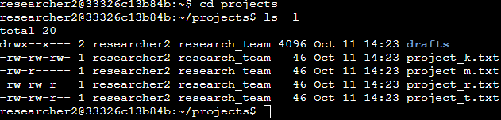 The first line of code that I used navigated me to the projects directory, and the second line of code displayed the files within the directory (ls), along with their permissions (-l).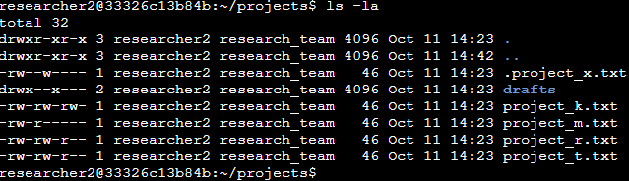

Changing the code to be ls -la does the same thing, but with the addition of any hidden files. I now know that the projects directory contains one directory and six files, one of them hidden.

## Describe the permissions string

The permissions string is 10 characters long, but can be broken down into 4 main sections.

1. The first character is the only character in its section. It can either be a d, meaning it is a directory, or a -, meaning it is a file.
2. Characters 2, 3, and 4 form the next section, and use a template that the next 2 sections will also use. The template being r for read, w for write, and x for execute. If the type of user does not have any level of permissions for a file, the character will instead show -. This section represents the permissions of the user.
3. Using the template from section 2, this section represents the permissions of the group.
4. Using the template from section 2, this section represents the permissions for other, any user in the network except for the user and the group.

For example, the file permissions of drafts reads drwx—x--- meaning that it is a directory, the user can read, write, and execute, users in the group can only execute, and other users cannot interact with it at all.

## Change file permissions

One of my instructions was to ensure that no files have write permissions for the owner type of other. project_k.txt is the only file in need of attention.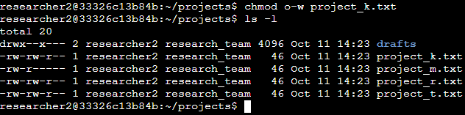

I used chmod which allows me to change the permissions for a type of user. o-w tells the system that I want to change the write permissions for the owner type of other.

I was also instructed to make sure project_m.txt is not readable or writable by the group or other. 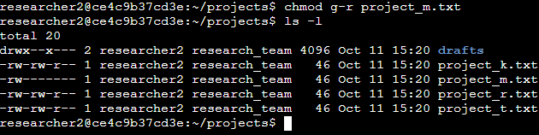 g-r tells the system that I want to change the read permissions for the owner type of group.

## Change file permissions on a hidden file

Another part of my instructions were to make sure that the archived and hidden file .project_x.txt is not writable to by anyone, but the user and group should still be able to read it. 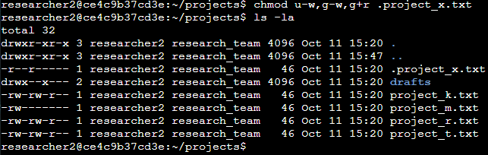Using chmod I was able to take away write permissions from the user and group and add read permissions to the group with a single line of code.

## Change directory permissions

Only the owner type of user should be able to access the drafts subdirectory.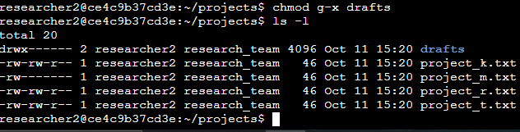 Again, using chmod I was able to take away execute permissions from the group.

## Summary

Bash can be a powerful tool to use for analyzing and changing the permissions of files and directories. I used ls -la and chmod often to complete my tasks with efficient, single lines of code.