Laboratory 1: Noise and Detection Limits

This laboratory will allow you to gain experience observing the behavior of noise and the estimation of detection limits. The experiment will use the UV-Vis absorbance spectrometer, Agilent (formerly Hewlett-Packard) model 8452, although what we learn here is completely relevant to any absorbance measurement. The HP-8452 is a single-beam diode-array spectrophotometer. A diode-array instrument disperses the whole range of spectral wavelengths λ across an array-type detector, so that all wavelengths can be recorded simultaneously, or in parallel. Nothing is scanned, so there is a great time advantage. As you may recall, to make an absorbance measurement, you first put a “blank” sample (i.e. usually a sample without the analyte of interest, but otherwise the same as your test sample) into the sample compartment of the instrument, which then records P₀, the absorbance of the blank sample at all wavelengths. You then replace the blank with your sample, and the instrument again records P at all wavelengths. The computer controlling the instrument then performs the following calculation to determine absorbance at each wavelength.
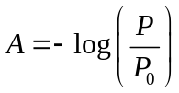 1-
The Beer-Lambert Law, also commonly called “Beer's Law” allows concentration c to be determined by A ≡ ε b c, where ε is the molar absorptivity (sometimes called the “extinction coefficient”), and b is the sample thickness. A plot of ε vs. the wavelength λ is called the spectrum.
Figure 1-1
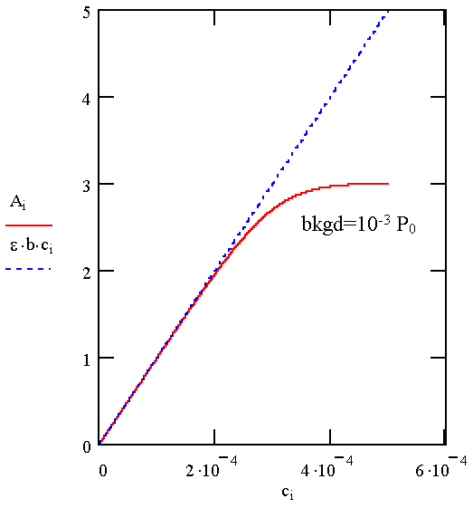

A plot of A or -log(P/P₀) vs. concentration predicts an infinite range of concentrations over which the instrument gives a linear relation between A and c. In reality, when A is high, the amount of light being absorbed by the sample is high and P is low. The amount of light falling on the detector is therefore low, making it more difficult to measure P accurately because of non-sample signals.

What the instrument actually senses is the apparent absorbance:
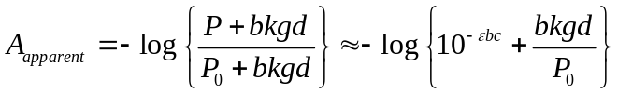 1-
where bkgd represents an amount of signal that is not related to the sample concentration (for example detector background from “dark current” and stray light). Notice that the first term in the right bracket is the same as the ideal case described in Eq. 1-1 above. There are several limitations to Beer’s Law, and we will discuss two in this lab.

1. Limit of accuracy at high absorbances. At very high absorbance the detector signal due to P (i.e. the light not absorbed by the sample) will be lower than the detector signal due to the background. We say that the signal-to-noise ratio is less than one, and the signal from the instrument is dominated by noise. A plot of Eq. 1-2 for a range of concentrations is shown in Fig. 1-1 for an ideal case of zero background (dotted blue line), and for the more typical case (solid red line) of a background that is 0.1% of the size of the detector response from P₀, i.e., bkgd/P₀ = 0.001.

Notice that the presence of the detector background limits the upper end of the absorbance that can be measured accurately. This happens in Fig. 1-1 where there is a significant deviation of the red line from the blue line. Notice also that this upper limit corresponds to a predictable limit.
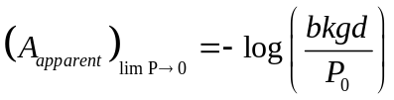 1-
In this lab, you will determine the upper limit for absorbance measurements by this spectrometer.

2. Limit of noise due to the light source. Noise on the light source (i.e. fluctuations in P₀) also affects the appearance of the calibration curve in important ways. Below in Figs. 1-2 and 1-3 are the same plot as in Fig. 1-1, but with random noise added to P₀ (0.01%). On the left in Fig. 1-2 is the high-concentration part of the calibration curve, showing the limit still at A ~ 3. But now the red curve looks noisy, due to the added random noise. On the right in Fig. 1-3 is the low-concentration part of the calibration curve. The noise on P₀ will not only affect the appearance of the calibration curve at high concentration, but, more importantly, it will affect the detection limit, which is at the low-concentration end of the calibration curve, as shown in Fig. 1-3.
Figure 1-2
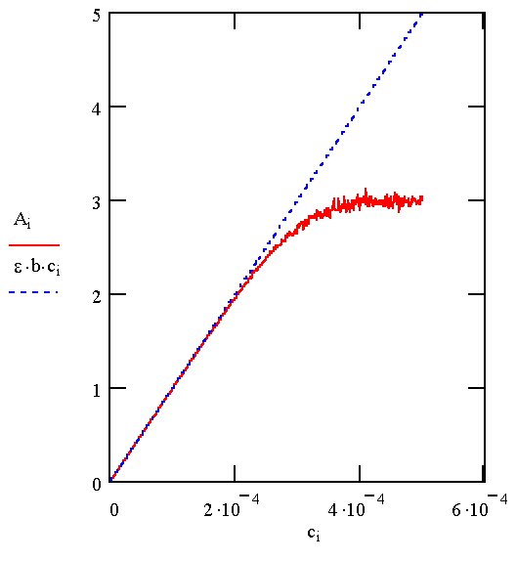
Figure 1-3
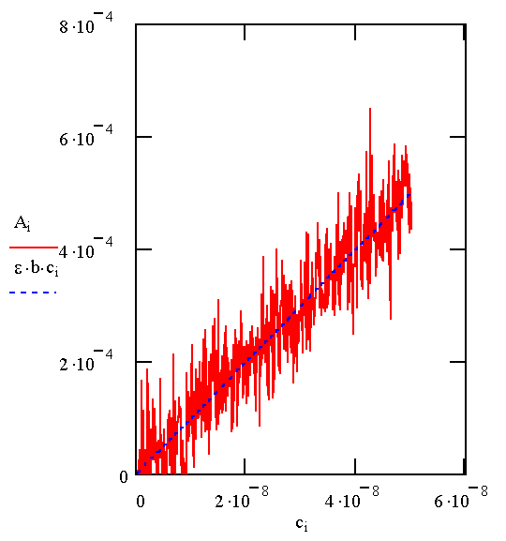

As analyte concentration becomes lower and lower and approaches zero, P→P₀ and any noise on P₀ limits the ability to determine concentration. Equation 1-4 below shows that the absorbance becomes noisy as the concentration approaches zero, or as P→P₀.
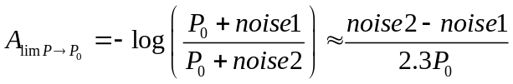 1-
To be thorough in this discussion, A in Eq. 1-3 describes noise having a standard deviation of σ_{blank} = 0.707 ⋅σ/2.3 • P₀, where σ/P₀ was 0.0001 in this example. Normally you would not know σ_{blank} without measuring it, so this formula is of little practical use except to demonstrate that A_{lim P→P0} is controlled by noise. In practical terms, it means that a sample can be too dilute to measure.

The important idea is that the limit of detection (LOD) is defined by the noise on the blank absorbance measurement,
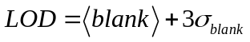 1-
where <blank> is the mean of the blank signal. Since <blank> is assumed to be zero in this case, the limit of detection is 3σ_{blank}, which we can calculate from the data. The factor of 3 is an arbitrary factor commonly used in the analytical chemistry community.

You will measure absorbance for a blank solution as a function of time. An example of this is shown in Fig. 1-4 below. The instrument will allow you to collect these data and export them. You can then calculate the standard deviation using Excel or whatever you prefer.
Figure 1-4
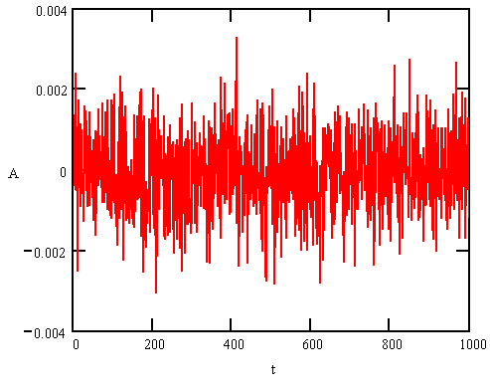

The noise on the blank sample is due to fluctuations in lamp intensity or P₀. The noise in Fig. 1-4 was created from hypothetical data using a Gaussian random number generator. In reality, the average intensity of a light source can drift over time, in addition to the fast fluctuations shown in Fig. 1-4. The behavior of noise in the instrument determines what strategy is used for attaining the best detection limit. In NMR, for example, lengthy times of signal-averaging improve signal-to-noise ratio in proportion to the square root of time. This is the case because the noise in an NMR spectrometer is dominated by the detector and it behaves like pure random noise. In the absorbance spectrometer, noise is from lamp intensity fluctuations, which are random on short time scales, but slowing drifting over long time scales. The purpose of this part of the experiment will be to observe the lamp noise of the absorbance spectrometer and calculate its detection limit. Your Teaching Assistant will show you how to monitor absorbance for the blank as a function of time. Inspecting how A varies over time will reveal whether the fluctuations behave simply as random noise or if long-term drift of the light intensity is a significant problem. Calculating the standard deviation of A_{blank} from these data allows you to determine the detection limit.

PRE-LAB ASSIGNMENT

Turn this in to your TA at the beginning of your lab period.

- Decide ahead of time what concentrations of quinine solutions you will prepare to obtain a calibration curve like that of Fig. 1-2, and what wavelength λ you will use to collect this curve. To minimize the amount of sample preparation time, choose 5 concentrations. For you to choose the right concentrations, you need some basis for guessing at the upper limit of A for the spectrometer and you also need to know the molar absorptivity ε for the sample. Both of these can be figured out from Figs. 1-7 and 1-8. In Fig. 1-7, we provide an absorbance spectrum of tonic water, which contains quinine and sodium benzoate. In Fig. 1-8, you can calculate the molar absorptivity ε of quinine at its absorbance maximum λ_{max}. The pathlength b of the sample cell will be 1 cm.
- Decide ahead of time what concentrations you will prepare to determine the detection limit of the spectrometer. Decide whether you even need to make any solutions or whether you can just repeat the blank many times. Explain what you decide to do.
- To prepare your solutions, you will need to weigh out quinine sulfate and dilute it in an aqueous solution of 0.05 M H₂SO₄. We recommend that you prepare 50.0 mL of a quinine stock solution that is 25 times more concentrated than your lowest solution concentration. Given the formula weight for quinine sulfate (782.96 g/mol), calculate how many grams of quinine sulfate you will need. You will also be given five 25.0-mL volumetric flasks for your five solutions. Calculate the volume of stock solution you will put into these flasks.
- Using the two data sets random_noise.dat and drift.dat, plot them and calculate the standard deviation for each. Think about this: if P₀ is drifting, will this hurt the detection limit because there is more fluctuation? How can one recognize drift?

EXPERIMENTAL

- Use your five solutions to make absorbance measurements to determine the upper limit of the absorbance spectrometer experimentally, as per your pre-lab work. Be sure to perform all of your dilutions with the 0.05 M sulfuric acid solution so that the pH is low and constant. This ensures that the quinine will be soluble.
- Study the behavior of noise to determine the limit of detection for various integration times. Your TA will instruct you on the use of the instrument so that you can measure absorbance and record your data on a diskette for analysis. (In the instrument settings, use a cycle time equal to the integration time.) Study the noise on the blank. This will use "kinetics mode" in the software, which allows you to store absorbance data for one wavelength as a function of time. You will only use a blank.
- Chose a wavelength of 340 nm and an integration time of 1 s. Record a blank measurement, then record a signal for the same blank sample for 64 s. Save the data set, using your last name or the first five letters of it as the file name. You can read it in Excel or whatever your software of choice is. First edit the text file in Notepad to remove the header at the beginning of the file.
- Record a blank measurement for an integration time of 0.25 s, but acquire for 16 s. This gives you the same number of data points and less time for the instrument to drift.
- Repeat b for a 10-s integration time, using a 640-s acquisition time so that you have the same number of points. What is the standard deviation, and is it what you expect? What is the new detection limit?

WRITTEN REPORT

- Provide a plot of A vs. c and report your graphical estimate of the limiting absorbance. Fit the data in the plot to the functional form of Eq. 1-2, and report the more exact value of the limiting absorbance and also the ratio of bkgd/P₀.
- Plot the data for each of the three integration times.
- Do the data behave as random noise in each case? You can answer this by seeing if the value of absorbance at one time is influenced by or correlated with the value at the previous time. Typically, there is some slow drift of P₀, giving correlation from point to point, but randomness over long periods of time.
- Use Excel or your favorite spreadsheet to calculate a standard deviation for each of the three integration times. Calculate the limit of detection in absorbance units for each integration time.
- Calculate the detection limit in molar concentration units for quinine.
- Do longer integration times improve the detection limit? Please comment.

This lab was created by Professor Mary J. Wirth, September, 2002. It was revised by Professor Thomas P. Beebe, Jr., September 2003.
This spectrum was obtained on the same absorbance spectrometer you will be using.
Figure 1-7.
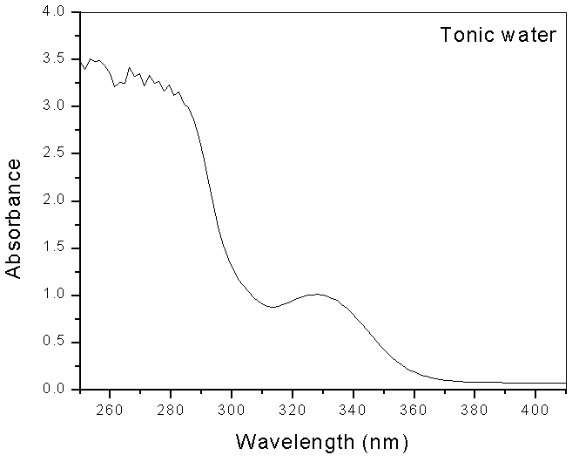
Figure 1-8. Spectrum of quinine, from "Handbook of Fluorescence spectra of Aromatic Molecules", I.B. Berlman, Academic Press, 1971.
