ACR Framework for Remotely Sensed Quantification of Forest Carbon
  - End-to-end pilot demonstration on a synthetic AOI
TÜV SÜD America - Forestry Team
2026-04-14
Table of contents
Objective 1
1 Impot AOI 1
2 Predictive Model 1
2.1 Simulate the pixel-level prediction raster 1
2.2 Calibration Plots 1
3 Validation Plots 1
3.1 Location generation 1
3.2 Dummy field measurements 1
3.3 Assessing model eligibility & equations 1
3.4 Statistical agreement 1
4 AOI-level mean carbon density 1
5 Interactive map 1
6 Re-measurements 1
7 Exports 1

Objective
A reproducible walk-through of ACR’s Framework for Remotely Sensed Quantification of Forest Carbon (v1.0, 2026), applied end-to-end to a synthetic ~5,000 ha forest AOI in the Oregon Cascades. Every numeric input is simulated; no real project data are used. The goal is to show how the Framework’s four stages fit together and to exercise every equation (s.2.4 mean carbon density, s.3.3 Eq. 2, s.3.4 Eqs. 3–6).
This report’s sections follow the ACR Framework below:
- s.1.4 Spatial scope: define the AOI.
- s.2 Predictive Model: simulate a pixel raster of aboveground carbon density and a Calibration Plot set used to fit it.
- s.3.1 Validation plot generation: run the ACR random-point script.
- s.3.2 Installation: simulate field measurement at each plot.
- s.3.3 Model eligibility: pair plots with pixels; compute area-weighted average carbon density per plot (Eq. 2).
- s.3.4 Statistical agreement: RMSE, 90 % CI, uncertainty percentages (Eqs. 3–6); pass/fail the 20 %/10 % thresholds.
- s.2.4 Mean AOI carbon density: summarize estimates.
- s.4 Re-measurement prep: audit trail to next reporting period.

library(sf)
library(terra)
library(ggplot2)
library(dplyr)
library(tibble)
library(tidyr)
library(readr)
library(leaflet)
library(htmlwidgets)
library(knitr)
set.seed(20260414)
output_dir <- "outputs_full"
if (!dir.exists(output_dir)) dir.create(output_dir, recursive = TRUE)

1 Impot AOI
Same synthetic Oregon Cascades polygon used in the validation-plot demo: an irregular ~5,000 ha tract centered near 44.5°N, 122.5°W. Built by perturbing a circle’s radius with sinusoidal plus random noise so the boundary is non-convex and realistic.
centroid_lon <- -122.5
centroid_lat <- 44.5
target_ha <- 5000
km_per_deg_lat <- 111
km_per_deg_lon <- 111 * cos(centroid_lat * pi / 180)
target_radius_km <- sqrt(target_ha / 100 / pi)
n_vert <- 120
theta <- seq(0, 2*pi, length.out = n_vert + 1)[-1]
radius_km <- target_radius_km *
(1 + 0.25 * sin(3*theta) + 0.12 * cos(5*theta) +
runif(n_vert, -0.06, 0.06))
lon <- centroid_lon + (radius_km * cos(theta)) / km_per_deg_lon
lat <- centroid_lat + (radius_km * sin(theta)) / km_per_deg_lat
coords <- rbind(cbind(lon, lat), c(lon[1], lat[1]))
aoi <- st_sf(name = "Demo AOI",
geometry = st_sfc(st_polygon(list(coords)), crs = 4326)) |>
st_make_valid()
aoi_ea <- st_transform(aoi, 6933) # equal-area for all area computations
aoi_area_ha <- as.numeric(st_area(aoi_ea)) / 1e4
cat(sprintf("AOI area: %.1f ha\n", aoi_area_ha))
AOI area: 5230.0 ha

2 Predictive Model
In a real project, a Predictive Model is trained on Calibration Plots (field-measured aboveground carbon) paired with remotely sensed covariates (Landsat/Sentinel/LiDAR/RADAR), then applied to every pixel across the AOI to produce a wall-to-wall map of predicted carbon density (t CO₂e / ha).
For the demo, we skip the regression fit and instead simulate the output of such a model: a 30 m pixel raster of predicted aboveground carbon density over the AOI, with spatial autocorrelation to mimic forest structural variation.

2.1 Simulate the pixel-level prediction raster
# Use an equal-area CRS (EPSG:6933) so pixels are truly 30 m × 30 m
aoi_vect <- vect(aoi_ea)
r_template <- rast(ext(aoi_vect), resolution = 30, crs = crs(aoi_vect))
# Coarse smooth field (low-freq sinusoid) + fine noise, clipped to AOI
xy <- xyFromCell(r_template, 1:ncell(r_template))
xn <- (xy[,1] - min(xy[,1])) / (max(xy[,1]) - min(xy[,1]))
yn <- (xy[,2] - min(xy[,2])) / (max(xy[,2]) - min(xy[,2]))
# Simulated AGC density in t CO2e / ha: mean ~ 350, sd ~ 70
agc_vals <- 350 +
80 * sin(2*pi*xn*1.5) * cos(2*pi*yn*1.2) +
40 * sin(2*pi*xn*4.0 + 0.7) +
rnorm(length(xn), 0, 30)
agc_vals <- pmax(agc_vals, 50)
r_pred <- setValues(r_template, agc_vals)
names(r_pred) <- "AGC_tCO2e_per_ha"
r_pred <- mask(r_pred, aoi_vect)
cat(sprintf("Pixels in AOI: %d (%.1f ha)\n",
global(!is.na(r_pred), "sum")[[1]],
global(!is.na(r_pred), "sum")[[1]] * 0.09))
Pixels in AOI: 58790 (5291.1 ha)
plot(r_pred, main = "Predicted aboveground carbon density (t CO2e / ha)")
plot(aoi_vect, add = TRUE, border = "black", lwd = 1.2)
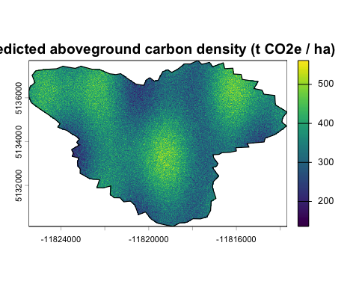

2.2 Calibration Plots
In practice, a Project Proponent would install ≥ Calibration Plots to parameterize the model. Here we fabricate 60 Calibration Plots for narrative completeness only. Important to note that they play no statistical role in the eligibility test (s.3.3 forbids Validation Plots from being reused as Calibration Plots for the current reporting period).
n_cal <- 60
cal_pts <- st_sample(aoi, size = n_cal, type = "random", exact = TRUE) |>
st_as_sf() |>
mutate(CalID = sprintf("C%02d", dplyr::row_number()))

3 Validation Plots

3.1 Location generation
Inline reproduction of ACR script ACR-Script-for-Validation-Plot- Location-Generation.r: equal-area sampling in EPSG:6933, n_points = 45, ACR-issued seed already set at top of document.
n_points <- 45
poly_sampling <- st_transform(aoi, 6933)
pts_geom <- st_sample(poly_sampling, size = n_points,
type = "random", exact = TRUE)
vp <- st_as_sf(pts_geom) |>
mutate(PointID = sprintf("P%02d", dplyr::row_number())) |>
st_transform(st_crs(aoi))
vp_ea <- st_transform(vp, 6933)

3.2 Dummy field measurements
Each Validation Plot is a circular plot of radius 17.84 m (0.1 ha = 1000 m², consistent with FIA subplot-style sampling). The observed aboveground carbon at each plot is the true underlying field sampled with realistic measurement noise and a small positive bias (simulating, for example, a predictive model that slightly under-predicts carbon in mature stands).
plot_radius_m <- 17.84 # 0.1 ha circular plot
vp_polys <- st_buffer(vp_ea, dist = plot_radius_m)
# Predicted area-weighted average carbon density at each plot (s.3.3 Eq. 2)
# average pixel value weighted by overlap area with the plot
ext_pred <- terra::extract(r_pred, vect(vp_polys),
weights = TRUE, fun = NULL)
pred_by_plot <- ext_pred |>
as_tibble() |>
group_by(ID) |>
summarise(C_pred = sum(AGC_tCO2e_per_ha * weight) / sum(weight),
.groups = "drop") |>
arrange(ID)
# Simulate observation: truth is the model's prediction plus a realistic
# deviation pattern. This is where a real field crew would walk in with
# diameter tapes / allometric equations.
obs_bias <- 8 # t CO2e / ha (model under-predicts slightly on average)
obs_noise <- 35 # plot-level residual sd
plots_df <- tibble(
PointID = vp$PointID,
C_pred = pred_by_plot$C_pred, # Ĉ_AVE,AG,p,VP,i
C_obs = pred_by_plot$C_pred + obs_bias +
rnorm(n_points, 0, obs_noise) # C_AG,VP,i
) |> mutate(residual = C_obs - C_pred)
kable(head(plots_df, 10), digits = 1,
caption = "Predicted vs. observed carbon density (first 10 plots)")
Predicted vs. observed carbon density (first 10 plots)
PointID | C_pred | C_obs | residual
P01 | 384.5 | 315.2 | -69.3
P02 | 364.5 | 336.1 | -28.4
P03 | 383.0 | 368.4 | -14.7
P04 | 350.4 | 339.4 | -11.0
P05 | 351.7 | 364.1 | 12.3
P06 | 465.1 | 468.1 | 3.0
P07 | 409.8 | 368.2 | -41.6
P08 | 348.0 | 343.7 | -4.3
P09 | 276.4 | 279.7 | 3.2
P10 | 358.7 | 317.9 | -40.8
ggplot(plots_df, aes(C_pred, C_obs)) +
geom_abline(slope = 1, intercept = 0, linetype = 2, color = "grey50") +
geom_point(color = "red3", size = 2) +
labs(x = "Predicted (t CO2e / ha)",
y = "Observed (t CO2e / ha)",
title = "Validation plot agreement",
subtitle = "Dashed = 1:1 line") +
theme_minimal()
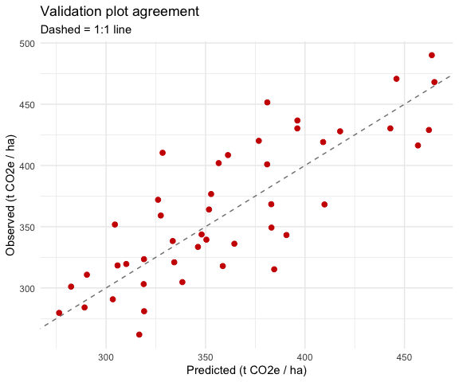

3.3 Assessing model eligibility & equations
ACR Framework s.3.3–3.4 defines four equations. We compute each explicitly.
N <- nrow(plots_df)
C_obs_bar <- mean(plots_df$C_obs)
C_pred_bar <- mean(plots_df$C_pred)
# Eq. 3 — Root Mean Squared Error
RMSE <- sqrt(mean((plots_df$C_obs - plots_df$C_pred)^2))
# Eq. 4 — Uncertainty percentage using RMSE (threshold < 20%)
UNC_RMSE <- (RMSE / C_obs_bar) * 100
# Eq. 5 — 90% Confidence Interval
CI90 <- (RMSE / sqrt(N)) * 1.645
# Eq. 6 — Uncertainty percentage at 90% CI (threshold <= 10%)
UNC_CI <- (CI90 / C_obs_bar) * 100
tibble(
Metric = c("N plots","Mean observed C (t CO2e/ha)",
"Mean predicted C (t CO2e/ha)",
"RMSE (Eq. 3)","UNC_RMSE % (Eq. 4)",
"90% CI (Eq. 5)","UNC_CI % (Eq. 6)"),
Value = c(N, C_obs_bar, C_pred_bar, RMSE, UNC_RMSE, CI90, UNC_CI)
) |> kable(digits = 2, caption = "Eligibility statistics")
Eligibility statistics
Metric | Value
N plots | 45.00
Mean observed C (t CO2e/ha) | 364.18
Mean predicted C (t CO2e/ha) | 361.34
RMSE (Eq. 3) | 33.90
UNC_RMSE % (Eq. 4) | 9.31
90% CI (Eq. 5) | 8.31
UNC_CI % (Eq. 6) | 2.28

3.4 Statistical agreement
Framework s.3.4: the Predictive Model is eligible when UNC_RMSE < 20 % and UNC_CI ≤ 10 %.
pass_rmse <- UNC_RMSE < 20
pass_ci <- UNC_CI <= 10
eligible <- pass_rmse && pass_ci
tibble(
Test = c("UNC_RMSE < 20%", "UNC_CI <= 10%", "Overall eligibility"),
Observed = c(sprintf("%.2f%%", UNC_RMSE),
sprintf("%.2f%%", UNC_CI),
ifelse(eligible, "PASS", "FAIL")),
Threshold = c("< 20%", "<= 10%", "both required"),
Result = c(ifelse(pass_rmse,"PASS","FAIL"),
ifelse(pass_ci, "PASS","FAIL"),
ifelse(eligible, "ELIGIBLE","NOT ELIGIBLE"))
) |> kable(caption = "ACR s.3.4 agreement test")
ACR s.3.4 agreement test
Test | Observed | Threshold | Result
UNC_RMSE < 20% | 9.31% | < 20% | PASS
UNC_CI <= 10% | 2.28% | <= 10% | PASS
Overall eligibility | PASS | both required | ELIGIBLE
If the test fails, s.3.4 allows the Project Proponent either to install additional Validation Plots from the same sequence (pending ACR approval) or to discontinue and request a fresh seed to restart s.3.

4 AOI-level mean carbon density
The pixel raster gives the Framework’s primary deliverable: AOI-level mean aboveground carbon density (used for crediting once the model is approved).
mean_C <- global(r_pred, "mean", na.rm = TRUE)[[1]]
total_C <- mean_C * aoi_area_ha # t CO2e across the whole AOI
tibble(
Quantity = c("AOI area (ha)",
"Mean AGC density (t CO2e / ha)",
"Total AGC stock (t CO2e)"),
Value = c(aoi_area_ha, mean_C, total_C)
) |> kable(digits = 1, caption = "AOI-level roll-up (s.2.4)")
AOI-level roll-up (s.2.4)
Quantity | Value
AOI area (ha) | 5230.0
Mean AGC density (t CO2e / ha) | 354.8
Total AGC stock (t CO2e) | 1855738.2

5 Interactive map
AOI outline, predictive raster thumbnail, Calibration Plots (blue), Validation Plot centers (red).
# Raster to WGS84 for web display (build a target template explicitly
# because auto-projection from an equal-area CRS occasionally fails to
# infer output extent)
aoi_wgs_vect <- vect(aoi)
r_tmpl_wgs <- rast(aoi_wgs_vect, resolution = 0.0005)
crs(r_tmpl_wgs) <- "EPSG:4326"
r_wgs <- project(r_pred, r_tmpl_wgs, method = "bilinear")
pal <- colorNumeric("YlGn", values(r_wgs), na.color = "transparent")
leaf <- leaflet() |>
addProviderTiles(providers$Esri.WorldImagery, group = "Imagery") |>
addProviderTiles(providers$CartoDB.Positron, group = "Basemap") |>
addRasterImage(r_wgs, colors = pal, opacity = 0.7,
group = "Predicted AGC") |>
addPolygons(data = aoi, fill = FALSE, color = "#222",
weight = 2, group = "AOI") |>
addCircleMarkers(data = st_transform(cal_pts, 4326),
radius = 3, color = "blue", fillOpacity = 0.8,
label = ~CalID, group = "Calibration plots") |>
addCircleMarkers(data = st_transform(vp, 4326),
radius = 5, color = "red", fillOpacity = 0.9,
label = ~PointID, group = "Validation plots") |>
addLegend(pal = pal, values = values(r_wgs),
title = "AGC (t CO2e/ha)", opacity = 0.8) |>
addLayersControl(
baseGroups = c("Basemap","Imagery"),
overlayGroups = c("AOI","Predicted AGC",
"Calibration plots","Validation plots"),
options = layersControlOptions(collapsed = FALSE)
) |>
hideGroup("Calibration plots")
html_path <- file.path(output_dir, "full_framework_map.html")
saveWidget(leaf, file = normalizePath(html_path, mustWork = FALSE),
selfcontained = TRUE)
leaf
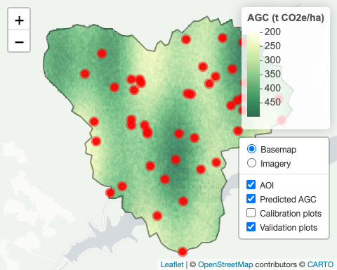

6 Re-measurements
Once the Predictive Model is deemed eligible, s.4 of the Framework kicks in at the next reporting period: the VVB may remeasure a subset of the existing Validation Plots to confirm stability, or the Project Proponent may request a new seed to draw a fresh sequence if conditions in the AOI have changed materially (disturbance, harvest, regrowth). The same script and the same 20 %/10 % thresholds apply.

7 Exports
write_csv(plots_df, file.path(output_dir, "validation_plots_eligibility.csv"))
writeRaster(r_pred, file.path(output_dir, "predicted_agc.tif"),
overwrite = TRUE)
suppressWarnings(st_write(vp, file.path(output_dir, "validation_points.shp"),
delete_layer = TRUE, quiet = TRUE))
suppressWarnings(st_write(cal_pts,
file.path(output_dir, "calibration_points.shp"),
delete_layer = TRUE, quiet = TRUE))
- outputs_full/predicted_agc.tif — simulated pixel prediction raster
- outputs_full/validation_points.shp — 45 plot centers
- outputs_full/calibration_points.shp — 60 simulated calibration plots
- outputs_full/validation_plots_eligibility.csv — predicted vs. observed
- outputs_full/full_framework_map.html — standalone interactive map

Notes
The Predictive Model here is a hand-crafted spatial field, not a fitted regression on real covariates; the observation process is Gaussian noise plus a constant bias rather than real allometric error; and the Calibration Plots are decorative. Everything downstream of the raster, including the ACR script, the equal-area sampling, the plot-pixel overlap, the RMSE and CI computations, the s.3.4 decision, demostrates a typical project runtime.

