Testing the wind disruption hypothesis for beetle refugia
Host distribution, thermal load, and terrain-wind effects on Mountain pine beetle attack (Dendroctonus ponderosae) across 1,740 m of relief in the Selkirk Mountains of British Columbia
Seamus Murphy, ORCID-0000-0002-1792-0351, seamusrobertmurphy@gmail.com
Refugia from mountain pine beetle (Dendroctonus ponderosae) are hypothesised to form where host density falls low enough for wind to disrupt the aggregation pheromone plume on which mass attack depends, yet the mechanism has never been tested spatially. We test it across 168 km² of inventoried forest spanning 1,740 m of relief in the Selkirk Mountains of southeastern British Columbia, combining the provincial Aerial Overview Survey record of beetle-caused mortality (1999–2015) with forest-inventory host cover and Global Wind Atlas wind speed. Attack is strongly unimodal in elevation, peaking near 1,430 m. Below 1,900 m this peak is attributable to host: conditioning on lodgepole pine presence removes it. Above 1,900 m it is not; attack more than halves while pine cover thins only slightly, a decline several times larger than a proportionate response to declining host would predict. We nonetheless find no wind effect. Entered alongside a linear elevation term, the component of the wind surface orthogonal to elevation is the strongest negative predictor in host-bearing stands and clears the interval test at every severity threshold above trace, but this result does not survive respecification. Because the response is unimodal, residualising wind against a straight line retains the curvature of elevation within the wind term; entering elevation as a quadratic or spline and residualising against the same basis raises the share of the wind surface explained by elevation from 0.62 to 0.73 and collapses the coefficient at every threshold, with no interval excluding zero. The apparent wind signal is therefore an artefact of elevation specification, a caution we judge more useful than the effect would have been. A heat-load index nearly independent of elevation predicts attack at the moderate-severity threshold in the direction warmth limitation implies; winter minima at every station within 100 km fall roughly ten degrees short of temperatures conventionally lethal to the insect, indicating that the operative cold mechanism is degree-day accumulation rather than freeze mortality. The methodological findings are firmer still: elevation explains 0.63 of the variance in the wind surface across the full landscape but 0.80 within a 2 × 4 km clip, where the point estimate reverses sign, though the clip contains too few spatial blocks to yield an interval excluding zero; coarsening the grain from 25 m to 100 m scarcely alters it. Analysed at the extent disturbance ecology conventionally adopts, this study would have reported the opposite result; with severity collapsed to presence, no result at all; and without a host layer, absence of pine misread as refugia.

## Cartography shared by the four map figures, defined once here so each figure can
## sit in the section it documents instead of being grouped at the end of Materials
## for want of its furniture. Graticule, EPSG, north arrow, bar scale and a
## representative fraction quoted against a stated printed width are set once and
## reused, so the panels are directly comparable.
PANEL_MM <- 85
rf <- function(w, mm = PANEL_MM)
paste0("1:", format(signif(w / (mm/1000), 2), big.mark = ",", scientific = FALSE))
clip_src <- rast(dpath("beetle_stages", "Beetle.Oubteak.2005.tif"))
clip_sf <- st_as_sf(project(as.polygons(ext(clip_src), crs = crs(clip_src)), crs(G)))
grid_sf <- st_as_sf(as.polygons(ext(G), crs = crs(G)))
ev <- as.vector(ext(G)); gw <- ev["xmax"] - ev["xmin"]; gh <- ev["ymax"] - ev["ymin"]
sub_utm <- paste0("EPSG:32611 WGS 84 / UTM 11N · ", rf(gw), " at ", PANEL_MM, " mm")
map_theme <- theme_bw(base_size = 8) +
theme(panel.grid = element_line(colour = "grey70", linewidth = .25, linetype = "dotted"),
axis.title = element_blank(), axis.text = element_text(size = 6, colour = "grey25"),
plot.title = element_text(face = "bold", size = 8.5, margin = margin(b = 1)),
plot.subtitle = element_text(size = 6, colour = "grey35", margin = margin(b = 3)),
legend.key.width = unit(3.2, "mm"), legend.key.height = unit(7, "mm"),
legend.title = element_text(size = 6.5), legend.text = element_text(size = 6))
north <- annotation_north_arrow(location = "tr", which_north = "true",
height = unit(6, "mm"), width = unit(5, "mm"),
pad_x = unit(1.2, "mm"), pad_y = unit(1.2, "mm"),
style = north_arrow_orienteering(text_size = 5, line_width = .6,
fill = c("white", "grey20"), text_col = "grey20"))
sbar <- annotation_scale(location = "bl", width_hint = .32, height = unit(1.3, "mm"),
text_cex = .45, line_width = .4, pad_x = unit(1.2, "mm"), pad_y = unit(1.2, "mm"),
bar_cols = c("grey20", "white"), text_col = "grey20")
## White plates behind the north arrow and the clip label. Without them the arrow is
## unreadable over the dark end of the wind ramp and the label collides with the
## severity polygons.
plate <- annotate("rect", xmin = ev["xmin"] + .885*gw, xmax = ev["xmax"],
ymin = ev["ymax"] - .115*gh, ymax = ev["ymax"],
fill = "white", alpha = .72, colour = NA)
clip_layer <- list(
geom_sf(data = clip_sf, fill = NA, colour = "#C0392B", linewidth = .45),
annotate("label", x = ev["xmax"] - .02*gw, y = ev["ymin"] + .035*gh,
label = "2 × 4 km clip", colour = "#C0392B", size = 1.9,
hjust = 1, vjust = 0, fontface = "bold", fill = "white", alpha = .85,
label.padding = unit(.6, "mm")))
study <- list(coord_sf(crs = 32611, datum = st_crs(4326), expand = FALSE,
xlim = ev[c("xmin","xmax")], ylim = ev[c("ymin","ymax")]),
scale_x_continuous(breaks = seq(-116.75, -116.60, .05)),
scale_y_continuous(breaks = seq(49.10, 49.24, .05)),
plate, north, sbar, map_theme)
## Colour limits from robust quantiles. The raw topographic position surface runs
## past 1,000 m at the grid edge, where the 625 m window is truncated, and on a
## full-range ramp that artefact flattens the whole interior to one colour.
panel <- function(r, title, legend, pal = "viridis", dir = 1, q = c(.02, .98)) {
lim <- unname(quantile(values(r, mat = FALSE), q, na.rm = TRUE))
ggplot() + geom_spatraster(data = r) +
scale_fill_viridis_c(option = pal, direction = dir, na.value = "grey88",
name = legend, limits = lim, oob = scales::squish) +
clip_layer + study + labs(title = title, subtitle = sub_utm)
}

1. Introduction
Disturbance refugia, defined by Krawchuk et al. (2020) as locations disturbed less severely or less frequently than the surrounding landscape, have become a organising concept for forest conservation under climate change. The concept is well developed for fire and much less so for insects. Krawchuk et al. (2020) note that few studies have explicitly identified refugia from insect outbreaks, and they propose a specific and testable mechanism for the most consequential insect disturbance in western North America. Refugia from mountain pine beetle (Dendroctonus ponderosae Hopkins), they suggest, could occur in areas of lower host density, where thinner stands allow greater wind penetration and so disrupt the aggregation pheromone communication on which mass attack depends.
The hypothesis is attractive because it is mechanistic and because each of its parts is independently plausible. Mass attack requires beetles to overwhelm host defences in a coordinated pulse, and the coordination is chemical. Beetle dispersal above the canopy is a flight behaviour sensitive to ambient conditions (Gray et al. 1972; Jones et al. 2019). Thinner stands admit more wind. What has been missing is a spatial test.
Cartwright (2018) came closest. Working at 30 m in lodgepole and whitebark pine in southern Oregon, she identified refugia from Landsat moisture anomalies during a 2009 drought and mountain pine beetle outbreak and modelled their landscape controls. Refugia were associated with topographically shaded slopes, convergent positions such as valleys, low soil bulk density, and thinner stands. The thinner-stand result is the host-density half of the hypothesis, confirmed. But she had no wind surface, so the mechanism itself went untested.
Testing it requires a wind surface, and that is where the problem starts. Gridded wind products of the kind now trivially available, the Global Wind Atlas among them, are produced by downscaling coarse mesoscale fields over a digital elevation model (Badger et al. 2014; Davis et al. 2023). A wind surface built this way is in part a transform of the terrain it was draped over. Offered to a model alongside elevation it is not an independent measurement, and the severity of the dependence is a function of the analysis extent: a coarse driving field is nearly flat over a few kilometres, so at small extents almost all the variation in the product is terrain. An analyst working at the scale of a burn perimeter or a cluster of field plots, which is the scale at which most disturbance ecology is done, is in the worst position and has the least warning.
A second and more elementary trap attends refugia work specifically. A cell that was not attacked may hold no host. Under the Krawchuk et al. (2020) framing this is the difference between asking what a place is a refugium from and what it is a refugium for, and it cannot be resolved without an independent map of host abundance. The precedent here is old and pointed: Hadley (1994) predicted heavier beetle mortality on hot, dry, south-facing slopes and found the reverse, because host density rather than moisture stress governed where attack succeeded.
We take these three problems to one landscape. We ask:
- Does terrain condition beetle-caused mortality once host abundance is accounted for, and where along the elevation gradient does host stop explaining the pattern?
- Does the component of the wind surface that is independent of elevation predict reduced attack where host is present, as Krawchuk et al. (2020) hypothesise?
- How much does the answer to question 2 depend on decisions the analyst makes freely: the extent of the study area, the grain of the cells, and whether damage is coded as a binary or as the ordinal severity class the survey records?
The design is built to make the third question answerable rather than rhetorical. The same response, the same predictors and the same model are refitted across each of those three axes: once across the full landscape and once inside a 2 by 4 km clip drawn from it, at 25 m, 50 m and 100 m, and at each severity threshold in turn. Two of the three change the answer, and they are not the two that get reported.

2. Materials

2.1 Study area
The Darkwoods Conservation Area lies in the South Selkirk Mountains of southeastern British Columbia. The terrain grid spans 16 by 17.5 km and 1,776 m of relief, from valley bottom to alpine. The modelled area is a subset of it, because cells carrying no inventory basal area cannot enter a model that conditions on stand structure; Table 1 reports the extent and relief of that subset, which are necessarily smaller. Both numbers are correct and they are not interchangeable. That range crosses the full biogeoclimatic sequence of the southern interior wet belt, from the dry warm Interior Cedar-Hemlock subzones through the moist warm subzones to the Engelmann Spruce-Subalpine Fir zone and its parkland variant (Ketcheson et al. 1991; Braumandl and Dykstra 2005). Lodgepole pine (Pinus contorta var. latifolia), the beetle’s principal host here, occupies the middle of that sequence and is scarce at both ends.
The site description and the terrain surfaces are inherited from a companion analysis of conifer regeneration on the same ground (Murphy et al. 2026), which used them to predict seedling intensity after a 2015 mixed-severity wildfire. Disturbance was a predictor in that study. Here it is the response. Figure 1 locates the landscape within British Columbia and shows the three spatial inputs the analysis rests on.

2.2 Beetle-caused mortality
polygons years hectares
301 14 7920
The response is the British Columbia Aerial Overview Survey, the operational provincial record of forest health, in which observers sketch-map damage annually from fixed-wing aircraft and label each polygon by year, causal agent, severity class and host species. We take polygons coded IBM, mountain pine beetle, for the outbreak window 1999 to 2015, and rasterise the maximum severity class reached by each cell.
Using the survey rather than a spectral classification is a deliberate trade. Red attack has been mapped from Landsat with respectable and improving accuracy (White et al. 2005; Meddens et al. 2013; Ye et al. 2021), but every such product is a model whose errors are spatially structured and not independent of terrain, because illumination, shadow and view angle all vary with slope and aspect. For a question about terrain, a response generated by a terrain-sensitive classifier risks recovering the classifier’s own terrain sensitivity. Sketch-mapping has larger and cruder errors, but they are observer errors, not errors generated by the predictors under test.
The severity scale is anchored to ground measurement. Twenty-eight field plots established in beetle-affected stands in 2020 recorded the basal area of pine killed, spanning 0.6 to 47.4 m2/ha, or 1.3 to 94.7 per cent of plot basal area, and these calibrated the spectral mapping used in the companion study (Murphy et al. 2026). Plot coordinates were not recoverable from the project archive, so the plots calibrate the severity scale but cannot be used to check the spatial placement of individual survey polygons. We state that limit rather than implying a spatial validation we did not perform.
The landscape and the response are shown together in Figure 1. Panel (a) places the grid in the province, panel (b) is the elevation surface that defines it, and panel (d) is the survey record this paper models: attack concentrated in a mid-elevation band, sparse in the valley on the right of the frame, and sparse again along the alpine crest on the left. Panel (c) is the wind surface whose relationship to that terrain the second half of the paper is about.
## The wind raster begins 715 m north of the grid's southern edge, so resampling onto G
## turns that strip into NA cells and na.value draws it grey. Left transparent it reads
## as a rendering fault rather than as missing data.
Wind_r <- resample(rast(dpath("terrain_environment", "Wind.utm.tif")), G)
prov <- st_transform(ne_states(country = c("Canada","United States of America"),
returnclass = "sf"), 3005)
site <- st_transform(st_centroid(grid_sf), 3005)
lab <- transform(as.data.frame(st_coordinates(site)), lab = "Darkwoods\nstudy area")
## BC is framed to the analysis grid's aspect ratio so the two rows of the figure are
## the same height and no band of white opens between them.
b0 <- st_bbox(prov[prov$name == "British Columbia", ]); tgt <- unname(gw/gh)
w0 <- unname(b0["xmax"]-b0["xmin"]); h0 <- unname(b0["ymax"]-b0["ymin"])
cx <- unname(b0["xmax"]+b0["xmin"])/2; cy <- unname(b0["ymax"]+b0["ymin"])/2
if (w0/h0 > tgt) h0 <- w0/tgt else w0 <- h0*tgt
pd <- .04*w0
bb <- c(xmin = cx-w0/2-pd, xmax = cx+w0/2+pd, ymin = cy-h0/2-pd, ymax = cy+h0/2+pd)
p_a <- ggplot() +
geom_sf(data = prov[prov$name != "British Columbia", ], fill = "grey93",
colour = "grey65", linewidth = .2) +
geom_sf(data = prov[prov$name == "British Columbia", ], fill = "grey82",
colour = "grey30", linewidth = .4) +
geom_sf(data = st_buffer(site, 22000), fill = "#C0392B", colour = "grey15",
linewidth = .3) +
geom_label_repel(data = lab, aes(X, Y, label = lab), size = 2.1, lineheight = .95,
colour = "grey10", nudge_x = -330000, nudge_y = 300000,
segment.colour = "grey25", segment.size = .3, min.segment.length = 0,
box.padding = .4, seed = 1, fill = "white", alpha = .9,
label.size = 0, label.padding = unit(.7, "mm")) +
annotate("text", x = bb["xmin"] + .34*(bb["xmax"]-bb["xmin"]),
y = bb["ymin"] + .70*(bb["ymax"]-bb["ymin"]), label = "British\nColumbia",
size = 2.3, colour = "grey30", fontface = "italic", lineheight = .95) +
coord_sf(crs = 3005, xlim = bb[c("xmin","xmax")], ylim = bb[c("ymin","ymax")],
datum = st_crs(4326), expand = FALSE) +
scale_x_continuous(breaks = seq(-135, -115, 5)) +
scale_y_continuous(breaks = seq(48, 60, 3)) +
north + sbar + map_theme +
labs(title = "(a) Location", subtitle = paste0("EPSG:3005 NAD83 / BC Albers · ",
rf(unname(bb["xmax"]-bb["xmin"])), " at ", PANEL_MM, " mm"))
p_b <- ggplot() + geom_spatraster(data = G) +
scale_fill_hypso_c(palette = "dem_screen", na.value = "transparent",
name = "Elevation\n(m)") +
clip_layer + study + labs(title = "(b) Elevation, the analysis grid", subtitle = sub_utm)
p_c <- ggplot() + geom_spatraster(data = Wind_r) +
scale_fill_viridis_c(option = "mako", direction = -1, na.value = "grey88",
name = "Wind speed\n(m s⁻¹)") +
clip_layer + study +
labs(title = "(c) Global Wind Atlas mean speed at 10 m", subtitle = sub_utm)
sev_f <- as.factor(severity)
levels(sev_f) <- data.frame(ID = 0:5, class = c("none","trace","light","moderate",
"severe","very severe"))
p_d <- ggplot() + geom_spatraster(data = sev_f) +
scale_fill_manual(values = c(none = "grey92", trace = "#FEE0B6", light = "#FDB863",
moderate = "#E08214", severe = "#B35806", `very severe` = "#7F3B08"),
na.value = "transparent", name = "Severity\nclass",
na.translate = FALSE) +
clip_layer + study +
labs(title = "(d) Beetle-caused mortality, 1999 to 2015", subtitle = sub_utm)
fig_site <- (p_a | p_b) / (p_c | p_d)
fig_site
ggsave("../03.outputs/PNG/fig-site-maps.png", fig_site,
width = 180, height = 172, units = "mm", dpi = 500, bg = "white")
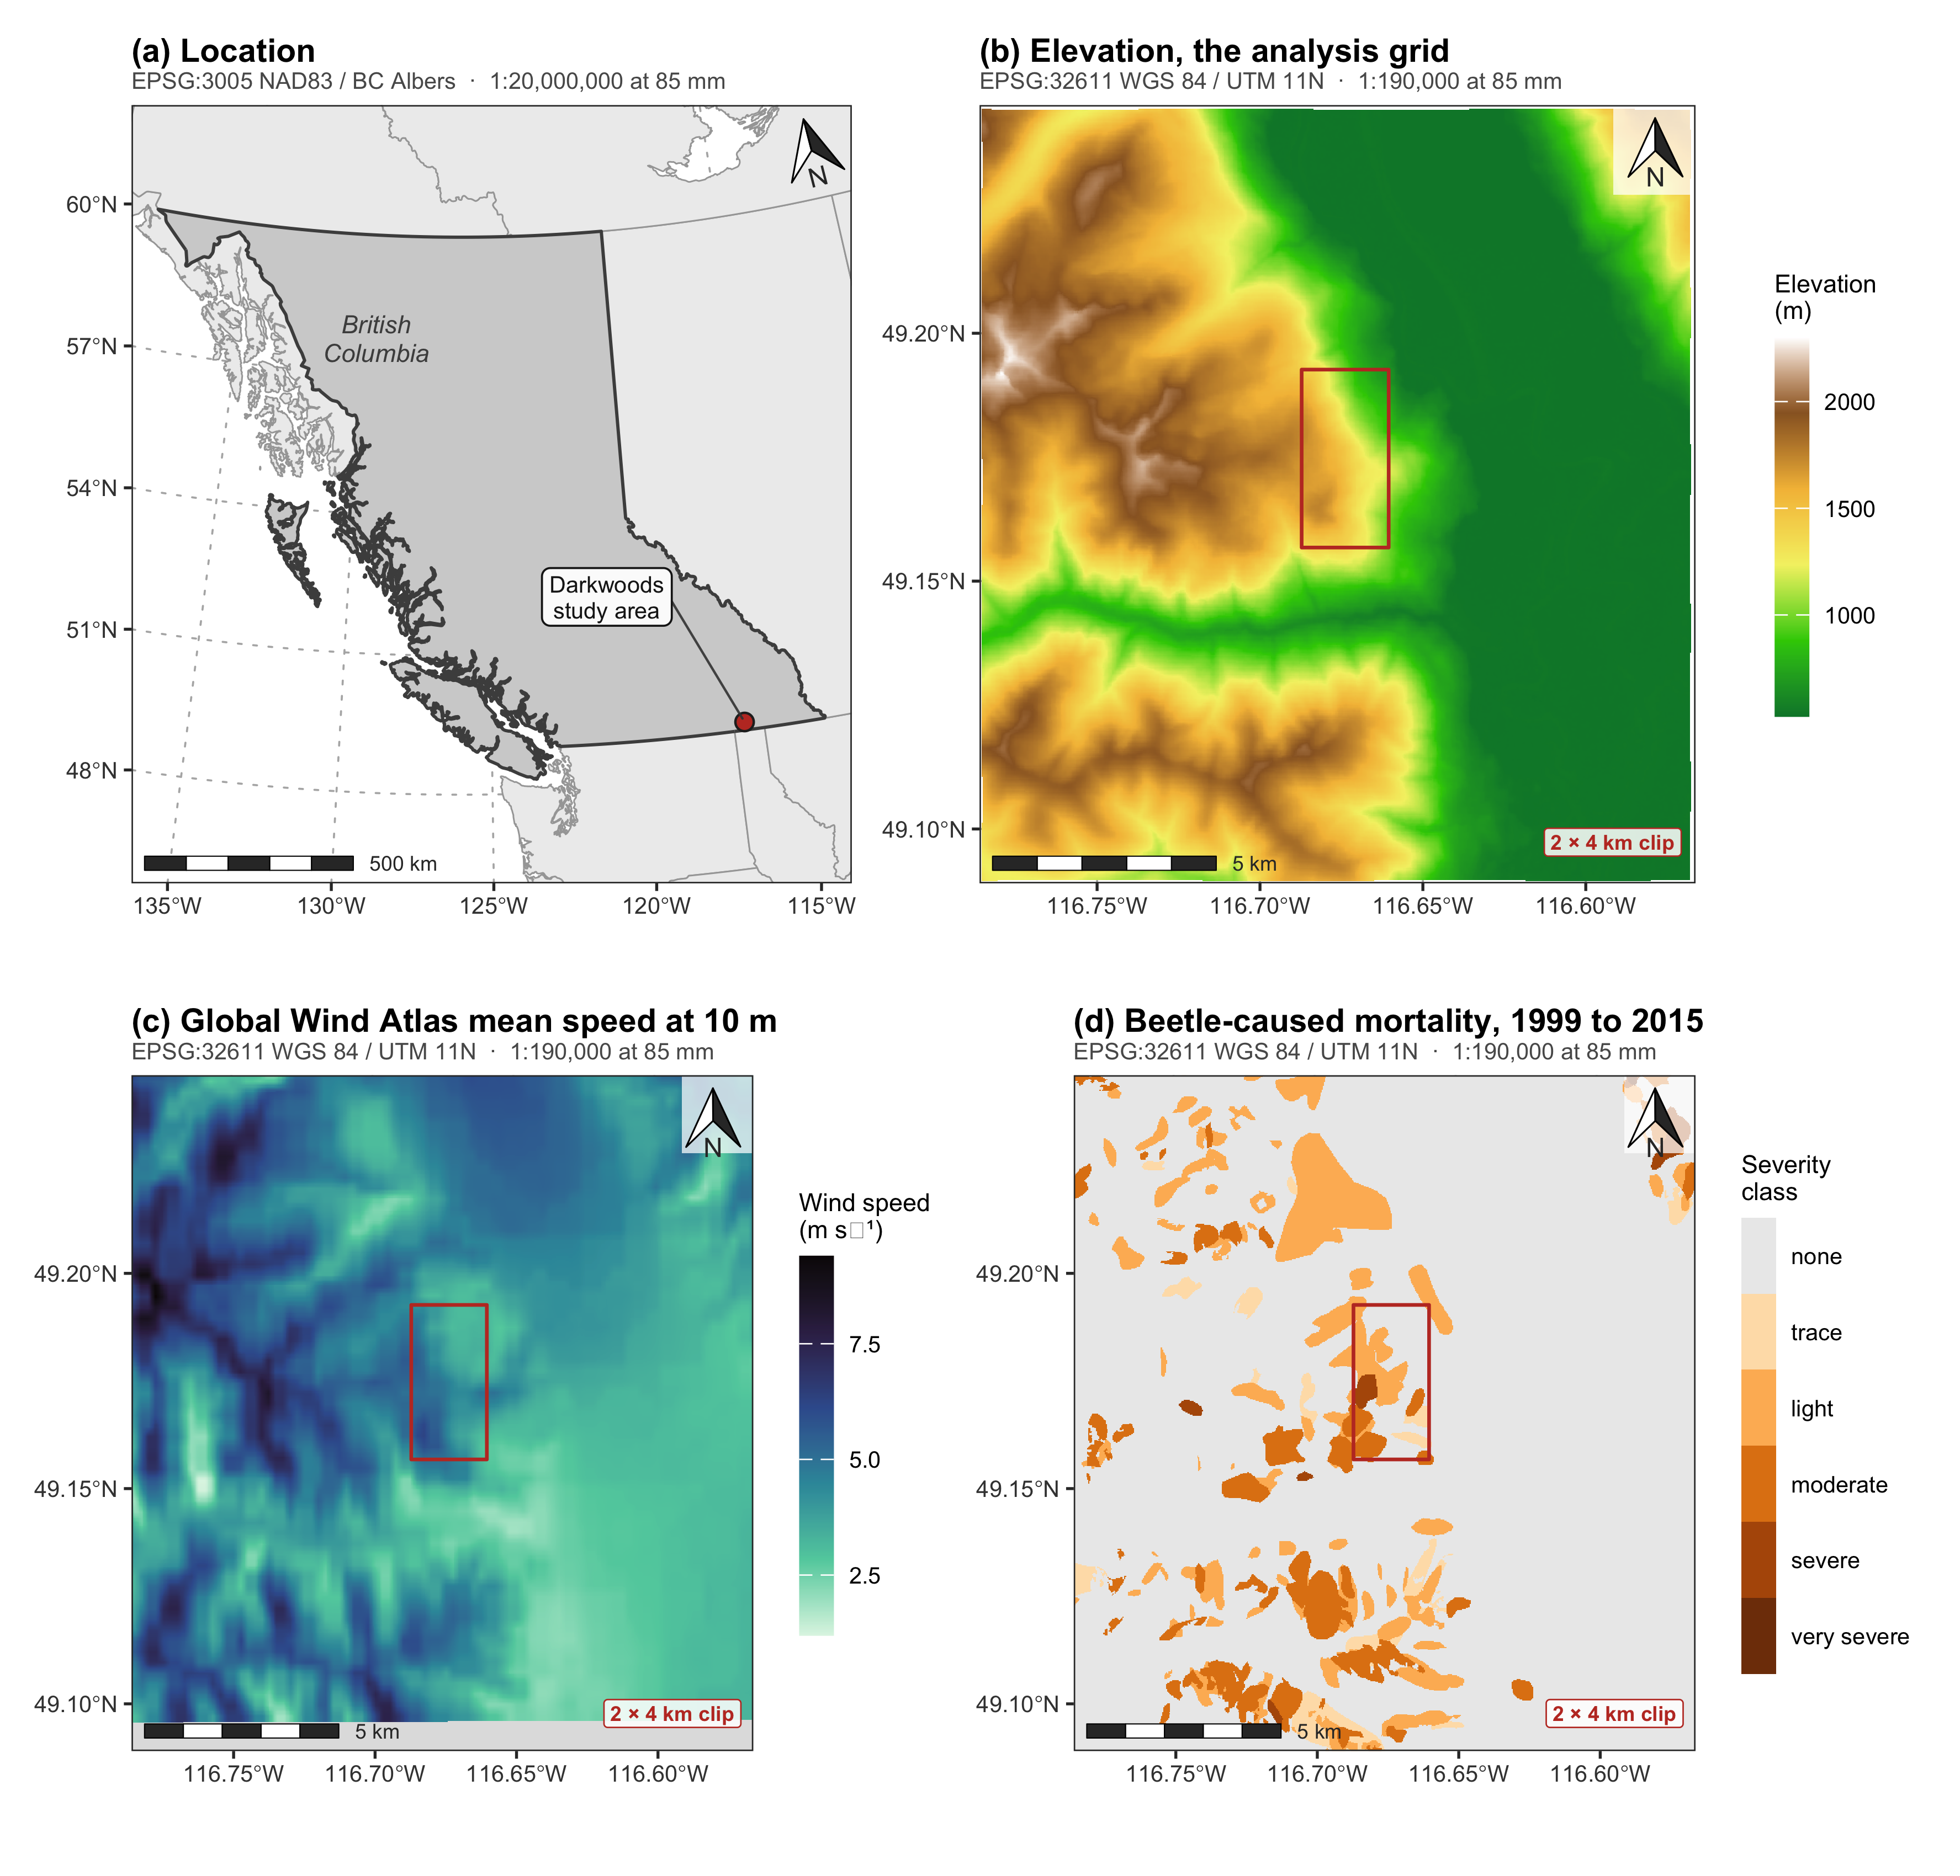
Figure 1: The study area and the three spatial inputs. (a) Location within British Columbia; the marker is a 22 km symbol, not the footprint. (b) The elevation surface, which is the analysis grid. (c) Global Wind Atlas mean speed at 10 m; the grey band along the southern edge lies outside the wind product’s extent and those cells carry no wind value. (d) Beetle-caused mortality from the Aerial Overview Survey, 1999 to 2015, as the maximum severity class recorded in any year. The red rectangle in (b) to (d) is the 2 by 4 km clip of Section 4.6. Graticules are WGS 84 degrees; the projection of each panel is given beneath its title, with a representative fraction for a printed panel width of 85 mm. The bar scale in (a) is nominal at the standard parallels of BC Albers and varies by more than ten per cent across the province.

2.3 Host abundance
vri_polygons with_lodgepole
2743 1024
Host abundance comes from the provincial Vegetation Resources Inventory, layer VEG_COMP_LYR_R1_POLY, retrieved from the British Columbia Data Catalogue web feature service for the study window. We accumulate the percentage cover of lodgepole pine across the three species slots each polygon records, and carry stand basal area alongside it.
The inventory’s vintage matters and we state it. These polygons carry a reference year of 2014 and an interpretation date of August 2014, with an attribution base date of 1 January 2014; the projected date of 31 December 2025 is the growth model’s roll-forward of age, height and volume, not a re-observation. Species composition therefore comes from photography flown in the fourteenth year of a seventeen-year outbreak window.
That is a limitation we cannot remove and should not hide. A stand whose pine was killed early in the outbreak will have been interpreted after the fact, and its recorded lodgepole percentage will be lower than the pine it carried when the beetle arrived. The bias runs in a specific direction: host is under-recorded exactly where attack was heaviest and earliest. It is therefore a candidate explanation for the reversal of the lodgepole coefficient at the severe threshold reported in Section 4.2, and we say so there rather than reading that reversal as ecology alone. It does not touch the presence-absence distinction the layer is mainly used for, since a stand that carried enough pine to be killed is not recorded as pine-free.
Without this layer the analysis cannot distinguish a refugium from an absence of pine, and ?@sec-host shows that the distinction accounts for most of the apparent terrain signal.
Figure 2 maps both layers. Lodgepole cover is concentrated in the middle of the elevation range and is scarce in the valley on the right of the frame, which is the pattern the whole host-conditioning argument turns on: the valley is not lightly attacked because it is sheltered, it is lightly attacked because it holds almost no host. Basal area defines the analysis frame, and the grey cells in panel (b) are the ones dropped for want of it.
fig_host <-
(ggplot() + geom_spatraster(data = host$PinePct) +
scale_fill_viridis_c(option = "viridis", direction = -1, na.value = "grey88",
name = "Lodgepole\ncover (%)") +
clip_layer + study + labs(title = "(a) Lodgepole pine cover", subtitle = sub_utm)) |
(ggplot() + geom_spatraster(data = host$Basal) +
scale_fill_viridis_c(option = "plasma", direction = -1, na.value = "grey88",
name = "Basal area\n(m² ha⁻¹)") +
clip_layer + study + labs(title = "(b) Stand basal area", subtitle = sub_utm))
fig_host
ggsave("../03.outputs/PNG/fig-host-maps.png", fig_host,
width = 180, height = 96, units = "mm", dpi = 500, bg = "white")
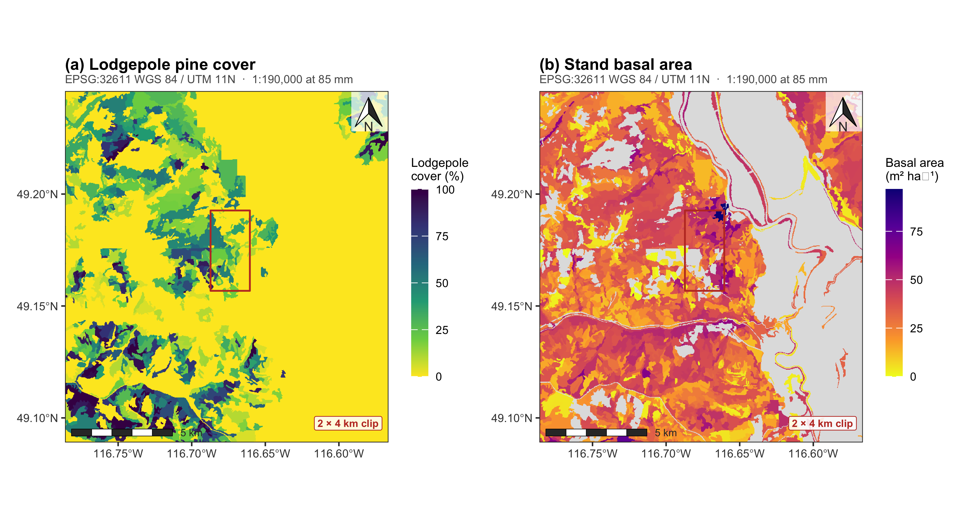
Figure 2: The forest inventory host layers, rasterised from vegetation resource inventory polygons onto the analysis grid. (a) Lodgepole pine cover, accumulated across the three species slots each polygon records. (b) Stand basal area, which defines the analysis frame: cells with no recorded basal area cannot enter a model that conditions on stand structure and are dropped. Grey is unmapped or non-productive ground. Projection, graticule and scale as in Figure 1.

2.4 Terrain and wind
Terrain surfaces are inherited unchanged from Murphy et al. (2026), which derived them from the 1 m Natural Resources Canada High Resolution Digital Elevation Model (Natural Resources Canada 2017), smoothed, depression-filled by the algorithm of Wang and Liu (2006) and aggregated to 25 m, with compound indices following Beers and Miller (1973) and Parker (1982). We add three surfaces of our own. The first is a topographic position index at a 625 m neighbourhood, because Cartwright (2018) found slope, elevation and heat load among the strongest controls on refugia and reported topographic position alongside them, and the inherited set carried no measure of topographic position at all.
The other two exist because the inherited set carries no aspect information at all, and so contains no term that can distinguish a warm slope from a cold one at the same elevation. That matters here specifically, because the confound this paper cannot resolve is between wind exposure and cold, and aspect bears on the two differently. We therefore compute a heat load index after McCune and Keon (2002), in which aspect is folded about the southwest to northeast axis so that southwest is hottest, and a shelter index after Winstral et al. (2002), the maximum upwind slope angle within 500 m along a bearing, which is positive where terrain rises upwind and negative on exposed convexities. The Global Wind Atlas supplies speed but no direction, so rather than assume a prevailing bearing we compute the shelter index on all eight cardinal and intercardinal bearings and average them, giving an omnidirectional index that requires no assumption about wind direction.
The decisive property of both is how they are built. They are derived from the elevation model by trigonometry rather than draped over it by downscaling, and Table 2 shows the consequence: their variance is essentially unrelated to elevation, where the wind product’s is largely elevation. A terrain-derived predictor is not automatically an elevation transform. The distinction is in the construction, not in the fact of using a digital elevation model.
The ruggedness surface carries a documentation gap we state rather than paper over. Its exact formulation is not recorded beyond the citations above, and its distribution is inconsistent with a vector ruggedness measure. We treat it as a reproducible but unnamed ruggedness surface and confine claims to its statistical behaviour.
Ambient wind is Global Wind Atlas mean wind speed at 10 m above ground level (Technical University of Denmark). The atlas is built by driving a mesoscale model from reanalysis, generalising the result by the method of Badger et al. (2014) to remove the local terrain and roughness signal, and then downscaling it microscale over a digital elevation model and a land-cover roughness map (Davis et al. 2023). Elevation and roughness are therefore inputs to the product, not covariates measured independently of it. That construction is why it cannot be assumed independent of elevation, and testing that assumption is the second half of this paper.
Figure 3 maps the six derived surfaces. Their point here is visual rather than statistical: slope, wetness, ruggedness and topographic position all trace the same drainage network and the same valley wall, whereas heat load and the shelter index divide the landscape by aspect instead, picking out southwest-facing ground the others do not distinguish. That is the difference Table 2 quantifies.
fig_terrain <-
(panel(terr$Slope, "(a) Slope", "Degrees", "cividis") |
panel(terr$TWI, "(b) Topographic wetness index", "TWI", "mako", -1) |
panel(terr$RIX, "(c) Ruggedness", "Index", "rocket", -1)) /
(panel(terr$TPI600, "(d) Topographic position, 625 m", "TPI (m)", "viridis") |
panel(terr$HLI, "(e) Heat load index", "HLI", "inferno") |
panel(terr$SxMean, "(f) Shelter index, omnidirectional", "Sx (deg)", "cividis", -1))
fig_terrain
ggsave("../03.outputs/PNG/fig-terrain-maps.png", fig_terrain,
width = 180, height = 118, units = "mm", dpi = 500, bg = "white")
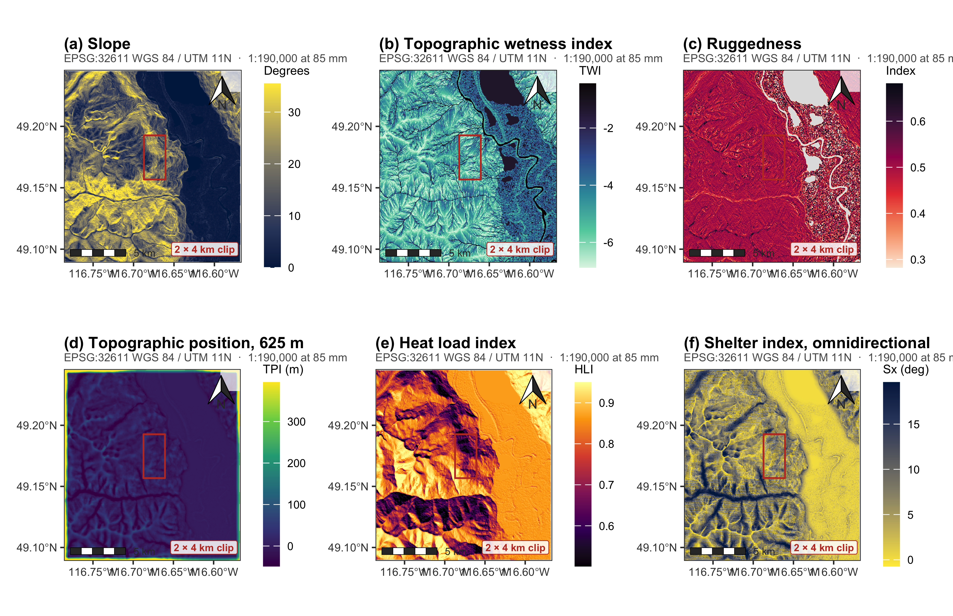
Figure 3: The six derived terrain predictors, all computed from the same 25 m elevation model. (a) Slope. (b) Topographic wetness index. (c) Ruggedness. (d) Topographic position at a 625 m neighbourhood. (e) Heat load index after McCune and Keon, aspect folded about the southwest to northeast axis. (f) Omnidirectional shelter index after Winstral, the maximum upwind slope angle within 500 m averaged over eight bearings. Colour ranges are clipped to the 2nd and 98th percentiles so that edge artefacts in the neighbourhood surfaces do not flatten the interior; values beyond those limits take the end colours. Panels share the projection, graticule and scale of Figure 1. The red rectangle is the 2 by 4 km clip.

2.5 Climate records
Because the interpretation in Section 4.1 turns on whether it is cold enough at the top of the gradient to kill beetles, we assembled the observational record that bears on it. Hourly observations from the British Columbia Wildfire Service network and daily observations from the Environment and Climate Change Canada network were retrieved for all stations within 100 km of the study area for the winters of the outbreak window. Retrieval is done by the script in 02.inputs/climate/, which streams roughly 2.7 GB of hourly and daily observations and writes the per-station-winter summary the manuscript reads. That division is deliberate: the network fetch and the reduction of hourly series to winter summaries cannot sit inside a document render, but every decision about which records to believe is made in Section 4.5, in code, and is visible there.
Two screens matter. Many older Wildfire Service sensors floor at exactly -20.0 °C, so a station-winter whose minimum sits exactly on that floor has an unknown true minimum and is excluded; the rule is applied and checked in Section 4.5 rather than inherited. Isolated single-observation spikes, colder than both neighbouring observations by more than 15 °C, are rejected as instrument error at the observation level, which is the one screen that must happen during retrieval because it needs the sub-daily series. One such value, a -40.0 °C daily minimum recorded on a day whose maximum was -4.5 °C and carrying no quality flag, would otherwise have produced exactly the conclusion the record does not support.
This network cannot furnish a temperature surface, for the reasons Section 4.5 sets out. It can establish whether lethal temperatures occur in this region at all, which is a weaker claim and a sufficient one.
with_terrain_and_host dropped_no_basal_area analysis_cells
388003.0 121353.0 266650.0
km2 attacked host_cells
168.2 55713.0 127604.0
Table 1: The analysis landscape, and the 2 by 4 km clip drawn from it that the companion study used. The clip samples under two thirds of the relief and under 4 per cent of the cells.
Extent | Cells | Area (km²) | Elevation (m) | Relief (m) | Attacked (%)
full landscape | 266,650 | 168.2 | 528 to 2268 | 1,740 | 20.9
2 by 4 km clip | 9,784 | 6.2 | 654 to 1747 | 1,093 | 45.3

3. Methods

3.1 Inference
The response is heavily clustered, so cell counts vastly overstate independent information. All coefficients are accompanied by percentile intervals from a spatial block bootstrap in which the landscape is partitioned into blocks of 40 by 40 cells, roughly 1 km on a side, and blocks are resampled with replacement 150 times. Blocks of this size are larger than any plausible correlation range of the survey polygons. We report the point estimate, the block interval, and the proportion of resamples reproducing the sign of the point estimate, and we treat a term as supported only when the interval excludes zero.

3.2 Orthogonalisation
Because the wind surface is built over the elevation surface, its coefficient in a model that also contains elevation is estimated from whatever small part of the joint distribution allows the two to vary separately. We therefore replace wind by the residual of wind regressed on elevation, rescaled to unit variance.
It is important to be exact about what this does and does not achieve, because it is easy to present it as a remedy for collinearity and it is not one. The substitution is a linear reparameterisation of the same model. Fitted values and deviance are unchanged, and by the Frisch-Waugh-Lovell theorem the residualised coefficient is the raw wind coefficient multiplied by the square root of one minus the R² of wind on elevation, with its standard error scaled identically. The test statistic, and therefore every supported-or-not verdict in this paper, is numerically the same in both parameterisations. Orthogonalisation buys no precision whatever: the estimate still comes from the same narrow part of the joint distribution, and the variance inflation is untouched. What changes is the interpretation of the two coefficients. The wind coefficient now refers to the part of the wind surface that elevation does not explain, which is the quantity the Krawchuk et al. (2020) hypothesis is about, and the elevation coefficient becomes the total elevation association including whatever is transmitted through wind, rather than the partial effect at fixed wind. The reparameterisation is worth making for that reason alone, and for no other.
Elevation Wind WindResid
Elevation 1.000 0.793 0.000
Wind 0.793 1.000 0.609
WindResid 0.000 0.609 1.000
Table 2: How much of each candidate predictor is elevation. The wind product is a downscaled mesoscale field draped over terrain and is largely an elevation transform. The heat load and shelter indices are computed from the same elevation model by trigonometry and are almost unrelated to it. Being terrain-derived and being an elevation transform are not the same thing.
Surface | How it is built | R² on elevation
Global Wind Atlas wind speed | mesoscale field downscaled over the DEM | 0.629
Heat load index (McCune and Keon) | trigonometric function of DEM aspect and slope | 0.000
Shelter index (Winstral, omnidirectional) | maximum upwind slope from the DEM within 500 m | 0.002
Topographic position, 625 m | deviation from surrounding DEM mean | 0.021

3.3 Response coding
Krawchuk et al. (2020) warn specifically against coding refugia as a binary, on the grounds that a refugium is a matter of degree and that thresholding discards the part of the signal that distinguishes a lightly touched stand from a destroyed one. The survey carries an ordinal severity class, so we can follow that advice. We fit the binary attacked model above for comparability with the refugia literature, and alongside it a cumulative logit at each severity threshold: the probability that a cell reached trace or worse, light or worse, moderate or worse, and severe or worse. Fitting the thresholds separately rather than imposing a single proportional-odds slope is deliberate. It is also the standard diagnostic for whether proportional odds holds, and Section 4.2 shows that here it does not.

4. Results
Raw attack appeared strongly unimodal. Conditioning on host presence flattens the gradient below 1,900 m, but not above it, where attack halves while lodgepole cover rises and stands thin.
Table 3: Attack across the elevation gradient, before and after conditioning on lodgepole presence. Raw attack is strongly unimodal. Conditioning on host presence flattens the gradient below 1,900 m, but not above it, where attack halves while lodgepole cover rises and stands thin.
band | Cells | Pine cover (%) | Basal area | Wind (m/s) | Attacked, all cells (%) | Attacked, host present (%)
(500,700] | 37,767 | 2.3 | 29.6 | 3.26 | 6.5 | 23.3
(700,900] | 29,089 | 6.8 | 33.6 | 3.30 | 10.1 | 30.6
(900,1100] | 27,172 | 11.4 | 33.6 | 3.42 | 15.1 | 26.2
(1100,1300] | 26,645 | 18.2 | 32.9 | 3.69 | 29.2 | 31.5
(1300,1500] | 35,264 | 23.3 | 33.3 | 4.17 | 36.0 | 37.4
(1500,1700] | 42,860 | 29.9 | 30.3 | 4.89 | 30.1 | 33.4
(1700,1900] | 48,278 | 30.9 | 29.5 | 5.70 | 21.9 | 28.1
(1900,2100] | 18,354 | 19.5 | 24.0 | 6.70 | 12.2 | 14.6
(2100,2300] | 1,221 | 13.8 | 19.2 | 7.74 | 0.0 | 0.0

Across the full gradient, attack is strongly unimodal (Table 3, Figure 4). It rises from under three per cent in the valley to a peak near 1,430 m and falls away to zero above 2,100 m.
Conditioning on host presence separates that curve into two different phenomena. Below roughly 1,900 m the hump is host distribution: among cells that contain lodgepole, attack runs between 23 and 37 per cent with no strong trend from the valley bottom upward, and the dramatic rise in the raw curve is the rise in pine cover. Attack is 30.2 per cent where lodgepole is present against 12.4 per cent where it is absent.
Above 1,900 m the conditioning does not remove the decline. Attack among host-bearing cells falls by about half, while stand basal area falls from 30.0 to 23.5. Stands are thinner and attack is suppressed.
Host cover is the conjunct that decides whether this is the pattern the Krawchuk et al. (2020) hypothesis requires, and it depends on the comparison, so we give both. Against the whole gradient below, mean lodgepole cover in host-bearing cells is 38.8 per cent above the threshold against 39.7 per cent below: essentially unchanged, so host scarcity cannot account for an attack rate that more than halves. Against the 1,750 to 1,900 m band immediately below, however, cover is 49.2 per cent, so the top of the gradient does carry about 21 per cent less pine than the band beneath it. The first comparison is flattered by the pine-poor valley it includes, which is the denominator problem Section 5.1 is about, and we would be inconsistent to rely on it alone.
The honest reading is that host thins somewhat at the top of the gradient while attack falls a great deal more, and the conjunction the hypothesis requires holds in the weaker form: the decline in attack is far too large to be a proportionate response to the decline in host. It is not the clean case of host holding constant.
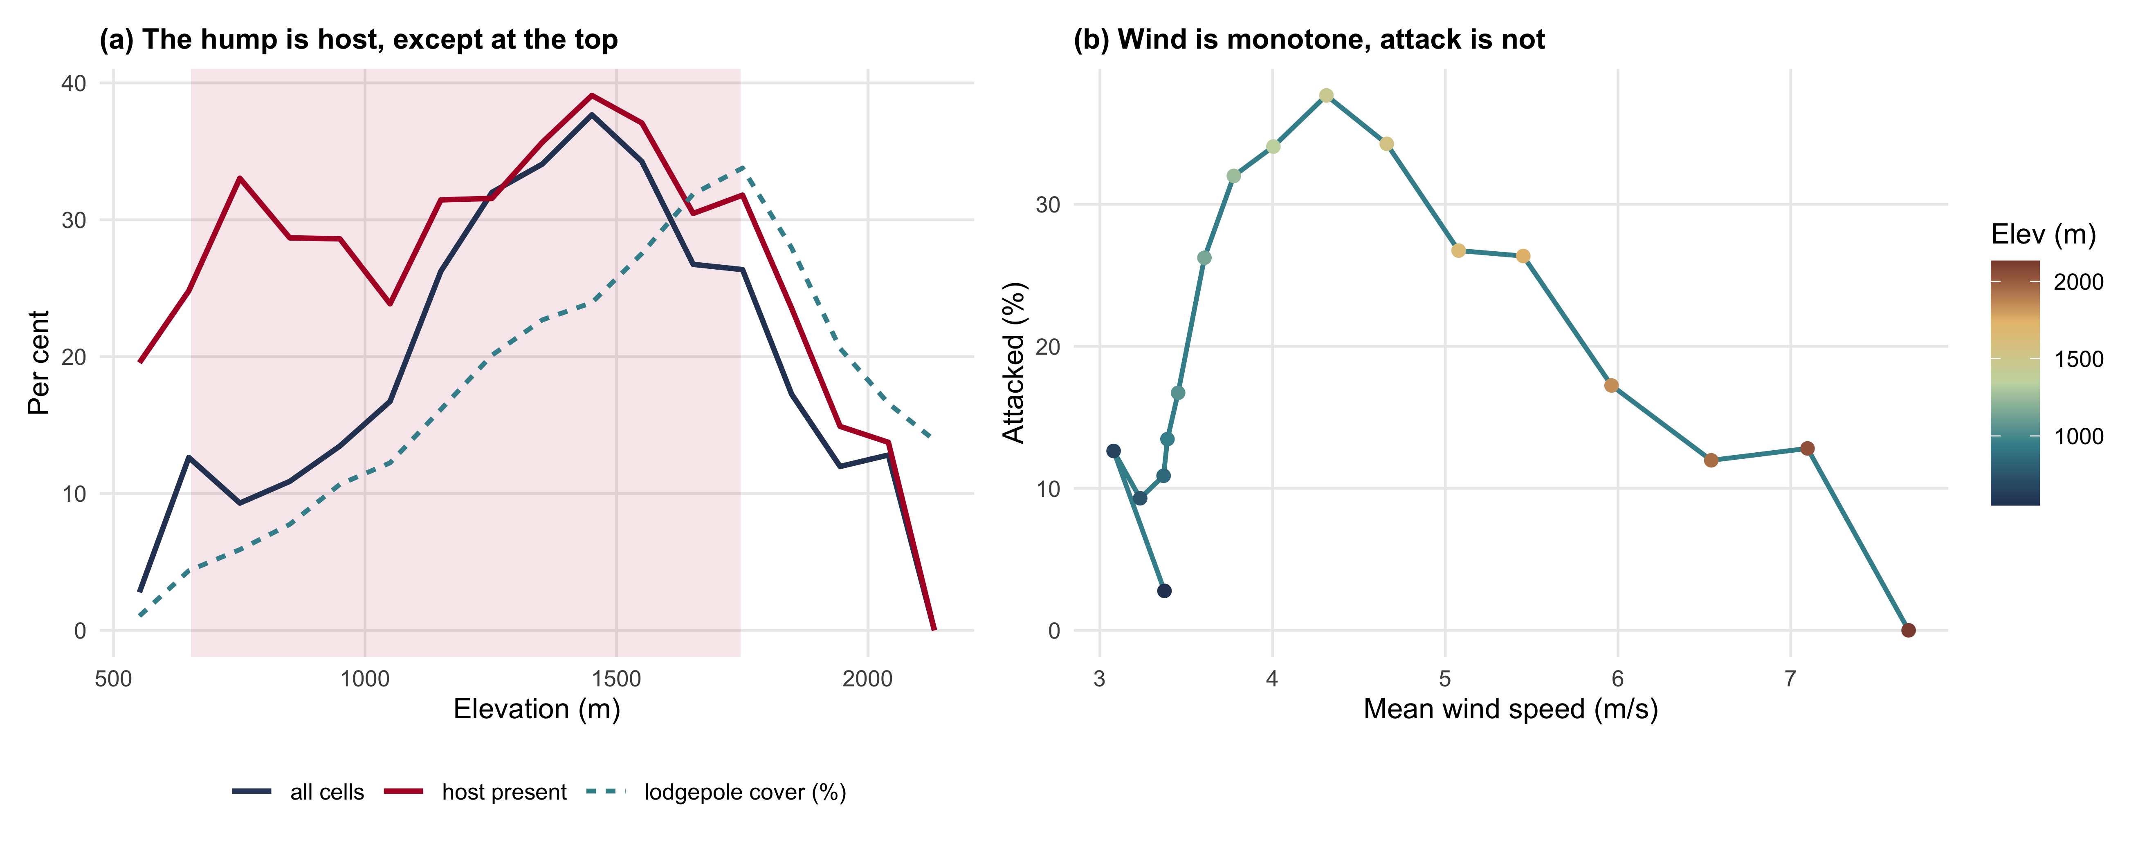
Figure 4: (a) Attack across the gradient, raw and conditioned on lodgepole presence, with mean lodgepole cover. Conditioning flattens the curve below 1,900 m and does not above it. (b) The same data against wind speed: wind rises monotonically with elevation while attack turns over, so no monotone wind relationship can hold across the gradient. Shading marks the elevation range of the 2 by 4 km clip.

4.1 The Krawchuk test
Table 4: The hypothesis test. Cells containing lodgepole pine only. Coefficients are per standard deviation; wind is entered as the component orthogonal to elevation. Intervals are percentile intervals from resampled 1 km spatial blocks, at the replicate count given in the Inference section. Only host cover clears the interval test; the orthogonalised wind term is the strongest negative coefficient and is directionally stable, but its interval reaches zero.
Term | beta | naive z | block 95% CI | sign stability | Supported
Elevation | -0.130 | -19.2 | [-0.396, +0.172] | 0.83 | no
WindResid | -0.176 | -26.8 | [-0.390, +0.037] | 0.95 | no
PinePct | +0.177 | +28.0 | [+0.046, +0.319] | 1.00 | yes
Basal | +0.028 | +4.3 | [-0.171, +0.199] | 0.65 | no
TPI600 | +0.002 | +0.4 | [-0.097, +0.111] | 0.53 | no
Slope | +0.004 | +0.5 | [-0.148, +0.152] | 0.50 | no
TWI | -0.010 | -1.5 | [-0.094, +0.050] | 0.61 | no
RIX | -0.024 | -3.8 | [-0.069, +0.022] | 0.84 | no

Restricted to cells that contain host, the orthogonalised wind term is the largest negative coefficient in the model, -0.176 per standard deviation, comparable in magnitude to the positive effect of lodgepole cover itself at +0.177 (Table 4). Its sign is reproduced in 95 per cent of spatial block resamples. Its 95 per cent block interval, however, runs [-0.390, +0.037] and reaches zero.
On this fit the hypothesis is supported in direction and unresolved in magnitude, and Section 4.3 later withdraws even the direction, so this section should be read as the conventional analysis whose specification we go on to test rather than as a result we stand behind. The descriptive result in ?@sec-host is not in doubt: attack more than halves at the top of the gradient while host cover thins only slightly. What is in doubt is whether the wind surface is the right explanation for it, and with roughly 175 independent 1 km blocks in this landscape the binary response cannot settle it. Host cover is the only term whose interval excludes zero, and it does so in the expected direction.
That verdict is a property of the response coding rather than of the data, and Section 4.2 revisits it. We report the binary model first because it is the form the refugia literature uses, and because the comparison between the two is itself a result.
Note also that elevation, entered alongside the orthogonalised wind term, is itself negative and unsupported. Once host is in the model the remaining elevation signal is weak; the suppression at the top of the gradient is not simply an elevation effect.

4.2 Disturbance severity metrics
The orthogonalised wind coefficient strengthens monotonically as the threshold rises and its block interval excludes zero at every threshold above trace, which the binary attacked model does not show.
Table 5: Cumulative logits at each severity threshold, cells containing lodgepole pine only. Each row is the same model fitted to a harder threshold. The orthogonalised wind coefficient strengthens monotonically as the threshold rises and its block interval excludes zero at every threshold above trace, which the binary attacked model does not show.
Threshold | Cells | Wind residual beta | block 95% CI | sign stability | Pine cover beta | Supported
trace or worse | 38,473 | -0.176 | [-0.390, +0.037] | 0.95 | +0.177 | no
light or worse | 34,839 | -0.203 | [-0.418, -0.015] | 0.98 | +0.204 | yes
moderate or worse | 13,862 | -0.390 | [-0.674, -0.066] | 0.99 | +0.243 | yes
severe or worse | 1,522 | -1.002 | [-1.552, -0.169] | 0.98 | -0.101 | yes

Collapsing the response to attacked or not costs the study its main result. Fitted at successively harder severity thresholds, the orthogonalised wind coefficient does not stay put: it strengthens monotonically from -0.176 at trace or worse to -1.002 at severe or worse, a 5.7-fold increase (Table 5). At every threshold above trace the block interval excludes zero. The first row is the binary model of Section 4.1 restated, since a cell reaching trace or worse is exactly a cell recorded as attacked, so the table is a strict extension of that fit rather than a competing one. It is also the weakest of the four, and it is the one the refugia literature would conventionally have reported.
This is a dose-response gradient of the shape the hypothesis predicts. Wherever the wind surface has a component independent of elevation, that component is associated with less attack, and the association is strongest where attack was heaviest. It also explains the binary result: a cell that reached trace severity is barely distinguishable from an unattacked cell, so a threshold drawn between them puts most of the noise in the response exactly where the model is asked to fit.
The slopes differ by a factor of 5.7 across the thresholds, so proportional odds does not hold and a single ordinal coefficient would be the wrong summary. Fitting one anyway returns -0.207, close to the trace-threshold estimate and concealing everything above it. Two other terms move with the threshold and are worth recording. Lodgepole cover, the only term that cleared the interval test in the binary model, weakens as the threshold rises and reverses at severe or worse (-0.101). One reading is ecological: host abundance governs whether a stand is attacked at all, not how hard. A second is an artefact of the inventory’s vintage, and we cannot separate them. As the Materials section states, composition was interpreted from 2014 photography, late in the outbreak window, so stands that lost their pine early carry a lower recorded lodgepole percentage than they did when the beetle reached them. That mechanism predicts a negative coefficient appearing specifically at the heaviest severities, which is exactly what is observed. We therefore report the reversal and decline to interpret it. Elevation turns positive at moderate or worse (+0.390), which is consistent with severe attack having been concentrated in the mid-elevation pine belt rather than at either end of the gradient.
We are nonetheless not able to attribute the gradient to wind rather than to cold, and the Discussion explains why the ordinal result does not help with that. More seriously, Section 4.3 shows that the sweep in this table does not survive entering elevation flexibly, so what looks here like improved statistical support is largely the unimodal elevation response returning through a predictor that was orthogonalised only against the linear part of elevation. This table should be read together with that one, and not on its own.

4.3 Wind effects by elevation
The ordinal sweep refitted with elevation entered flexibly instead of linearly, and the wind surface residualised against that same basis. Elevation explains eleven points more of the wind surface once curvature is allowed, and the orthogonalised wind coefficient loses between three fifths and seven tenths of its magnitude. No threshold clears the interval test under either flexible basis (Table 6).
Table 6: The ordinal sweep refitted with elevation entered flexibly instead of linearly, and the wind surface residualised against that same basis. Elevation explains eleven points more of the wind surface once curvature is allowed, and the orthogonalised wind coefficient loses between three fifths and seven tenths of its magnitude. No threshold clears the interval test under either flexible basis.
Elevation basis | R² wind on basis | Threshold | Wind residual beta | block 95% CI | Supported
linear | 0.617 | trace or worse | -0.176 | [-0.390, +0.037] | no
linear | 0.617 | light or worse | -0.203 | [-0.418, -0.015] | yes
linear | 0.617 | moderate or worse | -0.390 | [-0.674, -0.066] | yes
linear | 0.617 | severe or worse | -1.002 | [-1.552, -0.169] | yes
quad | 0.726 | trace or worse | -0.051 | [-0.261, +0.158] | no
quad | 0.726 | light or worse | -0.075 | [-0.254, +0.085] | no
quad | 0.726 | moderate or worse | -0.160 | [-0.445, +0.156] | no
quad | 0.726 | severe or worse | -0.661 | [-1.139, +0.237] | no
spline | 0.728 | trace or worse | -0.064 | [-0.270, +0.146] | no
spline | 0.728 | light or worse | -0.090 | [-0.266, +0.059] | no
spline | 0.728 | moderate or worse | -0.163 | [-0.439, +0.161] | no
spline | 0.728 | severe or worse | -0.676 | [-1.169, +0.222] | no

Sandel (2015) gives the diagnostic that motivates this test. For a genuinely linear relationship a coefficient is extent-independent and only the coefficient of determination moves as the extent changes; a coefficient that changes sign under truncation is therefore a symptom of an unmodelled nonlinearity rather than evidence of a general law of extent. Our response is unimodal in elevation and our wind surface is monotone in it, which is exactly the configuration that produces such a symptom, so the specification has to be tested rather than assumed.
It does not pass. Entering elevation as a quadratic raises the share of the wind surface that elevation explains from 0.617 to 0.726, and a natural spline on four degrees of freedom raises it to 0.728. Roughly eleven percentage points of the wind surface’s variance is therefore nonlinear in elevation, and the linear orthogonalisation used above leaves all of it inside what we had been calling the component of wind independent of elevation.
When that residue is removed the wind result goes with it. The coefficient at severe or worse falls from -1.002 to -0.661, and at moderate or worse from -0.390 to -0.160, losing between three fifths and seven tenths of its magnitude. Under both flexible bases every interval covers zero at every threshold. The monotone strengthening across thresholds survives in the point estimates, but nothing in the sweep clears the test this paper set itself.
We report this as the result rather than relegating it to a sensitivity appendix, because it changes what the preceding two sections mean. The dose-response in Table 5 is not evidence about wind. It is very largely the unimodal elevation response reappearing through a predictor that was never orthogonal to the curvature of elevation, only to its slope. The honest conclusion is that this study does not have a wind effect to report, and that the appearance of one was a consequence of how elevation was specified.

4.4 Thermal load by aspect
The host-present model with the two aspect-derived terms added, at each severity threshold the extended model can carry. Heat load is positive and strengthens sharply with severity: warmer aspects burn harder at the same elevation. The orthogonalised wind term is not displaced by it and in fact strengthens. The shelter index points the other way, which the text takes seriously rather than explaining away.
Table 7: The host-present model with the two aspect-derived terms added, at each severity threshold the extended model can carry. Heat load is positive and strengthens sharply with severity: warmer aspects burn harder at the same elevation. The orthogonalised wind term is not displaced by it and in fact strengthens. The shelter index points the other way, which the text takes seriously rather than explaining away.
Threshold | Cells | Wind residual | Heat load | Shelter
trace or worse | 38,473 | -0.214 [-0.424, +0.002] | +0.106 [-0.116, +0.331] | -0.153 [-0.253, -0.024]
light or worse | 34,839 | -0.234 [-0.441, -0.050] | +0.043 [-0.198, +0.274] | -0.152 [-0.262, -0.031]
moderate or worse | 13,862 | -0.505 [-0.804, -0.184] | +0.625 [+0.301, +1.030] | -0.013 [-0.144, +0.131]

The inherited predictor set had no aspect in it, so until now the model could not tell a warm slope from a cold one at the same elevation. Adding two aspect-derived terms does three things.
First, it supplies the one piece of thermal information available without a temperature surface. Heat load is positive at every threshold and strengthens steeply with severity (Table 7). Since heat load is essentially uncorrelated with elevation (Table 2), this is not the elevation gradient returning under another name: at a given elevation, southwest-facing ground carries heavier beetle-caused mortality than northeast-facing ground. That is the sign cold limitation predicts, and it is the first evidence in this study that the thermal axis is doing work independently of elevation.
Second, it leaves the wind coefficient standing. The orthogonalised wind term does not weaken when heat load is controlled for; it strengthens slightly at every threshold, so whatever the wind residual is tracking, it is not the warm-aspect effect in disguise. It is, however, largely the curvature of elevation: this model still enters elevation linearly, and Section 4.3 shows the wind term does not survive a flexible basis. Controlling for aspect does not rescue it.
Third, and least comfortably, the two exposure measures disagree. The shelter index is negative, meaning sheltered ground carries less attack and exposed ground more, which is the opposite of what the orthogonalised wind term says and the opposite of what Krawchuk et al. (2020) predict. The two are only weakly correlated with each other (-0.22), so they are not two measurements of one quantity that happen to disagree; they are measuring different things, and only one of them is a direct geometric description of exposure. We take this as evidence against treating any single surface as “wind exposure” and reporting its coefficient as though the phrase had one referent. It is also a caution against our own result: the wind residual’s negative sign is not corroborated by the one predictor in this study that describes exposure geometrically rather than by downscaling.
The severe threshold is absent from Table 7 because ten terms and 1522 events drive the fit into quasi-separation, with 14,466 cells at numerically zero fitted probability. The eight-term model of Table 5 is free of this at every threshold, which is why that table retains its severe row and this one does not.

4.5 Winter temperature thresholds
Observed winter minimum air temperatures from weather stations within 100 km, by elevation band, after excluding station-winters censored at the -20.0 °C sensor floor. Nothing in the record approaches the temperatures conventionally cited as lethal for this insect. Elevation orders the minima only weakly, which is cold-air pooling (Table 8). Figure 5 maps the network. No station lies inside the analysis grid, and the stations reaching the coldest minima are not the highest ones, which is the point the next paragraph develops.
Table 8: Observed winter minimum air temperatures from weather stations within 100 km, by elevation band, after excluding station-winters censored at the -20.0 °C sensor floor. Nothing in the record approaches the temperatures conventionally cited as lethal for this insect. Elevation orders the minima only weakly, which is cold-air pooling.
band | Stations | Station-winters | Coldest (°C) | Mean minimum (°C)
below 800 m | 16 | 212 | -28.2 | -15.9
800 to 1,500 m | 9 | 109 | -26.9 | -17.4
above 1,500 m | 3 | 26 | -28.7 | -19.4

stn <- aggregate(cbind(latitude, longitude, elevation_m) ~ station_name,
data = st, FUN = function(x) x[1])
coldest_by <- aggregate(min_temp_c_usable ~ station_name, data = use, FUN = min)
stn <- merge(stn, coldest_by, by = "station_name", all.x = TRUE)
stn_sf <- st_transform(st_as_sf(stn, coords = c("longitude","latitude"), crs = 4326), 3005)
xy <- st_coordinates(stn_sf); stn_sf$X <- xy[, 1]; stn_sf$Y <- xy[, 2]
site_bc <- st_transform(st_as_sf(as.polygons(ext(G), crs = crs(G))), 3005)
prov_bc <- st_transform(ne_states(country = c("Canada","United States of America"),
returnclass = "sf"), 3005)
bbs <- st_bbox(st_buffer(st_union(c(st_geometry(stn_sf), st_geometry(site_bc))), 25000))
sw <- unname(bbs["xmax"] - bbs["xmin"])
key <- stn_sf[order(stn_sf$min_temp_c_usable)[1:2], ]
fig_station <- ggplot() +
geom_sf(data = prov_bc, fill = "grey95", colour = "grey70", linewidth = .25) +
geom_sf(data = site_bc, fill = NA, colour = "#C0392B", linewidth = .6) +
geom_sf(data = stn_sf, aes(fill = elevation_m), shape = 21, size = 1.9,
colour = "grey20", stroke = .25) +
scale_fill_viridis_c(option = "viridis", name = "Station\nelevation (m)") +
geom_label_repel(data = as.data.frame(key), aes(X, Y, label = tolower(station_name)),
size = 2, colour = "grey10", fill = "white", alpha = .9,
label.size = 0, label.padding = unit(.7, "mm"), box.padding = .5,
min.segment.length = 0, segment.colour = "grey30",
segment.size = .3, seed = 1) +
annotate("label", x = bbs["xmin"] + .02*sw,
y = bbs["ymin"] + .04*(bbs["ymax"] - bbs["ymin"]),
label = "red outline:\nanalysis grid", size = 1.9, hjust = 0, vjust = 0,
colour = "#C0392B", fill = "white", alpha = .85,
label.padding = unit(.7, "mm")) +
coord_sf(crs = 3005, xlim = bbs[c("xmin","xmax")], ylim = bbs[c("ymin","ymax")],
datum = st_crs(4326), expand = FALSE) +
north + sbar + map_theme +
labs(title = "Weather stations screened for winter minima",
subtitle = paste0("EPSG:3005 NAD83 / BC Albers · ", rf(sw, 130), " at 130 mm"))
fig_station
ggsave("../03.outputs/PNG/fig-station-maps.png", fig_station,
width = 150, height = 130, units = "mm", dpi = 500, bg = "white")
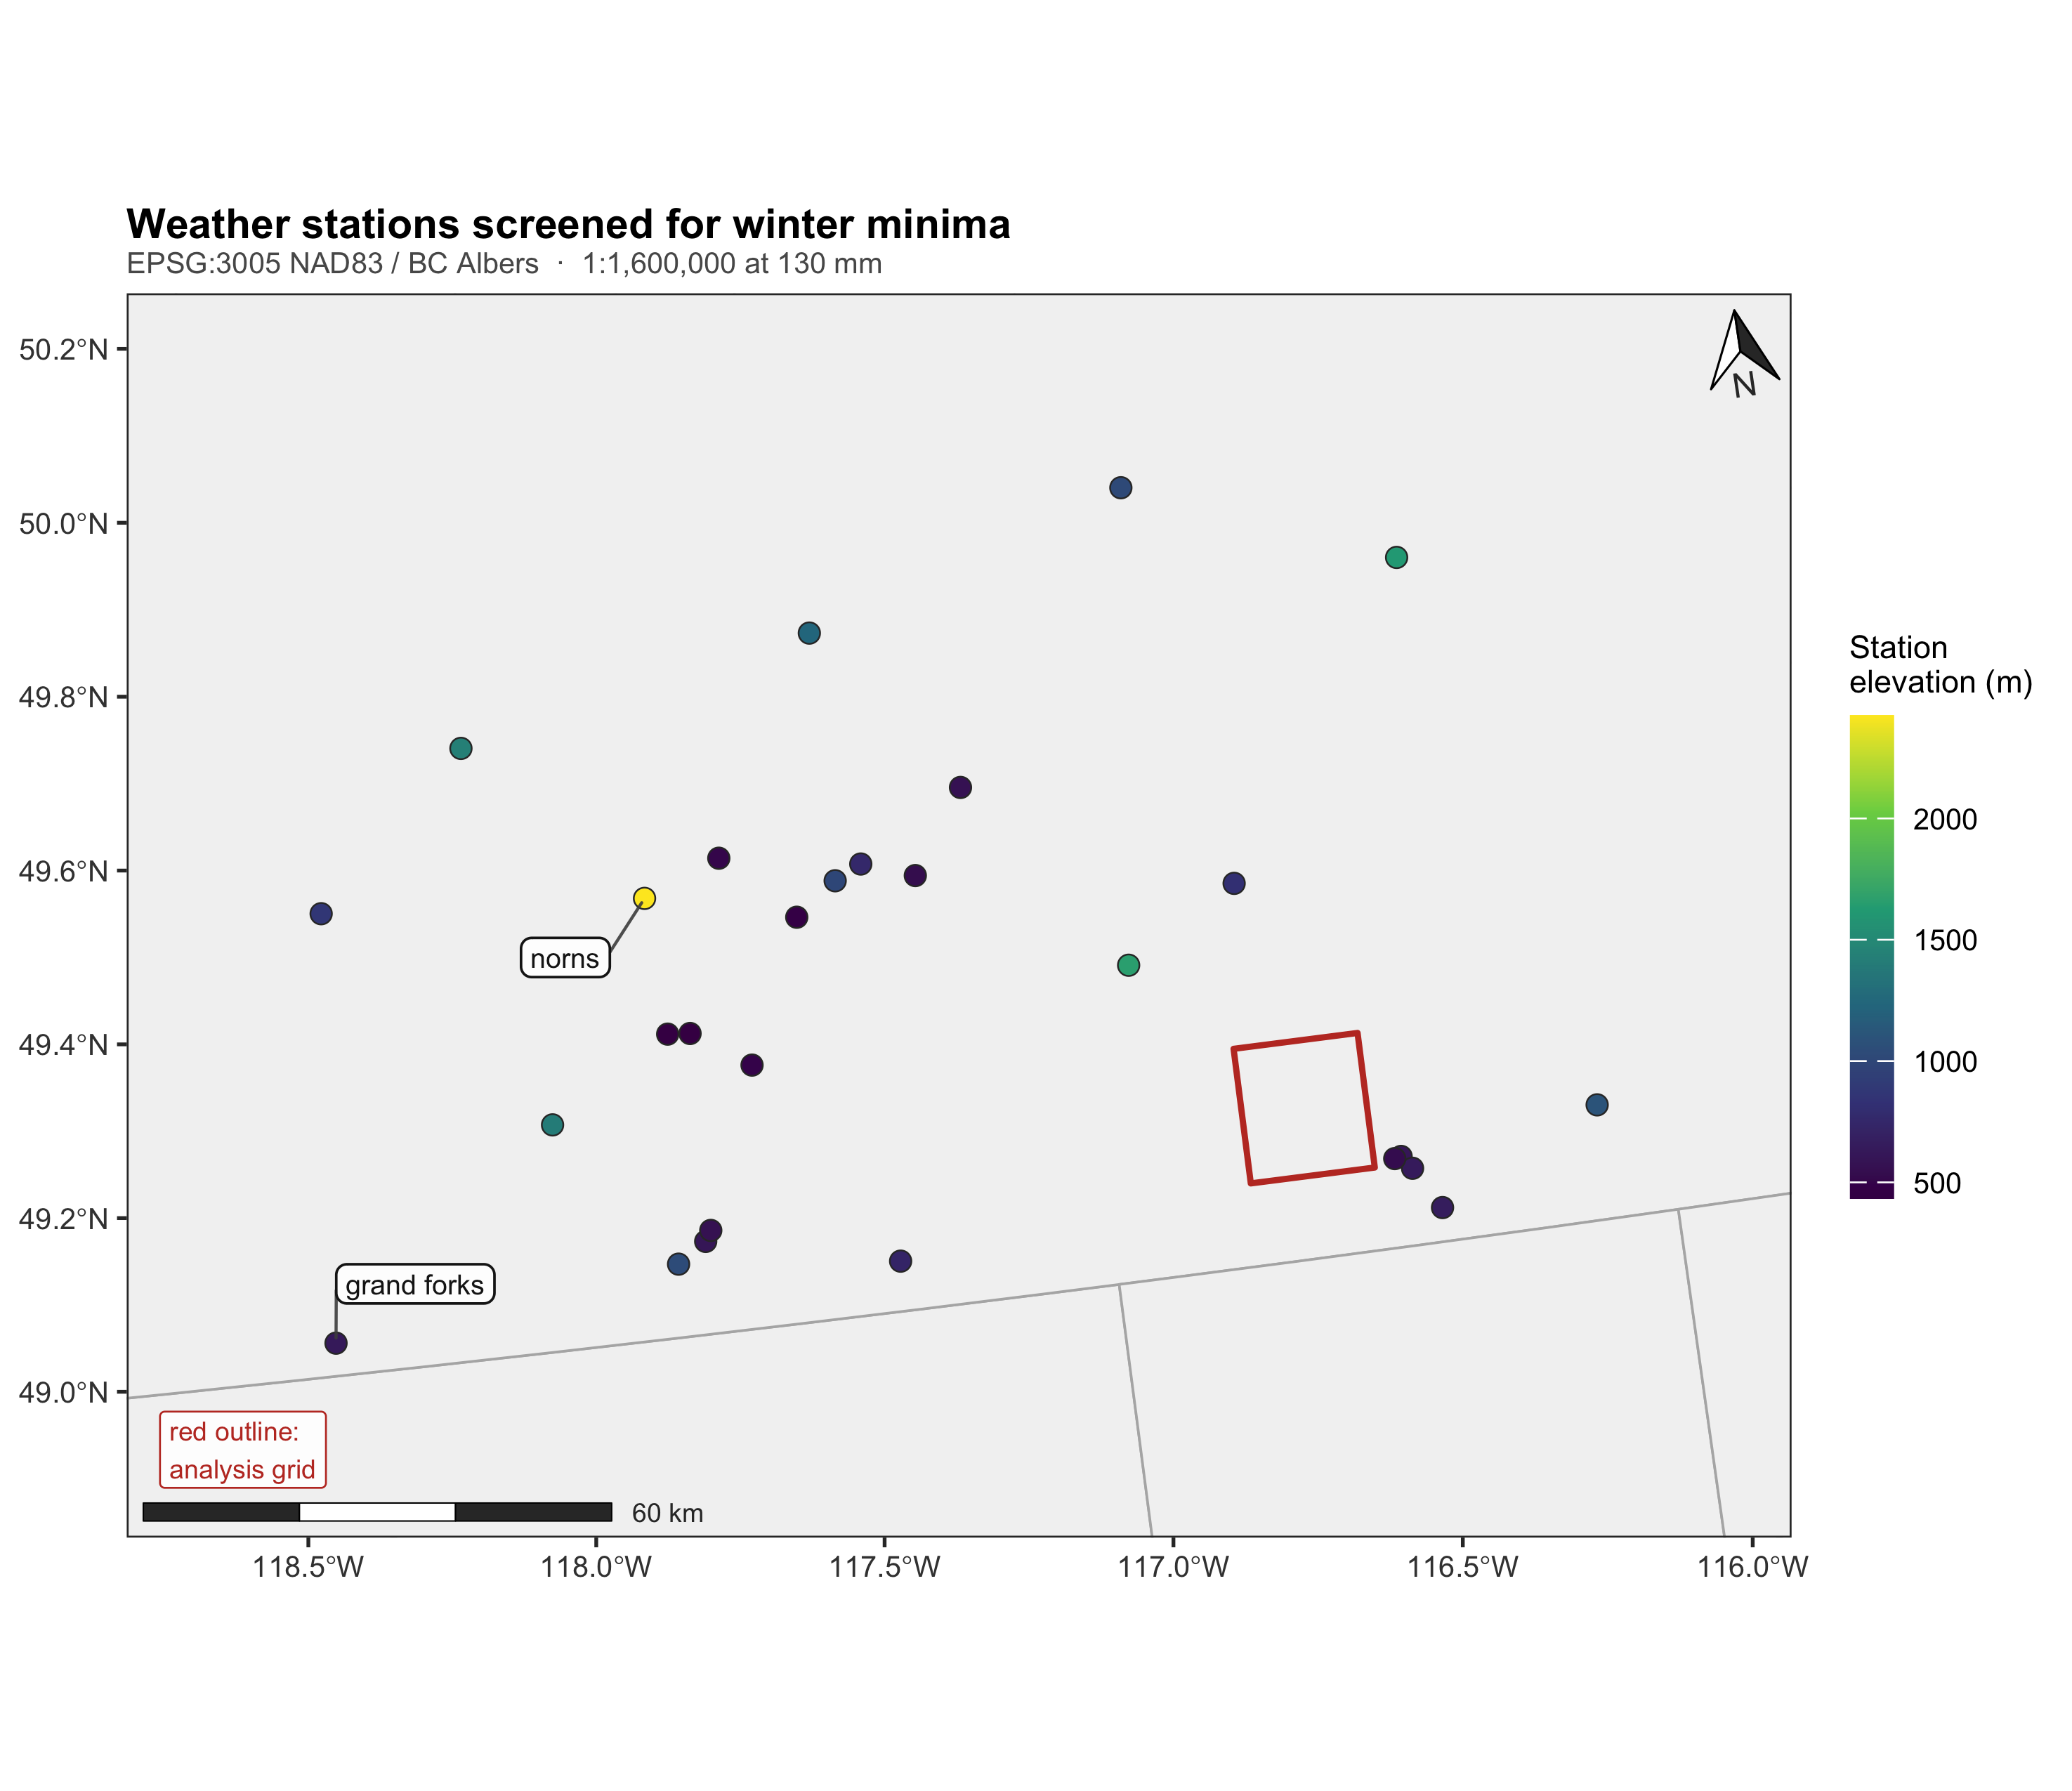
Figure 5: The weather station network behind the cold argument. All stations within 100 km of the study area that reported a usable winter minimum between 1999 and 2015, coloured by station elevation, with the analysis grid outlined in red. Only the two stations named in the text are labelled; labelling all of them at this scale would overplot. The alpine station at the top of the elevation range and the valley stations near the international boundary reach comparable minima, which is the cold-air pooling the text describes. Projection is BC Albers, so the analysis grid appears slightly rotated relative to its own UTM frame.
The cold explanation for the high-elevation suppression assumes it gets cold enough up there to kill beetles. That is checkable against observation, and it does not hold. Across 347 station-winters from 28 stations spanning 435 to 2423 m, retrieved and screened by the script in 02.inputs/climate/, the coldest defensible winter minimum anywhere in the region is -28.7 °C, at norns at 2,423 m in winter 2014. The number of station-winters reaching -35 °C or colder is 0, and the number reaching -40 °C or colder is 0. Above 1,500 m the mean winter minimum is -19.4 °C. The temperatures conventionally cited as lethal for mountain pine beetle larvae sit near -40 °C under bark, the figure at which Safranyik and Wilson (2006) report complete mortality, while Cooke (2009) measure a larval supercooling point with a median lethal value near -37 °C and caution against treating any fixed threshold as sufficient. Both are roughly ten degrees colder than anything this record contains. We note that neither is an air temperature and that phloem tracks air closely enough, within about two degrees, that the comparison holds; and that cold mortality is graded rather than a threshold, so the margin below is a margin against substantial mortality rather than a guarantee of none.
Two features of the record matter for the argument. Elevation orders these minima only weakly: grand forks, at 630 m, reaches -28.2 °C, within 0.5 °C of the alpine station 1,793 m higher. That is cold-air pooling, and it is the reason temperature cannot be treated as a linear function of elevation here. And 16 station-winters had to be set aside because the sensors floor at exactly -20.0 °C, a censoring artefact concentrated before 2008; taking a naive minimum over those would have manufactured a threshold that is not in the data.
This is a plausibility check and not a temperature surface. No station inside the study area reported during the outbreak window, and the stations that do report are spread across roughly 100 km of separate massifs, so these values bound the regional cold climate rather than map it. Within that limit the conclusion is reasonably firm: direct freeze mortality is unlikely to be what suppresses attack at the top of this gradient.

4.6 Area extents of coefficients
The same model fitted at three extents. As the analysis area shrinks, the share of wind variance explained by elevation rises and the orthogonalised wind coefficient reverses sign. The 2 by 4 km clip is the extent at which the companion study was run and is typical of disturbance ecology generally.
Table 9: The same model fitted at three extents. As the analysis area shrinks, the share of wind variance explained by elevation rises and the orthogonalised wind coefficient reverses sign. The 2 by 4 km clip is the extent at which the companion study was run and is typical of disturbance ecology generally.
Extent | Cells | Blocks | R² wind on elevation | VIF of raw wind | Wind residual beta | block 95% CI
full landscape (168 km²) | 266,650 | 253 | 0.629 | 2.7 | -0.304 | [-0.521, -0.098]
landscape, host present | 127,604 | 175 | 0.617 | 2.6 | -0.176 | [-0.390, +0.037]
2 by 4 km clip (6.2 km²) | 9,784 | 15 | 0.797 | 4.9 | +0.239 | [-1.260, +0.921]

The confound is a function of extent, and so is the answer. Across the landscape elevation explains 63 per cent of the variance in the wind surface; inside the 2 by 4 km clip it explains 80 per cent (Table 9). The orthogonalised wind coefficient is negative at landscape extent and positive inside the clip.
Two claims live in that table and they carry very different weight, so we separate them.
The collinearity result is firm. The share of wind variance that elevation explains rises from 0.629 across the landscape to 0.797 inside the clip, and that quantity is a property of the two surfaces rather than an estimate with sampling error in the usual sense. It is the mechanism this paper is about, and it does not depend on resolving the Krawchuk hypothesis.
The sign reversal is a comparison of two point estimates and is not, on this evidence, a demonstrated reversal. The clip contains only 15 spatial blocks, so its block interval runs [-1.260, +0.921]: it spans zero, and it also spans both landscape estimates. By the rule this paper set itself, that the interval must exclude zero, the clip coefficient is not distinguishable from zero, from the landscape estimate, or from its own opposite. What the clip demonstrates is that shrinking the extent destroys the ability to estimate the coefficient at all, which is a weaker claim than a reversal and still a damaging one for the practice we are criticising: a study run at this extent would report a positive point estimate with an interval too wide to notice that it had learned nothing. Establishing reversal proper would need the coefficient difference tested directly, by fitting an extent-by-wind interaction on the pooled data and bootstrapping that interaction on common blocks. We have not done that here and do not claim it.
The host-present model refitted at three grains. Predictors are aggregated by mean, severity class by maximum, the topographic position neighbourhood is held near-constant in metres, and the bootstrap blocks are rescaled to stay near 1 km. Unlike extent, grain changes nTothing: the collinearity, the sign and the magnitude are all stable across a four-fold change in cell size.
Table 10: The host-present model refitted at three grains. Predictors are aggregated by mean, severity class by maximum, the topographic position neighbourhood is held near-constant in metres, and the bootstrap blocks are rescaled to stay near 1 km. Unlike extent, grain changes nothing: the collinearity, the sign and the magnitude are all stable across a four-fold change in cell size.
Grain | TPI window | Host cells | Blocks | R² wind on elevation | Wind residual beta | block 95% CI | sign stability
25 m | 628 m | 127,604 | 175 | 0.617 | -0.176 | [-0.390, +0.037] | 0.95
50 m | 653 m | 35,249 | 175 | 0.619 | -0.183 | [-0.396, +0.014] | 0.96
100 m | 703 m | 10,260 | 178 | 0.620 | -0.208 | [-0.413, -0.026] | 0.98

Work et al. (2011), working on carabid beetles, found that the apparent importance of terrain derivatives changed with the resolution at which they were computed, because elevation error propagates into derived curvature differently at every grain. The concern transfers directly and is worth separating from extent, because the two are routinely confused.
Here they behave quite differently (Table 10). Aggregating the analysis from 25 m to 100 m, a sixteen-fold reduction in the number of cells, leaves the confound essentially untouched: elevation explains close to the same share of wind variance at every grain. The orthogonalised wind coefficient neither reverses nor decays, and its sign stability rises rather than falls. The suppression at the top of the gradient is a landscape-scale feature and it survives being looked at through a coarser lens.
The contrast with Section 4.6 is the point, and it is a contrast we should be careful not to overstate. Enlarging the cell by a factor of four changes almost nothing here; shrinking the study area destroys the estimate. Grain governs how finely a pattern is resolved, extent governs which part of the joint distribution of elevation and wind the model ever sees, and in this study only the second mattered.
That is a result about this landscape and this pair of surfaces, not a general ordering of the two axes. Wiens (1989) set out the distinction and warned in the same paper that correlations evident within one domain may disappear or change sign when the extent is enlarged past it, and Dungan et al. (2002) had already recommended that studies report unit size, shape, spacing and extent together for exactly this reason. The literature since has not settled which axis matters more, and where it has looked it has often found the opposite of what we find: McGarigal et al. (2016), reviewing several hundred multi-scale habitat studies, concluded that the emphasis on extent may if anything have left grain under-examined. Nor is reporting the weak point we first assumed. Estes et al. (2018) audited the ecological literature and found resolution and extent reported at closely comparable rates, near three fifths in both cases, so there is no asymmetry to correct.
What our result does add is narrower and we think more useful. Sandel (2015) shows that for a genuinely linear relationship the coefficient is extent-independent and only the coefficient of determination moves with extent. A coefficient that changes sign under truncation is therefore a diagnostic for an unmodelled nonlinearity rather than an instance of a general law. That is very likely what is happening here, and this paper contains the evidence for it: Figure 4 shows attack unimodal in elevation while wind rises monotonically, so no monotone wind term can hold across the whole gradient, and the clip lands on one limb of the hump. Read that way the finding is not “extent reverses inferences” but the sharper and more testable “truncating a gradient onto one limb of a unimodal response will reverse the apparent sign of anything monotonically correlated with the gradient.” Testing it properly means fitting the nonlinearity rather than assuming it away, which this study does not do and which is the first thing we would do next.

5. Discussion
The high-elevation suppression is real and it is not host limitation. Among cells carrying lodgepole pine, attack above 1,900 m runs at 13.7 per cent against 31.5 per cent below, while mean pine cover in those cells is 21 per cent lower than in the band immediately below and basal area is roughly a fifth lower, so the fall in attack is several times larger than the fall in host. Under the Krawchuk et al. (2020) definition these are refugia: locations disturbed less severely than the surrounding landscape, with host present, and predictably located by an enduring topographic feature. They match Cartwright (2018) in associating refugia with thinner stands.
What we cannot do is attribute them to wind, and it is worth being precise about why, because the ordinal result in Section 4.2 changes one half of the difficulty and leaves the other exactly where it was.
The statistical half looked, at first, much improved. Once severity is modelled as the ordinal variable it is, the orthogonalised wind term clears the interval test at every threshold above trace and strengthens monotonically with severity, and on that basis we initially took the binary null to be an artefact of coding. Section 4.3 withdraws that reading. Entering elevation flexibly, and residualising the wind surface against the same flexible basis rather than against a straight line, removes between three fifths and seven tenths of the coefficient and leaves no threshold clearing the interval test. The ordinal coding does recover structure the binary discards, and Krawchuk et al. (2020)’s conceptual warning against binary refugia coding stands. But the structure it recovers is not, on this evidence, attributable to wind: it is very largely the curvature of the elevation response, which the linear specification pushed into the wind term. We therefore do not report a wind effect, in either coding.
The identification half is untouched. The upper gradient is also where it is coldest, and cold limits this beetle through overwinter mortality and through the degree-day accumulation required for univoltine development (Carroll and Safranyik 2004; Safranyik and Wilson 2006; Cooke 2009). Crucially, cold predicts a dose-response in severity just as wind disruption does: fewer beetles surviving the winter means both fewer stands attacked and lighter attack in those that are. The monotone strengthening across thresholds is therefore fully consistent with cold limitation and does nothing to separate the two. Orthogonalising against elevation removes the linear elevation component of the wind surface, but it does not orthogonalise against temperature, which is not a linear function of elevation in a landscape with cold-air pooling.
We looked for a way out and do not think one exists at this extent. Separating exposure from cold needs a temperature surface whose fine-scale structure is not itself a function of the elevation model, and any surface of the form intercept plus lapse rate times elevation is an affine rescaling of the elevation layer no matter whether the lapse rate came from a physical constant or from real thermometers. It is collinear by construction and contributes nothing the elevation term does not already carry. Only a residual departure from that form would identify anything, and mapping such a residual across this landscape would itself require terrain as the interpolator. The gridded products with genuine sub-kilometre temperature structure all obtain it by regression or lapse rate onto a digital elevation model, so they reproduce the problem rather than solve it, and satellite land surface temperature is a nighttime and cloud-limited observation whose topographic correction in rugged terrain takes a high-resolution elevation model as an input.
Two results worth considering here. The first is that cold limitation here is almost certainly not freeze mortality. Section 4.5 shows that observed winter minima across the region fall roughly 11 degrees short of the temperatures conventionally cited as lethal for this insect, at every elevation for which there is a record. If larvae are not being killed outright, the cold mechanism that remains is the degree-day accumulation required to complete a generation in one year, which is a matter of accumulated warmth rather than of extreme events.
The second is that aspect gives purchase on exactly that. Because heat load is a trigonometric function of the elevation model rather than a field draped over it, it carries thermal information genuinely independent of elevation, and Section 4.4 finds it predicts attack severity strongly and in the direction warmth-limited development implies. The two results therefore point the same way: the thermal constraint that plausibly operates on this landscape is the one for which we have an elevation-independent proxy, and that proxy behaves as the constraint predicts.
This is a real gain and it is bounded in three ways. The station record is a regional plausibility check and not a temperature surface, since no station inside the study area reported during the outbreak window. Heat load is a modelled radiation load, not a measured temperature. And neither result touches the possibility that cold-air pooling produces local freeze events the regional station network never sampled, which is precisely the structure Section 4.5 shows is present when a valley station at 630 m matches an alpine station 1,793 m above it.
The deeper obstacle is that the quantity governing overwinter survival is not air temperature at all but temperature under the bark, which is not observed at landscape scale anywhere. Goodsman et al. (2024), validating the standard Canadian Forest Service winter mortality model against observed mortality in Banff National Park, found its spatial predictions poor and attributed the failure to precisely this: mountainous terrain is a hard prediction problem when under-bark temperatures are not measured directly. That is peer-reviewed confirmation that the confound we report unresolved is unresolved in this terrain generally, and not an artefact of our data being thin.
There is also a class of mechanism that would produce our result without involving pheromone plumes at all, and it should not be waved past. If exposed ground receives fewer arriving beetles, rather than the same number arriving to a disrupted signal, the observable consequence in a static model is identical: less attack on exposed convexities. We advance that as an alternative hypothesis of our own rather than as a finding transferred from elsewhere, because the obvious precedent does not in fact support it. Smith-McKenna et al. (2013), working on white pine blister rust in whitebark pine treeline communities, established that topographic position governs the delivery of a wind-borne propagule, which is the general premise the alternative needs; but the direction they report is the opposite of the one it would require, with high and exposed positions favouring interception of wind-dispersed spores rather than escaping it. Their agent is a fungus and its transport is passive rather than behavioural, so neither direction transfers cleanly to a flying insect that selects where it lands. What their result does establish is that the dispersal pathway is a live confound in terrain of this kind, whichever sign it takes here. Nothing in our design distinguishes it from pheromone disruption. Distinguishing them would need the dispersal process observed rather than inferred, through attack years, distance from the previous year’s attack, or trapping.
The honest summary is that we have located candidate refugia, confirmed the host-density half of the hypothesis, and found the wind half statistically well supported once severity is modelled properly, but still confounded with at least two alternative explanations on the same gradient.

5.1 Lower elevation effects
The result that should travel furthest is the one at the bottom of the gradient. Attack there is near zero, and any refugia mapping exercise that lacked a host layer would have identified the valley as a large, spatially coherent, topographically predictable refugium. It is not a refugium. It is a place with almost no pine. Conditioning on host raises attack in the lowest band from 6.5 per cent to 23.3 per cent, which is within the range observed at mid elevations.
Krawchuk et al. (2020) anticipate this in framing, asking of any candidate refugium both what it is a refugium from and what it is a refugium for, but the framework does not force the check and the data required to perform it are not always at hand. On this landscape the difference between performing it and not is the difference between reporting a 42 km2 valley refugium and reporting none. We would put the requirement more strongly than the framework currently does: a refugium claim without an independent host or habitat layer is not interpretable.

5.2 Limits to terrain predictors
The collinearity result in Section 4.6 generalises beyond wind. The mechanism is that a fine-resolution climate surface is produced by imposing terrain on a coarse field, so wherever the coarse field is nearly constant the product approaches a function of the terrain. That covers most gridded climate products used in landscape ecology. Three properties govern the severity and all three are checkable before any model is fitted: the ratio of analysis extent to the correlation length of the driving field, the relief of the study area, and which terrain variable does the work in the downscaling, which for wind is elevation and roughness but for radiation would be slope and aspect.
The consequence for synthesis is uncomfortable. If the strength of a confound scales with study extent, effect sizes for derived climate predictors are not comparable across studies of different extents, and small studies will systematically report the strongest apparent effects. That is a pattern easily mistaken for publication bias.
We would ask three things of any study entering such a surface into a disturbance model: report its regression on elevation, report the same diagnostic at more than one extent, and interpret only the orthogonalised coefficient. None requires new data. In this study each of them changed the answer.
The plot record calibrates severity but not location, because coordinates for the 28 ground plots were not recoverable from the project archive. The survey response is observer sketch-mapping with known positional and severity error, and rasterising polygons imposes a grain coarser than the 25 m analysis cell; the severity classes in particular are assigned by eye from an aircraft, so the ordinal gradient in Section 4.2 rests on an observer’s judgement of proportion killed rather than on measurement. The inventory is a modelled operational product, not a census, and its species percentages are polygon-level attributes applied uniformly within polygons. The grain test in ?@sec-grain spans 25 m to 100 m, which brackets the resolutions in common use and the 900 m2 Landsat grain at which Krawchuk et al. (2020) note refugia have typically been described, but it cannot speak to behaviour at the scale of the Landsat and Sentinel products a follow-up would likely use. Finally the analysis is correlational and the outbreak is one epidemic passage; frequency refugia in the sense of Krawchuk et al. (2020) cannot be addressed with a single outbreak window, and the static design cannot separate a wind effect on pheromone communication from a wind effect on dispersal itself.
The identification gained in Section 4.4 is partial in a specific and limiting sense. Heat load bears on the degree-day accumulation half of cold limitation, the half that governs whether a generation completes in one year. It says almost nothing about the overwinter minimum half, the lethal cold events that kill larvae outright, because those are driven by synoptic air mass intrusions and cold-air pooling rather than by radiation on a slope. A model that separates warm aspects from cool ones at the same elevation has therefore addressed one of the two thermal mechanisms and left the other untouched, and the separation rests on an assumed functional form, the McCune and Keon (2002) equation, rather than on an independent measurement. Testing the overwinter half still requires temperature data this landscape does not have.
The shelter index is also imperfect as a test of the mechanism. It is omnidirectional because the Global Wind Atlas supplies no wind direction, and an omnidirectional shelter index cannot represent a process that depends on where the wind actually comes from. A directional index computed on a known prevailing bearing would be a sharper instrument, and its disagreement with the wind residual might resolve in either direction under one.

6. Conclusions
Beetle-caused mortality at Darkwoods is unimodal across the 1,740 m of relief the modelled area spans. Below 1,900 m that pattern is the distribution of lodgepole pine, and conditioning on host removes almost all of it. Above 1,900 m it is not: attack more than halves while host cover thins only slightly and stands thin, so the decline in attack is far larger than a proportionate response to the decline in host. That is where the Krawchuk refugia hypothesis predicts refugia should be.
We do not find a wind effect. The component of the Global Wind Atlas surface orthogonal to a linear elevation term is the strongest negative predictor of attack in host-bearing stands, and modelled as the ordinal severity class it clears the interval test at every threshold above trace. But the response is unimodal in elevation, and orthogonalising against a straight line leaves the curvature of elevation inside the wind term. Entering elevation as a quadratic or a spline, and residualising wind against that same basis, collapses the coefficient at every threshold and leaves none of them clearing the test. The apparent wind signal is a specification artefact. Even had it survived, the attribution would have remained open, because cold limitation and dispersal interception both predict the same gradient; the specification result makes that question moot for this dataset.
Two further results narrow that gap without closing it. Observed winter minima from every station within 100 km fall about ten degrees short of the temperatures conventionally cited as lethal for this insect, so the cold mechanism that plausibly operates here is the accumulated warmth a generation needs, not freeze mortality. And a heat load index, which is a trigonometric function of the elevation model and therefore almost unrelated to elevation itself, predicts attack at the moderate severity threshold in the direction cold limitation implies, though not at the two lighter thresholds, so the thermal axis is doing work that is not the elevation gradient under another name. The wind residual survives its inclusion. But a geometric shelter index computed from the same elevation model carries the opposite sign to the wind residual while being nearly uncorrelated with it, which is a warning that “wind exposure” is not one measurable thing and that our own wind result lacks corroboration from the one predictor that describes exposure directly.
The methodological findings are firmer, and all three are failures of design rather than of data. Fitted inside a 2 by 4 km clip of the same landscape, elevation explains four fifths of the variance in the wind surface rather than two thirds, the wind coefficient’s point estimate turns positive, and its interval widens until it excludes nothing at all; a four-fold change of grain moves none of this. Extent is the axis that governs whether the coefficient can be estimated here. We do not generalise that ordering: the most likely reading, following Sandel (2015), is that truncating a gradient onto one limb of a unimodal response reverses the apparent sign of anything monotonically correlated with it, which is a statement about functional form rather than about extent as such. Collapsing severity to attacked or not converts the study’s clearest relationship into a null. And without a host layer, the pine-poor valley floor would have been mapped as the largest refugium on the mountain.

7. CRediT authorship declaration
Seamus Murphy: Conceptualization, Methodology, Software, Formal analysis, Investigation, Data curation, Writing - original draft, Writing - review & editing, Visualization.

8. Competing interest declaration
The author declares no known competing financial interests or personal relationships that could have appeared to influence the work reported in this paper.

9. Funding declaration
This research received no specific grant from any funding agency in the public, commercial or not-for-profit sectors.

10. Declaration of Generative AI
All prose, writing, results in the analysis and reporting contained within this document was derived and verified by the author. No generative tool was used to create, alter or manipulate research data or results. The author is responsible for the accuracy of all content.

11. References
Badger J, Frank H, Hahmann AN, Giebel G (2014) Wind-climate estimation based on mesoscale and microscale modeling: Statistical–dynamical downscaling for wind energy applications. Journal of Applied Meteorology and Climatology 53:1901–1919. https://doi.org/10.1175/JAMC-D-13-0147.1
Beers TW, Miller CI (1973) Manual of forest mensuration. T and C Enterprises, West Lafayette, Indiana
Braumandl TF, Dykstra PR (2005) A field guide for site identification and interpretation for the Nelson Forest Region: Supplement 1. British Columbia Ministry of Forests and Range, Forest Science Program, Victoria, British Columbia
Carroll AL, Safranyik L (2004) The bionomics of the mountain pine beetle in lodgepole pine forests: Establishing a context. In: Shore TL, Brooks JE, Stone JE (eds) Mountain pine beetle symposium: Challenges and solutions, october 30–31, 2003, kelowna, british columbia. Natural Resources Canada, Canadian Forest Service, Pacific Forestry Centre, Victoria, British Columbia, pp 21–32
Cartwright JM (2018) Landscape topoedaphic features create refugia from drought and insect disturbance in a lodgepole and whitebark pine forest. Forests 9:715. https://doi.org/10.3390/f9110715
Cooke BJ (2009) Forecasting mountain pine beetle overwintering mortality in a variable environment. Natural Resources Canada, Canadian Forest Service, Pacific Forestry Centre, Victoria, British Columbia
Davis NN, Badger J, Hahmann AN, et al (2023) The Global Wind Atlas: A high-resolution dataset of climatologies and associated web-based application. Bulletin of the American Meteorological Society 104:E1507–E1525. https://doi.org/10.1175/BAMS-D-21-0075.1
Dungan JL, Perry JN, Dale MRT, et al (2002) A balanced view of scale in spatial statistical analysis. Ecography 25:626–640. https://doi.org/10.1034/j.1600-0587.2002.250510.x
Estes L, Elsen PR, Treuer T, et al (2018) The spatial and temporal domains of modern ecology. Nature Ecology & Evolution 2:819–826. https://doi.org/10.1038/s41559-018-0524-4
Goodsman DW, Weber JD, Bleiker KP (2024) An evaluation of a winter mortality model for the mountain pine beetle. Forests 15:1425. https://doi.org/10.3390/f15081425
Gray B, Billings RF, Gara RI, Johnsey RL (1972) On the emergence and initial flight behaviour of the mountain pine beetle, Dendroctonus ponderosae, in eastern Washington. Zeitschrift für angewandte Entomologie 71:250–259. https://doi.org/10.1111/j.1439-0418.1972.tb01745.x
Hadley KS (1994) The role of disturbance, topography, and forest structure in the development of a montane forest landscape. Bulletin of the Torrey Botanical Club 121:47–61. https://doi.org/10.2307/2996883
Jones KL, Shegelski VA, Marculis NG, et al (2019) Factors influencing dispersal by flight in bark beetles (Coleoptera: Curculionidae: Scolytinae): From genes to landscapes. Canadian Journal of Forest Research 49:1024–1041. https://doi.org/10.1139/cjfr-2018-0304
Ketcheson MV, Braumandl TF, Meidinger D, et al (1991) Interior Cedar – Hemlock Zone. In: Meidinger DV, Pojar J (eds) Ecosystems of British Columbia. Research Branch, British Columbia Ministry of Forests, Victoria, British Columbia, pp 167–181
Krawchuk MA, Meigs GW, Cartwright JM, et al (2020) Disturbance refugia within mosaics of forest fire, drought, and insect outbreaks. Frontiers in Ecology and the Environment 18:235–244. https://doi.org/10.1002/fee.2190
McCune B, Keon D (2002) Equations for potential annual direct incident radiation and heat load. Journal of Vegetation Science 13:603–606. https://doi.org/10.1111/j.1654-1103.2002.tb02087.x
McGarigal K, Wan HY, Zeller KA, et al (2016) Multi-scale habitat selection modeling: A review and outlook. Landscape Ecology 31:1161–1175. https://doi.org/10.1007/s10980-016-0374-x
Meddens AJH, Hicke JA, Vierling LA, Hudak AT (2013) Evaluating methods to detect bark beetle-caused tree mortality using single-date and multi-date Landsat imagery. Remote Sensing of Environment 132:49–58. https://doi.org/10.1016/j.rse.2013.01.002
Murphy S, Leslie A, Wilson J, Banks LK (2026) Spatial patterns of conifer regeneration following mountain pine beetle outbreak (Dendroctonus ponderosae) and mixed-severity wildfire: A point process model of disturbance interactions in the southern Selkirk Mountains, British Columbia. Forest Ecology and Management 618:123985. https://doi.org/10.1016/j.foreco.2026.123985
Natural Resources Canada (2017) High resolution digital elevation model (HRDEM) – CanElevation series. https://open.canada.ca/data/en/dataset/957782bf-847c-4644-a757-e383c0057995
Parker AJ (1982) The topographic relative moisture index: An approach to soil-moisture assessment in mountain terrain. Physical Geography 3:160–168. https://doi.org/10.1080/02723646.1982.10642224
Safranyik L, Wilson B (eds) (2006) The mountain pine beetle: A synthesis of biology, management, and impacts on lodgepole pine. Natural Resources Canada, Canadian Forest Service, Pacific Forestry Centre, Victoria, British Columbia
Sandel B (2015) Towards a taxonomy of spatial scale-dependence. Ecography 38:358–369. https://doi.org/10.1111/ecog.01034
Smith-McKenna EK, Resler LM, Tomback DF, et al (2013) Topographic influences on the distribution of white pine blister rust in Pinus albicaulis treeline communities. Écoscience 20:215–229. https://doi.org/10.2980/20-3-3599
Technical University of Denmark Global wind atlas: Mean wind speed at 10 m above ground level. https://globalwindatlas.info
Wang L, Liu H (2006) An efficient method for identifying and filling surface depressions in digital elevation models for hydrologic analysis and modelling. International Journal of Geographical Information Science 20:193–213. https://doi.org/10.1080/13658810500433453
White JC, Wulder MA, Brooks D, et al (2005) Detection of red attack stage mountain pine beetle infestation with high spatial resolution satellite imagery. Remote Sensing of Environment 96:340–351. https://doi.org/10.1016/j.rse.2005.03.007
Wiens JA (1989) Spatial scaling in ecology. Functional Ecology 3:385–397. https://doi.org/10.2307/2389612
Winstral A, Elder K, Davis RE (2002) Spatial snow modeling of wind-redistributed snow using terrain-based parameters. Journal of Hydrometeorology 3:524–538. https://doi.org/10.1175/1525-7541(2002)003<0524:SSMOWR>2.0.CO;2
Work TT, St. Onge B, Jacobs JM (2011) Response of female beetles to LIDAR derived topographic variables in Eastern boreal mixedwood forests (Coleoptera, Carabidae). ZooKeys 147:623–639. https://doi.org/10.3897/zookeys.147.2013
Ye S, Rogan J, Zhu Z, et al (2021) Detecting subtle change from dense Landsat time series: Case studies of mountain pine beetle and spruce beetle disturbance. Remote Sensing of Environment 263:112560. https://doi.org/10.1016/j.rse.2021.112560

