Figures

Figure 1
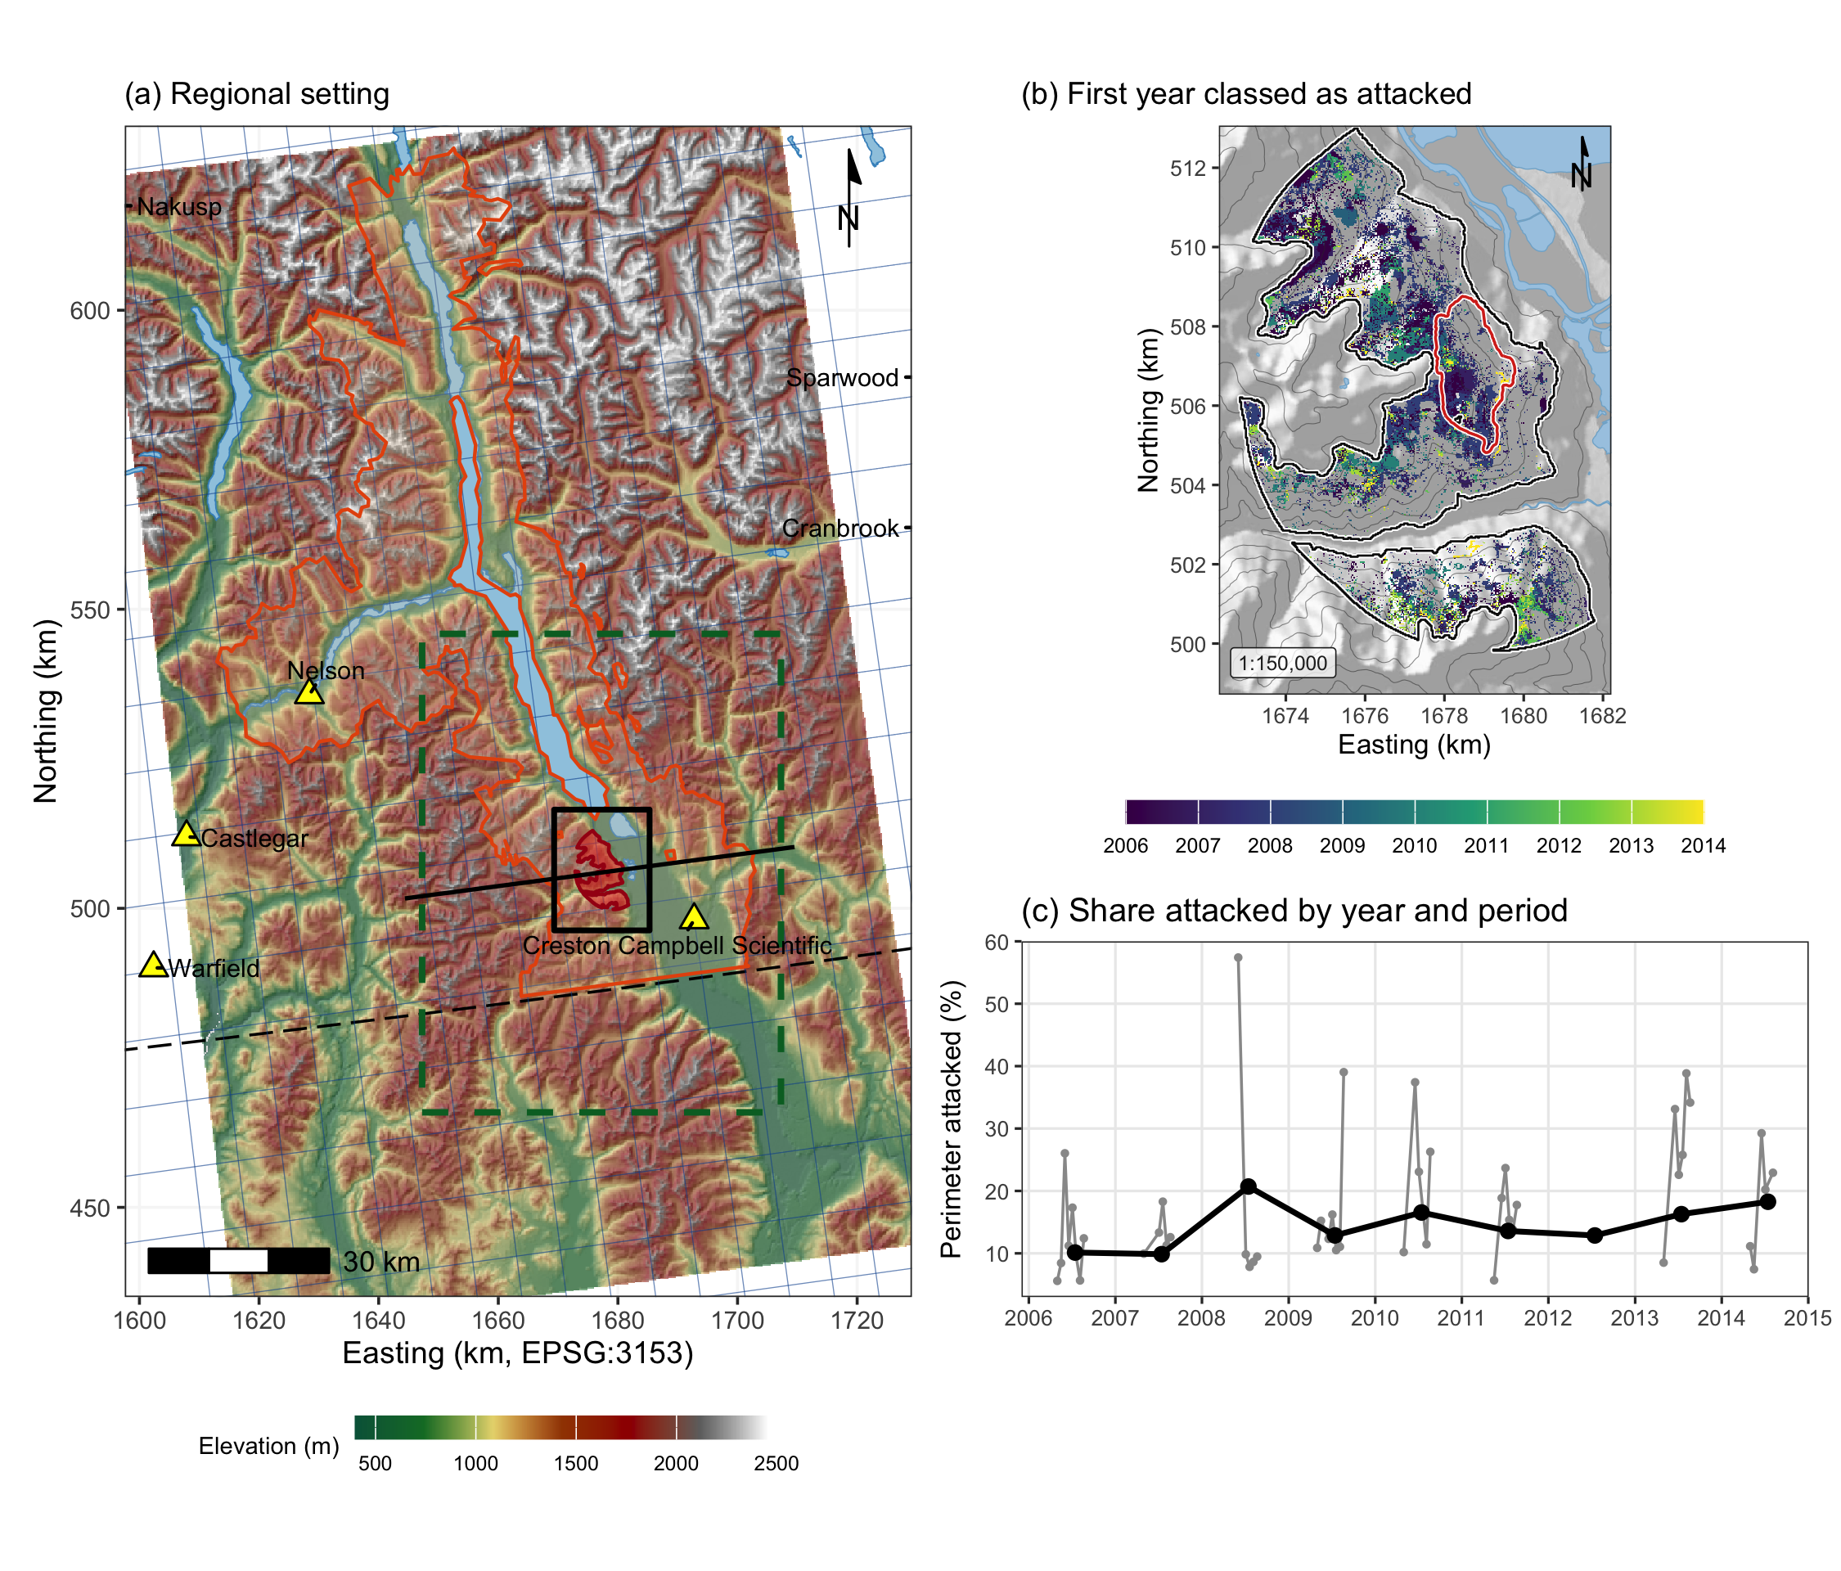
Figure 1. The study area and its red-stage attack. (a) Regional setting over the Copernicus 30 m elevation model. The red fill is the study perimeter, 5,573 ha, the black box the window of the 1 m lidar, the orange outline the 2017 lidar project, the green dashed box the regional wind domain, the blue grid the ERA5-Land reanalysis at 0.1 degree, the yellow triangles the seven hourly stations within 150 km, the black line the profile of Figure S3, and the long dash the Canada and United States border. (b) The first year each cell was attacked, with the 2015 Mt Midgeley burn in red. (c) The share of the perimeter attacked each year, black, and in each sixteen-day period, grey, the periods of each summer joined.

Figure 2
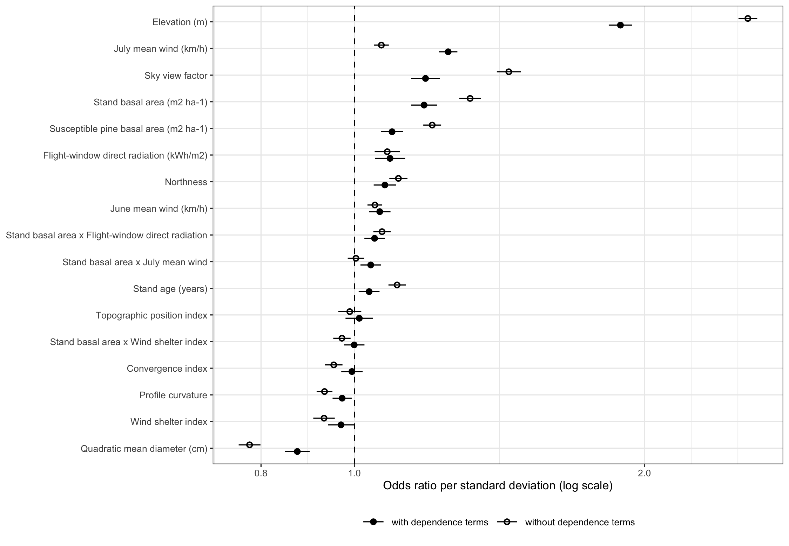
Figure 2. Odds ratios of the environmental terms of M3 per standard deviation, with 95 per cent confidence intervals, without the dependence terms over the nine years, open circles, and with them over the eight years with a previous map, filled circles. Terms are ordered by their odds ratio with the dependence terms, and the dashed line marks no effect.

Figure 3
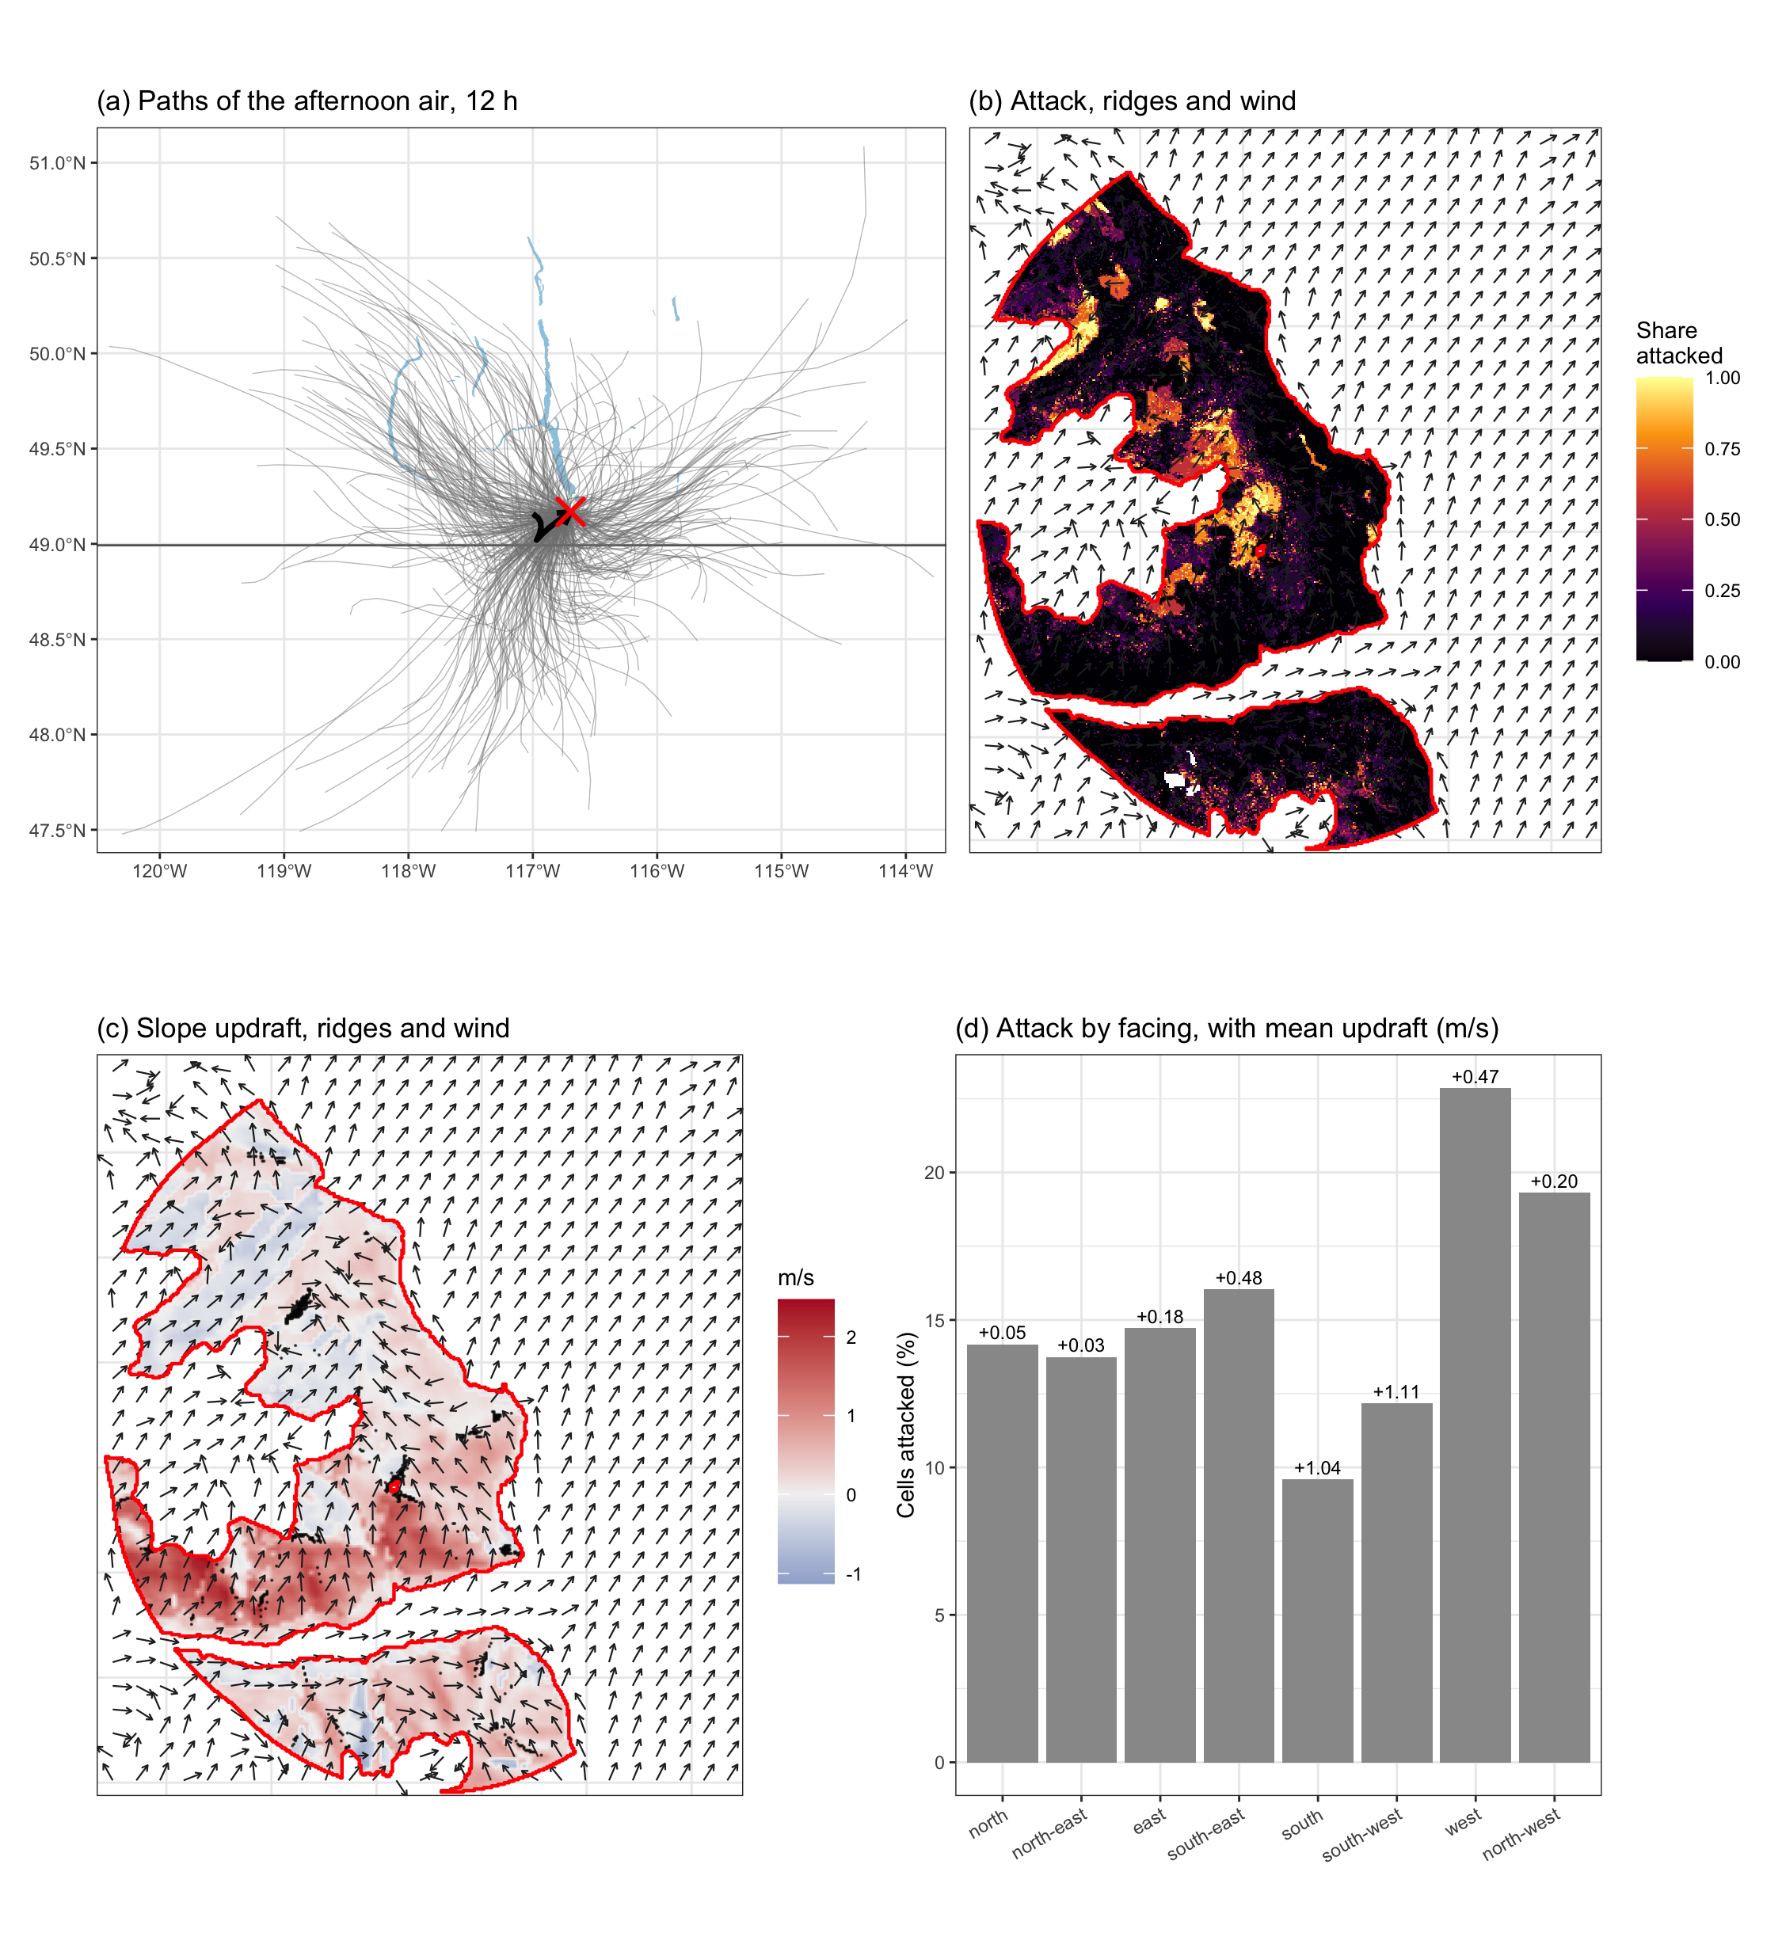
Figure 3. The afternoon air over the site and the attack it met, 1 July to 15 August. (a) HYSPLIT paths of the air over the 12 h before 14:00 on each flight day of 2005 to 2013, with the mean path in black. (b) The share of the annual maps of 2006 to 2014 on which each cell was attacked, with ridges in black and the modelled flight-hour wind as arrows. (c) The slope updraft of that wind, red where it rose and blue where it sank. (d) The share of cells attacked by the direction the ground faced, with the mean updraft above each bar. The red outline is the study perimeter.

