Testing the wind disruption and disturbance refugia hypothesis for mountain pine beetle outbreaks (Dendroctonus ponderosae)
Terrain, stand density and flight-period wind as controls on attack in the Selkirk Mountains of British Columbia
Seamus Murphy
2026-10-10
Running title. Terrain, wind and mountain pine beetle refugia
Correspondence. Seamus Murphy, TÜV SÜD, 2187 Comox Ave, Comox, British Columbia V9M 1P5, Canada. seamusrobertmurphy@gmail.com. ORCID 0000-0002-1792-0351.
Keywords. Mountain pine beetle, Disturbance refugia, Curculionidae, Scolytinae, British Columbia, thinning, dispersal, topography
Data availability statement. Landsat Collection 2 surface reflectance, the British Columbia Vegetation Resources Inventory, the Natural Resources Canada High Resolution Digital Elevation Model (Natural Resources Canada, 2017) and Environment and Climate Change Canada hourly station records are public. The derived data and the analysis code that reproduce every number, table and figure are at https://github.com/seamusrobertmurphy/beetle-topography-and-wind-study and will be deposited in the Dryad Digital Repository with the revised manuscript. The 28 field plots of Murphy et al. (2026) were used with the permission of its co-authors, Adrian Leslie, John Wilson and Lauren K. Banks.
Conflict of interest statement. The author declares no conflict of interest. The field plots used to train the classifier were collected under an earlier study the author led (Murphy et al., 2026) and are used with its co-authors’ agreement.
Author contributions. Seamus Murphy conceived and designed the study, assembled the data, wrote the code, performed the analysis and wrote the manuscript. The field plots and the Landsat classifications of red-stage mortality came from Murphy et al. (2026), whose co-authors took no part in the present article.
Acknowledgements. This work used no external funding. The author thanks the United States Geological Survey, the British Columbia Data Catalogue, Natural Resources Canada and Environment and Climate Change Canada for the open archives the study used.

Abstract
- Disturbance refugia from mountain pine beetle (Dendroctonus ponderosae) outbreaks have been proposed in thin stands of small trees, on shaded ground and where wind disrupts the aggregation pheromone, but little is known about how these mechanisms act together once attack nearby and earlier is taken into account.
- This study mapped red-stage attack in nine outbreak years and 47 sixteen-day Landsat periods across 5,573 ha of the Selkirk Mountains, British Columbia, with a classifier validated on field plots, and modelled it on annual forest inventory, terrain and a terrain-resolved wind field, entering the previous year’s attack first.
- Attack was clustered in every year, with positive spatial autocorrelation to a median of 2,640 m, and attack in and around a cell the year before dominated every model.
- Beside those terms attack rose with stand basal area (+0.167 log-odds per standard deviation, p < 0.001) and peaked in stands of 25 to 30 cm mean diameter, and north-facing ground had more attack rather than less. Flight-period wind lowered attack only where the canopy was open, and the effects of terrain shelter and openness did not survive a latent spatial field.
- Refugia on this landscape were stands with little host, and terrain and wind added small, scale-dependent modifiers to an outbreak whose spread was mostly contagion.

1. Introduction
Mountain pine beetle (Dendroctonus ponderosae Hopkins [Coleoptera: Curculionidae: Scolytinae]) is a bark beetle native to the pine forests of western North America, where lodgepole pine (Pinus contorta var. latifolia Engelm. ex S. Watson) is its main host through most of its range (Cooke et al., 2026; Safranyik & Carroll, 2006). Endemic populations persist in weakened and suppressed trees, while outbreaks occur infrequently and are followed by sharp declines (Raffa et al., 2008; Safranyik & Carroll, 2006). After 1976, when the Pacific Decadal Oscillation, a pattern of Pacific Ocean temperatures that shifts every few decades, entered its warm phase, extreme winter cold that kills the brood under the bark became rarer across the province (Macias Fauria & Johnson, 2009), and carried by wind, the outbreak then crossed the northern Rocky Mountains (Giroday et al., 2012).
In north-central Colorado and southern Wyoming, mapped from Landsat images for 1996 to 2011, tree mortality rarely reached 100 per cent even in a major outbreak (Meddens & Hicke, 2014). Places where more trees survive than in the surrounding forest are disturbance refugia, which Krawchuk et al. (2020) defined as locations disturbed less severely or less frequently than the landscape around them, noting that “few studies have explicitly identified refugia from insect outbreaks” (p. 235). They proposed that refugia from this beetle may occur “in areas with cooler temperatures (eg from topographic shading) that protect trees from water stress; in areas with lower host density, allowing for greater wind disruption of beetle pheromone communication and more vigorous tree growth and chemical defenses; and in areas with fewer large-diameter host trees” (Krawchuk et al., 2020, p. 239). In southern Oregon, refugia mapped at 30 m from Landsat during a severe outbreak in 2009 were “associated with topographically shaded slopes, convergent environments such as valleys, areas of relatively low soil bulk density, and in thinner forest stands” (Cartwright, 2018, p. 1).
In experimental stands of lodgepole pine, trees contained a few attacking beetles but died once the bark held more than about 40 beetle galleries per square metre (Raffa & Berryman, 1983), and over three to six years tree defences made no difference once beetle numbers in a stand passed a critical threshold (Boone et al., 2011). Once an outbreak is under way, whether a tree is killed therefore depends more on how many beetles are nearby than on its own defences. Populations become outbreaks once they can kill the average large tree in a stand (Shore et al., 2006), and lodgepole pines larger than 25 cm in diameter, whose thicker phloem feeds more larvae, produce on average more beetles than attack them (Carroll & Safranyik, 2004; Safranyik et al., 2010). When marked beetles were released in a mature lodgepole pine stand, most were caught 3 m above the ground and only 0.2 per cent rose above the canopy (Safranyik et al., 1992). Within a stand beetles fly under the crowns, downwind until they meet the scent of an attacked tree and then upwind towards it (Carroll & Safranyik, 2004; Safranyik et al., 1989), and new clusters of attack appeared 30 to 50 m from those of the year before (Robertson et al., 2007). On the Chilcotin Plateau an outbreak in a 12 km cell was best predicted by outbreaks in the neighbouring cells that year or in the same cell in the two years before (Aukema et al., 2008), and tree by tree in the Cypress Hills of Saskatchewan, infestations nearby in the previous year were the strongest single predictor of attack in every phase of the outbreak (Kunegel-Lion & Lewis, 2020).
Cold is the largest single effect of weather on the beetle’s numbers, and where summers are too cool for the brood to develop in one year, as at high elevations, mortality is severe and mass attack less successful (Logan & Powell, 2001; Safranyik & Carroll, 2006). In Colorado and southern Wyoming the outbreak began in several separate places, which suggested drought as a regional trigger (Chapman et al., 2012), and in Oregon and Washington, once beetle numbers nearby were accounted for, winter minimum temperature and drought had the largest effects on whether an outbreak grew large (Preisler et al., 2012). Within a landscape temperature follows the sun on each slope, and in the Morice Timber Supply Area of north-central British Columbia the most intense infestations were found early on warmer slopes facing south and west (Nelson et al., 2007). Elsewhere terrain entered as elevation, slope and aspect, whose effects followed the phase of the outbreak and the host. In Colorado the best predictors of red attack changed “from forest susceptibility to dispersal to host availability” as the outbreak grew (Walter & Platt, 2013, p. 317), and in western Montana the odds of red attack rose with elevation because lodgepole pine grew higher than the Douglas-fir around it (Wulder et al., 2006).
Thinned lodgepole and ponderosa pine stands across the western United States lost fewer trees to the beetle (Amman et al., 1988; Fettig et al., 2007; Mitchell et al., 1983). Mitchell et al. (1983) attributed this to the vigour of the remaining trees, while Bartos & Amman (1989), in the Uinta Mountains of Utah, proposed microclimate, having measured more light, warmth and wind in a thinned stand than in the unthinned stand beside it, a wind difference that doubled to at least 3.2 km/h between 4 and 6 p.m., when most beetles flew. In crowded stands, however, trees grow slowly and have thin phloem, so adding trees can raise attack in an open stand and lower it in a crowded one (Shore et al., 2006).
Wind can lower attack by breaking up the pheromone plume, the trail of scent downwind of an attacked tree, which Krawchuk et al. (2020) called “wind disruption of beetle pheromone communication” (p. 239), most of all in open stands, where more wind reaches the trunks (Bartos & Amman, 1989). Wind can also concentrate attack, because “alterations in wind speed may cause increased settlement in areas where wind speed is reduced” (de la Giroday et al., 2011, p. 1098), and the first beetles to arrive were “unable to distinguish between hosts, dead hosts and nonhosts during landing” (Hynum & Berryman, 1980) and judged a tree only after landing (Safranyik et al., 2010), so ground sheltered from the wind should receive more attack whatever the stand. Both effects act only during flight, which peaks in the early to mid afternoon (Safranyik & Carroll, 2006) and stops in winds above about 2 metres per second (Carroll & Safranyik, 2004), and studies of flight above the canopy resolved wind over terrain but not within the stand (Ainslie & Jackson, 2010; Jackson et al., 2008).
Few studies had tested these mechanisms together while accounting for attack nearby. This study mapped red-stage attack, trees whose needles had turned red in the year after they were attacked, across part of the Selkirk Mountains of southeastern British Columbia from the 28 field plots of an earlier study on the same ground (Murphy et al., 2026), once a year to test the refugia mechanisms and every sixteen days to test wind. It asked three questions, the first whether stand density, shading by terrain and the scarcity of large trees predicted attack once attack nearby was in the model, the second whether wind during flight lowered attack more in open stands than in closed ones, as disruption of the pheromone plume predicted, and the third whether ground sheltered from the afternoon wind, or facing away from it, had more attack whatever the stand, as deposition predicted.

2. Methods

2.1 Site terrain
The study area covered 5,573 ha on the eastern face of the Selkirk Mountains in southeastern British Columbia, above the Creston valley where the Kootenay River enters the south arm of Kootenay Lake (Figure 1), from 830 to 1,744 m in elevation. It was centred on the 480 ha burned by the 2015 Mt Midgeley fire (Murphy et al., 2026) and extended 5 km beyond the burn within the same band of elevation, to take in the range of stand density the pheromone mechanism needed. Along the latitude of its centre the ground fell from 2,072 m to 531 m within 7.6 km (Figure S3). The area held 61,923 cells of 30 m on the grid of Murphy et al. (2026). Attack was mapped once a year for the questions on refugia and every sixteen days for the wind test, the inventory once a year, the station winds every hour and the terrain once overall (Table S1).
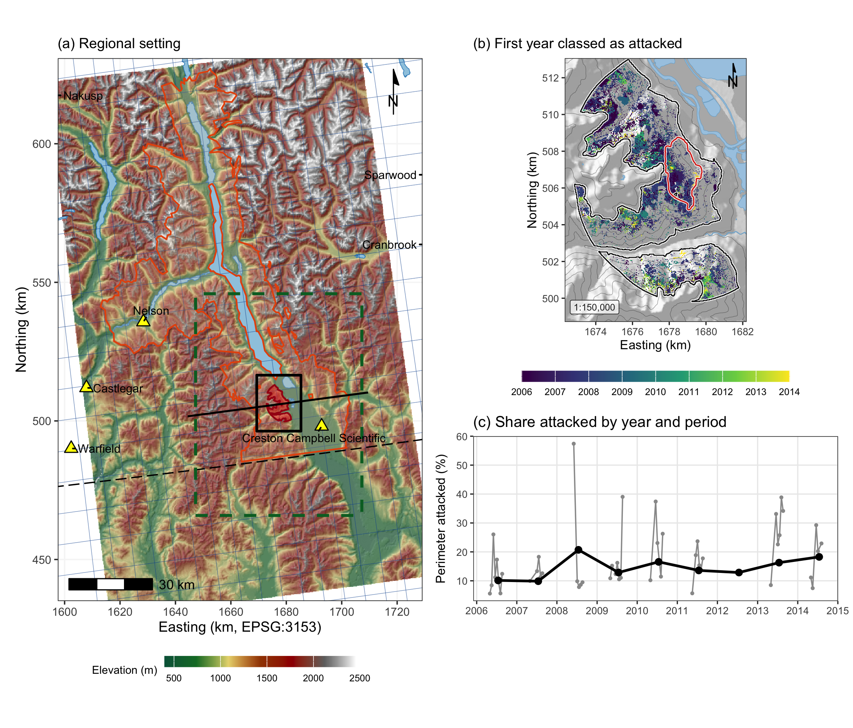
Figure 1: The study area and its red-stage attack. (a) Regional setting over the Copernicus 30 m elevation model. The red fill is the study perimeter, 5,573 ha, the black box the window of the 1 m lidar, the orange outline the 2017 lidar project, the green dashed box the regional wind domain, the blue grid the ERA5-Land reanalysis at 0.1 degree, the yellow triangles the seven hourly stations within 150 km, the black line the profile of Figure S3, and the long dash the Canada and United States border. (b) The first year each cell was attacked, with the 2015 Mt Midgeley burn in red. (c) The share of the perimeter attacked each year, black, and in each sixteen-day period, grey, the periods of each summer joined.
Stand structure came from British Columbia’s Vegetation Resources Inventory, the snapshot published in each study year, rasterised to the 30 m grid (Table 1). The attributes were basal area, crown closure, live stems per hectare, quadratic mean diameter of stems of 12.5 cm and larger, stand age, stand height, standing volume and susceptible pine basal area, the product of basal area and pine cover. The 2007 snapshot omitted basal area and live stems, so the 2006 snapshot stood in for it. The inventory is a projection rather than a census, and polygons interpreted from photographs taken late in the outbreak described stands the beetle had already attacked.
Terrain was computed in SAGA GIS from an elevation model extending beyond the perimeter, so that search radii near the edge fell on measured ground, and split terrain ruggedness into the properties of the ground the beetle’s biology concerns, with ruggedness kept as a candidate. Exposure was measured by the windward-leeward index, effective air flow height, the wind exposition index, topographic openness, sky view, the wind shelter index of Plattner et al. (2004) and geomorphon class, which assigns each cell a landform such as ridge, slope or valley. Landform was measured by wetness, valley depth and height above the valley floor, because groups of infested trees are “frequently associated with draws and gullies” (Safranyik & Carroll, 2006, p. 41). Aspect entered as northness, eastness and the heat load index of McCune & Keon (2002). Radiation was computed for the flight window, 1 July to 15 August from 12:00 to 17:00, and for the growing season, 1 May to 30 September, over which shading can protect trees from water stress (Krawchuk et al., 2020). Table S3 lists the variables that entered the models with the mechanism each represents.

2.2 Beetle outbreak
The response for the first and third questions was red-stage attack in each outbreak year from 2006 to 2014, measured, following Murphy et al. (2026), as the fall in the normalised difference moisture index (NDMI) from its value in 2005, when the outbreak began. NDMI tracks the moisture of the canopy and is used to detect forest disturbance in Landsat time series (Jin & Sader, 2005), and Murphy et al. (2026) validated their map of the burn site against 28 field plots of 20 by 20 m, in which beetle-killed pine was confirmed from pitch tubes, frass and the pattern of the egg galleries.
Each year was mapped from the median of cloud-masked Collection 2 Level-2 Landsat 5 and 8 scenes of 1 June to 31 August, differenced against 2005 and resampled by nearest neighbour onto the 30 m grid of Murphy et al. (2026), with Landsat 8 converted to the Landsat 5 scale by the coefficients of Roy et al. (2016) and matched to the Landsat 5 range over undisturbed forest. With lakes and rivers masked, attack covered from 9.9 to 20.7 per cent of the perimeter by year (Table S2, Figure 1).
No Landsat 5 or Landsat 8 images were taken in the summer of 2012, so its map was drawn from the median of the summer’s Landsat 7 scenes, which filled most of the strips that the failed scan-line corrector left in each one (Sadiq et al., 2016; Wulder et al., 2011). The index was put on the Landsat 5 scale by a line fitted on stable forest in 2010, when both satellites flew.
The response for the second question was red-stage attack in each sixteen-day period, the Landsat revisit interval, from 1 May to 22 September of the same years, with NDMI as the median of the period’s scenes differenced against the same period of 2005, so that the seasonal course of leaf moisture did not enter the difference. Periods in which the imagery saw less than a tenth of the perimeter were dropped, leaving 47 periods over eight years (Table S5).
The fall in NDMI that counted as attack was set by a classifier trained on the four pixels nearest the centre of each field plot, 112 pixels, against the 84 points of undisturbed forest that Murphy et al. (2026) digitised on the 2020 Landsat 8 scene, which fell in 68 distinct cells, each pixel entering with its deepest annual fall in NDMI against 2005. Random forest, a radial support vector machine and gradient boosting were scored over 100 splits, each holding out a quarter of the field plots and of the 100 m blocks of undisturbed pixels. The radial support vector machine was the most accurate, with kappa 0.859 ± 0.081 and overall accuracy 0.934 (Table S10; Table S6), and its cut, a fall in NDMI of 0.0616 against 2005, was applied to the annual and sixteen-day differences. The undisturbed pixels came from one patch of about 230 by 455 m, so the cross-validation measured how well the plots were separated from that patch rather than from undisturbed forest across the landscape.
Wind was summarised over the afternoon flight hours, 12:00 to 17:00, the flight period Safranyik & Carroll (2006) identified for this region (p. 18), which overlaps the emergence peak of 11:00 to 14:00 that Gray et al. (1972) recorded in eastern Washington. Across 236,079 hourly station records from May to September, 89.5 per cent of afternoon hours between 1 July and 15 August fell within the 19 to 41 degrees C in which beetles fly (McCambridge, 1971), against 51.4 per cent in the rest of the season (Figure 2).
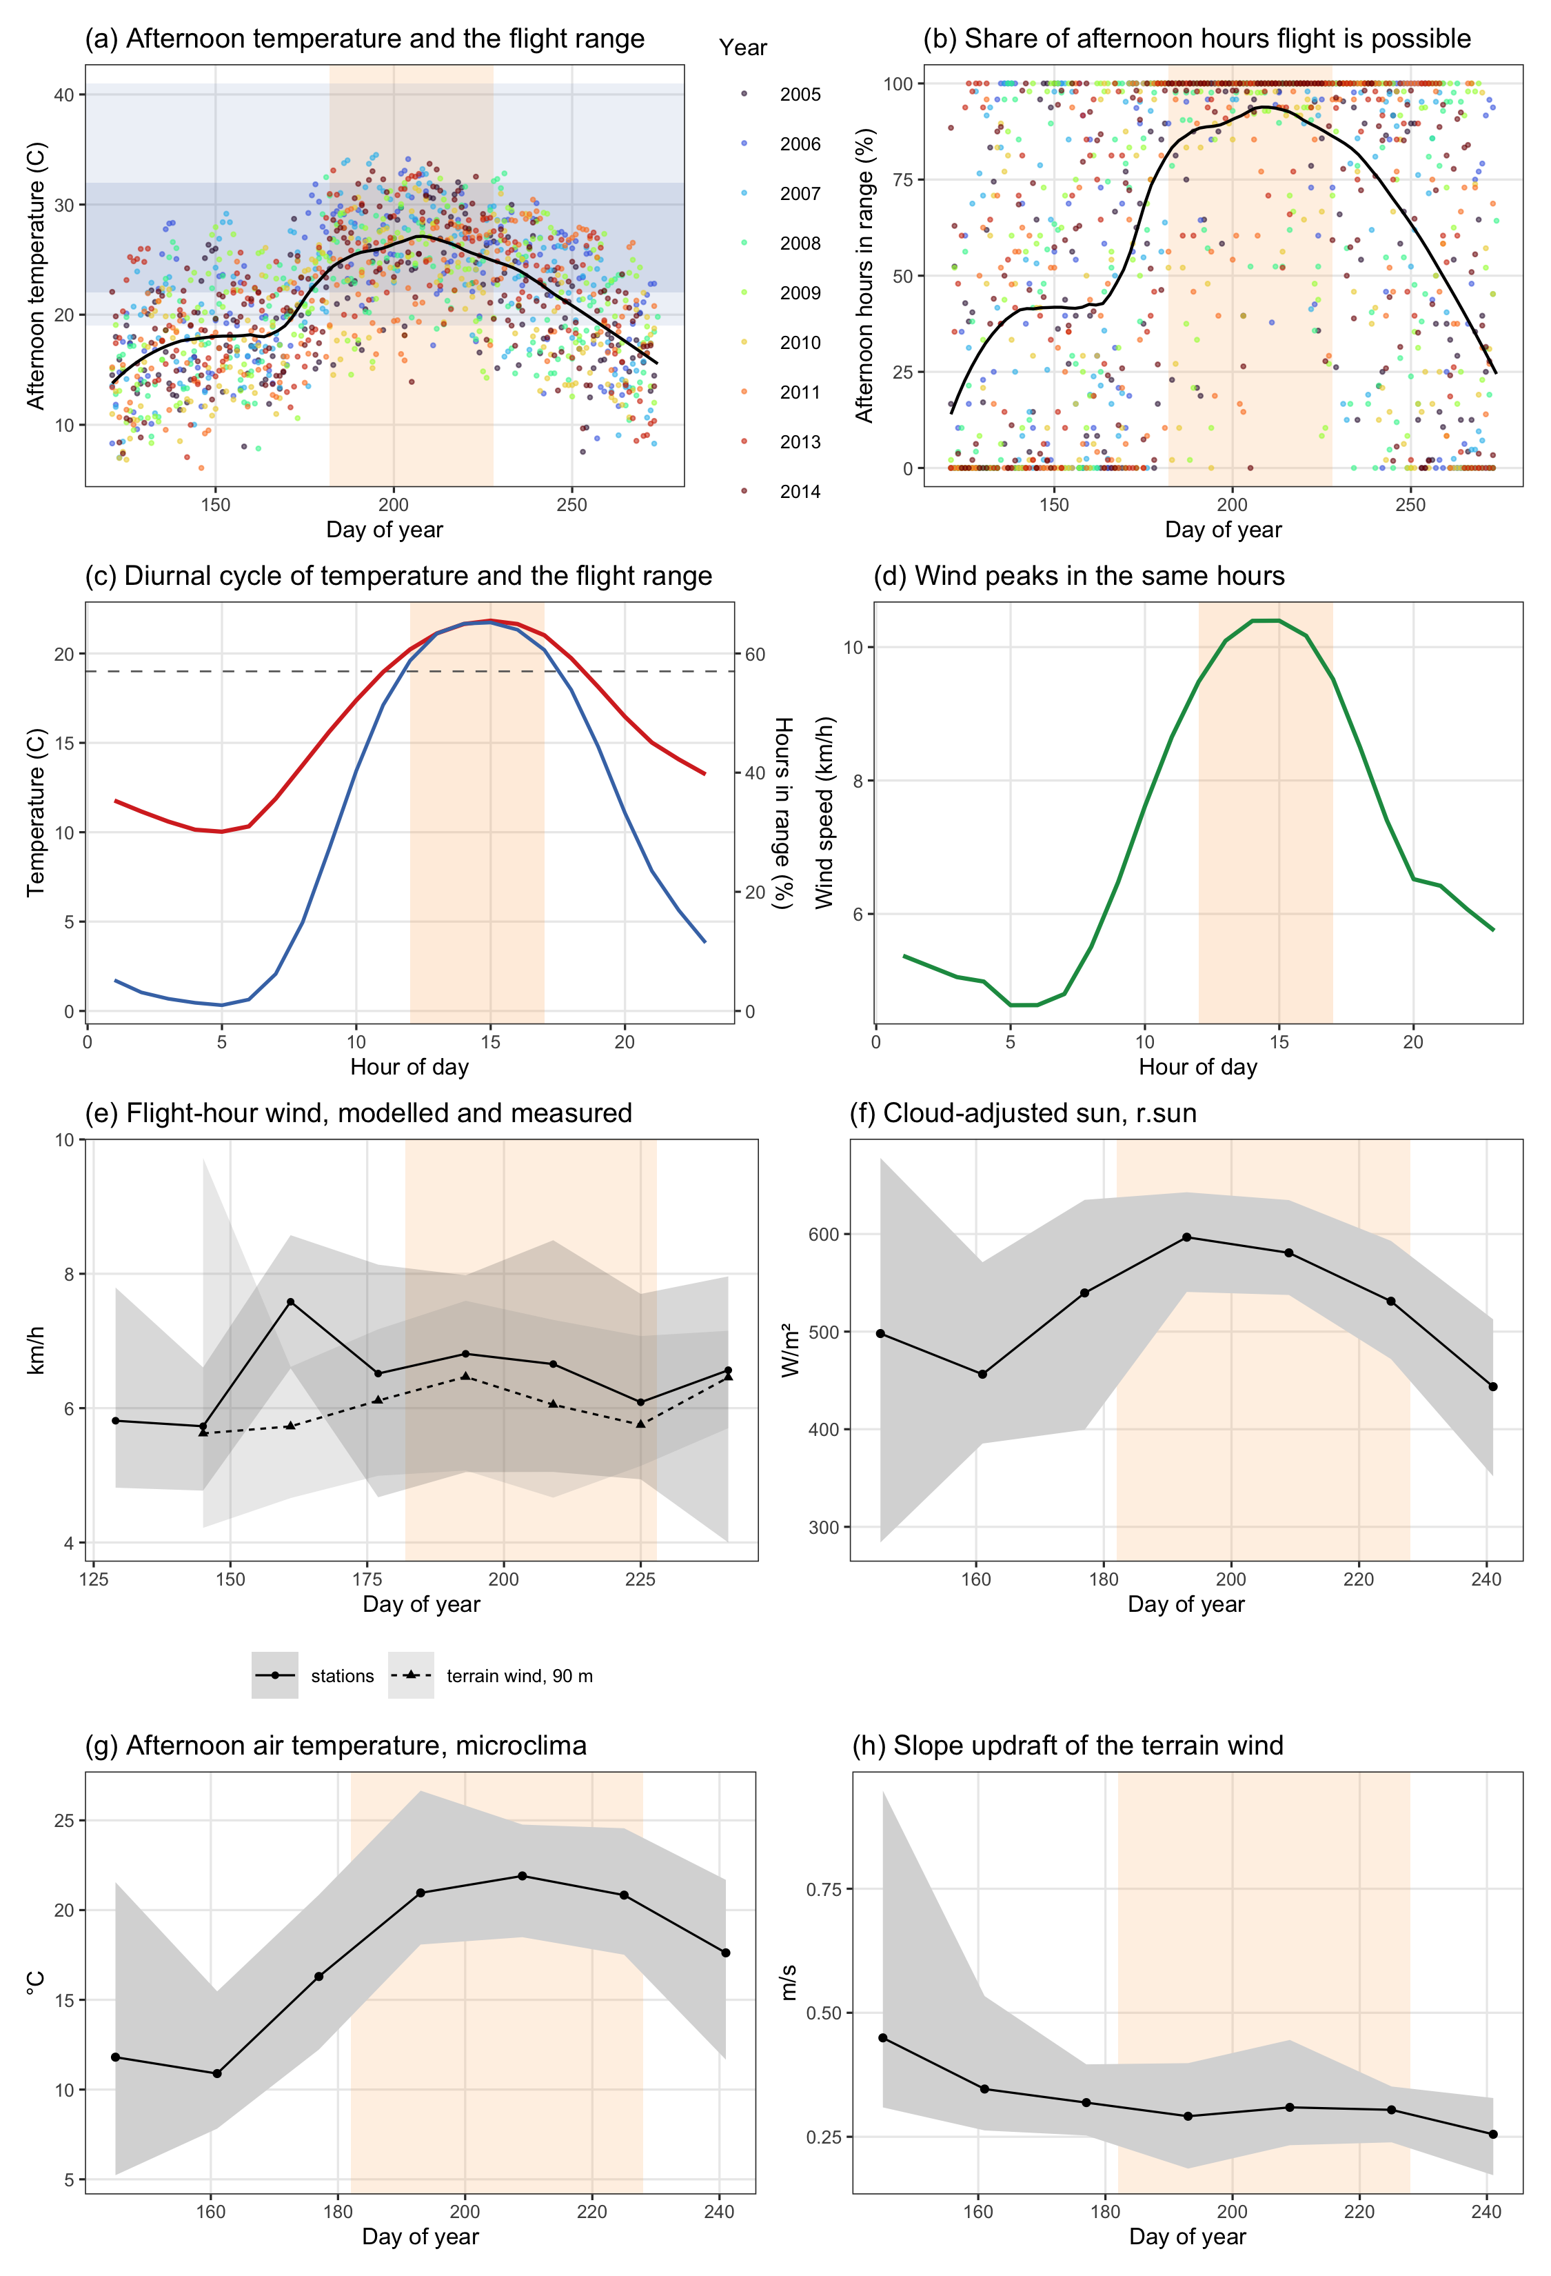
Figure 2: The flight window against the landscape’s own climate, from hourly Environment and Climate Change Canada station records for May to September of the study years. The shaded band marks the window, 1 July to 15 August, taken from the bionomics and not fitted to these data. (a) Mean afternoon temperature by day of year, with the 19 to 41 °C flight range and the 22 to 32 °C peak band marked. (b) The share of afternoon hours inside the flight range, day by day. (c) Mean temperature and the share of all hours inside the flight range, by hour, with the 12:00 to 17:00 restriction shaded. (d) Mean wind speed by hour, showing that the hours in which the beetle could fly were also the windiest of the day. (e) to (h) The modelled weather of the flight hours by sixteen-day period, the mean over the summers with the range of the summer means shaded, for (e) wind speed from WindNinja at 90 m, corrected, against the stations, (f) cloud-adjusted sun from r.sun, (g) afternoon air temperature from microclima, and (h) the slope updraft of the terrain wind, each the mean over the study area.
Hourly speed and direction from Environment and Climate Change Canada stations within 150 km were combined as vector components, adjusted for terrain with the MicroMet model of Liston & Elder (2006), which weights each observation by the slope in the wind direction and the curvature of the ground, and interpolated to the grid by inverse distance weighting. Each sixteen-day period was summarised by its mean flight-hour wind, which ran from 4.0 to 8.6 km/h between periods, and each year by its mean wind of June and of July.

2.3 Wind and lift
Wind over the terrain was modelled with WindNinja 4.0.0 (Forthofer et al., 2014), driven by the hourly ERA5-Land reanalysis (Muñoz-Sabater et al., 2021) for every flight hour of June to August 2005 to 2014 with its slope winds on, at 90 m over the study area, at 30 m and 10 m for each flight window, and at 500 m and 1 km over the surrounding valleys for checking against stations. Each cell received the mean speed, corrected by the model’s loss of speed on flat ground, a factor of 1.63 at 90 m, the share of hours in which the air moved upslope, and the slope updraft. At the valley stations the modelled direction erred by about 60 degrees (Table S10), so these terms were read as each slope’s exposure to the regional flow, and the valley wind was taken from 28 provincial stations (Figure S4).
Convective lift, the speed of rising air in the afternoon, was the velocity scale of Deardorff (1970) from the ERA5-Land sensible heat flux and the ERA5 boundary layer height (Hersbach et al., 2020), scaled by each slope’s share of the flight-window sun. Back-trajectories from HYSPLIT (Stein et al., 2015) on the North American Regional Reanalysis (Mesinger et al., 2006) traced the air over the site twelve hours back from 14:00 on every flight day of 2005 to 2013, and the share of their endpoints over red attack in the provincial and US Forest Service surveys entered the models as a source term. Sun on each slope was recomputed with r.sun in GRASS GIS (Šúri & Hofierka, 2004) under each hour’s cloud, afternoon air temperature with microclima (Maclean et al., 2019), refitted to Landsat land surface temperature, and the Landsat land surface temperature of the flight window and the roughness, north-facing share and spread of position of the 1 m lidar terrain within each cell entered as further terms.
These terms were read at the scales the beetle’s flight allows. Beetles that rise above the canopy travel on the wind, an estimated 30 to 110 km in a day (Jackson et al., 2008), so the terrain wind, the lift and the trajectories described which slopes the above-canopy stream reached. Within a stand a surrogate pheromone fell to about a tenth of its concentration within 10 m Brush & Lewis (2024), an effect that entered the models only through attack in and around the cell. The wind terms were therefore read as predictors of where beetles arrived and not of where they settled, and each entered the models from the same period or flight window of the previous summer, one term to a specification (Table S3).

2.4 Model design
Before any model was fitted, the spatial pattern of attack was described on each annual map, with attack present or absent in each cell. The join count (Moran, 1948) counted pairs of neighbouring attacked cells among the eight around each cell, and Moran’s I (Moran, 1950) was computed in distance classes of 60 m out to 6 km as a correlogram (Legendre & Fortin, 1989), both against 999 random permutations of the attacked cells among the cells mapped that year. The range of positive autocorrelation was the first distance class at which Moran’s I no longer exceeded the permuted values at p ≤ 0.05.
The annual models were built in the order Aukema et al. (2008) used, in which they first “determined an appropriate spatial neighborhood structure(s) and time lag(s) to account for spatial and temporal dependencies” (p. 351) and only then entered environmental variables. The first dependence term was the cell’s own state in the previous outbreak year, and the second the share of cells attacked around it in that year within 42, 90, 150, 210, 510 or 1,050 m, excluding the cell itself, with the radius chosen on AIC (Table S7). Each year contributed up to 4,000 attacked and 4,000 unattacked cells, because at a landscape prevalence near one cell in ten an unbalanced fit would report its intercept rather than its covariates.
The 52 environmental variables were grouped by mechanism (Table 1) and entered four logistic regressions in sequence, each adding one mechanism to the one before, and each was scored on its full fit, under ten-fold cross-validation on 1 km blocks and on a blind test that fitted the years to 2012 and predicted 2013 and 2014 (Table S9). Every model included the geomorphon class of the cell, and every continuous term was standardised, so that each coefficient was a change in log-odds per standard deviation. The sequence was fitted on all nine years without the dependence terms and on the eight years with a previous map without and with them, so that the change in each environmental term once attack nearby entered could be read directly. Before the final model was read, each candidate was screened on the years with a previous map by a likelihood ratio test of the variable added alone to the two dependence terms, by its variance inflation against the main effects of M3, and by its coefficient in an elastic net (Friedman et al., 2010; Zou & Hastie, 2005) that entered every candidate together with the dependence terms unpenalised, and its distribution was tested by the Shapiro-Wilk test on 5,000 cell-years (Table 1).
The first and third questions were answered with these annual models, the third by comparing the main effect of the wind shelter index with its interaction with basal area, in M3 with and without flight-window radiation. Each interaction was read as the slope of one term at one standard deviation either side of the mean of the other. Attack was also tabulated by quadratic mean diameter class, with Wilson intervals, a chi-square test across classes and a two-proportion test across 25 cm, the diameter Carroll & Safranyik (2004) gave as the boundary between beetle sinks and sources.
The second question was tested on the sixteen-day maps, on which wind varied between periods within a season as well as between years. Attack in a period was regressed on 15 stand and terrain variables, mean flight-hour wind, the geomorphon class and the interactions of wind with stand structure (E1), and E2 added the cell’s own state in the previous period and the share attacked within 90 m around it, chosen on AIC, with each period contributing up to 2,000 cells of each class. Because the red crowns of a period recorded the flight of the previous summer, every wind test was also run with the wind of the same period one year earlier.
Residual autocorrelation was measured as Moran’s I of the deviance residuals within each year. M3 with the dependence terms was then refitted with a Gaussian process smooth of easting and northing (Wood, 2017), its range set to the median range of positive autocorrelation, 2,640 m, and on cells coarsened to 90, 270 and 990 m with the dependence terms rebuilt at each grain, a coarse cell counting as attacked if any 30 m cell inside it was, as Aukema et al. (2008) defined their 12 km cells.
Further terms were tested beside M3 and E2 and are described in the Supporting Information. These were valley and ridge flatness (Gallant & Dowling, 2003), canopy height from lidar, winter minimum temperature, station pressure, and attack upwind and downwind of each cell weighted by winter survival.

3. Results
Attack was clustered in every year, with 3.2 to 5.8 times as many neighbouring pairs of attacked cells as random permutation produced and positive autocorrelation to a median of 2,640 m (Figure S17). Attack in the cell and within 150 m the year before dominated every model it entered, a cell attacked the year before had 9.1 times the odds of attack, and the two terms raised the area under the receiver operating characteristic curve (AUC) of M3 from 0.814 to 0.890. Of the 31 candidate variables, 28 improved the fit by likelihood ratio test once the dependence terms were in the model, the elastic net kept 16, the largest variance inflation among the main effects of M3 was 2.9, and every variable departed from a normal distribution (Table 1). The winter minimum, the survival of the brood and the weather of the flight window varied from year to year (Figure S1).
Table 1: Descriptive statistics and likelihood ratio test of covariate importance. Red-stage attack and the candidate variables of the annual models over the 72,000 sampled cell-years before standardisation, with the mean, standard deviation (SD), skewness and Shapiro-Wilk W on 5,000 cell-years, and the screening of each variable on the years with a previous map, as its slope β in a model of the two dependence terms with that variable alone, the deviance it explained, and the p-value of the likelihood ratio test. Terms marked previous summer were taken from the flight window of the summer before each map. * p ≤ 0.05, ** p ≤ 0.01, *** p ≤ 0.001, **** p ≤ 0.0001.
Covariate | Definition | Mean | SD | Skew | W | β | Deviance | LR-test
Red-stage attack (%) | Response, share of the perimeter attacked, 2006 to 2014 | 14.6 | 3.65 | +0.30
Susceptible pine basal area (m² ha⁻¹) | Stand basal area multiplied by lodgepole pine cover, Vegetation Resources Inventory | 8.47 | 10.3 | +1.31 | 0.804 | +0.3329 | 886.97 | 0.001****
Stand age (years) | Age of the leading species, Vegetation Resources Inventory | 113 | 25.4 | +1.30 | 0.893 | +0.0923 | 85.93 | 0.001****
Quadratic mean diameter (cm) | Quadratic mean diameter of stems of 12.5 cm and larger, Vegetation Resources Inventory | 26.5 | 6.11 | +1.10 | 0.934 | -0.0141 | 2.19 | 0.139
Sky view factor | Share of the sky not hidden by the surrounding terrain | 88.3 | 4.86 | -0.47 | 0.984 | +0.4119 | 1,362.54 | 0.001****
Northness | Cosine of aspect, 1 on ground facing north and -1 on ground facing south | 0.214 | 0.685 | -0.45 | 0.886 | +0.0435 | 18.26 | 0.001****
Elevation (m) | Elevation of the 30 m cell | 1,400 | 276 | -0.54 | 0.906 | +0.7528 | 3,987.76 | 0.001****
Stand basal area (m² ha⁻¹) | Basal area of the stand, Vegetation Resources Inventory | 35.3 | 12.4 | -0.78 | 0.915 | +0.1961 | 371.10 | 0.001****
Wind shelter index | Wind shelter index (Plattner et al., 2004) at the prevailing bearing, higher on slopes facing that wind | 21 | 29.8 | +1.70 | 0.597 | +0.0650 | 43.04 | 0.001****
Topographic position index | Elevation of the cell less the mean elevation around it, positive on ridges and spurs | 3.12 | 16.1 | -0.51 | 0.977 | +0.1393 | 201.48 | 0.001****
Convergence index | Convergence index, negative where slopes run together into hollows and positive over spurs | 0.538 | 8.81 | -0.07 | 0.974 | +0.0668 | 41.60 | 0.001****
Profile curvature | Curvature of the ground along the line of steepest slope | 0.0000622 | 0.00227 | -0.06 | 0.992 | +0.0457 | 21.34 | 0.001****
Flight-window direct radiation (kWh/m²) | Clear-sky direct radiation from 12:00 to 17:00, 1 July to 15 August | 140 | 37.6 | -0.15 | 0.993 | +0.2147 | 469.53 | 0.001****
July mean wind (km/h) | Mean station wind of July, interpolated to the cell | 7.17 | 0.576 | +0.25 | 0.916 | +0.2349 | 501.58 | 0.001****
June mean wind (km/h) | Mean station wind of June, interpolated to the cell | 7.18 | 0.508 | -0.28 | 0.948 | +0.0526 | 17.97 | 0.001****
July wind, previous summer (km/h) | Mean station wind of July of the previous summer, interpolated to the cell | 7.16 | 0.578 | +0.25 | 0.939 | -0.1076 | 117.15 | 0.001****
June wind, previous summer (km/h) | Mean station wind of June of the previous summer, interpolated to the cell | 7.13 | 0.515 | -0.02 | 0.948 | +0.0020 | 0.04 | 0.838
Surface temperature, previous flight window (°C) | Landsat land surface temperature over the previous summer’s flight window | 23.1 | 4.55 | +0.80 | 0.970 | -0.0554 | 21.42 | 0.001****
Ground roughness within the cell at 1 m (m) | Roughness of the 1 m bare-earth surface within the cell, 2017 lidar | 4.08 | 1.76 | +0.47 | 0.981 | -0.3983 | 1,314.02 | 0.001****
Share of the cell facing north at 5 m | Share of the cell’s 5 m terrain facing north, 2017 lidar | 0.216 | 0.356 | +1.38 | 0.624 | -0.0093 | 0.88 | 0.349
Spread of position at 55 m (m) | Spread of topographic position at 55 m within the cell, 2017 lidar | 0.84 | 0.573 | +2.33 | 0.822 | -0.2883 | 696.43 | 0.001****
Crown closure (%) | Share of the ground covered by tree crowns, Vegetation Resources Inventory | 50 | 13.2 | -1.61 | 0.799 | +0.1823 | 325.49 | 0.001****
Modelled wind at 90 m, previous summer (km/h) | WindNinja flight-hour wind speed at a 90 m mesh, corrected for the model’s loss of speed | 6.51 | 2.3 | +1.17 | 0.919 | +0.1808 | 357.43 | 0.001****
Upslope share of flight hours, previous summer | Share of flight hours in which the modelled wind blew upslope | 0.319 | 0.272 | +0.86 | 0.916 | -0.0467 | 21.70 | 0.001****
Shelter at the modelled wind direction, previous summer | Wind shelter index at the cell’s own modelled wind direction | 49.1 | 38.8 | +0.02 | 0.728 | -0.1516 | 220.28 | 0.001****
Modelled wind at 30 m, previous summer (km/h) | WindNinja flight-hour wind speed at a 30 m mesh, corrected | 4.95 | 2.55 | +0.95 | 0.941 | +0.1178 | 148.21 | 0.001****
Modelled wind at 10 m, previous summer (km/h) | WindNinja flight-hour wind speed at a 10 m mesh, corrected | 4.65 | 2.21 | +1.00 | 0.943 | +0.1484 | 235.31 | 0.001****
Convective lift, previous summer (m/s) | Convective velocity of the afternoon mixed layer (Deardorff, 1970), scaled by each slope’s sun | 2.29 | 0.311 | +0.06 | 0.999 | +0.2220 | 530.01 | 0.001****
Slope updraft of the terrain wind, previous summer (m/s) | Vertical speed of the modelled mean wind over the slope of the ground | 0.248 | 0.482 | +1.31 | 0.907 | -0.0903 | 83.20 | 0.001****
Cloud-adjusted flight-hour sun, previous summer (kWh/m²) | Flight-hour sun on each slope from r.sun under each hour’s cloud | 134 | 29.7 | -0.11 | 0.996 | +0.1904 | 378.54 | 0.001****
Slope temperature departure, previous summer (°C) | Departure of the cell’s afternoon air temperature from the reanalysis at its elevation, from microclima tuned to Landsat | -0.638 | 1.25 | -0.01 | 0.997 | +0.2407 | 587.93 | 0.001****
Trajectory endpoints over red attack, previous summer | Share of the HYSPLIT back-trajectory endpoints over red attack in the aerial surveys, one value a year | 0.0189 | 0.0102 | +0.47 | 0.832 | +0.0982 | 79.14 | 0.001****

3.1 Host and shade
Of the mechanisms in the first question, stand density acted through the amount of host and host size through a threshold, and shading was not supported. Basal area lowered AIC more than any other step of the model sequence, by 478 (Table S9), and entered M3 at +0.276 log-odds per standard deviation (p < 0.001), at +0.167 with the dependence terms and at +0.200 under the spatial field (Table 2; Figure 3), and it remained positive at a 270 m grain, +0.094 (p = 0.026). Attack depended on quadratic mean diameter class [χ²(5) = 980.1, p < 0.001, Cramér’s V = 0.117], peaking at 56.4 per cent of the balanced sample in the 25 to 30 cm class against 48.1 per cent at 20 to 25 cm and falling in the larger classes, whose stands held less pine. Elevation had the largest coefficient in every model, +0.940 in M3 (p < 0.001), and north-facing ground had more attack rather than less, +0.105 (p < 0.001). Cloud-free afternoon sun in the flight window raised attack by +0.144 (p < 0.001) in stands one standard deviation above the mean basal area and by +0.012 (p = 0.471) in stands one standard deviation below it.

Table 2: Regression estimates of red-stage attack by model, in log-odds per standard deviation of each continuous term, with the p-value of each estimate on the line beneath it, in the layout of Murphy et al. (2026). M0 held host size, shading and landform, M1 added stand basal area, M2 terrain exposure, shape and flight-window radiation, and M3 the interactions, over the nine years; M3 was then refitted with the dependence terms over the eight years with a previous map, and with a latent spatial field as well. Performance is each model’s AUC and RMSE on its full fit, the RMSE ratio of the test folds over the training folds under ten-fold cross-validation on 1 km blocks, and Theil’s U bias. Pine BA susceptible pine basal area, QMD quadratic mean diameter, Sky sky view factor, Elev. elevation, BA stand basal area, Shelt. wind shelter index, TPI topographic position, Conv. convergence, Curv. profile curvature, Rad. flight-window direct radiation, W-Jul and W-Jun the July and June station wind, Prev. cell attack in the cell the previous year, and Prev. 150 m the share attacked within 150 m the previous year. * p ≤ 0.05, ** p ≤ 0.01, *** p ≤ 0.001.
Model | Pine BA | Age | QMD | Sky | North | Elev. | BA | Shelt. | TPI | Conv. | Curv. | Rad. | W-Jul | W-Jun | Prev. cell | Prev. 150 m | BA×Shelt. | BA×W-Jul | BA×Rad. | AUC | RMSE | RMSE ratio | U bias
M0 | +0.272*** | +0.118*** | -0.097*** | +0.420*** | +0.128*** | +0.934*** |  |  |  |  |  |  |  |  |  |  |  |  |  | 0.804 | 0.423 | 1.003 | 0.0000
 | 0.001 | 0.001 | 0.001 | 0.001 | 0.001 | 0.001
M1 | +0.195*** | +0.101*** | -0.249*** | +0.381*** | +0.077*** | +0.945*** | +0.279*** |  |  |  |  |  |  |  |  |  |  |  |  | 0.807 | 0.422 | 1.000 | 0.0001
 | 0.001 | 0.001 | 0.001 | 0.001 | 0.001 | 0.001 | 0.001
M2 | +0.191*** | +0.101*** | -0.250*** | +0.387*** | +0.100*** | +0.941*** | +0.273*** | -0.069*** | -0.022 | -0.049*** | -0.074*** | +0.062*** |  |  |  |  |  |  |  | 0.808 | 0.421 | 1.005 | 0.0001
 | 0.001 | 0.001 | 0.001 | 0.001 | 0.001 | 0.001 | 0.001 | 0.001 | 0.118 | 0.001 | 0.001 | 0.001
M3 | +0.186*** | +0.102*** | -0.250*** | +0.369*** | +0.105*** | +0.940*** | +0.276*** | -0.073*** | -0.011 | -0.049*** | -0.071*** | +0.078*** | +0.064*** | +0.049*** |  |  | -0.030** | +0.004 | +0.066*** | 0.809 | 0.421 | 1.008 | 0.0001
 | 0.001 | 0.001 | 0.001 | 0.001 | 0.001 | 0.001 | 0.001 | 0.001 | 0.432 | 0.001 | 0.001 | 0.001 | 0.001 | 0.001 |  |  | 0.005 | 0.715 | 0.001
M3, dependence | +0.090*** | +0.035** | -0.136*** | +0.170*** | +0.073*** | +0.636*** | +0.167*** | -0.032* | +0.012 | -0.006 | -0.029* | +0.085*** | +0.224*** | +0.061*** | +2.208*** | +2.216*** | -0.000 | +0.039** | +0.048*** | 0.890 | 0.365 | 0.998 | 0.0000
 | 0.001 | 0.006 | 0.001 | 0.001 | 0.001 | 0.001 | 0.001 | 0.043 | 0.487 | 0.652 | 0.012 | 0.001 | 0.001 | 0.001 | 0.001 | 0.001 | 0.971 | 0.002 | 0.001
M3, spatial field | +0.032 | +0.029 | -0.069*** | +0.037 | +0.133*** | +1.199*** | +0.200*** | +0.096*** | +0.023 | +0.011 | -0.002 | +0.215*** | +0.209*** | +0.064*** | +2.282*** | +0.905*** | +0.009 | +0.034* | -0.018
 | 0.072 | 0.058 | 0.001 | 0.285 | 0.001 | 0.001 | 0.001 | 0.001 | 0.387 | 0.432 | 0.881 | 0.001 | 0.001 | 0.001 | 0.001 | 0.001 | 0.517 | 0.011 | 0.230

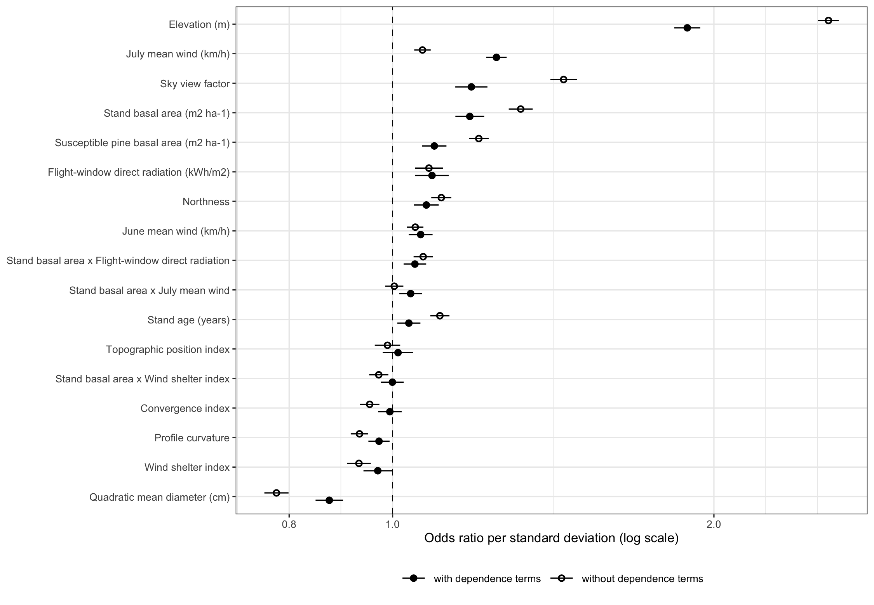
Figure 3: Odds ratios of the environmental terms of M3 per standard deviation, with 95 per cent confidence intervals, without the dependence terms over the nine years, open circles, and with them over the eight years with a previous map, filled circles. Terms are ordered by their odds ratio with the dependence terms, and the dashed line marks no effect.
Table 3: Geomorphon landform classes in M3, as log-odds against the reference class, slope, the most common class on the perimeter, over the nine years without the dependence terms and the eight years with them. Cells was the number of perimeter cells in each class and Attacked the share of those cells attacked over the nine annual maps. Ridge included the shoulder cells, counted with ridge, their neighbour on the geomorphon scale. Flat and pit did not occur on the perimeter, and a class of fewer than 30 cells was not estimated. * p ≤ 0.05, ** p ≤ 0.01, *** p ≤ 0.001, **** p ≤ 0.0001.
Landform | Cells | Attacked (%) | All years | With dependence
slope | 38,898 | 14.0 | reference | reference
spur | 11,796 | 18.2 | -0.011 | +0.080*
hollow | 8,751 | 12.3 | -0.028 | +0.057
valley | 1,609 | 10.7 | -0.210** | -0.002
ridge | 665 | 23.9 | -0.447**** | +0.038
peak | 32 | 41.7 | -0.268 | +0.063
footslope | 1 | 88.9 | not estimated | not estimated

3.2 Heat and terrain
In the flight window the late-morning surface temperature of north-facing ground was 21.4 °C against 24.8 °C on south-facing ground over 108 scenes, and it correlated -0.42 with northness and 0.02 with modelled flight-window radiation. With the measured temperature of the previous summer in place of radiation, northness entered at +0.258 (p < 0.001) and temperature at +0.560 (p < 0.001). The cloud-adjusted sun from r.sun entered the annual model at +0.063 (p = 0.003) and the microclima slope temperature at +0.129 (p = 0.001), and with the summer held at +0.037 (p = 0.089) and -0.462 (p < 0.001). The slope temperature correlated at 0.97 with the flight-window sun, and without the radiation terms it entered at +0.018 (p = 0.388) with the summer held. From the 1 m lidar terrain, roughness within the cell entered at -0.086 (p < 0.001), the share facing north at +0.028 (p = 0.036) and the spread of crown-scale position at +0.007 (p = 0.584).

3.3 Wind and density
Wind during flight lowered attack where the canopy was open and raised it where the canopy was closed (Figure S16). With the previous summer’s terrain wind at 90 m in the sixteen-day model, the speed itself could not be distinguished from zero, -0.014 (p = 0.271), but its interaction with crown closure was +0.071 (p < 0.001), so that its effect was -0.085 (p < 0.001) in stands one standard deviation below the mean crown closure and +0.056 (p = 0.003) one standard deviation above it, and -0.055 (p = 0.002) in stands of small trees. The terrain wind at 10 m gave the same pattern, an interaction with crown closure of +0.070 (p < 0.001). The station wind of the same period raised attack, +0.116 (p < 0.001), and the previous summer’s station wind, interpolated from the valley stations, did not interact with crown closure (p = 0.963).

3.4 Terrain wind
With the terrain wind of the previous summer in place of the station wind, attack rose after a windier summer in the annual models, at +0.077 (p < 0.001) per standard deviation of the corrected 90 m speed, more so with greater basal area, +0.057 (p < 0.001), and quadratic mean diameter, +0.046 (p < 0.001). The speed at 10 m entered at +0.077 (p < 0.001) and at 30 m at +0.012 (p = 0.387), and in the sixteen-day models at +0.040 (p < 0.001) and +0.015 (p = 0.195). The share of flight hours blowing upslope lowered attack in the sixteen-day model, -0.057 (p < 0.001), and could not be distinguished from zero in the annual model, -0.003 (p = 0.804). In the annual model the slope updraft entered at -0.029 (p = 0.050), and with the summer held at -0.015 (p = 0.314).
Convective lift of the previous summer raised attack in the annual model, +0.180 (p < 0.001), and lowered it in the sixteen-day model, -0.239 (p < 0.001). Read from the differences between cells within a summer, it lowered attack at both scales, -0.390 (p < 0.001) in the annual model and -0.121 (p < 0.001) in the sixteen-day model with the period held, and beside the 10 m speed and the upslope share at -0.402 (p < 0.001) and -0.360 (p < 0.001).

3.5 Shelter and lee
Ground sheltered from the afternoon wind had slightly more attack, as the third question predicted, but the effect depended on place, grain and the direction taken for the wind. The wind shelter index at the prevailing bearing, higher on slopes facing that wind, entered M3 at -0.073 (p < 0.001) and at -0.032 (p = 0.043) with the dependence terms, when its interaction with basal area was -0.000 (p = 0.971), but it changed sign under the spatial field, to +0.096 (p < 0.001), and lost significance at a 90 m grain. Sky view fell under the field from +0.369 to +0.037 (p = 0.285), and residual Moran’s I remained significant in every year, even with the field, at a median of 0.345. At the direction of the terrain wind the shelter index entered at -0.051 (p < 0.001) in the annual model and -0.064 (p < 0.001) in the sixteen-day model, so ground facing that wind had less attack at both scales. Among landforms, ridges had less attack than slopes, -0.447 (p < 0.001), as did valleys, -0.210 (p = 0.003), but with the dependence terms the ridge class entered at +0.038 (p = 0.697) and the valley class at -0.002 (p = 0.978) (Table 3). Where the modelled wind was pushed up the slope, attack fell, -0.103 (p < 0.001) in the sixteen-day model, and the fall was steepest on ridges and spurs, an interaction with topographic position of -0.029 (p < 0.001), and the share of cells attacked was highest on ground facing west (23 per cent) and lowest on ground facing south (10 per cent) (Figure 4).
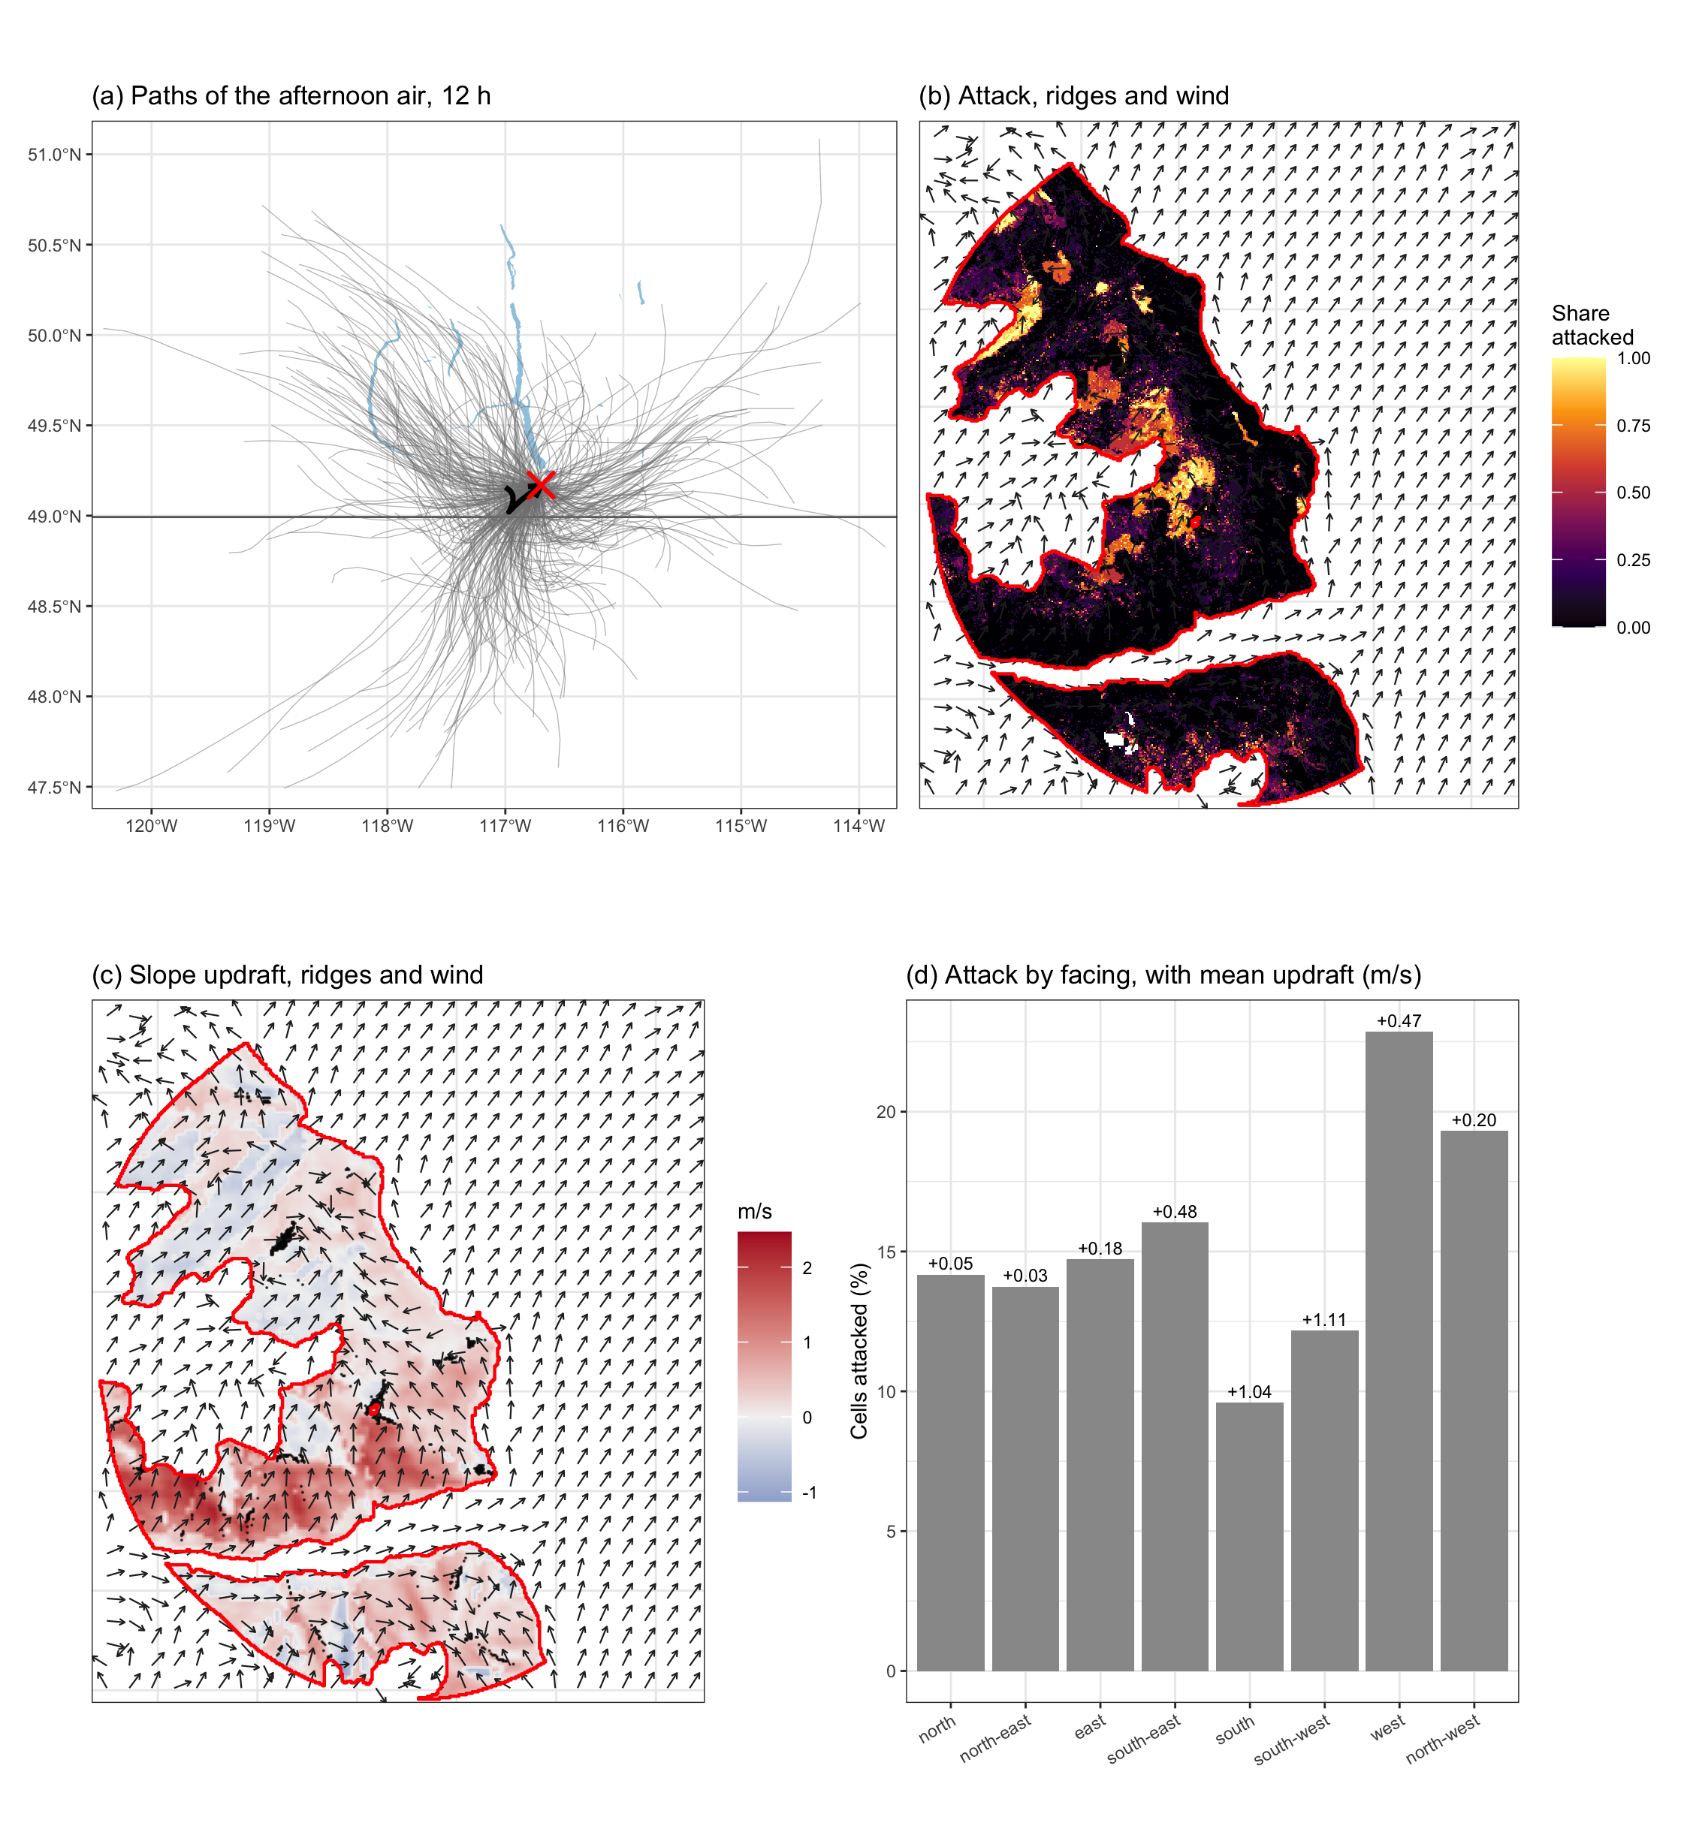
Figure 4: The afternoon air over the site and the attack it met, 1 July to 15 August. (a) HYSPLIT paths of the air over the 12 h before 14:00 on each flight day of 2005 to 2013, with the mean path in black. (b) The share of the annual maps of 2006 to 2014 on which each cell was attacked, with ridges in black and the modelled flight-hour wind as arrows. (c) The slope updraft of that wind, red where it rose and blue where it sank. (d) The share of cells attacked by the direction the ground faced, with the mean updraft above each bar. The red outline is the study perimeter.
The afternoon air’s endpoints lay over red attack of the same summer in a share of 0.019 over the flight windows, and that share in the previous summer raised attack in the annual model, +0.091 (p < 0.001), and the sixteen-day model, +0.074 (p < 0.001). The pressure, valley and ridge flatness, cold-air pooling, canopy height, winter minimum and upwind sources, and the maps of 2012, are reported in the Supporting Information.

4. Discussion

4.1 Host and contagion
Attack in a 30 m cell was predicted first by attack in and around it the year before, the order Aukema et al. (2008) followed on the Chilcotin Plateau, where temperature still “contributed to explaining outbreak probabilities” once neighbouring and earlier outbreaks were in the model (p. 348). Here the best neighbourhood was 150 m, close to the 140 m within which previous attack raised red attack above its background in Colorado (Walter & Platt, 2013), and the outbreak was already in the phase in which “almost all new mortality was associated with intensification of existing outbreaks, not expansion” (Meddens & Hicke, 2014, p. 83). The refugia mechanisms were therefore tested as modifiers of an outbreak that spread mostly by contagion, and few earlier studies had tested the three mechanisms that Krawchuk et al. (2020) proposed together on one landscape at 30 m with that dependence in the model.
Beside contagion, attack rose with the amount of host, the basis of the stand susceptibility rating used in British Columbia, which is built on “the percentage of susceptible pine by basal area”, pine age and stand density (Safranyik et al., 2010, p. 429; Shore et al., 2000), so the refugia this landscape showed were stands with little pine, as in thinning trials in which stands reduced in basal area lost fewer trees (Fettig et al., 2007; Hood et al., 2016; Mitchell et al., 1983). The amount of host is itself a product of forest history, because within climatically suitable areas “forest age-class structure will be the primary factor influencing host susceptibility and outbreak severity” (Taylor & Carroll, 2003, p. 42). Attack peaked in stands of 25 to 30 cm quadratic mean diameter, just above the 25 cm at which lodgepole pines change on average from beetle sinks to beetle sources (Carroll & Safranyik, 2004), because thicker phloem feeds more brood, from an average of 16 beetles to 94 as phloem thickened from 2.3 to 5.8 mm (Amman, 1972). Attack fell in stands of larger trees because those stands had little pine, not because the beetle avoided large trees (Shore et al., 2006), and epidemics also “often deplete the large diameter pine component of stands” (Shore et al., 2006, p. 110). Shading by terrain did not protect stands, since north-facing ground had more attack after host and elevation had entered. Elevation had the largest coefficient in every model, against the historical decline of mortality with elevation (Shore et al., 2006), but on this range the higher ground also had the pine, as in western Montana (Wulder et al., 2006), and milder winters after 1976 had favoured outbreaks (Macias Fauria & Johnson, 2009).

4.2 Wind and density
Wind lowered attack where the canopy was open and raised it where the canopy was closed, so the stand property through which wind acted was crown closure. That was the mechanism Bartos & Amman (1989) proposed in the Uinta Mountains of Utah, where a thinned stand was windier than the unthinned stand beside it by 3.2 km/h or more in the late afternoon and, in a recently thinned stand, “canopy density usually is insufficient to trap the pheromone and move it horizontally to attract other beetles” (p. 9), and a tracer gas released in place of pheromone was diluted fastest in the most open of three canopies (Thistle et al., 2004). The effect appeared with the terrain wind over sixteen-day periods and not with the station wind interpolated from the valleys, and in the annual models wind raised attack, more so where basal area was greater. Wind above the canopy carries beetles into new stands (Chen & Jackson, 2017; Jackson et al., 2008), which predicts more attack with wind where large hosts stand under a closed canopy, and under epidemic pressure pheromones from attacked trees nearby “may override the positive benefits of increased spacing and improved tree growth derived from partial cutting” (Schmid & Mata, 2005, p. 9).

4.3 Ridges and lee
The afternoon air reached the site from the south-west, from 193 to 256 degrees, and the least attack fell on the faces that met it, 10 per cent of cells on south-facing and 12 per cent on south-west-facing ground against 23 per cent on west-facing and 19 per cent on north-west-facing ground. This was the reverse of most studies of aspect, in which attack favoured southern slopes (Nelson et al., 2007; Walter & Platt, 2013), and of the Peace River region, where beetles “tend to accumulate on windward sides of barriers” (de la Giroday et al., 2011, p. 1107). Beetles released by Safranyik et al. (1989) “climbed towards the tree tops, and usually tracked to the north or northeast, generally crosswind and downwind” (p. 508), and “bark beetles do not fly in winds that exceed their maximum flight speed” (Carroll & Safranyik, 2004, pp. 22–23). These observations suggest that the afternoon wind lifted beetles up the south and south-west faces, carried them over the ridges and set them down on the north and west faces beyond, where the wind slackened. That would explain the least attack on south-facing ground and the fall in attack with slope updraft that was steepest on ridges and spurs, and it matches the reading Kunegel-Lion & Lewis (2020) gave of a north-facing onset in the Cypress Hills, where “the dominant winds in Cypress Hills come from the south-west” (p. 9). The south-west faces also took the most afternoon sun, and the heaviest attacks on a bole are “usually found on the northern aspect” (Safranyik & Carroll, 2006, p. 18), while in the Black Hills “The decreased number of attacks during midday coincides with the period of highest mean temperatures” (Schmid et al., 1991, p. 1445), but within a summer the modelled slope temperature no longer predicted attack once the sun was removed, so exposure to the wind was the term that remained.
Deposition also depends on the stand, since in simulations of beetles flying through forest, dispersal downwind shortened as trunks became denser (Byers, 2000). Convective lift and the heat of each slope pointed the same way. Lift raised attack after summers of stronger convection, but within a summer the slopes over which the air rose fastest had less attack, as the slope updraft did, although within a summer lift followed the sun on each slope and the two could not be separated. North-facing ground was about 3.4 °C cooler at the surface in the late morning, yet measured surface temperature raised attack beside northness and strengthened the northness effect, so the north-facing pattern was not a preference for cool ground. At the scale of single trees, rough ground within a cell had less attack and the north-facing share of a cell more, the same direction as aspect at 30 m, so the pattern held below the grain of the maps, although these terms improved the fit little.
The shelter index taken at one fixed bearing was small, was lost at a 90 m grain and changed sign under the spatial field, so it described where attack clustered as much as a property of the slope, and a refugium defined at 30 m and one defined at 1 km were different things, the concern for scale that Aukema et al. (2008) raised. No study has compared beetles landing on the windward and lee faces of the same ridge, and the test of this hypothesis is a record of wind and of landing beetles on the slopes themselves.

4.4 Limits and management
The response was classified rather than observed, and the classifier’s accuracy measured its separation of the field plots from undisturbed forest rather than agreement with ground mortality across the landscape (Meddens et al., 2013). The inventory postdated part of the outbreak, the terrain wind took its direction from the reanalysis and gave about half the speed measured on the valley floor, and the study covered one mountain range over nine outbreak years. For management, the refugia this landscape showed were stands with little host, the structure that thinning and a younger age structure produce, which terrain maps alone could not locate. Partial cutting substantially lowers the susceptibility of lodgepole pine stands (Mata et al., 2003; Shore et al., 2000), but in ponderosa pine it “may be ineffective for partially cut parcels of <10 acres if the partially cut stands are surrounded by unmanaged susceptible stands” (Schmid & Mata, 2005), which the dominance of attack nearby supported, and Six et al. (2014) found the field evidence that thinning protects stands during an outbreak weaker than policy had assumed.

References
Ainslie, B., & Jackson, P. L. (2010). Investigation into mountain pine beetle above-canopy dispersion using weather radar and an atmospheric dispersion model. Aerobiologia, 27, 51–65. https://doi.org/10.1007/s10453-010-9176-9
Amman, G. D. (1972). Mountain pine beetle brood production in relation to thickness of lodgepole pine phloem. Journal of Economic Entomology, 65(1), 138–140. https://doi.org/10.1093/jee/65.1.138
Amman, G. D., McGregor, M. D., Schmitz, R. F., & Oakes, R. D. (1988). Susceptibility of lodgepole pine to infestation by mountain pine beetles following partial cutting of stands. Canadian Journal of Forest Research, 18(6), 688–695. https://doi.org/10.1139/x88-105
Aukema, B. H., Carroll, A. L., Zheng, Y., Zhu, J., Raffa, K. F., Moore, R. D., Stahl, K., & Taylor, S. W. (2008). Movement of outbreak populations of mountain pine beetle: Influences of spatiotemporal patterns and climate. Ecography, 31(3), 348–358. https://doi.org/10.1111/j.0906-7590.2007.05453.x
Bartos, D. L., & Amman, G. D. (1989). Microclimate: An alternative to tree vigor as a basis for mountain pine beetle infestations (Research Paper INT-400). U.S. Department of Agriculture, Forest Service, Intermountain Research Station. https://doi.org/10.2737/int-rp-400
Boone, C. K., Aukema, B. H., Bohlmann, J., Carroll, A. L., & Raffa, K. F. (2011). Efficacy of tree defense physiology varies with bark beetle population density: A basis for positive feedback in eruptive species. Canadian Journal of Forest Research, 41(6), 1174–1188. https://doi.org/10.1139/x11-041
Brush, M., & Lewis, M. A. (2024). Mountain pine beetle spread in forests with varying host resistance. bioRxiv preprint, 20 January 2024. https://doi.org/10.1101/2024.01.17.575462
Byers, J. A. (2000). Wind-aided dispersal of simulated bark beetles flying through forests. Ecological Modelling, 125(2-3), 231–243. https://doi.org/10.1016/S0304-3800(99)00187-8
Carroll, A. L., & Safranyik, L. (2004). The bionomics of the mountain pine beetle in lodgepole pine forests: Establishing a context. In T. L. Shore, J. E. Brooks, & J. E. Stone (Eds.), Mountain pine beetle symposium: Challenges and solutions, October 30–31, 2003, Kelowna, British Columbia (pp. 21–32). Natural Resources Canada, Canadian Forest Service, Pacific Forestry Centre.
Cartwright, J. M. (2018). Landscape topoedaphic features create refugia from drought and insect disturbance in a lodgepole and whitebark pine forest. Forests, 9(11), 715. https://doi.org/10.3390/f9110715
Chapman, T. B., Veblen, T. T., & Schoennagel, T. (2012). Spatiotemporal patterns of mountain pine beetle activity in the southern rocky mountains. Ecology, 93(10), 2175–2185. https://doi.org/10.1890/11-1055.1
Chen, H., & Jackson, P. L. (2017). Climatic conditions for emergence and flight of mountain pine beetle: Implications for long-distance dispersal. Canadian Journal of Forest Research, 47(7), 974–984. https://doi.org/10.1139/cjfr-2016-0510
Cooke, B., Chubaty, A., & Carroll, A. (2026). The mountain pine beetle in a marginal boreal landscape: Cross-scale collapse triggered by population removal. Forest Ecology and Management, 609, 123645.
de la Giroday, H.-M. C., Carroll, A. L., Lindgren, B. S., & Aukema, B. H. (2011). Incoming! Association of landscape features with dispersing mountain pine beetle populations during a range expansion event in western Canada. Landscape Ecology, 26(8), 1097–1110. https://doi.org/10.1007/s10980-011-9628-9
Deardorff, J. W. (1970). Convective velocity and temperature scales for the unstable planetary boundary layer and for rayleigh convection. Journal of the Atmospheric Sciences, 27, 1211–1213. https://doi.org/10.1175/1520-0469(1970)027<1211:cvatsf>2.0.co;2
Fettig, C. J., Klepzig, K. D., Billings, R. F., Munson, A. S., Nebeker, T. E., Negrón, J. F., & Nowak, J. T. (2007). The effectiveness of vegetation management practices for prevention and control of bark beetle infestations in coniferous forests of the western and southern united states. Forest Ecology and Management, 238(1-3), 24–53. https://doi.org/10.1016/j.foreco.2006.10.011
Forthofer, J. M., Butler, B. W., & Wagenbrenner, N. S. (2014). A comparison of three approaches for simulating fine-scale surface winds in support of wildland fire management. Part i. Model formulation and comparison against measurements. International Journal of Wildland Fire, 23, 969–981. https://doi.org/10.1071/WF12089
Friedman, J., Hastie, T., & Tibshirani, R. (2010). Regularization paths for generalized linear models via coordinate descent. Journal of Statistical Software, 33(1). https://doi.org/10.18637/jss.v033.i01
Gallant, J. C., & Dowling, T. I. (2003). A multiresolution index of valley bottom flatness for mapping depositional areas. Water Resources Research, 39(12). https://doi.org/10.1029/2002WR001426
Giroday, H. C. de la, Carroll, A. L., & Aukema, B. H. (2012). Breach of the northern Rocky Mountain geoclimatic barrier: Initiation of range expansion by the mountain pine beetle. Journal of Biogeography, 39(6), 1112–1123. https://doi.org/10.1111/j.1365-2699.2011.02673.x
Gray, B., Billings, R. F., Gara, R. I., & Johnsey, R. L. (1972). On the emergence and initial flight behaviour of the mountain pine beetle, Dendroctonus ponderosae, in eastern Washington. Zeitschrift für Angewandte Entomologie, 71, 250–259. https://doi.org/10.1111/j.1439-0418.1972.tb01745.x
Hersbach, H., Bell, B., Berrisford, P., Hirahara, S., Horányi, A., Muñoz‐Sabater, J., Nicolas, J., Peubey, C., Radu, R., Schepers, D., Simmons, A., Soci, C., Abdalla, S., Abellan, X., Balsamo, G., Bechtold, P., Biavati, G., Bidlot, J., Bonavita, M., … Thépaut, J. (2020). The ERA5 global reanalysis. Quarterly Journal of the Royal Meteorological Society, 146, 1999–2049. https://doi.org/10.1002/qj.3803
Hood, S. M., Baker, S., & Sala, A. (2016). Fortifying the forest: Thinning and burning increase resistance to a bark beetle outbreak and promote forest resilience. Ecological Applications, 26(7), 1984–2000. https://doi.org/10.1002/eap.1363
Hynum, B. G., & Berryman, A. A. (1980). Dendroctonus ponderosae (Coleoptera: Scolytidae): Pre-aggregation landing and gallery initiation on lodgepole pine. The Canadian Entomologist, 112(2), 185–191. https://doi.org/10.4039/Ent112185-2
Jackson, P. L., Straussfogel, D., Lindgren, B. S., Mitchell, S., & Murphy, B. (2008). Radar observation and aerial capture of mountain pine beetle, Dendroctonus ponderosae Hopk. (Coleoptera: Scolytidae) in flight above the forest canopy. Canadian Journal of Forest Research, 38(8), 2313–2327. https://doi.org/10.1139/X08-066
Jin, S., & Sader, S. A. (2005). Comparison of time series tasseled cap wetness and the normalized difference moisture index in detecting forest disturbances. Remote Sensing of Environment, 94(3), 364–372. https://doi.org/10.1016/j.rse.2004.10.012
Krawchuk, M. A., Meigs, G. W., Cartwright, J. M., Coop, J. D., Davis, R., Holz, A., Kolden, C., & Meddens, A. J. H. (2020). Disturbance refugia within mosaics of forest fire, drought, and insect outbreaks. Frontiers in Ecology and the Environment, 18(5), 235–244. https://doi.org/10.1002/fee.2190
Kunegel-Lion, M., & Lewis, M. A. (2020). Factors governing outbreak dynamics in a forest intensively managed for mountain pine beetle. Scientific Reports, 10(1). https://doi.org/10.1038/s41598-020-63388-8
Legendre, P., & Fortin, M.-J. (1989). Spatial pattern and ecological analysis. Vegetatio, 80(2), 107–138. https://doi.org/10.1007/BF00048036
Liston, G. E., & Elder, K. (2006). A meteorological distribution system for high-resolution terrestrial modeling (MicroMet). Journal of Hydrometeorology, 7(2), 217–234. https://doi.org/10.1175/JHM486.1
Logan, J. A., & Powell, J. A. (2001). Ghost forests, global warming, and the mountain pine beetle (Coleoptera: Scolytidae). American Entomologist, 47(3), 160–173. https://doi.org/10.1093/ae/47.3.160
Macias Fauria, M., & Johnson, E. A. (2009). Large-scale climatic patterns and area affected by mountain pine beetle in British Columbia, Canada. Journal of Geophysical Research: Biogeosciences, 114(G1), G01012. https://doi.org/10.1029/2008JG000760
Maclean, I. M. D., Mosedale, J. R., & Bennie, J. J. (2019). Microclima: An R package for modelling meso- and microclimate. Methods in Ecology and Evolution, 10(2), 280–290. https://doi.org/10.1111/2041-210X.13093
Mata, S. A., Schmid, J. M., & Olsen, W. K. (2003). Growth of lodgepole pine stands and its relation to mountain pine beetle susceptibility (Research Paper RMRS-RP-42). U.S. Department of Agriculture, Forest Service, Rocky Mountain Research Station. https://doi.org/10.2737/RMRS-RP-42
McCambridge, W. F. (1971). Temperature limits of flight of the mountain pine beetle, Dendroctonus ponderosae. Annals of the Entomological Society of America, 64(2), 534–535. https://doi.org/10.1093/aesa/64.2.534
McCune, B., & Keon, D. (2002). Equations for potential annual direct incident radiation and heat load. Journal of Vegetation Science, 13(4), 603–606. https://doi.org/10.1111/j.1654-1103.2002.tb02087.x
Meddens, A. J. H., & Hicke, J. A. (2014). Spatial and temporal patterns of Landsat-based detection of tree mortality caused by a mountain pine beetle outbreak in Colorado, USA. Forest Ecology and Management, 322, 78–88. https://doi.org/10.1016/j.foreco.2014.02.037
Meddens, A. J. H., Hicke, J. A., Vierling, L. A., & Hudak, A. T. (2013). Evaluating methods to detect bark beetle-caused tree mortality using single-date and multi-date Landsat imagery. Remote Sensing of Environment, 132, 49–58. https://doi.org/10.1016/j.rse.2013.01.002
Mesinger, F., DiMego, G., Kalnay, E., Mitchell, K., Shafran, P. C., Ebisuzaki, W., Jović, D., Woollen, J., Rogers, E., Berbery, E. H., Ek, M. B., Fan, Y., Grumbine, R., Higgins, W., Li, H., Lin, Y., Manikin, G., Parrish, D., & Shi, W. (2006). North american regional reanalysis. Bulletin of the American Meteorological Society, 87(3), 343–360. https://doi.org/10.1175/BAMS-87-3-343
Mitchell, R. G., Waring, R. H., & Pitman, G. B. (1983). Thinning lodgepole pine increases tree vigor and resistance to mountain pine beetle. Forest Science, 29(1), 204–211. https://doi.org/10.1093/forestscience/29.1.204
Moran, P. A. P. (1948). The interpretation of statistical maps. Journal of the Royal Statistical Society Series B: Statistical Methodology, 10(2), 243–251. https://doi.org/10.1111/j.2517-6161.1948.tb00012.x
Moran, P. A. P. (1950). Notes on continuous stochastic phenomena. Biometrika, 37(1-2), 17–23. https://doi.org/10.1093/biomet/37.1-2.17
Muñoz-Sabater, J., Dutra, E., Agustí-Panareda, A., Albergel, C., Arduini, G., Balsamo, G., Boussetta, S., Choulga, M., Harrigan, S., Hersbach, H., Martens, B., Miralles, D. G., Piles, M., Rodríguez-Fernández, N. J., Zsoter, E., Buontempo, C., & Thépaut, J.-N. (2021). ERA5-land: A state-of-the-art global reanalysis dataset for land applications. Earth System Science Data, 13, 4349–4383. https://doi.org/10.5194/essd-13-4349-2021
Murphy, S., Leslie, A., Wilson, J., & Banks, L. K. (2026). Spatial patterns of conifer regeneration following mountain pine beetle outbreak (Dendroctonus ponderosae) and mixed-severity wildfire: A point process model of disturbance interactions in the southern Selkirk Mountains, British Columbia. Forest Ecology and Management, 618, 123985. https://doi.org/10.1016/j.foreco.2026.123985
Natural Resources Canada. (2017). High resolution digital elevation model (HRDEM) – CanElevation series. https://open.canada.ca/data/en/dataset/957782bf-847c-4644-a757-e383c0057995
Nelson, T. A., Boots, B., Wulder, M. A., & Carroll, A. L. (2007). Environmental characteristics of mountain pine beetle infestation hot spots. Journal of Ecosystems and Management. https://doi.org/10.22230/jem.2007v8n1a367
Plattner, C., Braun, L. N., & Brenning, A. (2004). Spatial variability of snow accumulation on Vernagtferner, Austrian Alps, in winter 2003/2004. Zeitschrift für Gletscherkunde Und Glazialgeologie, 39, 43–57.
Preisler, H. K., Hicke, J. A., Ager, A. A., & Hayes, J. L. (2012). Climate and weather influences on spatial temporal patterns of mountain pine beetle populations in washington and oregon. Ecology, 93(11), 2421–2434. https://doi.org/10.1890/11-1412.1
Raffa, K. F., Aukema, B. H., Bentz, B. J., Carroll, A. L., Hicke, J. A., Turner, M. G., & Romme, W. H. (2008). Cross-scale drivers of natural disturbances prone to anthropogenic amplification: The dynamics of bark beetle eruptions. BioScience, 58(6), 501–517. https://doi.org/10.1641/b580607
Raffa, K. F., & Berryman, A. A. (1983). The role of host plant resistance in the colonization behavior and ecology of bark beetles (Coleoptera: Scolytidae). Ecological Monographs, 53(1), 27–49. https://doi.org/10.2307/1942586
Robertson, C., Nelson, T. A., & Boots, B. (2007). Mountain pine beetle dispersal: The spatial–temporal interaction of infestations. Forest Science, 53(3), 395–405. https://doi.org/10.1093/forestscience/53.3.395
Roy, D. P., Kovalskyy, V., Zhang, H. K., Vermote, E. F., Yan, L., Kumar, S. S., & Egorov, A. (2016). Characterization of Landsat-7 to Landsat-8 reflective wavelength and normalized difference vegetation index continuity. Remote Sensing of Environment, 185, 57–70. https://doi.org/10.1016/j.rse.2015.12.024
Sadiq, A., Sulong, G., & Edwar, L. (2016). Recovering defective landsat 7 enhanced thematic mapper plus images via multiple linear regression model. IET Computer Vision, 10(8), 788–797.
Safranyik, L., & Carroll, A. L. (2006). The biology and epidemiology of the mountain pine beetle in lodgepole pine forests. In L. Safranyik & B. Wilson (Eds.), The mountain pine beetle: A synthesis of biology, management, and impacts on lodgepole pine (pp. 3–66). Natural Resources Canada, Canadian Forest Service, Pacific Forestry Centre.
Safranyik, L., Carroll, A. L., Régnière, J., Langor, D. W., Riel, W. G., Shore, T. L., Peter, B., Cooke, B. J., Nealis, V. G., & Taylor, S. W. (2010). Potential for range expansion of mountain pine beetle into the boreal forest of North America. The Canadian Entomologist, 142(5), 415–442. https://doi.org/10.4039/n08-CPA01
Safranyik, L., Linton, D. A., Silversides, R., & McMullen, L. H. (1992). Dispersal of released mountain pine beetles under the canopy of a mature lodgepole pine stand. Journal of Applied Entomology, 113(1-5), 441–450. https://doi.org/10.1111/j.1439-0418.1992.tb00687.x
Safranyik, L., Silversides, R., McMullen, L. H., & Linton, D. A. (1989). An empirical approach to modeling the local dispersal of the mountain pine beetle (Dendroctonus ponderosae Hopk.) (Col., Scolytidae) in relation to sources of attraction, wind direction and speed. Journal of Applied Entomology, 108(1-5), 498–511. https://doi.org/10.1111/j.1439-0418.1989.tb00484.x
Schmid, J. M., & Mata, S. A. (2005). Mountain pine beetle-caused tree mortality in partially cut plots surrounded by unmanaged stands (Research Paper RMRS-RP-54). U.S. Department of Agriculture, Forest Service, Rocky Mountain Research Station. https://doi.org/10.2737/RMRS-RP-54
Schmid, J. M., Mata, S. A., & Schmidt, R. A. (1991). Bark temperature patterns in ponderosa pine stands and their possible effects on mountain pine beetle behavior. Canadian Journal of Forest Research, 21(10), 1439–1446. https://doi.org/10.1139/x91-203
Shore, T. L., Safranyik, L., Hawkes, B. C., & Taylor, S. W. (2006). Effects of the mountain pine beetle on lodgepole pine stand structure and dynamics. In L. Safranyik & B. Wilson (Eds.), The mountain pine beetle: A synthesis of biology, management, and impacts on lodgepole pine (pp. 95–114). Natural Resources Canada, Canadian Forest Service, Pacific Forestry Centre.
Shore, T. L., Safranyik, L., & Lemieux, J. P. (2000). Susceptibility of lodgepole pine stands to the mountain pine beetle: Testing of a rating system. Canadian Journal of Forest Research, 30(1), 44–49. https://doi.org/10.1139/x99-182
Six, D., Biber, E., & Long, E. (2014). Management for mountain pine beetle outbreak suppression: Does relevant science support current policy? Forests, 5(1), 103–133. https://doi.org/10.3390/f5010103
Stein, A. F., Draxler, R. R., Rolph, G. D., Stunder, B. J. B., Cohen, M. D., & Ngan, F. (2015). NOAA’s HYSPLIT atmospheric transport and dispersion modeling system. Bulletin of the American Meteorological Society, 96, 2059–2077. https://doi.org/10.1175/BAMS-D-14-00110.1
Šúri, M., & Hofierka, J. (2004). A new GIS-based solar radiation model and its application to photovoltaic assessments. Transactions in GIS, 8(2), 175–190. https://doi.org/10.1111/j.1467-9671.2004.00174.x
Taylor, S. W., & Carroll, A. L. (2003). Disturbance, forest age, and mountain pine beetle outbreak dynamics in BC: A historical perspective. In Mountain pine beetle symposium: Challenges and solutions, October 30–31, 2003, Kelowna, British Columbia (pp. 41–51). Natural Resources Canada, Canadian Forest Service, Pacific Forestry Centre.
Thistle, H. W., Peterson, H., Allwine, G., Lamb, B., Strand, T., Holsten, E. H., & Shea, P. J. (2004). Surrogate pheromone plumes in three forest trunk spaces: Composite statistics and case studies. Forest Science, 50(5), 610–625. https://doi.org/10.1093/forestscience/50.5.610
Walter, J. A., & Platt, R. V. (2013). Multi-temporal analysis reveals that predictors of mountain pine beetle infestation change during outbreak cycles. Forest Ecology and Management, 302, 308–318. https://doi.org/10.1016/j.foreco.2013.03.038
Wood, S. N. (2017). Generalized additive models: An introduction with R (2nd ed.). Chapman; Hall/CRC. https://doi.org/10.1201/9781315370279
Wulder, M. A., White, J. C., Bentz, B., Alvarez, M. F., & Coops, N. C. (2006). Estimating the probability of mountain pine beetle red-attack damage. Remote Sensing of Environment, 101, 150–166. https://doi.org/10.1016/j.rse.2005.12.010
Wulder, M. A., White, J. C., Masek, J. G., Dwyer, J., & Roy, D. P. (2011). Continuity of landsat observations: Short term considerations. Remote Sensing of Environment, 115(2), 747–751.
Zou, H., & Hastie, T. (2005). Regularization and variable selection via the elastic net. Journal of the Royal Statistical Society Series B: Statistical Methodology, 67(2), 301–320. https://doi.org/10.1111/j.1467-9868.2005.00503.x

