Testing the wind disruption and disturbance refugia hypothesis for mountain pine beetle outbreaks (Dendroctonus ponderosae)
Terrain, stand density and flight-period wind as controls on attack in the Selkirk Mountains of British Columbia
Seamus Murphy
2026-09-30
Running title. Terrain, wind and mountain pine beetle refugia
Correspondence. Seamus Murphy, TÜV SÜD, 2187 Comox Ave, Comox, British Columbia V9M 1P5, Canada. seamusrobertmurphy@gmail.com. ORCID 0000-0002-1792-0351.
Keywords. Mountain pine beetle, Disturbance refugia, Curculionidae, Scolytinae, British Columbia, thinning, dispersal, topography
Data availability statement. Public datasets were used in this analysis. Beetle disturbance was classified from Landsat Collection 2 Level-2 surface reflectance, stand structure was derived from British Columbia’s provincial Vegetation Resources Inventory, terrain from the Natural Resources Canada High Resolution Digital Elevation Model (Natural Resources Canada, 2017) and wind from Environment and Climate Change Canada hourly station records. All derived data and the complete analysis code that reproduce every number, table and figure in this article are at https://github.com/seamusrobertmurphy/beetle-topography-and-wind-study and will be deposited in the Dryad Digital Repository, with a DOI, with the revised manuscript. The study’s classifier was trained on the 28 field plots of beetle-killed basal area established in July and August 2020 in the Darkwoods Conservation Area by Murphy, Leslie, Wilson and Banks (Murphy et al., 2026), whose plot locations, killed-basal-area measurements and Landsat classifications of red-stage mortality were used with the permission of those authors; that study and its co-authors, Adrian Leslie, John Wilson and Lauren K. Banks, are acknowledged as the source of the ground truth on which every attack map in this article rests.
Conflict of interest statement. The author has no conflict of interest to declare. The author was the lead author of the earlier study on the same ground (Murphy et al., 2026), and the field plots on which the classifier in this article was trained were collected under that study with its co-authors, Adrian Leslie, John Wilson and Lauren K. Banks. Those data are used here with their agreement, there is no dispute over the ownership of any data presented, and every contribution to the present article has been attributed by authorship or acknowledgement.
Author contributions. Seamus Murphy conceived and designed the present study, assembled the datasets, wrote the analysis code, performed the analysis, prepared the figures and tables, and wrote and revised the manuscript, which is every CRediT role. The 28 field plots of beetle-killed basal area and the Landsat classifications of red-stage mortality were produced under the earlier study by Murphy, Leslie, Wilson and Banks (2026), and the co-authors of that study contributed to the field data collection and the ground-truthing that this article reuses but took no part in the design, analysis or writing of the present article.

Abstract
- Disturbance refugia from mountain pine beetle (Dendroctonus ponderosae) outbreaks have been proposed in thin stands of small trees, on shaded ground and where wind disrupts the aggregation pheromone, but little is known about how these mechanisms act together once attack nearby and earlier is taken into account.
- This study mapped red-stage attack in eight outbreak years and 47 sixteen-day Landsat periods across 5,573 ha of the Selkirk Mountains, British Columbia, with a classifier validated on field plots, and modelled it on annual forest inventory, terrain and a terrain-resolved wind field, entering the previous year’s attack first.
- Attack was clustered in every year, with positive spatial autocorrelation to a median of 2,610 m, and attack in and around a cell the year before dominated every model.
- Beside those terms attack rose with stand basal area (+0.183 log-odds per standard deviation, p < 0.001) and peaked in stands of 25 to 30 cm mean diameter, and north-facing ground had more attack rather than less. Flight-hour wind did not lower attack where stems were fewer, and the effects of terrain shelter and openness did not survive a latent spatial field.
- Refugia on this landscape were stands with little host, and terrain and wind added small, scale-dependent modifiers to an outbreak whose spread was mostly contagion.

1. Introduction
Mountain pine beetle (Dendroctonus ponderosae Hopkins [Coleoptera: Curculionidae: Scolytinae]) has impacted more lodgepole pine (Pinus contorta Douglas ex Loudon) stands across British Columbia than any other disturbance event on record (Cooke et al., 2026; Sambaraju & Goodsman, 2021; Taylor & Carroll, 2003; Woo et al., 2024). The outbreak was eruptive, reaching epidemic numbers only when abundant susceptible hosts, high beetle density and favourable weather coincided, after which positive feedbacks spread attack from single trees to whole landscapes (Boone et al., 2011; Raffa et al., 2008). Both host and climate had changed before it began, since a decline in the area burned by wildfire had raised the share of the province’s pine forest in age classes susceptible to the beetle from about 17 per cent in the early 1900s to about 55 per cent (Shore et al., 2006; Taylor & Carroll, 2003), and warmer winters had reduced the extremely low temperatures that killed overwintering brood (Bentz et al., 2010; Macias Fauria & Johnson, 2009; Sambaraju et al., 2012).
Studies of host selection found that the first beetles to arrive in a stand, the pioneers, landed at random and by sight and then judged the host by tasting compounds in its bark (Hynum & Berryman, 1980; Safranyik et al., 2010). A pioneer female boring into the bark converted the host compound α-pinene into the aggregation pheromone trans-verbenol, which with other host volatiles drew a mass attack that was normally completed on a single tree within one to two days (Safranyik & Carroll, 2006). Mass attack overwhelmed the resin defences of healthy trees, which otherwise slowed attacking beetles and could expel them (Jarvis & Kulakowski, 2015; Raffa & Berryman, 1983; Safranyik & Carroll, 2006), and the efficacy of those defences declined as beetle density rose, which was the basis of positive feedback in an eruption (Boone et al., 2011). Populations therefore passed from an endemic phase, confined largely to weakened and injured trees, to an epidemic phase once they had enough individuals to overcome the defences of large, healthy trees, a transition that followed drought, several generations of favourable weather or immigration from another area (Jarvis & Kulakowski, 2015; Kunegel-Lion & Lewis, 2020; Shore et al., 2006).
Research indicates that the British Columbia outbreak spread east from the west-central interior, with further eruptions recorded in disjunct areas of the south (Aukema et al., 2006), and that outbreaking populations nearby in the same and the previous years were the best predictor of where new outbreaks appeared (Aukema et al., 2008). Dispersal studies suggest that most beetles attacked trees within a few hundred metres of the trees they emerged from, flying below the crowns and turning upwind on meeting an attractive odour plume (Carroll & Safranyik, 2004; Safranyik et al., 1989; Safranyik et al., 1992), so that infested spots grew outward from one generation to the next (Chen & Walton, 2011; Kunegel-Lion & Lewis, 2020), while only a small proportion, 0.2 per cent of the marked beetles in one release, rose above the canopy (Safranyik et al., 1992), where wind transported beetles into new stands and across the northern Rocky Mountains (Chen & Jackson, 2017; Giroday et al., 2012; Robertson et al., 2007). Landscape studies in the western United States and Canada tested the effects of weather, terrain, stand structure and previous attack on where infestations occurred (Chapman et al., 2012; Kunegel-Lion & Lewis, 2020; Preisler et al., 2012; Simard et al., 2011), and they suggest that infestation in the neighbourhood the previous year was the most important single predictor (Kunegel-Lion & Lewis, 2020), while the importance of forest susceptibility, dispersal and host availability changed as an outbreak developed (Walter & Platt, 2013). Terrain entered those studies mainly as elevation, slope and aspect, and Wulder et al. (2006) found that the odds of red-attack damage, meaning trees whose needles had turned red in the year after they were attacked, rose with elevation in their study area because lodgepole pine grew at higher elevations, along ridge tops, than the Douglas-fir around it.
Temperature set the timing and survival of each generation, in that late larval instars, the stage that normally overwintered under the bark, had higher thresholds for development than early instars, which kept a brood from reaching cold-susceptible stages before winter (Carroll & Safranyik, 2004), and temperature synchronised development so that enough adults emerged together to mass attack (Aukema et al., 2006). Larvae acquired cold tolerance from glycerol that accumulated through autumn and withstood temperatures near minus 40 degrees C in midwinter, whereas cold early or late in winter caused significant mortality, and thick bark and deep snow insulated a brood (Carroll & Safranyik, 2004; Safranyik & Carroll, 2006). Where heat accumulation was too low for a one-year life cycle, as on cool high ground, broods took two years, overwintered twice and suffered severe mortality, and adult emergence and dispersal were prolonged (Logan & Powell, 2001; Safranyik & Carroll, 2006), while drought in the same years lowered the resistance of the host (Meddens & Hicke, 2014; Shore et al., 2006; Taylor & Carroll, 2003). Terrain altered each of these through the sun a slope received, and hot spots, clusters of intense infestation, were typically found on warmer south- and west-facing slopes in the early years of an infestation in British Columbia (Nelson et al., 2007), so this study entered radiation during the flight window and over the growing season as well as aspect.
Krawchuk et al. (2020) defined disturbance refugia as “locations that are disturbed less severely or less frequently than other areas within the surrounding landscape” (p. 235), and Cartwright (2018), who mapped refugia at 30 m from anomalies in the normalised difference moisture index during a severe outbreak of this beetle in southern Oregon, found them “associated with topographically shaded slopes, convergent environments such as valleys, areas of relatively low soil bulk density, and in thinner forest stands” (p. 1). Krawchuk et al. (2020) also noted that “few studies have explicitly identified refugia from insect outbreaks” (p. 238) and proposed that refugia from this beetle could occur “in areas with cooler temperatures (eg from topographic shading) that protect trees from water stress; in areas with lower host density, allowing for greater wind disruption of beetle pheromone communication and more vigorous tree growth and chemical defenses; and in areas with fewer large-diameter host trees” (p. 239). The third mechanism rested on the finding that lodgepole pine trees of 25 cm or less in diameter were beetle sinks, in which more beetles attacked than emerged (Carroll & Safranyik, 2004), and the second on the thinning trials, in which thinned lodgepole and ponderosa pine stands lost fewer trees to the beetle (Amman et al., 1988; Fettig et al., 2007; Hood et al., 2016; Mitchell et al., 1983). Waring & Pitman (1985) attributed that effect to the vigour of released trees, whereas Bartos & Amman (1989) attributed it to microclimate, having measured more wind and light in a thinned stand that caught 5 per cent of the beetles trapped in the two stands and lost 2 per cent of its trees against 16 per cent, and a tracer standing in for pheromone diluted fastest in the most open of three canopies (Thistle et al., 2004), while within stands the probability of attack rose with stocking and tree size (Anhold & Jenkins, 1987; Negrón & Popp, 2004).
Wind could lower attack through what Krawchuk et al. (2020) called “wind disruption of beetle pheromone communication” (p. 239), acting on an aggregation already under way, which predicted an interaction between stand density and wind, or concentrate attack through deposition, acting before any host was chosen, which predicted a main effect of terrain shelter. Landing beetles “were unable to distinguish between hosts, dead hosts and nonhosts during landing” (Hynum & Berryman, 1980), and de la Giroday et al. (2011) found that landscape features “provide impactive surfaces for interception of insects” and that settlement rose “in areas where wind speed is reduced”, the pattern of deposition that the wind shelter index of Plattner et al. (2004) was built to predict for snow. Both routes concerned the wind during flight, which was bounded between 19 and 41 degrees C, peaked in the early to mid afternoon and did not occur in winds above about 2 metres per second, the beetle’s maximum flight speed (Bleiker & Van Hezewijk, 2016; Carroll & Safranyik, 2004; McCambridge, 1971; Safranyik & Carroll, 2006), and both had to be read beside the dependence of attack on attack nearby the year before (Aukema et al., 2008; Walter & Platt, 2013).
This study grew out of a study of conifer regeneration after the 2015 Mt Midgeley fire on the same ground (Murphy et al., 2026), whose 28 field plots of beetle-killed basal area, 30 m Landsat grid and perimeter it used, and in which terrain ruggedness was the largest terrain effect on seedling intensity, a coefficient of +0.626 (p < 0.001), without showing which property of the terrain the beetle responded to. Refugia from this beetle had been tested on transects at alpine treeline (Maher et al., 2021), a machine-learning model of the Alberta outbreak entered wind as a July to August mean of daily station speeds (Ramazi et al., 2021), and models of flight above the canopy resolved the wind over terrain without the stand beneath it (Ainslie & Jackson, 2010; Jackson et al., 2008). This study mapped red-stage attack at 30 m in the Selkirk Mountains once a year, to test the refugia mechanisms against stand structure, terrain and radiation, and every sixteen days, to test wind with a terrain-resolved flight-hour wind field, and read every environmental term beside attack nearby in the previous year or period. The study addressed three questions. Do stand density, topographic shading and the scarcity of large hosts predict red-stage attack once attack nearby and earlier is in the model? Does flight-period wind act on attack through stand density, the form plume disruption takes? Does terrain shelter act as a main effect, as deposition predicts, or only through stand density, as plume disruption predicts?

2. Methods
The literature in the Introduction was assembled under a written protocol, frozen before the first search, from two indexes, the author’s reading store and one round of citation chasing, which returned 1,257 unique records, of which 198 were retained and 35 read in full.

2.1 Site terrain
The study area covered 5,573 ha of the Selkirk Mountains in southeastern British Columbia, 61,923 cells of 30 m from 830 to 1,744 m in elevation, on the grid of Murphy et al. (2026) so that the results compared directly with theirs. It was centred on their site, the 2015 Mt Midgeley fire, and extended beyond its 480 ha of burned area by a 5 km buffer cut to the elevation band of that site, which took in the range of stand density the pheromone mechanism needed while keeping the added ground comparable. Attack was mapped once a year for the questions on refugia and every sixteen days for the wind test, the inventory once a year, the station winds every hour and the terrain once (Table S1).
Stand structure came from the provincial Vegetation Resources Inventory, taking for each study year the snapshot the province published for that year, rasterised to the 30 m grid (Table 1). The attributes were basal area, crown closure, live stems per hectare, quadratic mean diameter of stems of 12.5 cm and larger, stand age, stand height, standing volume and susceptible pine basal area, the product of basal area and pine cover. The 2007 snapshot omitted basal area and live stems, so the 2006 snapshot stood in for it. The inventory is a projection rather than a census, and polygons interpreted from late-outbreak photography described stands the beetle had already attacked.
Terrain surfaces were computed with SAGA GIS over an elevation model extending beyond the perimeter, so that search radii near the edge fell on measured ground. They separated the ruggedness index of Murphy et al. (2026) into the properties the beetle’s biology points to, with ruggedness kept as a candidate so that the separation was tested rather than assumed. Exposure entered as the windward-leeward index, effective air flow height, the wind exposition index and the wind shelter index of Plattner et al. (2004), “the maximum gradient within a given radius in upwind direction”, together with topographic openness and sky view. Shape entered as ruggedness, topographic position, convergence, slope, curvature and geomorphon class, and landform as wetness, valley depth and height above the valley floor, because infested groups are reported in draws and gullies and deep snow insulates overwintering brood (Kautz et al., 2023; Safranyik & Carroll, 2006). Aspect entered as northness, eastness and the heat load index of McCune & Keon (2002). Radiation was computed twice, because flight and shading depend on different quantities, once over the flight window of 1 July to 15 August from 12:00 to 17:00 and once over the whole growing season from 1 May to 30 September, the quantity the shading mechanism of Krawchuk et al. (2020) concerns. The first varied 15-fold across the ground and the second 2.9-fold. Temperature differences between slopes at the same elevation were represented by these radiation surfaces and by northness rather than modelled, since Running et al. (1987) found that closed forest canopies “may exhibit virtually no slope related differences in surface temperature when the surface is an actively transpiring canopy” (p. 475). The variables that entered the models are listed with their mechanisms in Table S3.
Figure 1 near here
Table 1 near here

2.2 Beetle outbreak
The response for the first and third questions was red-stage attack in each of eight outbreak years, 2006 to 2011, 2013 and 2014, excluding 2012, when Landsat 7 was the only sensor and its scan-line corrector had failed. The index and baseline followed Murphy et al. (2026), who mapped red-stage mortality on this ground as the fall in the normalised difference moisture index (NDMI), an index used to detect forest disturbance in Landsat time series (Jin & Sader, 2005), against 2005, and validated the map against 28 field plots of 20 by 20 m in which beetle-killed pine was confirmed from pitch tubes, frass and gallery architecture. Each annual image was the median of the cloud-masked Collection 2 Level-2 scenes from 1 June to 31 August, from Landsat 5 for 2005 to 2011 and Landsat 8 for 2013 and 2014, the Landsat 8 years adjusted by the band-pass coefficients of Roy et al. (2016) and then matched to the Landsat 5 range over forest that showed no attack. Each year was mapped on its own with lakes and rivers masked, and attack covered from 9.9 to 20.7 per cent of the perimeter by year (Table S2, Figure 2).
The response for the second question was red-stage attack in each sixteen-day period, the Landsat revisit interval, from 1 May to 22 September of the same years, NDMI being the median of the scenes in each period differenced against the same period of 2005 so that the seasonal course of leaf moisture did not enter the difference. Periods in which the imagery saw less than a tenth of the perimeter were dropped, which left 47 periods over eight years.
The fall in NDMI that counted as attack was set by a classifier trained on the four pixels nearest the centre of each field plot, 112 pixels, against the 84 points of undisturbed forest that Murphy et al. (2026) digitised on the 2020 Landsat 8 scene, which fell in 68 distinct cells. Each pixel entered with its deepest annual fall in NDMI against 2005. Random forest, a radial support vector machine and gradient boosting were compared over 100 random splits, each holding out a quarter of the field plots and of the 100 m blocks of undisturbed pixels, so that neighbouring pixels never fell on both sides of a split. The radial support vector machine classified most accurately, with kappa 0.859 ± 0.081 (95 per cent interval 0.682 to 1.000) and overall accuracy 0.934 ± 0.037, the three models differing by less than one standard deviation of the splits (Table 2). Its prediction changed class at a fall in NDMI of 0.0616 against 2005, and that cut was applied to the annual and the sixteen-day differences. The undisturbed pixels came from one patch of about 230 by 455 m, so the cross-validation measured separation of the plots from that patch rather than from undisturbed forest across the landscape.
Wind was summarised over the flight hours of 12:00 to 17:00, following the flight period Safranyik & Carroll (2006) give for this region, where “peak flight is in the early to mid afternoon”, and the 11:00 to 14:00 emergence peak of Gray et al. (1972). In 236,079 hourly station records from May to September, 89.5 per cent of afternoon hours inside the flight window fell within the 19 to 41 degrees C flight range against 51.4 per cent outside it (Figure S1). Hourly speed and direction from Environment and Climate Change Canada stations within 150 km were combined as vector components and adjusted for terrain with the MicroMet model of Liston & Elder (2006), which weights each observation by the slope in the wind direction and the curvature of the ground. The adjustment depends on direction and not on speed, so it was computed once for each of 16 sectors of 22.5 degrees over an elevation model extending beyond the perimeter, with a curvature length scale of 600 m. Each period was summarised by its mean flight-hour wind and its share of flight hours below 5 km/h. Mean flight-hour wind ran from 4.0 to 8.6 km/h between periods and varied by up to 5.1 km/h across the grid within a period. The annual models took the same terrain-adjusted wind over the flight hours of 1 July to 15 August of each year, 230 hours from 6 to 9 stations a year, and the mean station wind of June and of July, interpolated to the grid by inverse distance weighting, as the wind that varied between years.
Figure 2 near here

2.3 Model design
The spatial pattern of attack was described on each annual map before any model was fitted, following Aukema et al. (2008), who treated attack as its presence or absence in the cells of a grid. The join count (Moran, 1948) was the number of pairs of attacked cells that were neighbours, counting the eight cells around each, and Moran’s I (Moran, 1950) was computed in distance classes of 60 m out to 6 km as a correlogram (Legendre & Fortin, 1989). Both were compared with 999 random relabellings of the attacked cells among the cells mapped that year, and the range of positive autocorrelation was the first distance class at which Moran’s I no longer exceeded the relabellings at p ≤ 0.05.
The annual models were built in the order of Aukema et al. (2008), who “determined an appropriate spatial neighborhood structure(s) and time lag(s) to account for spatial and temporal dependencies” before any environmental variable entered. The dependence terms were the cell’s own state in the previous outbreak year, 2011 in the case of 2013, and the share of cells attacked around it that year within 42, 90, 150, 210, 510 or 1,050 m, excluding the cell itself, the radius being chosen on AIC (Table 3). Each year contributed up to 4,000 attacked and 4,000 unattacked cells, because at a landscape prevalence near one cell in ten an unbalanced fit would report its intercept rather than its covariates.
The environmental terms were 14 variables grouped by the mechanism each represented (Table S3). Four logistic regressions were fitted in sequence, each adding one mechanism to the one before, M0 host size, shading and landform, M1 stand density as basal area, M2 terrain exposure to wind, terrain shape and flight-window direct radiation, and M3 the interactions of basal area with the wind shelter index, July wind and flight-window radiation. Every model carried the geomorphon class of the cell, and every continuous term was standardised, so that a coefficient was a change in log-odds per standard deviation. The sequence was fitted on all eight years without the dependence terms, and then on the seven years with a previous map, without and with them, so that the change each environmental term underwent once attack nearby and earlier entered could be read directly. The third question compared the main effect of the wind shelter index with its interaction with basal area, in M3 fitted with and without flight-window radiation. Each interaction was read as the slope of one term at one standard deviation either side of the mean of the other. Attack was also tabulated by quadratic mean diameter class, with Wilson intervals, a chi-square test across classes and a two-proportion test across the 25 cm source-sink boundary (Carroll & Safranyik, 2004).
The second question was tested on the sixteen-day maps, where wind varied between periods within a season as well as between years. Attack in a period was regressed on 15 stand and terrain variables, mean flight-hour wind, the geomorphon class and the interactions of wind with live stems and with standing volume, first alone (E1), then with the cell’s own state in the previous period and the share attacked within 90 m around it (E2), and then with the same two terms for the same period of the previous year (E3), the radii being chosen on AIC as for the annual models. Each period contributed up to 2,000 cells of each class.
Three checks tested the scale of the inference. Moran’s I of the deviance residuals was computed within each year on the eight nearest sampled cells for every annual model. M3 with the dependence terms was refitted with a Gaussian process smooth of easting and northing (Wood, 2017), a latent spatial field of the kind the Cox process model of Murphy et al. (2026) carried, with its Matérn range set to the median range of positive autocorrelation, 2,610 m. M3 was also refitted with the cell coarsened to 90, 270 and 990 m, a coarse cell counting as attacked if any 30 m cell inside it was, the definition Aukema et al. (2008) used on their 12 km cells, with the previous year’s state and the share of the eight neighbouring cells rebuilt at each grain.

3. Results
Attack was clustered in every year, with 3.2 to 5.3 times as many pairs of neighbouring attacked cells as random relabelling produced and positive autocorrelation to a median of 2,610 m (Figure 3). The previous year’s attack in the cell and within 150 m, the best of six radii (Table 3), dominated every model it entered, a cell attacked the year before having 7.6 times the odds of attack, and the two terms raised the AUC of M3 from 0.805 to 0.879.

3.1 Refugia mechanisms
Stand density was supported through the amount of host, host size acted as a threshold, and shading was not supported. Each step of the model sequence lowered AIC, most when basal area entered, by 459 (Table 4). Basal area entered M3 at +0.290 log-odds per standard deviation (p < 0.001) and remained positive with the dependence terms, +0.183, and under the spatial field, +0.181, as did susceptible pine basal area, whereas stand age could not be told from zero under the field (p = 0.157) (Table 5). Attack depended on quadratic mean diameter class [χ²(5) = 715.1, p < 0.001, Cramér’s V = 0.106], peaking in the 25 to 30 cm class at 55.8 per cent of the balanced sample against 48.2 per cent at 20 to 25 cm and falling in the larger classes, whose stands held less pine (Table 6). North-facing ground had more attack, +0.112 (p < 0.001), and afternoon sun in the flight window raised attack in stands one standard deviation above the mean basal area, +0.145 (p < 0.001), and not in stands one standard deviation below it, +0.011 (p = 0.547).

3.2 Wind and density
Flight-hour wind did not lower attack where stems were fewer. In E1 the interaction of wind with live stems was -0.012 (p = 0.034), which meant attack rose with wind at 411 stems per hectare, +0.026 (p = 0.001), and not at 1,077, +0.002 (p = 0.847). With the previous period’s attack entered (E2) the interaction became +0.051 (p < 0.001) and wind raised attack at both densities (Figure 4). The interaction of wind with standing volume could not be told from zero in either model (p = 0.642 and p = 0.296).

3.3 Terrain shelter
Leeward ground had slightly more attack, and once the previous year’s attack was in the model the effect did not depend on density. The wind shelter index, which rose on slopes facing the prevailing wind, entered M3 at -0.066 (p < 0.001) and at -0.040 (p = 0.016) with the dependence terms, when its interaction with basal area was -0.021 (p = 0.110), and sky view entered at +0.327 (p < 0.001). Both terrain terms depended on the grain and the place, since under the spatial field sky view fell to -0.009 (p = 0.799) and the shelter index changed sign to +0.082 (p < 0.001), and the shelter index lost significance at 90 m and sky view at 270 m, while basal area remained positive at 270 m, +0.094 (p = 0.037) (Figure 5). Residual Moran’s I remained significant in every year even with the spatial field, with a median of 0.337.

4. Discussion

4.1 Contagion first
Attack in a 30 m cell was predicted first by attack in and around it the year before, and every environmental term was read beside those terms rather than instead of them. That order was the one Aukema et al. (2008) argued for, having found that outbreaking populations within 18 km in the same year and within 6 km in the two years before explained more of the outbreak’s movement across British Columbia than climate did. The scale here was far finer and the pattern the same. The share attacked within 150 m the year before fitted better than any wider neighbourhood, close to the 140 m within which previous attack raised the rate of red attack above its background in Colorado (Walter & Platt, 2013), and it matched short-range dispersal, which “takes place under the forest canopy” and is “determined by the relative proximity of brood trees within individual stands” (Safranyik et al., 2010, p. 428). The outbreak was already epidemic in these years, and the dominance of the dependence terms fitted that phase. Walter & Platt (2013) found that distance to the previous year’s infestation “increased in importance relative to other predictors” as an outbreak progressed (p. 315), and Meddens & Hicke (2014) found that late in an outbreak “almost all new mortality was associated with intensification of existing outbreaks, not expansion” (p. 83). The dependence terms raised AUC from 0.805 to 0.879, whereas the whole environmental sequence from M0 to M3 raised it by 0.006, so the refugia mechanisms were tested as modifiers of an outbreak whose spread was mostly contagion.

4.2 Host and density
Attack rose with the amount of host, through basal area, susceptible pine basal area and stand age, which are the variables of the stand susceptibility rating used in British Columbia, built on “the percentage of susceptible pine by basal area”, pine age and stand density together with climate (Safranyik et al., 2010, p. 429; Shore et al., 2000). Stands with little host were therefore the refugia this landscape showed, in agreement with the thinning trials in which stands reduced in basal area lost fewer trees (Amman et al., 1988; Fettig et al., 2007; Hood et al., 2016; Mitchell et al., 1983). The amount of host is itself a product of forest history. Taylor & Carroll (2003) concluded that within climatically suitable areas “forest age-class structure will be the primary factor influencing host susceptibility and outbreak severity” (p. 42), and the area of mature lodgepole pine in British Columbia had more than tripled over the century of fire control before the outbreak (Shore et al., 2006). Basal area here measured the amount of pine rather than crowding, because dense unmanaged stands have thinner phloem and “beetle production and subsequent tree mortality in dense, unmanaged stands tend to be less than in more open stands” (Shore et al., 2006, p. 103). Walter & Platt (2013) found red attack moving to less dense stands once an outbreak became epidemic, whereas here it rose with basal area in every model through to 2014.
Attack peaked in stands of 25 to 30 cm quadratic mean diameter. The peak sat at the source-sink boundary of Carroll & Safranyik (2004), above which stems produced enough brood to sustain a population, and brood production rose with phloem thickness from an average of 16 to 94 beetles in the range Amman (1972) tested. During epidemics the share of trees killed rises with diameter above about 10 cm (Shore et al., 2006), so the fall in attack in stands of larger trees did not reflect the beetle’s preference. It reflected composition, since stands of the largest trees here held little pine, and epidemics “often deplete the large diameter pine component of stands” (Shore et al., 2006, p. 110), after which smaller trees are attacked in later years (Meddens & Hicke, 2014).

4.3 Elevation and climate
Elevation carried the largest coefficient in every model, with more attack on higher ground. That ran against the historical pattern, in which mortality “tends to decline with elevation” because the cool climate of high ground slows development and lowers brood survival (Shore et al., 2006, p. 103), and in which cooler summers at high elevation stretch the life cycle over two years, with severe mortality (Safranyik & Carroll, 2006). Three readings fit the result. Host distribution was one, since where elevation entered an earlier model of red attack its sign followed the host’s distribution rather than the beetle’s preference (Wulder et al., 2006). Outbreak phase was another, since in Colorado red attack “moved from high elevations to in 2003 to low elevations in 2005 and 2006” (Walter & Platt, 2013, p. 316). The third was a warming climate, which in British Columbia favoured outbreaks “by reducing the occurrence of extremely low winter temperatures province-wide” (Macias Fauria & Johnson, 2009, p. 1) and made climates that had limited epidemics more favourable (Taylor & Carroll, 2003). The design could not separate the three, because on this range the higher ground also held the pine.

4.4 Aspect and sun
North-facing ground had more attack in every model, the reverse of both the shading mechanism of Krawchuk et al. (2020) and the association of red attack with southern aspects in Colorado (Walter & Platt, 2013), while where attack has been traced against aspect elsewhere it reached south-facing and drier ground first (Kaiser et al., 2012; Nelson et al., 2007). Aspect here more likely measured where lodgepole pine grew on this range than a thermal effect. Afternoon sun in the flight window raised attack only in dense stands, which fitted the biology of flight rather than of host stress. Within the thermal range for flight, “flight propensity increases with increasing light intensity” (Safranyik & Carroll, 2006, p. 15), and in the thinned stand of Bartos & Amman (1989), where more light reached the ground, pheromone traps caught 5 per cent of the beetles trapped in the two stands, which they explained by beetles sensing “the difference in light intensity or the greater air turbulence in thinned stands” and avoiding them (p. 9). Sun on a dense stand therefore helped flight without opening the canopy that holds the aggregation plume.

4.5 Wind and density
Flight-hour wind did not lower attack where stems were fewer. The interaction of stems with wind was small, where it could be read it meant more attack in windier periods among the stands with fewer stems, the reverse of plume disruption, and once attack in the previous period entered, wind raised attack at every density. The plume mechanism rests on measurements inside the canopy, where Bartos & Amman (1989) found a thinned stand windier than an unthinned one by about 1.6 km/h on average and by 3.2 km/h or more in the late afternoon, and argued that in a thinned stand the pheromone “rises through the canopy on convection currents and is dispersed above the canopy” (p. 9), while tracer plumes diluted fastest in the most open of three canopies (Thistle et al., 2004). A stand one standard deviation below the mean here held 411 stems per hectare, which was not the open canopy those trials created, and neither the inventory nor a terrain model of station wind could resolve a contrast at that scale. Under epidemic pressure the benefit of spacing may also be lost, since in ponderosa pine the influence of pheromones from attacked trees in adjacent unmanaged stands “may override the positive benefits of increased spacing and improved tree growth derived from partial cutting” (Schmid & Mata, 2005, p. 9). Wind above the canopy carries beetles into new stands (Chen & Jackson, 2017; Jackson et al., 2008; Safranyik et al., 2010), and Safranyik et al. (1989) found that “wind speed had negligible effect on the fit of the model for relative directional distribution of beetles” within a stand, both of which predict more attack with wind rather than less, the direction the models with dependence terms showed. The foliage of an attacked tree also stays green “usually until May and June of the year following attack” (Safranyik & Carroll, 2006, p. 11), so red crowns seen in a period recorded the flight of the previous summer.

4.6 Terrain and scale
Leeward ground had more attack than windward ground at the same elevation and stand structure, and once the previous year’s attack entered, the effect did not depend on density, which is the signature deposition predicts, since a beetle descending through slowing air settles where the flow decelerates (Byers, 2000) and de la Giroday et al. (2011) found landscape features that met the wind acting as surfaces that intercepted dispersing beetles. The effect was small, it was lost at 90 m, and under the spatial field it changed sign, as did the effect of open ground, so both terrain terms described where attack clustered on this range as much as a property of the slope. Pioneer beetles also land at random before choosing a host (Hynum & Berryman, 1980; Safranyik et al., 2010), which would weaken any deposition pattern. The environmental results depended on the scale at which they were read, the concern Aukema et al. (2008) raised in choosing 12 km cells. A latent spatial field removed the terrain terms while basal area, pine basal area, northness and flight-window radiation held, residual autocorrelation remained in every year so that the p-values in every model were optimistic, and basal area held to 270 m while at about 1 km nearly every cell held an attacked cell. Mortality accrues faster in small areas than across large ones (Meddens & Hicke, 2014), and the controls on red attack change through an outbreak “from forest susceptibility to dispersal to host availability” (Walter & Platt, 2013, p. 317), so a refugium defined at 30 m and one defined at 1 km were different objects, and this study supported the first mainly through the amount of host.

4.7 Limits and management
The response was classified rather than observed. The classifier separated the field plots from one patch of undisturbed forest, so its accuracy measured that separation and not agreement with ground mortality across the landscape. Landsat classifications of red stage elsewhere reached kappa of 0.86 to 0.88 against fine-resolution reference imagery (Meddens et al., 2013), and high spatial resolution imagery has been assessed for detecting red attack directly (Coops et al., 2006), which would give an independent test of these maps. The inventory postdated part of the outbreak, since polygons interpreted after the beetle passed described the stand it left. Temperature entered the models only through elevation, radiation and aspect, so development and overwinter survival were not measured directly. The study covered one mountain range over eight outbreak years.
For management the result gave a narrow answer. Refugia on this landscape were stands with little host, which is the structure thinning and a younger age structure produce, and terrain maps alone could not locate them. The rating system of Shore et al. (2000) places partially cut lodgepole pine stands in its low susceptibility class (Mata et al., 2003), and regularly spaced mature stands of at least 4 by 4 m may lose fewer trees (Shore et al., 2006). The dominance of attack nearby here agreed with the limits found in the field. In ponderosa pine, partial cutting “may be ineffective for partially cut parcels of <10 acres if the partially cut stands are surrounded by unmanaged susceptible stands” and stands “should be managed on a landscape basis” (Schmid & Mata, 2005), and the field evidence that thinning protects stands during an outbreak is weaker than policy has assumed (Six et al., 2014). This study found no evidence that flight-period wind strengthens that protection.

References
Ainslie, B., & Jackson, P. L. (2010). Investigation into mountain pine beetle above-canopy dispersion using weather radar and an atmospheric dispersion model. Aerobiologia, 27, 51–65. https://doi.org/10.1007/s10453-010-9176-9
Amman, G. D. (1972). Mountain pine beetle brood production in relation to thickness of lodgepole pine phloem. Journal of Economic Entomology, 65(1), 138–140. https://doi.org/10.1093/jee/65.1.138
Amman, G. D., McGregor, M. D., Schmitz, R. F., & Oakes, R. D. (1988). Susceptibility of lodgepole pine to infestation by mountain pine beetles following partial cutting of stands. Canadian Journal of Forest Research, 18(6), 688–695. https://doi.org/10.1139/x88-105
Anhold, J. A., & Jenkins, M. J. (1987). Potential mountain pine beetle (coleoptera: Scolytidae) attack of lodgepole pine as described by stand density index. Environmental Entomology, 16(3), 738–742. https://doi.org/10.1093/ee/16.3.738
Aukema, B. H., Carroll, A. L., Zheng, Y., Zhu, J., Raffa, K. F., Moore, R. D., Stahl, K., & Taylor, S. W. (2008). Movement of outbreak populations of mountain pine beetle: Influences of spatiotemporal patterns and climate. Ecography, 31(3), 348–358. https://doi.org/10.1111/j.0906-7590.2007.05453.x
Aukema, B. H., Carroll, A. L., Zhu, J., Raffa, K. F., Sickley, T. A., & Taylor, S. W. (2006). Landscape level analysis of mountain pine beetle in british columbia, canada: Spatiotemporal development and spatial synchrony within the present outbreak. Ecography, 29(3), 427–441. https://doi.org/10.1111/j.2006.0906-7590.04445.x
Bartos, D. L., & Amman, G. D. (1989). Microclimate: An alternative to tree vigor as a basis for mountain pine beetle infestations (Research Paper INT-400). U.S. Department of Agriculture, Forest Service, Intermountain Research Station. https://doi.org/10.2737/int-rp-400
Bentz, B. J., Régnière, J., Fettig, C. J., Hansen, E. M., Hayes, J. L., Hicke, J. A., Kelsey, R. G., Negrón, J. F., & Seybold, S. J. (2010). Climate change and bark beetles of the western united states and canada: Direct and indirect effects. BioScience, 60(8), 602–613. https://doi.org/10.1525/bio.2010.60.8.6
Bleiker, K. P., & Van Hezewijk, B. H. (2016). Flight period of mountain pine beetle (coleoptera: Curculionidae) in its recently expanded range. Environmental Entomology, 45(6), 1561–1567. https://doi.org/10.1093/ee/nvw121
Boone, C. K., Aukema, B. H., Bohlmann, J., Carroll, A. L., & Raffa, K. F. (2011). Efficacy of tree defense physiology varies with bark beetle population density: A basis for positive feedback in eruptive species. Canadian Journal of Forest Research, 41(6), 1174–1188. https://doi.org/10.1139/x11-041
Byers, J. A. (2000). Wind-aided dispersal of simulated bark beetles flying through forests. Ecological Modelling, 125(2-3), 231–243. https://doi.org/10.1016/S0304-3800(99)00187-8
Carroll, A. L., & Safranyik, L. (2004). The bionomics of the mountain pine beetle in lodgepole pine forests: Establishing a context. In T. L. Shore, J. E. Brooks, & J. E. Stone (Eds.), Mountain pine beetle symposium: Challenges and solutions, October 30–31, 2003, Kelowna, British Columbia (pp. 21–32). Natural Resources Canada, Canadian Forest Service, Pacific Forestry Centre.
Cartwright, J. M. (2018). Landscape topoedaphic features create refugia from drought and insect disturbance in a lodgepole and whitebark pine forest. Forests, 9(11), 715. https://doi.org/10.3390/f9110715
Chapman, T. B., Veblen, T. T., & Schoennagel, T. (2012). Spatiotemporal patterns of mountain pine beetle activity in the southern rocky mountains. Ecology, 93(10), 2175–2185. https://doi.org/10.1890/11-1055.1
Chen, H., & Jackson, P. L. (2017). Climatic conditions for emergence and flight of mountain pine beetle: Implications for long-distance dispersal. Canadian Journal of Forest Research, 47(7), 974–984. https://doi.org/10.1139/cjfr-2016-0510
Chen, H., & Walton, A. (2011). Mountain pine beetle dispersal: Spatiotemporal patterns and role in the spread and expansion of the present outbreak. Ecosphere, 2(6), art66. https://doi.org/10.1890/es10-00172.1
Cooke, B., Chubaty, A., & Carroll, A. (2026). The mountain pine beetle in a marginal boreal landscape: Cross-scale collapse triggered by population removal. Forest Ecology and Management, 609, 123645.
Coops, N. C., Johnson, M., Wulder, M. A., & White, J. C. (2006). Assessment of QuickBird high spatial resolution imagery to detect red attack damage due to mountain pine beetle infestation. Remote Sensing of Environment, 103(1), 67–80. https://doi.org/10.1016/j.rse.2006.03.012
de la Giroday, H.-M. C., Carroll, A. L., Lindgren, B. S., & Aukema, B. H. (2011). Incoming! Association of landscape features with dispersing mountain pine beetle populations during a range expansion event in western Canada. Landscape Ecology, 26(8), 1097–1110. https://doi.org/10.1007/s10980-011-9628-9
Fettig, C. J., Klepzig, K. D., Billings, R. F., Munson, A. S., Nebeker, T. E., Negrón, J. F., & Nowak, J. T. (2007). The effectiveness of vegetation management practices for prevention and control of bark beetle infestations in coniferous forests of the western and southern united states. Forest Ecology and Management, 238(1-3), 24–53. https://doi.org/10.1016/j.foreco.2006.10.011
Giroday, H. C. de la, Carroll, A. L., & Aukema, B. H. (2012). Breach of the northern Rocky Mountain geoclimatic barrier: Initiation of range expansion by the mountain pine beetle. Journal of Biogeography, 39(6), 1112–1123. https://doi.org/10.1111/j.1365-2699.2011.02673.x
Gray, B., Billings, R. F., Gara, R. I., & Johnsey, R. L. (1972). On the emergence and initial flight behaviour of the mountain pine beetle, Dendroctonus ponderosae, in eastern Washington. Zeitschrift für Angewandte Entomologie, 71, 250–259. https://doi.org/10.1111/j.1439-0418.1972.tb01745.x
Hood, S. M., Baker, S., & Sala, A. (2016). Fortifying the forest: Thinning and burning increase resistance to a bark beetle outbreak and promote forest resilience. Ecological Applications, 26(7), 1984–2000. https://doi.org/10.1002/eap.1363
Hynum, B. G., & Berryman, A. A. (1980). Dendroctonus ponderosae (Coleoptera: Scolytidae): Pre-aggregation landing and gallery initiation on lodgepole pine. The Canadian Entomologist, 112(2), 185–191. https://doi.org/10.4039/Ent112185-2
Jackson, P. L., Straussfogel, D., Lindgren, B. S., Mitchell, S., & Murphy, B. (2008). Radar observation and aerial capture of mountain pine beetle, Dendroctonus ponderosae Hopk. (Coleoptera: Scolytidae) in flight above the forest canopy. Canadian Journal of Forest Research, 38(8), 2313–2327. https://doi.org/10.1139/X08-066
Jarvis, D. S., & Kulakowski, D. (2015). Long-term history and synchrony of mountain pine beetle outbreaks in lodgepole pine forests. Journal of Biogeography. https://doi.org/10.1111/jbi.12489
Jin, S., & Sader, S. A. (2005). Comparison of time series tasseled cap wetness and the normalized difference moisture index in detecting forest disturbances. Remote Sensing of Environment, 94(3), 364–372. https://doi.org/10.1016/j.rse.2004.10.012
Kaiser, K. E., McGlynn, B. L., & Emanuel, R. E. (2012). Ecohydrology of an outbreak: Mountain pine beetle impacts trees in drier landscape positions first. Ecohydrology, 6(3), 444–454. https://doi.org/10.1002/eco.1286
Kautz, M., Peter, F. J., Harms, L., Kammen, S., & Delb, H. (2023). Patterns, drivers and detectability of infestation symptoms following attacks by the European spruce bark beetle. Journal of Pest Science, 96(1), 403–414. https://doi.org/10.1007/s10340-022-01490-8
Krawchuk, M. A., Meigs, G. W., Cartwright, J. M., Coop, J. D., Davis, R., Holz, A., Kolden, C., & Meddens, A. J. H. (2020). Disturbance refugia within mosaics of forest fire, drought, and insect outbreaks. Frontiers in Ecology and the Environment, 18(5), 235–244. https://doi.org/10.1002/fee.2190
Kunegel-Lion, M., & Lewis, M. A. (2020). Factors governing outbreak dynamics in a forest intensively managed for mountain pine beetle. Scientific Reports, 10(1). https://doi.org/10.1038/s41598-020-63388-8
Legendre, P., & Fortin, M.-J. (1989). Spatial pattern and ecological analysis. Vegetatio, 80(2), 107–138. https://doi.org/10.1007/BF00048036
Liston, G. E., & Elder, K. (2006). A meteorological distribution system for high-resolution terrestrial modeling (MicroMet). Journal of Hydrometeorology, 7(2), 217–234. https://doi.org/10.1175/JHM486.1
Logan, J. A., & Powell, J. A. (2001). Ghost forests, global warming, and the mountain pine beetle (Coleoptera: Scolytidae). American Entomologist, 47(3), 160–173. https://doi.org/10.1093/ae/47.3.160
Macias Fauria, M., & Johnson, E. A. (2009). Large-scale climatic patterns and area affected by mountain pine beetle in British Columbia, Canada. Journal of Geophysical Research: Biogeosciences, 114(G1), G01012. https://doi.org/10.1029/2008JG000760
Maher, C. T., Millar, C. I., Affleck, D. L. R., Keane, R. E., Sala, A., Tobalske, C., Larson, A. J., & Nelson, C. R. (2021). Alpine treeline ecotones are potential refugia for a montane pine species threatened by bark beetle outbreaks. Ecological Applications, 31(3), e02274. https://doi.org/10.1002/eap.2274
Mata, S. A., Schmid, J. M., & Olsen, W. K. (2003). Growth of lodgepole pine stands and its relation to mountain pine beetle susceptibility (Research Paper RMRS-RP-42). U.S. Department of Agriculture, Forest Service, Rocky Mountain Research Station. https://doi.org/10.2737/RMRS-RP-42
McCambridge, W. F. (1971). Temperature limits of flight of the mountain pine beetle, Dendroctonus ponderosae. Annals of the Entomological Society of America, 64(2), 534–535. https://doi.org/10.1093/aesa/64.2.534
McCune, B., & Keon, D. (2002). Equations for potential annual direct incident radiation and heat load. Journal of Vegetation Science, 13(4), 603–606. https://doi.org/10.1111/j.1654-1103.2002.tb02087.x
Meddens, A. J. H., & Hicke, J. A. (2014). Spatial and temporal patterns of Landsat-based detection of tree mortality caused by a mountain pine beetle outbreak in Colorado, USA. Forest Ecology and Management, 322, 78–88. https://doi.org/10.1016/j.foreco.2014.02.037
Meddens, A. J. H., Hicke, J. A., Vierling, L. A., & Hudak, A. T. (2013). Evaluating methods to detect bark beetle-caused tree mortality using single-date and multi-date Landsat imagery. Remote Sensing of Environment, 132, 49–58. https://doi.org/10.1016/j.rse.2013.01.002
Mitchell, R. G., Waring, R. H., & Pitman, G. B. (1983). Thinning lodgepole pine increases tree vigor and resistance to mountain pine beetle. Forest Science, 29(1), 204–211. https://doi.org/10.1093/forestscience/29.1.204
Moran, P. A. P. (1948). The interpretation of statistical maps. Journal of the Royal Statistical Society Series B: Statistical Methodology, 10(2), 243–251. https://doi.org/10.1111/j.2517-6161.1948.tb00012.x
Moran, P. A. P. (1950). Notes on continuous stochastic phenomena. Biometrika, 37(1-2), 17–23. https://doi.org/10.1093/biomet/37.1-2.17
Murphy, S., Leslie, A., Wilson, J., & Banks, L. K. (2026). Spatial patterns of conifer regeneration following mountain pine beetle outbreak (Dendroctonus ponderosae) and mixed-severity wildfire: A point process model of disturbance interactions in the southern Selkirk Mountains, British Columbia. Forest Ecology and Management, 618, 123985. https://doi.org/10.1016/j.foreco.2026.123985
Natural Resources Canada. (2017). High resolution digital elevation model (HRDEM) – CanElevation series. https://open.canada.ca/data/en/dataset/957782bf-847c-4644-a757-e383c0057995
Negrón, J. F., & Popp, J. B. (2004). Probability of ponderosa pine infestation by mountain pine beetle in the Colorado Front Range. Forest Ecology and Management, 191(1-3), 17–27. https://doi.org/10.1016/j.foreco.2003.10.026
Nelson, T. A., Boots, B., Wulder, M. A., & Carroll, A. L. (2007). Environmental characteristics of mountain pine beetle infestation hot spots. Journal of Ecosystems and Management. https://doi.org/10.22230/jem.2007v8n1a367
Plattner, C., Braun, L. N., & Brenning, A. (2004). Spatial variability of snow accumulation on Vernagtferner, Austrian Alps, in winter 2003/2004. Zeitschrift für Gletscherkunde Und Glazialgeologie, 39, 43–57.
Preisler, H. K., Hicke, J. A., Ager, A. A., & Hayes, J. L. (2012). Climate and weather influences on spatial temporal patterns of mountain pine beetle populations in washington and oregon. Ecology, 93(11), 2421–2434. https://doi.org/10.1890/11-1412.1
Raffa, K. F., Aukema, B. H., Bentz, B. J., Carroll, A. L., Hicke, J. A., Turner, M. G., & Romme, W. H. (2008). Cross-scale drivers of natural disturbances prone to anthropogenic amplification: The dynamics of bark beetle eruptions. BioScience, 58(6), 501–517. https://doi.org/10.1641/b580607
Raffa, K. F., & Berryman, A. A. (1983). The role of host plant resistance in the colonization behavior and ecology of bark beetles (Coleoptera: Scolytidae). Ecological Monographs, 53(1), 27–49. https://doi.org/10.2307/1942586
Ramazi, P., Kunegel‐Lion, M., Greiner, R., & Lewis, M. A. (2021). Predicting insect outbreaks using machine learning: A mountain pine beetle case study. Ecology and Evolution, 11(19), 13014–13028. https://doi.org/10.1002/ece3.7921
Robertson, C., Nelson, T. A., & Boots, B. (2007). Mountain pine beetle dispersal: The spatial–temporal interaction of infestations. Forest Science, 53(3), 395–405. https://doi.org/10.1093/forestscience/53.3.395
Roy, D. P., Kovalskyy, V., Zhang, H. K., Vermote, E. F., Yan, L., Kumar, S. S., & Egorov, A. (2016). Characterization of Landsat-7 to Landsat-8 reflective wavelength and normalized difference vegetation index continuity. Remote Sensing of Environment, 185, 57–70. https://doi.org/10.1016/j.rse.2015.12.024
Running, S. W., Nemani, R. R., & Hungerford, R. D. (1987). Extrapolation of synoptic meteorological data in mountainous terrain and its use for simulating forest evapotranspiration and photosynthesis. Canadian Journal of Forest Research, 17(6), 472–483. https://doi.org/10.1139/x87-081
Safranyik, L., & Carroll, A. L. (2006). The biology and epidemiology of the mountain pine beetle in lodgepole pine forests. In L. Safranyik & B. Wilson (Eds.), The mountain pine beetle: A synthesis of biology, management, and impacts on lodgepole pine (pp. 3–66). Natural Resources Canada, Canadian Forest Service, Pacific Forestry Centre.
Safranyik, L., Carroll, A. L., Régnière, J., Langor, D. W., Riel, W. G., Shore, T. L., Peter, B., Cooke, B. J., Nealis, V. G., & Taylor, S. W. (2010). Potential for range expansion of mountain pine beetle into the boreal forest of North America. The Canadian Entomologist, 142(5), 415–442. https://doi.org/10.4039/n08-CPA01
Safranyik, L., Linton, D. A., Silversides, R., & McMullen, L. H. (1992). Dispersal of released mountain pine beetles under the canopy of a mature lodgepole pine stand. Journal of Applied Entomology, 113(1-5), 441–450. https://doi.org/10.1111/j.1439-0418.1992.tb00687.x
Safranyik, L., Silversides, R., McMullen, L. H., & Linton, D. A. (1989). An empirical approach to modeling the local dispersal of the mountain pine beetle (Dendroctonus ponderosae Hopk.) (Col., Scolytidae) in relation to sources of attraction, wind direction and speed. Journal of Applied Entomology, 108(1-5), 498–511. https://doi.org/10.1111/j.1439-0418.1989.tb00484.x
Sambaraju, K. R., Carroll, A. L., Zhu, J., Stahl, K., Moore, R. D., & Aukema, B. H. (2012). Climate change could alter the distribution of mountain pine beetle outbreaks in western canada. Ecography, 35(3), 211–223. https://doi.org/10.1111/j.1600-0587.2011.06847.x
Sambaraju, K. R., & Goodsman, D. W. (2021). Mountain pine beetle: An example of a climate-driven eruptive insect impacting conifer forest ecosystems. CAB Reviews, 16(018). https://doi.org/10.1079/PAVSNNR202116018
Schmid, J. M., & Mata, S. A. (2005). Mountain pine beetle-caused tree mortality in partially cut plots surrounded by unmanaged stands (Research Paper RMRS-RP-54). U.S. Department of Agriculture, Forest Service, Rocky Mountain Research Station. https://doi.org/10.2737/RMRS-RP-54
Shore, T. L., Safranyik, L., Hawkes, B. C., & Taylor, S. W. (2006). Effects of the mountain pine beetle on lodgepole pine stand structure and dynamics. In L. Safranyik & B. Wilson (Eds.), The mountain pine beetle: A synthesis of biology, management, and impacts on lodgepole pine (pp. 95–114). Natural Resources Canada, Canadian Forest Service, Pacific Forestry Centre.
Shore, T. L., Safranyik, L., & Lemieux, J. P. (2000). Susceptibility of lodgepole pine stands to the mountain pine beetle: Testing of a rating system. Canadian Journal of Forest Research, 30(1), 44–49. https://doi.org/10.1139/x99-182
Simard, M., Powell, E. N., Raffa, K. F., & Turner, M. G. (2011). What explains landscape patterns of tree mortality caused by bark beetle outbreaks in greater yellowstone? Global Ecology and Biogeography, 21(5), 556–567. https://doi.org/10.1111/j.1466-8238.2011.00710.x
Six, D., Biber, E., & Long, E. (2014). Management for mountain pine beetle outbreak suppression: Does relevant science support current policy? Forests, 5(1), 103–133. https://doi.org/10.3390/f5010103
Taylor, S. W., & Carroll, A. L. (2003). Disturbance, forest age, and mountain pine beetle outbreak dynamics in BC: A historical perspective. In Mountain pine beetle symposium: Challenges and solutions, October 30–31, 2003, Kelowna, British Columbia (pp. 41–51). Natural Resources Canada, Canadian Forest Service, Pacific Forestry Centre.
Thistle, H. W., Peterson, H., Allwine, G., Lamb, B., Strand, T., Holsten, E. H., & Shea, P. J. (2004). Surrogate pheromone plumes in three forest trunk spaces: Composite statistics and case studies. Forest Science, 50(5), 610–625. https://doi.org/10.1093/forestscience/50.5.610
Walter, J. A., & Platt, R. V. (2013). Multi-temporal analysis reveals that predictors of mountain pine beetle infestation change during outbreak cycles. Forest Ecology and Management, 302, 308–318. https://doi.org/10.1016/j.foreco.2013.03.038
Waring, R. H., & Pitman, G. B. (1985). Modifying lodgepole pine stands to change susceptibility to mountain pine beetle attack. Ecology, 66(3), 889–897. https://doi.org/10.2307/1940551
Woo, H., Bone, C., Nadeem, K., & Taylor, S. W. (2024). Influence of mountain pine beetle outbreaks on large fires in british columbia. Ecosphere (Washington, D.C), 15(1), e4722. https://doi.org/https://doi.org/10.1002/ecs2.4722
Wood, S. N. (2017). Generalized additive models: An introduction with R (2nd ed.). Chapman; Hall/CRC. https://doi.org/10.1201/9781315370279
Wulder, M. A., White, J. C., Bentz, B., Alvarez, M. F., & Coops, N. C. (2006). Estimating the probability of mountain pine beetle red-attack damage. Remote Sensing of Environment, 101, 150–166. https://doi.org/10.1016/j.rse.2005.12.010

Acknowledgements
This work used no external funding. Beetle disturbance was classified from Landsat Collection 2 Level-2 surface reflectance distributed by the United States Geological Survey; stand structure from the British Columbia Data Catalogue; terrain from Natural Resources Canada; and wind from Environment and Climate Change Canada. The author thanks those agencies for maintaining the open archives the study rests on.

Tables
Table 1: Stand structure over the 64,000 sampled cell-years, from the annual Vegetation Resources Inventory snapshots. SD was the standard deviation, SE the standard error of the mean, and Skew and Kurt. the bias-corrected skewness and excess kurtosis.
Attribute | Mean | SD | SE | Median | Min | Max | Skew | Kurt.
Stand basal area (m² ha⁻¹) | 35.07 | 12.62 | 0.050 | 37.57 | 0.40 | 93.49 | -0.78 | +1.59
Crown closure (%) | 50.13 | 13.35 | 0.053 | 50.00 | 1.00 | 90.00 | -1.59 | +3.17
Live stems (n/ha) | 780.55 | 320.62 | 1.267 | 794.00 | 13.00 | 5257.00 | +1.09 | +14.40
Quadratic mean diameter (cm) | 26.43 | 6.14 | 0.024 | 26.06 | 13.55 | 78.78 | +1.08 | +2.50
Stand age (years) | 113.34 | 25.69 | 0.102 | 110.00 | 14.00 | 337.00 | +1.44 | +9.39
Stand height (m) | 26.19 | 5.99 | 0.024 | 26.28 | 7.00 | 42.30 | -0.09 | +0.42
Standing volume (m³ ha⁻¹) | 264.45 | 134.29 | 0.531 | 262.47 | 0.69 | 889.64 | +0.10 | -0.27
Lodgepole pine cover (%) | 23.56 | 27.02 | 0.107 | 17.40 | 0.00 | 100.00 | +1.12 | +0.38
Susceptible pine basal area (m² ha⁻¹) | 8.24 | 10.26 | 0.041 | 3.96 | 0.00 | 48.30 | +1.36 | +1.37

Table 2: Accuracy of the three red-stage classifiers over repeated random splits that held out a quarter of the field plots and of the 100 m blocks of undisturbed pixels, as mean and standard deviation with the 2.5th and 97.5th percentiles of the splits. The model with the highest mean kappa set the cut used on every map.
Model | Accuracy | Accuracy 95% | Kappa | Kappa 95% | Sensitivity | Specificity | Chosen
gradient boosting | 0.912 ± 0.049 | 0.820 to 1.000 | 0.810 ± 0.106 | 0.614 to 1.000 | 0.920 | 0.899
random forest | 0.898 ± 0.046 | 0.810 to 0.976 | 0.778 ± 0.099 | 0.585 to 0.948 | 0.925 | 0.854
radial support vector machine | 0.934 ± 0.037 | 0.859 to 1.000 | 0.859 ± 0.081 | 0.682 to 1.000 | 0.913 | 0.968 | yes

Table 3: Dependence terms compared on AIC over 55,963 sampled cell-years with a previous map. Own state was attack in the cell in the previous outbreak year, and the share was the proportion of cells attacked within the radius around it that year, excluding the cell. Delta AIC was the difference from the lowest.
Terms | k | AIC | Delta AIC
intercept | 1 | 77,583 | 24,284.1
intercept + own state | 2 | 57,386 | 4,087.3
intercept + own state + share within 42 m | 3 | 54,545 | 1,245.5
intercept + own state + share within 90 m | 3 | 53,434 | 134.9
intercept + own state + share within 150 m | 3 | 53,299 | 0.0
intercept + own state + share within 210 m | 3 | 53,392 | 93.3
intercept + own state + share within 510 m | 3 | 54,220 | 920.9
intercept + own state + share within 1050 m | 3 | 55,029 | 1,729.5

Table 4: The annual models, each adding one mechanism to the one before, over all eight years without the dependence terms and over the seven years with a previous map without and with them. M0 held host size, shading and landform, M1 added basal area, M2 terrain exposure, terrain shape and flight-window radiation, and M3 the interactions of basal area with wind shelter, July wind and flight-window radiation. AUC was the area under the receiver operating characteristic curve and Brier skill the reduction in mean squared error of the fitted probabilities against the base rate.
Years | Dependence | Model | n | AIC | AUC | Brier skill
2006 to 2014 | no | M0 | 64,000 | 70,228 | 0.795 | 0.268
2006 to 2014 | no | M1 | 64,000 | 69,769 | 0.799 | 0.274
2006 to 2014 | no | M2 | 64,000 | 69,652 | 0.800 | 0.275
2006 to 2014 | no | M3 | 64,000 | 69,556 | 0.801 | 0.277
2007 to 2014 | no | M0 | 55,963 | 61,035 | 0.799 | 0.274
2007 to 2014 | yes | M0 | 55,963 | 49,050 | 0.876 | 0.431
2007 to 2014 | no | M1 | 55,963 | 60,601 | 0.804 | 0.280
2007 to 2014 | yes | M1 | 55,963 | 48,904 | 0.876 | 0.434
2007 to 2014 | no | M2 | 55,963 | 60,493 | 0.805 | 0.282
2007 to 2014 | yes | M2 | 55,963 | 48,881 | 0.877 | 0.434
2007 to 2014 | no | M3 | 55,963 | 60,407 | 0.805 | 0.284
2007 to 2014 | yes | M3 | 55,963 | 48,534 | 0.879 | 0.439

Table 5: Coefficients of M3 over all eight years, with the dependence terms over the seven years with a previous map, and with a latent spatial field as well. Continuous terms were changes in log-odds per standard deviation and dependence terms per unit, and the geomorphon classes are not shown. Significance was marked * p ≤ 0.05, ** p ≤ 0.01, *** p ≤ 0.001, **** p ≤ 0.0001.
Term | All years | With dependence | With spatial field
Susceptible pine basal area (m² ha⁻¹) | +0.162**** | +0.094**** | +0.047**
Stand age (years) | +0.080**** | +0.029* | +0.022
Quadratic mean diameter (cm) | -0.228**** | -0.134**** | -0.060**
Sky view factor | +0.327**** | +0.161**** | -0.009
Northness | +0.112**** | +0.066**** | +0.171****
Elevation (m) | +0.934**** | +0.633**** | +1.164****
Stand basal area (m² ha⁻¹) | +0.290**** | +0.183**** | +0.181****
Wind shelter index | -0.066**** | -0.040* | +0.082***
Topographic position index | -0.005 | +0.018 | +0.051
Convergence index | -0.056**** | -0.029* | -0.015
Profile curvature | -0.070**** | -0.035** | -0.003
Flight-window direct radiation (kWh/m²) | +0.078**** | +0.085**** | +0.208****
July mean wind (km/h) | +0.034*** | +0.217**** | +0.192****
June mean wind (km/h) | +0.057**** | +0.042** | +0.035*
Attack in the same cell, previous year |  | +2.033**** | +2.129****
Attack within 150 m, previous year |  | +2.186**** | +0.827****
Stand basal area x Wind shelter index | -0.044**** | -0.021 | +0.009
Stand basal area x July mean wind | -0.014 | +0.022 | +0.013
Stand basal area x Flight-window direct radiation | +0.067**** | +0.054**** | -0.016

Table 6: Red-stage attack by quadratic mean diameter class on the balanced annual sample, with Wilson 95 per cent intervals and the mean susceptible pine and total basal area of each class. The 25 cm boundary was the source-sink threshold of the species’ bionomics. The sample held equal numbers of attacked and unattacked cells in each year, so the percentages compared classes and were not landscape rates.
QMD class (cm) | n | Attacked | Attacked (%) | 95% CI (%) | Pine BA (m² ha⁻¹) | BA (m² ha⁻¹)
<15 | 611 | 193 | 31.6 | 28.0 to 35.4 | 1.1 | 3.2
15-20 | 7,026 | 3,060 | 43.6 | 42.4 to 44.7 | 10.8 | 23.5
20-25 | 18,540 | 8,945 | 48.2 | 47.5 to 49.0 | 8.2 | 28.6
25-30 | 24,346 | 13,580 | 55.8 | 55.2 to 56.4 | 9.7 | 39.8
30-40 | 11,118 | 5,340 | 48.0 | 47.1 to 49.0 | 5.5 | 42.4
>40 | 2,359 | 882 | 37.4 | 35.5 to 39.4 | 0.4 | 45.2

Figures
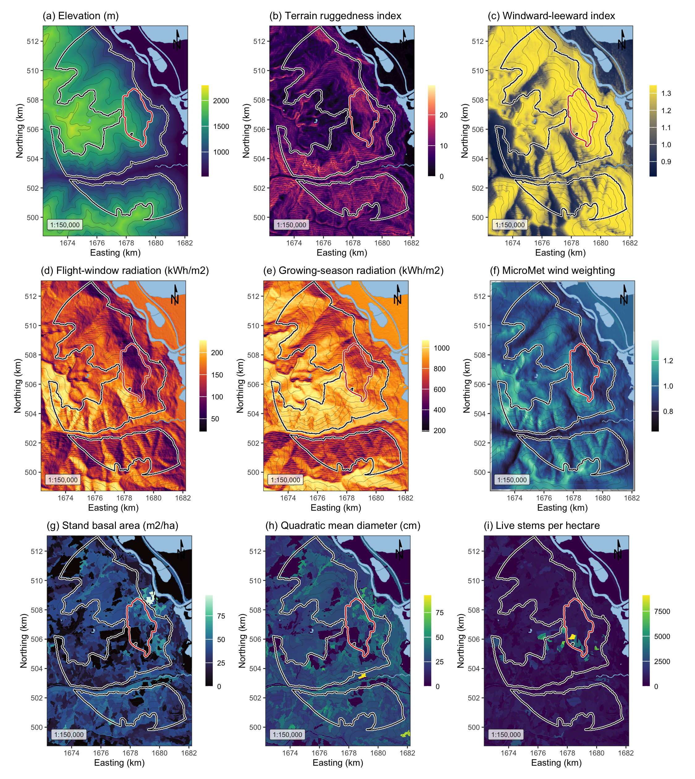
Figure 1: Landscape, terrain and stand surfaces across the study area, all EPSG:3153 at 30 m over Esri World Shaded Relief. (a) elevation; (b) terrain ruggedness index; (c) windward-leeward index at the prevailing bearing; (d) flight-window direct radiation; (e) growing-season direct radiation; (f) the MicroMet wind weighting factor at the prevailing bearing; (g) stand basal area; (h) quadratic mean diameter; (i) live stems per hectare. The white outline marked the study perimeter and the red outline the 2015 Mt Midgeley burn, with contours at 200 m.

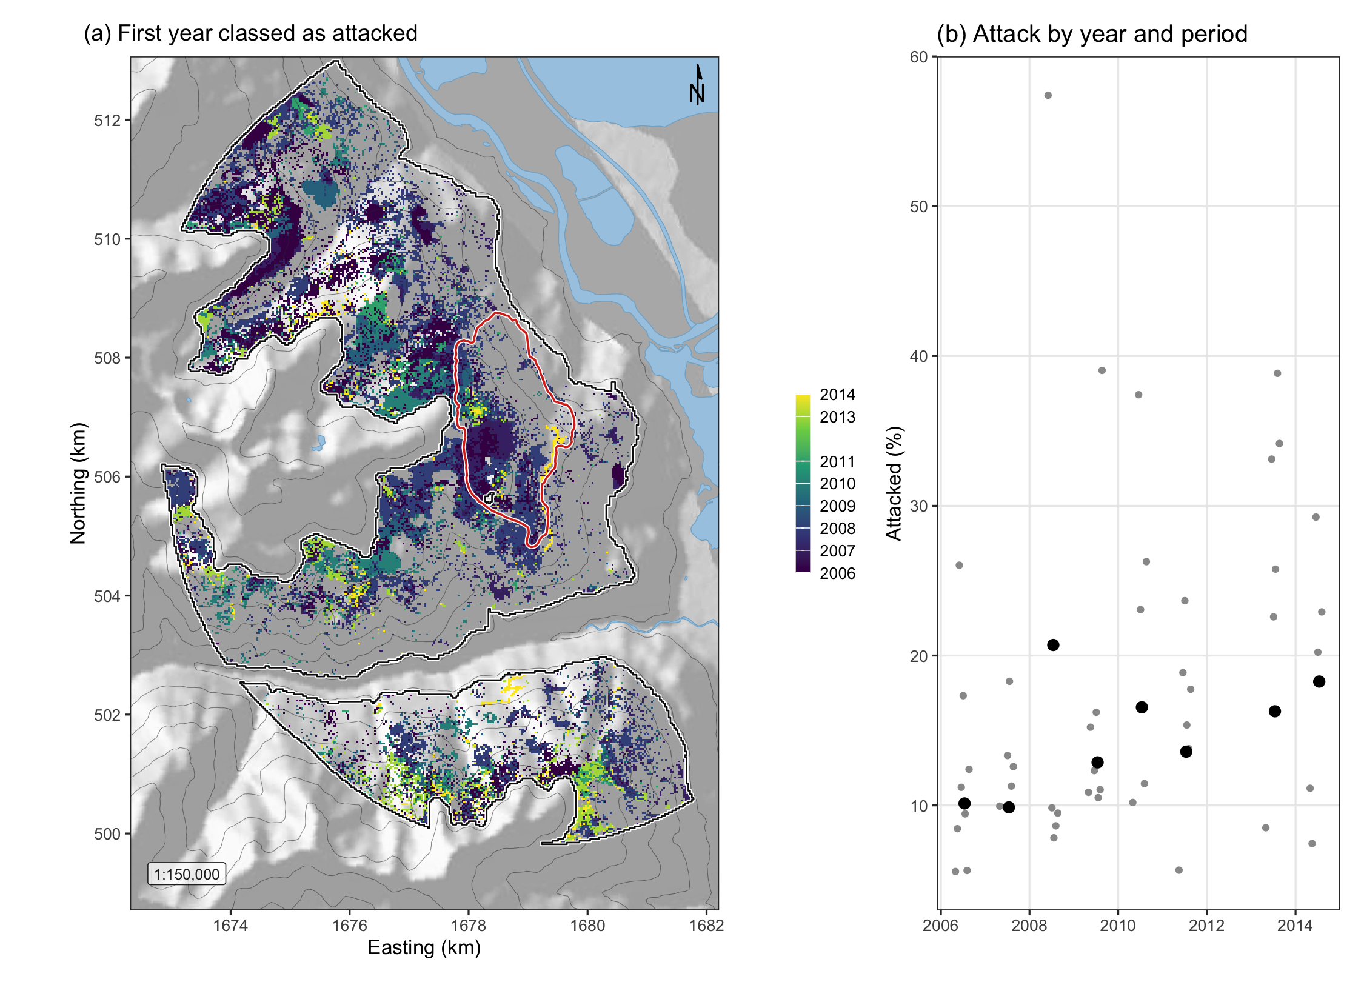
Figure 2: Red-stage attack across the study perimeter. (a) The first year in which each cell was classed as attacked, over shaded relief with the perimeter in white and the 2015 Mt Midgeley burn in red. (b) The share of the perimeter classed as attacked in each year, black, and of the cells seen in each sixteen-day period, grey.

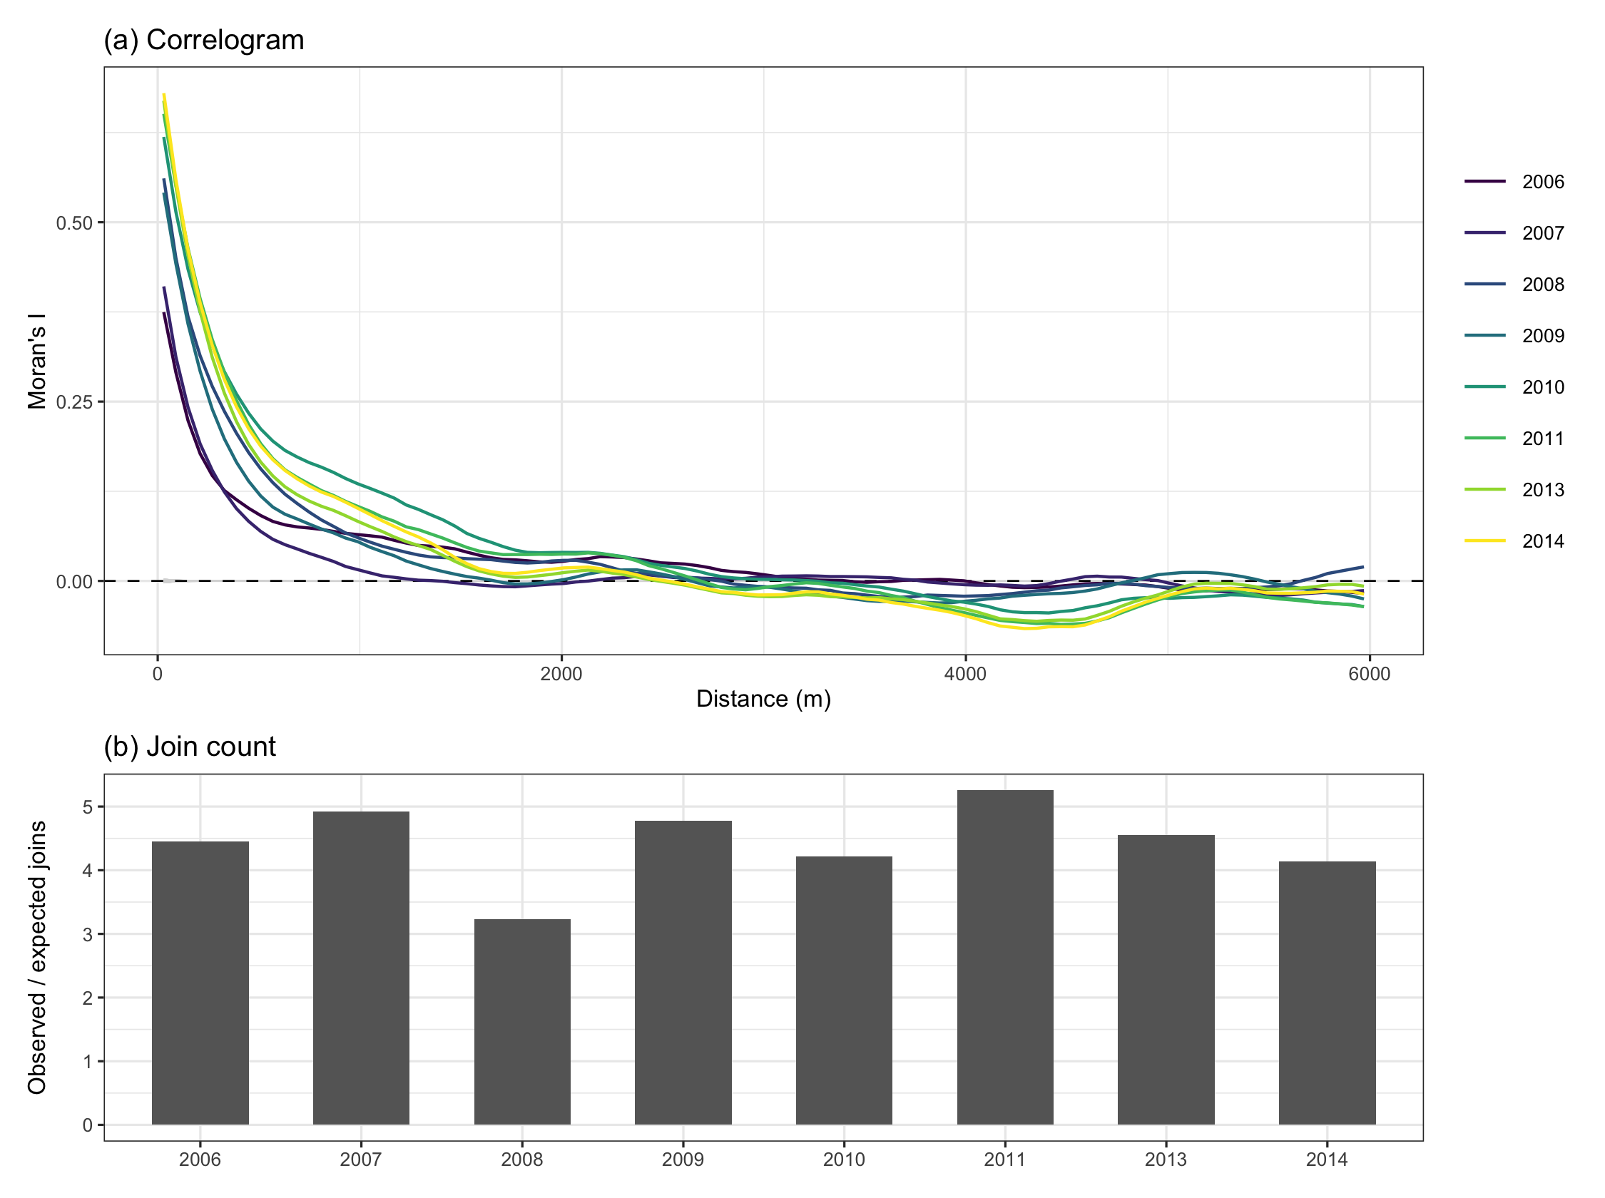
Figure 3: Spatial pattern of red-stage attack on the annual maps. (a) Moran’s I in distance classes of 60 m, one line per year, against the 2.5th to 97.5th percentiles of 999 random relabellings of the attacked cells, grey. (b) The number of pairs of neighbouring attacked cells divided by its expectation under relabelling.

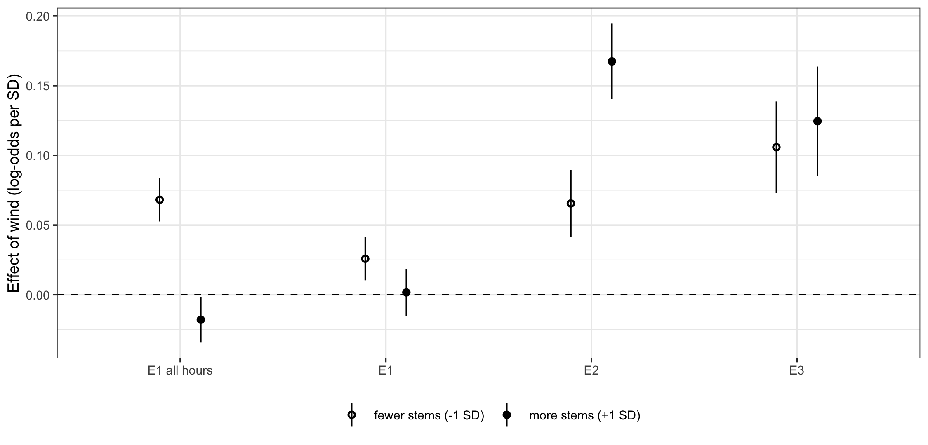
Figure 4: The effect of flight-period wind on the log-odds of attack, per standard deviation of wind, in stands one standard deviation below and above the mean of live stems, 411 and 1,077 stems per hectare, in the sixteen-day models, with 95 per cent confidence intervals. E1 all hours used wind averaged over the whole day and the other models the hours of 12:00 to 17:00. E2 added the previous period’s attack and E3 the previous year’s as well. Plume disruption predicts a negative effect at the lower density.

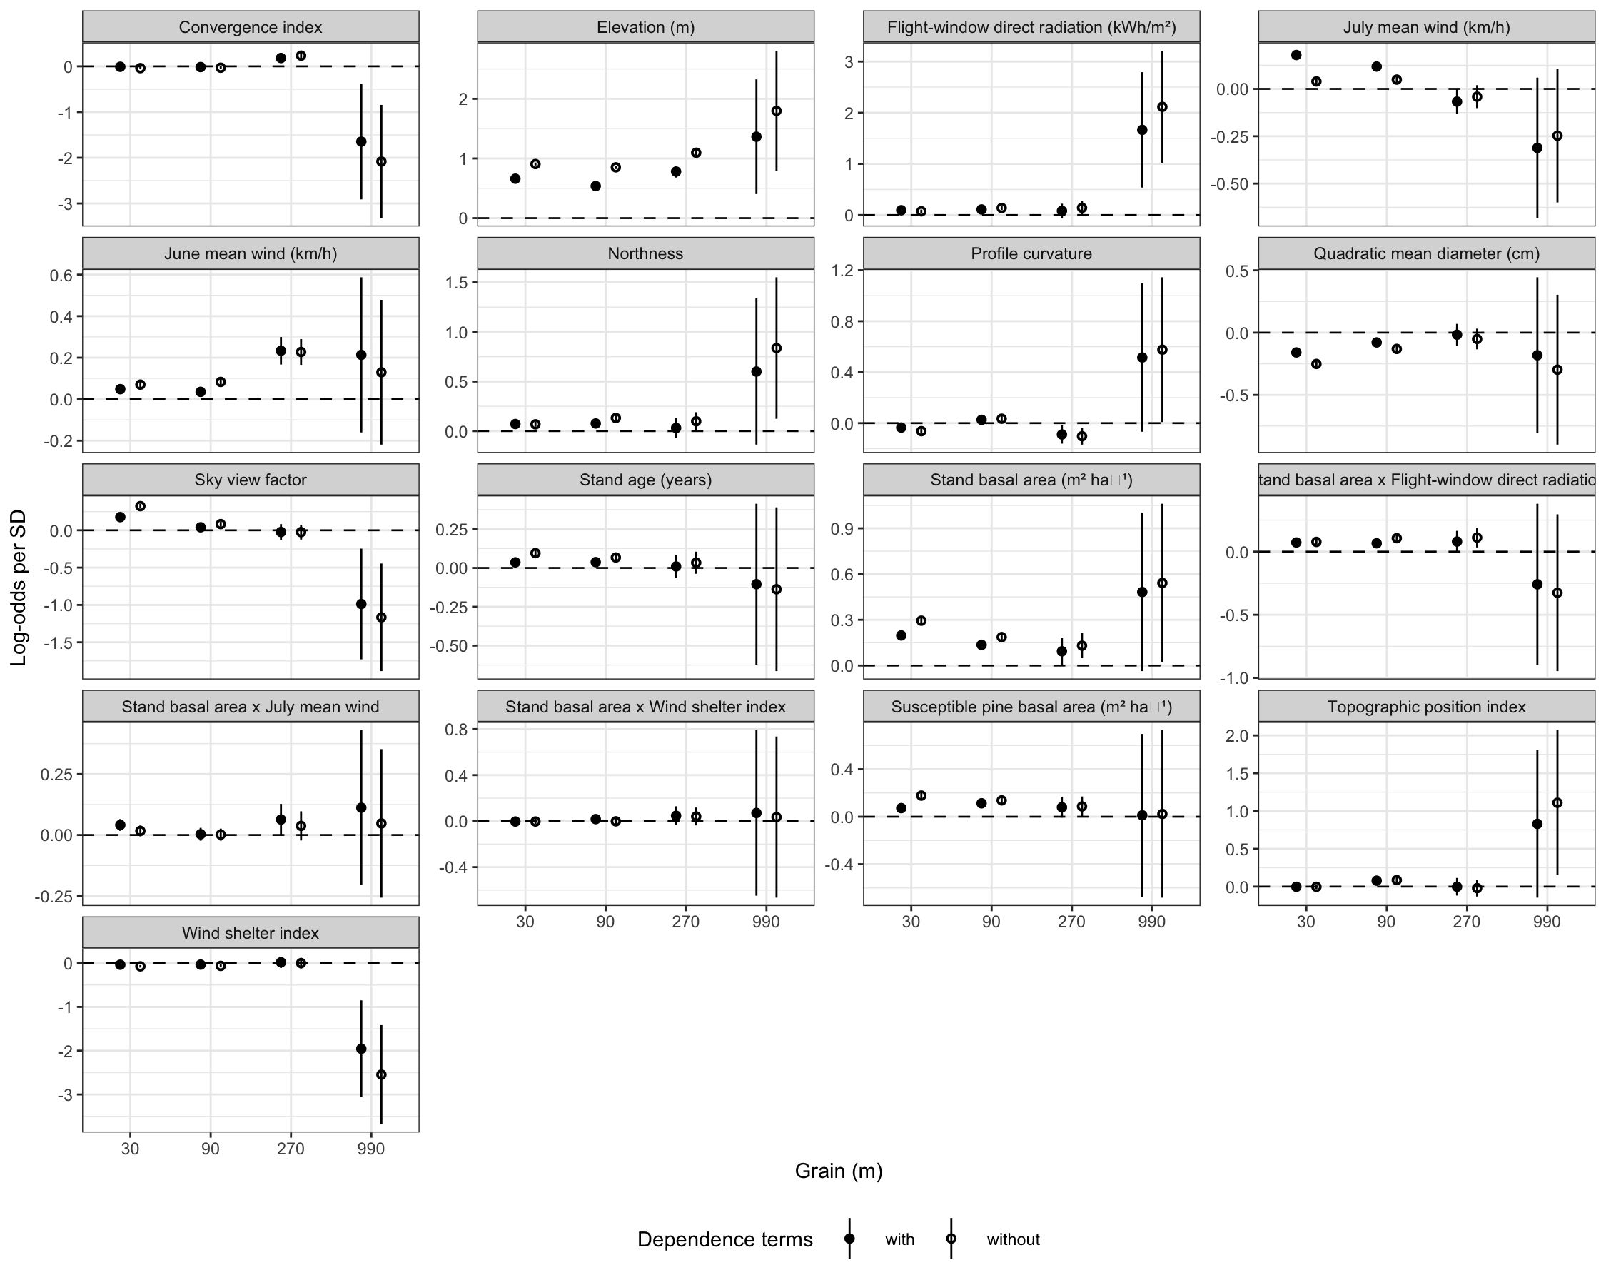
Figure 5: The coefficients of M3 refitted at four grains, with their 95 per cent confidence intervals, without the dependence terms, open circles, and with them rebuilt at each grain, filled circles.

