Spatial and temporal patterns of conifer regeneration following Mountain pine beetle outbreak (Dendroctonus ponderosae) and mixed-severity wildfire; A point process model of disturbance interactions in the Darkwoods Conservation Area

Seamus Murphy,^{a.1,✳} Adrian Leslie,^{b} Lauren K Banks,^{c} John Wilson^{d}
^{a.1}Primary: Bangor University, Wales, LL572DG; ORCID:0000-0002-1792-0351
^{b}Nature Conservancy Canada, Dept, Street Address, City, Country, Postal Code
^{c}University of Waterloo, Department of Biology, University of Waterloo, Waterloo, ON, Canada, N2L 3G1; ORCID: 0000-0001-6197-4245
^{d}Wildlife and Environmental Society of Malawi, Dept, Street Address, City, Country, Postal Code

Abstract: Understanding disturbance interactions between bark beetles and wildfire events poses a key question in forest ecology of the Pacific Northwest. These agents of natural disturbances have played key roles in the evolution of forest structure and ecosystem function. However, there is growing concern about the potential of compounded disturbances resulting from their increasingly frequent, intense, and overlapping occurrences. Therefore, it is essential to improve our understanding of the linkages between these disturbances and their potential impacts on the successional trajectories and functional resilience conifer assemblages. Few studies have examined the spatial patterns of conifer regeneration following beetle-fire disturbance legacies. In this study, we applied spatial point pattern analysis to investigate seedling intensity (m⁻¹) of seven conifer species across three 4-ha plots. These plots were situated in areas of bark beetle tree mortality where stands had experienced mixed-severity wildfire within nine years of the initial beetle attack. To derive spatial covariates of natural disturbances, we predicted using multispectral indices from Landsat time series trained with composite burn plots and forest health inventories that were sampled from areas of low, moderate, and high severity wildfire burn, and from areas of beetle-attacked trees showing signs of red or grey stages of outbreak. Best performing spectral indices yielded high overall classification accuracy and user’s accuracy with acceptable single-class classifications, namely NBDR (k = 0.792; UA = 0.872) and NDMI (k = 0.750; UA = 0.824). The stem locations of seedlings were modelled against an inhomogeneous null model of complete spatial randomness to examine global measures of nearest neighbour, distance to seed source, and local patterns of within-plot clustering and dispersion of different species. Finally, a Cox point process function was applied to estimate the individual effects of specific covariates on patterns of seedling intensity. To varying degrees and directions, we observed variance in seedling patterns between conifer species, influenced by red-stage beetle outbreak, low and high severity burn, distance to seed source, aspect, and ambient wind speed. Findings suggest that although the ecological effects of Mountain pine beetle outbreak on wildfire severity may diminish over time as surface fuels decay during grey stages, disturbances occurring at closer intervals is likely to result in diverging outcomes for host- and non-host species, and across different topographic variants. We conclude that the additive effects of increasing beetle-fire disturbance interactions on conifer assemblages depend not only on their varying regeneration traits in post-fire recovery, but also on their spatial distribution at the micro-scale, raising further questions on the resilience of pioneering Lodgepole pine cohorts.

Keywords: Wildfire, Mountain pine beetle, conifer regeneration, seedlings, disturbance interactions

*Corresponding Author, E-mail: seamusrobertmurphy@gmail.com

1 Introduction
In recent decades, the forests of British Columbia have experienced heightened levels of disturbance caused by outbreaks of Mountain pine beetle (MPB) ^{1–4} and wildfire ^{5–10}. Increasing frequency, intensity, and extent of these events have led to concerns over “linked” or “compounded” disturbances occurring. Such beetle-fire interactions may affect landscape-level changes in conifer assemblages and post-fire trajectories as a result of weakening response mechanisms and shifts in structural diversity ¹¹. Such concerns are particularly pronounced in the fire-prone, pine-dominated forests (Pinus contorta var. latifolia) of southern interior British Columbia and western Alberta, where the spread of MPB outbreaks and the geographic scale of wildfire events have been shifting under warming conditions ^{12–15}.
In response to the unprecedented levels of disturbance caused by Mountain Pine beetle outbreaks across the province interior of British Columbia ^{3,16–18}, numerous studies have explored the “linked” effects of pre-fire MPB outbreaks on fuel profiles and ecological severity of wildfire burn ^{19–25}. While findings remain mixed, reports indicate heightened fire activity in terms of crowning, rates of initial spread ²⁴, and deep charring ²⁶ in MPB-killed stands compared to non-MPB-affected stands of Lodgepole pine. Recent investigations have delved into potential “linked” and “compounded” disturbances, affecting long-term post-fire trajectories through altered distribution, abundance, timing, and establishment rates of seed banks across gradients of MPB and wildfire histories ^{19,27,28}. However, results from these studies remain inconclusive, with variations in outcomes related to unpredictability of early-outbreak fire behaviour during green stages of MPB attack ¹⁵, as well as uncertainties surrounding seritony and resilience of canopy and ground seed banks following crown and surface fires ^{20,25,29}.
The potential severity of ecological impact caused by disturbance interactions between MPB and fire is highly contingent upon the temporal stage of MPB outbreaks, as fuel structure and loading undergo dramatic changes between the green, red and grey stages of attack ^{19,30}. In the initial 12 to 24 months following MPB attack, infested trees exhibit red needles due to reduced sapwood and foliar moisture ^{21,23,31–33}. During this period, >50% retention of dead needles contributes to fine fuel loads in the canopy ²⁵, and increased light and wind exposure leads to the drying of surface fuels and fuel ladders ^{19,22,25}. Subsequently, the grey stage ensues when remaining needles and heavy snags fall to the floor, providing a mix of surface fuels, including downed logs, litter decay, and potential growth of post-fire saplings and grasses ^{29,34–36}.
Apart from spatial variation in fuel structures, there are crucial temporal dynamics influencing post-fire regeneration processes and seedbanks of dominant conifers that are important to compounded disturbances in MPB-fire interactions ^{37,38}. For Lodgepole pine, prevalent in BC’s interior plateau, key seritony mechanisms and their timings are closely tied to fire-dependent triggers, with regeneration patterns favouring pyriscent cues over xericent or senescence cues ^{11,28,39–42}. Timing is key here, as these fire cues activate the dispersal of much larger pulses of Lodgepole pine seed from viable canopy stores. Alternatively, in grey stage outbreaks where stands become exposed, higher rates of xericsent dispersal occur from fallen ground stores that are vulnerable to overheating, longer flame residence during surface fires, and increased predation.
For other conifers, surface fires pose varied. For Western larch (Larix occidentalis), Engelmann spruce (Picea engelmannii), and Western hemlock (Tsuga heterophylla), which produce smaller cones with light papery seeds, surface fires carry greater risk as seed banks are often deposited in fine fuel loads. Rather, successful seed dispersal relies on wind-dependent mechanisms where topography and location of seed source are critical to regeneration patterns. For thicker-barked species like Douglas-fir (Pseudotsuga menziesii), with heavier seeds, wind plays a lesser role than post-fire proximity to seed source and topography. For the largest cone producers, Ponderosa pine (Pinus ponderosae) and Western white pine (Pinus monticola), which produce thickly coated single-wing seeds, regeneration patterns beyond their wind-dispersal thresholds are associated with zootic mechanisms ^{9,43–47}.
In subalpine and montane forests where disturbance regimes are experiencing increasingly shorter-intervals, regeneration processes are particularly determined by topography as heightened impacts on southwards slopes are likely pronounced under warming climates while on north-facing slopes or in areas of geomorphic sheltering there is potential for regeneration to withstand changing disturbance legacies ⁴⁸. Such topographic effects have been noted in sites situated along the margins of a species niche ⁴⁹, as found in the patterns of seedling establishment ^{50–52} of Western hemlock ⁵³, Ponderosa pine and Douglas-fir ^{54–57}, as well as Western larch ^{58,59}. Additionally, this study’s framework is informed by research highlighting the spatial effects of topographic variability on the spread of MPB outbreaks and recovery patterns of host conifers ⁶⁰.
In accordance with our third hypothesis, we posited the significance of these spatial effects based on recent investigations highlighting the relevance of these landscape metrics to the spread of MPB outbreaks and to the patterns of seedling establishment in post-fire environments ^{60–62}.
This study investigates an overarching framework consisting of three hypotheses rooted in the ‘fire strategists’ classification system proposed by Rowe and others (Table 1) ^{63,64}. Categorising conifers into ‘fire-resisters, ‘fire-avoiders, ‘fire-evaders, ‘fire-invaders’ based on their seed-production, dispersal, establishment, and adult resilience ^{7,65,66}, these hypothesis are designed to explore the impact of varying disturbance legacies of MPB-fire interactions on the patterns of seedlings among host and non-host species across different topographic contexts. Specifically, the study anticipates significantly lower seedling intensity in areas of high severity fire among ‘fire avoiders’, ‘fire-resisters’, than among ‘fire evaders’ and ‘fire invaders’. Areas of red and grey-stage beetle outbreak are expected to exhibit lower seedling intensity among host species (Pinus spp.) than among non-host species. Finally, areas subjected to combined disturbances of high severity fire and beetle outbreak are expected to demonstrate lower seedling intensity among host species than among non-host species, with such patterns framed by topographic features at the micro-site scale.

Table 1. Post-fire regeneration strategies of conifers.
Species | Mature  bark | Young  bark | Sexual  maturity | Fire  resilience | Seed  dispersal | Seed production & size  (n/gm, length x width) | Seedbed  preferences | Fire  strategist
Douglas fir (Pseudotsuga m.) | Very thick | Thick | 12-15yrs | High as mature | 3% >80m | Bumper crops every 2-11yrs; 103/gm, 5.2 x 3.1mm | Mineral soil and organic seed beds with high shade intolerance | Fire-register
Engelmann spruce  (Picea engelmannii) | Thin | Very thin | 15-40yrs | Very low | 50% <30m  20% <60m | Bumper crops every 3-5yrs; 439/gm, 2.8 x 1.7mm | Moist, mineral soil, partial shade | Fire-avoider
Lodgepole pine  (Pinus contorta) | Very thin | Very thin | 5-15yrs | Low | 50% <18m, 20% <40m | Bumper crops every 1-3yrs; 346/gm, 3.4 x 1.9mm | Moderate-high severity burn, mineral soil with full light | Fire-evader
Ponderosa pine  (Pinus ponderosa) | Very thick | Thick | 4-8yrs | Very high | 50% >25m, 20% >60m | Bumper crops every 2-8yrs; 20/gm, 8.9 x 5.7mm | Mineral soil or ash, in full light | Fire-resister
Western hemlock  (Tsuga heterophylla) | Medium | Thin | 25-30yrs | Low | 50% <90m,  20% <120m | Bumper crops every 3-4yrs; 494/gm, 3.1 x 1.9mm | Most seedbeds, shade tolerant, sensitive to frost, drought | Fire avoider
Western larch  (Larix occidentalis) | Very thick | Thick | 25-45yrs | Most resistant | 50% >45m, 20% >110m | Annual, bumper every 5yrs; 283/gm, 4.4 x 2.2mm | High-severity burn patches, mineral soils with high light exposure | Fire-invader
Western white pine  (Pinus monticola) | Thin | Very thin | 20-30yrs | Low | <32km (zootic) | Bumper crops every 2-4yrs; 52/gm, 6.8 x 3.9mm | Moderate-high severity burn patches | Fire-invader

Scientific studies combining remote sensing methods of wildfire and beetle outbreak mapping with point pattern analysis for investigating finer-scale spatial patterns of post-disturbance regeneration in different conifers are limited ^{26,28,54,71}. In response, this study applied stem-mapping methods and supervised classification of multispectral images to examine the spatial patterns of conifer seedlings established in forest areas affected by the mixed-severity Mt Midgeley Wildfire of 2015 and impacted by a pre-fire MPB outbreak occurring from 2004 to 2014. The analysis was implemented in two stages. In stage 1, forest disturbances, we mapped topography and ambient wind using a combination of field sampling, ground truthing, digital terrain models, public geospatial datasets, and multispectral vegetation-differenced indices. In stage 2, we sampled seedling locations within three 4-ha plots. Employing point process models equipped with a distance-weighted log-Gaussian Cox process and fitted with spatial covariates derived from the preceding stage, we assessed the spatial patterns of seedling density and intensity of each species across disturbance gradients.

2. Materials and methods

2.1 Study site
In August 2015, the Mt Midgeley Wildfire burned a defined expanse of 479.77ha of forest located along the southeast perimeter of the Darkwoods Conservation Area ⁷². The BC Wildfire Service characterised the event as a mixed severity wildfire, reporting a total of 28.4ha of high severity burn (5.9%), 139.8ha of medium severity burn (29.1%), 189.9ha of low severity burn (39.6%), and 121.7ha of unburned forest (25.4%). Within the designated boundaries of this burn site, Mountain pine beetle activity was first detected in 2004 ⁷³, with records documenting beetle attacks running from light to severe intensity across a cumulative area of 231.61ha by end of year 2014 (48.2%) ⁷⁴.
The site is characterised by variable topography, spanning elevations from 1,744 metres to 830 metres above sea level. This variability extends across three biogeoclimatic zones: the Yahk Wet Mild Engelmann Spruce-Subalpine Fir zone (ESSFwm4, 207.63 hectares, 43.28%), the Ymir Moist Warm Interior Cedar-Hemlock zone (ICHmw4, 84.72 hectares, 17.69%), and the West Kootenay Dry Warm Interior Cedar-Hemlock zone (ICHdw1, 187.42 hectares, 39.07%) ^{49,75}. Soil composition comprises fine-grained meta-sedimentary rocks with sandy loam textures, medium-coarse colluvial and glaciofluvial fragments, along with occasional deposits of morainal debris and Granodiorite outcrops. Parent materials consist of argillite, sandstones, and mudstones, contributing to surface layers of Humo-Ferric Podzols, Dystic Brunisols, and Gleysols ^{76,77}.
To account for variable topography, a digital elevation model with 1-metre resolution was obtained from the High Resolution Digital Elevation Model repository maintained by Natural Resources Canada ⁷⁸. This model underwent processing, including Gaussian smoothing and interpolation, followed by the application of a sink-filling algorithm ⁷⁹. Terrain rasters were generated for aspect and slope, along with two additional metrics: the topographic wetness index (TWI) and terrain ruggedness index (RIX) ^{80,81}. Terrain ruggedness rasters were tested at multiple scales before a final resolution of 30 metres was chosen based on the coefficient of variation of internal metrics and Landsat data.
Ambient wind conditions were assessed using raster data from the Global Wind Atlas repository ⁸², reporting mean monthly wind speeds at 10 metres above ground between 9.4 m/s in upper elevations and 3.7 m/s in lower elevations from 2015 to 2020. Climatic data for local precipitation, obtained from the PRISM Climate Group, revealed a mean annual rainfall of 596 mm between 1981 and 2010 ⁸³.
Analysis of pre-fire records indicated the prevalence of Lodgepole pine stands, with co-dominant cohorts of Engelmann spruce at upper elevations ⁸⁴, and mixed mosaics of Douglas-fir, Western larch, Ponderosa pine, Western hemlock, and Western white pine at lower elevations ⁷⁵.
Descriptive statistics were calculated below for all covariates including yet-described classes of MPB & fire disturbances (Sections 2.3 & 2.4), which was done by pooling observations and applying ratio-estimation at each location ⁸⁵ (Tables 2.1 & 2.2).

Table 2.1 Mean topographic and environmental conditions by plot and species (SD).
 | Elevation | Slope | RIX | Aspect | TWI | Wind
Pooled | 1516 (224.2) | 13.81(7.96) | 0.51 (0.06) | 91.5 (58.2) | 5.03 (1.27) | 4.88 (0.79)
Plot 1 | 1769 (14.1) | 7.82 (4.99) | 0.55 (0.07) | 144.0(79.2) | 5.19 (0.61) | 5.75 (0.12)
Plot 2 | 1672 (12.7) | 7.56 (1.47) | 0.48 (0.05) | 99.2 (29.9) | 4.78 (1.28) | 5.32 (0.09)
Plot 3 | 1251 (37.8) | 22.5 (2.72) | 0.50 (0.03) | 51.7 (10.5) | 5.13 (1.53) | 3.97 (0.13)
Pinus c. | 1516 (224.5) | 13.70 (8.97) | 0.51 (0.060) | 91.4 (57.6) | 5.04 (1.28) | 4.88 (0.79)
Larix o. | 1511 (226.7) | 13.55 (8.21) | 0.508 (0.060) | 93.9 (64.3) | 4.942 (1.288) | 4.86 (0.80)
Picea e. | 1509 (225.1) | 13.83 (8.20) | 0.507 (0.062) | 91.0 (56.8) | 5.076 (1.278) | 4.87 (0.78)
Pseudo m. | 1510 (222.3) | 14.20 (7.70) | 0.505 (0.057) | 86.3 (48.4) | 4.890 (1.370) | 4.85 (0.77)
Pinus p. | 1406 (208.2) | 16.93 (7.46) | 0.491 (0.043) | 68.6 (26.7) | 4.996 (1.343) | 4.47 (0.68)
Pinus a. | 1709 (291.1) | 10.15 (5.48) | 0.539 (0.060) | 156.6(100.8) | 5.121 (0.773) | 5.59 (0.34)
Tsuga h. | 1475 (218.0) | 13.89 (7.79) | 0.504 (0.046) | 77.4 (28.0) | 5.001 (0.991) | 4.89 (0.77)

Table 2.2 Percentage distribution of plots and species by beetle outbreak stages, wildfire severity, and biogeoclimatic ecosystem subzones.
 | Beetle outbreak stage |  |  |  | Fire burn severity |  |  | Biogeoclimatic subzone
 | NA | Grey | Red | NA | Low | Med | High | ICHdw¹ | ICHmw⁴ | ESSFmw⁴
Pooled | 0.72 | 0.04 | 0.25 | 0.06 | 0.38 | 0.44 | 0.13 | 0.06 | 0.35 | 0.59
Plot 1 | 0.55 | 0.12 | 0.33 | 0.00 | 0.40 | 0.44 | 0.16 | 0.00 | 0.00 | 1.00
Plot 2 | 0.49 | 0.02 | 0.49 | 0.15 | 0.19 | 0.56 | 0.10 | 0.00 | 0.00 | 1.00
Plot 3 | 1.00 | 0.00 | 0.00 | 0.02 | 0.51 | 0.34 | 0.13 | 0.15 | 0.85 | 0.00
Pinus c. | 0.72 | 0.04 | 0.24 | 0.06 | 0.37 | 0.43 | 0.13 | 0.06 | 0.35 | 0.59
Larix o. | 0.69 | 0.05 | 0.26 | 0.05 | 0.36 | 0.43 | 0.15 | 0.07 | 0.35 | 0.58
Picea e. | 0.66 | 0.04 | 0.30 | 0.04 | 0.40 | 0.45 | 0.11 | 0.04 | 0.38 | 0.58
Pseudo m. | 0.74 | 0.03 | 0.23 | 0.02 | 0.42 | 0.46 | 0.09 | 0.08 | 0.34 | 0.58
Pinus p. | 0.79 | 0.02 | 0.19 | 0.04 | 0.42 | 0.47 | 0.07 | 0.13 | 0.49 | 0.38
Pinus a. | 0.63 | 0.04 | 0.33 | 0.02 | 0.42 | 0.37 | 0.19 | 0.00 | 0.04 | 0.96
Tsuga h. | 0.82 | 0.00 | 0.18 | 0.06 | 0.41 | 0.47 | 0.06 | 0.00 | 0.41 | 0.59

2.2 Image processing
We acquired multispectral satellite images from the archives of Landsat 7 ETM+ and Landsat 8 OLI (Table 3). Pre- and post-disturbance images were selected from cloud free days (<20%) between June 01 and August 30. These images underwent processing, including level1 terrain corrections and level2 atmospheric correction procedures. Georeferencing of raster tiles was performed using ground control points and a digital elevation model to enhance topographic accuracy. Radiative and aerosol correction was carried out based on Landsat surface reflectance products ^{86,87}.

To analyse the spatial and temporal extent of beetle outbreak, we examined a time series of inter-annual vegetation-differenced images from Landsat 7 ETM+L1GT and Landsat 8 OLI collections spanning nine years (2005-2014). Predicting the spatial severity of wildfires, on the other hand, relied on two Landsat image collections capturing scenes before and after the disturbance. This enabled the derivation of vegetation-differenced indices to be used in the mapping of burn severity classes. The following table lists the study’s raster collections taken from both MPB and wildfire analyses.

Table 3 Study’s raster collections of satellite imagery.
Scene | Satellite sensor | Date of acquisition | Resolution (m)
Pre-outbreak  Early-outbreak  Early-outbreak  Early-outbreak  Mid-outbreak  Mid-outbreak  Mid-outbreak  Post-outbreak  Post-outbreak  Pre-fire (-1yr)  Pre-fire (-1mth)  Post-fire (+1yr)  Post-fire (+5yrs) | Landsat 7  Landsat 7  Landsat 7  Landsat 7  Landsat 7  Landsat 7  Landsat 7  Landsat 7  Landsat 8  Landsat 8  Landsat 8  Landsat 8  Landsat 8 | 2003 Aug 20  2005 Aug 09  2006 Aug 28  2007 Aug 15  2008 Aug 17  2009 Aug 20  2010 Aug 07  2011 Aug 10  2013 Aug 31  2014 July 01  2015 July 04  2016 July 20  2020 Sept 03 | < 30m  < 30m  < 30m  < 30m  < 30m  < 30m  < 30m  < 30m  < 30m  < 30m  < 30m  < 30m  < 30m

2.3 Wildfire mapping
We generated reference data for wildfire burn mapping by assessing 94 burn plots. This dataset comprised 9 burn plots established immediately post-fire in 2015, resampled in 2020, and 85 aerial photo plots. The evaluation of all burn plots followed a composite burn index framework (CBI), akin to the CBI framework developed by Key and Benson ^{88–90}. Aerial sampling, aligned with the same scoring framework, was executed using the methods outlined by Collins et al. ⁹¹ Assigning CBI values to burn plots involved weighted estimates of fire effects observed across four vegetation layers: 1) substrate, 2) ground shrubs, 3) understorey, and 4) overstorey. The burn severity classes were ranked on a scale from 0.00 to 10.00, where <2.50 indicated no change, 2.50-5.00 indicated low burn, 5.00-7.50 indicated moderate burn, and >7.50 indicated maximum change caused by fire (Table 4).

Table 4 Scoring criteria of composite burn index used to classify wildfire burn severity in burn plots.
 | Burn severity scale
Vegetation layer | Weighting | Unburned | Low | Medium | High
Substrates
Charred litter & snag (%) | 1.00 | 0% | <50% | 50%-90% | >90%
Charred duff & fine roots (%) | 1.00 | 0% | <25% | 25%-50% | >75%
Ground shrub (<1m)
Charred foliage (%) | 1.00 | 0% | <25% | 25%-50% | >75%
Resprouting (%) | 1.00 | 100% | >90% | 30%-90% | <30%
Understorey (1-5m)
Charred foliage (%) | 1.00 | 0% | <10% | 10%-50% | >50%
Residual/resprouting (%) | 1.00 | 100% | >90% | 20%-90% | <20%
Overstorey (>5m)
Charred height (m) | 1.00 | 0m | <1.8m | 1.8 - 4m | >4m
Canopy black (%) | 2.00 | 0% | <20% | 20%-80% | >80%
Canopy green (%) | 1.00 | 100% | >80% | 20%-80% | <20%

We transformed burn plots into coded and digitally processed training samples for the classification of five spectral indices using ArcMap v.10.7. The selection of candidate spectral indices was informed by their demonstrated predictive power in published wildfire studies (Table 5). To preserve the integrity of spectral training data, we mapped preliminary locations of burn severity plots before commencing the survey. This mapping targeted the centre points of plots situated in regions with relatively uniform disturbance conditions, organised in a four-cell quadrant within the Landsat raster grid (60m x 60m).

In areas where mosaics of burn severity classes were present, we enforced a minimum plot diameter of 20m and a minimum spacing of 45m between severity classes. This approach served to mitigate autocorrelation issues and ensure a composite spectrum for each class ^{92,93}, with the aim of enhancing quality of the dataset and overall classification accuracy.

Table 5 Spectral indices used in burn severity mapping.
Spectral index | Formula | References
Normalised Burn Ratio Index | $\frac{(NIR-SWIR2)}{(NIR+SWIR2)}$ | ⁹⁰
Burned Area Index 2 - Landsat | $\left(1- \sqrt{\frac{NIR}{RED}}\right)*\left(\frac{SWIR2-NIR}{\sqrt{SWIR2+NIR}}+1\right)$ | ⁹⁴
Mid-InfraRed Burn index | $10*SWIR2+9.8*SWIR1+2$ | ^{93,95}
Thermal Vegetation Index | $\frac{(NIR- TIR)}{(NIR+TIR)}$ | ⁹⁶
Thermal Vegetation Index - Shortwave | $\frac{(NIR-SWIR2*TIR1)}{(NIR+SWIR2*TIR1)}$ | ⁹⁷
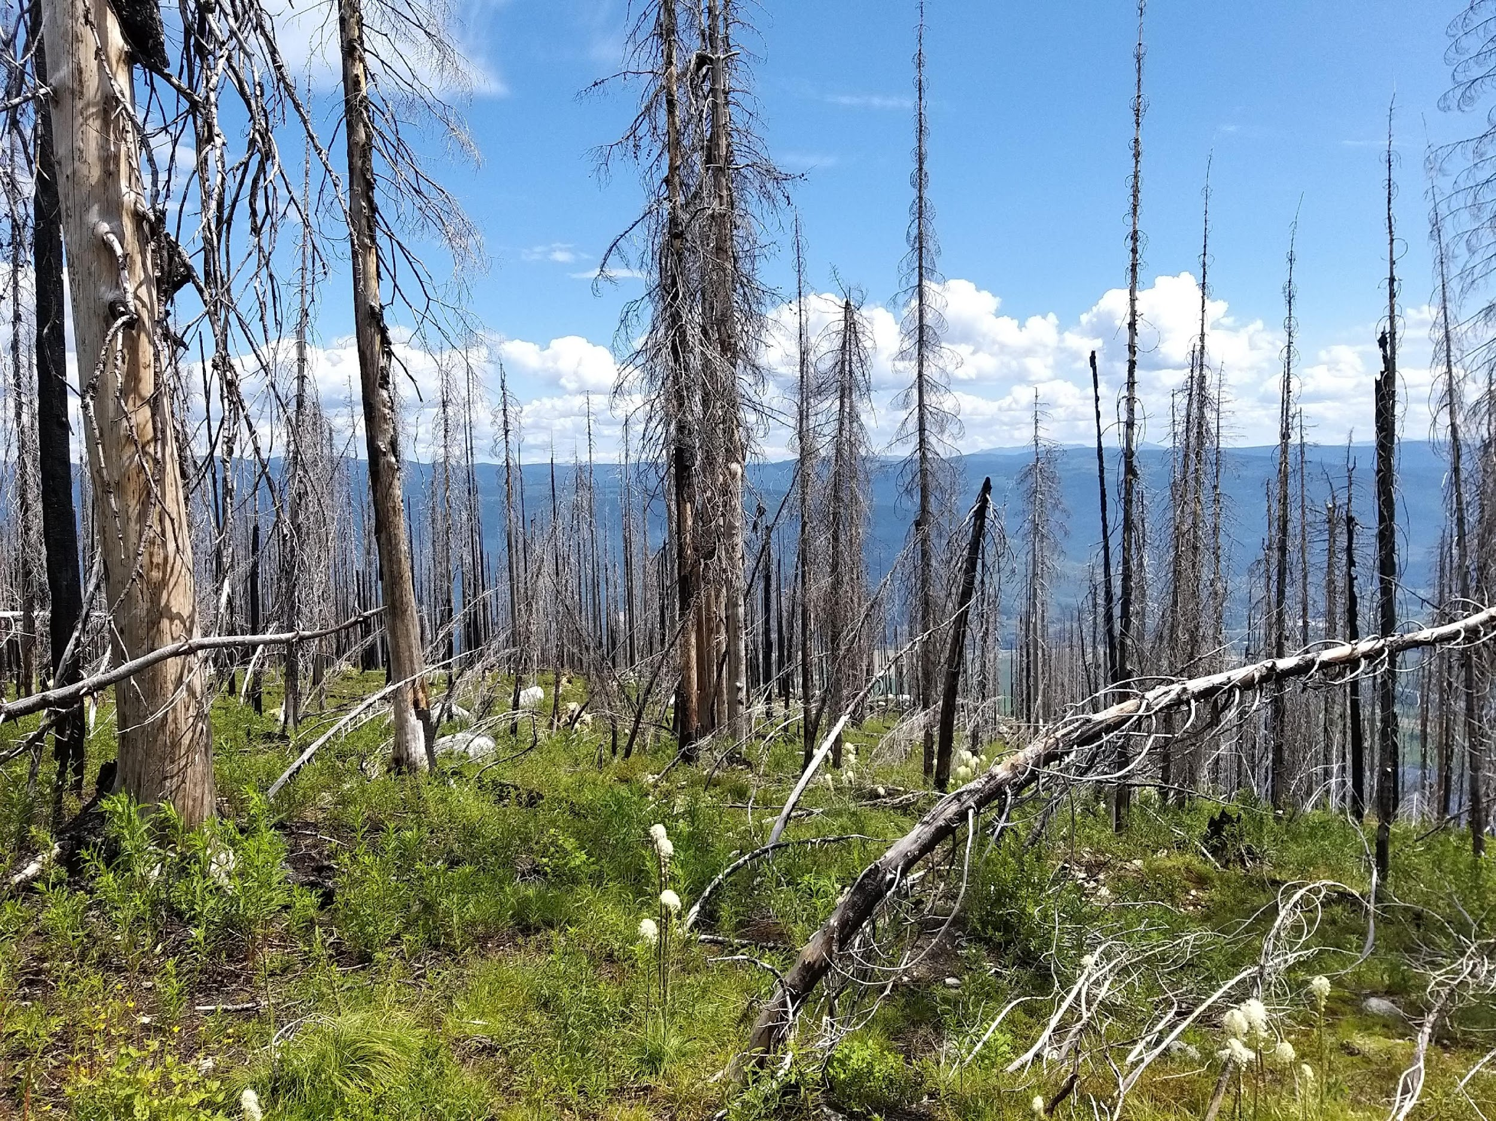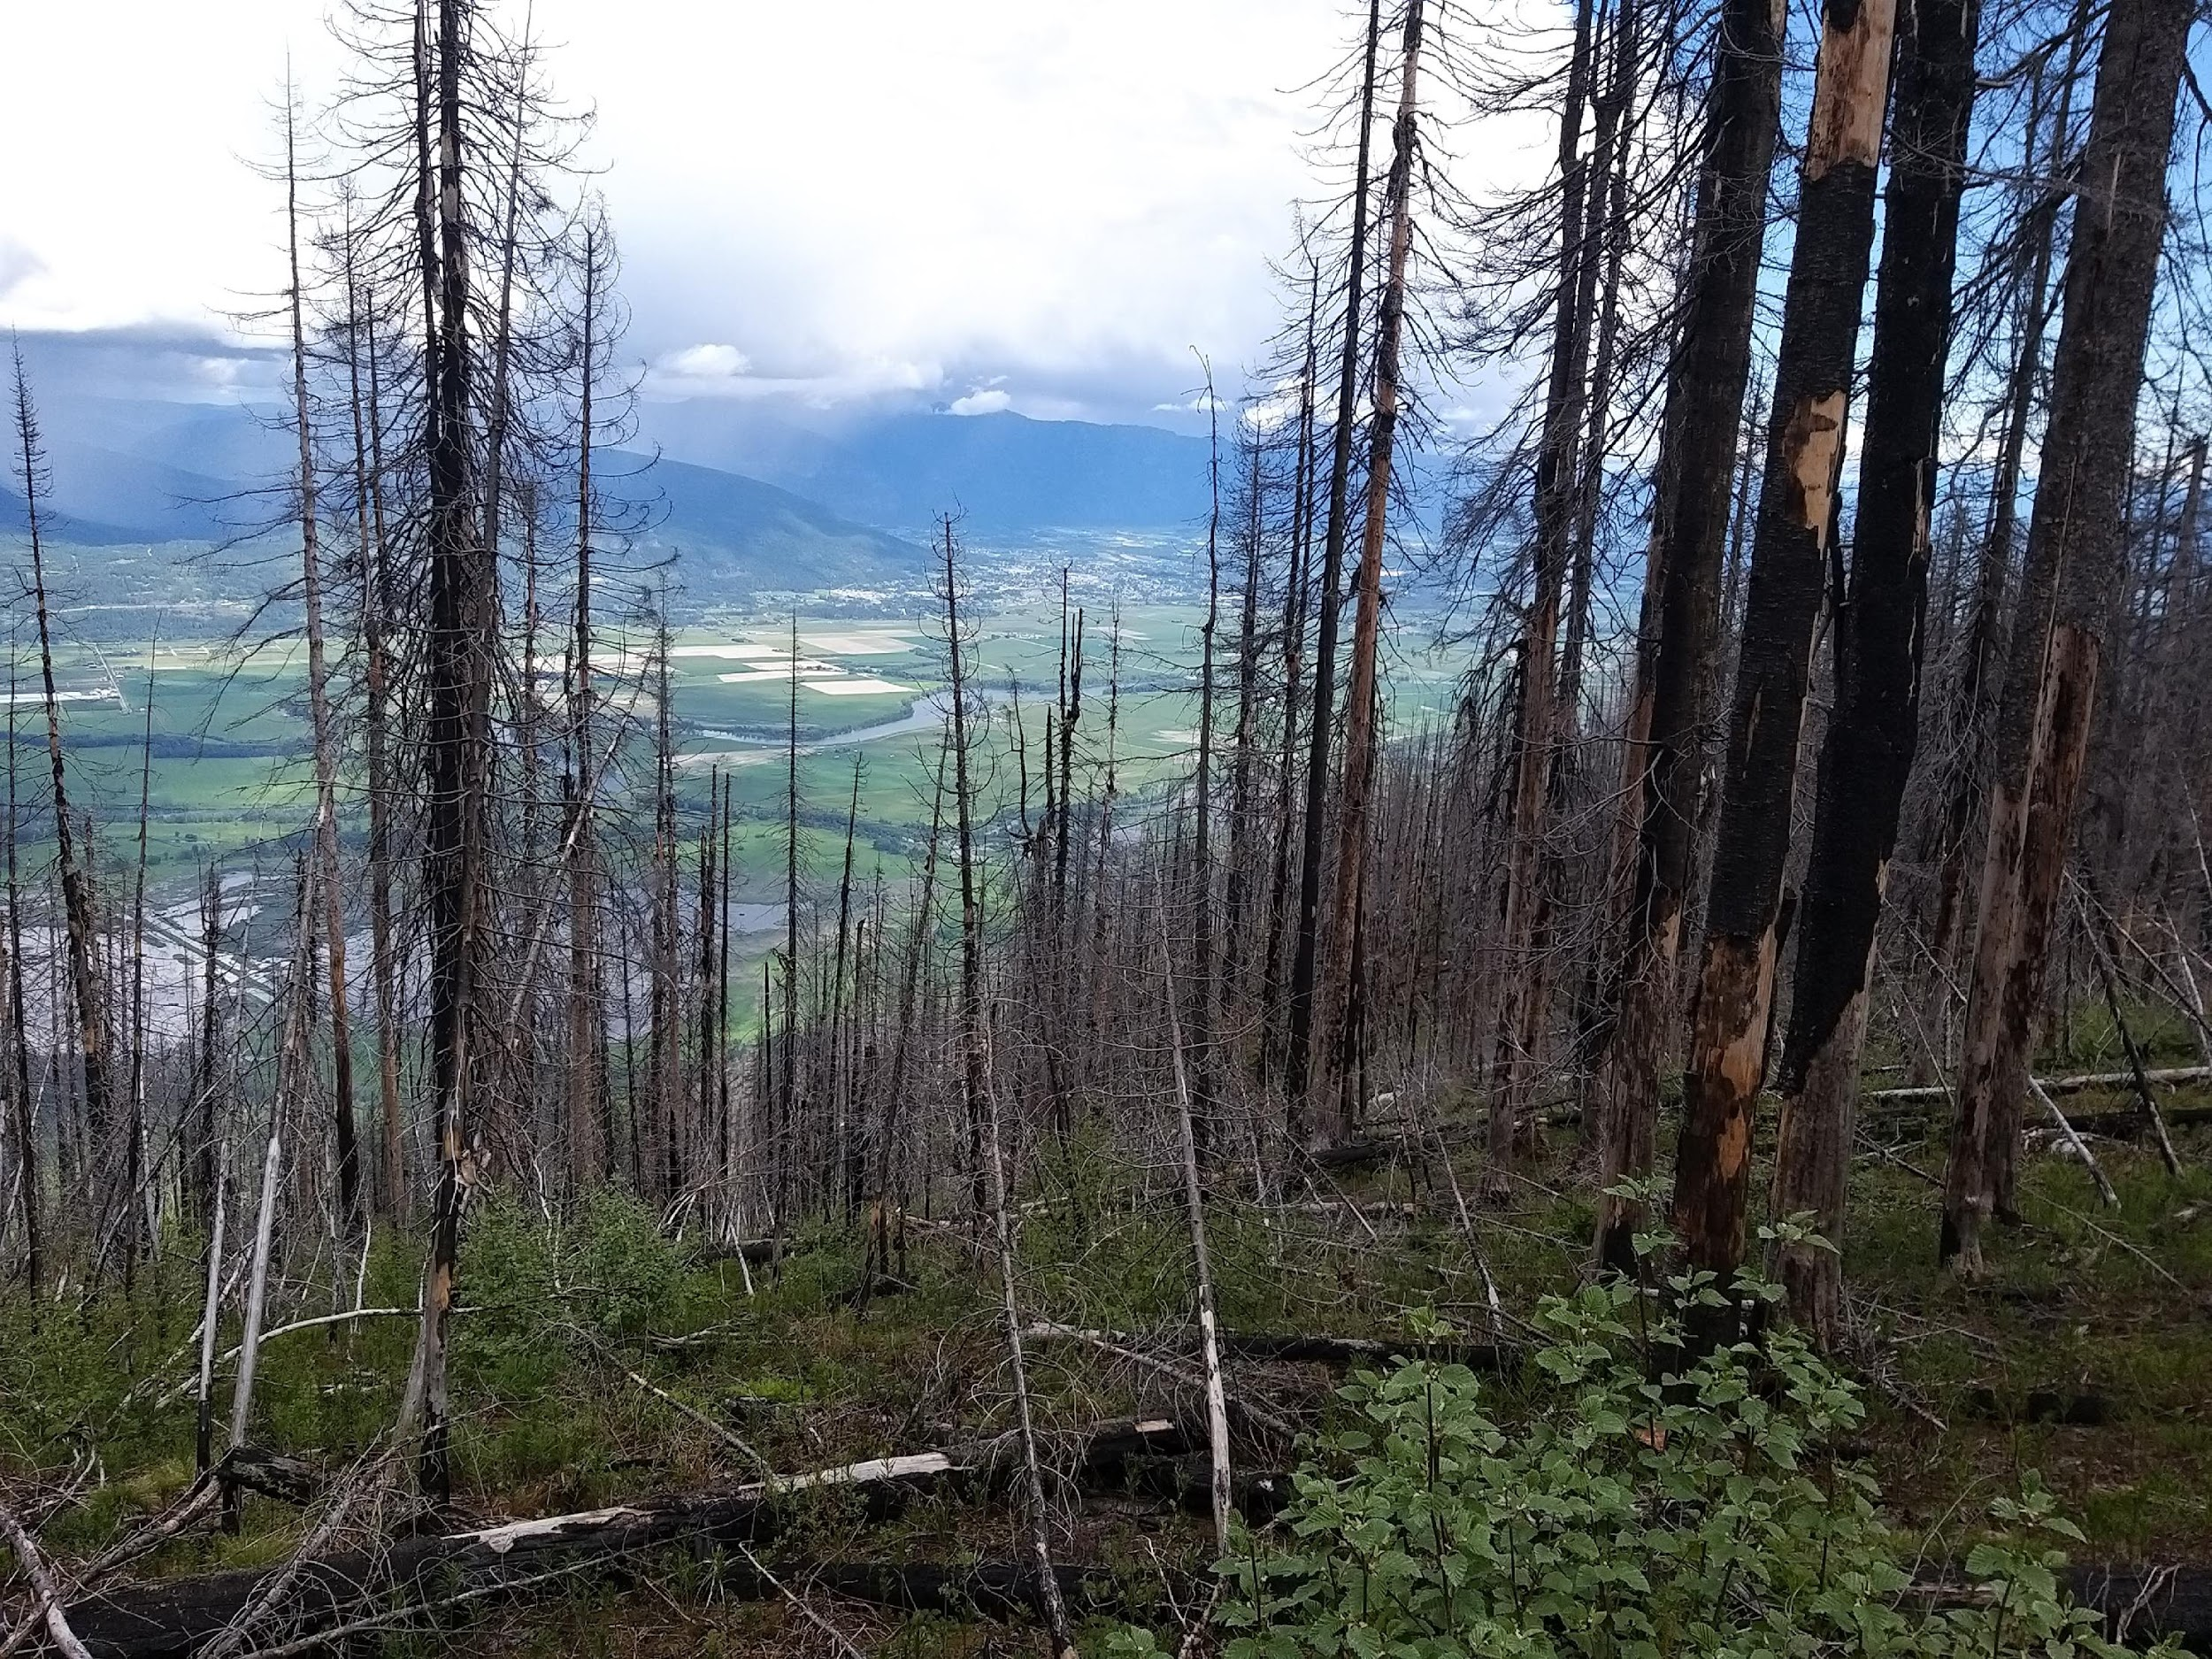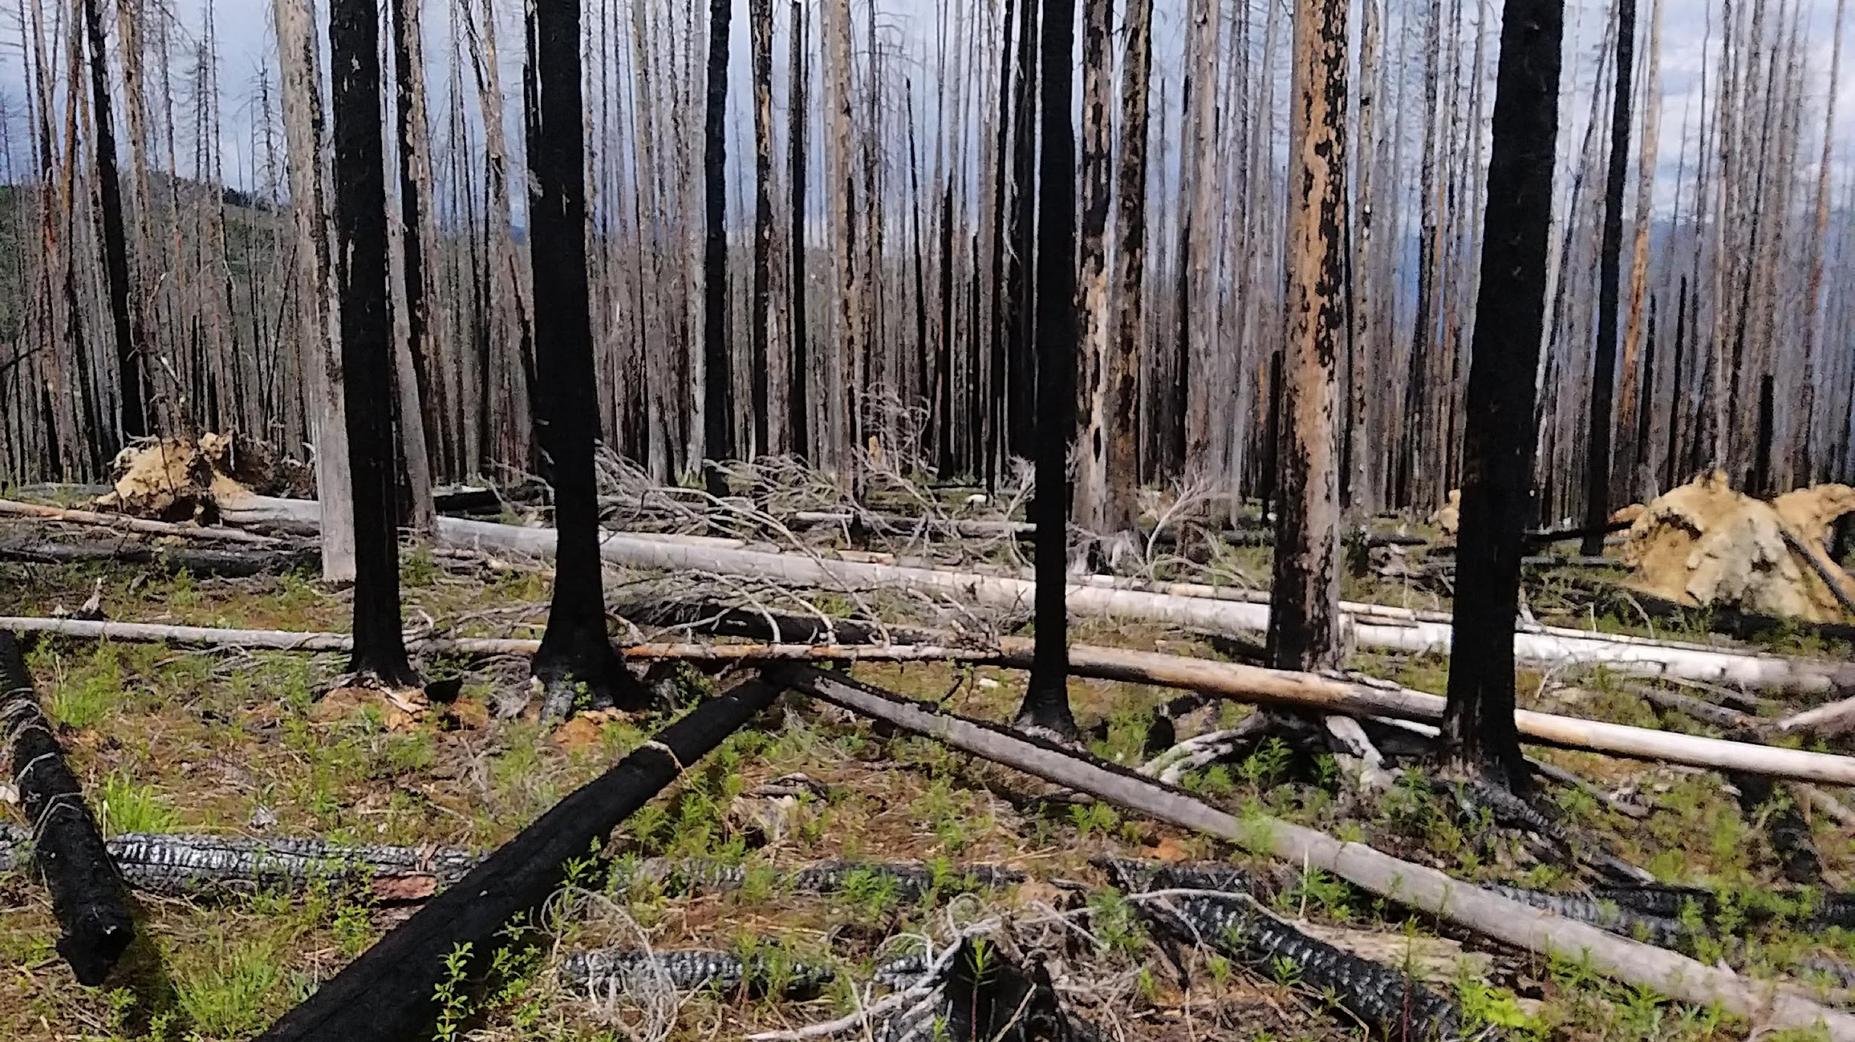

Fig. 1 High severity burn plots assigned composite burn scores of 7.91, 8.66, 7.56, respectively.
Before undertaking image classification, the sensitivity of spectral variables to wildfire burn effects underwent a three-step assessment process: 1) separability index analysis, 2) analysis of variance, and 3) regression analysis. The separability index was computed using the formula:
$M= \frac{‖{u_{2} - u}_{1}‖}{σ_{2} + σ_{1}}$ ^{88,95}

Here µ₁ and µ₂ represented the mean values of spectral bands for the vegetation scorch of the burn severity class and other pooled data, while σ₁ and σ₂ denoted the corresponding standard deviations. Given the non-normal distribution observed in spectral variables, analysis of variance employed non-parametric methods, namely the Kruskal Wallis H-test and Wilcoxon sum-ranked test. Table 6 below presents the results of sensitivity analyses for spectral bands in descending order of their discriminatory power. Notably, the findings highlighted that the NIR wavelength exhibited the highest efficacy in detecting unburned areas from others (M = 0.510, p < 0.00002).

Table 6 Power of each spectral bands to discern burn classes according to separability distance score (Mdist) and results of Wilcoxon rank-sum nonparametric analysis of variance (^{W}). Presence of heteroscedasticity among spectral variables reported according to results of Shapiro-Wilk test (SW^{p}). Significance levels: * = 0.05; ** = 0.01; *** = 0.001.
 | High burn |  | Moderate burn |  | Low burn |  | Unburned
 | Mdist^{W} | SW^{p} | Mdist^{W} | SW^{p} | Mdist^{W} | SW^{p} | Mdist^{W} | SW^{p}
Aerosol | 0.730*** | 0.958 | 0.061 | 0.901* | 0.854*** | 0.850** | 0.119 | 0.962
Blue | 0.731*** | 0.943 | 0.072 | 0.921 | 0.884*** | 0.841*** | 0.118 | 0.952
Green | 0.546*** | 0.913* | 0.180 | 0.961 | 1.484*** | 0.879** | 0.081 | 0.917*
Red | 0.697*** | 0.845*** | 0.137 | 0.988 | 1.484*** | 0934 | 0.179 | 0.930
NIR | 0.140* | 0.877** | 0.748*** | 0.972 | 0.849* | 0.970 | 0.510*** | 0.817***
SW1 | 0.616*** | 0.911* | 0.073 | 0.942 | 0.204*** | 0.911 | 0.078 | 0.875**
SW2 | 0.813*** | 0.978 | 0.096 | 0.881* | 0.795*** | 0.932 | 0.008 | 0.876**
TIR1 | 1.033*** | 0.984 | 0.091 | 0.938 | 1.076*** | 0.930 | 0.109 | 0.856**
TIR2 | 1.026*** | 0.984 | 0.065 | 0.924 | 1.029*** | 0.942 | 0.105 | 0.861**

Significant variability was found in separability scores of spectral bands across burn classes. As anticipated, heightened burn effects yielded the most substantial separability values, proving statistically significant across all bands except NIR (M > 0.546, p <0.001). For NIR wavelengths, the discernment of high burn effects from other burn classes yielded moderate separability values (M = 0.140, p < 0.05). Remarkably, the Thermal Infrared 1 band exhibited the highest separability in detecting high burn effects (M = 1.033).
Conversely, low burn effects resulted in highly significant separability values across all wavelengths except NIR (M < 0.204, p < 0.001), with the Green band (M = 1.484) and Red band (M = 1.484) presenting the highest M-values. In the case of areas with moderate burn and unburned forest, the NIR band was the sole wavelength demonstrating significant separability in detecting fire effects (M = 0.748, p < 0.001).
Table 7 below displays the results of sensitivity analyses for spectral indices (band combinations) arranged in descending order of their discriminatory power. When considering all burn classes collectively, two indices exhibited noteworthy separability values in their ability to distinguish burned areas from unburned areas: the NBR (M = 0.399, p < 0.001) and TVI indices (M = 0.454, p < 0.001).

Table 7 Power of spectral variables to distinguish burn classes based on separability distance score (Mdist) and Wilcoxon rank-sum analysis (^{W}). Heteroscedasticity is indicated by the Shapiro-Wilk test (SW^{p}). Significance levels: * = 0.05; ** = 0.01; *** = 0.001.
 | High burn |  | Moderate burn |  | Low burn |  | Unburned
 | Mdist^{W} | SW^{p} | Mdist^{W} | SW^{p} | Mdist^{W} | SW^{p} | Mdist^{W} | SW^{p}
NBR | 0.442*** | 0.924 | 0.424* | 0.955 | 0.711*** | 0.911* | 0.399*** | 0.925
BAI2-SL | 0.400** | 0.711*** | 0.220 | 0.959 | 0.621*** | 0.905* | 0.122 | 0.953
MIRBI | 0.740*** | 0.956 | 0.016 | 0.897* | 0.954*** | 0.922 | 0.032 | 0.876**
TVI | 0.167 | 0.922* | 0.619*** | 0.976 | 0.270 | 0.939 | 0.454*** | 0.872**
TVI-SW | 0.864*** | 0.977 | 0.261 | 0.919 | 1.081*** | 0.976 | 0.112 | 0.835***
The MIRBI index demonstrated significant discriminatory power in distinguishing high and low burn severity (M > 0.740, p < 0.001), but proved ineffective for moderate and overall burn detection versus unburned areas (M < 0.016). NBR emerged as a key candidate for wildfire mapping, exhibiting significance in both overall burn distinctions (p < 0.001) and individual burn classes (p < 0.05).
Regression diagnostics using support vector machine kernels tuned with optimised cost margin of 0.316-1.105 assessed predictive relationships between spectral indices and composite burn index values. Covariance levels (R²), prediction accuracy (RMSE), and overfitting risk (RMSE^{ratio}) were examined using repeated 10k-fold cross-validation. The NBR index showed the highest correlation with field-measured composite burn values (R² = 0.879). TVI (R2 = 0.584) and MIRBI indices (R2 = 0.551) followed in explained variance. NBR demonstrated superior predictive accuracy (RMSE = 1.05), reducing model error by more than 0.8 CBI values compared to TVI (RMSE = 1.88) and MIRBI (RMSE = 1.94) indices.
Results in Table 8 revealed that NBR surpassed other indices in minimising error, while adhering to permissible error thresholds. TVI and MIRBI indices were rejected due to overfitting metrics exceeding 1.1 RMSE^{ratio} between cross-validation and fitted model performances. Theil’s U-statistic confirmed TVI and MIRBI models exhibited overall bias above recommended levels (Ubias > 10%).

Table 8 Regression diagnostics assess spectral variables' ability to predict composite burn index values using covariance (R²), root mean square error (RMSE), overfitting trends (RMSE^{ratio}), and model bias (U^{bias}). Epsilon (ε) and Cost value (C) were fitted for noise tolerance and penalising sigma, respectively.
 | R² | RMSE | RMSE^{ratio} | U^{bias} | C | ε
NBR | 0.879*** | 1.05 | 0.46 | 0.035 | 0.316 | 0.10
BAI2-SL | 0.183*** | 2.61 | 1.09 | 0.307 | 1.105 | 0.10
MIRBI | 0.551*** | 1.94 | 1.16 | 0.469 | 0.316 | 0.10
TVI | 0.584*** | 1.88 | 1.16 | 0.432 | 0.474 | 0.10
TVI-SW | 0.241*** | 2.54 | 1.10 | 0.343 | 0.158 | 0.10

According to results of regression diagnostics and sensitivity analyses, we identified NBR as our best candidate predictor of wildfire disturbances. To confirm empirical accuracy of spectral indices to classify fire severity, we split our dataset into training and validation data. Seventy-five percent of the data was used to train a Support Vector Machine algorithm and the remaining 25% was used to evaluate the model’s accuracy. Model accuracy was assessed using a 10k-fold cross-validation method. Results from confusion matrices are presented below in Table 9.
Tests revealed the NBR spectral index as the top performer, exhibiting the highest kappa value (k = 0.792) and overall accuracy (OA = 0.872). Consistent with kappa values, overall accuracy values mirrored a parallel hierarchy of index accuracy, showcasing the weakest agreement with TVI and the strongest with NBR. However, NBR predictions exhibited notable single-class misclassification errors in areas with low burn intensity (>0.216, <0.554).
As the most effective model, the NBR spectral index was employed to classify a vegetation-differenced image derived from pre- and post-disturbance rasters (2014-2016) (Figure 5). The resulting NBR-classified burn map was then compared with wildfire reporting data from the Mt Midgeley Wildfire by the British Columbia Wildfire Service.

Table 9 Accuracy assessment of spectral predictors to detect areas of wildfire burn classes. Results reported on overall accuracy assessment (OA) and according to kappa scores for classification of high severity burn (HB), moderate severity burn (MB), low severity burn (LB), and unburned areas (UB).
 | Commission error |  |  |  |  | Omission errors
 | Kappa | HB | MB | LB | UB | HB | MB | LB | UB | OA
NBR | 0.79 | 0.02 | 0.00 | 0.22 | 0.20 | 0.04 | 0.00 | 0.55 | 0.02 | 0.87
BAI2-SL | 0.62 | 0.00 | 0.06 | 0.28 | 0.52 | 0.30 | 0.00 | 0.00 | 0.00 | 0.73
MIRB | 0.60 | 0.00 | 0.00 | 0.48 | 0.13 | 0.00 | 0.15 | 0.19 | 0.00 | 0.70
TVI | 0.31 | 0.72 | 0.00 | 0.66 | 0.21 | 0.63 | 0.11 | 0.02 | 0.25 | 0.46
TVI-SW | 0.66 | 0.18 | 0.05 | 0.34 | 0.51 | 0.34 | 0.07 | 0.37 | 0.03 | 0.50
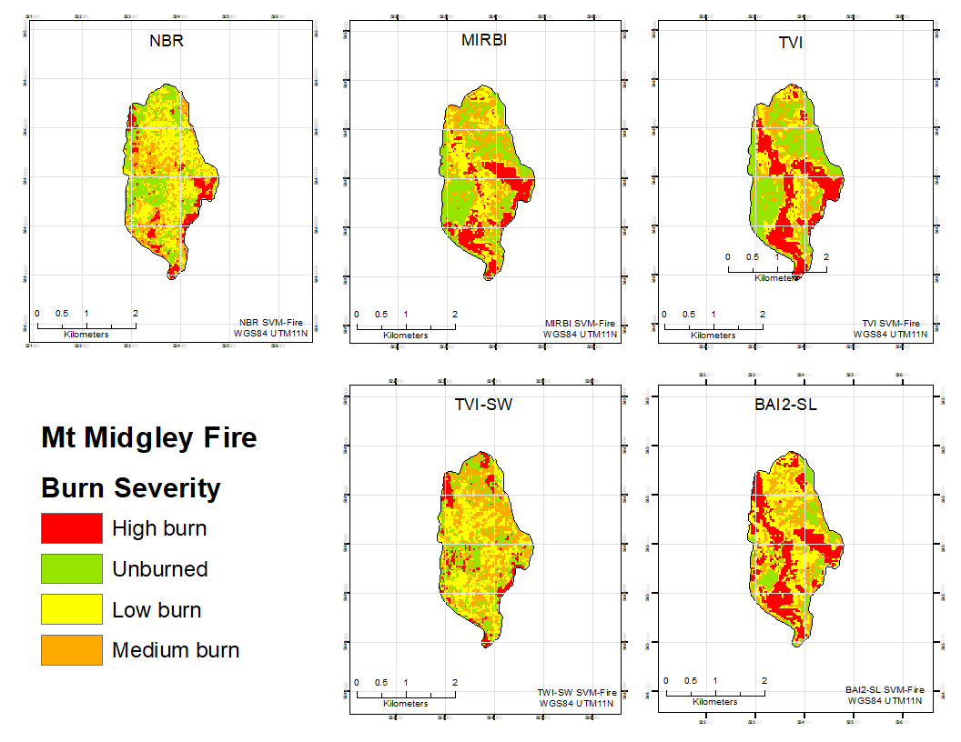

Fig. 2 Results of classification of wildfire burn severity based on five spectral indices.

2.4 Beetle mapping
In this section, we conducted a comprehensive mapping of red-stage beetle outbreak, serving as an indicative measure of tree mortality caused by the mountain pine beetle attack. Utilising inter-annual Landsat imagery spanning from 2005 to 2014 and incorporating four spectral indices selected from established sources (Table 10)^{98–100}, we delineated the spatial distribution of this critical stage of beetle disturbance.
The reference data employed for training and validating models in beetle mapping operations was sampled from 28 square field plots (20 x 20m) purposely established in beetle-affected regions during July and August of 2020. Following the methodology outlined by Carlson and others ¹⁰¹, remote positioning was initially mapped using ArcMap 10.7 targeting diverse topographic characteristics as well as outbreak severity and outbreak stages. This involved geopositioning of plot centres to align with a designated Landsat pixel quadrant (60m x 60m). To validate that red attack evidence was caused by pine beetles (Dendroctonus ponderosae), tree boles were surveyed for pitch tubes, frass texture, frass colour, and architecture of egg galleries ^{55,102,103}. Assessments of beetle outbreaks were quantified by scoring plots based on the fraction of basal area composed of beetle-killed pine trees relative to the total basal area of each plot (400m²) screening final red-stage candidates for model inputs (>80%).
Preceding image classification process, three stages of analysis were executed to evaluate the sensitivity of spectral indices to mountain pine beetle damage: 1) separability index analysis (Mdist), 2) analysis of variance, and 3) linear regression analyses.

Table 10 Spectral indices used in beetle outbreak mapping.
Spectral index | Formula | Reference
Norm. diff. moisture index | $\frac{(RED-NIR)}{(RED+NIR)}$ | ^{13,104}
Tasselled cap brightness | $0.2034*AEROSOL+0.4158*BLUE+0.5524*GREEN$  $+0.5741*RED+0.3124*GREEN+0.2303*SWIR2$ | ¹⁰⁵
Tasseled cap greenness | $-0.1603*AEROSOL-0.2819*BLUE-0.4934*GREEN$  $+0.7940*RED-0.0002*GREEN-0.1446*SWIR2$ | ¹⁰⁶
Tasselled cap wetness | $0.0315*AEROSOL+0.2021*BLUE+0.3102*GREEN$  $+0.1594*RED-0.6806*GREEN-0.6109*SWIR2$ | ^{107–109}

Table 11 below displays bands ranked in descending order of their discriminatory power (Mdist), with the NIR spectral region exhibiting notable discriminative capability to detect red-stage outbreaks (M = 1.135). The separability index identified aerosol, blue, long-shortwave infrared, and red bands with moderate discriminatory power (M < 0.3). Notably, the long-shortwave and red bands outperformed others based on analysis of variance (p < 0.000004).

Table 11 Descriptive statistics for spectral bands are reported (M=mean, SD=standard deviation, Mdn=median, SE=standard error). Power of spectral variables' to distinguish between red-attack and non-red-attack stands is assessed via separability distance score (Mdist) and Wilcoxon rank-sum analysis (W). Heteroscedasticity is examined using the Shapiro-Wilk test (SWp). Significance levels: * = 0.05, ** = 0.01, *** = 0.001.
Spectral ^{nm}  wavelength | M | SD | Mdn | SE | Mdist^{W} | SW^{p}
NIR | 11674.510 | 2238.136 | 10834.500 | 127.118 | 1.135*** | 0.923***
Aerosol | 8432.161 | 139.832 | 8438.000 | 7.942 | 0.296*** | 0.904***
Blue | 7689.177 | 160.719 | 7675.500 | 9.128245 | 0.294*** | 0.841***
SWIR2 | 6637.829 | 706.8761 | 6482.500 | 40.14787 | 0.284*** | 0.797***
Red | 6426.016 | 316.7762 | 6341.5 | 17.99168 | 0.197*** | 0.727***
Green | 7068.503 | 240.7531 | 6998.000 | 13.67386 | 0.011 | 0.794***
In Table 12, results were presented outlining the discriminatory power of spectral indices. NDMI emerged as the top performer among the five candidates, displaying the highest separability scores (M = 1.004) and ranking second in the ranked-sum test of variance (p = 0.00000008).

Table 12 Descriptive statistics for candidate indices are reported (M=mean, SD=standard deviation, Mdn=median, SE=standard error). Power of spectral indices to distinguish between red-attack and non-red-attack stands is assessed according to separability distance scores (Mdist) and Wilcoxon rank-sum analysis (W). Heteroscedasticity is examined using the Shapiro-Wilk test (SWp). Significance levels: * = 0.05, ** = 0.01, *** = 0.001.
Spectral ^{nm}  index | M | SD | Mdn | SE | Mdist^{W} | SW^{p}
NDMI | 0.5836 | 0.144 | 0.551 | 0.027 | 1.004 | 0.943
TAS-Wet | -4013.162 | 399.494 | -3911.261 | 75.497 | 0.240*** | 0.904**
TAS-Bright | 16470.480 | 616.788 | 16354.130 | 116.562 | 0.171*** | 0.917*
TAS-Green | 8528.016 | 299.830 | 8474.081 | 56.663 | 0.092 | 0.906*

To validate the robustness of these associations, regression analyses were conducted utilising a support vector machine kernel with an optimised cost margin ranging from 0.316 to 2.368 (Table 13 and Figure 4). In Table 13, findings revealed a pronounced correlation between NDMI and the basal area of beetle-affected trees (R² = 0.905). Notably, the NDMI model exhibited superior predictive accuracy (RMSE = 4.83) while avoiding overfitting to observed data.

Table 13 Regression diagnostics comparing performances of spectral variables to predict beetle outbreak severity based on levels of covariance (R²); root mean square error (RMSE); risk of overfitting (RMSE^{ratio}); and model bias (U^{bias}). Hyperparameters fitted for features of noise tolerance or insensitivity loss function as Epsilon (ε) and model Cost value or measure of the penalizing sigma (C). Significance levels: * = 0.05, ** = 0.01, *** = 0.001.
 | a(B) | R² | RMSE | RMSE^{ratio} | U^{bias} | Cost-C | Gamma
NDMI | 0.738 (0.863) | 0.905*** | 4.83 | 1.09 | 0.176 | 0.947 | 0.10
TAS-Wet | 2.131 (0.804) | 0.904*** | 4.92 | 1.69 | 0.049 | 0.316 | 0.10
TAS-Green | 3.250 (0.764) | 0.650*** | 8.87 | 1.16 | 0.030 | 2.368 | 0.10
TAS-Bright | 3.523 (0.738) | 0.679*** | 8.36 | 1.16 | 0.032 | 1.263 | 0.10
Prior to image classification, the pixel clustering process was implemented through two stages. Initial mean segmentation and unsupervised classification (ISODATA) were implemented, followed by supervised classification (SVM). Reference data was derived from partitioning which was stratified proportionately by classes: 75% of the dataset served as training data for the Support Vector Machine Classifier (SVM-beetle), and the remaining 25% was used for model validation through the development of confusion matrices (Table 14).
Tests revealed the NDMI spectral index as the top performer, exhibiting the highest kappa value (k = 0.750) and overall accuracy (OA = 0.824), with acceptable levels of error across all single-class classifications (0.133 - 0.199).

Table 14 Accuracy assessment of spectral predictors to detect areas of beetle outbreak. Results reported on overall accuracy assessment (OA) and according to kappa scores of classifications of areas affected by red attack stage tree mortality (RA) and elsewhere (Non-RA). Significance levels: * = 0.05, ** = 0.01, *** = 0.001.
 | Commission Errors |  |  | Omission Errors
 | Kappa | RA | Non-RA | RA | Non-RA | OA
NDMI | 0.750 | 0.198 | 0.133 | 0.199 | 0.166 | 0.824
TAS-wet | 0.693 | 0.158 | 0.271 | 0.158 | 0.242 | 0.796
TAS-bright | 0.605 | 0.250 | 0.424 | 0.211 | 0.416 | 0.730
TAS-green | 0.570 | 0.290 | 0.625 | 0.380 | 0.502 | 0.861
Recognized as the optimal index, NDMI was chosen to predict red-stage outbreak from a series of vegetation-differenced images derived by subtracting the 2005 pre-disturbance scene from the annual outbreak scenes (see Figure 4).
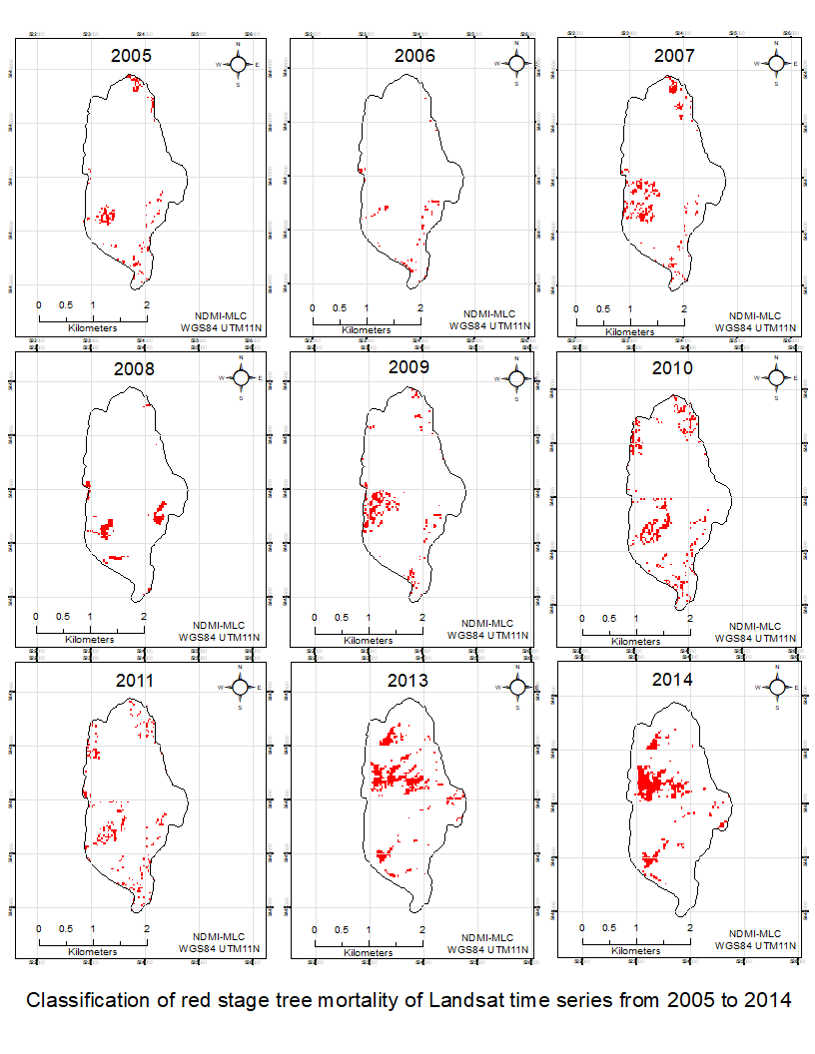

Fig. 3 Results of classification of red stage tree mortality of Landsat time series from 2005 to 2014.

2.5 Regeneration models
Empirical analysis utilised point-process models to investigate the spatial patterns of conifer regeneration in relation to seed source, topography, wind, MPB and fire disturbances. This was implemented over two stages: first, simulations of complete spatial randomness were passed over known locations of seedlings; second, Cox-process regression models were fitted with a distance-weighted log-Gaussian function to examine the significance and direction of effects of covariates on the spatial patterns of seedling intensity (stems/m⁻¹). All empirical models were prioritised by parsimony, with a meticulous screening of predictors aimed at minimising environmental spillover and addressing the impacts of spatial autocorrelation between clusters ^{110–112}.
Conifer seedlings were sampled in the summer of 2020 across three 4ha-plots (200m x 200m) plots established within the Midgeley Fire burn site perimeter. A purposive sampling approach distributed seedling plots across gradients of fire severity and beetle outbreak histories. Additionally, plots were located within 200m of residual forest to account for distance effects of parent seed sources on seedling patterns. Spatial covariates, accounting for location-dependent effects of topography, wind, wildfire burn severity, and beetle outbreak stages, were classified as discrete rasters (sections 2.1 - 2.4) and then processed into stacks of .im image files ready for inputs as per requirements of the spatstat package in R ¹¹³.
The stem location, species, and height of seedlings were recorded throughout each plot, with central location, mean height, and stem count of seedlings found in conspecific clusters. Screening deemed post-fire seedlings valid based on known growth rates and their maximum height potential since the wildfire disturbance ¹¹⁴. Conifer species with fewer than 30 individuals across all three sample plots were excluded. In total, 3886 seedlings of seven conifer species were recorded.
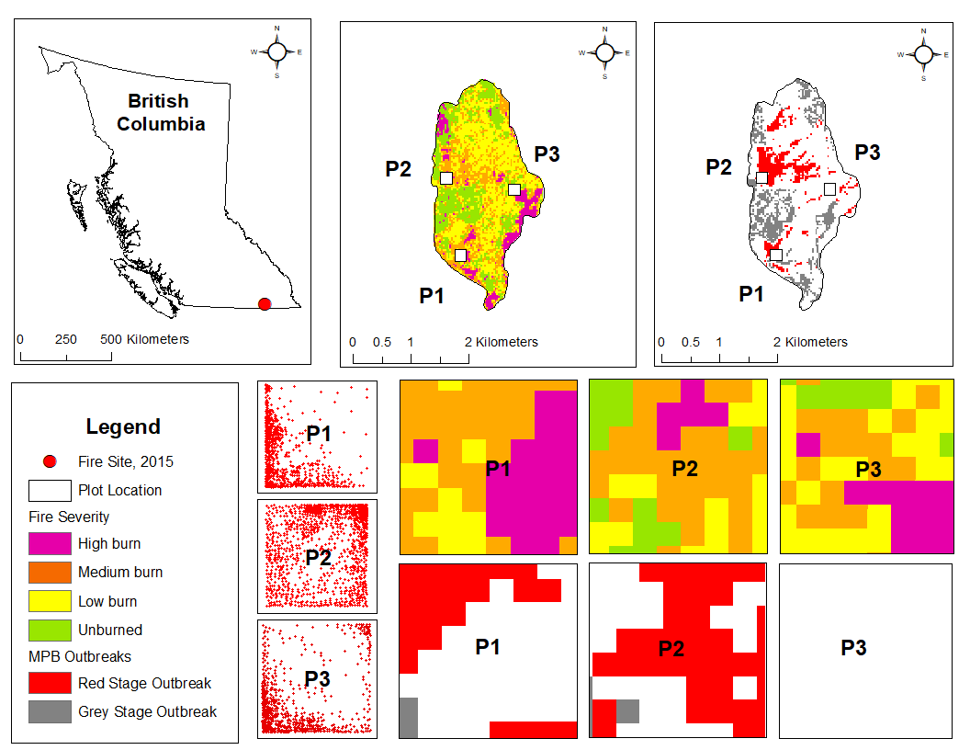

Fig. 6 Classified multispectral Landsat images showing study plot locations (P1, P2, P3) above time series of mountain pine beetle outbreaks occurring from 2004-2014 (top right) and wildfire burn severity mapping of Mt Midgeley Fire of 2015 (top centre). Middle row: Plot disturbance maps of mixed-severity fire effects. Bottom row: Plot disturbance maps of beetle outbreak stages. Second from bottom right: Stem map diagram of post-fire seedlings in 2020.
To analyse non-spatial measures, including absolute density (ha⁻¹), distance to nearest neighbour (NNdist), and distance to seed sources (SSdist), all seedling observations were consolidated using ratio estimation (Table 15) ⁸⁵. Employing Ripley’s K-function of spatial dependence, patterns of seedling intensity (stems/m⁻¹) were compared against a null model of non-constant intensity which was repeated through 999 simulations using the Monte Carlo method ^{115,116}. To explore emerging patterns of clustering and dispersion, the null model was fitted with a nonparametric Epanechnikov kernel ^{54,56,85,117} and an isotropic edge correction ¹¹⁸. With updated kernels, goodness-of-fit tests were executed to inform the strength of spatial relationships across a range of distances from 0 to 15m. Subsequently, cross-validation of these methods were used to identify an optimal bandwidth of 11m ^{119,120}. The above estimations were then refitted to explore bivariate pair correlation between species at different scales, investigating patterns in deviations from the null model at varying distances between conifers ^{54,56}.
To examine and quantify the spatial effects of different covariates on seedling intensity, an inhomogeneous, locally-weighted Cox-process model was implemented. Following similar approaches to Meddens and others, a candidate list of covariates was screened using likelihood ratio tests ^{22,35}. Linear slope estimates for each predictor were compared against an intercept-only model, and covariates were excluded if odds did not exhibit significant increase (p<0.05, Table 15). The remaining predictors underwent evaluation through a penalised LASSO regression model ¹²¹, wherein a denotative tuning constraint was applied by minimising the residual sum of squares to zero and scoring covariates based on their enduring magnitude (115). This process yielded a definitive list of eight covariates deemed suitable for empirical modelling: SSdist, Aspect, RIX, wind, MPB-grey, MPB-red, Fire-high, and Fire-low.

Table 15 Likelihood ratio test of covariate importance
 | Covariate | β | Deviance | LR-test
1 | SS-dist | -0.1872 | 13093.01 | 0.000
2 | Elevation | 0.0006 | 45.84 | 0.000
3 | Slope | -0.0272 | 147.72 | 0.000
4 | Aspect | -0.0029 | 142.84 | 0.000
5 | RIX | 2.7832 | 84.27 | 0.000
6 | TWI | 0.0022 | 0.05 | 0.818
7 | Wind | 0.5114 | 364.85 | 0.000
8 | MPB-grey | -1.9035 | 228.18 | 0.000
9 | MPB-red | 1.0734 | 637.34 | 0.000
10 | Fire-high | 0.3044 | 38.32 | 0.000
11 | Fire-med | 0.6579 | 398.02 | 0.000
12 | Fire-low | 0.0824 | 6.20 | 0.013

With our final subset of covariates, we constructed a generalised model employing a log-Gaussian Cox process. This design allowed us to assess the likelihood of seedling intensity y_{ij} based on locally-weighted relationships within a conditional slope expressed as:
$Pr\left(u_{ij}\right)= \frac{r(y+ r_{ij})}{r\left(y+1\right)r(r_{ij})}p_{ij}^{r_{ij}} (1- p_{ij})^{y}$
The inhomogeneous Cox process model was deemed the appropriate spatial model, as it enables estimation of probability of seedling intensity at a particular location while considering multiple known and unknown factors weighted according to their proximity to the observation. Here, the seedling outcome γ_{ij} of the ith observation at the jth location was influenced by two factors r_{ij} and p_{ij}., with random effects u_{ij} measured in levels of outcome uncertainty. This emphasises the effects of spatial randomness, as the model considers multiple realisations (M) along a Gaussian distribution with its mean set to zero and a variance matrix (Σ) of dimensions q x q weighted in intensity by its distance from the mean. From these estimates, we assessed the probability of seedling intensity Y_{i} of species_{I} in spatial relation to chosen parameters by fitting the model as follows:
$Y_{i}=exp⁡(SSdist\left(i\right)+RA(i)+GA(i)+BS(i)+RIX(i)+AS(i)+W(i)+ε_{i}$
where SSdist represents distance to seed sources, RA is precedence of red attack tree mortality and GA is precedence of grey attack tree mortality, BS is dummy variable of burn severity, RIX, AS, are topographic values of terrain ruggedness, aspect and slope, W is mean post-fire wind conditions, and ε_{i} is the error term ^{122,123}.

3. Results

3.1 Spatial patterns of conifer regeneration density between plots
We sampled 3886 post-fire seedlings across three plots. Mean regeneration density (ha⁻¹) significantly differed between plots (h = 342.97; df = 2, p<0.000), with higher density in plot 1 (318.0 ± 122.2ha-1) than plot 2 (230.4 ± 103.4ha-1) and plot 3 (306.6 ± 140.2ha-1, Table 16). Plot location significantly influenced the mean distance to nearest neighbour (h = 440.03, df = 2, p<0.000) and distance to nearest seed source (h = 683.68, df = 2, p<0.000). In plot 1, seedlings were clustered closer to each other (1.82m) and to their nearest seed source (20.68 ± 17.57m) than in other plots. Spatial patterns of seedling intensity (m⁻²) varied by plot (Figure 14). In plot 1, dispersion was significant beyond 9m, while in plot 3, significant patterns extended up to 24m and 22m, respectively.

Table 14 Mean values (Stdev) reporting absolute ‘Density’, nearest-neighbour distance ‘NNdist’, and distance to seed source ‘SSdist’ of all conifer seedlings. Statistical significance of variance in plot density and nearest neighbour distance reported at 0.05, 0.01, 0.001 levels as *, **, *** according to the Kruskal Wallis test. Significant deviations from CSR towards clustering (<1.000) and dispersion (>1.000) reported at 0.05, 0.01, 0.001 levels as #, #, ### according to Clark & Evans Aggregation test.
 | Density (ha⁻¹) | NNdist (m) | SSdist (m) | CE-index
Pooled | 285.1 (130.3) | 2.24 | 35.40 (29.81) | 0.177###
Plot 1 | 318.8 (121.8)*** | 1.82 | 20.68 (17.57) | 0.583###
Plot 2 | 230.2 (103.7) | 2.85*** | 28.96 (13.69) | 1.005
Plot 3 | 307.0 (140.3) | 2.03 | 49.99 (37.83) | 0.807###
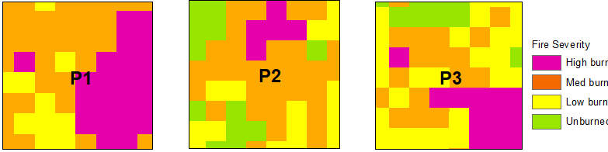
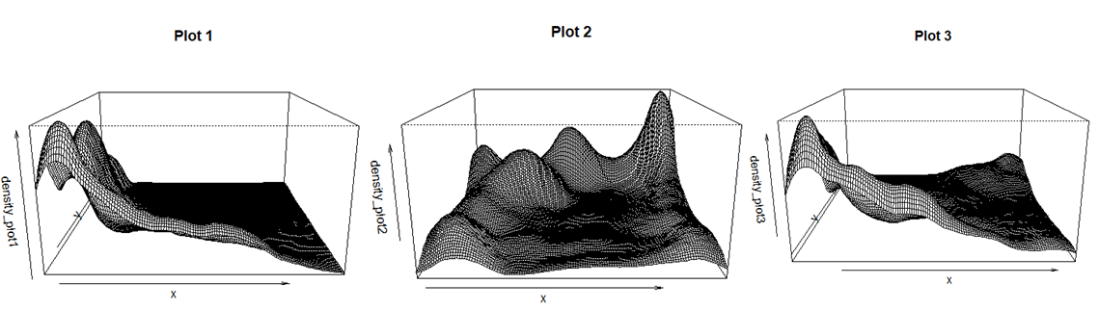
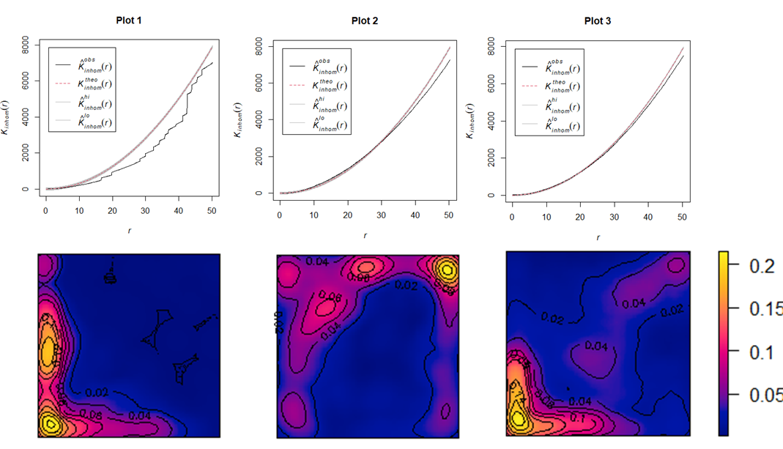
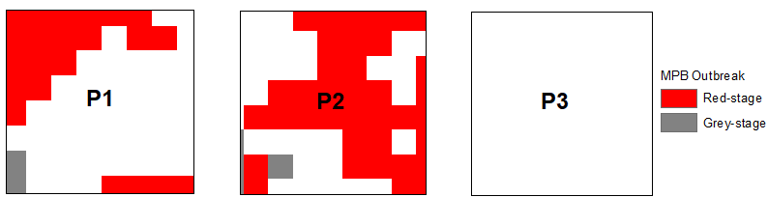

Fig. 7 Top row: Ripley’s K-diagrams showing regeneration patterns of dispersion and clustering below and above the null model in each plot. Second from top row: Kernel density heat maps depicting seedling intensity at a bandwidth of 10m. Third from top row: Diagram of stem mapped data by species. Bottom row: Perspective maps representing kernel density on a 3-dimensional plane.

These spatial trends were contrary to descriptive analysis of plot disturbances (Table 2.2, Figure 13). In plot 1, with dispersed seedlings, larger areas experienced high severity burn (h = 15.83, df = 2, p = 0.0004) and moderate severity burn (h = 137.19, df = 2, p < 0.000). Meanwhile, in plot 2, where seedlings clustered, significantly greater areas were affected by red-stage outbreak (h = 969.49, df = 2, p<0.000).
The findings above regarding plot-level and global variance in seedling density present conflicting evidence concerning our primary hypothesis H1 and secondary hypothesis H2. On one hand, the spatial distribution of seedling density implies a detrimental impact of wildfire on regeneration across plots, as dispersion patterns align with larger areas affected by higher severity burn. Conversely, variations in seedling density (ha⁻¹) between plots indicate a positive influence of wildfire on regeneration patterns, with the highest density observed in plot 1. Accordingly, it becomes imperative to apply finer scale analysis between species and within plots to better understand seedling patterns and disturbance interactions.

3.2 Spatial patterns of post-fire regeneration density between species
Across the total sample, there was statistically significant variation in mean seedling density between species (h = 1568, df = 7, p < 0.000) (Table 15). Lodgepole pine exhibited the highest relative density, comprising 73.5% of the post-fire seedlings sampled. Subsequent species with discernible contributions were Western larch (8.2%) and Engelman spruce (7.4%).
Spatial analyses revealed distinct clustering patterns among all conifers (p < 0.05). Substantial deviations from complete spatial randomness were identified among Lodgepole pine, Douglas-fir, Engelman spruce, and Western hemlock at intermediate scales ranging from 10 to 55m. Additionally, significant departures from CSR were noted among Western larch, Ponderosa pine, and Western white pine at distances spanning from 60 to 180m (Figure 15).

Table 15 Mean values (Stdev) reporting absolute ‘Density’, nearest-neighbour distance ‘NNdist’, and distance to seed source ‘SSdist’ seedlings by species across all plots. *Kruskal Wallis nonparametric test of variance: values reported in bold significantly higher than other plots at 0.05, 0.01, 0.001 levels as *, **, ***. Significant deviations from CSR towards clustering (<1.000) and dispersion (>1.000) shown in bold at 0.05, 0.01, 0.001 levels as #, #, ### according to the Hopskel and Skellam index.
 | Density^{ha-1} (%) | NNdist (m) | SSdist (m) | HS-index
Pinus contorta | 239.8 (74.4%)*** | 2.61 | 35.29 (29.62) | 0.803**
Larix o. | 26.7 (8.3%) | 8.26 | 33.25 (28.03) | 0.844**
Picea e. | 24.2 (7.5%) | 8.54 | 35.90 (30.70) | 0.833**
Pseudo. M. | 17.4 (5.4%) | 10.18 | 36.20 (29.73) | 0.843**
Pinus p. | 7.1 (2.2%) | 14.53 | 44.79 (40.86) | 0.768**
Pinus m. | 4.3 (1.3%) | 21.00 | 26.84 (20.54) | 0.867*
Tsuga h. | 2.8 (0.9%) | 21.71*** | 42.32 (35.45) | 0.725*
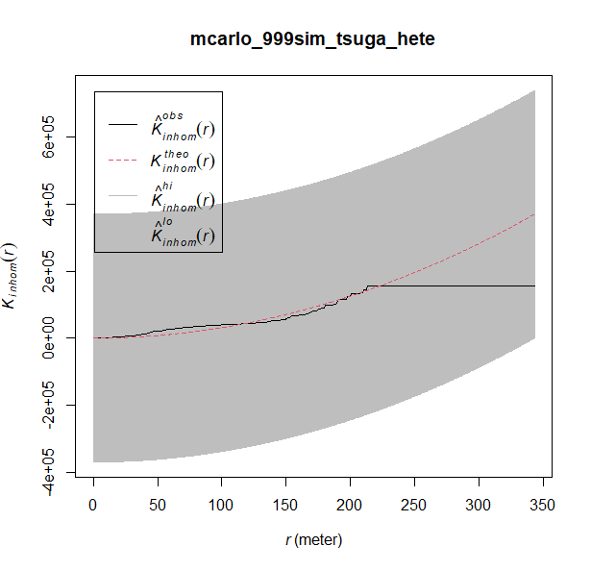
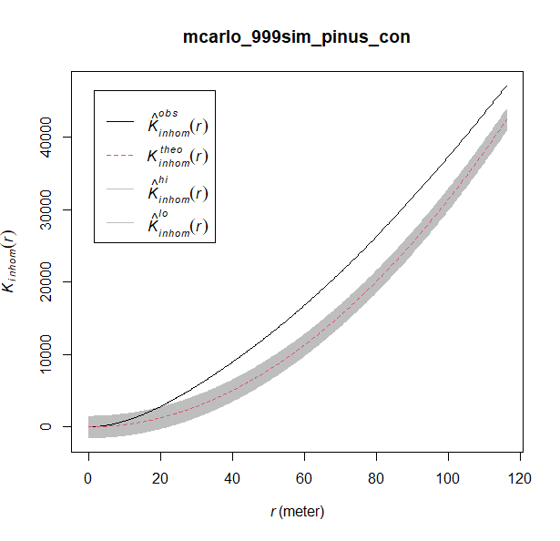
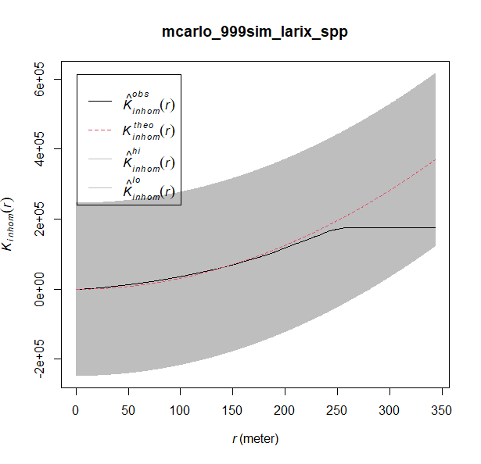
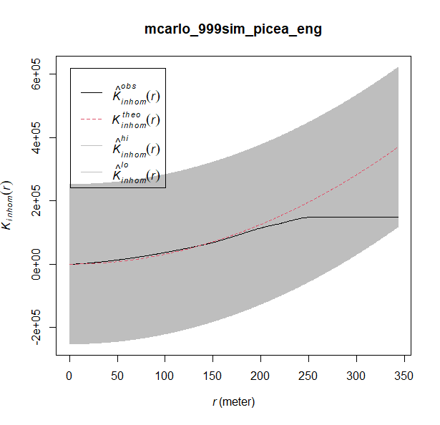
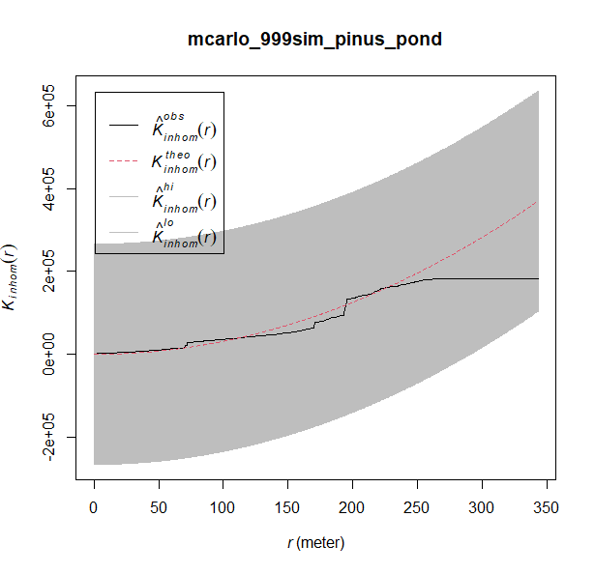
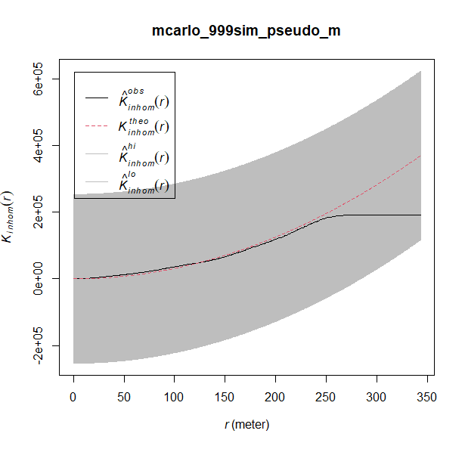
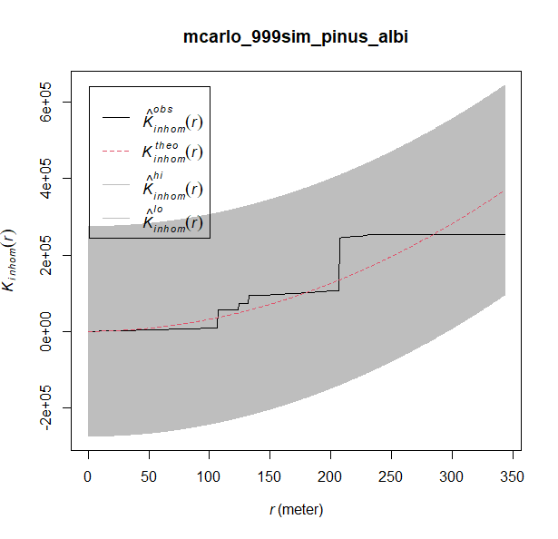

Fig. 8 Ripley’s K-diagrams of regeneration patterns of each conifer species across all plots. Clockwise from top left: Pinus contorta, Larix occidentalis, Picea engelmannii, Pseudotsuga menziesii, Pinus ponderosa, Pinus monticola, and Tsuga heterophylla.

3.1 Spatial patterns of seedling intensity in response to covariates by species
Cox process models indicated that spatial patterns of all conifer seedlings combined were positively associated with low severity fire (p<0.001), while increasing distance to seed sources, higher wind speeds, red-stage beetle outbreaks, and high severity fire were negatively associated (p<0.01, Table 16). Specifically, in areas with low severity fire, seedling intensity among conifers collectively increased by 18.1%. Conversely, intensity decreased by 18.9% in high severity fire areas and by 14.3% in regions affected by red-stage beetle outbreaks
When disaggregated by species, high severity fire had significantly adverse effects on regeneration patterns for four species: Lodgepole pine, Douglas-fir, Ponderosa pine, and Western hemlock (p<0.05). The strength of these relationships varied markedly. Notably, in high burn areas, seedling intensity decreased most significantly for 'fire-avoiders' like Western redcedar (β = -1.851), followed by 'fire resisters' like Ponderosa pine (β = -1.030) and Douglas-fire (β = -0.627). In contrast, Lodgepole pine exhibited a comparatively modest decrease of 17.3%, in part confirming our first hypothesis (H1).
Combined disturbances from beetle outbreaks and wildfires significantly affected seedling patterns for only one species, Lodgepole pine. Additionally, the effects of beetle outbreaks, though variable between host and non-host species, yielded unexpected outcomes. Red-stage beetle outbreaks negatively impacted seedling intensity of two host species, Lodgepole pine (β = -0.167, p<0.001) and Western white pine (β = -1.151, p<0.05). Conversely, grey-stage beetle outbreaks had no significant effect on seedling intensity of any species.

Table 16 Regression estimates of seedling intensity and their influence by covariates according to inhomogeneous Cox-process models.
 | Int. | SS-dist | Aspect | RIX | Wind | MPB-G | MPB-R | Fire-high | Fire-low
All seeds | -3.051*** | -0.097*** | 0.003 | -0.312 | -0.189*** | 0.339 | -0.116** | -0.206*** | 0.182***
 | 0.188 | 0.002 | 0.000 | 0.323 | 0.023 | 0.185 | 0.044 | 0.053 | 0.037
Pinus  contorta | -3.311*** | -0.100*** | 0.001* | -0.122 | -0.240*** | 0.173 | -0.167** | -0.173** | 0.168***
 | 0.221 | 0.002 | 0.001 | 0.375 | 0.031 | 0.231 | 0.052 | 0.06 | 0.043
Larix  occidentalis | -5.186*** | -0.093*** | 0.002 | -0.862 | -0.234* | 0.892 | -0.094 | -0.085 | 0.225
 | 0.665 | 0.005 | 0.001 | 1.138 | 0.093 | 0.56 | 0.156 | 0.174 | 0.134
Picea  engelmannii | -5.697*** | -0.085*** | -0.001 | 0.165 | -0.204* | 0.749 | 0.005 | -0.348 | 0.196
 | 0.666 | 0.006 | 0.001 | 1.159 | 0.129 | 0.528 | 0.157 | 0.201 | 0.135
Pseudo. menziesii | -5.993*** | -0.083*** | 0.005 | -0.505 | -0.150 | 0.823 | -0.315 | -0.627* | 0.406**
 | 0.803 | 0.007 | 0.002 | 1.359 | 0.128 | 0.613 | 0.194 | 0.265 | 0.155
Pinus  ponderosa. | -3.527* | -0.101*** | -0.006 | -2.56 | -0.530* | -14.822 | 0.233 | -1.030* | 0.024
 | 1.502 | 0.013 | 0.005 | 2.502 | 0.253 | 2.171 | 0.37 | 0.448 | 0.258
Pinus  monticola | -17.940*** | -0.085*** | 0.010*** | 1.257 | 1.469** | -16.057 | -1.151* | 0.409 | 0.601
 | 2.792 | 0.018 | 0.003 | 2.659 | 0.523 | 2.53 | 0.477 | 0.47 | 0.452
Tsuga heterophylla | -15.070*** | -0.104*** | -0.012 | 11.871* | 0.333 | -13.737 | -0.897 | -1.851* | 0.006
 | 2.480 | 0.021 | 0.008 | 4.905 | 0.336 | 2.530 | 0.575 | 0.814 | 0.365

Wind exerted significantly adverse effects on the regeneration of four conifer species—Lodgepole pine, Western larch, Engelman spruce, and Ponderosa pine (p<0.05). In contrast, for Western white pine, wind demonstrated a significant positive impact on patterns of seedling intensity (p<0.01). Specifically, in areas where the mean wind speed exceeded the site average by 1m/s (4.9m/s; see Table 2.1), the seedling intensity of Western white pine increased by a substantial 146.9%. Furthermore, Western white pine exhibited greater abundance on southern-facing aspects (p<0.001), distinguishing it from other conifers that thrived on eastern and north-eastern aspects. This suggests a pivotal role of topography and wind in the dispersion and establishment of specific conifers under changing environments. Considering the biogeoclimatic history of Western white pine in the Creston Valley, it is plausible that average wind vectors from a westerly direction favour its downhill expansion as a 'fire invader' into exposed areas subsequent to the wildfire disturbance.

4. Discussion
In this study, we examined the spatial patterns of post-fire conifer regeneration following disturbance events of mixed-severity wildfire and mountain pine beetle outbreaks. Our exploration centred on three hypotheses: (H1) anticipating lower seedling intensity in high severity fire zones for different conifer groups; (H2) expecting diminished seedling intensity in areas of beetle outbreak for host species compared to non-hosts; and (H3) projecting reduced seedling intensity in locations experiencing combined disturbances from both high severity fire and beetle outbreaks for host species versus non-host species.
Our results offered partial support for these hypotheses. ‘Fire evaders,’ notably Lodgepole pine, exhibited significantly higher seedling intensity in high severity fire areas compared to ‘fire resistors' such as Douglas-fir and Ponderosa pine. Additionally, seedling intensity was notably lower among host species (Lodgepole pine and Ponderosa pine) than among non-host species in areas of beetle outbreak, aligning with our expectations. However, the effects of combined disturbances were only significant for Lodgepole pine and negligible for Western white pine and Ponderosa pine. Intriguingly, our models highlighted the pivotal role of abiotic factors, specifically topography and wind, in influencing the spatial patterns of post-fire and post-beetle conifer regeneration among both host and non-host species.

4.1 Species responses to mixed severity fire events
Historically, wildfire and beetle outbreaks have been pivotal in shaping the dynamics of forest ecosystems in Southern Interior British Columbia. Existing literature underscores the diverse regeneration strategies of conifers as key determinants in stand competition between early- and late-seral species ^{65,124–126}. Our findings align with these theoretical frameworks, revealing a nuanced relationship between post-fire regeneration and varying traits of post-fire seed dispersal and fire-resilience. Notably, wildfire had more pronounced effects on ‘fire avoiders’ and ‘fire resisters,’ such as Western hemlock, Douglas-fir, and Ponderosa pine, which possess characteristics making them susceptible to mixed-severity fires and the resulting post-disturbance stand mosaic patterns.
While distance to residual forest constrained post-fire regeneration, intraspecific mechanisms of seed dispersal conferred advantages to ‘fire-evaders’ and early seral species, such as Lodgepole pine, vying for exposed light, space, and soil minerals. This observation prompts further analysis to discern the links between higher regeneration rates and available space versus distance to seed sources in our study site.

4.2 Species responses to beetle outbreaks preceding wildfire events
We explored the efficacy of remote sensing methods combined with traditional field surveys in detecting Mountain pine beetle outbreaks and wildfire burn severity in our study. Our results affirmed the accuracy of these measures for detecting MPB attacks, with an Overall Accuracy score of 82.4% that was consistent with estimates from studies by Wulder et al. ¹⁵ and White et al. ¹²⁷. Moreover, accuracy of measures for detecting wildfire burn severity classed were also consistent with previous studies (>87% OA).⁸⁸
Amidst the ongoing discourse on climate warming trends heightening risks of compounded disturbances between wildfires and beetle outbreaks ^{128–131}, our findings contribute novel evidence regarding the temporal dynamics of these disturbance partnerships. Notably, red-stage beetle outbreaks had a detrimental effect on Lodgepole pine seedling patterns, whereas grey-stage outbreaks showed no significant negative associations (β = 0.173). Intriguingly, low severity fire produced significantly positive benefits (β = 0.168, p<0.000). The observed variability in seedling patterns across grey and red-stage outbreaks and different fire severities implies a weakening impact of beetle-caused tree mortality on the ecological consequences of subsequent wildfire events over time. This aligns with previous studies suggesting that such outcomes relate to the gradual decay and loss of surface fuels induced by wind or climate since the initial attack ^{20,26,28}.
Given the significance of topography and wind, our models suggest that wildfire and beetle disturbances should be considered in conjunction with site-level environmental factors. Research suggests that in such exposed sites of these subalpine and montane forests, topographic features only serve to intensify climatic shifts in growing conditions and disturbance regimes ^{132,133}. This highlights the particular significance of topography to seed dispersion among serotinous Lodgepole pine stands where prevailing winds may impede or benefit processes of seed rain. Furthermore, such processes are especially important in sites of mixed-severity fires, where aerial dispersal provides a critical seed source to burn patches at lower elevations that are otherwise separated from residual parent trees ¹¹⁶. Important to note, however, this study was limited in its analysis of serotinous versus non-serotinous processes. To offer insight on these issues, further data collection is needed to investigate processes of seed production. This calls for future research to investigate such potential links between biotic and abiotic drivers of seed delivery and seedling establishment across varying scales.

Bibliography
1. A. Dhar, L. Parrott, and C. D. B. Hawkins, “Aftermath of Mountain Pine Beetle Outbreak in British Columbia: Stand Dynamics, Management Response and Ecosystem Resilience,” 8, Forests 7(8), 171, Multidisciplinary Digital Publishing Institute (2016) [doi:10.3390/f7080171].
2. N. B. Grimm et al., “The impacts of climate change on ecosystem structure and function,” Front. Ecol. Environ. 11(9), 474–482 (2013) [doi:10.1890/120282].
3. K. F. Raffa et al., “Cross-scale Drivers of Natural Disturbances Prone to Anthropogenic Amplification: The Dynamics of Bark Beetle Eruptions,” BioScience 58(6), 501–517 (2008) [doi:10.1641/B580607].
4. P. J. van Mantgem et al., “Widespread increase of tree mortality rates in the western United States,” Science 323(5913), 521–524 (2009) [doi:10.1126/science.1165000].
5. L. D. Daniels, R. W. Gray, and P. Burton, “2017 Megafires in British Columbia-Urgent need to adapt and improve resilience to wildfire,” Proc. Fire Contin. Future Wildland Fire Eds SM Hood Drury T Steelman R Steffens Fort Collins CO Rocky Mt. Res. Stn. (2020).
6. G. Filmon, “Firestorm 2003. Provincial review of the 2003 fire season” (2004).
7. A. Hamann and T. Wang, “Potential effects of climate change on ecosystem and tree species distribution in British Columbia,” Ecology 87(11), 2773–2786 (2006) [doi:10.1890/0012-9658(2006)87[2773:peocco]2.0.co;2].
8. J. S. Littell et al., “Climate and wildfire area burned in western U.S. ecoprovinces, 1916–2003,” Ecol. Appl. 19(4), 1003–1021 (2009) [doi:10.1890/07-1183.1].
9. R. A. Loehman, J. A. Clark, and R. E. Keane, “Modeling Effects of Climate Change and Fire Management on Western White Pine (Pinus monticola) in the Northern Rocky Mountains, USA,” 4, Forests 2(4), 832–860, Molecular Diversity Preservation International (2011) [doi:10.3390/f2040832].
10. R. H. Waring and N. C. Coops, “Predicting large wildfires across western North America by modeling seasonal variation in soil water balance,” Clim. Change 135, 325–339 (2016) [doi:10.1007/s10584-015-1569-x].
11. B. Buma, “Disturbance interactions: characterization, prediction, and the potential for cascading effects,” Ecosphere 6(4), 1–15 (2015) [doi:10.1890/ES15-00058.1].
12. K. Jia et al., “Fractional vegetation cover estimation algorithm for Chinese GF-1 wide field view data,” Remote Sens. Environ. 177, 184–191 (2016) [doi:10.1016/j.rse.2016.02.019].
13. L. Safranyik, B. Wilson, and Pacific Forestry Centre, The mountain pine beetle: a synthesis of biology, management, and impacts on lodgepole pine, Canadian Forest Service, Pacific Forestry Centre, Victoria, BC (2006).
14. M. A. Wulder et al., “Surveying mountain pine beetle damage of forests: A review of remote sensing opportunities,” For. Ecol. Manag. 221(1–3), 27–41, Elsevier (2006).
15. M. A. Wulder et al., “Estimating the probability of mountain pine beetle red-attack damage,” Remote Sens. Environ. 101(2), 150–166 (2006) [doi:10.1016/j.rse.2005.12.010].
16. S. W. Taylor et al., “Forest, climate and mountain pine beetle outbreak dynamics in western Canada,” Mt. Pine Beetle Synth. Biol. Manag. Impacts Lodg. Pine, 67–94, Canadian Forest Service: Victoria, BC, Canada (2006).
17. J. Westfall and M. Duthie-Holt, 2021 summary of forest health conditions in British Columbia, Ministry of Forests and Range, Forest Practices Branch (2021).
18. J. Westfall and T. Ebata, 2011 summary of forest health conditions in British Columbia, Ministry of Forests and Range, Forest Practices Branch (2011).
19. B. J. Harvey et al., “Fire severity and tree regeneration following bark beetle outbreaks: the role of outbreak stage and burning conditions,” Ecol. Appl. 24(7), 1608–1625, Wiley (2014).
20. J. A. Hicke et al., “Effects of bark beetle-caused tree mortality on wildfire,” For. Ecol. Manag. 271, 81–90, Elsevier (2012).
21. M. J. Jenkins et al., “Fuels and fire behavior dynamics in bark beetle-attacked forests in Western North America and implications for fire management,” For. Ecol. Manag. 275, 23–34, Elsevier (2012).
22. A. J. H. Meddens, J. A. Hicke, and C. A. Ferguson, “Spatiotemporal patterns of observed bark beetle-caused tree mortality in British Columbia and the western United States,” Ecol. Appl. Publ. Ecol. Soc. Am. 22(7), 1876–1891 (2012) [doi:10.1890/11-1785.1].
23. W. G. Page, M. J. Jenkins, and M. E. Alexander, “Foliar moisture content variations in lodgepole pine over the diurnal cycle during the red stage of mountain pine beetle attack,” Environ. Model. Softw. 49, 98–102, Elsevier (2013).
24. D. D. B. Perrakis et al., “Modeling Wildfire Spread in Mountain Pine Beetle-Affected Forest Stands, British Columbia, Canada,” 2, Fire Ecol. 10(2), 10–35, SpringerOpen (2014) [doi:10.4996/fireecology.1002010].
25. M. Simard et al., “Do mountain pine beetle outbreaks change the probability of active crown fire in lodgepole pine forests?,” Ecol. Monogr. 81(1), 3–24 (2011) [doi:10.1890/10-1176.1].
26. A. C. Talucci and M. A. Krawchuk, “Dead forests burning: the influence of beetle outbreaks on fire severity and legacy structure in sub-boreal forests,” Ecosphere 10(5), e02744 (2019) [doi:10.1002/ecs2.2744].
27. B. J. Harvey, D. C. Donato, and M. G. Turner, “High and dry: Post-fire tree seedling establishment in subalpine forests decreases with post-fire drought and large stand-replacing burn patches,” Glob. Ecol. Biogeogr. 25(6), 655–669, Wiley Online Library (2016).
28. A. C. Talucci, K. P. Lertzman, and M. A. Krawchuk, “Drivers of lodgepole pine recruitment across a gradient of bark beetle outbreak and wildfire in British Columbia,” For. Ecol. Manag. 451, 117500 (2019) [doi:10.1016/j.foreco.2019.117500].
29. T. Schoennagel et al., “Effects of mountain pine beetle on fuels and expected fire behavior in lodgepole pine forests, Colorado, USA,” PloS One 7(1), e30002, Public Library of Science San Francisco, USA (2012).
30. C. Stevens-Rumann, P. Morgan, and C. Hoffman, “Bark beetles and wildfires: How does forest recovery change with repeated disturbances in mixed conifer forests?,” Ecosphere 6(6), art100 (2015) [doi:10.1890/ES14-00443.1].
31. G. D. Amman, Mountain Pine Beetle Dynamics in Lodgepole Pine Forests: Population Dynamics, US Department of Agriculture, Forest Service, Intermountain Forest and Range … (1983).
32. J. Henigman et al., “Field guide to forest damage in British Columbia.,” Field Guide For. Damage Br. Columbia, British Columbia Ministry of Forests (1999).
33. W. M. Jolly et al., “Relationships between moisture, chemistry, and ignition of Pinus contorta needles during the early stages of mountain pine beetle attack,” For. Ecol. Manag. 269, 52–59, Elsevier (2012).
34. D. C. Donato et al., “Bark beetle effects on fuel profiles across a range of stand structures in Douglas-fir forests of Greater Yellowstone,” Ecol. Appl. 23(1), 3–20, Wiley Online Library (2013).
35. A. J. H. Meddens et al., “Evaluating methods to detect bark beetle-caused tree mortality using single-date and multi-date Landsat imagery,” Remote Sens. Environ. 132, 49–58 (2013) [doi:10.1016/j.rse.2013.01.002].
36. A. L. Carroll et al., “Effects of Climate Change on Range Expansion by the Mountain Pine Beetle in British Columbia,” 10 (2003).
37. D. M. Bell, J. B. Bradford, and W. K. Lauenroth, “Early indicators of change: divergent climate envelopes between tree life stages imply range shifts in the western United States,” Glob. Ecol. Biogeogr. 23(2), 168–180 (2014) [doi:10.1111/geb.12109].
38. D. G. McCullough, R. A. Werner, and D. Neumann, “Fire and Insects in Northern and Boreal Forest Ecosystems of North America,” Annu. Rev. Entomol. 43(1), 107–127 (1998) [doi:10.1146/annurev.ento.43.1.107].
39. B. Buma and C. A. Wessman, “Disturbance interactions can impact resilience mechanisms of forests,” Ecosphere 2(5), 1–13, Wiley Online Library (2011).
40. D. G. Despain, D. L. Clark, and J. J. Reardon, “Simulation of crown fire effects on canopy seed bank in lodgepole pine,” Int. J. Wildland Fire 6(1), 45–49, CSIRO Publishing (1996).
41. B. B. Lamont et al., “Canopy seed storage in woody plants,” Bot. Rev. 57, 277–317, Springer (1991).
42. F. P. Teste, V. J. Lieffers, and S. M. Landhäusser, “Seed release in serotinous lodgepole pine forests after mountain pine beetle outbreak,” Ecol. Appl. 21(1), 150–162, Wiley Online Library (2011).
43. N. E. West, “Rodent-influenced establishment of ponderosa pine and bitterbrush seedlings in central Oregon,” Ecology 49(5), 1009–1011, Wiley Online Library (1968).
44. S. B. Vander Wall, “Seed Dispersal in Pines (Pinus),” Bot. Rev., 1–33, Springer (2023).
45. J. N. Owens, The reproductive biology of western white pine, Forest Renewal BC (2005).
46. J. N. Owens and M. Molder, “Seed-cone differentiation and sexual reproduction in western white pine (Pinus monticola),” Can. J. Bot. 55(20), 2574–2590, NRC Research Press Ottawa, Canada (1977).
47. E. Toffin et al., “Colonization of weakened trees by mass-attacking bark beetles: no penalty for pioneers, scattered initial distributions and final regular patterns,” R. Soc. Open Sci. 5(1), 170454 (2018) [doi:10.1098/rsos.170454].
48. T. J. Hoecker, W. D. Hansen, and M. G. Turner, “Topographic position amplifies consequences of short-interval stand-replacing fires on postfire tree establishment in subalpine conifer forests,” For. Ecol. Manag. 478, 118523, Elsevier (2020).
49. D. V. Meidinger and J. Pojar, Eds., Ecosystems of British Columbia, Research Branch, Ministry of Forests, Victoria, B.C (1991).
50. K. J. Kemball, G. G. Wang, and A. R. Westwood, “Are mineral soils exposed by severe wildfire better seedbeds for conifer regeneration?,” Can. J. For. Res. 36(8), 1943–1950, NRC Research Press (2006) [doi:10.1139/x06-073].
51. M. Veilleux-Nolin and S. Payette, “Influence of recent fire season and severity on black spruce regeneration in spruce–moss forests of Quebec, Canada1This article is one of a selection of papers from the 7th International Conference on Disturbance Dynamics in Boreal Forests.,” Can. J. For. Res. 42(7), 1316–1327, NRC Research Press (2012) [doi:10.1139/x2012-098].
52. J. K. Kreye, J. M. Varner, and C. J. Dugaw, “Spatial and temporal variability of forest floor duff characteristics in long-unburned Pinus palustris forests,” Can. J. For. Res. 44(12), 1477–1486, NRC Research Press (2014) [doi:10.1139/cjfr-2014-0223].
53. S. C. Grossnickle and J. H. Russell, “Physiological variation among western redcedar (Thuja plicata Donn ex D. Don) populations in response to short-term drought,” Ann. For. Sci. 67(5), 506–506 (2010) [doi:10.1051/forest/2010008].
54. M. E. Chambers et al., “Patterns of conifer regeneration following high severity wildfire in ponderosa pine – dominated forests of the Colorado Front Range,” For. Ecol. Manag. 378, 57–67 (2016) [doi:10.1016/j.foreco.2016.07.001].
55. A. P. Lerch et al., “Mountain Pine Beetle Dynamics and Reproductive Success in Post-Fire Lodgepole and Ponderosa Pine Forests in Northeastern Utah,” PLOS ONE 11(10), e0164738, Public Library of Science (2016) [doi:10.1371/journal.pone.0164738].
56. J. P. Ziegler et al., “Tree Regeneration Spatial Patterns in Ponderosa Pine Forests Following Stand-Replacing Fire: Influence of Topography and Neighbors,” 10, Forests 8(10), 391, Multidisciplinary Digital Publishing Institute (2017) [doi:10.3390/f8100391].
57. C. H. Sieg et al., “Fires Following Bark Beetles: Factors Controlling Severity and Disturbance Interactions in Ponderosa Pine,” Fire Ecol. 13(3), 1–23 (2017) [doi:10.4996/fireecology.130300123].
58. B. P. Oswald and L. F. Neuenschwander, “Microsite characteristics and safe site description for western larch germination and initial seedling establishment,” U.S. Dept. of Agriculture, Forest Service, Intermountain Research Station (1995).
59. A. M. Sparks et al., “An experimental assessment of the impact of drought and fire on western larch injury, mortality and recovery,” Int. J. Wildland Fire 27(7), 490 (2018) [doi:10.1071/WF18044].
60. K. S. Hadley, “The Role of Disturbance, Topography, and Forest Structure in the Development of a Montane Forest Landscape,” Bull. Torrey Bot. Club 121(1), 47–61, Torrey Botanical Society (1994) [doi:10.2307/2996883].
61. D. C. Donato et al., “Conifer regeneration in stand-replacement portions of a large mixed-severity wildfire in the Klamath-Siskiyou Mountains,” Can. J. For. Res. 394 823-838 39(4), 823–838 (2009) [doi:10.1139/X09-016].
62. H. Tonbul, T. Kavzoglu, and S. Kaya, “Assessment of Fire Severity and Post-Fire Regeneration Based on Topographical Features Using Multitemporal Landsat Imagery: a Case Study in Mersin, Turkey,” ISPRS - Int. Arch. Photogramm. Remote Sens. Spat. Inf. Sci. 41B8, 763–769 (2016) [doi:10.5194/isprs-archives-XLI-B8-763-2016].
63. S. Z. Dobrowski et al., “Forest structure and species traits mediate projected recruitment declines in western US tree species,” Glob. Ecol. Biogeogr. 24(8), 917–927 (2015) [doi:10.1111/geb.12302].
64. L. S. Rowe, “Concepts of fire effects on plant individuals and species In Wein RW, & MacLean DA (Eds.), The role of fire in northern circumpolar ecosystems (pp. 135–151),” New York, NY: John Wiley & Sons.[Google Scholar] (1983).
65. J. Agee, “The Landscape Ecology of Western Forest Fire Regimes,” Northwest Sci. 72, 24–34 (1998).
66. A. S. Mathys et al., “Diverging distribution of seedlings and mature trees reflects recent climate change in British Columbia,” Ecol. Model. 384, 145–153 (2018) [doi:10.1016/j.ecolmodel.2018.06.008].
67. D. Kolotelo, “Anatomy and Morphology of Conifer Tree Seed Forest Nursery Technical Series 1.1,” BC Minist. For. Surrey BC Can. 60 (1997).
68. T. T. Kozlowski, “Importance, development, and germination,” No Title (1972).
69. H. Singh, “Embryology of gymnosperms,” Schweizerbart’sche Verlagsbuchhandlung (1978).
70. G. S. Allen, J. N. Owens, and others, “The life history of Douglas Fir.,” Life Hist. Douglas Fir (1972).
71. A. Talucci et al., “The influence of bark beetle outbreaks on burn severity for sub-boreal forests in British Columbia,” B53H-2479 (2019).
72. B. MFLNRO, “Mt. Midgeley Wildfire - Post-Wildfire Risk Analysis - Preliminary Report,” Public Wildfire Assessment REport 15 N70624 (2015).
73. K. Buston and L. Maclachlan, “Overview of forest health conditions in southern british columbia” (2018).
74. J. Westfall, T. Ebata, and Bains, Babita, “Forest Health Strategy 2019-2020; Arrow & Cascadia Timber Supply Areas,” Pest Management Report 15, Ministry of Forests, Lands, Natural Resource Operations and Rural Development (2020).
75. D. MacKillop, A field guide to ecosystem classification and identification for Southeast British Columbia: the East Kootenay, British Columbia, Victoria, B.C. (2018).
76. G. J. Barton, E. H. Moran, and C. Berenbrock, “Surveying Cross Sections of the Kootenai River Between Libby Dam, Montana, and Kootenay Lake, British Columbia, Canada,” USGS Numbered Series 2004–1045, U.S. Geological Survey, Reston, VA, p. 42 (2004) [doi:10.3133/ofr20041045].
77. J. D. Cochrane, “Characteristics of historical forest fires in complex mixed-conifer forests of southeastern British Columbia,” University of British Columbia (2007) [doi:10.14288/1.0100776].
78. Natural Resources Canada, “High Resolution Digital Elevation Model (HRDEM),” Geospatial (2017).
79. L. Wang and H. Liu, “An efficient method for identifying and filling surface depressions in digital elevation models for hydrologic analysis and modelling,” Int. J. Geogr. Inf. Sci. 20(2), 193–213, Taylor & Francis (2006).
80. T. W. Beers and C. I. Miller, Manual of forest mensuration, T & C Enterprises (1973).
81. A. J. Parker, “The topographic relative moisture index: an approach to soil-moisture assessment in mountain terrain,” Phys. Geogr. 3(2), 160–168, Taylor & Francis (1982).
82. “Global Wind Atlas,” Global Wind Atlas.
83. C. Daly and K. Bryant, “The PRISM Climate and Weather System – An Introduction,” 5.
84. A. Beaudoin et al., “Tracking forest attributes across Canada between 2001 and 2011 using a k nearest neighbors mapping approach applied to MODIS imagery,” Can. J. For. Res. 48(1), 85–93, NRC Research Press (2018) [doi:10.1139/cjfr-2017-0184].
85. T. Wiegand and K. A. Moloney, Handbook of spatial point-pattern analysis in ecology, CRC press (2013).
86. C. D. Mobley, “Polarized reflectance and transmittance properties of windblown sea surfaces,” Appl. Opt. 54(15), 4828–4849, Optica Publishing Group (2015) [doi:10.1364/AO.54.004828].
87. J. Martin et al., “Automatic Sun Glint Removal of Multispectral High-Resolution Worldview-2 Imagery for Retrieving Coastal Shallow Water Parameters,” 1, Remote Sens. 8(1), 37, Multidisciplinary Digital Publishing Institute (2016) [doi:10.3390/rs8010037].
88. L. Schepers et al., “Burned Area Detection and Burn Severity Assessment of a Heathland Fire in Belgium Using Airborne Imaging Spectroscopy (APEX),” 3, Remote Sens. 6(3), 1803–1826, Multidisciplinary Digital Publishing Institute (2014) [doi:10.3390/rs6031803].
89. G. Hope et al., “Post-wildfire Natural Hazards Risk Analysis in British Columbia,” Prov. B.C (2016).
90. C. Key and N. Benson, “Landscape assessment: remote sensing of severity, the normalized burn ratio and ground measure of severity, the composite burn index,” FIREMON Fire Eff. Monit. Inventory Syst. Ogden Utah USDA For. Serv. Rocky Mt. Res Stn. (2005).
91. L. Collins et al., “The utility of Random Forests for wildfire severity mapping,” Remote Sens. Environ. 216, 374–384 (2018) [doi:10.1016/j.rse.2018.07.005].
92. L. B. Lentile et al., “Remote sensing techniques to assess active fire characteristics and post-fire effects,” Int. J. Wildland Fire 15(3), 319 (2006) [doi:10.1071/WF05097].
93. S. Trigg and S. Flasse, “An evaluation of different bi-spectral spaces for discriminating burned shrub-savannah,” Int. J. Remote Sens. 22(13), 2641–2647, Taylor & Francis (2001) [doi:10.1080/01431160110053185].
94. F. Filipponi, “BAIS2: Burned Area Index for Sentinel-2,” 7, Proceedings 2(7), 364, Multidisciplinary Digital Publishing Institute (2018) [doi:10.3390/ecrs-2-05177].
95. B. N. Tran et al., “Evaluation of Spectral Indices for Assessing Fire Severity in Australian Temperate Forests,” 11, Remote Sens. 10(11), 1680, Multidisciplinary Digital Publishing Institute (2018) [doi:10.3390/rs10111680].
96. A. Smith et al., “Production of Landsat ETM+ reference imagery of burned areas within Southern African savannahs: comparison of methods and application to MODIS,” Int. J. Remote Sens. 28(12), 2753–2775, Taylor & Francis (2007).
97. Z. A. Holden et al., “Evaluation of novel thermally enhanced spectral indices for mapping fire perimeters and comparisons with fire atlas data,” Int. J. Remote Sens. Vol 26 No 21 4801-­4808 (2005) [doi:10.1080/01431160500239008].
98. S. Jin and S. A. Sader, “Comparison of time series tasseled cap wetness and the normalized difference moisture index in detecting forest disturbances,” Remote Sens. Environ. 94(3), 364–372, Elsevier (2005).
99. B. D. Woodward, P. H. Evangelista, and A. G. Vorster, “Mapping progression and severity of a Southern Colorado spruce beetle outbreak using calibrated image composites,” Forests 9(6), 336, MDPI (2018).
100. J. A. Walter and R. V. Platt, “Multi-temporal analysis reveals that predictors of mountain pine beetle infestation change during outbreak cycles,” For. Ecol. Manag. 302, 308–318, Elsevier (2013).
101. A. R. Carlson et al., “Evidence of compounded disturbance effects on vegetation recovery following high-severity wildfire and spruce beetle outbreak,” PLOS ONE 12(8), e0181778, Public Library of Science (2017) [doi:10.1371/journal.pone.0181778].
102. S. K. Hagle, Field guide to diseases and insect pests of northern and central Rocky Mountain conifers, US Department of Agriculture, Forest Service, State and Private Forestry … (2003).
103. G. D. Amman, “Mountain pine beetle--identification, biology, causes of outbreaks, and entomological research needs,” BC-X - Can. For. Serv. Pac. For. Res. Cent. (1982).
104. B. Gao, “NDWI—A normalized difference water index for remote sensing of vegetation liquid water from space,” Remote Sens. Environ. 58(3), 257–266 (1996) [doi:10.1016/S0034-4257(96)00067-3].
105. M. Hansen et al., “Forest structure classification in the North Columbia mountains using the Landsat TM Tasseled Cap wetness component,” Can. J. Remote Sens. 27(1), 20–32, Taylor & Francis (2001).
106. W. B. Cohen et al., “An efficient and accurate method for mapping forest clearcuts in the Pacific Northwest using Landsat imagery,” Photogramm. Eng. Remote Sens. 64(4), 293–299, [Falls Church, Va.] American Society of Photogrammetry. (1998).
107. S. E. Franklin, Remote sensing for sustainable forest management, CRC press (2001).
108. S. E. Franklin et al., “Change detection and landscape structure mapping using remote sensing,” For. Chron. 78(5), 618–625, NRC Research Press Ottawa, Canada (2002).
109. J. B. Collins and C. E. Woodcock, “An assessment of several linear change detection techniques for mapping forest mortality using multitemporal Landsat TM data,” Remote Sens. Environ. 56(1), 66–77, Elsevier (1996).
110. A. Klippel, F. Hardisty, and R. Li, “Interpreting spatial patterns: An inquiry into formal and cognitive aspects of Tobler’s first law of geography,” Ann. Assoc. Am. Geogr. 101(5), 1011–1031, Taylor & Francis (2011).
111. R. Tapia-McClung, “Detecting hot spots of mountain pine beetle infestations in the forests of British Columbia: An approach using local spatial autocorrelation” (2006).
112. M. Agovino et al., “Spatial analysis of wildfire incidence in the USA: The role of climatic spillovers,” Environ. Dev. Sustain. 23(4), 6084–6105, Springer (2021).
113. A. Baddeley, E. Rubak, and R. Turner, Spatial Point Patterns: Methodology and Applications with R, 1st edition, Chapman and Hall/CRC, Boca Raton ; London ; New York (2015).
114. J. Agee, “Fire Ecology of Pacific Northwest Forests,” Bark Beetles Fuels Fire Bibliogr. (1996).
115. A. J. Larson and D. Churchill, “Tree spatial patterns in fire-frequent forests of western North America, including mechanisms of pattern formation and implications for designing fuel reduction and restoration treatments,” For. Ecol. Manag. 267, 74–92 (2012) [doi:10.1016/j.foreco.2011.11.038].
116. S. L. Malone et al., “Mixed-Severity Fire Fosters Heterogeneous Spatial Patterns of Conifer Regeneration in a Dry Conifer Forest,” 1, Forests 9(1), 45, Multidisciplinary Digital Publishing Institute (2018) [doi:10.3390/f9010045].
117. A. Baddeley et al., “On tests of spatial pattern based on simulation envelopes,” Ecol. Monogr. 84(3), 477–489 (2014) [doi:10.1890/13-2042.1].
118. I. Yamada and P. A. Rogerson, “An empirical comparison of edge effect correction methods applied to K-function analysis,” Geogr. Anal. 35(2), 97–109, Wiley Online Library (2003).
119. E. Pielou, “The use of plant-to-neighbour distances for the detection of competition,” J. Ecol., 357–367, JSTOR (1962).
120. B. Van Es, “Likelihood cross-validation bandwidth selection for nonparametric kernel density estimators,” J. Nonparametric Stat. 1(1–2), 83–110, Taylor & Francis (1991) [doi:10.1080/10485259108832513].
121. V. Fonti and E. Belitser, “Feature selection using lasso,” VU Amst. Res. Pap. Bus. Anal. 30, 1–25, Business Analytics Master Amsterdam, The Netherland (2017).
122. I. W. Renner et al., “Point process models for presence-only analysis,” Methods Ecol. Evol. 6(4), 366–379, Wiley Online Library (2015).
123. J. B. Illian, S. H. Sørbye, and H. Rue, “A toolbox for fitting complex spatial point process models using integrated nested Laplace approximation (INLA)” (2012).
124. R. P. McIntosh, “The background and some current problems of theoretical ecology,” Synthese 43, 195–255, Springer (1980).
125. S. T. A. Pickett and P. S. White, Eds., The Ecology of Natural Disturbance and Patch Dynamics, 1st edition, Academic Press, San Diego (1987).
126. D. C. Glenn-Lewin, R. K. Peet, and T. T. Veblen, Plant Succession: Theory and prediction, Springer Science & Business Media (1992).
127. J. C. White et al., “Detection of red attack stage mountain pine beetle infestation with high spatial resolution satellite imagery,” Remote Sens. Environ. 96(3–4), 340–351, Elsevier (2005).
128. V. H. Dale et al., “Climate Change and Forest Disturbances: Climate change can affect forests by altering the frequency, intensity, duration, and timing of fire, drought, introduced species, insect and pathogen outbreaks, hurricanes, windstorms, ice storms, or landslides,” BioScience 51(9), 723–734 (2001) [doi:10.1641/0006-3568(2001)051[0723:CCAFD]2.0.CO;2].
129. R. T. Paine, M. J. Tegner, and E. A. Johnson, “Compounded Perturbations Yield Ecological Surprises,” Ecosystems 1(6), 535–545 (1998) [doi:10.1007/s100219900049].
130. D. Kulakowski et al., “Compounded disturbances in sub-alpine forests in western Colorado favour future dominance by quaking aspen (Populus tremuloides),” J. Veg. Sci. 24(1), 168–176 (2013) [doi:10.1111/j.1654-1103.2012.01437.x].
131. C. Bigler, D. Kulakowski, and T. T. Veblen, “Multiple disturbance interactions and drought influence fire severity in Rocky Mountain subalpine forests,” Ecology 86(11), 3018–3029, Wiley Online Library (2005).
132. C. E. Littlefield, “Topography and post-fire climatic conditions shape spatio-temporal patterns of conifer establishment and growth,” Fire Ecol. 15(1), 34 (2019) [doi:10.1186/s42408-019-0047-7].
133. J. Badger et al., “Wind-Climate Estimation Based on Mesoscale and Microscale Modeling: Statistical-Dynamical Downscaling for Wind Energy Applications,” J. Appl. Meteorol. Climatol. 53(8), 1901–1919 (2014) [doi:10.1175/JAMC-D-13-0147.1].

Morphology of seed sizes was defined according to longitudinal and cross-sectional dimensions measured from micropyle to chalazal end, and between upper (abixial) and lower (adaxial) surfaces of a winged female ovule fertilised by male pollen grain and documented within interior British Columbia ^{46,67–70}.

