Testing the wind disruption hypothesis for mountain pine beetle (Dendroctonus ponderosae) refugia
Terrain shelter, stand density and flight-period wind as controls on attack at two scales in the Selkirk Mountains of British Columbia
Seamus Murphy
2026-09-02

Author contributions
SM conceived and designed the study, assembled the data, performed the analysis and wrote the manuscript.

Acknowledgements
This work used no external funding. Beetle disturbance was classified from Landsat Collection 2 Level-2 surface reflectance distributed by the United States Geological Survey; stand structure from the British Columbia Data Catalogue; terrain from Natural Resources Canada; and wind from Environment and Climate Change Canada. The author thanks those agencies for maintaining the open archives the study rests on.

Abstract
Disturbance refugia from mountain pine beetle (Dendroctonus ponderosae Hopkins) outbreaks have been hypothesised by Krawchuk et al. (2020) to form where tree defences remain effective, on shaded ground that spares trees water stress or in thin stands with few large hosts where wind may disrupt the aggregation pheromone, and none has been fitted spatially. All three were tested across 5,573 ha of the Selkirk Mountains, British Columbia, using 59 sixteen-day Landsat epochs over eight outbreak years with annualized forest inventory, geomorphometric variables and a terrain-resolved MicroMet wind field from hourly station records. Wind disruption was supported conditionally, in that attack fell where a thin stand and strong flight-period wind coincided, the density-by-wind interaction -0.049 for stem density (p < 0.001) and -0.017 for standing volume (p < 0.05), both holding against within-season contagion. Terrain acted differently. Leeward ground had more attack as a main effect, -0.249, independent of stand density, and open gentle ground above shallow valleys more still, sky view +0.275, which is the pattern expected if wind-borne beetles, which land without discriminating hosts, settle where the flow slows. Attack responded to host size as a threshold, peaking at 31.5 per cent in the 25 to 30 cm quadratic mean diameter class. The shade hypothesis failed, since north-facing slopes showed more attack (+0.383). Refugia are therefore proposed to lie on warm, windward ground in thin stands during windy flight periods, and the terrain ruggedness signal of the companion study resolves into shelter and openness.

Keywords
mountain pine beetle, forest disturbance, insect outbreaks, Landsat time series, refugia, British Columbia

1. Introduction
Mountain pine beetle (Dendroctonus ponderosae Hopkins) has killed more lodgepole pine (Pinus contorta Douglas ex Loudon) in British Columbia than any other cause on record (Taylor and Carroll 2003; Sambaraju and Goodsman 2021). Mortality is not distributed evenly across a landscape, and the stands that survive supply the structure and seed from which the next forest develops. Such stands are termed disturbance refugia, places buffered from disturbance over time (Krawchuk et al. 2020). Locating a refugium does not explain it, and explanation requires a mechanism linking survival to a measurable property of the site, such as terrain, soil or stand structure (Cartwright 2018).
Krawchuk et al. (2020) proposed such a mechanism, that refugia could occur “in areas with cooler temperatures (eg from topographic shading) that protect trees from water stress; in areas with lower host density, allowing for greater wind disruption of beetle pheromone communication and more vigorous tree growth and chemical defenses; and in areas with fewer large-diameter host trees” (p. 239). These are three testable claims. Topographic shading reduces attack by relieving water stress on cool ground. Low host density reduces attack by admitting the wind that disperses the aggregation pheromone. A scarcity of large-diameter hosts reduces attack by limiting brood production. Two of the three act through terrain, and none has been fitted spatially. The one field test of refugia from this beetle since, by Maher et al. (2021), concerns a fourth mechanism, the krummholz growth form of whitebark pine at alpine treeline, surveyed on transects rather than fitted spatially. Of the prior work cited here, only Murphy et al. (2026) enters a wind term, in a companion study on this same landscape whose response is conifer regeneration rather than beetle attack.
That companion study is the origin of this one. Murphy et al. (2026) fitted the density of conifer seedlings after the 2015 Mt Midgeley fire against seed source distance, fire severity, the red and grey stages of the beetle outbreak, aspect, wind and terrain ruggedness, on the grounds that topography acts as “both disturbance modifier and regeneration filter”, and terrain ruggedness survived its variable selection into the final set of eight covariates, entering the model for all seedlings at +0.626 (p < 0.001), the largest positive terrain term in that study. A ruggedness coefficient records that relief matters without saying which property of the relief the organism responds to. The beetle outbreak that paper entered as a covariate is the response here, and the single ruggedness index is replaced by the terrain quantities the beetle’s biology names, exposure to the prevailing wind, openness to the sky, position on the slope and depth of the valley, so that the relief signal the parent study found can be read component by component.
The wind mechanism is a claim about conditions within the canopy rather than in open air. Cartwright (2018), the only prior study designed to model the controls on an insect refugium, located refugia in stands of low basal area, reasoning that “thinner stands also increase wind penetration, helping to disperse beetle pheromones and disrupt chemical communications needed to coordinate attacks.” Powell and Bentz (2014) state the converse as a condition for outbreak, that “higher local host density, which minimizes pheromone plume dispersion, reduces wind, and promotes successful switching to nearby hosts, positively influences outbreak propensity.” A model that removes stand density and then reads a terrain coefficient as a wind effect has eliminated the pathway it set out to test.
Terrain acts on attack through more than airflow, because emergence and flight “are not directly dependent on chemical cues, but mainly driven by temperature and wind conditions” (Netherer et al. 2021), and flight is itself confined to a temperature window, between 19 and 41 degrees C and mostly between 22 and 32, and most flights occur “on bright sunny days, and peak flight is in the early to mid afternoon” (McCambridge 1971; Safranyik and Carroll 2006). Radiation during the flight window is therefore a different quantity from radiation accumulated across the season, and it is the seasonal quantity that the shading pathway concerns. Light, temperature and wind are therefore less three competing explanations than one bundle of correlated conditions, because stand density governs “tree vigour and within-stand microclimate, which in turn influence success of bark beetle dispersal, host selection, attack or brood development” (Safranyik and Carroll 2006) (Bartos and Amman 1989). Cool sites also slow development enough to push the beetle onto a two-year cycle (Sambaraju and Goodsman 2021), and water stress does not act on defence in one direction, since conifer terpene synthesis rises with moderate stress and falls under severe drought (Netherer et al. 2021), so shade and vigour both predict less attack on cool ground by routes this design cannot separate.
Two further constraints determine the interval over which a wind term can meaningfully be measured, and both are temporal rather than spatial, the first operating within the day. Gray et al. (1972) recorded emergence in D. ponderosae against ambient temperature and found that emergence “began when temperatures rose above 20’ C” and “ceased in the afternoon at about the same threshold temperature”, with “Peak emergence occurred between 11 a. m. and 2 p. m.” and “the sharp decline in activity which occurred when ambient temperatures exceeded 30’ C”. Flight is therefore limited at both ends and confined to a few hours of the afternoon, so a daily or monthly mean wind speed averages across many hours in which no beetle is flying.
The second constraint operates across the season and is a property of the population rather than of the individual, because mass attack is a threshold phenomenon. Howe et al. (2022) conclude that “a combination of stand-level spatial aggregation, behavioral shifts, and higher quality of attainable hosts defines a critical threshold beyond which continual population growth becomes self-driving”, and Cooke et al. (2025) define the irruption threshold as “the population density at which endemic populations may transition towards the epidemic state”. Carroll and Safranyik (2004) place the same argument on the thermal side, requiring “thermal environments conducive to overwintering survival and with sufficient heat accumulation to maintain a synchronous univoltine life cycle”. Two consequences follow for the present design. Attack in one year is not independent of attack in the year before, which is why previous-year and neighbourhood pressure enter the models. An environmental variable acting on this system does so by regulating that threshold rather than by adding to attack (Cooke et al. 2025). A wind effect on mass attack through the plume is therefore expected as an interaction with host density, and not as a main effect.
A third consideration concerns where a dispersing beetle comes down, and it changes what a terrain main effect can mean. Hynum and Berryman (1980) monitored landing on lodgepole pine with landing traps and found that the beetle “is not attracted to lodgepole pine” before the first gallery is started and that beetles “were unable to distinguish between hosts, dead hosts and nonhosts during landing”, so where a beetle lands is decided by its transport rather than by the tree beneath it. Within a stand that transport is short and wind-directed, in that Safranyik et al. (1989) predicted the directional distribution of dispersing beetles from hourly wind direction, and Safranyik et al. (1992) recaptured most released beetles near 3 m above the ground and estimated that “only 0.2 % of the marked beetles dispersed above the stand canopy”. Above the canopy it is long, because Jackson et al. (2008) observed beetles by radar to more than 800 m above the forest, and Chen and Jackson (2017) describe long-distance dispersal as three phases, “the ascent, transport, and descent”, whose mechanisms “are poorly known”, with unstable air under the canopy during emergence that “would help loft beetles above the forest canopy”. A beetle descending from that transport arrives as a wind-borne particle, and de la Giroday et al. (2011) set out what follows, that landscape features “provide impactive surfaces for interception of insects”, that a heavier airborne object is more likely to “impact a surface rather than be swept around the obstacle into lee-ward eddies”, and that settlement rises “in areas where wind speed is reduced”. Where the flow slows is the lee of ridges and sheltered ground, which is the pattern the wind shelter index of Plattner et al. (2004) was built to predict for snow.
Deposition and plume disruption therefore make different predictions, and the difference is what this design can test. Deposition acts before any host is chosen and predicts a main effect of terrain shelter that does not depend on stand density. Plume disruption acts on an aggregation already under way and predicts an interaction between stand density and wind, with no requirement that shelter act alone. A terrain coefficient read without this distinction can be assigned to the wrong mechanism.
No available product reports the quantity the plume hypothesis concerns, an instantaneous below-canopy wind speed at flight height during the flight period. Gridded climatologies report a long-run mean at 10 m over open ground and are downscaled over a digital elevation model, which makes them in part a transform of the terrain variables offered alongside them (Badger et al. 2014; Davis et al. 2023). Wind is therefore taken from station observations of each 16-day period, modified over the terrain with the MicroMet model of Liston and Elder (2006), and the response is measured at Landsat’s own 16-day repeat, which is the finest interval the sensor and the flight period share.
Table 1 sets out the direction expected of each attribute and the reasoning behind it. This study addresses five questions. Does stand density predict moderate-to-high disturbance, as the pheromone mechanism requires? Does topographic shading predict it, against the competing microclimate and adaptive-seasonality arguments? Does terrain shape predict it once density and radiation are already in the model? Is the density effect conditional on wind, which is the form plume disruption takes? Does terrain shelter act as a main effect, which is what deposition of wind-borne beetles predicts, or only through stand density, which is what plume disruption predicts?
Table 1: Landscape attributes entered in this study, the direction expected of each, and the reasoning behind that expectation.
Attribute | Expected | Rationale
Stand basal area, volume, crown closure, stems | positive | Denser canopy holds the pheromone plume together; thinner stands admit wind that disperses it (Powell and Bentz 2014; Cartwright 2018; Krawchuk et al. 2020).
Quadratic mean diameter | positive above 25 cm | Trees under 25 cm are beetle sinks, over 25 cm are sources (Carroll and Safranyik 2004).
Lodgepole pine cover and basal area | positive | Attack cannot occur where the host is absent; a cell without pine is not a refugium (Cartwright 2018).
Flight-period direct radiation | positive | Flight is confined to 19 to 41 degrees C and peaks on bright afternoons, so sunlit slopes are reachable (McCambridge 1971; Safranyik and Carroll 2006).
Growing-season direct radiation | negative | Shading cools, relieving water stress and sustaining defence, and cool sites also push the beetle toward a two-year cycle (Krawchuk et al. 2020; Sambaraju and Goodsman 2021).
Terrain exposure to wind | negative | Wind disrupts the pheromone plume, so exposed ground should have less attack (Krawchuk et al. 2020).
Terrain shelter and sky view | positive, as a main effect | Beetles land without discriminating hosts after wind-borne transport, so sheltered, open ground should receive more landings whatever the stand (Hynum and Berryman 1980; Jackson et al. 2008; Chen and Jackson 2017).
Terrain ruggedness | uncertain | The strongest terrain term in the companion study on this landscape, but fitted there against regeneration rather than attack (Murphy et al. 2026).
Convergence, wetness, valley depth, slope position | positive in convergent terrain | Infested groups gather in draws and gullies, and deep snow insulates overwintering brood (Safranyik and Carroll 2006).
Flight-period wind speed | negative | The mechanism acts during dispersal, and no study specifies the interval, so it is taken at the flight period (Jones et al. 2019; Krawchuk et al. 2020).
Elevation | uncertain | A composite of temperature, snowpack, season length and host distribution that this design cannot separate (Sambaraju and Goodsman 2021).

2. Materials and methods

2.1 Study area
Table 2 sets out the datasets this study combines and the resolution of each. The asymmetry it shows is the one on which the analysis depends, in that the response varies every sixteen days, the inventory once a year, the station wind every hour, and the terrain not at all.
Table 2: The datasets this study combines, with the structure and resolution of each. Every count is read from the files at render time. Spatial resolution is the grid the variable is analysed on; temporal resolution is the interval at which it varies.
Dataset | Source | Variables | Spatial | Temporal | Period # | n
Beetle attack  (per year) | Landsat 5 and 8 C2L2 | Mod-to-high NDMI binary | 30 m | 1 year | 2006-2014, (excl. 2012) | 8 yrs
Beetle attack  (per 16 days) | Landsat 5 and 8 C2L2 | Mod-to-high NDMI binary | 30 m | 16 days | 2006-2014, (excl. 2012) | 59 epochs
Stand structure | VRI Historical,  BC Data Catalogue | Basal area, volume, stems, quadratic mean diameter, age, height | 30 m  (rasterized) | 1 year (projected^{-yr}) | 2005-2014 | 9 windows
Terrain | NRCan High-Res DEM, SAGA Indices | 29 geomorphometric surfaces incl. radiation, exposure, landform | 30 m | Static | n/a | 29 shapes
Station wind | Environment & Climate Change Canada | Speed and direction | 4-7 stations | 1 hour | May-Sept 2005-2014 | 236,079 ^{-hr}
Terrain-wind | DEM-conditioned MicroMet of station data | Weighting factor, modified speed, diverted direction | 30 m | 16 days &  1 year | 2005-2014 | 16 sectors
Modelling yr | Assembled by 38-assemble-model-data.R | Response and covariates (one row per cell-year) | 30 m | 1 year | 2006-2014, (excl. 2012) | 111,707 cell^{-yr}
Modelling 16-day | Assembled by 45-epoch-model-data.R | Response and covariates (one row per cell-year) | 30 m | 16 days | 2006-2014, (excl. 2012) | 66,302 cell^{-epoch}
# Note asymmetry in wind responses from every 16 days, to annually for inventory data, and timeless for terrain variables.

The study area is 5,573 ha of the Selkirk Mountains in southeastern British Columbia, 61,923 cells at 30 m, spanning 830 to 1,744 m, which is 914 m of relief.
The coordinate reference system is EPSG:3153, NAD83(CSRS) / BC Albers, which is the parent study’s grid and was adopted so that results are directly comparable to it.
The perimeter is anchored on the 2015 Mt Midgeley fire, 480 ha, which is the parent study’s site. The present study extends beyond that boundary, because 480 ha does not contain the stand-density contrast the pheromone mechanism requires. The extension is constrained rather than arbitrary, in that the perimeter is the burn buffered 5 km and then cut to the elevation band the parent study’s site occupies, so that the added ground is ecologically comparable.
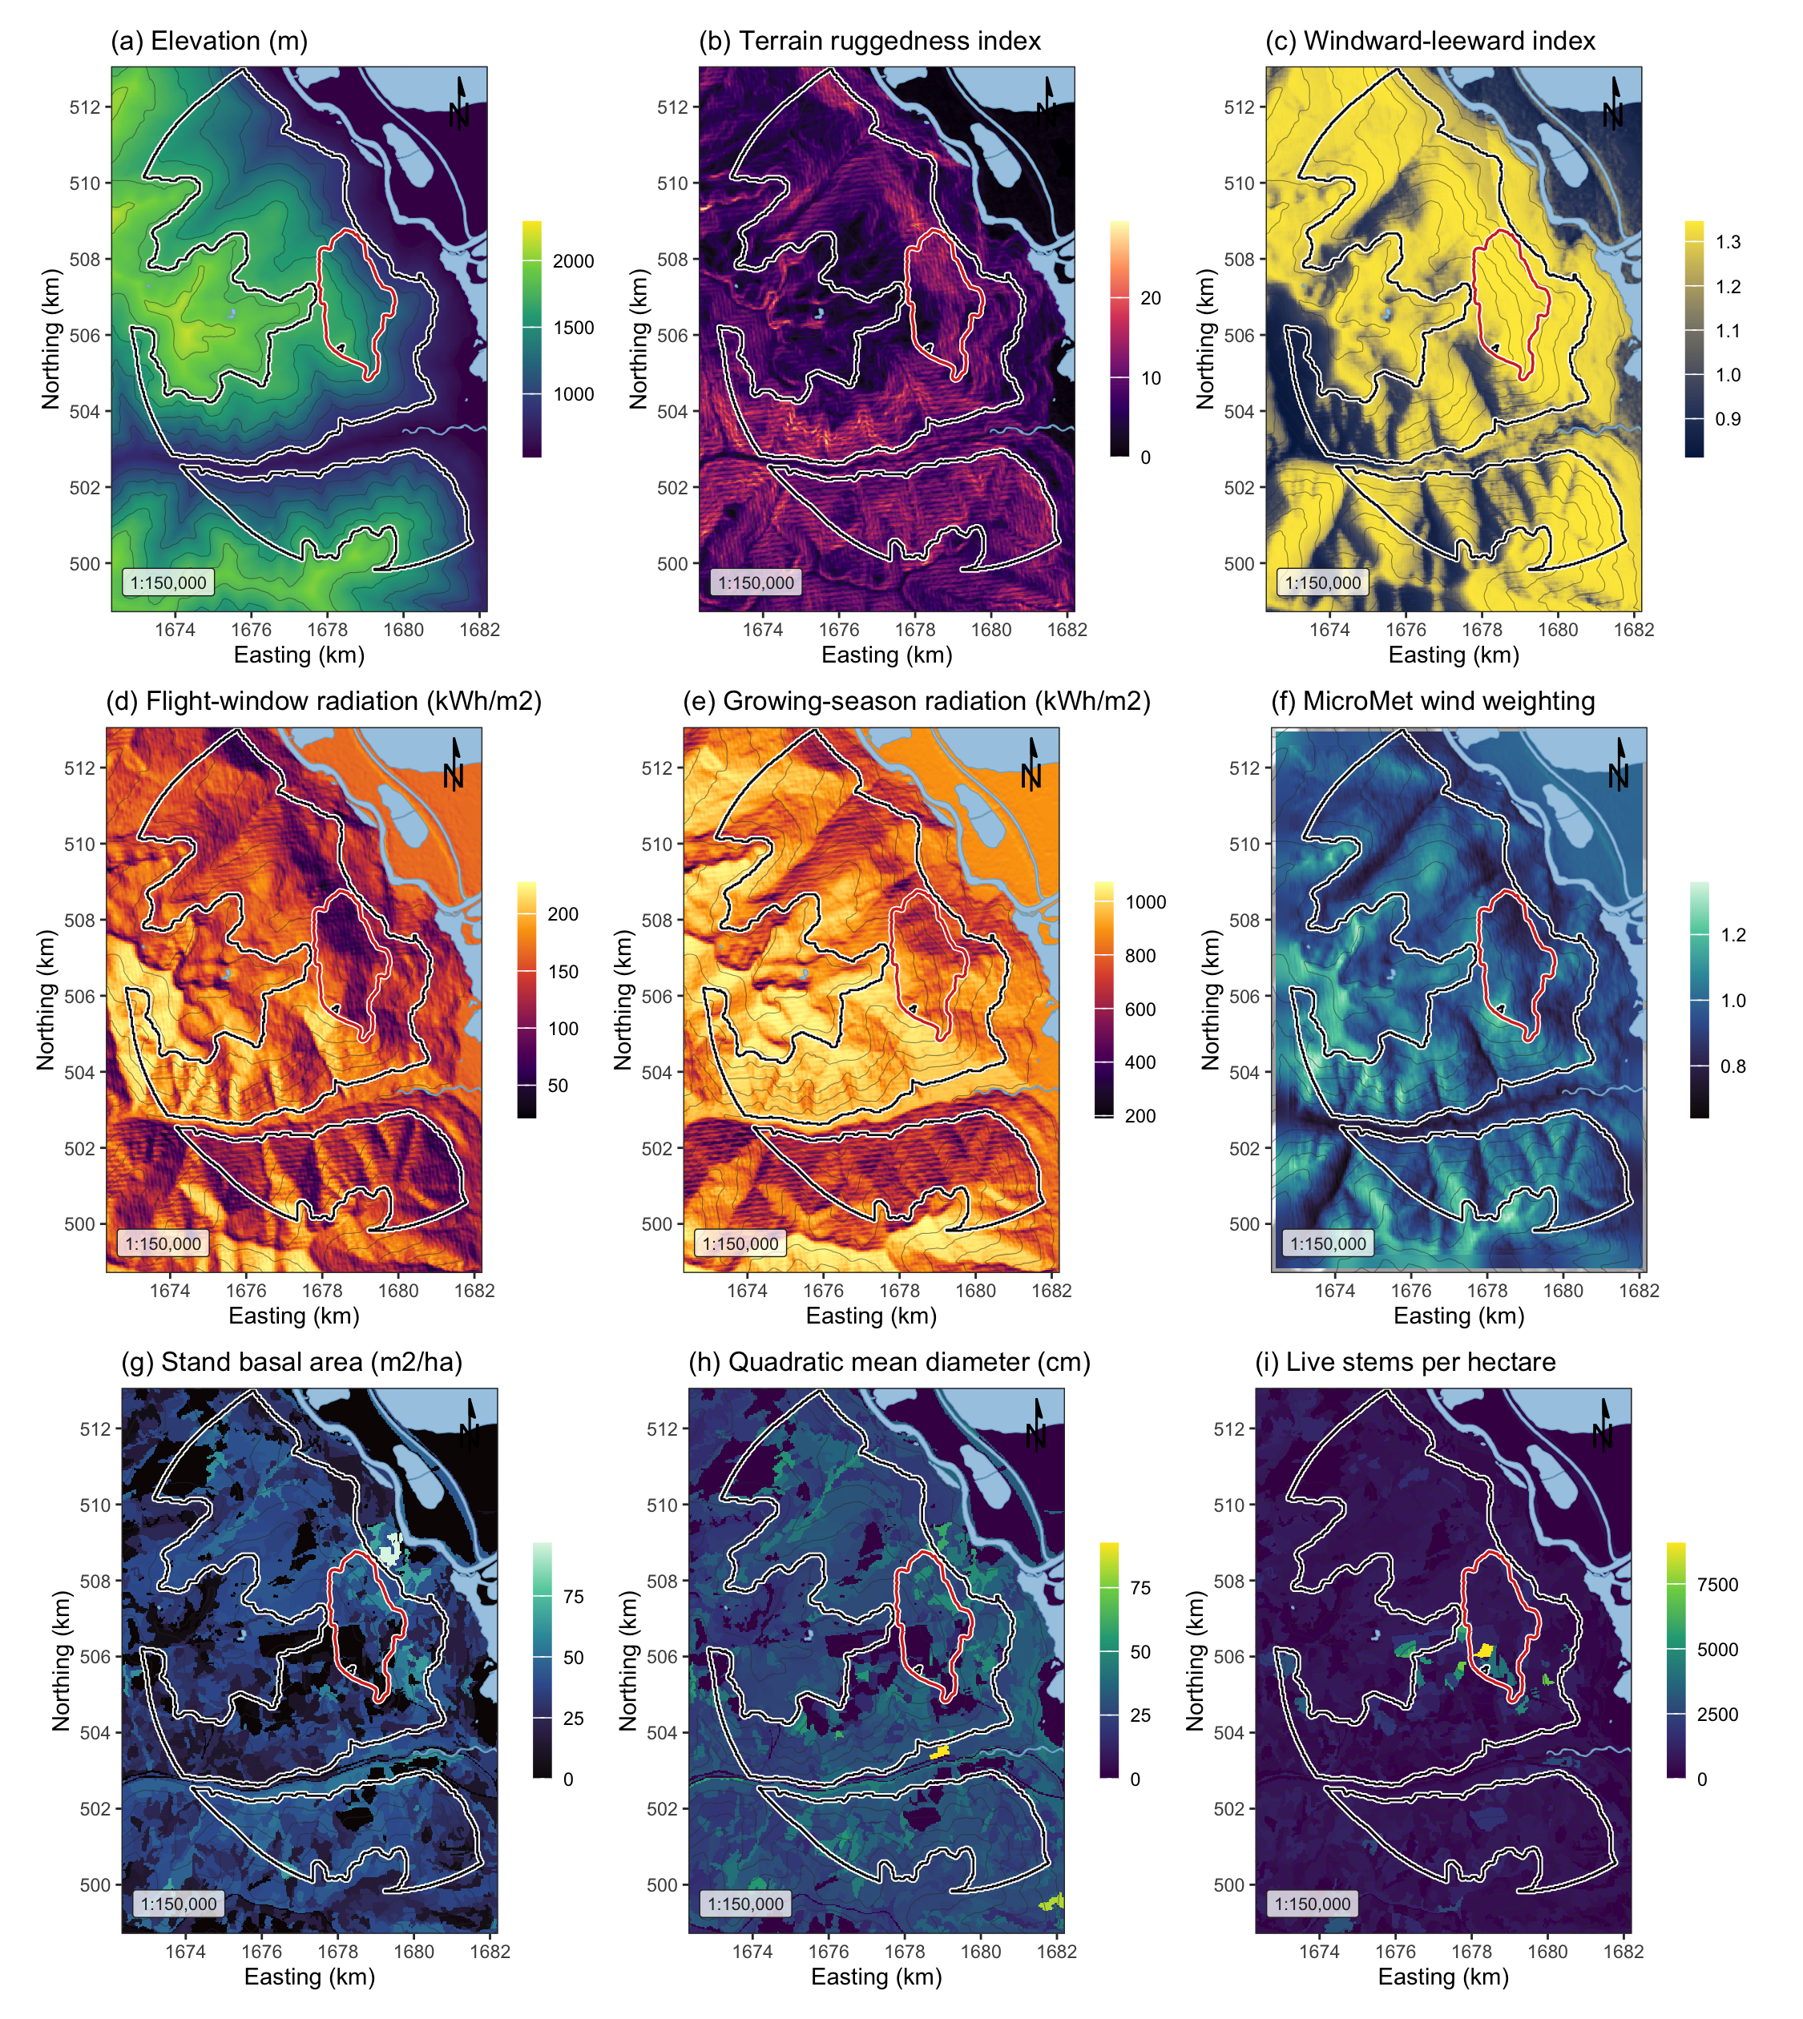
Figure 1: Landscape, terrain and stand surfaces across the study area, all EPSG:3153 at 30 m over Esri World Shaded Relief. (a) elevation; (b) terrain ruggedness index; (c) windward-leeward index at the prevailing bearing; (d) flight-window direct radiation, the thermal limit on flight; (e) growing-season direct radiation, the shading pathway; (f) the MicroMet wind weighting factor at the prevailing bearing; (g) stand basal area; (h) quadratic mean diameter, whose 25 cm source-sink threshold falls near the midpoint of the scale; (i) live stems per hectare. The white outline is the study perimeter and the red outline the 2015 Mt Midgeley burn. Contours are at 200 m.

2.2 Beetle disturbance
The response is annual moderate-to-high beetle disturbance, classified from Landsat imagery by a support vector machine. Training used the 28 ground plots of Murphy et al. (2026), in which the basal area of pine killed by the beetle was measured on 20 m plots centred within 60 by 60 m quadrants of four Landsat cells, so that no plot straddles a cell edge, following the plot-to-pixel protocols of Carlson et al. (2017) and Lentile et al. (2006). Plots were labelled low, moderate or high by tertiles of killed basal area, at 8.9 and 26.8 square metres per hectare, with undisturbed forest as the unaffected class. The classifier separates moderate or high from the rest on the changes in NDVI, NBR and tasselled-cap wetness against 2005, taken in the year of each plot’s deepest NDMI decline. Accuracy is leave-one-out, because a held-out quarter of 38 plots is too small to trust, and was 0.737, kappa 0.475. Annual maps were predicted over the perimeter with water masked, each year on its own. It covers eight outbreak years, 2006 to 2014, excluding 2012, the one year covered only by Landsat 7, which has flown with its scan-line corrector off since May 2003. Annual prevalence inside the perimeter runs 3.9 to 18.6 per cent, pooled 9.7 per cent over 111,707 cell-years. Figure 2 shows where the outbreak arrived first and how much of the perimeter it reached each year.
Years are never merged into one layer, because merging destroys the year-to-year variation this study measures and because the merged layer over the wider grid reached 73 per cent of the landscape, a figure not credible for a beetle outbreak. The provincial aerial overview survey is not used as a response and supplies no training label, and is retained only as a visual check.
Table 3: Moderate-to-high beetle disturbance by year inside the study perimeter.
Year | Cells | Moderate-to-high (%)
2006 | 13,224 | 4.2
2007 | 13,225 | 3.9
2008 | 13,285 | 18.6
2009 | 13,556 | 7.3
2010 | 13,538 | 13.5
2011 | 14,944 | 9.8
2013 | 14,943 | 10.0
2014 | 14,992 | 9.7

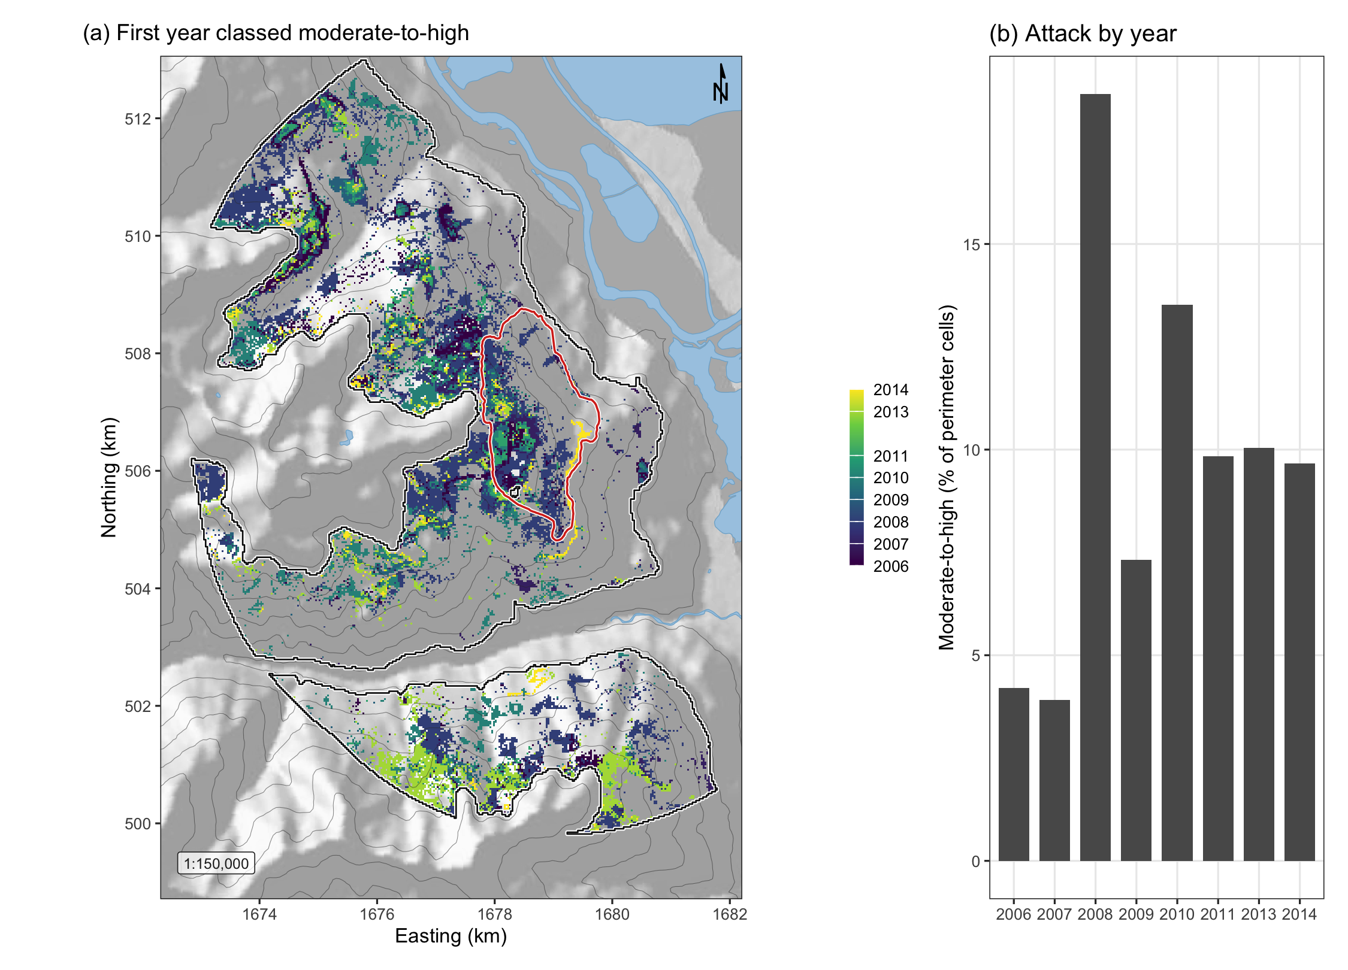
Figure 2: Spread of moderate-to-high beetle disturbance across the study perimeter. (a) The first year in which each cell entered the moderate-to-high class, over shaded relief with the perimeter in white and the 2015 Mt Midgeley burn in red; cells never classed as attacked show the relief alone. This is a display product built from the eight annual maps, which are fitted separately for visualization purposes but remain unmerged in analysis. (b) The share of perimeter cells classed moderate-to-high in each year.

2.3 Stand structure
Stand structure comes from the provincial Vegetation Resources Inventory layer VEG_COMP_LYR_R1_POLY, retrieved by web feature service over the perimeter. Six attributes cover the mechanism and the stem-size threshold, namely total basal area, crown closure, live stems per hectare, quadratic mean diameter over stems 12.5 cm and up, stand age, and susceptible pine basal area, formed as total basal area times the pine share of cover.
Every model is fitted on annualized stand structure. Each cell-year takes the inventory snapshot the province published for that year, depleted for harvest and projected for growth to it, so the host terms vary in time as well as in space.
One year is substituted. The 2007 delivery lists basal area and live stems as columns and fills neither, 0 and 3 per cent of polygons against 70 to 97 per cent in every other year, so the preceding year is carried forward rather than averaged. The inventory is itself a projection, so carrying forward reproduces a stand structure the province published, where averaging would invent one it did not.
Cell-years at or above the 25 cm source-sink threshold make up 67.1 per cent of the sample.
Table 4: Stand structure across the study perimeter, from the Vegetation Resources Inventory. n is cell-years. SD is the standard deviation of the landscape; SE is the standard error of the mean and is small by construction at this n, so it should not be read as precision about any one cell.
Attribute | Mean | SD | SE | Median | Min | Max | Skew | Kurt.
Stand basal area (m²/ha) | 35.56 | 11.60 | 0.035 | 37.39 | 0.98 | 62.43 | -1.01 | +1.42
Crown closure (%) | 50.10 | 13.54 | 0.041 | 50.00 | 3.00 | 70.00 | -1.74 | +3.37
Live stems (n/ha) | 772.75 | 312.80 | 0.936 | 775.00 | 23.00 | 4600.00 | +1.70 | +19.51
Quadratic mean diameter (cm) | 27.38 | 6.40 | 0.019 | 26.95 | 13.55 | 58.90 | +0.73 | +1.24
Stand age (years) | 115.46 | 20.88 | 0.062 | 116.00 | 22.00 | 237.00 | -0.78 | +1.97
Stand height (m) | 26.97 | 6.27 | 0.019 | 27.90 | 7.00 | 40.30 | -0.26 | +0.23
Standing volume (m³/ha) | 272.33 | 131.38 | 0.393 | 281.47 | 0.82 | 586.61 | +0.01 | -0.35
Lodgepole pine cover (%) | 20.11 | 23.93 | 0.072 | 10.00 | 0.00 | 100.00 | +1.45 | +1.56
Susceptible pine BA (m²/ha) | 7.07 | 8.85 | 0.026 | 4.00 | 0.00 | 48.30 | +1.63 | +2.63

The inventory is a projected operational product, not a census, and its polygons here have reference years spanning several decades. A polygon interpreted from late-outbreak photography describes a stand the beetle had already attacked, so that basal area and pine cover are post-attack over part of the study window. No unattacked vintage exists, and the limitation is therefore reported rather than corrected, and returned to in the Discussion.

2.4 Geomorphometry
Terrain is described by 29 geomorphometric surfaces computed with SAGA GIS over the full reprojected elevation model and clipped afterwards, so that a search radius near the boundary still falls on measured ground. The set decomposes the single ruggedness index of Murphy et al. (2026) into the quantities the biology names, and ruggedness itself is kept as a candidate so that the decomposition is tested against it rather than assumed.
Radiation is computed twice because two mechanisms require different quantities. Flight-window insolation is direct and diffuse radiation over 1 July to 15 August restricted to 12:00 to 17:00, the hours identified as the flight peak (Safranyik and Carroll 2006), while growing-season insolation is the whole-day total from 1 May to 30 September, which is the shading quantity the first mechanism of Krawchuk et al. (2020) concerns. A single annual heat index cannot separate the two. Flight-window direct radiation spans a 7-fold range here against 2.6-fold for the season total.
Exposure enters as the windward-leeward index and effective air flow height at the prevailing bearing, the omnidirectional wind exposition index, the wind shelter index of Plattner et al. (2004), which is “the maximum gradient within a given radius in upwind direction”, and topographic openness. Shape enters as terrain ruggedness, vector ruggedness, topographic position and its multi-scale form, convergence, slope, curvature and geomorphon class. Landform enters as topographic wetness, valley depth, height above the valley floor, normalised height and mid-slope position, because infested groups are reported in draws and gullies and deep snow insulates overwintering brood (Safranyik and Carroll 2006), and slope was one of the two site variables that best explained symptom abundance after attack by the European spruce bark beetle (Kautz et al. 2023). Aspect enters as its northward and eastward components with the heat load index of McCune and Keon (2002).

2.5 Terrain-resolved wind
Station wind interpolated from four to seven valley stations is nearly flat within a year, so wind is additionally computed as a field varying in space, using the MicroMet model of Liston and Elder (2006). The wind component of that model is seven closed-form equations and was implemented directly from the source paper, whose equation numbers are given below.
Terrain slope $β$ and slope azimuth $ξ$ come from the elevation model, equations 12 and 13 of Liston and Elder (2006). Curvature $Ω_{c}$ is a cell’s elevation minus the mean of the two opposite cells one curvature length scale away, taken on four direction lines and averaged (their equation 14); the length scale is estimated as the first lag at which elevation autocorrelation falls below 0.5, which is 600 m here. Writing $θ$ for the wind bearing, the slope in the wind direction is
$$Ω_{s}=βcos\left(θ-ξ\right) \left(1\right)$$
with $Ω_{s}$ and $Ω_{c}$ each scaled to $\left[-0.5, 0.5\right]$. The terrain weighting factor applied to the observed speed $W$ is
$$W_{w}=1+γ_{s}Ω_{s}+γ_{c}Ω_{c}, γ_{s}=γ_{c}=0.5 \left(2\right)$$
giving the terrain-modified speed
$$W_{t}=W_{w}W \left(3\right)$$
and a diversion of the wind direction of
$$θ_{d}=-1/2 Ω_{s}sin​\left[2\left(ξ-θ\right)\right]. \left(4\right)$$
By Equation 2, $W_{w}$ depends on direction and not on speed, so it is computed once for each of 16 direction bins and each hourly observation is multiplied by the surface for its own bin, so that nothing is averaged before the terrain acts on it. Over all bins $W_{w}$ runs 0.60 to 1.38. Speed and direction are combined as vector components, because averaging degrees across the 360 to 0 discontinuity is not meaningful. The resulting field varies 1.9 to 2.8 km/h across the grid within a year and is not a repackaged terrain index, correlating +0.148 with the windward-leeward index and +0.123 with flight-window radiation. Its strongest association is with elevation, +0.320.

2.6 Flight-window wind
The flight window is 1 July to 15 August and the hours 12:00 to 17:00, and neither bound was chosen from these data, which is the discipline that multi-year phenology modelling of forest insects applies when it fixes activity windows from monitoring rather than from the response (Pawson et al. 2021). The dates are the flight period Safranyik and Carroll (2006) give for this region, and the hours follow their “peak flight is in the early to mid afternoon” together with the 11:00 to 14:00 emergence peak of Gray et al. (1972), taken here to the later side because emergence precedes the flight it initiates. Because the window is fixed a priori it can be checked against the landscape’s own climate, and Figure 3 does that. Across 236,079 hourly station records from May to September of the nine study years, 89.5 per cent of afternoon hours inside the window fall within the 19 to 41 degrees C flight range, against 51.4 per cent outside it, and the afternoon mean is 26.0 against 19.2 degrees C. The window therefore roughly doubles the share of hours in which flight is thermally possible. The same figure shows the same daily pattern in wind. Mean speed peaks in the same hours as temperature, at 10.4 km/h in mid-afternoon against 4.6 km/h at dawn, so the hours the beetle can fly are also the windiest of the day, a coincidence of timing the mechanism depends on.
Station wind is Environment and Climate Change Canada hourly records, never reduced before the terrain acts on them.
Summarised over a whole season, every hour of wind collapses into one number per metric and a coefficient then rests on as many values as there are seasons. Stand density varies from cell to cell while a season’s wind does not, so the response is measured over each sixteen-day epoch, wind varies within a season as well as between seasons, and the interaction the mechanism predicts is identified.
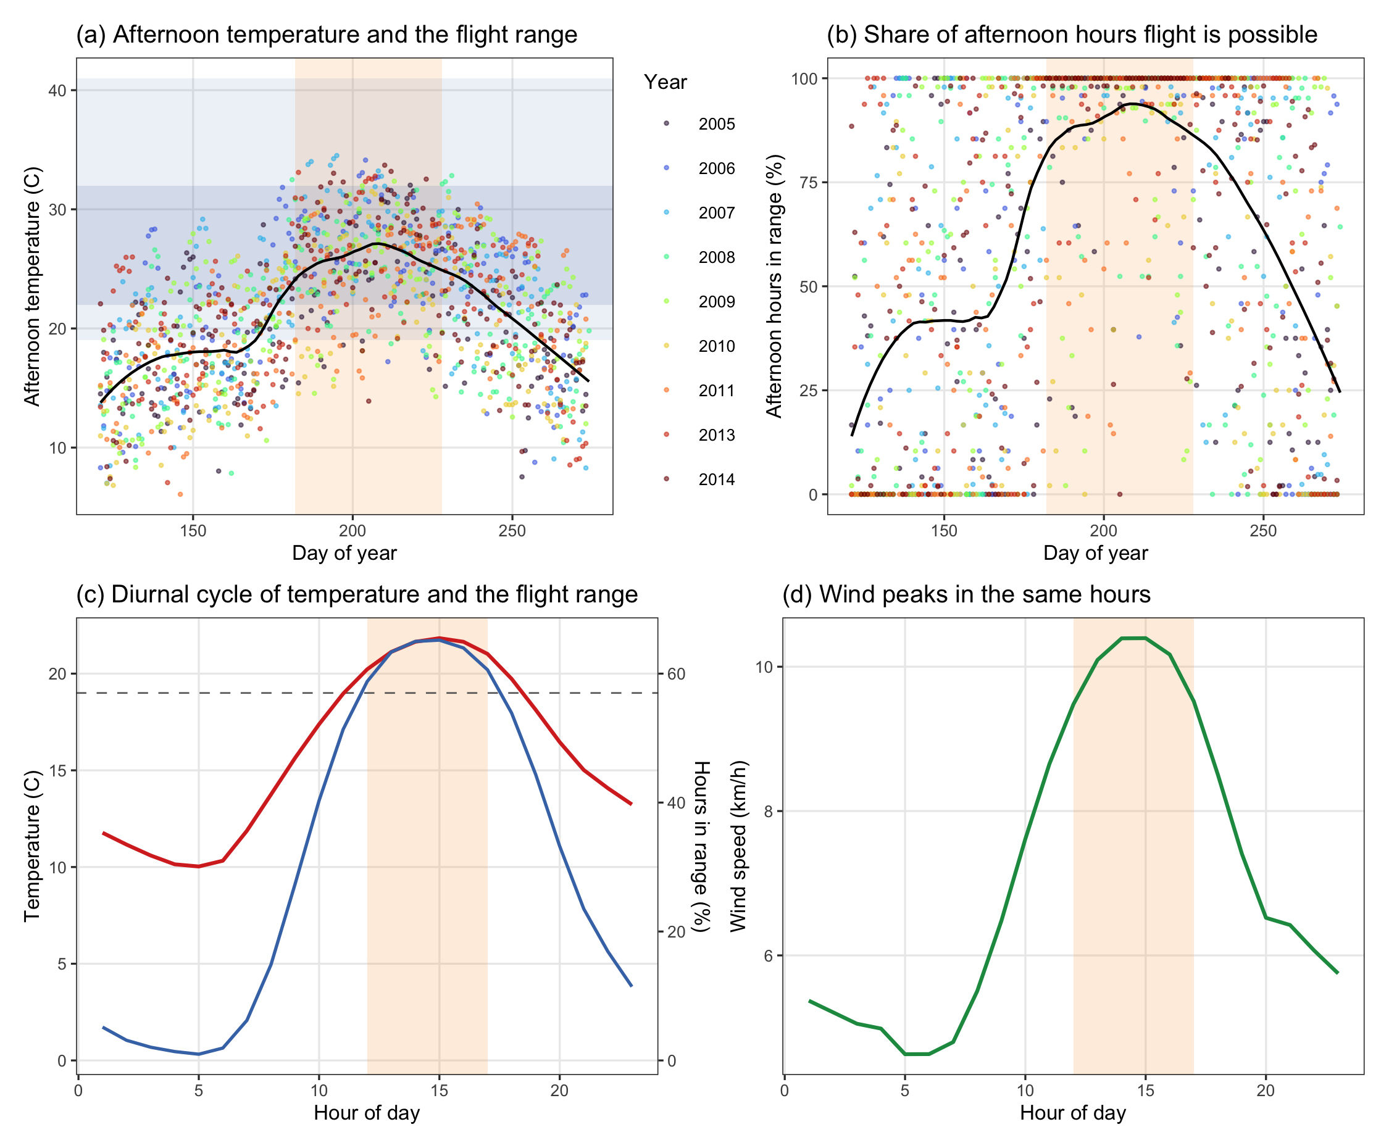
Figure 3: The flight window against the landscape’s own climate, from hourly Environment and Climate Change Canada station records for May to September of the nine study years. The window, 1 July to 15 August, is the shaded band; it is taken from the bionomics and is not fitted to these data. (a) Mean afternoon temperature by day of year, with the 19 to 41 degrees C flight range and the 22 to 32 degrees C peak band marked. (b) The share of afternoon hours falling inside the flight range, day by day. (c) The diurnal curve, mean temperature and the share of all hours inside the flight range, by hour, with the 12:00 to 17:00 restriction shaded. (d) Mean wind speed by hour, on the same axis, showing that the hours the beetle can fly are also the windiest of the day.

2.7 Variable selection
The candidate set is 45 variables in six groups, one group for each pathway the Introduction names. The groups are stand density, host quality, terrain exposure to wind, which holds the shelter and openness indices the deposition question turns on, terrain shape, landscape context, and flight-window wind. Selection proceeds in four stages and is required to retain at least one variable from each pathway, so that a collinearity filter cannot silently delete a hypothesis the Introduction established.
Fitting uses a class-balanced sample of 42,791 cell-years, 4,000 of each class per year. Landscape prevalence is about 10 per cent, and an unbalanced fit at that prevalence reports the intercept rather than the covariates.

2.8 Models
Every model is a logistic regression of moderate-to-high disturbance $y_{it}$ in cell $i$ and year $t$ on standardised covariates,
logitPryit=1=α+xit⊤β+γgi+k​δk zk,it 5
where $γ_{g\left(i\right)}$ is the effect of the geomorphon landform class $g$ of cell $i$ and the $z_{k,it}$ are the interaction terms. Coefficients are therefore log-odds per standard deviation. Four annual models are fitted, each adding one claim to the last, so that every term’s contribution is visible as a change in fit rather than asserted, and the sixteen-day models described under flight-window wind carry the interaction in time.
M0 fits the shading and host-size mechanisms together with landform context, that is host size, topographic shading, and the terrain that governs where cold air and snow collect. M1 adds stand density, which the first question concerns. M2 adds terrain shape, terrain exposure to wind and flight-window radiation, which the second and third questions concern, and its shelter main effect is the first half of the fifth. M3 adds the three interactions the fourth and fifth questions require, stand density by terrain exposure, by flight-window radiation and by flight-window wind. The fifth question is answered by reading the shelter main effect in M2 and M3 against the density by shelter interaction in M3, because deposition predicts the first without the second and plume disruption predicts the second whether or not the first is present. The sixteen-day models answer the fourth question in the domain where wind varies within a season.

3. Results
Table 5: Model comparison, panel A of the model table. Each model adds one pathway to the previous. AIC ranks on likelihood and a parameter penalty; the remaining columns are predictive error on the fitted probabilities. RMSE is the root mean squared error and is the square root of the Brier score; RMSE (%) expresses it against the prevalence of the response. Brier skill is the improvement over predicting the prevalence for every cell, where 0 is no better than the base rate.
Model | AIC | ΔAIC | RMSE | RMSE% | MAE | Brier | Log loss | AUC | Brier skill
M0 host, shading, landform | 41,239 | 1,187 | 0.396 | 157.1 | 0.314 | 0.157 | 0.481 | 0.758 | 0.168
M1 + stand density | 40,913 | 861 | 0.394 | 156.3 | 0.311 | 0.155 | 0.478 | 0.763 | 0.176
M2 + terrain and flight radiation | 40,605 | 553 | 0.393 | 155.7 | 0.309 | 0.154 | 0.474 | 0.769 | 0.182
M3 + interactions | 40,052 | 0 | 0.390 | 154.6 | 0.304 | 0.152 | 0.467 | 0.779 | 0.194

Table 6: Full model M3, panel B of the model table, continuous terms ordered by absolute effect. Coefficients are log-odds per standard deviation on a class-balanced sample, so the intercept is not landscape prevalence. SE is the standard error of the coefficient. The geomorphon landform classes are also in this model and are not reported here.
Term | Beta | SE | z | p
Stand basal area (m2/ha) | +0.453 | 0.029 | 15.66 | < 0.001
Northness | +0.383 | 0.016 | 24.25 | < 0.001
Elevation (m) | +0.373 | 0.023 | 16.04 | < 0.001
Susceptible pine basal area (m2/ha) | +0.362 | 0.015 | 23.53 | < 0.001
Flight-window direct radiation (kWh/m2) | +0.335 | 0.024 | 14.02 | < 0.001
Quadratic mean diameter (cm) | -0.333 | 0.027 | -12.47 | < 0.001
July mean wind (km/h) | +0.283 | 0.014 | 20.73 | < 0.001
Sky view factor | +0.275 | 0.025 | 10.80 | < 0.001
Wind shelter index | -0.249 | 0.023 | -11.04 | < 0.001
Stand age (years) | +0.227 | 0.019 | 12.20 | < 0.001
Stand basal area x Flight-window direct radiation | +0.091 | 0.021 | 4.32 | < 0.001
Height above valley floor (m) | +0.084 | 0.026 | 3.23 | 0.001
Crown closure (%) | -0.079 | 0.022 | -3.52 | < 0.001
Stand basal area x July mean wind | -0.077 | 0.016 | -4.73 | < 0.001
Convergence index | -0.076 | 0.015 | -4.92 | < 0.001
Valley depth (m) | -0.064 | 0.023 | -2.81 | 0.005
Profile curvature | -0.063 | 0.015 | -4.23 | < 0.001
Live stems (n/ha) | +0.062 | 0.017 | 3.70 | < 0.001
Vector ruggedness measure | +0.035 | 0.022 | 1.62 | 0.106
Mid-slope position | +0.032 | 0.015 | 2.18 | 0.030
June mean wind (km/h) | +0.026 | 0.014 | 1.85 | 0.065
Stand basal area x Wind shelter index | +0.025 | 0.026 | 0.99 | 0.324
Topographic position index | +0.004 | 0.027 | 0.15 | 0.879

Each pathway improved the fit. AIC fell 326 when stand density entered, a further 308 with terrain and flight-window radiation, and a further 553 with the interactions (Table 5).
Stand basal area was the strongest density term, entering at +0.453 log-odds per standard deviation, an odds ratio of 1.573, so that a stand one standard deviation above the mean in basal area had 57.3 per cent higher odds of moderate-to-high disturbance (p < 0.001). Live stems per hectare took the same sign at +0.062 (p < 0.001) and crown closure the opposite at -0.079 (p < 0.001).
Basal area and live stems both rose with attack, the direction a plume-holding canopy implies, while crown closure fell. Crown closure is also the one measure the inventory caps, recorded to a ceiling of 60 per cent, so that its coefficient describes a truncated variable and should not be read as the others are.
Radiation entered the model once, as direct radiation during the flight window at +0.335, which represents the thermal limit on flying. Growing-season radiation did not survive selection, so northness stands in for the shading pathway, the two correlating -0.824. Northness was +0.383, so that shaded, north-facing ground had more attack rather than less, against the prediction.
Terrain predicted attack independently of both stand structure and radiation, and it did so through shelter and openness rather than through ruggedness, because neither terrain ruggedness nor the windward-leeward index survived selection into the full model. The wind shelter index as computed here rises on slopes facing the prevailing bearing, correlating +0.71 with that orientation, and it entered at -0.249 (p < 0.001), so leeward ground had more attack and windward ground less. Sky view factor, which is high on gentle, open, upper ground, was +0.275 (p < 0.001), height above the valley floor +0.084 and valley depth -0.064, so attack sat on open, sheltered ground standing above shallow valleys rather than in deep ones. Elevation was +0.373, and the vector ruggedness measure +0.035 was not distinguishable from zero (p = 0.106).
Fitted without flight-window radiation, stand density interacted with terrain exposure at +0.066, which would ordinarily be read as plume disruption acting through terrain. With radiation in the model that interaction shrank to +0.025 and was no longer distinguishable from zero (p = 0.324), while density interacted with radiation at +0.091. On a range whose prevailing bearing is 258 degrees the windward slopes face west, and these are also the slopes taking afternoon sun, so that 62 per cent of the apparent interaction was radiation and what remained was too small to support a claim on its own. The shelter main effect did not move between the two fits, so the fifth question resolved one way. Shelter acted alone, as deposition predicts, and not through stand density, as plume disruption would require.
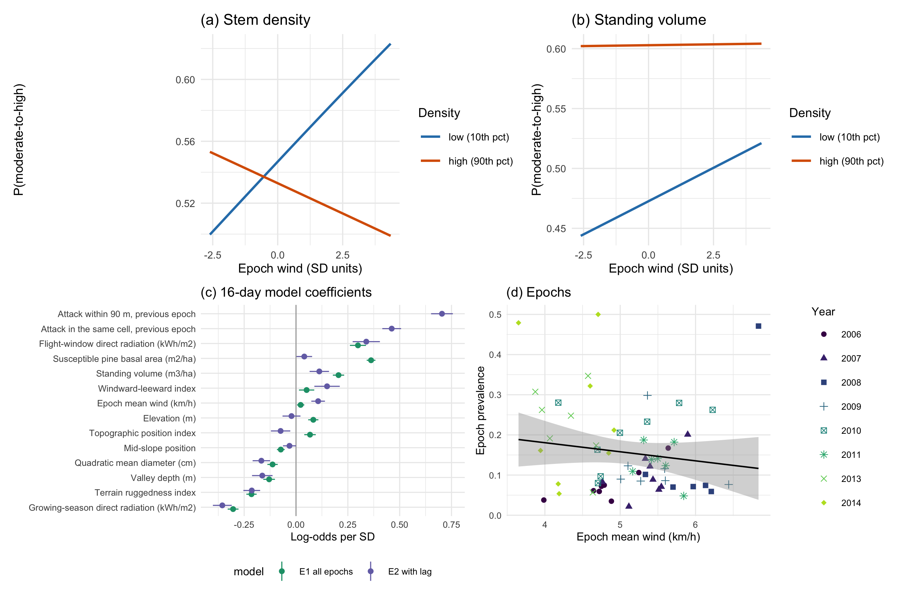
Figure 4: The refugia mechanism as fitted. (a) Predicted probability of moderate-to-high disturbance against terrain-resolved epoch wind, at the 10th and 90th percentiles of stem density, all other terms held at their means; the lines cross, so wind raises attack in thin stands and lowers it in dense ones, which is the interaction. (b) The same for standing volume, where the interaction is a fifth the size and attenuates the dense-stand slope without reversing it, so the lines converge rather than cross over the observed range. (c) Coefficients of the 16-day model, with and without the within-season spread term; the shift of a term between the two fits is what that term absorbs. (d) Epoch prevalence against epoch mean wind, one point per epoch, years distinguished by both shape and shade so the panel remains legible in black and white.

3.1 Density and wind
Stand density interacted negatively with terrain-resolved wind, which is the form the pheromone mechanism predicts. Attack fell where a thin stand and strong wind coincided, the interaction -0.049 for stem density (p < 0.001) and -0.017 for standing volume (p < 0.05). Expressed as odds, each standard deviation of the epoch wind regime multiplied the contribution of stem density by 0.952, a reduction of 4.8 per cent. Both interactions held after the previous epoch of the same season was entered, so neither is the outbreak’s own spread appearing as a wind coefficient.
Wind alone gave no protection, its main effect being +0.022, which is marginally more attack rather than less, and the density terms were positive, so that a thin stand in still air showed no reduction either. The mechanism was present only where the two coincided.

3.2 Previous-year pressure
Attack recurred where it had already occurred, by a margin large enough to change how every other coefficient should be read. A cell attacked in one year was between 9 and 88 times more likely to be attacked in the next. Entering persistence and 90 m neighbourhood spread separately, following the autologistic design used for this province, gave +0.725 and +0.696, raising discrimination from 0.775 to 0.861.
The informative result was which environmental terms held after that term entered. Sky view moved from +0.312 to +0.232 and the wind shelter index from -0.245 to -0.205, both describing conditions a cell has whether or not the beetle was ever present. The landform terms were less stable, valley depth falling from -0.042 to +0.012 while mid-slope position moved from +0.050 to +0.060. Part of what the landform terms measured was therefore where the outbreak had already been, which is the same failure the terrain-wind index showed against radiation.

3.3 Host as diameter
Table 7: Moderate-to-high beetle disturbance by quadratic mean diameter class, on the balanced sample. The 25 cm boundary is the source-sink threshold of the species’ bionomics. Intervals are Wilson score intervals on the class proportion, which is why they are asymmetric in the smallest class..
QMD class (cm) | n | Attacked | Attacked (%) | 95% CI (%) ##
<15 | 395 | 111 | 28.1 | 23.9-32.7
15-20 | 4,101 | 783 | 19.1 | 17.9-20.3
20-25 | 9,286 | 1,998 | 21.5 | 20.7-22.4
25-30 | 17,119 | 5,391 | 31.5 | 30.8-32.2
30-40 | 10,247 | 2,291 | 22.4 | 21.6-23.2
>40 | 1,643 | 217 | 13.2 | 11.7-14.9
## Note that 30 m cells in a spreading outbreak are not independent, so the tests reported beneath this table are anti-conservative

Coding host as diameter changed the picture that cover alone gives. Attack peaked in the 25 to 30 cm class at 31.5 per cent and fell above it, to 22.4 per cent at 30 to 40 cm and 13.2 per cent above 40 (Table 7). The step across the 25 cm source-sink boundary is from 21.5 to 31.5 per cent.
In the full model diameter was -0.333 per standard deviation (z = -12.47), negative because the relationship is not monotone, since a linear term fitted through a humped response returns the slope of its falling limb, which is the larger part of the range. The class table rather than the coefficient is therefore the result here, and the interpretation stands, because a stand’s cover says nothing about whether its stems can produce brood.
The pattern was not an artefact of the class boundaries, in that across all six classes attack depended on diameter class, $χ^{2}$ = 678.2 on 5 degrees of freedom, p < 0.001, with Cramer’s V = 0.126. The step across the 25 cm source-sink boundary specifically, from the 20 to 25 class to the 25 to 30 class, is +10.0 percentage points, 95 per cent confidence interval 8.9 to 11.1, p < 0.001. With 42,791 cells a chi-square is significant on trivial differences, which is why the effect size is quoted beside it, and 30 m cells in a spreading outbreak are not independent, so both p-values are anti-conservative.

3.4 The wind window
The wind variable is the epoch wind regime, the mean over every hourly station observation in the sixteen days an epoch covers, each hour modified over the terrain by its own bearing. It is not restricted to the flight window, and that choice follows from how the insect disperses. Jackson et al. (2008) tracked mountain pine beetle on weather radar and confirmed the returns by aerial capture, finding beetles “at altitudes up to more than 800 m above the forest canopy” and estimating that those in flight above the canopy “may move 30 to 110 km$⋅$day$​^{-1}$”, at a mean density of 4,950 and a maximum of 18,600 beetles per hectare. Ainslie and Jackson (2010) subsequently reproduced that above-canopy dispersion with an atmospheric model. An insect carried in the boundary layer at those heights and over those distances is exposed to the atmospheric regime of the period rather than to the wind measured within a stand between noon and five, and the variable is named accordingly.
Table 8 refits the 16-day model under four definitions of the window. These are every hour, the 12:00 to 17:00 hours the flight peak occupies, the 11:00 to 18:00 hours that fall inside the thermal limits on this landscape more than half the time, and only those hours whose observed temperature fell inside the 19 to 41 degrees C range itself. The stem-density interaction was negative and distinguishable from zero under all four definitions, so the mechanism does not depend on the choice, although it was largest over the full regime and the standing-volume interaction was the term sensitive to that choice.
Table 8: The 16-day model refitted under four definitions of the wind window. The epoch wind regime, every hour, is the definition used throughout this paper. Coefficients are log-odds per standard deviation. The thermal-limits row is fitted on fewer cell-epochs because two epochs had too few qualifying hours, so its AIC is not comparable with the other three.
Definition | Cell-epochs | Wind (km/h) | Stems x wind | p | Volume x wind | p | AUC
Epoch wind regime (all hrs) | 71,127 | 5.04 | -0.0941 | < 0.001 | -0.0410 | < 0.001 | 0.668
12:00-17:00 | 71,127 | 6.45 | -0.0565 | < 0.001 | -0.0082 | 0.325 | 0.667
11:00-18:00 | 71,127 | 6.32 | -0.0623 | < 0.001 | -0.0161 | 0.054r | 0.667
Inside the 19-41 C range | 69,711 | 5.67 | -0.0596 | < 0.001 | -0.0325 | < 0.001 | 0.666

4. Discussion

4.1 Two scales
The five questions resolved into one pattern. Terrain acted on attack as a main effect of shelter and openness that did not depend on stand density, and wind acted on attack as an interaction with stand density that appeared only where wind varied in time. Deposition predicts the first and plume disruption the second, and neither mechanism produced the other’s signature. The one place the two could have been confused, the density by shelter interaction, fell by 62 per cent when flight-window radiation entered and could not then be distinguished from zero, while the shelter main effect did not move, so a terrain index alone would have supported the plume mechanism on evidence that was partly sunlight.
This is unlikely to be peculiar to the present dataset. A shelter index and an afternoon radiation surface are both functions of slope and aspect, and on a range whose prevailing flight-window bearing is 258 degrees the slopes that meet the wind are the west-facing ones, which are also the slopes taking afternoon sun during the flight peak. Any study entering a terrain wind index without a radiation term on the same clock will attribute radiation to wind, and any study reading a terrain main effect as plume disruption has assigned a deposition signature to the wrong mechanism.

4.2 What was supported
Of the three mechanisms Krawchuk et al. (2020) propose, two were supported and one failed. Low host density admitting the wind that disperses the aggregation pheromone was supported in the conditional form the mechanism specifies rather than as a main effect. The claim was never that dense stands are attacked more, but that a dense canopy holds a plume together and that the advantage this confers on the beetle should diminish as wind speed rises, and both halves of that prediction are present. A scarcity of large-diameter hosts was supported as a threshold rather than as a gradient, attack peaking at 31.5 per cent in the 25 to 30 cm class, at the source-sink boundary of Carroll and Safranyik (2004), and falling away on both sides.
Topographic shading was not supported, and it fails on a surrogate rather than on the quantity the mechanism names. Growing-season radiation did not survive variable selection, so northness stands in for the pathway, the two correlating -0.824. Northness was +0.383, so that shaded ground had more attack where the mechanism requires less. Northness tests aspect, and aspect measures more than shade, which makes this the least secure of the three verdicts, and the water-stress pathway Krawchuk et al. (2020) describe is not measured here at all.
The fifth question, which Krawchuk et al. (2020) did not pose, was answered as well, in that terrain shelter acted as a main effect and not through density, the deposition signature the companion study’s ruggedness coefficient was recording without being able to name.

4.3 The wind claim
Stand density interacts with terrain-resolved wind at -0.049 for stem density and -0.017 for standing volume, both negative, at p < 0.001 and p = 0.038 respectively. A dense stand therefore confers less advantage on the beetle where and when wind speed is higher, which is what Krawchuk et al. (2020) predict. The result held after the previous epoch of the same season was entered, so it is not the outbreak’s own spread appearing as a wind coefficient.
Two limits remain attached to the claim. The interaction is small, roughly a tenth of the stand basal area main effect, and the wind field, although it varies in space, remains terrain-modified station data rather than measurement on the ridge. What is established is therefore that the modelled wind field behaves as the mechanism requires, not that the air itself did.

4.4 Landing zones
Read with the dispersal literature, the terrain results describe where beetles come down rather than where they choose to attack. Hynum and Berryman (1980) showed that landing is not host-directed, Jackson et al. (2008) that part of the population travels far above the canopy, and Chen and Jackson (2017) that the descent phase of that transport is the least understood. A beetle descending through slowing air behaves as any wind-borne particle does and settles where the flow decelerates, in the lee of ridges and on sheltered slopes, which is what the shelter index measures and why the same index predicts where snow accumulates (Plattner et al. 2004). Three results fit that reading and none contradicts it. Leeward ground had more attack as a main effect, -0.249, and the effect did not detectably depend on stand density. Open, gently sloping ground above shallow valleys had more attack, sky view +0.275, height above the valley floor +0.084 and valley depth -0.064. The density by wind interaction that plume disruption predicts appeared only in the sixteen-day models, where wind varies in time, and not through terrain, where it varies in space. Terrain shelter therefore reads as a landing zone and the sixteen-day wind as plume disruption, two mechanisms at two scales rather than one.
The one prior study to read terrain this way found the opposite face of the same frame, in that de la Giroday et al. (2011) associated the highest infestation intensities in the Peace River region with southwest-facing open slopes and mid-slope ridges, the surfaces that meet a westerly wind, after first establishment in canyons and valleys, whereas here the association was leeward and deep valleys held the least attack. Impaction on faces that meet the wind and settlement where it slows are both deposition, and which one a landscape shows may depend on how much of its relief a descending beetle clears.
This is an interpretation rather than an observation, because no beetle was tracked to the ground here. Sky view factor also sets diffuse radiation, so part of its coefficient may be sunlight, and deep valleys are also the coldest cells on the landscape, so the same pattern would follow from slower development as readily as from deposition (Sambaraju and Goodsman 2021). The component reading is nonetheless what the parent study could not give, because a ruggedness index records that relief matters without saying how, and decomposed here into shelter, openness and valley position the relief signal resolves into a landing surface.

4.5 What stays confounded
Elevation is among the largest terms in the model at +0.373, but it is not a single quantity, combining temperature, snowpack, growing-season length and the distribution of lodgepole pine in a way this design cannot separate. Reporting the elevation coefficient as a result would therefore be reporting a composite.
Three limits sit outside the model and bound every result in it. The inventory postdates part of the outbreak, because polygons interpreted after the beetle passed describe the stand it left, and total basal area discriminates only weakly on its own, a univariate AUC of 0.601. The response is classified rather than observed, from 38 plots inside one burn, so the reported accuracy measures how well the classifier reproduces those plots and not agreement with ground mortality elsewhere. Every conclusion rests on one mountain range across eight years.

4.6 Conclusions
Terrain and wind acted on mountain pine beetle attack by two mechanisms at two scales. Across 59 sixteen-day epochs, stand density interacted negatively with terrain-resolved wind, -0.049 for stem density and -0.017 for standing volume, and both held after a within-season spread term was entered, so a dense canopy conferred less advantage on the beetle where and when wind speed was higher, which is what plume disruption requires. Across the landscape, terrain shelter acted as a main effect and not through stand density, leeward ground having more attack at -0.249 whatever the stand, and open gentle ground above shallow valleys more still, which is what deposition of wind-borne beetles requires. Sheltered open ground therefore behaves as a landing zone, and the ruggedness signal the companion study found on this landscape resolves into that surface.
Of the three mechanisms Krawchuk et al. (2020) name, two were supported. Host density was supported through stand basal area at +0.453, with live stems agreeing in sign and crown closure alone running counter, and large-diameter host as a threshold at 25 to 30 cm rather than as a gradient, at the source-sink boundary of Carroll and Safranyik (2004). Topographic shading was not supported, failing on its surrogate northness at +0.383.
Two measurement results extend beyond this landscape. A terrain wind index is in part a measurement of incident radiation, because entering flight-window radiation moved the density by shelter interaction from +0.066 to +0.025, so a study entering such an index without a radiation term on the same clock will attribute radiation to wind. A landform variable in a spreading outbreak also records in part where the outbreak has already been.
For pest management the result means that refugia cannot be mapped from terrain alone, and that the map has two layers. A stand’s exposure to the prevailing wind sets how many beetles arrive, and its density during the windy weeks of the flight period sets how many of those succeed, so thinning can be expected to lower attack on windward ground during windy flight periods and to do little on the sheltered lee slopes where beetles come down, and only by the modest margin the interaction measures.

References
Ainslie B, Jackson PL (2010) Investigation into mountain pine beetle above-canopy dispersion using weather radar and an atmospheric dispersion model. Aerobiologia 27:51–65. https://doi.org/10.1007/s10453-010-9176-9
Badger J, Frank H, Hahmann AN, Giebel G (2014) Wind-climate estimation based on mesoscale and microscale modeling: Statistical–dynamical downscaling for wind energy applications. Journal of Applied Meteorology and Climatology 53:1901–1919. https://doi.org/10.1175/JAMC-D-13-0147.1
Bartos DL, Amman GD (1989) Microclimate: An alternative to tree vigor as a basis for mountain pine beetle infestations. U.S. Department of Agriculture, Forest Service, Intermountain Research Station, Ogden, UT
Carlson AR, Sibold JS, Assal TJ, Negrón JF (2017) Evidence of compounded disturbance effects on vegetation recovery following high-severity wildfire and spruce beetle outbreak. PLOS ONE 12:e0181778. https://doi.org/10.1371/journal.pone.0181778
Carroll AL, Safranyik L (2004) The bionomics of the mountain pine beetle in lodgepole pine forests: Establishing a context. In: Shore TL, Brooks JE, Stone JE (eds) Mountain pine beetle symposium: Challenges and solutions, October 30–31, 2003, Kelowna, British Columbia. Natural Resources Canada, Canadian Forest Service, Pacific Forestry Centre, Victoria, British Columbia, pp 21–32
Cartwright JM (2018) Landscape topoedaphic features create refugia from drought and insect disturbance in a lodgepole and whitebark pine forest. Forests 9:715. https://doi.org/10.3390/f9110715
Chen H, Jackson PL (2017) Climatic conditions for emergence and flight of mountain pine beetle: Implications for long-distance dispersal. Canadian Journal of Forest Research 47:974–984. https://doi.org/10.1139/cjfr-2016-0510
Cooke BJ, MacQuarrie CJK, Carroll AL (2025) On the deduction and quantification of irruptive dynamics in mountain pine beetle population and proxy data. Journal of Applied Entomology 149:309–323. https://doi.org/10.1111/jen.13262
Davis NN, Badger J, Hahmann AN, et al (2023) The Global Wind Atlas: A high-resolution dataset of climatologies and associated web-based application. Bulletin of the American Meteorological Society 104:E1507–E1525. https://doi.org/10.1175/BAMS-D-21-0075.1
de la Giroday H-MC, Carroll AL, Lindgren BS, Aukema BH (2011) Incoming! Association of landscape features with dispersing mountain pine beetle populations during a range expansion event in western Canada. Landscape Ecology 26:1097–1110. https://doi.org/10.1007/s10980-011-9628-9
Gray B, Billings RF, Gara RI, Johnsey RL (1972) On the emergence and initial flight behaviour of the mountain pine beetle, Dendroctonus ponderosae, in eastern Washington. Zeitschrift für angewandte Entomologie 71:250–259. https://doi.org/10.1111/j.1439-0418.1972.tb01745.x
Howe M, Raffa KF, Aukema BH, et al (2022) Numbers matter: How irruptive bark beetles initiate transition to self-sustaining behavior during landscape-altering outbreaks. Oecologia 198:681–698. https://doi.org/10.1007/s00442-022-05129-4
Hynum BG, Berryman AA (1980) Dendroctonus ponderosae (Coleoptera: Scolytidae): Pre-aggregation landing and gallery initiation on lodgepole pine. The Canadian Entomologist 112:185–191. https://doi.org/10.4039/Ent112185-2
Jackson PL, Straussfogel D, Lindgren BS, et al (2008) Radar observation and aerial capture of mountain pine beetle, Dendroctonus ponderosae Hopk. (Coleoptera: Scolytidae) in flight above the forest canopy. Canadian Journal of Forest Research 38:2313–2327. https://doi.org/10.1139/X08-066
Jones KL, Shegelski VA, Marculis NG, et al (2019) Factors influencing dispersal by flight in bark beetles (Coleoptera: Curculionidae: Scolytinae): From genes to landscapes. Canadian Journal of Forest Research 49:1024–1041. https://doi.org/10.1139/cjfr-2018-0304
Kautz M, Peter FJ, Harms L, et al (2023) Patterns, drivers and detectability of infestation symptoms following attacks by the European spruce bark beetle. Journal of Pest Science 96:403–414. https://doi.org/10.1007/s10340-022-01490-8
Krawchuk MA, Meigs GW, Cartwright JM, et al (2020) Disturbance refugia within mosaics of forest fire, drought, and insect outbreaks. Frontiers in Ecology and the Environment 18:235–244. https://doi.org/10.1002/fee.2190
Lentile LB, Holden ZA, Smith AMS, et al (2006) Remote sensing techniques to assess active fire characteristics and post-fire effects. International Journal of Wildland Fire 15:319–345. https://doi.org/10.1071/WF05097
Liston GE, Elder K (2006) A meteorological distribution system for high-resolution terrestrial modeling (MicroMet). Journal of Hydrometeorology 7:217–234. https://doi.org/10.1175/JHM486.1
Maher CT, Millar CI, Affleck DLR, et al (2021) Alpine treeline ecotones are potential refugia for a montane pine species threatened by bark beetle outbreaks. Ecological Applications 31:e02274. https://doi.org/10.1002/eap.2274
McCambridge WF (1971) Temperature limits of flight of the mountain pine beetle, Dendroctonus ponderosae. Annals of the Entomological Society of America 64:534–535. https://doi.org/10.1093/aesa/64.2.534
McCune B, Keon D (2002) Equations for potential annual direct incident radiation and heat load. Journal of Vegetation Science 13:603–606. https://doi.org/10.1111/j.1654-1103.2002.tb02087.x
Murphy S, Leslie A, Wilson J, Banks LK (2026) Spatial patterns of conifer regeneration following mountain pine beetle outbreak (Dendroctonus ponderosae) and mixed-severity wildfire: A point process model of disturbance interactions in the southern Selkirk Mountains, British Columbia. Forest Ecology and Management 618:123985. https://doi.org/10.1016/j.foreco.2026.123985
Natural Resources Canada (2017) High resolution digital elevation model (HRDEM) – CanElevation series. https://open.canada.ca/data/en/dataset/957782bf-847c-4644-a757-e383c0057995
Netherer S, Kandasamy D, Jirosová A, et al (2021) Interactions among Norway spruce, the bark beetle Ips typographus and its fungal symbionts in times of drought. Journal of Pest Science 94:591–614. https://doi.org/10.1007/s10340-021-01341-y
Pawson SM, Kerr JL, Kimberley MO, et al (2021) Large-scale, multi-year, phenology modelling of forest insects in Pinus radiata plantations. Journal of Pest Science 94:1375–1392. https://doi.org/10.1007/s10340-021-01328-9
Plattner C, Braun LN, Brenning A (2004) Spatial variability of snow accumulation on Vernagtferner, Austrian Alps, in winter 2003/2004. Zeitschrift für Gletscherkunde und Glazialgeologie 39:43–57
Powell JA, Bentz BJ (2014) Phenology and density-dependent dispersal predict patterns of mountain pine beetle (Dendroctonus ponderosae) impact. Ecological Modelling 273:173–185. https://doi.org/10.1016/j.ecolmodel.2013.10.034
Safranyik L, Carroll AL (2006) The biology and epidemiology of the mountain pine beetle in lodgepole pine forests. In: Safranyik L, Wilson B (eds) The mountain pine beetle: A synthesis of biology, management, and impacts on lodgepole pine. Natural Resources Canada, Canadian Forest Service, Pacific Forestry Centre, Victoria, British Columbia, pp 3–66
Safranyik L, Linton DA, Silversides R, McMullen LH (1992) Dispersal of released mountain pine beetles under the canopy of a mature lodgepole pine stand. Journal of Applied Entomology 113:441–450. https://doi.org/10.1111/j.1439-0418.1992.tb00687.x
Safranyik L, Silversides R, McMullen LH, Linton DA (1989) An empirical approach to modeling the local dispersal of the mountain pine beetle (Dendroctonus ponderosae Hopk.) (Col., Scolytidae) in relation to sources of attraction, wind direction and speed. Journal of Applied Entomology 108:498–511. https://doi.org/10.1111/j.1439-0418.1989.tb00484.x
Sambaraju KR, Goodsman DW (2021) Mountain pine beetle: An example of a climate-driven eruptive insect impacting conifer forest ecosystems. CAB Reviews 16: https://doi.org/10.1079/PAVSNNR202116018
Taylor SW, Carroll AL (2003) Disturbance, forest age, and mountain pine beetle outbreak dynamics in BC: A historical perspective. In: Mountain pine beetle symposium: Challenges and solutions, October 30–31, 2003, Kelowna, British Columbia. Natural Resources Canada, Canadian Forest Service, Pacific Forestry Centre, Victoria, British Columbia, pp 41–51

Statements and declarations

4.7 Funding
The author declares that no funds, grants, or other support were received during the preparation of this manuscript.

4.8 Competing interests
The author has no relevant financial or non-financial interests to disclose.

4.9 Ethics approval
This study used only publicly archived remote sensing, inventory and meteorological data. No animals, human participants or protected material were involved, so no ethics approval was required.

4.10 Data availability
Every dataset used here is public and none was collected by the author. Beetle disturbance is classified from Landsat Collection 2 Level-2 surface reflectance. Stand structure is the provincial Vegetation Resources Inventory layer VEG_COMP_LYR_R1_POLY, retrieved from the British Columbia Data Catalogue web feature service by 02.inputs/beetle/34-fetch-vri.py. Terrain derives from the Natural Resources Canada High Resolution Digital Elevation Model (Natural Resources Canada 2017), with geomorphometry computed by SAGA GIS in 37-geomorphometry.R. Wind is Environment and Climate Change Canada hourly station data, retrieved by 30-wind-hourly-metrics.R and 36-wind-direction.R.
All derived data and the complete analysis code that reproduce every number, table and figure in this article are available at https://github.com/seamusrobertmurphy/beetle-topography-and-wind-study.

Figure legends
Figure 1. Landscape, terrain and stand surfaces across the study area, all EPSG:3153 at 30 m over Esri World Shaded Relief, which is reproduced under Esri’s attribution requirement. (a) elevation; (b) terrain ruggedness index; (c) windward-leeward index at the prevailing bearing; (d) flight-window direct radiation, the thermal limit on flight; (e) growing-season direct radiation, the shading pathway; (f) the MicroMet wind weighting factor at the prevailing bearing; (g) stand basal area; (h) quadratic mean diameter, whose 25 cm source-sink threshold falls near the midpoint of the scale; (i) live stems per hectare. The white outline is the study perimeter and the red outline the 2015 Mt Midgeley burn. Kootenay Lake and the Kootenay River are from the British Columbia Freshwater Atlas. Contours are at 200 m. The surfaces are drawn unclipped, so they extend beyond the perimeter within which the models are fitted.
Figure 2. Spread of moderate-to-high beetle disturbance across the study perimeter. (a) The first year in which each cell entered the moderate-to-high class, over shaded relief with the perimeter in white and the 2015 Mt Midgeley burn in red; cells never classed as attacked show the relief alone. This is a display product built from the eight annual maps, which are fitted separately and never merged for analysis. (b) The share of perimeter cells classed moderate-to-high in each year.
Figure 3. The flight window against the landscape’s own climate, from hourly Environment and Climate Change Canada station records for May to September of the nine study years. The window, 1 July to 15 August, is the shaded band; it is taken from the bionomics and is not fitted to these data. (a) Mean afternoon temperature by day of year, with the 19 to 41 degrees C flight range and the 22 to 32 degrees C peak band marked. (b) The share of afternoon hours falling inside the flight range, day by day. (c) The diurnal curve, mean temperature and the share of all hours inside the flight range, by hour, with the 12:00 to 17:00 restriction shaded. (d) Mean wind speed by hour, on the same axis, showing that the hours the beetle can fly are also the windiest of the day.
Figure 4. The refugia mechanism as fitted. (a) Predicted probability of moderate-to-high disturbance against terrain-resolved epoch wind, at the 10th and 90th percentiles of stem density, all other terms held at their means; the lines cross, so wind raises attack in thin stands and lowers it in dense ones, which is the interaction. (b) The same for standing volume, where the interaction is a fifth the size and attenuates the dense-stand slope without reversing it, so the lines converge rather than cross over the observed range. (c) Coefficients of the 16-day model, with and without the within-season spread term. (d) Epoch prevalence against epoch mean wind, one point per epoch, years distinguished by both shape and shade so the panel remains legible in black and white.
R version 4.4.1 (2024-06-14)
Platform: aarch64-apple-darwin20
Running under: macOS 15.7.7
Matrix products: default
BLAS: /opt/local/Library/Frameworks/R.framework/Versions/4.4-arm64/Resources/lib/libRblas.0.dylib
LAPACK: /opt/local/Library/Frameworks/R.framework/Versions/4.4-arm64/Resources/lib/libRlapack.dylib; LAPACK version 3.12.0
locale:
[1] en_CA.UTF-8/en_CA.UTF-8/en_CA.UTF-8/C/en_CA.UTF-8/en_CA.UTF-8
time zone: America/Vancouver
tzcode source: internal
attached base packages:
[1] stats graphics grDevices utils datasets methods base
other attached packages:
[1] ggnewscale_0.5.2 e1071_1.7-17 ggspatial_1.1.10 tidyterra_1.1.0
[5] patchwork_1.3.2 ranger_0.18.0 car_3.1-5 carData_3.0-6
[9] mgcv_1.9-4 nlme_3.1-168 knitr_1.51 ggplot2_4.0.2
[13] tidyr_1.3.2 dplyr_1.2.0 sf_1.1-0 terra_1.9-1
loaded via a namespace (and not attached):
[1] gtable_0.3.6 xfun_0.57 lattice_0.22-9
[4] vctrs_0.7.2 tools_4.4.1 generics_0.1.4
[7] tibble_3.3.1 proxy_0.4-29 pkgconfig_2.0.3
[10] Matrix_1.7-5 KernSmooth_2.23-26 data.table_1.18.2.1
[13] RColorBrewer_1.1-3 S7_0.2.1 lifecycle_1.0.5
[16] compiler_4.4.1 farver_2.1.2 codetools_0.2-20
[19] htmltools_0.5.9 class_7.3-23 yaml_2.3.12
[22] Formula_1.2-5 pillar_1.11.1 classInt_0.4-11
[25] wk_0.9.5 abind_1.4-8 tidyselect_1.2.1
[28] digest_0.6.39 purrr_1.2.1 labeling_0.4.3
[31] splines_4.4.1 fastmap_1.2.0 grid_4.4.1
[34] cli_3.6.5 magrittr_2.0.4 withr_3.0.2
[37] scales_1.4.0 rmarkdown_2.30 otel_0.2.0
[40] reticulate_1.45.0 png_0.1-9 evaluate_1.0.5
[43] viridisLite_0.4.3 s2_1.1.9 rlang_1.1.7
[46] Rcpp_1.1.1 glue_1.8.0 DBI_1.3.0
[49] pROC_1.19.0.1 jsonlite_2.0.0 R6_2.6.1
[52] units_1.0-1

