Testing the wind disruption hypothesis for beetle refugia
Stand density, terrain and wind as competing controls on mountain pine beetle attack (Dendroctonus ponderosae) in the Southern Interior of British Columbia
Seamus Murphy^{,a,}*
ª TÜV SÜD, 2187 Comox Ave, Comox, BC V9M 1P5, Canada; ORCID: 0000-0002-1792-0351
*Corresponding Author. E-mail: seamusrobertmurphy@gmail.com

Abstract
Refugia from mountain pine beetle (Dendroctonus ponderosae Hopkins) are hypothesised to form where tree defences hold, on shaded ground that spares trees water stress, or in thin stands with few large hosts, where wind may disrupt the aggregation pheromone or vigour sustain chemical defence. None has been fitted spatially. All three were tested across 5,573 ha of the Selkirk Mountains, British Columbia, using 59 sixteen-day Landsat epochs over eight outbreak years, year-matched forest inventory, 29 geomorphometric variables, and a terrain-resolved MicroMet wind field from hourly station records. The wind disruption hypothesis held, conditionally. Attack fell where a thin stand and strong flight-period wind coincided, the density-by-wind interaction -0.049 for stem density (p < 0.001) and -0.017 for standing volume (p < 0.05), both surviving a within-season contagion term. Neither protected alone. Wind alone carried marginally more attack (+0.022), and thin stands in still air did not. A refugium here is a conjunction of stand and weather, not a fixed place. The model cannot separate plume disruption from the vigour that also accompanies low density. Host size held as a threshold, not a gradient. Attack peaked at 39.7 per cent in the 25 to 30 cm quadratic mean diameter class, the source-sink boundary of Carroll & Safranyik (2004), and fell away on both sides. Above that class pine basal area falls from 10.2 to 1.4 square metres per hectare while total basal area rises, as expected of a pioneer, because the larger stands are not pine. The rise across 25 cm is the size threshold, the fall above it host scarcity. Temperature and hydrology failed in reverse. North-facing slopes, which the water-stress mechanism predicts should escape, carried more attack, +0.305. Refugia here were warm, not cool, so terrain wind indices at these elevations partly carry insolation.
Keywords: Dendroctonus ponderosae, forest disturbance, insect outbreaks, Landsat time series, refugia, British Columbia

1. Introduction
Mountain pine beetle (Dendroctonus ponderosae Hopkins) has killed more lodgepole pine (Pinus contorta Douglas ex Loudon) in British Columbia than any other agent on record (Sambaraju & Goodsman, 2021; Taylor & Carroll, 2003). An outbreak never kills a landscape evenly. The patches that survive are the source of structure and seed for the next forest, and they are called disturbance refugia, places buffered from disturbance over time (Krawchuk et al., 2020). Finding a refugium is not the same as explaining one. Explanation needs a mechanism that ties survival to something measurable on the ground, such as terrain, soil or the structure of the stand itself (Cartwright, 2018).
Krawchuk et al. (2020) proposed such a mechanism, that refugia could occur “in areas with cooler temperatures (eg from topographic shading) that protect trees from water stress; in areas with lower host density, allowing for greater wind disruption of beetle pheromone communication and more vigorous tree growth and chemical defenses; and in areas with fewer large-diameter host trees” (p. 239). These are treated here as three testable hypotheses. Under H1, topographic shading reduces attack by relieving water stress on cool ground. Under H2, low host density reduces attack by admitting the wind that disperses the aggregation pheromone. Under H3, a scarcity of large-diameter hosts reduces attack by limiting brood production. Two of the three act through terrain, and none has been fitted to a map. Only one of the studies the screen retained enters a wind term, a companion study on this same landscape whose response is conifer regeneration rather than beetle attack (Murphy, Leslie, Wilson, & Banks, 2026).
The wind half is a claim about canopy, not open air. Cartwright (2018) is the one retained study designed to model what controls an insect refugium, and it located refugia in stands of low basal area, reasoning that “thinner stands also increase wind penetration, helping to disperse beetle pheromones and disrupt chemical communications needed to coordinate attacks.” Powell & Bentz (2014) state the converse as the condition for outbreak, that “higher local host density, which minimizes pheromone plume dispersion, reduces wind, and promotes successful switching to nearby hosts, positively influences outbreak propensity.” A model that controls stand density out and then reads a terrain coefficient as a wind effect has removed the pathway it set out to test.
Terrain acts through more than airflow. Flight has a temperature window. The beetle flies between 19 and 41 degrees C, mostly between 22 and 32, and Safranyik & Carroll (2006) and McCambridge (1971) report that “most flights occur on bright sunny days, and peak flight is in the early to mid afternoon”. Radiation during the flight window is therefore a different quantity from radiation across the season, and the season quantity is the one the shading pathway concerns. Light, temperature and wind are not competing explanations but one bundle. Stand density governs “tree vigour and within-stand microclimate, which in turn influence success of bark beetle dispersal, host selection, attack or brood development” (Safranyik & Carroll, 2006); Bartos & Amman (1989) set the two halves of that bundle against each other in their own title, microclimate against tree vigour. A third route leads to the same place. Cool sites slow development enough to push the beetle onto a two-year cycle (Sambaraju & Goodsman, 2021). So shade and vigour both predict less attack on cool ground, by routes this design cannot separate.
Two further constraints decide what a wind term can be measured over, and both are temporal rather than spatial. The first is the day. Gray, Billings, Gara, & Johnsey (1972) recorded emergence in D. ponderosae against ambient temperature and found that on days whose maximum stayed within optimal limits, emergence “began when temperatures rose above 20’ C, then increased in the morning hours with increasing temperatures, and ceased in the afternoon at about the same threshold temperature”, with “Peak emergence occurred between 11 a. m. and 2 p. m. when 61 percent (232 out of 379) of the beetles were collected”. They also record “the sharp decline in activity which occurred when ambient temperatures exceeded 30’ C”. Flight is therefore gated at both ends and confined to a few hours, and a daily or monthly mean wind speed averages across hours in which no beetle is flying.
The second is the season, and it is a population constraint rather than an individual one. Mass attack is a threshold phenomenon. Howe, Raffa, Aukema, Gratton, & Carroll (2022) conclude that “a combination of stand-level spatial aggregation, behavioral shifts, and higher quality of attainable hosts defines a critical threshold beyond which continual population growth becomes self-driving”, and Cooke, MacQuarrie, & Carroll (2025) define the irruption threshold as “the population density at which endemic populations may transition towards the epidemic state”. Carroll & Safranyik (2004) place the same argument on the thermal side, requiring “thermal environments conducive to overwintering survival and with sufficient heat accumulation to maintain a synchronous univoltine life cycle”. Two things follow for this design. Attack in one year is not independent of attack in the year before, which is why previous-year and neighbourhood pressure enter the models. And an environmental variable that acts on this system acts by regulating that threshold rather than by adding to attack. Cooke et al. (2025) report that “in every study where an Allee effect was demonstrated, investigators also identified at least one extrinsic environmental factor (e.g., winter weather, summer drought, microclimatic effect) that was regulating its strength”. A wind effect on mass attack is therefore expected as an interaction with host density, which is what this study fits, and not as a main effect.
No product reports the wind the hypothesis concerns, an instantaneous below-canopy speed at flight height during the flight period. Gridded climatologies report a long-run mean at 10 m over open ground and are downscaled over a digital elevation model, making them partly a transform of the terrain offered alongside them (Badger, Frank, Hahmann, & Giebel, 2014; Davis et al., 2023). Nor does the literature state the interval over which wind should be summarised. Wind is therefore taken from station observations of each 16-day period, modified over the terrain with the MicroMet model of Liston & Elder (2006), and the response is measured at Landsat’s own 16-day repeat, which is the finest interval the sensor and the flight period share.
Table 1 gives the direction expected of each attribute and the reasoning behind it. This study asks five questions. Does stand density predict moderate-to-high disturbance, as the pheromone mechanism requires? Does topographic shading predict it, against the competing microclimate and adaptive-seasonality arguments? Does terrain shape predict it once density and radiation are already in the model? Is the density effect conditional on wind, which is the form the mechanism actually takes?
Table 1: Landscape attributes entered in this study, the direction expected of each, and the reasoning behind that expectation.
Attribute | Expected | Rationale
Stand BA, volume, crown closure, stems | positive | Denser canopy holds the pheromone plume; thinner stands admit wind that disperses it (Cartwright, 2018; Krawchuk et al., 2020; Powell & Bentz, 2014).
Quadratic mean diameter | positive >25cm | Trees under 25 cm are beetle sinks, over 25 cm are sources (Carroll & Safranyik, 2004).
Lodgepole pine cover and basal area | positive | Attack cannot occur where the host is absent; a cell without pine is not a refugium (Cartwright, 2018).
Flight-period direct radiation | positive | Flight is gated between 19 & 41C and peaks on bright afternoons, so sunlit slopes are reachable (McCambridge, 1971; Safranyik & Carroll, 2006).
Growing-season direct radiation | negative | Shading cools, relieving water stress and defence; cool sites also push beetle toward 2-yr cycle (Krawchuk et al., 2020; Sambaraju & Goodsman, 2021).
Terrain exposure to wind | negative | Wind disrupts the pheromone plume, so exposed ground should carry less attack (Krawchuk et al., 2020).
Terrain ruggedness | uncertain | The strongest terrain term in the companion study on this landscape, but fitted there against regeneration rather than attack (Murphy et al., 2026).
Convergence, wetness, valley depth, slope | positive in convergent terrain | Infested groups gather in draws and gullies, and deep snow insulates overwintering brood (Safranyik & Carroll, 2006).
Flight-period wind speed | negative | Mechanism during dispersal. No study specifies interval, so assumed at flight period (Jones et al., 2019; Krawchuk et al., 2020).
Elevation | uncertain | A composite of temperature, snowpack, season length and host distribution that this design cannot separate (Sambaraju & Goodsman, 2021).

2. Materials

2.1 Study area
Table 2 sets out the datasets this study combines and the resolution of each. The asymmetry it shows is the one the analysis depends on. The response varies every sixteen days, the inventory once a year, the station wind every hour, and the terrain not at all.
Table 2: The datasets this study combines, with the structure and resolution of each. Every count is read from the files at render time. Spatial resolution is the grid the variable is analysed on; temporal resolution is the interval at which it varies. Note that the response varies every 16 days, the inventory once a year and the terrain not at all, which is the asymmetry the wind analysis depends on.
Dataset | Source | Variables | Spatial resolution | Temporal resolution | Period | n
Beetle disturbance, annual | Landsat 5 and 8 Collection 2 Level-2 | Moderate-to-high disturbance, binary, from NDMI | 30 m | 1 year | 2006-2014, excluding 2012 | 8 years
Beetle disturbance, 16-day | Landsat 5 and 8 Collection 2 Level-2 | Moderate-to-high disturbance, binary, from NDMI | 30 m | 16 days, the sensor’s repeat | 2006-2014, excluding 2012 | 59 epochs
Stand structure | VRI Historical, BC Data Catalogue | Basal area, volume, stems, quadratic mean diameter, age, height | Polygon, rasterised to 30 m | 1 year, projected to each year | 2005-2014 | 9 snapshots
Terrain | NRCan High Resolution DEM, indices by SAGA GIS | 29 geomorphometric surfaces incl. radiation, exposure, landform | 30 m | Static | n/a | 29 surfaces
Station wind | Environment and Climate Change Canada | Speed and direction | 4 to 7 valley stations | 1 hour | 2005-2014, May to September | 236,079 hourly records
Terrain-resolved wind | MicroMet over the DEM, driven by station wind | Weighting factor, modified speed, diverted direction | 30 m | 16 days, and 1 year | 2005-2014 | 16 direction bins
Modelling table, annual | Assembled by 38-assemble-model-data.R | Response and every covariate, one row per cell-year | 30 m | 1 year | 2006-2014, excluding 2012 | 111,707 cell-years
Modelling table, 16-day | Assembled by 45-epoch-model-data.R | Response and every covariate, one row per cell-epoch | 30 m | 16 days | 2006-2014, excluding 2012 | 66,302 cell-epochs

The study area is 5,573 ha of the Selkirk Mountains in southeastern British Columbia, 61,923 cells at 30 m, spanning 830 to 1,744 m and 914 m of relief.
The coordinate reference system is EPSG:3153, NAD83(CSRS) / BC Albers. This is the parent study’s grid, adopted so that results are directly comparable to it. Murphy et al. (2026) report that “All disturbance and covariate rasters were aligned to a common 30 m grid in EPSG:3153, the native resolution of the Landsat-derived dNBR and dNDMI products”, and that “The plot anchor was georeferenced with a handheld GPS receiver in EPSG:3153”.
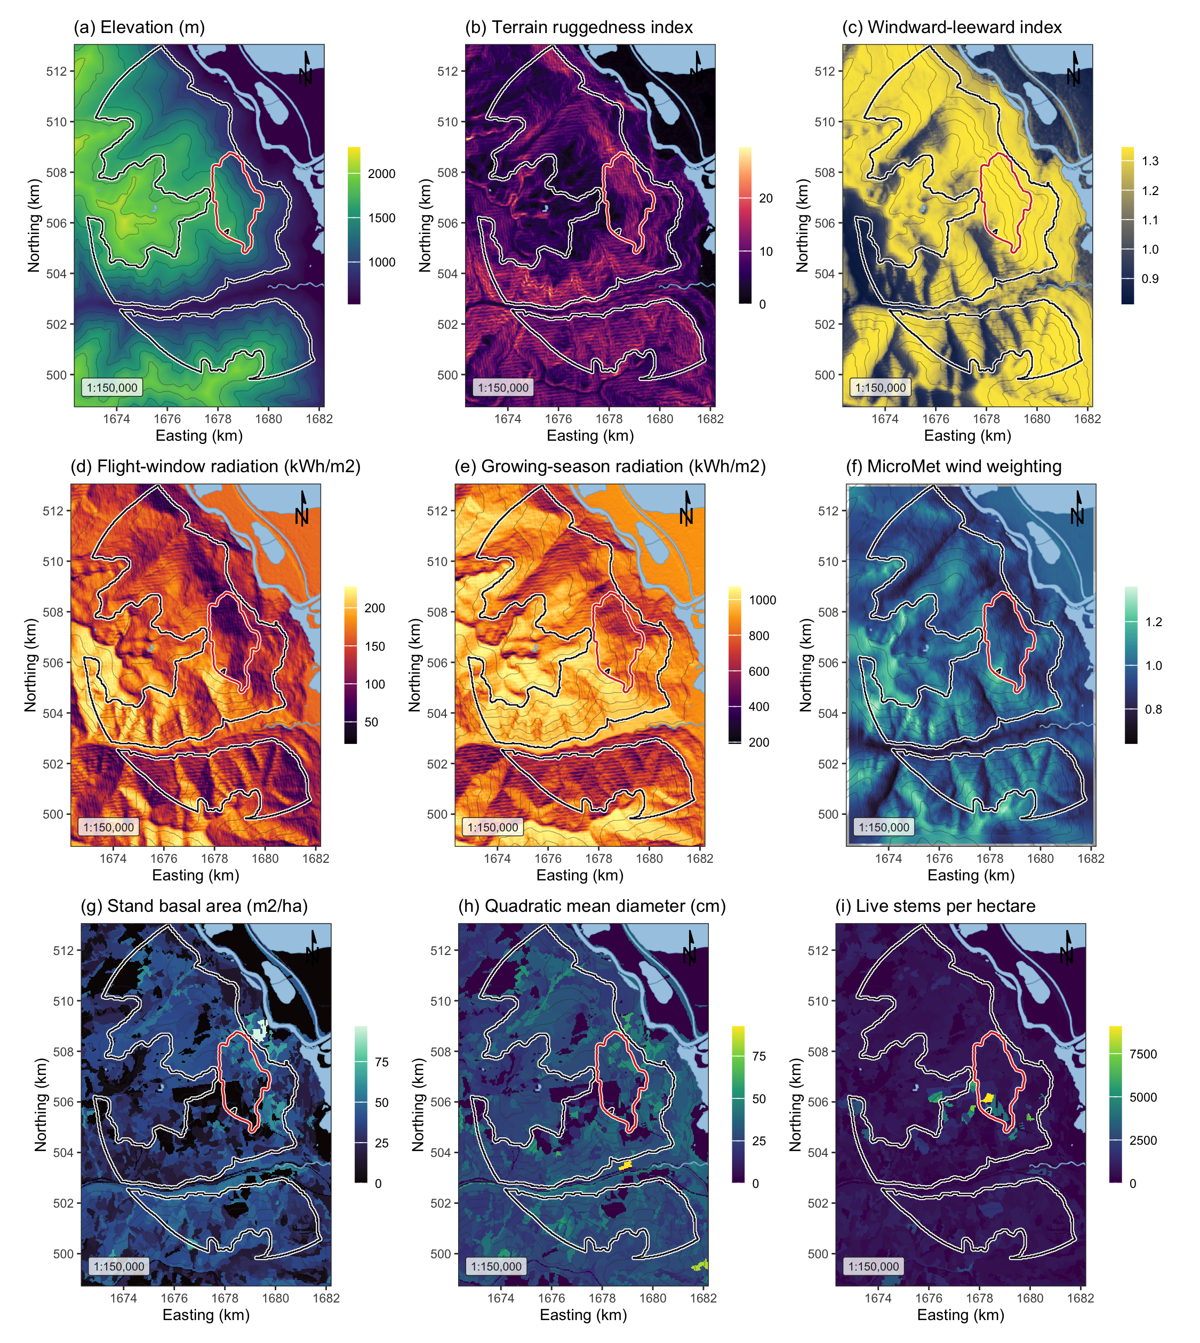
Figure 1: Landscape, terrain and stand surfaces across the study area, all EPSG:3153 at 30 m over Esri World Shaded Relief. (a) elevation; (b) terrain ruggedness index; (c) windward-leeward index at the prevailing bearing; (d) flight-window direct radiation, the thermal gate on flight; (e) growing-season direct radiation, the shading pathway; (f) the MicroMet wind weighting factor at the prevailing bearing; (g) stand basal area; (h) quadratic mean diameter, whose 25 cm source-sink threshold falls near the midpoint of the scale; (i) live stems per hectare. The white outline is the study perimeter and the red outline the 2015 Mt Midgeley burn. Contours are at 200 m.
The perimeter is anchored on the 2015 Mt Midgeley fire, 480 ha, which is the parent study’s site. That study reports its site as spanning “elevations from 830 to 1744 m a.s.l.”; the digital elevation model used here returns 856 to 1,744 m inside the same perimeter, which reproduces the statement. The present study extends beyond that hard boundary, because 480 ha does not contain the stand-density contrast the pheromone mechanism requires. The extension is not arbitrary. The perimeter is the burn buffered 5 km and then cut to the elevation band the parent’s site occupies, so the added ground is ecologically the same kind of ground. Without that cut a 1 km buffer already reaches the Kootenay Lake surface at 534 m, which is not a site elevation.

2.2 Beetle disturbance
The response is annual moderate-to-high beetle disturbance, classified from Landsat normalised difference moisture index by the method of the parent study and rebuilt for this project. It covers eight outbreak years, 2006 to 2014, excluding 2012, the one year covered only by Landsat 7, which has flown with its scan-line corrector off since May 2003. Annual prevalence inside the perimeter runs 4.9 to 19.2 per cent, pooled 12.9 per cent over 111,707 cell-years.
Years are never unioned. Unioning destroys the year-to-year spread this study measures, and the union layer over the wider grid reached 73 per cent of the landscape, which is not credible for a beetle outbreak.
The provincial aerial overview survey is not used as a response and supplies no training label. It is retained only as a visual check.
Table 3: Moderate-to-high beetle disturbance by year inside the study perimeter.
Year | Cells | Moderate-to-high (%)
2006 | 13,224 | 4.9
2007 | 13,225 | 6.0
2008 | 13,285 | 19.2
2009 | 13,556 | 12.4
2010 | 13,538 | 16.5
2011 | 14,944 | 13.5
2013 | 14,943 | 14.4
2014 | 14,992 | 15.2

2.3 Stand structure
Stand structure comes from the provincial Vegetation Resources Inventory layer VEG_COMP_LYR_R1_POLY, retrieved by web feature service over the perimeter. Six attributes cover the mechanism and the stem-size threshold. These are total basal area, crown closure, live stems per hectare, quadratic mean diameter over stems 12.5 cm and up, stand age, and susceptible pine basal area formed as total basal area times the pine share of cover.
Every model is fitted on year-matched stand structure. Each cell-year takes the inventory snapshot the province published for that year, depleted for harvest and projected for growth to it, so the host terms vary in time as well as in space.
One year is substituted. The 2007 delivery lists basal area and live stems as columns and fills neither, 0 and 3 per cent of polygons against 70 to 97 per cent in every other year, so the preceding year is carried forward rather than averaged. The inventory is itself a projection, so carrying forward reproduces a stand structure the province published, where averaging would invent one it did not.
67.1 per cent of cell-years sit at or above the 25 cm source-sink threshold.
Table 4: Stand structure across the study perimeter, from the Vegetation Resources Inventory. n is cell-years. SD is the standard deviation of the landscape; SE is the standard error of the mean and is small by construction at this n, so it should not be read as precision about any one cell. Skewness and kurtosis are the bias-corrected third and fourth standardised moments; kurtosis is excess, so 0 is Gaussian and positive is heavy-tailed.
Attribute | n | Mean | SD | SE | Median | Min | Max | Skew | Kurt.
Stand basal area (m2/ha) | 111,707 | 35.56 | 11.60 | 0.035 | 37.39 | 0.98 | 62.43 | -1.01 | +1.42
Crown closure (%) | 111,707 | 50.10 | 13.54 | 0.041 | 50.00 | 3.00 | 70.00 | -1.74 | +3.37
Live stems (n/ha) | 111,707 | 772.75 | 312.80 | 0.936 | 775.00 | 23.00 | 4600.00 | +1.70 | +19.51
Quadratic mean diameter (cm) | 111,707 | 27.38 | 6.40 | 0.019 | 26.95 | 13.55 | 58.90 | +0.73 | +1.24
Stand age (years) | 111,707 | 115.46 | 20.88 | 0.062 | 116.00 | 22.00 | 237.00 | -0.78 | +1.97
Stand height (m) | 111,707 | 26.97 | 6.27 | 0.019 | 27.90 | 7.00 | 40.30 | -0.26 | +0.23
Standing volume (m3/ha) | 111,707 | 272.33 | 131.38 | 0.393 | 281.47 | 0.82 | 586.61 | +0.01 | -0.35
Lodgepole pine cover (%) | 111,707 | 20.11 | 23.93 | 0.072 | 10.00 | 0.00 | 100.00 | +1.45 | +1.56
Susceptible pine basal area (m2/ha) | 111,707 | 7.07 | 8.85 | 0.026 | 4.00 | 0.00 | 48.30 | +1.63 | +2.63

The inventory is a projected operational product, not a census, and its polygons here have reference years spanning several decades. A polygon interpreted from late-outbreak photography describes a stand the beetle had already attacked, so basal area and pine cover are post-attack for part of the window. There is no unattacked vintage, so this is reported rather than corrected, and the Discussion returns to it.

2.4 Geomorphometry
Terrain is described by 29 geomorphometric surfaces computed with SAGA GIS over the full reprojected elevation model and clipped afterwards, so a search radius near the boundary still falls on real ground.
Radiation is computed twice because two mechanisms need it. Flight-window insolation is direct and diffuse radiation over 1 July to 15 August restricted to 12:00 to 17:00, the hours Safranyik & Carroll (2006) identify as the flight peak; growing-season insolation is the whole-day total from 1 May to 30 September, the shading quantity Krawchuk et al. (2020)’s first mechanism concerns. A single annual heat index cannot separate them. Flight-window direct radiation spans a 7-fold range here against 2.6-fold for the season total.
Exposure enters as the windward-leeward index and effective air flow height at the prevailing bearing, the omnidirectional wind exposition index, the wind shelter index and topographic openness. Shape enters as terrain ruggedness, vector ruggedness, topographic position and its multi-scale form, convergence, slope, curvature and geomorphon class. Landform enters as topographic wetness, valley depth, height above the valley floor, normalised height and mid-slope position, because infested groups are reported in draws and gullies and deep snow insulates overwintering brood (Safranyik & Carroll, 2006). Aspect enters as its northward and eastward components with the heat load index of McCune & Keon (2002).
One distinction matters. The strongest aspect statements in Safranyik & Carroll (2006) concern the aspect of the bole, not the slope, and are within-tree effects a 30 m raster cannot measure. Nothing here tests them.

2.5 Terrain-resolved wind
Station wind interpolated from four to seven valley stations is nearly flat within a year, so wind is also computed as a field varying in space, using the MicroMet model of Liston & Elder (2006). WindNinja, the usual tool, ships no macOS binary. MicroMet’s wind component is seven equations rather than a program, implemented directly with the paper’s equation numbers against each.
Terrain slope $β$ and slope azimuth $ξ$ come from the elevation model (Liston & Elder (2006), their equations 12 and 13). Curvature $Ω_{c}$ is a cell’s elevation minus the mean of the two opposite cells one curvature length scale away, taken on four direction lines and averaged (their equation 14); the length scale is estimated as the first lag at which elevation autocorrelation falls below 0.5, which is 600 m here. Writing $θ$ for the wind bearing, the slope in the wind direction is
$$Ω_{s}=βcos\left(θ-ξ\right) \left(1\right)$$
with $Ω_{s}$ and $Ω_{c}$ each scaled to $\left[-0.5, 0.5\right]$. The terrain weighting factor applied to the observed speed $W$ is
$$W_{w}=1+γ_{s}Ω_{s}+γ_{c}Ω_{c}, γ_{s}=γ_{c}=0.5 \left(2\right)$$
giving the terrain-modified speed
$$W_{t}=W_{w}W \left(3\right)$$
and a diversion of the wind direction of
$$θ_{d}=-1/2 Ω_{s}sin​\left[2\left(ξ-θ\right)\right]. \left(4\right)$$
By Equation 2, $W_{w}$ depends on direction and not on speed, so it is computed once for each of 16 direction bins and each hourly observation multiplied by the surface for its own bin; nothing is averaged before the terrain acts on it. Over all bins $W_{w}$ runs 0.60 to 1.38. Speed and direction combine as components because averaging degrees across the 360/0 line is meaningless. The field varies 1.9 to 2.8 km/h across the grid within a year, and is not a repackaged terrain index. It correlates +0.148 with the windward-leeward index and +0.123 with flight radiation. Its strongest association is with elevation, +0.320.

2.6 Flight-window wind
The flight window is 1 July to 15 August and the hours 12:00 to 17:00, and neither bound was chosen from these data. The dates are the flight period Safranyik & Carroll (2006) give for this region; the hours follow their “peak flight is in the early to mid afternoon” and Gray et al. (1972)’s 11:00 to 14:00 emergence peak, taken here to the later side because emergence precedes the flight it initiates. Because the window is fixed a priori it can be checked against the landscape’s own climate, and Figure 2 does that. Across 236,079 hourly station records from May to September of the nine study years, 89.5 per cent of afternoon hours inside the window fall within the 19 to 41 degrees C flight gate, against 51.4 per cent outside it, and the afternoon mean is 26.0 against 19.2 degrees C. The window therefore roughly doubles the share of hours in which flight is thermally possible. The same figure shows the same daily pattern in wind. Mean speed peaks in the same hours as temperature, at 10.4 km/h in mid-afternoon against 4.6 km/h at dawn, so the hours the beetle can fly are also the windiest of the day. That is a coincidence of timing the mechanism depends on.
Station wind is Environment and Climate Change Canada hourly records, and it enters in three places. It is the observation MicroMet modifies over the terrain, it supplies the prevailing bearing the directional terrain indices are computed at, and it is the climate against which the flight window is checked in Figure 2. The records are never reduced before the terrain acts on them.
Hourly readings give detail, not independent observations. Summarised over a whole season, every hour of wind collapses into one number per metric, a coefficient rests on as many values as there are seasons, and its standard error looks small without being believable. Stand density varies cell to cell; a season’s wind does not. The response is therefore measured over each sixteen-day epoch, so that wind varies within a season as well as between seasons and the interaction the mechanism predicts is identified.
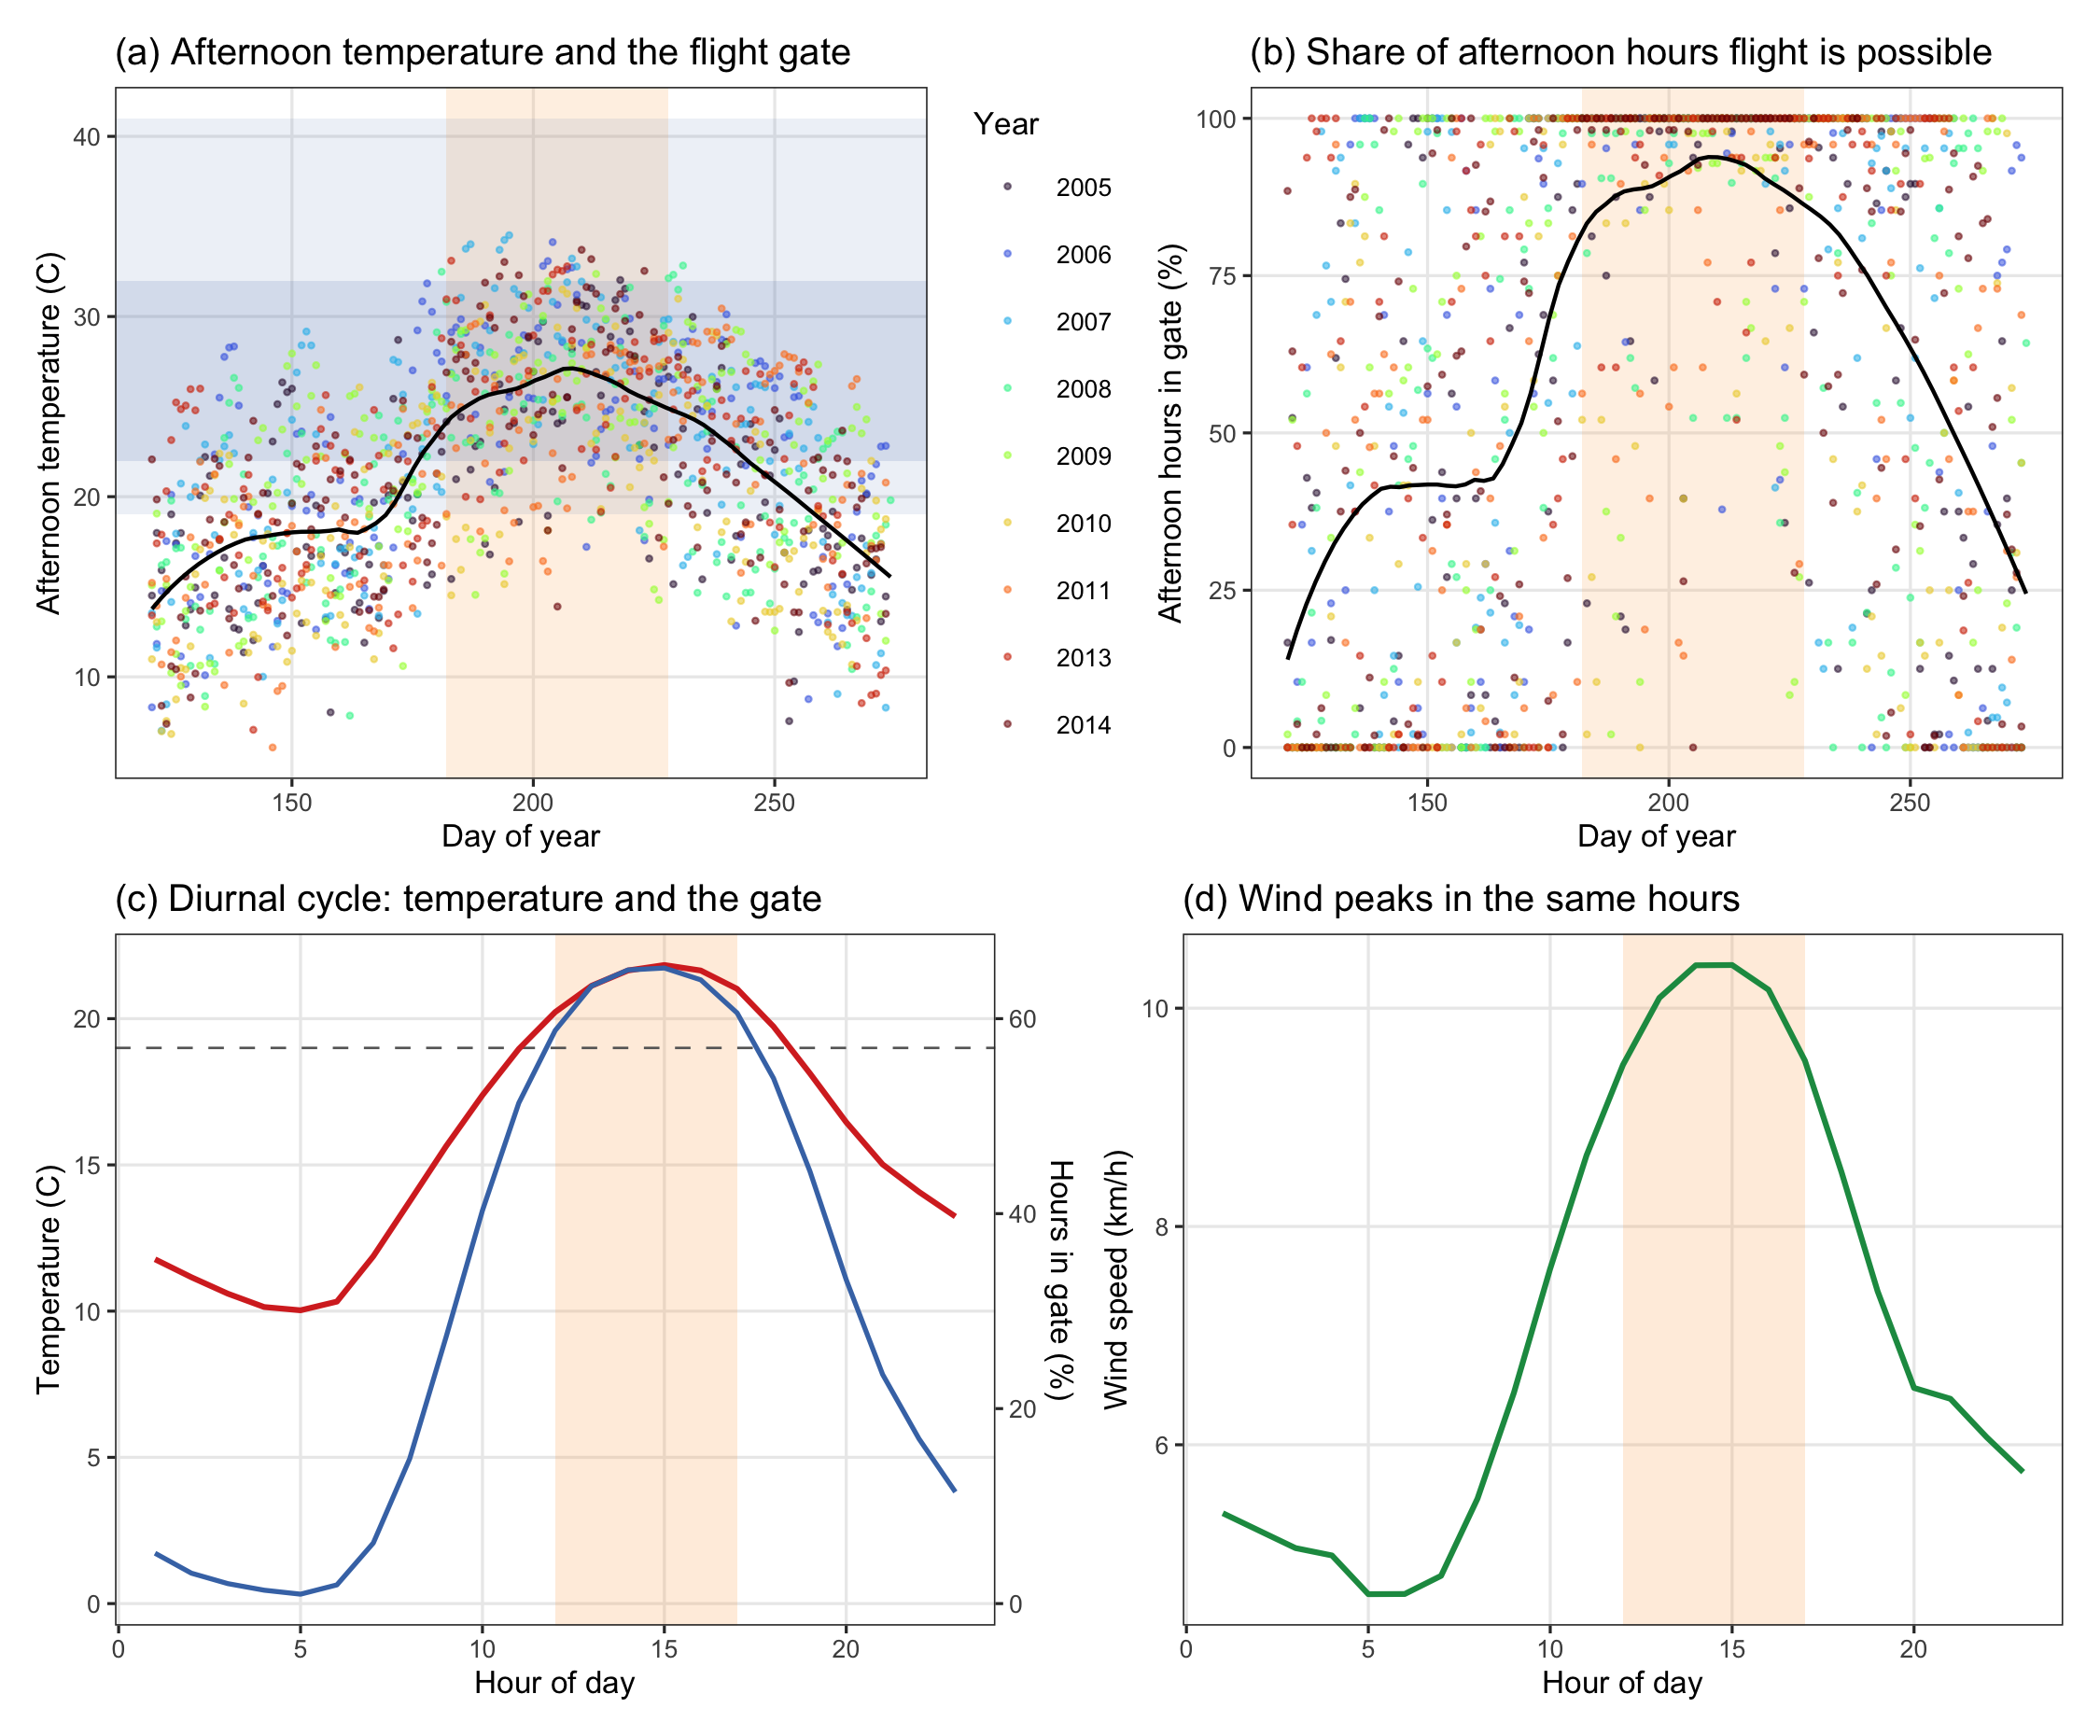
Figure 2: The flight window against the landscape’s own climate, from hourly Environment and Climate Change Canada station records for May to September of the nine study years. The window, 1 July to 15 August, is the shaded band; it is taken from the bionomics and is not fitted to these data. (a) Mean afternoon temperature by day of year, with the 19 to 41 degrees C flight gate and the 22 to 32 degrees C peak band marked. (b) The share of afternoon hours falling inside the flight gate, day by day. (c) The diurnal curve, mean temperature and the share of all hours inside the gate, by hour, with the 12:00 to 17:00 restriction shaded. (d) Mean wind speed by hour, on the same axis, showing that the hours the beetle can fly are also the windiest of the day.

3. Methods

3.1 Variable selection
The candidate set is 45 variables in six groups, one group for each pathway the review names. The groups are stand density, host quality, terrain exposure to wind, terrain shape, landscape context, and flight-window wind. Selection proceeds in four stages and is required to retain at least one variable from each pathway, so that a collinearity filter cannot silently delete a hypothesis the review established.
Fitting uses a class-balanced sample of 46,359 cell-years, 4,000 of each class per year. Landscape prevalence is about 13 per cent, and an unbalanced fit at that prevalence reports the intercept rather than the covariates.

3.2 Models
Every model is a logistic regression of moderate-to-high disturbance $y_{it}$ in cell $i$ and year $t$ on standardised covariates,
logitPryit=1=α+xit⊤β+γgi+k​δk zk,it 5
where $γ_{g\left(i\right)}$ is the effect of the geomorphon landform class $g$ of cell $i$ and the $z_{k,it}$ are the interaction terms. Coefficients are therefore log-odds per standard deviation. Four models are fitted, each adding one claim to the last, so that every term’s contribution is visible as a change in fit rather than asserted.
M0 fits Krawchuk’s first and third mechanisms together with landform context, that is host size, topographic shading, and the terrain that governs where cold air and snow collect. M1 adds stand density, the second of Krawchuk’s mechanisms, which is objective 1. M2 adds terrain shape, terrain exposure to wind, and flight-window radiation, which are objectives 3 and 4. M3 adds the three interactions objective 4 requires, stand density by terrain exposure, by flight-window radiation, and by flight-window wind.

4. Results
Table 5: Model comparison, panel A of the model table. Each model adds one pathway to the previous. AIC ranks on likelihood and a parameter penalty; the remaining columns are predictive error on the fitted probabilities. RMSE is the root mean squared error and is the square root of the Brier score; RMSE (%) expresses it against the prevalence of the response. Brier skill is the improvement over predicting the prevalence for every cell, where 0 is no better than the base rate. MAPE and Theil’s U are not reported, because both divide by the observed value, which is zero for the majority class of a binary response, so both are undefined without discarding that class.
Model | AIC | ΔAIC | RMSE | RMSE (%) | MAE | Brier | Log loss | AUC | Brier skill
M0 host size + shading + landform | 46,964 | 1,734 | 0.407 | 131.5 | 0.333 | 0.166 | 0.506 | 0.776 | 0.224
M1 + stand density | 46,507 | 1,277 | 0.405 | 130.6 | 0.329 | 0.164 | 0.501 | 0.783 | 0.234
M2 + terrain and flight radiation | 45,764 | 534 | 0.401 | 129.5 | 0.323 | 0.161 | 0.493 | 0.792 | 0.247
M3 + interactions | 45,230 | 0 | 0.399 | 128.7 | 0.319 | 0.159 | 0.487 | 0.800 | 0.257

Table 6: Full model M3, panel B of the model table, continuous terms ordered by absolute effect. Coefficients are log-odds per standard deviation on a class-balanced sample, so the intercept is not landscape prevalence. SE is the standard error of the coefficient. The geomorphon landform classes are also in this model and are not reported here.
Term | Beta | SE | z | p
Susceptible pine basal area (m2/ha) | +0.536 | 0.015 | 35.25 | < 0.001
Stand basal area (m2/ha) | +0.504 | 0.027 | 18.59 | < 0.001
Flight-window direct radiation (kWh/m2) | +0.497 | 0.030 | 16.49 | < 0.001
Windward-leeward index | +0.394 | 0.030 | 13.31 | < 0.001
Quadratic mean diameter (cm) | -0.362 | 0.025 | -14.47 | < 0.001
Elevation (m) | +0.337 | 0.018 | 18.44 | < 0.001
Northness | +0.305 | 0.015 | 19.79 | < 0.001
Stand age (years) | +0.260 | 0.017 | 14.98 | < 0.001
Flight-window calm hours (share below 5 km/h) | -0.131 | 0.019 | -6.81 | < 0.001
Topographic wetness index | +0.130 | 0.020 | 6.53 | < 0.001
Crown closure (%) | -0.125 | 0.022 | -5.80 | < 0.001
July mean wind (km/h) | +0.119 | 0.016 | 7.43 | < 0.001
Valley depth (m) | -0.104 | 0.022 | -4.66 | < 0.001
Stand basal area x Flight-window direct radiation | +0.103 | 0.021 | 4.90 | < 0.001
Topographic position index | +0.094 | 0.024 | 3.92 | < 0.001
Stand basal area x Flight-window calm hours | +0.085 | 0.016 | 5.36 | < 0.001
Mid-slope position | +0.068 | 0.014 | 4.99 | < 0.001
June mean wind (km/h) | +0.055 | 0.015 | 3.76 | < 0.001
Vector ruggedness measure | -0.052 | 0.021 | -2.49 | 0.013
Live stems (n/ha) | +0.051 | 0.017 | 3.01 | 0.003
Profile curvature | -0.042 | 0.013 | -3.26 | 0.001
Stand basal area x Windward-leeward index | -0.040 | 0.024 | -1.65 | 0.098
Convergence index | -0.025 | 0.014 | -1.73 | 0.083
Terrain ruggedness index | -0.005 | 0.025 | -0.19 | 0.848

Every pathway earned its place. AIC fell 457 when stand density entered, 743 more with terrain and flight radiation, and 534 more with the interactions (Table 5).
Stand basal area is the strongest density term. It entered at +0.504 log-odds per standard deviation, an odds ratio of 1.656, so a stand one standard deviation above the mean in basal area had 65.6 per cent higher odds of moderate-to-high disturbance (p < 0.001). Live stems per hectare has the same sign at +0.051 (p < 0.01), crown closure the opposite at -0.125 (p < 0.001).
Basal area and live stems both rise with attack, which is the direction a plume-holding canopy implies, while crown closure falls. Crown closure is also the one measure the inventory caps. It is recorded to a ceiling of 60 per cent, so its coefficient describes a truncated variable and should not be read as the others are.
Radiation enters the model once. Direct radiation during the flight window is +0.497, the temperature limit on flying. Growing-season radiation did not survive selection, so northness stands in for the shading pathway, and the two correlate -0.824. Northness is +0.305. Shaded, north-facing ground therefore has more attack, against the prediction.
Terrain predicted attack independently of both. The windward-leeward index was +0.394 and elevation +0.337, while ruggedness is -0.005 and not distinguishable from zero (p = 0.848), the vector ruggedness measure agreeing in sign at -0.052. Ruggedness takes the opposite sign to that of Murphy et al. (2026), whose response is seedling establishment rather than attack.
Fitted without flight-window radiation, stand density interacts with terrain exposure at -0.068, which reads as a wind result pointing the wrong way. With radiation in the model that interaction is -0.040 (p = 0.098) and density interacts with radiation at +0.103. On a range whose prevailing bearing is 258 degrees the windward slopes face west, which are also the slopes taking afternoon sun, so part of the apparent exposure effect was the sun. Not all of it. The interaction stays positive and far from zero, which is the wrong sign for pheromone disruption.
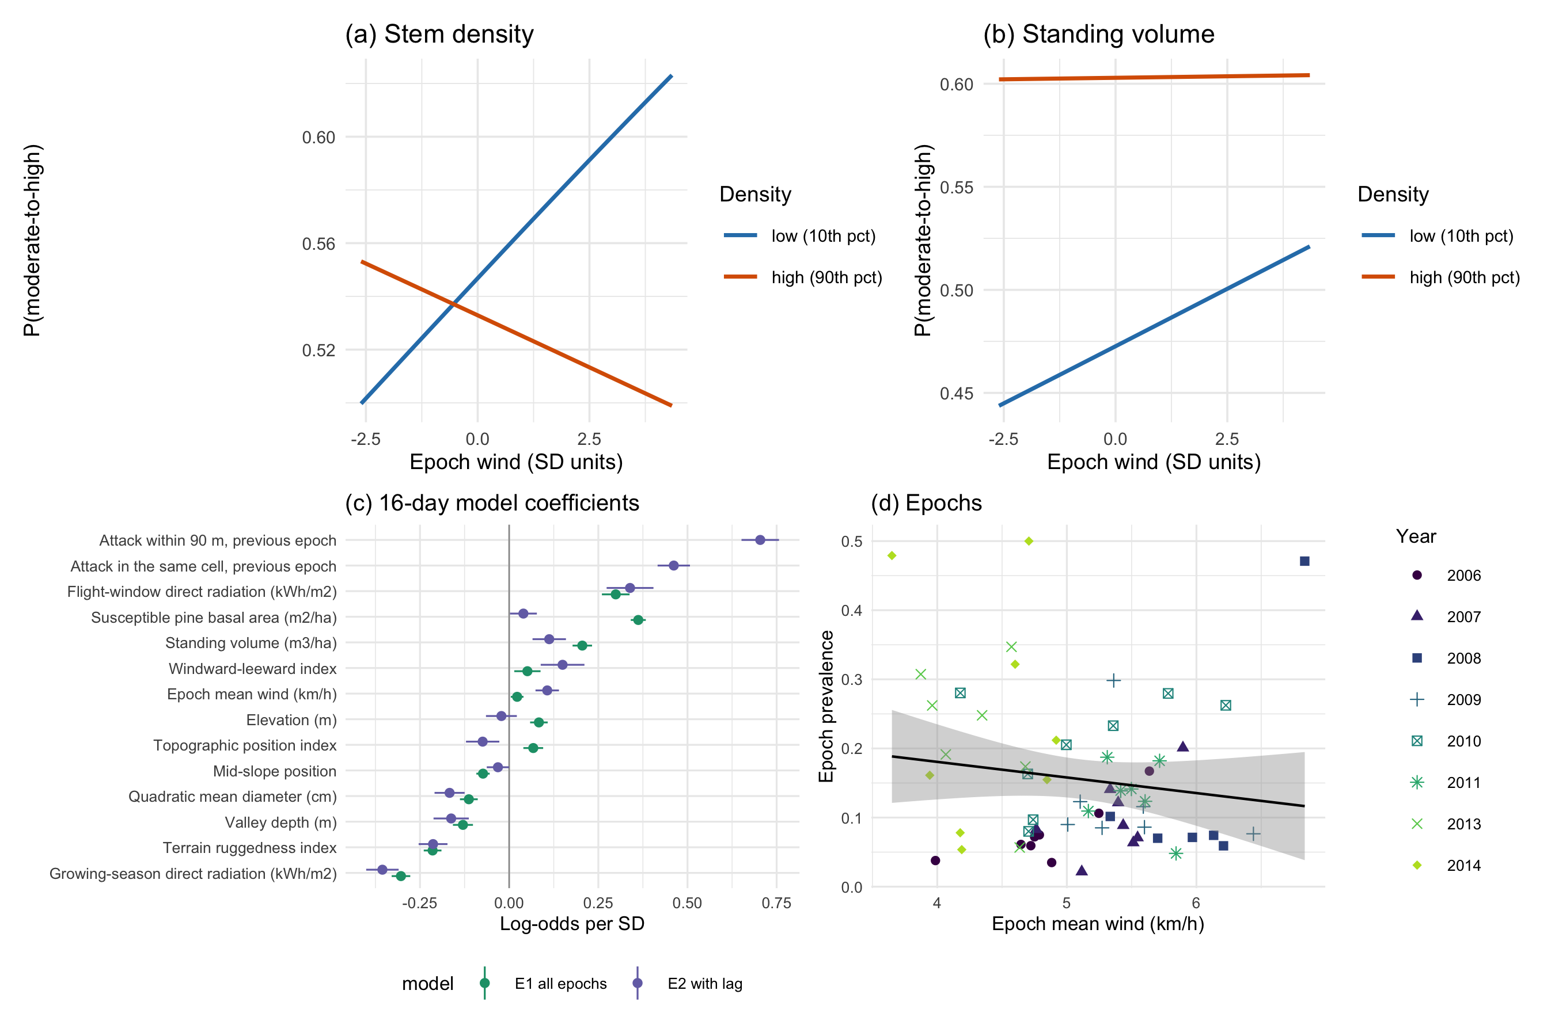
Figure 3: The refugia mechanism as fitted. (a) Predicted probability of moderate-to-high disturbance against terrain-resolved epoch wind, at the 10th and 90th percentiles of stem density, all other terms held at their means; the lines cross, so wind raises attack in thin stands and lowers it in dense ones, which is the interaction. (b) The same for standing volume, where the interaction is a fifth the size and attenuates the dense-stand slope without reversing it, so the lines converge rather than cross over the observed range. (c) Coefficients of the 16-day model, with and without the within-season spread term; the shading of a term between the two fits is what the within-season spread term absorbs. (d) Epoch prevalence against epoch mean wind, one point per epoch, years distinguished by both shape and shade so the panel survives black-and-white printing.

4.1 Density and wind
Stand density interacts negatively with terrain-resolved wind, which is the form the pheromone mechanism predicts. Attack falls where a thin stand and strong wind coincide, the interaction -0.049 for stem density (p < 0.001) and -0.017 for standing volume (p < 0.05). Expressed as odds, each standard deviation of the epoch wind regime multiplied the contribution of stem density by 0.952, a reduction of 4.8 per cent. Both interactions survive entering the previous epoch of the same season, so neither is the outbreak’s own spread appearing as a wind coefficient.
Wind on its own does not protect. Its main effect is +0.022, marginally more attack rather than less, and the density terms are positive, so a thin stand in still air shows no reduction either. The mechanism is present only as the conjunction of the two.

4.2 Previous-year pressure
Attack recurs where it was, by a margin that changes how every other coefficient reads. A cell attacked one year is between 16 and 139 times more likely to be attacked the next. Entering persistence and 90 m spread separately, after the autologistic design used for this province, gives +0.901 and +1.001, raising discrimination from 0.801 to 0.900.
Which environmental terms survive is the informative part. Ruggedness keeps 1.23 of its value, and it describes a condition a cell has whether or not the beetle was there. The landform terms are not stable. Valley depth keeps 0.18 while mid-slope position moves to 1.35, growing rather than shrinking. Part of what the landform terms measured was where the outbreak had already been, which is the same failure the terrain-wind index showed against radiation.

4.3 Host as diameter
Table 7: Moderate-to-high beetle disturbance by quadratic mean diameter class, on the balanced sample. The 25 cm boundary is the source-sink threshold of the species’ bionomics. Intervals are Wilson score intervals on the class proportion, which is why they are asymmetric in the smallest class. Note that 30 m cells in a spreading outbreak are not independent, so the tests reported beneath this table are anti-conservative.
QMD class (cm) | n | Attacked | Attacked (%) | 95% CI (%)
<15 | 436 | 113 | 25.9 | 22.0-30.2
15-20 | 4,325 | 1,057 | 24.4 | 23.2-25.7
20-25 | 9,934 | 2,627 | 26.4 | 25.6-27.3
25-30 | 19,090 | 7,576 | 39.7 | 39.0-40.4
30-40 | 10,903 | 2,724 | 25.0 | 24.2-25.8
>40 | 1,671 | 262 | 15.7 | 14.0-17.5

Coding host as diameter changes the picture cover alone gives. Attack peaks in the 25 to 30 cm class at 39.7 per cent and falls away above it, to 25.0 per cent at 30 to 40 cm and 15.7 per cent above 40 (Table 7). The step across the 25 cm source-sink boundary is from 26.4 to 39.7 per cent.
In the full model diameter is -0.362 per standard deviation (z = -14.47). It is negative because the relationship is not monotone. A linear term fitted through a humped response returns the slope of its falling limb, which is the larger part of the range. The class table, not the coefficient, is the result here, and the point stands, because a stand’s cover says nothing about whether its stems can produce brood.
The pattern is not an artefact of the class boundaries. Across all six classes attack depends on diameter class, $χ^{2}$ = 1230.4 on 5 degrees of freedom, p < 0.001, with Cramer’s V = 0.163. The step across the 25 cm source-sink boundary specifically, from the 20 to 25 class to the 25 to 30 class, is +13.2 percentage points, 95 per cent confidence interval 12.1 to 14.4, p < 0.001. With 46,359 cells a chi-square is significant on trivial differences, which is why the effect size is quoted beside it, and 30 m cells in a spreading outbreak are not independent, so both p-values are anti-conservative.
The smallest class is not evidence. It has 436 cells against 19,090 in the modal class, and a stand below 15 cm quadratic mean diameter in an inventory whose vintage postdates the outbreak is more likely a stand the beetle already stripped of large stems than a stand attacked at that size.

4.4 The wind window
The wind variable is the epoch wind regime, the mean over every hourly station observation in the sixteen days an epoch covers, each hour modified over the terrain by its own bearing. It is not restricted to the flight window, and that follows from how the insect disperses. Jackson, Straussfogel, Lindgren, Mitchell, & Murphy (2008) tracked mountain pine beetle on weather radar and confirmed the returns by aerial capture, finding beetles “at altitudes up to more than 800 m above the forest canopy” and estimating that those in flight above the canopy “may move 30–110 km$⋅$day$​^{-1}$”, at a mean density of 4950 and a maximum of 18,600 beetles per hectare. Ainslie & Jackson (2010) then reproduced that above-canopy dispersion with an atmospheric model. An insect carried in the boundary layer at those heights and distances is exposed to the atmospheric regime of the period, not to the wind measured in a stand between noon and five, and the variable is named for what it measures.
Table 8 refits the 16-day model under four definitions of the window. These are every hour, the 12:00 to 17:00 hours the flight peak occupies, the 11:00 to 18:00 hours that clear the thermal gate on this landscape more than half the time, and only those hours whose observed temperature fell inside the 19 to 41 degrees C gate itself. The stem-density interaction is negative and distinguishable from zero under all four, so the mechanism does not depend on the choice. It is largest over the full regime, and the standing-volume interaction is the term that depends on it.
Table 8: The 16-day model refitted under four definitions of the wind window. The epoch wind regime, every hour, is the definition used throughout this paper. Coefficients are log-odds per standard deviation. The thermal-gate row is fitted on fewer cell-epochs because two epochs had too few qualifying hours, so its AIC is not comparable with the other three.
Definition | Cell-epochs | Wind (km/h) | Stems x wind | p | Volume x wind | p | AUC
Epoch wind regime (all hours) | 71,127 | 5.04 | -0.0941 | < 0.001 | -0.0410 | < 0.001 | 0.668
12:00-17:00 | 71,127 | 6.45 | -0.0565 | < 0.001 | -0.0082 | 0.325 | 0.667
11:00-18:00 | 71,127 | 6.32 | -0.0623 | < 0.001 | -0.0161 | 0.054 | 0.667
Inside the 19-41 C gate | 69,711 | 5.67 | -0.0596 | < 0.001 | -0.0325 | < 0.001 | 0.666

5. Discussion

5.1 Radiation versus wind
The clearest result of this study is methodological. It changes what a terrain variable in this literature can be read as.
Fitted with a terrain-wind index and no radiation, stand density interacts with terrain exposure at -0.068, and the natural reading is a wind effect. Add flight-window radiation and that interaction becomes -0.040, p = 0.098, while density by radiation appears at +0.103. About two fifths of the apparent exposure effect was the sun. The rest was not, and what survives keeps the sign the mechanism forbids.
That is not a peculiarity of this dataset. A windward-leeward index and an afternoon radiation surface are both functions of slope and aspect, and on a range whose prevailing flight-window bearing is 258 degrees the windward slopes are the west-facing ones, which are also the slopes that take afternoon sun during the flight peak. Any study that enters a terrain-derived wind index without a radiation term on the same clock will attribute radiation to wind.

5.2 Refugia tested
This study tested the three mechanisms Krawchuk et al. (2020) propose for refugia from mountain pine beetle, using a response measured at the sixteen-day cadence the sensor and the insect share. Support was partial. H2, low host density admitting the wind that disperses the aggregation pheromone, was supported, and in the conditional form the mechanism specifies rather than as a main effect. H3, a scarcity of large-diameter hosts, was supported as a threshold rather than as a gradient. H1, topographic shading, was not supported, and the term that rejects it is the least secure in the study.
H2, host density, holds, and it holds in the conditional form the mechanism specifies rather than as a bare main effect. Stand basal area predicts disturbance at +0.504, and its interaction with wind is -0.017 while stem density’s is -0.049. The claim was never that dense stands are attacked more. It was that a dense canopy holds a plume together, and that the advantage this gives the beetle should shrink as the wind rises. Both halves are present.
H3, large-diameter host, holds as a threshold rather than a gradient. Attack peaks at 39.7 per cent in the 25 to 30 cm class, at the source-sink boundary of Carroll & Safranyik (2004), and falls away on both sides.
H1, topographic shading, does not hold, and it fails on a stand-in rather than on the quantity the mechanism names. Growing-season radiation did not survive variable selection, so northness stands in for the pathway, and it correlates -0.824 with it. Northness is +0.305, so shaded ground has more attack where the mechanism requires less. Northness tests aspect, and aspect measures more than shade, so this is the least secure of the three verdicts. The water-stress pathway Krawchuk et al. (2020) describe is not measured here at all.

5.3 The wind claim
Stand density interacts with terrain-resolved wind at -0.049 for stem density and -0.017 for standing volume, both negative, at p < 0.001 and p = 0.038 respectively. A dense stand is worth less to the beetle where and when the wind blows harder, which is what Krawchuk et al. (2020) predict. The result survives entering the previous epoch of the same season, so it is not the outbreak’s own spread appearing as a wind coefficient.
The mechanism concerns a plume that persists for minutes over a flight period of weeks, and the wind term is measured over the sixteen days an epoch covers for that reason. Krawchuk et al. (2020) name wind without naming the interval it should be summarised over, and nothing in the literature since has supplied one.
Two limits stay attached to the claim. The interaction is small, roughly a tenth of the stand basal area main effect. And the wind field, though it varies in space, is still terrain-modified station data rather than measurement on the ridge, so what is established is that the modelled wind field behaves as the mechanism requires, not that the air did.

5.4 Ruggedness and regeneration
The two papers now share a grid, a landscape and a terrain covariate set, and they disagree on the sign of ruggedness. It is -0.005 for beetle attack here, against a positive coefficient for conifer regeneration in Murphy et al. (2026). Read together they describe a landscape in which rugged ground both resists the disturbance and shelters the recovery from it. That is a coherent picture, not a contradiction, and it is only visible because the two studies were fitted on the same grid in EPSG:3153.

5.5 Remaining confounded
Elevation is among the largest terms in the model, +0.337, and elevation is not one thing. It combines temperature, snowpack, growing-season length and the distribution of lodgepole pine, and this design cannot take them apart. Reporting the elevation coefficient as a result would be reporting a composite.
The same caution now applies in reverse to every terrain term in the model. Radiation took about a third of one terrain interaction. There is no guarantee that some further unmeasured environmental surface would not take the rest, or another.
Three limits sit outside the model and bound every result in it. The inventory postdates part of the outbreak, because polygons interpreted after the beetle passed describe the stand it left, and total basal area discriminates only weakly on its own, 0.603. The response is classified rather than observed, inferred from Landsat moisture indices trained on plots cut from those same indices, so the reported accuracy measures separability and not agreement with ground mortality. And every conclusion rests on one mountain range across 8 years and 59 epochs.

6. Conclusions
The wind-disruption mechanism proposed by Krawchuk et al. (2020) holds on this landscape, at the resolution the sensor and the insect share. Across 59 sixteen-day epochs, stand density interacts negatively with terrain-resolved wind, -0.049 for stem density and -0.017 for standing volume, and both survive a within-season spread term. A dense canopy is worth less to the beetle where and when the wind blows harder, which is what a plume-disruption mechanism requires.
Of the three mechanisms that proposal names, two hold. Host density holds through stand basal area, +0.504, with live stems agreeing in sign and crown closure alone running the other way, and large-diameter host holds as a threshold at 25 to 30 cm rather than as a slope, at the source-sink boundary of Carroll & Safranyik (2004). Topographic shading does not hold, and it fails on a surrogate. Growing-season radiation did not survive selection, so northness stands in for the pathway at +0.305, and the two correlate -0.824.
Two measurement results travel beyond this landscape, and both concern variables that look like one thing and behave as another.
A terrain wind index is partly a measurement of sunlight. Entering flight-window radiation weakened the density by terrain-exposure interaction from -0.068 to -0.040. On any range whose prevailing bearing puts the windward slopes into the afternoon sun, and that is most of them, a study entering a windward-leeward index without a radiation term on the same clock will attribute radiation to wind.
A landform variable in a spreading outbreak partly records where the outbreak has already been. Entering previous-year attack left valley depth retaining 0.18 of its coefficient and moved mid-slope position to 1.35, against 1.23 for ruggedness, which describes a condition a cell has whether or not the beetle ever arrived. Landform terms fitted without a contagion term are not measuring landform alone.

Acknowledgements
We thank the Nature Conservancy of Canada for providing access to the Darkwoods Conservation Area and for logistical and field support, including technical guidance throughout from Adrian Leslie. Darkwoods, at 63,000 hectares the largest private conservation property in Canada, is situated within the traditional territories of the Ktunaxa, Syilx, and Sinixt Peoples in the West Kootenay region of British Columbia. Beetle disturbance was classified from Landsat Collection 2 Level-2 surface reflectance distributed by the United States Geological Survey; stand structure from the British Columbia Data Catalogue; terrain from Natural Resources Canada; and wind from Environment and Climate Change Canada. The author thanks those agencies for maintaining the open archives the study rests on.

Declaration of Competing Interests
The author declares that they have no known competing financial interests or personal relationships that could have appeared to influence the work reported in this paper.

Declaration of Generative AI Non-Use
The author declares that no generative AI or AI-assisted technologies were used in the preparation, writing, or editing of this manuscript.

Funding
This research did not receive any specific grant from funding agencies in the public, commercial, or not-for-profit sectors.

CRediT Author Contributions
Seamus Murphy: conceptualization; data curation; formal analysis; investigation; methodology; software; validation; visualisation; writing, original draft; writing, review and editing.

Data Availability
Every dataset used here is public and none was collected by the author. Beetle disturbance is classified from Landsat Collection 2 Level-2 surface reflectance. Stand structure is the provincial Vegetation Resources Inventory layer VEG_COMP_LYR_R1_POLY, retrieved from the British Columbia Data Catalogue web feature service by 02.inputs/beetle/34-fetch-vri.py. Terrain derives from the Natural Resources Canada High Resolution Digital Elevation Model (Natural Resources Canada, 2017), with geomorphometry computed by SAGA GIS in 37-geomorphometry.R. Wind is Environment and Climate Change Canada hourly station data, retrieved by 30-wind-hourly-metrics.R and 36-wind-direction.R. All derived data and the complete analysis code that reproduce every number, table and figure in this article are archived at Dryad under doi:PLACEHOLDER-DRYAD-DOI, and are mirrored at https://github.com/seamusrobertmurphy/beetle-topography-and-wind-study.
R version 4.4.1 (2024-06-14)
Platform: aarch64-apple-darwin20
Running under: macOS 15.7.7
Matrix products: default
BLAS: /opt/local/Library/Frameworks/R.framework/Versions/4.4-arm64/Resources/lib/libRblas.0.dylib
LAPACK: /opt/local/Library/Frameworks/R.framework/Versions/4.4-arm64/Resources/lib/libRlapack.dylib; LAPACK version 3.12.0
locale:
[1] en_CA.UTF-8/en_CA.UTF-8/en_CA.UTF-8/C/en_CA.UTF-8/en_CA.UTF-8
time zone: America/Vancouver
tzcode source: internal
attached base packages:
[1] stats graphics grDevices utils datasets methods base
other attached packages:
[1] ggnewscale_0.5.2 e1071_1.7-17 ggspatial_1.1.10 tidyterra_1.1.0
[5] patchwork_1.3.2 ranger_0.18.0 car_3.1-5 carData_3.0-6
[9] mgcv_1.9-4 nlme_3.1-168 knitr_1.51 ggplot2_4.0.2
[13] tidyr_1.3.2 dplyr_1.2.0 sf_1.1-0 terra_1.9-1
loaded via a namespace (and not attached):
[1] gtable_0.3.6 xfun_0.57 lattice_0.22-9
[4] vctrs_0.7.2 tools_4.4.1 generics_0.1.4
[7] tibble_3.3.1 proxy_0.4-29 pkgconfig_2.0.3
[10] Matrix_1.7-5 KernSmooth_2.23-26 data.table_1.18.2.1
[13] RColorBrewer_1.1-3 S7_0.2.1 lifecycle_1.0.5
[16] compiler_4.4.1 farver_2.1.2 codetools_0.2-20
[19] htmltools_0.5.9 class_7.3-23 yaml_2.3.12
[22] Formula_1.2-5 pillar_1.11.1 classInt_0.4-11
[25] wk_0.9.5 abind_1.4-8 tidyselect_1.2.1
[28] digest_0.6.39 purrr_1.2.1 labeling_0.4.3
[31] splines_4.4.1 fastmap_1.2.0 grid_4.4.1
[34] cli_3.6.5 magrittr_2.0.4 withr_3.0.2
[37] scales_1.4.0 rmarkdown_2.30 otel_0.2.0
[40] reticulate_1.45.0 png_0.1-9 evaluate_1.0.5
[43] viridisLite_0.4.3 s2_1.1.9 rlang_1.1.7
[46] Rcpp_1.1.1 glue_1.8.0 DBI_1.3.0
[49] pROC_1.19.0.1 jsonlite_2.0.0 R6_2.6.1
[52] units_1.0-1

13. References
Ainslie, B., & Jackson, P. L. (2010). Investigation into mountain pine beetle above-canopy dispersion using weather radar and an atmospheric dispersion model. Aerobiologia, 27, 51–65. https://doi.org/10.1007/s10453-010-9176-9
Badger, J., Frank, H., Hahmann, A. N., & Giebel, G. (2014). Wind-climate estimation based on mesoscale and microscale modeling: Statistical–dynamical downscaling for wind energy applications. Journal of Applied Meteorology and Climatology, 53(8), 1901–1919. https://doi.org/10.1175/JAMC-D-13-0147.1
Bartos, D. L., & Amman, G. D. (1989). Microclimate: An alternative to tree vigor as a basis for mountain pine beetle infestations (Research Paper No. INT-400). Ogden, UT: U.S. Department of Agriculture, Forest Service, Intermountain Research Station. https://doi.org/10.2737/int-rp-400
Carroll, A. L., & Safranyik, L. (2004). The bionomics of the mountain pine beetle in lodgepole pine forests: Establishing a context. In T. L. Shore, J. E. Brooks, & J. E. Stone (Eds.), Mountain pine beetle symposium: Challenges and solutions, October 30–31, 2003, Kelowna, British Columbia (pp. 21–32). Victoria, British Columbia: Natural Resources Canada, Canadian Forest Service, Pacific Forestry Centre.
Cartwright, J. M. (2018). Landscape topoedaphic features create refugia from drought and insect disturbance in a lodgepole and whitebark pine forest. Forests, 9(11), 715. https://doi.org/10.3390/f9110715
Cooke, B. J., MacQuarrie, C. J. K., & Carroll, A. L. (2025). On the deduction and quantification of irruptive dynamics in mountain pine beetle population and proxy data. Journal of Applied Entomology, 149, 309–323. https://doi.org/10.1111/jen.13262
Davis, N. N., Badger, J., Hahmann, A. N., Hansen, B. O., Mortensen, N. G., Kelly, M., … Drummond, R. (2023). The Global Wind Atlas: A high-resolution dataset of climatologies and associated web-based application. Bulletin of the American Meteorological Society, 104(8), E1507–E1525. https://doi.org/10.1175/BAMS-D-21-0075.1
Gray, B., Billings, R. F., Gara, R. I., & Johnsey, R. L. (1972). On the emergence and initial flight behaviour of the mountain pine beetle, Dendroctonus ponderosae, in eastern Washington. Zeitschrift für Angewandte Entomologie, 71, 250–259. https://doi.org/10.1111/j.1439-0418.1972.tb01745.x
Howe, M., Raffa, K. F., Aukema, B. H., Gratton, C., & Carroll, A. L. (2022). Numbers matter: How irruptive bark beetles initiate transition to self-sustaining behavior during landscape-altering outbreaks. Oecologia, 198, 681–698. https://doi.org/10.1007/s00442-022-05129-4
Jackson, P. L., Straussfogel, D., Lindgren, B. S., Mitchell, S., & Murphy, B. (2008). Radar observation and aerial capture of mountain pine beetle, Dendroctonus ponderosae Hopk. (Coleoptera: Scolytidae) in flight above the forest canopy. Canadian Journal of Forest Research, 38(8), 2313–2327. https://doi.org/10.1139/X08-066
Jones, K. L., Shegelski, V. A., Marculis, N. G., Wijerathna, A. N., & Evenden, M. L. (2019). Factors influencing dispersal by flight in bark beetles (Coleoptera: Curculionidae: Scolytinae): From genes to landscapes. Canadian Journal of Forest Research, 49, 1024–1041. https://doi.org/10.1139/cjfr-2018-0304
Krawchuk, M. A., Meigs, G. W., Cartwright, J. M., Coop, J. D., Davis, R., Holz, A., … Meddens, A. J. H. (2020). Disturbance refugia within mosaics of forest fire, drought, and insect outbreaks. Frontiers in Ecology and the Environment, 18(5), 235–244. https://doi.org/10.1002/fee.2190
Liston, G. E., & Elder, K. (2006). A meteorological distribution system for high-resolution terrestrial modeling (MicroMet). Journal of Hydrometeorology, 7(2), 217–234. https://doi.org/10.1175/JHM486.1
McCambridge, W. F. (1971). Temperature limits of flight of the mountain pine beetle, Dendroctonus ponderosae. Annals of the Entomological Society of America, 64(2), 534–535. https://doi.org/10.1093/aesa/64.2.534
McCune, B., & Keon, D. (2002). Equations for potential annual direct incident radiation and heat load. Journal of Vegetation Science, 13(4), 603–606. https://doi.org/10.1111/j.1654-1103.2002.tb02087.x
Murphy, S., Leslie, A., Wilson, J., & Banks, L. K. (2026). Spatial patterns of conifer regeneration following mountain pine beetle outbreak (Dendroctonus ponderosae) and mixed-severity wildfire: A point process model of disturbance interactions in the southern Selkirk Mountains, British Columbia. Forest Ecology and Management, 618, 123985. https://doi.org/10.1016/j.foreco.2026.123985
Natural Resources Canada. (2017). High resolution digital elevation model (HRDEM) – CanElevation series. Retrieved from https://open.canada.ca/data/en/dataset/957782bf-847c-4644-a757-e383c0057995
Powell, J. A., & Bentz, B. J. (2014). Phenology and density-dependent dispersal predict patterns of mountain pine beetle (Dendroctonus ponderosae) impact. Ecological Modelling, 273, 173–185. https://doi.org/10.1016/j.ecolmodel.2013.10.034
Safranyik, L., & Carroll, A. L. (2006). The biology and epidemiology of the mountain pine beetle in lodgepole pine forests. In L. Safranyik & B. Wilson (Eds.), The mountain pine beetle: A synthesis of biology, management, and impacts on lodgepole pine (pp. 3–66). Victoria, British Columbia: Natural Resources Canada, Canadian Forest Service, Pacific Forestry Centre.
Sambaraju, K. R., & Goodsman, D. W. (2021). Mountain pine beetle: An example of a climate-driven eruptive insect impacting conifer forest ecosystems. CAB Reviews, 16(018). https://doi.org/10.1079/PAVSNNR202116018
Taylor, S. W., & Carroll, A. L. (2003). Disturbance, forest age, and mountain pine beetle outbreak dynamics in BC: A historical perspective. In Mountain pine beetle symposium: Challenges and solutions, October 30–31, 2003, Kelowna, British Columbia (pp. 41–51). Victoria, British Columbia: Natural Resources Canada, Canadian Forest Service, Pacific Forestry Centre.

