Testing the wind disruption and disturbance refugia hypothesis for mountain pine beetle outbreaks (Dendroctonus ponderosae)
Terrain, stand density and flight-period wind as controls on attack in the Selkirk Mountains of British Columbia
Seamus Murphy
2026-09-16
Running title. Terrain, wind and mountain pine beetle refugia
Correspondence. Seamus Murphy, TÜV SÜD, 2187 Comox Ave, Comox, British Columbia V9M 1P5, Canada. seamusrobertmurphy@gmail.com. ORCID 0000-0002-1792-0351.
Keywords. Mountain pine beetle, forest disturbance, insect outbreaks, Landsat time series, refugia, British Columbia
Data availability statement. Every dataset used was public. Beetle disturbance was classified from Landsat Collection 2 Level-2 surface reflectance, stand structure came from the provincial Vegetation Resources Inventory, terrain from the Natural Resources Canada High Resolution Digital Elevation Model (Natural Resources Canada, 2017) and wind from Environment and Climate Change Canada hourly station records. All derived data and the complete analysis code that reproduce every number, table and figure in this article are at https://github.com/seamusrobertmurphy/beetle-topography-and-wind-study and will be deposited in the Dryad Digital Repository, with a DOI, with the revised manuscript.
Conflict of interest statement. The author has no conflict of interest to declare. There is no dispute over the ownership of the data presented, and every contribution has been attributed by acknowledgement.
Author contributions. Seamus Murphy took every CRediT role, conceptualization, methodology, software, validation, formal analysis, investigation, data curation, visualization, project administration, writing of the original draft, and review and editing.

Abstract
- Disturbance refugia from mountain pine beetle (Dendroctonus ponderosae) outbreaks have been hypothesised by Krawchuk et al. (2020) to form where tree defences remain effective, on shaded ground that spares trees water stress or in thin stands with few large hosts where wind may disrupt the aggregation pheromone.
- All three were tested across 5,573 ha of the Selkirk Mountains, British Columbia, using 59 sixteen-day Landsat epochs over eight outbreak years with annualized forest inventory, geomorphometric variables and a terrain-resolved MicroMet wind field from hourly station records.
- Wind disruption was supported conditionally, in that attack fell where a thin stand and strong flight-period wind coincided, the density-by-wind interaction -0.049 for stem density (P < 0.001) and -0.017 for standing volume (P < 0.05), both remaining after within-season contagion entered the model.
- Terrain acted differently. Leeward ground had more attack as a main effect, -0.267, independent of stand density, and open gentle ground more still, sky view +0.285, which is the pattern expected if wind-borne beetles, which land without discriminating hosts, settle where the flow slows. Attack responded to host size as a threshold, peaking at 31.5 per cent in the 25 to 30 cm quadratic mean diameter class.
- The shade hypothesis failed, since north-facing slopes showed more attack (+0.384). Refugia are therefore proposed to lie on warm, windward ground in thin stands during windy flight periods, and the terrain ruggedness signal of the companion study resolves into shelter and openness.

1. Introduction
Mountain pine beetle (Dendroctonus ponderosae Hopkins [Coleoptera: Curculionidae: Scolytinae]) has impacted more lodgepole pine (Pinus contorta Douglas ex Loudon) stands across British Columbia than any other disturbance event on record (Sambaraju & Goodsman, 2021; Taylor & Carroll, 2003). However, mortality is not distributed evenly across a landscape, and the stands that survive supply the structure and seed from which the next forest develops. Such stands are termed disturbance refugia, places buffered from disturbance over time (Krawchuk et al., 2020). Locating a refugium does not explain it, and explanation requires a mechanism linking survival to a measurable property of the site, such as terrain, soil or stand structure (Cartwright, 2018). Krawchuk et al. (2020) proposed such a mechanism, that refugia could occur “in areas with cooler temperatures (eg from topographic shading) that protect trees from water stress; in areas with lower host density, allowing for greater wind disruption of beetle pheromone communication and more vigorous tree growth and chemical defenses; and in areas with fewer large-diameter host trees” (p. 239). These are three testable claims. Topographic shading reduces attack by relieving water stress on cool ground. Low host density reduces attack by admitting the wind that disperses the aggregation pheromone. A scarcity of large-diameter hosts reduces attack by limiting brood production, because stems under 25 cm in diameter are sinks for the beetle and stems above it are sources (Carroll & Safranyik, 2004), and attack cannot occur where the host is absent, so a cell without pine is not a refugium (Cartwright, 2018). Two of the three act through terrain. This study fitted the three together on one landscape, following Cartwright (2018), who modelled the controls on an insect refugium in stands of low basal area, and Maher et al. (2021), who tested refugia from this beetle on transects at alpine treeline.
The part wind plays in the beetle’s dispersal is well studied. Within a stand, dispersal follows the wind close to the ground (Safranyik et al., 1989; Safranyik et al., 1992), while above the canopy beetles have been tracked by radar to more than 800 m and moved tens of kilometres in a day (Ainslie & Jackson, 2010; Chen & Jackson, 2017; Jackson et al., 2008), and the factors that govern dispersal by flight are reviewed by Jones et al. (2019). The wind mechanism of the refugia hypothesis is narrower and concerns conditions inside the canopy during an attack. Cartwright (2018) reasoned that “thinner stands also increase wind penetration, helping to disperse beetle pheromones and disrupt chemical communications needed to coordinate attacks”, and Powell & Bentz (2014) give the converse as a condition for outbreak. Stand density was therefore kept in every model fitted here, since a model that removes it and then reads a terrain coefficient as a wind effect has removed the pathway it set out to test. On the same reasoning, ground exposed to the wind and periods of stronger flight-period wind should both have less attack (Jones et al., 2019; Krawchuk et al., 2020). Two constraints set the interval over which such a wind term can be measured. Flight is confined to a temperature window, between 19 and 41 degrees C, on bright afternoons when “peak flight is in the early to mid-afternoon” (Gray et al., 1972; McCambridge, 1971; Safranyik & Carroll, 2006). A daily or monthly mean wind speed averages across many hours in which no beetle is flying, and radiation during the flight window is a different quantity from radiation accumulated across the season, which is the quantity the shading pathway concerns. Mass attack is also a threshold phenomenon, the irruption threshold being “the population density at which endemic populations may transition towards the epidemic state” (Cooke et al., 2025; Howe et al., 2022). Attack in one year is thus not independent of attack in the year before, which is why previous-year and neighbourhood pressure enter the models, and an environmental variable acts on this system by regulating that threshold rather than by adding to attack. A wind effect through the plume is then expected as an interaction with host density and not as a main effect. Shade and vigour both predict less attack on cool ground by routes this design cannot separate, since cool sites slow development (Sambaraju & Goodsman, 2021) while water stress does not act on defence in one direction (Netherer et al., 2021).
Where a dispersing beetle comes down changes what a terrain main effect can mean. Hynum & Berryman (1980) monitored landing on lodgepole pine with landing traps and found that beetles “were unable to distinguish between hosts, dead hosts and nonhosts during landing”. Where a beetle lands is decided by its transport rather than by the tree beneath it, and a beetle descending from transport above the canopy arrives as a wind-borne particle. de la Giroday et al. (2011) set out what follows, that landscape features “provide impactive surfaces for interception of insects” and that settlement rises “in areas where wind speed is reduced”. The ground where the flow slows, the lee of ridges and sheltered slopes, is where such a beetle should come to rest, which is the pattern the wind shelter index of Plattner et al. (2004) was built to predict for snow. Deposition and plume disruption thus make different predictions, and the difference is what this design can test. Deposition acts before any host is chosen and predicts a main effect of terrain shelter that does not depend on stand density, whereas plume disruption acts on an aggregation already under way and predicts an interaction between stand density and wind with no requirement that shelter act alone. A terrain coefficient read without this distinction is assigned to a mechanism it may not belong to. Landform enters for a different reason, in that infested groups are reported in draws and gullies and deep snow insulates overwintering brood (Safranyik & Carroll, 2006), while elevation enters as a composite of temperature, snowpack, season length and host distribution that this design cannot separate (Sambaraju & Goodsman, 2021).
This study grew out of a companion study of conifer regeneration after the 2015 Mt Midgeley fire on the same ground (Murphy et al., 2026), which classified burn severity and red-stage beetle mortality from Landsat time series against field reference plots, stem-mapped 3,886 seedlings of seven conifer species by sub-metre GPS across three 4 ha plots, and fitted inhomogeneous log-Gaussian Cox process models of seedling intensity to distance from seed source, burn severity, beetle mortality, aspect, wind and terrain ruggedness. The present study took from it the 28 field plots of 20 by 20 m in which beetle-killed basal area was measured against pitch tubes, frass and gallery architecture, its 30 m Landsat grid and its perimeter. In that model terrain ruggedness was the largest terrain effect on seedling intensity, +0.626 (P < 0.001). A ruggedness coefficient says that the shape of the ground governed what survived and regenerated without saying which property of that shape the beetle responded to. The present study turned the beetle outbreak that model treated as a covariate into the response and replaced the single ruggedness index with the four terrain properties the beetle’s biology names, exposure to the prevailing wind, openness to the sky, position on the slope and depth of the valley, so that the effect of relief could be separated into its parts.
The study addressed three questions. Do the three mechanisms Krawchuk et al. (2020) named, stand density, topographic shading and the scarcity of large hosts, predict moderate-to-high disturbance once host, terrain and previous attack are in the model? Does wind act on attack through stand density, which is the form plume disruption takes, and only where wind varies in time? Does terrain shelter act as a main effect, which is what deposition of wind-borne beetles predicts, or only through stand density, which is what plume disruption predicts?

2. Methods

2.1 Study area
The study area covered 5,573 ha of the Selkirk Mountains in southeastern British Columbia, 61,923 cells of 30 m spanning 830 to 1,744 m, 914 m of relief, on the grid of the parent study, EPSG:3153, NAD83(CSRS) / BC Albers, so that results compared directly with it. The perimeter was centred on the 2015 Mt Midgeley fire, 480 ha, which was the parent study’s site, and extended beyond it because 480 ha did not contain the stand-density contrast the pheromone mechanism requires. The extension was constrained rather than arbitrary. The perimeter was the burn buffered by 5 km and then cut to the elevation band the parent study’s site occupies, so that the added ground was comparable to it. Table S1 sets out the datasets the study combined and the resolution of each. The analysis depended on the unevenness it shows, with the response varying every sixteen days, the inventory once a year, the station winds every hour, and the terrain not at all.
Figure 1 near here

2.2 Beetle disturbance and flight-period wind
The response was moderate-to-high beetle disturbance in each of eight outbreak years, 2006 to 2014 excluding 2012, the one year covered only by Landsat 7, which has flown with its scan-line corrector off since May 2003. It was classified from Landsat imagery by a support vector machine trained on the 28 ground plots of Murphy et al. (2026), in which the basal area of pine killed by the beetle was measured on 20 m plots centred within 60 by 60 m quadrants of four Landsat cells so that no plot straddled a cell edge, following the plot-to-pixel protocols of Carlson et al. (2017) and Lentile et al. (2006). Plots were labelled low, moderate or high by tertiles of killed basal area, at 8.9 and 26.8 square metres per hectare, with undisturbed forest as the unaffected class. The classifier separated moderate or high from the rest on the changes against 2005 in three Landsat indices of canopy greenness, burn and moisture, the normalised difference vegetation index, the normalised burn ratio and tasselled-cap wetness, taken in the year of each plot’s deepest decline in the normalised difference moisture index (NDMI). Accuracy was estimated by leaving one plot out at a time, since a held-out quarter of 38 plots was too small to trust, and was 0.737, kappa 0.475. Each year was then predicted over the perimeter with water masked. The years were never merged into one layer, because merging destroys the year-to-year variation this study measured. Annual prevalence inside the perimeter ran from 3.9 to 18.6 per cent, pooled 9.7 per cent over 111,707 cell-years (Table S2), and Figure 2 shows where the outbreak arrived first and how much of the perimeter it reached each year.
Figure 2 near here
The flight window was 1 July to 15 August and the hours 12:00 to 17:00. Neither bound was chosen from these data, which is what multi-year phenology studies of forest insects do when they fix activity windows from monitoring rather than from the response (Pawson et al., 2021). The dates were the flight period Safranyik & Carroll (2006) give for this region. The hours followed their “peak flight is in the early to mid afternoon” together with the 11:00 to 14:00 emergence peak of Gray et al. (1972), taken to the later side because emergence precedes the flight it starts.
The window was checked against the station climate. Figure 3 presents time series of 236,079 hourly station records from May to September of the nine study years. Inside the window, 89.5 per cent of afternoon hours fell within the 19 to 41 degrees C flight range, against 51.4 per cent outside it, and the afternoon mean was 26.0 against 19.2 degrees C, so the window roughly doubled the share of hours in which flight was thermally possible. Wind followed the same daily pattern, with mean speed peaking in the same hours as temperature, at 10.4 km/h in mid-afternoon against 4.6 km/h at dawn. The hours in which the beetle could fly were therefore also the windiest of the day.
Station wind from Environment and Climate Change Canada entered hour by hour, and the terrain adjustment described next acted on each observation rather than on a mean. Wind was then summarised by sixteen-day epoch, the interval at which the response was measured and the finest at which wind varied within a season as well as between seasons.
Figure 3 near here

2.3 Terrain-resolved wind
Station wind interpolated from four to seven valley stations was nearly flat within a year, so wind was also computed as a field varying in space with the MicroMet model of Liston & Elder (2006), whose wind component is seven equations implemented directly from the source paper and set out in Methods S1. The terrain weighting factor depends on direction and not on speed. It was computed once for each of 16 wind direction sectors of 22.5 degrees, the sixteen points of the compass, and each hourly observation was multiplied by the surface for its own sector, so that nothing was averaged before the terrain acted on it. Over all sectors the factor ran from 0.60 to 1.38.
Speed and direction were combined as vector components, because averaging degrees across the 360 to 0 discontinuity is not meaningful. The resulting field varied from 1.9 to 2.8 km/h across the grid within a year. It was not a terrain index under another name, correlating +0.148 with the windward-leeward index and +0.123 with flight-window radiation, while its strongest association was with elevation at +0.320.

2.4 Stand structure
Stand structure came from the provincial Vegetation Resources Inventory layer VEG_COMP_LYR_R1_POLY, retrieved within the perimeter. Six of its attributes covered the mechanism and the stem-size threshold, total basal area, crown closure, live stems per hectare, quadratic mean diameter over stems of 12.5 cm and larger, stand age, and susceptible pine basal area, formed as total basal area times the pine share of cover.
Every model was fitted on annualized stand structure. Each cell-year took the inventory snapshot the province published for that year, depleted for harvest and projected for growth to it, so the host terms varied in time as well as in space. One year was substituted, because the 2007 inventory dataset omitted basal area and live stems variables, so the 2006 record stood in for 2007 rather than an average derived from 2006 and 2008 records. The inventory is itself a projection, so an average would produce a stand structure the province never published, whereas the 2006 record is one it did. Cell-years at or above the 25 cm source-sink threshold made up 67.1 per cent of the sample (Table 1).
Table 1 near here
The inventory is a projected operational product rather than a census, and its polygons here had reference years spanning several decades. A polygon interpreted from late-outbreak photography described a stand the beetle had already attacked, and basal area and pine cover were post-attack over part of the study window. Unattacked vintages were not reported in this study, and the limit this places on the results is taken up in the Discussion.

2.5 Geomorphometry
Terrain was described by surfaces computed with SAGA GIS over the full reprojected elevation model and clipped afterwards, so that a search radius near the boundary still fell on measured ground. The set separated the single ruggedness index of Murphy et al. (2026) into the properties the beetle’s biology points to, while ruggedness itself was kept as a candidate so that the separation was tested against it rather than assumed.
Radiation was computed twice because two mechanisms require different quantities. Flight-window radiation was the direct and diffuse total over 1 July to 15 August restricted to 12:00 to 17:00, the hours identified as the flight peak (Safranyik & Carroll, 2006), while growing-season radiation was the whole-day total from 1 May to 30 September, the shading quantity the first mechanism of Krawchuk et al. (2020) concerns. A single annual heat index cannot separate the two, flight-window direct radiation spanning a 7-fold range here against 2.6-fold for the season total.
Exposure entered as the windward-leeward index and effective air flow height at the prevailing bearing, the wind exposition index over all directions, the wind shelter index of Plattner et al. (2004), which is “the maximum gradient within a given radius in upwind direction”, and topographic openness. Shape entered as terrain ruggedness, vector ruggedness, topographic position and its multi-scale form, convergence, slope, curvature and geomorphon class, a landform class read from the pattern of horizons visible around a cell. Landform entered as topographic wetness, valley depth, height above the valley floor, normalised height and mid-slope position, because infested groups are reported in draws and gullies and deep snow insulates overwintering brood (Safranyik & Carroll, 2006), and because slope was one of the two site variables that best explained symptom abundance after attack by the European spruce bark beetle (Kautz et al., 2023). Aspect entered as its northward and eastward components with the heat load index of McCune & Keon (2002).

2.6 Beetle refugia modelling
Candidates were grouped by pathway, stand density, host size, topographic shading, flight-window radiation, terrain exposure to wind, terrain shape, landform and flight-window wind. Selection ran over four stages and was required to keep at least one variable from each pathway, so that a filter could not silently remove a hypothesis the Introduction established. Candidates whose univariate logistic fit was not significant at 0.01 left first. Clusters at an absolute correlation of 0.75 then kept their member with the highest univariate area under the receiver operating characteristic curve (AUC), variables were removed until every variance inflation factor was below 5, and a lasso penalty chosen by ten-fold cross-validation at the one-standard-error rule, the selection Murphy et al. (2026) used, removed the rest, with the highest-ranked survivor of each pathway exempt. Table S3 gives every candidate and the stage at which it left. The 15 variables that entered the models, 8 of them terrain, are listed in Table 2 with the direction expected of each. Fitting used a class-balanced sample of 42,791 cell-years, 4,000 of each class per year, because landscape prevalence was about 10 per cent and an unbalanced fit at that prevalence would report the magnitude of the intercept rather than the effect of the covariates.
Table 2 near here
Every model was a logistic regression of moderate-to-high disturbance $y_{it}$ in cell $i$ and year $t$ on standardised covariates,
logitPryit=1=α+xit⊤β+γgi+k​δk zk,it 1
where $γ_{g\left(i\right)}$ was the effect of the geomorphon landform class $g$ of cell $i$ and the $z_{k,it}$ were the interaction terms, so that every coefficient was a change in log-odds per standard deviation of its variable. Four annual models were fitted in sequence, each adding one mechanism to the one before, M0 host size, shading and landform, M1 stand density, M2 terrain shape, terrain exposure and flight-window radiation, and M3 the interactions of stand density with terrain exposure, flight-window radiation and flight-window wind. They were compared on AIC and on predictive error on the fitted probabilities. M0 to M2 answered the first question and M3 the second at the annual scale. The sixteen-day models answered the second question again where wind varied within a season, the scale at which the plume mechanism acts. Their response was a fall in NDMI at or below -0.080 against the same sixteen-day epoch of 2005, nine epochs from May in each of the eight years. It was regressed on the same covariates, with the epoch wind regime of the terrain-resolved field in place of the annual wind terms and its interactions with stem density and standing volume, and refitted with the attack of the previous epoch in the cell and within 90 m entered, so that the interaction was read against within-season spread. The third question compared the coefficient of terrain shelter on its own, from M2 and M3, with the coefficient of the shelter by density interaction from M3. Deposition predicts the first present and the second absent, whereas plume disruption predicts the second present whether or not the first is.

3. Results

3.1 The three mechanisms
Table 3 near here
Each mechanism improved the fit when it entered. AIC fell by 298 when stand density entered, by a further 322 with terrain and flight-window radiation, and by a further 562 with the interactions (Table 3).
Table 4 near here
Stand basal area was the density term the penalty kept. It entered at +0.430 log-odds per standard deviation, an odds ratio of 1.537, so a stand one standard deviation above the mean in basal area had 53.7 per cent higher odds of moderate-to-high disturbance (P < 0.001), the direction a canopy that keeps the pheromone plume together implies. Live stems and crown closure left at the penalty stage (Table S3), and crown closure is in any case recorded by the inventory to a ceiling of 60 per cent.
Table 5 near here
Host size acted as a threshold rather than a gradient. Attack peaked in the 25 to 30 cm class at 31.5 per cent and fell above it, to 22.4 per cent at 30 to 40 cm and 13.2 per cent above 40 (Table 5). The step across the 25 cm source-sink boundary ran from 21.5 to 31.5 per cent, +10.0 percentage points (95 per cent confidence interval 8.9 to 11.1, P < 0.001). In the full model diameter was -0.341 per standard deviation (z = -15.37), negative because a linear term fitted through a humped response returned the slope of its falling limb, so the class table rather than the coefficient was the result here. Across all six classes attack depended on diameter class [$χ^{2}$ = 678.2 on 5 degrees of freedom, P < 0.001, Cramer’s V = 0.126], while 30 m cells in a spreading outbreak were not independent, so both P-values were anti-conservative.
Topographic shading was not supported. Radiation entered the model once, as direct radiation during the flight window, at +0.319, the term that represents the temperature limit on flight, while growing-season radiation did not survive selection, so northness, which correlated -0.824 with it, stood in for the shading pathway. Northness entered at +0.384, so shaded, north-facing ground had more attack rather than less, against the prediction.

3.2 Wind through stand density in time
Stand density interacted negatively with terrain-resolved wind, the form the pheromone mechanism predicted. Attack fell where a thin stand and strong wind coincided, the interaction being -0.049 for stem density (P < 0.001) and -0.017 for standing volume (P < 0.05). Expressed as odds, each standard deviation of the epoch wind regime multiplied the contribution of stem density by 0.952, a reduction of 4.8 per cent. Both interactions remained after the previous epoch of the same season was entered, so neither was the outbreak’s own spread appearing as a wind coefficient.
Wind alone gave no protection. Its main effect was +0.022, marginally more attack rather than less, and the density terms were positive, so a thin stand in still air showed no reduction either and the mechanism appeared only where the two coincided. The interaction was refitted under four definitions of the wind window, and the stem-density interaction was negative under all four and distinguishable from zero under three (Table S4).
Figure 4 near here
Attack recurred where it had already occurred, by a margin large enough to change how every other coefficient should be read. A cell attacked in one year was between 9 and 88 times more likely to be attacked in the next. Entering persistence and 90 m neighbourhood spread separately, following the autologistic design used for this province, gave +0.725 and +0.692 and raised discrimination from 0.774 to 0.857.
The result that mattered was which environmental terms remained after that term entered. Sky view moved from +0.317 to +0.225 and the wind shelter index from -0.260 to -0.215, both describing conditions a cell had whether or not the beetle was ever present. Conversely, the shape terms were less stable, convergence moving from -0.081 to -0.045 and profile curvature from -0.064 to -0.036. Part of what the landform terms measured was thus where the outbreak had already been, the same failure the terrain-wind index showed against radiation.

3.3 Terrain shelter alone or through density
Terrain predicted attack after stand structure and radiation were in the model, through shelter and openness rather than ruggedness, since neither terrain ruggedness nor the windward-leeward index survived selection (Table S3). The wind shelter index as computed here rose on slopes that faced the prevailing wind, correlating +0.71 with that orientation, and it entered at -0.267 (P < 0.001), so leeward ground had more attack and windward ground less. Sky view factor, the share of the sky visible from a cell, which is high on gentle, open, upper ground, entered at +0.285 (P < 0.001), so open, sheltered ground had the most attack. The two valley terms, valley depth and height above the valley floor, left at the penalty stage once sky view and elevation were in the model. Elevation entered at +0.381. Of the shape terms, convergence entered at -0.077 and profile curvature at -0.059, while topographic position was not distinguishable from zero (P = 0.521). The landform classes are in Table 6.
Table 6 near here
The third question was tested by fitting the full model twice. Without flight-window radiation, stand density interacted with terrain shelter at +0.055, which on its own would read as plume disruption acting through terrain. With radiation in the model, that interaction shrank to +0.023 and was no longer distinguishable from zero (P = 0.371), while density interacted with radiation at +0.073. On a range whose prevailing bearing was 258 degrees the windward slopes faced west, and those were also the slopes that took the afternoon sun, so 59 per cent of the apparent shelter interaction was radiation and the remainder was too small to support a claim. The shelter coefficient itself did not move between the two fits. Shelter therefore acted alone, as deposition predicts, and not through stand density, as plume disruption would require.

4. Discussion

4.1 Two scales
The three questions resolved into one pattern. Terrain acted on attack as a main effect of shelter and openness that did not depend on stand density, while wind acted on attack as an interaction with stand density that appeared only where wind varied in time. Deposition predicted the first and plume disruption the second, and neither mechanism produced the other’s signature. The one place the two could have been confused, the density by shelter interaction, fell by 59 per cent when flight-window radiation entered and could not then be distinguished from zero, while the shelter main effect did not move. A terrain index alone would therefore have supported the plume mechanism on evidence that was partly sunlight.
The wind half of that pattern remained after the previous epoch of the same season was entered, so it was not the outbreak’s own spread appearing as a wind coefficient. Two limits remained attached to it. The interaction was small, roughly a tenth of the stand basal area main effect, and the wind field was terrain-modified station data rather than measurement on the ridge, so what was established was that the modelled wind field behaved as the mechanism required, not that the air itself did.

4.2 What was supported
Of the three mechanisms Krawchuk et al. (2020) proposed, two were supported and one failed. Low host density admitting the wind that disperses the aggregation pheromone was supported in the conditional form the mechanism specified rather than as a main effect. The claim was never that dense stands were attacked more, but that a dense canopy kept a plume together and that the advantage this conferred on the beetle should diminish as wind speed rose, and both halves of that prediction were present. A scarcity of large-diameter hosts was supported as a threshold rather than as a gradient, attack peaking at 31.5 per cent in the 25 to 30 cm class, at the source-sink boundary of Carroll & Safranyik (2004), and falling away on both sides.
Topographic shading was not supported, and it failed on a surrogate rather than on the quantity the mechanism named. Growing-season radiation did not survive variable selection, so northness stood in for the pathway, the two correlating -0.824. Northness was +0.384, so shaded ground had more attack where the mechanism required less. Northness tested aspect, and aspect measured more than shade, which made this the least secure of the three verdicts, while the water-stress pathway Krawchuk et al. (2020) described was not measured here at all.

4.3 Landing zones
Read with the dispersal literature, the terrain results described where beetles came down rather than where they chose to attack. A beetle descending through slowing air behaved as any wind-borne particle did and settled where the flow decelerated, in the lee of ridges and on sheltered slopes, which was what the shelter index measured and why the same index predicted where snow accumulated (Plattner et al., 2004). Three results fitted that reading and none contradicted it. Leeward ground had more attack as a main effect, -0.267, and the effect did not detectably depend on stand density. Open, gently sloping ground had more attack, sky view +0.285, and the valley terms did not survive the penalty beside it. The density by wind interaction that plume disruption predicted appeared only in the sixteen-day models, where wind varied in time, and not through terrain, where it varied in space. Terrain shelter therefore read as a landing zone and the sixteen-day wind as plume disruption, two mechanisms at two scales rather than one.
A prior study that read terrain this way found the opposite association. de la Giroday et al. (2011) associated the highest infestation intensities in the Peace River region with southwest-facing open slopes and mid-slope ridges, the surfaces that met a westerly wind, after first establishment in canyons and valleys, whereas here the association was leeward and with open ground. Impaction on faces that met the wind and settlement where it slowed were both deposition, and which one a landscape showed may have depended on how much of its relief a descending beetle cleared.
The reading was an interpretation rather than an observation. No beetle was tracked to the ground here, sky view factor also set diffuse radiation, so part of its coefficient may have been sunlight, and open upper ground warmed first, so the same pattern would have followed from faster development as readily as from deposition (Sambaraju & Goodsman, 2021). The component reading was nonetheless more than a ruggedness index could give, since that index recorded that relief mattered without saying how.

4.4 Two measurement lessons
Two measurement results extended beyond this landscape. The first was that a terrain wind index was in part a measurement of incident radiation, flight-window radiation having moved the density by shelter interaction from +0.055 to +0.023. That confusion was unlikely to be peculiar to the present dataset. A shelter index and an afternoon radiation surface were both functions of slope and aspect, and on a range whose prevailing flight-window bearing was 258 degrees the slopes that met the wind were the west-facing ones, which were also the slopes taking afternoon sun during the flight peak. Any study entering a terrain wind index without a radiation term on the same clock would attribute radiation to wind.
The second was that a landform variable in a spreading outbreak recorded in part where the outbreak had already been, previous-year attack having moved convergence from -0.081 to -0.045 while sky view moved only from +0.317 to +0.225. The terms that remained described conditions a cell had whether or not the beetle was ever present, and the terms that moved described its shape, so part of what a landform coefficient measured in this outbreak was the outbreak’s own history.

4.5 Limits and management
Elevation was among the largest terms in the model at +0.381, but it was not a single quantity. It combined temperature, snowpack, growing-season length and the distribution of lodgepole pine in a way this design could not separate, so reporting the elevation coefficient as a result would have been reporting a composite.
Three limits lay outside the model and bounded every result in it. The inventory postdated part of the outbreak, since polygons interpreted after the beetle passed described the stand it left, and total basal area discriminated only weakly on its own, a univariate AUC of 0.601. The response was classified rather than observed, from 38 plots inside one burn, so the reported accuracy measured how well the classifier reproduced those plots and not agreement with ground mortality elsewhere. Every conclusion rested on one mountain range across eight years.
For pest management the result meant that refugia could not be mapped from terrain alone, and that the map had two layers. A stand’s exposure to the prevailing wind set how many beetles arrived, and its density during the windy weeks of the flight period set how many of those succeeded. Thinning could therefore be expected to lower attack on windward ground during windy flight periods and to do little on the sheltered lee slopes where beetles came down, and only by the modest margin the interaction measured.

References
Ainslie, B., & Jackson, P. L. (2010). Investigation into mountain pine beetle above-canopy dispersion using weather radar and an atmospheric dispersion model. Aerobiologia, 27, 51–65. https://doi.org/10.1007/s10453-010-9176-9
Carlson, A. R., Sibold, J. S., Assal, T. J., & Negrón, J. F. (2017). Evidence of compounded disturbance effects on vegetation recovery following high-severity wildfire and spruce beetle outbreak. PLOS ONE, 12(8), e0181778. https://doi.org/10.1371/journal.pone.0181778
Carroll, A. L., & Safranyik, L. (2004). The bionomics of the mountain pine beetle in lodgepole pine forests: Establishing a context. In T. L. Shore, J. E. Brooks, & J. E. Stone (Eds.), Mountain pine beetle symposium: Challenges and solutions, October 30–31, 2003, Kelowna, British Columbia (pp. 21–32). Natural Resources Canada, Canadian Forest Service, Pacific Forestry Centre.
Cartwright, J. M. (2018). Landscape topoedaphic features create refugia from drought and insect disturbance in a lodgepole and whitebark pine forest. Forests, 9(11), 715. https://doi.org/10.3390/f9110715
Chen, H., & Jackson, P. L. (2017). Climatic conditions for emergence and flight of mountain pine beetle: Implications for long-distance dispersal. Canadian Journal of Forest Research, 47(7), 974–984. https://doi.org/10.1139/cjfr-2016-0510
Cooke, B. J., MacQuarrie, C. J. K., & Carroll, A. L. (2025). On the deduction and quantification of irruptive dynamics in mountain pine beetle population and proxy data. Journal of Applied Entomology, 149, 309–323. https://doi.org/10.1111/jen.13262
de la Giroday, H.-M. C., Carroll, A. L., Lindgren, B. S., & Aukema, B. H. (2011). Incoming! Association of landscape features with dispersing mountain pine beetle populations during a range expansion event in western Canada. Landscape Ecology, 26(8), 1097–1110. https://doi.org/10.1007/s10980-011-9628-9
Gray, B., Billings, R. F., Gara, R. I., & Johnsey, R. L. (1972). On the emergence and initial flight behaviour of the mountain pine beetle, Dendroctonus ponderosae, in eastern Washington. Zeitschrift für Angewandte Entomologie, 71, 250–259. https://doi.org/10.1111/j.1439-0418.1972.tb01745.x
Howe, M., Raffa, K. F., Aukema, B. H., Gratton, C., & Carroll, A. L. (2022). Numbers matter: How irruptive bark beetles initiate transition to self-sustaining behavior during landscape-altering outbreaks. Oecologia, 198, 681–698. https://doi.org/10.1007/s00442-022-05129-4
Hynum, B. G., & Berryman, A. A. (1980). Dendroctonus ponderosae (Coleoptera: Scolytidae): Pre-aggregation landing and gallery initiation on lodgepole pine. The Canadian Entomologist, 112(2), 185–191. https://doi.org/10.4039/Ent112185-2
Jackson, P. L., Straussfogel, D., Lindgren, B. S., Mitchell, S., & Murphy, B. (2008). Radar observation and aerial capture of mountain pine beetle, Dendroctonus ponderosae Hopk. (Coleoptera: Scolytidae) in flight above the forest canopy. Canadian Journal of Forest Research, 38(8), 2313–2327. https://doi.org/10.1139/X08-066
Jones, K. L., Shegelski, V. A., Marculis, N. G., Wijerathna, A. N., & Evenden, M. L. (2019). Factors influencing dispersal by flight in bark beetles (Coleoptera: Curculionidae: Scolytinae): From genes to landscapes. Canadian Journal of Forest Research, 49, 1024–1041. https://doi.org/10.1139/cjfr-2018-0304
Kautz, M., Peter, F. J., Harms, L., Kammen, S., & Delb, H. (2023). Patterns, drivers and detectability of infestation symptoms following attacks by the European spruce bark beetle. Journal of Pest Science, 96(1), 403–414. https://doi.org/10.1007/s10340-022-01490-8
Krawchuk, M. A., Meigs, G. W., Cartwright, J. M., Coop, J. D., Davis, R., Holz, A., Kolden, C., & Meddens, A. J. H. (2020). Disturbance refugia within mosaics of forest fire, drought, and insect outbreaks. Frontiers in Ecology and the Environment, 18(5), 235–244. https://doi.org/10.1002/fee.2190
Lentile, L. B., Holden, Z. A., Smith, A. M. S., Falkowski, M. J., Hudak, A. T., Morgan, P., Lewis, S. A., Gessler, P. E., & Benson, N. C. (2006). Remote sensing techniques to assess active fire characteristics and post-fire effects. International Journal of Wildland Fire, 15(3), 319–345. https://doi.org/10.1071/WF05097
Liston, G. E., & Elder, K. (2006). A meteorological distribution system for high-resolution terrestrial modeling (MicroMet). Journal of Hydrometeorology, 7(2), 217–234. https://doi.org/10.1175/JHM486.1
Maher, C. T., Millar, C. I., Affleck, D. L. R., Keane, R. E., Sala, A., Tobalske, C., Larson, A. J., & Nelson, C. R. (2021). Alpine treeline ecotones are potential refugia for a montane pine species threatened by bark beetle outbreaks. Ecological Applications, 31(3), e02274. https://doi.org/10.1002/eap.2274
McCambridge, W. F. (1971). Temperature limits of flight of the mountain pine beetle, Dendroctonus ponderosae. Annals of the Entomological Society of America, 64(2), 534–535. https://doi.org/10.1093/aesa/64.2.534
McCune, B., & Keon, D. (2002). Equations for potential annual direct incident radiation and heat load. Journal of Vegetation Science, 13(4), 603–606. https://doi.org/10.1111/j.1654-1103.2002.tb02087.x
Murphy, S., Leslie, A., Wilson, J., & Banks, L. K. (2026). Spatial patterns of conifer regeneration following mountain pine beetle outbreak (Dendroctonus ponderosae) and mixed-severity wildfire: A point process model of disturbance interactions in the southern Selkirk Mountains, British Columbia. Forest Ecology and Management, 618, 123985. https://doi.org/10.1016/j.foreco.2026.123985
Natural Resources Canada. (2017). High resolution digital elevation model (HRDEM) – CanElevation series. https://open.canada.ca/data/en/dataset/957782bf-847c-4644-a757-e383c0057995
Netherer, S., Kandasamy, D., Jirosová, A., Kalinová, B., Schebeck, M., & Schlyter, F. (2021). Interactions among Norway spruce, the bark beetle Ips typographus and its fungal symbionts in times of drought. Journal of Pest Science, 94(3), 591–614. https://doi.org/10.1007/s10340-021-01341-y
Pawson, S. M., Kerr, J. L., Kimberley, M. O., Meurisse, N., Somchit, C., & Wardhaugh, C. W. (2021). Large-scale, multi-year, phenology modelling of forest insects in Pinus radiata plantations. Journal of Pest Science, 94(4), 1375–1392. https://doi.org/10.1007/s10340-021-01328-9
Plattner, C., Braun, L. N., & Brenning, A. (2004). Spatial variability of snow accumulation on Vernagtferner, Austrian Alps, in winter 2003/2004. Zeitschrift für Gletscherkunde Und Glazialgeologie, 39, 43–57.
Powell, J. A., & Bentz, B. J. (2014). Phenology and density-dependent dispersal predict patterns of mountain pine beetle (Dendroctonus ponderosae) impact. Ecological Modelling, 273, 173–185. https://doi.org/10.1016/j.ecolmodel.2013.10.034
Safranyik, L., & Carroll, A. L. (2006). The biology and epidemiology of the mountain pine beetle in lodgepole pine forests. In L. Safranyik & B. Wilson (Eds.), The mountain pine beetle: A synthesis of biology, management, and impacts on lodgepole pine (pp. 3–66). Natural Resources Canada, Canadian Forest Service, Pacific Forestry Centre.
Safranyik, L., Linton, D. A., Silversides, R., & McMullen, L. H. (1992). Dispersal of released mountain pine beetles under the canopy of a mature lodgepole pine stand. Journal of Applied Entomology, 113(1-5), 441–450. https://doi.org/10.1111/j.1439-0418.1992.tb00687.x
Safranyik, L., Silversides, R., McMullen, L. H., & Linton, D. A. (1989). An empirical approach to modeling the local dispersal of the mountain pine beetle (Dendroctonus ponderosae Hopk.) (Col., Scolytidae) in relation to sources of attraction, wind direction and speed. Journal of Applied Entomology, 108(1-5), 498–511. https://doi.org/10.1111/j.1439-0418.1989.tb00484.x
Sambaraju, K. R., & Goodsman, D. W. (2021). Mountain pine beetle: An example of a climate-driven eruptive insect impacting conifer forest ecosystems. CAB Reviews, 16(018). https://doi.org/10.1079/PAVSNNR202116018
Taylor, S. W., & Carroll, A. L. (2003). Disturbance, forest age, and mountain pine beetle outbreak dynamics in BC: A historical perspective. In Mountain pine beetle symposium: Challenges and solutions, October 30–31, 2003, Kelowna, British Columbia (pp. 41–51). Natural Resources Canada, Canadian Forest Service, Pacific Forestry Centre.

Acknowledgements
This work used no external funding. Beetle disturbance was classified from Landsat Collection 2 Level-2 surface reflectance distributed by the United States Geological Survey; stand structure from the British Columbia Data Catalogue; terrain from Natural Resources Canada; and wind from Environment and Climate Change Canada. The author thanks those agencies for maintaining the open archives the study rests on.

Tables
Table 1: Stand structure across the study perimeter, from the Vegetation Resources Inventory, over 111,707 cell-years. SD was the standard deviation of the landscape and SE the standard error of the mean. Skew and Kurt. were the bias-corrected skewness and excess kurtosis.
Attribute | Mean | SD | SE# | Median | Min | Max | Skew | Kurt.
Stand basal area (m² ha⁻¹) | 35.56 | 11.60 | 0.035 | 37.39 | 0.98 | 62.43 | -1.01 | +1.42
Crown closure (%) | 50.10 | 13.54 | 0.041 | 50.00 | 3.00 | 70.00 | -1.74 | +3.37
Live stems (n/ha) | 772.75 | 312.80 | 0.936 | 775.00 | 23.00 | 4600.00 | +1.70 | +19.51
Quadratic mean diameter (cm) | 27.38 | 6.40 | 0.019 | 26.95 | 13.55 | 58.90 | +0.73 | +1.24
Stand age (years) | 115.46 | 20.88 | 0.062 | 116.00 | 22.00 | 237.00 | -0.78 | +1.97
Stand height (m) | 26.97 | 6.27 | 0.019 | 27.90 | 7.00 | 40.30 | -0.26 | +0.23
Standing volume (m³ ha⁻¹) | 272.33 | 131.38 | 0.393 | 281.47 | 0.82 | 586.61 | +0.01 | -0.35
Lodgepole pine cover (%) | 20.11 | 23.93 | 0.072 | 10.00 | 0.00 | 100.00 | +1.45 | +1.56
Susceptible pine BA (m² ha⁻¹) | 7.07 | 8.85 | 0.026 | 4.00 | 0.00 | 48.30 | +1.63 | +2.63
# Note the standard error is small because it is computed over 111,707 cell-years, and it measures the precision of the landscape mean, rather than of any one cell.

Table 2: The variables that entered the models after selection, the pathway each served, and the direction expected of it from the mechanism named in the Introduction. AUC was the area under the receiver operating characteristic curve of the univariate fit, with the asterisks beside it marking its significance, * P ≤ 0.05, ** P ≤ 0.01, *** P ≤ 0.001, **** P ≤ 0.0001.
Variable | Pathway | Expected | Univariate AUC
Elevation (m) | Landform | uncertain | 0.682****
Susceptible pine BA (m² ha⁻¹) | Host size | positive | 0.678****
Stand basal area (m² ha⁻¹) | Stand density | positive | 0.601****
Sky view factor | Topographic shading | positive, as main effect | 0.686****
Stand age (years) | Host size | positive | 0.571****
July mean wind (km/h) | Flight-window wind, stations | negative | 0.563****
Northness | Topographic shading | negative | 0.586****
Quadratic mean diameter (cm) | Host size | positive above 25 cm | 0.510****
June mean wind (km/h) | Flight-window wind, stations | negative | 0.534****
Wind shelter index | Terrain exposure to wind | negative, the index rising windward | 0.526****
MicroMet flight-window wind (km/h) | Flight-window wind, terrain-resolved | negative | 0.580****
Topographic position index | Terrain shape | more attack in convergent terrain | 0.585****
Flight-window direct radiation (kWh/m2) | Flight-window radiation | positive | 0.561****
Convergence index | Terrain shape | more attack in convergent terrain | 0.530****
Profile curvature | Terrain shape | more attack in convergent terrain | 0.514****

Table 3: Comparison of the four annual models, each adding one mechanism to the one before. RMSE was the root mean squared error and MAE the mean absolute error, both on the fitted probabilities, and AUC the area under the receiver operating characteristic curve. Brier skill was the improvement over predicting the prevalence for every cell, where 0 was no better than that base rate.
Model | AIC | ΔAIC | RMSE | MAE | AUC | Brier skill
M0 host size, shading, terrain | 41,269 | 1,182 | 0.396 | 0.315 | 0.758 | 0.166
M1 + stand density | 40,971 | 884 | 0.394 | 0.312 | 0.761 | 0.175
M2 + terrain, flight radiation | 40,649 | 562 | 0.393 | 0.309 | 0.767 | 0.182
M3 + interactions | 40,087 | 0 | 0.390 | 0.305 | 0.778 | 0.193

Table 4: Coefficients of the full annual model M3, continuous terms ordered by absolute size. Each coefficient was the change in log-odds per standard deviation of its variable, fitted on a class-balanced sample, so the intercept was not the landscape prevalence. SE was the standard error and z the Wald statistic. Significance was marked * P ≤ 0.05, ** P ≤ 0.01, *** P ≤ 0.001, **** P ≤ 0.0001. The geomorphon landform classes of the same model were reported in Table 6.
Term | Beta | SE | z
Stand basal area (m² ha⁻¹) | +0.430**** | 0.024 | 18.20
Northness | +0.384**** | 0.015 | 24.85
Elevation (m) | +0.381**** | 0.016 | 24.18
Susceptible pine BA (m² ha⁻¹) | +0.343**** | 0.015 | 23.65
Quadratic mean diameter (cm) | -0.341**** | 0.022 | -15.37
Flight-window direct radiation (kWh/m2) | +0.319**** | 0.023 | 13.98
July mean wind (km/h) | +0.286**** | 0.014 | 20.95
Sky view factor | +0.285**** | 0.023 | 12.60
Wind shelter index | -0.267**** | 0.021 | -12.48
Stand age (years) | +0.201**** | 0.018 | 11.31
Convergence index | -0.077**** | 0.015 | -5.07
Stand basal area x July mean wind | -0.077**** | 0.016 | -4.81
Stand basal area x Flight-window direct radiation | +0.073*** | 0.020 | 3.58
Profile curvature | -0.059**** | 0.014 | -4.10
June mean wind (km/h) | +0.030* | 0.014 | 2.20
Stand basal area x Wind shelter index | +0.023 | 0.025 | 0.89
Topographic position index | -0.015 | 0.023 | -0.64

Table 5: Moderate-to-high beetle disturbance by quadratic mean diameter class, on the balanced sample. The 25 cm boundary was the source-sink threshold of the species’ bionomics. Intervals were Wilson score intervals on the class proportion, which is why they were asymmetric in the smallest class. Because 30 m cells in a spreading outbreak were not independent, the tests reported in the text were anti-conservative.
QMD class (cm) | n | Attacked | Attacked (%) | 95% CI (%)
<15 | 395 | 111 | 28.1 | 23.9-32.7
15-20 | 4,101 | 783 | 19.1 | 17.9-20.3
20-25 | 9,286 | 1,998 | 21.5 | 20.7-22.4
25-30 | 17,119 | 5,391 | 31.5 | 30.8-32.2
30-40 | 10,247 | 2,291 | 22.4 | 21.6-23.2
>40 | 1,643 | 217 | 13.2 | 11.7-14.9

Table 6: Geomorphon landform classes in the full annual model M3, as coefficients against the reference class, slope, the most common class on the perimeter. Cells was the number of perimeter cells in each class and Attacked the share of those cells classed moderate-to-high over all years. Flat and pit did not occur on the perimeter. Significance was marked * P ≤ 0.05, ** P ≤ 0.01, *** P ≤ 0.001, **** P ≤ 0.0001.
Class | Cells | Attacked (%) | Beta | SE
slope (reference) | 72,262 | 9.6
spur | 22,050 | 12.6 | -0.075* | 0.035
hollow | 12,988 | 6.0 | -0.091 | 0.053
valley | 2,963 | 3.8 | -0.676**** | 0.121
ridge# | 1,276 | 11.0 | -1.160**** | 0.119
peak | 168 | 22.6 | -0.523* | 0.227
# Ridge includes the 16 shoulder cells on the perimeter. No shoulder cell was classed as attacked in any year, so the class could not be estimated on its own and was counted with ridge, its neighbour on the geomorphon scale.

Figures
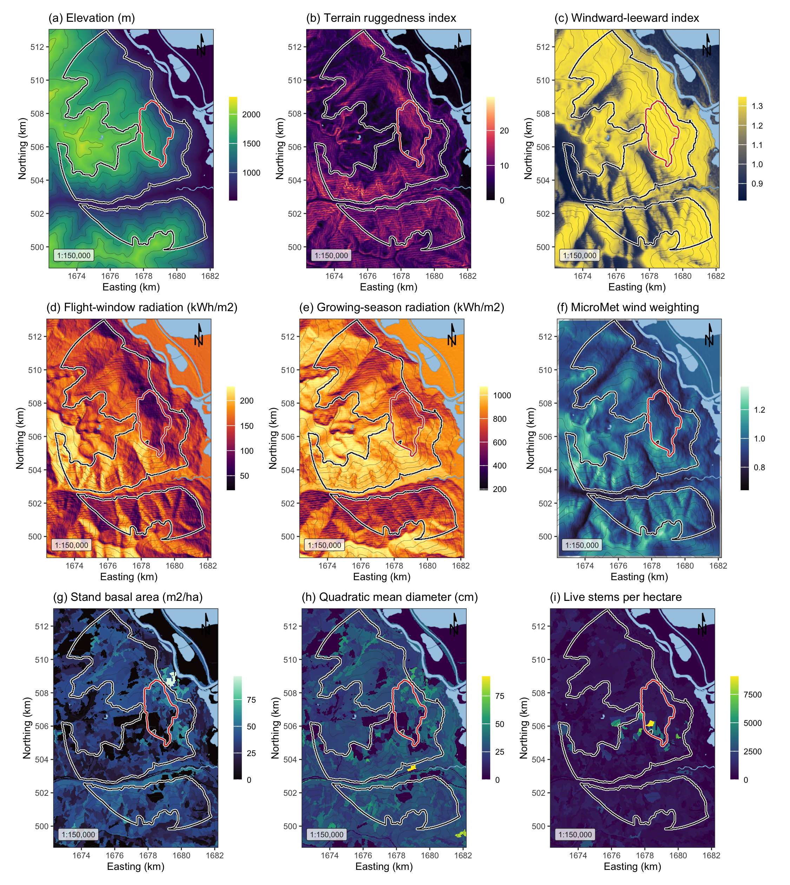
Figure 1: Landscape, terrain and stand surfaces across the study area, all EPSG:3153 at 30 m over Esri World Shaded Relief. (a) elevation; (b) terrain ruggedness index; (c) windward-leeward index at the prevailing bearing; (d) flight-window direct radiation, the thermal limit on flight; (e) growing-season direct radiation, the shading pathway; (f) the MicroMet wind weighting factor at the prevailing bearing; (g) stand basal area; (h) quadratic mean diameter, whose 25 cm source-sink threshold fell near the midpoint of the scale; (i) live stems per hectare. The white outline marked the study perimeter and the red outline the 2015 Mt Midgeley burn, with contours at 200 m.

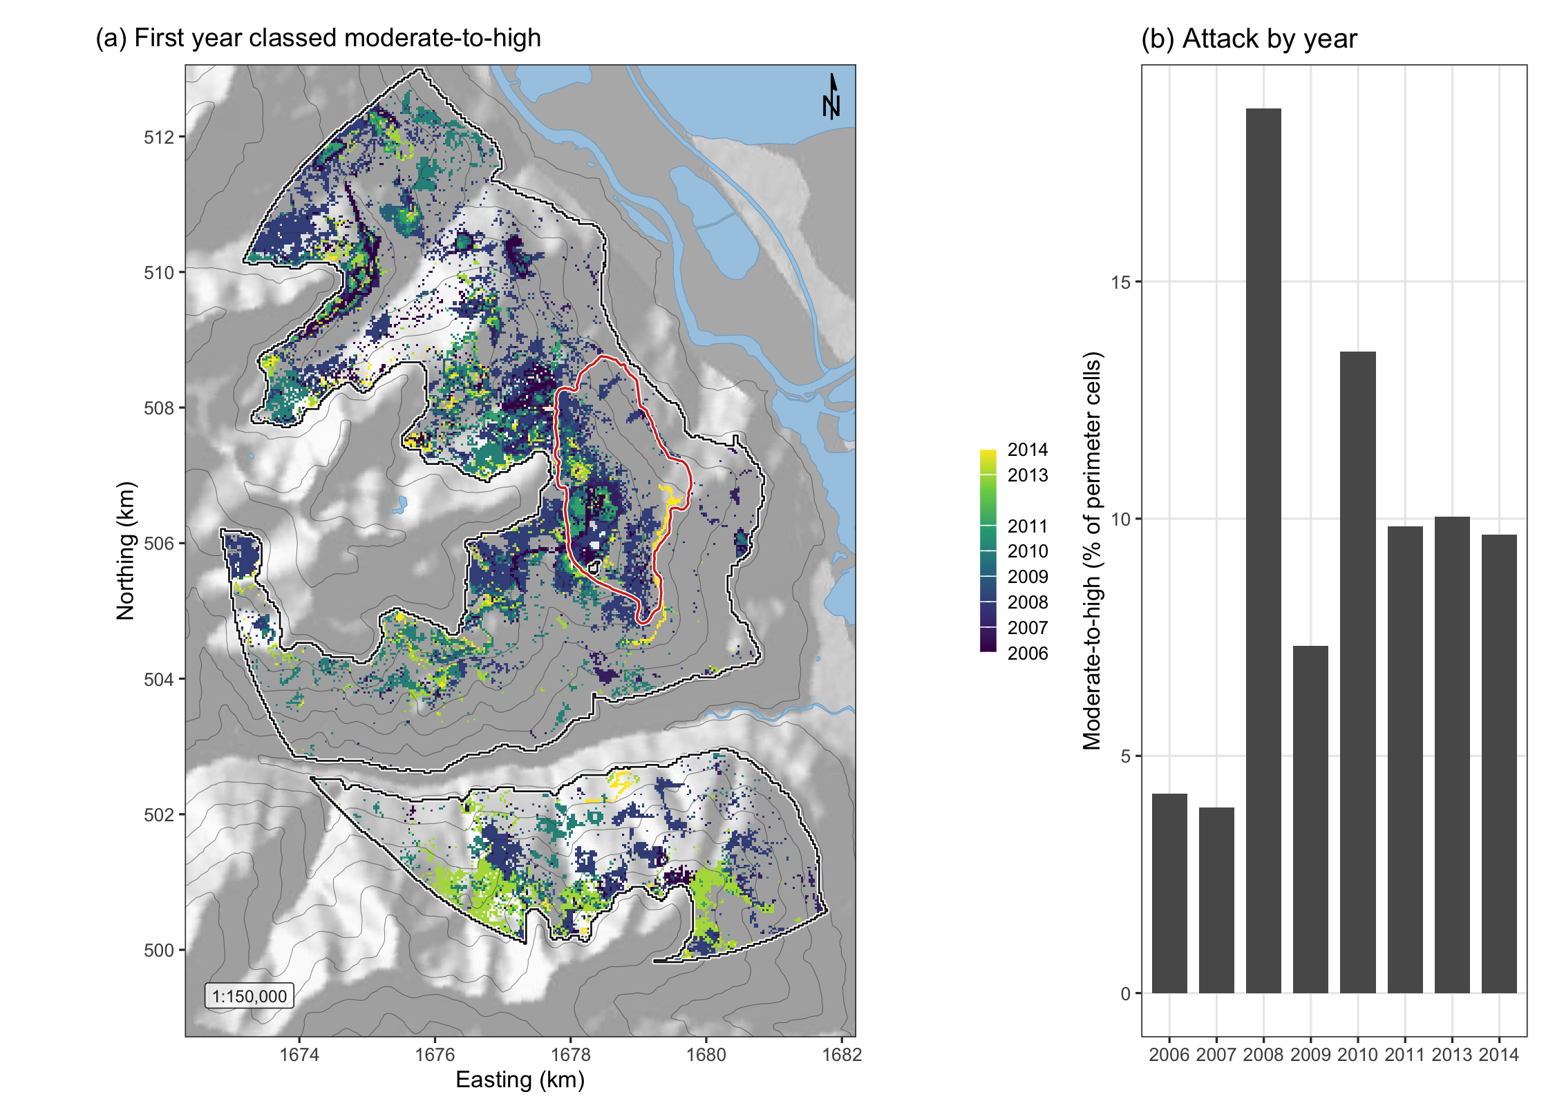
Figure 2: Spread of moderate-to-high beetle disturbance across the study perimeter. (a) The first year in which each cell entered the moderate-to-high class, over shaded relief with the perimeter in white and the 2015 Mt Midgeley burn in red; cells never classed as attacked showed the relief alone. The panel was built from the eight annual maps for display, and those maps were fitted separately and never merged for analysis. (b) The share of perimeter cells classed moderate-to-high in each year.

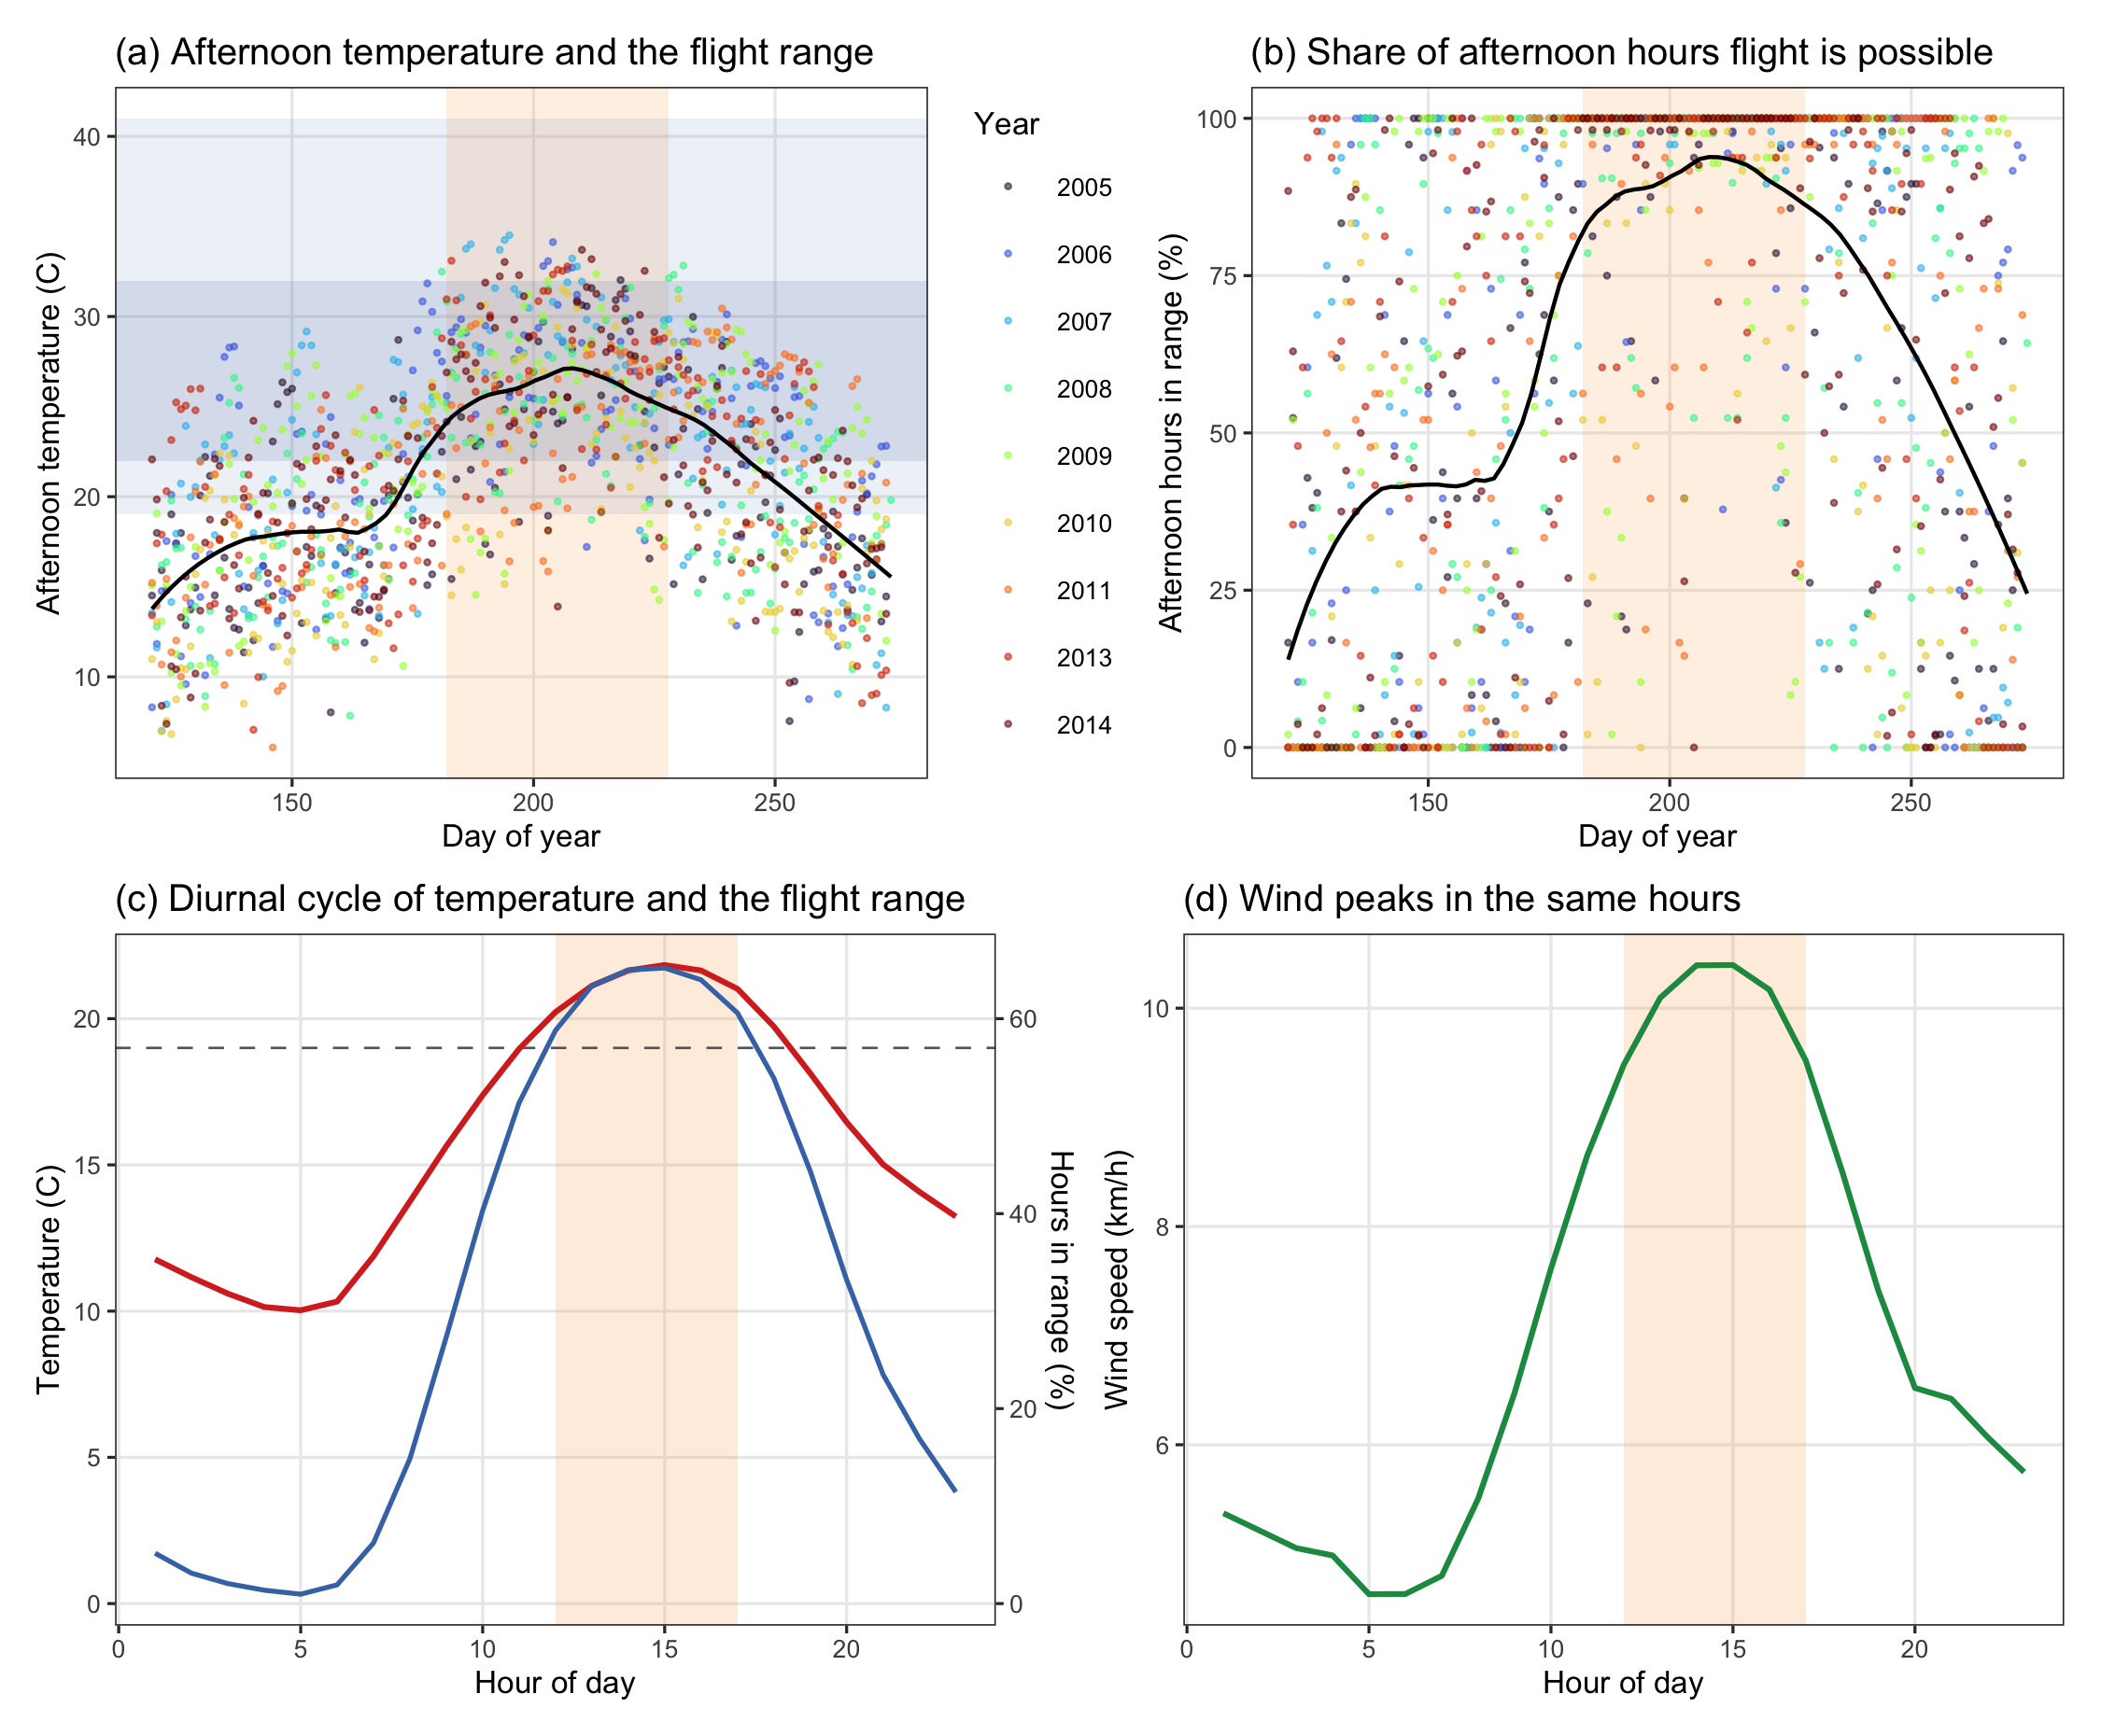
Figure 3: The flight window against the landscape’s own climate, from hourly Environment and Climate Change Canada station records for May to September of the nine study years. The shaded band marked the window, 1 July to 15 August, taken from the bionomics and not fitted to these data. (a) Mean afternoon temperature by day of year, with the 19 to 41 degrees C flight range and the 22 to 32 degrees C peak band marked. (b) The share of afternoon hours inside the flight range, day by day. (c) Mean temperature and the share of all hours inside the flight range, by hour, with the 12:00 to 17:00 restriction shaded. (d) Mean wind speed by hour on the same axis, showing that the hours in which the beetle could fly were also the windiest of the day.

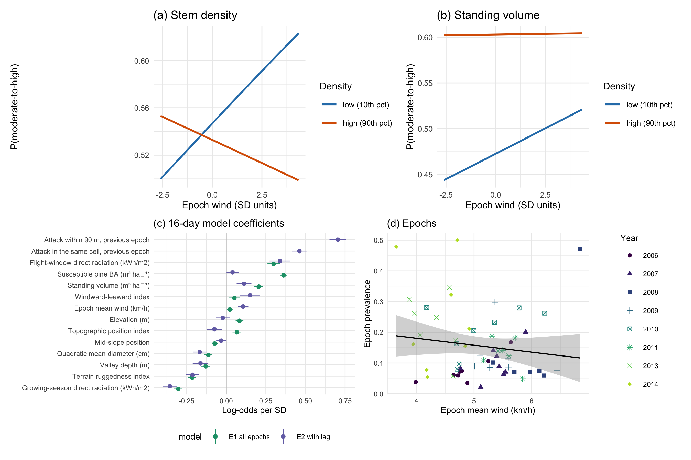
Figure 4: The refugia mechanism as fitted in the sixteen-day models. (a) Predicted probability of moderate-to-high disturbance against terrain-adjusted epoch wind at the 10th and 90th percentiles of stem density, with all other terms held at their means. The lines crossed, so wind raised attack in thin stands and lowered it in dense ones, which was the interaction. (b) The same for standing volume, where the interaction was a fifth the size and flattened the dense-stand line without reversing it, so the lines converged rather than crossed over the observed range. (c) Coefficients of the sixteen-day model with and without the within-season spread term, where the shift of a term between the two fits was the part of it that the spread term absorbed. (d) Prevalence in each epoch against its mean wind, one point per epoch, with years distinguished by shape and shade so that the panel remained legible in black and white.

