Wind disrupts beetle attack in thin stands, but only at the insect’s own timescale
Seamus Murphy
2026-08-27

Abstract
Refugia from mountain pine beetle (Dendroctonus ponderosae) are thought to form where stands are thin enough for wind to break up the pheromone plume that coordinates mass attack. It names three mechanisms, shading, low host density and few large-diameter hosts, and none has been fitted. We tested all three over 5,573 ha of the Selkirk Mountains, British Columbia, at 30 m and Landsat’s 16-day repeat, 59 epochs across 8 outbreak years, with wind from a terrain-resolved field driven hourly. Stand density interacted negatively with wind, -0.094 for stem density and -0.041 for standing volume, both surviving a within-season spread term. Host held through standing volume, attack peaking at 45.9 per cent at 25 to 30 cm. Shading failed: shaded ground carried more attack, not less. Resolution decided it. One map a year, same wind field and covariates, gave +0.031, the opposite sign.

1. Introduction
Mountain pine beetle (Dendroctonus ponderosae Hopkins) has killed more lodgepole pine (Pinus contorta Douglas ex Loudon) in British Columbia than any other agent on record (Taylor and Carroll 2003; Sambaraju and Goodsman 2021). Where a landscape is not killed uniformly, the surviving patches shape what the forest becomes, and the framework for them is disturbance refugia, places buffered from disturbance over time (Krawchuk et al. 2020). Explaining refugia rather than locating them needs mechanistic links to terrain, soil and stand structure (Cartwright 2018).
Krawchuk et al. (2020) proposed such a mechanism: refugia could occur “in areas with cooler temperatures (eg from topographic shading) that protect trees from water stress; in areas with lower host density, allowing for greater wind disruption of beetle pheromone communication and more vigorous tree growth and chemical defenses; and in areas with fewer large-diameter host trees”. Three mechanisms, two of them terrain, and none has been fitted spatially. Of the studies our screen retained, only a companion study on this landscape enters a wind term, and its response is conifer regeneration rather than attack (Murphy et al. 2026).
Why a plume should matter at all is a population argument. A lodgepole pine resists a single beetle through resin flow and an induced response that saturates the phloem with terpenes, so overwhelming that defence takes the near-simultaneous arrival of many individuals. Arrival is coordinated chemically, pioneer females oxidising a host monoterpene to trans-verbenol while arriving males release exo-brevicomin, and colonisation is normally complete within one to two days (Safranyik and Carroll 2006). Because that signal is airborne it is in principle susceptible to wind, and that susceptibility is the premise under test. Stem size sets a second constraint: bark thickness, phloem thickness and moisture retention all rise with diameter, and Carroll and Safranyik (2004) put the consequence as a threshold, pine at or below 25 cm being on average beetle sinks and larger trees sources.
The wind half is a claim about canopy, not open air. Cartwright (2018) found insect refugia in stands of low basal area: “thinner stands also increase wind penetration, helping to disperse beetle pheromones and disrupt chemical communications needed to coordinate attacks.” Powell and Bentz (2014) state the converse as the condition for outbreak, “higher local host density, which minimizes pheromone plume dispersion, reduces wind, and promotes successful switching to nearby hosts”. A model that controls stand density out and then reads a terrain coefficient as a wind effect has removed the pathway it set out to test.
Terrain also acts through heat. Flight is thermally gated at 19 to 41 degrees C, and “most flights occur on bright sunny days, and peak flight is in the early to mid afternoon” (McCambridge 1971; Safranyik and Carroll 2006). Radiation during the flight window is therefore a different quantity from radiation across the season, and the season quantity is the one the shading pathway concerns. Cool sites also push the beetle toward a two-year cycle (Sambaraju and Goodsman 2021), so shading and tree vigour predict the same sign by independent routes (Bartos and Amman 1989).
No product reports the wind the hypothesis concerns, an instantaneous below-canopy speed at flight height during the flight period. Gridded climatologies report a long-run mean at 10 m over open ground, downscaled over a digital elevation model, which makes them partly a transform of the terrain offered alongside them (Badger et al. 2014; Davis et al. 2023). Nor does the literature state the interval over which wind should be summarised. We therefore take wind from station observations of each 16-day period, modify it over the terrain, and test the response at Landsat’s own 16-day repeat rather than annually. Appendix S1 gives the direction expected of every attribute entered and the reasoning behind it.

2. Methods
The study area is 5,573 ha of the Selkirk Mountains in southeastern British Columbia, 61,923 cells at 30 m in EPSG:3153, spanning 830 to 1,744 m (Figure 1). The grid and the perimeter are the parent study’s (Murphy et al. 2026), anchored on the 2015 Mt Midgeley fire and expanded to the elevation band that site occupies, because 480 ha cannot carry the stand-density contrast the mechanism runs on.
The response is moderate-to-high beetle disturbance, classified from Landsat normalised difference moisture index by the parent study’s method. It covers 8 outbreak years, 2006 to 2014, excluding 2012, the one year flown only by Landsat 7 with its scan-line corrector off. Pooled prevalence is 12.5 per cent over 122,700 cell-years (Appendix S3). Years are never unioned: unioning destroys the year-to-year spread this study measures.
Stand structure comes from the provincial Vegetation Resources Inventory (Appendix S4). Six attributes carry the mechanism and the stem-size threshold: basal area, crown closure, live stems per hectare, quadratic mean diameter over stems 12.5 cm and up, stand age, and susceptible pine basal area. Terrain is 29 geomorphometric surfaces computed with SAGA GIS over the full elevation model and clipped afterwards, so a search radius near the boundary sees real ground. Radiation is computed twice, because two mechanisms need it: flight-window insolation over 1 July to 15 August restricted to 12:00 to 17:00, the hours Safranyik and Carroll (2006) identify as the flight peak, and growing-season insolation as the whole-day total from 1 May to 30 September. A single annual index cannot separate them, the flight-window surface spanning a 7-fold range here against 2.6-fold for the season total.
Station wind interpolated from four to seven valley stations is nearly flat within a year, so wind is also computed as a field varying in space, using the MicroMet model of Liston and Elder (2006). Its wind component is seven equations rather than a program, implemented directly. Terrain slope, azimuth and curvature give a weighting factor $W_{w}=1+γ_{s}Ω_{s}+γ_{c}Ω_{c}$ with $γ_{s}=γ_{c}=0.5$, a modified speed $W_{t}=W_{w}W$, and a direction diversion $θ_{d}=-0.5 Ω_{s}sin\left[2\left(ξ-θ\right)\right]$. $W_{w}$ depends on direction and not speed, so it is computed once for each of 16 direction bins and each hourly observation multiplied by the surface for its own bin; nothing is averaged before the terrain acts on it. The field varies 1.9 to 2.8 km/h across the grid within a year, and is not a repackaged terrain index, correlating +0.153 with the windward-leeward index.
45 candidate variables in six groups, one per pathway, passed a four-stage selection required to retain at least one variable from each group, so a collinearity filter could not delete a hypothesis. Fitting used a class-balanced sample of 47,328 cell-years, because an unbalanced fit at 12 per cent prevalence reports the intercept rather than the covariates. Four annual logistic models each add one claim to the last: host size, shading and landform (M0), stand density (M1), terrain shape, exposure and flight radiation (M2), and the interactions (M3). Two further annual models add previous-year attack and 90 m neighbourhood pressure after the autologistic design used for this province (M4), and replace station wind with the terrain-resolved field (M5). The 16-day models (E1, E2) refit the same covariates over 59 epochs, E2 adding the previous epoch of the same season. Model comparison is in Appendix S2.

3. Results
Every pathway earns its place. AIC falls 498 when stand density enters, 744 more with terrain and flight radiation, and 1,065 more with the interactions.
Stand density does not behave as one variable (Table 1). Standing volume carries +0.381 log-odds per standard deviation, but live stems per hectare carries -0.099 and crown closure -0.183, both negative and both far from zero (p = < 1e-16). As a main effect the density pathway is mixed, and standing wood in large stems is the only measure of it that points the way the mechanism predicts. That is a weaker reading than it first appears, because the mechanism’s prediction is not about a main effect at all.
Radiation enters once. Flight-window direct radiation carries +0.487, which is the thermal gate on flight. Growing-season radiation did not survive selection, so the shading pathway is carried by northness, with which it correlates -0.834. Northness is +0.382: shaded, north-facing ground carries more attack, against the prediction. Terrain predicts attack independently of both, the windward-leeward index at +0.358 and elevation at +0.329, while terrain ruggedness is -0.036 and not distinguishable from zero (p = 0.124).
A terrain index is partly an insolation measurement. Fitted without flight-window radiation, stand density interacts with terrain exposure at +0.311. With radiation in the model that interaction falls to +0.221 (p = < 1e-16) and density interacts with radiation at -0.144. On a range whose prevailing bearing is 258 degrees the windward slopes face west, which are also the slopes taking afternoon sun, so about a third of the apparent exposure effect was the sun. The remainder is not, and it stays positive, which is the wrong sign for pheromone disruption. That is the annual answer, and the next paragraph shows it is an artefact of the calendar.
Temporal resolution decided the outcome (Figure 2). At 16 days, stand density interacts with terrain-resolved wind at -0.094 for stem density (p = < 1e-16) and -0.041 for standing volume (p = 4.91e-07), both negative, which is the mechanism’s signature: a dense stand is worth less where and when the wind blows harder. Both survive entering the previous epoch of the same season, which carries +0.672, so the result is not the outbreak’s own spread wearing a wind coefficient, and they discriminate at 0.668 and 0.756 respectively. With one map a year, the same wind field, covariates and classification threshold give +0.031 (p = 0.0364), the opposite sign. Nothing about the landscape or the wind product changed between the two. What changed is that an annual response can only ask whether windy summers carry less attack than calm ones, and a summer contains both windy and calm weeks.
Attack also recurs where it was, by a margin that changes how every other coefficient reads. Entering persistence and 90 m spread separately gives +0.873 and +0.950 and raises discrimination from 0.799 to 0.888. Which environmental terms survive is the informative part. Ruggedness keeps 0.61 of its value, a term describing a condition a cell has whether or not the beetle was there. The landform terms are not stable: valley depth keeps 0.50 while mid-slope position moves to 1.32, growing rather than shrinking. Part of what the landform terms measured was where the outbreak had already been.
Host coded as diameter holds as a threshold rather than a slope. Attack peaks in the 25 to 30 cm class at 45.9 per cent, stepping up from 36.3 per cent below the 25 cm source-sink boundary of Carroll and Safranyik (2004) and falling to 17.0 per cent above 40 cm (Appendix S5). The linear coefficient is negative, -0.422, because a straight line through a humped response returns the slope of its falling limb.

4. Conclusions
Of the three mechanisms Krawchuk et al. (2020) name, two hold at the resolution the sensor and the insect share and one does not. Host density holds in the conditional form the mechanism specifies rather than as a bare main effect, which is the important distinction: as main effects the three density measures disagree in sign, but what a dense canopy buys shrinks as the wind rises, and that is the claim. Large-diameter host holds as a threshold at 25 to 30 cm. Topographic shading fails, and it fails on a surrogate: growing-season radiation did not survive selection, so the pathway is carried by northness, which correlates -0.834 with it. Northness tests aspect, and aspect carries more than shade, so this is the least secure of the three verdicts.
The methodological finding is the more transferable one, and it has three parts. A terrain index is not an environmental measurement: entering flight-window radiation cut the density by terrain-exposure interaction from +0.311 to +0.221. A landform variable in a spreading outbreak records the outbreak’s own history: entering previous-year pressure left valley depth at 0.50 of its value while mid-slope position moved to 1.32, against 0.61 for ruggedness. And an annual response cannot test a mechanism that operates over weeks: the same wind field, covariates and threshold gave +0.031 annually against -0.094 at sixteen days. A test that aggregates past the flight period is not a weaker version of the right test. It is a different question, and this study answers it in the opposite direction.
Since no previous study has fitted a wind term at all, nothing establishes the resolution at which one should be fitted. Our answer is that it must be no coarser than the flight period. For managers reading refugia maps built from annual disturbance products, that matters directly: a map that shows no wind signal may be showing the calendar rather than the landscape.
Four limits stay attached. Flight-window radiation and terrain exposure are not separable here, correlating -0.599, so the positive flight radiation coefficient is consistent with the thermal gate and with exposure alike, and the annual density by exposure interaction stays positive after radiation enters. The wind field is modelled from station data rather than measured on the ridge, so what is established is that the modelled field behaves as the mechanism requires, not that the air did. The inventory postdates part of the outbreak, which is the likeliest reason total basal area discriminates below chance at 0.516. And every conclusion rests on one mountain range over 8 years and 59 epochs.

5. Open research
This study complies with the Ecological Society of America’s Open Research Policy. Every dataset is public and none was collected by the authors. Beetle disturbance is classified from Landsat Collection 2 Level-2 surface reflectance. Stand structure is the provincial Vegetation Resources Inventory layer VEG_COMP_LYR_R1_POLY, retrieved from the British Columbia Data Catalogue web feature service. Terrain derives from the Natural Resources Canada High Resolution Digital Elevation Model (Natural Resources Canada 2017), with geomorphometry computed by SAGA GIS. Wind is Environment and Climate Change Canada hourly station data. All processing scripts and the derived model tables that reproduce every number reported here will be deposited in Dryad on acceptance, and are available to reviewers on request.
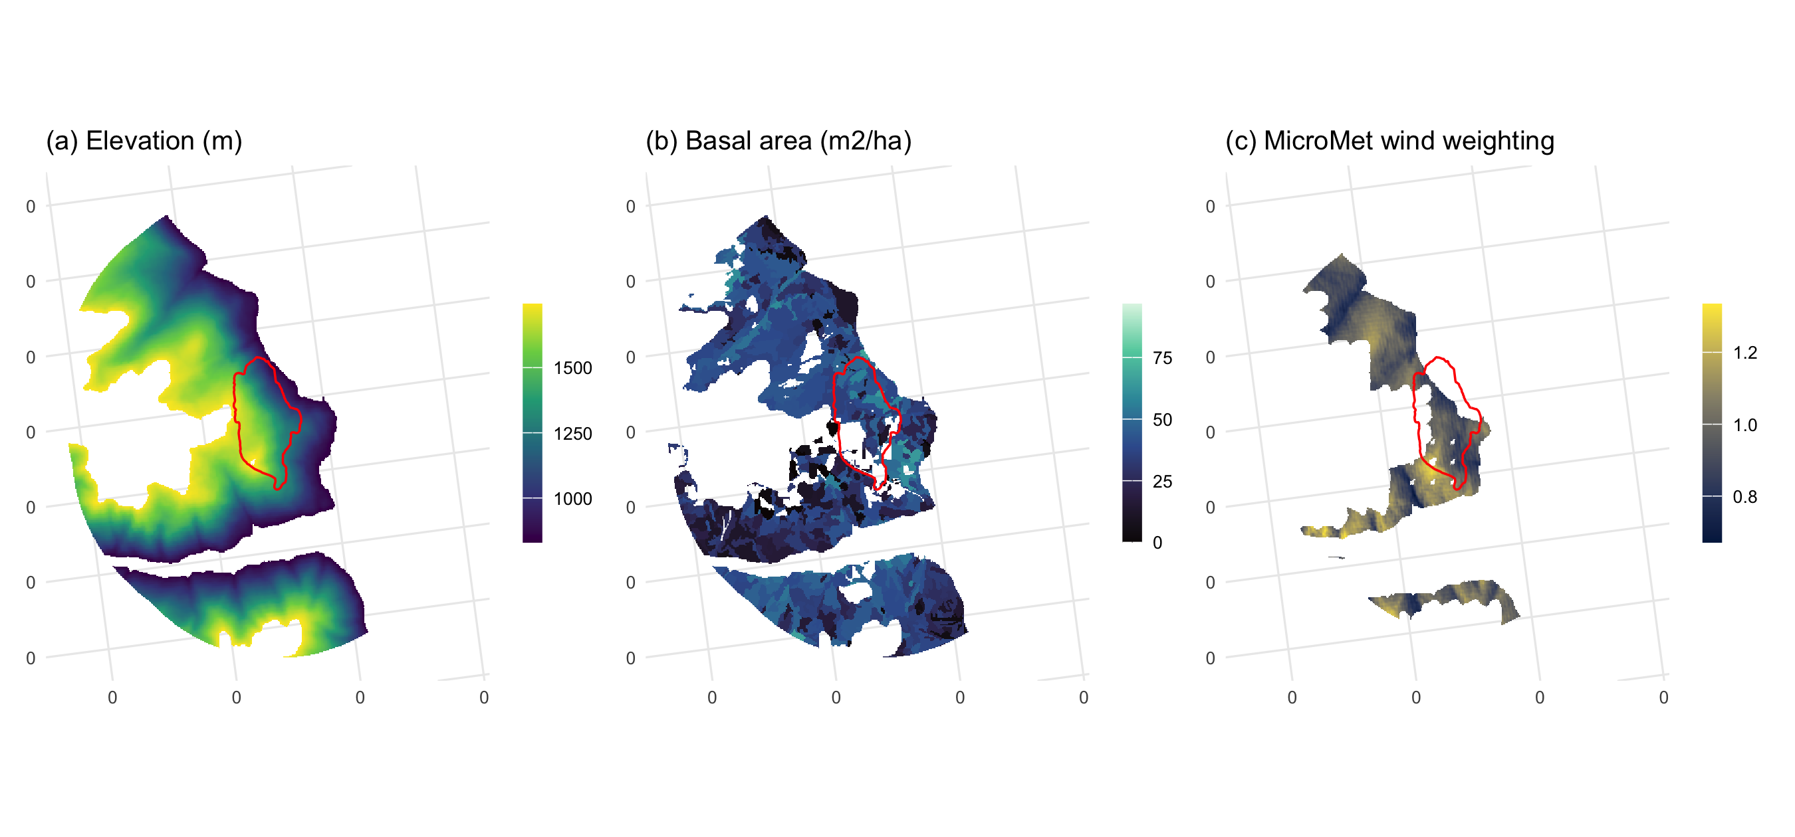
Figure 1. The study area, all panels EPSG:3153 at 30 m with the 2015 Mt Midgeley burn outlined in red and ticks in kilometres. (a) elevation; (b) stand basal area from the Vegetation Resources Inventory, the density term the pheromone-disruption mechanism runs through; (c) the MicroMet wind weighting factor at the prevailing bearing, the terrain-resolved wind field.
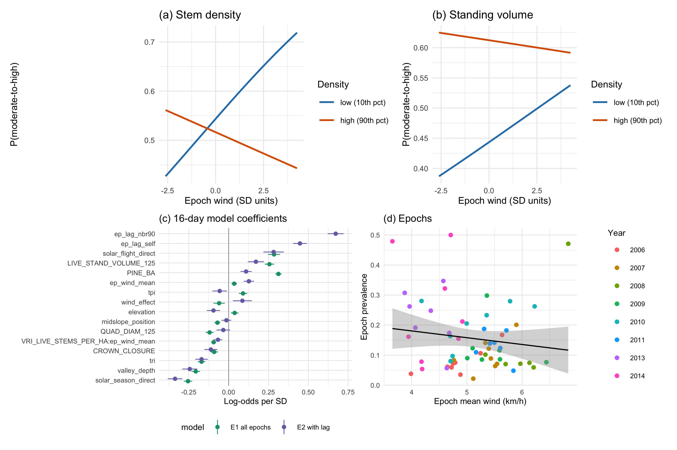
Figure 2. The refugia mechanism as fitted at 16 days. (a) Predicted probability of moderate-to-high disturbance against terrain-resolved epoch wind, at the 10th and 90th percentiles of stem density, all other terms at their means; the lines cross, so wind raises attack in thin stands and lowers it in dense ones, which is the interaction. (b) The same for standing volume. (c) Coefficients of the 16-day model, with and without the within-season spread term. (d) Epoch prevalence against epoch mean wind, one point per epoch.
Table 1. The terms the three mechanisms turn on, and the specification contrasts the paper rests on. Coefficients are log-odds per standard deviation on a class-balanced sample. The annual models are M3, M3 without flight-window radiation, and M5; the 16-day models are E1 and E2. The three mechanisms are those of Krawchuk et al. (2020). Growing-season direct radiation did not survive variable selection, so the shading pathway is represented by northness.
 | Term | Beta | z | p
Mechanism 1: shading | Northness (shading surrogate) | +0.382 | 23.2 | < 1e-16
Mechanism 2: host density | Standing volume | +0.381 | 15.6 | < 1e-16
 | Live stems per hectare | -0.099 | -5.4 | 8.29e-08
 | Crown closure | -0.183 | -9.0 | < 1e-16
Mechanism 3: host size | Quadratic mean diameter | -0.422 | -18.4 | < 1e-16
 | Susceptible pine basal area | +0.459 | 32.4 | < 1e-16
Terrain | Flight-window direct radiation | +0.487 | 17.2 | < 1e-16
 | Terrain ruggedness index | -0.036 | -1.5 | 0.124
 | Windward-leeward index | +0.358 | 12.4 | < 1e-16
 | Elevation | +0.329 | 18.2 | < 1e-16
Radiation and exposure | Density x terrain exposure, no radiation | +0.311 | 19.2 | < 1e-16
 | Density x terrain exposure, with radiation | +0.221 | 10.6 | < 1e-16
Resolution decides the sign | Density x wind, annual (M5) | +0.031 | 2.1 | 0.0364
 | Stem density x wind, 16-day (E1) | -0.094 | -11.7 | < 1e-16
 | Standing volume x wind, 16-day (E1) | -0.041 | -5.0 | 4.91e-07
 | Standing volume x wind, 16-day with lag (E2) | -0.039 | -2.7 | 0.00726

Supporting information
Five components accompany this paper and are supplied as stand-alone documents at submission. They are reproduced below for review.

5.1 Appendix S1
Appendix S1. Landscape attributes entered in this study, the direction expected of each, and the reasoning behind that expectation.
Attribute | Expected | Rationale
Stand basal area, volume, crown closure, stems | positive | Denser canopy holds the pheromone plume together; thinner stands admit wind that disperses it (Powell and Bentz 2014; Cartwright 2018; Krawchuk et al. 2020).
Quadratic mean diameter | positive above 25 cm | Trees under 25 cm are beetle sinks, over 25 cm are sources (Carroll and Safranyik 2004).
Lodgepole pine cover and basal area | positive | Attack cannot occur where the host is absent; a cell without pine is not a refugium (Cartwright 2018).
Flight-period direct radiation | positive | Flight is gated between 19 and 41 degrees C and peaks on bright afternoons, so sunlit slopes are reachable (McCambridge 1971; Safranyik and Carroll 2006).
Growing-season direct radiation | negative | Shading cools, relieving water stress and funding defence, and cool sites also push the beetle toward a two-year cycle (Krawchuk et al. 2020; Sambaraju and Goodsman 2021).
Terrain exposure to wind | negative | Wind disrupts the pheromone plume, so exposed ground should carry less attack (Krawchuk et al. 2020).
Terrain ruggedness | uncertain | The strongest terrain term in the companion study on this landscape, but fitted there against regeneration rather than attack (Murphy et al. 2026).
Convergence, wetness, valley depth, slope position | positive in convergent terrain | Infested groups gather in draws and gullies, and deep snow insulates overwintering brood (Safranyik and Carroll 2006).
Flight-period wind speed | negative | The mechanism acts during dispersal, and no study specifies the interval, so it is taken at the flight period (Jones et al. 2019; Krawchuk et al. 2020).
Elevation | uncertain | A composite of temperature, snowpack, season length and host distribution that this design cannot separate (Sambaraju and Goodsman 2021).

5.2 Appendix S2
Appendix S2. Annual model comparison. Each model adds one pathway to the previous.
Model | Parameters | AIC | dAIC
M0 host size + shading + landform | 15 | 49,547 | 2,307
M1 + stand density | 18 | 49,049 | 1,809
M2 + terrain and flight radiation | 25 | 48,305 | 1,065
M3 + interactions | 30 | 47,240 | 0

5.3 Appendix S3
Appendix S3. Moderate-to-high beetle disturbance by year inside the study perimeter.
Year | Cells | Moderate-to-high (%)
2006 | 15,339 | 4.5
2007 | 15,340 | 5.6
2008 | 15,340 | 20.2
2009 | 15,340 | 11.5
2010 | 15,322 | 15.5
2011 | 15,340 | 13.3
2013 | 15,339 | 14.2
2014 | 15,340 | 15.1

5.4 Appendix S4
Appendix S4. Stand structure across the study perimeter, from the Vegetation Resources Inventory.
Attribute | Min | Median | Mean | Max
BASAL_AREA | 2.1 | 37.1 | 35.2 | 64.3
CROWN_CLOSURE | 4.0 | 48.0 | 45.3 | 60.0
LIVE_STAND_VOLUME_125 | 0.9 | 292.9 | 283.4 | 620.3
PINE_BA | 0.0 | 3.2 | 5.4 | 31.7
PROJ_AGE_1 | 20.0 | 124.0 | 125.2 | 184.0
PROJ_HEIGHT_1 | 7.7 | 29.0 | 28.1 | 41.6
PinePct | 0.0 | 10.0 | 17.4 | 100.0
QUAD_DIAM_125 | 13.5 | 30.3 | 30.1 | 62.3
VRI_LIVE_STEMS_PER_HA | 64.0 | 686.0 | 670.0 | 1614.0

5.5 Appendix S5
Appendix S5. Moderate-to-high beetle disturbance by quadratic mean diameter class, on the balanced sample. The 25 cm boundary is the source-sink threshold of the species’ bionomics.
QMD class (cm) | Cells | Attacked (%)
<15 | 736 | 31.5
15-20 | 2,371 | 23.8
20-25 | 7,058 | 36.3
25-30 | 14,634 | 45.9
30-40 | 18,902 | 24.5
>40 | 3,627 | 17.0

6. References
Badger J, Frank H, Hahmann AN, and Giebel G. 2014. Wind-climate estimation based on mesoscale and microscale modeling: Statistical–dynamical downscaling for wind energy applications. Journal of Applied Meteorology and Climatology 53: 1901–19.
Bartos DL and Amman GD. 1989. Microclimate: An alternative to tree vigor as a basis for mountain pine beetle infestations. Ogden, UT: U.S. Department of Agriculture, Forest Service, Intermountain Research Station.
Carroll AL and Safranyik L. 2004. The bionomics of the mountain pine beetle in lodgepole pine forests: Establishing a context. In: Shore TL, Brooks JE, Stone JE (Eds). Mountain pine beetle symposium: Challenges and solutions, october 30–31, 2003, kelowna, british columbia. Victoria, British Columbia: Natural Resources Canada, Canadian Forest Service, Pacific Forestry Centre.
Cartwright JM. 2018. Landscape topoedaphic features create refugia from drought and insect disturbance in a lodgepole and whitebark pine forest. Forests 9: 715.
Davis NN, Badger J, Hahmann AN, et al. 2023. The Global Wind Atlas: A high-resolution dataset of climatologies and associated web-based application. Bulletin of the American Meteorological Society 104: E1507–25.
Jones KL, Shegelski VA, Marculis NG, et al. 2019. Factors influencing dispersal by flight in bark beetles (Coleoptera: Curculionidae: Scolytinae): From genes to landscapes. Canadian Journal of Forest Research 49: 1024–41.
Krawchuk MA, Meigs GW, Cartwright JM, et al. 2020. Disturbance refugia within mosaics of forest fire, drought, and insect outbreaks. Frontiers in Ecology and the Environment 18: 235–44.
Liston GE and Elder K. 2006. A meteorological distribution system for high-resolution terrestrial modeling (MicroMet). Journal of Hydrometeorology 7: 217–34.
McCambridge WF. 1971. Temperature limits of flight of the mountain pine beetle, Dendroctonus ponderosae. Annals of the Entomological Society of America 64: 534–5.
Murphy S, Leslie A, Wilson J, and Banks LK. 2026. Spatial patterns of conifer regeneration following mountain pine beetle outbreak (Dendroctonus ponderosae) and mixed-severity wildfire: A point process model of disturbance interactions in the southern Selkirk Mountains, British Columbia. Forest Ecology and Management 618: 123985.
Natural Resources Canada. 2017. High resolution digital elevation model (HRDEM) – CanElevation series. https://open.canada.ca/data/en/dataset/957782bf-847c-4644-a757-e383c0057995.
Powell JA and Bentz BJ. 2014. Phenology and density-dependent dispersal predict patterns of mountain pine beetle (Dendroctonus ponderosae) impact. Ecological Modelling 273: 173–85.
Safranyik L and Carroll AL. 2006. The biology and epidemiology of the mountain pine beetle in lodgepole pine forests. In: Safranyik L, Wilson B (Eds). The mountain pine beetle: A synthesis of biology, management, and impacts on lodgepole pine. Victoria, British Columbia: Natural Resources Canada, Canadian Forest Service, Pacific Forestry Centre.
Sambaraju KR and Goodsman DW. 2021. Mountain pine beetle: An example of a climate-driven eruptive insect impacting conifer forest ecosystems. CAB Reviews 16.
Taylor SW and Carroll AL. 2003. Disturbance, forest age, and mountain pine beetle outbreak dynamics in BC: A historical perspective. Mountain pine beetle symposium: Challenges and solutions, october 30–31, 2003, kelowna, british columbia. Victoria, British Columbia: Natural Resources Canada, Canadian Forest Service, Pacific Forestry Centre.

