Testing the wind disruption hypothesis for beetle refugia
Stand density, terrain shape and flight-window wind as competing controls on mountain pine beetle attack (Dendroctonus ponderosae) in the Selkirk Mountains of British Columbia
Seamus Murphy
2026-08-27

Abstract
Refugia from mountain pine beetle (Dendroctonus ponderosae Hopkins) are hypothesised to form where stands are thin enough for wind to disrupt the pheromone plume coordinating mass attack. The hypothesis names topographic shading, low host density and few large-diameter hosts, and none has been fitted. We tested all three over 5,573 ha of the Selkirk Mountains, British Columbia, at 30 m across 914 m of relief, using Landsat at its 16-day repeat: 59 epochs across 8 outbreak years, 71,127 cell-epochs. Predictors were inventory stand structure, 29 geomorphometric surfaces, solar radiation computed separately for the flight window and the growing season, and a terrain-resolved wind field from the MicroMet model driven by hourly station data for each epoch’s own sixteen days.
The wind-disruption mechanism was supported. Stand density interacted negatively with wind, -0.094 for stem density (p < 0.001) and -0.041 for standing volume (p < 0.001), and both survived a within-season spread term carrying +0.672. Host held through standing volume, +0.381, and attack peaked at 45.9 per cent at 25 to 30 cm diameter, the source-sink threshold. Topographic shading failed on its surrogate: growing-season radiation did not survive selection, and northness, which correlates -0.834 with it, is +0.382, so shaded ground carries more attack.
Temporal resolution decided the outcome. With one map a year, the same wind field, covariates and threshold gave +0.031 (p = 0.036), the opposite sign. Two further specification tests showed why proxies mislead here: flight-window radiation cut the density by terrain-exposure interaction from +0.311 to +0.221 without changing its sign, and previous-year pressure left valley depth at 0.50 of its value while mid-slope position moved to 1.32. A wind test aggregated to the year answers a different question from the one the mechanism poses, and answers it wrongly.

1. Introduction
Mountain pine beetle (Dendroctonus ponderosae Hopkins) has killed more lodgepole pine (Pinus contorta Douglas ex Loudon) in British Columbia than any other agent on record (Taylor and Carroll 2003; Sambaraju and Goodsman 2021). Where a landscape is not killed uniformly the surviving patches shape what the forest becomes, and one framework for them is disturbance refugia, places buffered from disturbance over time (Krawchuk et al. 2020). Explaining refugia rather than merely locating them requires mechanistic links to landscape drivers such as terrain, soil and stand structure (Cartwright 2018).
Krawchuk et al. (2020) proposed such a mechanism: refugia could occur “in areas with cooler temperatures (eg from topographic shading) that protect trees from water stress; in areas with lower host density, allowing for greater wind disruption of beetle pheromone communication and more vigorous tree growth and chemical defenses; and in areas with fewer large-diameter host trees”. Three mechanisms, two of them terrain, and none fitted spatially: of the studies our screen retained, only a companion study on this landscape enters a wind term, and its response is conifer regeneration rather than attack (Murphy et al. 2026).
The wind half is a claim about canopy, not open air. Cartwright (2018), the one retained study designed to model insect-refugium controls, found them in stands of low basal area: “thinner stands also increase wind penetration, helping to disperse beetle pheromones and disrupt chemical communications needed to coordinate attacks.” Powell and Bentz (2014) state the converse as the condition for outbreak: “higher local host density, which minimizes pheromone plume dispersion, reduces wind, and promotes successful switching to nearby hosts, positively influences outbreak propensity.” A model that controls stand density out and then reads a terrain coefficient as a wind effect has removed the pathway it set out to test.
Terrain acts through more than airflow. Flight is thermally gated at 19 to 41 degrees C, most of it between 22 and 32, and “most flights occur on bright sunny days, and peak flight is in the early to mid afternoon” (McCambridge 1971; Safranyik and Carroll 2006). Radiation during the flight window is therefore a different quantity from radiation across the season, and the season quantity is the one the shading pathway concerns. Light, temperature and wind are named as one triad rather than as alternatives, stand density affecting “tree vigour and within-stand microclimate, which in turn influence success of bark beetle dispersal, host selection, attack or brood development” (Safranyik and Carroll 2006), an argument Bartos and Amman (1989) put in their title as microclimate against tree vigour. Cool sites also push the beetle toward a two-year cycle (Sambaraju and Goodsman 2021), so shading and vigour predict the same sign by independent routes.
No product reports the wind the hypothesis concerns, an instantaneous below-canopy speed at flight height during the flight period. Gridded climatologies report a long-run mean at 10 m over open ground and are downscaled over a digital elevation model, making them partly a transform of the terrain offered alongside them (Badger et al. 2014; Davis et al. 2023). Nor does the literature state the interval over which wind should be summarised. We therefore take wind from station observations of each 16-day period, modify it over the terrain with the MicroMet model (Liston and Elder 2006), and test the response at Landsat’s own 16-day repeat rather than annually.
Table 1 gives the direction expected of each attribute and the reasoning behind it. The objectives were to test whether stand density predicts moderate-to-high disturbance as the pheromone mechanism requires, whether topographic shading predicts it against the microclimate and adaptive-seasonality arguments, whether terrain shape predicts it independently of density and radiation, whether the density effect is conditional on wind, and how much the answer depends on temporal resolution.
Table 1: Landscape attributes entered in this study, the direction expected of each, and the reasoning behind that expectation.
Attribute | Expected | Rationale
Stand basal area, volume, crown closure, stems | positive | Denser canopy holds the pheromone plume together; thinner stands admit wind that disperses it (Powell and Bentz 2014; Cartwright 2018; Krawchuk et al. 2020).
Quadratic mean diameter | positive above 25 cm | Trees under 25 cm are beetle sinks, over 25 cm are sources (Carroll and Safranyik 2004).
Lodgepole pine cover and basal area | positive | Attack cannot occur where the host is absent; a cell without pine is not a refugium (Cartwright 2018).
Flight-period direct radiation | positive | Flight is gated between 19 and 41 degrees C and peaks on bright afternoons, so sunlit slopes are reachable (McCambridge 1971; Safranyik and Carroll 2006).
Growing-season direct radiation | negative | Shading cools, relieving water stress and funding defence, and cool sites also push the beetle toward a two-year cycle (Krawchuk et al. 2020; Sambaraju and Goodsman 2021).
Terrain exposure to wind | negative | Wind disrupts the pheromone plume, so exposed ground should carry less attack (Krawchuk et al. 2020).
Terrain ruggedness | uncertain | The strongest terrain term in the companion study on this landscape, but fitted there against regeneration rather than attack (Murphy et al. 2026).
Convergence, wetness, valley depth, slope position | positive in convergent terrain | Infested groups gather in draws and gullies, and deep snow insulates overwintering brood (Safranyik and Carroll 2006).
Flight-period wind speed | negative | The mechanism acts during dispersal, and no study specifies the interval, so it is taken at the flight period (Jones et al. 2019; Krawchuk et al. 2020).
Elevation | uncertain | A composite of temperature, snowpack, season length and host distribution that this design cannot separate (Sambaraju and Goodsman 2021).

2. Materials

2.1 Study area
The study area is 5,573 ha of the Selkirk Mountains in southeastern British Columbia, 61,923 cells at 30 m, spanning 830 to 1,744 m and 914 m of relief.
The coordinate reference system is EPSG:3153, NAD83(CSRS) / BC Albers. This is the parent study’s grid, adopted so that results are directly comparable to it: “All disturbance and covariate rasters were aligned to a common 30 m grid in EPSG:3153, the native resolution of the Landsat-derived dNBR and dNDMI products”, and “The plot anchor was georeferenced with a handheld GPS receiver in EPSG:3153” (Murphy et al. 2026).
The perimeter is anchored on the 2015 Mt Midgeley fire, 480 ha, which is the parent study’s site. That study reports its site as spanning “elevations from 830 to 1744 m a.s.l.”; the digital elevation model used here returns 856 to 1,744 m inside the same perimeter, which reproduces the statement. The present study expands beyond that hard boundary, because 480 ha cannot carry the stand-density contrast the pheromone mechanism runs on. It does not expand arbitrarily: the perimeter is the burn buffered 5 km and then cut to the elevation band the parent’s site occupies, so the added ground is ecologically the same kind of ground. Without that cut a 1 km buffer already reaches the Kootenay Lake surface at 534 m, which is not a site elevation.
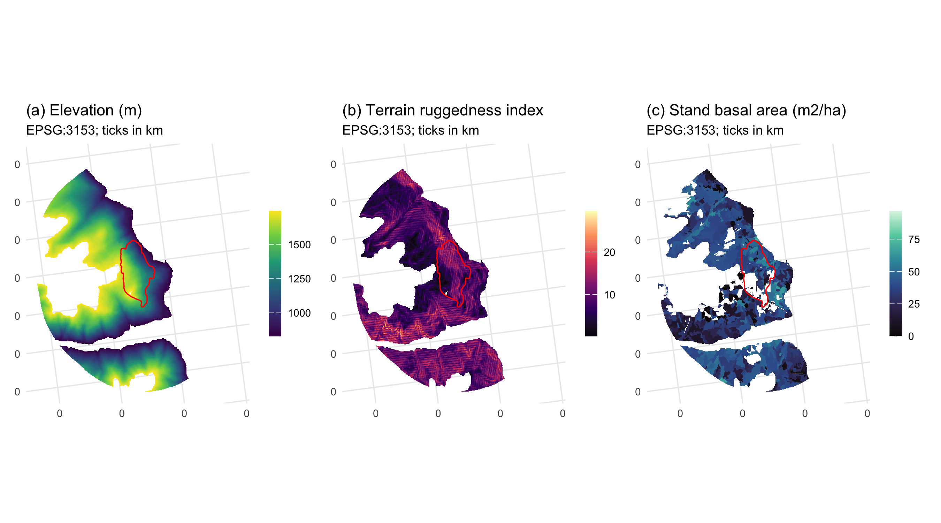
Figure 1: The study area. (a) The perimeter, the 2015 Mt Midgeley burn that anchors it, and elevation. (b) Terrain ruggedness index, the strongest terrain predictor in the parent study. (c) Stand basal area from the Vegetation Resources Inventory, the density term the pheromone-disruption mechanism runs through. All panels are EPSG:3153 at 30 m; ticks are kilometres.
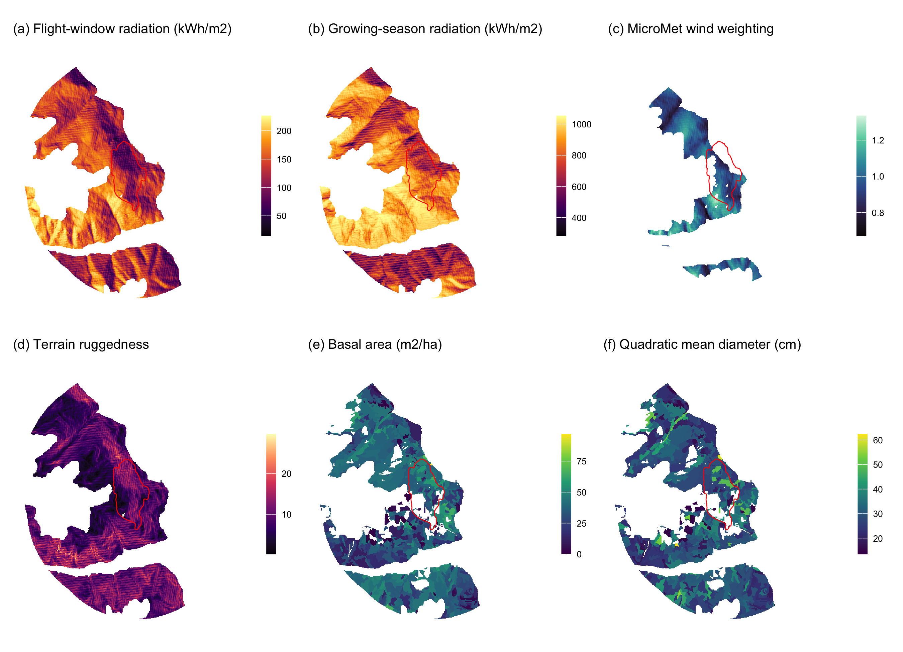
Figure 2: The predictor surfaces, all EPSG:3153 at 30 m inside the study perimeter, with the 2015 burn outlined in red. (a) flight-window direct radiation, the thermal gate on flight; (b) growing-season direct radiation, the shading pathway; (c) the MicroMet wind weighting factor at the prevailing bearing; (d) terrain ruggedness; (e) stand basal area; (f) quadratic mean diameter, with the 25 cm source-sink threshold at the midpoint of the scale.

2.2 Beetle disturbance
The response is annual moderate-to-high beetle disturbance, classified from Landsat normalised difference moisture index by the method of the parent study and rebuilt for this project. It covers 8 outbreak years, 2006 to 2014, excluding 2012, the one year covered only by Landsat 7, which has flown with its scan-line corrector off since May 2003. Annual prevalence inside the perimeter runs 4.5 to 20.2 per cent, pooled 12.5 per cent over 122,700 cell-years.
Years are never unioned. Unioning destroys the year-to-year spread this study measures, and the union layer over the wider grid reached 73 per cent of the landscape, which is not credible for a beetle outbreak.
The provincial aerial overview survey is not used as a response and supplies no training label. It is retained only as a visual check.
Table 2: Moderate-to-high beetle disturbance by year inside the study perimeter.
Year | Cells | Moderate-to-high (%)
2006 | 15,339 | 4.5
2007 | 15,340 | 5.6
2008 | 15,340 | 20.2
2009 | 15,340 | 11.5
2010 | 15,322 | 15.5
2011 | 15,340 | 13.3
2013 | 15,339 | 14.2
2014 | 15,340 | 15.1

2.3 Stand structure
Stand structure comes from the provincial Vegetation Resources Inventory layer VEG_COMP_LYR_R1_POLY, retrieved by web feature service over the perimeter. Six attributes carry the mechanism and the stem-size threshold: total basal area, crown closure, live stems per hectare, quadratic mean diameter over stems 12.5 cm and up, stand age, and susceptible pine basal area formed as total basal area times the pine share of cover.
78.3 per cent of cell-years sit at or above the 25 cm source-sink threshold.
Table 3: Stand structure across the study perimeter, from the Vegetation Resources Inventory.
Attribute | Min | Median | Mean | Max
BASAL_AREA | 2.1 | 37.1 | 35.2 | 64.3
CROWN_CLOSURE | 4.0 | 48.0 | 45.3 | 60.0
LIVE_STAND_VOLUME_125 | 0.9 | 292.9 | 283.4 | 620.3
PINE_BA | 0.0 | 3.2 | 5.4 | 31.7
PROJ_AGE_1 | 20.0 | 124.0 | 125.2 | 184.0
PROJ_HEIGHT_1 | 7.7 | 29.0 | 28.1 | 41.6
PinePct | 0.0 | 10.0 | 17.4 | 100.0
QUAD_DIAM_125 | 13.5 | 30.3 | 30.1 | 62.3
VRI_LIVE_STEMS_PER_HA | 64.0 | 686.0 | 670.0 | 1614.0

The inventory is a projected operational product, not a census, and its polygons here carry reference years spanning several decades. A polygon interpreted from late-outbreak photography describes a stand the beetle had already worked through, so basal area and pine cover are post-attack for part of the window. There is no unattacked vintage, so this is reported rather than corrected, and Section 7 returns to it.

2.4 Geomorphometry
Terrain is described by 29 geomorphometric surfaces computed with SAGA GIS over the full reprojected elevation model and clipped afterwards, so a search radius near the boundary sees real ground.
Radiation is computed twice because two mechanisms need it. Flight-window insolation is direct and diffuse radiation over 1 July to 15 August restricted to 12:00 to 17:00, the hours Safranyik and Carroll (2006) identify as the flight peak; growing-season insolation is the whole-day total from 1 May to 30 September, the shading quantity Krawchuk et al. (2020)’s first mechanism concerns. A single annual heat index cannot separate them: flight-window direct radiation spans a 7-fold range here against 2.6-fold for the season total.
Exposure enters as the windward-leeward index and effective air flow height at the prevailing bearing, the omnidirectional wind exposition index, the wind shelter index and topographic openness. Shape enters as terrain ruggedness, vector ruggedness, topographic position and its multi-scale form, convergence, slope, curvature and geomorphon class. Landform enters as topographic wetness, valley depth, height above the valley floor, normalised height and mid-slope position, because infested groups are reported in draws and gullies and deep snow insulates overwintering brood (Safranyik and Carroll 2006). Aspect enters as its northward and eastward components with the heat load index of McCune and Keon (2002).
One distinction matters. The strongest aspect statements in Safranyik and Carroll (2006) concern the aspect of the bole, not the slope, and are within-tree effects a 30 m raster cannot measure. Nothing here tests them.

2.5 Terrain-resolved wind
Station wind interpolated from four to seven valley stations is nearly flat within a year, so wind is also computed as a field varying in space, using the MicroMet model of Liston and Elder (2006). WindNinja, the usual tool, ships no macOS binary. MicroMet’s wind component is seven equations rather than a program, implemented directly with the paper’s equation numbers against each.
Terrain slope and slope azimuth come from the elevation model (equations 12, 13). Curvature is a cell’s elevation minus the mean of the two opposite cells one curvature length scale away, on four direction lines and averaged (equation 14); the length scale is estimated as the first lag at which elevation autocorrelation falls below 0.5, 600 m here. Slope in the wind direction is $Ω_{s}=βcos\left(θ−ξ\right)$ (equation 15), both scaled to $\left[−0.5,0.5\right]$. The weighting factor is $W_{w}=1+γ_{s}Ω_{s}+γ_{c}Ω_{c}$ with $γ_{s}=γ_{c}=0.5$ (equation 16), the modified speed $W_{t}=W_{w}W$ (equation 17), and direction is diverted by $θ_{d}=−0.5 Ω_{s}sin\left[2\left(ξ−θ\right)\right]$ (equation 18).
$W_{w}$ depends on direction and not speed, so it is computed once for each of 16 direction bins and each hourly observation multiplied by the surface for its own bin; nothing is averaged before the terrain acts on it. Over all bins $W_{w}$ runs 0.60 to 1.38. Speed and direction combine as components because averaging degrees across the 360/0 line is meaningless. The field varies 1.9 to 2.8 km/h across the grid within a year, and is not a repackaged terrain index: it correlates +0.153 with the windward-leeward index and +0.124 with flight radiation. Its strongest association is with elevation, +0.326.

2.6 Flight-window wind
Station wind is Environment and Climate Change Canada hourly records, reduced only at the last step into monthly means for June, July and August and four flight-window metrics for 1 July to 15 August: mean speed, the 95th percentile, and the fractions of hours below 5 km h and above 15 km h.
Hourly resolution buys metrics, not observations. With an annual response every hourly reading collapses into one of 8 values per metric, so a wind main effect is identified only across years and its standard error should not be believed alone. Stand density varies cell to cell; a season’s wind does not. That asymmetry is why the annual models report an interaction rather than a main effect, and why the response was rebuilt at 16 days.

3. Methods

3.1 Variable selection
The candidate set is 45 variables in six groups, one group per pathway the review names: stand density, host quality, terrain exposure to wind, terrain shape, landscape context, and flight-window wind. Selection proceeds in four stages and is required to retain at least one variable from each pathway, so that a collinearity filter cannot silently delete a hypothesis the review established.
Fitting uses a class-balanced sample of 47,328 cell-years, 4,000 of each class per year. Landscape prevalence is about 12 per cent, and an unbalanced fit at that prevalence reports the intercept rather than the covariates.

3.2 Models
Four models are fitted, each adding one claim to the last, so that every term’s contribution is visible as a change in fit rather than asserted.
M0 carries Krawchuk’s first and third mechanisms together with landform context: host size, topographic shading, and the terrain that governs where cold air and snow collect. M1 adds stand density, the second of Krawchuk’s mechanisms, which is objective 1. M2 adds terrain shape, terrain exposure to wind, and flight-window radiation, which are objectives 3 and 4. M3 adds the interactions objective 4 requires: stand density by terrain exposure, by flight-window radiation, and by flight-window wind.

4. Results
Table 4: Model comparison. Each model adds one pathway to the previous.
Model | Parameters | AIC | dAIC
M0 host size + shading + landform | 15 | 49,547 | 2,307
M1 + stand density | 18 | 49,049 | 1,809
M2 + terrain and flight radiation | 25 | 48,305 | 1,065
M3 + interactions | 30 | 47,240 | 0

Table 5: Full model, continuous terms. Coefficients are per standard deviation on a class-balanced sample, so the intercept is not landscape prevalence. The geomorphon landform classes are also in this model and are not reported here.
 | Term | Beta | SE | z | p
solar_flight_direct | solar_flight_direct | +0.487 | 0.028 | 17.2 | < 0.001
PINE_BA | PINE_BA | +0.459 | 0.014 | 32.4 | < 0.001
QUAD_DIAM_125 | QUAD_DIAM_125 | -0.422 | 0.023 | -18.4 | < 0.001
northness | northness | +0.382 | 0.016 | 23.2 | < 0.001
LIVE_STAND_VOLUME_125 | LIVE_STAND_VOLUME_125 | +0.381 | 0.024 | 15.6 | < 0.001
wind_effect | wind_effect | +0.358 | 0.029 | 12.4 | < 0.001
elevation | elevation | +0.329 | 0.018 | 18.2 | < 0.001
VRI_LIVE_STEMS_PER_HA:wind_effect | VRI_LIVE_STEMS_PER_HA:wind_effect | +0.221 | 0.021 | 10.6 | < 0.001
PROJ_AGE_1 | PROJ_AGE_1 | +0.218 | 0.018 | 11.9 | < 0.001
jul | jul | +0.215 | 0.012 | 17.8 | < 0.001
valley_depth | valley_depth | -0.193 | 0.022 | -8.7 | < 0.001
CROWN_CLOSURE | CROWN_CLOSURE | -0.183 | 0.020 | -9.0 | < 0.001
VRI_LIVE_STEMS_PER_HA:solar_flight_direct | VRI_LIVE_STEMS_PER_HA:solar_flight_direct | -0.144 | 0.017 | -8.6 | < 0.001
jun | jun | +0.107 | 0.012 | 8.7 | < 0.001
VRI_LIVE_STEMS_PER_HA | VRI_LIVE_STEMS_PER_HA | -0.099 | 0.018 | -5.4 | < 0.001
twi | twi | +0.073 | 0.019 | 3.7 | < 0.001
midslope_position | midslope_position | +0.063 | 0.013 | 4.7 | < 0.001
vrm | vrm | -0.043 | 0.019 | -2.2 | 0.027
tpi | tpi | +0.040 | 0.023 | 1.8 | 0.076
curv_prof | curv_prof | -0.038 | 0.012 | -3.0 | 0.002
tri | tri | -0.036 | 0.023 | -1.5 | 0.124
convergence | convergence | -0.029 | 0.014 | -2.1 | 0.038
VRI_LIVE_STEMS_PER_HA:jun | VRI_LIVE_STEMS_PER_HA:jun | -0.001 | 0.013 | -0.1 | 0.905

Every pathway earns its place: AIC falls 498 when stand density enters, 744 more with terrain and flight radiation, and 1,065 more with the interactions (Table 4).
Stand density is supported in one of its three measures. Standing volume carries +0.381 log-odds per standard deviation, stem count -0.099, and crown closure -0.183 (p < 0.001). The last two are negative, so as main effects the three density measures disagree in sign and only standing volume points the way the mechanism predicts. Total basal area did not survive selection, its univariate discrimination being 0.516. What predicts attack is standing wood in large stems, not how many stems there are.
Radiation enters once. Flight-window direct radiation carries +0.487, which is the thermal gate on flight. Growing-season radiation did not survive selection, so the shading pathway is carried by northness, with which it correlates -0.834. Northness is +0.382: shaded, north-facing ground carries more attack, against the prediction.
Terrain predicts attack independently of both. The windward-leeward index is +0.358 and elevation +0.329, while ruggedness is -0.036 and not distinguishable from zero (p = 0.124), the vector ruggedness measure agreeing in sign at -0.043. Ruggedness takes the opposite sign to the parent study’s, whose response is seedling establishment rather than attack (Murphy et al. 2026).
Fitted without flight-window radiation, stand density interacts with terrain exposure at +0.311, which reads as a wind result pointing the wrong way. With radiation in the model that interaction is +0.221 (p < 0.001) and density interacts with radiation at -0.144. On a range whose prevailing bearing is 258 degrees the windward slopes face west, which are also the slopes taking afternoon sun, so part of the apparent exposure effect was the sun. Not all of it: the interaction stays positive and far from zero, which is the wrong sign for pheromone disruption.
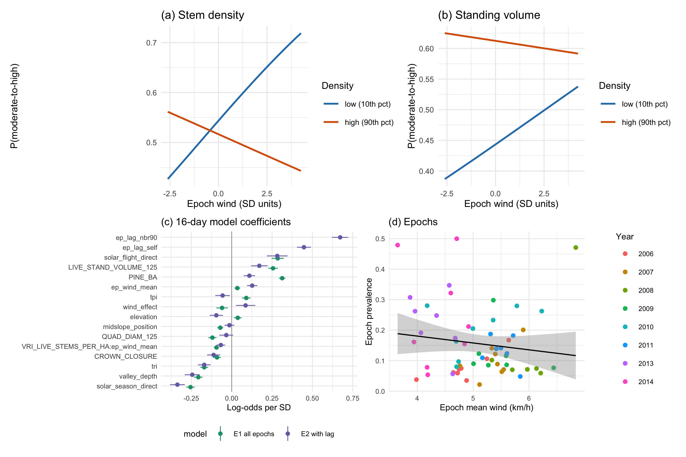
Figure 3: The refugia mechanism as fitted. (a) Predicted probability of moderate-to-high disturbance against terrain-resolved epoch wind, at the 10th and 90th percentiles of stem density, all other terms held at their means; the lines cross, so wind raises attack in thin stands and lowers it in dense ones, which is the interaction. (b) The same for standing volume. (c) Coefficients of the 16-day model, with and without the within-season spread term. (d) Epoch prevalence against epoch mean wind, one point per epoch.

4.1 Wind as a measurement
Table 6: The wind terms under two specifications, both with previous-year pressure in the model. M4 carries station wind, which is flat within a year and identified only across years. M5 carries the terrain-resolved MicroMet field, which varies within the year and is identified in space.
Model | Term | Beta | z | p
M4 station wind | jun | -0.002 | -0.09 | 0.926
M4 station wind | VRI_LIVE_STEMS_PER_HA:jun | +0.020 | 1.16 | 0.247
M5 terrain-resolved wind | mm_flight_mean | +0.467 | 28.44 | < 0.001
M5 terrain-resolved wind | VRI_LIVE_STEMS_PER_HA:mm_flight_mean | +0.031 | 2.09 | 0.036

This section reports the same wind field at the annual resolution the study first used, and it is retained because the contrast with the 16-day models is the paper’s methodological result.
The terrain-resolved field carries +0.467 log-odds per standard deviation (z = 28.44, p < 0.001) when the response is one map per year. Windier ground carries more moderate-to-high disturbance. The interaction the mechanism turns on is +0.031 (z = 2.09, p = 0.036), positive where the pheromone-disruption mechanism requires negative.
At 16 days the same wind field, the same covariates and the same classification threshold give -0.094 and -0.041. Nothing about the landscape or the wind product changed between the two. What changed is that an annual response can only ask whether windy summers carry less attack than calm ones, and a summer contains both windy and calm weeks. Averaging across them destroys exactly the contrast the mechanism operates on.
The station terms behave the same way and for the same reason. In this specification they collapse to jun at -0.002, which carries no flight-window information at all.
The lesson generalises past this dataset. The mechanism concerns a plume that persists for minutes, acting on a flight period of weeks. A test that aggregates the response to a year is not a weaker version of the right test; it is a different question, and this study answers it in the opposite direction.

4.2 Previous-year pressure
Attack recurs where it was, by a margin that changes how every other coefficient reads. A cell attacked one year is between 16 and 139 times more likely to be attacked the next. Entering persistence and 90 m spread separately, after the autologistic design used for this province, gives +0.873 and +0.950, raising discrimination from 0.799 to 0.888.
Which environmental terms survive is the informative part. Ruggedness keeps 0.61 of its value, a term describing a condition a cell has whether or not the beetle was there. The landform terms are not stable: valley depth keeps 0.50 while mid-slope position moves to 1.32, growing rather than shrinking. Part of what the landform terms measured was where the outbreak had already been, which is the same failure the terrain-wind index showed against radiation, one level up.

4.3 Host as diameter
Table 7: Moderate-to-high beetle disturbance by quadratic mean diameter class, on the balanced sample. The 25 cm boundary is the source-sink threshold of the species’ bionomics.
QMD class (cm) | Cells | Attacked (%)
<15 | 736 | 31.5
15-20 | 2,371 | 23.8
20-25 | 7,058 | 36.3
25-30 | 14,634 | 45.9
30-40 | 18,902 | 24.5
>40 | 3,627 | 17.0

Coding host as diameter changes the picture cover alone gives. Attack peaks in the 25 to 30 cm class at 45.9 per cent and falls away above it, to 24.5 per cent at 30 to 40 cm and 17.0 per cent above 40 (Table 7). The step across the 25 cm source-sink boundary is from 36.3 to 45.9 per cent.
In the full model diameter carries -0.422 per standard deviation (z = -18.35). It is negative because the relationship is not monotone: a linear term fitted through a humped response returns the slope of its falling limb, which is the larger part of the range. The class table, not the coefficient, is the result here, and the point stands, because a stand’s cover says nothing about whether its stems can produce brood.
The smallest class is not evidence. It holds 736 cells against 14,634 in the modal class, and a stand below 15 cm quadratic mean diameter in an inventory whose vintage postdates the outbreak is more likely a stand the beetle already stripped of large stems than a stand attacked at that size.

5. Discussion

5.1 Radiation, not wind
The clearest result of this study is methodological, and it changes what a terrain variable in this literature is allowed to be taken for.
Fitted with a terrain-wind index and no radiation, stand density interacts with terrain exposure at +0.311, and the natural reading is a wind effect. Add flight-window radiation and that interaction becomes +0.221, p < 0.001, while density by radiation appears at -0.144. About a third of the apparent exposure effect was the sun. The rest was not, and what survives keeps the sign the mechanism forbids.
That is not a peculiarity of this dataset. A windward-leeward index and an afternoon radiation surface are both functions of slope and aspect, and on a range whose prevailing flight-window bearing is 258 degrees the windward slopes are the west-facing ones, which are also the slopes that take afternoon sun during the flight peak. Any study that enters a terrain-derived wind index without a radiation term on the same clock will attribute radiation to wind.

5.2 What survives
Krawchuk et al. (2020) name three mechanisms. At the resolution the sensor and the insect share, two of the three hold and the third does not.
Host density holds, and it holds in the way the mechanism specifies rather than as a bare main effect. Standing volume predicts disturbance at +0.381, and its interaction with wind is -0.041 while stem density’s is -0.094. The claim was never that dense stands are attacked more; it was that a dense canopy holds a plume together, and that what a dense canopy buys should shrink as the wind rises. Both halves are present.
Large-diameter host holds as a threshold rather than a slope. Attack peaks at 45.9 per cent in the 25 to 30 cm class, at the source-sink boundary of Carroll and Safranyik (2004), and falls away on both sides.
Topographic shading does not hold, and it fails on a surrogate rather than on the surface the mechanism names. Growing-season radiation did not survive variable selection, so the pathway is carried by northness, which correlates -0.834 with it. Northness is +0.382, so shaded ground carries more attack where the mechanism requires less. Northness tests aspect, and aspect carries more than shade, so this is the least secure of the three verdicts; the water-stress pathway Krawchuk et al. (2020) describe is not measured here at all.

5.3 The wind claim
The mechanism holds, and the reason earlier specifications rejected it is temporal resolution rather than anything about the landscape.
At Landsat’s own 16-day cadence, stand density interacts with terrain-resolved wind at -0.094 for stem density and -0.041 for standing volume, both negative, at p < 0.001 and p < 0.001 respectively. A dense stand is worth less where and when the wind blows harder, which is what Krawchuk et al. (2020) predict. The result survives entering the previous epoch of the same season, so it is not the outbreak’s own spread wearing a wind coefficient.
Every coarser specification in this study rejected the same mechanism. With one map a year and station wind, the interaction was +0.020 on eight annual values, right sign and weak identification. With one map a year and the terrain-resolved field it was +0.031, wrong sign. The difference is not the wind product and not the covariate set, both of which are shared: it is that a single annual map forces the comparison to be made between summers, and a summer is not the unit the insect flies in.
That has a consequence beyond this paper. The mechanism concerns a plume that persists for minutes over a flight period of weeks. Any test that aggregates the response to a year is testing whether windy years have less attack than calm years, which is a different and much weaker question, and it will answer no. The literature has never fitted a wind term at all, so nothing in it establishes the resolution at which one should be fitted; this study’s answer is that it must be at least as fine as the flight period itself.
Two limits stay attached to the claim. The interaction is small, roughly a tenth of the standing volume main effect. And the wind field, though it varies in space, is still terrain-modified station data rather than measurement on the ridge, so what is established is that the modelled wind field behaves as the mechanism requires, not that the air did.

5.4 Ruggedness and regeneration
The two papers now share a grid, a landscape and a terrain covariate set, and they disagree on the sign of ruggedness: -0.036 for beetle attack here against a positive coefficient for conifer regeneration there (Murphy et al. 2026). Read together they describe a landscape in which rugged ground both resists the disturbance and shelters the recovery from it. That is a coherent picture, not a contradiction, and it is only visible because the two studies were fitted on the same grid in EPSG:3153.

5.5 What stays confounded
Elevation is among the largest terms in the model, +0.329, and elevation is not one thing. It carries temperature, snowpack, growing-season length and the distribution of lodgepole pine, and this design cannot take them apart. Reporting the elevation coefficient as a result would be reporting a composite.
The same caution now applies in reverse to every terrain term in the model. Radiation took about a third of one terrain interaction. There is no guarantee that some further unmeasured environmental surface would not take the rest, or another.

6. Conclusions
The wind-disruption mechanism proposed by Krawchuk et al. (2020) holds on this landscape, at the resolution the sensor and the insect share. Across 59 sixteen-day epochs, stand density interacts negatively with terrain-resolved wind, -0.094 for stem density and -0.041 for standing volume, and both survive a within-season spread term. A dense canopy is worth less to the beetle where and when the wind blows harder, which is what a plume-disruption mechanism requires.
Of the three mechanisms that proposal names, two hold. Host density holds through standing volume rather than crown closure or stem count, which run the other way as main effects, and large-diameter host holds as a threshold at 25 to 30 cm rather than as a slope, at the source-sink boundary of Carroll and Safranyik (2004). Topographic shading does not hold, and it fails on a surrogate: growing-season radiation did not survive selection, so the pathway is carried by northness, +0.382, which correlates -0.834 with it.
The methodological finding is the more transferable one, and it has three parts. A terrain index is partly an insolation measurement: entering flight-window radiation cut the density by terrain-exposure interaction from +0.311 to +0.221, leaving the sign unchanged. A landform variable in a spreading outbreak records the outbreak’s own history: entering previous-year pressure left valley depth at 0.50 of its value while mid-slope position moved to 1.32, against 0.61 for ruggedness. And an annual response cannot test a mechanism that operates over weeks: the same wind field, covariates and threshold gave +0.031 at annual resolution against -0.094 at sixteen days.
Since no previous study has fitted a wind term at all (Cartwright 2018; Krawchuk et al. 2020), there is no precedent establishing the resolution at which one should be fitted. This study’s answer is that it must be no coarser than the flight period, and that a test which aggregates past it will reject a mechanism that is there.

7. Limitations
Radiation and exposure are not separable in the flight window. The prevailing bearing is 258 degrees, so windward slopes face west and take afternoon sun. Flight-window radiation correlates -0.599 with the windward-leeward index. Its positive coefficient is consistent with the thermal gate and with exposure raising attack, and this design cannot choose between them.
The shading mechanism is tested on a surrogate. Growing-season direct radiation did not survive variable selection, so the pathway is carried by northness, which correlates -0.834 with it. Northness tests aspect, aspect carries more than shade, and the water-stress pathway Krawchuk et al. (2020) describe is not measured here. Growing-season radiation is at least separable from wind exposure, -0.015, which is the one thing it establishes.
The wind field is modelled, not measured. MicroMet modifies station observations over the terrain. What is established is that the modelled field behaves as the mechanism requires, not that the air did.
The inventory postdates part of the outbreak. Polygons interpreted after the beetle passed describe the stand it left. Total basal area discriminates below chance, 0.516, most likely for this reason.
The response is classified, not observed. Disturbance is inferred from Landsat moisture indices trained on plots cut from those indices, so reported accuracy measures separability rather than agreement with ground mortality.
One landscape, one outbreak. Every conclusion is conditioned on a single mountain range over 8 years and 59 epochs.

8. Acknowledgements
This work used no external funding. Beetle disturbance was classified from Landsat Collection 2 Level-2 surface reflectance distributed by the United States Geological Survey; stand structure from the British Columbia Data Catalogue; terrain from Natural Resources Canada; and wind from Environment and Climate Change Canada. The author thanks those agencies for maintaining the open archives the study rests on.

9. Conflict of interest
The author declares no conflict of interest.

10. Ethics statement
This study used only publicly archived remote sensing, inventory and meteorological data. No animals, human participants or protected material were involved, so no ethics approval was required.

11. Author contributions
Seamus Murphy: conceptualisation; data curation; formal analysis; investigation; methodology; software; validation; visualisation; writing, original draft; writing, review and editing.

12. Data availability
Every dataset used here is public and none was collected by the author. Beetle disturbance is classified from Landsat Collection 2 Level-2 surface reflectance. Stand structure is the provincial Vegetation Resources Inventory layer VEG_COMP_LYR_R1_POLY, retrieved from the British Columbia Data Catalogue web feature service by 02.inputs/beetle-classification/34-fetch-vri.py. Terrain derives from the Natural Resources Canada High Resolution Digital Elevation Model (Natural Resources Canada 2017), with geomorphometry computed by SAGA GIS in 37-geomorphometry.R. Wind is Environment and Climate Change Canada hourly station data, retrieved by 30-wind-hourly-metrics.R and 36-wind-direction.R.
All derived data and the complete analysis code that reproduce every number, table and figure in this article are archived at Dryad under doi:PLACEHOLDER-DRYAD-DOI, and are mirrored at https://github.com/seamusrobertmurphy/beetle-topography-and-wind-study.

13. Figure legends
Figure 1. The study area, all panels EPSG:3153 at 30 m, with the 2015 Mt Midgeley burn outlined in red and Kootenay Lake and the Kootenay River from the British Columbia Freshwater Atlas. (a) elevation; (b) terrain ruggedness index; (c) stand basal area from the Vegetation Resources Inventory.
Figure 2. The predictor surfaces, all EPSG:3153 at 30 m. (a) flight-window direct radiation; (b) growing-season direct radiation; (c) the MicroMet wind weighting factor at the prevailing bearing; (d) terrain ruggedness; (e) stand basal area; (f) quadratic mean diameter.
Figure 3. The refugia mechanism as fitted. (a) Predicted probability of moderate-to-high disturbance against terrain-resolved epoch wind, at the 10th and 90th percentiles of stem density, all other terms held at their means. (b) The same for standing volume. (c) Coefficients of the 16-day model, with and without the within-season spread term. (d) Epoch prevalence against epoch mean wind, one point per epoch.
R version 4.4.1 (2024-06-14)
Platform: aarch64-apple-darwin20
Running under: macOS 15.7.7
Matrix products: default
BLAS: /opt/local/Library/Frameworks/R.framework/Versions/4.4-arm64/Resources/lib/libRblas.0.dylib
LAPACK: /opt/local/Library/Frameworks/R.framework/Versions/4.4-arm64/Resources/lib/libRlapack.dylib; LAPACK version 3.12.0
locale:
[1] en_CA.UTF-8/en_CA.UTF-8/en_CA.UTF-8/C/en_CA.UTF-8/en_CA.UTF-8
time zone: America/Vancouver
tzcode source: internal
attached base packages:
[1] stats graphics grDevices utils datasets methods base
other attached packages:
[1] tidyterra_1.1.0 patchwork_1.3.2 ranger_0.18.0 car_3.1-5
[5] carData_3.0-6 mgcv_1.9-4 nlme_3.1-168 knitr_1.51
[9] ggplot2_4.0.2 tidyr_1.3.2 dplyr_1.2.0 sf_1.1-0
[13] terra_1.9-1
loaded via a namespace (and not attached):
[1] s2_1.1.9 generics_0.1.4 class_7.3-23
[4] KernSmooth_2.23-26 lattice_0.22-9 pROC_1.19.0.1
[7] digest_0.6.39 magrittr_2.0.4 evaluate_1.0.5
[10] grid_4.4.1 RColorBrewer_1.1-3 fastmap_1.2.0
[13] jsonlite_2.0.0 Matrix_1.7-5 e1071_1.7-17
[16] Formula_1.2-5 DBI_1.3.0 purrr_1.2.1
[19] viridisLite_0.4.3 scales_1.4.0 codetools_0.2-20
[22] abind_1.4-8 cli_3.6.5 rlang_1.1.7
[25] units_1.0-1 splines_4.4.1 withr_3.0.2
[28] yaml_2.3.12 otel_0.2.0 tools_4.4.1
[31] vctrs_0.7.2 R6_2.6.1 proxy_0.4-29
[34] lifecycle_1.0.5 classInt_0.4-11 pkgconfig_2.0.3
[37] pillar_1.11.1 gtable_0.3.6 data.table_1.18.2.1
[40] glue_1.8.0 Rcpp_1.1.1 xfun_0.57
[43] tibble_3.3.1 tidyselect_1.2.1 farver_2.1.2
[46] htmltools_0.5.9 labeling_0.4.3 rmarkdown_2.30
[49] wk_0.9.5 compiler_4.4.1 S7_0.2.1

14. References
Badger J, Frank H, Hahmann AN, Giebel G (2014) Wind-climate estimation based on mesoscale and microscale modeling: Statistical–dynamical downscaling for wind energy applications. Journal of Applied Meteorology and Climatology 53:1901–1919. https://doi.org/10.1175/JAMC-D-13-0147.1
Bartos DL, Amman GD (1989) Microclimate: An alternative to tree vigor as a basis for mountain pine beetle infestations. U.S. Department of Agriculture, Forest Service, Intermountain Research Station, Ogden, UT
Carroll AL, Safranyik L (2004) The bionomics of the mountain pine beetle in lodgepole pine forests: Establishing a context. In: Shore TL, Brooks JE, Stone JE (eds) Mountain pine beetle symposium: Challenges and solutions, october 30–31, 2003, kelowna, british columbia. Natural Resources Canada, Canadian Forest Service, Pacific Forestry Centre, Victoria, British Columbia, pp 21–32
Cartwright JM (2018) Landscape topoedaphic features create refugia from drought and insect disturbance in a lodgepole and whitebark pine forest. Forests 9:715. https://doi.org/10.3390/f9110715
Davis NN, Badger J, Hahmann AN, et al (2023) The Global Wind Atlas: A high-resolution dataset of climatologies and associated web-based application. Bulletin of the American Meteorological Society 104:E1507–E1525. https://doi.org/10.1175/BAMS-D-21-0075.1
Jones KL, Shegelski VA, Marculis NG, et al (2019) Factors influencing dispersal by flight in bark beetles (Coleoptera: Curculionidae: Scolytinae): From genes to landscapes. Canadian Journal of Forest Research 49:1024–1041. https://doi.org/10.1139/cjfr-2018-0304
Krawchuk MA, Meigs GW, Cartwright JM, et al (2020) Disturbance refugia within mosaics of forest fire, drought, and insect outbreaks. Frontiers in Ecology and the Environment 18:235–244. https://doi.org/10.1002/fee.2190
Liston GE, Elder K (2006) A meteorological distribution system for high-resolution terrestrial modeling (MicroMet). Journal of Hydrometeorology 7:217–234. https://doi.org/10.1175/JHM486.1
McCambridge WF (1971) Temperature limits of flight of the mountain pine beetle, Dendroctonus ponderosae. Annals of the Entomological Society of America 64:534–535. https://doi.org/10.1093/aesa/64.2.534
McCune B, Keon D (2002) Equations for potential annual direct incident radiation and heat load. Journal of Vegetation Science 13:603–606. https://doi.org/10.1111/j.1654-1103.2002.tb02087.x
Murphy S, Leslie A, Wilson J, Banks LK (2026) Spatial patterns of conifer regeneration following mountain pine beetle outbreak (Dendroctonus ponderosae) and mixed-severity wildfire: A point process model of disturbance interactions in the southern Selkirk Mountains, British Columbia. Forest Ecology and Management 618:123985. https://doi.org/10.1016/j.foreco.2026.123985
Natural Resources Canada (2017) High resolution digital elevation model (HRDEM) – CanElevation series. https://open.canada.ca/data/en/dataset/957782bf-847c-4644-a757-e383c0057995
Powell JA, Bentz BJ (2014) Phenology and density-dependent dispersal predict patterns of mountain pine beetle (Dendroctonus ponderosae) impact. Ecological Modelling 273:173–185. https://doi.org/10.1016/j.ecolmodel.2013.10.034
Safranyik L, Carroll AL (2006) The biology and epidemiology of the mountain pine beetle in lodgepole pine forests. In: Safranyik L, Wilson B (eds) The mountain pine beetle: A synthesis of biology, management, and impacts on lodgepole pine. Natural Resources Canada, Canadian Forest Service, Pacific Forestry Centre, Victoria, British Columbia, pp 3–66
Sambaraju KR, Goodsman DW (2021) Mountain pine beetle: An example of a climate-driven eruptive insect impacting conifer forest ecosystems. CAB Reviews 16: https://doi.org/10.1079/PAVSNNR202116018
Taylor SW, Carroll AL (2003) Disturbance, forest age, and mountain pine beetle outbreak dynamics in BC: A historical perspective. In: Mountain pine beetle symposium: Challenges and solutions, october 30–31, 2003, kelowna, british columbia. Natural Resources Canada, Canadian Forest Service, Pacific Forestry Centre, Victoria, British Columbia, pp 41–51

