Online Resources
Net emissions and removals from Canada’s managed forestland with and without the disaggregation of natural disturbances
Online Resources for the article submitted to Climatic Change. Each item is cited in the article by its number. The code that produced every table and figure is in the article’s source file in the repository named in the Data availability statement.
Online Resource 1 Tier 1 defaults of the 2006 Guidelines matched to Canada’s ecological zones. The zones and their codes followed the ecological zone table of the forest land chapter, and the area was each zone’s extent within Canada. Biomass consumption was the product of fuel load and combustion factor in the IPCC biomass consumption table, as mean and standard error. The combustion factor came from the IPCC combustion factor table, as mean and standard deviation. The combustion factor table gave no wildfire value for other temperate forests or for grassland, so the values of all other temperate forests and of all savanna grasslands were used. The emission factors were the IPCC emission factor row named, as mean and standard deviation. Tundra had no printed error and no combustion factor.
Ecological zone | Area (Mha) | IPCC biomass consumption row | Biomass consumption (t/ha) | Combustion factor | IPCC emission factor row | CO2 (g/kg) | CH4 (g/kg) | N2O (g/kg)
Polar (P) | 244 | Tundra | 10.0 |  | Savanna and grassland | 1613 ± 95 | 2.3 ± 0.9 | 0.21 ± 0.10
Boreal tundra woodland (Bb) | 223 | Boreal forest, wildfire (general) | 52.8 ± 48.4 | 0.40 ± 0.06 | Extra tropical forest | 1569 ± 131 | 4.7 ± 1.9 | 0.26 ± 0.07
Boreal coniferous forest (Ba) | 206 | Boreal forest, wildfire (general) | 52.8 ± 48.4 | 0.40 ± 0.06 | Extra tropical forest | 1569 ± 131 | 4.7 ± 1.9 | 0.26 ± 0.07
Boreal mountain system (BM) | 75 | Boreal forest, wildfire (general) | 52.8 ± 48.4 | 0.40 ± 0.06 | Extra tropical forest | 1569 ± 131 | 4.7 ± 1.9 | 0.26 ± 0.07
Temperate mountain system (TeM) | 68 | Other temperate forests, wildfire | 19.8 ± 6.3 | 0.45 ± 0.16 | Extra tropical forest | 1569 ± 131 | 4.7 ± 1.9 | 0.26 ± 0.07
Temperate continental forest (TeDc) | 60 | Other temperate forests, wildfire | 19.8 ± 6.3 | 0.45 ± 0.16 | Extra tropical forest | 1569 ± 131 | 4.7 ± 1.9 | 0.26 ± 0.07
Temperate steppe (TeBSk) | 46 | Grassland, mid or late dry season burns | 4.1 ± 3.1 | 0.77 ± 0.26 | Savanna and grassland | 1613 ± 95 | 2.3 ± 0.9 | 0.21 ± 0.10
Temperate desert (TeBWk) | 5 | Grassland, mid or late dry season burns | 4.1 ± 3.1 | 0.77 ± 0.26 | Savanna and grassland | 1613 ± 95 | 2.3 ± 0.9 | 0.21 ± 0.10
Temperate oceanic forest (TeDo) | 2 | Other temperate forests, wildfire | 19.8 ± 6.3 | 0.45 ± 0.16 | Extra tropical forest | 1569 ± 131 | 4.7 ± 1.9 | 0.26 ± 0.07
Online Resource 2 Area burned in Canada and British Columbia by year and recorded cause, 2001 to 2024, from the fire points of the Canadian National Fire Database. Natural, human and unknown are the database’s cause codes.
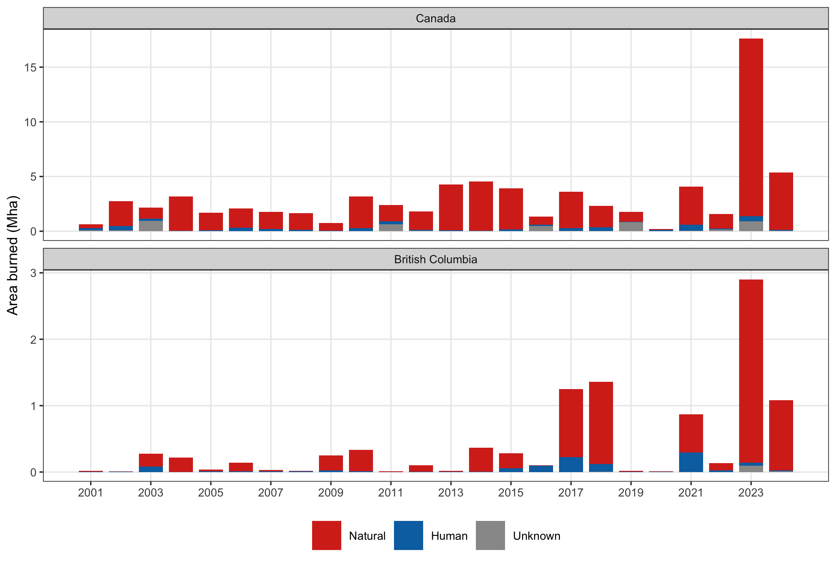
Online Resource 3 Each term of the Tier 1 fire estimate as the global default supplied it and as the national datasets supply it. The national datasets are the 2026 Fire Behaviour Prediction fuel types and the peatland map of the Canadian Forest Service. The burned areas are from the National Burned Area Composite and the fire points of the Canadian National Fire Database, and the emission factors and natural share from the inventory’s own method. Areas are counted on the 2 km grid described in the article’s Methods.
Quantity | Tier 1 global default | National dataset
Forest fuel classes on the 2 km grid | Two IPCC biomass consumption rows, boreal forest 380 Mha and temperate forest 109 Mha | FBP fuel types, conifer 300 Mha, mixedwood 88 Mha, deciduous 198 Mha, grass 76 Mha
Biomass consumption (t dry matter per ha) | IPCC biomass consumption table, 52.8 ± 48.4 boreal and 19.8 ± 6.3 temperate | CBM-CFS3 disturbance matrices on the pools of each stand, with a burn severity sub-model from 2026
Organic soil (Mha) | IPCC default raster, 92 | Peatland map, 96, of which 32 also organic in the default raster
Area burned in 2023 (Mha) | MODIS MCD64A1 other forest as FAO published it, 2.7 | National Burned Area Composite, 14.8; fire points, 17.6
Area burned in 2023 on organic soil (%) | IPCC default raster, 27 | Peatland map, 21
Area burned in 2023 by fuel (%) | MCD12Q1 forest 15, woody savanna and savanna 79 | FBP conifer 39, mixedwood 24, deciduous 27
Emission factors (g per kg) | IPCC emission factor table, 1,569 carbon dioxide, 4.7 methane, 0.26 nitrous oxide | Inventory split of combusted carbon, 90 per cent carbon dioxide, 9 per cent carbon monoxide, 1 per cent methane
Natural share | None | Fire points cause field, 92 per cent natural in 2023; inventory rule, every wildfire
Online Resource 4 Fuel consumption and emission factors behind the estimates generated by the FAOSTAT algorithm for Canada, 2001 to 2024, recovered by division. Fuel was biomass burned divided by burned area, named by the row of the IPCC biomass consumption table it equalled. Each emission factor was the gas emitted divided by biomass burned. Every item’s factors equalled the savanna and grassland row of the IPCC emission factor table, whose extra tropical forest row is given last for comparison. No carbon dioxide was disseminated for the savanna, grassland and shrubland items.
Item | Burned area (ha a year) | Fuel (t/ha) | IPCC biomass consumption row | CH4 (g/kg) | N2O (g/kg) | CO2 (g/kg)
Other forest | 340,209 | 41.2 to 47.6 | Between all boreal forest and all other temperate forests | 2.3 | 0.21 | 1,613
Woody savanna | 1,195,105 | 3.3 | Savanna woodland, mid or late dry season burns | 2.3 | 0.21
Savanna | 754,333 | 4.1 | Grassland, mid or late dry season burns | 2.3 | 0.21
Grassland | 55,585 | 4.1 | Grassland, mid or late dry season burns | 2.3 | 0.21
Open shrubland | 34,955 | 14.3 | All shrublands | 2.3 | 0.21
Emission factor row, extra tropical forest |  |  |  | 4.7 | 0.26 | 1,569
Online Resource 5 Net emissions, five-year mean and reduction for British Columbia under three accounts, 2017 to 2024, from the provincial lines of the national inventory. The five-year mean was that of 2012 to 2016. The burned area share was the province’s share of the area burned in Canada. The threshold account left out the natural disturbance line only in years that passed both the national and the provincial test.
Year | Account | Burned area share (%) | Net emissions (Mt CO2e) | Five-year mean (Mt CO2e) | Reduction (Mt CO2e)
2017 | Disaggregated | 35.9 | 38.0 | 42.2 | 4.2
2017 | Undisaggregated | 35.9 | 228.0 | 77.0 | -151.0
2017 | Threshold | 35.9 | 228.0 | 67.4 | -160.6
2018 | Disaggregated | 60.5 | 42.0 | 42.2 | 0.2
2018 | Undisaggregated | 60.5 | 272.0 | 77.0 | -195.0
2018 | Threshold | 60.5 | 42.0 | 67.4 | 25.4
2019 | Disaggregated | 1.5 | 33.0 | 42.2 | 9.2
2019 | Undisaggregated | 1.5 | 65.0 | 77.0 | 12.0
2019 | Threshold | 1.5 | 65.0 | 67.4 | 2.4
2020 | Disaggregated | 6.6 | 31.0 | 42.2 | 11.2
2020 | Undisaggregated | 6.6 | 60.0 | 77.0 | 17.0
2020 | Threshold | 6.6 | 60.0 | 67.4 | 7.4
2021 | Disaggregated | 21.1 | 29.0 | 42.2 | 13.2
2021 | Undisaggregated | 21.1 | 199.0 | 77.0 | -122.0
2021 | Threshold | 21.1 | 29.0 | 67.4 | 38.4
2022 | Disaggregated | 9.0 | 25.0 | 42.2 | 17.2
2022 | Undisaggregated | 9.0 | 80.0 | 77.0 | -3.0
2022 | Threshold | 9.0 | 80.0 | 67.4 | -12.6
2023 | Disaggregated | 22.2 | 19.0 | 42.2 | 23.2
2023 | Undisaggregated | 22.2 | 399.0 | 77.0 | -322.0
2023 | Threshold | 22.2 | 19.0 | 67.4 | 48.4
2024 | Disaggregated | 20.8 | 16.0 | 42.2 | 26.2
2024 | Undisaggregated | 20.8 | 226.0 | 77.0 | -149.0
2024 | Threshold | 20.8 | 16.0 | 67.4 | 51.4
Online Resource 6 The emission reduction of each account from 10,000 Monte Carlo draws with the published model interval on every annual value. The mean and standard deviation are those of the draws, and the 5th and 95th percentiles bound the 90 per cent interval. The relative half width is half the distance between those percentiles over the mean, the 90 per cent confidence interval of Equation 8, and the adjustment factor is that half width times 0.524417 over 1.645006, the share of the reduction withheld. Both are printed only where the mean reduction is positive.
Year | Account | Mean reduction (Mt CO2e) | Standard deviation (Mt CO2e) | 5th percentile (Mt CO2e) | 95th percentile (Mt CO2e) | Relative half width (%) | Adjustment factor (%)
2017 | Disaggregated | 6.7 | 33.7 | -49 | 61 | 821 | 261.6
2017 | Undisaggregated | -80.8 | 34.4 | -137 | -24
2017 | Threshold | -127.2 | 34.1 | -183 | -71
2018 | Disaggregated | 1.5 | 33.6 | -54 | 57 | 3692 | 1176.9
2018 | Undisaggregated | -126.5 | 34.1 | -183 | -71
2018 | Threshold | 67.7 | 33.9 | 12 | 123 | 82 | 26.2
2019 | Disaggregated | 9.7 | 34.0 | -46 | 66 | 574 | 182.9
2019 | Undisaggregated | -18.5 | 33.9 | -74 | 37
2019 | Threshold | -65.0 | 33.9 | -120 | -8
2020 | Disaggregated | -0.7 | 34.3 | -57 | 55
2020 | Undisaggregated | 109.4 | 34.0 | 53 | 166 | 52 | 16.5
2020 | Threshold | 63.4 | 33.9 | 7 | 119 | 88 | 28.1
2021 | Disaggregated | 12.0 | 33.6 | -43 | 67 | 458 | 146.0
2021 | Undisaggregated | -165.7 | 33.8 | -221 | -110
2021 | Threshold | 78.1 | 33.6 | 23 | 133 | 70 | 22.4
2022 | Disaggregated | -20.2 | 33.8 | -76 | 35
2022 | Undisaggregated | 2.6 | 34.0 | -53 | 59 | 2126 | 677.8
2022 | Threshold | -44.1 | 34.0 | -100 | 11
2023 | Disaggregated | 34.4 | 33.8 | -21 | 91 | 163 | 51.8
2023 | Undisaggregated | -853.8 | 34.2 | -909 | -797
2023 | Threshold | 100.3 | 34.3 | 44 | 156 | 56 | 17.9
2024 | Disaggregated | 21.4 | 34.0 | -35 | 79 | 264 | 84.2
2024 | Undisaggregated | -296.9 | 34.1 | -353 | -241
2024 | Threshold | 87.3 | 34.2 | 31 | 143 | 64 | 20.4

