Refitting a beetle by fire disturbance interaction
Why the additive model of beetle mortality and burn severity was the defensible one, Darkwoods Conservation Area, British Columbia
Seamus Murphy
2026-09-03
Abstract
Where a mountain pine beetle outbreak precedes wildfire, the outbreak may change the severity of the fire, a linked disturbance, or change what the fire leaves behind, a compound disturbance, and field studies of lodgepole pine at short intervals have found little of either. Few studies have tested both on one landscape with the same surfaces, and fewer have asked whether the likelihood used to fit a beetle by fire product term in a regeneration model can be trusted to judge it. This study tested both on the beetle outbreak of 2005 to 2014 and the mixed-severity Mt Midgeley wildfire of 2015 in the Darkwoods Conservation Area, southern Selkirk Mountains, British Columbia (annual Landsat beetle classifications, a classified burn severity raster, the provincial Aerial Overview Survey, and the mapped conifer seedlings of three four-hectare plots). The probability of high-severity burning was modelled on prior grey-stage attack, lodgepole pine cover and elevation by logistic regression with spatial block bootstrap intervals, and the parent study’s inhomogeneous point process model of regeneration was refitted with beetle by fire product terms under its published Poisson likelihood, under a spatial block bootstrap and under a cluster-robust sandwich estimator. Prior attack did not change the probability of high-severity burning (log-odds 0.043 for attacked against unattacked cells, block bootstrap interval spanning zero at every block size), and the count of attack years showed no hump-shaped effect. The product terms were decisive under the Poisson likelihood (likelihood ratio test, p < 0.001) and absent under inference that respected the clustering the parent study documented; the coefficients were identical, the intervals 2.3 to 5.9 times wider, none of sixteen product-term intervals excluded zero, and the sandwich estimator agreed. Neither a linked nor a compound effect was detectable, in agreement with field studies of the same forest type, so the additive specification of the parent study was the defensible one, and the ease with which clustered seedlings counted as independent observations produced an interaction was the result that applied beyond this landscape.

Introduction
Mountain pine beetle (Dendroctonus ponderosae Hopkins) outbreak and wildfire have overlapped across the conifer forests of western North America since the late 1990s, and the field has settled on two words for what one disturbance can do to the next. Talucci (2019) gave the definitions. “Short-interval disturbances may create linked effects where the first event influences the frequency or severity of the second event (Simard et al. 2011). Short-interval disturbances can also create compound effects in which the first event alters the ecological outcome of the second event, sensu Paine et al. (1998).” Liang et al. (2016) used the same pair, in that “One disturbance type may be linked with another by changing its extent, severity, or probability of occurrence” and, if such a link exists, the two “may produce compound effects on ecosystems”. In this literature an interaction is that dependence between events, tested by a product term, by a sequence contrast or by a factorial design, and the present study kept that meaning and used product term for the statistical quantity alone.
The mechanism behind a linked effect was real and measurable, because Jenkins et al. (2012) showed that beetle-killed foliage lost moisture and changed in chemistry within a year of attack and burned more readily as a result, and Meigs et al. (2011) mapped beetle effects on tree mortality and surface fuels from Landsat time series. Taking that mechanism up to the stand and the landscape proved harder. Simard et al. (2011) modelled crown fire through a beetle outbreak in lodgepole pine (Pinus contorta Douglas ex Loudon var. latifolia Engelm. ex S. Watson) and found the probability of active crown fire no higher, and in the red stage lower, than in unattacked stands. Harvey et al. (2014) found that the effect of prior attack on burn severity depended on outbreak stage and was small beside the effect of weather, Hart et al. (2015) found no relationship between outbreak extent and area subsequently burned across the western United States, and Liang et al. (2016) found across the Southern Rocky Mountains that “The severity of fire was unrelated to pre-fire outbreak severity, and no evidence of MPB mortality increasing fire occurrence was found.” Talucci (2019) summarised the subalpine work as “generally finding minimal or no effects of outbreak severity on fire severity”, and her own field result was that “The effect of outbreak severity on fire severity was limited, with six of seven fire effects showing no evidence of an effect”. Her Landsat analysis of three sub-boreal fires was the one positive result, in that “intermediate levels of outbreak generate a fuel arrangement that supports the greatest probability of high severity fire on these landscapes”, after accounting for fire weather and terrain.
The compound question, whether a prior outbreak changes what regenerates after the fire, has the same field answer for lodgepole pine at short intervals. Talucci (2019) found that “Fire severity and cone abundance were the primary drivers of recruitment density in burned stands, while substantial underlying tree mortality from the MPB outbreaks did not play a role”, and Harvey et al. (2014) found no direct effect of outbreak severity on initial post-fire regeneration of lodgepole pine in the northern Rocky Mountains. The mechanism the compound claim rests on is a feedback within the refugia framework of Krawchuk et al. (2020), in which “insect-caused mortality of mature trees could reduce the capacity of fire refugia to serve as seed sources for post-fire tree regeneration”. Mathys et al. (2018) separated the two life stages the question joins, in that “Small changes in temperature and precipitation impact seedlings more than adult trees, whereas the opposite is the case with bark beetles and wind storms”, so beetle attack is a fact about adult host trees and regeneration a fact about seedlings.
Part of the contest over both questions concerned inference. Prior disturbance was not assigned at random, both causes tracked host abundance and terrain, and burn severity was measured on a raster whose cells were far from independent. Stevens-Rumann et al. (2016), asking the linked question with fire in place of beetle across four large fires, fitted a spatially explicit autoregression because burn severity was autocorrelated, McIntire and Fortin (2006) measured disturbance edges as zones tens of metres wide and noted that “because of lack of independence of data points, the effective degrees of freedom is less than the number of sample plots”, and Magnussen et al. (2017) showed in forest inventory that omitting residual spatial autocorrelation left confidence intervals too narrow rather than merely imprecise. A product term was exactly the quantity such a failure would overstate. Within the point-process studies of post-fire regeneration the covariate effects have been reported under Poisson error, by Ziegler et al. (2017), who fitted “an inhomogeneous Cox process model, a weighted generalized linear model with a log-link and Poisson error distribution”, by Malone et al. (2018), and by the parent study of this analysis, and none of the three reported intervals that accounted for the clustering all three documented.
That parent study (Murphy et al., 2026) modelled conifer regeneration across three four-hectare plots inside the 2015 Mt Midgeley burn in the Darkwoods Conservation Area, British Columbia, from classified Landsat surfaces of burn severity and of red-stage and grey-stage beetle mortality. Its abstract reported that “areas of overlapping beetle mortality and high burn severity had significantly reduced lodgepole pine regeneration”, and its conclusions that the results suggested “the ecological consequences of beetle-fire interactions weaken as surface fuels decay over time”. Both were statements of a compound effect. The fitted trend entered eight covariates additively, seed source distance, aspect, terrain ruggedness, wind, grey-stage and red-stage beetle mortality, and high and low burn severity, and no product of a beetle indicator with a fire indicator entered the pooled fit or any of the seven per-species fits. The parent study read its compound statements from main effects, which an additive fit permits, and opened a discussion of how far inherited raster layers and a fitted trend could support such a claim. This paper ran the tests that discussion called for, on the same data, against the position the field studies above had reached.
The objectives of this study were to (1) test the linked effect, whether prior beetle attack changed the probability of high-severity burning within the Mt Midgeley burn after accounting for host cover and elevation, and whether the hump-shaped form Talucci (2019) reported recurred, and (2) test the compound effect, whether prior beetle attack changed the regeneration response to burn severity, by refitting the published point process model with beetle by fire product terms and comparing it against the published additive fit under inference that accounted for the clustering of the seedlings.
The wording was kept narrow throughout. A designed factorial can justify the language of interaction outright, as Bansal et al. (2014) did in crossing burn severity with canopy cover and reporting effects that were conditional by construction, and Talucci (2019) retained her weather by outbreak product terms “regardless of statistical significance, because of the known interaction between fire weather and fuels”. An observational fit over ground that neither treatment nor randomisation touched could not, and Estabrook et al. (2025) described burn severity as contingent on weather and then fitted weather as main effects. This study reported whether each term was retained and what interval its coefficient had, and it did not report that the two causes interact.
The paper is arranged around the two objectives. The Methods describe the surfaces, the limits the surfaces placed on what could be compared, and the two models. The Results report the severity model (Section 3.1) and the regeneration model (Section 3.2). The Discussion sets each against the field studies above and closes with the inferential point, which is that the product terms were decisive under the likelihood the published model was fitted with and absent under inference that accounted for the clustering the parent study itself documented, with the same coefficients either way.

Materials and methods

Study area
The study was set in the Darkwoods Conservation Area, in the southern Selkirk Mountains of southeastern British Columbia. A mountain pine beetle outbreak affected the property through the decade to 2014, and the Mt Midgeley wildfire burned part of it in 2015 in a mixed-severity mosaic, with intervals from attack to fire of one to eleven years and a median of seven (Murphy et al., 2026). The outbreak preceded the fire, and for mountain pine beetle the reverse sequence is weak, because McHugh et al. (2003) found the species “not attracted to fire-damaged trees” where other bark beetles colonised them, and Liang et al. (2016) found post-fire beetle severity “lowest in areas with higher burn severity, due to the limited availability of live host trees”, so the linked effect tested here ran from beetle to fire.

Attack chronology
An association between a prior disturbance and a later one depends on the dating of the prior one. Kulakowski and Veblen (2006) dated a nineteenth-century outbreak from growth releases in surviving non-host trees, Meyer et al. (2016) reconstructed pre-attack structure by returning recently dead trees to the live tally, and Estabrook et al. (2025) showed how a forest inventory’s remeasurement interval degraded its record of pre-fire condition. Here attack was dated from the annual Landsat classifications, 9 files in all, with the attack year of a cell taken as the first file that recorded it (Table 1).
Table 1: Annual Landsat classifications that dated beetle attack, with the number of cells in each carrying red-attack class code 44, the code the grey-stage union was built from. The class legend followed the provincial survey’s severity coding, but the layers were Landsat classifications and not survey products.
Year | Cells carrying the code | In the dating window
2005 | 534 | yes
2006 | 1530 | yes
2007 | 573 | yes
2008 | 0
2009 | 324 | yes
2010 | 0
2011 | 137 | yes
2013 | 0
2014 | 0

Wulder et al. (2006) found red-attack foliage detectable for roughly one to three years after the attack that produced it, so a first detection dated the change in crown colour within a window rather than to a year, and Talucci (2019) noted for her own red-stage surfaces that “the snapshot captured during the red phase of the outbreaks is not fully indicative of what burned a decade later.” The series was also thinner than its file count. There was no file for 2012, the files for 2013 and 2014 used a different classification legend and recorded the red-attack code in no cell, and two files inside the window, for 2008 and 2010, were likewise empty of it, so the grey-stage union rested on 5 annual observations across a 7-year window that closed in 2011. Two attack surfaces were used. The grey-stage union recorded whether a cell was attacked at any time from 2005 to 2011, and the attack-year count recorded in how many of those annual files the cell carried the red-attack code, from zero to 5, which served as the graded measure of outbreak severity that Talucci (2019) modelled as a continuous spectral change.

Classified surfaces
Table 2: Footprints of the local classified surfaces against the terrain grid. Every disturbance surface was confined to a rectangle of roughly eight square kilometres, and the terrain grid covered thirty-four times that area.
Surface | Rows | Cols | Cell (m) | Width (km) | Height (km) | Extent (km2)
Elevation, terrain grid | 695 | 639 | 25.11 | 16.05 | 17.45 | 280.09
Beetle red stage | 135 | 66 | 29.56 | 1.95 | 3.99 | 7.78
Beetle grey stage, corrected | 135 | 66 | 29.56 | 1.95 | 3.99 | 7.78
Beetle grey stage, deprecated | 135 | 66 | 29.56 | 1.95 | 3.99 | 7.78
Beetle continuous (spatstat) | 52 | 47 | 29.49 | 1.39 | 1.53 | 2.13
Burn severity, classified | 134 | 66 | 30.00 | 1.98 | 4.02 | 7.96
Beetle by fire intersection | 136 | 67 | 29.56 | 1.98 | 4.02 | 7.96

The fire perimeter enclosed 4.8 km², the beetle red-stage raster spanned a rectangle of 7.78 km² around it, and the terrain grid covered 280 km² of the same landscape (Table 2).

Severity codes
Burn severity here meant the three classes of the parent study’s classified differenced Normalised Burn Ratio raster, low, moderate and high, and the word is used in the sense Lentile et al. (2006) gave it, the degree of ecosystem change the fire caused as measured after it, distinct from fire intensity and from immediate fire severity. Lentile et al. (2006) cautioned that class thresholds transfer poorly between environments and that at 30 m the moderate class is the most mixed, and the classes were kept as the parent study defined them. The raster used integer codes that were not in severity order, so the order was established from the three binary class masks rather than assumed (Table 3).
Table 3: Decoding of the classified burn severity raster against its own binary class masks and against the fire perimeter. The integer codes were not in severity order, and code 16 fell inside the perimeter but in none of the three severity classes.
Class | Code | Cells | Inside perimeter (%)
Outside perimeter | 0 | 3514 | 0.1
Inside perimeter, unclassified | 16 | 1268 | 100.0
Low | 32 | 2144 | 99.9
Moderate | 34 | 1383 | 99.8
High | 1 | 535 | 100.0

Code 1 was high severity, code 34 moderate and code 32 low. Code 16 was the class that no severity mask claimed, 1,268 cells lying inside the fire perimeter but assigned to none of high, moderate or low, which corresponded to what Talucci (2019) called “MPB-affected fire refugia (Meddens et al. 2018), locations that experience insect outbreak but did not burn within a given fire event” where they were attacked.

Aerial survey
The provincial Aerial Overview Survey was the operational record of forest health in British Columbia, in which observers sketch-mapped damage each year from fixed-wing aircraft and labelled each polygon by year, cause, severity class and host species (Province of British Columbia, Ministry of Forests, 2026). It was coarse and observer-based, and its errors were positional and perceptual rather than spectral, so they were uncorrelated with the errors of the Landsat classification.
Over the terrain grid the survey held 608 damage polygons of all causes and years, of which 276 were mountain pine beetle within the 2005 to 2014 outbreak window.

Spatial coverage
Everything the study analysed lay inside one small burn, and Figure 1 shows what that meant at three nested scales. The regional panel shows the international border because the provincial survey stopped there, and so did any comparison drawn from it.
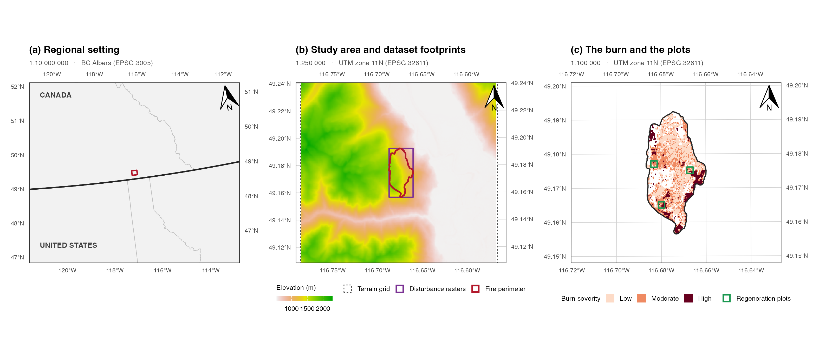
Figure 1: The study area at three nested scales. (a) Regional setting, with the Canada and United States border and provincial and state boundaries. (b) The terrain grid, the rectangle shared by every disturbance raster, and the fire perimeter inside it. (c) The burn with its classified severity and the three four-hectare regeneration plots that held the point pattern of Section 3.2. Each panel is drawn to the stated representative fraction at the panel width given in the text, carries a true-north arrow and is bounded by a WGS 84 graticule labelled on all four sides.
The scales were 1:10 000 000, 1:250 000 and 1:100 000, each exact at the drawn panel width of 2.70 inches, which was measured off the assembled figure and the extents rebuilt at it. Panels (b) and (c) are in the UTM zone 11N grid the analysis worked in, panel (a) in BC Albers, and all three are bounded by a WGS 84 graticule. The terrain grid covered 280 km², every disturbance raster shared a footprint of 7.78 km², and the fire perimeter inside it enclosed 4.8 km².

Data limits
Beetle mortality is under-detected in Landsat time series even where it is mapped, because Rodman et al. (2021) found that a standard change-detection algorithm “more accurately detected wildfire than spruce beetle-induced tree mortality, and both mortality agents were more easily detected when they occurred at high severity”, and predicted about forty per cent less affected area than alternative methods, so an absence of attack in a Landsat product was weak evidence of absence and every local surface was checked against the survey. The check found a further limit. The annual rasters of 2005 to 2011 held data on only a fraction of the cells outside the fire perimeter and no data on the rest, and every beetle surface in the study descended from those files and inherited that boundary (Table 4).
Table 4: Where each beetle surface stopped against the fire perimeter, on the native beetle grid. The annual rasters held no data over almost the whole area outside the perimeter, and the two derived surfaces inherited it.
Surface | Cells present | Inside perimeter | Outside perimeter | Note
Annual rasters, any data | 5487 | 5477 | 10 | nodata over the rest
Corrected grey stage, 2005 to 2011 | 1541 | 1540 | 1 | union of red-attack code 44
Red stage, as published | 493 | 493 | 0 | substituted for a missing layer

The annual rasters held data on 0.3 per cent of the 3,429 cells lying outside the fire perimeter, all 9 files had an identical no-data count of 3,423 cells, 3,419 of them outside the perimeter, and the boundary the no-data traced was the fire perimeter, so the annual series had been clipped to the perimeter before classification. The corrected grey union placed 1 of its 1541 cells outside the perimeter and the published red-stage surface 0 of its 493. The two surfaces also stopped in different places inside the perimeter (Table 5).
Table 5: The two beetle surfaces against the classified severity footprint. Grey attack was recorded throughout the perimeter, whereas red attack was confined to the three classified severity classes and absent from the cells inside the perimeter that no class mask claimed.
Region | Cells | Annual data (%) | Grey attack (%) | Red attack (%)
Outside the fire perimeter | 3429 | 0.3 | 0.0 | 0.0
Inside perimeter, unclassified severity | 1367 | 99.7 | 33.1 | 0.0
Inside the classified severity footprint | 4136 | 99.5 | 26.3 | 11.9

Inside the perimeter but outside the classified severity footprint, the annual rasters were 99.7 per cent observed, the grey union recorded attack on 33.1 per cent of cells and the red-stage surface on 0 per cent, because the red-stage surface stopped at the classified severity footprint, standing in for a layer, mpb_red_na.tif, that is absent from the parent repository (Murphy, 2026a). The grey union, the denser surface and the one observed throughout the perimeter, was therefore the attack surface used in the models.
Table 6: The two local surfaces against the independent Aerial Overview Survey, by burn severity class. Local rates were computed only over cells the annual rasters observed. The survey found no shortage of beetle attack outside the burn.
Class | Cells | Observed (%) | Observed | Grey (%) | Red (%) | Survey (%) | Elevation (m)
Outside perimeter | 3429 | 0.3 | 10 | 10.0 | 0.0 | 40.4 | 1190
Inside perimeter, unclassified | 1367 | 99.7 | 1363 | 33.2 | 0.0 | 51.8 | 1442
Low | 2158 | 100.0 | 2158 | 20.8 | 6.3 | 24.5 | 1367
Moderate | 1403 | 100.0 | 1403 | 34.6 | 20.7 | 40.6 | 1449
High | 553 | 100.0 | 553 | 27.7 | 12.1 | 33.1 | 1408

The survey settled whether the ground outside the perimeter was attacked. It recorded 40.4 per cent of that ground as attacked, a rate no lower than any burned class and higher than two of the three, while the annual rasters observed only 10 of the 3,429 cells there (Table 6, shaded row). A contingency table of red attack against severity built over every cell of the published surface would have reported attack on 0.0 per cent of cells outside the perimeter against 20.7 per cent at moderate severity and would have measured the extent of the file rather than the forest (Figure 2). Two consequences followed for the design. A comparison of attacked stands that burned against attacked stands that did not, the comparison McIntire and Fortin (2006) made across disturbance boundaries tens of metres wide, was not available, and the fire perimeter used as a hard clip discarded the boundary zone in which such a comparison is made. Every comparison in this study was therefore made inside the perimeter, where the three severity classes were observed at better than 100 per cent and the clip could not generate differences among them.
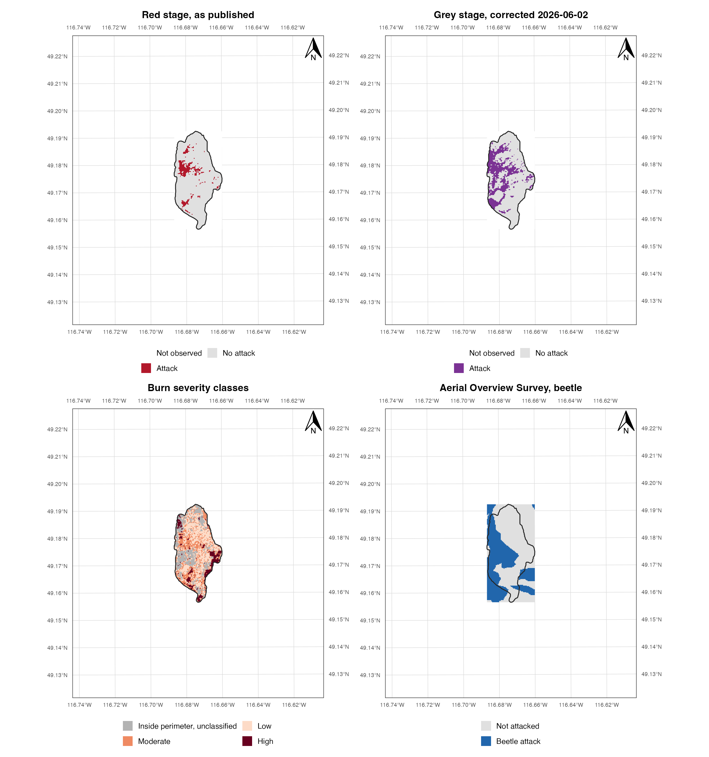
Figure 2: The clip, mapped at 1:50 000 in UTM zone 11N (EPSG:32611) with a WGS 84 graticule labelled on all four sides. Top left, the published red-stage surface, which stopped at the classified burn. Top right, the corrected grey-stage union, which reached the fire perimeter and stopped there. Bottom left, the burn severity classes. Bottom right, the independent Aerial Overview Survey, which stopped at nothing. The unburned ground in the two upper panels is empty because it was never observed, not because it was never attacked.

Statistical analysis
The first objective followed the form of the Landsat analysis of Talucci (2019), who modelled the probability of high burn severity on outbreak severity, weather and terrain. Here the response was whether an observed cell inside the perimeter burned at high severity, and the predictors were prior grey-stage attack, lodgepole presence and centred elevation, in three specifications, attack alone, attack with host and elevation, and the attack-year count with its square in place of the binary attack, the last being the test of the hump-shaped form. A single fire gave no contrast in fire weather, so the models could not separate fuels from weather as hers did, and that limit is taken up in the Discussion. Because the response was spatially dependent, the intervals were spatial block bootstrap percentile intervals, following the block resampling of the companion refugia analysis of this landscape (Murphy, 2026b), with 2,000 replicates over square blocks of 500 m and a sweep across 300, 400, 500, 750 m, the block sizes set by a Pearson residual correlogram of the conditioned model and by Moran’s I on the response at queen adjacency.
The second objective was addressed by reproducing the published point process fit and then extending it. The parent study estimated an inhomogeneous point process trend by the Berman-Turner device, in which the seedlings entered as data points, a regular grid of dummy points held the quadrature weights and the trend was estimated by weighted Poisson regression on the pooled set (Baddeley and Turner, 2000; Berman and Turner, 1992), the same construction Ziegler et al. (2017) and Malone et al. (2018) used for post-fire regeneration. That specification was reproduced exactly, including its 10 m quadrature spacing, its eight covariates and its sentinel handling, and the reproduction was checked against the published coefficient table and its standard errors. Four beetle by fire product terms were then added, grey and red attack each crossed with high and low severity, and the two fits were compared by a likelihood ratio test under the published Poisson likelihood. Because Waagepetersen (2007) showed that the Poisson score was a composite likelihood whose trend estimates were consistent for a clustered process but whose variance was not, the same fit was given intervals by a spatial block bootstrap of 2,000 replicates over 25, 50, 75, 100 m blocks across the quadrature grid, with the block sizes set by a residual correlogram inside the plots, and by a cluster-robust sandwich estimator (Liang and Zeger, 1986) clustered on the same blocks.
All analyses were run in R 4.4.1 with terra 1.9.1 and sf 1.1.0. Every number, table and figure in this paper was computed from the source rasters when the document was rendered, each table was written to disk from the same object that rendered it, and every agreement the text reports between two independently computed quantities was asserted in the source document so that a disagreement stopped the render.

Results

Burn severity

Analysis frame
The frame was every observed cell inside the fire perimeter, 5,413 cells, of which 553 burned at high severity and 1,518 had prior grey-stage attack, with lodgepole pine present on 64 per cent of them. High severity occurred on 10.1 per cent of attacked cells and 10.3 per cent of unattacked cells.

Covariate collinearity
Table 7: Attack, host cover and elevation by burn severity class, and the crude contrast between cells with lodgepole and cells without it.
Stratum | Cells | Attacked (%) | Lodgepole (%) | Elevation (m)
By burn severity
High severity | 553 | 27.7 | 18.1 | 1408
Low severity | 2158 | 20.8 | 17.2 | 1367
Moderate severity | 1403 | 34.6 | 24.4 | 1449
Unclassified severity | 1299 | 33.2 | 20.2 | 1442
By host presence
Lodgepole absent | 1973 | 15.3 | 0.0 | 1258
Lodgepole present | 3440 | 35.3 | 31.3 | 1498

Host and elevation moved together (Table 7), in that lodgepole percentage correlated with elevation at r = 0.52 across the frame and the binary host indicator the model fitted at r = 0.52, a variance inflation factor of about 1.38, which over 5,413 cells would have disqualified nothing. The binding constraint was information rather than correlation, because dependence at this scale meant the frame held nothing like 5,413 independent observations and the block bootstrap of Section 3.1.4 put the effective number at the 27 blocks a 500 m grid gave.

Severity coefficients
Table 8: Log-odds of high burn severity on prior grey-stage attack, alone, conditioned on host presence and elevation, and with the attack-year count and its square in place of the binary attack. Intervals are spatial block bootstrap percentiles at 500 m blocks, and an interval that excludes zero is marked.
Model | Term | Estimate | Interval
Attack only | y | -0.021 | [-0.752, 0.772]
Attack, host, elevation | y | 0.043 | [-0.608, 0.665]
Attack, host, elevation | host | -1.049 | [-1.929, -0.001] | clears zero
Attack, host, elevation | ec | 0.117 | [-0.087, 0.368]
Attack count and square, host, elevation | cnt | 0.153 | [-0.618, 0.779]
Attack count and square, host, elevation | I(cnt^2) | -0.042 | [-0.175, 0.125]
Attack count and square, host, elevation | host | -1.050 | [-1.929, 0.006]
Attack count and square, host, elevation | ec | 0.117 | [-0.089, 0.368]

Prior attack did not change the probability of high-severity burning. The crude log-odds of high severity for attacked against unattacked cells were -0.021 (95 per cent block bootstrap interval -0.752 to 0.772) and 0.043 (-0.608 to 0.665) with host presence and elevation in the model, both spanning zero (Table 8). The hump-shaped form did not recur. With the attack-year count in place of the binary attack, the linear term was 0.153 (-0.618 to 0.779) and the squared term -0.042 (-0.175 to 0.125), both spanning zero. Lodgepole presence had the largest coefficient in the frame, at -1.049 (-1.929 to -0.001), so cells with lodgepole were less likely to burn at high severity, with an interval that excluded zero, and elevation was 0.117 (-0.087 to 0.368) in log-odds per 100 m.

Block bootstrap
Moran’s I on the response was 0.57 at queen adjacency, so naive standard errors would have been meaningless, and a block bootstrap needed blocks large enough to contain the dependence and numerous enough to resample.
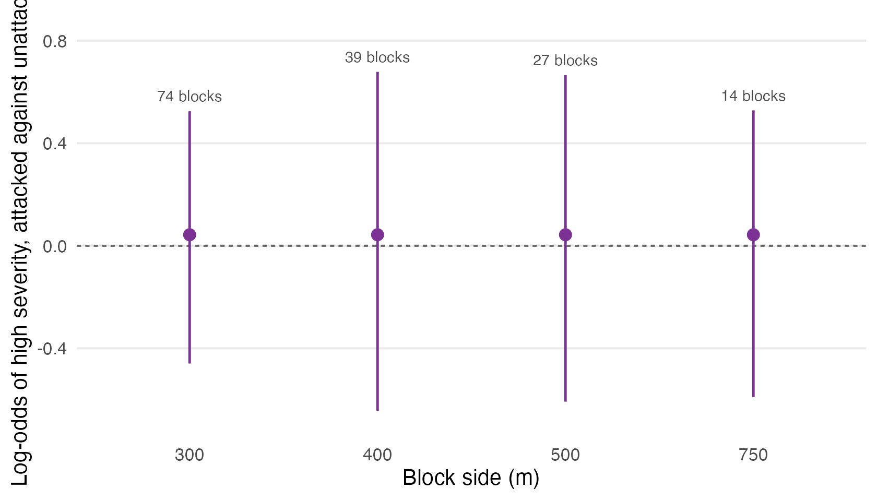
Figure 3: The attack coefficient of the conditioned severity model under block bootstraps of increasing block size. The estimate was the same at every block size and only the interval changed, with the number of blocks each size gave printed above it.
Table 9: The block sweep as numbers, giving the attack coefficient, its interval at each block size and the blocks each size gave.
Block side (m) | Blocks | Estimate | Interval
300 | 74 | 0.043 | [-0.459, 0.525] | spans zero
400 | 39 | 0.043 | [-0.644, 0.678] | spans zero
500 | 27 | 0.043 | [-0.608, 0.665] | spans zero
750 | 14 | 0.043 | [-0.590, 0.528] | spans zero

Table 10: Residual correlogram of the conditioned severity model across the burn, by distance lag, the left panel of Figure 4 at the precision the block-size argument used.
Lag (m) | Residual correlation
(0,100] | 0.372
(100,200] | 0.159
(200,300] | 0.093
(300,500] | 0.039
(500,800] | 0.012
(800,1.2e+03] | -0.005
(1.2e+03,Inf] | -0.024

Residual dependence in the conditioned model fell from 0.372 within 100 m to 0.039 by 500 m (Table 10, Figure 4 left), so a 500 m block contained most of it. Over a burn of about 4.0 by 2.0 km the two requirements of a block bootstrap conflicted, blocks large enough to contain the dependence and numerous enough to resample, because the burn gave 27 blocks at 500 m and only 14 at 750 m, where the roughly 1 km blocks of the companion study would have given eight. The attack coefficient spanned zero at all 4 block sizes tried (Figure 3, Table 9), with the interval at its narrowest, [-0.459, 0.525], on 74 blocks of 300 m, so the null did not rest on a convenient choice of block.

Regeneration interaction
The seedling point pattern lay wholly inside the burn and every cell entering the model was equally masked, so the second objective was untouched by the perimeter. The published model was refitted with the beetle by fire product terms and compared against the published additive fit.

Model specification
The seedling shapefile held 3,912 points, of which 46 had a species code outside the seven-species lookup the parent study used, leaving 3,866, all inside the plot windows. The fit used 3,866 data points against 1,282 quadrature points over 12.69 ha.

Fit reproduction
Table 11: The published additive trend as reported by the parent study’s final refit and as recomputed here from the same rasters, with the standard errors of each. The standard-error columns show that the published uncertainty was the naive Poisson uncertainty, which is the premise of Section 3.2.5.
Term | Published | Recomputed | Published SE | Poisson SE | Difference | SE difference
(Intercept) | -4.2504 | -4.2504 | 0.2099 | 0.2099 | 0 | 0
SS_dist | -0.0121 | -0.0121 | 0.0005 | 0.0005 | 0 | 0
Aspect | 0.5538 | 0.5538 | 0.0427 | 0.0427 | 0 | 0
RIX | 0.6262 | 0.6262 | 0.3064 | 0.3064 | 0 | 0
Wind | 0.2721 | 0.2721 | 0.0327 | 0.0327 | 0 | 0
MPB_G | -0.0007 | -0.0007 | 0.0513 | 0.0513 | 0 | 0
MPB_R | -0.3095 | -0.3095 | 0.0555 | 0.0555 | 0 | 0
Fire_H | 0.2071 | 0.2071 | 0.0574 | 0.0574 | 0 | 0
Fire_L | 0.3952 | 0.3952 | 0.0379 | 0.0379 | 0 | 0

All 9 coefficients of the additive fit agreed with the published values to four decimal places, and so did the standard errors, to within 0e+00 (Table 11). The right-hand columns set the published standard errors beside those implied by an ordinary weighted Poisson fit to the same design matrix, and they were the same numbers, so the published uncertainty was Poisson uncertainty and the rest of this section rests on that reproduction. Two further features of the fit mattered for what followed. The grey-stage coefficient was -0.0007, zero to three decimal places, so the parent study’s corrected refit had found no grey-stage main effect, and the two fire terms were indicators for high and low severity, so they were contrasts against whatever the reference category contained.

Covariate support
Table 12: Quadrature points inside the three plots, by burn severity class and beetle surface. The reference category of the published fit was the union of the two rows with no severity indicator, so it pooled moderate severity with unburned and unclassified ground.
Class | Quadrature points | Area (ha) | Grey attacked | Red attacked | In reference category
Low | 323 | 3.23 | 70 | 54
Moderate | 553 | 5.53 | 270 | 218 | yes
High | 288 | 2.88 | 68 | 54
Inside perimeter, unclassified | 118 | 1.18 | 31 | 0 | yes

The reference category of the published fit was every quadrature point with neither severity indicator, 671 points, of which 553 were moderate severity and the remainder unburned or unclassified ground (Table 12), so the published fire coefficients were contrasts against a pooled category that was 82 per cent moderate severity, and neither coefficient meant quite what its label suggested. The grey union recorded attack on 439 of 1,282 quadrature points (Murphy, 2026a). Red attack was confined as Section 2.7 describes, appearing on 326 quadrature points and on none outside the classified severity classes.

Product terms
Table 13: The additive trend as published, and the same trend with the four beetle by fire product terms added. Intervals are the naive Poisson intervals the published likelihood implied, and terms excluding zero on those intervals are marked. Section 3.2.5 reads the same fit under spatial inference.
Term | Model | Estimate | Interval
SS_dist | As published | -0.012 | [-0.013, -0.011] | excludes zero
Aspect | As published | 0.554 | [0.470, 0.637] | excludes zero
RIX | As published | 0.626 | [0.026, 1.227] | excludes zero
Wind | As published | 0.272 | [0.208, 0.336] | excludes zero
MPB_G | As published | -0.001 | [-0.101, 0.100]
MPB_R | As published | -0.309 | [-0.418, -0.201] | excludes zero
Fire_H | As published | 0.207 | [0.095, 0.320] | excludes zero
Fire_L | As published | 0.395 | [0.321, 0.470] | excludes zero
SS_dist | With product terms | -0.011 | [-0.012, -0.010] | excludes zero
Aspect | With product terms | 0.648 | [0.555, 0.741] | excludes zero
RIX | With product terms | 0.526 | [-0.090, 1.141]
Wind | With product terms | 0.306 | [0.239, 0.374] | excludes zero
MPB_G | With product terms | 0.036 | [-0.086, 0.158]
MPB_R | With product terms | -0.586 | [-0.722, -0.450] | excludes zero
Fire_H | With product terms | -0.139 | [-0.285, 0.007]
Fire_L | With product terms | 0.367 | [0.283, 0.451] | excludes zero
MPB_G:Fire_H | With product terms | 0.574 | [0.251, 0.897] | excludes zero
MPB_G:Fire_L | With product terms | -0.714 | [-0.979, -0.449] | excludes zero
MPB_R:Fire_H | With product terms | 0.298 | [-0.046, 0.643]
MPB_R:Fire_L | With product terms | 0.939 | [0.667, 1.211] | excludes zero

Under the likelihood the published model was fitted with, the product terms were decisive. The fit with product terms improved on the additive fit by likelihood ratio test [χ²(4) = 99.2, p < 0.001], and 3 of the 4 product terms had Poisson intervals excluding zero (Table 13). An analyst who stopped here would have reported a compound effect as confirmed, against the field studies of Talucci (2019) and Harvey et al. (2014), with the parent study’s own machinery behind the claim. Two features of the fit argued against that reading. The product terms did not share a sign, in that grey attack raised regeneration at high severity and lowered it at low severity, and the fitted signs reversed between the two beetle surfaces on the same severity class. Adding them also moved the main effects sharply, taking the high-severity term from 0.207 to -0.139, whereas a product term that was real would usually have left the rest of the model roughly where it found it.

Spatial inference
Estimating the trend of a log-Gaussian Cox process by the Berman-Turner device was legitimate, because Baddeley and Turner (2000) and Waagepetersen (2007) showed the Poisson score to be a composite likelihood that returned consistent trend estimates whether or not the process was Poisson. The variance it reported was another matter, because the standard errors were those of the Poisson model the fit was arithmetically equivalent to, which assumed seedlings placed independently given the covariates. The estimates therefore came from the Cox specification and the uncertainty from the Poisson one, and only the second was affected.
Post-fire conifer regeneration is clustered, for reasons the field has named. Malone et al. (2018) wrote that “A clustered spatial pattern can be an indication of species having similar ecological requirements [78], facilitation among individuals [79,80], or dispersal limitations at larger scales [81]”, and found regenerating conifers “clustered at distances up to at least 30 m”, and Ziegler et al. (2017) found that “All species had aggregated spatial patterns, with aggregation greatest at smaller scales” and that their Cox models “underpredicted tree densities at smaller distances”. The parent study itself established the same for this pattern, in that it tested the observed pattern against 999 Monte Carlo simulations of Ripley’s inhomogeneous K under a null of non-constant intensity and reported significant clustering for every species examined (Murphy et al., 2026). The residuals of the refit said the same thing directly.
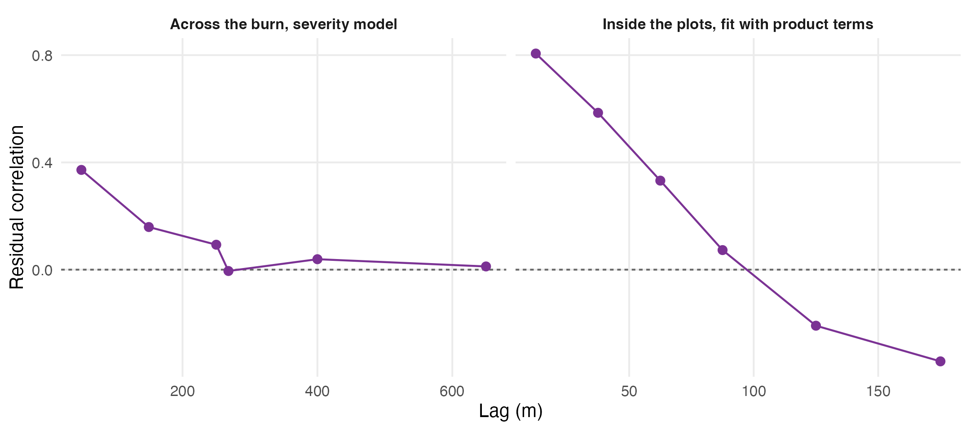
Figure 4: Residual dependence at the two scales the study worked at. Left, the conditioned severity model of Section 3.1 across the burn, where dependence had largely decayed by 500 m. Right, the fit with product terms over the quadrature points inside the regeneration plots, where it had decayed by about 100 m. Each panel set the block sizes tried at its own scale.
Table 14: Residual correlogram of the fit with product terms over the quadrature points inside the plots, the right panel of Figure 4 at the precision that set the block sizes tried.
Lag (m) | Residual correlation
(0,25] | 0.806
(25,50] | 0.585
(50,75] | 0.332
(75,100] | 0.073
(100,150] | -0.209
(150,200] | -0.342
(200,Inf] | -0.014

Residual dependence inside the plots ran at 0.806 within 25 m and was still 0.332 between 50 and 75 m, crossing zero at around 100 m (Table 14, Figure 4 right). A block that contained it therefore had to be at least 75 to 100 m on a side, and a 200 m plot gave few of those, the same conflict Section 3.1.4 met at landscape scale, two orders of magnitude smaller.
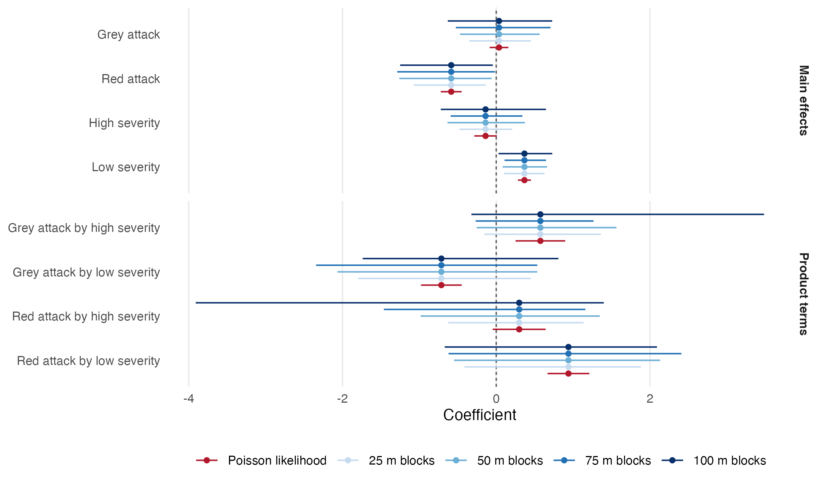
Figure 5: The four product terms and the main effects they modified, under the Poisson likelihood the published model was fitted with and under a spatial block bootstrap across block sizes spanning the residual range. The estimate was the same in every case and only the interval changed. Product terms that excluded zero under the Poisson likelihood excluded it at no block size.
Table 15: The same intervals as numbers, with the count of bootstrap draws that identified each term. A term short of the full count was unestimable in some resample because the blocks carrying its cells were not drawn, and its interval is then a percentile over the draws that did identify it.
Block side (m) | Blocks | Term | Estimate | Interval | Draws
25 | 234 | MPB_G | 0.036 | [-0.351, 0.451] | 2000/2000 | spans zero
25 | 234 | MPB_R | -0.586 | [-1.070, -0.136] | 2000/2000 | clears zero
25 | 234 | Fire_H | -0.139 | [-0.479, 0.208] | 2000/2000 | spans zero
25 | 234 | Fire_L | 0.367 | [0.099, 0.628] | 2000/2000 | clears zero
25 | 234 | MPB_G:Fire_H | 0.574 | [-0.154, 1.361] | 2000/2000 | spans zero
25 | 234 | MPB_G:Fire_L | -0.714 | [-1.798, 0.449] | 2000/2000 | spans zero
25 | 234 | MPB_R:Fire_H | 0.298 | [-0.624, 1.137] | 1998/2000 | spans zero
25 | 234 | MPB_R:Fire_L | 0.939 | [-0.414, 1.881] | 2000/2000 | spans zero
50 | 70 | MPB_G | 0.036 | [-0.472, 0.564] | 2000/2000 | spans zero
50 | 70 | MPB_R | -0.586 | [-1.261, -0.059] | 2000/2000 | clears zero
50 | 70 | Fire_H | -0.139 | [-0.635, 0.374] | 2000/2000 | spans zero
50 | 70 | Fire_L | 0.367 | [0.084, 0.662] | 2000/2000 | clears zero
50 | 70 | MPB_G:Fire_H | 0.574 | [-0.255, 1.564] | 2000/2000 | spans zero
50 | 70 | MPB_G:Fire_L | -0.714 | [-2.065, 0.534] | 2000/2000 | spans zero
50 | 70 | MPB_R:Fire_H | 0.298 | [-0.984, 1.347] | 1999/2000 | spans zero
50 | 70 | MPB_R:Fire_L | 0.939 | [-0.549, 2.132] | 2000/2000 | spans zero
75 | 36 | MPB_G | 0.036 | [-0.525, 0.707] | 2000/2000 | spans zero
75 | 36 | MPB_R | -0.586 | [-1.288, -0.018] | 2000/2000 | clears zero
75 | 36 | Fire_H | -0.139 | [-0.592, 0.340] | 2000/2000 | spans zero
75 | 36 | Fire_L | 0.367 | [0.109, 0.647] | 2000/2000 | clears zero
75 | 36 | MPB_G:Fire_H | 0.574 | [-0.268, 1.266] | 1999/2000 | spans zero
75 | 36 | MPB_G:Fire_L | -0.714 | [-2.343, 0.534] | 2000/2000 | spans zero
75 | 36 | MPB_R:Fire_H | 0.298 | [-1.462, 1.159] | 1906/2000 | spans zero
75 | 36 | MPB_R:Fire_L | 0.939 | [-0.620, 2.408] | 2000/2000 | spans zero
100 | 27 | MPB_G | 0.036 | [-0.630, 0.728] | 2000/2000 | spans zero
100 | 27 | MPB_R | -0.586 | [-1.250, -0.045] | 2000/2000 | clears zero
100 | 27 | Fire_H | -0.139 | [-0.722, 0.647] | 2000/2000 | spans zero
100 | 27 | Fire_L | 0.367 | [0.030, 0.729] | 2000/2000 | clears zero
100 | 27 | MPB_G:Fire_H | 0.574 | [-0.323, 3.484] | 2000/2000 | spans zero
100 | 27 | MPB_G:Fire_L | -0.714 | [-1.737, 0.808] | 2000/2000 | spans zero
100 | 27 | MPB_R:Fire_H | 0.298 | [-3.909, 1.399] | 1965/2000 | spans zero
100 | 27 | MPB_R:Fire_L | 0.939 | [-0.670, 2.091] | 1996/2000 | spans zero

Table 16: A second variance estimate, independent of the bootstrap. Standard errors for the fit with product terms under the naive Poisson likelihood and under a cluster-robust sandwich clustered on the same spatial blocks, with the ratio between them.
Block side (m) | Term | Poisson SE | Cluster-robust SE | Ratio
75 | Grey attack | 0.062 | 0.257 | 4.1
75 | Red attack | 0.069 | 0.281 | 4.0
75 | High severity | 0.075 | 0.202 | 2.7
75 | Low severity | 0.043 | 0.135 | 3.1
75 | Grey attack by high severity | 0.165 | 0.297 | 1.8
75 | Grey attack by low severity | 0.135 | 0.743 | 5.5
75 | Red attack by high severity | 0.176 | 0.430 | 2.4
75 | Red attack by low severity | 0.139 | 0.645 | 4.7
100 | Grey attack | 0.062 | 0.289 | 4.6
100 | Red attack | 0.069 | 0.258 | 3.7
100 | High severity | 0.075 | 0.284 | 3.8
100 | Low severity | 0.043 | 0.175 | 4.1
100 | Grey attack by high severity | 0.165 | 0.330 | 2.0
100 | Grey attack by low severity | 0.135 | 0.663 | 4.9
100 | Red attack by high severity | 0.176 | 0.427 | 2.4
100 | Red attack by low severity | 0.139 | 0.622 | 4.5

None of the 16 product-term intervals excluded zero across the four block sizes (Figure 5, Table 15). The estimates did not move, because the estimates were not what the Poisson likelihood got wrong, and the intervals widened by a factor of 2.3 to 5.9 against the naive Poisson intervals of Table 13, which was the whole of the difference between a compound effect that looked overwhelming and one that was absent. The cluster-robust sandwich agreed on both counts (Table 16), inflating the standard errors by a factor of 1.8 to 5.5, in the same range as the bootstrap widening, and of the 8 product-term intervals it implied across the block sizes the correlogram supported, 0 excluded zero. The two estimators shared the assumption that blocks were independent of one another and differed in everything else, in that the bootstrap resampled blocks and the sandwich summed scores within them.
The widening factor was computed only over the 26 of 32 term-by-block combinations that every one of the 2,000 draws could estimate. The four product cells rested on 54 to 70 quadrature points each, so a resample that missed the blocks holding one of them left that term unidentified, and 6 combinations were affected, every one involving red attack or high severity, the worst losing 94 draws of 2,000. The percentile for such a term was taken over whichever resamples happened to contain its cells, which were the resamples that overweighted them, and that inflated the interval for a reason unconnected with spatial dependence; left in, those combinations put the top of the widening range at 7.7 rather than 5.9. The count of usable draws is reported in Table 15 for every cell, and none of it changed the verdict, because the affected intervals were already the widest and every product term spanned zero on the identified combinations alone.
The only terms among those shown whose intervals excluded zero at every block size were low severity and red attack, neither of them a product term, so the regeneration data supported main effects for red-stage beetle attack and low burn severity and supported no statement about the two causes acting together. Three plots totalling 12.7 ha gave 36 at 75 m and 27 at 100 m across the block sizes the residual range permitted, and a product term asked those blocks to resolve a difference of differences across four severity-by-attack combinations. The published likelihood answered the question confidently because it counted 3,866 seedlings as 3,866 independent pieces of evidence.

Discussion

Principal findings
In the Darkwoods Conservation Area, prior beetle attack did not change the probability that a cell burned at high severity in 2015. The log-odds for attacked against unattacked cells were 0.043 (block bootstrap interval -0.608 to 0.665) with lodgepole presence and elevation in the model, the interval spanned zero at every block size tried, and the count of attack years showed no hump-shaped effect. Lodgepole presence had the largest coefficient, -1.049 (-1.929 to -0.001), with cells holding the host less likely to burn at high severity.
The compound effect was not supported. Under the likelihood the parent study used it was decisive [χ²(4) = 99.2, p < 0.001], with 3 of 4 product terms excluding zero. Under inference that accounted for the clustering of the seedling pattern every product term spanned zero at every block size tried, and a cluster-robust sandwich clustered on the same blocks agreed. The estimates did not move and the intervals widened by a factor of 2.3 to 5.9, which was the whole distance between a confirmed compound effect and none.

Linked disturbance
The null on the linked effect agreed with the field studies of this forest type. Talucci (2019) found “minimal or no effects of outbreak severity on fire severity” across the subalpine literature and “six of seven fire effects showing no evidence of an effect” in her own plots, Harvey et al. (2014) found the effect small beside weather, and Liang et al. (2016) found severity “unrelated to pre-fire outbreak severity” across an ecoregion. The one form this study could not test was hers, the hump in the probability of high severity at intermediate outbreak severity after accounting for fire weather, because a single fire gave no weather contrast and, as she put it, “In subalpine forests, fuels become relatively less important as a controlling variable when fire weather becomes extreme (Bessie and Johnson 1995), while under moderate fire weather conditions, fuels may be more important for burn severity.” The attack-year count stood in for her continuous outbreak severity and showed no curvature, but the count ran from zero to 5 over a window that closed four years before the fire, and whether the Mt Midgeley fire burned under moderate or extreme weather is not recorded in these surfaces.
The moderate class carried a measurement caveat that any severity-class analysis inherits. Lentile et al. (2006) reported that high-severity fire produced more homogeneous effects than moderate or low, so at 30 m the moderate class is the most mixed, and Talucci (2019) noted “discrepancies between field observations and satellite-measured change” where prefire mortality existed. Modelling high severity against the rest, as she did, kept the least mixed class as the response, which is one reason the reversed form of the first objective was preferred to a tabulation of attack across classes.

Compound disturbance
The null on the compound effect likewise agreed with the field. Talucci (2019) found recruitment driven by fire severity and cone abundance “while substantial underlying tree mortality from the MPB outbreaks did not play a role”, and that “Sub-boreal lodgepole pine forests are generally resilient when MPB outbreaks and wildfire recur in short intervals”, and Harvey et al. (2014) found no direct effect of outbreak severity on initial lodgepole regeneration. Liang et al. (2016) reported a positive compound effect on seedling reestablishment from an area ratio and qualified it themselves against Harvey. The parent study’s abstract sentence about overlapping mortality and high severity was a statement of the feedback Krawchuk et al. (2020) described, in which beetle-killed canopy reduces the seed source a fire refugium supplies, and this study found that the data the parent study built could not support that feedback either way, which meant the additive specification was the right one to have fitted. The finding was therefore not a revision of the parent study’s ecology but a statement about what these data could be asked, with the limit located in the inference rather than in the landscape.
The mechanism of the disagreement between the Poisson fit and the field studies was not specific to this landscape. A point process trend fitted by the Berman-Turner device was a weighted Poisson regression (Baddeley and Turner, 2000; Berman and Turner, 1992), and a Poisson likelihood counted every seedling as an independent piece of evidence about the covariates, whereas post-fire regeneration clusters through dispersal limitation, facilitation and shared microsite (Malone et al., 2018; Ziegler et al., 2017). The parent study devoted two figures and 999 Monte Carlo simulations to establishing that the seedling pattern was clustered (Murphy et al., 2026), and the residual correlogram of Figure 4 reached the same verdict from inside the model with dependence of 0.806 within 25 m. How the intervals of covariate effects in inhomogeneous point process models of regeneration should be computed once that clustering is admitted is a question the point-pattern literature has not settled, in that Ziegler et al. (2017) relied on replication across eighteen plots and a random effect for fire, Malone et al. (2018) reported least-squares fits without stating the error model, and the parent study reported Poisson errors. The block bootstrap and cluster-robust sandwich used here are two answers among several, and the size of the correction they returned, a widening of 2.3 to 5.9, is what this study can contribute to that question.
The caution this implied was not new. Modelling conifer regeneration after a large mixed-severity fire, Donato et al. (2009) excluded from their candidate set any model with more than five predictors or any interaction term, on the stated ground that the sample was too modest to support them, and reported relative importance among additive predictors instead. That was a judgement made in advance, on a study of comparable design and larger extent, and it reached by prior reasoning the conclusion this paper reached by measurement, which put a number on the room the data in fact allowed.

Extent constraints
Every result here was bounded by an extent chosen by a disturbance rather than by a design. The burn covered about eight square kilometres and the regeneration plots totalled 12.7 ha inside it, which was the ground on which beetle and fire co-occurred at all, so not an arbitrary choice, but not a neutral one either. Across the burn, lodgepole cover and elevation correlated at r = 0.52 and could not be separated, where the companion study distinguished them because 1,776 m of relief held pine-poor ground at every height (Murphy, 2026b). The same conflict governed the inference at both scales, because a block bootstrap needed blocks large enough to contain the dependence and numerous enough to resample, and the extent capped the first before the second was comfortable, with 27 blocks of 500 m across the burn where 1 km would have given eight, and 36 at 75 m and 27 at 100 m inside the plots where the residual range demanded 75 to 100 m.
Both results were nulls, and a null has a floor set by its sample. Nothing here showed that beetle mortality and burn severity did not interact; it showed that 5,413 cells in 27 blocks could not detect a linked effect of the size these surfaces could record, and that 3,866 seedlings across 12.7 ha, clustered as this pattern was, could not resolve a difference of differences across four severity-by-attack combinations. Residual dependence that neither the bootstrap nor the sandwich captured would have left every interval still too narrow, which for two null results was a conservative failure, because a fuller accounting could only widen intervals that already spanned zero.
The first objective was answered inside the perimeter only, because the comparison the linked-disturbance literature makes, between attacked stands that burned and attacked stands that did not, needed beetle surfaces that reached beyond the burn, and recovering it would mean rebuilding the classification over the unclipped landscape. The severity reference category of the regeneration model was inherited rather than chosen, because the published specification had indicators for high and low severity only and pooled moderate severity with unburned and unclassified ground into a reference that was 82 per cent moderate; it was reproduced rather than repaired, because the object was to test the published model rather than replace it. The provincial survey was a coarse instrument, its polygons sketched from an aircraft at a mapping scale far coarser than 30 m, and it was used only to test whether ground outside the perimeter was attacked at all, which it could answer, and not to measure severity, which it could not.

Research priorities
Of the three tasks that follow, in descending order of value against cost, the first is to repeat the compound-effect test where extent is not the binding constraint, which given the dependence range measured here means a distributed plot network rather than three contiguous plots. The published point process results should be reported with intervals that respect the clustering, which is inexpensive because the estimates are unchanged and which on the evidence of Figure 5 leaves two main effects standing. Testing the linked effect in the form of Talucci (2019), with fire weather as a covariate, requires more than one fire or a fire whose weather record spans the burn, and rebuilding the beetle classification over the unclipped landscape would restore the comparison across the perimeter that these surfaces could not make.

Conclusions
This study tested, on the data of the parent study, the two effects the field distinguishes between a beetle outbreak and the fire that follows it, and found neither, in agreement with the field studies of lodgepole pine at short intervals. Prior attack did not change the probability of high-severity burning within the Mt Midgeley burn, at 0.043 in log-odds after conditioning on host and elevation with an interval spanning zero at every block size the extent supported, and the count of attack years showed no hump. The beetle by fire product terms were decisive under the published Poisson likelihood and absent under inference that accounted for the clustering the parent study itself documented, with identical coefficients either way and intervals that differed by a factor of 2.3 to 5.9.
The additive model of the parent study was therefore the defensible one, because nothing found here supported modelling beetle and fire any other way with data of this extent, and the apparent support for doing so came from a likelihood that counted clustered seedlings as independent observations. A compound effect of beetle and fire on regeneration in this landscape has not been demonstrated, these data could not demonstrate it, and the size of the correction that separated a confident interaction from none was the finding that applies elsewhere.

Author statements
Author contribution statement. SM, conceptualisation, methodology, software, formal analysis, data curation, writing (original draft), writing (review and editing), visualisation.
Competing interests statement. The author is also an author of Murphy et al. (2026), the study re-analysed here, and declares no other competing interests.
Funding statement. The author declares no specific funding for this work.
Data availability statement. The raster surfaces analysed here are held by the parent study (Murphy et al., 2026) and are not redistributed with this manuscript. The corrected grey-stage package of 2 June 2026 is documented in Murphy (2026a). The provincial Aerial Overview Survey is open under the Open Government Licence for British Columbia (Province of British Columbia, Ministry of Forests, 2026). The executable source document that produced every number, table and figure in this paper, together with the derived inputs needed to run it, will be deposited on acceptance and the identifier added here.
Acknowledgements. The author thanks the co-authors of the parent study for the discussion of spatial inference and remote-sensing limits in disturbance ecology out of which this analysis grew.

Declaration of generative AI and AI-assisted technologies in the manuscript preparation process
All prose, writing, results in the analysis and reporting contained within this document was derived and verified by the author. No generative tool was used to create, alter or manipulate research data or results. The author is responsible for the accuracy of all content.

References
Baddeley, A., Turner, R., 2000. Practical maximum pseudolikelihood for spatial point patterns. Australian & New Zealand Journal of Statistics 42, 283–322. https://doi.org/10.1111/1467-842X.00128
Bansal, S., Jochum, T., Wardle, D.A., Nilsson, M.-C., 2014. The interactive effects of surface-burn severity and canopy cover on conifer and broadleaf tree seedling ecophysiology. Canadian Journal of Forest Research 44, 1032–1041. https://doi.org/10.1139/cjfr-2014-0112
Berman, M., Turner, T.R., 1992. Approximating point process likelihoods with GLIM. Journal of the Royal Statistical Society Series C: Applied Statistics 41, 31–38. https://doi.org/10.2307/2347614
Donato, D.C., Fontaine, J.B., Campbell, J.L., Robinson, W.D., Kauffman, J.B., Law, B.E., 2009. Conifer regeneration in stand-replacement portions of a large mixed-severity wildfire in the Klamath–Siskiyou Mountains. Canadian Journal of Forest Research 39, 823–838. https://doi.org/10.1139/X09-016
Estabrook, T., Fried, J., Xi, W., Su, H., Zhang, J., 2025. Linking burn severity to pre-fire forest structure and weather on the Dixie fire offers potential to map prospective burn severity. Canadian Journal of Forest Research 55, 1–20. https://doi.org/10.1139/cjfr-2024-0305
Hart, S.J., Schoennagel, T., Veblen, T.T., Chapman, T.B., 2015. Area burned in the western United States is unaffected by recent mountain pine beetle outbreaks. Proceedings of the National Academy of Sciences 112, 4375–4380. https://doi.org/10.1073/pnas.1424037112
Harvey, B.J., Donato, D.C., Turner, M.G., 2014. Recent mountain pine beetle outbreaks, wildfire severity, and postfire tree regeneration in the US Northern Rockies. Proceedings of the National Academy of Sciences 111, 15120–15125. https://doi.org/10.1073/pnas.1411346111
Jenkins, M.J., Page, W.G., Hebertson, E.G., Alexander, M.E., 2012. Fuels and fire behavior dynamics in bark beetle-attacked forests in Western North America and implications for fire management. Forest Ecology and Management 275, 23–34. https://doi.org/10.1016/j.foreco.2012.02.036
Krawchuk, M.A., Meigs, G.W., Cartwright, J.M., Coop, J.D., Davis, R., Holz, A., Kolden, C., Meddens, A.J.H., 2020. Disturbance refugia within mosaics of forest fire, drought, and insect outbreaks. Frontiers in Ecology and the Environment 18, 235–244. https://doi.org/10.1002/fee.2190
Kulakowski, D., Veblen, T.T., 2006. The effect of fires on susceptibility of subalpine forests to a 19th century spruce beetle outbreak in western Colorado. Canadian Journal of Forest Research 36, 2974–2982. https://doi.org/10.1139/x06-182
Lentile, L.B., Holden, Z.A., Smith, A.M.S., Falkowski, M.J., Hudak, A.T., Morgan, P., Lewis, S.A., Gessler, P.E., Benson, N.C., 2006. Remote sensing techniques to assess active fire characteristics and post-fire effects. International Journal of Wildland Fire 15, 319–345. https://doi.org/10.1071/WF05097
Liang, K.-Y., Zeger, S.L., 1986. Longitudinal data analysis using generalized linear models. Biometrika 73, 13–22. https://doi.org/10.1093/biomet/73.1.13
Liang, L., Hawbaker, T.J., Zhu, Z., Li, X., Gong, P., 2016. Forest disturbance interactions and successional pathways in the Southern Rocky Mountains. Forest Ecology and Management 375, 35–45. https://doi.org/10.1016/j.foreco.2016.05.010
Magnussen, S., Breidenbach, J., Mauro, F., 2017. The challenge of estimating a residual spatial autocorrelation from forest inventory data. Canadian Journal of Forest Research 47, 1557–1566. https://doi.org/10.1139/cjfr-2017-0247
Malone, S.L., Fornwalt, P.J., Battaglia, M.A., Chambers, M.E., Iniguez, J.M., Sieg, C.H., 2018. Mixed-severity fire fosters heterogeneous spatial patterns of conifer regeneration in a dry conifer forest. Forests 9, 45. https://doi.org/10.3390/f9010045
Mathys, A.S., Coops, N.C., Simard, S.W., Waring, R.H., Aitken, S.N., 2018. Diverging distribution of seedlings and mature trees reflects recent climate change in British Columbia. Ecological Modelling 384, 145–153. https://doi.org/10.1016/j.ecolmodel.2018.06.008
McHugh, C.W., Kolb, T.E., Wilson, J.L., 2003. Bark beetle attacks on ponderosa pine following fire in northern Arizona. Environmental Entomology 32, 510–522. https://doi.org/10.1603/0046-225X-32.3.510
McIntire, E.J.B., Fortin, M.-J., 2006. Structure and function of wildfire and mountain pine beetle forest boundaries. Ecography 29, 309–318. https://doi.org/10.1111/j.2006.0906-7590.04278.x
Meigs, G.W., Kennedy, R.E., Cohen, W.B., 2011. A Landsat time series approach to characterize bark beetle and defoliator impacts on tree mortality and surface fuels in conifer forests. Remote Sensing of Environment 115, 3707–3718. https://doi.org/10.1016/j.rse.2011.09.009
Meyer, M.D., Bulaon, B., MacKenzie, M., Safford, H.D., 2016. Mortality, structure, and regeneration in whitebark pine stands impacted by mountain pine beetle in the southern Sierra Nevada. Canadian Journal of Forest Research 46, 572–581. https://doi.org/10.1139/cjfr-2015-0464
Murphy, S., 2026b. Topographic refugia from mountain pine beetle, and why terrain-derived wind surfaces cannot find them at small extents.
Murphy, S., 2026a. Memo: Grey-stage raster derivation was wrong; corrected here.
Murphy, S., Leslie, A., Wilson, J., Banks, L.K., 2026. Spatial patterns of conifer regeneration following mountain pine beetle outbreak (dendroctonus ponderosae) and mixed-severity wildfire: A point process model of disturbance interactions in the southern Selkirk Mountains, British Columbia. Forest Ecology and Management 618, 123985. https://doi.org/10.1016/j.foreco.2026.123985
Province of British Columbia, Ministry of Forests, 2026. Pest infestation polygons (Aerial Overview Survey).
Rodman, K.C., Andrus, R.A., Veblen, T.T., Hart, S.J., 2021. Disturbance detection in Landsat time series is influenced by tree mortality agent and severity, not by prior disturbance. Remote Sensing of Environment 254, 112244. https://doi.org/10.1016/j.rse.2020.112244
Simard, M., Romme, W.H., Griffin, J.M., Turner, M.G., 2011. Do mountain pine beetle outbreaks change the probability of active crown fire in lodgepole pine forests? Ecological Monographs 81, 3–24. https://doi.org/10.1890/10-1176.1
Stevens-Rumann, C.S., Prichard, S.J., Strand, E.K., Morgan, P., 2016. Prior wildfires influence burn severity of subsequent large fires. Canadian Journal of Forest Research 46, 1375–1385. https://doi.org/10.1139/cjfr-2016-0185
Talucci, A.C., 2019. Beetle outbreaks and wildfires: Drivers of fire severity, recruitment, and structural legacies for sub-boreal forests in British Columbia (PhD dissertation). Oregon State University.
Waagepetersen, R.P., 2007. An estimating function approach to inference for inhomogeneous Neyman–Scott processes. Biometrics 63, 252–258. https://doi.org/10.1111/j.1541-0420.2006.00667.x
Wulder, M.A., White, J.C., Bentz, B., Alvarez, M.F., Coops, N.C., 2006. Estimating the probability of mountain pine beetle red-attack damage. Remote Sensing of Environment 101, 150–166. https://doi.org/10.1016/j.rse.2005.12.010
Ziegler, J.P., Hoffman, C.M., Fornwalt, P.J., Sieg, C.H., Battaglia, M.A., Chambers, M.E., Iniguez, J.M., 2017. Tree regeneration spatial patterns in ponderosa pine forests following stand-replacing fire: Influence of topography and neighbors. Forests 8, 391. https://doi.org/10.3390/f8100391

