A beetle by fire disturbance interaction review
Why the additive model of beetle mortality and burn severity was the defensible one, Darkwoods Conservation Area, British Columbia
Abstract
Where mountain pine beetle outbreak and wildfire overlap, their joint effect on the forest is usually described as an interaction and usually modelled as a sum. Few studies have tested whether the data behind such a description can support a product term, and fewer have asked whether the likelihood used to fit that term can be trusted to judge it. This study tested both, on the beetle outbreak of 2005 to 2014 and the mixed-severity Mt Midgeley wildfire of 2015 in the Darkwoods Conservation Area, southern Selkirk Mountains, British Columbia (annual Landsat beetle classifications, a classified burn severity raster, the provincial Aerial Overview Survey, and the mapped conifer seedlings of three four-hectare plots). Beetle attack was compared across burn severity classes in three independent records, conditioned on lodgepole pine cover and elevation by logistic regression with spatial block bootstrap intervals, and the parent study’s inhomogeneous point process model of regeneration was refitted with beetle by fire product terms under its published Poisson likelihood, under a spatial block bootstrap and under a cluster-robust sandwich estimator. Every local beetle surface descended from annual classifications clipped to the fire perimeter before classification, and the unclipped provincial survey recorded attack outside the perimeter at a rate no lower than inside it, so any burned against unburned contrast measured the clip. Inside the perimeter all three records agreed that attack peaked at moderate severity, and the peak held after conditioning at 0.416 in log-odds against low severity (block bootstrap interval excluding zero at every block size), whereas the fall at high severity did not. The product terms were decisive under the Poisson likelihood (likelihood ratio test, p < 0.001) and absent under inference that respected the clustering the parent study documented; the coefficients were identical, the intervals 2.3 to 5.9 times wider, none of sixteen product-term intervals excluded zero, and the sandwich estimator agreed. These data could not show a beetle by fire interaction, so the additive specification of the parent study was the defensible one, and the confidence with which clustered seedlings counted as independent observations produced an interaction was the result that applied beyond this landscape.

Introduction
Mountain pine beetle (Dendroctonus ponderosae Hopkins) outbreak and wildfire have overlapped across the conifer forests of western North America since the late 1990s, and the overlap has usually been described as an interaction. Talucci and Krawchuk (2019) and Meigs et al. (2011) both framed the beetle to fire sequence as a change in fuels and therefore in the severity of the fire that followed, and Krawchuk et al. (2020) placed compound disturbance at the centre of the refugia concept. In each case the claim that the two causes interacted was a claim about a product rather than a sum.
The mechanism behind the claim was real and measurable, because Jenkins et al. (2012) showed that beetle-killed foliage lost moisture and changed in chemistry within a year of attack and burned more readily as a result. Taking that mechanism up to the stand and the landscape proved harder. Simard et al. (2011) modelled crown fire through a beetle outbreak in lodgepole pine (Pinus contorta Douglas ex Loudon var. latifolia Engelm. ex S. Watson) and found the probability of active crown fire no higher, and in the red stage lower, than in unattacked stands. Harvey et al. (2014) found that the effect of prior attack on burn severity depended on outbreak stage and was small beside the effect of weather, and Hart et al. (2015) found no relationship between outbreak extent and area subsequently burned across the western United States. The literature was therefore contested rather than empty, and the value of asking the question again lay in the particular landscape and in the treatment of confounding rather than in the question itself.
Part of that contest concerned inference. Prior disturbance was not assigned at random, both causes tracked host abundance and terrain, and burn severity was measured on a raster whose cells were far from independent. Stevens-Rumann et al. (2016), asking the same question with fire in place of beetle across four large fires, fitted a spatially explicit autoregression because burn severity was autocorrelated, and Magnussen et al. (2017) showed in forest inventory that omitting residual spatial autocorrelation left confidence intervals too narrow rather than merely imprecise. An interaction term was exactly the quantity such a failure would overstate.
The parent study of this analysis (Murphy et al., 2026) modelled conifer regeneration across three four-hectare plots inside the 2015 Mt Midgeley burn in the Darkwoods Conservation Area, British Columbia, from classified Landsat surfaces of burn severity and of red-stage and grey-stage beetle mortality. Its abstract reported that “areas of overlapping beetle mortality and high burn severity had significantly reduced lodgepole pine regeneration”, and its conclusions that the results suggested “the ecological consequences of beetle-fire interactions weaken as surface fuels decay over time”. Both were statements about what happened where the two causes coincided. The fitted trend entered eight covariates additively, seed source distance, aspect, terrain ruggedness, wind, grey-stage and red-stage beetle mortality, and high and low burn severity, and no product of a beetle indicator with a fire indicator entered the pooled fit or any of the seven per-species fits. The parent study read its joint-condition statements from main effects, which an additive fit permits, and opened a discussion of how far inherited raster layers and a fitted trend could support a compound-disturbance claim. This paper ran the spatial inference tests that discussion called for, on the same data.
The objectives of this study were to (1) test whether prior beetle mortality was associated with subsequent burn severity in this landscape, where the outbreak ran from 2005 to 2014 and the fire burned in 2015, so that any effect ran from beetle to fire and never the reverse, and (2) test whether a beetle by fire product term was supported in the published regeneration model, by refitting that model with the product terms and comparing it against the published additive fit.
The wording was kept narrow throughout. A designed factorial can justify the language of interaction outright, as Bansal et al. (2014) did in crossing burn severity with canopy cover and reporting effects that were conditional by construction. An observational fit over ground that neither treatment nor randomisation touched could not, and the convention in this literature has been more careful, in that Estabrook et al. (2025) described burn severity as contingent on weather and then fitted weather as main effects. This study reported whether the product term was retained and what interval its coefficient had, and it did not report that the two causes interact.
Each objective required a prior check, and the paper is arranged around them. The first check was whether the beetle surfaces could answer the first objective at all, and Section 3.1 reports that they could not across the fire perimeter, which reduced the first objective to a comparison within the burn (Section 3.2). The second check was whether the likelihood the published model was fitted with could be trusted to judge a product term, and Section 3.3 reports that the term was decisive under that likelihood and absent under inference that accounted for the clustering the parent study itself documented, with the same coefficients either way. That difference, rather than the ecology of either objective, was the result that applied beyond the landscape it was measured in.

Materials and methods

Study area
The study was set in the Darkwoods Conservation Area, in the southern Selkirk Mountains of southeastern British Columbia. A mountain pine beetle outbreak affected the property through the decade to 2014, and the Mt Midgeley wildfire burned part of it in 2015 in a mixed-severity mosaic, with intervals from attack to fire of one to eleven years and a median of seven (Murphy et al., 2026).

Attack chronology
An association between a prior disturbance and a later one depends on the dating of the prior one. Kulakowski and Veblen (2006) dated a nineteenth-century outbreak from growth releases in surviving non-host trees, Meyer et al. (2016) reconstructed pre-attack structure by returning recently dead trees to the live tally, and Estabrook et al. (2025) showed how a forest inventory’s remeasurement interval degraded its record of pre-fire condition. Here attack was dated from the annual Landsat classifications, 9 files in all, with the attack year of a cell taken as the first file that recorded it (Table 1).
Table 1: Annual Landsat classifications that dated beetle attack, with the number of cells in each carrying red-attack class code 44, the code the grey-stage union was built from. The class legend followed the provincial survey’s severity coding, but the layers were Landsat classifications and not survey products.
Year | Cells carrying the code | In the dating window
2005 | 534 | yes
2006 | 1530 | yes
2007 | 573 | yes
2008 | 0
2009 | 324 | yes
2010 | 0
2011 | 137 | yes
2013 | 0
2014 | 0

Wulder et al. (2006) found red-attack foliage detectable for roughly one to three years after the attack that produced it, so a first detection dated the change in crown colour within a window rather than to a year. The series was also thinner than its file count. There was no file for 2012, the files for 2013 and 2014 used a different classification legend and recorded the red-attack code in no cell, and two files inside the window, for 2008 and 2010, were likewise empty of it, so the grey-stage union rested on 5 annual observations across a 7-year window that closed in 2011. The response used throughout was therefore the undated union, which recorded whether a cell was attacked at any time from 2005 to 2011 and not when, and nothing in the study turned on the interval from attack to fire.

Classified surfaces
Table 2: Footprints of the local classified surfaces against the terrain grid. Every disturbance surface was confined to a rectangle of roughly eight square kilometres, and the terrain grid covered thirty-four times that area.
Surface | Rows | Cols | Cell (m) | Width (km) | Height (km) | Extent (km2)
Elevation, terrain grid | 695 | 639 | 25.11 | 16.05 | 17.45 | 280.09
Beetle red stage | 135 | 66 | 29.56 | 1.95 | 3.99 | 7.78
Beetle grey stage, corrected | 135 | 66 | 29.56 | 1.95 | 3.99 | 7.78
Beetle grey stage, deprecated | 135 | 66 | 29.56 | 1.95 | 3.99 | 7.78
Beetle continuous (spatstat) | 52 | 47 | 29.49 | 1.39 | 1.53 | 2.13
Burn severity, classified | 134 | 66 | 30.00 | 1.98 | 4.02 | 7.96
Beetle by fire intersection | 136 | 67 | 29.56 | 1.98 | 4.02 | 7.96

The fire perimeter enclosed 4.8 km², the beetle red-stage raster spanned a rectangle of 7.78 km² around it, and the terrain grid covered 280 km² of the same landscape (Table 2), so the raster held roughly 2.98 km² of ground outside the burn on which beetle attack could in principle have been mapped.

Severity codes
The classified severity raster used integer codes that were not in severity order, so the order was established from the three binary class masks rather than assumed (Table 3).
Table 3: Decoding of the classified burn severity raster against its own binary class masks and against the fire perimeter. The integer codes were not in severity order, and code 16 fell inside the perimeter but in none of the three severity classes.
Class | Code | Cells | Inside perimeter (%)
Outside perimeter | 0 | 3514 | 0.1
Inside perimeter, unclassified | 16 | 1268 | 100.0
Low | 32 | 2144 | 99.9
Moderate | 34 | 1383 | 99.8
High | 1 | 535 | 100.0

Code 1 was high severity, code 34 moderate and code 32 low, so a table built on the numeric order of the codes would have reported the two most severe classes the wrong way round. Code 16 was the class that no severity mask claimed, 1,268 cells lying inside the fire perimeter but assigned to none of high, moderate or low.

Aerial survey
The provincial Aerial Overview Survey was the operational record of forest health in British Columbia, in which observers sketch-mapped damage each year from fixed-wing aircraft and labelled each polygon by year, cause, severity class and host species (Province of British Columbia, Ministry of Forests, 2026). It was coarse and observer-based, and its errors were positional and perceptual rather than spectral, so they were uncorrelated with the errors of the Landsat classification whose footprint was under test.
Over the terrain grid the survey held 608 damage polygons of all causes and years, of which 276 were mountain pine beetle within the 2005 to 2014 outbreak window.

Spatial coverage
Everything the study analysed lay inside one small burn, and Figure 1 shows what that meant at three nested scales. The regional panel shows the international border because the provincial survey stopped there, and so did any comparison drawn from it.
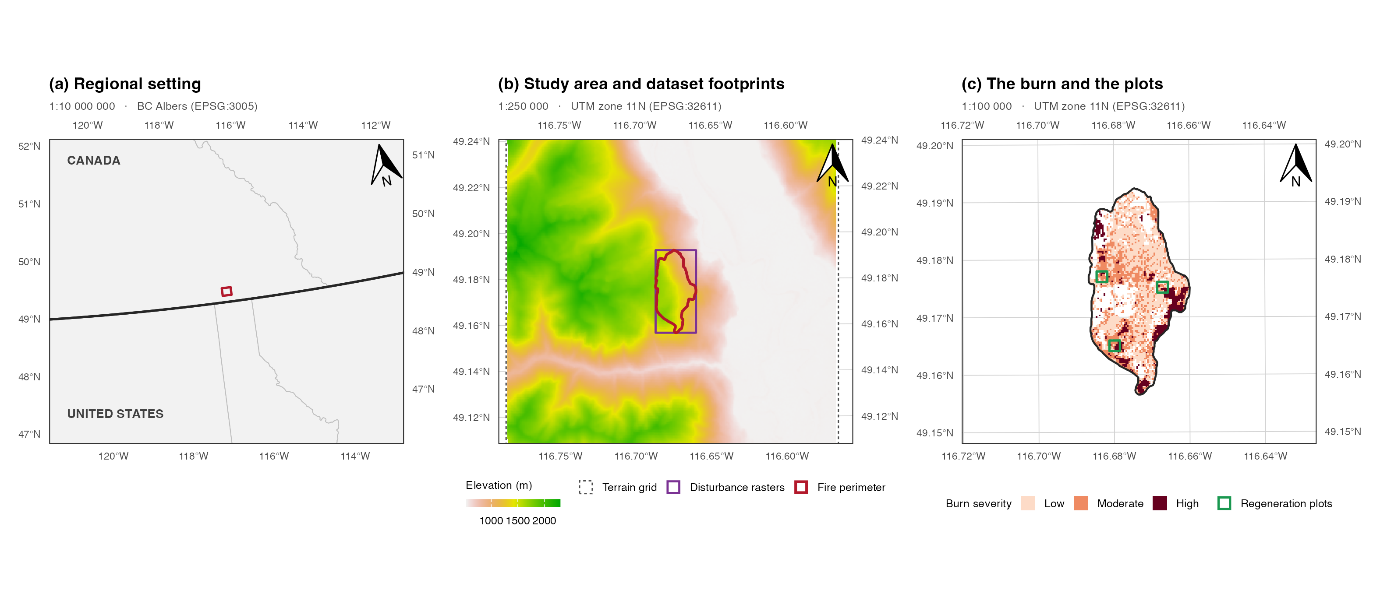
Figure 1: The study area at three nested scales. (a) Regional setting, with the Canada and United States border and provincial and state boundaries. (b) The terrain grid, the rectangle shared by every disturbance raster, and the fire perimeter inside it. (c) The burn with its classified severity and the three four-hectare regeneration plots that held the point pattern of Section 3.3. Each panel is drawn to the stated representative fraction at the panel width given in the text, carries a true-north arrow and is bounded by a WGS 84 graticule labelled on all four sides.
The scales were 1:10 000 000, 1:250 000 and 1:100 000, each exact at the drawn panel width of 2.70 inches, which was measured off the assembled figure and the extents rebuilt at it. Panels (b) and (c) are in the UTM zone 11N grid the analysis worked in, panel (a) in BC Albers, and all three are bounded by a WGS 84 graticule. Panel (b) holds the provenance problem in one frame, in that the terrain grid covered 280 km², every disturbance raster shared a footprint of 7.78 km², and the fire perimeter inside it enclosed 4.8 km². Terrain was mapped across the landscape and disturbance only in a rectangle drawn around the fire, and Section 3.1 shows that the beetle surfaces stopped tighter still.

Statistical analysis
The first objective was addressed in three steps. Each beetle surface was first tabulated against the fire perimeter and against the classified severity footprint on the native beetle grid, and the two local surfaces were compared with the survey by severity class over the cells the annual rasters observed. Attack in the corrected grey-stage union was then modelled by logistic regression on severity class alone, on severity class with lodgepole presence and centred elevation, and with a quadratic elevation term, over every observed cell inside the perimeter. Because the response was spatially dependent, the intervals were spatial block bootstrap percentile intervals, following the block resampling of the companion refugia analysis of this landscape (Murphy, 2026a), with 2,000 replicates over square blocks of 500 m and a sweep across 300, 400, 500, 750 m, the block sizes set by a Pearson residual correlogram of the conditioned model and by Moran’s I on the response at queen adjacency.
The second objective was addressed by reproducing the published point process fit and then extending it. The parent study estimated an inhomogeneous point process trend by the Berman-Turner device, in which the seedlings entered as data points, a regular grid of dummy points held the quadrature weights and the trend was estimated by weighted Poisson regression on the pooled set (Baddeley and Turner, 2000; Berman and Turner, 1992). That specification was reproduced exactly, including its 10 m quadrature spacing, its eight covariates and its sentinel handling, and the reproduction was checked against the published coefficient table and its standard errors. Four beetle by fire product terms were then added, grey and red attack each crossed with high and low severity, and the two fits were compared by a likelihood ratio test under the published Poisson likelihood. Because Waagepetersen (2007) showed that the Poisson score was a composite likelihood whose trend estimates were consistent for a clustered process but whose variance was not, the same fit was given intervals by a spatial block bootstrap of 2,000 replicates over 25, 50, 75, 100 m blocks across the quadrature grid, with the block sizes set by a residual correlogram inside the plots, and by a cluster-robust sandwich estimator (Liang and Zeger, 1986) clustered on the same blocks.
All analyses were run in R 4.4.1 with terra 1.9.1 and sf 1.1.0. Every number, table and figure in this paper was computed from the source rasters when the document was rendered, each table was written to disk from the same object that rendered it, and every agreement the text reports between two independently computed quantities was asserted in the source document so that a disagreement stopped the render.

Results

Surface provenance

Perimeter clipping
Table 4: Where each beetle surface stopped against the fire perimeter, on the native beetle grid. The annual rasters held no data over almost the whole area outside the perimeter, and the two derived surfaces inherited it.
Surface | Cells present | Inside perimeter | Outside perimeter | Note
Annual rasters, any data | 5487 | 5477 | 10 | nodata over the rest
Corrected grey stage, 2005 to 2011 | 1541 | 1540 | 1 | union of red-attack code 44
Red stage, as published | 493 | 493 | 0 | substituted for a missing layer

The annual rasters of 2005 to 2011 held data on 0.3 per cent of the 3,429 cells lying outside the fire perimeter and no data on the rest (Table 4). Every beetle surface in the study descended from those files and inherited the boundary, so that the corrected grey union placed 1 of its 1541 cells outside the perimeter and the published red-stage surface placed 0 of its 493. All 9 annual files had an identical no-data count of 3,423 cells, 3,419 of them outside the perimeter, and the boundary the no-data traced was the fire perimeter, a shape no property of beetle ecology would produce. The annual series was therefore clipped to the fire perimeter before classification.

Nested masks
Table 5: The two beetle surfaces against the classified severity footprint. Grey attack was recorded throughout the perimeter, whereas red attack was confined to the three classified severity classes and absent from the cells inside the perimeter that no class mask claimed.
Region | Cells | Annual data (%) | Grey attack (%) | Red attack (%)
Outside the fire perimeter | 3429 | 0.3 | 0.0 | 0.0
Inside perimeter, unclassified severity | 1367 | 99.7 | 33.1 | 0.0
Inside the classified severity footprint | 4136 | 99.5 | 26.3 | 11.9

The red and grey surfaces did not stop in the same place. Inside the perimeter but outside the classified severity footprint, the annual rasters were 99.7 per cent observed, the corrected grey union recorded attack on 33.1 per cent of cells and the published red-stage surface on 0 per cent (Table 5). The same ground in the same years was either a third attacked or not attacked at all depending on which derivative of the same annual files was consulted, so the contrast was not ecological. Two clips therefore sat one inside the other. The annual series stopped at the fire perimeter, and the published red-stage surface stopped at the classified severity footprint, because it stood in for a layer, mpb_red_na.tif, that is absent from the parent repository (Murphy, 2026b).

Survey corroboration
Table 6: The two local surfaces against the independent Aerial Overview Survey, by burn severity class. Local rates were computed only over cells the annual rasters observed. The survey found no shortage of beetle attack outside the burn.
Class | Cells | Observed (%) | Observed | Grey (%) | Red (%) | Survey (%) | Elevation (m)
Outside perimeter | 3429 | 0.3 | 10 | 10.0 | 0.0 | 40.4 | 1190
Inside perimeter, unclassified | 1367 | 99.7 | 1363 | 33.2 | 0.0 | 51.8 | 1442
Low | 2158 | 100.0 | 2158 | 20.8 | 6.3 | 24.5 | 1367
Moderate | 1403 | 100.0 | 1403 | 34.6 | 20.7 | 40.6 | 1449
High | 553 | 100.0 | 553 | 27.7 | 12.1 | 33.1 | 1408

If the zeroes outside the burn were ecological, the provincial survey should also have found little beetle attack there, and if they were clipping it should have found as much there as anywhere. Outside the fire perimeter the survey recorded 40.4 per cent of the ground as attacked, a rate no lower than any burned class and higher than two of the three, while the annual rasters observed only 10 of the 3,429 cells there (Table 6, shaded row). The local record outside the burn was therefore very nearly absent rather than sparse, and the comparison rested on the survey alone, which found beetle attack outside the burn in ordinary abundance. A contingency table of red attack against severity built over every cell of the published surface would have reported attack on 0.0 per cent of cells outside the perimeter against 20.7 per cent at moderate severity, the strongest compound-disturbance signal in the data and the exact pattern a raster clipped to the burn would produce, and the zero it reported outside the burn described the extent of the file rather than the forest (Figure 2).
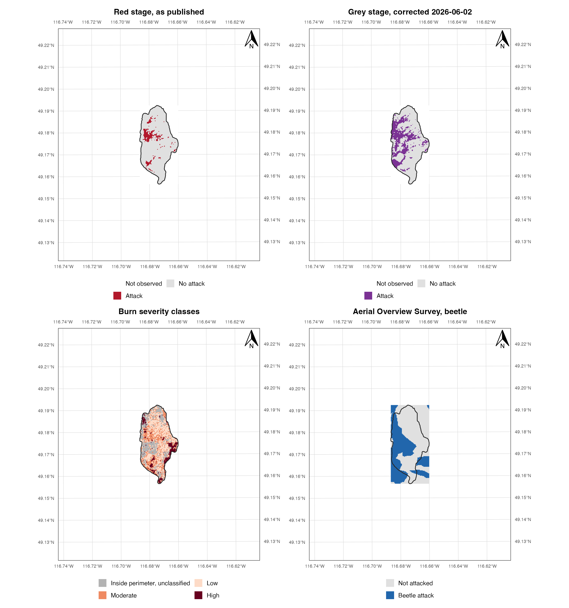
Figure 2: The clip, mapped at 1:50 000 in UTM zone 11N (EPSG:32611) with a WGS 84 graticule labelled on all four sides. Top left, the published red-stage surface, which stopped at the classified burn. Top right, the corrected grey-stage union, which reached the fire perimeter and stopped there. Bottom left, the burn severity classes. Bottom right, the independent Aerial Overview Survey, which stopped at nothing. The unburned ground in the two upper panels is empty because it was never observed, not because it was never attacked.

Within-burn gradient
The clip removed any comparison that crossed the fire perimeter and left untouched any comparison made inside it, where the three severity classes were observed at better than 100 per cent.
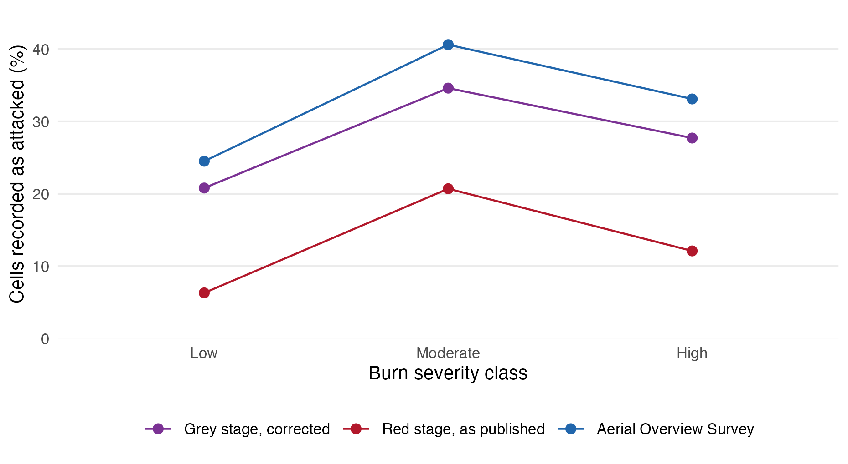
Figure 3: Beetle attack across burn severity within the fire perimeter, in the two local surfaces and in the independent survey. The three records shared no common measurement pathway and all three peaked at moderate severity.
Table 7: The same three records as counts and rates, with the cells and the mean elevation of each severity class.
Class | Cells | Grey (%) | Red (%) | Survey (%) | Elevation (m)
Low | 2158 | 20.8 | 6.3 | 24.5 | 1367
Moderate | 1403 | 34.6 | 20.7 | 40.6 | 1449
High | 553 | 27.7 | 12.1 | 33.1 | 1408

Within the perimeter the three records agreed on the shape of attack across severity (Figure 3, Table 7). The corrected grey union ran 20.8, 34.6, 27.7 per cent across low, moderate and high severity, the published red-stage surface 6.3, 20.7, 12.1 and the independent survey 24.5, 40.6, 33.1, and all three peaked at moderate and fell at high. The two local surfaces shared a measurement pathway with each other but not with the survey, so the agreement was not one instrument repeating itself. The agreement was not yet evidence about fire, because moderate severity also occupied the highest mean elevation of the three burned classes at 1449 m, and the companion refugia analysis of this landscape found beetle attack peaking near 1,430 m for reasons unconnected with fire (Murphy, 2026a). A severity gradient that was also an elevation gradient would reproduce the beetle elevation optimum whether or not severity mattered, so host abundance and elevation were conditioned on next.

Gradient conditioning
Both causes tracked host abundance and topography, and lodgepole-rich stands at mid elevation were both more attackable and more burnable, so an apparent association between them could have been host distribution seen twice.

Analysis frame
The frame was every observed cell inside the fire perimeter, 5,413 cells, of which 1,518 recorded grey-stage attack, with lodgepole pine present on 64 per cent of them.

Covariate collinearity
Table 8: Attack, host cover and elevation by burn severity class, and the crude contrast between cells with lodgepole and cells without it.
Stratum | Cells | Attacked (%) | Lodgepole (%) | Elevation (m)
By burn severity
High severity | 553 | 27.7 | 18.1 | 1408
Low severity | 2158 | 20.8 | 17.2 | 1367
Moderate severity | 1403 | 34.6 | 24.4 | 1449
Unclassified severity | 1299 | 33.2 | 20.2 | 1442
By host presence
Lodgepole absent | 1973 | 15.3 | 0.0 | 1258
Lodgepole present | 3440 | 35.3 | 31.3 | 1498

Attack was recorded on 35.3 per cent of cells with lodgepole against 15.3 per cent of cells without it (Table 8), the same direction and roughly the same size as the host contrast the companion study found at landscape extent. Host and elevation moved together, in that lodgepole percentage correlated with elevation at r = 0.52 across the frame and the binary host indicator the model fitted at r = 0.52, a variance inflation factor of about 1.38, which over 5,413 cells would have disqualified nothing. The binding constraint was information rather than correlation, because dependence at this scale meant the frame held nothing like 5,413 independent observations, the block bootstrap of Section 3.2.4 put the effective number at the 27 blocks a 500 m grid gave, and two predictors that moved together could not be separated on that many. The companion study separated them at landscape extent because its elevation gradient ran far enough for pine-poor ground to occur at every height and its extent gave hundreds of blocks rather than tens.

Conditioned coefficients
Table 9: Burn severity coefficients on grey-stage attack, as log-odds against low severity, crude and then conditioned on host presence and elevation. Intervals are spatial block bootstrap percentiles at 500 m blocks, and an interval that excludes zero is marked.
Model | Term | Estimate | Interval
Severity only | sevModerate | 0.705 | [0.337, 1.009] | clears zero
Severity only | sevHigh | 0.378 | [-0.368, 1.185]
Severity only | sevUnclassified | 0.639 | [-0.072, 1.139]
+ host + elevation | sevModerate | 0.416 | [0.071, 0.730] | clears zero
+ host + elevation | sevHigh | 0.286 | [-0.395, 1.052]
+ host + elevation | sevUnclassified | 0.328 | [-0.296, 0.868]
+ host + elevation | host | 0.186 | [-0.510, 0.939]
+ host + elevation | ec | 0.424 | [0.252, 0.684] | clears zero
+ elevation squared | sevModerate | 0.403 | [0.032, 0.728] | clears zero
+ elevation squared | sevHigh | 0.277 | [-0.377, 1.062]
+ elevation squared | sevUnclassified | 0.306 | [-0.320, 0.857]
+ elevation squared | host | 0.196 | [-0.503, 0.977]
+ elevation squared | ec | 0.415 | [0.236, 0.644] | clears zero
+ elevation squared | I(ec^2) | 0.023 | [-0.047, 0.116]

The moderate-severity peak held after conditioning, attenuated. The crude log-odds of attack at moderate against low severity were 0.705 (95 per cent block bootstrap interval 0.337 to 1.009) and fell to 0.416 (0.071 to 0.730) with host presence and elevation in the model, so roughly 41 per cent of the crude association was host and terrain and the remainder still excluded zero (Table 9). A quadratic elevation term moved it hardly at all.
Attack at high severity was never distinguishable from attack at low severity, because its interval spanned zero in every specification, at -0.395 to 1.052 in the conditioned model. The non-monotone shape that all three records traced was therefore supported at its peak and not at its fall, and whether attack declined at high severity could not be settled from the 553 cells of that class.
Host cover could not be separated from elevation, and elevation was the covariate that remained. Entered alongside elevation, host presence had an interval of -0.510 to 0.939, spanning zero despite the crude contrast of 35.3 against 15.3 per cent, whereas elevation was the only covariate whose interval excluded zero in every specification, at 0.252 to 0.684 in log-odds per 100 m. This did not contradict the companion study’s finding that host governed the landscape pattern. It meant that at this extent the question could not be asked, for the reason Section 3.2.2 gives, in that the two predictors moved together and 27 effective observations could not separate them.
Table 10: The elevation term inside the burn against the landscape-scale form the companion study reported. The quadratic term was negligible and its implied optimum fell far outside the elevation range the burn spanned.
Quantity | Value
Elevation range spanned by the burn | 872 to 1747 m
Linear elevation, log-odds per 100 m | 0.424 [0.252, 0.684]
Quadratic elevation term | 0.023 [-0.047, 0.116]
Implied optimum of the fitted quadratic | 503 m
Landscape-scale optimum, companion study | about 1,430 m

The companion study found beetle attack peaking near 1,430 m across 1,776 m of relief (Murphy, 2026a). Inside this burn the fitted quadratic placed its optimum at 503 m, far below anything the clip contained, so over the 874 m of truncated gradient the relationship was monotone increasing and the landscape-scale optimum was out of view rather than contradicted (Table 10). An analyst working only inside this perimeter would have reported that beetle attack rose with elevation without limit.

Block bootstrap
Moran’s I on the response was 0.66 at queen adjacency, so naive standard errors would have been meaningless, and a block bootstrap needed blocks large enough to contain the dependence and numerous enough to resample.
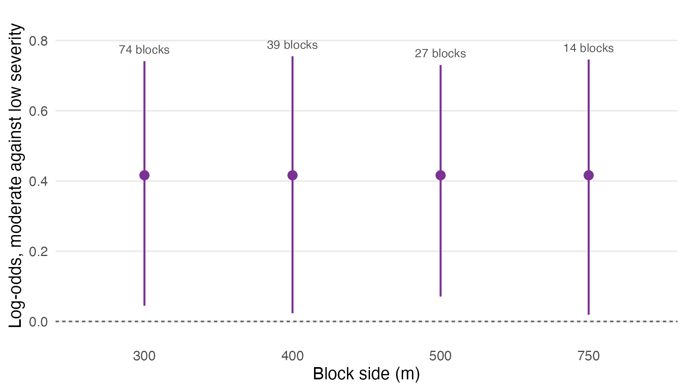
Figure 4: The moderate-against-low severity coefficient under block bootstraps of increasing block size. The estimate was the same at every block size and only the interval changed, with the number of blocks each size gave printed above it.
Table 11: The block sweep as numbers, giving the moderate-against-low coefficient, its interval at each block size and the blocks each size gave.
Block side (m) | Blocks | Estimate | Interval
300 | 74 | 0.416 | [0.045, 0.741] | clears zero
400 | 39 | 0.416 | [0.023, 0.755] | clears zero
500 | 27 | 0.416 | [0.071, 0.730] | clears zero
750 | 14 | 0.416 | [0.019, 0.746] | clears zero

Table 12: Residual correlogram of the conditioned model across the burn, by distance lag, the left panel of Figure 5 at the precision the block-size argument used.
Lag (m) | Residual correlation
(0,100] | 0.394
(100,200] | 0.206
(200,300] | 0.101
(300,500] | 0.057
(500,800] | 0.049
(800,1.2e+03] | 0.020
(1.2e+03,Inf] | -0.055

Residual dependence in the conditioned model fell from 0.394 within 100 m to 0.057 by 500 m (Table 12, Figure 5 left), so a 500 m block contained most of it. Over a burn of about 4.0 by 2.0 km the two requirements of a block bootstrap conflicted, blocks large enough to contain the dependence and numerous enough to resample, because the burn gave 27 blocks at 500 m and only 14 at 750 m, where the roughly 1 km blocks of the companion study would have given eight. The moderate-severity coefficient excluded zero at all 4 block sizes tried, so the conclusion did not rest on a convenient choice of block (Figure 4, Table 11). It was weakest at 750 m, where the lower bound sat at 0.019 on 14 blocks, and that margin was the edge of what this extent supported.

Regeneration interaction
The seedling point pattern lay wholly inside the burn and every cell entering the model was equally masked, so the second objective was untouched by the perimeter clip. The published model was refitted with the beetle by fire product terms and compared against the published additive fit.

Model specification
The seedling shapefile held 3,912 points, of which 46 had a species code outside the seven-species lookup the parent study used, leaving 3,866, all inside the plot windows. The fit used 3,866 data points against 1,282 quadrature points over 12.69 ha.

Fit reproduction
Table 13: The published additive trend as reported by the parent study’s final refit and as recomputed here from the same rasters, with the standard errors of each. The standard-error columns show that the published uncertainty was the naive Poisson uncertainty, which is the premise of Section 3.3.5.
Term | Published | Recomputed | Published SE | Poisson SE | Difference | SE difference
(Intercept) | -4.2504 | -4.2504 | 0.2099 | 0.2099 | 0 | 0
SS_dist | -0.0121 | -0.0121 | 0.0005 | 0.0005 | 0 | 0
Aspect | 0.5538 | 0.5538 | 0.0427 | 0.0427 | 0 | 0
RIX | 0.6262 | 0.6262 | 0.3064 | 0.3064 | 0 | 0
Wind | 0.2721 | 0.2721 | 0.0327 | 0.0327 | 0 | 0
MPB_G | -0.0007 | -0.0007 | 0.0513 | 0.0513 | 0 | 0
MPB_R | -0.3095 | -0.3095 | 0.0555 | 0.0555 | 0 | 0
Fire_H | 0.2071 | 0.2071 | 0.0574 | 0.0574 | 0 | 0
Fire_L | 0.3952 | 0.3952 | 0.0379 | 0.0379 | 0 | 0

All 9 coefficients of the additive fit agreed with the published values to four decimal places, and so did the standard errors, to within 0e+00 (Table 13). The right-hand columns set the published standard errors beside those implied by an ordinary weighted Poisson fit to the same design matrix, and they were the same numbers, so the published uncertainty was Poisson uncertainty and the rest of this section rests on that reproduction. Two further features of the fit mattered for what followed. The grey-stage coefficient was -0.0007, zero to three decimal places, so the parent study’s corrected refit had found no grey-stage main effect, and the two fire terms were indicators for high and low severity, so they were contrasts against whatever the reference category contained.

Covariate support
Table 14: Quadrature points inside the three plots, by burn severity class and beetle surface. The reference category of the published fit was the union of the two rows with no severity indicator, so it pooled moderate severity with unburned and unclassified ground.
Class | Quadrature points | Area (ha) | Grey attacked | Red attacked | In reference category
Low | 323 | 3.23 | 70 | 54
Moderate | 553 | 5.53 | 270 | 218 | yes
High | 288 | 2.88 | 68 | 54
Inside perimeter, unclassified | 118 | 1.18 | 31 | 0 | yes

The reference category of the published fit was every quadrature point with neither severity indicator, 671 points, of which 553 were moderate severity and the remainder unburned or unclassified ground (Table 14). Moderate was the class with the most beetle attack of the three, across the whole burn (Figure 3) and inside the plots, so the published fire coefficients were contrasts against a pooled category that was 82 per cent the severity class with the strongest beetle association, and neither coefficient meant quite what its label suggested. The corrected grey union recorded attack on 439 of 1,282 quadrature points (Murphy, 2026b). Red attack was confined as Section 3.1 describes, appearing on 326 quadrature points and on none outside the classified severity classes, which brought the narrower of the two clips into the model.

Product terms
Table 15: The additive trend as published, and the same trend with the four beetle by fire product terms added. Intervals are the naive Poisson intervals the published likelihood implied, and terms excluding zero on those intervals are marked. Section 3.3.5 reads the same fit under spatial inference.
Term | Model | Estimate | Interval
SS_dist | As published | -0.012 | [-0.013, -0.011] | excludes zero
Aspect | As published | 0.554 | [0.470, 0.637] | excludes zero
RIX | As published | 0.626 | [0.026, 1.227] | excludes zero
Wind | As published | 0.272 | [0.208, 0.336] | excludes zero
MPB_G | As published | -0.001 | [-0.101, 0.100]
MPB_R | As published | -0.309 | [-0.418, -0.201] | excludes zero
Fire_H | As published | 0.207 | [0.095, 0.320] | excludes zero
Fire_L | As published | 0.395 | [0.321, 0.470] | excludes zero
SS_dist | With product terms | -0.011 | [-0.012, -0.010] | excludes zero
Aspect | With product terms | 0.648 | [0.555, 0.741] | excludes zero
RIX | With product terms | 0.526 | [-0.090, 1.141]
Wind | With product terms | 0.306 | [0.239, 0.374] | excludes zero
MPB_G | With product terms | 0.036 | [-0.086, 0.158]
MPB_R | With product terms | -0.586 | [-0.722, -0.450] | excludes zero
Fire_H | With product terms | -0.139 | [-0.285, 0.007]
Fire_L | With product terms | 0.367 | [0.283, 0.451] | excludes zero
MPB_G:Fire_H | With product terms | 0.574 | [0.251, 0.897] | excludes zero
MPB_G:Fire_L | With product terms | -0.714 | [-0.979, -0.449] | excludes zero
MPB_R:Fire_H | With product terms | 0.298 | [-0.046, 0.643]
MPB_R:Fire_L | With product terms | 0.939 | [0.667, 1.211] | excludes zero

Under the likelihood the published model was fitted with, the product terms were decisive. The fit with product terms improved on the additive fit by likelihood ratio test [χ²(4) = 99.2, p < 0.001], and 3 of the 4 product terms had Poisson intervals excluding zero (Table 15). An analyst who stopped here would have reported the compound-disturbance interaction as confirmed, with the parent study’s own machinery behind the claim. Two features of the fit argued against that reading. The product terms did not share a sign, in that grey attack raised regeneration at high severity and lowered it at low severity, and the fitted signs reversed between the two beetle surfaces on the same severity class. Adding them also moved the main effects sharply, taking the high-severity term from 0.207 to -0.139, whereas a product term that was real would usually have left the rest of the model roughly where it found it.

Spatial inference
Estimating the trend of a log-Gaussian Cox process by the Berman-Turner device was legitimate, because Baddeley and Turner (2000) and Waagepetersen (2007) showed the Poisson score to be a composite likelihood that returned consistent trend estimates whether or not the process was Poisson. The variance it reported was another matter, because the standard errors were those of the Poisson model the fit was arithmetically equivalent to, which assumed seedlings placed independently given the covariates. The estimates therefore came from the Cox specification and the uncertainty from the Poisson one, and only the second was affected.
The parent study itself established that the process was not Poisson, in that it tested the observed pattern against 999 Monte Carlo simulations of Ripley’s inhomogeneous K under a null of non-constant intensity and reported significant clustering for every species examined (Murphy et al., 2026), the expected result for conifer regeneration, which clusters for seed-dispersal and microsite reasons unconnected with the covariates. The residuals of the refit said the same thing directly.
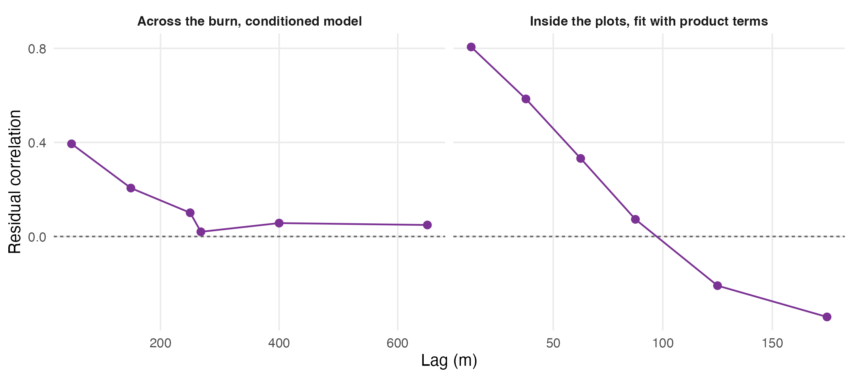
Figure 5: Residual dependence at the two scales the study worked at. Left, the conditioned model of Section 3.2 across the burn, where dependence had largely decayed by 500 m. Right, the fit with product terms over the quadrature points inside the regeneration plots, where it had decayed by about 100 m. Each panel set the block sizes tried at its own scale.
Table 16: Residual correlogram of the fit with product terms over the quadrature points inside the plots, the right panel of Figure 5 at the precision that set the block sizes tried.
Lag (m) | Residual correlation
(0,25] | 0.806
(25,50] | 0.585
(50,75] | 0.332
(75,100] | 0.073
(100,150] | -0.209
(150,200] | -0.342
(200,Inf] | -0.014

Residual dependence inside the plots ran at 0.806 within 25 m and was still 0.332 between 50 and 75 m, crossing zero at around 100 m (Table 16, Figure 5 right). A block that contained it therefore had to be at least 75 to 100 m on a side, and a 200 m plot gave few of those, the same conflict Section 3.2.4 met at landscape scale, two orders of magnitude smaller.
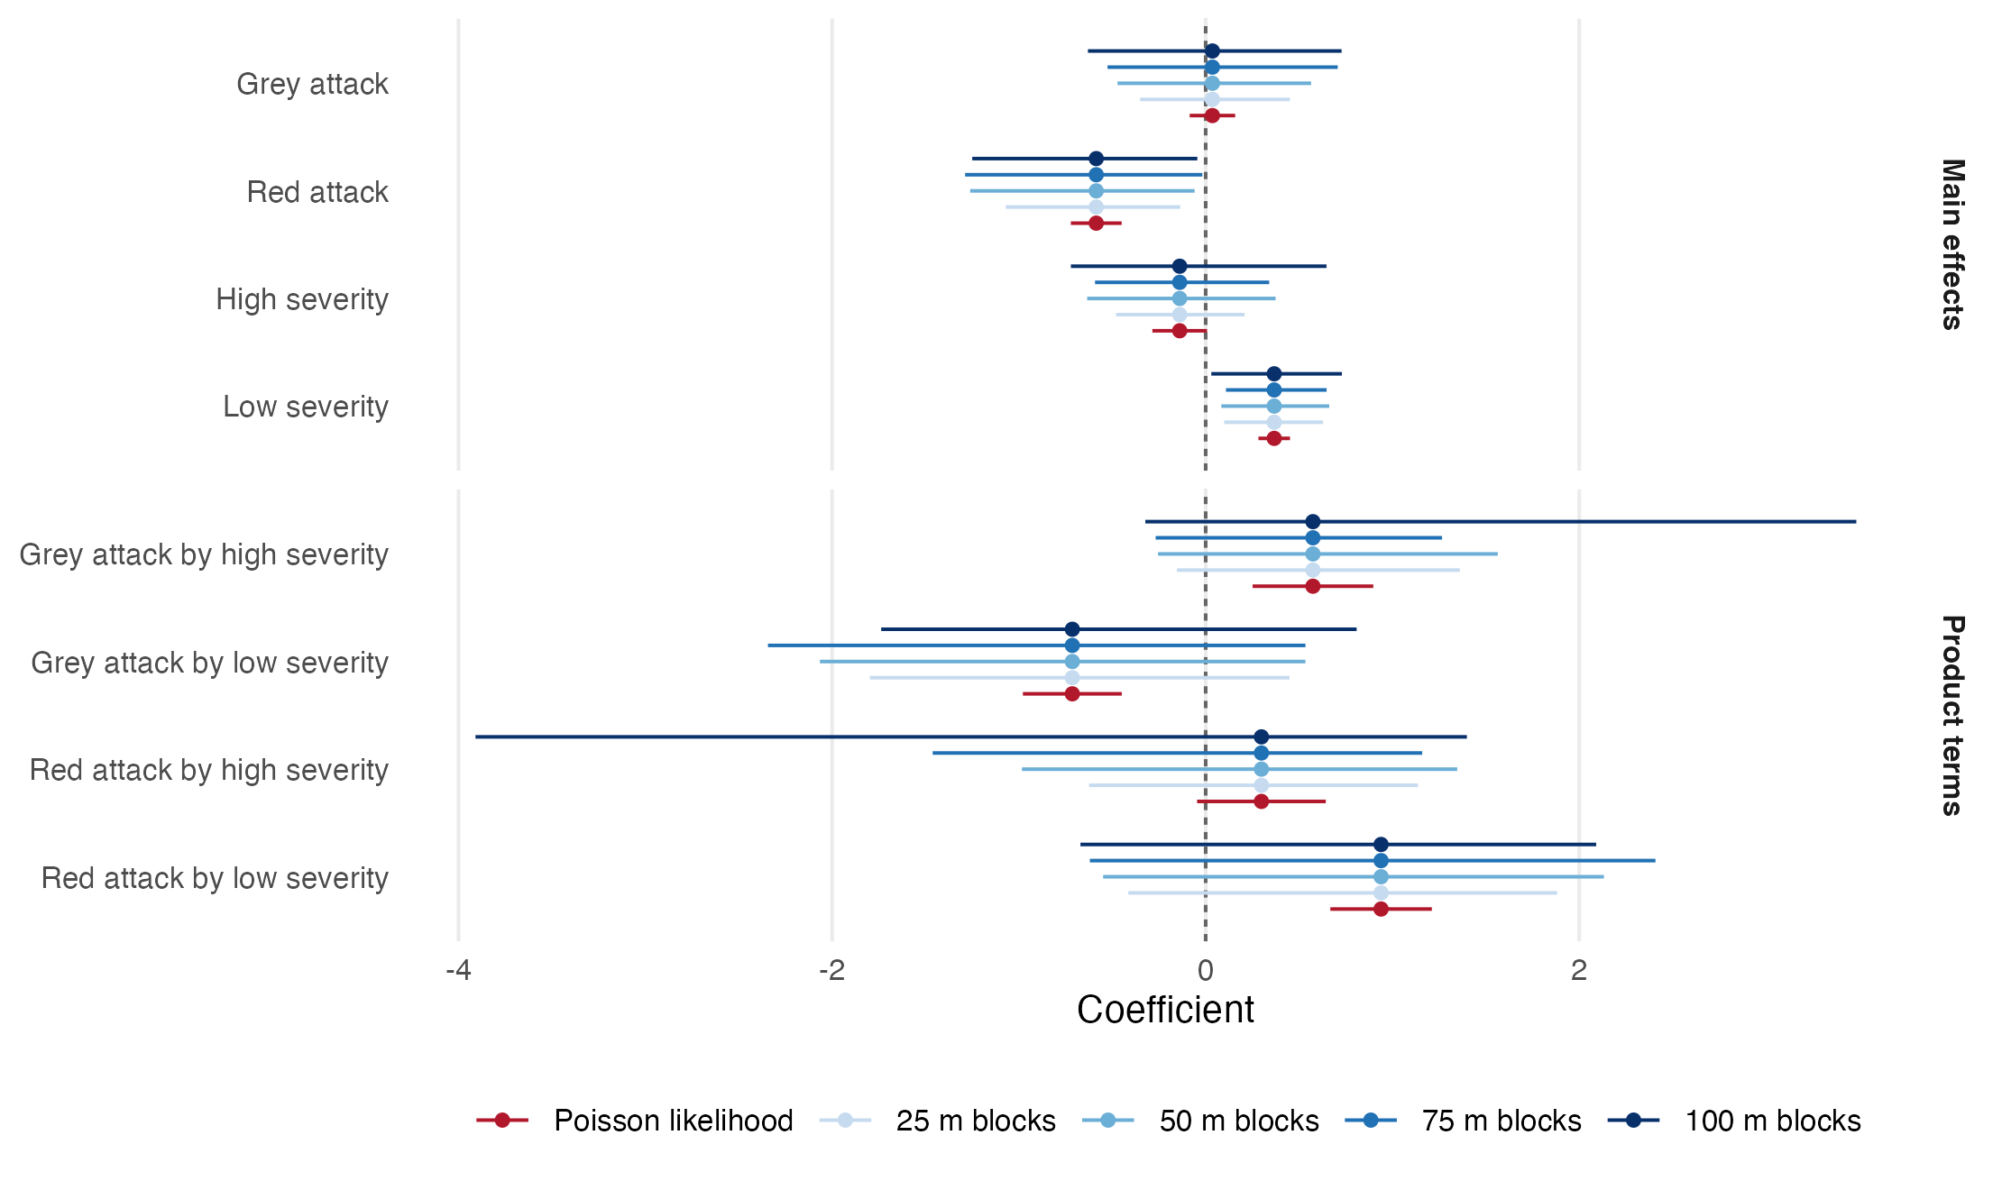
Figure 6: The four product terms and the main effects they modified, under the Poisson likelihood the published model was fitted with and under a spatial block bootstrap across block sizes spanning the residual range. The estimate was the same in every case and only the interval changed. Product terms that excluded zero under the Poisson likelihood excluded it at no block size.
Table 17: The same intervals as numbers, with the count of bootstrap draws that identified each term. A term short of the full count was unestimable in some resample because the blocks carrying its cells were not drawn, and its interval is then a percentile over the draws that did identify it.
Block side (m) | Blocks | Term | Estimate | Interval | Draws
25 | 234 | MPB_G | 0.036 | [-0.351, 0.451] | 2000/2000 | spans zero
25 | 234 | MPB_R | -0.586 | [-1.070, -0.136] | 2000/2000 | clears zero
25 | 234 | Fire_H | -0.139 | [-0.479, 0.208] | 2000/2000 | spans zero
25 | 234 | Fire_L | 0.367 | [0.099, 0.628] | 2000/2000 | clears zero
25 | 234 | MPB_G:Fire_H | 0.574 | [-0.154, 1.361] | 2000/2000 | spans zero
25 | 234 | MPB_G:Fire_L | -0.714 | [-1.798, 0.449] | 2000/2000 | spans zero
25 | 234 | MPB_R:Fire_H | 0.298 | [-0.624, 1.137] | 1998/2000 | spans zero
25 | 234 | MPB_R:Fire_L | 0.939 | [-0.414, 1.881] | 2000/2000 | spans zero
50 | 70 | MPB_G | 0.036 | [-0.472, 0.564] | 2000/2000 | spans zero
50 | 70 | MPB_R | -0.586 | [-1.261, -0.059] | 2000/2000 | clears zero
50 | 70 | Fire_H | -0.139 | [-0.635, 0.374] | 2000/2000 | spans zero
50 | 70 | Fire_L | 0.367 | [0.084, 0.662] | 2000/2000 | clears zero
50 | 70 | MPB_G:Fire_H | 0.574 | [-0.255, 1.564] | 2000/2000 | spans zero
50 | 70 | MPB_G:Fire_L | -0.714 | [-2.065, 0.534] | 2000/2000 | spans zero
50 | 70 | MPB_R:Fire_H | 0.298 | [-0.984, 1.347] | 1999/2000 | spans zero
50 | 70 | MPB_R:Fire_L | 0.939 | [-0.549, 2.132] | 2000/2000 | spans zero
75 | 36 | MPB_G | 0.036 | [-0.525, 0.707] | 2000/2000 | spans zero
75 | 36 | MPB_R | -0.586 | [-1.288, -0.018] | 2000/2000 | clears zero
75 | 36 | Fire_H | -0.139 | [-0.592, 0.340] | 2000/2000 | spans zero
75 | 36 | Fire_L | 0.367 | [0.109, 0.647] | 2000/2000 | clears zero
75 | 36 | MPB_G:Fire_H | 0.574 | [-0.268, 1.266] | 1999/2000 | spans zero
75 | 36 | MPB_G:Fire_L | -0.714 | [-2.343, 0.534] | 2000/2000 | spans zero
75 | 36 | MPB_R:Fire_H | 0.298 | [-1.462, 1.159] | 1906/2000 | spans zero
75 | 36 | MPB_R:Fire_L | 0.939 | [-0.620, 2.408] | 2000/2000 | spans zero
100 | 27 | MPB_G | 0.036 | [-0.630, 0.728] | 2000/2000 | spans zero
100 | 27 | MPB_R | -0.586 | [-1.250, -0.045] | 2000/2000 | clears zero
100 | 27 | Fire_H | -0.139 | [-0.722, 0.647] | 2000/2000 | spans zero
100 | 27 | Fire_L | 0.367 | [0.030, 0.729] | 2000/2000 | clears zero
100 | 27 | MPB_G:Fire_H | 0.574 | [-0.323, 3.484] | 2000/2000 | spans zero
100 | 27 | MPB_G:Fire_L | -0.714 | [-1.737, 0.808] | 2000/2000 | spans zero
100 | 27 | MPB_R:Fire_H | 0.298 | [-3.909, 1.399] | 1965/2000 | spans zero
100 | 27 | MPB_R:Fire_L | 0.939 | [-0.670, 2.091] | 1996/2000 | spans zero

Table 18: A second variance estimate, independent of the bootstrap. Standard errors for the fit with product terms under the naive Poisson likelihood and under a cluster-robust sandwich clustered on the same spatial blocks, with the ratio between them.
Block side (m) | Term | Poisson SE | Cluster-robust SE | Ratio
75 | Grey attack | 0.062 | 0.257 | 4.1
75 | Red attack | 0.069 | 0.281 | 4.0
75 | High severity | 0.075 | 0.202 | 2.7
75 | Low severity | 0.043 | 0.135 | 3.1
75 | Grey attack by high severity | 0.165 | 0.297 | 1.8
75 | Grey attack by low severity | 0.135 | 0.743 | 5.5
75 | Red attack by high severity | 0.176 | 0.430 | 2.4
75 | Red attack by low severity | 0.139 | 0.645 | 4.7
100 | Grey attack | 0.062 | 0.289 | 4.6
100 | Red attack | 0.069 | 0.258 | 3.7
100 | High severity | 0.075 | 0.284 | 3.8
100 | Low severity | 0.043 | 0.175 | 4.1
100 | Grey attack by high severity | 0.165 | 0.330 | 2.0
100 | Grey attack by low severity | 0.135 | 0.663 | 4.9
100 | Red attack by high severity | 0.176 | 0.427 | 2.4
100 | Red attack by low severity | 0.139 | 0.622 | 4.5

None of the 16 product-term intervals excluded zero across the four block sizes (Figure 6, Table 17). The estimates did not move, because the estimates were not what the Poisson likelihood got wrong, and the intervals widened by a factor of 2.3 to 5.9 against the naive Poisson intervals of Table 15, which was the whole of the difference between an interaction that looked overwhelming and one that was absent. The cluster-robust sandwich agreed on both counts (Table 18), inflating the standard errors by a factor of 1.8 to 5.5, in the same range as the bootstrap widening, and of the 8 product-term intervals it implied across the block sizes the correlogram supported, 0 excluded zero. The two estimators shared the assumption that blocks were independent of one another and differed in everything else, in that the bootstrap resampled blocks and the sandwich summed scores within them.
The widening factor was computed only over the 26 of 32 term-by-block combinations that every one of the 2,000 draws could estimate. The four product cells rested on 54 to 70 quadrature points each, so a resample that missed the blocks holding one of them left that term unidentified, and 6 combinations were affected, every one involving red attack or high severity, the worst losing 94 draws of 2,000. The percentile for such a term was taken over whichever resamples happened to contain its cells, which were the resamples that overweighted them, and that inflated the interval for a reason unconnected with spatial dependence; left in, those combinations put the top of the widening range at 7.7 rather than 5.9. The count of usable draws is reported in Table 17 for every cell, and none of it changed the verdict, because the affected intervals were already the widest and every product term spanned zero on the identified combinations alone.
The only terms among those shown whose intervals excluded zero at every block size were low severity and red attack, neither of them a product term, so the regeneration data supported main effects for red-stage beetle attack and low burn severity and supported no statement about the two causes acting together. Three plots totalling 12.7 ha gave 36 at 75 m and 27 at 100 m across the block sizes the residual range permitted, and a product term asked those blocks to resolve a difference of differences across four severity-by-attack combinations. The published likelihood answered the question confidently because it counted 3,866 seedlings as 3,866 independent pieces of evidence.

Discussion

Principal findings
In the Darkwoods Conservation Area, beetle attack and burn severity could not be compared across the fire perimeter, because every local beetle surface descended from annual Landsat classifications that held no data across almost all of the unburned forest before any classification was run. A contingency table built across that boundary reported attack rising from 0.0 per cent of cells outside the burn to 20.7 per cent at moderate severity and measured the mask, whereas the provincial Aerial Overview Survey, never clipped, found attack outside the perimeter at 40.4 per cent, a rate no lower than inside it.
Within the burn the severity gradient was real and narrow. Three records that shared no measurement pathway agreed that attack peaked at moderate severity, and conditioning on lodgepole cover and elevation attenuated that peak by about 41 per cent without removing it, to 0.416 in log-odds against low severity (block bootstrap interval 0.071 to 0.730). The fall at high severity was not supported in any specification, so the non-monotone shape was a claim these data supported at its peak and not at its fall.
The beetle by fire interaction was not supported. Under the likelihood the parent study used it was decisive [χ²(4) = 99.2, p < 0.001], with 3 of 4 product terms excluding zero. Under inference that accounted for the clustering of the seedling pattern every product term spanned zero at every block size tried, and a cluster-robust sandwich clustered on the same blocks agreed. The estimates did not move and the intervals widened by a factor of 2.3 to 5.9, which was the whole distance between a confirmed interaction and none.

Clustered point patterns
The parent study reported that “areas of overlapping beetle mortality and high burn severity had significantly reduced lodgepole pine regeneration” and read from that the suggestion that “the ecological consequences of beetle-fire interactions weaken as surface fuels decay over time”, from a specification that entered the two causes additively and tested no product between them. This paper added the product and found that the data could not support it either way, so the additive specification was the right one to have fitted, and the finding was not a revision of the parent study’s ecology but a statement about what these data could be asked, with the limit located in the inference rather than in the landscape.
The mechanism was not specific to this landscape. A point process trend fitted by the Berman-Turner device was a weighted Poisson regression (Baddeley and Turner, 2000; Berman and Turner, 1992), and a Poisson likelihood counted every seedling as an independent piece of evidence about the covariates. The parent study devoted two figures and 999 Monte Carlo simulations to establishing that the seedling pattern was not independent, reporting significant clustering in every species examined (Murphy et al., 2026), and the residual correlogram of Figure 5 reached the same verdict from inside the model with dependence of 0.806 within 25 m. Clustered point patterns have routinely been fitted this way, because the software makes the Poisson path the path of least resistance, and what made the choice consequential here was the size of the correction, since a misspecified likelihood usually leaves a coefficient where it was and moves the interval around it, and the interval was what the claim rested on.
The caution this implied was not new, and the more careful practice already existed. Modelling conifer regeneration after a large mixed-severity fire, Donato et al. (2009) excluded from their candidate set any model with more than five predictors or any interaction term, on the stated ground that the sample was too modest to support them, and reported relative importance among additive predictors instead. That was a judgement made in advance, on a study of comparable design and larger extent, and it reached by prior reasoning the conclusion this paper reached by measurement. A restraint exercised on principle was cheap but unquantified and left open how much room the data would in fact have allowed, whereas a restraint reached by measurement put a number on it, and that number was what transferred to the next study. The result reported here was therefore a quantification of a discipline this literature already exercised.

Extent constraints
Every result here was bounded by an extent chosen by a disturbance rather than by a design. The burn covered about eight square kilometres and the regeneration plots totalled 12.7 ha inside it, which was the ground on which beetle and fire co-occurred at all, so not an arbitrary choice, but not a neutral one either. Across the burn, lodgepole cover and elevation correlated at r = 0.52 and could not be separated, where the companion study distinguished them because 1,776 m of relief held pine-poor ground at every height (Murphy, 2026a), and the fitted elevation optimum of 503 m fell far below the range the clip spanned, so the landscape-scale optimum was out of view rather than contradicted. The same conflict governed the inference at both scales, because a block bootstrap needed blocks large enough to contain the dependence and numerous enough to resample, and the extent capped the first before the second was comfortable, with 27 blocks of 500 m across the burn where 1 km would have given eight, and 36 at 75 m and 27 at 100 m inside the plots where the residual range demanded 75 to 100 m.
The interaction result was a null bounded by its sample, in that nothing here showed that beetle mortality and burn severity did not interact; it showed that 3,866 seedlings across 12.7 ha, clustered as this pattern was, could not resolve a difference of differences across four severity-by-attack combinations, and a larger or better distributed sample could return a different answer. The direction of any remaining error ran differently for the two results. Residual dependence that neither the bootstrap nor the sandwich captured would have left the intervals still too narrow, which for the product terms was a conservative failure, because their intervals already spanned zero and a fuller accounting could only widen them, whereas the moderate-severity peak was a positive result resting on an interval that excluded zero, and an interval that was too narrow was exactly what would have produced it. The negative result was therefore the more secure of the two, and the positive one was reported with its weakest block size named for that reason.
The first objective was answered in a reduced form, because the within-burn gradient was not the question the compound-disturbance literature asked, which was whether beetle-killed stands burned differently from stands that were not attacked, and recovering that comparison would mean rebuilding the classification over the unclipped landscape. Two beetle surfaces disagreed, and the corrected grey-stage union was preferred throughout as the denser of the two, observed throughout the perimeter and derived by a documented script (Murphy, 2026b), whereas the published red-stage surface stood in for a layer absent from the parent repository. The severity reference category was inherited rather than chosen, because the published specification had indicators for high and low severity only and pooled moderate severity with unburned and unclassified ground into a reference that was 82 per cent moderate; it was reproduced rather than repaired, because the object was to test the published model rather than replace it. The provincial survey was a coarse instrument, its polygons sketched from an aircraft at a mapping scale far coarser than 30 m, and it was used only to test whether ground outside the perimeter was attacked at all, which it could answer, and not to measure severity, which it could not.

Research priorities
Of the three tasks that follow, in descending order of value against cost, the first is to repeat the interaction test where extent is not the binding constraint, which given the dependence range measured here means a distributed plot network rather than three contiguous plots. The published point process results should be reported with intervals that respect the clustering, which is inexpensive because the estimates are unchanged and which on the evidence of Figure 6 leaves two main effects standing. Recovering the first objective in its original form requires rebuilding the beetle classification over the unclipped landscape, which is justified only if the Landsat archive is being revisited anyway.

Conclusions
This study tested, on the data of the parent study, a description of compound disturbance as an interaction that the literature has applied far more often than it has tested, and reached three findings stated at the confidence the data supported. The beetle surfaces underlying the parent study stopped at the fire perimeter, in the source files and before classification, so any comparison of beetle attack across that boundary measured the clip and not the forest, which is checkable in any study that inherits rasters it did not build and is cheap to check. Inside the burn, beetle attack was elevated at moderate severity relative to low by 0.416 in log-odds after conditioning on host and elevation, excluding zero under a spatial block bootstrap at every block size the extent supported, whereas attack at high severity was not distinguishable from attack at low severity in any specification. The beetle by fire product term was decisive under the published Poisson likelihood and absent under inference that accounted for the clustering the parent study itself documented, with identical coefficients either way and intervals that differed by a factor of 2.3 to 5.9.
The additive model of the parent study was the defensible one, because nothing found here supported modelling beetle and fire any other way with data of this extent, and the apparent support for doing so came from a likelihood that counted clustered seedlings as independent observations. A compound-disturbance interaction in this landscape has not been demonstrated, these data could not demonstrate it, and the confidence with which they appeared to was the finding that applies elsewhere.

Author statements
Author contribution statement. SM, conceptualisation, methodology, software, formal analysis, data curation, writing (original draft), writing (review and editing), visualisation.
Competing interests statement. The author is also an author of Murphy et al. (2026), the study re-analysed here, and declares no other competing interests.
Funding statement. The author declares no specific funding for this work.
Data availability statement. The raster surfaces analysed here are held by the parent study (Murphy et al., 2026) and are not redistributed with this manuscript. The corrected grey-stage package of 2 June 2026 is documented in Murphy (2026b). The provincial Aerial Overview Survey is open under the Open Government Licence for British Columbia (Province of British Columbia, Ministry of Forests, 2026). The executable source document that produced every number, table and figure in this paper, together with the derived inputs needed to run it, will be deposited on acceptance and the identifier added here.
Acknowledgements. The author thanks the co-authors of the parent study for the discussion of spatial inference and remote-sensing limits in disturbance ecology out of which this analysis grew.

Declaration of generative AI and AI-assisted technologies in the manuscript preparation process
All prose, writing, results in the analysis and reporting contained within this document was derived and verified by the author. No generative tool was used to create, alter or manipulate research data or results. The author is responsible for the accuracy of all content.

References
Baddeley, A., Turner, R., 2000. Practical maximum pseudolikelihood for spatial point patterns. Australian & New Zealand Journal of Statistics 42, 283–322. https://doi.org/10.1111/1467-842X.00128
Bansal, S., Jochum, T., Wardle, D.A., Nilsson, M.-C., 2014. The interactive effects of surface-burn severity and canopy cover on conifer and broadleaf tree seedling ecophysiology. Canadian Journal of Forest Research 44, 1032–1041. https://doi.org/10.1139/cjfr-2014-0112
Berman, M., Turner, T.R., 1992. Approximating point process likelihoods with GLIM. Journal of the Royal Statistical Society Series C: Applied Statistics 41, 31–38. https://doi.org/10.2307/2347614
Donato, D.C., Fontaine, J.B., Campbell, J.L., Robinson, W.D., Kauffman, J.B., Law, B.E., 2009. Conifer regeneration in stand-replacement portions of a large mixed-severity wildfire in the Klamath–Siskiyou Mountains. Canadian Journal of Forest Research 39, 823–838. https://doi.org/10.1139/X09-016
Estabrook, T., Fried, J., Xi, W., Su, H., Zhang, J., 2025. Linking burn severity to pre-fire forest structure and weather on the Dixie fire offers potential to map prospective burn severity. Canadian Journal of Forest Research 55, 1–20. https://doi.org/10.1139/cjfr-2024-0305
Hart, S.J., Schoennagel, T., Veblen, T.T., Chapman, T.B., 2015. Area burned in the western United States is unaffected by recent mountain pine beetle outbreaks. Proceedings of the National Academy of Sciences 112, 4375–4380. https://doi.org/10.1073/pnas.1424037112
Harvey, B.J., Donato, D.C., Turner, M.G., 2014. Recent mountain pine beetle outbreaks, wildfire severity, and postfire tree regeneration in the US Northern Rockies. Proceedings of the National Academy of Sciences 111, 15120–15125. https://doi.org/10.1073/pnas.1411346111
Jenkins, M.J., Page, W.G., Hebertson, E.G., Alexander, M.E., 2012. Fuels and fire behavior dynamics in bark beetle-attacked forests in Western North America and implications for fire management. Forest Ecology and Management 275, 23–34. https://doi.org/10.1016/j.foreco.2012.02.036
Krawchuk, M.A., Meigs, G.W., Cartwright, J.M., Coop, J.D., Davis, R., Holz, A., Kolden, C., Meddens, A.J.H., 2020. Disturbance refugia within mosaics of forest fire, drought, and insect outbreaks. Frontiers in Ecology and the Environment 18, 235–244. https://doi.org/10.1002/fee.2190
Kulakowski, D., Veblen, T.T., 2006. The effect of fires on susceptibility of subalpine forests to a 19th century spruce beetle outbreak in western Colorado. Canadian Journal of Forest Research 36, 2974–2982. https://doi.org/10.1139/x06-182
Liang, K.-Y., Zeger, S.L., 1986. Longitudinal data analysis using generalized linear models. Biometrika 73, 13–22. https://doi.org/10.1093/biomet/73.1.13
Magnussen, S., Breidenbach, J., Mauro, F., 2017. The challenge of estimating a residual spatial autocorrelation from forest inventory data. Canadian Journal of Forest Research 47, 1557–1566. https://doi.org/10.1139/cjfr-2017-0247
Meigs, G.W., Kennedy, R.E., Cohen, W.B., 2011. A Landsat time series approach to characterize bark beetle and defoliator impacts on tree mortality and surface fuels in conifer forests. Remote Sensing of Environment 115, 3707–3718. https://doi.org/10.1016/j.rse.2011.09.009
Meyer, M.D., Bulaon, B., MacKenzie, M., Safford, H.D., 2016. Mortality, structure, and regeneration in whitebark pine stands impacted by mountain pine beetle in the southern Sierra Nevada. Canadian Journal of Forest Research 46, 572–581. https://doi.org/10.1139/cjfr-2015-0464
Murphy, S., 2026a. Topographic refugia from mountain pine beetle, and why terrain-derived wind surfaces cannot find them at small extents.
Murphy, S., Leslie, A., Wilson, J., Banks, L.K., 2026. Spatial patterns of conifer regeneration following mountain pine beetle outbreak (dendroctonus ponderosae) and mixed-severity wildfire: A point process model of disturbance interactions in the southern Selkirk Mountains, British Columbia. Forest Ecology and Management 618, 123985. https://doi.org/10.1016/j.foreco.2026.123985
Province of British Columbia, Ministry of Forests, 2026. Pest infestation polygons (Aerial Overview Survey).
Simard, M., Romme, W.H., Griffin, J.M., Turner, M.G., 2011. Do mountain pine beetle outbreaks change the probability of active crown fire in lodgepole pine forests? Ecological Monographs 81, 3–24. https://doi.org/10.1890/10-1176.1
Stevens-Rumann, C.S., Prichard, S.J., Strand, E.K., Morgan, P., 2016. Prior wildfires influence burn severity of subsequent large fires. Canadian Journal of Forest Research 46, 1375–1385. https://doi.org/10.1139/cjfr-2016-0185
Talucci, A.C., Krawchuk, M.A., 2019. Dead forests burning: The influence of beetle outbreaks on fire severity and legacy structure in sub-boreal forests. Ecosphere 10, e02744. https://doi.org/10.1002/ecs2.2744
Waagepetersen, R.P., 2007. An estimating function approach to inference for inhomogeneous Neyman–Scott processes. Biometrics 63, 252–258. https://doi.org/10.1111/j.1541-0420.2006.00667.x
Wulder, M.A., White, J.C., Bentz, B., Alvarez, M.F., Coops, N.C., 2006. Estimating the probability of mountain pine beetle red-attack damage. Remote Sensing of Environment 101, 150–166. https://doi.org/10.1016/j.rse.2005.12.010

