Figures
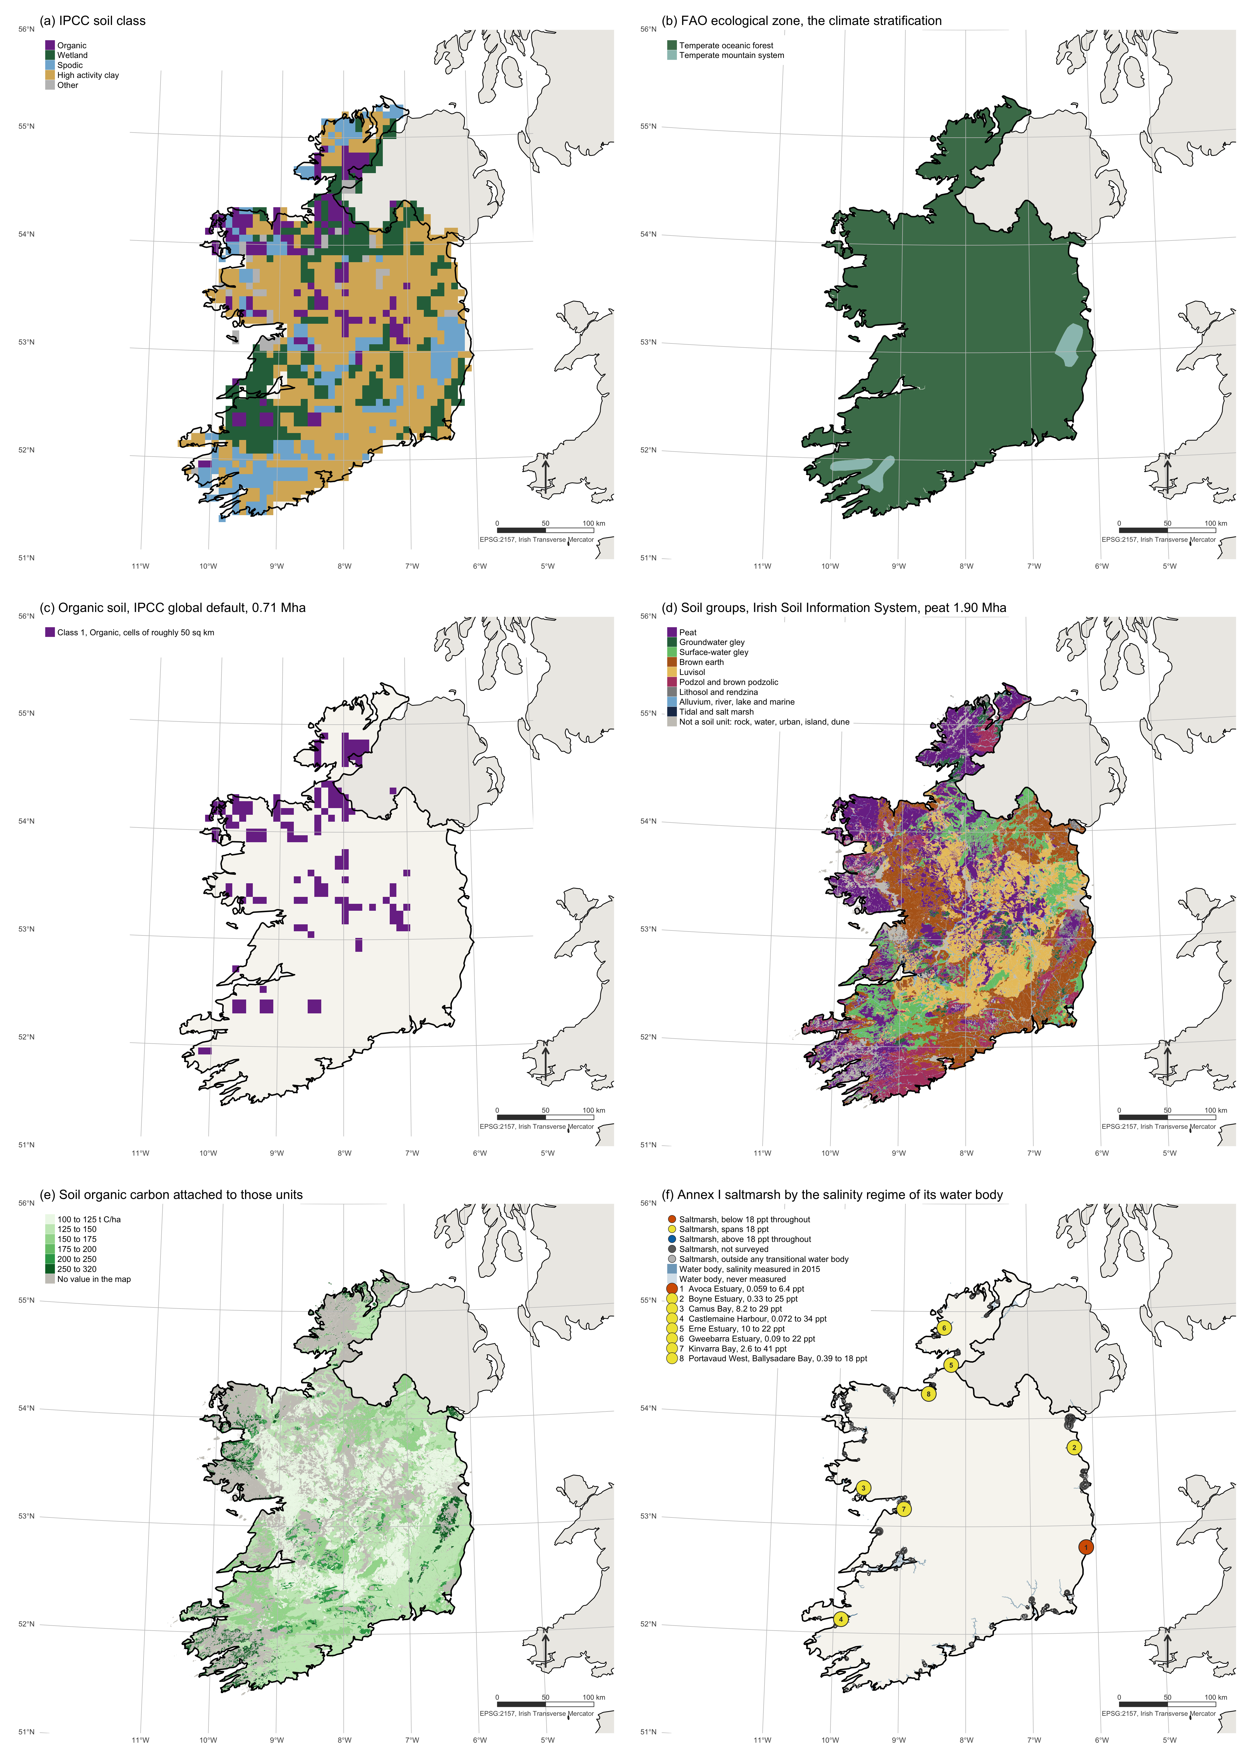
Figure 1: The Irish spatial inputs, six maps on one scale in EPSG:2157. (a) The 5 arc-minute IPCC soil classification derived from the Harmonised World Soil Database, clipped to the Republic of Ireland, which selects the soil class of the reference stock. (b) FAO Global Ecological Zones 2010, the climate stratification, which selects the climate zone. (c) Cells classified organic in the same IPCC layer, 0.71 Mha, the area to which the global default applies the flux-based method. (d) Soil groups of the Irish Soil Information System at 1:250,000, collapsed from its plain-English classes, with peat at 1.90 Mha and the two gleys marking the wetland mineral soils of the Chapter 5 method. (e) The soil organic carbon value attached to each unit of the same map, with unattributed area in grey. (f) Confirmed Annex I saltmarsh drawn at polygon centroids, sized by area and coloured by the salinity regime of the transitional water body containing it, over the Water Framework Directive transitional network shaded by whether Inland Fisheries Ireland measured it in 2015, with the eight measured systems numbered; Tralee Bay, the only system above 18 ppt throughout, is a coastal water body absent from this layer.
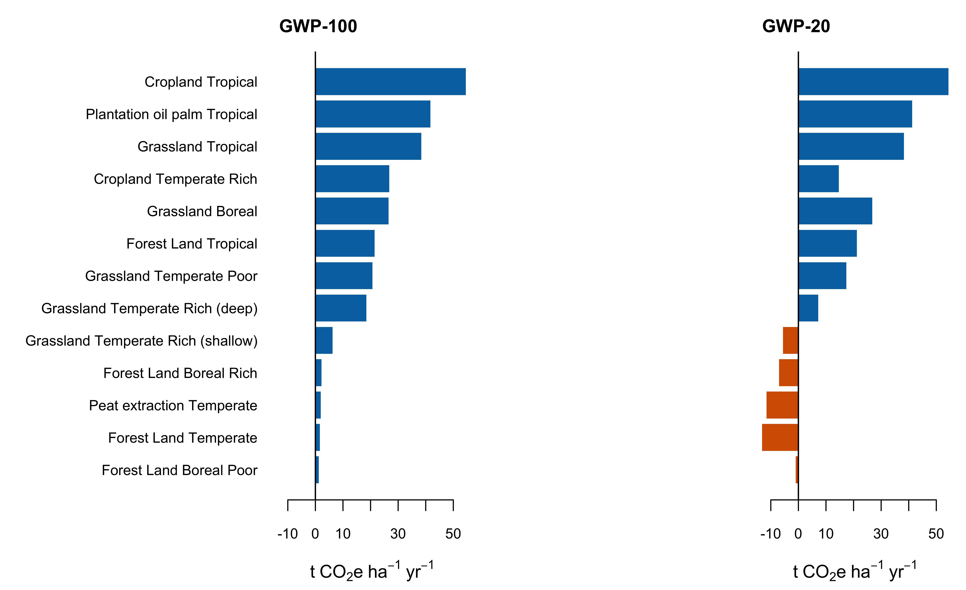
Figure 2: Benefit of rewetting by land use, climate and nutrient status, at two horizons. Bars left of zero are cases where rewetting increases radiative forcing. The GWP-20 panel is the same emission factors under a different weighting; nothing else changes between them.
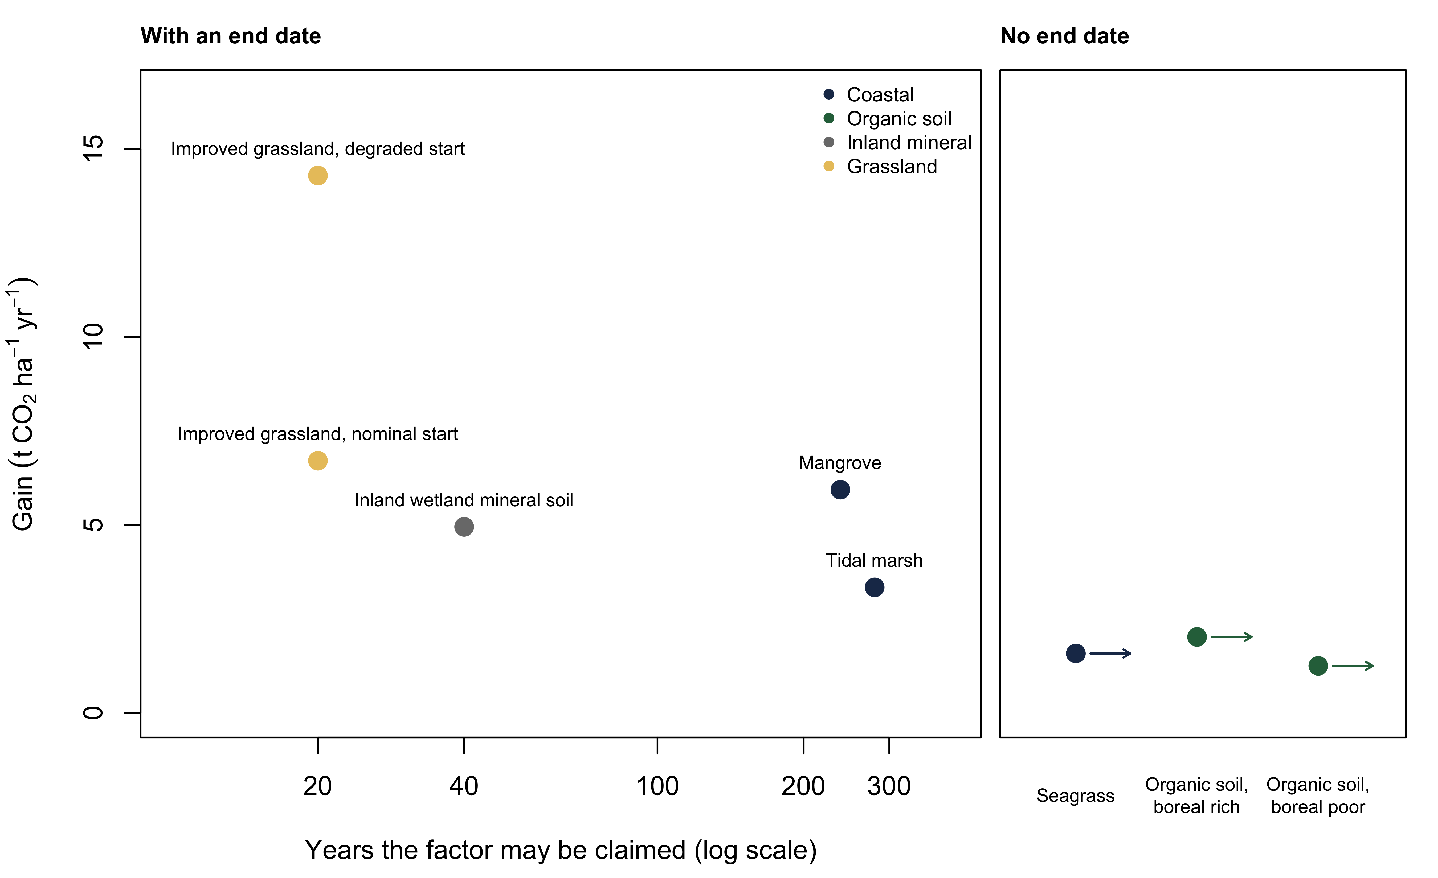
Figure 3: Annual gain against the years over which it may be claimed. The left panel holds pathways with an end date, on a logarithmic axis. Mangrove and tidal marsh are placed at the years a bare soil takes to reach its Wetlands Supplement Table 4.11 stock ceiling, an upper bound. The right panel holds the pathways with no end date in the guidance, rewetted organic soils and seagrass, which has no published ceiling. Two pathways with the same annual factor are not the same asset if one runs for twenty years and the other to a stock ceiling two centuries away.
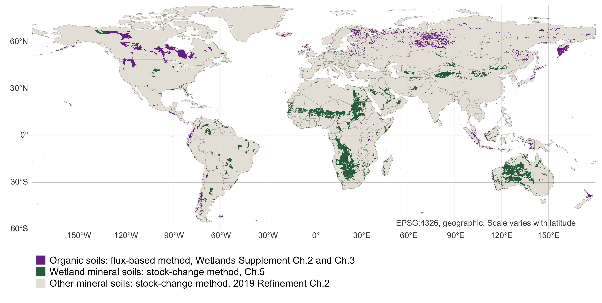
Figure 4: The soils the Tier 1 gain pathways apply to, from the 5 arc-minute IPCC soil classification. Organic soils carry the flux-based method of Wetlands Supplement Chapters 2 and 3; wetland mineral soils carry the Chapter 5 stock-change method; all other mineral soils fall under the 2019 Refinement Chapter 2 reference stocks. The two coloured classes are the soils this paper’s ledger covers, and the boundary between them is the boundary between the two accounting logics of the guidance.

