Mapping Marbled Murrelet habitat in the Clayoquot Sound using ALS LiDAR data
Murphy, S
2026-10-26

Abstract
Provincial airborne laser scans flown in 2019 measured old-growth forest structure across Clayoquot Sound, British Columbia, but the only Marbled Murrelet nesting-habitat model built from such scans and located nests, trained in Desolation Sound, lost accuracy when transferred there. Whether a model built from Clayoquot Sound’s own nests would do better was unknown. This study rebuilt that model from the 2019 scans and the nests of birds radio-tracked from 2000 to 2002 (16 nest cells and 3,827 background cells of 1 ha in tall, unharvested forest). Maximum entropy modeling of forest vertical complexity and internal forest gaps was scored by five-fold spatial cross-validation in 10 km blocks. Neither measure separated nest cells from background cells (forest vertical complexity, P = 0.54; internal forest gaps, P = 0.10), and nest cells had more internal gaps than background cells, the reverse of the Desolation Sound relation. The model classed 62.5 percent of held-out nest cells and 40.8 percent of background cells correctly, an average accuracy of 51.7 percent and no better than chance. Its ranking of nest cells could not be shown to differ from that of the model transferred from Desolation Sound. With so few located nests, the transferred model, or one fitted to nests pooled across regions, remained the better-supported basis for mapping nesting habitat in Clayoquot Sound.

Keywords
Airborne laser scanning; Brachyramphus marmoratus; habitat suitability; lidar; MaxEnt; model transferability; old-growth forest

1. Introduction
The Marbled Murrelet, Brachyramphus marmoratus (Gmelin, 1789), is a seabird that nests inland in old-growth coniferous forest. It was listed as threatened in Canada and the United States, and loss of that forest was the primary reason given for its decline (Burger, 2001). Because its nests were cryptic and difficult to locate (Burger, 2001), the nesting habitat retained for it in British Columbia was mapped from forest inventory, air photographs and aerial surveys and judged against the few nests found by radio telemetry (Burger et al., 2018; Mather et al., 2010).
The provincial habitat model classed forest-cover polygons as suitable by stand age, height, elevation and distance to the sea (Mather et al., 2010). Against 171 radio-tracked nests, it placed 52.6 percent in suitable habitat, 69.4 percent in Clayoquot Sound and 52.1 percent in Desolation Sound (Burger et al., 2018). Air photo interpretation and low-level aerial surveys ranked stands by canopy features seen from above (Burger et al., 2009; Waterhouse et al., 2008), and the survey ranks separated nests from random points in Desolation Sound and Toba Inlet but not in Clayoquot Sound (Waterhouse et al., 2009). All of these methods inferred forest structure from maps or from observers’ ranks rather than measuring it.
Airborne laser scanning measured canopy height and the vertical arrangement of vegetation directly, and murrelet models built from it scored well against survey data. In southwestern Oregon, a lidar model of stand occupancy reached an area under the receiver operating characteristic curve (AUC), on which 0.5 marks chance, of 0.74, against 0.64 for a model built from vegetation maps (Hagar et al., 2014). Laser-scan measures of tall treetops predicted habitat suitability in redwood timberland in northern California (Lamphear et al., 2025), and canopy and terrain measures predicted helicopter survey ranks on northern Vancouver Island with an overall accuracy of 71.05 percent (Clyde, 2017).
Among the studies reviewed here, Cosgrove et al. (2024) were the first to train a laser-scan model on located nests in British Columbia, fitting maximum entropy modeling (MaxEnt) to radio-tracked nests in Desolation Sound in 1 ha cells. Predicted suitability rose with forest vertical complexity, the spread of point heights, and fell with internal forest gaps, the empty space below the top of the canopy. The model scored an AUC of 0.77 and a Boyce index, a measure of how closely predicted suitability tracked nest frequency, of 0.99 in Desolation Sound. Transferred to Clayoquot Sound, it scored 0.63 and 0.67, below the AUC of 0.7 those authors set for a good model. In Oregon, a lidar occupancy model transferred from the Coos Bay District to the Siuslaw National Forest scored an AUC of 0.73, against 0.78 for a model selected from Siuslaw data (Hagar et al., 2018). In the two sounds, ground plots at radio-tracked nests showed canopy height and complexity relating to nest sites in opposite directions, and Silvergieter and Lank (2011a, p. 11) judged that “the limited size of our dataset and strong regional interactions precluded” testing Desolation Sound models against Clayoquot Sound nests.
No study in this review had built a laser-scan model from Clayoquot Sound nests. The provincial scans flown there in 2019 and the public release of the nest locations (Cooke et al., 2022) made it possible to test whether a model built from local nests would outperform one transferred from Desolation Sound. The objectives of this study were to (1) rebuild the two-measure model of Cosgrove et al. (2024) from Clayoquot Sound nests and open laser scans and score it on spatially separate groups of nests, and (2) compare that score with that of the Desolation Sound model transferred to Clayoquot Sound. Table 1 gives the expected direction of each measure and its source.
Table 1: Laser-scan measures entered in the model, with the direction of their relation to nest sites expected from prior work.
Measure | Expected direction | Reasoning | Source
Forest vertical complexity | Positive | Taller forest with more variable structure was expected to offer more nest platforms and overhead cover, and in Desolation Sound the probability of a nest rose with vertical complexity. Ground plots at Clayoquot Sound nests found shorter and less varied canopy than at random sites, the reverse of Desolation Sound, so the direction is contested for Clayoquot Sound. | (Cosgrove et al., 2024; Silvergieter and Lank, 2011a)
Internal forest gaps | Negative | Gaps within and under the canopy were expected to give flight access to nests, but in Desolation Sound the probability of a nest fell as internal gaps increased, the reverse of the expected direction. | (Cosgrove et al., 2024)

2. Methods

2.1 Study area
Clayoquot Sound, on the west coast of Vancouver Island, British Columbia (Figure 1), supported one of the highest concentrations of breeding Marbled Murrelets south of Alaska, including more than 10 percent of the estimated provincial population (Burger, 2001). The study area was the smallest convex polygon around the nests, widened by 5 km.

2.2 Literature review
The literature review followed a protocol fixed on 28 September 2026, before the first search. A curated reference library and Semantic Scholar were searched for Marbled Murrelet with airborne laser scanning or lidar, with habitat suitability, MaxEnt or transferability, and with Clayoquot Sound. One round of backward and forward citation chasing was then run from five central records. Records were retained if they were
- peer-reviewed articles, reviews, chapters, conference papers or agency reports supplying a method, threshold or data product,
- published in English from 1990 to 2026, and
- concerned with laser-scan measures at nest sites, nesting-habitat models and their transfer, or nesting habitat in Clayoquot Sound.
Of 157 records retrieved, 101 were unique, 70 were excluded on title and abstract and 31 were retained, of which 24 were read in full. The other 7 could not be reached, among them unpublished reports and a thesis from the 1990s and journal articles behind paywalls. Every quotation taken from the records read was checked word for word against the source by a script.

2.3 Nest data
From 2000 to 2002, Marbled Murrelets captured at sea were radio-tracked to their nests in Clayoquot Sound (Cosgrove et al., 2024). The published data set listed 36 nests confirmed on the ground, with a positional error of about 50 m (Cooke et al., 2022). No nest location was mapped in this paper.

2.4 Laser scans
Point clouds came from the 2019 Vancouver Island acquisition of LidarBC, the open lidar program of the Province of British Columbia, and only nests inside that acquisition were used. Of the 322 tiles centered in the study area, the 29 within 150 m of a nest and 40 drawn at random from the rest were used. Points classed as noise or withheld were dropped, and each tile was thinned at random and evened to 12 points per square meter in 10 m cells, so that point density did not differ between nest and background tiles.

2.5 Harvest screen
Forest harvested from 1998 to 2022 was screened out with the Canada Forest Harvest 1985–2022 product of the National Terrestrial Ecosystem Monitoring System, which records the year of stand-replacing harvest on a 30 m grid (Hermosilla et al., 2016).
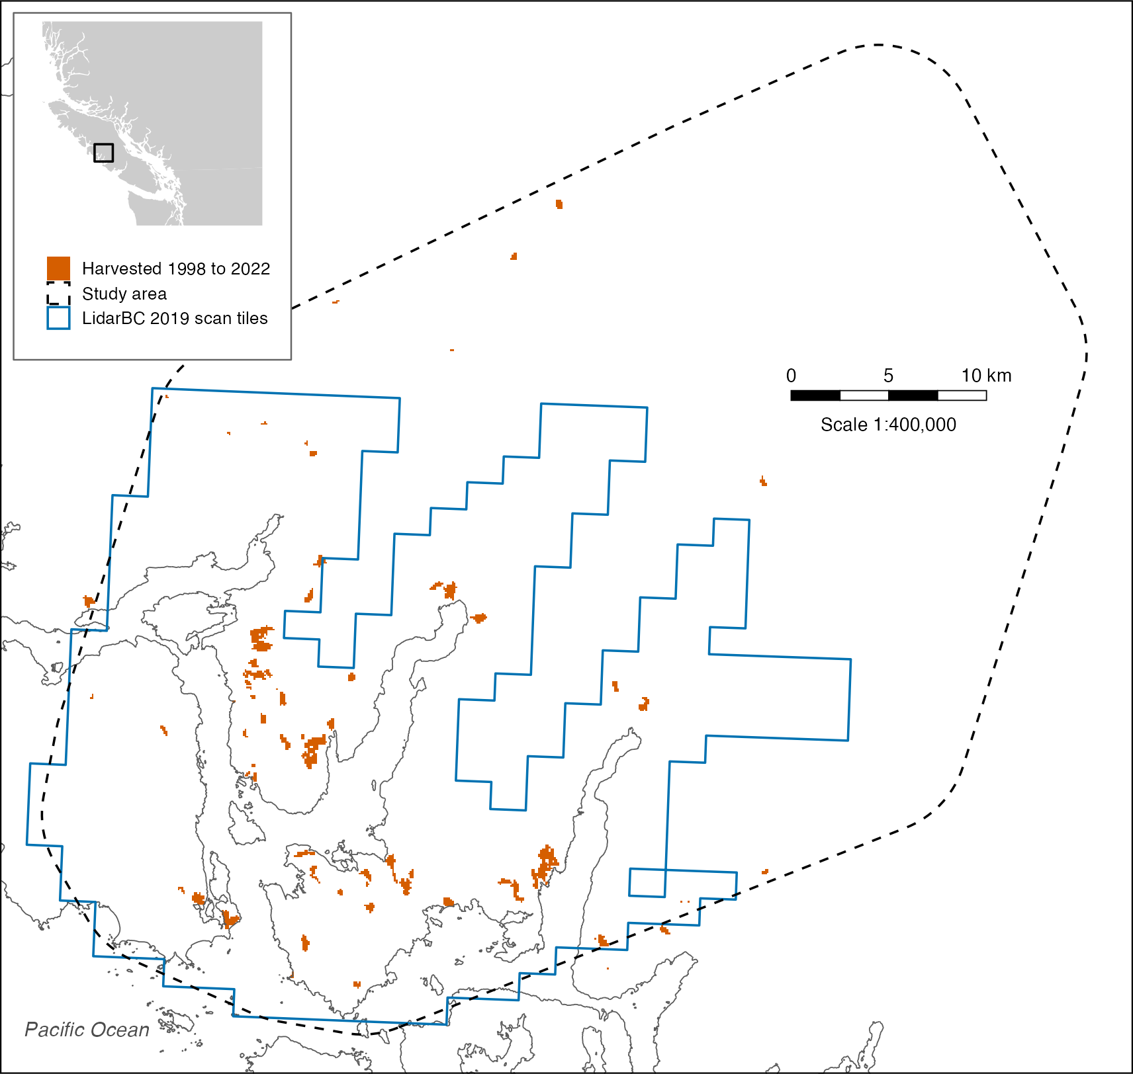
Figure 1: Clayoquot Sound on the west coast of Vancouver Island, British Columbia. The dashed line bounds the study area, drawn 5 km around the radio-tracked nests, the blue line bounds the 322 LidarBC scan tiles flown in 2019, each about 2.5 km², and orange marks forest harvested from 1998 to 2022. Nest locations are not shown. The inset places the study area on Vancouver Island. Scale 1:400,000.

2.6 Forest structure
Heights were normalized to the ground by a triangulated surface on ground points, and points below 0 m or at or above 100 m were discarded. Following the grid and definitions of Cosgrove et al. (2024), five measures were computed in 1 ha cells with lidR (Roussel et al., 2020). Forest vertical complexity was the standard deviation of point heights, and internal forest gaps were the number of empty 1 m³ voxels below the highest filled voxel of each 1 m column, summed over the cell. Forest height, the 95th percentile of point heights, canopy cover, the share of 1 m columns with a point, and point density were used only to define available forest.

2.7 Available forest
A cell was available forest if
- forest height was at least 20 m,
- canopy cover was at least 90 percent,
- point density was at least 10 points per square meter, and
- no 30 m pixel inside it was harvested from 1998 to 2022.
Nest cells were available-forest cells with a nest, and background cells were all available-forest cells in the background tiles (Table 2). The nest sample was small, and the nests were found 17 to 19 years before the scans were flown.
Table 2: Nests and 1 ha cells at each step from the nest file to the modeled sample. Available forest was at least 20 m tall with at least 90% canopy cover and no harvest from 1998 to 2022.
Step | Count
Nests in file | 36
Nest cells scanned | 20
Nest cells in available forest | 16
Background cells scanned | 7,869
Background cells in available forest | 3,827

2.8 Model fitting
Following the top model of Cosgrove et al. (2024), MaxEnt was fitted to forest vertical complexity and internal forest gaps in the maxnet package (Phillips et al., 2017), with linear and product features and a regularization multiplier of 0.2. Predictions were taken on the complementary log-log scale. For spatial block cross-validation, cells were assigned to five folds by 10 km square blocks allocated at random (Valavi et al., 2018), and each fold was predicted by a model trained on the other four. Each model’s classification threshold maximized the sum of sensitivity, the share of nest cells classed as nesting habitat, and specificity, the share of background cells classed as not, on its training cells (Liu et al., 2005).

2.9 Separability
On each measure, the separability of nest and background cells was given by the index M of Kaufman and Remer (1994), the absolute difference between the two means divided by the sum of the two standard deviations. The difference was tested with a Wilcoxon rank-sum test, as in Cosgrove et al. (2024).

2.10 Evaluation
Held-out predictions were pooled across folds and scored with the measures of Murphy et al. (2026). Discrimination was measured by AUC with a DeLong 95 percent confidence interval (CI) (Robin et al., 2011) and the continuous Boyce index (Hirzel et al., 2006). Classification at each fold’s threshold was summarized by sensitivity, specificity, overall accuracy with an exact binomial interval, Cohen’s kappa and the commission and omission error of each class. Agreement between prediction and the observed 0 or 1 outcome was measured by root mean square error (RMSE), relative RMSE (RMSE over the mean outcome), mean absolute error, Brier score, the coefficient of determination (R²) of outcome on prediction with its F test. Theil’s U bias gave the share of squared error due to the gap between mean prediction and mean outcome. Overfitting was measured by the RMSE ratio, held-out over training RMSE, with a model rejected above 1.1 (Murphy et al., 2026), and residual autocorrelation by Moran’s I with inverse-distance weights and the Durbin-Watson test on residuals ordered by easting. The model was compared with that of Cosgrove et al. (2024), in Desolation Sound and transferred to Clayoquot Sound, on the AUC and Boyce index those authors reported. Analyses were run in R 4.4.1 (R Core Team, 2024) with lidR 4.2.3, maxnet 0.1.4, blockCV 3.2.0, pROC 1.19.0.1 and ecospat 4.1.3.

3. Results

3.1 Sample
The 2019 scans covered 20 cells with a nest, of which 16 were available forest, against 3,827 available-forest cells among the 7,869 scanned cells of the background tiles (Table 2).

3.2 Separability
Neither measure separated nest cells from background cells (Table 3, Figure 2). Forest vertical complexity averaged 10.67 ± 1.47 m (95 percent CI 9.89 to 11.46) at nest cells and 10.37 ± 2.43 m (10.29 to 10.45) at background cells [M = 0.08, Wilcoxon rank-sum test, W = 33,355, P = 0.54]. Internal forest gaps were larger at nest cells, 177.5 ± 40.9 thousand empty voxels per hectare (155.7 to 199.3), than at background cells, 157.5 ± 56.8 thousand (155.7 to 159.3), the reverse of the negative relation found in Desolation Sound, although the difference was not significant [M = 0.21, W = 37,889, P = 0.10].
Table 3: Laser-scan measures at nest and background cells in available forest, as mean ± standard deviation (95% confidence interval), with the separability index M and the Wilcoxon rank-sum statistic W. Internal forest gaps are in thousands of empty 1 m³ voxels per ha. * P ≤ 0.05, ** P ≤ 0.01, *** P ≤ 0.001, **** P ≤ 0.0001.
Measure | Nest | Background | M | W
Forest vertical complexity (m) | 10.67 ± 1.47 (9.89–11.46) | 10.37 ± 2.43 (10.29–10.45) | 0.08 | 33,355
Internal forest gaps | 177.52 ± 40.90 (155.73–199.31) | 157.46 ± 56.84 (155.66–159.26) | 0.21 | 37,889
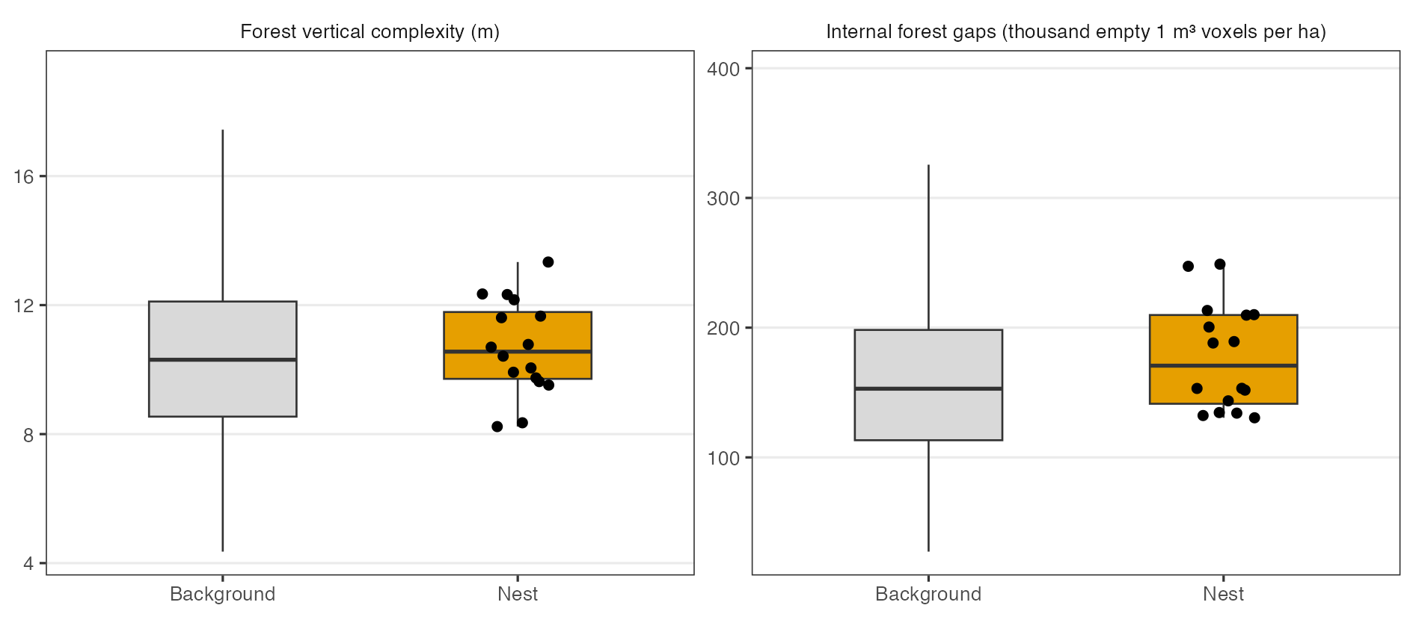
Figure 2: Forest vertical complexity and internal forest gaps at 16 nest cells (points) and 3,827 background cells in available forest, Clayoquot Sound. Boxes span the middle half of the values, the bar marks the median, and whiskers reach the furthest value within 1.5 box lengths.

3.3 Model evaluation
The Clayoquot Sound model discriminated nest cells from background cells no better than chance (Table 4). Its AUC was 0.53 (95 percent CI 0.39 to 0.67), against 0.77 for the Desolation Sound model in its own area and 0.63 for that model transferred to Clayoquot Sound, and its Boyce index was 0.10 against 0.99 and 0.67. At the training thresholds, 10 of 16 held-out nest cells and 2,264 of 3,827 background cells were classed as nesting habitat, a sensitivity of 62.5 percent and a specificity of 40.8 percent, for an average accuracy of 51.7 percent. Cohen’s kappa, the agreement beyond chance, was 0.00 (95 percent CI -0.03 to 0.03).
The model did not overfit, its RMSE ratio of 1.01 lying below the rejection threshold of 1.1, but nearly all of its error was systematic [Theil’s U bias = 0.96], because predictions averaged 0.60 while nest cells made up 0.004 of all cells. Residuals were spatially autocorrelated [Moran’s I = 0.12, P < 0.001].
Table 4: Performance of the Clayoquot Sound model on held-out cells pooled over five spatial folds, beside the Desolation Sound model of Cosgrove et al. (2024) in its own area and transferred to Clayoquot Sound. Intervals are 95% confidence intervals. AUC is the area under the receiver operating characteristic curve, RMSE root mean square error and MAE mean absolute error. * P ≤ 0.05, ** P ≤ 0.01, *** P ≤ 0.001, **** P ≤ 0.0001.
Measure | Clayoquot Sound, local | Desolation Sound, own area | Desolation Sound, transferred
AUC | 0.53 (0.39 to 0.67) | 0.77 | 0.63
Boyce index | 0.10 | 0.99 | 0.67
Overall accuracy | 0.41 (0.39 to 0.43)
Kappa | 0.00 (-0.03 to 0.03)
Commission error, nest | 1.00
Omission error, nest | 0.38
Commission error, background | 0.00
Omission error, background | 0.59
R² | 0.00003
RMSE | 0.61
RMSE ratio | 1.01
Relative RMSE | 145.98
MAE | 0.60
Brier score | 0.37
Theil's U bias | 0.96
Moran's I of residuals | 0.12****
Durbin-Watson | 2.01

4. Discussion
In Clayoquot Sound, a MaxEnt model rebuilt from 16 local nest cells and open 2019 laser scans ranked held-out nest cells above background cells no more often than chance. The 95 percent interval on its AUC included both chance and the 0.63 reached by the same model transferred from Desolation Sound (Cosgrove et al., 2024). The local model therefore did not outperform the transferred one, although these data could not show that it did worse. In Oregon, a locally selected lidar model also improved little on a transferred one, 0.78 against 0.73, but there the transferred model was already adequate on 772 surveyed stands (Hagar et al., 2018).
The two measures did not relate to nest sites in Clayoquot Sound as they did in Desolation Sound. Internal forest gaps were larger at nest cells than at background cells, the reverse of the Desolation Sound relation (Cosgrove et al., 2024), and forest vertical complexity hardly differed. Ground plots at 27 Clayoquot Sound and 37 Desolation Sound nests also showed opposite relations, with shorter and less varied canopy than at random sites in Clayoquot Sound but taller and more varied canopy in Desolation Sound (Silvergieter and Lank, 2011a). Nest trees in Clayoquot Sound exceeded other available trees in height by an average of 15 percent of total height, against 30 percent in Desolation Sound (Silvergieter and Lank, 2011b), a smaller contrast that a 1 ha summary of point heights would be less able to detect. If nest-site selection differed between the two sounds in this way, a model built on Desolation Sound relations would be expected to transfer poorly, as it did, and a model of the same form fitted in Clayoquot Sound would have little to separate.
The background cells may explain much of the weak result, because 49 percent of the scanned background cells met the definition of available forest, so nest cells were compared with forest of much the same kind. Waterhouse et al. (2009) gave the same reason for the failure of aerial survey ranks in Clayoquot Sound, which “has more uniform coverage of suitable forest (Zharikov et al. 2006); consequently a higher proportion of random points might fall within suitable nesting habitat, thereby minimizing the differences between nests and random points” (Waterhouse et al., 2009, p. 90). The features that decided which stand a bird used may also have gone unmeasured by a 1 ha summary of point heights. Silvergieter and Lank (2011a), who modeled nest-site selection with resource selection functions (RSF), noted that “relative numbers of potential nesting platforms, a key requirement of nesting habitat and an important component of RSF models at Clayoquot Sound, cannot be quantitatively measured by remote methods” (Silvergieter and Lank, 2011a, p. 15).
The small sample limited the comparison, because with 16 nest cells over five folds the 95 percent interval on AUC spanned 0.28, and spatially autocorrelated residuals meant that the cells were not independent, so the true uncertainty was probably wider. Nest positions had an error of about 50 m within 100 m cells (Cooke et al., 2022), and forest change other than harvest in the 17 to 19 years between the nest searches and the scans could not be measured. The error was almost entirely systematic because MaxEnt output on the complementary log-log scale ranked relative suitability and was not scaled to the small share of nest cells, so the RMSE, Brier score and R² described calibration more than discrimination.
For management in Clayoquot Sound, these results did not support replacing the transferred Desolation Sound model, or the provincial habitat model, which placed 69.4 percent of Clayoquot Sound nests in suitable habitat (Burger et al., 2018), with a model fitted to the few local nests. Two approaches might make better use of open scans than two stand-level measures, and both could be tested with data already public. One would be a model fitted to nests pooled across regions with terms for region, as Silvergieter and Lank (2011a) fitted to ground plots, and the other would use measures of individual tall trees taken from the scans, the predictors of Lamphear et al. (2025).

5. Conclusion
Open laser scans flown in 2019 and 16 local nest cells were not enough to build a Marbled Murrelet nesting-habitat model for Clayoquot Sound that separated nests from available forest, and the local model could not be shown to improve on the model transferred from Desolation Sound. Until more nests could be located in Clayoquot Sound, the transferred model, or a model fitted to nests pooled across regions, offered the better-supported basis for mapping nesting habitat there.

Data availability
Every line of code that built, fitted and tested the model is in the manuscript source at https://github.com/seamusrobertmurphy/lidar-marbled-murrelet. Nest locations are public under a CC0 license at the Movebank Data Repository (Cooke et al., 2022), point clouds at LidarBC (https://lidar.gov.bc.ca/) under the Open Government Licence British Columbia, and harvest years at the National Terrestrial Ecosystem Monitoring System (Hermosilla et al., 2016).

Author contributions
Seamus Murphy carried out the conceptualization, methodology, software, formal analysis, data curation and visualization, and wrote, reviewed and edited the manuscript.

Funding
This research did not receive any specific grant from funding agencies in the public, commercial, or not-for-profit sectors.

Competing interests
The author declares no known competing financial interests or personal relationships that could have appeared to influence the work reported in this paper.

References
Burger, A.E., 2001. Using radar to estimate populations and assess habitat associations of marbled murrelets. The Journal of Wildlife Management 65, 696. https://doi.org/10.2307/3803021
Burger, A.E., Waterhouse, F.L., Donaldson, A., Whittaker, C., Lank, D.B., 2009. New methods for assessing marbled murrelet nesting habitat: Air photo interpretation and low-level aerial surveys. Journal of Ecosystems and Management. https://doi.org/10.22230/jem.2009v10n1a407
Burger, A., Waterhouse, F.L., Deal, J., Lank, D., Donald, D.S., 2018. The reliability and application of methods used to predict suitable nesting habitat for marbled murrelets. Journal of Ecosystems and Management 18. https://doi.org/10.22230/jem.2018v18n1a593
Clyde, G.E., 2017. A fine-scale lidar-based habitat suitability mapping methodology for the marbled murrelet (Brachyramphus marmoratus) on Vancouver Island, British Columbia (Master’s thesis). University of Victoria, Victoria, British Columbia.
Cooke, F., Lank, D.B., Bradley, R.W., Parker, N.R., Lougheed, C., Lougheed, L.W., McFarlane Tranquila, L.A., Pastran, S.A., Greene, R., Vincent, P., Bertram, D.F., 2022. Data from: Study "marbled murrelets at Clayoquot Sound, British Columbia, Canada (2000-2002)". https://doi.org/10.5441/001/1.KG210889
Cosgrove, C., Coops, N., Waterhouse, F., Goodbody, T., 2024. Modeling marbled murrelet nesting habitat: A quantitative approach using airborne laser scanning data in British Columbia, Canada. Avian Conservation and Ecology 19. https://doi.org/10.5751/ace-02585-190105
Hagar, J.C., Aragon, R., Haggerty, P., Hollenbeck, J.P., 2018. Modeling habitat for marbled murrelets on the Siuslaw National Forest, Oregon, using lidar data, Open-File Report. US Geological Survey. https://doi.org/10.3133/ofr20181035
Hagar, J.C., Eskelson, B.N.I., Haggerty, P.K., Nelson, S.K., Vesely, D.G., 2014. Modeling marbled murrelet (Brachyramphus marmoratus) habitat using LiDAR-derived canopy data. Wildlife Society Bulletin 38, 237–249. https://doi.org/10.1002/wsb.407
Hermosilla, T., Wulder, M.A., White, J.C., Coops, N.C., Hobart, G.W., Campbell, L.B., 2016. Mass data processing of time series Landsat imagery: Pixels to data products for forest monitoring. International Journal of Digital Earth 9, 1035–1054. https://doi.org/10.1080/17538947.2016.1187673
Hirzel, A.H., Le Lay, G., Helfer, V., Randin, C., Guisan, A., 2006. Evaluating the ability of habitat suitability models to predict species presences. Ecological Modelling 199, 142–152. https://doi.org/10.1016/j.ecolmodel.2006.05.017
Kaufman, Y.J., Remer, L.A., 1994. Detection of forests using mid-IR reflectance: An application for aerosol studies. IEEE Transactions on Geoscience and Remote Sensing 32, 672–683. https://doi.org/10.1109/36.297984
Lamphear, D.W., Hamm, K.A., Early, D.A., McDonald, T.L., 2025. Marbled murrelet habitat suitability in redwood timberlands of northern coastal California utilizing LiDAR-derived individual tree metrics. PLOS ONE 20, e0307726. https://doi.org/10.1371/journal.pone.0307726
Liu, C., Berry, P.M., Dawson, T.P., Pearson, R.G., 2005. Selecting thresholds of occurrence in the prediction of species distributions. Ecography 28, 385–393. https://doi.org/10.1111/j.0906-7590.2005.03957.x
Mather, M., Chatwin, T., Cragg, J., Sinclair, L., Bertram, D.F., 2010. Marbled murrelet nesting habitat suitability model for the British Columbia coast. BC Journal of Ecosystems and Management 11, 91–102.
Murphy, S., Leslie, A., Wilson, J., Banks, L.K., 2026. Spatial patterns of conifer regeneration following mountain pine beetle outbreak (Dendroctonus ponderosae) and mixed-severity wildfire: A point process model of disturbance interactions in the southern Selkirk Mountains, British Columbia. Forest Ecology and Management 618, 123985. https://doi.org/10.1016/j.foreco.2026.123985
Phillips, S.J., Anderson, R.P., Dudík, M., Schapire, R.E., Blair, M.E., 2017. Opening the black box: An open-source release of Maxent. Ecography 40, 887–893. https://doi.org/10.1111/ecog.03049
R Core Team, 2024. R: A language and environment for statistical computing. Version 4.4.1. R Foundation for Statistical Computing, Vienna, Austria.
Robin, X., Turck, N., Hainard, A., Tiberti, N., Lisacek, F., Sanchez, J.-C., Müller, M., 2011. pROC: An open-source package for R and S+ to analyze and compare ROC curves. BMC Bioinformatics 12. https://doi.org/10.1186/1471-2105-12-77
Roussel, J.-R., Auty, D., Coops, N.C., Tompalski, P., Goodbody, T.R.H., Meador, A.S., Bourdon, J.-F., Boissieu, F. de, Achim, A., 2020. lidR: An R package for analysis of airborne laser scanning (ALS) data. Remote Sensing of Environment 251, 112061. https://doi.org/10.1016/j.rse.2020.112061
Silvergieter, M.P., Lank, D.B., 2011a. Patch scale nest-site selection by marbled murrelets (Brachyramphus marmoratus). Avian Conservation and Ecology 6. https://doi.org/10.5751/ace-00483-060206
Silvergieter, M.P., Lank, D.B., 2011b. Marbled murrelets select distinctive nest trees within old-growth forest patches. Avian Conservation and Ecology 6. https://doi.org/10.5751/ace-00462-060203
Valavi, R., Elith, J., Lahoz-Monfort, J.J., Guillera-Arroita, G., 2018. blockCV: An R package for generating spatially or environmentally separated folds for k-fold cross-validation of species distribution models. Methods in Ecology and Evolution 10, 225–232. https://doi.org/10.1111/2041-210x.13107
Waterhouse, F.L., Burger, A.E., Lank, D.B., Ott, P., Krebs, E., Parker, N., 2009. Using the low-level aerial survey method to identify marbled murrelet nesting habitat. Journal of Ecosystems and Management. https://doi.org/10.22230/jem.2009v10n1a413
Waterhouse, F.L., Donaldson, A., Lank, D.B., Ott, P., Krebs, E., 2008. Using air photos to interpret quality of marbled murrelet nesting habitat in south coastal British Columbia. Journal of Ecosystems and Management. https://doi.org/10.22230/jem.2008v9n1a381

