Working Notes/Edits

This proposed outline aims to provide a comprehensive and structured approach, focusing on the integration of local knowledge and remote sensing data in the mapping of wetland inundation dynamics and migrant fishing camps across the Lake Chilwa basin.

In sub-Saharan Africa, and Southern Malawi particularly, notable progress has been made in the integration of remote sensing methods and multi-disciplinary data collection, with several studies providing important insights into ecosystem dynamics of nearby watersheds within Southern Malawi.^{63–65}

The long-term data archives from Landsat satellites provide opportunities to study extensive changes occurring in lakes. For instance, Kutser demonstrated the suitability of Landsat archives for mapping changes in CDOM in Swedish lakes over the last three decades.¹⁵ Remote sensing has also proven valuable in mapping shallow water benthic habitats in inland waters and estimating lake primary production using satellite observations. This integration of remote sensing insights with local knowledge and land-use practices, often referred to as the socio-ecological system (SES) approach, has shown success in various fields, including conservation, rural development, and risk management.

1.2 Limitations to Remote Sensing with Static Maps

1.3 Importance of Local Knowledge
To address these limitations, the integration of local ecological knowledge becomes essential. Social science literature emphasizes incorporating such knowledge to comprehend social-ecological systems and their dynamics, providing a context-specific lens for conservation and development programs.

1.4 Benefits of Socio-Ecological Systems Approach
Recent studies globally, especially in conservation, development, and risk management fields, have successfully integrated remote sensing and local knowledge using the SES approach. This method evaluates landscape dynamics through remote sensing while emphasizing the social dimensions with local knowledge and land-use practices. Such integration contributes to a more holistic understanding of ecosystems and human interactions.

1.5 Focus on Lake Chilwa’s SES
In the context of Lake Chilwa in Southern Malawi, characterized by fluctuating, mobile complexity and being a large Ramsar site mostly inaccessible, applying the SES approach presents unique challenges and opportunities. Rapid population growth and the expansion of agriculture pose significant threats to the socio-ecological balance. The pressure on biodiversity, including the decline of flora and fauna, specifically aquatic plants and various species of fish, reptiles, amphibians, birds, and mammals, requires careful consideration.

1.6 Challenges to Lake Chilwa’s SES Success
Challenges to the SES success of Lake Chilwa include the identified rapid population growth and expansion of agriculture, as highlighted by Chiotha (2018). The pressure on biodiversity resulting in the decline of aquatic plants, fish, reptiles, amphibians, birds, and mammals, as observed in Lake Malombe, underscores the urgent need for effective conservation policies.

1.7 Importance of Local Scale for Conservation Policies
Lake Chilwa's socio-ecological system involves three tribes spanning three districts and two countries, emphasizing the need for policies addressing local dynamics at both spatial and temporal scales.

1.8 Proposed Methodology
This paper proposes an interdisciplinary and replicable methodology that integrates remote sensing and local knowledge to develop knowledge for integrated landscape management at a local scale. Beyond the methodology, the article aims to provide a comprehensive report for Ramsar site managers, combining human and environmental perspectives.

1.9 Future Projects in Lake Chilwa/Malawi
Implementing SES methods is crucial for understanding local dynamics spatially and temporally, ensuring successful conservation efforts and gaining acceptance from local populations.

1.10 Significance of Considering Human Practices: 'Migrant Men and Large Migrant Camps'
Recognizing the spatial and temporal aspects of human practices, along with local expectations regarding development and income sources, is pivotal for the success of conservation actions within the site.

1.11 Overall Objective
The primary objective of this paper is to describe and analyze the local dynamics of the SES through the integration of remote sensing and local knowledge inputs, offering valuable insights for Ramsar site managers and contributing to the ongoing discourse on conservation policies.

2.1 Study Site Definition

Lake Chilwa, located southeast of Lake Malawi (Fig. 1), is the second-largest lake in Malawi, covering approximately 2284 km2. Positioned in a shallow basin, it lies at an elevation of 623 m above sea level (masl), making it one of Africa's most productive lakes (Schuyt, 2005). This tectonic depression features a radial drainage pattern with 14 streams converging from the surrounding watershed, bordered by Mt. Zomba and lower hills to the west, the Mlanje massif to the south, and lower hills in Mozambique to the east. A sandbar separates Lake Chilwa from Lake Chiuta in the north; detailed geological information can be found in Morgan and Kalk (1970).
The Lake Chilwa ecosystem is characterized by a shallow, enclosed, endorheic saline lake with an average depth of 1–2 m (RIS, 2009). Surrounding marshlands, dominated by Typha, form a belt around the lake, with a seasonally inundated grassland floodplain. Designated a Ramsar site in 1996, it supports 1% of the individuals in a population of one water bird species, justifying its ecological significance. Despite its importance, the catchment area faces intense human pressure, hosting one of the highest population densities in Malawi, approximately 162 people per km2 (Bhima, 2006). This heightened population activity poses a substantial threat to the wetland, causing degradation and loss of biodiversity and interconnected ecosystem services.
The lake's hydrology is a pivotal factor shaping the wetland's ecology, influencing water chemistry, physical properties, and vegetation and soil characteristics (Howard-Williams and Walker, 1974; Beadle, 1981). Derived from Shuttle Radar Topography Mission (SRTM) data, the catchment boundary spans 8784 km2, with 65% in Malawi and 35% in Mozambique. Although figures slightly differ from the Lake Chilwa wetland management plan, they are based on the best available digital elevation data. The catchment receives an average annual rainfall of approximately 1362 mm. Water levels vary between 621.3 and 625.5 masl, peaking at the end of the rainy season in April. Seasonal fluctuations overlay longer wetter and drying cycles (see Fig. 3), occasionally leading to complete drying, with eight occurrences in the last century, the most recent being in 1996/1997. Six perennial rivers (Sombani, Namdzi, Likangala, Thondwe, Domasi, and Phalombe) and one additional secondary watercourse feed into Lake Chilwa, with limited pressure from human water-consumption reported across all networks. However, consumption data is notably scarce and dated to caution over future trends.
To report climatic trends across the site, we obtained downscaled gridded values of mean monthly temperature and precipitation for the entire Lake Chilwa basin from the PRISM platform. Using the prior timeframe of ‘climate normals’ spanning between 1981 and 2011, we derived the following climographs showing yearly change along with bi-annual maps at 30m raster resolution showing mean dry and wet months.
Lake Chilwa is a key fishing water in Malawi, and its annual fish production significantly influences Malawi's national fish catch. FishStat Plus database and local Fisheries Department data, covering 1992–2002, offer insights into Chilwa's contribution to fisheries productivity and its connection to lake water level. Over 85% of Malawi's annual fish production is believed to come from the traditional sector, possibly resulting in underestimated annual figures.
Lake Chilwa regularly passes through extended periods of complete drying and re-filling that repeat approximately every fifteen years and which are followed immediately by ‘bumper years’ of pronounced fish stocks. Since 1900, Lake Chilwa experienced 10 major recessions in 1900, 1914-15, 1922, 1934, 1952, 1961, 1967, 1973, 1995 and most recently in 2012-13. These fluctuations are represented in the following graph, which marks several recessions and subsequent periods of inflated productivity preceding the year 2000. Essentially, it is a transient world that in some seasons supports a thriving fishery economy, a bustling marketing network and burgeoning lakeshore settlements, while in the following season the lakeshore may become deserted with large areas remaining completely inaccessible.
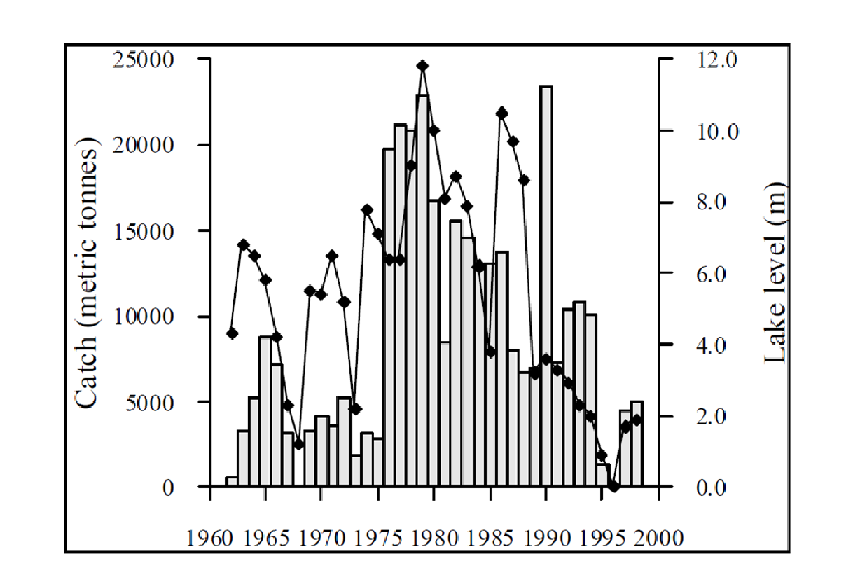

Fig. 1: Maps x 3: Inset map of national location; elevation map of Lake Chilwa Basin, histogram of FishStat data or hydrology below for study window 1960-2020 (Allison & Mvula, 2002)

2.2 Data Collection and Analyses

2.2.1. Remote Sensing Data

2.2.2 Image processing
Landsat image collections were georeferenced using the Malawi Digital Elevation Model (reference) in order to limit inaccuracies caused by positioning of solar radiation and sensor anglers.
Figure 2: Flowchart of the processing chain used to classify the landscape structure by remote sensing from a Sentinel-2 satellite image.

