Environment Setup
This page loads all shared dependencies, authenticates to Google Earth Engine, and derives the study area boundary and hydrological base layers used throughout the analysis.

Packages, GEE Authentication, and AOI
All computational pages source _common.R, which handles package loading, GEE authentication, helper function definitions, and AOI derivation from HydroSHEDS level-6 basins.
source("_common.R")

Area of Interest
We derive the AOI from HydroSHEDS basin boundaries filtered by a point location within Lake Chilwa. The level-6 basin becomes the primary clip boundary for all subsequent raster and vector queries.
print(paste("Level 6 basins containing point:", nrow(basin_l6_sf)))
[1] "Level 6 basins containing point: 1"
print(paste("Level 8 sub-catchments:", nrow(basin_l8_sf)))
[1] "Level 8 sub-catchments: 1"
tmap_mode("view")
tm_shape(st_as_sf(aoi_sf)) + tm_borders(col = "red", lwd = 2) +
tm_shape(basin_l8_sf) + tm_borders(col = "blue", lwd = 0.5, lty = "dashed") +
tm_shape(st_as_sf(poi_sf)) + tm_symbols(fill = "green", size = 1) +
tm_basemap("Esri.WorldImagery") +
tm_scalebar(position = c("right", "bottom"))
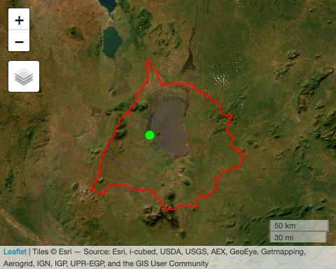

Hydrological Base Layers
We import elevation and processed hydrology data from multiple sources for cartographic and cross-validation purposes: MERIT Hydro (v1.0.3), HydroSHEDS (v1.1), and JRC Global Surface Water (v1.4).
# HydroSHEDS: conditioned DEM (~90m)
dem <- ee$Image("WWF/HydroSHEDS/03VFDEM")$clip(aoi_ee)
hydro_flowdir <- ee$Image("WWF/HydroSHEDS/03DIR")$clip(aoi_ee)
hydro_flowacc <- ee$Image("WWF/HydroSHEDS/03ACC")$clip(aoi_ee)
hydro_rivers <- ee$FeatureCollection("WWF/HydroSHEDS/v1/FreeFlowingRivers")$filterBounds(aoi_ee)
hydro_lakes <- ee$FeatureCollection("projects/sat-io/open-datasets/HydroLakes/lake_poly_v10")$filterBounds(aoi_ee)
hydro_rivers_sf <- ee_to_sf(hydro_rivers)
hydro_lakes_sf <- ee_to_sf(hydro_lakes)
# MERIT Hydro: flow direction, upstream drainage, water elevation, channel width
merit_flowdir <- ee$Image("MERIT/Hydro/v1_0_1")$select("dir")$clip(aoi_ee)
merit_drainup <- ee$Image("MERIT/Hydro/v1_0_1")$select("upa")$clip(aoi_ee)
merit_elev <- ee$Image("MERIT/Hydro/v1_0_1")$select("elv")$clip(aoi_ee)
merit_wth <- ee$Image("MERIT/Hydro/v1_0_1")$select("wth")$clip(aoi_ee)
merit_rivers <- merit_drainup$gt(10)
# JRC Global Surface Water
gsw_occurrence <- ee$Image("JRC/GSW1_4/GlobalSurfaceWater")$select("occurrence")$clip(aoi_ee)
gsw_seasonality <- ee$Image("JRC/GSW1_4/GlobalSurfaceWater")$select("seasonality")$clip(aoi_ee)
gsw_recurrence <- ee$Image("JRC/GSW1_4/GlobalSurfaceWater")$select("recurrence")$clip(aoi_ee)
gsw_transition <- ee$Image("JRC/GSW1_4/GlobalSurfaceWater")$select("transition")$clip(aoi_ee)
gsw_monthly <- ee$ImageCollection("JRC/GSW1_4/MonthlyHistory")$filterBounds(aoi_ee)
print(paste("JRC monthly images:", gsw_monthly$size()$getInfo()))
[1] "JRC monthly images: 454"
print(paste("Number of lakes within watershed:", nrow(hydro_lakes_sf)))
[1] "Number of lakes within watershed: 3"
tmap_mode("view")
tm_shape(st_as_sf(aoi_sf)) + tm_borders(col = "red", lwd = 2) +
tm_shape(hydro_rivers_sf) + tm_lines(col = "steelblue", lwd = 1.5) +
tm_shape(hydro_lakes_sf) + tm_polygons(fill = "steelblue", lwd = 1) +
tm_shape(st_as_sf(poi_sf)) + tm_symbols(fill = "green", size = 1) +
tm_scalebar(position = c("right", "bottom")) +
tm_basemap("Esri.WorldImagery")
