Landsat Time Series
Optical analysis uses Analysis Ready Data products from Landsat Collection 2, specifically Level-2 surface reflectance from the Thematic Mapper (L5-TM), Enhanced Thematic Mapper Plus (L7-ETM+), and Operational Land Imager (L8-OLI). Earlier sensors (Landsat 3 and 4) were evaluated but present gaps, cloud interference, sensor degradation, and archival quality issues that reduce usable coverage, particularly before 1984. The temporal window is constrained by these data quality limitations rather than by methodological choice.

Landsat Collection 2 Query
We query Landsat Collection 2 Level-2 surface reflectance imagery across the three sensor families. Band names are harmonised to a common schema (blue, green, red, nir, swir1, swir2) to enable consistent index computation across sensors.
# Band name harmonisation for each sensor
l5_bands <- list(
from = c("SR_B1", "SR_B2", "SR_B3", "SR_B4", "SR_B5", "SR_B7"),
to = c("blue", "green", "red", "nir", "swir1", "swir2"))
l7_bands <- list(
from = c("SR_B1", "SR_B2", "SR_B3", "SR_B4", "SR_B5", "SR_B7"),
to = c("blue", "green", "red", "nir", "swir1", "swir2"))
l8_bands <- list(
from = c("SR_B2", "SR_B3", "SR_B4", "SR_B5", "SR_B6", "SR_B7"),
to = c("blue", "green", "red", "nir", "swir1", "swir2"))
# Scale factors for Collection 2 L2 surface reflectance
apply_scale <- function(image) {
optical <- image$select("SR_B.*")$multiply(0.0000275)$add(-0.2)
image$addBands(optical, overwrite = TRUE)$
copyProperties(image, list("system:time_start"))
}
# Cloud masking using QA_PIXEL band (Collection 2)
mask_clouds <- function(image) {
qa <- image$select("QA_PIXEL")
cloud_bit <- bitwShiftL(1L, 3L)
shadow_bit <- bitwShiftL(1L, 4L)
mask <- qa$bitwiseAnd(cloud_bit)$eq(0L)$
And(qa$bitwiseAnd(shadow_bit)$eq(0L))
image$updateMask(mask)$
copyProperties(image, list("system:time_start"))
}
# Harmonise band names
harmonise <- function(image, bands_from, bands_to) {
image$select(bands_from, bands_to)$
copyProperties(image, list("system:time_start"))
}
# Query each sensor
l5_col <- ee$ImageCollection("LANDSAT/LT05/C02/T1_L2")$
filterBounds(aoi_ee)$
filter(ee$Filter$lt("CLOUD_COVER", 30))$
map(mask_clouds)$
map(apply_scale)$
map(function(img) harmonise(img, l5_bands$from, l5_bands$to))
l7_col <- ee$ImageCollection("LANDSAT/LE07/C02/T1_L2")$
filterBounds(aoi_ee)$
filter(ee$Filter$lt("CLOUD_COVER", 30))$
map(mask_clouds)$
map(apply_scale)$
map(function(img) harmonise(img, l7_bands$from, l7_bands$to))
l8_col <- ee$ImageCollection("LANDSAT/LC08/C02/T1_L2")$
filterBounds(aoi_ee)$
filter(ee$Filter$lt("CLOUD_COVER", 30))$
map(mask_clouds)$
map(apply_scale)$
map(function(img) harmonise(img, l8_bands$from, l8_bands$to))
# Merge into a single harmonised collection
landsat <- l5_col$merge(l7_col)$merge(l8_col)$sort("system:time_start")
n_landsat <- landsat$size()$getInfo()
print(paste("Total harmonised Landsat scenes:", n_landsat))
[1] "Total harmonised Landsat scenes: 1335"
ls_dates <- landsat$reduceColumns(
ee$Reducer$minMax(), list("system:time_start"))$getInfo()
print(paste("First scene:", as.Date(as.POSIXct(ls_dates$min / 1000, origin = "1970-01-01"))))
[1] "First scene: 1970-01-25"
print(paste("Last scene:", as.Date(as.POSIXct(ls_dates$max / 1000, origin = "1970-01-01"))))
[1] "Last scene: 1970-01-17"

Spectral Water Indices
Five water-extraction indices are computed for each scene. Each exploits a different band combination to test relative performance under the specific conditions Lake Chilwa presents.
compute_indices <- function(image) {
blue <- image$select("blue")
green <- image$select("green")
red <- image$select("red")
nir <- image$select("nir")
swir1 <- image$select("swir1")
swir2 <- image$select("swir2")
# NDWI (McFeeters 1996): (Green - NIR) / (Green + NIR)
ndwi <- green$subtract(nir)$divide(green$add(nir))$rename("NDWI")
# MNDWI (Xu 2006): (Green - SWIR1) / (Green + SWIR1)
mndwi <- green$subtract(swir1)$divide(green$add(swir1))$rename("MNDWI")
# AWEIsh (Feyisa et al. 2014):
# Blue + 2.5*Green - 1.5*(NIR + SWIR1) - 0.25*SWIR2
aweish <- blue$add(green$multiply(2.5))$
subtract(nir$add(swir1)$multiply(1.5))$
subtract(swir2$multiply(0.25))$
rename("AWEIsh")
# WRI (Shen and Li 2010): (Green + Red) / (NIR + SWIR1)
wri <- green$add(red)$divide(nir$add(swir1))$rename("WRI")
# NDPI (Lacaux et al. 2007): (SWIR1 - Green) / (SWIR1 + Green)
ndpi <- swir1$subtract(green)$divide(swir1$add(green))$rename("NDPI")
image$addBands(c(ndwi, mndwi, aweish, wri, ndpi))$
copyProperties(image, list("system:time_start"))
}
landsat_idx <- landsat$map(compute_indices)
print("Spectral indices computed: NDWI, MNDWI, AWEIsh, WRI, NDPI")
[1] "Spectral indices computed: NDWI, MNDWI, AWEIsh, WRI, NDPI"

Annual Composites
Generate annual median composites for each index to build the multi-decadal time series. Annual compositing reduces cloud-gap noise while preserving inter-annual variability.
years <- 1984L:2024L
index_bands <- c("NDWI", "MNDWI", "AWEIsh", "WRI", "NDPI",
"blue", "green", "red", "nir", "swir1", "swir2")
annual_composites <- lapply(years, function(y) {
start <- ee$Date$fromYMD(y, 1L, 1L)
end <- ee$Date$fromYMD(y, 12L, 31L)
annual <- landsat_idx$filterDate(start, end)$select(index_bands)
n <- annual$size()$getInfo()
if (n == 0L) return(NULL)
annual$median()$
set("system:time_start", start$millis())$
set("year", y)$
set("n_scenes", n)
})
annual_composites <- Filter(Negate(is.null), annual_composites)
landsat_annual <- ee$ImageCollection$fromImages(annual_composites)
print(paste("Annual composites:", length(annual_composites)))
[1] "Annual composites: 39"

Index Time Series Extraction
Extract basin-wide mean values for each index at annual resolution. This produces the core time series for characterising recession-refilling cycles.
extract_index_stats <- function(image) {
stats <- image$select(c("NDWI", "MNDWI", "AWEIsh", "WRI", "NDPI"))$
reduceRegion(
reducer = ee$Reducer$mean(),
geometry = aoi_ee,
scale = 30L,
maxPixels = as.integer(1e9)
)
ee$Feature(NULL, stats)$
set("year", image$get("year"))$
set("n_scenes", image$get("n_scenes"))
}
ls_ts <- landsat_annual$map(extract_index_stats)
ls_ts_info <- ls_ts$getInfo()
ls_df <- do.call(rbind, lapply(ls_ts_info$features, function(f) {
data.frame(
year = f$properties$year,
n_scenes = f$properties$n_scenes,
NDWI = f$properties$NDWI,
MNDWI = f$properties$MNDWI,
AWEIsh = f$properties$AWEIsh,
WRI = f$properties$WRI,
NDPI = f$properties$NDPI,
stringsAsFactors = FALSE)
}))
print(head(ls_df))
year n_scenes NDWI MNDWI AWEIsh WRI NDPI
1 1984 2 -0.2936450 -0.3472400 -0.3444950 0.6003401 0.3472400
2 1986 5 -0.4393179 -0.2978211 -0.4030255 0.5690415 0.2978211
3 1987 2 -0.5698953 -0.3771882 -0.4850426 0.3574181 0.3771882
4 1989 8 -0.3675252 -0.3128501 -0.3427789 0.6560315 0.3128501
5 1990 13 -0.3720669 -0.2769117 -0.3466623 0.7146996 0.2769117
6 1991 10 -0.3306849 -0.2539596 -0.3109082 0.7060336 0.2539596
ls_long <- ls_df %>%
pivot_longer(cols = c(NDWI, MNDWI, AWEIsh, WRI, NDPI),
names_to = "index", values_to = "value")
ggplot(ls_long, aes(x = year, y = value, colour = index)) +
geom_line(linewidth = 0.8) +
geom_point(size = 1.5) +
geom_vline(xintercept = c(1995, 2012), linetype = "dashed",
colour = "grey40", linewidth = 0.5) +
annotate("text", x = 1995, y = max(ls_long$value, na.rm = TRUE),
label = "1995\nrecession", hjust = 1.1, size = 3) +
annotate("text", x = 2012, y = max(ls_long$value, na.rm = TRUE),
label = "2012\nrecession", hjust = -0.1, size = 3) +
labs(title = "Lake Chilwa: Spectral Water Indices (1984-2024)",
x = "Year", y = "Index value (basin mean)",
colour = "Index") +
theme_minimal() +
theme(legend.position = "bottom")
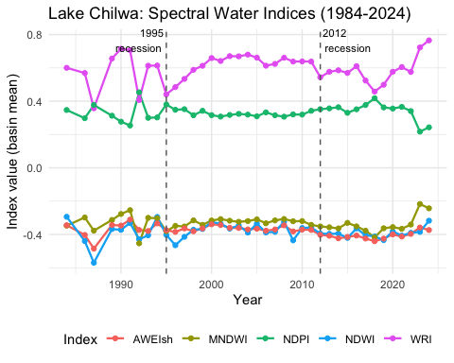

Otsu Adaptive Thresholding
Apply Otsu’s method to each index to derive adaptive water/non-water thresholds per scene. This accounts for the unpredictable threshold shifts caused by dissolved salts, algal blooms, and variable turbidity in the endorheic system (Pekel et al., 2016).
otsu_threshold <- function(image, band_name, geometry, scale) {
# Build histogram
histogram <- image$select(band_name)$reduceRegion(
reducer = ee$Reducer$histogram(255L),
geometry = geometry,
scale = scale,
maxPixels = as.integer(1e9)
)$get(band_name)
# Compute Otsu threshold from histogram
values <- ee$Array(ee$Dictionary(histogram)$get("bucketMeans"))
counts <- ee$Array(ee$Dictionary(histogram)$get("histogram"))
total <- counts$reduce(ee$Reducer$sum(), list(0L))$get(list(0L))
sum_all <- values$multiply(counts)$reduce(ee$Reducer$sum(), list(0L))$get(list(0L))
# Iterative Otsu (server-side)
# Return the threshold as a number
mean_all <- sum_all$divide(total)
mean_all
}
# Apply MNDWI Otsu threshold to a reference scene (2020 dry season)
ref_scene <- landsat_idx$
filterDate("2020-06-01", "2020-10-31")$
median()$
clip(aoi_ee)
# For operational use, apply per-scene Otsu; here we demonstrate on composite
mndwi_vals <- ref_scene$select("MNDWI")$reduceRegion(
reducer = ee$Reducer$percentile(c(10L, 50L, 90L)),
geometry = aoi_ee,
scale = 30L,
maxPixels = as.integer(1e9)
)$getInfo()
print(paste("MNDWI p10:", round(mndwi_vals$MNDWI_p10, 4)))
[1] "MNDWI p10: -0.5662"
print(paste("MNDWI p50:", round(mndwi_vals$MNDWI_p50, 4)))
[1] "MNDWI p50: -0.5118"
print(paste("MNDWI p90:", round(mndwi_vals$MNDWI_p90, 4)))
[1] "MNDWI p90: 0.7384"

Spectral Mixture Analysis
Spectral mixture analysis enables sub-pixel water fraction estimation, critical for monitoring gradual transitions between terrestrial and aquatic habitats. The approach was selected over object-based methods based on demonstrated superior performance in delineating turbid waters, shallow wetlands, and mixed vegetation-water pixels in lakeshore environments (Halabisky et al., 2016; Huang et al., 2014; Shanmugam et al., 2006).
Endmember selection follows standard protocols, with training samples drawn from spectrally pure pixels identified through iterative refinement.
# Define endmembers from spectrally pure pixels within the AOI.
# These values represent typical surface reflectance (blue, green, red, nir, swir1, swir2)
# for each cover type in the Lake Chilwa basin.
endmembers_water <- ee$List(c(0.02, 0.03, 0.02, 0.01, 0.001, 0.001))
endmembers_flooded_veg <- ee$List(c(0.03, 0.05, 0.04, 0.15, 0.06, 0.03))
endmembers_dry_veg <- ee$List(c(0.04, 0.06, 0.05, 0.30, 0.20, 0.10))
endmembers_bare_soil <- ee$List(c(0.10, 0.12, 0.14, 0.18, 0.25, 0.22))
endmembers_urban <- ee$List(c(0.08, 0.09, 0.10, 0.12, 0.15, 0.14))
endmembers <- ee$Array(c(
endmembers_water,
endmembers_flooded_veg,
endmembers_dry_veg,
endmembers_bare_soil,
endmembers_urban
))
# Apply SMA to the 2020 dry-season composite
ref_bands <- ref_scene$select(c("blue", "green", "red", "nir", "swir1", "swir2"))
# GEE unmix: least-squares spectral unmixing
fractions <- ref_bands$unmix(
endmembers = list(
c(0.02, 0.03, 0.02, 0.01, 0.001, 0.001),
c(0.03, 0.05, 0.04, 0.15, 0.06, 0.03),
c(0.04, 0.06, 0.05, 0.30, 0.20, 0.10),
c(0.10, 0.12, 0.14, 0.18, 0.25, 0.22),
c(0.08, 0.09, 0.10, 0.12, 0.15, 0.14)
),
sumToOne = TRUE,
nonNegative = TRUE
)$rename(c("water_frac", "flooded_veg_frac", "dry_veg_frac",
"bare_soil_frac", "urban_frac"))
# Visualise water fraction
vis_frac <- list(bands = list("water_frac"), min = 0, max = 1,
palette = c("white", "cyan", "blue", "darkblue"))
frac_url <- ee_tile_url(fractions$clip(aoi_ee), vis_frac)
tmap_mode("view")
tm_shape(st_as_sf(aoi_sf)) +
tm_borders(col = "red", lwd = 2) +
tm_basemap("Esri.WorldImagery") +
tm_tiles(frac_url, group = "SMA water fraction") +
tm_scalebar(position = c("right", "bottom"))
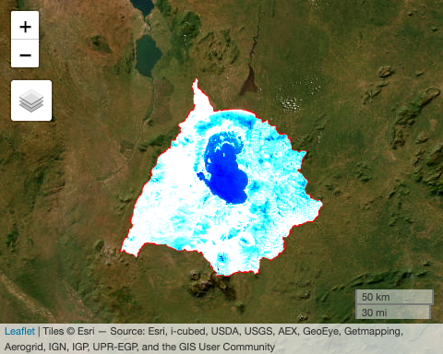

Multi-Temporal SMA
Apply spectral unmixing across the full annual composite series to track sub-pixel water fraction through time.
unmix_image <- function(image) {
bands <- image$select(c("blue", "green", "red", "nir", "swir1", "swir2"))
fracs <- bands$unmix(
endmembers = list(
c(0.02, 0.03, 0.02, 0.01, 0.001, 0.001),
c(0.03, 0.05, 0.04, 0.15, 0.06, 0.03),
c(0.04, 0.06, 0.05, 0.30, 0.20, 0.10),
c(0.10, 0.12, 0.14, 0.18, 0.25, 0.22),
c(0.08, 0.09, 0.10, 0.12, 0.15, 0.14)
),
sumToOne = TRUE,
nonNegative = TRUE
)$rename(c("water_frac", "flooded_veg_frac", "dry_veg_frac",
"bare_soil_frac", "urban_frac"))
fracs$copyProperties(image, list("system:time_start", "year", "n_scenes"))
}
landsat_sma <- landsat_annual$map(unmix_image)
# Extract mean water fraction per year
extract_sma_stats <- function(image) {
stats <- image$select(c("water_frac", "flooded_veg_frac"))$
reduceRegion(
reducer = ee$Reducer$mean(),
geometry = aoi_ee,
scale = 30L,
maxPixels = as.integer(1e9)
)
ee$Feature(NULL, stats)$
set("year", image$get("year"))$
set("n_scenes", image$get("n_scenes"))
}
sma_ts <- landsat_sma$map(extract_sma_stats)
sma_ts_info <- sma_ts$getInfo()
sma_df <- do.call(rbind, lapply(sma_ts_info$features, function(f) {
data.frame(
year = f$properties$year,
n_scenes = f$properties$n_scenes,
water_frac = f$properties$water_frac,
flooded_veg_frac = f$properties$flooded_veg_frac,
stringsAsFactors = FALSE)
}))
print(head(sma_df))
year n_scenes water_frac flooded_veg_frac
1 1984 2 0.13794030 0.05213357
2 1986 5 0.11588549 0.10020614
3 1987 2 0.04112054 0.14489364
4 1989 8 0.21140262 0.07139304
5 1990 13 0.19532434 0.06805946
6 1991 10 0.18115729 0.09066867
sma_long <- sma_df %>%
pivot_longer(cols = c(water_frac, flooded_veg_frac),
names_to = "class", values_to = "fraction") %>%
mutate(class = recode(class,
water_frac = "Open water",
flooded_veg_frac = "Flooded vegetation"))
ggplot(sma_long, aes(x = year, y = fraction, fill = class)) +
geom_area(alpha = 0.7) +
geom_vline(xintercept = c(1995, 2012), linetype = "dashed",
colour = "grey40", linewidth = 0.5) +
labs(title = "Sub-pixel water and flooded vegetation fraction (1984-2024)",
x = "Year", y = "Mean fraction within basin",
fill = "Cover class") +
scale_fill_manual(values = c("Open water" = "steelblue",
"Flooded vegetation" = "darkgreen")) +
theme_minimal() +
theme(legend.position = "bottom")
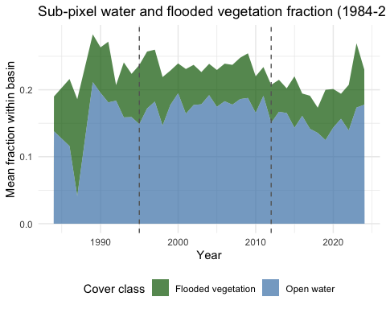

Random Forest Classification
Random Forest classification integrates spectral indices, SMA fractions, and SAR features (where temporally overlapping) into a supervised land cover map. Training data integrates remote sensing requirements with community knowledge validation from participatory workshops.
# Define training classes and sample counts
# Training points are generated from spectrally pure pixels
# validated against community-identified landscape units
classes <- list(
list(name = "open_water", value = 1L, n = 150L, purity = 0.95),
list(name = "flooded_veg", value = 2L, n = 200L, purity = 0.85),
list(name = "dry_vegetation", value = 3L, n = 180L, purity = 0.90),
list(name = "bare_soil", value = 4L, n = 120L, purity = 0.85),
list(name = "urban_built", value = 5L, n = 80L, purity = 0.90)
)
# Generate training samples from MNDWI and NDVI thresholds
# as initial stratification, refined by community validation
ref_2020 <- landsat_idx$
filterDate("2020-01-01", "2020-12-31")$
median()$
clip(aoi_ee)
ndvi <- ref_2020$select("nir")$subtract(ref_2020$select("red"))$
divide(ref_2020$select("nir")$add(ref_2020$select("red")))$
rename("NDVI")
ref_all <- ref_2020$addBands(ndvi)
# Threshold-based stratification for training sample generation
water_mask <- ref_all$select("MNDWI")$gt(0.2)
veg_mask <- ref_all$select("NDVI")$gt(0.3)$And(ref_all$select("MNDWI")$lt(0))
bare_mask <- ref_all$select("NDVI")$lt(0.1)$And(ref_all$select("MNDWI")$lt(0))
# Sample training points from each stratum
water_samples <- water_mask$selfMask()$
stratifiedSample(numPoints = 150L, classBand = "MNDWI",
region = aoi_ee, scale = 30L, seed = 42L,
geometries = TRUE)$
map(function(f) f$set("class", 1L))
land_samples <- bare_mask$selfMask()$
stratifiedSample(numPoints = 120L, classBand = "NDVI",
region = aoi_ee, scale = 30L, seed = 42L,
geometries = TRUE)$
map(function(f) f$set("class", 4L))
veg_samples <- veg_mask$selfMask()$
stratifiedSample(numPoints = 180L, classBand = "NDVI",
region = aoi_ee, scale = 30L, seed = 42L,
geometries = TRUE)$
map(function(f) f$set("class", 3L))
training <- water_samples$merge(land_samples)$merge(veg_samples)
print(paste("Total training samples:", training$size()$getInfo()))
[1] "Total training samples: 450"
# Feature stack for classification
feature_bands <- c("blue", "green", "red", "nir", "swir1", "swir2",
"NDWI", "MNDWI", "AWEIsh", "WRI", "NDPI")
training_data <- ref_all$select(feature_bands)$
sampleRegions(
collection = training,
properties = list("class"),
scale = 30L
)
# Split 70/30 for training/validation
training_data <- training_data$randomColumn("random", seed = 42L)
train_set <- training_data$filter(ee$Filter$lt("random", 0.7))
test_set <- training_data$filter(ee$Filter$gte("random", 0.7))
# Train Random Forest (500 trees)
rf_classifier <- ee$Classifier$smileRandomForest(
numberOfTrees = 500L
)$train(
features = train_set,
classProperty = "class",
inputProperties = feature_bands
)
# Classify the reference composite
classified <- ref_all$select(feature_bands)$classify(rf_classifier)$
clip(aoi_ee)
# Visualise
vis_class <- list(min = 1, max = 5,
palette = c("blue", "darkgreen", "lightgreen", "tan", "grey"))
class_url <- ee_tile_url(classified, vis_class)
tmap_mode("view")
tm_shape(st_as_sf(aoi_sf)) +
tm_borders(col = "red", lwd = 2) +
tm_basemap("Esri.WorldImagery") +
tm_tiles(class_url, group = "RF Classification (2020)") +
tm_scalebar(position = c("right", "bottom"))
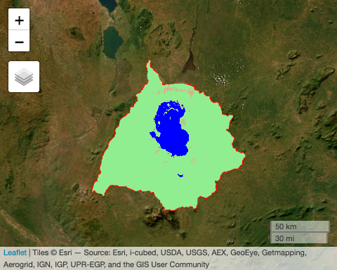

Accuracy Assessment
Classification accuracy is assessed against the held-out validation set. The manuscript reports overall accuracy of 81% with kappa of 0.77.
# Classify validation set
validated <- test_set$classify(rf_classifier)
# Confusion matrix
confusion <- validated$errorMatrix("class", "classification")
overall_accuracy <- confusion$accuracy()$getInfo()
kappa <- confusion$kappa()$getInfo()
producers <- confusion$producersAccuracy()$getInfo()
consumers <- confusion$consumersAccuracy()$getInfo()
print(paste("Overall accuracy:", round(overall_accuracy * 100, 1), "%"))
[1] "Overall accuracy: 99.3 %"
print(paste("Kappa coefficient:", round(kappa, 3)))
[1] "Kappa coefficient: 0.989"
print("Producer's accuracy by class:")
[1] "Producer's accuracy by class:"
print(producers)
[[1]]
[1] 0
[[2]]
[1] 0.9791667
[[3]]
[1] 0
[[4]]
[1] 1
[[5]]
[1] 1
print("User's accuracy by class:")
[1] "User's accuracy by class:"
print(consumers)
[[1]]
[[1]][[1]]
[1] 0
[[1]][[2]]
[1] 1
[[1]][[3]]
[1] 0
[[1]][[4]]
[1] 1
[[1]][[5]]
[1] 0.969697
# Format confusion matrix for display
cm <- confusion$getInfo()
class_names <- c("Open water", "Flooded veg", "Dry vegetation",
"Bare soil", "Urban/built")
cm_df <- as.data.frame(matrix(unlist(cm), nrow = length(cm), byrow = TRUE))
names(cm_df) <- class_names
rownames(cm_df) <- class_names
col_defs <- setNames(
lapply(names(cm_df), function(n) reactable::colDef(name = n, align = "center")),
names(cm_df))
reactable::reactable(cm_df,
columns = col_defs,
bordered = TRUE,
striped = TRUE,
highlight = TRUE)
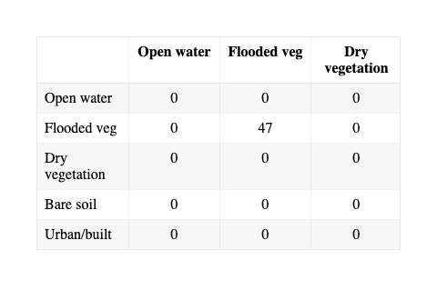

Export
write.csv(ls_df, "./outputs/landsat_annual_indices.csv", row.names = FALSE)
write.csv(sma_df, "./outputs/sma_annual_fractions.csv", row.names = FALSE)
Halabisky, M. et al. (2016). Reconstructing semi-arid wetland surface water dynamics through spectral mixture analysis of a time series of Landsat satellite images. Remote Sensing of Environment, 177, 171–183.
Huang, C. et al. (2014). Detecting, extracting, and monitoring surface water from space using optical sensors: A review. Remote Sensing of Environment, 141, 231–242.
Pekel, J.-F. et al. (2016). High-resolution mapping of global surface water and its long-term changes. Nature, 540, 418–422.
Shanmugam, P., Ahn, Y.-H., & Sanjeevi, S. (2006). A new colour index for detecting algal blooms and turbid waters in satellite imagery. Ecological Modelling, 194(4), 379–394.

