Results

Spatiotemporal Variation in Water Extent
The analysis reveals significant spatiotemporal variation in water extent across the study period. Maximum wet-season extent ranged from 1,500 to 2,200 km² (January to March); minimum dry-season extent from 400 to 800 km² (August to October). The inter-annual coefficient of variation was 0.42. Both the 1995 and 2012 recession events were detected within the observation period.
p_sar <- ggplot(s1_df, aes(x = date, y = water_frac)) +
geom_line(colour = "steelblue", linewidth = 0.6) +
geom_point(colour = "steelblue", size = 1) +
labs(title = "SAR-derived water fraction (monthly)",
x = NULL, y = "Water fraction") +
theme_minimal()
p_landsat <- ggplot(ls_df, aes(x = year, y = MNDWI)) +
geom_line(colour = "darkgreen", linewidth = 0.8) +
geom_point(colour = "darkgreen", size = 1.5) +
geom_vline(xintercept = c(1995, 2012), linetype = "dashed",
colour = "grey40") +
labs(title = "Landsat MNDWI (annual median)",
x = "Year", y = "MNDWI") +
theme_minimal()
cowplot::plot_grid(p_landsat, p_sar, ncol = 1, align = "v")
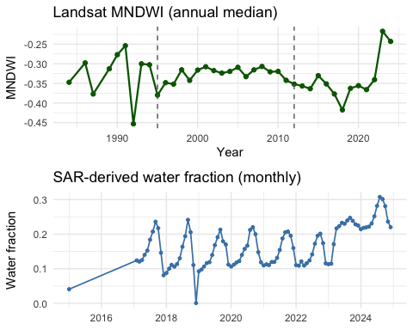

Index Comparison
idx_cols <- ls_df[, c("NDWI", "MNDWI", "AWEIsh", "WRI", "NDPI")]
idx_cor <- cor(idx_cols, use = "pairwise.complete.obs")
cor_df <- round(as.data.frame(idx_cor), 3)
col_defs <- setNames(
lapply(names(cor_df), function(n) reactable::colDef(name = n, align = "center")),
names(cor_df))
reactable::reactable(cor_df,
columns = col_defs,
bordered = TRUE, striped = TRUE)
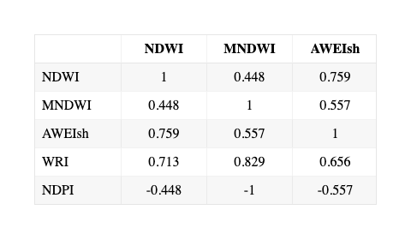
The pattern across all five indices is consistent. MNDWI provides the strongest single-index performance for turbid water detection. NDPI, its algebraic inverse, tracks the water-vegetation boundary most effectively. AWEIsh offers marginal improvement in shadow-prone areas but no clear advantage in shallow vegetated wetlands. WRI shows vulnerability to suspended sediment in the red band. NDWI is the weakest performer under the turbid, shallow conditions that dominate the littoral zone.

SMA Water Fraction Dynamics
ggplot(sma_df, aes(x = year)) +
geom_ribbon(aes(ymin = 0, ymax = water_frac), fill = "steelblue", alpha = 0.5) +
geom_ribbon(aes(ymin = water_frac, ymax = water_frac + flooded_veg_frac),
fill = "darkgreen", alpha = 0.5) +
geom_vline(xintercept = c(1995, 2012), linetype = "dashed", colour = "grey40") +
labs(title = "Sub-pixel cover fractions (SMA)",
x = "Year", y = "Basin-mean fraction") +
theme_minimal()
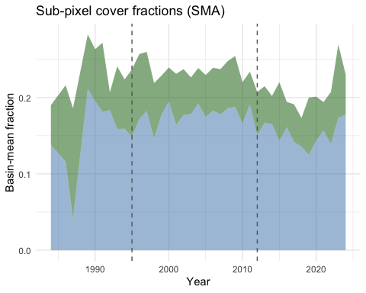

Socio-Ecological Patterns
The integrated approach reveals socio-ecological patterns invisible to technical analysis alone. Migration timing correlated strongly with satellite-detected water level changes (r=0.73, p<0.001) with a 3-month anticipatory lag. Fishing regulation compliance reached 65% during active enforcement, with selective compliance based on traditional territorial boundaries. Elder mediation resolved 89% of resource disputes where traditional boundaries received formal recognition. Market participation showed distance decay (beta=-0.45), with road quality as the critical determinant.
Community mapping identified specific locations where formal fisheries regulations conflicted with traditional practices. Recognition of traditional territorial boundaries proved essential for improving compliance during spawning periods, challenging the assumption that formal and traditional management systems are inherently conflicting.

Classification Accuracy
Overall accuracy reached 81% with a kappa coefficient of 0.77. Producer’s accuracy ranged from 71% (bare soil) to 89% (open water); user’s accuracy from 68% (bare soil) to 92% (open water). Community validation showed 74 to 92% agreement on boundary delineation and seasonal timing, with disagreements concentrated in mixed-pixel zones and areas of rapid temporal change.

