Monte Carlo Simulation Tools for REDD+ Uncertainty Estimates

Tentative workflow and toolset for estimating uncertainty using Monte Carlo simulation

2024-12-19

## Environment setup

# some parent packages need github sourcing   
#install.packages(c("glue","remotes"))  
#remotes::install_github("ropensci/allodb")   
  
# note: warning messages turned off for this setup chunk  
easypackages::packages(  
 "animation", "BIOMASS", "caret", "dataMaid", "DescTools", "dplyr",  
 "extrafont", "FawR", "ForestToolsRS", "ggplot2", "htmltools",  
 "janitor", "jsonlite", "lattice", "kableExtra", "kernlab",  
 "knitr", "Mlmetrics", "olsrr", "plotly", "psych", "RColorBrewer",  
 "rmarkdown", "readxl", "solarizeddox", "tibble", "tidymodels", "tidyverse",  
 "tinytex", "tune", "useful", "webshot", "webshot2",  
 prompt = F  
 )

## Error in contrib.url(repos, type) :   
## trying to use CRAN without setting a mirror  
## Error in contrib.url(repos, type) :   
## trying to use CRAN without setting a mirror  
## Error in contrib.url(repos, type) :   
## trying to use CRAN without setting a mirror  
## Error in contrib.url(repos, type) :   
## trying to use CRAN without setting a mirror

knitr::opts_chunk$set(  
 echo = TRUE,   
 message = FALSE,   
 warning = FALSE,  
 error = FALSE,   
 comment = NA,   
 tidy.opts = list(width.cutoff = 60)  
)  
  
options(htmltools.dir.version = FALSE, htmltools.preserve.raw = FALSE)  
sf::sf_use_s2(use_s2 = FALSE)

## Introduction

The ART-TREES Standard V2.01cites methodological requirements for calculating uncertainty in emission factors and activity data, ensuring robust assessment and reporting of accuracy and model bias. Contracted with the project **Guyana 10026.DRCT.00000.00000**, the Guyana team will provide the following deliverables:

**Monte Carlo Simulation for Uncertainty Estimation**

* Develop Monte Carlo simulation pathways to quantify uncertainty in emission factors and activity data, ensuring consistency with ART-TREES’s emphasis on robust uncertainty analysis and corrective bias assessment.
* Use R or other software to create systems that streamline data workflows and enhance accessibility for MRV purposes. Monte Carlo Simulation for Uncertainty Estimation
* Document methodologies and provide results in formats compliant with ART-TREES reporting standards.

**Reporting and Training Materials**

* Prepare technical reports that detail uncertainty estimation methods and database management workflows.
* Develop and deliver training materials to strengthen stakeholder capacity to use ART-TREES-aligned tools and methodologies.

### ART Requirements for Monte Carlo Methods

To reduce risk of over-crediting, the TREES 2.0 Standard (August 2021)1 outlines requirements for reporting uncertainty in emissions and removals, and adjusting estimates where uncertainty levels exceed the defined threshold of a half-width of a 90% confidence interval between the upper and lower bounds (Relative RMSE ≤ 10%). Monte Carlo simulations are identified as an appropriate methodology due to their capacity to model variance and provide conservative estimates from large-scale higly-variable datasets. Specifically, “Monte Carlo simulations shall use the 90% confidence interval and a simulation n of 10,000” (p.45).

**Aggregation of Uncertainty Across Crediting Periods**  
The TREES Standard provides a level of flexibility in allowing participants to aggregate uncertainty deductions across multiple crediting periods. At the end of each crediting period, participants may calculate a consolidated uncertainty deduction based on the summed gross emissions reductions and removals achieved over their entire ART participation. If prior uncertainty deductions exceeded the aggregated deduction sum for the total period, the over-deducted credits will be issued into the participant’s registry account. This approach aims to incentivize participants to refine data quality and uncertainty estimates.

**Exemption for Allometric Estimates**  
An exemption from requirements for Monte Carlo simulations is granted to allometric modeled estimates. The TREES Standards V2.0 states that “such errors are considered consistent between emissions in the crediting level and crediting periods” which therefore do not materially influence the net results.

**Inclusion of Biomass Map Uncertainty**  
Conversely, uncertainty must be assessed and reported for emissions factors derived from biomass maps, as these datasets directly impact the accuracy of emission estimates. TREES participants are encouraged to adopt best practices, such as those outlined in the CEOS LPV Biomass Protocol 2021, to enhance calibration, validation, and reliability of spatially explicit datasets. In this guidance document, key recommendations for good practices include appropriate scaling, temporally & spatially consistent reference data and remote sensing, and the use of approved error metrics (90% CI or RMSE). In particular, three likely sources of uncertainty in biomass estimation are highlighted separately for consideration in assessing and calibrating predictions2.

* Measurement Uncertainty in tree measurements (i.e DBH and height).
* Allometric Model Errors in statistically inferring biomass from from tree measurements
* Sampling & Spatial Uncertainty arising from autocorrelation & over-fitting

**Calculating Uncertainty Deductions**  
Cited on page 46 of the TREES Standards V2.0, calculations of uncertainty deductions are derived using the following formulae:

**EQ 10**

Table 1: Parameters used in Equation 10

|  |  |
| --- | --- |
|  | Uncertainty deduction for year () |
|  | Gross greenhouse gas emissions reductions for year () |
|  | Gross greenhouse gas removals for year () |
|  | The uncertainty adjustment factor for year |

**EQ 11**

The uncertainty adjustment factor () quantifies the proportional adjustment to emissions reductions and removals based on statistical uncertainty. It is defined as:

Table 2: Parameters used in Equation 11

|  |  |
| --- | --- |
|  | The half-width of 90% confidence interval as percentage of mean |
|  | value for a 90% confidence interval |
|  | A scaling constant to adjust the proportion. |

### Current Methods

In Appendix I, annotated results are presented from a rapid literature review of current methodologies and discussions of Monte Carlo simulations of biomass estimations used in REDD+ studies and programs. The search was conducted using keywords including “Monte Carlo simulations,” “biomass estimation,” “carbon stock uncertainty,” and “REDD+ projects”. Variants and combinations of these terms, including “forest carbon accounting” and “allometric uncertainty,” were also explored. Data sources were visited among Scopus, Web of Science, and Google Scholar,and specialized journals in forestry, remote sensing, and carbon management. The temporal window of the review focused on studies published in the last two decades (2003–2023), reflecting the period during which Monte Carlo methods gained prominence in forest biomass estimation and REDD+ research evolved into a critical global framework. Additional attention was given to high-impact reviews and meta-analyses that provide state-of-the-art evaluations of the field.

Table 3: Search parameters used in a review of Monte Carlo tools in REDD+ reporting.

| **Parameter** | **Description** |
| --- | --- |
| **Keywords** | Monte Carlo simulations |
|  | Biomass estimation |
|  | Carbon stock uncertainty |
|  | REDD+ projects |
|  | Forest carbon accounting |
|  | Allometric uncertainty |
| **Data Sources** | Scopus |
|  | Web of Science |
|  | Google Scholar |
|  | Grey Literature from REDD+ working groups (i.e. UNFCCC, IPCC) |
| **Temporal Window** | 2003–2023 |
| **Focus Areas** | Applications of Monte Carlo simulations in biomass and carbon stock estimations. |
|  | Addressing uncertainty in input data (e.g., allometric equations, plot-level measurements). |
|  | Integration of Monte Carlo methods in REDD+ policy frameworks and carbon accounting. |
| **Inclusion Criteria** | Peer-reviewed articles and high-impact reviews |
|  | Case studies and empirical research involving REDD+ projects. |
|  | Discussions of methodological advancements or critiques of Monte Carlo approaches. |

Table 4: Results of a review of literature on Monte Carlo methodologies in REDD+ projects.

| **REDD+ scheme**[1] | **Monte Carlo applied** | **Region** | **Key Findings** | **Ref** |
| --- | --- | --- | --- | --- |
| ADD | Uncertainty of SAAB estimate | Rondônia, Brazil | Estimated ± 20% measurement error in SAAB using Monte Carlo simulations; emphasized large trees’ role in biomass. | 3 |
| ADD | AGB Uncertainty | Kenya, Mozambique | Assessed mixed-effects models in estimating mangrove biomass. | 4 |
| ADD | Blanket uncertainty propagation | Ghana | AGB prediction error >20%; addressed error propagation from trees to pixels in remote sensing. | 5 |
| ADD | Plot-based uncertainty | New Zealand | Cross-plot variance greatest magnitude of uncertainty | 6 |
| JNR | Multi-scale AGB uncertainty modeling | Minnesota, USA | Cross-scale tests showing effects of spatial resolution on AGB uncertainty. | 7 |
| NA | Allometric uncertainty modeling | Panama | Allometric models identified as largest source of biomass estimation error. | 8 |
| ADD | Sampling and allometric uncertainty | Tapajos Nat Forest, Brazil | Significance of allometric models on uncertainty of root biomass, 95% CI, 21 plots. | 9 |
| ADD | Uncertainty of volume estimates | Santa Catarina, Brazil | Negligible effects of residual uncertainty on large-area estimates | 10 |
|  |  |  |  | 11 |
|  |  |  |  | 12 |
|  |  |  |  | 13 |
|  |  |  |  | 14 |

315 86 910 1611 1213 14

### SimVoi Design & Limitations

* Details of the design and parameters of the existing excel tool are available [here](https://www.artredd.org/wp-content/uploads/2021/12/MC-4-estimating-ER-from-forests-update-1-1.xlsx) and [here](https://winrock.org/wp-content/uploads/2018/02/UncertaintyReport-12.26.17.pdf?utm_source=chatgpt.com).

## Demonstration script

### Import data

This section outlines the tools for importing and preparing forestry and biomass data for analysis, a key step in building ART-TREES-compliant MRV systems. Using the allodb package, we load a global allometry database and a dummy dataset from the Smithsonian Institute ForestGEO project.

library("allodb") # https://docs.ropensci.org/allodb/  
set.seed(333)  
#data(ufc) # spuRs::vol.m3(dataset$dbh.cm, dataset$height.m, multiplier = 0.5)  
data(scbi_stem1)  
dataset = scbi_stem1  
head(dataset) |> tibble::as_tibble()

# A tibble: 6 × 6  
 treeID stemID dbh genus species Family   
 <int> <int> <dbl> <chr> <chr> <chr>   
1 2695 2695 1.41 Acer negundo Sapindaceae  
2 1229 38557 1.67 Acer negundo Sapindaceae  
3 1230 1230 1.42 Acer negundo Sapindaceae  
4 1295 32303 1.04 Acer negundo Sapindaceae  
5 1229 32273 2.47 Acer negundo Sapindaceae  
6 66 31258 2.19 Acer negundo Sapindaceae

psych::describe(dataset)

vars n mean sd median trimmed mad min max  
treeID 1 2287 2778.66 1929.26 2525.00 2705.54 2091.95 1 6207.00  
stemID 2 2287 16577.12 16197.88 5022.00 15661.27 5749.52 1 40180.00  
dbh 3 2287 5.52 10.80 1.67 2.65 0.79 1 92.02  
genus* 4 2287 16.37 6.52 18.00 16.71 0.00 1 31.00  
species* 5 2287 13.26 9.60 8.00 11.31 0.00 1 40.00  
Family* 6 2287 13.07 4.02 13.00 13.33 0.00 1 22.00  
 range skew kurtosis se  
treeID 6206.00 0.27 -1.11 40.34  
stemID 40179.00 0.40 -1.75 338.71  
dbh 91.02 3.81 16.30 0.23  
genus* 30.00 -0.57 0.14 0.14  
species* 39.00 1.59 1.30 0.20  
Family* 21.00 -0.58 1.44 0.08

str(dataset)

tibble [2,287 × 6] (S3: tbl_df/tbl/data.frame)  
 $ treeID : int [1:2287] 2695 1229 1230 1295 1229 66 2600 4936 1229 1005 ...  
 $ stemID : int [1:2287] 2695 38557 1230 32303 32273 31258 2600 4936 36996 1005 ...  
 $ dbh : num [1:2287] 1.41 1.67 1.42 1.04 2.47 ...  
 $ genus : chr [1:2287] "Acer" "Acer" "Acer" "Acer" ...  
 $ species: chr [1:2287] "negundo" "negundo" "negundo" "negundo" ...  
 $ Family : chr [1:2287] "Sapindaceae" "Sapindaceae" "Sapindaceae" "Sapindaceae" ...

Tables 1-3: Smithsonian Institute GEOForest dataset from allodb package (n = 2287)

## Probability density functions

Accurate selection of probability density functions (PDFs) is essential for modeling uncertainties in carbon stocks and activity data. This section describes methodologies for fitting PDFs to data, ensuring results are robust and aligned with ART-TREES best practices.

* Use of statistical tests for goodness-of-fit validation.
* Integration of domain expertise to refine parameter selection.

# add allometry database  
data(equations)  
data("equations_metadata")  
show_cols = c("equation_id", "equation_taxa", "equation_allometry")  
eq_tab_acer = new_equations(subset_taxa = "Acer")  
head(eq_tab_acer[, show_cols])

# A tibble: 6 × 3  
 equation_id equation_taxa equation_allometry   
 <chr> <chr> <chr>   
1 a4e4d1 Acer saccharum exp(-2.192-0.011*dbh+2.67*(log(dbh)))   
2 dfc2c7 Acer rubrum 2.02338*(dbh^2)^1.27612   
3 eac63e Acer rubrum 5.2879*(dbh^2)^1.07581   
4 f49bcb Acer pseudoplatanus exp(-5.644074+(2.5189*(log(pi*dbh))))   
5 14bf3d Acer mandshuricum 0.0335*(dbh)^1.606+0.0026*(dbh)^3.323+0.1222*…  
6 0c7cd6 Acer mono 0.0202*(dbh)^1.810+0.0111*(dbh)^2.740+0.1156*…

# Compute above ground biomass  
dataset$agb = allodb::get_biomass(  
 dbh = dataset$dbh,  
 genus = dataset$genus,  
 species = dataset$species,  
 coords = c(-78.2, 38.9)  
 )  
  
# examine dbh ~ agb function  
dbh_agb = lm(dbh ~ agb, data = dataset)  
#olsrr::ols_test_breusch_pagan(lm(dbh_agb)) #<0.0000  
#h = lattice::histogram(dbh ~ agb, data = dataset)  
plot(  
 x = dataset$dbh,  
 y = dataset$agb,  
 col = factor(scbi_stem1$genus),  
 xlab = "DBH (cm)",  
 ylab = "AGB (kg)"  
)  
  
# examine univariate distributions  
h1 = hist(dataset$dbh, breaks=10, col="red")  
xfit<-seq(min(dataset$dbh),max(dataset$dbh),length=40)  
yfit<-dnorm(xfit,mean=mean(dataset$dbh),sd=sd(dataset$dbh))  
yfit <- yfit*diff(h1$mids[1:2])*length(dataset$dbh)  
lines(xfit, yfit, col="blue", lwd=2)  
  
h2 = hist(dataset$agb, breaks=10, col="red")  
xfit<-seq(min(dataset$agb),max(dataset$agb),length=40)  
yfit<-dnorm(xfit,mean=mean(dataset$agb),sd=sd(dataset$agb))  
yfit <- yfit*diff(h2$mids[1:2])*length(dataset$agb)  
lines(xfit, yfit, col="blue", lwd=2)  
wilcox.test(dataset$dbh) # p<0.00001

Wilcoxon signed rank test with continuity correction  
  
data: dataset$dbh  
V = 2616328, p-value < 2.2e-16  
alternative hypothesis: true location is not equal to 0

wilcox.test(dataset$agb) # p<0.00001

Wilcoxon signed rank test with continuity correction  
  
data: dataset$agb  
V = 2616328, p-value < 2.2e-16  
alternative hypothesis: true location is not equal to 0

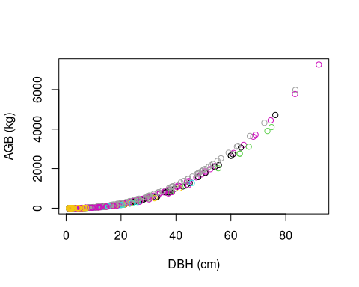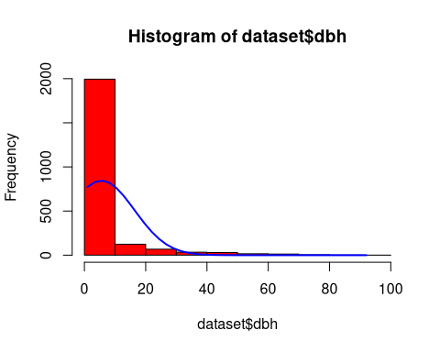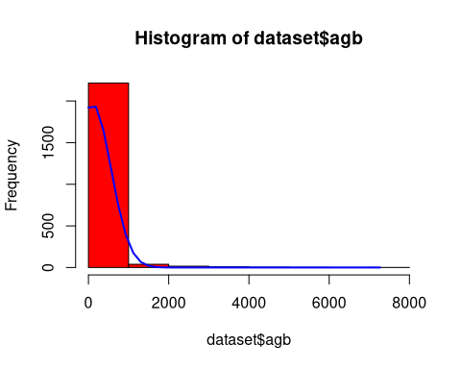

## Simulation Regime

This section introduces the design of the Monte Carlo simulation regime, including:

* Simulation parameters are defined to balance computational efficiency and statistical robustness.
* Cross-validation techniques are employed to evaluate model performance and identify bias or variance.

The LGOCV acronym used in the caret package functions below stands for “leave one group out cross validation”. We must select the % of test data that is set out from the build upon which the model will be repeatedly trained. Note, the following code applies functions to full dataset without explicit training-test split. **Questions remains on whether we require cross-validation uncertainty estimate to review internal bias, and whether we would like to develop Monte Carlo tools for spatial uncertainty used in Activity Data analysis**. For your consideration, the consultant has previously developed Monte Carlo tools for LULC applications, saved [here](https://github.com/seamusrobertmurphy/02-lulc-classification)

# Cross-validation split for bias detection  
#samples = caret::createDataPartition(dataset_tidy$volume, p = 0.80, list = FALSE)  
#train_data = dataset_tidy[samples, ]  
#test_data = dataset_tidy[-samples, ]  
  
# Simulation pattern & regime  
monte_carlo = trainControl(  
 method = "LGOCV",  
 number = 10, # number of simulations  
 p = 0.8) # percentage resampled  
  
  
# Training model fit with all covariates (".") & the simulation  
lm_monte_carlo = train(  
 data = dataset,   
 agb ~ .,   
 na.action = na.omit,  
 trControl = monte_carlo)  
  
lm_monte_carlo

Random Forest   
  
2287 samples  
 6 predictor  
  
No pre-processing  
Resampling: Repeated Train/Test Splits Estimated (10 reps, 80%)   
Summary of sample sizes: 1832, 1832, 1832, 1832, 1832, 1832, ...   
Resampling results across tuning parameters:  
  
 mtry RMSE Rsquared MAE   
 2 334.91964 0.5977225 114.373822  
 47 83.37237 0.9711580 14.009351  
 93 49.98649 0.9895214 8.593528  
  
RMSE was used to select the optimal model using the smallest value.  
The final value used for the model was mtry = 93.

## Plot residuals

To enable access to these predictions, we need to instruct caret to retain the resampled predictions by setting savePredictions = "final" in our trainControl() function. It’s important to be aware that if you’re working with a large dataset or numerous resampling iterations, the resulting train() object may grow significantly in size. This happens because caret must store a record of every row, including both the observed values and predictions, for each resampling iteration. By visualizing the results, we can offer insights into the performance of our model on the resampled data.

monte_carlo_viz = trainControl(  
 method = "LGOCV",   
 p = 0.8,   
 number = 1, # just for saving previous results  
 savePredictions = "final")   
  
lm_monte_carlo_viz = train(  
 agb ~ .,   
 data = dataset,   
 method = "lm",  
 na.action = na.omit,  
 trControl = monte_carlo_viz)  
  
head(lm_monte_carlo_viz$pred) # residuals

intercept pred obs rowIndex Resample  
1 TRUE -39.259595 0.2822055 2 Resample1  
2 TRUE -8.616432 0.7664882 5 Resample1  
3 TRUE -31.913620 0.5637806 6 Resample1  
4 TRUE -97.233363 0.1832042 10 Resample1  
5 TRUE 356.407185 161.5561844 20 Resample1  
6 TRUE 1393.945330 1095.2695394 22 Resample1

lm_monte_carlo_viz$pred |>   
 ggplot(aes(x=pred,y=obs)) +  
 geom_point(shape=1) +   
 geom_abline(slope=1, colour='blue') +  
 coord_obs_pred()

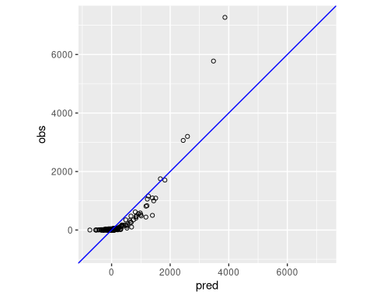

## Uncertainty Estimates

This section discusses the trade-offs and methodological choices in uncertainty estimation using Monte Carlo simulations. It aligns with ART-TREES principles by:

* Quantifying confidence intervals for emissions estimates.
* Addressing potential biases in the modeling process.
* Ensuring robustness in uncertainty reporting.

***Working Notes…***

References to key studies on cross-validation methods provide a theoretical foundation for the approach.**Monte Carlo cross-validation** (MCCV) involves randomly dividing the dataset into two parts: a training subset and a validation subset, without reusing data points. The model is trained on the training subset, denoted as ( n_t ), and assessed on the validation subset, ( n_v ). While there are ( ) distinct ways to form the training subsets, MCCV bypasses the computational burden of evaluating all these combinations by sampling a smaller number of iterations. Zhang

demonstrated that performing MCCV for ( N ) iterations yields results comparable to exhaustive cross-validation over all possible subsets. However, studies investigating MCCV for large dataset sizes (( N )) remain limited.

The trade-off between bias and variance in MCCV is influenced by the choice of ( k ) (iterations) and ( n_t ) (training subset size). Increasing ( k ) or ( n_t ) tends to reduce bias but increases variance. Larger training subsets lead to greater similarity across iterations, which can result in overfitting to the training data. For a deeper analysis, see

. The bias-variance characteristics of ( k )-fold cross-validation (kFCV) and MCCV differ, but their bias levels can be aligned by selecting appropriate values for ( k ) and ( n_t ). A detailed comparison of the bias and variance for both approaches can be found in

, where MCCV is referred to as the “repeated-learning testing-model.”

Monte Carlo Simulation in LULC Classification of Activity Data Assessment:

library(ForesToolboxRS)  
dir.create("./data/testdata")  
download.file("https://github.com/ytarazona/ft_data/raw/main/data/LC08_232066_20190727_SR.zip",destfile = "testdata/LC08_232066_20190727_SR.zip")  
unzip("testdata/LC08_232066_20190727_SR.zip", exdir = "testdata") download.file("https://github.com/ytarazona/ft_data/raw/main/data/signatures.zip", destfile = "testdata/signatures.zip")  
unzip("testdata/signatures.zip", exdir = "testdata")  
  
image <- stack("./data/testdata/LC08_232066_20190727_SR.tif")  
sig <- read_sf("./data/testdata/signatures.shp")  
classRF <- mla(img = image, model = "randomForest", endm = sig, training_split = 80)  
print(classRF)

# Classification  
colmap <- c("#0000FF","#228B22","#FF1493", "#00FF00")  
plot(classRF$Classification, main = "RandomForest Classification", col = colmap, axes = TRUE)

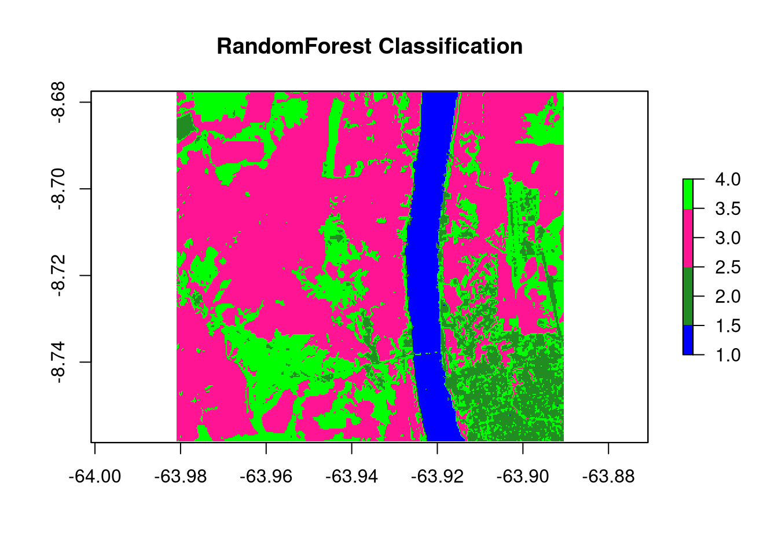

plot(  
 cal_ml$svm_mccv,  
 main = "Monte Carlo Cross-Validation calibration",  
 col = "darkmagenta",  
 type = "b",  
 ylim = c(0, 0.4),  
 ylab = "Error between 0 and 1",  
 xlab = "Number of iterations"  
)  
lines(cal_ml$randomForest_mccv, col = "red", type = "b")  
lines(cal_ml$naiveBayes_mccv, col = "green", type = "b")  
lines(cal_ml$knn_mccv, col = "blue", type = "b")  
legend(  
 "topleft",  
 c(  
 "Support Vector Machine",  
 "Random Forest",  
 "Naive Bayes",  
 "K-nearest Neighbors"  
 ),  
 col = c("darkmagenta", "red", "green", "blue"),  
 lty = 1,  
 cex = 0.7  
)

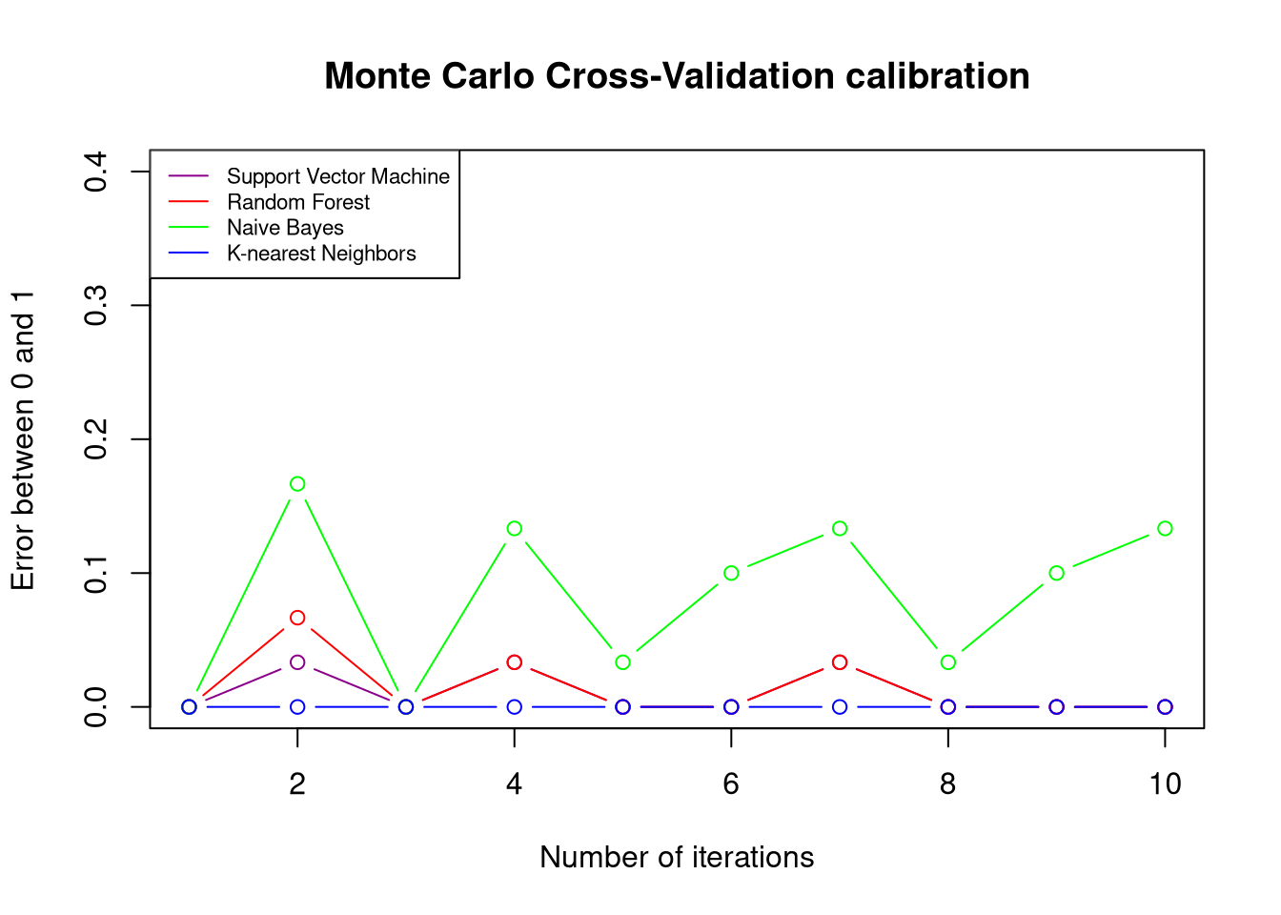

Burman, P. (1989). A comparative study of ordinary cross-validation, ( v )-fold cross-validation, and the repeated learning testing-model methods. *Biometrika*, **76**, 503–514.

Hastie, T., Tibshirani, R., & Friedman, J. (2011). *The Elements of Statistical Learning: Data Mining, Inference, and Prediction*. 2nd ed. New York: Springer.

Zhang, P. (1993). Model selection via multifold cross-validation. *Annals of Statistics*, **21**, 299–313.

### Runtime snapshot

devtools::session_info()

─ Session info ───────────────────────────────────────────────────────────────  
 setting value  
 version R version 4.4.2 (2024-10-31)  
 os Fedora Linux 40 (Workstation Edition)  
 system x86_64, linux-gnu  
 ui X11  
 language (EN)  
 collate en_CA.UTF-8  
 ctype en_CA.UTF-8  
 tz America/Vancouver  
 date 2024-12-19  
 pandoc 3.1.3 @ /usr/libexec/rstudio/bin/pandoc/ (via rmarkdown)  
  
─ Packages ───────────────────────────────────────────────────────────────────  
 package * version date (UTC) lib source  
 abind 1.4-8 2024-09-12 [2] CRAN (R 4.4.1)  
 allodb * 0.0.1.9000 2024-12-19 [1] Github (ropensci/allodb@4207f86)  
 animation * 2.7 2021-10-07 [2] CRAN (R 4.4.0)  
 assertthat 0.2.1 2019-03-21 [2] CRAN (R 4.4.0)  
 backports 1.5.0 2024-05-23 [2] CRAN (R 4.4.0)  
 BIOMASS * 2.1.11 2023-09-29 [2] CRAN (R 4.4.0)  
 boot 1.3-31 2024-08-28 [2] CRAN (R 4.4.1)  
 broom * 1.0.7 2024-09-26 [2] CRAN (R 4.4.1)  
 cachem 1.1.0 2024-05-16 [2] CRAN (R 4.4.0)  
 car 3.1-3 2024-09-27 [2] CRAN (R 4.4.1)  
 carData 3.0-5 2022-01-06 [2] CRAN (R 4.4.0)  
 caret * 7.0-1 2024-12-10 [2] CRAN (R 4.4.2)  
 cellranger 1.1.0 2016-07-27 [2] CRAN (R 4.4.0)  
 chromote 0.3.1 2024-08-30 [2] CRAN (R 4.4.1)  
 class 7.3-22 2023-05-03 [2] CRAN (R 4.4.0)  
 classInt 0.4-10 2023-09-05 [2] CRAN (R 4.4.0)  
 cli 3.6.3 2024-06-21 [2] CRAN (R 4.4.0)  
 codetools 0.2-20 2024-03-31 [2] CRAN (R 4.4.0)  
 colorspace 2.1-1 2024-07-26 [2] CRAN (R 4.4.1)  
 CoprManager 0.5.7 2024-10-31 [4] local  
 data.table 1.16.4 2024-12-06 [2] CRAN (R 4.4.2)  
 dataMaid * 1.4.1 2021-10-08 [2] CRAN (R 4.4.1)  
 DBI 1.2.3 2024-06-02 [2] CRAN (R 4.4.0)  
 DEoptimR 1.1-3-1 2024-11-23 [2] CRAN (R 4.4.2)  
 DescTools * 0.99.58 2024-11-08 [2] CRAN (R 4.4.1)  
 devtools 2.4.5 2022-10-11 [2] CRAN (R 4.4.0)  
 dials * 1.3.0 2024-07-30 [2] CRAN (R 4.4.1)  
 DiceDesign 1.10 2023-12-07 [2] CRAN (R 4.4.0)  
 digest 0.6.37 2024-08-19 [2] CRAN (R 4.4.1)  
 dplyr * 1.1.4 2023-11-17 [2] CRAN (R 4.4.0)  
 e1071 1.7-16 2024-09-16 [2] CRAN (R 4.4.1)  
 easypackages 0.1.0 2016-12-05 [2] CRAN (R 4.4.0)  
 ellipsis 0.3.2 2021-04-29 [2] CRAN (R 4.4.0)  
 evaluate 1.0.1 2024-10-10 [2] CRAN (R 4.4.1)  
 Exact 3.3 2024-07-21 [2] CRAN (R 4.4.1)  
 expm 1.0-0 2024-08-19 [2] CRAN (R 4.4.1)  
 extrafont * 0.19 2023-01-18 [2] CRAN (R 4.4.0)  
 extrafontdb 1.0 2012-06-11 [2] CRAN (R 4.4.0)  
 farver 2.1.2 2024-05-13 [2] CRAN (R 4.4.0)  
 fastmap 1.2.0 2024-05-15 [2] CRAN (R 4.4.0)  
 forcats * 1.0.0 2023-01-29 [2] CRAN (R 4.4.0)  
 foreach 1.5.2 2022-02-02 [2] CRAN (R 4.4.0)  
 Formula 1.2-5 2023-02-24 [2] CRAN (R 4.4.0)  
 fs 1.6.5 2024-10-30 [2] CRAN (R 4.4.1)  
 furrr 0.3.1 2022-08-15 [2] CRAN (R 4.4.0)  
 future 1.34.0 2024-07-29 [2] CRAN (R 4.4.1)  
 future.apply 1.11.3 2024-10-27 [2] CRAN (R 4.4.1)  
 generics 0.1.3 2022-07-05 [2] CRAN (R 4.4.0)  
 ggplot2 * 3.5.1 2024-04-23 [2] CRAN (R 4.4.0)  
 gld 2.6.6 2022-10-23 [2] CRAN (R 4.4.0)  
 globals 0.16.3 2024-03-08 [2] CRAN (R 4.4.0)  
 glue 1.8.0 2024-09-30 [2] CRAN (R 4.4.1)  
 goftest 1.2-3 2021-10-07 [2] CRAN (R 4.4.0)  
 gower 1.0.2 2024-12-17 [2] CRAN (R 4.4.2)  
 GPfit 1.0-8 2019-02-08 [2] CRAN (R 4.4.0)  
 gridExtra 2.3 2017-09-09 [2] CRAN (R 4.4.0)  
 gtable 0.3.6 2024-10-25 [2] CRAN (R 4.4.1)  
 hardhat 1.4.0 2024-06-02 [2] CRAN (R 4.4.0)  
 haven 2.5.4 2023-11-30 [2] CRAN (R 4.4.0)  
 hms 1.1.3 2023-03-21 [2] CRAN (R 4.4.0)  
 htmltools * 0.5.8.1 2024-04-04 [2] CRAN (R 4.4.0)  
 htmlwidgets 1.6.4 2023-12-06 [2] CRAN (R 4.4.0)  
 httpuv 1.6.15 2024-03-26 [2] CRAN (R 4.4.0)  
 httr 1.4.7 2023-08-15 [2] CRAN (R 4.4.0)  
 infer * 1.0.7 2024-03-25 [2] CRAN (R 4.4.0)  
 ipred 0.9-15 2024-07-18 [2] CRAN (R 4.4.1)  
 iterators 1.0.14 2022-02-05 [2] CRAN (R 4.4.0)  
 janitor * 2.2.0 2023-02-02 [2] CRAN (R 4.4.0)  
 jsonlite * 1.8.9 2024-09-20 [2] CRAN (R 4.4.1)  
 kableExtra * 1.4.0 2024-01-24 [2] CRAN (R 4.4.0)  
 kernlab * 0.9-33 2024-08-13 [2] CRAN (R 4.4.1)  
 KernSmooth 2.23-24 2024-05-17 [2] CRAN (R 4.4.0)  
 knitr * 1.49 2024-11-08 [2] CRAN (R 4.4.1)  
 labeling 0.4.3 2023-08-29 [2] CRAN (R 4.4.0)  
 later 1.4.1 2024-11-27 [2] CRAN (R 4.4.2)  
 lattice * 0.22-6 2024-03-20 [2] CRAN (R 4.4.0)  
 lava 1.8.0 2024-03-05 [2] CRAN (R 4.4.0)  
 lazyeval 0.2.2 2019-03-15 [2] CRAN (R 4.4.0)  
 lhs 1.2.0 2024-06-30 [2] CRAN (R 4.4.1)  
 lifecycle 1.0.4 2023-11-07 [2] CRAN (R 4.4.0)  
 listenv 0.9.1 2024-01-29 [2] CRAN (R 4.4.0)  
 lmom 3.2 2024-09-30 [2] CRAN (R 4.4.1)  
 lubridate * 1.9.4 2024-12-08 [2] CRAN (R 4.4.2)  
 magrittr 2.0.3 2022-03-30 [2] CRAN (R 4.4.0)  
 MASS 7.3-61 2024-06-13 [2] CRAN (R 4.4.0)  
 Matrix 1.7-1 2024-10-18 [2] CRAN (R 4.4.1)  
 memoise 2.0.1 2021-11-26 [2] CRAN (R 4.4.0)  
 mime 0.12 2021-09-28 [2] CRAN (R 4.4.0)  
 miniUI 0.1.1.1 2018-05-18 [2] CRAN (R 4.4.0)  
 minpack.lm 1.2-4 2023-09-11 [2] CRAN (R 4.4.0)  
 mnormt 2.1.1 2022-09-26 [2] CRAN (R 4.4.0)  
 modeldata * 1.4.0 2024-06-19 [2] CRAN (R 4.4.0)  
 ModelMetrics 1.2.2.2 2020-03-17 [2] CRAN (R 4.4.0)  
 munsell 0.5.1 2024-04-01 [2] CRAN (R 4.4.0)  
 mvtnorm 1.3-2 2024-11-04 [2] CRAN (R 4.4.1)  
 nlme 3.1-166 2024-08-14 [2] CRAN (R 4.4.1)  
 nnet 7.3-19 2023-05-03 [2] CRAN (R 4.4.0)  
 nortest 1.0-4 2015-07-30 [2] CRAN (R 4.4.0)  
 olsrr * 0.6.1 2024-11-06 [2] CRAN (R 4.4.1)  
 pander 0.6.5 2022-03-18 [2] CRAN (R 4.4.0)  
 parallelly 1.40.1 2024-12-04 [2] CRAN (R 4.4.2)  
 parsnip * 1.2.1 2024-03-22 [2] CRAN (R 4.4.0)  
 pillar 1.10.0 2024-12-17 [2] CRAN (R 4.4.2)  
 pkgbuild 1.4.5 2024-10-28 [2] CRAN (R 4.4.1)  
 pkgconfig 2.0.3 2019-09-22 [2] CRAN (R 4.4.0)  
 pkgload 1.4.0 2024-06-28 [2] CRAN (R 4.4.1)  
 plotly * 4.10.4 2024-01-13 [2] CRAN (R 4.4.0)  
 plyr 1.8.9 2023-10-02 [2] CRAN (R 4.4.0)  
 pROC 1.18.5 2023-11-01 [2] CRAN (R 4.4.0)  
 processx 3.8.4 2024-03-16 [2] CRAN (R 4.4.0)  
 prodlim 2024.06.25 2024-06-24 [2] CRAN (R 4.4.0)  
 profvis 0.4.0 2024-09-20 [2] CRAN (R 4.4.1)  
 promises 1.3.2 2024-11-28 [2] CRAN (R 4.4.2)  
 proxy 0.4-27 2022-06-09 [2] CRAN (R 4.4.0)  
 ps 1.8.1 2024-10-28 [2] CRAN (R 4.4.1)  
 psych * 2.4.6.26 2024-06-27 [2] CRAN (R 4.4.1)  
 purrr * 1.0.2 2023-08-10 [2] CRAN (R 4.4.0)  
 R6 2.5.1 2021-08-19 [2] CRAN (R 4.4.0)  
 randomForest 4.7-1.2 2024-09-22 [2] CRAN (R 4.4.1)  
 rappdirs 0.3.3 2021-01-31 [2] CRAN (R 4.4.1)  
 RColorBrewer * 1.1-3 2022-04-03 [2] CRAN (R 4.4.0)  
 Rcpp 1.0.13-1 2024-11-02 [2] CRAN (R 4.4.1)  
 readr * 2.1.5 2024-01-10 [2] CRAN (R 4.4.0)  
 readxl * 1.4.3 2023-07-06 [2] CRAN (R 4.4.0)  
 recipes * 1.1.0 2024-07-04 [2] CRAN (R 4.4.1)  
 remotes 2.5.0 2024-03-17 [2] CRAN (R 4.4.0)  
 reshape2 1.4.4 2020-04-09 [2] CRAN (R 4.4.0)  
 rlang 1.1.4 2024-06-04 [2] CRAN (R 4.4.0)  
 rmarkdown * 2.29 2024-11-04 [1] CRAN (R 4.4.2)  
 robustbase 0.99-4-1 2024-09-27 [2] CRAN (R 4.4.1)  
 rootSolve 1.8.2.4 2023-09-21 [2] CRAN (R 4.4.0)  
 rpart 4.1.23 2023-12-05 [2] CRAN (R 4.4.0)  
 rsample * 1.2.1 2024-03-25 [2] CRAN (R 4.4.0)  
 rstudioapi 0.17.1 2024-10-22 [2] CRAN (R 4.4.1)  
 Rttf2pt1 1.3.12 2023-01-22 [2] CRAN (R 4.4.0)  
 scales * 1.3.0 2023-11-28 [2] CRAN (R 4.4.0)  
 sessioninfo 1.2.2 2021-12-06 [2] CRAN (R 4.4.0)  
 sf 1.0-19 2024-11-05 [2] CRAN (R 4.4.2)  
 shiny 1.10.0 2024-12-14 [2] CRAN (R 4.4.2)  
 snakecase 0.11.1 2023-08-27 [2] CRAN (R 4.4.0)  
 solarizeddocx 0.0.1.9000 2024-12-20 [1] Github (tjmahr/solarizeddocx@8f82bf1)  
 stringi 1.8.4 2024-05-06 [2] CRAN (R 4.4.0)  
 stringr * 1.5.1 2023-11-14 [2] CRAN (R 4.4.0)  
 survival 3.8-3 2024-12-17 [2] CRAN (R 4.4.2)  
 svglite 2.1.3 2023-12-08 [2] CRAN (R 4.4.0)  
 systemfonts 1.1.0 2024-05-15 [2] CRAN (R 4.4.0)  
 terra 1.8-5 2024-12-12 [2] CRAN (R 4.4.2)  
 tibble * 3.2.1 2023-03-20 [2] CRAN (R 4.4.0)  
 tidymodels * 1.2.0 2024-03-25 [2] CRAN (R 4.4.0)  
 tidyr * 1.3.1 2024-01-24 [2] CRAN (R 4.4.0)  
 tidyselect 1.2.1 2024-03-11 [2] CRAN (R 4.4.0)  
 tidyverse * 2.0.0 2023-02-22 [2] CRAN (R 4.4.0)  
 timechange 0.3.0 2024-01-18 [2] CRAN (R 4.4.1)  
 timeDate 4041.110 2024-09-22 [2] CRAN (R 4.4.1)  
 tinytex * 0.54 2024-11-01 [2] CRAN (R 4.4.1)  
 tune * 1.2.1 2024-04-18 [2] CRAN (R 4.4.0)  
 tzdb 0.4.0 2023-05-12 [2] CRAN (R 4.4.0)  
 units 0.8-5 2023-11-28 [2] CRAN (R 4.4.0)  
 urlchecker 1.0.1 2021-11-30 [2] CRAN (R 4.4.0)  
 useful * 1.2.6.1 2023-10-24 [2] CRAN (R 4.4.0)  
 usethis 3.1.0 2024-11-26 [2] CRAN (R 4.4.2)  
 utf8 1.2.4 2023-10-22 [2] CRAN (R 4.4.0)  
 vctrs 0.6.5 2023-12-01 [2] CRAN (R 4.4.0)  
 viridisLite 0.4.2 2023-05-02 [2] CRAN (R 4.4.0)  
 webshot * 0.5.5 2023-06-26 [2] CRAN (R 4.4.0)  
 webshot2 * 0.1.1 2023-08-11 [2] CRAN (R 4.4.0)  
 websocket 1.4.2 2024-07-22 [2] CRAN (R 4.4.1)  
 withr 3.0.2 2024-10-28 [2] CRAN (R 4.4.1)  
 workflows * 1.1.4 2024-02-19 [2] CRAN (R 4.4.0)  
 workflowsets * 1.1.0 2024-03-21 [2] CRAN (R 4.4.0)  
 xfun 0.49 2024-10-31 [2] CRAN (R 4.4.1)  
 xml2 1.3.6 2023-12-04 [2] CRAN (R 4.4.0)  
 xtable 1.8-4 2019-04-21 [2] CRAN (R 4.4.0)  
 yaml 2.3.10 2024-07-26 [2] CRAN (R 4.4.1)  
 yardstick * 1.3.1 2024-03-21 [2] CRAN (R 4.4.0)  
  
 [1] /home/seamus/R/x86_64-redhat-linux-gnu-library/4.4  
 [2] /usr/local/lib/R/library  
 [3] /usr/lib64/R/library  
 [4] /usr/share/R/library  
  
──────────────────────────────────────────────────────────────────────────────

Sys.getenv()

CHROME_DESKTOP RStudio.desktop  
CLICOLOR_FORCE 1  
DBUS_SESSION_BUS_ADDRESS  
 unix:path=/run/user/1000/bus  
DEBUGINFOD_IMA_CERT_PATH  
 /etc/keys/ima:  
DEBUGINFOD_URLS https://debuginfod.fedoraproject.org/  
DESKTOP_SESSION gnome  
DISPLAY :0  
EARTHENGINE_ENV ./  
EARTHENGINE_PYTHON ./bin/python3  
EDITOR /usr/bin/nano  
GDK_BACKEND x11  
GDM_LANG en_CA.UTF-8  
GDMSESSION gnome  
GIO_LAUNCHED_DESKTOP_FILE  
 /usr/share/applications/rstudio.desktop  
GIO_LAUNCHED_DESKTOP_FILE_PID  
 21940  
GIT_ASKPASS rpostback-askpass  
GNOME_SETUP_DISPLAY :1  
HISTCONTROL ignoredups  
HISTSIZE 1000  
HOME /home/seamus  
HOSTNAME fedora  
INVOCATION_ID 327fbd2d502c443c915eb192d601d8cb  
JOURNAL_STREAM 9:206656  
LANG en_CA.UTF-8  
LD_LIBRARY_PATH /usr/lib64/R/lib:/usr/lib/jvm/jre/lib/server:/usr/lib64/R/lib:/usr/lib/jvm/jre/lib/server  
LESSOPEN ||/usr/bin/lesspipe.sh %s  
LN_S ln -s  
LOGNAME seamus  
MAIL /var/spool/mail/seamus  
MAKE make  
MANAGERPID 2148  
MEMORY_PRESSURE_WATCH /sys/fs/cgroup/user.slice/user-1000.slice/user@1000.service/app.slice/dbus-:1.2-org.gnome.Nautilus@2.service/memory.pressure  
MEMORY_PRESSURE_WRITE c29tZSAyMDAwMDAgMjAwMDAwMAA=  
MOZ_GMP_PATH /usr/lib64/mozilla/plugins/gmp-gmpopenh264/system-installed  
MPLENGINE tkAgg  
NO_AT_BRIDGE 1  
NOT_CRAN true  
ORIGINAL_XDG_CURRENT_DESKTOP  
 GNOME  
PAGER /usr/bin/less  
PATH /usr/bin:/home/seamus/.local/bin:/home/seamus/bin:/usr/local/bin:/usr/local/sbin:/usr/bin:/usr/sbin:/usr/libexec/quarto/bin:/usr/libexec/rstudio/bin/postback  
PKGLOAD_PARENT_TEMPDIR  
 /tmp/RtmpoWjcEE  
PWD /home/seamus/repos/monte-carlo-trees  
PYTHONIOENCODING utf-8  
QT_IM_MODULE ibus  
R_ARCH   
R_BROWSER /usr/bin/xdg-open  
R_BZIPCMD /usr/bin/bzip2  
R_CLI_HAS_HYPERLINK_IDE_HELP  
 true  
R_CLI_HAS_HYPERLINK_IDE_RUN  
 true  
R_CLI_HAS_HYPERLINK_IDE_VIGNETTE  
 true  
R_DOC_DIR /usr/share/doc/R  
R_GZIPCMD /usr/bin/gzip  
R_HOME /usr/lib64/R  
R_INCLUDE_DIR /usr/include/R  
R_LIBS /home/seamus/R/x86_64-redhat-linux-gnu-library/4.4:/usr/local/lib/R/library:/usr/lib64/R/library:/usr/share/R/library  
R_LIBS_SITE /usr/local/lib/R/site-library:/usr/local/lib/R/library:/usr/lib64/R/library:/usr/share/R/library  
R_LIBS_USER /home/seamus/R/x86_64-redhat-linux-gnu-library/4.4  
R_PAPERSIZE a4  
R_PAPERSIZE_USER a4  
R_PDFVIEWER /usr/bin/xdg-open  
R_PLATFORM x86_64-redhat-linux-gnu  
R_PRINTCMD   
R_RD4PDF times,inconsolata,hyper  
R_RUNTIME   
R_SESSION_TMPDIR /tmp/RtmpoWjcEE  
R_SHARE_DIR /usr/share/R  
R_STRIP_SHARED_LIB strip --strip-unneeded  
R_STRIP_STATIC_LIB strip --strip-debug  
R_TEXI2DVICMD /usr/bin/texi2dvi  
R_UNZIPCMD /usr/bin/unzip  
R_ZIPCMD /usr/bin/zip  
RETICULATE_MINICONDA_ENABLED  
   
RETICULATE_PYTHON_FALLBACK  
 /usr/bin/python3  
RMARKDOWN_MATHJAX_PATH  
 /usr/libexec/rstudio/resources/mathjax-27  
RMARKDOWN_PREVIEW_DIR /tmp/RtmpBbpCT1  
RS_LOG_LEVEL WARN  
RS_RPOSTBACK_PATH /usr/libexec/rstudio/bin/rpostback  
RS_SHARED_SECRET 00a07829-9f6c-4854-84ff-175daaf6e3f8  
RSTUDIO 1  
RSTUDIO_CHILD_PROCESS_PANE  
 render  
RSTUDIO_CLI_HYPERLINKS  
 true  
RSTUDIO_CONSOLE_COLOR 256  
RSTUDIO_CONSOLE_WIDTH 116  
RSTUDIO_DESKTOP_EXE /usr/libexec/rstudio/rstudio  
RSTUDIO_LONG_VERSION 2024.09.1+394  
RSTUDIO_PANDOC /usr/libexec/rstudio/bin/pandoc  
RSTUDIO_PROGRAM_MODE desktop  
RSTUDIO_SESSION_PID 62795  
RSTUDIO_SESSION_PORT 9763  
RSTUDIO_USER_IDENTITY seamus  
RSTUDIO_VERSION 2024.09.1.394  
RSTUDIOAPI_IPC_REQUESTS_FILE  
 /tmp/RtmpBbpCT1/rstudio-ipc-requests-f54b26e71e24.rds  
RSTUDIOAPI_IPC_RESPONSE_FILE  
 /tmp/RtmpBbpCT1/rstudio-ipc-response-f54b56eb406d.rds  
RSTUDIOAPI_IPC_SHARED_SECRET  
 1aff6de5-7dfc-45d8-a907-0e6753c9d2b4  
SED /usr/bin/sed  
SESSION_MANAGER local/unix:@/tmp/.ICE-unix/2347,unix/unix:/tmp/.ICE-unix/2347  
SHELL /bin/bash  
SHLVL 0  
SSH_AUTH_SOCK /run/user/1000/keyring/ssh  
SYSTEMD_EXEC_PID 18447  
TAR /usr/bin/gtar  
TERM xterm-256color  
TZDIR /usr/share/zoneinfo  
USER seamus  
USERNAME seamus  
WAYLAND_DISPLAY wayland-0  
XAUTHORITY /run/user/1000/.mutter-Xwaylandauth.0YW1Y2  
XDG_CURRENT_DESKTOP GNOME  
XDG_DATA_DIRS /home/seamus/.local/share/flatpak/exports/share:/var/lib/flatpak/exports/share:/usr/local/share/:/usr/share/  
XDG_MENU_PREFIX gnome-  
XDG_RUNTIME_DIR /run/user/1000  
XDG_SESSION_CLASS user  
XDG_SESSION_DESKTOP gnome  
XDG_SESSION_TYPE wayland  
XMODIFIERS @im=ibus  
ZOTERO_API YLGf46K04lL7uCAcolJ6V62G

.libPaths()

[1] "/home/seamus/R/x86_64-redhat-linux-gnu-library/4.4"  
[2] "/usr/local/lib/R/library"   
[3] "/usr/lib64/R/library"   
[4] "/usr/share/R/library"

(1) ART, S. *The REDD+ Environmental Excellence Standard*; 2021. <https://www.artredd.org/wp-content/uploads/2021/12/TREES-2.0-August-2021-Clean.pdf>.

(2) Duncanson, L.; Disney, M.; Armston, J.; Nickeson, J.; Minor, D.; Camacho, F. Aboveground Woody Biomass Product Validation Good Practices Protocol. **2021**. <https://doi.org/10.5067/DOC/CEOSWGCV/LPV/AGB.001>.

(3) Brown, I. F.; Foster Brown, I.; Martinelli, L. A.; Wayt Thomas, W.; Moreira, M. Z.; Cid Ferreira, C. A.; Victoria, R. A. Uncertainty in the Biomass of Amazonian Forests: An Example from Rondônia, Brazil. *Forest Ecology and Management* **1995**, *75* (1–3), 175–189. <https://doi.org/10.1016/0378-1127(94)03512-u>.

(4) Cohen, R.; Kaino, J.; Okello, J. A.; Bosire, J. O.; Kairo, J. G.; Huxham, M.; Mencuccini, M. Uncertainty to Estimates of Above-Ground Biomass for Kenyan Mangroves: A Scaling Procedure from Tree to Landscape Level. In *Forest ecology and management*; 2013; Vol. 310, pp 968–982. <https://doi.org/10.1016/j.foreco.2013.09.047>.

(5) Chen, Q.; Laurin, G. V.; Valentini, R. Uncertainty of Remotely Sensed Aboveground Biomass over an African Tropical Forest: Propagating Errors from Trees to Plots to Pixels. *Remote Sensing of Environment* **2015**, *160*, 134–143. <https://doi.org/10.1016/j.rse.2015.01.009>.

(6) Holdaway, R. J.; McNeill, S. J.; Mason, N. W. H.; Carswell, F. E. Propagating Uncertainty in Plot-Based Estimates of Forest Carbon Stock and Carbon Stock Change. *Ecosystems* **2014**, *17*, 627–640. <https://doi.org/10.1007/s10021-014-9749-5>.

(7) Chen, Q.; McRoberts, R. E.; Wang, C.; Radtke, P. J. Forest Aboveground Biomass Mapping and Estimation Across Multiple Spatial Scales Using Model-Based Inference. *Remote Sensing of Environment* **2016**, *184*, 350–360. <https://doi.org/10.1016/j.rse.2016.07.023>.

(8) Chave, J.; Condit, R.; Aguilar, S.; Hernandez, A.; Lao, S.; Perez, R. Error Propagation and Scaling for Tropical Forest Biomass Estimates. *Philosophical Transactions of the Royal Society of London. Series B: Biological Sciences* **2004**, *359* (1443), 409–420.

(9) Keller, M.; Palace, M.; Hurtt, G. Biomass Estimation in the Tapajos National Forest, Brazil. *Forest Ecology and Management* **2001**, *154*, 371–382.

(10) McRoberts, R. E.; Moser, P.; Oliveira, L. Z.; Vibrans, A. C. A General Method for Assessing the Effects of Uncertainty in Individual-Tree Volume Model Predictions on Large-Area Volume Estimates 222 with a Subtropical Forest Illustration. *Canadian Journal of Forest Research* **2015**, *45*.

(11) Melson, S. L.; Harmon, M. E.; Fried, J. S.; Domingo, J. B. Estimates of Live-Tree Carbon Stores in the Pacific Northwest Are Sensitive to Model Selection. *Carbon Balance and Management* **2011**, *6*, 2.

(12) Molto, Q.; Rossi, V.; Blanc, L. Error Propagation in Biomass Estimation in Tropical Forests. *Methods in Ecology and Evolution* **2013**, *4*, 175–183. <https://doi.org/10.1111/j.2041-210x.2012.00266.x>.

(13) Picard, N.; Bosela, F. B.; Rossi, V. Reducing the Error in Biomass Estimates Strongly Depends on Model Selection. *Annals of Forest Science* **2015**, *72* (6), 811–823. <https://doi.org/10.1007/s13595-014-0434-9>.

(14) Yanai, R. D.; Battles, J. J.; Richardson, A. D.; Blodgett, C. A.; Wood, D. M.; Rastetter, E. B. Estimating Uncertainty in Ecosystem Budget Calculations. *Ecosystems* **2010**, *13*, 239–248. <https://doi.org/10.1007/s10021-010-9315-8>.

(15) Case, B. S.; Hall, R. J. Assessing Prediction Errors of Generalized Tree Biomass and Volume Equations for the Boreal Forest Region of West-Central Canada. *Canadian Journal of Forest Research* **2008**, *38*, 878–889. <https://doi.org/10.1139/x07-212>.

(16) McRoberts, R. E.; Westfall, J. A. Propagating Uncertainty Through Individual Tree Volume Model Predictions to Large-Area Volume Estimates. *Annals of Forest Science* **2016**, *73*, 625–633. <https://doi.org/10.1007/s13595-015-0473-x>.

1. ADD: Avoided Deforestation and Degradation, JNR: Jurisdictional & Nested REDD+,