Trader Workflow
This is a consolidated handover that states what each stage does, why it is built that way, and how to run it, and it carries the key code and figures from three notebooks so a new reader can pick up the repository and continue the search. Three-notebook pipeline includes 01 Trader Metrics, 02 Trader Controls, 03 Trader Execution that are implemented in spot crypto trading on binance. The single question this pipeline exists to answer is whether there is a rule the model can trade that clears transaction fees on data it has never seen.

0. Overview 2
0.1 After-Fee Evaluation 2
0.2 Pipeline Overview 2
0.3 Data Frames 2
0.4 Hard Rules 3
0.5 Running It 4
1. Trader Metrics 4
1.1 Environment Setup 5
1.2 Rank Universe 7
1.3 Performance Metrics 13
1.4 Entry Points 14
1.5 Exit Points 15
1.6 Decision Checklist 17
2. Trader Controls 17
2.1 Key Variables 18
2.2 Volatility Filter 21
2.3 Four-Gate Screen 24
2.4 Edge Sizing 27
2.5 Hold Period 30
2.6 Stacked Defences 30
2.7 Signal Journal 30
2.8 Frozen Harness 34
3. Trader Execution 35
3.1 Data Preparation 36
3.2 Feature Variables 41
3.3 Entries Exits 46
3.4 Sharpening Entries 65
3.5 Survivorship Pipeline 66
3.6 Variable Selection 70
3.7 Training Regime 73
3.8 Model Tuning 76
3.9 Model Assessment 77
3.10 Stability 80
3.11 Edge Diagnostics 83
3.12 Regime Conditioning 88
4. Shared Method 90
4.1 Multi-Frame Loop 91
4.2 After-Fee Scoreboard 91
4.3 Embargoed Splits 91
4.4 Reproducibility 91
5. Findings 91
5.1 Current State 91
5.2 The Lead 92
5.3 Next Steps 92
Appendices 93
A. File Map 93
B. Glossary 94
C. Environment 94
D Committee Layer 95

0. Overview

0.1 After-Fee Evaluation
The goal is one trading strategy that makes money after fees on data it has never seen. Every stage in these three notebooks serves that test, and nothing is accepted without passing it.
A candidate is scored on a blind final year that is held out from all training and tuning. It must clear three bars at once: beat a coin flip at the real base rate, beat buy and hold, and return more than zero per trade after the round-trip fee of about 0.20 percent. A rule that ranks trades well but still loses to the fee is a NO-GO. The fee is the adversary, not the market.
The search runs across three decision frames so intraday, interday, and longer holding each get a fair test. A frame is a whole system: its own bars, its own label, its own features, scored on its own out-of-sample. The frames are compared, never pooled, because a five-minute label and a four-hour label do not mean the same thing.

0.2 Pipeline Overview
The work splits into three notebooks that run in order. Each hands a clean input to the next.
Notebook | Role | The question it answers | Key outputs
01 Trader Metrics | Signal layer | What is worth measuring on a coin | indicators, entry and exit signals, a ranked shortlist, the decision checklist
02 Trader Controls | Risk and rules layer | What the account is allowed to do | position caps, stops, the daily loss circuit, the fee model, the four-gate screen, position sizing
03 Trader Execution | Modeling and search layer | Whether a tradeable edge survives fees | the datasets, the features, the model, and the after-fee scoreboard that returns GO or NO-GO
Metrics defines the vocabulary of signals. Controls sets the boundaries any strategy must live inside, above all the fee and the loss limits. Execution builds the datasets and the model and runs the honest test. The controls are not a step bolted on at the end. They are the filter the whole search is judged against.

0.3 Data Frames
Each frame is built from the same Binance Vision archives into its own dataset, dataset_5m_allmarket, dataset_1h_allmarket, and dataset_4h_allmarket, all stored as Parquet. One builder serves all three and retunes its feature windows, its label horizon, and its liquidity and volatility screens to the frame.
Frame | Bar | Trade style it targets | Default label
5m | 5 minutes | intraday scalps | a shorter ATR barrier, roughly two hours
1h | 1 hour | day-to-day swings | +2 / -1 ATR triple barrier, two wall-clock days
4h | 4 hours | multi-day holds | +2 / -1 ATR triple barrier, two wall-clock days
The higher-timeframe context shifts with the frame, so a five-minute model still sees the one-hour and four-hour trend, a one-hour model sees the four-hour and daily trend, and a four-hour model sees the daily and weekly trend. That is how each frame gets multi-resolution information without the datasets ever being merged. Every modelling section in Part 3 runs this same 1h, 4h, 5m loop and reports one block per frame.

0.4 Hard Rules
Every candidate strategy lives inside a fixed set of controls, summarised here and detailed in Part 2. None is negotiable, and the after-fee test in the last row overrides any in-sample result. The rows marked revised carry the adjustments logged below; the rest are unchanged from the charter.
Control | Setting | Why
Position cap | 5 percent of equity at entry | one bad name cannot sink the book
Default size | half Kelly, a quarter on minimum signals | size to the edge, not the conviction
Fat-pitch exception | one position to 10 percent, with reward-to-risk at least 3:1, a named cause, and a written exit | rare, documented, reversible
Label geometry | longer-horizon, less fee-punishing triple barrier, replacing the +2 / -1 ATR default | the old label lost before any prediction; fewer round trips cut fee drag
Hard stop | ATR-scaled per frame, provisional, replacing the fixed 7 percent | trend protection sized to each coin's volatility, not a flat percent
Trailing stop | ATR-scaled per frame, provisional, replacing the fixed 10 percent | lets winners run scaled to volatility; settled by the exit-geometry sweep
Regime gate | act only when BTC is trending up | deploys the real but drowned cross-sectional signal in the regime where it works
Daily circuit | halt new orders if rolling 24-hour drawdown passes 3 percent | stop the bleeding, existing stops stay live
Drawdown ramp | below a 5 percent rolling-week loss, cut new size with each further 1 percent | shrink the book, do not just block it
Cash floor | keep at least 10 percent in cash | always able to act
Position limit | at most 3 new positions per week | forces selectivity
Direction | spot only, never short, never margin, never leverage | the mandate; shorting is logged below as research, not policy
Averaging down | never | a loser is exited or held, not fed
Anchoring | cost basis never enters hold or sell logic | decide on forward value only
The bar | nothing ships unless it beats a coin flip, buy-and-hold, and the fee out of sample | the fee is the adversary
Adjustments logged. Four changes were made to release model potential without adding ruin risk. All are bounded and stay inside the no-short mandate. They are documented here as the intended design; the code-level work lands in Part 3 (the label, exit, and regime sections) and has not yet been rebuilt into the on-disk datasets.
- Exit geometry. The fixed 7 percent hard stop and 10 percent trailing stop become ATR-scaled per frame and stay provisional until the exit-geometry sweep, which fits per-coin trailing stops and a time-decaying take-profit and scores them after fees. The flat percent ignored each coin's volatility and conflicted with the code's existing 5 percent and roughly 8.5 percent ATR stops.
- Label. The default +2 / -1 ATR triple barrier is replaced by a longer-horizon, less fee-punishing geometry with fewer round trips. The old label had negative unconditional expectancy, a base rate near 0.313 against a breakeven near 0.333, so it lost before the model predicted anything.
- Regime gate Deploy the cross-sectional signal only when BTC is trending up. Relative strength is real and broad but drowned by a negative universe baseline, and a regime filter is the cheapest in-mandate way to test whether it turns positive.
- Longer-horizon frame. Extend the search toward the daily frame alongside 4h, because coarser frames cut the fee count per unit of return, which is the central obstacle.
Unchanged and kept tight. The 5 percent position cap, half-Kelly sizing, the 3 percent daily circuit, the drawdown ramp, the 10 percent cash floor, the three-new-per-week cap, no averaging down, no anchoring, and the after-fee bar. These bound survival, not the search. Loosening them would amplify a model that is still at the coin-flip floor, which is how no edge becomes ruin.
Open question on shorting. Going long the strong third and short the weak third would monetize the cross-sectional spread directly, even against a negative baseline. It is left out because it breaks the spot-only mandate and imports unbounded loss and liquidation risk. If ever tested, it should be small, market-neutral, unleveraged, and paper-first, still behind the after-fee bar.

0.5 Running It
The notebooks run on a MacPorts Python through a project .venv kernel. Secrets live in the run environment, never in the repository: the Binance and Alpaca keys, BINANCE_TESTNET, and the single money switch LIVE_TRADING, which stays false until a strategy has earned the right to trade. No real order is placed while it is false; the agent reads the market or runs against the Binance testnet.
One knob drives the modelling cells. LOAD_FRAME selects the active frame, 1h by default. Import Data loads that frame's Parquet into df and feat, and every modelling cell consumes those two. The multi-frame sections in Part 3, model assessment, stability, edge diagnostics, selectivity, and regime conditioning, loop over 1h, 4h, and 5m on their own and restore the active frame when they finish, so the rest of the notebook is unaffected.
Run order is top to bottom. The code cells carried into this document have their outputs cleared, so run them on the Mac with the .venv kernel to regenerate every figure and table. One environment caveat: the repository sits on an exFAT volume that scatters ._ AppleDouble files, which can crash matplotlib; clear them if an import throws a 0xb0 decode error.

1. Trader Metrics
The signal layer, from 01-trader-metrics. A read-only daily scan over public market data, no keys and no orders, sharing Part 3's data spine: price from the survivorship-complete data.binance.vision 1h archives resampled to daily, and the universe from Part 3's point-in-time Stage B screen.
The sections below present the signal families the model in Part 3 actually ranks and trades on, cross-sectional relative strength, the momentum family including MACD, the Supertrend and BTC-relative trend signals, the ATR-scaled exits, and the regime state, each tied to the feature it becomes and the evidence for it. The runnable daily indicator board is kept throughout as an illustrative within-coin read, a place to eyeball candidates, not a trade trigger. Any signal must clear the after-fee, out-of-sample bar in Part 3 before it means anything, and on the 1h frame the verdict so far is NO-GO.

1.1 Environment Setup
The scan runs on Python 3.11 with dependencies pinned in inputs/requirements.txt and reinstalled on each fresh kernel: pandas-ta-classic for indicators, pykalman for smoothing, plotly and matplotlib for charts. No exchange login or API key is needed, because both the price history and the universe come from Part 3's offline archives through build_dataset_1h. ccxt is kept only for an optional live top-up of the still-forming day.
Provenance is proven, not asserted. Price comes from the official data.binance.vision monthly per-symbol OHLCV zips, exchange-direct and checksummed, covering every USDT pair ever listed including delisted ones. That survivorship-complete source is what removes the universe-level bias the old live top-N-by-volume scan carried. The second cell pulls one month of BTCUSDT bars straight from the archive at 1h, 4h, and 5m to show the source and format.
import sys, subprocess
from pathlib import Path
# assign Python kernel,
REQUIRED_PY = (3, 11)
if sys.version_info[:2] < REQUIRED_PY: raise RuntimeError(
f"This notebook needs Python {REQUIRED_PY[0]}.{REQUIRED_PY[1]} or newer, "
f"but the kernel is {sys.version.split()[0]}. Switch to a 3.11+ kernel and re-run.")
# Install only the libraries THIS notebook imports that are missing from the active kernel. The
# consolidated notebook runs on one venv that must carry both the ch1/ch2 scan libraries and the ch3
# model libraries; installing the full ../inputs/requirements.txt on top of that mix trips a numpy/numba
# resolver conflict and can leave pandas-ta-classic uninstalled, so a targeted install is used instead.
import importlib.util
_need = {"numpy": "numpy", "pandas": "pandas", "ccxt": "ccxt", "plotly": "plotly",
"pandas_ta_classic": "pandas-ta-classic", "pykalman": "pykalman"}
_missing = [pkg for mod, pkg in _need.items() if importlib.util.find_spec(mod) is None]
if _missing:
print("installing missing packages:", ", ".join(_missing))
subprocess.run([sys.executable, "-m", "pip", "install", "--break-system-packages",
"--disable-pip-version-check", *_missing], check=True)
# import package modules and naming
import warnings, numpy as np, pandas as pd
pd.set_option("display.notebook_repr_html", False) # IDE-safe: render DataFrames as text, not HTML
from datetime import datetime
import ccxt
import pandas_ta_classic as ta
from pykalman import KalmanFilter
import plotly, plotly.graph_objects as go, plotly.io as pio
warnings.filterwarnings("ignore")
pio.renderers.default = "plotly_mimetype+notebook_connected"
# quick sanity check
print(f"Environment ready · python {sys.version.split()[0]} ({sys.executable})")
print(f" ccxt {ccxt.__version__} · pandas {pd.__version__} · "
f"numpy {np.__version__} · plotly {plotly.__version__}")
Environment ready · python 3.12.13 (/Volumes/PortableSSD/Github/day-trader/.venv/bin/python)
ccxt 4.5.59 · pandas 2.3.3 · numpy 2.4.6 · plotly 6.8.0
# Demo: how each frame is downloaded, and from where. Every frame sources the SAME official Binance
# public archive at data.binance.vision -- monthly per-symbol OHLCV kline zips, one file per interval,
# exchange-direct and checksummed (NOT a live API). ccxt is only a live top-up for the bar still
# forming. This cell pulls one month at 1h, 4h and 5m to prove the source and format; the full pull is
# the commands in the table.
import io, zipfile, urllib.request, pandas as pd
BINANCE_VISION = "https://data.binance.vision/"
def vision_url(symbol, interval, month):
return f"{BINANCE_VISION}data/spot/monthly/klines/{symbol}/{interval}/{symbol}-{interval}-{month}.zip"
provenance = pd.DataFrame([
("1h (old)", "acquire_vision.py download --interval 1h", "klines_1h/<SYM>/", "dataset_1h_allmarket.parquet"),
("1d (old)", "flow_data.py --interval 1d --all-market", "klines/<SYM>/", "daily_flow.csv"),
("4h (new)", "acquire_vision.py download --interval 4h", "klines_4h/<SYM>/", "dataset_4h_allmarket.parquet"),
("5m (new)", "acquire_vision.py download --interval 5m --symbols <scalp set>", "klines_5m/<SYM>/", "dataset_5m_allmarket.parquet"),
], columns=["frame", "download command", "raw klines on disk", "built dataset"])
print("Survivorship-complete: acquire_vision.py crawl enumerates EVERY symbol ever listed (incl.")
print("delisted), so dead coins are not silently dropped the way the exchangeInfo path is.\n")
print(provenance.to_string(index=False))
print("\nLIVE proof of source + format (one month of BTCUSDT, straight from the archive):")
for interval in ("1h", "4h", "5m"):
u = vision_url("BTCUSDT", interval, "2024-01")
try:
raw = urllib.request.urlopen(u, timeout=15).read()
z = zipfile.ZipFile(io.BytesIO(raw))
bars = pd.read_csv(io.BytesIO(z.read(z.namelist()[0])), header=None).iloc[:, :6]
bars.columns = ["open_time", "open", "high", "low", "close", "volume"]
print(f" {interval:3s}: {len(bars):5d} bars, {len(raw)/1024:5.0f} KB <- {u}")
except Exception as e:
print(f" {interval:3s}: offline ({e}); full archive lives under inputs/binance-data/klines_{interval}/")
Survivorship-complete: acquire_vision.py crawl enumerates EVERY symbol ever listed (incl.
delisted), so dead coins are not silently dropped the way the exchangeInfo path is.
frame download command raw klines on disk built dataset
1h (old) acquire_vision.py download --interval 1h klines_1h/<SYM>/ dataset_1h_allmarket.parquet
1d (old) flow_data.py --interval 1d --all-market klines/<SYM>/ daily_flow.csv
4h (new) acquire_vision.py download --interval 4h klines_4h/<SYM>/ dataset_4h_allmarket.parquet
5m (new) acquire_vision.py download --interval 5m --symbols <scalp set> klines_5m/<SYM>/ dataset_5m_allmarket.parquet
LIVE proof of source + format (one month of BTCUSDT, straight from the archive):
1h : 744 bars, 42 KB <- https://data.binance.vision/data/spot/monthly/klines/BTCUSDT/1h/BTCUSDT-1h-2024-01.zip
4h : 186 bars, 11 KB <- https://data.binance.vision/data/spot/monthly/klines/BTCUSDT/4h/BTCUSDT-4h-2024-01.zip
5m : 8928 bars, 455 KB <- https://data.binance.vision/data/spot/monthly/klines/BTCUSDT/5m/BTCUSDT-5m-2024-01.zip

1.2 Rank Universe
The decision-grade ranking in Part 3 is cross-sectional, not within-coin. At each bar it ranks the screened universe by a strength signal and holds only the top third, reading that cohort's after-fee return against the market and the bottom third (inputs/cross_sectional_4h.py). This is the classic momentum result: relative strength across coins often carries an edge where predicting each coin in isolation does not. The universe is thin, a median of five to seven coins per 4h bar, so it ranks into terciles at a five-coin floor rather than deciles.
The finding is real but drowned. Across the candidate signals most show the top third beating the market and a positive long-short spread that holds across train and test, the most robust being the adaptive-Supertrend direction and the daily Supertrend state. But the universe's own after-fee baseline is about minus 0.38 percent per trade, so even the best top third beats the market while staying below zero. The edge exists; the negative baseline sinks it. The levers to lift it are the regime gate, a less fee-punishing label, and a coarser frame, all logged in 0.4.
The runnable board below is the illustrative within-coin read. It loads 400 daily bars per coin from the 1h archives, computes a Kalman smoother, Bollinger Bands, Ichimoku, the Archer trend flag, RSI, Choppiness, and the triple-Supertrend, and ranks Supertrend-first. Stablecoins are dropped as flat by construction. Treat a green cell as worth a look, checked against the Part 3 evaluation, not as a signal in its own right.
# Data spine: Chapter Three's survivorship-complete 1h archives (data.binance.vision -- every USDT pair
# ever listed, incl. delisted), resampled to daily here. This REPLACES the old live ccxt top-20-by-volume
# scan, which was survivorship-biased at the universe level (it only ever saw today's big coins, was
# point-in-time blind, and so disagreed with the evaluation universe in Chapter Three). ccxt is kept only
# as an OPTIONAL live top-up for the still-forming day; the universe and the history come from the archives.
import os, sys
for _up in (".", "..", "../.."): # make inputs/ importable regardless of cwd
_cand = os.path.abspath(os.path.join(_up, "inputs"))
if os.path.isdir(_cand):
sys.path.insert(0, _cand); break
import build_dataset_1h as bd # Chapter Three's loader, Supertrend bands, screen
H1_ROOT = os.path.join(bd.BINANCE_DATA, "klines_1h") # survivorship-complete 1h archives (~600 coins)
TIMEFRAME = "1d" # scan frame; daily bars are resampled from the 1h archives in load_daily()
LIMIT = 400 # daily bars kept per coin for the indicator board
SCAN_N = 20 # screened coins shown on the board (a display cap, NOT the universe filter)
LIVE_TOPUP = False # True = append the forming day's bar from ccxt (needs network); archives are closed bars
def load_daily(symbol, limit=LIMIT):
"""Daily OHLCV for one coin, resampled from the survivorship-complete 1h archives (no live fetch).
`symbol` may be 'BTC/USDT' or 'BTCUSDT'. Returns a datetime-indexed OHLCV frame of the last `limit`
closed daily bars -- the same data Chapter Three screens and models, just aggregated to the day."""
o = bd.load_coin(H1_ROOT, symbol.replace("/", ""))
if o.empty:
raise FileNotFoundError(f"no 1h archive for {symbol} under {H1_ROOT}")
o = o.set_index("datetime").sort_index()
d = o.resample("1D").agg({"open": "first", "high": "max", "low": "min",
"close": "last", "volume": "sum"}).dropna()
return d.tail(limit)
exchange = getattr(ccxt, "binance")() # public client, kept ONLY for the optional live top-up
exchange.set_sandbox_mode(False)
print(f"Data spine: survivorship-complete 1h archives -> {TIMEFRAME} bars | {LIMIT} bars/coin | "
f"board top {SCAN_N} | live top-up {LIVE_TOPUP}")
Data spine: survivorship-complete 1h archives -> 1d bars | 400 bars/coin | board top 20 | live top-up False
def calculate_indicator(symbol, limit=LIMIT):
df = load_daily(symbol, limit) # daily OHLCV from the survivorship 1h archives
if LIVE_TOPUP: # optional: append the still-forming day (ccxt)
try:
b = exchange.fetch_ohlcv(symbol, timeframe="1d", limit=2)[-1]
df.loc[pd.to_datetime(b[0], unit="ms")] = {"open": b[1], "high": b[2], "low": b[3],
"close": b[4], "volume": b[5]}
except Exception:
pass
close, low = df["close"].iloc[-1], df["low"].iloc[-1]
# Kalman threshold & smoother
kf = KalmanFilter(transition_matrices=[1], observation_matrices=[1],
initial_state_mean=0, initial_state_covariance=1,
observation_covariance=1, transition_covariance=.01)
state_means, _ = kf.filter(df["close"].values)
df["kf_mean"] = state_means
kalman = df["kf_mean"].iloc[-1]
above_kalman = bool(low > kalman)
# Trend: Is EMA-14 leading the Kalman mean?
df.ta.ema(length=14, append=True)
ema_cross = bool(df["EMA_14"].iloc[-1] > kalman)
# Bollinger(14) mean-reversion envelope.
bb = df.ta.bbands(length=14)
bbl, bbu = bb["BBL_14_2.0"].iloc[-1], bb["BBU_14_2.0"].iloc[-1]
# Ichimoku projections.
ich = df.ta.ichimoku()[1]
isa_9, isb_26 = ich["ISA_9"].iloc[-1], ich["ISB_26"].iloc[-1]
# Archer MA trend flag, RSI, Choppiness.
amat = bool(df.ta.amat()["AMATe_LR_8_21_2"].iloc[-1] == 1)
rsi = float(df.ta.rsi().iloc[-1])
chop = round(float(df.ta.chop().iloc[-1]), 2)
# Candle shape check: any doji / dragonfly / gravestone candles?
o, h, l, c = df["open"].iloc[-1], df["high"].iloc[-1], df["low"].iloc[-1], df["close"].iloc[-1]
rng = h - l
body = abs(c - o)
upper = h - max(o, c)
lower = min(o, c) - l
doji = bool(rng > 0 and body <= 0.10 * rng)
dragonfly = bool(doji and lower >= 0.6 * rng and upper <= 0.10 * rng)
gravestone = bool(doji and upper >= 0.6 * rng and lower <= 0.10 * rng)
# MACD (12,26,9)
macd_line = df["close"].ewm(span=12, adjust=False).mean() - df["close"].ewm(span=26, adjust=False).mean()
signal_line = macd_line.ewm(span=9, adjust=False).mean()
macd, sig = macd_line.iloc[-1], signal_line.iloc[-1]
macd_prev, sig_prev = macd_line.iloc[-2], signal_line.iloc[-2]
macd_buy = bool(macd_prev <= sig_prev and macd > sig)
macd_sell = bool(macd_prev >= sig_prev and macd < sig)
macd_below_zero = bool(macd < 0)
# Triple-Supertrend baseline -- Chapter Three's actual rules benchmark (the three bands the live bot
# trails) plus the EMA-200 filter, so the two chapters share ONE baseline. 3/3 bands up AND price above
# EMA-200 = long. This, not the indicator votes below, is the aligned benchmark; the votes stay context.
_ups = np.array([bd._supertrend_band(df, p, m)[0] for p, m in bd.ST_BANDS])
_ema200 = df["close"].ewm(span=bd.ST_EMA, adjust=True).mean()
st_agree = int(_ups[:, -1].sum())
st_buy = bool(st_agree == 3 and close > _ema200.iloc[-1])
buy = amat and ema_cross and above_kalman
sell = (not amat) and (not ema_cross) and (not above_kalman)
row = dict(Symbol=symbol, ST_buy=st_buy, ST_agree=st_agree, Buy=buy, Sell=sell,
Close=round(float(close), 4),
RSI=round(rsi, 2), Chop=chop, AMAT=amat,
Ichimoku_9=round(float(isa_9), 4), Ichimoku_26=round(float(isb_26), 4),
EMA_gt_Kalman=ema_cross, Low_gt_Kalman=above_kalman,
Doji=doji, Dragonfly=dragonfly, Gravestone=gravestone,
MACD=round(float(macd),4), MACD_Signal=round(float(sig),4),
MACD_Buy=macd_buy, MACD_Sell=macd_sell, MACD_below_zero=macd_below_zero)
return df, row
def plot(symbol):
from plotly.subplots import make_subplots
df, _ = calculate_indicator(symbol)
# price (candles + Kalman + EMA-14) on top, a volume histogram beneath, coloured by candle
# direction and sharing the x-axis -- the OHLCV + volume view used across the chapters.
vol_col = ["#26a69a" if c >= o else "#ef5350" for o, c in zip(df.open, df.close)]
fig = make_subplots(rows=2, cols=1, shared_xaxes=True, vertical_spacing=0.03,
row_heights=[0.78, 0.22])
fig.add_trace(go.Candlestick(x=df.index, open=df.open, high=df.high, low=df.low,
close=df.close, name=symbol), row=1, col=1)
fig.add_trace(go.Scatter(x=df.index, y=df["kf_mean"], name="Kalman",
line=dict(color="orange", width=2), opacity=0.7), row=1, col=1)
fig.add_trace(go.Scatter(x=df.index, y=df["EMA_14"], name="EMA-14",
line=dict(color="purple", width=2), opacity=0.7), row=1, col=1)
fig.add_trace(go.Bar(x=df.index, y=df["volume"], marker_color=vol_col, name="volume",
showlegend=False), row=2, col=1)
fig.update_layout(title=symbol, xaxis_rangeslider_visible=False)
fig.update_yaxes(title_text="price", row=1, col=1)
fig.update_yaxes(title_text="volume", row=2, col=1)
return fig
def color_boolean(val):
if val is True: return "background-color: lightgreen"
if val is False: return "background-color: pink"
return "background-color: lightblue"
print("Engine ready.")
Engine ready.
# Universe: PREFER Chapter Three's survivorship-complete, point-in-time-screened set (the Stage B
# profile). A profile counts as survivorship-COMPLETE once it has been run over the full klines panel
# that includes delisted coins -- its survivorship.delisted_share > 0. Until then the newest profile is
# survivor-ONLY and the scan inherits that bias, so this cell prefers a complete profile the moment one
# lands and otherwise falls back to the survivor-only set with a printed caveat. Stablecoins (USDC,
# FDUSD, ...) are dropped: they are liquid and "active" so they pass the profile screen, but they are
# flat by construction (a useless candlestick) and would fail Chapter Two's ATR volatility gate.
import json, glob, profile_panel as pp
# USD/EUR-pegged bases to drop from a price-momentum scan (Chapter Two's ATR floor is the general gate)
_STABLE = {"USDC", "USDT", "FDUSD", "USD1", "TUSD", "DAI", "USDP", "BUSD", "GUSD", "USDD",
"FRAX", "PYUSD", "AEUR", "EUR", "EURI", "EURT", "XUSD", "USTC", "USDS"}
def _pick_profile():
"""Newest profile whose survivorship shows delisted coins (complete); else the newest profile."""
for ds in sorted(glob.glob(os.path.join(pp.PROFILE_ROOT, "*", "decision_summary.json")), reverse=True):
if json.load(open(ds)).get("survivorship", {}).get("delisted_share", 0) > 0:
return os.path.dirname(ds), True
return pp.latest_run(), False
_run, _complete = _pick_profile()
if _run is None:
raise FileNotFoundError("no Stage B profile yet -- run `python inputs/profile_panel.py` (Chapter 3, Stage B)")
_md = pd.read_parquet(os.path.join(_run, "symbol_metadata.parquet"))
_on_disk = sum(1 for d in os.listdir(H1_ROOT) if os.path.isdir(os.path.join(H1_ROOT, d)) and not d.startswith("._"))
_screened = _md[(_md["active"]) & (~_md["illiquid_flag"])].sort_values("quote_volume_median", ascending=False)
universe = [f"{s[:-4]}/USDT" for s in _screened["symbol"]
if s.endswith("USDT") and s[:-4] not in _STABLE
and os.path.isdir(os.path.join(H1_ROOT, s))][:SCAN_N]
today = datetime.now().strftime("%Y-%m-%d")
_tag = "survivorship-COMPLETE" if _complete else "survivor-ONLY (delisted coins not yet profiled)"
print(f"{today}: {_tag} universe from profile {os.path.basename(_run)} -- scanning "
f"{len(universe)} of {len(_screened)} screened coins ({_on_disk} on disk; stablecoins dropped).")
if not _complete:
print(" note: the raw klines panel already includes delisted coins, but Stage B has not been re-run")
print(" over it. Re-run `python inputs/profile_panel.py` to upgrade this scan to the survivorship-")
print(" complete universe; this cell will then prefer that profile automatically.")
universe
2026-07-03: survivor-ONLY (delisted coins not yet profiled) universe from profile 2026-06-23T072849Z -- scanning 20 of 381 screened coins (600 on disk; stablecoins dropped).
note: the raw klines panel already includes delisted coins, but Stage B has not been re-run
over it. Re-run `python inputs/profile_panel.py` to upgrade this scan to the survivorship-
complete universe; this cell will then prefer that profile automatically.
['BTC/USDT',
'ETH/USDT',
'SOL/USDT',
'RE/USDT',
'BNB/USDT',
'PEPE/USDT',
'DOGE/USDT',
'SUI/USDT',
'AVAX/USDT',
'ENA/USDT',
'LINK/USDT',
'ADA/USDT',
'SHIB/USDT',
'TRX/USDT',
'ARB/USDT',
'DOT/USDT',
'LTC/USDT',
'NEAR/USDT',
'TAO/USDT',
'BONK/USDT']
rows = []
for symbol in universe:
try: rows.append(calculate_indicator(symbol)[1])
except Exception as e: print(f"skip {symbol}: {type(e).__name__}")
results = pd.DataFrame(rows)
print(f"\nscored {len(results)} pairs | {int(results.Buy.sum())} buys | {int(results.Sell.sum())} sells")
results.head()
skip RE/USDT: KeyError
scored 19 pairs | 0 buys | 14 sells
{"comm_id":"642f6457-30f4-423f-a43f-e9d853cab3c7","shape":{"columns":21,"rows":5},"source":"pandas","title":"pandas","version":1}

1.3 Performance Metrics
MACD is not retired; it feeds the model in three forms, each made scale-invariant so it fits a pipeline that compares hundreds of coins.
As a feature, the builder computes the PPO histogram (f_ta_pta_ppo_hist), which the code labels a scale-free MACD. PPO is MACD divided by price, so a sixty-thousand-dollar coin and a fraction-of-a-cent coin are comparable, which raw MACD is not. It sits in the optional pandas-ta momentum block beside TRIX, the Vortex indicator, CMO, the Fisher transform, and the Chande Kroll Stop, the wider momentum family the model carries.
As a cross-sectional signal, MACD and PPO are among the strength keys cross_sectional_4h ranks coins by, so momentum enters the relative-strength test in 1.2 directly.
As a standalone rule, inputs/walkforward.py trades a daily MACD signal-line cross-up with ATR exits and an optional MACD cross-down exit. Scored after fees out of sample its verdict is NO-GO, one more confirmation that a single momentum trigger does not beat the fee on its own, which is why the model uses MACD as one ranked feature among many rather than as a trigger.
The methodology itself is unchanged: MACD reads momentum as the velocity of a trend, the 12-period EMA against the 26, with a crossover above the zero line bullish and below bearish and the histogram measuring how fast the lines converge or diverge. The board in 1.2 still reports a guarded crossover, MACD_Buy and MACD_Sell filtered by MACD_below_zero, as context beside the Supertrend baseline. The divergence taxonomy from the original chapter remains a design note, not implemented in the model.

1.4 Entry Points
The trend signals the model actually reads are the Supertrend family, not the illustrative board flags. The triple-Supertrend (f_st_) votes three ATR bands and the EMA-200 gate into an agreement score, signed distances, and a reversal flip. The Modern Adaptive Supertrend (f_mst_) adds a Kaufman efficiency-ratio regime gate and a commit filter that cuts false flips by around 80 percent. EMA-200 is the trend gate the live bot trails. The first signal not derived from the coin's own price is BTC lead-lag relative strength (f_btc_): BTC's own momentum, the coin's momentum relative to BTC, and a rolling beta and correlation, the market beta of crypto.
The honest finding from Part 3 is that the entry rule alone, these trend signals fired as a long trigger, sits at the efficient-market floor on the 1h frame: the trend reverses back through the entry almost as often as it continues. That is why the search moved to cross-sectional ranking and a coarser frame rather than to more entry features. The board's top candidates below illustrate an entry read on daily candles; they are not the decision-grade entry.
top = (results.sort_values(['ST_buy','Buy','EMA_gt_Kalman','AMAT','RSI'], ascending=[False,False,False,False,True]).reset_index(drop=True).head(10))
bottom = (results.sort_values(['Sell','AMAT','RSI'],ascending=[False,False,False]).reset_index(drop=True).head(10))
print("ranked.")
if top['Buy'].any():
print("Entry candidates showing bullish trends and Kalman lead prices:")
for s in top.loc[top['Buy'], 'Symbol']: print(" ", s)
else: print("No long signals showing strongest-ranked names.")
top.style.map(color_boolean)
ranked.
No long signals showing strongest-ranked names.
<pandas.io.formats.style.Styler at 0x147a997c0>
from IPython.display import HTML
HTML(plot(top['Symbol'].iloc[0]).to_html(include_plotlyjs=True, full_html=False))
<IPython.core.display.HTML object>
# Save the chart as a standalone, self-contained HTML file you can open in any browser.
# include_plotlyjs=True embeds the library so it works offline. No nbformat / .show() needed.
fig = plot(top['Symbol'].iloc[0])
fig.write_html('../outputs/HTML/chart.html', include_plotlyjs=True, auto_open=False)
print('saved outputs/HTML/chart.html')
saved outputs/HTML/chart.html

1.5 Exit Points
Exits are ATR-scaled, not signal-based. The stop and trailing stop are sized to each coin's volatility per frame and settled by the exit-geometry sweep, which fits per-coin trailing stops and a time-decaying take-profit and scores them after fees, as logged in 0.4. A MACD cross-down was tried as an optional signal exit in walkforward.py and left off by default, so the exit design is volatility geometry, not a momentum trigger.
Read exits before entries. The board's weakest-ranked names below are the illustrative exit read, flagged when none of the long conditions hold and price sits below the Kalman mean.
if bottom['Sell'].any():
print("Exit candidates trending down showing prices below Kalman:")
for s in bottom.loc[bottom['Sell'], 'Symbol']: print(" ", s)
else: print("No short signals today; showing weakest-ranked names.")
bottom.style.map(color_boolean)
Exit candidates trending down showing prices below Kalman:
TAO/USDT
BNB/USDT
ETH/USDT
BTC/USDT
BONK/USDT
LINK/USDT
SUI/USDT
ARB/USDT
PEPE/USDT
AVAX/USDT
<pandas.io.formats.style.Styler at 0x1527bd460>
The exit-geometry view is shared verbatim with Part 3 through inputs/exit_geometry_viz.py, so the exit points and the trend around each entry sit beside the ranking tables and cannot drift from the model's picture. It draws the three Supertrend trailing lines and EMA-200 over the survivorship 4h archive, shades the window before each entry, annotates the entry with its Supertrend agreement, EMA-200 side, and RSI, and tracks agreement, RSI, and volume beneath. These are the ATR-scaled exits of 1.5 seen on the candles; their after-fee scoring lives in Part 3. This view is fixed to one representative resolution, BTC/USDT on the 4h frame (frame=4, the working frame), to illustrate the exit mechanics; it does not loop over 5m, 1h, and 4h. The multi-frame sweep is only in the Part 3 modelling sections.
# Exit geometry + entry trend context (single source: inputs/exit_geometry_viz.py)
import os, sys
for _up in (".", "..", "../.."):
_cand = os.path.abspath(os.path.join(_up, "inputs"))
if os.path.isdir(_cand):
sys.path.insert(0, _cand); break
import exit_geometry_viz as egv
egv.render("BTC/USDT", frame=4, show=True, save=False) # display inline; chapter three saves the PNGs
[single] BTC/USDT 4h: 282 trades exits: 63 TP / 214 stop / 5 time mean net +0.07%/trade
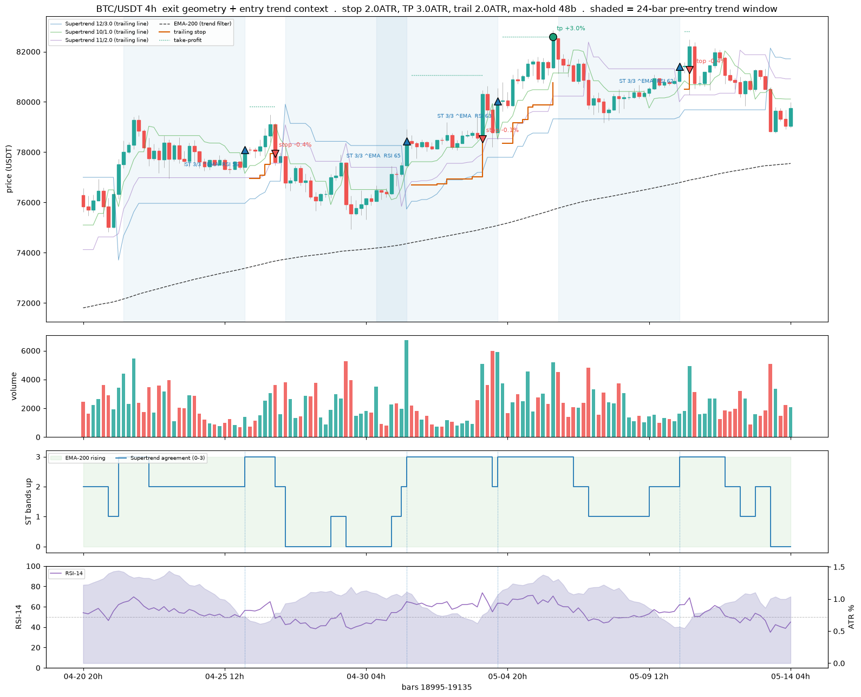
[compare] BTC/USDT 4h: anchored on entry at bar 19113
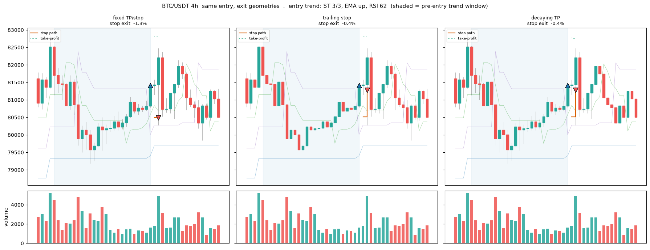

1.6 Decision Checklist
The decision is not a board reading; it is the after-fee scoreboard. A signal counts only if it beats a coin flip, buy-and-hold, and the fee on a blind final year, and Part 3 runs that test per frame across 1h, 4h, and 5m. On the 1h frame the verdict is NO-GO, at the efficient-market floor; 4h carries a little more signal; the cross-sectional relative strength of 1.2 is the one real but still-underwater lead.
Two controls shape where a signal is allowed to trade. The regime state (f_rg_) gives the model observable context: trailing realized volatility and its own-history percentile, a short and a long trend drift, a Kaufman trend efficiency, up-down breadth, and the BTC market regime. The regime gate in 0.4 then deploys the cross-sectional signal only when BTC is trending up, the cheapest in-mandate way to lift the underwater edge.
The daily board is demoted to what it is, an eyeball scan. Read exits before entries, treat a green cell as a candidate to check against the Part 3 evaluation, size and fence it in Part 2, and remember every snapshot is saved and dated under outputs/. The signals table is written to CSV on each run.
stamp = datetime.now().strftime('%Y%m%d')
path = f'../outputs/CSV/DailySignals_{stamp}.csv'
results.to_csv(path, index=False)
print("saved", path)
saved ../outputs/CSV/DailySignals_20260703.csv

2. Trader Controls
The risk and rules layer, from 02-trader-controls. The boundaries every candidate strategy must live inside, above all the fee. This is a selective, high-conviction swing design, not a scalper: a trade held for a clean three to five percent move can absorb a 0.2 percent round trip, a trade chasing half a percent cannot, so the fee is the floor. Three guardrails enforce that, a cap on trades per day, a minimum net-edge floor on thin trades, and the after-fee validation protocol.
The control logic is demonstrated on synthetic OHLCV so it is legible without a data dependency; in production it consumes the same survivorship-complete archives as Parts 1 and 3. The 0.4 adjustments live here where they touch sizing and stops: the stop and trailing stop are ATR-scaled and provisional pending the exit-geometry sweep, and the regime gate is a new control layered on top and implemented in Part 3.

2.1 Key Variables
Every tunable parameter lives in one CONFIG block, never hard-coded, and the risk-bounding ones are operator-owned and held outside the model's reach: reviewed weekly, and when the bot is built, lifted into a locked module the strategy file cannot write to. Secrets stay in the operator's Keychain, never in the repo.
The block sets the venue fences (the round-trip fee and modelled slippage), the per-trade economics (the net-edge floor, the take-profit target, the ATR-based stop), the ATR band (floor and ceiling), and the hard selection gates. The stop and take-profit here are a starting point, provisional pending the exit-geometry sweep in Part 3 and superseded by the ATR-scaled exits logged in 0.4. A Supertrend band is itself an ATR-channel trailing stop, so it belongs to this controls vocabulary alongside the volatility filter and the sizing rule.
import sys, subprocess
from pathlib import Path
# Pin the kernel to the same interpreter the rest of the repo uses.
REQUIRED_PY = (3, 11)
if sys.version_info[:2] < REQUIRED_PY:
raise RuntimeError(
f"This notebook needs Python {REQUIRED_PY[0]}.{REQUIRED_PY[1]} or newer, "
f"but the kernel is {sys.version.split()[0]}. Switch to a 3.11+ kernel and re-run.")
# Install only the libraries THIS notebook imports that are missing (same targeted approach as the
# Part 1 environment cell, avoiding the numpy/numba resolver conflict of the full requirements install).
import importlib.util
_need = {"numpy": "numpy", "pandas": "pandas", "ccxt": "ccxt", "plotly": "plotly", "kaleido": "kaleido"}
_missing = [pkg for mod, pkg in _need.items() if importlib.util.find_spec(mod) is None]
if _missing:
print("installing missing packages:", ", ".join(_missing))
subprocess.run([sys.executable, "-m", "pip", "install", "--break-system-packages",
"--disable-pip-version-check", *_missing], check=True)
import warnings, numpy as np, pandas as pd
pd.set_option("display.notebook_repr_html", False) # IDE-safe: render DataFrames as text, not HTML
from datetime import datetime, timezone
import ccxt
import plotly, plotly.graph_objects as go, plotly.io as pio
warnings.filterwarnings("ignore")
pio.renderers.default = "plotly_mimetype+notebook_connected"
from IPython.display import HTML, Image, display
def show(fig):
"""Render a plotly figure as a STATIC PNG so it displays in any editor and in the Word export.
Interactive HTML output blanks in some IDEs (Positron / VS Code, and anything that does not render
text/html); a PNG always renders. Falls back to self-contained inline HTML with plotly.js embedded
(offline-safe, no CDN) if the static-image engine (kaleido) is unavailable."""
try:
display(Image(fig.to_image(format="png", scale=2)))
except Exception:
display(HTML(fig.to_html(include_plotlyjs=True, full_html=False)))
# Resolve outputs to the repo-root outputs/ (absolute, cwd-independent) so the screen CSVs and the
# signal-journal HTML land in the MASTER <repo>/outputs/ and <repo>/outputs/journal/, not a duplicate
# folder beside this notebook. Repo root = parent of the inputs/ dir, found regardless of cwd (as in ch3).
import os
_INPUTS = next((os.path.abspath(c) for c in ("inputs", os.path.join("..", "inputs")) if os.path.isdir(c)), None)
REPO_ROOT = Path(_INPUTS).parent if _INPUTS else Path("..").resolve()
OUTPUTS = REPO_ROOT / "outputs"; OUTPUTS.mkdir(parents=True, exist_ok=True)
print(f"Environment ready · python {sys.version.split()[0]}")
print(f" ccxt {ccxt.__version__} · pandas {pd.__version__} · "
f"numpy {np.__version__} · plotly {plotly.__version__}")
installing missing packages: kaleido
Collecting kaleido
Downloading kaleido-1.3.0-py3-none-any.whl.metadata (5.6 kB)
Collecting choreographer>=1.3.0 (from kaleido)
Downloading choreographer-1.3.0-py3-none-any.whl.metadata (6.9 kB)
Collecting logistro>=1.0.8 (from kaleido)
Downloading logistro-2.0.1-py3-none-any.whl.metadata (3.9 kB)
Collecting orjson>=3.10.15 (from kaleido)
Downloading orjson-3.11.9-cp312-cp312-macosx_15_0_arm64.whl.metadata (41 kB)
Requirement already satisfied: packaging in /Applications/Positron.app/Contents/Resources/app/extensions/positron-python/python_files/lib/ipykernel/py3 (from kaleido) (26.0)
Requirement already satisfied: platformdirs>=4.3.6 in /Applications/Positron.app/Contents/Resources/app/extensions/positron-python/python_files/lib/ipykernel/py3 (from choreographer>=1.3.0->kaleido) (4.4.0)
Collecting simplejson>=3.19.3 (from choreographer>=1.3.0->kaleido)
Downloading simplejson-4.1.1-cp312-cp312-macosx_11_0_arm64.whl.metadata (3.8 kB)
Downloading kaleido-1.3.0-py3-none-any.whl (55 kB)
Downloading choreographer-1.3.0-py3-none-any.whl (52 kB)
Downloading logistro-2.0.1-py3-none-any.whl (8.6 kB)
Downloading orjson-3.11.9-cp312-cp312-macosx_15_0_arm64.whl (128 kB)
Downloading simplejson-4.1.1-cp312-cp312-macosx_11_0_arm64.whl (91 kB)
Installing collected packages: simplejson, orjson, logistro, choreographer, kaleido
━━━━━━━━━━━━━━━━━━━━━━━━━━━━━━━━━━━━━━━━ 5/5 [kaleido]━━━ 4/5 [kaleido]apher]
plejson
Environment ready · python 3.12.13
ccxt 4.5.59 · pandas 2.3.3 · numpy 2.4.6 · plotly 6.8.0
# -- CONFIG -- outside the model's reach.
CONFIG = dict(
# Venue fences — Binance crypto round trip (0.075%/side with BNB, 0.1% without)
round_trip_fee_pct = 0.15, # two sides, BNB-discounted; use 0.20 without BNB
expected_slippage_pct = 0.05, # modelled slippage per round trip
# Edge & exit (per-trade economics)
edge_floor_pct = 1.5, # minimum NET expected move to allow a trade
take_profit_pct = 10.0, # target gain; aligned to the Ch3 model label (+10%); must exceed edge_floor_pct
stop_atr_mult = 1.5, # ATR-based stop; the Ch3 label uses a fixed -5% stop, so the stop model (ATR vs fixed) is the open item for 3C exit tuning
# ATR band — selection filter AND live guardrail
atr_length = 14,
atr_floor_pct = 2.5, # below this a coin can't reach TP in the window
atr_ceiling_pct = 12.0, # above this it gaps through stop/TP unpredictably
# Hard gates (selection screen)
min_quote_volume_usdt = 30_000_000,# liquidity floor, 24h quote volume USDT
max_spread_pct = 0.05, # spread ceiling, well under the fee
min_history = 120, # candles required to span regimes
history_limit = 180, # candles pulled per coin (90–180)
# Frequency & position limits
max_trades_per_day = 3, # hard cap — defence one against volume-hiding
max_open_positions = 4, # concurrent positions (3–4 at this account size)
risk_per_trade_pct = 1.0, # % of account risked per trade (constant $ risk)
max_position_pct = 30.0, # cap any single position at this % of account
min_notional_usdt = 10.0, # venue minimum clip; below this a trade isn't worth it
# Hold window — a walk-forward RANGE, not a fixed number (swing band)
hold_window_days_min = 1,
hold_window_days_max = 20, # aligned to the Ch3 model horizon (20 days)
# Account & scan
account_usdt = 750.0, # proving-rig size (~$500–1000)
scan_top_n = 25, # scan wide (15–25), hold few (3–4)
)
# Public, read-only Binance client (currently not armed for orders).
EXCHANGE = "binance"
exchange = getattr(ccxt, EXCHANGE)()
exchange.set_sandbox_mode(False) # public market data only
ALLOW_SYNTHETIC = True # if a live fetch fails (offline / geo-blocked), fall back to
# deterministic synthetic data so the notebook still renders.
print(f"Configured {EXCHANGE} | account ${CONFIG['account_usdt']:.0f} | "
f"edge floor {CONFIG['edge_floor_pct']}% | ATR band "
f"{CONFIG['atr_floor_pct']}–{CONFIG['atr_ceiling_pct']}% | scan top {CONFIG['scan_top_n']}")
Configured binance | account $750 | edge floor 1.5% | ATR band 2.5–12.0% | scan top 25

2.2 Volatility Filter
The control demos run on synthetic OHLCV so the logic is the point, not the bars; synthetic_ohlcv and fetch_daily provide deterministic per-coin data offline, and the live path falls back to it if the network is unavailable. In production the same functions read the survivorship archives proven in Part 1.
The ATR band is the average true range over 14 days as a percent of price, a read of a coin's typical daily move, and it does two unrelated jobs. As a selection filter it admits or rejects a coin before the model sees it: below the floor, roughly two to three percent daily, a coin cannot reach the take-profit inside the hold window; above the ceiling it gaps through the stop and take-profit unpredictably and the indicators lose meaning. As a live guardrail it keeps the model from trading a coin that has drifted out of the tradable band.
def synthetic_ohlcv(symbol, n=None, daily_vol=None, seed=None):
"""Deterministic fake OHLCV for offline/geo-blocked demo. Seeded by symbol."""
n = n or CONFIG["history_limit"]
s = abs(hash(symbol)) % (2**32) if seed is None else seed
rng = np.random.default_rng(s)
dv = daily_vol if daily_vol is not None else float(rng.uniform(0.01, 0.10))
rets = rng.normal(0, dv, n)
close = 100 * np.exp(np.cumsum(rets))
high = close * (1 + np.abs(rng.normal(0, dv/2, n)))
low = close * (1 - np.abs(rng.normal(0, dv/2, n)))
openp = np.r_[close[0], close[:-1]]
vol = rng.uniform(1e6, 5e6, n)
idx = pd.date_range("2025-01-01", periods=n, freq="D")
return pd.DataFrame({"open":openp,"high":high,"low":low,"close":close,"volume":vol}, index=idx)
def fetch_daily(symbol, limit=None):
"""Daily OHLCV, unclosed bar dropped. Falls back to synthetic if offline."""
limit = limit or CONFIG["history_limit"]
try:
bars = exchange.fetch_ohlcv(symbol, timeframe="1d", limit=limit)
df = pd.DataFrame(bars[:-1], columns=["timestamp","open","high","low","close","volume"])
df["timestamp"] = pd.to_datetime(df["timestamp"], unit="ms")
return df.set_index("timestamp")
except Exception as e:
if ALLOW_SYNTHETIC:
return synthetic_ohlcv(symbol, n=limit)
raise
def fetch_quote_volume(symbol):
"""24h quote volume in USDT (the liquidity gate input)."""
try:
return float(exchange.fetch_ticker(symbol).get("quoteVolume") or 0.0)
except Exception:
if ALLOW_SYNTHETIC:
return float(np.random.default_rng(abs(hash(symbol))%2**32).uniform(2e6, 2.5e8))
raise
def fetch_spread_pct(symbol):
"""Top-of-book spread as a percent of mid (the spread gate input)."""
try:
ob = exchange.fetch_order_book(symbol, limit=5)
bid, ask = ob["bids"][0][0], ob["asks"][0][0]
mid = (bid + ask) / 2
return (ask - bid) / mid * 100.0
except Exception:
if ALLOW_SYNTHETIC:
return float(np.random.default_rng(abs(hash(symbol))%2**32 + 7).uniform(0.005, 0.12))
raise
def build_universe(top_n=None):
"""Most-traded /USDT spot pairs by quote volume on the execution venue."""
top_n = top_n or CONFIG["scan_top_n"]
try:
tk = exchange.fetch_tickers()
usdt = [(s, d.get("quoteVolume") or 0) for s, d in tk.items()
if s.endswith("/USDT") and ":" not in s]
uni = [s for s, _ in sorted(usdt, key=lambda x: -x[1])[:top_n]]
if uni:
return uni
except Exception:
pass
# offline demo universe: a deliberate spread of regimes for the screen to sort
print("(offline) using synthetic demo universe")
return ["BTC/USDT","ETH/USDT","SOL/USDT","BNB/USDT","XRP/USDT","ADA/USDT",
"AVAX/USDT","LINK/USDT","LTC/USDT","DOGE/USDT","TRX/USDT","DOT/USDT"]
universe = build_universe()
print(f"universe ({len(universe)}):", ", ".join(universe[:12]), "..." if len(universe) > 12 else "")
universe (25): USDC/USDT, RE/USDT, BTC/USDT, ETH/USDT, USD1/USDT, SOL/USDT, ZEC/USDT, XRP/USDT, AIGENSYN/USDT, BNB/USDT, WLD/USDT, ADA/USDT ...
def compute_atr_pct(df, length=None):
"""ATR(length) as a percent of price. TR = max(H−L, |H−Cprev|, |L−Cprev|);
ATR = simple moving average of TR (as written in §2); atr_pct = ATR/price×100."""
length = length or CONFIG["atr_length"]
h, l, c = df["high"], df["low"], df["close"]
pc = c.shift(1)
tr = pd.concat([(h - l).abs(), (h - pc).abs(), (l - pc).abs()], axis=1).max(axis=1)
atr = tr.rolling(length).mean()
return (atr / c) * 100.0
def atr_band_figure(symbol):
"""Live-guardrail view: ATR(14)% over time against the tradable band."""
df = fetch_daily(symbol)
atr_pct = compute_atr_pct(df)
lo, hi = CONFIG["atr_floor_pct"], CONFIG["atr_ceiling_pct"]
fig = go.Figure()
fig.add_trace(go.Scatter(x=atr_pct.index, y=atr_pct, name="ATR(14) %",
line=dict(color="#0B3D66", width=1.6)))
fig.add_hrect(y0=lo, y1=hi, fillcolor="#2E8B57", opacity=0.10, line_width=0,
annotation_text="tradable band", annotation_position="top left")
fig.add_hline(y=lo, line=dict(color="#2E8B57", dash="dash"),
annotation_text=f"floor {lo}%")
fig.add_hline(y=hi, line=dict(color="#B22222", dash="dash"),
annotation_text=f"ceiling {hi}%")
fig.update_layout(title=f"{symbol} — daily ATR% vs tradable band (selection + live guardrail)",
template="plotly_white", height=360,
yaxis_title="ATR(14) as % of price", xaxis_title=None,
margin=dict(l=40, r=20, t=50, b=30))
return fig
show(atr_band_figure(universe[0]))
<IPython.core.display.HTML object>

2.3 Four-Gate Screen
Coins are screened individually each week on daily OHLCV plus the order-book top, through four gates. Gate 1 liquidity rejects anything below a 24-hour quote-volume floor, evaluated first because it is the cheap hard gate. Gate 2 is the ATR band, floor to ceiling as above. Gate 3 spread rejects anything wider than a tight ceiling well under the fee floor. Gate 4 history rejects tokens too young to carry a full indicator history. A coin passes only if all four hold, and the screen targets a shortlist of fifteen to twenty-five coins to hold positions on three or four.
The same four-gate screen is replayed point-in-time over history in Part 3, so each training row is kept only if it would have passed as of that bar. Because the archives carry no top-of-book spread, the historical replay approximates it with a Corwin-Schultz high-low estimator while the live screen uses the real spread. The candidate scatter places every scanned coin on liquidity against volatility, with survivors inside the band.
def screen_coin(symbol, cfg=CONFIG):
"""Run the four gates on one coin. Liquidity is evaluated first (it is the cheap,
hard gate); all four numbers are recorded for the table either way."""
df = fetch_daily(symbol, cfg["history_limit"])
candle_count = int(len(df))
quote_vol = fetch_quote_volume(symbol)
spread = fetch_spread_pct(symbol)
atr_series = compute_atr_pct(df, cfg["atr_length"])
atr_pct = float(atr_series.iloc[-1]) if atr_series.notna().any() else float("nan")
g1 = quote_vol >= cfg["min_quote_volume_usdt"] # liquidity (hard)
g2 = (cfg["atr_floor_pct"] <= atr_pct <= cfg["atr_ceiling_pct"]) if atr_pct == atr_pct else False
g3 = spread <= cfg["max_spread_pct"] # spread (hard)
g4 = candle_count >= cfg["min_history"] # history (sufficiency)
gates = {"liquidity": bool(g1), "atr_band": bool(g2), "spread": bool(g3), "history": bool(g4)}
passed = all(gates.values())
fail = "" if passed else ",".join(k for k, v in gates.items() if not v)
return {"symbol": symbol,
"quote_volume_24h_usdt": round(quote_vol, 0),
"atr_pct": round(atr_pct, 3),
"spread_pct": round(spread, 4),
"candle_count": candle_count,
"pass": bool(passed), "fail_reason": fail, **gates}
def run_screen(universe, cfg=CONFIG, save=True):
rows = []
for s in universe:
try:
rows.append(screen_coin(s, cfg))
except Exception as e:
print("skip", s, type(e).__name__, str(e)[:60])
tab = pd.DataFrame(rows).sort_values(["pass", "quote_volume_24h_usdt"],
ascending=[False, False]).reset_index(drop=True)
if save and len(tab):
stamp = datetime.now(timezone.utc).strftime("%Y%m%d")
path = OUTPUTS / f"Candidates_{stamp}.csv"
tab.to_csv(path, index=False)
print(f"saved {path} ({int(tab['pass'].sum())} of {len(tab)} passed)")
return tab
screen = run_screen(universe)
cols = ["symbol","quote_volume_24h_usdt","atr_pct","spread_pct","candle_count","pass","fail_reason"]
_view = screen[cols]
print(f"\nfour-gate screen -- {int(screen['pass'].sum())} of {len(screen)} coins passed:")
print(_view.to_string(index=False)) # text table: renders in every editor and in the Word export
display(_view)
saved /Volumes/PortableSSD/Github/day-trader/outputs/Candidates_20260703.csv (8 of 25 passed)
four-gate screen -- 8 of 25 coins passed:
symbol quote_volume_24h_usdt atr_pct spread_pct candle_count pass fail_reason
BTC/USDT 832615460.0 3.684 0.0000 179 True
ETH/USDT 379033585.0 4.667 0.0006 179 True
SOL/USDT 136457635.0 5.707 0.0122 179 True
ZEC/USDT 104224344.0 8.112 0.0022 179 True
XRP/USDT 75449872.0 4.061 0.0089 179 True
BNB/USDT 55292109.0 3.365 0.0018 179 True
DOGE/USDT 36316199.0 4.708 0.0131 179 True
NEAR/USDT 35074617.0 7.338 0.0496 179 True
USDC/USDT 1549435709.0 0.066 0.0010 179 False atr_band
RE/USDT 1177959926.0 29.159 0.0316 15 False atr_band,history
USD1/USDT 163019681.0 0.056 0.0020 179 False atr_band
AIGENSYN/USDT 62784896.0 13.464 0.0350 50 False atr_band,history
WLD/USDT 45386007.0 12.301 0.0233 179 False atr_band
ADA/USDT 39352344.0 5.498 0.0570 179 False spread
RLUSD/USDT 35989339.0 0.049 0.0100 162 False atr_band
TRX/USDT 28898507.0 1.529 0.0312 179 False liquidity,atr_band
XLM/USDT 22339211.0 6.301 0.0495 179 False liquidity
ALLO/USDT 22155548.0 18.236 0.0556 179 False liquidity,atr_band,spread
TLM/USDT 21851389.0 15.357 0.1115 179 False liquidity,atr_band,spread
THE/USDT 21464389.0 14.793 0.1419 179 False liquidity,atr_band,spread
SUI/USDT 20824696.0 5.483 0.0132 179 False liquidity
SPCXB/USDT 19889484.0 6.858 0.0063 21 False liquidity,history
XPL/USDT 19119288.0 11.972 0.0090 179 False liquidity
U/USDT 18593414.0 0.041 0.0100 171 False liquidity,atr_band
AAVE/USDT 17583002.0 7.998 0.0113 179 False liquidity
{"comm_id":"5c452cde-c961-47a1-b355-5115223b5aea","shape":{"columns":7,"rows":25},"source":"pandas","title":"_view","variable_path":["{\"type\":\"str\",\"data\":\"_view\"}"],"version":1}
def screen_scatter(tab, cfg=CONFIG):
passed = tab[tab["pass"]]; failed = tab[~tab["pass"]]
fig = go.Figure()
for d, name, col in [(failed, "rejected", "#B22222"), (passed, "candidate", "#2E8B57")]:
if len(d):
fig.add_trace(go.Scatter(
x=d["atr_pct"], y=d["quote_volume_24h_usdt"], mode="markers+text",
text=d["symbol"].str.replace("/USDT", ""), textposition="top center",
textfont=dict(size=9), name=name,
marker=dict(size=11, color=col, opacity=0.8,
line=dict(width=1, color="white"))))
fig.add_vrect(x0=cfg["atr_floor_pct"], x1=cfg["atr_ceiling_pct"],
fillcolor="#2E8B57", opacity=0.07, line_width=0)
fig.add_vline(x=cfg["atr_floor_pct"], line=dict(color="#2E8B57", dash="dash"))
fig.add_vline(x=cfg["atr_ceiling_pct"], line=dict(color="#B22222", dash="dash"))
fig.add_hline(y=cfg["min_quote_volume_usdt"], line=dict(color="#888", dash="dot"),
annotation_text="liquidity floor", annotation_position="bottom right")
fig.update_layout(title="Selection screen — liquidity vs volatility (survivors inside the band, above the floor)",
template="plotly_white", height=440, yaxis_type="log",
xaxis_title="daily ATR(14) %", yaxis_title="24h quote volume (USDT, log)",
margin=dict(l=60, r=20, t=50, b=40))
return fig
def spread_bars(tab, cfg=CONFIG):
t = tab.sort_values("spread_pct")
colors = ["#2E8B57" if v <= cfg["max_spread_pct"] else "#B22222" for v in t["spread_pct"]]
fig = go.Figure(go.Bar(x=t["symbol"].str.replace("/USDT",""), y=t["spread_pct"],
marker_color=colors))
fig.add_hline(y=cfg["max_spread_pct"], line=dict(color="#888", dash="dash"),
annotation_text=f"spread ceiling {cfg['max_spread_pct']}%")
fig.update_layout(title="Spread gate — top-of-book spread vs ceiling",
template="plotly_white", height=320, yaxis_title="spread %",
margin=dict(l=50, r=20, t=50, b=40))
return fig
show(screen_scatter(screen))
show(spread_bars(screen))
<IPython.core.display.HTML object>
<IPython.core.display.HTML object>

2.4 Edge Sizing
The net-edge fence is the entry gate: a trade is refused unless the estimated move minus the round-trip fee and slippage clears the edge floor. It is measured on net, not gross, and it refuses rather than warns. Exit coupling is enforced in code: the edge floor must sit below the take-profit, and the ATR floor must be high enough that a normal multi-day range reaches the take-profit inside the hold window.
Position sizing is volatility-scaled to keep dollar risk roughly constant across coins: the stop distance times the position value is held near a fixed risk budget, so a higher-ATR coin earns a smaller clip and a calmer coin a larger one, never past the per-position cap or below the venue minimum. At a small account this pushes toward a few larger positions rather than many tiny clips that waste edge on fees. The take-profit and stop in the CONFIG reference an older fixed label and are provisional pending the exit-geometry and label sweeps in 0.4 and Part 3.
# -- Net edge fence (entry gate) ---
def net_edge(est_move_pct, cfg=CONFIG):
"""NET expected move after round-trip fee and slippage (not gross)."""
return est_move_pct - cfg["round_trip_fee_pct"] - cfg["expected_slippage_pct"]
def net_edge_ok(est_move_pct, cfg=CONFIG):
"""The fence: refuse unless net move clears the floor. Refuses, does not warn."""
return net_edge(est_move_pct, cfg) >= cfg["edge_floor_pct"]
# -- Exit coupling (enforced ordering) ---
def validate_exit_coupling(cfg=CONFIG):
rt = cfg["round_trip_fee_pct"] + cfg["expected_slippage_pct"]
days_to_tp = cfg["take_profit_pct"] / cfg["atr_floor_pct"] # at the ATR floor
return {
"edge_floor < take_profit": cfg["edge_floor_pct"] < cfg["take_profit_pct"],
"round_trip < edge_floor": rt < cfg["edge_floor_pct"],
"take_profit > 2x round_trip (alive)": cfg["take_profit_pct"] > 2 * rt,
f"TP reachable at the ATR floor within the window (about {days_to_tp:.1f} days)":
days_to_tp <= cfg["hold_window_days_max"],
}
# -- ATR-scaled position sizing (constant dollar risk) ---
def position_plan(atr_pct, cfg=CONFIG, account=None):
"""Size so dollar risk is ~constant across coins: higher ATR -> smaller position.
stop% = stop_atr_mult × daily ATR%; size = risk_budget / stop%. Capped at
max_position_pct, floored at the venue minimum notional."""
account = account or cfg["account_usdt"]
stop_pct = cfg["stop_atr_mult"] * atr_pct
risk_budget = account * cfg["risk_per_trade_pct"] / 100.0
raw = risk_budget / (stop_pct / 100.0) if stop_pct > 0 else 0.0
capped = min(raw, account * cfg["max_position_pct"] / 100.0)
final = max(capped, cfg["min_notional_usdt"])
return {"atr_pct": round(atr_pct, 3), "stop_pct": round(stop_pct, 3),
"risk_budget_usdt": round(risk_budget, 2), "raw_size_usdt": round(raw, 2),
"position_usdt": round(final, 2),
"floored_at_min": bool(final == cfg["min_notional_usdt"] and capped < cfg["min_notional_usdt"])}
print("Net-edge fence (gross est. move -> net -> allowed?):")
for m in (1.0, 1.5, 2.0, 3.5):
print(f" est {m:>4}% -> net {net_edge(m):>5.2f}% -> {'ALLOW' if net_edge_ok(m) else 'refuse'}")
print("\nExit-coupling checks (config must satisfy all):")
for k, v in validate_exit_coupling().items():
print(f" [{'ok' if v else 'XX'}] {k}")
Net-edge fence (gross est. move -> net -> allowed?):
est 1.0% -> net 0.80% -> refuse
est 1.5% -> net 1.30% -> refuse
est 2.0% -> net 1.80% -> ALLOW
est 3.5% -> net 3.30% -> ALLOW
Exit-coupling checks (config must satisfy all):
[ok] edge_floor < take_profit
[ok] round_trip < edge_floor
[ok] take_profit > 2x round_trip (alive)
[ok] TP reachable at the ATR floor within the window (about 4.0 days)
cands = screen[screen["pass"]].copy()
if len(cands):
plans = cands["atr_pct"].apply(lambda a: pd.Series(position_plan(a)))
sized = pd.concat([cands[["symbol","atr_pct"]].reset_index(drop=True),
plans.reset_index(drop=True)[["stop_pct","position_usdt","floored_at_min"]]], axis=1)
sized = sized.sort_values("position_usdt", ascending=False).reset_index(drop=True)
display(sized)
fig = go.Figure(go.Bar(x=sized["symbol"].str.replace("/USDT",""), y=sized["position_usdt"],
marker_color="#0B3D66",
text=[f"ATR {a:.1f}%" for a in sized["atr_pct"]], textposition="outside"))
fig.add_hline(y=CONFIG["account_usdt"]*CONFIG["max_position_pct"]/100,
line=dict(color="#B22222", dash="dash"),
annotation_text=f"position cap ({CONFIG['max_position_pct']}% of acct)")
fig.add_hline(y=CONFIG["min_notional_usdt"], line=dict(color="#888", dash="dot"),
annotation_text="min notional")
fig.update_layout(title="ATR-scaled position sizing: constant $ risk (higher ATR means a smaller clip)",
template="plotly_white", height=360, yaxis_title="position size (USDT)",
margin=dict(l=50, r=20, t=50, b=40))
show(fig)
else:
print("No candidates cleared the screen on this run — widen the universe or revisit the band.")
{"comm_id":"6fe0fce3-f885-4a1c-8da3-81608c204dc5","shape":{"columns":5,"rows":8},"source":"pandas","title":"sized","variable_path":["{\"type\":\"str\",\"data\":\"sized\"}"],"version":1}
<IPython.core.display.HTML object>

2.5 Hold Period
The hold period is the swing band, days to about two weeks. Scalping and day-trading are ruled out by fees and the pattern-day-trading rule, position-trading by underusing the signal stack. Within the swing band the hold window is a walk-forward parameter, searched roughly one to twenty days and picked by out-of-sample results, not by a gut figure. Shorter holds demand a higher ATR to reach the target in time; longer holds tolerate a lower one. This is the same coupling as the edge fence, seen on the time axis.

2.6 Stacked Defences
The defences are layered, not single. The selection screen keeps unsuitable coins out, the net-edge fence keeps thin trades out, the ATR band is both a selection filter and a live guardrail, the position cap and venue minimum bound each clip, and the per-day trade cap and the cash floor bound the book. Above them sit the 0.4 controls: the ATR-scaled stop and trailing stop, provisional pending the exit-geometry sweep, and the new regime gate that only lets the cross-sectional signal trade when BTC is trending up, implemented in Part 3.
The floor fence is the minimum net edge; the venue fences are the fee and slippage assumptions that define it. Each defence is cheap and independent, so a coin must clear all of them and any one can veto.

2.7 Signal Journal
A learning aid, not a trader. For each coin it finds every entry and exit the MACD logic produced, draws the candles with the moving averages and a volume histogram, marks each signal, and writes a table beside the chart recording what the model saw, trend, RSI, and volatility, and whether the fee fence would actually let the trade fire. Each study sheet is saved as a self-contained HTML page under outputs/journal/, so a visual library builds up on every run. The net-edge column uses the take-profit as a stand-in for the expected move until the Part 3 model supplies a real per-trade estimate; the entries marked would-fire are the ones that clear both the fee floor and the ATR band.
from plotly.subplots import make_subplots
def compute_signals(df, cfg=CONFIG):
"""Add MACD, signal, histogram, EMAs, RSI(14), ATR% and crossover flags to a daily frame."""
c = df["close"]
df["ema12"] = c.ewm(span=12, adjust=False).mean()
df["ema26"] = c.ewm(span=26, adjust=False).mean()
df["macd"] = df["ema12"] - df["ema26"]
df["signal"] = df["macd"].ewm(span=9, adjust=False).mean()
df["hist"] = df["macd"] - df["signal"]
d = c.diff(); up = d.clip(lower=0).rolling(14).mean(); dn = (-d.clip(upper=0)).rolling(14).mean()
df["rsi"] = 100 - 100 / (1 + up / dn)
df["atr_pct"] = compute_atr_pct(df, cfg["atr_length"])
df["cross_up"] = (df["macd"] > df["signal"]) & (df["macd"].shift(1) <= df["signal"].shift(1))
df["cross_down"] = (df["macd"] < df["signal"]) & (df["macd"].shift(1) >= df["signal"].shift(1))
return df
def signal_events(df, cfg=CONFIG):
"""One row per entry/exit, documenting what the model saw and whether the fee fence would let
an entry fire. est. move uses the take-profit target until the predictive model supplies one."""
rows = []
for i in range(1, len(df)):
buy, sell = bool(df["cross_up"].iloc[i]), bool(df["cross_down"].iloc[i])
if not (buy or sell):
continue
atr = float(df["atr_pct"].iloc[i]); rsi = float(df["rsi"].iloc[i])
trend = "up" if df["ema12"].iloc[i] > df["ema26"].iloc[i] else "down"
net = cfg["take_profit_pct"] - cfg["round_trip_fee_pct"] - cfg["expected_slippage_pct"]
in_band = (cfg["atr_floor_pct"] <= atr <= cfg["atr_ceiling_pct"]) if atr == atr else False
fires = buy and net >= cfg["edge_floor_pct"] and in_band
rows.append({
"date": str(df.index[i].date()),
"action": "enter / buy" if buy else "exit / sell",
"price": round(float(df["close"].iloc[i]), 4),
"trend": trend,
"rsi": round(rsi, 0) if rsi == rsi else None,
"atr_pct": round(atr, 2) if atr == atr else None,
"net_edge_pct": round(net, 2),
"fence": ("would fire" if fires else
"exit" if sell else
"blocked: out of band" if not in_band else "blocked: thin edge"),
"size_usdt": position_plan(atr)["position_usdt"] if fires else None,
"note": ("MACD crossed above signal -> momentum turning up" if buy
else "MACD crossed below signal -> momentum turning down"),
})
return pd.DataFrame(rows)
def journal_overview(df, symbol, window=120):
"""Candles + EMAs + buy/sell markers on top, a volume histogram in the middle, MACD underneath."""
w = df.tail(window)
vol_col = ["#26a69a" if c >= o else "#ef5350" for o, c in zip(w["open"], w["close"])]
fig = make_subplots(rows=3, cols=1, shared_xaxes=True, row_heights=[0.62, 0.16, 0.22],
vertical_spacing=0.05,
subplot_titles=(f"{symbol} - price with model entries (buy) and exits (sell)",
"volume", "MACD (momentum)"))
fig.add_trace(go.Candlestick(x=w.index, open=w["open"], high=w["high"], low=w["low"], close=w["close"],
name="price", showlegend=False), row=1, col=1)
fig.add_trace(go.Scatter(x=w.index, y=w["ema12"], line=dict(color="#1f77b4", width=1), name="EMA-12"), row=1, col=1)
fig.add_trace(go.Scatter(x=w.index, y=w["ema26"], line=dict(color="#9467bd", width=1), name="EMA-26"), row=1, col=1)
b, s = w[w["cross_up"]], w[w["cross_down"]]
fig.add_trace(go.Scatter(x=b.index, y=b["low"] * 0.96, mode="markers",
marker=dict(symbol="triangle-up", size=12, color="#2E8B57"), name="model buy"), row=1, col=1)
fig.add_trace(go.Scatter(x=s.index, y=s["high"] * 1.04, mode="markers",
marker=dict(symbol="triangle-down", size=12, color="#C0392B"), name="model sell"), row=1, col=1)
fig.add_trace(go.Bar(x=w.index, y=w["volume"], name="volume", showlegend=False,
marker_color=vol_col), row=2, col=1)
fig.add_trace(go.Bar(x=w.index, y=w["hist"], opacity=0.4, name="histogram",
marker_color=["#2E8B57" if h >= 0 else "#C0392B" for h in w["hist"]]), row=3, col=1)
fig.add_trace(go.Scatter(x=w.index, y=w["macd"], line=dict(color="#0B3D66"), name="MACD"), row=3, col=1)
fig.add_trace(go.Scatter(x=w.index, y=w["signal"], line=dict(color="#E08A1E"), name="signal"), row=3, col=1)
fig.update_layout(template="plotly_white", height=680, xaxis_rangeslider_visible=False,
margin=dict(l=40, r=20, t=46, b=30), legend=dict(orientation="h", y=1.06))
return fig
def save_journal(symbol, cfg=CONFIG, outdir=None):
"""Study sheet for one coin: overview chart + an events table documenting the model's actions,
saved as a self-contained HTML page under outputs/journal/. Returns (path, fig, events)."""
outdir = Path(outdir or (OUTPUTS / "journal")); outdir.mkdir(parents=True, exist_ok=True)
df = compute_signals(fetch_daily(symbol, max(cfg["history_limit"], 220)), cfg)
ev = signal_events(df, cfg)
fig = journal_overview(df, symbol)
stamp = datetime.now(timezone.utc).strftime("%Y%m%d")
path = outdir / f"journal_{symbol.replace('/', '-')}_{stamp}.html"
last = ev.iloc[-1].to_dict() if len(ev) else {}
intro = (f"<h2 style='font-family:Arial'>{symbol} - signal journal</h2>"
f"<p style='font-family:Arial;max-width:820px;color:#333'>Each triangle is a MACD/signal crossover: "
f"green = the model would consider entering, red = it would exit. The table records what the model saw "
f"at each point and whether the fee fence would let an entry actually fire. Latest event: "
f"<b>{last.get('action','-')}</b> on {last.get('date','-')} at {last.get('price','-')} "
f"({last.get('fence','-')}).</p>")
style = ("<style>table{border-collapse:collapse;font-family:Arial;font-size:13px}"
"th,td{border:1px solid #ddd;padding:6px 9px;text-align:left}"
"th{background:#0B3D66;color:#fff}tr:nth-child(even){background:#f5f7fa}</style>")
path.write_text("<html><head><meta charset='utf-8'>" + style + "</head><body>" + intro +
fig.to_html(include_plotlyjs="cdn", full_html=False) +
"<h3 style='font-family:Arial'>What the model saw and did</h3>" +
ev.to_html(index=False, border=0) + "</body></html>")
return path, fig, ev
# Build a journal for the top few coins that cleared tonight's screen (fallback to liquid majors).
try:
to_study = list(screen[screen["pass"]]["symbol"].head(3))
except Exception:
to_study = []
if not to_study:
to_study = ["BTC/USDT", "ETH/USDT", "SOL/USDT"]
journals = []
for sym in to_study:
try:
path, fig, ev = save_journal(sym)
journals.append((sym, path, fig, ev))
print(f"saved {path} - {len(ev)} entries/exits documented")
except Exception as e:
print("skip", sym, type(e).__name__, str(e)[:60])
print(f"\n{len(journals)} journal(s) saved under outputs/journal/")
# Show the first journal inline: the chart, then the table of what the model did.
if journals:
sym, path, fig, ev = journals[0]
print(f"\n--- {sym} ---")
show(fig)
display(ev)
saved /Volumes/PortableSSD/Github/day-trader/outputs/journal/journal_BTC-USDT_20260703.html - 21 entries/exits documented
saved /Volumes/PortableSSD/Github/day-trader/outputs/journal/journal_ETH-USDT_20260703.html - 12 entries/exits documented
saved /Volumes/PortableSSD/Github/day-trader/outputs/journal/journal_SOL-USDT_20260703.html - 12 entries/exits documented
3 journal(s) saved under outputs/journal/
--- BTC/USDT ---
<IPython.core.display.HTML object>
{"comm_id":"532798b4-d42b-4684-93b2-50670c5e041c","shape":{"columns":10,"rows":21},"source":"pandas","title":"ev","variable_path":["{\"type\":\"str\",\"data\":\"ev\"}"],"version":1}

2.8 Frozen Harness
The yardstick is frozen and operator-owned. Every walk-forward run appends one line to a log, the parameters tried, the out-of-sample after-fee result, and whether it was kept or discarded, and the operator reviews it weekly. The model never writes to the harness or the log, which keeps the evaluation surface human rather than automated away. The harness fixes the out-of-sample window, the train window, the embargo that straddles the cut, the regime set, the fee assumption, and the metric, identical across every comparison so results are commensurable.
The dated candidate table and the experiment log are written under outputs/ each run, and nothing else: the notebook screens and sizes only, no orders, with LIVE_TRADING left false and never read here.
# Frozen evaluation harness — versioned, identical across every comparison. (locked)
HARNESS = dict(
version = "harness-v1",
oos_window_days = 90,
train_window_days = 365,
embargo_days = 20, # straddles the train/test cut
regime_set = ["bull", "bear", "sideways"],
fee_assumption_pct = CONFIG["round_trip_fee_pct"],
metric = "oos_after_fee_expectancy",
)
def log_experiment(params: dict, oos_result: dict, kept: bool, why: str,
path=OUTPUTS / "experiment_log.csv"):
"""Append one line per walk-forward run. The artefact the operator wakes to."""
row = {"ts_utc": datetime.now(timezone.utc).isoformat(timespec="seconds"),
"harness": HARNESS["version"], "kept": bool(kept), "why": why,
**{f"p_{k}": v for k, v in params.items()},
**{f"oos_{k}": v for k, v in oos_result.items()}}
df = pd.DataFrame([row])
header = not path.exists()
df.to_csv(path, mode="a", header=header, index=False)
return path
# Demonstration entry (replace with real walk-forward output once that loop exists).
p = log_experiment(
params=dict(edge_floor_pct=CONFIG["edge_floor_pct"], take_profit_pct=CONFIG["take_profit_pct"],
atr_floor_pct=CONFIG["atr_floor_pct"], threshold=2),
oos_result=dict(after_fee_expectancy_pct=-0.4, win_rate=0.41, n_trades=37, vs_buy_hold_pct=+1.2),
kept=False, why="no demonstrated OOS edge after fees (matches standing NO-GO)")
print("logged ->", p)
_log = pd.read_csv(p)
print(f'\nexperiment_log.csv ({len(_log)} rows; last 3):')
print(_log.tail(3).to_string(index=False)) # text fallback: renders in every IDE
display(_log.tail(3))
logged -> /Volumes/PortableSSD/Github/day-trader/outputs/experiment_log.csv
experiment_log.csv (4 rows; last 3):
ts_utc harness kept why p_edge_floor_pct p_take_profit_pct p_atr_floor_pct p_threshold oos_after_fee_expectancy_pct oos_win_rate oos_n_trades oos_vs_buy_hold_pct
2026-07-01T06:03:11+00:00 harness-v1 False no demonstrated OOS edge after fees (matches standing NO-GO) 1.5 10.0 2.5 2 -0.4 0.41 37 1.2
2026-07-01T19:47:44+00:00 harness-v1 False no demonstrated OOS edge after fees (matches standing NO-GO) 1.5 10.0 2.5 2 -0.4 0.41 37 1.2
2026-07-03T17:22:54+00:00 harness-v1 False no demonstrated OOS edge after fees (matches standing NO-GO) 1.5 10.0 2.5 2 -0.4 0.41 37 1.2
{"comm_id":"e63a4be1-d9d6-42ef-acf2-9d2b202296a3","shape":{"columns":12,"rows":3},"source":"pandas","title":"pandas","version":1}
print("Artefacts written this run:")
for f in sorted(OUTPUTS.glob("Candidates_*.csv")) + [OUTPUTS / "experiment_log.csv"]:
if f.exists():
print(f" {f} ({f.stat().st_size} bytes)")
print("\nReminder: this notebook screens and sizes only. No orders are placed; "
"LIVE_TRADING stays 'false' in inputs/config.py and is never read here.")
Artefacts written this run:
/Volumes/PortableSSD/Github/day-trader/outputs/Candidates_20260629.csv (1946 bytes)
/Volumes/PortableSSD/Github/day-trader/outputs/Candidates_20260701.csv (1956 bytes)
/Volumes/PortableSSD/Github/day-trader/outputs/Candidates_20260703.csv (1995 bytes)
/Volumes/PortableSSD/Github/day-trader/outputs/experiment_log.csv (706 bytes)
Reminder: this notebook screens and sizes only. No orders are placed; LIVE_TRADING stays 'false' in inputs/config.py and is never read here.

3. Trader Execution
The modeling and search layer, from 03-trader-execution. Where the datasets, features, and model meet the after-fee test, run per frame across 1h, 4h, and 5m. This is the decision-grade chapter: everything Parts 1 and 2 describe is built, screened point-in-time, labelled, trained, and scored on a blind final year here, and only what clears the fee out of sample counts.
The 0.4 adjustments are implemented across these sections: the label in 3.1 and 3.7, the ATR-scaled exits in 3.3, the regime gate in 3.12, and the longer-horizon frame across every per-frame loop. The cells run top to bottom on the project .venv. LOAD_FRAME selects the active frame the single-frame cells consume; the multi-frame sections from 3.9 on loop over all three frames on their own and restore the active frame afterward.

3.1 Data Preparation
The environment imports the shared loader build_dataset_1h, the split and cost machinery, and the model libraries. The three frames are built offline from the survivorship-complete data.binance.vision archives into dataset_5m_allmarket, dataset_1h_allmarket, and dataset_4h_allmarket, one builder retuned per frame. LOAD_FRAME picks the active frame, Import Data loads its Parquet into df and feat, and the train-test split holds out the final year with an embargo equal to the label horizon so no future leaks across the cut. The label is the ATR-scaled triple barrier; the 0.4 revision toward a longer, less fee-punishing geometry is the intended change tracked here.
import os, sys
from pathlib import Path
if sys.version_info[:2] < (3, 11):
raise RuntimeError(f"Use the project .venv (Python 3.12); kernel is {sys.version.split()[0]}.")
try:
import numpy as np, pandas as pd, joblib
pd.set_option("display.notebook_repr_html", False) # IDE-safe: render DataFrames as text, not HTML
import matplotlib.pyplot as plt
except ModuleNotFoundError as e:
raise RuntimeError(
f"Missing '{e.name}'. This kernel is not the project .venv (running {sys.executable}). "
"Switch to 'Python (day-trader .venv)' via Kernel -> Change Kernel, then re-run."
) from e
# Shared modeling + evaluation code: the SAME functions the scripts run.
INPUTS_DIR = None
for cand in ["inputs", os.path.join("..", "inputs")]:
if os.path.isdir(cand):
INPUTS_DIR = os.path.abspath(cand)
sys.path.insert(0, INPUTS_DIR); break
REPO_ROOT = Path(INPUTS_DIR).parent # repo root = parent of inputs/, regardless of cwd
import build_dataset_1h as bd # 1h features, ATR-scaled label, point-in-time screen
import train_model as tm # shared: build_models, evaluate, confidence_filtered, costs
import train_model_1h as t1 # 1h load + final-year split
import eval_report
HAVE_LGBM = tm.HAVE_LGBM
def _layer(mod):
try:
__import__(mod); return "yes"
except Exception:
return "no"
OUTPUTS = REPO_ROOT / "outputs" # absolute <repo>/outputs, never the cwd-relative one
MODEL_DIR = OUTPUTS / "3B-model-training"; MODEL_DIR.mkdir(parents=True, exist_ok=True)
print(f"outputs -> {OUTPUTS}")
print(f"env ready . kernel: {sys.executable}")
print(f"python {sys.version.split()[0]} . lightgbm {'yes' if HAVE_LGBM else 'no'}"
f" . pandas-ta {_layer('pandas_ta')} . TA-Lib {_layer('talib')}")
# --- inline table rendering (Positron-safe) -------------------------------------------
# Positron routes a bare display(df) to its live Data Explorer pane, which shows blank
# inline and dies on reload. show_table() emits a static HTML table that renders in the
# cell and survives reload, in Positron, Jupyter and VS Code alike.
from IPython.display import HTML, display, Markdown, Image # noqa: F401 (Markdown/Image used later)
def show_table(x):
obj = x.to_frame() if (hasattr(x, "to_frame") and getattr(x, "ndim", 2) == 1) else x
display(HTML(obj.to_html()))
# --- inline figure rendering (Positron-safe) ------------------------------------------
# Positron (and nbconvert with a non-interactive backend) route plt.show() to a side pane, so
# matplotlib figures never embed in the .ipynb and the saved notebook reads blank. show_fig()
# rasterises the figure to an inline PNG that renders in the cell and survives reload -- the
# plot analogue of show_table() above. Pass a Figure; None is tolerated (some plotters return
# None when there is nothing to draw). Use show_fig(fig) in place of plt.show().
import io as _io
def show_fig(fig, dpi=120):
if fig is None:
print("(no figure to show)"); return
buf = _io.BytesIO()
fig.savefig(buf, format="png", dpi=dpi, bbox_inches="tight")
plt.close(fig)
display(Image(data=buf.getvalue()))
outputs -> /Volumes/PortableSSD/Github/day-trader/outputs
env ready . kernel: /Volumes/PortableSSD/Github/day-trader/.venv/bin/python
python 3.12.13 . lightgbm yes . pandas-ta no . TA-Lib yes
# Knobs live in the scripts so the notebook cannot drift. Read-only here.
CONFIG = dict(
oos_days = t1.OOS_DAYS, # final year held out of sample
embargo_days = t1.EMBARGO_DAYS, # = label horizon in days
conf_hi = tm.CONF_HI, # confidence filter act-long (Keller Metric 1)
conf_lo = tm.CONF_LO, # act-short / stand-aside
cost_pct = tm.COST_PCT, # round-trip drag (fee + slippage), Metric 2
)
lab = bd.LABEL
print(f"label: +{lab['tgt_atr']} ATR before -{lab['stp_atr']} ATR within {lab['horizon_bars']} bars "
f"({lab['horizon_bars']//bd.BARS_PER_DAY}d) . hold out final {CONFIG['oos_days']}d, "
f"embargo +/-{CONFIG['embargo_days']}d . confidence {CONFIG['conf_lo']}-{CONFIG['conf_hi']} . "
f"cost {CONFIG['cost_pct']:.2f}% round trip")
label: +2.0 ATR before -1.0 ATR within 12 bars (2d) . hold out final 365d, embargo +/-2d . confidence 0.4-0.6 . cost 0.20% round trip
# Import Data: build provenance for EVERY built frame (1h, 4h, 5m) + the load of ONE active frame.
# Reads the LIVE config from build_dataset_1h and file timestamps; does NOT rebuild anything. The
# modelling cells below consume df/feat, so exactly one frame is loaded -- 1h by default, switch with
# LOAD_FRAME. The Multi-Resolution Datasets section above compares all three head to head.
import os, datetime as _dt
LOAD_FRAME = "1h" # active modelling frame: "1h", "4h" or "5m" (drives df/feat + bd config below)
def _ds_path(label): return os.path.join(bd.BINANCE_DATA, f"dataset_{label}_allmarket.parquet")
def _kl_root(label): return os.path.join(bd.BINANCE_DATA, f"klines_{label}")
def _built(p):
base = os.path.splitext(p)[0]
for ext in (".parquet", ".csv"):
f = base + ext
if os.path.exists(f):
return (f"{os.path.basename(f)} "
f"{_dt.datetime.fromtimestamp(os.path.getmtime(f)):%Y-%m-%d %H:%M}, "
f"{os.path.getsize(f)/1e6:.0f} MB")
return "NOT BUILT YET"
# --- provenance: every built frame (nothing loaded yet) ---
print("SOURCE / LOCATION (Binance spot, data.binance.vision archives; one dataset per frame)")
for _lab in ("1h", "4h", "5m"):
tag = " <- active" if _lab == LOAD_FRAME else ""
print(f" [{_lab:>3s}] {_built(_ds_path(_lab))}{tag}")
print(f" klines: {_kl_root(_lab)}")
print(" storage : Parquet (columnar, compressed, dtype-preserving); CSV is the fallback")
# --- active frame: configure it, then report the config it drives ---
bd.configure(LOAD_FRAME) # point bd (DATASET_PATH, windows, label, screen) at it
print(f"\nACTIVE FRAME = {LOAD_FRAME} (the cells below model this frame)")
print(f" flow table : {_built(bd.DEFAULT_FLOW)}")
print(f" dataset : {_built(bd.DATASET_PATH)}")
print("\nTIME WINDOWS (counts of bars; 1 bar = the active frame)")
print(f" wall-clock (daily x bars/day): {bd.WC}")
print(f" intraday : {bd.HR}")
print(f"\nLABEL (ATR-scaled triple barrier): {bd.LABEL}")
print(f"SCREEN gates : {bd.SCREEN}")
print(f"DATA-QUALITY gate : {bd.DATA_QUALITY}")
print("\nTo (re)build offline from the .venv (reference - not run here):")
print(f" .venv/bin/python inputs/binance-data/flow_data.py --interval {LOAD_FRAME} --all-market")
print(f" .venv/bin/python inputs/build_dataset_1h.py --interval {LOAD_FRAME}")
# --- load the active dataset + report its characteristics ---
# bd.read_frame prefers the Parquet file (real dtypes kept, ~2.6x smaller, loads in seconds);
# it falls back to the CSV if only that exists.
raw = bd.read_frame(bd.DATASET_PATH)
if raw is not None:
raw = raw.sort_values("datetime").reset_index(drop=True)
feat = bd.feature_columns(raw)
insamp = raw["in_sample"] if "in_sample" in raw.columns else pd.Series(True, index=raw.index)
df = raw[insamp].reset_index(drop=True) # model on the point-in-time in-sample rows
print(f"\nLOADED {len(raw):,} rows from Parquet ({LOAD_FRAME} frame)")
print(f" in-sample rows : {len(df):,} ({len(df)/len(raw):.1%} of total)")
print(f" coins : {raw['symbol'].nunique()}")
print(f" features : {len(feat)}")
print(f" date range : {raw['datetime'].min()} -> {raw['datetime'].max()}")
print(f" base rate all / in-sample : {raw['label'].mean():.3f} / {df['label'].mean():.3f}")
fams = [("wall-clock", "f_wc_"), ("intraday", "f_hr_"), ("in-house TA", "f_ta_"),
("pandas-ta", "f_ta_pta_"), ("TA-Lib", "f_tl_"), ("flow", "f_flow_")]
parts = []
for nm, pre in fams:
if pre == "f_ta_":
cols = [c for c in feat if c.startswith("f_ta_") and not c.startswith("f_ta_pta_")]
else:
cols = [c for c in feat if c.startswith(pre)]
parts.append(f"{nm} {len(cols)}")
print(" feature families : " + ", ".join(parts))
print(f" in-sample rows with any NaN feature: {int(df[feat].isna().any(axis=1).sum()):,}")
print(" rows per coin:")
show_table(raw["symbol"].value_counts().rename("rows").to_frame())
else:
df = None; feat = []
print(f"\n{LOAD_FRAME} dataset not built yet. Build it from the project .venv:\n"
f" .venv/bin/python inputs/build_dataset_1h.py --interval {LOAD_FRAME}\n"
"(or a coin subset: add -s BTCUSDT ETHUSDT ...)")
SOURCE / LOCATION (Binance spot, data.binance.vision archives; one dataset per frame)
[ 1h] dataset_1h_allmarket.parquet 2026-06-21 11:15, 684 MB <- active
klines: /Volumes/PortableSSD/Github/day-trader/inputs/binance-data/klines_1h
[ 4h] dataset_4h_allmarket.parquet 2026-06-23 20:30, 2008 MB
klines: /Volumes/PortableSSD/Github/day-trader/inputs/binance-data/klines_4h
[ 5m] dataset_5m_allmarket.parquet 2026-06-24 23:02, 2990 MB
klines: /Volumes/PortableSSD/Github/day-trader/inputs/binance-data/klines_5m
storage : Parquet (columnar, compressed, dtype-preserving); CSV is the fallback
ACTIVE FRAME = 1h (the cells below model this frame)
flow table : flow_1h.parquet 2026-06-21 10:36, 458 MB
dataset : dataset_1h_allmarket.parquet 2026-06-21 11:15, 684 MB
TIME WINDOWS (counts of bars; 1 bar = the active frame)
wall-clock (daily x bars/day): {'ema_fast': 336, 'ema_mid': 2184, 'ema_slow': 3000, 'rsi': 336, 'bb': 336, 'bb_std': 2.0, 'atr': 336, 'rv_short': 168, 'rv_long': 720, 'vol': 480, 'mom': [120, 240, 480, 1440]}
intraday : {'ema_fast': 12, 'ema_mid': 26, 'ema_slow': 50, 'rsi': 14, 'bb': 20, 'bb_std': 2.0, 'atr': 14, 'rv_short': 24, 'rv_long': 168, 'vol': 24, 'mom': [6, 12, 24, 72, 168]}
LABEL (ATR-scaled triple barrier): {'tgt_atr': 2.0, 'stp_atr': 1.0, 'horizon_bars': 48, 'atr_len': 14}
SCREEN gates : {'min_quote_volume_usdt': 30000000, 'qv_window': 24, 'atr_floor_pct': 0.5, 'atr_ceiling_pct': 2.5, 'atr_len': 14, 'min_history_bars': 2880, 'spread_proxy_ceiling_pct': 0.5, 'spread_window': 24}
DATA-QUALITY gate : {'max_gap_ratio': 0.02, 'max_single_gap_hours': 72}
To (re)build offline from the .venv (reference - not run here):
.venv/bin/python inputs/binance-data/flow_data.py --interval 1h --all-market
.venv/bin/python inputs/build_dataset_1h.py --interval 1h
LOADED 1,640,660 rows from Parquet (1h frame)
in-sample rows : 458,539 (27.9% of total)
coins : 47
features : 61
date range : 2017-10-16 11:00:00 -> 2026-06-18 23:00:00
base rate all / in-sample : 0.322 / 0.313
feature families : wall-clock 13, intraday 14, in-house TA 8, pandas-ta 7, TA-Lib 15, flow 4
in-sample rows with any NaN feature: 0
rows per coin:
<IPython.core.display.HTML object>

3.2 Feature Variables
Every feature is causal and scale-invariant, computed from past bars only and normalized so hundreds of coins compare. The families span an in-house wall-clock and intraday baseline, extra oscillators, an optional pandas-ta momentum block including the scale-free PPO, an optional TA-Lib block, the trade-flow imbalance, the triple-Supertrend (f_st_), the Modern Adaptive Supertrend (f_mst_), BTC lead-lag relative strength (f_btc_), multi-timeframe context (f_4h_, f_d1_, f_w1_), and the regime state (f_rg_). Feature integration verifies the higher-timeframe joins are causal with no lookahead.
if df is not None:
fam = [("wall-clock (wc)", "f_wc_"), ("intraday (hr)", "f_hr_"),
("in-house TA", "f_ta_"), ("pandas-ta", "f_ta_pta_"),
("TA-Lib", "f_tl_"), ("flow", "f_flow_")]
for name, pre in fam:
if pre == "f_ta_":
cols = [c for c in feat if c.startswith("f_ta_") and not c.startswith("f_ta_pta_")]
else:
cols = [c for c in feat if c.startswith(pre)]
print(f" {name:16s}: {len(cols)}")
print(f" {'TOTAL':16s}: {len(feat)}")
show_table(df[feat].describe().T[["mean", "std", "min", "max"]].round(3))
wall-clock (wc) : 13
intraday (hr) : 14
in-house TA : 8
pandas-ta : 7
TA-Lib : 15
flow : 4
TOTAL : 61
<IPython.core.display.HTML object>
# Where the newest feature families are integrated, and how. All are causal, scale-invariant
# functions in inputs/build_dataset_1h.py, wired into build_coin() beside the in-house / pandas-ta /
# TA-Lib / flow blocks. The source is shown live so the documentation cannot drift from the code.
# f_st_, f_btc_, f_4h_/f_d1_ populate on the next dataset rebuild.
import inspect
st_cols = [c for c in (feat or []) if c.startswith("f_st_")]
btc_cols = [c for c in (feat or []) if c.startswith("f_btc_")]
mtf_cols = [c for c in (feat or []) if c.startswith("f_4h_") or c.startswith("f_d1_")]
print(f"f_st_ triple-Supertrend : {len(st_cols)} cols {st_cols}")
print(f"f_btc_ BTC lead-lag / rel-str : {len(btc_cols)} cols {btc_cols}")
print(f"f_4h_/f_d1_ multi-timeframe : {len(mtf_cols)} cols {mtf_cols}")
print("\nintegration point -> build_coin(df, symbol_slash, flow, btc):")
print(" feats.update(supertrend_block(df)) # f_st_ : 3 ATR bands voting + EMA-200 gate")
print(" feats.update(btc_block(df, btc)) # f_btc_ : BTC momentum, relative strength, beta/corr")
print(" feats.update(multitf_block(df)) # f_4h_/f_d1_ : 4h + daily trend, causally aligned")
print(" # btc = load_btc_series(klines_root) is loaded ONCE in build() and threaded through each coin")
print("\n--- key code: btc_block (new information) and multitf_block (causal higher-timeframe context) ---")
print(inspect.getsource(bd.btc_block))
print(inspect.getsource(bd.multitf_block))
f_st_ triple-Supertrend : 0 cols []
f_btc_ BTC lead-lag / rel-str : 0 cols []
f_4h_/f_d1_ multi-timeframe : 0 cols []
integration point -> build_coin(df, symbol_slash, flow, btc):
feats.update(supertrend_block(df)) # f_st_ : 3 ATR bands voting + EMA-200 gate
feats.update(btc_block(df, btc)) # f_btc_ : BTC momentum, relative strength, beta/corr
feats.update(multitf_block(df)) # f_4h_/f_d1_ : 4h + daily trend, causally aligned
# btc = load_btc_series(klines_root) is loaded ONCE in build() and threaded through each coin
--- key code: btc_block (new information) and multitf_block (causal higher-timeframe context) ---
def btc_block(df: pd.DataFrame, btc) -> dict:
"""f_btc_* : BTC momentum (market state), the coin's momentum relative to BTC, and the coin's
rolling beta and correlation to BTC. Empty dict if BTC is unavailable (e.g. building BTC itself
against a missing series). For BTC vs itself the relatives are ~0 and beta/corr ~1, which is
correct and harmless."""
out = {}
if btc is None:
return out
idx = pd.to_datetime(df["datetime"]).astype("datetime64[ns]").to_numpy()
bc = btc.reindex(idx)
if bc.isna().all():
return out
bc = pd.Series(bc.to_numpy(float), index=df.index)
close = df["close"]
bret, cret = bc.pct_change(), close.pct_change()
for k in (6, 24, 168): # BTC market-state momentum
out[f"f_btc_mom_{k}"] = bc / bc.shift(k) - 1.0
for k in (24, 168): # relative strength vs BTC
out[f"f_btc_rel_mom_{k}"] = (close / close.shift(k) - 1.0) - (bc / bc.shift(k) - 1.0)
win = 168 # rolling beta + correlation to BTC
out["f_btc_beta_168"] = cret.rolling(win).cov(bret) / (bret.rolling(win).var() + EPS)
out["f_btc_corr_168"] = cret.rolling(win).corr(bret)
return out
def multitf_block(df: pd.DataFrame, rules=None) -> dict:
"""Higher-timeframe CONTEXT (e.g. f_4h_*, f_d1_*): a compact causal, scale-invariant set on
resampled higher-timeframe candles (RSI, fast-slow EMA spread, momentum, ATR%, Supertrend
direction), aligned onto the decision frame so bar t only sees higher-tf bars closed by t.
`rules` defaults to the module MTF_RULES, which configure() retunes per interval."""
if rules is None:
rules = MTF_RULES
out = {}
base = df[["datetime"]].copy()
base["datetime"] = pd.to_datetime(base["datetime"]).astype("datetime64[ns]")
for rule, pre in rules:
r = _resample_ohlcv(df, rule)
if len(r) < 30:
continue
c = r["close"]
feat = pd.DataFrame({"datetime": r["datetime"].astype("datetime64[ns]")})
feat[f"{pre}_rsi"] = (_rsi(c, 14) / 100.0).values
ef, es = c.ewm(span=12, adjust=False).mean(), c.ewm(span=26, adjust=False).mean()
feat[f"{pre}_ema_fast_slow"] = ((ef - es) / c).values
feat[f"{pre}_mom_10"] = (c / c.shift(10) - 1.0).values
feat[f"{pre}_atr_pct"] = (_atr_pct(r, 14) / 100.0).values
up, _ = _supertrend_band(r, 10, 3.0)
feat[f"{pre}_st_up"] = up.astype(float)
m = pd.merge_asof(base, feat.sort_values("datetime"), on="datetime", direction="backward")
for col in feat.columns:
if col != "datetime":
out[col] = m[col].values
return out
# --- Exploratory data analysis on the loaded dataset (read-only) -------------------------
# Six tidy views: (1) dimensions + characteristics, (2) label balance by year, (3) per-coin
# composition, (4) feature redundancy, (5) class separation, (6) correlation + distributions.
# All on the in-sample rows the model trains on.
if df is not None and feat:
# 1) dimensions & characteristics
chars = pd.DataFrame(
{"value": [f"{len(df):,}", f"{df['symbol'].nunique()}", f"{len(feat)}",
f"{df['datetime'].min():%Y-%m-%d} to {df['datetime'].max():%Y-%m-%d}",
f"{df['label'].mean():.3f}", f"{int((df['label']==1).sum()):,} / {int((df['label']==0).sum()):,}",
f"{int(df[feat].isna().any(axis=1).sum()):,}",
f"{df.memory_usage(deep=True).sum()/1e6:.0f} MB"]},
index=["in-sample rows", "coins", "features", "date span", "base rate (P win)",
"label 1 / 0", "rows with any NaN feature", "in-memory size"])
print("DATASET DIMENSIONS & CHARACTERISTICS")
show_table(chars)
# 2) label balance by calendar year (is the +2/-1 ATR barrier stable across regimes?)
yr = (df.assign(year=df["datetime"].dt.year).groupby("year")
.agg(rows=("label", "size"), base_rate=("label", "mean")).round(3))
print("\nlabel base rate by year:")
show_table(yr)
# 3) per-coin composition (which coins dominate the fit?)
g = df.groupby("symbol")
per_coin = pd.DataFrame({"rows": g.size(), "row_share": (g.size()/len(df)).round(3),
"base_rate": g["label"].mean().round(3),
"first": g["datetime"].min().dt.date.astype(str),
"last": g["datetime"].max().dt.date.astype(str)}).sort_values("rows", ascending=False)
print(f"\ntop 10 coins carry {per_coin['row_share'].head(10).sum():.0%} of rows (panel tilts to long-history coins):")
show_table(per_coin.head(10))
# 4) feature redundancy: most correlated pairs (the variable-selection step prunes these)
corr = df[feat].corr()
cc = corr.where(~np.eye(len(feat), dtype=bool)).abs().unstack().dropna()
top_pairs = cc.sort_values(ascending=False)[::2].head(10).round(3).reset_index()
top_pairs.columns = ["feature_a", "feature_b", "abs_corr"]
print("\nmost correlated feature pairs (redundancy):")
show_table(top_pairs)
# 5) most label-discriminative features: standardized gap between label 1 and 0
m1, m0 = df[df.label == 1][feat].mean(), df[df.label == 0][feat].mean()
sep = ((m1 - m0) / df[feat].std().replace(0, np.nan)).abs().sort_values(ascending=False).round(3)
print("\ntop 12 features by class separation |mean(1) - mean(0)| / sd:")
show_table(sep.head(12).rename("separation").to_frame())
# 6) visuals: correlation heatmap of the most-separating features + their distributions
top_feats = sep.head(16).index.tolist()
fig, axes = plt.subplots(1, 2, figsize=(15, 6), gridspec_kw={"width_ratios": [1, 1]})
im = axes[0].imshow(df[top_feats].corr(), cmap="RdBu_r", vmin=-1, vmax=1)
axes[0].set_xticks(range(len(top_feats))); axes[0].set_xticklabels(top_feats, rotation=90, fontsize=6)
axes[0].set_yticks(range(len(top_feats))); axes[0].set_yticklabels(top_feats, fontsize=6)
axes[0].set_title("Correlation of the most label-separating features")
fig.colorbar(im, ax=axes[0], fraction=0.046, pad=0.04)
for f in sep.head(6).index: # distributions by class
axes[1].hist(df[df.label == 0][f], bins=60, alpha=0.3, density=True, label=None)
axes[1].set_title("Distributions of the 6 most-separating features (in-sample)")
axes[1].set_xlabel("standardized feature value"); axes[1].set_xlim(-3, 3)
fig.tight_layout()
(OUTPUTS / "PNG").mkdir(parents=True, exist_ok=True)
fig.savefig(OUTPUTS / "PNG" / "3-eda-overview.png", dpi=150)
plt.show()
else:
print("build the 1h dataset first (see Import Data).")
DATASET DIMENSIONS & CHARACTERISTICS
<IPython.core.display.HTML object>
label base rate by year:
<IPython.core.display.HTML object>
top 10 coins carry 81% of rows (panel tilts to long-history coins):
<IPython.core.display.HTML object>
most correlated feature pairs (redundancy):
<IPython.core.display.HTML object>
top 12 features by class separation |mean(1) - mean(0)| / sd:
<IPython.core.display.HTML object>

3.3 Entries Exits
The entry and exit mechanics are drawn on real candles so the picture and the after-fee scoreboard cannot drift, all through the shared exit_geometry_viz. The panels show OHLCV with the three Supertrend trailing bands and EMA-200, the entry and exit points across regimes and multiple timelines, the entry design on candles, the exit geometry with its ratcheting trailing stop and decaying take-profit, and a side-by-side comparison of exit configurations. The exits are the ATR-scaled, per-frame geometry of 0.4, seen here before they are scored.
# --- OHLCV candles + trend geometry across select coins -------------------------------
# A clean overview of WHAT the model trades, before the per-barrier zooms below: real OHLCV
# candlesticks (price + volume) for several coins, each with the trend geometry the entry rule
# reads -- the three Supertrend trailing bands and the EMA-200 filter -- and the entry/exit
# points marked on the bars. Entry triangles fire where all three bands agree on an uptrend and
# price holds above EMA-200; exits are coloured by the barrier that closed the trade. The entry +
# exit mechanics are the SAME functions the exit-geometry sweep runs (exit_geometry_viz), so the
# picture and the scoreboard cannot drift. The candle/volume/trend drawing is kept inline so the
# notebook stands on its own.
import exit_geometry_viz as egv
GALLERY_COINS = ["BTC/USDT", "ETH/USDT", "SOL/USDT", "DOGE/USDT"] # any coins with klines on disk
GALLERY_FRAME = 1 # interval hours (1 = 1h, matches the loaded dataset; 4 = 4h)
GALLERY_WINDOW = 220 # candles to show for legibility; markers are those inside the window
GALLERY_CFG = dict(stop_mult=2.0, tp_atr=3.0, trail=2.0, tp_decay=False) # one exit geometry
GALLERY_FEE = 0.001 # 10 bps per side
_BAND_COL = ["#1f77b4", "#2ca02c", "#9467bd"] # the three Supertrend bands
_EXIT_STYLE = {"stop": ("#ef5350", "v", "stop"), # marker colour, shape, label
"tp": ("#1b9e77", "o", "take-profit"),
"time": ("#9e9e9e", "D", "time stop")}
def ohlcv_trend_panel(symbol, frame=GALLERY_FRAME, window=GALLERY_WINDOW,
cfg=GALLERY_CFG, fee=GALLERY_FEE):
"""Draw one coin: OHLCV candles + Supertrend bands + EMA-200 + entry/exit markers, volume below."""
bd.configure(frame) # 1h or 4h feature/label geometry
max_hold = bd.LABEL["horizon_bars"] * 4
o = bd.load_coin(bd.DEFAULT_KLINES_ROOT, symbol.replace("/", "")).reset_index(drop=True)
if o.empty:
print(f"no klines for {symbol} under {bd.DEFAULT_KLINES_ROOT}"); return
lines, ema, entries, ups = egv.compute_trend(o) # 3 Supertrend bands + EMA-200 + entry mask
trades, _ = egv.simulate_with_path(o, entries, cfg, fee, max_hold) # which barrier each trade hit
n = len(o); s = max(0, n - window); e = n - 1; x = np.arange(s, e + 1)
op, cl = o["open"].to_numpy(), o["close"].to_numpy()
hi, lo, vol = o["high"].to_numpy(), o["low"].to_numpy(), o["volume"].to_numpy()
up = cl >= op # green/red per candle
fig, (axp, axv) = plt.subplots(2, 1, figsize=(15, 8), sharex=True,
gridspec_kw={"height_ratios": [3, 1]})
# OHLC candles: wick = high-low line, body = open-close rectangle
axp.vlines(x, lo[s:e + 1], hi[s:e + 1], color="#888", lw=0.6, zorder=1)
for k in range(s, e + 1):
axp.add_patch(plt.Rectangle((k - 0.3, min(op[k], cl[k])), 0.6, max(abs(cl[k] - op[k]), 1e-9),
color="#26a69a" if up[k] else "#ef5350", zorder=2))
# trend geometry: the bands the entry rule reads
for li, ln in enumerate(lines):
axp.plot(x, np.asarray(ln)[s:e + 1], lw=0.9, alpha=0.6, color=_BAND_COL[li],
label=f"Supertrend {bd.ST_BANDS[li][0]}/{bd.ST_BANDS[li][1]}")
axp.plot(x, ema[s:e + 1], color="#333", lw=1.1, ls="--", label=f"EMA-{bd.ST_EMA}")
# entry / exit points that fall inside the window
ne = nx = 0
for t in trades:
if s <= t["i"] <= e:
axp.scatter([t["i"]], [t["entry"]], marker="^", s=90, color="#1f77b4",
edgecolor="k", zorder=6); ne += 1
if s <= t["j"] <= e:
col, mk, _ = _EXIT_STYLE[t["reason"]]
axp.scatter([t["j"]], [t["exit"]], marker=mk, s=80, color=col,
edgecolor="k", zorder=6); nx += 1
axp.scatter([], [], marker="^", s=70, color="#1f77b4", edgecolor="k", label="entry (3/3 ST & >EMA)")
for r, (col, mk, lab) in _EXIT_STYLE.items():
axp.scatter([], [], marker=mk, s=70, color=col, edgecolor="k", label=f"exit: {lab}")
axp.set_title(f"{symbol} {bd.INTERVAL} OHLCV + trend geometry . last {window} bars . "
f"{ne} entries / {nx} exits in view")
axp.set_ylabel("price (USDT)"); axp.legend(loc="upper left", fontsize=7, ncol=3)
# volume, coloured by candle direction
axv.bar(x, vol[s:e + 1], width=0.7, alpha=0.85,
color=np.where(up[s:e + 1], "#26a69a", "#ef5350"))
axv.set_ylabel("volume")
ticks = np.linspace(s, e, 6).astype(int)
axv.set_xticks(ticks)
axv.set_xticklabels([f"{o['datetime'].iloc[k]:%m-%d %Hh}" for k in ticks])
axv.set_xlabel(f"last {window} {bd.INTERVAL} bars")
fig.tight_layout()
(OUTPUTS / "PNG").mkdir(parents=True, exist_ok=True)
fig.savefig(OUTPUTS / "PNG" / f"3-ohlcv-trend-{symbol.replace('/', '')}.png", dpi=150)
show_fig(fig)
print(f"{symbol}: {len(trades)} trades total . {ne} entries / {nx} exits in the {window}-bar window")
_prev_frame = bd.INTERVAL_HOURS # restore the notebook's frame after
try:
for _sym in GALLERY_COINS:
ohlcv_trend_panel(_sym)
finally:
bd.configure(_prev_frame) # leave bd as the rest of the nb expects
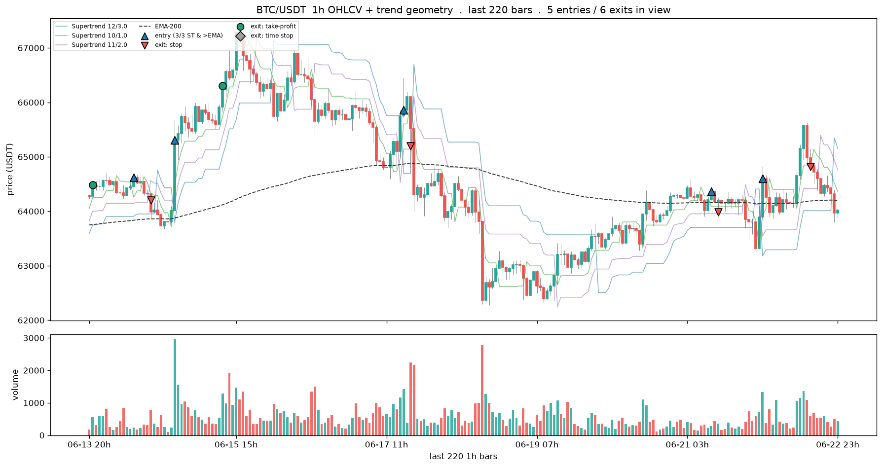
BTC/USDT: 1145 trades total . 5 entries / 6 exits in the 220-bar window
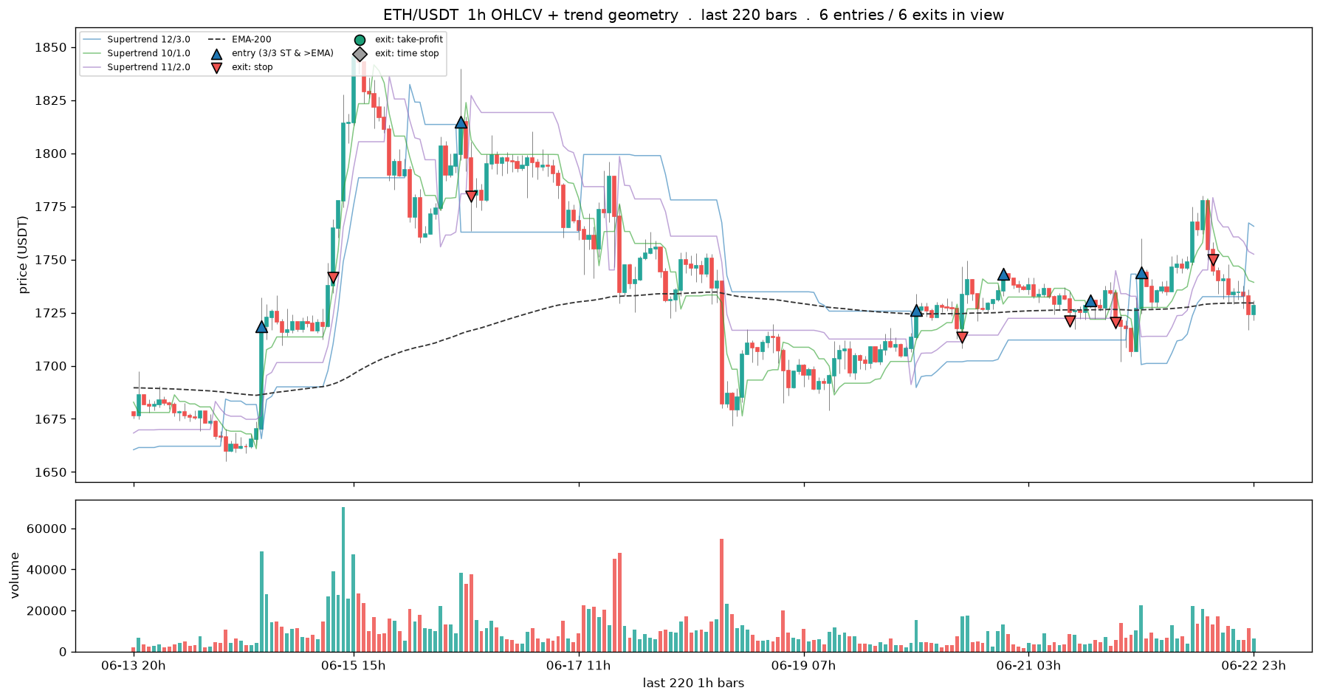
ETH/USDT: 1166 trades total . 6 entries / 6 exits in the 220-bar window
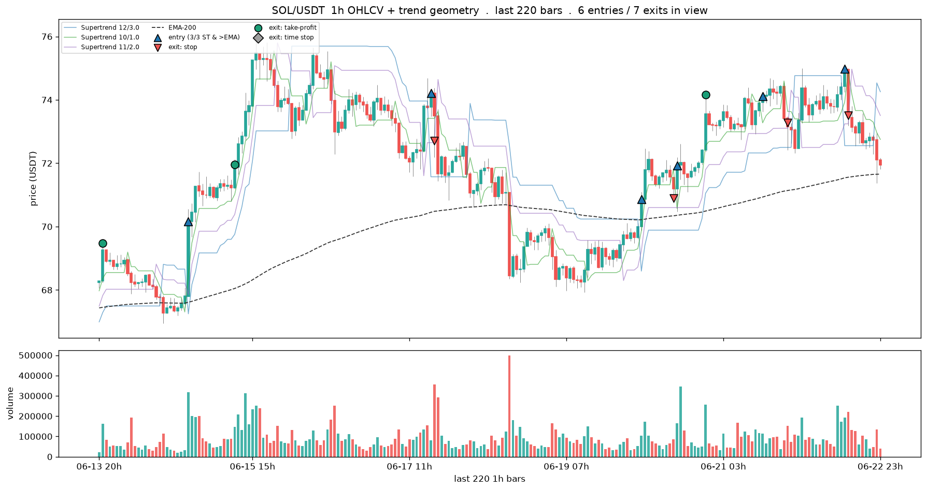
SOL/USDT: 820 trades total . 6 entries / 7 exits in the 220-bar window
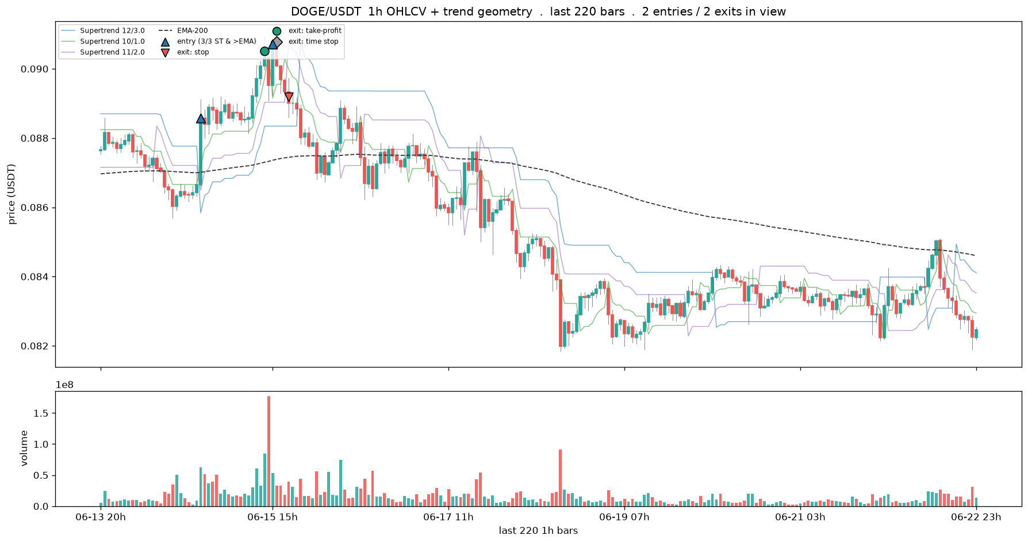
DOGE/USDT: 804 trades total . 2 entries / 2 exits in the 220-bar window
# --- Entries/exits across history: shared drawing helpers + the across-years walk --------
# Leaves the recent-window gallery to show the SAME Supertrend+EMA entry/exit rule across regimes.
# The helpers defined here are reused by the two cells below, so run this block first. Each cell
# loads + computes its own coin/frame (cheap) and restores bd's frame on exit, so the per-barrier
# cells further down are unaffected. Entry/exit mechanics are exit_geometry_viz, identical to the
# after-fee scoreboard, so the picture cannot drift from the numbers.
import exit_geometry_viz as egv
HIST_SYMBOL = "BTC/USDT" # longest history; the canonical regimes
HIST_CFG = dict(stop_mult=2.0, tp_atr=3.0, trail=2.0, tp_decay=False)
HIST_FEE = 0.001
_HBAND = ["#1f77b4", "#2ca02c", "#9467bd"]
_HEXIT = {"stop": ("#ef5350", "v", "stop"), "tp": ("#1b9e77", "o", "take-profit"),
"time": ("#9e9e9e", "D", "time stop")}
def hist_setup(symbol, frame):
"""Load a coin at a frame; compute the trend, the trades, and per-bar trend context once."""
bd.configure(frame)
o = bd.load_coin(bd.DEFAULT_KLINES_ROOT, symbol.replace("/", "")).reset_index(drop=True)
if o.empty:
print(f"no klines for {symbol} at {bd.INTERVAL}"); return None
lines, ema, entries, ups = egv.compute_trend(o)
trades, atrp = egv.simulate_with_path(o, entries, HIST_CFG, HIST_FEE, bd.LABEL["horizon_bars"] * 4)
ctx = egv.trend_context(o, ups, ema)
return dict(o=o, lines=lines, ema=ema, trades=trades, atrp=atrp, ctx=ctx)
def _hist_candles(ax, o, s, e): # OHLC candles, body width adapts to density
op, cl, hi, lo = (o[c].to_numpy() for c in ("open", "close", "high", "low"))
bw = 0.6 if (e - s) < 300 else (0.5 if (e - s) < 600 else 0.4)
ax.vlines(np.arange(s, e + 1), lo[s:e + 1], hi[s:e + 1], color="#888", lw=0.5, zorder=1)
for k in range(s, e + 1):
ax.add_patch(plt.Rectangle((k - bw / 2, min(op[k], cl[k])), bw, max(abs(cl[k] - op[k]), 1e-9),
color="#26a69a" if cl[k] >= op[k] else "#ef5350", zorder=2))
return bw
def hist_panel(H, s, e, title):
"""OHLCV candles + the three Supertrend bands + EMA-200 + entry/exit markers over [s, e]."""
o, lines, ema, trades = H["o"], H["lines"], H["ema"], H["trades"]
s = max(0, s); e = min(len(o) - 1, e); x = np.arange(s, e + 1)
fig, (axp, axv) = plt.subplots(2, 1, figsize=(15, 7), sharex=True, gridspec_kw={"height_ratios": [3, 1]})
bw = _hist_candles(axp, o, s, e)
for li, ln in enumerate(lines):
axp.plot(x, np.asarray(ln)[s:e + 1], lw=0.8, alpha=0.55, color=_HBAND[li],
label=f"Supertrend {bd.ST_BANDS[li][0]}/{bd.ST_BANDS[li][1]}")
axp.plot(x, ema[s:e + 1], color="#333", lw=1.0, ls="--", label=f"EMA-{bd.ST_EMA}")
ne = nx = 0
for t in trades:
if s <= t["i"] <= e:
axp.scatter([t["i"]], [t["entry"]], marker="^", s=70, color="#1f77b4", edgecolor="k", zorder=6); ne += 1
if s <= t["j"] <= e:
col, mk, _ = _HEXIT[t["reason"]]
axp.scatter([t["j"]], [t["exit"]], marker=mk, s=60, color=col, edgecolor="k", zorder=6); nx += 1
axp.scatter([], [], marker="^", s=60, color="#1f77b4", edgecolor="k", label="entry")
for r, (col, mk, lab) in _HEXIT.items():
axp.scatter([], [], marker=mk, s=60, color=col, edgecolor="k", label=f"exit: {lab}")
axp.set_title(f"{title} . {ne} entries / {nx} exits"); axp.set_ylabel("price (USDT)")
axp.legend(loc="upper left", fontsize=7, ncol=3)
up = o["close"].to_numpy() >= o["open"].to_numpy()
axv.bar(x, o["volume"].to_numpy()[s:e + 1], width=max(bw, 0.5), alpha=0.85,
color=np.where(up[s:e + 1], "#26a69a", "#ef5350")); axv.set_ylabel("volume")
tk = np.linspace(s, e, 6).astype(int); axv.set_xticks(tk)
axv.set_xticklabels([f"{o['datetime'].iloc[k]:%Y-%m-%d}" for k in tk], fontsize=8)
fig.tight_layout(); show_fig(fig)
return ne, nx
def hist_critical(H, t, title):
"""Zoom one trade: candles + volume + the trailing-stop/take-profit path + the entry's trend drivers."""
o, lines, ema, ctx, atrp = H["o"], H["lines"], H["ema"], H["ctx"], H["atrp"]
s = max(0, t["i"] - 30); e = min(len(o) - 1, t["j"] + 15); x = np.arange(s, e + 1)
fig, (ax, axv) = plt.subplots(2, 1, figsize=(13, 7.5), sharex=True,
gridspec_kw={"height_ratios": [3, 1]})
bw = _hist_candles(ax, o, s, e)
for li, ln in enumerate(lines):
ax.plot(x, np.asarray(ln)[s:e + 1], lw=0.8, alpha=0.5, color=_HBAND[li])
ax.plot(x, ema[s:e + 1], color="#333", lw=1.0, ls="--", label=f"EMA-{bd.ST_EMA}")
jx = np.arange(t["i"] + 1, t["i"] + 1 + len(t["spath"]))
ax.plot(jx, t["spath"], color="#d95f02", lw=1.6, drawstyle="steps-post", label="trailing stop")
if np.isfinite(t["tpath"]).any():
ax.plot(jx, t["tpath"], color="#1b9e77", lw=1.0, ls=":", label="take-profit")
ax.scatter([t["i"]], [t["entry"]], marker="^", s=130, color="#1f77b4", edgecolor="k", zorder=6)
col, mk, lab = _HEXIT[t["reason"]]
ax.scatter([t["j"]], [t["exit"]], marker=mk, s=130, color=col, edgecolor="k", zorder=6)
why = (f"entry {o['datetime'].iloc[t['i']]:%Y-%m-%d %Hh}\n"
f"Supertrend {ctx['agree'][t['i']]}/3 agree\n"
f"price {'above' if ctx['ema_up'][t['i']] else 'below'} rising EMA-200\n"
f"RSI {ctx['rsi'][t['i']]:.0f} ATR {atrp[t['i']] * 100:.1f}%")
ax.annotate(why, (t["i"], t["entry"]), textcoords="offset points", xytext=(8, -82), fontsize=8,
color="#1f77b4", bbox=dict(boxstyle="round", fc="#eef4fb", ec="#1f77b4", alpha=0.9))
ax.annotate(f"{lab} exit {t['ret'] * 100:+.1f}%", (t["j"], t["exit"]), textcoords="offset points",
xytext=(6, 12), fontsize=9, color=col)
ax.set_title(f"{title} . {lab} exit {t['ret'] * 100:+.1f}%"); ax.set_ylabel("price (USDT)")
ax.legend(loc="upper left", fontsize=8)
upc = o["close"].to_numpy() >= o["open"].to_numpy()
axv.bar(x, o["volume"].to_numpy()[s:e + 1], width=max(bw, 0.5), alpha=0.85,
color=np.where(upc[s:e + 1], "#26a69a", "#ef5350")); axv.set_ylabel("volume")
tk = np.linspace(s, e, 5).astype(int); axv.set_xticks(tk)
axv.set_xticklabels([f"{o['datetime'].iloc[k]:%m-%d %Hh}" for k in tk], fontsize=8)
fig.tight_layout(); show_fig(fig)
# --- the across-years walk: one BTC episode per panel, drawn on the 4h frame --------------
_prev_frame = bd.INTERVAL_HOURS
try:
H = hist_setup(HIST_SYMBOL, 4)
_dts = H["o"]["datetime"].values.astype("datetime64[ns]")
def _i(d): return int(np.searchsorted(_dts, np.datetime64(d)))
EPOCHS = [
("2019 spring rally", "2019-04-01", "2019-06-20"),
("2020 COVID crash + recovery", "2020-02-20", "2020-05-05"),
("2020 H2 bull market start", "2020-10-01", "2020-12-20"),
("2021 blow-off top + May crash", "2021-04-05", "2021-05-25"),
("2023 ETF run-up", "2023-10-10", "2024-01-05"),
("2024 post-halving chop", "2024-02-20", "2024-05-01"),
]
for name, a, b in EPOCHS:
ne, nx = hist_panel(H, _i(a), _i(b), f"{HIST_SYMBOL} 4h . {name}")
print(f"{name:34s} {a} -> {b} {ne} entries / {nx} exits")
print("\nnote: the 2022 LUNA/bear leg is omitted because the rule fires ZERO entries there -- it "
"stands aside\nwhen no uptrend exists, which is itself the correct (and only safe) behaviour.")
finally:
bd.configure(_prev_frame) # leave bd as the rest of the notebook expects
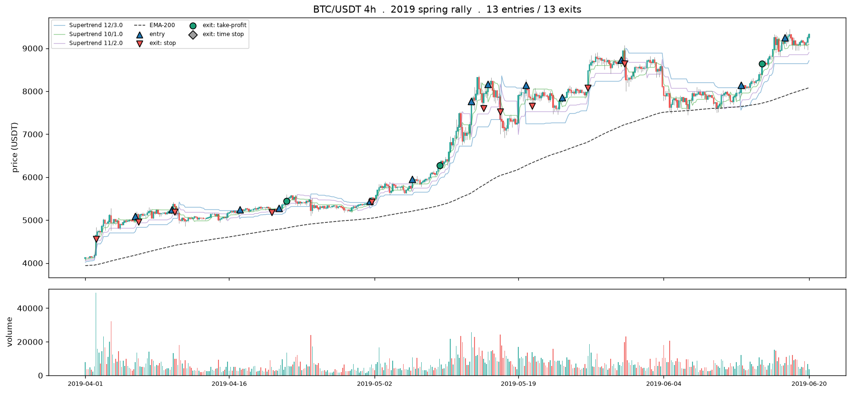
2019 spring rally 2019-04-01 -> 2019-06-20 13 entries / 13 exits
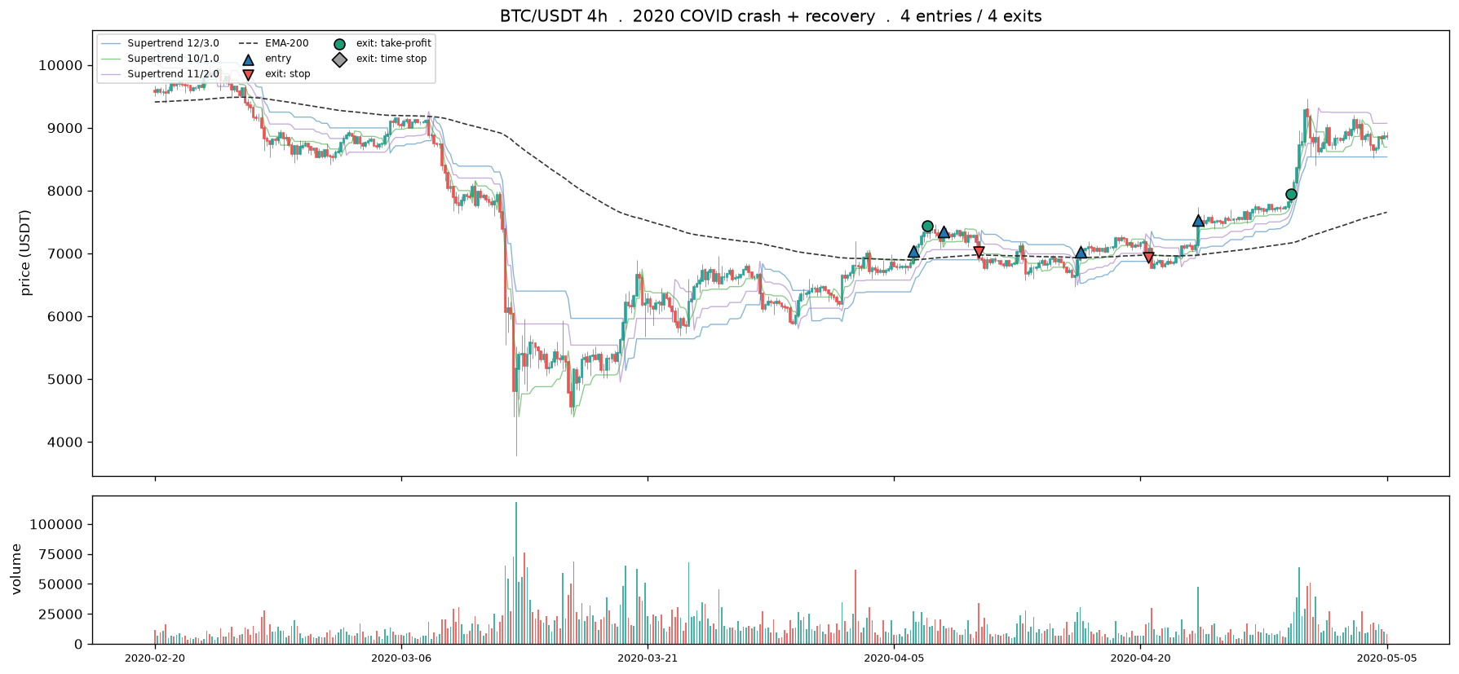
2020 COVID crash + recovery 2020-02-20 -> 2020-05-05 4 entries / 4 exits
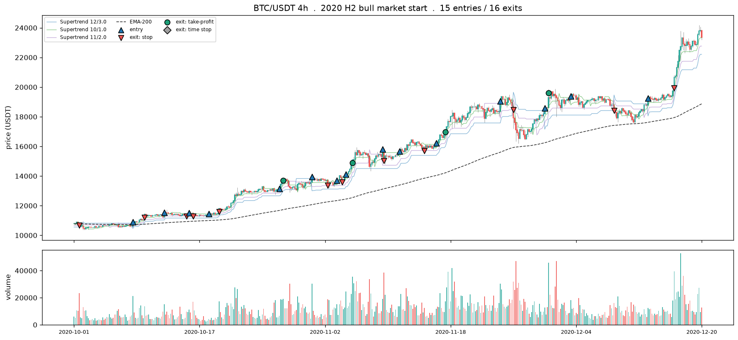
2020 H2 bull market start 2020-10-01 -> 2020-12-20 15 entries / 16 exits
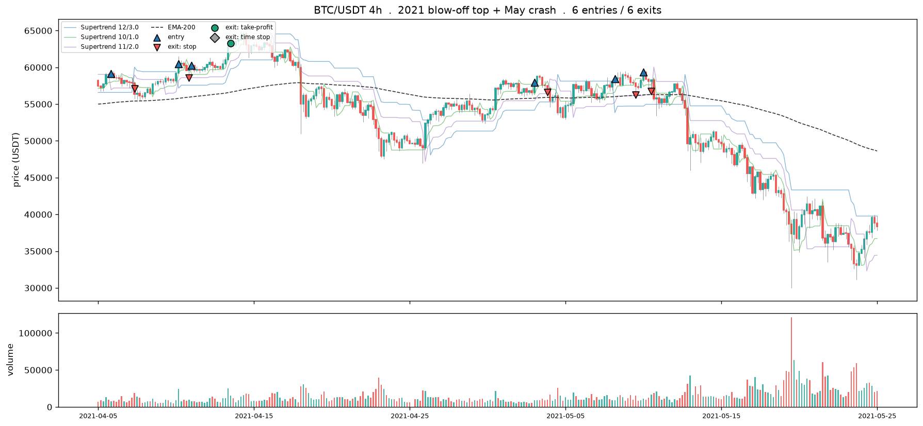
2021 blow-off top + May crash 2021-04-05 -> 2021-05-25 6 entries / 6 exits
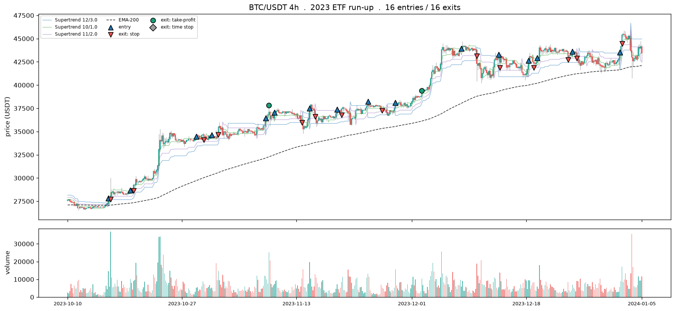
2023 ETF run-up 2023-10-10 -> 2024-01-05 16 entries / 16 exits
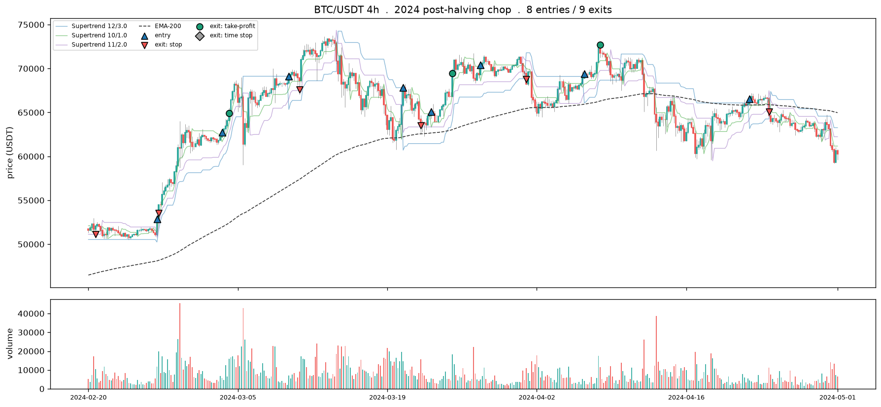
2024 post-halving chop 2024-02-20 -> 2024-05-01 8 entries / 9 exits
note: the 2022 LUNA/bear leg is omitted because the rule fires ZERO entries there -- it stands aside
when no uptrend exists, which is itself the correct (and only safe) behaviour.
# --- The same rule at different timeline lengths -----------------------------------------
# Lever 1: change frame (1h -> 4h) keeps the candle count but multiplies the span at equal legibility.
# Lever 2: widen the window on one frame. hist_setup / hist_panel come from the across-years cell
# above, so run that one first.
_prev_frame = bd.INTERVAL_HOURS
try:
for frame, nbars, tag in [(1, 220, "1h, recent ~220 bars (fine detail)"),
(4, 220, "4h, recent ~220 bars (same candle count, 4x the span)")]:
H = hist_setup(HIST_SYMBOL, frame); n = len(H["o"])
hist_panel(H, n - nbars, n - 1, f"{HIST_SYMBOL} . {tag}")
H = hist_setup(HIST_SYMBOL, 4); n = len(H["o"]) # lever 2: long window, same 4h frame
hist_panel(H, n - 700, n - 1, f"{HIST_SYMBOL} . 4h, long ~700-bar window (zoomed out)")
print("1h vs 4h at equal candle count is lever 1 (frame); 220 vs 700 on 4h is lever 2 (window). "
"Past ~900 candles, step to a coarser frame rather than zoom further.")
finally:
bd.configure(_prev_frame)
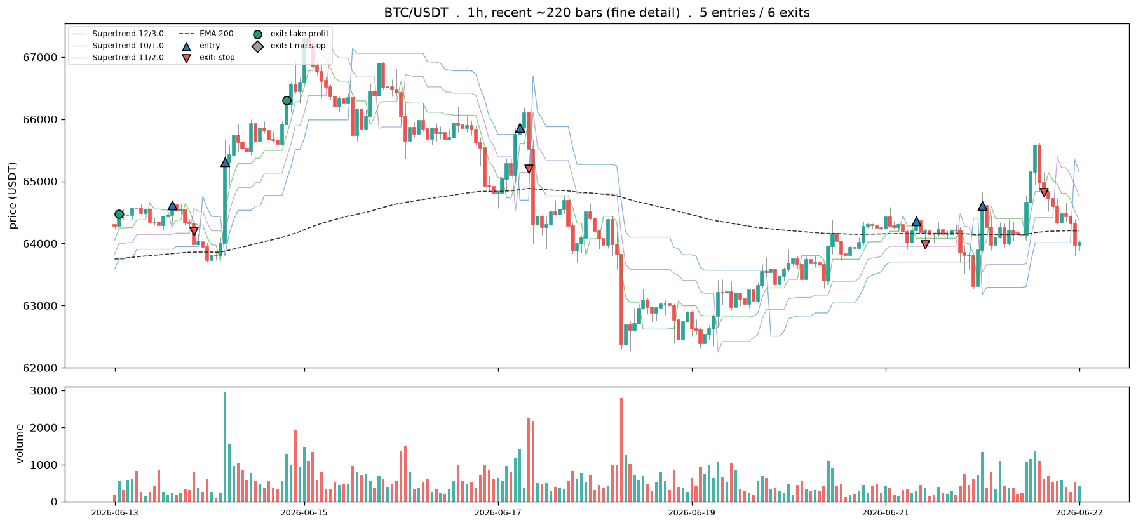
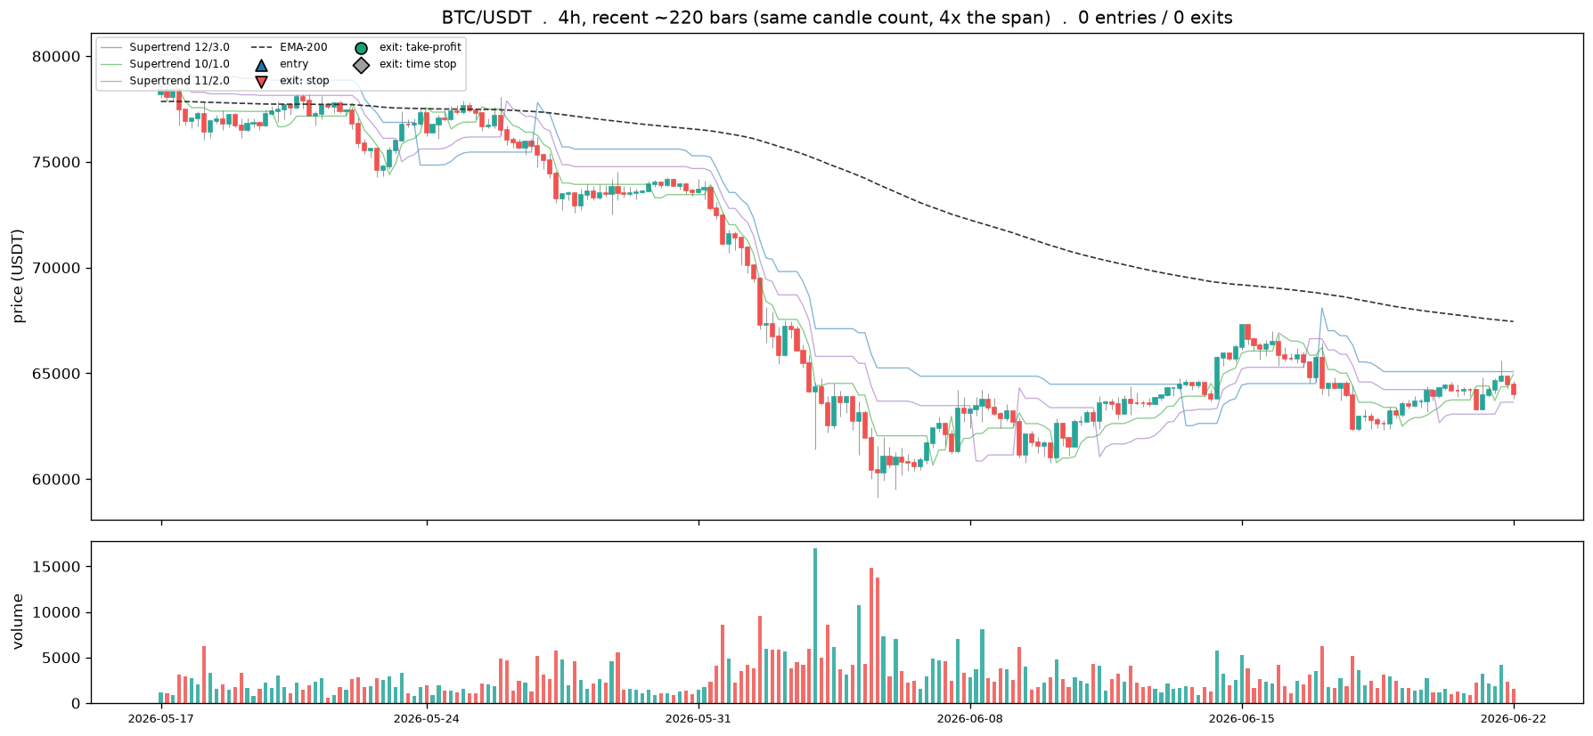
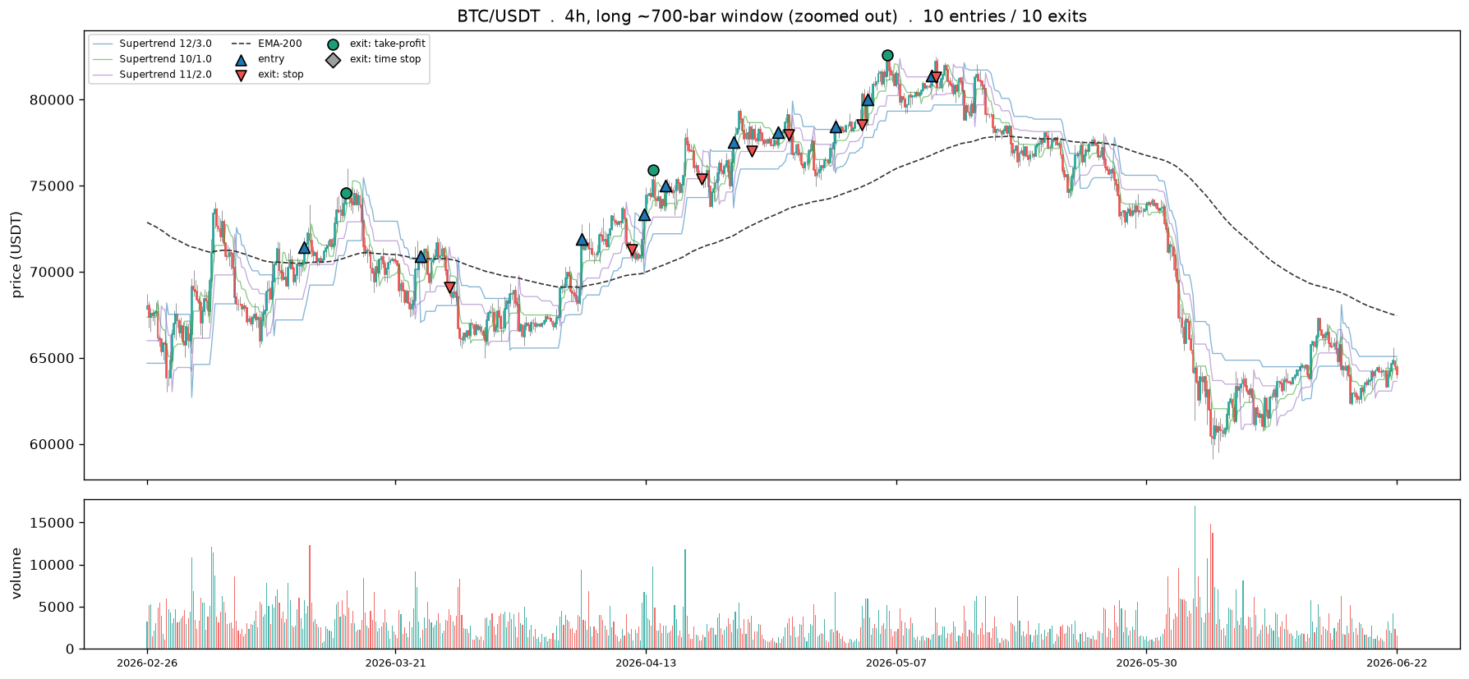
1h vs 4h at equal candle count is lever 1 (frame); 220 vs 700 on 4h is lever 2 (window). Past ~900 candles, step to a coarser frame rather than zoom further.
# --- Critical entries and exits, and why the signal fired --------------------------------
# The largest winners and losers by after-fee return, each zoomed in with the trend drivers that
# fired the entry and the barrier that closed it. Helpers come from the across-years cell above.
_prev_frame = bd.INTERVAL_HOURS
try:
H = hist_setup(HIST_SYMBOL, 4)
ranked = sorted(H["trades"], key=lambda t: t["ret"])
winners, losers = ranked[-2:][::-1], ranked[:2] # 2 biggest gains, 2 biggest losses
print(f"from {len(H['trades'])} BTC 4h trades . best {winners[0]['ret']*100:+.1f}% / "
f"worst {losers[0]['ret']*100:+.1f}%")
for rank, t in enumerate(winners, 1):
hist_critical(H, t, f"{HIST_SYMBOL} 4h . top winner #{rank}")
for rank, t in enumerate(losers, 1):
hist_critical(H, t, f"{HIST_SYMBOL} 4h . worst loser #{rank}")
finally:
bd.configure(_prev_frame)
from 282 BTC 4h trades . best +15.5% / worst -8.7%
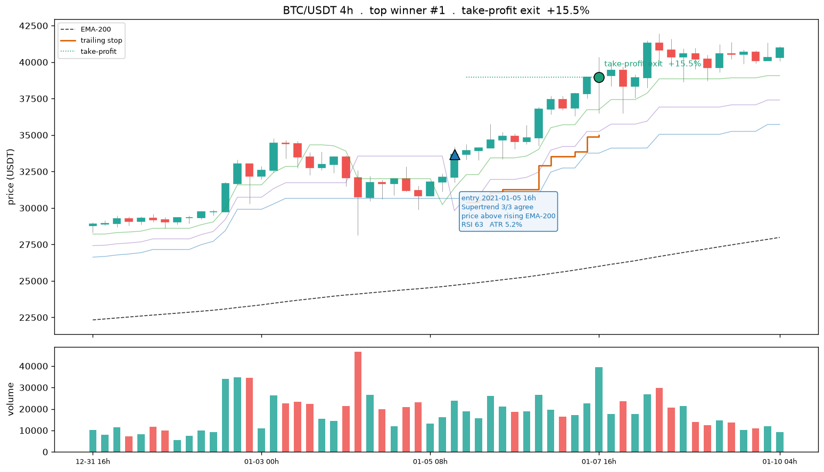
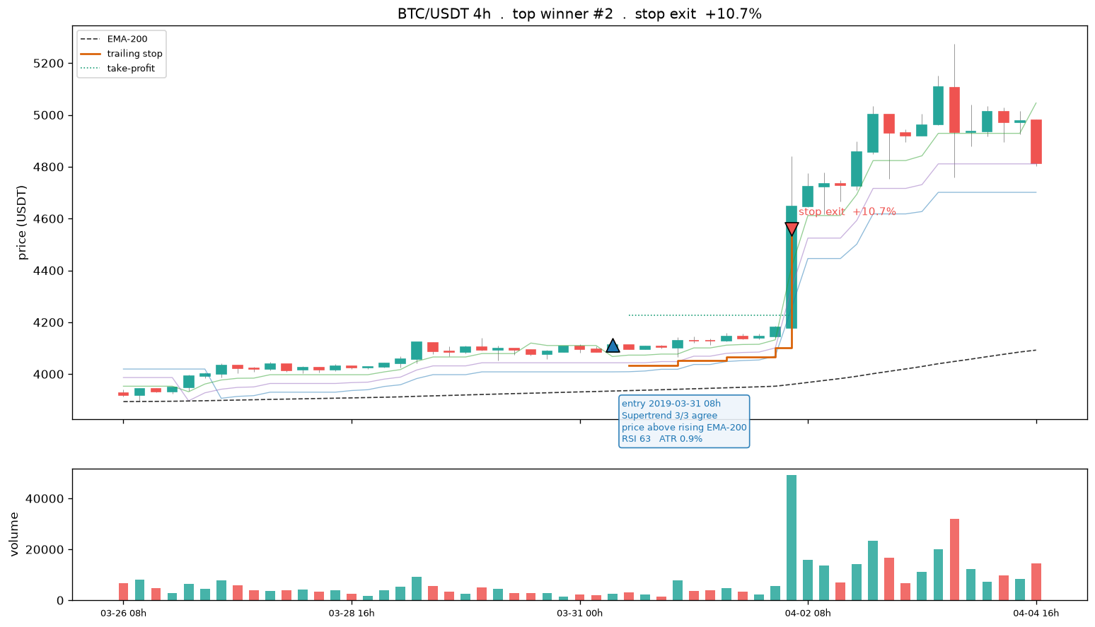
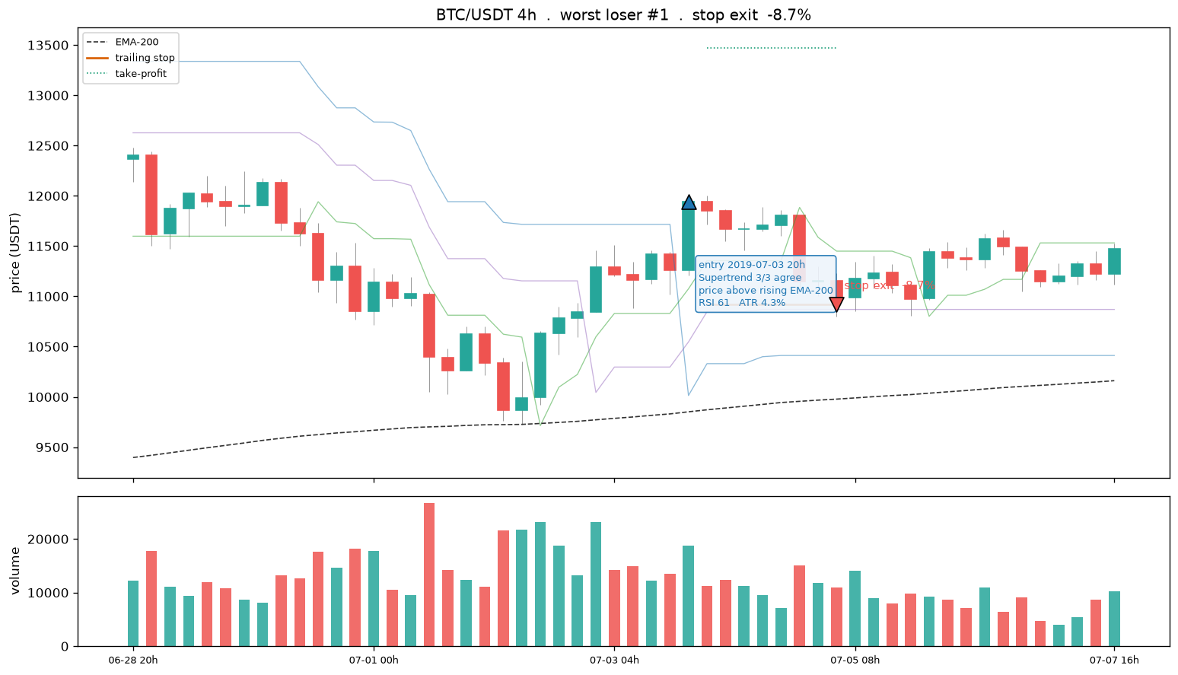
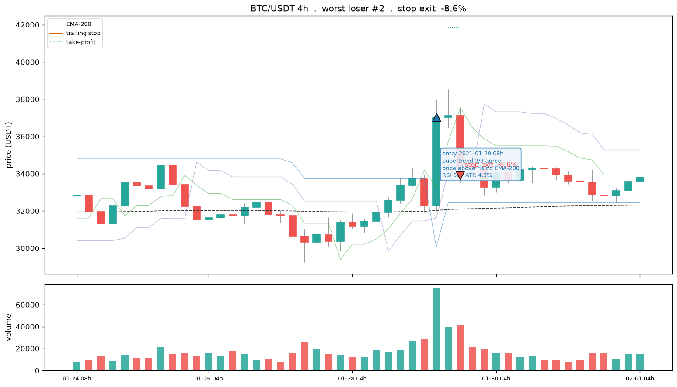
# --- Entry design on real candles: the ATR triple-barrier the labeller draws ----------
# Reload raw OHLC (the dataset keeps features+label, not price), recompute the per-bar
# high range (+tgt ATR take-profit) and low range (-stp ATR stop), and overlay the barrier
# box for a handful of entries coloured by outcome. This is the picture of "where we enter".
ENTRY_SYMBOL = "BTC/USDT" # any coin in df; the kline folder form just drops the slash
WINDOW_BARS = 160 # number of 1h candles to show
N_ENTRIES = 5 # entries to annotate with their full barrier box
if df is not None:
lab = bd.LABEL
folder = ENTRY_SYMBOL.replace("/", "")
ohlc = bd.load_coin(bd.DEFAULT_KLINES_ROOT, folder).reset_index(drop=True)
if ohlc.empty:
print(f"no raw klines for {folder} under {bd.DEFAULT_KLINES_ROOT}")
else:
atr = bd._atr_pct(ohlc, lab["atr_len"]) / 100.0 # per-bar ATR fraction
ohlc["hi_range"] = ohlc["close"] * (1 + lab["tgt_atr"] * atr) # upper barrier (take-profit)
ohlc["lo_range"] = ohlc["close"] * (1 - lab["stp_atr"] * atr) # lower barrier (stop)
labels = df.loc[df["symbol"] == ENTRY_SYMBOL, ["datetime", "label", "trade_ret"]]
ohlc = ohlc.merge(labels, on="datetime", how="left") # realised win/loss per bar
valid = ohlc.dropna(subset=["label"])
end = int(valid.index.max()); start = max(0, end - WINDOW_BARS + 1)
win = ohlc.iloc[start:end + 1].reset_index(drop=True)
x = np.arange(len(win))
def _candles(ax, w, xs): # OHLC bars without mplfinance
ax.vlines(xs, w["low"], w["high"], color="#444", linewidth=0.6, zorder=1)
for i in xs:
o, c = w["open"].iloc[i], w["close"].iloc[i]
ax.add_patch(plt.Rectangle((i - 0.3, min(o, c)), 0.6, max(abs(c - o), 1e-9),
color=("#26a69a" if c >= o else "#ef5350"), zorder=2))
fig, (ax1, axv, ax2) = plt.subplots(3, 1, figsize=(15, 11), sharex=True,
gridspec_kw={"height_ratios": [3, 1, 1]})
_candles(ax1, win, x)
ax1.plot(x, win["hi_range"], color="#1b9e77", lw=0.9, alpha=0.6,
label=f"high range +{lab['tgt_atr']} ATR (take-profit)")
ax1.plot(x, win["lo_range"], color="#d95f02", lw=0.9, alpha=0.6,
label=f"low range -{lab['stp_atr']} ATR (stop)")
ent = win.index[win["label"].notna()].tolist()
for k in np.linspace(0, len(ent) - 1, min(N_ENTRIES, len(ent))).astype(int):
t = ent[k]; c = win["close"].iloc[t]
tgt, stp = win["hi_range"].iloc[t], win["lo_range"].iloc[t]
won = win["label"].iloc[t] == 1
wdt = min(lab["horizon_bars"], len(win) - 1 - t) # box width = horizon, clipped
col = "#26a69a" if won else "#ef5350"
ax1.add_patch(plt.Rectangle((t, stp), wdt, tgt - stp, alpha=0.10, color=col, zorder=0))
ax1.hlines(tgt, t, t + wdt, color="#1b9e77", lw=1.3, zorder=3)
ax1.hlines(stp, t, t + wdt, color="#d95f02", lw=1.3, zorder=3)
ax1.scatter([t], [c], marker="^" if won else "v", s=80, color=col, edgecolor="k", zorder=4)
ax1.set_title(f"{ENTRY_SYMBOL} 1h candles . ATR triple-barrier entry design "
f"(+{lab['tgt_atr']}/-{lab['stp_atr']} ATR, {lab['horizon_bars']}-bar horizon) "
f". green box = win, red box = loss")
ax1.set_ylabel("price (USDT)"); ax1.legend(loc="upper left", fontsize=8)
upc = (win["close"] >= win["open"]).to_numpy()
axv.bar(x, win["volume"].to_numpy(), width=0.7, alpha=0.85,
color=np.where(upc, "#26a69a", "#ef5350")); axv.set_ylabel("volume")
ax2.fill_between(x, 0, atr.iloc[start:end + 1].values * 100, color="#7570b3", alpha=0.4)
ax2.set_ylabel("ATR %")
ticks = np.linspace(0, len(win) - 1, 6).astype(int)
ax2.set_xticks(ticks)
ax2.set_xticklabels([f"{win['datetime'].iloc[i]:%m-%d %Hh}" for i in ticks])
ax2.set_xlabel(f"last {len(win)} in-sample 1h bars")
fig.tight_layout()
(OUTPUTS / "PNG").mkdir(parents=True, exist_ok=True)
fig.savefig(OUTPUTS / "PNG" / "3-entry-design-candles.png", dpi=150)
show_fig(fig)
nwin = int(win["label"].eq(1).sum()); ntot = int(win["label"].notna().sum())
print(f"window {win['datetime'].iloc[0]:%Y-%m-%d %Hh} -> {win['datetime'].iloc[-1]:%Y-%m-%d %Hh}"
f" | {ntot} labelled entries, {nwin} wins ({nwin / max(ntot, 1):.0%}), "
f"base rate {df.loc[df['symbol'] == ENTRY_SYMBOL, 'label'].mean():.0%}")
else:
print("build/load the 1h dataset first (see Import Data).")
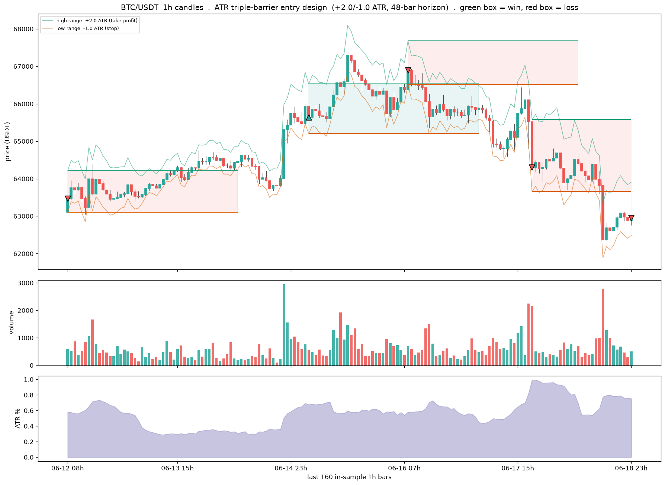
window 2026-06-12 08h -> 2026-06-18 23h | 111 labelled entries, 35 wins (32%), base rate 31%
# --- Exit geometry on real candles + the trend data around each entry --------------------
# Heavy multi-panel rendering lives in inputs/exit_geometry_viz.py (single source, also used by
# chapters 1 and 2). Here the pipeline stays legible: trend -> entries -> exit simulation -> plot.
import exit_geometry_viz as egv
EXIT_SYMBOL = "BTC/USDT" # any coin with klines on disk
EXIT_CFG = dict(stop_mult=2.0, tp_atr=3.0, trail=2.0, tp_decay=False) # one exit configuration
FEE = 0.001 # 10 bps per side
MAX_HOLD = bd.LABEL["horizon_bars"] * 4 # time stop, generous vs the label horizon
ohlc = bd.load_coin(bd.DEFAULT_KLINES_ROOT, EXIT_SYMBOL.replace("/", "")).reset_index(drop=True)
lines, ema, entries, ups = egv.compute_trend(ohlc) # 3 Supertrend trailing lines + EMA-200 + entries
trades, atrp = egv.simulate_with_path(ohlc, entries, EXIT_CFG, FEE, MAX_HOLD) # exit mechanics, path recorded
fig = egv.plot_single(ohlc, lines, ema, ups, trades, atrp, EXIT_CFG, MAX_HOLD, FEE, # shaded pre-entry window,
f"{EXIT_SYMBOL} {bd.INTERVAL}", # ST-agreement + RSI panels,
OUTPUTS / "PNG" / "3-exit-geometry-candles.png", show=False) # entry trend annotations
show_fig(fig) # embed inline (Positron-safe)
[single] BTC/USDT 1h: 1145 trades exits: 181 TP / 963 stop / 1 time mean net -0.35%/trade -> /Volumes/PortableSSD/Github/day-trader/outputs/PNG/3-exit-geometry-candles.png
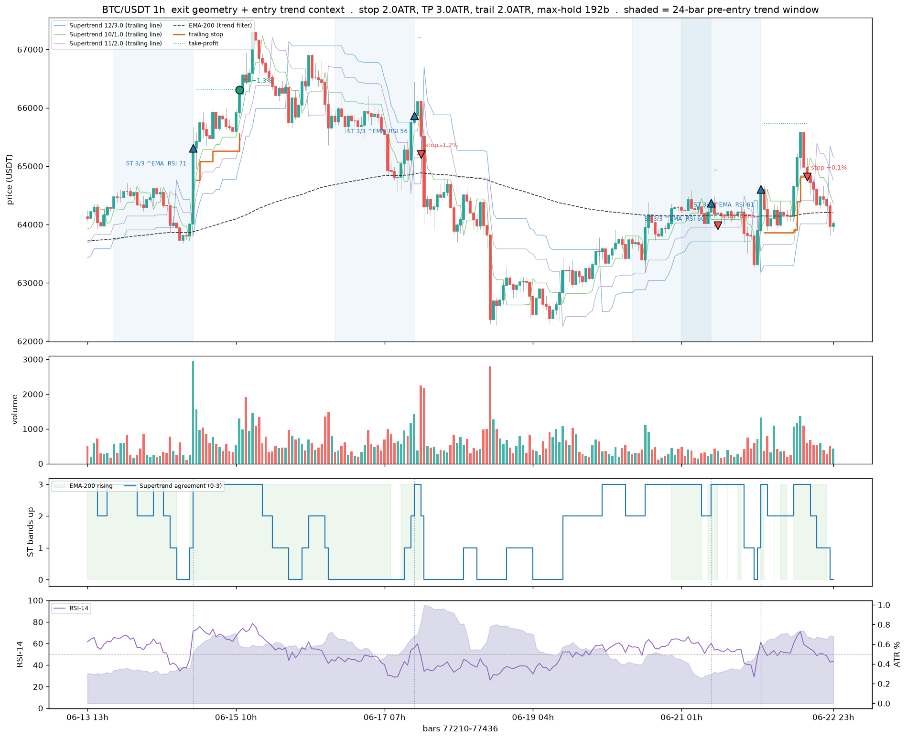
# --- Same entry, several exit geometries: how the shape changes where a trade exits ------
# Reuses ohlc / lines / ema / ups / entries from the Exit Geometry cell above.
COMPARE_CFGS = [("fixed TP/stop", dict(stop_mult=2.0, tp_atr=3.0, trail=0.0, tp_decay=False)),
("trailing stop", dict(stop_mult=2.0, tp_atr=3.0, trail=2.0, tp_decay=False)),
("decaying TP", dict(stop_mult=2.0, tp_atr=3.0, trail=2.0, tp_decay=True))]
fig = egv.plot_compare(ohlc, lines, ema, ups, entries, COMPARE_CFGS, MAX_HOLD, FEE,
f"{EXIT_SYMBOL} {bd.INTERVAL}",
OUTPUTS / "PNG" / "3-exit-geometry-compare.png", show=False)
show_fig(fig) # embed inline (Positron-safe)
[compare] BTC/USDT 1h: anchored on entry at bar 77414 -> /Volumes/PortableSSD/Github/day-trader/outputs/PNG/3-exit-geometry-compare.png
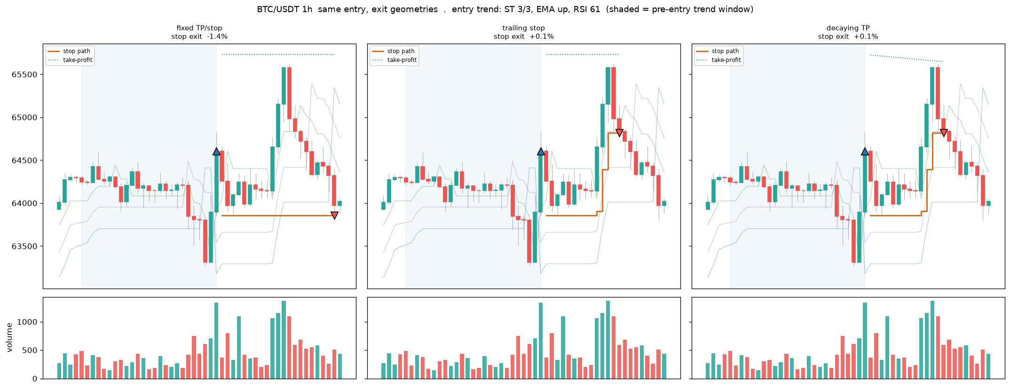

3.4 Sharpening Entries
An honest test of whether a sharper entry helps. Range and volatility entry conditions never pay, trend and momentum pay only marginally, and an early BTC-trend-gated entry that fires a few bars before the Supertrend flip lifts a single year to breakeven but does not survive walk-forward, positive in only a minority of folds. The conclusion carried through the rest of the chapter is that more price-derived entry features will not cross the fee line, which is why the search turns to cross-sectional framing and a coarser frame.
# --- Sharpening: which single conditions lift the win rate toward/over breakeven? ------
# Win rate by decile of the most label-separating features, against the barrier breakeven.
# Green decile clears breakeven (a sharper entry); the table ranks the best filters found.
if df is not None and feat:
lab = bd.LABEL
breakeven = lab["stp_atr"] / (lab["stp_atr"] + lab["tgt_atr"]) # gross win-rate breakeven
base = df["label"].mean()
m1, m0 = df[df.label == 1][feat].mean(), df[df.label == 0][feat].mean()
sep = ((m1 - m0) / df[feat].std().replace(0, np.nan)).abs().sort_values(ascending=False)
top = sep.head(8).index.tolist()
fig, axes = plt.subplots(2, 4, figsize=(16, 7), sharey=True)
rows = []
for ax, f in zip(axes.ravel(), top):
d = df[[f, "label"]].dropna()
q = pd.qcut(d[f], 10, labels=False, duplicates="drop")
wr = d.groupby(q)["label"].mean()
ax.bar(wr.index, wr.values, color=np.where(wr.values >= breakeven, "#26a69a", "#ef5350"))
ax.axhline(breakeven, color="k", ls="--", lw=1)
ax.axhline(base, color="#888", ls=":", lw=1)
ax.set_title(f, fontsize=8); ax.set_xticks([])
rows.append((f, round(float(wr.max()), 3), round(float(wr.max() - breakeven), 3)))
for a in (axes[0, 0], axes[1, 0]):
a.set_ylabel("win rate")
fig.suptitle(f"Win rate by feature decile . dashed = breakeven {breakeven:.3f}, "
f"dotted = base rate {base:.3f} . green decile clears breakeven")
fig.tight_layout()
(OUTPUTS / "PNG").mkdir(parents=True, exist_ok=True)
fig.savefig(OUTPUTS / "PNG" / "3-entry-sharpening.png", dpi=150)
plt.show()
tbl = (pd.DataFrame(rows, columns=["feature", "best_decile_winrate", "lift_over_breakeven"])
.sort_values("lift_over_breakeven", ascending=False).reset_index(drop=True))
print("Best single-feature entry filters (in-sample, GROSS of cost):")
show_table(tbl)
print(f"cost drag is ~{CONFIG['cost_pct']:.2f}% round trip; on a +{lab['tgt_atr']} ATR target a "
f"win must clear breakeven by more than that to pay. ")
if tbl["lift_over_breakeven"].max() <= 0:
print("NONE clear breakeven gross -> 1h single-feature entries do not sharpen past the barrier math.")
print("Matches the handover: sharpen via a coarser (4h+) frame and cross-sectional ranking, "
"not more 1h features.")
else:
print("build/load the 1h dataset first (see Import Data).")
Best single-feature entry filters (in-sample, GROSS of cost):
<IPython.core.display.HTML object>
cost drag is ~0.20% round trip; on a +2.0 ATR target a win must clear breakeven by more than that to pay.

3.5 Survivorship Pipeline
The three-stage pipeline that makes the panel survivorship-complete and point-in-time honest. Stage A crawls the data.binance.vision listing to enumerate every USDT pair ever listed, delisted coins included, and downloads them checksum-verified. Stage B profiles coverage, gaps, listing timelines, and liquidity to derive the usable start, the minimum history, and the purge and embargo. Stage C is the forward-chained walk-forward splitter with per-fold point-in-time universes and train-only transforms. This is the spine Parts 1 and 2 borrow their universe from.
# Stage A: prove the historical universe includes dead coins. Crawl is ~4s, no download here.
# (inputs/ is already on sys.path from the Environment cell.)
import acquire_vision as av
crawl = av.crawl_archive_symbols(quote='USDT', verbose=False)
uni = crawl['symbols']
print(f"historical USDT universe (incl. dead coins): {len(uni)} pairs "
f"(+{len(crawl['leveraged'])} leveraged excluded)")
# Stage A.5 guard: known-delisted pairs MUST be present, else the list came from a live endpoint.
aud = av.audit_dead_coins(uni)
# Survivorship share vs a dated active snapshot (writes inputs/binance-data/exchange_info_snapshot_<date>.json).
active, snap_path = av.snapshot_exchange_info()
part = av.partition_survivorship(uni, active)
print(f"survivorship: {part['n_universe']} universe / {part['n_active']} active / "
f"{part['n_delisted']} delisted = {part['delisted_share']:.1%} dead coins")
# The heavy pull (operator's Mac): python inputs/acquire_vision.py download --interval 1h
historical USDT universe (incl. dead coins): 612 pairs (+52 leveraged excluded)
dead-coin audit: 10/10 known-delisted present in universe
snapshot: 442 active USDT pairs as of 2026-07-03 -> /Volumes/PortableSSD/Github/day-trader/inputs/binance-data/exchange_info_snapshot_2026-07-03.json
survivorship: 612 universe / 423 active / 189 delisted = 30.9% dead coins
# Stage B: panel profiling. Loads the persisted profile; BUILDS it on first run if absent
# (writes run-stamped artefacts under outputs/3A-training-test-data/panel-profile/). Rebuild with:
# python inputs/profile_panel.py
# pp.latest_run() resolves the run dir PORTABLY: latest.txt records an absolute path, so on a
# different mount (the exFAT SSD remounting, a fresh checkout) that path is re-rooted under the
# current PROFILE_ROOT rather than read empty -- independent of the notebook's cwd.
import json, os, pandas as pd
import profile_panel as pp
run = pp.latest_run()
if run is None:
print('No Stage B profile found -- building over the full klines_1h panel.')
print('First run only; it streams every coin twice, so expect a few minutes...')
pp.profile(root=pp.DEFAULT_KLINES_ROOT, out_root=pp.PROFILE_ROOT, make_plot=False)
run = pp.latest_run()
md_tbl = pd.read_parquet(os.path.join(run, 'symbol_metadata.parquet'))
dec = json.load(open(os.path.join(run, 'decision_summary.json')))
print('profile run :', run)
print('symbols :', len(md_tbl), '| delisted share:', f"{dec['survivorship']['delisted_share']:.1%}")
print('usable start :', dec['usable_start_date'])
print('min history :', dec['min_history_days'], 'days')
print('purge/embargo:', dec['purge_embargo_days'], 'days', f"({dec['purge_embargo_bars']} bars)")
print('point-of-entry:', dec['point_of_entry_rule'][:90], '...')
_view = md_tbl[['symbol', 'first_bar', 'last_bar', 'n_bars', 'coverage', 'max_gap_hours',
'halt_flag', 'active']].head(10)
print(f'\nsymbol metadata (first 10 of {len(md_tbl)} rows):')
print(_view.to_string(index=False)) # text fallback: renders in every IDE
display(_view)
profile run : /Volumes/PortableSSD/Github/day-trader/outputs/3A-training-test-data/panel-profile/2026-06-23T072849Z
symbols : 384 | delisted share: 0.0%
usable start : 2019-08-01
min history : 157 days
purge/embargo: 125 days (3000 bars)
point-of-entry: coin enters at its first valid bar (realistic; mirrors when trading would actually begin) ...
symbol metadata (first 10 of 384 rows):
symbol first_bar last_bar n_bars coverage max_gap_hours halt_flag active
BTCUSDT 2017-08-17 04:00:00+00:00 2026-06-20 23:00:00+00:00 77389 0.9984 75 True True
ETHUSDT 2017-08-17 04:00:00+00:00 2026-06-20 23:00:00+00:00 77389 0.9984 75 True True
BNBUSDT 2017-11-06 03:00:00+00:00 2026-06-20 23:00:00+00:00 75453 0.9984 75 True True
NEOUSDT 2017-11-20 03:00:00+00:00 2026-06-20 23:00:00+00:00 75117 0.9984 75 True True
LTCUSDT 2017-12-13 03:00:00+00:00 2026-06-20 23:00:00+00:00 74565 0.9984 75 True True
QTUMUSDT 2018-03-19 08:00:00+00:00 2026-06-20 23:00:00+00:00 72289 0.9988 10 False True
ADAUSDT 2018-04-17 04:00:00+00:00 2026-06-20 23:00:00+00:00 71597 0.9988 10 False True
TUSDUSDT 2018-05-31 09:00:00+00:00 2026-06-20 23:00:00+00:00 66541 0.9422 3995 True True
IOTAUSDT 2018-05-31 09:00:00+00:00 2026-06-20 23:00:00+00:00 70536 0.9988 10 False True
ONTUSDT 2018-06-08 07:00:00+00:00 2026-06-20 23:00:00+00:00 70356 0.9989 10 False True
{"comm_id":"bdcb48dd-183b-4834-9b3f-c9849a6cd044","shape":{"columns":8,"rows":10},"source":"pandas","title":"_view","variable_path":["{\"type\":\"str\",\"data\":\"_view\"}"],"version":1}
# Stage C: the splitter draws usable_start + per-fold universes from the Stage B run above.
# Reuses `bd` (build_dataset_1h) from the Environment cell.
import wf_splitter as wf
print(wf.METHODOLOGY)
pb, lf, lh = wf.purge_embargo_bars()
print(f'purge/embargo = max(feature lookback {lf}, label horizon {lh}) = {pb} bars '
f'= {wf.purge_embargo_days()} days')
df_wf = bd.read_frame(bd.DATASET_PATH)
if df_wf is not None:
if 'in_sample' in df_wf.columns:
df_wf = df_wf[df_wf['in_sample']].copy()
sp = wf.WalkForwardSplitter(n_folds=5, test_days=120, scheme='expanding',
usable_start=wf.load_usable_start(),
universes=wf.load_universes())
_folds = sp.fold_table(df_wf) # per-fold spans + coin counts (C.5 composition audit)
print(f'\nwalk-forward folds ({len(_folds)}):')
print(_folds.to_string(index=False)) # text fallback: renders in every IDE
display(_folds)
# Regime-stability metrics (fits a model per fold; run on the .venv):
# wf.evaluate_walkforward(df_wf, bd.feature_columns(df_wf), sp)
else:
print('No dataset yet at', bd.DATASET_PATH)
## Splitting methodology: forward-chained, not stratified
Objective: estimate out-of-sample performance under REGIME DRIFT, not interpolation within a
known distribution. The data-generating process drifts across time -- the 2017-18 ICO mania,
the 2021 bull run, the 2022 deleveraging, and the current regime are different processes. A
split that interleaves test bars among training bars borrows the future to predict the past
and yields an error estimate that will not survive live trading.
Stratified sampling is rejected. Stratifying on variance forces similar class proportions
across splits by drawing observations regardless of position in time, which destroys the
temporal ordering that is the whole object of interest. It answers "can the model interpolate
within a known distribution"; the question that matters is "can it extrapolate forward into an
unknown regime." Only a forward-chained split measures that.
Design: expanding/rolling walk-forward on shared calendar boundaries; purge/embargo =
max(feature lookback, label horizon) at every cut; split on time not on coins; per-fold
universe drawn point-in-time from the Stage B profile; transforms fit on train only;
per-fold metrics weighted by coin count.
purge/embargo = max(feature lookback 3000, label horizon 48) = 3000 bars = 125 days
walk-forward folds (5):
fold train_start train_end test_start test_end n_train n_test n_coins embargo_days
0 2019-08-01 2024-06-23 2024-10-26 2025-02-23 271088 28742 21 125
1 2019-08-01 2024-10-21 2025-02-23 2025-06-23 294746 25482 19 125
2 2019-08-01 2025-02-18 2025-06-23 2025-10-21 329261 31086 23 125
3 2019-08-01 2025-06-18 2025-10-21 2026-02-18 356443 24993 21 125
4 2019-08-01 2025-10-16 2026-02-18 2026-06-18 387233 16801 20 125
{"comm_id":"82f451d3-7201-40f6-b89e-1e15ee2a3276","shape":{"columns":9,"rows":5},"source":"pandas","title":"_folds","variable_path":["{\"type\":\"str\",\"data\":\"_folds\"}"],"version":1}

3.6 Variable Selection
Feature selection on the training window only, so the choice never sees the blind year. It ranks the candidate features and prunes the redundant and the near-zero-signal, keeping the causal, scale-invariant set the model trains on, with the after-fee out-of-sample scoreboard as the final arbiter of whether a family earns its place.
# Stage ii: elastic-net (glmnet-analogue) variable selection on the TRAINING split ONLY, via
# inputs/variable_selection.py end-to-end: build_matrix -> enet_cv -> CV curve + coef paths ->
# screen at lambda.1se -> refit survivors for 95% CIs. The blind final year is never touched.
import importlib, variable_selection as vs
importlib.reload(vs)
from IPython.display import Image, display
VARSEL_DIR = OUTPUTS / "AA-evals" / "varselect"
VARSEL_DIR.mkdir(parents=True, exist_ok=True)
if df is not None and feat:
tr_vs, _te_vs, _cut = t1.split(df) # select on TRAIN; OOS stays blind
samp = tr_vs.dropna(subset=[*feat, "label"])
if len(samp) > 25000: # saga path is slow; 25k screens fine
samp = samp.sample(25000, random_state=0)
X, y, _ = vs.build_matrix(samp, y_col="label", x_cols=feat, standardize=True)
res = vs.enet_cv(X, y, family="binomial", l1_ratio=1.0, n_folds=10, verbose=False)
print(f"lasso path on {len(samp):,} TRAIN rows x {len(feat)} features.")
print(f"lambda.min={res['lambda_min']:.4g} (nonzero {int(res['nonzero'][res['i_min']])}), "
f"lambda.1se={res['lambda_1se']:.4g} (nonzero {int(res['nonzero'][res['i_1se']])})")
p_cv = vs.plot_cv_curve(res, str(VARSEL_DIR / "cv_curve.png"))
p_cp = vs.plot_coefpath(res, str(VARSEL_DIR / "coefpath.png"))
p_cph = vs.plot_coefpath_interactive(res, str(VARSEL_DIR / "coefpath.html"))
display(Image(filename=p_cv)); display(Image(filename=p_cp))
kept = vs.screen(res, "1se") or vs.screen(res, "min") # survivors, largest |coef| first
SELECTED_FEATURES = [n for n, _ in kept]
ci_cols = (SELECTED_FEATURES or [n for n, _ in vs.screen(res, "min")])[:12]
p_ci = vs.plot_coef_ci(samp, "binomial", str(VARSEL_DIR / "coef_ci.png"),
y_col="label", x_cols=ci_cols,
title="Screened coefficients (logit, 95% CI)")
display(Image(filename=p_ci))
print(f"\nelastic-net kept {len(SELECTED_FEATURES)} of {len(feat)} features at lambda.1se.")
print("top kept:", ", ".join(f"{n}({v:+.3f})" for n, v in kept[:15]))
print("interactive coefficient path (open in browser):", p_cph)
print("\nTo train the head-to-head on this subset: set feat = SELECTED_FEATURES then re-run training.")
else:
SELECTED_FEATURES = []
print("build the 1h dataset first (see Import Data).")
lasso path on 25,000 TRAIN rows x 61 features.
lambda.min=0.000494 (nonzero 45), lambda.1se=0.01121 (nonzero 0)
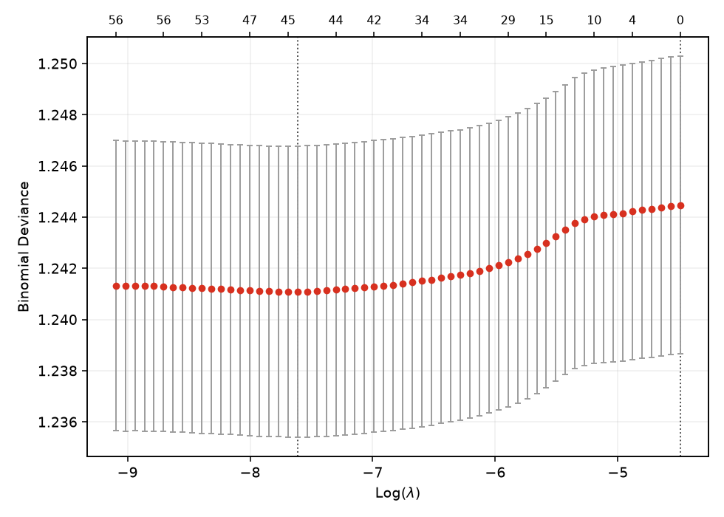
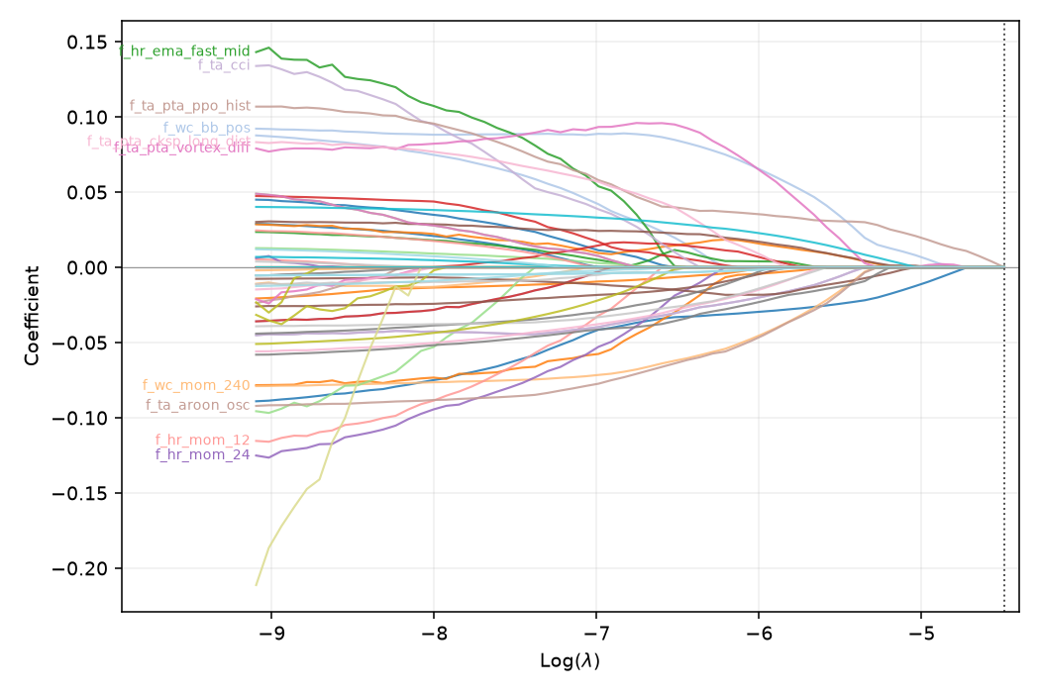
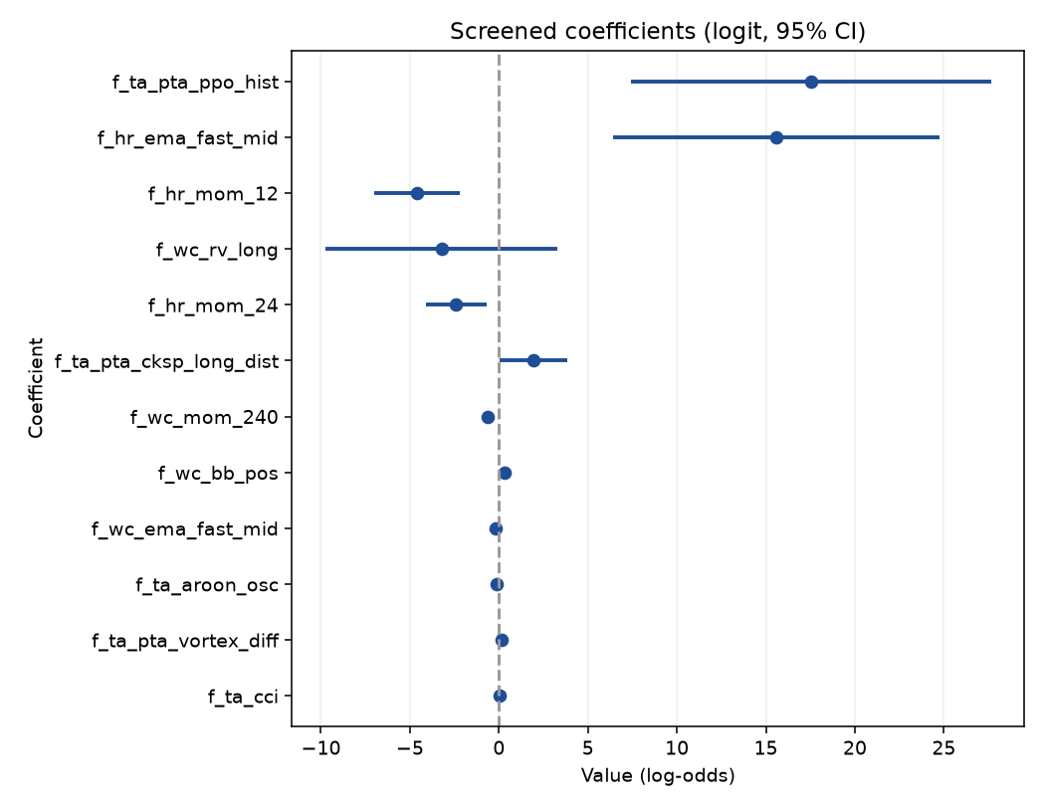
elastic-net kept 45 of 61 features at lambda.1se.
top kept: f_hr_ema_fast_mid(+0.093), f_wc_bb_pos(+0.088), f_ta_aroon_osc(-0.086), f_ta_pta_vortex_diff(+0.086), f_ta_pta_ppo_hist(+0.083), f_hr_mom_24(-0.083), f_wc_mom_240(-0.075), f_ta_cci(+0.071), f_hr_mom_12(-0.071), f_ta_pta_cksp_long_dist(+0.071), f_wc_rv_long(-0.070), f_wc_ema_fast_mid(-0.066), f_wc_atr_pct(+0.066), f_tl_sar_dist(-0.049), f_ta_pta_fisher(-0.046)
interactive coefficient path (open in browser): /Volumes/PortableSSD/Github/day-trader/outputs/AA-evals/varselect/coefpath.html
To train the head-to-head on this subset: set feat = SELECTED_FEATURES then re-run training.

3.7 Training Regime
The model trains on all history before the final-year cut and is scored once on the blind year. A capped sample keeps the in-notebook fit quick; the full fit runs from the .venv. The section reports the held-out margin of the model's confident picks over the base rate, the feature importances, and a look at one tree, so the training is legible rather than a black box. The label and horizon are the 0.4 geometry.
# Split and scoring come from the scripts: t1.split for the 1h final-year hold-out; tm.evaluate,
# tm.build_models, tm.confidence_filtered shared with inputs/train_model.py. Nothing reimplemented.
train, test, cut = t1.split(df)
Xtr, ytr, Xte, yte = train[feat], train["label"], test[feat], test["label"]
base_te = yte.mean()
span = lambda d: f"{d['datetime'].min().date()} to {d['datetime'].max().date()}"
print(f"train {len(train):,} ({span(train)}) . test {len(test):,} ({span(test)}) . "
f"cut {pd.Timestamp(cut).date()} embargo +/-{t1.EMBARGO_DAYS}d . base rate {base_te:.3f}")
train 381,207 (2017-12-15 to 2025-06-16) . test 76,789 (2025-06-19 to 2026-06-18) . cut 2025-06-18 embargo +/-2d . base rate 0.303
# Fast interactive pass. The full-fidelity 3-model run on ALL history is inputs/train_model_1h.py
# (script / auto-eval). The heavy part here is evaluate()'s 5-fold TimeSeriesSplit CV on each model
# (3 models x (5 CV fits + 1 final fit) on ~381k rows = minutes). For the notebook we fit a bounded
# sample taken across the whole period and re-sorted by time, so the time-series CV stays
# chronological. Raise TRAIN_CAP or set it to None for the full run (slow).
TRAIN_CAP = 80_000
if TRAIN_CAP is None or len(train) <= TRAIN_CAP:
tr_fit = train
else:
tr_fit = train.sample(TRAIN_CAP, random_state=0).sort_values("datetime")
Xtr_f, ytr_f = tr_fit[feat], tr_fit["label"]
print(f"fitting on {len(tr_fit):,} of {len(train):,} train rows "
f"({tr_fit['datetime'].min().date()} to {tr_fit['datetime'].max().date()})"
+ (" [sampled for the notebook; full run is inputs/train_model_1h.py]"
if (TRAIN_CAP and len(train) > TRAIN_CAP) else ""))
lines, scored = [], []
for name, mdl in tm.build_models(HAVE_LGBM):
prec, m = tm.evaluate(name, mdl, Xtr_f, ytr_f, Xte, yte, base_te, lines)
scored.append((prec, name, mdl, m))
print("\n".join(lines))
_, best_name, best_model, best = max(scored, key=lambda t: t[0])
print(f"\nchosen: {best_name} (precision {best['prec']:.3f} vs base {base_te:.3f}, AUC {best['auc']:.3f})")
fitting on 80,000 of 381,207 train rows (2017-12-16 to 2025-06-16) [sampled for the notebook; full run is inputs/train_model_1h.py]
--- LogisticRegression ---
train CV ROC-AUC (5-fold TimeSeriesSplit): 0.528
test accuracy : 0.484
test precision(buy): 0.307 (base rate 0.303)
test recall(buy) : 0.560
test ROC-AUC : 0.504
confusion matrix [rows=true 0/1, cols=pred 0/1]:
[[24164, 29352], [10241, 13032]]
precision lift over base rate: +0.004
confidence filter (act if p>=0.60 or p<=0.40): keeps 2.7% of test rows (n=2075)
precision(buy) 0.285 recall 0.663 F1 0.398 (base rate 0.303)
--- RandomForest ---
train CV ROC-AUC (5-fold TimeSeriesSplit): 0.526
test accuracy : 0.489
test precision(buy): 0.310 (base rate 0.303)
test recall(buy) : 0.557
test ROC-AUC : 0.509
confusion matrix [rows=true 0/1, cols=pred 0/1]:
[[24627, 28889], [10319, 12954]]
precision lift over base rate: +0.007
confidence filter (act if p>=0.60 or p<=0.40): keeps 1.2% of test rows (n=931)
precision(buy) 0.000 recall 0.000 F1 0.000 (base rate 0.303)
--- LightGBM ---
train CV ROC-AUC (5-fold TimeSeriesSplit): 0.520
test accuracy : 0.534
test precision(buy): 0.311 (base rate 0.303)
test recall(buy) : 0.440
test ROC-AUC : 0.510
confusion matrix [rows=true 0/1, cols=pred 0/1]:
[[30769, 22747], [13024, 10249]]
precision lift over base rate: +0.008
confidence filter (act if p>=0.60 or p<=0.40): keeps 27.8% of test rows (n=21316)
precision(buy) 0.292 recall 0.349 F1 0.318 (base rate 0.303)
chosen: LightGBM (precision 0.311 vs base 0.303, AUC 0.510)
# Honesty gate: precision must clearly beat the base rate and AUC clear 0.55. It does not
# trade; Metric 2 (next cell) is the money test.
margin = best["prec"] - base_te
go = (best["prec"] > base_te + 0.05) and (best["auc"] > 0.55)
verdict = "GO" if go else "NO-GO"
print("HONESTY GATE:", "GO (edge survives out-of-sample)" if go
else "NO-GO (no demonstrable edge - do not trade)")
MODEL_DIR.mkdir(parents=True, exist_ok=True) # self-sufficient: works even if the setup cell was not re-run
joblib.dump({"model": best_model, "features": feat, "name": best_name,
"trained_through": str(pd.Timestamp(cut).date()),
"test_base_rate": float(base_te), "go": bool(go)}, MODEL_DIR / "model_1h.joblib")
summary = (f"{best_name}: test precision(buy)={best['prec']:.3f} base_rate={base_te:.3f} "
f"lift={margin:+.3f} AUC={best['auc']:.3f} recall={best['rec']:.3f} acc={best['acc']:.3f} -> {verdict}")
(MODEL_DIR / "model_metrics_1h.txt").write_text(summary + "\n\n" + "\n".join(lines) + "\n")
print("saved", MODEL_DIR / "model_1h.joblib", "and model_metrics_1h.txt")
HONESTY GATE: NO-GO (no demonstrable edge - do not trade)
saved /Volumes/PortableSSD/Github/day-trader/outputs/3B-model-training/model_1h.joblib and model_metrics_1h.txt
# Metrics 2 (P&L after costs) and 3 (regime-stratified AUC) plus AA-evals bookkeeping, from
# inputs/eval_report.py - the same record the script writes. Appends one row to
# outputs/AA-evals/evaluation-scores.md (+ .pdf, .docx), tagged "head-to-head (1h)".
imp = getattr(best_model, "feature_importances_", None)
regime = "f_wc_rv_long" if "f_wc_rv_long" in test.columns else next((c for c in feat if "rv_long" in c), None)
meta = dict(dataset_rows=len(df), n_features=len(feat),
train_rows=len(train), test_rows=len(test), base_rate=float(base_te),
cut=str(pd.Timestamp(cut).date()), embargo=t1.EMBARGO_DAYS,
conf_hi=tm.CONF_HI, conf_lo=tm.CONF_LO, chosen=best_name, verdict=verdict,
eval_type="head-to-head (1h)",
dataset_label=f"{len(df):,}r / {len(feat)}f (1h all-market)",
fi_names=list(feat) if imp is not None else None,
fi_values=[float(v) for v in imp] if imp is not None else None,
regime_vol=test[regime].tolist() if regime else None,
trade_ret=test["trade_ret"].tolist() if "trade_ret" in test.columns else None,
cost_pct=tm.COST_PCT)
results = [m for (_, _, _, m) in scored]
rec = eval_report.write_comparison(str(OUTPUTS / "AA-evals"), results, yte, meta)
print("evaluation record:", rec["md"])
evaluation record: /Volumes/PortableSSD/Github/day-trader/outputs/AA-evals/2026-07-03/eval-head-to-head-20260703.md
# Teaching display: the strongest tree model's top features. The AA-evals record above
# already saves this chart; this is just an inline look.
tree = next((mdl for (_, name, mdl, _) in scored
if name in ("LightGBM", "RandomForest")), None)
imp = getattr(tree, "feature_importances_", None) if tree is not None else None
if imp is not None:
order = np.argsort(imp)[::-1][:15]
fig, ax = plt.subplots(figsize=(8, 5))
ax.barh([feat[i] for i in order][::-1], imp[order][::-1], color="#0B3D66")
ax.set_title(f"{tree.__class__.__name__}: top 15 feature importances")
fig.tight_layout()
(OUTPUTS / "PNG").mkdir(parents=True, exist_ok=True)
fig.savefig(OUTPUTS / "PNG" / "3B-feature-importance.png", dpi=160)
plt.show()

3.8 Model Tuning
Two sweeps, both scored on the after-fee out-of-sample scoreboard and logged to the consolidated scoreboard: the label-geometry sweep over the ATR barrier and horizon, and the model hyperparameter sweep over expanding time-series folds. These run full-market as scripts from the .venv; the cell shows the commands and renders the persisted result.
# The sweeps are full-market and run as scripts from the project .venv:
# .venv/bin/python inputs/sweep_label_1h.py # Priority 1b: label geometry (target, stop, horizon)
# .venv/bin/python inputs/walkforward.py # Priority 1a: exit geometry (stop, take-profit, trail)
# Both append to the consolidated scoreboard; here we render that one table so tuning reads off it.
#from IPython.display import Markdown, display
#scoreboard = OUTPUTS / "AA-evals" / "evaluation-scores.md"
#if scoreboard.exists():
# display(Markdown(scoreboard.read_text()))
#else:
# print("no evaluation-scores.md yet - run a model (cells above) or a sweep script first.")
# Quick inline 1b probe (small grid; the full grid is the script above):
# import sweep_label_1h as sw
# coins, scols = sw.precompute(bd.DEFAULT_KLINES_ROOT, bd.DEFAULT_FLOW_CSV, None)
# sw.score_cell(coins, scols, 3.0, 1.0, 48, tm.COST_PCT/100.0, tm.CONF_HI)

3.9 Model Assessment
The caret-style scorecard, across every built frame. For each of 1h, 4h, and 5m it fits a bounded zoo on a sampled slice and scores a blind final year, reporting Full and cross-validated RMSE on predicted probabilities, the RMSEratio overfit flag, and the after-fee blind read, one block per frame. Frames are scored independently and stacked, never pooled.
# Model Assessment (stage iv): caret-style scorecard across EVERY built frame (1h, 4h, 5m), one row
# block per frame, so the resolutions sit in a single table on the same metric scale. Each frame is a
# SEPARATE model -- its own label geometry, feature set and blind out-of-sample -- so they are scored
# independently and stacked, NOT pooled into one training set (which would blend incompatible labels).
# RECOMPUTE=True fits a bounded zoo (logreg/rf/histgbm/lightgbm) on an ASSESS_CAP-row slice of each frame
# plus that frame's blind final-year test; RECOMPUTE=False shows the latest persisted full-zoo record.
# RMSE/MAE are on predicted PROBABILITIES (RMSE = sqrt(Brier)); CV is expanding-window time-series
# out-of-fold; RMSEratio = Full/CV (~1 generalises, well below 1 overfits). Refresh full-history per frame:
# .venv/bin/python inputs/model_assessment_1h.py --dataset inputs/binance-data/dataset_4h_allmarket.parquet
import glob
import model_assessment_1h as ma
from IPython.display import Markdown, display
RECOMPUTE = True # True = bounded zoo in-notebook per frame; False = cached full-zoo record
ASSESS_CAP = 60_000 # rows sampled per frame for the in-notebook fit (None = full frame, heavy)
ASSESS_FRAMES = ["1h", "4h", "5m"] # frames to score; any not built on disk are skipped with a note
ASSESS_ZOO = ["logreg", "rf", "histgbm", "lightgbm"]
def _assess_block(rows, frame):
"""One frame's caret rows, ranked by CV RMSE (lower = better), with a Frame column prepended."""
ranked = sorted(rows, key=lambda r: r["cv_rmse"])
block = [{"Frame": frame, "Model": r["model"], "Hyperparameters": r["hp"],
"Full MAE": round(r["full_mae"], 4), "Full RMSE": round(r["full_rmse"], 4),
"CV MAE": round(r["cv_mae"], 4), "CV RMSE": round(r["cv_rmse"], 4),
"RMSEratio": round(r["rmse_ratio"], 3)} for r in ranked]
return block, ranked[0]
recs = sorted(glob.glob(str(OUTPUTS / "AA-evals" / "*" / "model-assessment-*.md")))
if RECOMPUTE:
_active = globals().get("LOAD_FRAME") # reuse the already-loaded frame if it is one of these
_df_live = globals().get("df")
_prev = _active if _active is not None else bd.INTERVAL # restore the notebook's active frame afterwards
table, summary = [], []
try:
for _frame in ASSESS_FRAMES:
bd.configure(_frame) # retune windows/label/screen + DATASET_PATH per frame
path = bd.DATASET_PATH
if not (os.path.exists(path) or os.path.exists(os.path.splitext(path)[0] + ".csv")):
print(f"[{_frame}] dataset not built ({os.path.basename(path)}); skipping.")
continue
reused = (_frame == _active and _df_live is not None)
dff = None
try:
dff = _df_live if reused else bd.read_frame(path) # reuse active frame; load the others on demand
featf = bd.feature_columns(dff)
dfa = (dff if (ASSESS_CAP is None or len(dff) <= ASSESS_CAP)
else dff.sample(ASSESS_CAP, random_state=0).sort_values("datetime"))
print(f"[{_frame}] assessing {len(dfa):,} of {len(dff):,} in-sample rows, {len(featf)} features "
f"({'reusing loaded frame' if reused else 'loaded from disk'})...")
rows, tr_a, te_a, _ = ma.assess(dfa, featf, only=ASSESS_ZOO)
block, best = _assess_block(rows, _frame)
table += block
blind = ma.blind_metrics(best["est"], tr_a, te_a, featf, tm.COST_PCT / 100.0, tm.CONF_HI)
verdict = "GO" if (np.isfinite(blind["net"]) and blind["net"] > 0
and blind["prec"] > blind["base"] and blind["auc"] > 0.55) else "NO-GO"
summary.append(dict(frame=_frame, best=best, blind=blind, verdict=verdict))
except Exception as _e:
print(f"[{_frame}] skipped: {type(_e).__name__}: {_e}")
finally:
if dff is not None and not reused:
del dff # free the on-demand frame before the next one
finally:
bd.configure(_prev) # leave bd as the rest of the notebook expects
if table:
show_table(pd.DataFrame(table)) # one combined scorecard, a block per frame
print("\nbest model per frame (by CV RMSE), with its blind final-year after-fee read:")
for s in summary:
b, bl = s["best"], s["blind"]
pct = (bl["prec"] / bl["base"] - 1) * 100 if bl["base"] else float("nan")
print(f" [{s['frame']:>2s}] {b['model']:<10s} CV RMSE {b['cv_rmse']:.4f} (Full/CV {b['rmse_ratio']:.3f})"
f" . blind AUC {bl['auc']:.3f}, precision {bl['prec']:.3f} vs base {bl['base']:.3f} "
f"({pct:+.1f}%), net {bl['net']*100:+.3f}%/trade on {bl['trades']:,} -> {s['verdict']}")
print(f"\ncross-validation: {ma.CV_SPLITS}-fold expanding-window TimeSeriesSplit per frame (time-ordered, "
f"no future leak); each frame's final year is its own blind test. Frames are scored "
f"independently and stacked, never pooled: the label geometry and features differ per resolution.")
else:
print("no built frames to assess; build at least one dataset (see Import Data), then re-run.")
elif recs:
print(f"RECOMPUTE off -- showing latest persisted full-zoo record: {os.path.basename(recs[-1])}")
display(Markdown(open(recs[-1]).read()))
else:
print("build a dataset first (see Import Data), then set RECOMPUTE=True.")
[1h] assessing 60,000 of 458,539 in-sample rows, 61 features (reusing loaded frame)...
LogReg.glm full RMSE 0.4982 CV RMSE 0.5018 ratio 0.993
LogReg.enet full RMSE 0.4982 CV RMSE 0.5013 ratio 0.994
RF full RMSE 0.4915 CV RMSE 0.4976 ratio 0.988
LightGBM full RMSE 0.4277 CV RMSE 0.5001 ratio 0.855
HistGBM full RMSE 0.4659 CV RMSE 0.4980 ratio 0.935
[4h] assessing 60,000 of 3,939,629 in-sample rows, 90 features (loaded from disk)...
[4h] skipped: ValueError: Input X contains NaN.
LogisticRegression does not accept missing values encoded as NaN natively. For supervised learning, you might want to consider sklearn.ensemble.HistGradientBoostingClassifier and Regressor which accept missing values encoded as NaNs natively. Alternatively, it is possible to preprocess the data, for instance by using an imputer transformer in a pipeline or drop samples with missing values. See https://scikit-learn.org/stable/modules/impute.html You can find a list of all estimators that handle NaN values at the following page: https://scikit-learn.org/stable/modules/impute.html#estimators-that-handle-nan-values
[5m] assessing 60,000 of 5,529,861 in-sample rows, 96 features (loaded from disk)...
LogReg.glm full RMSE 0.4987 CV RMSE 0.5023 ratio 0.993
LogReg.enet full RMSE 0.4987 CV RMSE 0.5019 ratio 0.994
RF full RMSE 0.4934 CV RMSE 0.4994 ratio 0.988
LightGBM full RMSE 0.4376 CV RMSE 0.5050 ratio 0.867
HistGBM full RMSE 0.4895 CV RMSE 0.5020 ratio 0.975
<IPython.core.display.HTML object>
best model per frame (by CV RMSE), with its blind final-year after-fee read:
[1h] RF CV RMSE 0.4976 (Full/CV 0.988) . blind AUC 0.512, precision 0.000 vs base 0.298 (-100.0%), net -0.714%/trade on 1 -> NO-GO
[5m] RF CV RMSE 0.4994 (Full/CV 0.988) . blind AUC 0.530, precision nan vs base 0.393 (+nan%), net +nan%/trade on 0 -> NO-GO
cross-validation: 5-fold expanding-window TimeSeriesSplit per frame (time-ordered, no future leak); each frame's final year is its own blind test. Frames are scored independently and stacked, never pooled: the label geometry and features differ per resolution.

3.10 Stability
The Monte Carlo robustness gate, per frame. It resamples the model's held-out confident trades ten thousand times to ask whether the result is robust or luck and what the realistic worst case is, reporting total return, drawdown, and Sharpe with their worst-case percentiles, the probability of a loss, and a sign-flip p-value. A frame is ROBUST only if the fifth-percentile total is positive, the loss probability is low, and the p-value small. On the current label every frame reads FRAGILE, the honest reading of a negative-mean series compounded.
# Monte Carlo robustness (the Stability gate) across EVERY built frame (1h, 4h, 5m). A single backtest is
# ONE path; this resamples the after-fee per-trade returns 10k times per frame to ask whether the result
# is robust or luck, and the realistic worst case. PRIMARY subject per frame = the trained model's
# held-out confident trades (ed.model_trade_returns: train before the final-year cut, predict the held-out
# year, keep P(up) >= CONF_HI, net each by the round-trip cost). If a frame yields < 20 such trades it
# falls back to that frame's triple-Supertrend baseline OOS trades (one-year window sized to the frame via
# bd.INTERVAL_HOURS). ROBUST requires bootstrap P5 total > 0, p(loss) < 5%, sign-flip p-value < 0.05. Each
# frame is a separate system, shown in sequence, never pooled. STAB_CAP bounds rows per frame for speed.
import importlib, monte_carlo_1h as mc, edge_diagnostics as ed, exit_geometry_1h as eg
importlib.reload(mc)
STAB_CAP = 150_000 # rows per frame for the model subject (None = full frame, heavier)
STAB_FRAMES = ["1h", "4h", "5m"] # frames to stress-test; any not built on disk are skipped with a note
def _mc_report(rets, subject, tag):
s = mc.summary(np.array(rets), n_sims=10000)
show_table(pd.DataFrame(
{"actual": [f"{s['actual_total']:+.1%}", f"{s['actual_maxdd']:.1%}", f"{s['actual_sharpe']:.2f}"],
"P5 (worst)": [f"{s['total_p5']:+.1%}", f"{s['maxdd_worst5']:.1%}", f"{s['sharpe_p5']:.2f}"],
"median": [f"{s['total_p50']:+.1%}", f"{s['maxdd_p50']:.1%}", f"{s['sharpe_p50']:.2f}"],
"P95": [f"{s['total_p95']:+.1%}", "-", "-"]},
index=["total return", "max drawdown", "Sharpe"]))
print(f"{subject}: trades {s['n_trades']} prob(loss) {s['prob_loss']:.1%} "
f"sign-flip p-value {s['perm_pvalue']:.4f} -> {mc.verdict(s)}")
print("monte carlo record:", mc.write_record(s, str(OUTPUTS / "AA-evals"), label=subject + ".", tag=tag))
def _baseline_rets(frame_df):
"""Frame-aware triple-Supertrend OOS trades over the liquid coins -- the fallback when the model has
too few confident trades. The one-year window is sized to the current frame (bd.INTERVAL_HOURS)."""
oos_n = int(round(365 * 24 / bd.INTERVAL_HOURS)) # one year of bars at this frame
coins = sorted(sym.replace("/", "") for sym in frame_df["symbol"].unique())[:20]
out = []
for sym in coins:
d = bd.load_coin(bd.DEFAULT_KLINES_ROOT, sym)
if len(d) < oos_n + bd.ST_EMA:
continue
oos = d.iloc[-oos_n:].reset_index(drop=True)
ent = eg.supertrend_entries(oos)
out += [t["ret"] for t in eg.simulate(oos, ent, dict(stop_mult=2.0, tp_atr=3.0, trail=0.0, tp_decay=False))]
return out
_active = globals().get("LOAD_FRAME") # reuse the already-loaded frame if it is one of these
_df_live = globals().get("df")
_prev = _active if _active is not None else bd.INTERVAL # restore the notebook's active frame afterwards
try:
for _frame in STAB_FRAMES:
bd.configure(_frame) # retune windows/label/screen + DATASET_PATH + klines root
path = bd.DATASET_PATH
if not (os.path.exists(path) or os.path.exists(os.path.splitext(path)[0] + ".csv")):
print(f"\n[{_frame}] dataset not built ({os.path.basename(path)}); skipping.")
continue
reused = (_frame == _active and _df_live is not None)
dff = None
try:
dff = _df_live if reused else bd.read_frame(path) # reuse active frame; load the others on demand
featf = bd.feature_columns(dff)
dfa = (dff if (STAB_CAP is None or len(dff) <= STAB_CAP)
else dff.sample(STAB_CAP, random_state=0).sort_values("datetime").reset_index(drop=True))
print(f"\n=== [{_frame}] Stability Monte Carlo "
f"({'reusing loaded frame' if reused else 'loaded from disk'}, {len(dfa):,} rows) ===")
model_rets = ed.model_trade_returns(dfa, featf)
if len(model_rets) >= 20:
_mc_report(model_rets, f"{_frame} trained model (held-out OOS, confident picks)", _frame)
else:
print(f"[{_frame}] only {len(model_rets)} confident model trades on the held-out year; "
f"falling back to the triple-Supertrend baseline.")
base = _baseline_rets(dff)
if len(base) >= 20:
_mc_report(base, f"{_frame} triple-Supertrend baseline (OOS)", _frame)
else:
print(f"[{_frame}] not enough trades for Monte Carlo (need >=20).")
except Exception as _e:
print(f"[{_frame}] skipped: {type(_e).__name__}: {_e}")
finally:
if dff is not None and not reused:
del dff # free the on-demand frame before the next one
finally:
bd.configure(_prev) # leave bd as the rest of the notebook expects
=== [1h] Stability Monte Carlo (reusing loaded frame, 150,000 rows) ===
<IPython.core.display.HTML object>
1h trained model (held-out OOS, confident picks): trades 1476 prob(loss) 100.0% sign-flip p-value 1.0000 -> FRAGILE
monte carlo record: /Volumes/PortableSSD/Github/day-trader/outputs/AA-evals/2026-07-03/monte-carlo-20260703-1h.md
=== [4h] Stability Monte Carlo (loaded from disk, 150,000 rows) ===
<IPython.core.display.HTML object>
4h trained model (held-out OOS, confident picks): trades 2010 prob(loss) 92.7% sign-flip p-value 0.7403 -> FRAGILE
monte carlo record: /Volumes/PortableSSD/Github/day-trader/outputs/AA-evals/2026-07-03/monte-carlo-20260703-4h.md
=== [5m] Stability Monte Carlo (loaded from disk, 150,000 rows) ===
<IPython.core.display.HTML object>
5m trained model (held-out OOS, confident picks): trades 398 prob(loss) 100.0% sign-flip p-value 1.0000 -> FRAGILE
monte carlo record: /Volumes/PortableSSD/Github/day-trader/outputs/AA-evals/2026-07-03/monte-carlo-20260703-5m.md

3.11 Edge Diagnostics
Why the scoreboard says NO-GO, in three questions plus the honest selectivity test, run per frame. Q1 asks whether a pre-cost edge exists at all against a base-rate coin flip and a one-bar persistence rule. Q5 asks whether any edge is stable across eras or an artifact of one regime. Q6 sweeps the confidence threshold to see whether selectivity pays. The out-of-sample selectivity test then chooses the threshold on train and scores it once on the blind year, so a thin in-sample peak cannot pass. The verdict is a genuine floor, not a leakage artifact; the leakage audit is clean.
# Edge diagnostics (Q1 pre-cost, Q5 regimes, Q6 selectivity) across EVERY built frame (1h, 4h, 5m),
# computed IN THIS NOTEBOOK. For each built frame it retunes bd (windows/label/screen/klines root),
# loads that dataset, runs the out-of-fold sweep (ed.run), writes a frame-tagged dated record + a
# selectivity PNG, and renders both. Each frame is a separate model on its own out-of-sample, shown in
# sequence and never pooled. SAMPLE_CAP bounds rows per frame (None = full frame, heavier, esp. 5m).
import glob
import edge_diagnostics as ed
from IPython.display import Markdown, Image, display
RECOMPUTE = True # True = recompute in-notebook per frame; False = show cached records
SAMPLE_CAP = 60_000 # rows per frame for the in-notebook sweep (None = full frame)
N_SPLITS = 5
DIAG_FRAMES = ["1h", "4h", "5m"] # frames to diagnose; any not built on disk are skipped with a note
recs = sorted(glob.glob(str(OUTPUTS / "AA-evals" / "*" / "edge-diagnostics-*.md")))
if RECOMPUTE:
_active = globals().get("LOAD_FRAME") # reuse the already-loaded frame if it is one of these
_df_live = globals().get("df")
_prev = _active if _active is not None else bd.INTERVAL # restore the notebook's active frame afterwards
written = []
try:
for _frame in DIAG_FRAMES:
bd.configure(_frame) # retune windows/label/screen + DATASET_PATH + klines root
path = bd.DATASET_PATH
if not (os.path.exists(path) or os.path.exists(os.path.splitext(path)[0] + ".csv")):
print(f"[{_frame}] dataset not built ({os.path.basename(path)}); skipping.")
continue
reused = (_frame == _active and _df_live is not None)
dff = None
try:
dff = _df_live if reused else bd.read_frame(path) # reuse active frame; load the others on demand
featf = bd.feature_columns(dff)
dfa = (dff if (SAMPLE_CAP is None or len(dff) <= SAMPLE_CAP)
else dff.sample(SAMPLE_CAP, random_state=0).sort_values("datetime").reset_index(drop=True))
print(f"[{_frame}] edge diagnostics on {len(dfa):,} of {len(dff):,} rows "
f"({'reusing loaded frame' if reused else 'loaded from disk'}); trains the out-of-fold sweep...")
rec = ed.run(dfa, featf, bd.DEFAULT_KLINES_ROOT,
label=f"{bd.INTERVAL} ({'full frame' if SAMPLE_CAP is None else f'{len(dfa):,}-row sample'})",
out_dir=str(OUTPUTS / "AA-evals"), n_splits=N_SPLITS)
written.append(rec["md"])
display(Markdown(f"---\n### {bd.INTERVAL} frame\n\n" + open(rec["md"]).read()))
display(Image(filename=rec["png"]))
except Exception as _e:
print(f"[{_frame}] skipped: {type(_e).__name__}: {_e}")
finally:
if dff is not None and not reused:
del dff # free the on-demand frame before the next one
finally:
bd.configure(_prev) # leave bd as the rest of the notebook expects
if written:
print("records written:")
for _m in written:
print(" ", _m)
else:
print("no built frames to diagnose; build at least one dataset (see Import Data), then re-run.")
elif recs:
print(f"RECOMPUTE off -- showing the latest persisted records ({min(3, len(recs))} of {len(recs)}):")
for _m in recs[-3:]:
display(Markdown(open(_m).read()))
else:
print("load the dataset first (see Import Data), then set RECOMPUTE=True.")
[1h] edge diagnostics on 60,000 of 458,539 rows (reusing loaded frame); trains the out-of-fold sweep...
<IPython.core.display.Markdown object>
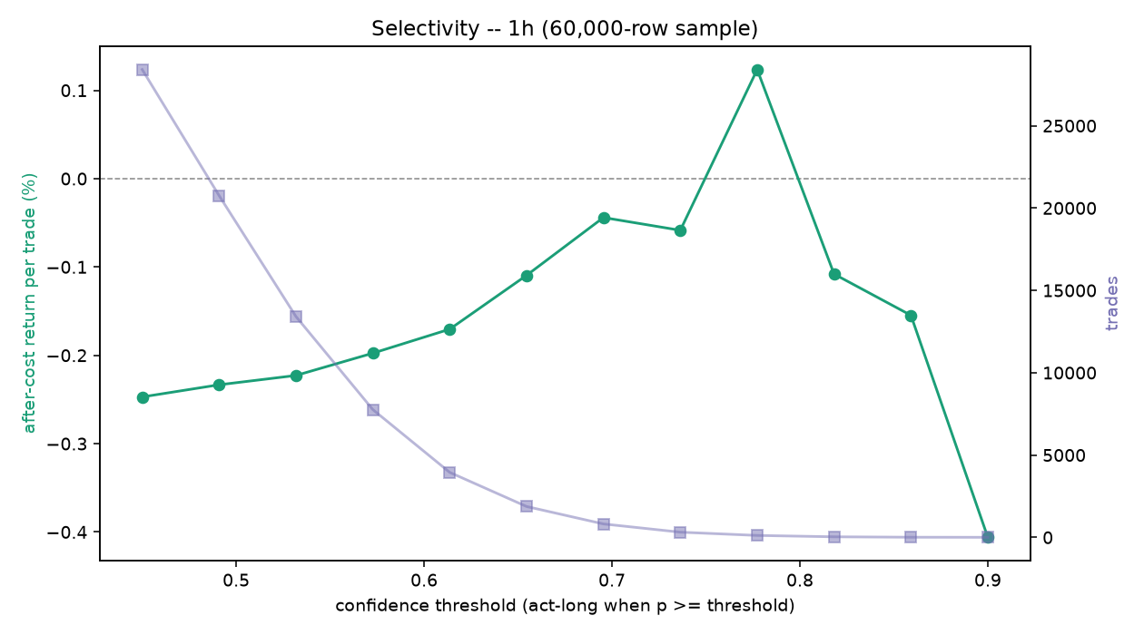
[4h] edge diagnostics on 60,000 of 3,939,629 rows (loaded from disk); trains the out-of-fold sweep...
<IPython.core.display.Markdown object>
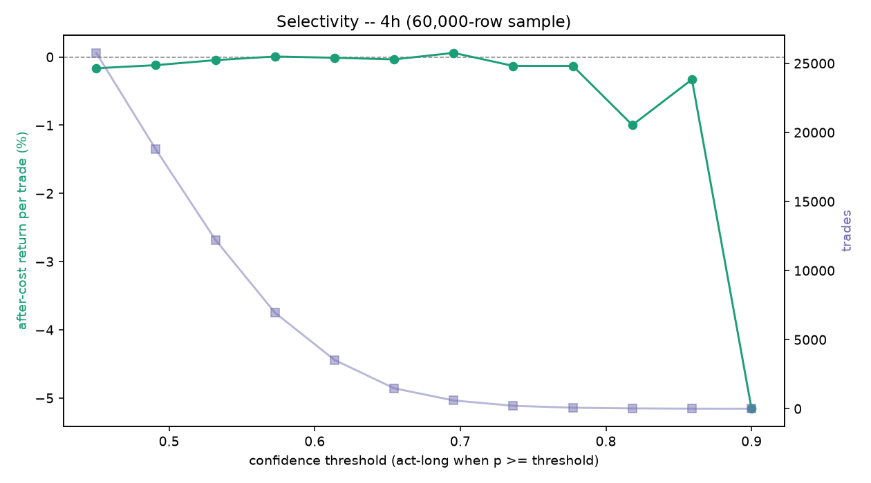
[5m] edge diagnostics on 60,000 of 5,529,861 rows (loaded from disk); trains the out-of-fold sweep...
<IPython.core.display.Markdown object>
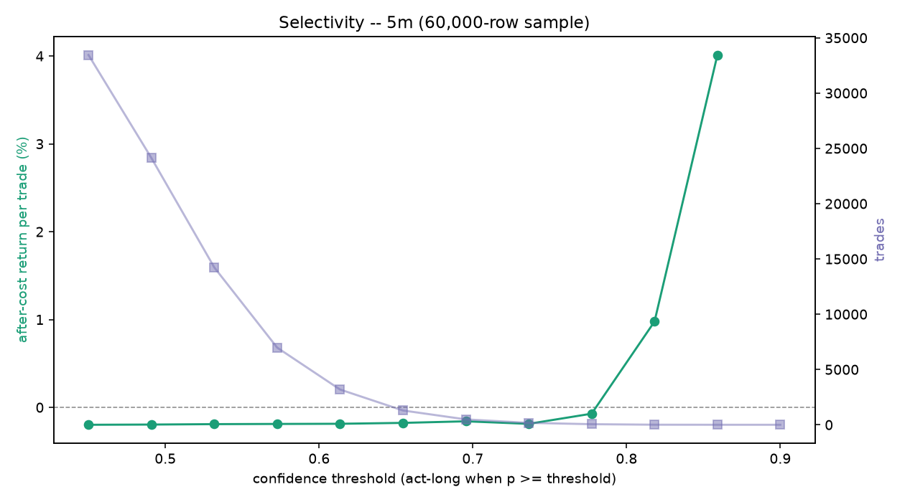
records written:
/Volumes/PortableSSD/Github/day-trader/outputs/AA-evals/2026-07-03/edge-diagnostics-1h-20260703.md
/Volumes/PortableSSD/Github/day-trader/outputs/AA-evals/2026-07-03/edge-diagnostics-4h-20260703.md
/Volumes/PortableSSD/Github/day-trader/outputs/AA-evals/2026-07-03/edge-diagnostics-5m-20260703.md
# Out-of-sample selectivity across EVERY built frame (1h, 4h, 5m): the confidence threshold is fit on
# TRAIN (the cutoff with the best total after-cost P&L above a trade floor), then scored ONCE on the
# blind final year across the universe (ed.oos_selectivity) -- per frame, one row each. This is the
# honest answer to "does a selective operating point clear fees", versus the in-sample Q6 curve. Reuses
# the loaded frame, loads the others on demand and frees them, and restores bd afterward. SEL_CAP bounds rows.
import edge_diagnostics as ed
SEL_CAP = 80_000 # rows per frame (None = full frame, heavier)
SEL_FRAMES = ["1h", "4h", "5m"] # frames to test; any not built on disk are skipped with a note
_active = globals().get("LOAD_FRAME")
_df_live = globals().get("df")
_prev = _active if _active is not None else bd.INTERVAL
rows = []
try:
for _frame in SEL_FRAMES:
bd.configure(_frame)
path = bd.DATASET_PATH
if not (os.path.exists(path) or os.path.exists(os.path.splitext(path)[0] + ".csv")):
print(f"[{_frame}] dataset not built ({os.path.basename(path)}); skipping.")
continue
reused = (_frame == _active and _df_live is not None)
dff = None
try:
dff = _df_live if reused else bd.read_frame(path)
featf = bd.feature_columns(dff)
dfa = (dff if (SEL_CAP is None or len(dff) <= SEL_CAP)
else dff.sample(SEL_CAP, random_state=0).sort_values("datetime").reset_index(drop=True))
print(f"[{_frame}] OOS selectivity on {len(dfa):,} of {len(dff):,} rows "
f"({'reusing loaded frame' if reused else 'loaded from disk'}); threshold on train, scored once...")
s = ed.oos_selectivity(dfa, featf)
rows.append({"Frame": bd.INTERVAL, "threshold (train)": s["threshold"],
"OOS trades": f"{s['oos_trades']:,}",
"OOS after-cost/trade": f"{s['oos_after_per_trade']*100:+.3f}%",
"OOS total after-cost": f"{s['oos_total_after']*100:+.1f}%",
"OOS win": (f"{s['oos_win']:.2f}" if s['oos_trades'] else "-"),
"OOS prec/base": (f"{s['oos_prec']:.3f}/{s['oos_base']:.3f}" if s['oos_trades'] else "-"),
"blind ends": s["cut"], "verdict": s["verdict"]})
except Exception as _e:
print(f"[{_frame}] skipped: {type(_e).__name__}: {_e}")
finally:
if dff is not None and not reused:
del dff
finally:
bd.configure(_prev)
if rows:
show_table(pd.DataFrame(rows))
else:
print("load the dataset first (see Import Data).")
[1h] OOS selectivity on 80,000 of 458,539 rows (reusing loaded frame); threshold on train, scored once...
[4h] OOS selectivity on 80,000 of 3,939,629 rows (loaded from disk); threshold on train, scored once...
[5m] OOS selectivity on 80,000 of 5,529,861 rows (loaded from disk); threshold on train, scored once...
<IPython.core.display.HTML object>

3.12 Regime Conditioning
The handoff's Part 2 fix: condition one model on observable regime state rather than switch between per-regime models. The f_rg_ block gives the model trailing volatility and its own-history percentile, trend drift, a Kaufman efficiency, up-down breadth, and the BTC market regime, and the ablation trains the same model with and without it, per frame, comparing cross-era stability and after-fee edge. It carries the same model-performance scoreboard and the Monte Carlo robustness gate. Conditioning is a generalization fix, more eras profitable and a less bad worst era, not by itself a free edge across the fee line.
# Regime-conditioning ablation (handoff Part 2) across EVERY built frame (1h, 4h, 5m), computed IN THIS
# NOTEBOOK so re-running reflects the latest regime_conditioning.py (incl. the model-performance + Monte
# Carlo metrics). For each built frame it retunes bd, loads that dataset, and trains the model WITH vs
# WITHOUT the f_rg_ regime block (recomputing f_rg_ from that frame's klines if the dataset predates the
# block), writes a frame-tagged dated record, and renders it. Each frame is a separate model scored on
# its own out-of-sample; the frames are shown in sequence, never pooled. SAMPLE_CAP bounds rows per frame.
import glob, importlib
import regime_conditioning as rc
importlib.reload(rc) # pick up the latest regime_conditioning.py (model-performance + Monte Carlo metrics)
from IPython.display import Markdown, display
RECOMPUTE = True # True = recompute in-notebook per frame; False = show cached records
SAMPLE_CAP = 30_000 # rows per frame for the in-notebook ablation (None = full frame, heavy)
N_SPLITS = 4
ABLATE_FRAMES = ["1h", "4h", "5m"] # frames to ablate; any not built on disk are skipped with a note
recs = sorted(glob.glob(str(OUTPUTS / "AA-evals" / "*" / "regime-conditioning-*.md")))
if RECOMPUTE:
_active = globals().get("LOAD_FRAME") # reuse the already-loaded frame if it is one of these
_df_live = globals().get("df")
_prev = _active if _active is not None else bd.INTERVAL # restore the notebook's active frame afterwards
written = []
try:
for _frame in ABLATE_FRAMES:
bd.configure(_frame) # retune windows/label/screen + DATASET_PATH + klines root
path = bd.DATASET_PATH
if not (os.path.exists(path) or os.path.exists(os.path.splitext(path)[0] + ".csv")):
print(f"[{_frame}] dataset not built ({os.path.basename(path)}); skipping.")
continue
reused = (_frame == _active and _df_live is not None)
dff = None
try:
dff = _df_live if reused else bd.read_frame(path) # reuse active frame; load the others on demand
featf = bd.feature_columns(dff)
dfa = (dff if (SAMPLE_CAP is None or len(dff) <= SAMPLE_CAP)
else dff.sample(SAMPLE_CAP, random_state=0).sort_values("datetime").reset_index(drop=True))
print(f"[{_frame}] regime ablation on {len(dfa):,} of {len(dff):,} rows "
f"({'reusing loaded frame' if reused else 'loaded from disk'}); trains two models and "
f"recomputes f_rg_ from klines if the dataset predates the block, so give it a moment...")
rec = rc.run(dfa, featf, bd.DEFAULT_KLINES_ROOT,
label=f"{bd.INTERVAL} ({'full frame' if SAMPLE_CAP is None else f'{len(dfa):,}-row sample'})",
out_dir=str(OUTPUTS / "AA-evals"), n_splits=N_SPLITS)
written.append(rec["md"])
display(Markdown(f"---\n### {bd.INTERVAL} frame\n\n" + open(rec["md"]).read()))
except Exception as _e:
print(f"[{_frame}] skipped: {type(_e).__name__}: {_e}")
finally:
if dff is not None and not reused:
del dff # free the on-demand frame before the next one
finally:
bd.configure(_prev) # leave bd as the rest of the notebook expects
if written:
print("records written:")
for _m in written:
print(" ", _m)
else:
print("no built frames to ablate; build at least one dataset (see Import Data), then re-run.")
elif recs:
print(f"RECOMPUTE off -- showing the latest persisted records ({min(3, len(recs))} of {len(recs)}):")
for _m in recs[-3:]:
display(Markdown(open(_m).read()))
else:
print("load the dataset first (see Import Data), then set RECOMPUTE=True.")
[1h] regime ablation on 30,000 of 458,539 rows (reusing loaded frame); trains two models and recomputes f_rg_ from klines if the dataset predates the block, so give it a moment...
<IPython.core.display.Markdown object>
[4h] regime ablation on 30,000 of 3,939,629 rows (loaded from disk); trains two models and recomputes f_rg_ from klines if the dataset predates the block, so give it a moment...
<IPython.core.display.Markdown object>
[5m] regime ablation on 30,000 of 5,529,861 rows (loaded from disk); trains two models and recomputes f_rg_ from klines if the dataset predates the block, so give it a moment...
<IPython.core.display.Markdown object>
records written:
/Volumes/PortableSSD/Github/day-trader/outputs/AA-evals/2026-07-03/regime-conditioning-20260703-1h.md
/Volumes/PortableSSD/Github/day-trader/outputs/AA-evals/2026-07-03/regime-conditioning-20260703-4h.md
/Volumes/PortableSSD/Github/day-trader/outputs/AA-evals/2026-07-03/regime-conditioning-20260703-5m.md

4. Shared Method
The machinery shared by every part, the discipline that keeps the three notebooks telling one story and keeps the picture from drifting from the numbers.

4.1 Multi-Frame Loop
The same search runs on three decision frames, 1h, 4h, and 5m, and each is a whole system with its own bars, its own label horizon, its own features, and its own screen, all retuned in place by one builder. The frames are compared, never pooled: a five-minute label and a four-hour label do not mean the same thing, and stacking their rows would blend incompatible targets. Every modelling section in Part 3 from 3.9 on loops over the three frames, scores each on its own out-of-sample, restores the active frame, and reports one block per frame. Cross-timeframe information still reaches each frame through causal higher-timeframe features, so a one-hour model sees the four-hour and daily trend without the datasets being merged.

4.2 After-Fee Scoreboard
One test decides everything. A candidate is scored on a blind final year held out from all training and tuning, and it counts only if it beats a coin flip at the real base rate, beats buy and hold, and returns more than zero per trade after the round-trip fee of about 0.20 percent. The fee is the adversary: a rule that ranks trades well but loses to the fee is a NO-GO. Every sweep, every model, and every ablation reports to this same scoreboard, logged under outputs/AA-evals/, so results across the notebooks are commensurable and no in-sample number can override the out-of-sample verdict.

4.3 Embargoed Splits
Financial bars are autocorrelated, so a random split leaks the future into the past. The evaluation cuts time-ordered: train on all history before a final-year cut, embargo a band equal to the label horizon across the cut so no label straddles it, and score the held-out year once. Cross-validation inside the training window walks expanding time-series folds, never random k-fold. Stage C generalizes this to a forward-chained walk-forward with per-fold point-in-time universes, so a fold only ever sees coins that would have passed the screen as of that bar.

4.4 Reproducibility
Single sources of truth keep the story consistent. The exit mechanics are one module, exit_geometry_viz, shared verbatim by all three notebooks, so the candles and the scoreboard cannot disagree. The triple-Supertrend is one benchmark across the chapters and one feature family in the model. Datasets and the flow table are Parquet, columnar and dtype-preserving, because round-tripping timestamps through CSV silently broke the split. The build is offline and deterministic from the checksummed archives, and every evaluation writes a dated record, so a result can be traced to the run that produced it.

5. Findings
The honest state of the search as of this revision. Nothing has cleared the after-fee bar yet; what follows is where each frame lands and where the edge, such as it is, actually lives.

5.1 Current State
On the 1h frame, direction prediction sits at the efficient-market floor. The label sweeps, the seven-model zoo, and the Monte Carlo robustness gate all land NO-GO, the zoo's AUC hovers around 0.50, and the default label has negative unconditional expectancy, a base rate near 0.313 against a breakeven near 0.333, so it loses before the model predicts. The 4h frame carries a little more signal, AUC around 0.55 against 0.51, and the daily and weekly context lifts it further, but it still does not clear the fee out of sample. The 5m scalp frame is ruled out by the controls layer on the fee wall: the moves are too small to survive 0.2 percent a round trip. The NO-GO is real, not a leakage artifact; the leakage audit is clean.

5.2 The Lead
One signal is genuinely present. Ranking the universe cross-sectionally by relative strength and holding the top third each bar shows a real and broad edge: most momentum and trend signals produce a positive top-minus-bottom spread that holds across train and test, the top third beats the market for a large majority of them, and the most robust is the adaptive-Supertrend direction. But it is not yet a long-only GO. The universe's own after-fee baseline is about minus 0.38 percent per trade, so even the best top third beats the market while staying below zero. The edge exists and is stable; the negative baseline is what sinks it. This is categorically different from the time-series entry work, which had no stable signal at all.

5.3 Next Steps
The levers are the ones logged in 0.4, all bounded and in-mandate. First, a regime gate: deploy the cross-sectional signal only when BTC is trending up, the cheapest way to test whether the underwater edge surfaces in the regime where it works. Second, a less fee-punishing label: a longer horizon with fewer round trips, since the fee count per unit of return is the central obstacle. Third, a coarser frame: extend toward daily, which cuts the fee count further. Held as research, not policy, is shorting, the one change that would monetize the cross-sectional spread directly by longing the strong third and shorting the weak third, kept out because it breaks the spot-only mandate and imports unbounded loss. Each of these changes the search, not real exposure: the live switch stays off until a configuration clears the bar.

Appendices

A. File Map
Which module powers which section.
Module | Powers
inputs/build_dataset_1h.py | the frame builder: features, label, screen, configure per frame (3.1, 3.2)
inputs/acquire_vision.py | Stage A, survivorship-complete acquisition from data.binance.vision (3.5)
inputs/profile_panel.py | Stage B, coverage, gap, and liquidity profiling and the point-in-time universe (3.5, and the Part 1 and 2 universe)
inputs/wf_splitter.py | Stage C, the forward-chained walk-forward splitter (3.5)
inputs/train_model_1h.py | the train and test split, the loader, and the shared evaluation (3.7)
inputs/train_model.py | the shared cost and confidence constants and the eval helper
inputs/variable_selection.py | feature selection on the training window (3.6)
inputs/model_assessment_1h.py | the caret-style scorecard, the model zoo, and the tuner (3.9)
inputs/sweep_label_1h.py | the label-geometry sweep (3.8)
inputs/monte_carlo_1h.py | the Monte Carlo robustness gate (3.10)
inputs/edge_diagnostics.py | the Q1, Q5, and Q6 diagnostics and the out-of-sample selectivity test (3.11)
inputs/regime_conditioning.py | the regime-conditioning ablation (3.12)
inputs/cross_sectional_4h.py | cross-sectional tercile ranking (1.2, 5.2)
inputs/exit_geometry_1h.py | the exit-geometry sweep (2.4, 3.3)
inputs/exit_geometry_viz.py | the shared exit and entry-context visualization (1.6, 2.x, 3.3)
inputs/baseline_supertrend_1h.py | the triple-Supertrend after-fee baseline (1.x, 3.10)
inputs/supertrend.py | the live bot's triple-Supertrend rule
inputs/walkforward.py | the MACD signal-line cross-up entry experiment (1.3)
inputs/entry_sharpening_4h.py | the entry-sharpening tests (3.4)
inputs/flow_data.py | the trade-flow imbalance data
inputs/config.py | operator configuration and the LIVE_TRADING switch
01/02/03-trader-*.ipynb | the source chapters this notebook consolidates

B. Glossary
Term | Meaning
Label | the supervised target: did a coin's trade hit the profit barrier before the stop within the horizon
Triple barrier | a label set by an upper (take-profit), a lower (stop), and a time barrier, here ATR-scaled
ATR | average true range, a coin's typical bar-to-bar move, used to scale stops and the volatility band
Supertrend | an ATR-channel trailing stop; three of them behind an EMA-200 gate form the aligned baseline
Kelly | growth-optimal position size given an edge; the book sizes at half-Kelly to buffer estimation error
Base rate | the unconditional share of positive labels, the coin-flip a model must beat
Breakeven | the win rate at which a fixed-payoff trade nets zero after fees
Embargo | a gap around the train and test cut so no label straddles it and leaks
RMSEratio | Full RMSE over cross-validated RMSE; near 1 generalizes, well below 1 overfits
PPO | the percentage price oscillator, a scale-free MACD used as a feature
Cross-sectional | ranking coins against each other each bar, versus predicting each in isolation
Regime state | observable market context (volatility, trend efficiency, BTC regime) the model conditions on
Corwin-Schultz | a high-low estimator of the bid-ask spread, used where the archives carry no order book
Survivorship-complete | a universe that includes every coin ever listed, delisted ones included
Point-in-time | a screen replayed as of each bar, so a row is kept only if it would have passed then
Walk-forward | forward-chained train-then-test folds that respect time order
GO / NO-GO | the after-fee out-of-sample verdict that gates everything

C. Environment
The repository uses MacPorts, never Homebrew; install with sudo port install or a language-native installer, and the pipeline runs from the project .venv, a MacPorts Python, with pandas-ta and TA-Lib pip-installed there. Note the two pandas-ta forks: the scan chapters import pandas-ta-classic while the model builder imports pandas-ta, so the consolidated venv needs both. The notebook needs Python 3.11 or newer, and the environment cells install only the libraries each part imports that are missing, to avoid a numpy and numba resolver conflict.
The repository sits on an exFAT SSD, which cannot store extended attributes, so macOS scatters ._-prefixed AppleDouble files on every write. They are git-ignored but can crash matplotlib with a 0xb0 decode error; clear them with a find ... -name '._*' -delete if an import throws it. The durable fix is to keep the repository on an APFS or HFS+ volume.
Secrets live in the run environment, never in the repository and never in a .env file.
Variable | Purpose
BINANCE_API_KEY, BINANCE_API_SECRET | Binance access
BINANCE_TESTNET | true uses the testnet; false is real funds
ALPACA_API_KEY, ALPACA_API_SECRET, ALPACA_BASE_URL | Alpaca, the later-stage equities venue
LIVE_TRADING | the money switch; false until a strategy clears the bar, and never armed by the model

D Committee Layer
Added 2026-08-16. A qualitative research layer now sits beside the quant pipeline: the TradingAgents multi-agent committee (TauricResearch, v0.3.1, built and validated in its own venv at /Volumes/PortableSSD/Github/TradingAgents) and a local paper-trading engine that rehearses execution against live prices. Neither places real orders.

D.1 Committee Research
inputs/ta_research.py runs each symbol through the committee in crypto mode: market, sentiment and news analysts, a bull and bear debate, a three-way risk panel, and a portfolio manager who returns one of five ratings (Buy, Overweight, Hold, Underweight, Sell) with a written thesis. Models: Claude Sonnet 5 in the debate seats, Haiku 4.5 for quick tasks; alpha in the reflection loop is benchmarked to BTC-USD, not SPY. Ratings and executive summaries append to memory/research-log.md; the framework's own decision log, which auto-grades each call against the realised five-day return on the next same-ticker run, lives in memory/ta-decisions.md; full report trees land under outputs/ta-reports/.
The committee automates Principle 1 (every entry needs an affirmative case and a devil's advocate) and adds the information channels the price-only pipeline cannot see: news, social sentiment, prediction-market odds. It is a candidate signal being graded on the same after-fee bar as every other candidate. It never places orders and never overrides the hard rules. First live run, 2026-08-16: BTC-USD rated Underweight, target 55000, horizon 2-4 months (outputs/ta-reports/reports/BTC-USD_20260816_173215/).

D.2 Paper Trading
inputs/paper_trade.py simulates the book locally against live Binance public prices (no keys, no orders, not even testnet). State in memory/paper-portfolio.json; every entry and exit journals to memory/trade-log.md; memory/portfolio.md is rewritten on every mark. The engine enforces the hard rules mechanically: max 3 new positions per rolling week, 5% notional cap (2% default), 10% cash floor, -7% hard stop from entry, 10% trailing stop from peak, never average down. Kelly inputs are journaled with each entry; with no signal past the after-fee bar, p is unvalidated, f* is at or below zero, and every paper entry is flagged as a rehearsal override rather than a bet Kelly endorses.
open --from-ratings opens only committee Buy or Overweight names; mark applies stops and rewrites the snapshot; a periodic mark loop turns the journal into a live paper track record.

D.3 Live Readiness
Live trading requires, in order: Binance API keys in the environment, BINANCE_TESTNET=true burn-in through inputs/trade_binance.py, and only then the deliberate LIVE_TRADING=true switch. The standing gate is unchanged: no signal, committee included, has yet beaten buy-and-hold and a coin flip on the out-of-sample after-fee scoreboard, so the honest book is small, defensive, and mostly cash until one does.

