Sean Connelly

UPP 465

Professor Tilahun

3/3/20

Spatial Statistics – Point Pattern Analysis Lab

Three point pattern event data - Pattern 1, Pattern 2, and Pattern 3 - have been provided to

you. Your task in this assignment is to examine these three patterns and report back on your

findings. Specifically, answer the following questions:

1. Populate the table below:

|  |  |  |  |
| --- | --- | --- | --- |
| Data | Number of Events | Area of Observation | Average Intensity |
| Pattern 1 | 508 | 100 | 5.08 per unit area |
| Pattern 2 | 423 | 100 | 4.23 per unit area |
| Pattern 3 | 116 | 100 | 1.16 per unit area |

1. Assessment of point patterns requires you to compare your event data against a pattern of CSR with the same level of average intensity. For each of the three patterns, if you were to carve out a 2 square unit area:
   1. How many points do you expect to see in that area if the pattern is CSR? (e.g Pattern 1)

Under CSR, expected *n = λA*

*n = (5.08)(2)*

*n = (5.08)(2)*

*n = 10.16*

* 1. What is the probability of observing exactly 5 events in the 2 square unit area if the pattern is CSR? (e.g Pattern 1)

*P(X = x) = (e-λλx) / x!*

*P(X = 5) = (e-10.1610.165) / 5!*

*P(X = 5) = (e-10.1610.165) / 5!*

*P(X = 5) = 0.0349*

* 1. Populate the table below. Show your detailed work for both a and b for one of the patterns.

|  |  |  |
| --- | --- | --- |
| Data | Expected Count in 2 Square Unit Area | Probability(X=5) in  the 2 Square Unit Area |
| Pattern 1 | 10.16 | 0.0349 |
| Pattern 2 | 8.46 | 0.0765 |
| Pattern 3 | 2.32 | 0.0550 |

1. For each pattern, estimate the Kernel Density and show a plot overlaid with the point patterns.

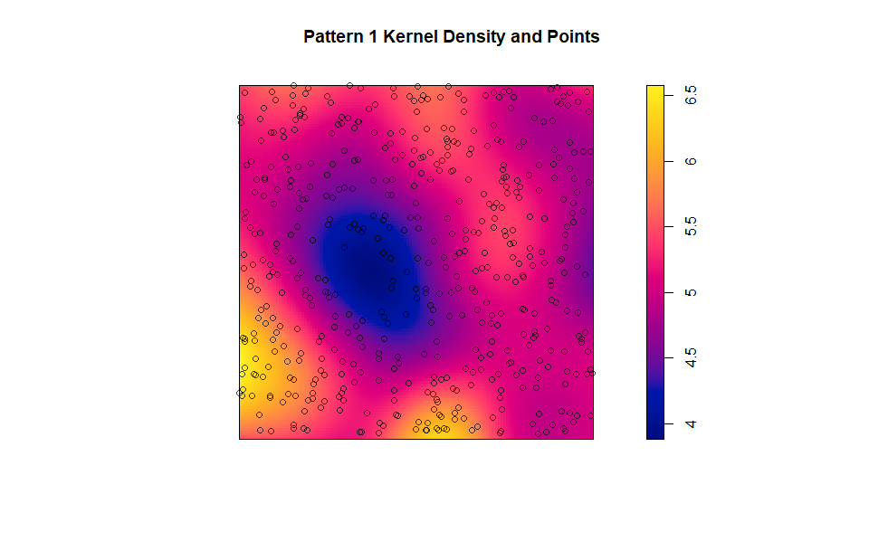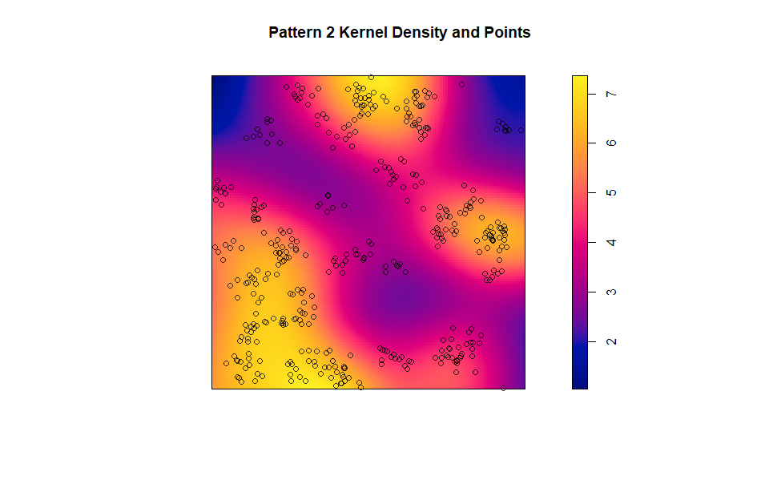

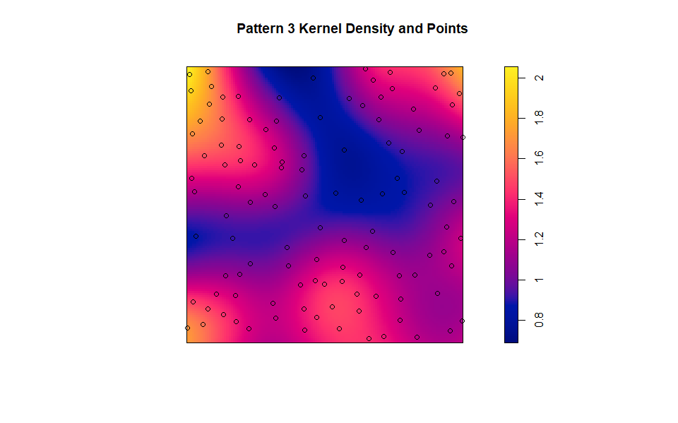

1. Using the G function and the Ripley's K function assess whether each point pattern resembles a CSR, a clustered pattern, or a regular pattern. Include figures that show the envelope and the values of the G and K functions for all three patterns. Briefly explain the figures and your conclusion

|  |  |
| --- | --- |
| Data | Pattern Type |
| Pattern 1 | CSR |
| Pattern 2 | Clustered |
| Pattern 3 | Regular |

Please see the plots on the pages below for a more detailed discussion on the patterns.

Pattern 1 shows clear signs of Complete Spatial Randomness. Both G(*r*) and K(*r*) observed values fall well within the randomization envelope.

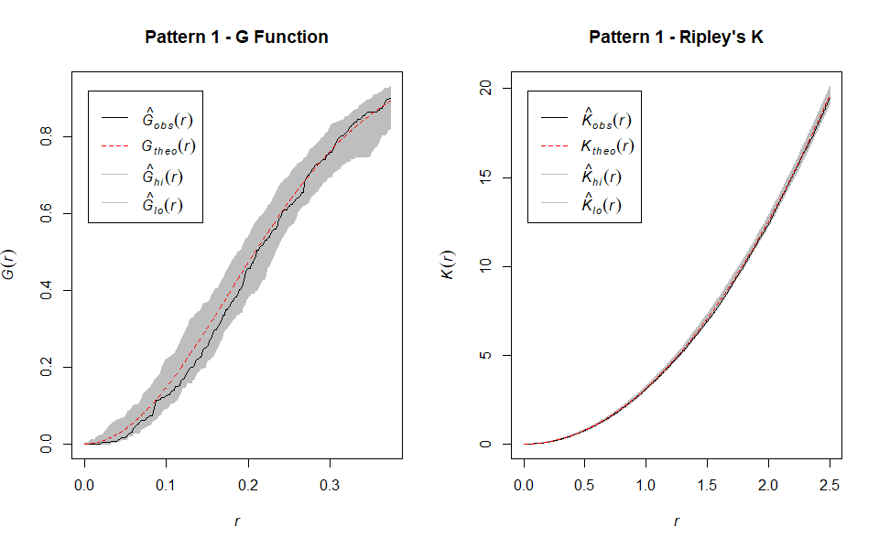\

Pattern 2 shows evidence of clustering. Both G(*r*) and K(*r*) observed values are above the randomization envelope for all reasonable values of *r*.

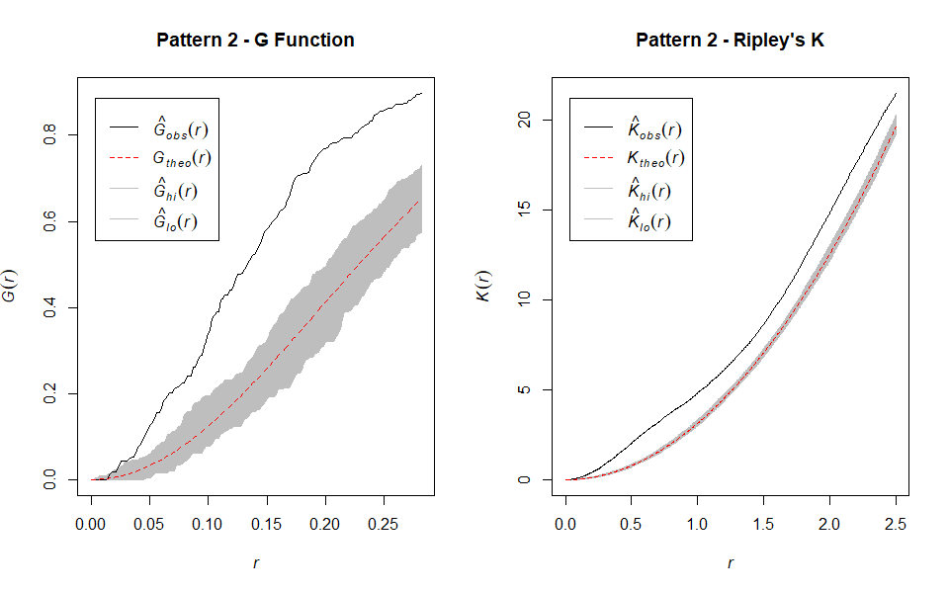

Pattern 3 is the most complicated pattern of the point event datasets analyzed. G(*r*) suggests that that Pattern 3 is regularly spaced, however this finding is less certain as *r* increases. Ripley’s K, which measures how many events there are at any given *r*, hints towards CSR, however, the relative lack of events and intensity compared to Patterns 1 and 2 may mean the function is biased at high levels of *r*. There is more evidence to suggest that Pattern 3 is regular.

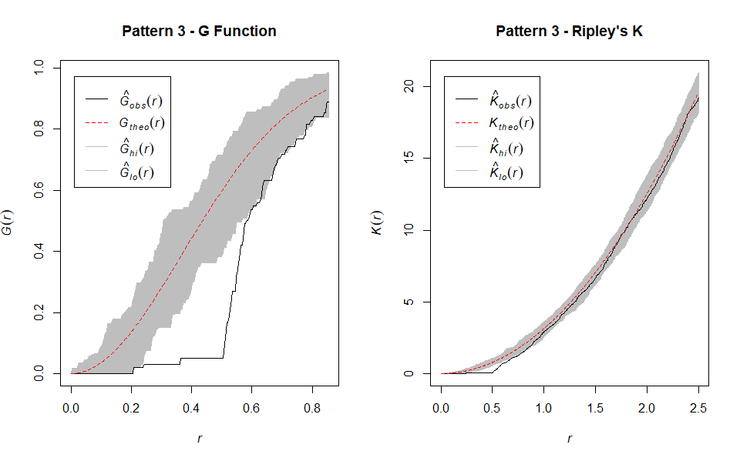

# Load libraries ----------------------------------------------------------

#make sure the below libraries are installed on your machine. Use

install.packages("LIBRARYNAME")

rm(list = ls()) #clear objects in memory

# Set working directory

setwd(paste0(here::here(), "/06_PPA_Assignment"))

# Load additional libraries

pacman::p_load(tidyverse, # for basic data manipulation, visualization

scales, # for formatting number output

patchwork, # for arranging ggplots in grids

sf, # simple features for spatial

nngeo, # nearest neighbors

summarytools, # for checking data frame characteristics

here, # for relative file paths

knitr, # for tables

kableExtra, # table styling

janitor) # for cleaning and tabulations

#load your spatial libraries

library(sp)

library(raster)

library(spatstat)

library(rgdal)

library(maptools)

library(rgeos)

library(GISTools)

library(shapefiles)

library(aspace)

options(stringsAsFactors = FALSE, scipen = 999)

# Assignment -------------------------------------------------------------

# Import point patterns data

p1 <- readRDS("Raw_Data/pattern1.rds")

p2 <- readRDS("Raw_Data/pattern2.rds")

p3 <- readRDS("Raw_Data/pattern3.rds")

# 1. Populate the table below

# Number of events

p1$n

p2$n

p3$n

# Area of observation

spatstat::area(p1$window)

spatstat::area(p2$window)

spatstat::area(p3$window)

# Average intensity

p1$n / spatstat::area(p1$window)

p2$n / spatstat::area(p2$window)

p3$n / spatstat::area(p3$window)

# 2. Assessment of point patterns requires you to compare your event data

against a pattern of CSR with the same level of average intensity. For each of

the three patterns, if you were to carve out a 2 square unit area:

# a. How many points do you expect to see in that area if the pattern is

CSR?

p1_csr_hat <- (p1$n / spatstat::area(p1$window)) * 2

p2_csr_hat <- (p2$n / spatstat::area(p2$window)) * 2

p3_csr_hat <- (p3$n / spatstat::area(p3$window)) * 2

p1_csr_hat

p2_csr_hat

p3_csr_hat

# b. What is the prob of observing exactly 5 events in the 2 square unit

area if the pattern is CSR?

p1_prob5 <- (exp(-p1_csr_hat) * (p1_csr_hat ^ 5)) / factorial(5)

p2_prob5 <- (exp(-p2_csr_hat) * (p2_csr_hat ^ 5)) / factorial(5)

p3_prob5 <- (exp(-p3_csr_hat) * (p3_csr_hat ^ 5)) / factorial(5)

p1_prob5

p2_prob5

p3_prob5

# 3. For each pattern, estimate the Kernel Density and show a plot overlaid

with the point patterns.

# Calculate densities

p1_density <- density(p1)

p2_density <- density(p2)

p3_density <- density(p3)

# P1

plot(p1_density, main = "Pattern 1 Kernel Density and Points")

plot(p1, add = TRUE)

# P2

plot(p2_density, main = "Pattern 2 Kernel Density and Points")

plot(p2, add = TRUE)

# P3

plot(p3_density, main = "Pattern 3 Kernel Density and Points")

plot(p3, add = TRUE)

# 4. Using the G function and the Ripley's K function assess whether each

point pattern resembles a CSR, a clustered pattern, or a regular pattern.

Include figures that show the envelope and the values of the G and K functions

for all three patterns. Briefly explain the figures and your conclusion

# P1, G and Ripley's K

par(mfrow = c(1, 2))

p1_g_env <- envelope(p1, Gest)

plot(p1_g_env, main = "Pattern 1 - G Function")

p1_k_env <- envelope(p1, Kest)

plot(p1_k_env, main = "Pattern 1 - Ripley's K")

# P2, G and Ripley's K

par(mfrow = c(1, 2))

p2_g_env <- envelope(p2, Gest)

plot(p2_g_env, main = "Pattern 2 - G Function")

p2_k_env <- envelope(p2, Kest)

plot(p2_k_env, main = "Pattern 2 - Ripley's K")

# P3, G and Ripley's K

par(mfrow = c(1, 2))

p3_g_env <- envelope(p3, Gest)

plot(p3_g_env, main = "Pattern 3 - G Function")

p3_k_env <- envelope(p3, Kest)

plot(p3_k_env, main = "Pattern 3 - Ripley's K")