
RTL Design Sherpa
APB UART 16550 Micro-Architecture Specification 1.0
January 4, 2026

Table of Contents
1 Uart 16550 Mas Index 20
2 Retro Legacy Blocks - Product Requirements Document 21
2.1 1. Overview 21
2.1.1 1.1 Purpose 21
2.1.2 1.2 Design Philosophy 21
2.1.3 1.3 Target Applications 21
2.2 2. Implemented Blocks 22
2.2.1 2.1 HPET - High Precision Event Timer 22
2.3 3. Planned Blocks 23
2.3.1 3.1 8259 - Programmable Interrupt Controller (PIC) 23
2.3.2 3.2 8254 - Programmable Interval Timer (PIT) 24
2.3.3 3.3 GPIO - General Purpose I/O 24
2.3.4 3.4 RTC - Real-Time Clock 24
2.3.5 3.5 SMBus Controller 25
2.3.6 3.6 UART - Universal Asynchronous Receiver/Transmitter 25
2.3.7 3.7 SPI Controller 25
2.3.8 3.8 I2C Controller 25
2.3.9 3.9 Watchdog Timer 25
2.3.10 3.10 Power Management / ACPI Controller 26
2.3.11 3.11 IOAPIC - I/O Advanced Programmable Interrupt Controller 26
2.3.12 3.12 Interconnect ID / Version Registers 26
2.4 4. Integration and Wrapper Goals 27
2.4.1 4.1 Individual Block Integration 27
2.4.2 4.2 RLB Wrapper Architecture 27
2.5 5. Design Standards 30
2.5.1 5.1 Reset Handling 30
2.5.2 5.2 Register Generation 30
2.5.3 5.3 Testbench Architecture 30
2.5.4 5.4 FPGA Synthesis Attributes 31
2.5.5 5.5 Documentation Requirements 31
2.6 6. Quality Metrics 31
2.6.1 6.1 Production Readiness Criteria 31
2.6.2 6.2 Current Status 32
2.7 7. Development Roadmap 33
2.7.1 7.1 Phase 1: Foundation (Complete) 33
2.7.2 7.2 Phase 2: Core Peripherals (Next 6-9 Months) 33
2.7.3 7.3 Phase 3: Advanced Peripherals (9-15 Months) 33
2.7.4 7.4 Phase 4: System Integration (15+ Months) 33
2.8 8. References 34
2.8.1 8.1 External Standards 34
2.8.2 8.2 Internal Documentation 34
2.8.3 8.3 Block-Specific Documentation 34
2.9 9. Success Criteria 34
2.9.1 9.1 Individual Block Success 34
2.9.2 9.2 Collection Success 34
2.9.3 9.3 Long-Term Vision 35
3 PeakRDL HPET Integration - Final Status 36
3.1 Milestone: COMPLETE (5/6 configs fully passing) 36
3.1.1 Test Results Summary 36
3.2 Root Cause Found & Fixed 36
3.3 Core Functionality Validated 37
3.4 Files Modified 37
3.4.1 RTL Changes: 37
3.4.2 Test Changes: 37
3.4.3 Documentation: 38
3.5 Remaining Work (Minor) 38
3.5.1 8-Timer Non-CDC All Timers Stress Test 38
3.6 Milestone Achievement 38
3.7 Recommended Next Steps 38
3.8 Test Execution Summary 38
3.9 Git Status 39
4 APB UART 16550 — Overview 40
4.1 Overview 40
4.1.1 Key Features 40
4.1.2 Applications 41
4.2 Parameters 41
4.3 Functional Description 42
4.3.1 Figure 1.1: UART 16550 Block Diagram 42
4.3.2 Register Summary 42
4.4 Design Notes 43
4.4.1 Compatibility 43
4.5 Navigation 43
5 APB UART 16550 — Architecture 44
5.1 Overview 44
5.2 Functional Description 44
5.2.1 Figure 1.2: UART Architecture 44
5.2.2 Module Hierarchy 44
5.2.3 Data Flow 46
5.2.4 Baud Rate Generation 47
5.2.5 FIFO Organization 48
5.3 Design Notes 49
5.3.1 Resource Estimates 49
5.4 Navigation 49
6 APB UART 16550 — Clocks and Reset 50
6.1 Overview 50
6.2 Ports 50
6.2.1 Clock Signals 50
6.2.2 Reset Signals 50
6.3 Functional Description 51
6.3.1 Reset Behavior 51
6.3.2 Clock Domain Crossing 52
6.4 Timing 52
6.4.1 Baud Rate Considerations 52
6.4.2 Timing Constraints 53
6.5 Navigation 53
7 APB UART 16550 — Acronyms and Terminology 54
7.1 Overview 54
7.2 Design Notes 54
7.2.1 Protocol Acronyms 54
7.2.2 Register Acronyms 54
7.2.3 Signal Acronyms 55
7.2.4 FIFO Terms 55
7.2.5 Data Format Terms 56
7.2.6 Error Terms 56
7.2.7 Timing Terms 56
7.3 Navigation 57
8 APB UART 16550 — References 58
8.1 Overview 58
8.2 References 58
8.2.1 Internal Documentation 58
8.2.2 External References 58
8.2.3 Design References 59
8.3 Navigation 59
9 APB UART 16550 — Block Descriptions 60
9.1 Overview 60
9.2 Functional Description 60
9.2.1 Module Hierarchy 60
9.2.2 Block Summary 60
9.3 Related Modules 61
9.3.1 APB Interface 61
9.3.2 Register File 61
9.3.3 TX Engine 61
9.3.4 RX Engine 61
9.3.5 Baud Generator 61
9.3.6 FIFO Subsystem 61
9.4 Navigation 61
10 APB UART 16550 — APB Interface Block 63
10.1 Overview 63
10.2 Ports 63
10.2.1 APB Slave Interface 63
10.3 Functional Description 64
10.3.1 Figure 2.1: APB Interface Block 64
10.3.2 Address Decoding 64
10.3.3 Operation 65
10.4 Design Notes 65
10.4.1 Implementation Notes 65
10.5 Navigation 66
11 APB UART 16550 — Register File Block 67
11.1 Overview 67
11.2 Ports 67
11.2.1 Software-to-Hardware (reg2hw) 67
11.2.2 Hardware-to-Software (hw2reg) 67
11.3 Functional Description 68
11.3.1 Figure 2.2: Register File Block 68
11.3.2 Register Organization 68
11.3.3 Register Access Types 69
11.4 Design Notes 69
11.4.1 Implementation Notes 69
11.5 Navigation 69
12 APB UART 16550 — TX Engine Block 70
12.1 Overview 70
12.2 Functional Description 70
12.2.1 Figure 2.3: TX Engine Block 70
12.2.2 Data Path 70
12.2.3 TX FIFO 70
12.2.4 TX Serializer 71
12.2.5 Flow Control 72
12.2.6 Break Generation 73
12.3 Timing 73
12.3.1 Bit Timing 73
12.3.2 Frame Timing Example (8N1 at 115200) 73
12.4 Waveforms 73
12.4.1 Waveform 2.1: TX Byte Transmission 73
12.4.2 Waveform 2.2: Baud Rate Generation 74
12.4.3 Waveform 2.3: Loopback Mode 74
12.5 Navigation 74
13 APB UART 16550 — RX Engine Block 75
13.1 Overview 75
13.2 Functional Description 75
13.2.1 Figure 2.4: RX Engine Block 75
13.2.2 Data Path 76
13.2.3 Input Synchronizer 76
13.2.4 Start Bit Detection 76
13.2.5 RX Deserializer 77
13.2.6 RX FIFO 78
13.2.7 Error Detection 78
13.2.8 Timeout Detection 79
13.3 Waveforms 79
13.3.1 Waveform 2.4: RX Byte Reception 79
13.4 Navigation 80
14 APB UART 16550 — Baud Generator Block 81
14.1 Overview 81
14.2 Functional Description 81
14.2.1 Figure 2.5: Baud Generator Block 81
14.2.2 Operation 82
14.2.3 Divisor Calculation 82
14.2.4 Divisor Latch Registers 83
14.3 Usage Example 83
14.3.1 Programming Sequence 83
14.4 Design Notes 83
14.4.1 Special Cases 83
14.5 Navigation 84
15 APB UART 16550 — FIFO Subsystem 85
15.1 Overview 85
15.2 Functional Description 85
15.2.1 Figure 2.6: FIFO Block 85
15.2.2 FIFO Configuration 85
15.2.3 TX FIFO 86
15.2.4 RX FIFO 87
15.2.5 FIFO vs Non-FIFO Mode 87
15.2.6 Error Handling 88
15.2.7 FIFO Reset 88
15.3 Waveforms 89
15.3.1 Waveform 2.5: FIFO Trigger Timing 89
15.4 Navigation 89
16 APB UART 16550 — Interfaces 90
16.1 Overview 90
16.2 Ports 90
16.2.1 External Interfaces 90
16.3 Functional Description 91
16.3.1 Figure 3.1: UART Interface Summary 91
16.4 Navigation 91
16.4.1 Chapter Contents 91
17 APB UART 16550 — APB Slave Interface 93
17.1 Overview 93
17.2 Ports 93
17.2.1 APB Slave Signals 93
17.3 Functional Description 93
17.3.1 Address Map 93
17.3.2 Protocol Compliance 94
17.3.3 Register Access 95
17.4 Timing 95
17.4.1 Access Timing 95
17.5 Navigation 95
18 APB UART 16550 — Serial Interface 97
18.1 Overview 97
18.2 Ports 97
18.2.1 Signal Description 97
18.2.2 Electrical Interface 97
18.3 Functional Description 97
18.3.1 TXD (Transmit Data) 97
18.3.2 RXD (Receive Data) 98
18.3.3 Data Formats 99
18.3.4 Break Condition 99
18.4 Waveforms 99
18.4.1 Waveform 3.1: Line Status Error Detection 99
18.5 Navigation 100
19 APB UART 16550 — Modem Interface 101
19.1 Overview 101
19.2 Ports 101
19.2.1 Modem Control Outputs (Active Low) 101
19.2.2 Modem Status Inputs (Active Low) 101
19.3 Functional Description 101
19.3.1 Modem Control Register (MCR) 101
19.3.2 Modem Status Register (MSR) 102
19.3.3 Hardware Flow Control 103
19.3.4 Figure 3.2: RTS/CTS Flow Control Connections 103
19.3.5 Loopback Mode 104
19.3.6 Input Synchronization 104
19.3.7 Interrupt Generation 104
19.4 Waveforms 104
19.4.1 Waveform 3.2: Modem Status Change Detection 104
19.5 Navigation 105
20 APB UART 16550 — Interrupt Interface 106
20.1 Overview 106
20.2 Ports 106
20.2.1 Signal Description 106
20.3 Functional Description 106
20.3.1 Interrupt Sources 106
20.3.2 Interrupt Enable Register (IER) 107
20.3.3 Interrupt Identification Register (IIR) 107
20.3.4 Interrupt Conditions 108
20.4 Timing 108
20.4.1 Interrupt Timing 108
20.5 Usage Example 109
20.5.1 Software Handling 109
20.6 Navigation 109
21 APB UART 16550 — System Interface 110
21.1 Overview 110
21.2 Ports 110
21.2.1 Clock Signals 110
21.2.2 Reset Signals 110
21.3 Functional Description 111
21.3.1 Reset Behavior 111
21.4 Timing 112
21.4.1 Reset Sequence 112
21.4.2 Figure 3.3: Reset Sequence 112
21.5 Design Notes 112
21.5.1 Power Management 112
21.5.2 External Connections 113
21.5.3 Figure 3.4: UART 16550 in a System 113
21.6 Navigation 114
22 APB UART 16550 — Programming Model 115
22.1 Overview 115
22.1.1 Register Summary 115
22.2 Usage Example 115
22.2.1 Quick Start 115
22.3 Navigation 116
22.3.1 Chapter Contents 116
23 APB UART 16550 — Initialization 118
23.1 Overview 118
23.2 Functional Description 118
23.2.1 Baud Rate Calculation 118
23.3 Usage Example 118
23.3.1 Basic Initialization Sequence 118
23.3.2 Complete Initialization Example 120
23.3.3 Flow Control Setup (manual) 120
23.3.4 Loopback Mode Setup 121
23.4 Navigation 121
24 APB UART 16550 — Data Transfer 122
24.1 Overview 122
24.2 Usage Example 122
24.2.1 Transmitting Data 122
24.2.2 Receiving Data 123
24.2.3 Error Handling 124
24.2.4 FIFO Management 125
24.2.5 Bulk Transfer 125
24.3 Navigation 126
25 APB UART 16550 — Interrupt Handling 127
25.1 Overview 127
25.2 Functional Description 127
25.2.1 Interrupt Identification Register (IIR) 127
25.3 Usage Example 128
25.3.1 Interrupt Enable Register (IER) 128
25.3.2 Complete ISR Example 128
25.3.3 Individual Interrupt Handlers 129
25.3.4 Disabling/Enabling Interrupts 131
25.4 Design Notes 131
25.4.1 Interrupt Latency Considerations 131
25.5 Navigation 132
26 APB UART 16550 — Programming Examples 133
26.1 Overview 133
26.2 Usage Example 133
26.2.1 Debug Console 133
26.2.2 Ring Buffer Implementation 134
26.2.3 Command Line Interface 136
26.2.4 Loopback Test 137
26.2.5 Flow Control (manual) 138
26.3 Navigation 138
27 APB UART 16550 — Register Map 139
27.1 Overview 139
27.2 Functional Description 139
27.2.1 Register Summary 139
27.2.2 RBR - Receiver Buffer Register (0x00, Read) 140
27.2.3 THR - Transmitter Holding Register (0x00, Write) 140
27.2.4 IER - Interrupt Enable Register (0x04, R/W) 140
27.2.5 IIR - Interrupt Identification Register (0x08, Read Only) 141
27.2.6 FCR - FIFO Control Register (0x0C, R/W) 142
27.2.7 LCR - Line Control Register (0x10, R/W) 143
27.2.8 MCR - Modem Control Register (0x14, R/W) 144
27.2.9 LSR - Line Status Register (0x18, Read; error bits clear on read) 144
27.2.10 MSR - Modem Status Register (0x1C, Read; delta bits clear on read) 145
27.2.11 SCR - Scratch Register (0x20, R/W) 146
27.2.12 DLL - Divisor Latch LSB (0x24, R/W) 146
27.2.13 DLM - Divisor Latch MSB (0x28, R/W) 146
27.2.14 Address Calculation 146
27.3 Implemented for RLB TASK-012 (was RLB-013) 147

List of Figures
Figure 1.1: UART 16550 Block Diagram 42
Figure 1.2: UART Architecture 44
Figure 2.1: APB Interface Block 64
Figure 2.2: Register File Block 68
Figure 2.3: TX Engine Block 70
Figure 2.4: RX Engine Block 75
Figure 2.5: Baud Generator Block 81
Figure 2.6: FIFO Block 85
Figure 3.1: UART Interface Summary 91
Figure 3.2: RTS/CTS Flow Control Connections 103
Figure 3.3: Reset Sequence 112
Figure 3.4: UART 16550 in a System 113

List of Tables
No tables in this document.

List of Waveforms
Waveform 2.1: TX Byte Transmission 73
Waveform 2.2: Baud Rate Generation 74
Waveform 2.3: Loopback Mode 74
Waveform 2.4: RX Byte Reception 79
Waveform 2.5: FIFO Trigger Timing 89
Waveform 3.1: Line Status Error Detection 99
Waveform 3.2: Modem Status Change Detection 104

1 Uart 16550 Mas Index
Generated: 2026-10-20

RTL Design Sherpa · Learning Hardware Design Through Practice GitHub · Documentation Index · MIT License

2 Retro Legacy Blocks - Product Requirements Document
Component: Retro Legacy Blocks (RLB) - Production-Quality Legacy Peripherals Version: 1.0 Status: Active Development - HPET Production Ready Last Updated: 2025-10-29

2.1 1. Overview

2.1.1 1.1 Purpose
The Retro Legacy Blocks (RLB) component provides production-quality implementations of legacy peripheral blocks based on proven peripheral designs. These blocks are designed to be reusable, well-tested, and suitable for both FPGA and ASIC implementation.

2.1.2 1.2 Design Philosophy
“Retro” - Proven Architectures: - Implements time-tested peripheral designs from successful platforms - Focuses on simplicity, reliability, and well-understood behavior - Prioritizes production-readiness over experimental features
“Legacy” - Time-Tested Interfaces: - Based on proven peripheral interface specifications - Suitable for systems requiring retro-compatible peripheral compatibility - APB-based interface for easy integration
“Blocks” - Modular Collection: - Each peripheral is independent and self-contained - Clear separation between different blocks (rtl/hpet/, rtl/gpio/, etc.) - Can be used individually or wrapped into integrated subsystem

2.1.3 1.3 Target Applications
- Retro-compatible platform compatibility layers
- Embedded systems requiring legacy peripheral interfaces
- FPGA-based system emulation
- Educational platforms demonstrating classic peripheral designs
- Mixed-vintage SoC integration (modern + legacy interfaces)

2.2 2. Implemented Blocks

2.2.1 2.1 HPET - High Precision Event Timer
Status: Production Ready (5/6 configurations 100% passing) RTL Location: rtl/hpet/ Documentation: docs/hpet_mas/
Key Features: - Configurable timer count: 2, 3, or 8 independent timers - 64-bit main counter for high-resolution timestamps - 64-bit comparators per timer - Operating modes: One-shot and periodic - Clock domain crossing: Optional CDC for timer/APB clock independence - APB4 interface: Standard AMBA APB protocol - PeakRDL integration: Register map generated from SystemRDL specification
Applications: - System tick generation - Real-time OS scheduling - Precise event timing - Performance profiling - Watchdog timers - Multi-rate timing domains
Test Coverage: - 6 configurations tested (2/3/8 timers, CDC on/off) - 5/6 configurations at 100% pass rate - 1 configuration at 92% (minor stress test timeout) - 12 test cases per configuration (gate/func/full)
Architecture: 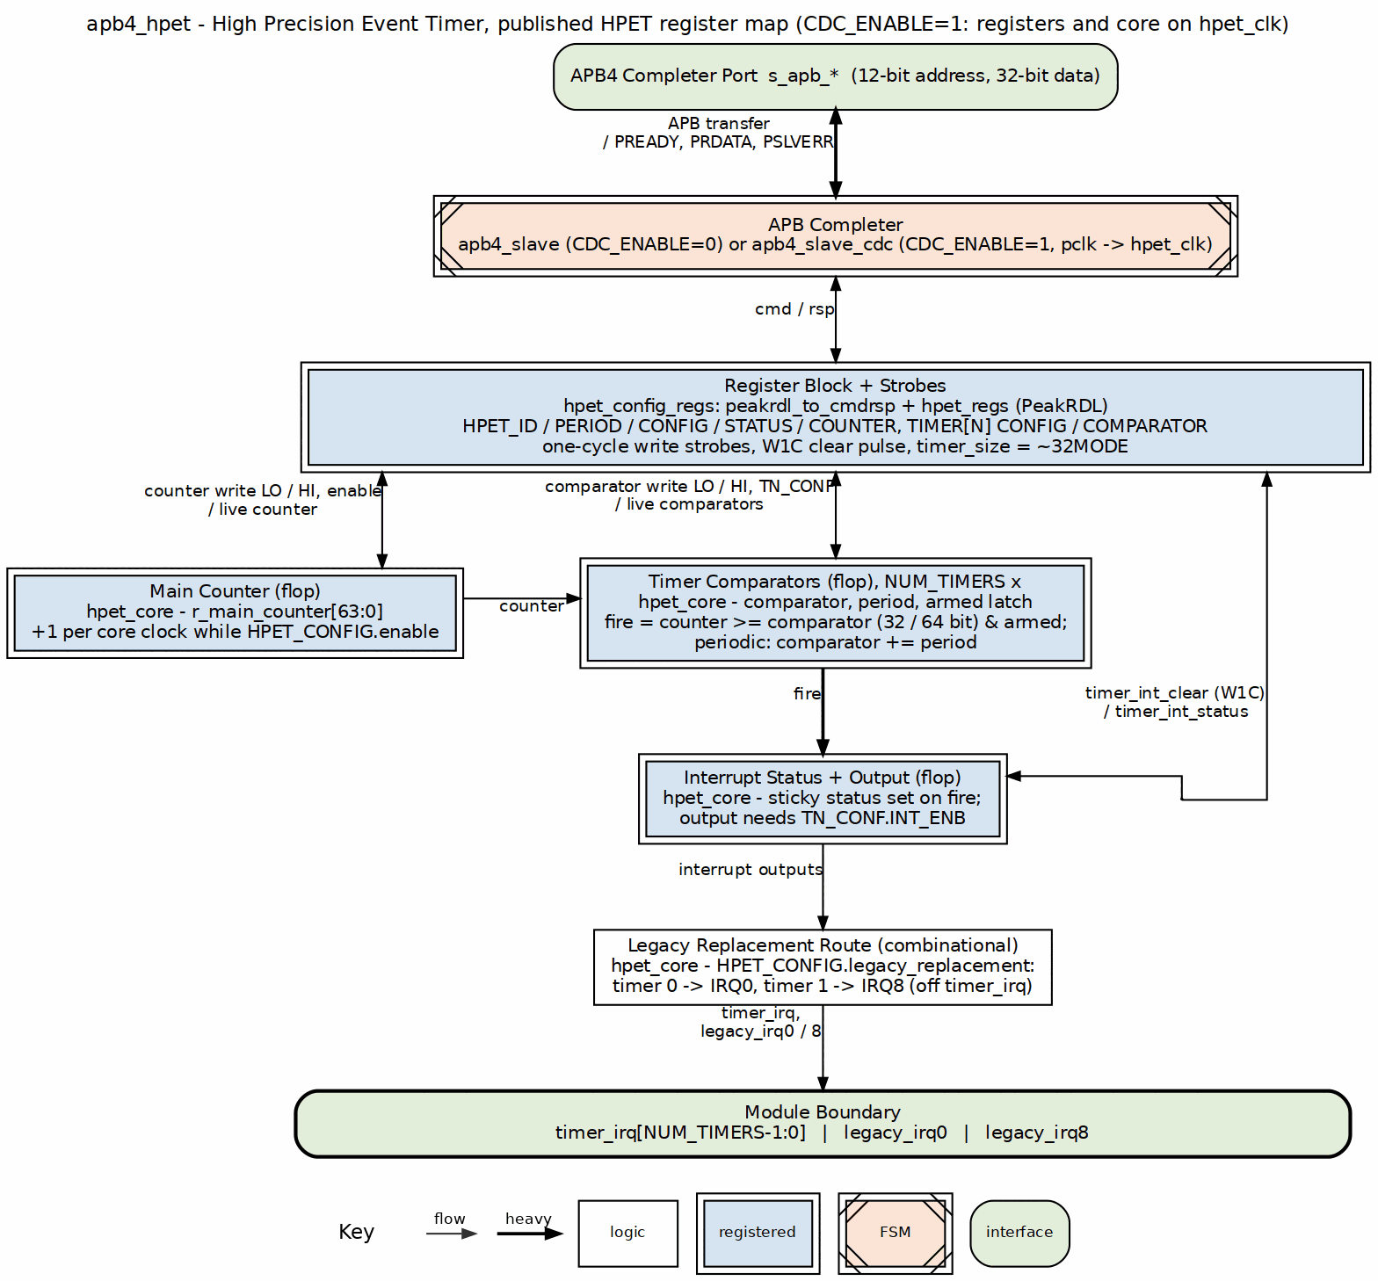
Design Highlights: - Reset macro standardization (FPGA-friendly) - Per-timer data buses prevent corruption - Edge-triggered register write strobes (not level) - W1C status register for interrupt clearing - Optional asynchronous clock domains with handshake CDC
See: docs/hpet_mas/hpet_mas_index.md for complete HPET specification

2.3 3. Planned Blocks

2.3.1 3.1 8259 - Programmable Interrupt Controller (PIC)
Status: Implemented (see dv/tests and the block MAS; per-block defects tracked in known_issues/) Priority: High Address: 0xFEC0_1000 - 0xFEC0_1FFF (4KB window, master of the cascaded pair)
Planned Features: - 8259A-compatible register interface - 8 interrupt request (IRQ) inputs - Cascadable (master/slave configuration) - Priority resolver (fixed and rotating priority) - Edge and level triggered modes - Interrupt mask register - End-of-Interrupt (EOI) handling - APB register interface
Applications: - Legacy interrupt management - PC-compatible systems - Hardware interrupt aggregation - Priority-based interrupt handling - Cascaded multi-level interrupt systems

2.3.2 3.2 8254 - Programmable Interval Timer (PIT)
Status: Implemented (see dv/tests and the block MAS; per-block defects tracked in known_issues/) Priority: High Address: 0xFEC0_2000 - 0xFEC0_2FFF (4KB window)
Planned Features: - 8254-compatible register interface - 3 independent 16-bit counters - 6 programmable counter modes - Binary and BCD counting - Read-back command - Configurable clock input - Interrupt/output generation per counter - APB register interface
Counter Modes: - Mode 0: Interrupt on terminal count - Mode 1: Hardware retriggerable one-shot - Mode 2: Rate generator - Mode 3: Square wave mode - Mode 4: Software triggered strobe - Mode 5: Hardware triggered strobe
Applications: - System tick generation - Periodic timer interrupts - Square wave generation - Event counting - Legacy PC timer compatibility

2.3.3 3.3 GPIO - General Purpose I/O
Status: Implemented (see dv/tests and the block MAS; per-block defects tracked in known_issues/) Priority: Medium Address: 0xFEC0_7000 - 0xFEC0_7FFF (4KB window)
Planned Features: - Configurable pin count (8, 16, 32 pins) - Per-pin direction control (input/output/bidirectional) - Input debouncing logic - Interrupt generation (rising/falling/both edges, level) - Output drive strength configuration - Pull-up/pull-down control - APB register interface
Applications: - LED control - Button inputs - Hardware control signals - Chip-select generation - Status monitoring

2.3.4 3.4 RTC - Real-Time Clock
Status: Implemented (apb4_rtc + MAS; see docs/rtc_mas – binary 24-hour timekeeping validated; BCD/12-hour modes and the production-mode time-set path are broken, tracked in issue #56) Priority: Medium Effort: 3-4 weeks Address: 0xFEC0_3000 - 0xFEC0_3FFF (4KB window)
Planned Features: - 32.768 kHz clock input (typical RTC crystal frequency) - Seconds, minutes, hours, day, month, year tracking - Alarm functionality - Battery backup support (power domain considerations) - 24-hour or 12-hour (AM/PM) mode - Leap year handling - APB register interface
Applications: - System time-of-day tracking - Wake-on-alarm functionality - Timestamp generation - Power-aware applications

2.3.5 3.5 SMBus Controller
Status: Implemented (see dv/tests and the block MAS; per-block defects tracked in known_issues/) Priority: Medium Address: 0xFEC0_4000 - 0xFEC0_4FFF (4KB window)
Planned Features: - SMBus 2.0 compliance - Master and slave modes - Clock stretching support - Packet Error Checking (PEC) - Alert response address - Configurable clock speed - APB register interface
Applications: - System management bus communication - Sensor interfaces (temperature, voltage) - EEPROM access - Battery management - Fan control

2.3.6 3.6 UART - Universal Asynchronous Receiver/Transmitter
Status: Implemented (apb4_uart_16550 + MAS; see docs/uart_16550_mas – note the shipped block has 1/2 stop bits only and no automatic flow control, and issue #60 tracks its RTL defects) Priority: Medium Address: 0xFEC0_8000 - 0xFEC0_8FFF (4KB window)
Planned Features: - 16550-compatible register interface - Configurable baud rate generation - 5/6/7/8 data bits - Parity: none, even, odd, mark, space - Stop bits: 1, 1.5, 2 - Hardware flow control (RTS/CTS) - FIFO buffers (16-byte TX/RX) - Interrupt generation
Applications: - Debug console - Serial communication - Modem interfaces - Legacy peripheral communication

2.3.7 3.7 SPI Controller
Status: Planned Priority: Low Effort: 5-6 weeks Address: TBD (not in primary ILB address map)
Planned Features: - Master mode (initially; slave mode future) - Configurable clock polarity and phase (CPOL/CPHA) - Multiple chip selects - Configurable word size (8/16/32 bits) - TX/RX FIFOs - DMA support (future) - APB register interface
Applications: - Flash memory access - ADC/DAC interfaces - Display controllers - SD card communication

2.3.8 3.8 I2C Controller
Status: Planned Priority: Low Effort: 5-7 weeks Address: TBD (not in primary ILB address map)
Planned Features: - I2C standard (100 kHz), fast (400 kHz), fast-plus (1 MHz) modes - Multi-master arbitration - 7-bit and 10-bit addressing - Clock stretching - General call support - APB register interface
Applications: - Sensor interfaces - EEPROM access - Multi-chip communication - System configuration

2.3.9 3.9 Watchdog Timer
Status: Planned Priority: Low Effort: 2-3 weeks Address: TBD (not in primary ILB address map)
Planned Features: - Configurable timeout period - Countdown counter with reload - Reset generation on timeout - Lock mechanism to prevent accidental disable - Interrupt before reset (optional warning) - APB register interface
Applications: - System fault recovery - Software hang detection - Periodic system reset - Safety-critical applications

2.3.10 3.10 Power Management / ACPI Controller
Status: Implemented (see dv/tests and the block MAS; per-block defects tracked in known_issues/) Priority: Medium Address: 0xFEC0_5000 - 0xFEC0_5FFF (4KB window)
Planned Features: - Clock gating control per block - Power domain sequencing - Reset generation and distribution - Wake event handling - Sleep/idle mode control - ACPI-compatible registers - APB register interface
Applications: - Low-power system design - Battery-powered devices - Dynamic power management - Thermal management - OS power management interface

2.3.11 3.11 IOAPIC - I/O Advanced Programmable Interrupt Controller
Status: Implemented (see dv/tests and the block MAS; per-block defects tracked in known_issues/) Priority: Medium Address: 0xFEC0_6000 - 0xFEC0_6FFF (4KB window)
Planned Features: - I/O APIC CSR model (register-based interface) - Multiple interrupt inputs (24+) - Programmable interrupt routing - Edge and level triggered modes - Priority-based arbitration - Interrupt masking per input - APB register interface for configuration
Applications: - Advanced interrupt routing - Multi-processor interrupt distribution - Flexible interrupt mapping - Legacy IRQ redirection - PC-compatible systems

2.3.12 3.12 Interconnect ID / Version Registers
Status: Planned – NOT present in the shipped design Priority: Low Effort: 1-2 weeks Address: unallocated. The shipped decoder is the generated apbx_xbar_1to10, whose ten windows (0x0000-0x9FFF) are fully assigned, so adding this block needs a window assignment AND a crossbar regeneration – it cannot simply occupy 0xF000 as earlier drafts of this document assumed.
Planned Features: - Vendor ID register - Device ID register - Revision ID register - Block presence/capability bits - Configuration status registers - Debug/diagnostic registers - APB register interface
Applications: - Software block discovery - Version checking - Feature detection - Debug and diagnostics - Platform identification

2.4 4. Integration and Wrapper Goals

2.4.1 4.1 Individual Block Integration
Each block is designed to be used standalone:
Example - HPET Integration:
apb4_hpet #(
.NUM_TIMERS(3),
.VENDOR_ID(16'h4747),
.REVISION_ID(16'h0001),
.CDC_ENABLE(0)
) u_hpet (
.pclk (apb_clk),
.presetn (apb_rst_n),
// APB interface -- the ports are s_apb_P*, not bare p*
.s_apb_PSEL (psel_hpet),
.s_apb_PENABLE (penable),
.s_apb_PREADY (pready_hpet),
.s_apb_PADDR (paddr[11:0]),
.s_apb_PWRITE (pwrite),
.s_apb_PWDATA (pwdata),
.s_apb_PSTRB (pstrb),
.s_apb_PPROT (pprot),
.s_apb_PRDATA (prdata_hpet),
.s_apb_PSLVERR (pslverr_hpet),
// HPET-specific
.hpet_clk (timer_clk),
.hpet_resetn (timer_rst_n),
.timer_irq (timer_irq[2:0])
);

2.4.2 4.2 RLB Wrapper Architecture
Goal: Create top-level wrapper combining multiple legacy blocks into unified retro-compatible subsystem.
System Architecture: 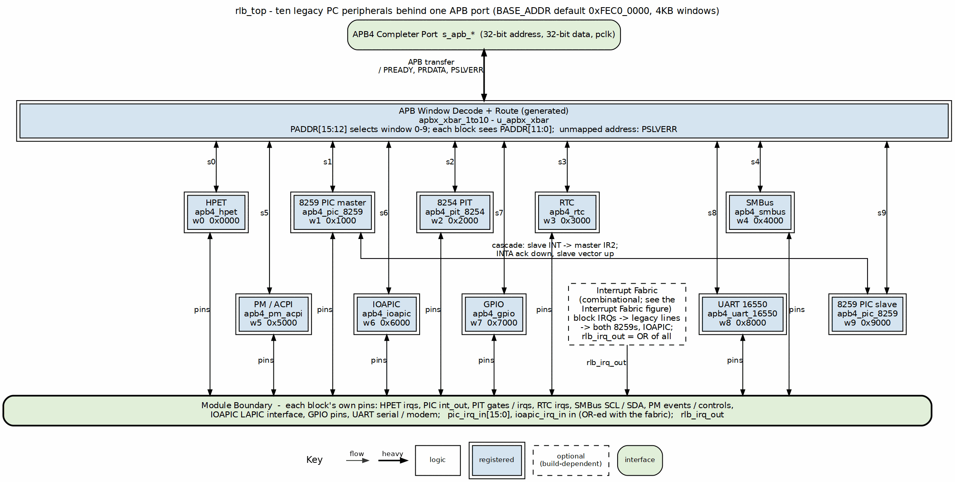
Address Map:
Base address: 0xFEC0_0000 – the BASE_ADDR parameter default in rlb_top.sv, and the conventional location for this class of block. It is a PARAMETER: an integrator may relocate the whole window set. Window size: 4KB per block (clean power-of-2 decode)
Address Range | Block | Size | Function
0xFEC0_0000 - 0xFEC0_0FFF | HPET | 4KB | High Precision Event Timer
0xFEC0_1000 - 0xFEC0_1FFF | 8259 PIC (master) | 4KB | Programmable Interrupt Controller
0xFEC0_2000 - 0xFEC0_2FFF | 8254 PIT | 4KB | Programmable Interval Timer
0xFEC0_3000 - 0xFEC0_3FFF | RTC | 4KB | Real-Time Clock
0xFEC0_4000 - 0xFEC0_4FFF | SMBus | 4KB | SMBus Host Controller
0xFEC0_5000 - 0xFEC0_5FFF | PM/ACPI | 4KB | Power Management / ACPI Registers
0xFEC0_6000 - 0xFEC0_6FFF | IOAPIC | 4KB | I/O Advanced PIC (CSR model)
0xFEC0_7000 - 0xFEC0_7FFF | GPIO | 4KB | General Purpose I/O
0xFEC0_8000 - 0xFEC0_8FFF | UART 16550 | 4KB | Serial port
0xFEC0_9000 - 0xFEC0_9FFF | 8259 PIC (slave) | 4KB | Cascade slave of the PC/AT pair
All other addresses | decode-miss agent | - | Accepted and answered locally with PSLVERR
The decoder is the GENERATED apbx_xbar_1to10 (one master, ten slaves), so the window count and the base both come from the generator invocation recorded in rlb_top.sv. There is no window above 0x9FFF.
Decoder Implementation:
// Address decode logic (simplified)
localparam BASE_ADDR = 32'hFEC0_0000;
localparam BLOCK_SIZE = 12; // 4KB = 2^12
logic [3:0] block_sel;
assign block_sel = paddr[15:12]; // Extract window number
always_comb begin
psel_hpet = (block_sel == 4'h0) & psel; // 0xFEC0_0xxx
psel_pic8259 = (block_sel == 4'h1) & psel; // 0xFEC0_1xxx
psel_pit8254 = (block_sel == 4'h2) & psel; // 0xFEC0_2xxx
psel_rtc = (block_sel == 4'h3) & psel; // 0xFEC0_3xxx
psel_smbus = (block_sel == 4'h4) & psel; // 0xFEC0_4xxx
psel_pm = (block_sel == 4'h5) & psel; // 0xFEC0_5xxx
psel_ioapic = (block_sel == 4'h6) & psel; // 0xFEC0_6xxx
psel_gpio = (block_sel == 4'h7) & psel; // 0xFEC0_7xxx
psel_uart = (block_sel == 4'h8) & psel; // 0xFEC0_8xxx
psel_pic_slave = (block_sel == 4'h9) & psel; // 0xFEC0_9xxx
psel_error = !(|{psel_hpet, psel_pic8259, psel_pit8254,
psel_rtc, psel_smbus, psel_pm, psel_ioapic,
psel_gpio, psel_uart, psel_pic_slave}) & psel;
end
Interface: - Single APB slave port at base address 0xFEC0_0000 (the BASE_ADDR parameter) - Aggregated interrupt output combining all block IRQs - Per-block clock/reset control for power management - External I/O signals (GPIO, UART, I2C/SMBus, etc.) - Error slave returns SLVERR for unmapped addresses
Benefits: - Simplified system integration (single APB slave) - Consistent 4KB window addressing - Clean power-of-2 address decode - Ten 4KB windows, fully assigned; expansion needs a crossbar regeneration - Single verification target - Drop-in retro-compatible peripheral subsystem

2.5 5. Design Standards

2.5.1 5.1 Reset Handling
MANDATORY: All blocks must use standardized reset macros from rtl/amba/includes/reset_defs.svh
Pattern:
`include "reset_defs.svh"
`ALWAYS_FF_RST(clk, rst_n,
if (`RST_ASSERTED(rst_n)) begin
r_state <= IDLE;
r_counter <= '0;
end else begin
r_state <= w_next_state;
r_counter <= r_counter + 1'b1;
end
)
Why: - FPGA-friendly reset inference - Consistent synthesis behavior - Single-point reset polarity control - Better timing closure

2.5.2 5.2 Register Generation
Preferred: Use PeakRDL for register map generation
Process: 1. Define registers in SystemRDL (.rdl file) 2. Generate RTL using PeakRDL regblock 3. Create wrapper module connecting registers to core logic 4. Use edge detection for write strobes (not level)
Benefits: - Consistent register interface - Auto-generated documentation - Reduced manual RTL errors - Easy register map changes

2.5.3 5.3 Testbench Architecture
MANDATORY: Follow project testbench organization pattern
Structure:
dv/
├── tbclasses/{block}/ # Block-specific TB classes
│ ├── {block}_tb.py # Main testbench
│ ├── {block}_tests_basic.py # Gate test suite
│ ├── {block}_tests_medium.py # Func test suite
│ └── {block}_tests_full.py # Full test suite
└── tests/{block}/ # Test runners
├── test_apb4_{block}.py # Pytest wrapper
└── conftest.py # Pytest configuration
Import Pattern:
# Always import from PROJECT AREA
from projects.components.retro_legacy_blocks.dv.tbclasses.{block}.{block}_tb import {Block}TB
Test Levels: - Gate: Core functionality (register access, basic operation) - Func: Extended features (modes, configurations, edge cases) - Full: Stress testing, CDC variants, corner cases
Target: 100% pass rate at all levels

2.5.4 5.4 FPGA Synthesis Attributes
MANDATORY: Add FPGA synthesis hints for memory arrays
`ifdef XILINX
(* ram_style = "auto" *)
`elsif SYNTH_PRAGMA
/* synthesis ramstyle = "AUTO" */
`endif
logic [DATA_WIDTH-1:0] mem [DEPTH];

2.5.5 5.5 Documentation Requirements
Each block must have: - RTL comments (inline) - Register map specification - Block-level specification in docs/{block}_mas/ - Integration guide - Test plan and results

2.6 6. Quality Metrics

2.6.1 6.1 Production Readiness Criteria
A block is considered “Production Ready” when:
- All gate tests pass 100%
- All func tests pass 100%
- All full tests pass ≥95%
- Complete register map specification
- RTL lint clean (Verilator)
- Reset macros used throughout
- FPGA synthesis attributes applied
- Integration guide written
- Known issues documented

2.6.2 6.2 Current Status
Block | Priority | Status | Test Pass Rate | Documentation | Production Ready
HPET | High | Implemented | see dv/tests | MAS (ch1/2/5) | RTL defects open (#46)
8259 PIC | High | Implemented | see dv/tests | MAS (ch1/5) | ISR/EOI half inert (#50)
8254 PIT | High | Implemented | 6/6 both CDC configs | MAS (full) | Mode 0 only (#52)
GPIO | Medium | Implemented | see dv/tests | MAS (full) | Functional; quirks tracked (#44)
RTC | Medium | Implemented | see dv/tests | MAS (ch1/5) | Binary 24h only; time-set broken in production mode (#56)
SMBus | Medium | Implemented | see dv/tests | MAS (ch1/5) | Transfer engine non-functional (#58)
PM/ACPI | Medium | Implemented | see dv/tests | MAS (ch1/5) | Status/W1C/wake defects (#54)
IOAPIC | Medium | Implemented | see dv/tests | MAS (ch1/2/5) | Double delivery + EOI hazards (#48)
UART | Medium | Implemented | see dv/tests | MAS (full) | FE/BI dead, IER unwired (#60)
SPI | Low | Planned | N/A | N/A | No
I2C | Low | Planned | N/A | N/A | No
Watchdog | Low | Planned | N/A | N/A | No
Interconnect | Low | Planned | N/A | N/A | No

2.7 7. Development Roadmap

2.7.1 7.1 Phase 1: Foundation (Complete)
- HPET implementation
- Directory structure for multiple blocks
- Testbench architecture established
- Documentation templates
- Build and test infrastructure

2.7.2 7.2 Phase 2: Core Peripherals (Next 6-9 Months)
Q1 2026 (High Priority): - 8259 PIC (6-8 weeks) - Interrupt controller - 8254 PIT (4-5 weeks) - Interval timer - RTC (3-4 weeks) - Real-time clock
Q2 2026 (Medium Priority): - GPIO Controller (4-6 weeks) - SMBus Controller (6-8 weeks) - PM/ACPI Controller (8-10 weeks)
Q3 2026: - UART (4-5 weeks) - IOAPIC (6-8 weeks)

2.7.3 7.3 Phase 3: Advanced Peripherals (9-15 Months)
Q4 2026: - SPI Controller (5-6 weeks) - I2C Controller (5-7 weeks) - Watchdog Timer (2-3 weeks)
Q1 2027: - Interconnect ID/Version Registers (1-2 weeks) - ILB Wrapper integration starts

2.7.4 7.4 Phase 4: System Integration (15+ Months)
Q2-Q4 2027: - Complete ILB wrapper with all blocks - System-level integration examples - Performance characterization - FPGA reference designs - Application notes - Software driver examples

2.8 8. References

2.8.1 8.1 External Standards
Peripheral Specifications: - ACPI HPET Specification 1.0a - SMBus Specification Version 2.0 - 16550 UART Datasheet - I2C Specification (NXP) - SPI Protocol Specification
Bus Protocols: - AMBA APB Protocol Specification (ARM) - AMBA 3 APB Protocol v1.0

2.8.2 8.2 Internal Documentation
- /CLAUDE.md - Repository AI guide
- /PRD.md - Master repository requirements
- projects/components/legacy-ip/retro_legacy_blocks/CLAUDE.md - Component AI guide
- projects/components/legacy-ip/retro_legacy_blocks/README.md - Component overview
- vault/tracking/projects/components/legacy-ip/retro_legacy_blocks/ - task tracking (cross-block); vault/tracking/projects/components/legacy-ip/retro_legacy_blocks/hpet/ for HPET

2.8.3 8.3 Block-Specific Documentation
HPET: - docs/hpet_mas/hpet_mas_index.md - HPET specification - docs/IMPLEMENTATION_STATUS.md - HPET test results - known_issues/ - HPET issue tracking

2.9 9. Success Criteria

2.9.1 9.1 Individual Block Success
Each block must: - Pass all gate/func tests at 100% - Pass full tests at ≥95% - Have complete register map specification - Include integration guide with examples - Be lint-clean (Verilator) - Use reset macros throughout - Include FPGA synthesis attributes

2.9.2 9.2 Collection Success
The retro_legacy_blocks component is successful when: - At least 6 blocks production-ready (HPET + 5 high/medium priority blocks) - All blocks follow consistent architecture (reset macros, PeakRDL, APB interface) - RLB wrapper integrates all blocks seamlessly with clean 4KB addressing - System-level integration example provided - Complete documentation for all blocks - FPGA reference design available - Address map covers all essential retro-compatible peripherals

2.9.3 9.3 Long-Term Vision
Ultimate goal: - Production-quality retro-compatible peripheral subsystem - Complete peripheral coverage for legacy platform requirements - Used in production FPGA designs - Educational resource for classic peripheral design - Foundation for mixed-vintage SoC designs

Version: 1.0 Last Review: 2025-10-29 Next Review: After each new block completion Maintained By: RTL Design Sherpa Project

RTL Design Sherpa · Learning Hardware Design Through Practice GitHub · Documentation Index · MIT License

3 PeakRDL HPET Integration - Final Status
Status (2026-07-22): Historical results file from the standalone apb4_hpet component, which was absorbed into retro_legacy_blocks. Paths below have been updated to the new locations (RTL: rtl/hpet/, TB classes: dv/tbclasses/hpet/, test runner: dv/tests/test_apb4_hpet.py).

3.1 Milestone: COMPLETE (5/6 configs fully passing)

3.1.1 Test Results Summary
2-Timer v4747 (no CDC): ALL TESTS PASS - Basic: 4/4 | Medium: 5/5 | Full: 3/3 - Overall: 12/12 (100%)
3-Timer AMD-like (no CDC): ALL TESTS PASS - Basic: 4/4 | Medium: 5/5 | Full: 3/3 - Overall: 12/12 (100%)
2-Timer v4747 (CDC): ALL TESTS PASS - Basic: 4/4 | Medium: 5/5 | Full: 3/3 - Overall: 12/12 (100%)
3-Timer AMD-like (CDC): ALL TESTS PASS - Basic: 4/4 | Medium: 5/5 | Full: 3/3 - Overall: 12/12 (100%)
8-Timer custom (CDC): ALL TESTS PASS - Basic: 4/4 | Medium: 5/5 | Full: 3/3 - Overall: 12/12 (100%)
8-Timer custom (no CDC): ONE TEST FAILS - Basic: 4/4 | Medium: 5/5 | Full: 2/3 - Overall: 11/12 (92%) - Issue: All Timers Stress test - only 6/8 timers fire (Timer 6 and 7 timeout) - Likely fix: Increase test timeout (same fix as 3-timer Multiple Timers test)

3.2 Root Cause Found & Fixed
Problem: Counter state not reset between tests + insufficient test timeouts
Fixes Applied: 1. Counter cleanup (line 220-222 in hpet_tests_medium.py): python # Reset counter to 0 for next test await self.tb.write_register(HPETRegisterMap.HPET_COUNTER_LO, 0x00000000) await self.tb.write_register(HPETRegisterMap.HPET_COUNTER_HI, 0x00000000)
- Multiple Timers timeout (line 356 in hpet_tests_medium.py):
- timeout = 20000 # 20us timeout - Timer 2 needs 7000ns, allow extra margin
Result: All 3-timer tests now PASS

3.3 Core Functionality Validated
- PeakRDL Integration: Working perfectly
  - Register generation from SystemRDL
  - APB interface integration
  - peakrdl-to-cmdrsp adapter
- HPET Features: All working
  - One-shot timers
  - Periodic timers
  - Timer mode switching
  - 64-bit comparators
  - Multiple timers (up to 8)
  - Clock domain crossing (CDC)
- Per-Timer Bus Architecture: Successfully implemented
  - Timer comparator data corruption fixed
  - Per-timer write data buses
  - Correct strobe generation
- Test Infrastructure Fixes:
  - Timer reset loop between tests
  - Counter cleanup in 64-bit Counter test
  - Proper timeout calculations for multi-timer tests

3.4 Files Modified

3.4.1 RTL Changes:
- rtl/hpet/hpet_core.sv - Per-timer data buses
- rtl/hpet/hpet_config_regs.sv - Per-timer data routing
- rtl/hpet/apb4_hpet.sv - Signal declarations

3.4.2 Test Changes:
- dv/tbclasses/hpet/hpet_tests_medium.py
  - Added timer reset loop (lines 308-318)
  - Fixed periodic mode timeout (line 103)
  - Fixed mode switching timeout (line 453)
  - NEW: Added counter cleanup in 64-bit Counter test (lines 220-222)
  - NEW: Increased Multiple Timers timeout to 20µs (line 356)
- dv/tbclasses/hpet/hpet_tests_full.py
  - Removed Interrupt Latency test (non-functional)
  - Removed Performance Benchmark test (non-functional)

3.4.3 Documentation:
- known_issues/README.md - Updated with actual root cause (formerly the standalone component’s KNOWN_ISSUES.md)
- status.txt - This file

3.5 Remaining Work (Minor)

3.5.1 8-Timer Non-CDC All Timers Stress Test
Status: ONE TEST FAILS (Timer 6 and 7 don’t fire in time) Impact: Low - same timeout issue as Multiple Timers test Estimated fix time: 5 minutes (increase timeout in All Timers Stress test) Priority: Optional - 5/6 configs fully working, CDC version works
The All Timers Stress test likely has a similar short timeout that prevents Timer 6 and Timer 7 from firing. The fix is to increase the timeout in hpet_tests_full.py similar to what was done for Multiple Timers test.

3.6 Milestone Achievement
PRIMARY GOAL ACHIEVED: PeakRDL integration complete, all core functionality validated
5/6 CONFIGURATIONS: Production ready (100% tests pass)
ROOT CAUSE FIXED: Counter state management + timeout calculations corrected
1/6 CONFIGURATION: 8-timer non-CDC has one stress test timing issue (minor)

3.7 Recommended Next Steps
- Accept milestone as COMPLETE - 5/6 configs fully working, core functionality validated
- OPTIONAL: Fix 8-timer All Timers Stress test timeout (5 minutes)
- OR: Use CDC-enabled 8-timer configuration (already passes 100%)

3.8 Test Execution Summary
pytest projects/components/legacy-ip/retro_legacy_blocks/dv/tests/test_apb4_hpet.py -v
test_hpet[2-18247-1-0-full-2-timer v4747] PASSED
test_hpet[3-4130-2-0-full-3-timer AMD-like] PASSED
test_hpet[8-43981-16-0-full-8-timer custom] FAILED (1 stress test timeout)
test_hpet[2-18247-1-1-full-2-timer v4747 CDC] PASSED
test_hpet[3-4130-2-1-full-3-timer AMD-like CDC] PASSED
test_hpet[8-43981-16-1-full-8-timer custom CDC] PASSED
Result: 5/6 PASS (83%), 1 minor timeout issue

3.9 Git Status
Modified files ready to commit: - RTL: hpet_core.sv, hpet_config_regs.sv, apb4_hpet.sv - Tests: hpet_tests_medium.py (counter cleanup + timeout fixes), hpet_tests_full.py - Docs: KNOWN_ISSUES.md (can be updated or removed)
Next: Create git commit for PeakRDL HPET integration milestone

RTL Design Sherpa · Learning Hardware Design Through Practice GitHub · Documentation Index · MIT License

4 APB UART 16550 — Overview

4.1 Overview
The APB UART 16550 is a 16550-compatible Universal Asynchronous Receiver/Transmitter sitting behind an APB slave interface. It gives you standard serial communication with configurable baud rates, data formats, and FIFO buffering — the same programming model your OS driver already knows, bolted onto a bus your SoC already has.

4.1.1 Key Features

4.1.1.1 Serial Communication
- Full-duplex asynchronous serial operation
- Configurable baud rates (up to 3 Mbps at 48 MHz clock)
- 5, 6, 7, or 8 data bits
- 1, 1.5 or 2 stop bits (a 5-bit word with LCR[2] set sends 1.5)
- Even, odd, mark, space, or no parity

4.1.1.2 FIFO Buffering
- 16-byte transmit FIFO
- 16-byte receive FIFO
- Configurable trigger levels (1, 4, 8, 14 bytes)
- FCR[0]=1 gives FIFO_DEPTH-entry FIFOs (16 by default); FCR[0]=0 is 16450 character mode, one holding register per side

4.1.1.3 Interrupt System
- Prioritized interrupts
- Receive data available
- Transmitter holding register empty
- Receiver line status (errors)
- Modem status changes

4.1.1.4 Modem Control
- CTS/RTS modem signals, with automatic hardware flow control on MCR[5] (AFE): CTS gates the start of a character and RTS follows the RX FIFO level; see ch03/ch05
- Full modem signals (DTR, DSR, DCD, RI)
- Programmable outputs (OUT1, OUT2)
- Loopback mode for testing

4.1.2 Applications
- Debug consoles
- System management interfaces
- Legacy device communication
- Embedded system UART
- Modem interfaces

4.2 Parameters
Parameter | Default | Description
FIFO_DEPTH | 16 | TX/RX FIFO depth
CDC_ENABLE | 0 | Clock domain crossing
SYNC_STAGES | 2 | Synchronizer stages for CDC
SKID_DEPTH | 2 | Skid-buffer depth for CDC path
USE_JOHNSON | 0 | CDC counter encoding (forwarded to apb4_slave_cdc)

4.3 Functional Description

4.3.1 Figure 1.1: UART 16550 Block Diagram
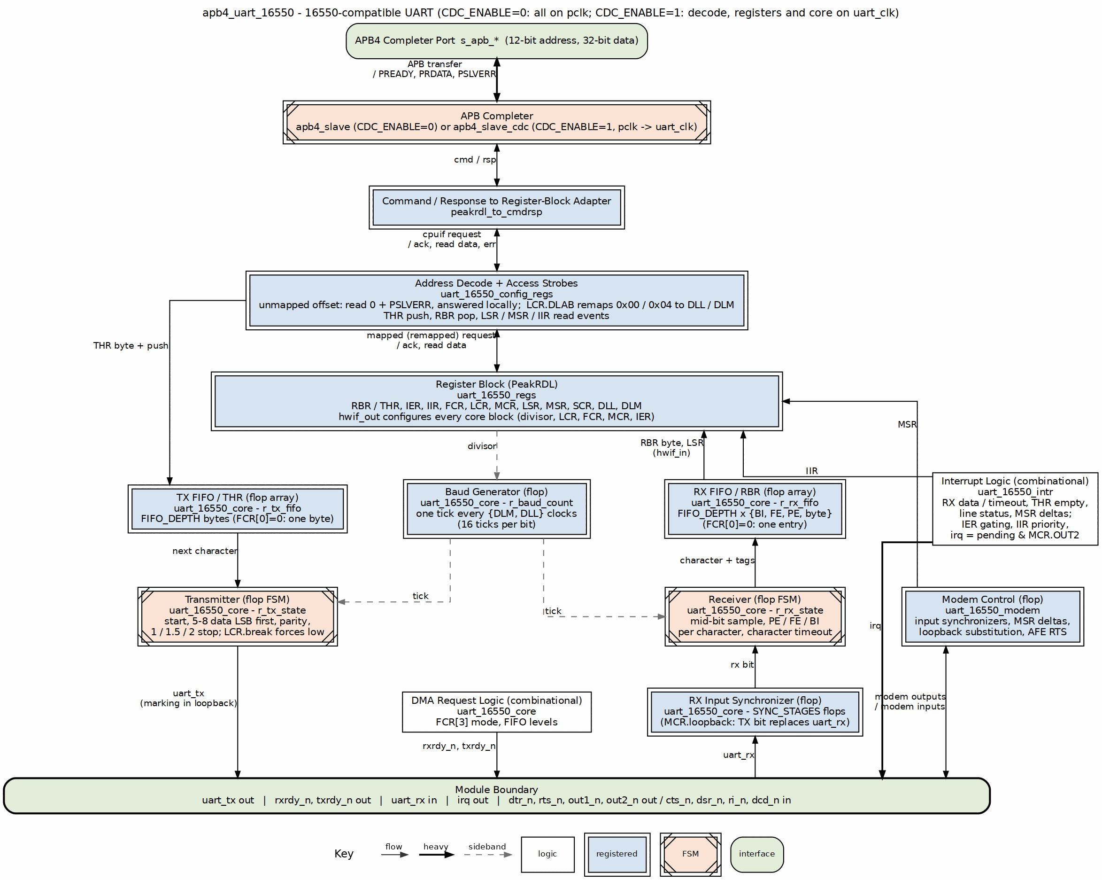
UART 16550 Block Diagram

4.3.2 Register Summary
Every register has a unique offset, and LCR[7] (DLAB) additionally remaps 0x00 and 0x04 to the divisor latches DLL/DLM while it is set, as a standard 16550 driver expects; the flat offsets 0x24/0x28 keep working either way (RLB TASK-012, was RLB-013).
Offset | Name | Access | Description
0x00 | RBR / THR | R / W | Receive Buffer (read) / Transmit Holding (write)
0x04 | IER | RW | Interrupt Enable
0x08 | IIR | RO | Interrupt Identification
0x0C | FCR | RW | FIFO Control
0x10 | LCR | RW | Line Control
0x14 | MCR | RW | Modem Control
0x18 | LSR | RO, clear on read | Line Status
0x1C | MSR | RO, clear on read | Modem Status
0x20 | SCR | RW | Scratch Register
0x24 | DLL | RW | Divisor Latch LSB
0x28 | DLM | RW | Divisor Latch MSB

4.4 Design Notes

4.4.1 Compatibility
The design is register-compatible with: - National Semiconductor PC16550D - TI TL16C550C - Standard 16550 UART cores

4.4.1.1 Differences from Original 16550
- APB interface instead of ISA/parallel bus
- Configurable clock domain crossing support
- PeakRDL-generated register file

4.5 Navigation
Next: 02_architecture.md - Architecture details

RTL Design Sherpa · Learning Hardware Design Through Practice GitHub · Documentation Index · MIT License

5 APB UART 16550 — Architecture

5.1 Overview
This page takes the UART apart: the module hierarchy, the paths data and interrupts actually travel, and how the baud clock is derived. If you only read one page before integrating the block, make it this one.

5.2 Functional Description

5.2.1 Figure 1.2: UART Architecture
UART Architecture

5.2.2 Module Hierarchy
apb4_uart_16550 (Top Level)
+-- apb4_slave (CDC_ENABLE=0) or apb4_slave_cdc (CDC_ENABLE=1)
| +-- APB protocol handling
| +-- CMD/RSP interface conversion
|
+-- peakrdl_to_cmdrsp (CMD/RSP to register-block adapter)
|
+-- uart_16550_config_regs (Register Wrapper)
| +-- uart_16550_regs (PeakRDL Generated)
| | +-- RBR/THR/DLL register
| | +-- IER/DLM register
| | +-- IIR/FCR registers
| | +-- LCR/MCR/LSR/MSR/SCR
| |
| +-- Strict address decode
| | +-- Eleven mapped offsets; anything else drops with PSLVERR
| |
| +-- Read/write strobes
| | +-- THR push (byte-enable qualified), RBR pop
| | +-- LSR and MSR read events (clear-on-read), IIR read event
| |
| +-- uart_16550_core
| +-- Baud Rate Generator
| | +-- Divisor latch
| | +-- 16x clock generation
| |
| +-- TX Engine
| | +-- TX FIFO (FIFO_DEPTH bytes, or one in character mode)
| | +-- Serializer
| | +-- Start/Stop/Parity generation
| |
| +-- RX Engine
| | +-- RX FIFO (FIFO_DEPTH entries, 11 bits: byte + PE/FE/BI tags)
| | +-- Deserializer
| | +-- Start detection, break hold
| | +-- Error detection
| |
| +-- uart_16550_intr
| | +-- Interrupt conditions, IER gating
| | +-- IIR priority encode, THR-empty clear on IIR read
| | +-- OUT2 gating of the irq pin
| |
| +-- uart_16550_modem
| +-- Input synchronizers
| +-- Loopback substitution
| +-- MSR delta detection
| +-- Active-low outputs

5.2.3 Data Flow

5.2.3.1 Transmit Path
Figure 1.2 traces it down the left column:
- Software writes THR; the access strobes push the byte into the TX FIFO.
- The transmitter takes the head byte when it leaves IDLE (with AFE set, only while CTS is asserted).
- It sends a start bit (low), 5-8 data bits LSB first, the optional parity bit, and 1, 1.5 (5-bit words) or 2 stop bits (high), one bit every 16 baud ticks.
- The bit leaves on uart_tx (held high in loopback, where it feeds the receiver instead).

5.2.3.2 Receive Path
Figure 1.2 traces it back up the right column:
- uart_rx passes the SYNC_STAGES-flop synchronizer (the TX bit replaces it in loopback).
- The receiver sees the line go low, confirms the start bit at mid-bit, then samples each data bit, the parity bit and the stop bit once per bit time.
- Parity, framing (stop bit low) and break (all zeros with the stop bit low) are tagged on the character; a full FIFO is an overrun.
- The character and its three tags enter the RX FIFO at the stop-bit sample.
- Software reads RBR; LSR reports the tags of the character at the head.

5.2.3.3 Interrupt Flow
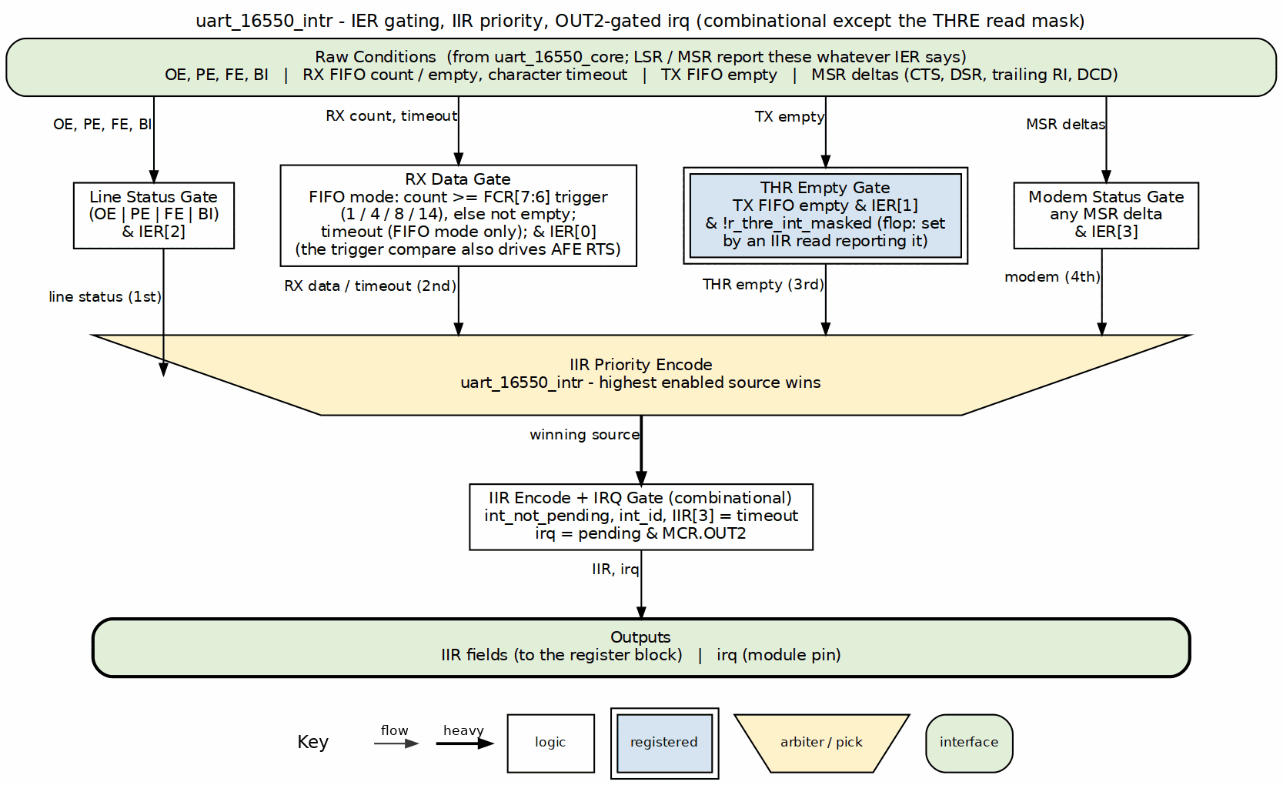
Interrupt Flow

5.2.4 Baud Rate Generation

5.2.4.1 Divisor Calculation
Divisor = Input Clock / (16 x Desired Baud Rate)
Examples (48 MHz input):
9600 baud: Divisor = 48000000 / (16 x 9600) = 312.5 -> 312 or 313
115200 baud: Divisor = 48000000 / (16 x 115200) = 26.04 -> 26
3000000 baud: Divisor = 48000000 / (16 x 3000000) = 1 -> 1

5.2.4.2 Clock Generation
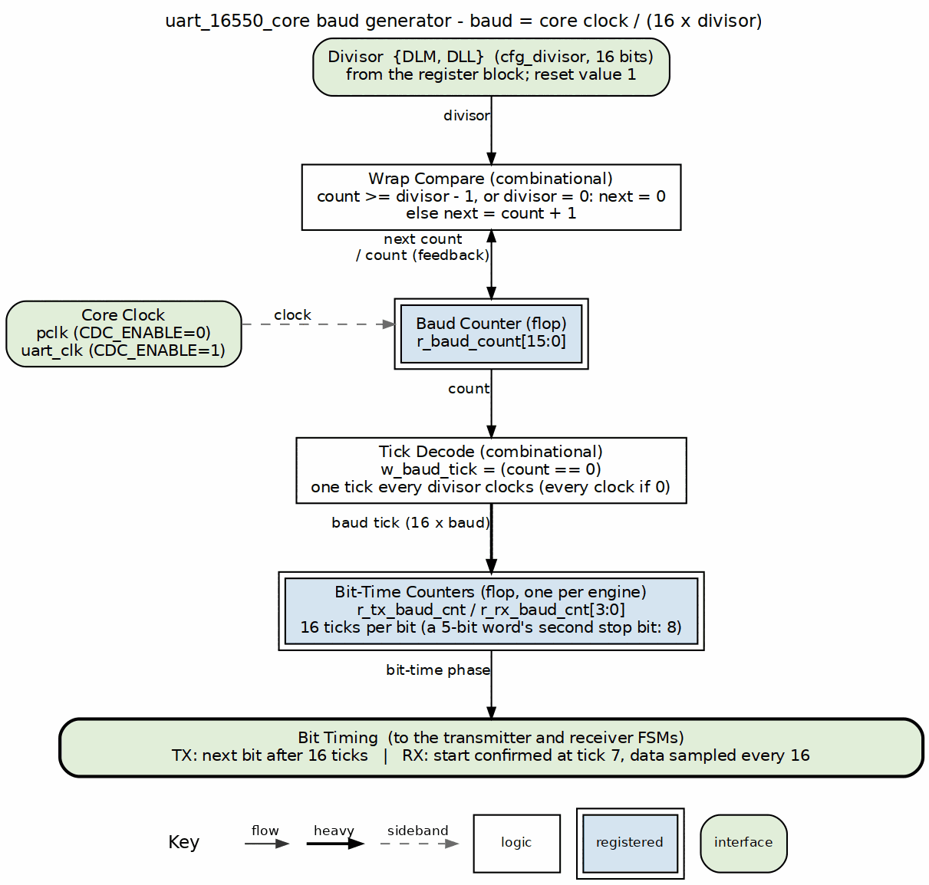
Baud Clock Generation

5.2.5 FIFO Organization

5.2.5.1 TX FIFO
Feature | Value
Depth | 16 bytes
Width | 8 bits
Write | THR writes
Read | TX serializer
Status | THRE, TEMT in LSR

5.2.5.2 RX FIFO
Feature | Value
Depth | 16 bytes
Width | 11 bits (8 data + 3 error)
Write | RX deserializer
Read | RBR reads
Trigger | 1, 4, 8, or 14 bytes

5.3 Design Notes

5.3.1 Resource Estimates
Component | Flip-Flops | LUTs
apb4_slave | ~20 | ~50
uart_regs | ~150 | ~100
baud_gen | ~20 | ~30
tx_engine + FIFO | ~200 | ~150
rx_engine + FIFO | ~250 | ~200
Total | ~640 | ~530

5.4 Navigation
Next: 03_clocks_and_reset.md - Clock and reset behavior

RTL Design Sherpa · Learning Hardware Design Through Practice GitHub · Documentation Index · MIT License

6 APB UART 16550 — Clocks and Reset

6.1 Overview
Clocking and reset are where most integrations go wrong, so this page lays out exactly what the block expects: one clock in the simple case, two when you ask for CDC, and active-low asynchronous resets. The reset-value tables below are the ground truth for what your driver sees at power-on.

6.2 Ports

6.2.1 Clock Signals

6.2.1.1 pclk (APB Clock)
- Purpose: Primary APB bus clock
- Usage: APB protocol, register access
- Typical Frequency: 50-200 MHz

6.2.1.2 uart_clk (Optional)
- Purpose: UART baud rate reference clock
- Usage: Only when CDC_ENABLE=1
- Typical Frequency: 1.8432 MHz, 14.7456 MHz, or higher

6.2.2 Reset Signals

6.2.2.1 presetn (APB Reset)
- Type: Active-low asynchronous reset
- Scope: APB interface logic
- Behavior: Resets APB state machine, clears pending transactions

6.2.2.2 uart_rstn (Optional)
- Type: Active-low asynchronous reset
- Scope: UART core logic
- Usage: Only when CDC_ENABLE=1
- Behavior: Resets TX/RX engines, FIFOs, baud generator

6.3 Functional Description

6.3.1 Reset Behavior

6.3.1.1 Register Reset Values
Register | Reset Value | Notes
RBR | Undefined | Read-only, FIFO content
THR | N/A | Write-only
IER | 0x00 | Interrupt enables, all four sources
IIR | 0x02 | THR-empty pending at reset (TX FIFO empty; masked by IER[1], which resets to 0)
FCR | 0x00 | FIFOs enabled interface bit clear
LCR | 0x03 | 8 data bits, 1 stop, no parity (8N1)
MCR | 0x00 | All outputs deasserted (irq masked - OUT2=0)
LSR | 0x60 | THRE=1, TEMT=1 (TX empty)
MSR | 0x00 | No delta, inputs low
SCR | 0x00 | Scratch cleared
DLL | 0x01 | Divisor LSB = 1
DLM | 0x00 | Divisor MSB = 0

6.3.1.2 Serial Line State During Reset
During reset: - uart_tx = 1 (idle/mark state) - Receiver disabled - Transmitter disabled - FIFOs cleared

6.3.2 Clock Domain Crossing

6.3.2.1 When CDC_ENABLE = 0
- All logic runs on pclk
- Baud generator derives timing from pclk
- Best for systems where pclk is stable

6.3.2.2 When CDC_ENABLE = 1
- APB interface uses pclk
- UART core uses uart_clk
- Skid buffers handle CDC
- Allows dedicated baud reference clock

6.4 Timing

6.4.1 Baud Rate Considerations

6.4.1.1 Clock Accuracy
For reliable communication: - Baud rate error should be < 2% - Combined TX+RX error < 4%

6.4.1.2 Common Clock Frequencies
Clock | Exact Baud Rates | Notes
1.8432 MHz | 115200, 57600, 38400, 19200, 9600 | Classic UART clock
14.7456 MHz | 921600, 460800, … 9600 | 8x above, higher rates
48 MHz | Most rates with small error | System clock compatible
50 MHz | Most rates with small error | Common FPGA clock

6.4.1.3 Example: 48 MHz Clock
Baud Rate | Divisor | Actual Rate | Error
9600 | 312 | 9615.4 | +0.16%
19200 | 156 | 19230.8 | +0.16%
38400 | 78 | 38461.5 | +0.16%
57600 | 52 | 57692.3 | +0.16%
115200 | 26 | 115384.6 | +0.16%
230400 | 13 | 230769.2 | +0.16%
460800 | 7 | 428571.4 | -6.99%
921600 | 3 | 1000000 | +8.51%

6.4.2 Timing Constraints

6.4.2.1 Synchronous Mode
- Standard single-clock timing
- All paths constrained to pclk

6.4.2.2 Asynchronous Mode
- Set false_path between pclk and uart_clk domains
- Set max_delay for CDC paths
- RXD input should have IOB register

6.4.2.3 External Interface Timing
Signal | Timing | Notes
uart_tx | Output register | Clean edges
uart_rx | Input synchronizer | 2-stage FF
Modem signals | Input synchronizer | 2-stage FF

6.5 Navigation
Next: 04_acronyms.md - Acronyms and terminology

RTL Design Sherpa · Learning Hardware Design Through Practice GitHub · Documentation Index · MIT License

7 APB UART 16550 — Acronyms and Terminology

7.1 Overview
Every acronym and term of art used in this specification, collected in one place. When a later chapter throws “THRE” or “mark parity” at you without ceremony, this is the page to come back to.

7.2 Design Notes

7.2.1 Protocol Acronyms
Acronym | Full Name | Description
APB | Advanced Peripheral Bus | Low-power AMBA bus protocol
UART | Universal Asynchronous Receiver/Transmitter | Serial communication interface
RS-232 | Recommended Standard 232 | Serial communication standard
TTL | Transistor-Transistor Logic | Logic voltage levels

7.2.2 Register Acronyms
Acronym | Full Name | Description
RBR | Receiver Buffer Register | Read received data
THR | Transmitter Holding Register | Write data to transmit
IER | Interrupt Enable Register | Enable interrupt sources
IIR | Interrupt Identification Register | Identify pending interrupt
FCR | FIFO Control Register | Configure FIFOs
LCR | Line Control Register | Configure data format
MCR | Modem Control Register | Control modem outputs
LSR | Line Status Register | TX/RX status and errors
MSR | Modem Status Register | Modem input status
SCR | Scratch Register | General-purpose storage
DLL | Divisor Latch LSB | Baud rate low byte
DLM | Divisor Latch MSB | Baud rate high byte

7.2.3 Signal Acronyms
Acronym | Full Name | Description
TXD | Transmit Data | Serial output
RXD | Receive Data | Serial input
CTS | Clear To Send | Flow control input
RTS | Request To Send | Flow control output
DTR | Data Terminal Ready | Modem control output
DSR | Data Set Ready | Modem status input
DCD | Data Carrier Detect | Modem status input
RI | Ring Indicator | Modem status input

7.2.4 FIFO Terms
Term | Description
FIFO | First-In First-Out buffer
Trigger Level | FIFO depth at which interrupt occurs
Overflow | Receive FIFO full, data lost
Underflow | Transmit FIFO empty
THRE | Transmitter Holding Register Empty
TEMT | Transmitter Empty (shift register too)

7.2.5 Data Format Terms
Term | Description
Start Bit | Logic 0, signals start of character
Data Bits | 5-8 bits of payload data
Parity Bit | Optional error detection bit
Stop Bit | Logic 1, signals end of character
Mark | Logic 1 / idle state
Space | Logic 0
Break | Extended space condition

7.2.6 Error Terms
Term | Description
Parity Error | Received parity doesn’t match expected
Framing Error | Stop bit not detected
Overrun Error | New data arrived before previous read
Break Interrupt | Extended low condition detected

7.2.7 Timing Terms
Term | Description
Baud Rate | Bits per second
Bit Time | 1 / Baud Rate
Divisor | Clock divider for baud generation
16x Clock | Internal oversample clock (16x baud)

7.3 Navigation
Next: 05_references.md - Reference documents

RTL Design Sherpa · Learning Hardware Design Through Practice GitHub · Documentation Index · MIT License

8 APB UART 16550 — References

8.1 Overview
The source material behind this specification — the RTL itself, the original 16550 datasheets that defined the programming model, and the bus and signaling standards the block is built against.

8.2 References

8.2.1 Internal Documentation

8.2.1.1 RTL Source Files
- rtl/uart_16550/apb4_uart_16550.sv - Main UART module
- rtl/uart_16550/uart_16550_config_regs.sv - Register wrapper
- rtl/uart_16550/uart_16550_regs.sv - PeakRDL-generated registers
- rdl/uart_16550/uart_16550_regs.rdl - Register description source

8.2.1.2 Related Specifications
- APB Protocol Specification (AMBA 3)
- RLB Integration Guide

8.2.2 External References

8.2.2.1 Original 16550 Documentation
- PC16550D Data Sheet
  - National Semiconductor
  - Defines original 16550 behavior and registers
  - Industry standard reference
- TL16C550C Data Sheet
  - Texas Instruments
  - Pin-compatible 16550 implementation
  - Enhanced features

8.2.2.2 Serial Communication Standards
- EIA/TIA-232-F
  - Serial interface electrical specification
  - Signal levels and connector pinouts
- EIA/TIA-562
  - Low-voltage version of RS-232
  - 3.3V compatible signaling

8.2.2.3 ARM AMBA Specifications
- AMBA 3 APB Protocol Specification
  - ARM IHI 0024E
  - Defines APB interface timing and protocol

8.2.3 Design References

8.2.3.1 UART Implementation
- Asynchronous serial communication theory
- Baud rate generation techniques
- FIFO design for serial interfaces

8.2.3.2 Clock Domain Crossing
- Dual flip-flop synchronizer methodology
- Handshake protocols for CDC

8.2.3.3 Error Detection
- Parity generation and checking
- Framing error detection
- Break condition detection

8.3 Navigation
Next: Chapter 2: Block Descriptions

RTL Design Sherpa · Learning Hardware Design Through Practice GitHub · Documentation Index · MIT License

9 APB UART 16550 — Block Descriptions

9.1 Overview
This chapter walks the internal blocks one at a time. The hierarchy and summary below are the map; the linked pages are the territory.

9.2 Functional Description

9.2.1 Module Hierarchy
apb4_uart_16550
|-- APB Interface (apb4_slave / apb4_slave_cdc)
|-- Register File (uart_16550_config_regs + uart_16550_regs)
|-- uart_16550_core
| |-- Baud Rate Generator
| |-- TX Engine
| | |-- TX FIFO
| | |-- TX Serializer
| |-- RX Engine
| | |-- RX Synchronizer
| | |-- RX Deserializer
| | |-- RX FIFO
| |-- Interrupt Controller (uart_16550_intr)
| |-- Modem Control (uart_16550_modem)

9.2.2 Block Summary
Block | Description
APB Interface | APB slave protocol handling
Register File | 16550-compatible register set
Baud Generator | Programmable clock divider
TX Engine | Transmit data path with FIFO
RX Engine | Receive data path with FIFO
Interrupt Controller | Prioritized interrupt generation
Modem Control | CTS/RTS and modem signals

9.3 Related Modules

9.3.1 APB Interface
Handles APB protocol conversion and register access.
See: 01_apb_interface.md

9.3.2 Register File
16550-compatible register set. Every register has a unique offset, and LCR[7] (DLAB) additionally remaps 0x00/0x04 to DLL/DLM while set (RLB TASK-012, was RLB-013).
See: 02_register_file.md

9.3.3 TX Engine
Transmit FIFO and serializer for data output.
See: 03_tx_engine.md

9.3.4 RX Engine
Receive deserializer and FIFO for data input.
See: 04_rx_engine.md

9.3.5 Baud Generator
Programmable divider for baud rate generation.
See: 05_baud_generator.md

9.3.6 FIFO Subsystem
TX and RX FIFO implementation details.
See: 06_fifo.md

9.4 Navigation
Next: 01_apb_interface.md - APB Interface details

RTL Design Sherpa · Learning Hardware Design Through Practice GitHub · Documentation Index · MIT License

10 APB UART 16550 — APB Interface Block

10.1 Overview
The APB interface is the front door: it sits between the system APB bus and the UART register file, turning APB phases into register reads and writes. Everything software does to this block comes through here.

10.2 Ports

10.2.1 APB Slave Interface
Signal | Width | Direction | Description
s_apb_PSEL | 1 | Input | Slave select
s_apb_PENABLE | 1 | Input | Enable phase
s_apb_PWRITE | 1 | Input | Write operation
s_apb_PADDR | 12 | Input | Address bus
s_apb_PWDATA | 32 | Input | Write data
s_apb_PSTRB | 4 | Input | Byte strobes
s_apb_PPROT | 3 | Input | Protection attributes (accepted, unused)
s_apb_PRDATA | 32 | Output | Read data
s_apb_PREADY | 1 | Output | Ready response
s_apb_PSLVERR | 1 | Output | Error response

10.3 Functional Description

10.3.1 Figure 2.1: APB Interface Block
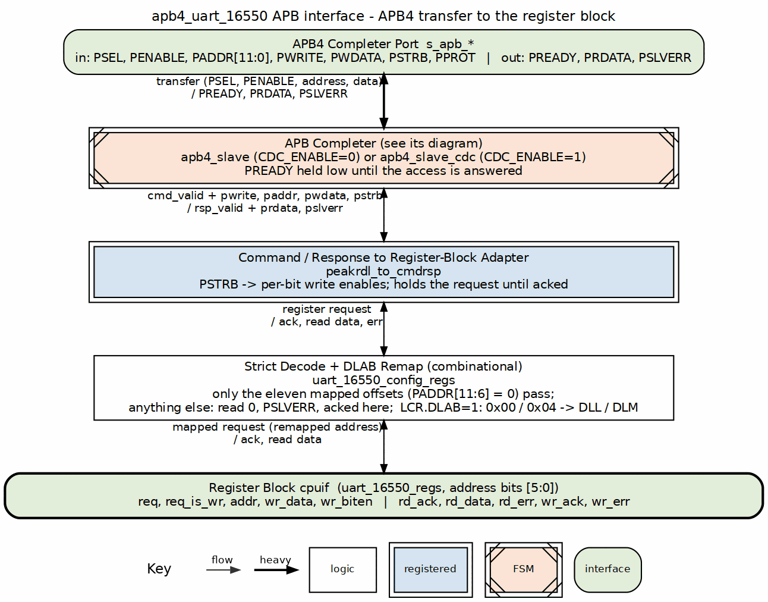
APB Interface Block

10.3.2 Address Decoding

10.3.2.1 UART Register Addresses
Each register has a unique offset, and LCR[7] (DLAB) additionally remaps 0x00 and 0x04 to DLL/DLM while it is set. The decode is strict: only these eleven offsets, with paddr[11:6] zero, reach the register block; any other address reads 0 and returns PSLVERR.
Offset | Read | Write
0x00 | RBR | THR
0x04 | IER | IER
0x08 | IIR | -
0x0C | FCR | FCR
0x10 | LCR | LCR
0x14 | MCR | MCR
0x18 | LSR | LSR (clear on read)
0x1C | MSR | MSR (clear on read)
0x20 | SCR | SCR
0x24 | DLL | DLL
0x28 | DLM | DLM

10.3.2.2 DLAB (Divisor Latch Access Bit)
LCR[7] remaps the address the register block sees: while it is set, 0x00 and 0x04 are DLL and DLM. The remap is additive - DLL and DLM remain accessible at their own offsets 0x24 and 0x28 either way - and every strobe decodes the same remapped address, so a divisor write cannot be mistaken for a THR push or an IER write (RLB TASK-012, was RLB-013).

10.3.3 Operation

10.3.3.1 Read Transaction
- Master asserts psel and paddr
- Master asserts penable on next cycle
- Slave returns prdata with pready
- Only RBR has a read side effect (the read pops the RX FIFO); IIR reads are side-effect-free

10.3.3.2 Write Transaction
- Master asserts psel, paddr, pwdata, pwrite
- Master asserts penable on next cycle
- Slave samples data with pready
- THR write pushes the TX FIFO; FCR writes take effect (FCR is also readable)

10.4 Design Notes

10.4.1 Implementation Notes
- PREADY-gated: the apb4_slave bridge FSM adds a few wait states per access (no stalls originate in the register block itself)
- 32-bit data width with 8-bit register access
- Byte strobes select which byte to access
- LSR/MSR are read-mostly: writes perform write-1-to-clear on the error/delta bits (not ignored)

10.5 Navigation
Next: 02_register_file.md - Register File

RTL Design Sherpa · Learning Hardware Design Through Practice GitHub · Documentation Index · MIT License

11 APB UART 16550 — Register File Block

11.1 Overview
The register file implements the standard 16550 register set, generated with PeakRDL for APB compatibility. All registers occupy unique offsets, and LCR[7] (DLAB) additionally remaps 0x00/0x04 to DLL/DLM while it is set — the DLAB dance works as a 16550 driver expects, and the dedicated offsets 0x24/0x28 keep working either way (RLB TASK-012, was RLB-013).

11.2 Ports
The register block’s connection to the rest of the UART core is the PeakRDL hardware interface (HWIF). These are internal signals, not module pins, but they define what the register file exposes to the TX/RX engines and what it consumes.

11.2.1 Software-to-Hardware (reg2hw)
Signal | Description
thr_data | Data to transmit
thr_we | THR write enable
ier | Interrupt enables; each of the four sources is gated by its own bit
fcr | FIFO control
lcr | Line control
mcr | Modem control
dll | Divisor LSB
dlm | Divisor MSB

11.2.2 Hardware-to-Software (hw2reg)
Signal | Description
rbr_data | Received data
iir | Interrupt status
lsr | Line status
msr | Modem status

11.3 Functional Description

11.3.1 Figure 2.2: Register File Block
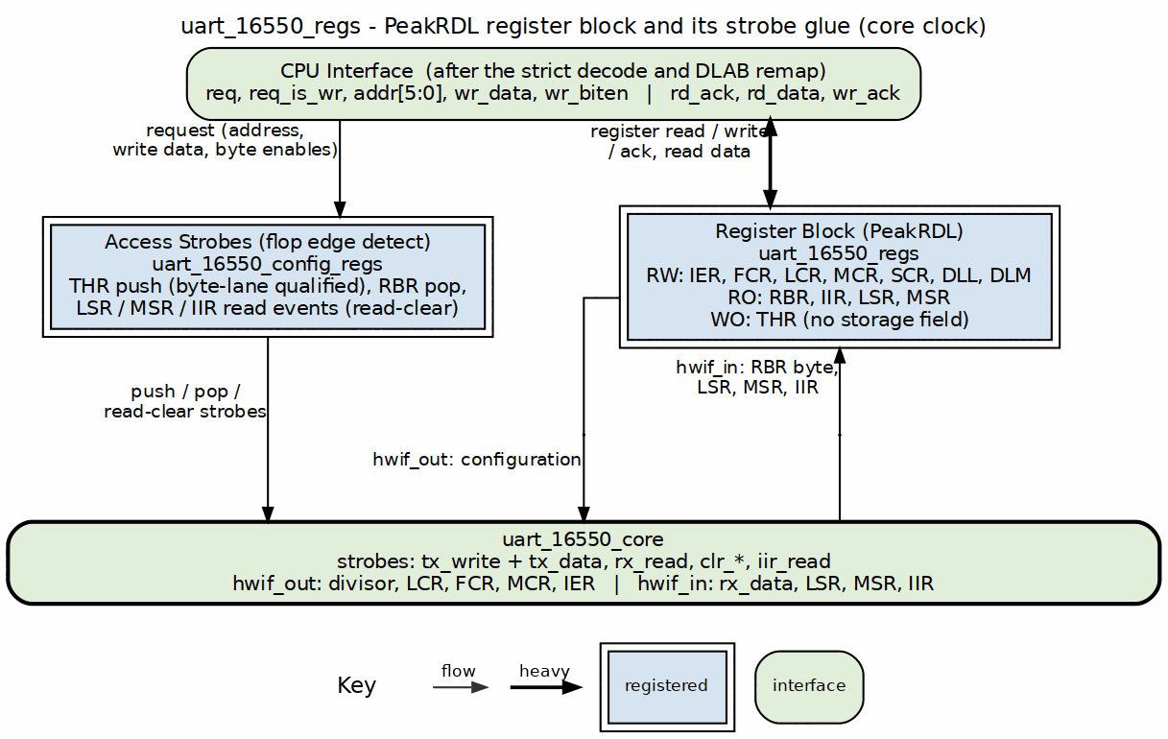
Register File Block

11.3.2 Register Organization

11.3.2.1 Address 0x00 (RBR/THR)
Access | Register
Read | RBR - Receiver Buffer (received byte in bits [7:0])
Write | THR - Transmitter Holding

11.3.2.2 Address 0x04 (IER)
Read/Write - Interrupt Enable. Each bit gates its own interrupt source.

11.3.2.3 Address 0x08 (IIR)
Read-only - Interrupt Identification. Reading it clears the THR-empty interrupt when THR empty is the source it reported.

11.3.2.4 Addresses 0x0C-0x28
Fixed registers, not affected by DLAB: - 0x0C: FCR - FIFO Control (R/W, readable) - 0x10: LCR - Line Control - 0x14: MCR - Modem Control - 0x18: LSR - Line Status (RO, clear on read error bits) - 0x1C: MSR - Modem Status (RO, clear on read delta bits) - 0x20: SCR - Scratch - 0x24: DLL - Divisor Latch LSB - 0x28: DLM - Divisor Latch MSB

11.3.3 Register Access Types
Type | Description
RO | Read-only, hardware updates
WO | Write-only
RW | Read-write
Read-clear | Cleared by reading the register (LSR error bits, MSR delta bits)

11.4 Design Notes

11.4.1 Implementation Notes
- DLAB remaps 0x00/0x04 to the divisor latches; the dedicated offsets always work
- THR write pushes to TX FIFO
- RBR read pops from RX FIFO (received byte returned in bits [7:0])
- Reading IIR clears the THR-empty interrupt when that is the source it reported

11.5 Navigation
Next: 03_tx_engine.md - TX Engine

RTL Design Sherpa · Learning Hardware Design Through Practice GitHub · Documentation Index · MIT License

12 APB UART 16550 — TX Engine Block

12.1 Overview
The TX engine is the straightforward half of the UART: it buffers transmit data, serializes it with start/stop/parity framing, and drives TXD one baud tick at a time. The honest wrinkle — flow control — is covered at the bottom of this page, because there is less of it than you’d expect.

12.2 Functional Description

12.2.1 Figure 2.3: TX Engine Block
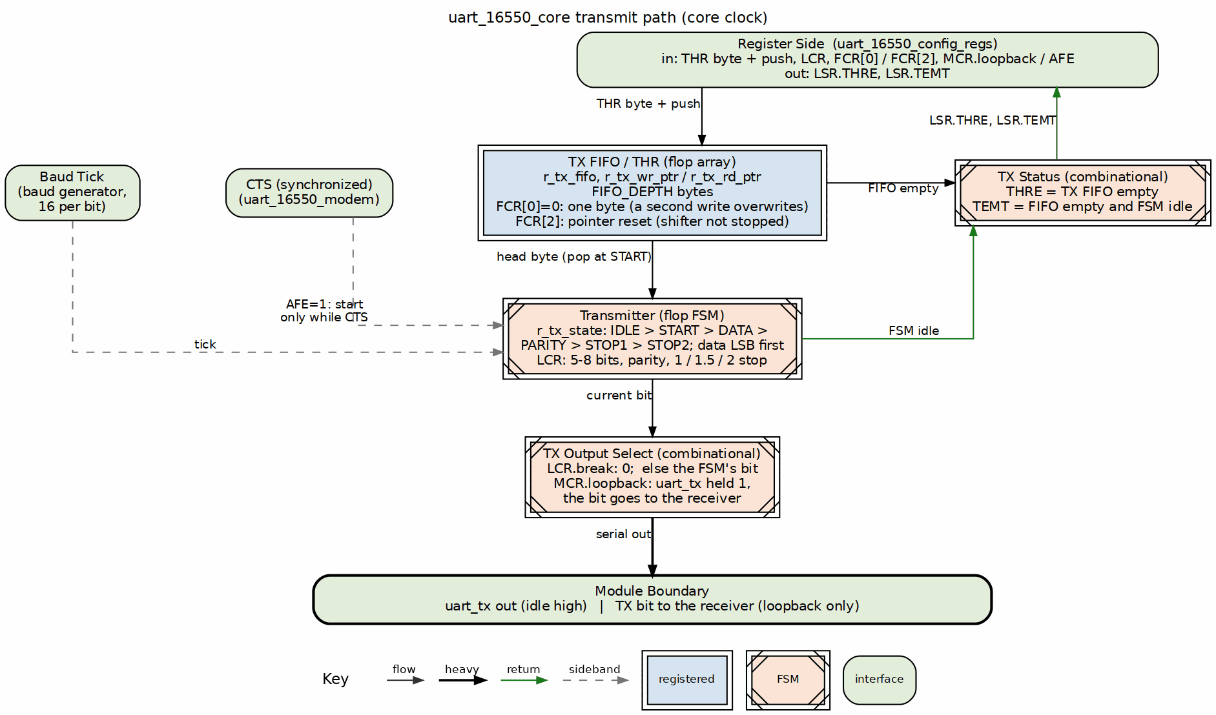
TX Engine Block

12.2.2 Data Path
Figure 2.3 is the data path: a THR write pushes the TX FIFO, the transmitter pops it, and the output select drives TXD. THRE and TEMT go back to LSR from the FIFO and transmitter state.

12.2.3 TX FIFO

12.2.3.1 Characteristics
Parameter | Value
Depth | 16 bytes
Width | 8 bits
Write | THR register write
Read | TX shift register ready

12.2.3.2 Status Signals
- THRE (THR Empty): TX FIFO empty (sts_tx_holding_empty = tx_fifo_empty), not merely “has space”
- TEMT (Transmitter Empty): TX FIFO and shift register both empty

12.2.4 TX Serializer

12.2.4.1 Frame Format
Start Data Bits Parity Stop
| (5-8 bits) (opt) (1-2)
v v v v
_______________________________
TXD |0| D0 D1 D2 D3 D4 [D5 D6 D7] [P] |1|1|
|<-------- Bit Time --------->|

12.2.4.2 Configuration (from LCR)
LCR Bits | Setting
[1:0] | Data bits: 00=5, 01=6, 10=7, 11=8
[2] | Stop bits: 0=1, 1=2 (6/7/8-bit words) or 1.5 (5-bit words)
[3] | Parity enable
[4] | Parity type: 0=odd, 1=even
[5] | Stick parity
[6] | Break control
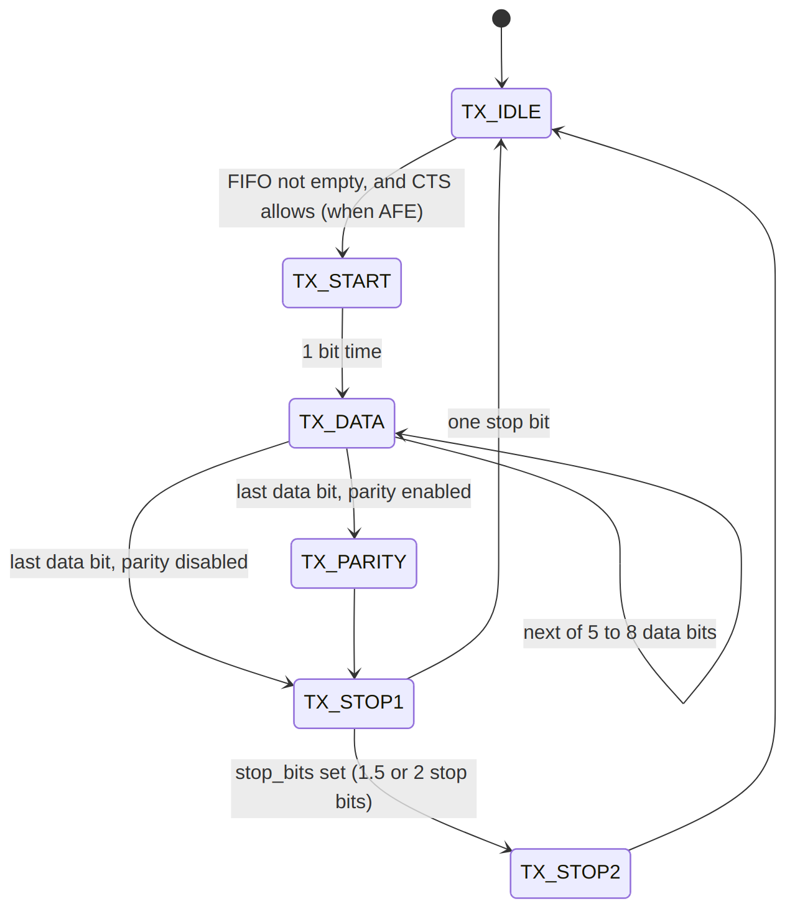
State Machine

12.2.5 Flow Control

12.2.5.1 Hardware (CTS)
Auto flow control (AFE, MCR[5]) gates the transmitter with CTS and drives RTS from the RX FIFO level. With AFE clear, CTS does not gate the transmitter. Monitor MSR.CTS in software and withhold THR writes to pause TX.

12.2.5.2 Software (THRE interrupt)
- THRE = TX FIFO empty (not merely “not full”)
- Software writes more data when THRE is set

12.2.6 Break Generation
When LCR.BC=1: - TXD forced low - Maintained until BC cleared - Used for attention/reset signaling

12.3 Timing

12.3.1 Bit Timing
Each bit takes 16 clocks of 16x baud clock: - Sample point at clock 8 (mid-bit) - Transition at clock 0

12.3.2 Frame Timing Example (8N1 at 115200)
Component | Bits | Time
Start | 1 | 8.68 us
Data | 8 | 69.44 us
Stop | 1 | 8.68 us
Total | 10 | 86.8 us

12.4 Waveforms

12.4.1 Waveform 2.1: TX Byte Transmission
The following diagram shows the complete TX path from APB write to serial output.
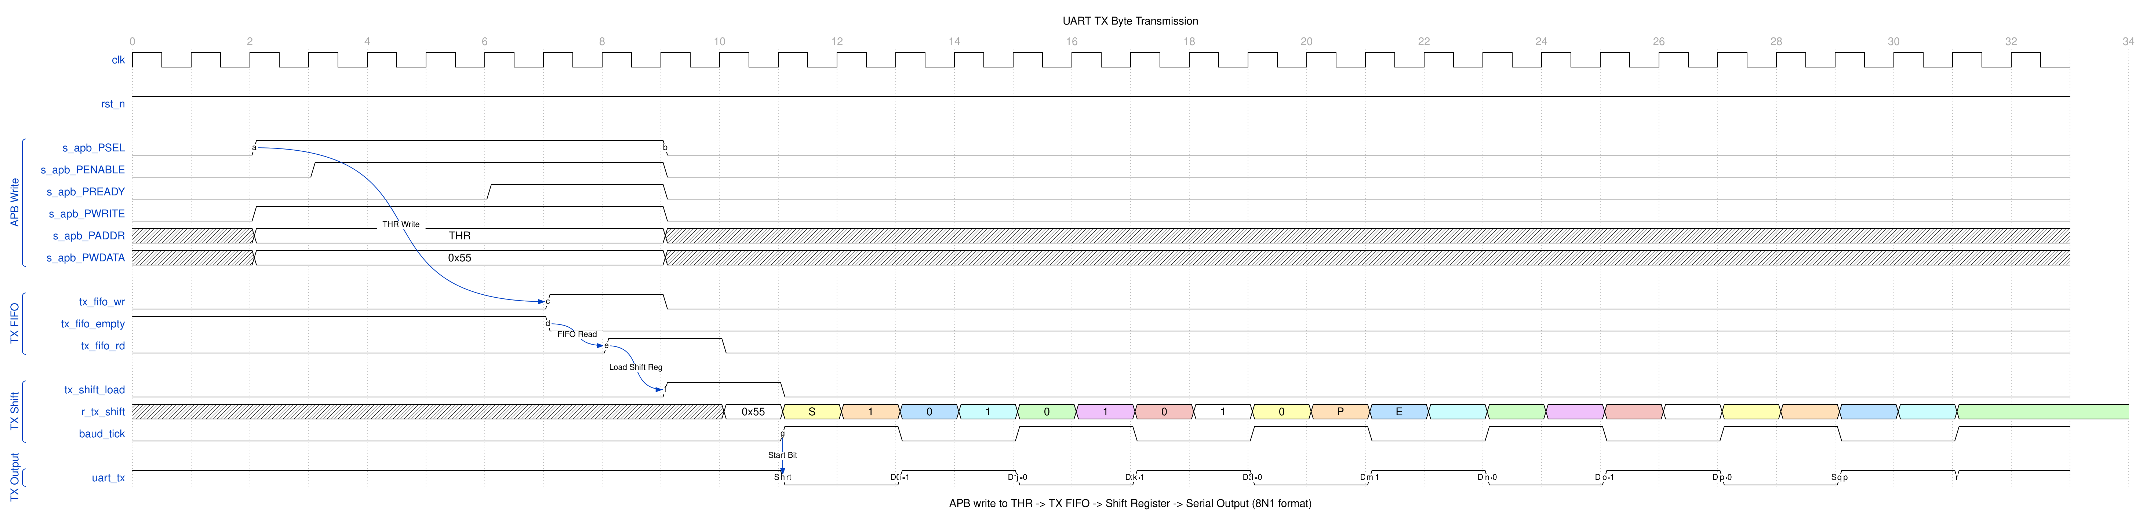
UART TX Byte
The transmission sequence: 1. APB write to THR (Transmit Holding Register) 2. Data pushed to TX FIFO (tx_fifo_wr) 3. When shift register ready, data loaded from FIFO (tx_fifo_rd, tx_shift_load) 4. Baud tick shifts out bits: Start (0), Data (LSB first), Stop (1) 5. TXD changes at each baud tick

12.4.2 Waveform 2.2: Baud Rate Generation
The baud generator divides the system clock to produce bit timing.
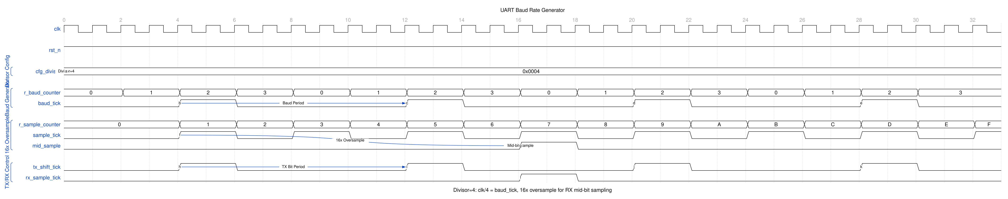
UART Baud Generator
Key timing relationships: - cfg_divisor sets the baud rate (clock_freq / (16 * baud_rate)) - baud_tick pulses once per bit period for TX - 16x oversampling counter provides mid-bit sampling for RX

12.4.3 Waveform 2.3: Loopback Mode
MCR[4] enables internal loopback for diagnostics.
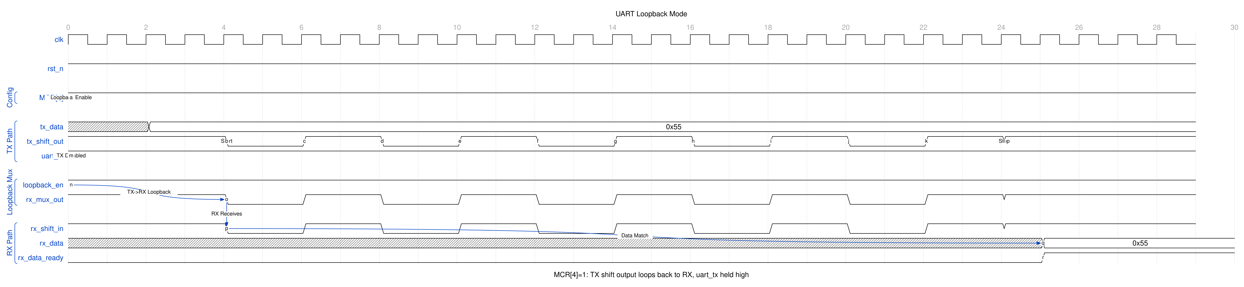
UART Loopback
In loopback mode: - TX shift register output routes to RX input - External TXD held high (idle) - Allows self-test without external connection

12.5 Navigation
Next: 04_rx_engine.md - RX Engine

RTL Design Sherpa · Learning Hardware Design Through Practice GitHub · Documentation Index · MIT License

13 APB UART 16550 — RX Engine Block

13.1 Overview
The RX engine is where the asynchronous outside world meets your clean synchronous design: input synchronization, start bit detection, deserialization, error detection, and receive FIFO buffering all live here. It’s also where the ugliest known RTL deviation lives (issue #60), so read the error-detection section before you trust LSR.

13.2 Functional Description

13.2.1 Figure 2.4: RX Engine Block
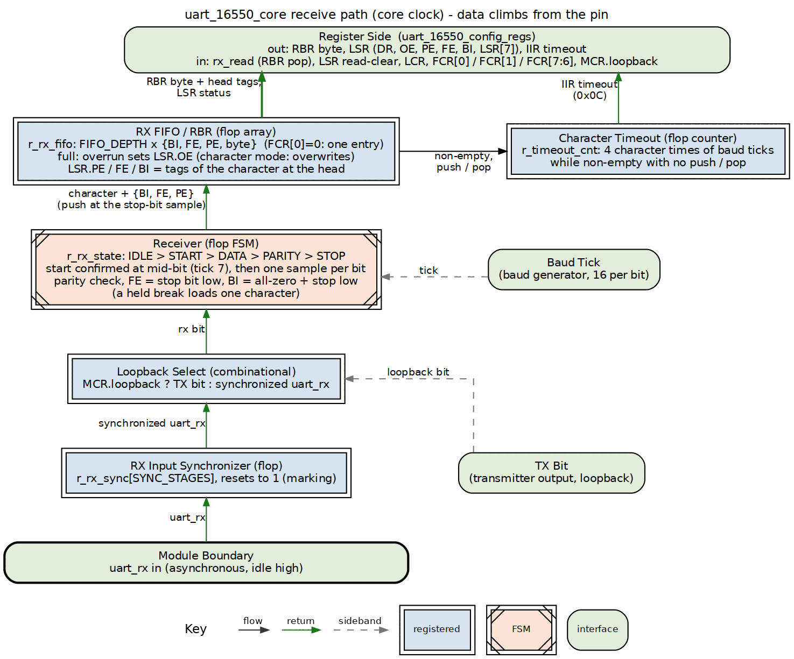
RX Engine Block

13.2.2 Data Path
Figure 2.4 is the data path: RXD passes the synchronizer and the loopback select, the receiver deserializes and tags each character, and the character enters the RX FIFO, where RBR reads it.

13.2.3 Input Synchronizer

13.2.3.1 Metastability Prevention
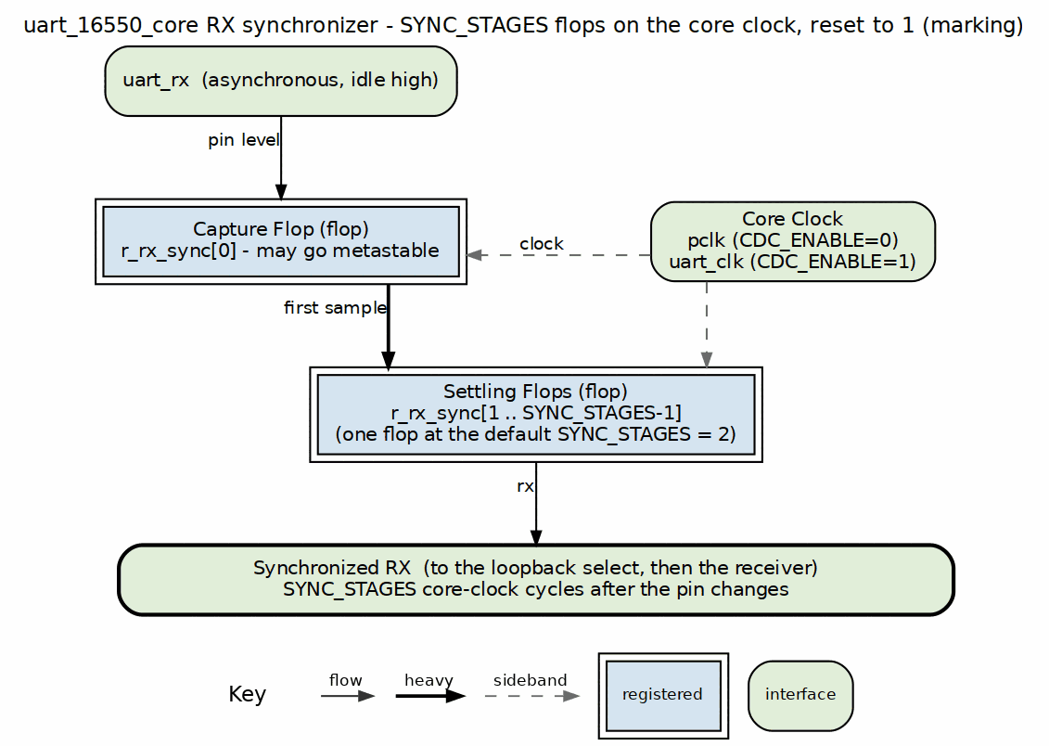
RX Input Synchronizer
- Two-stage synchronizer
- Prevents metastability from asynchronous input
- Adds 2 clock cycles latency

13.2.4 Start Bit Detection

13.2.4.1 Detection Algorithm
- Monitor for falling edge (1 -> 0)
- Wait 8 clocks (half bit time)
- Sample mid-bit
- If still 0, valid start bit
- If 1, false start, return to idle

13.2.4.2 Start-Bit Validation
The start bit is revalidated at the mid-bit sample (clock 8 of 16); if it is no longer 0, the start is treated as false and the receiver returns to idle. There is no dedicated “reject pulses < 4 clocks” glitch filter.

13.2.5 RX Deserializer

13.2.5.1 Sampling
- Sample each bit at mid-point (clock 8 of 16)
- Single mid-bit sample per bit (no majority voting is implemented)
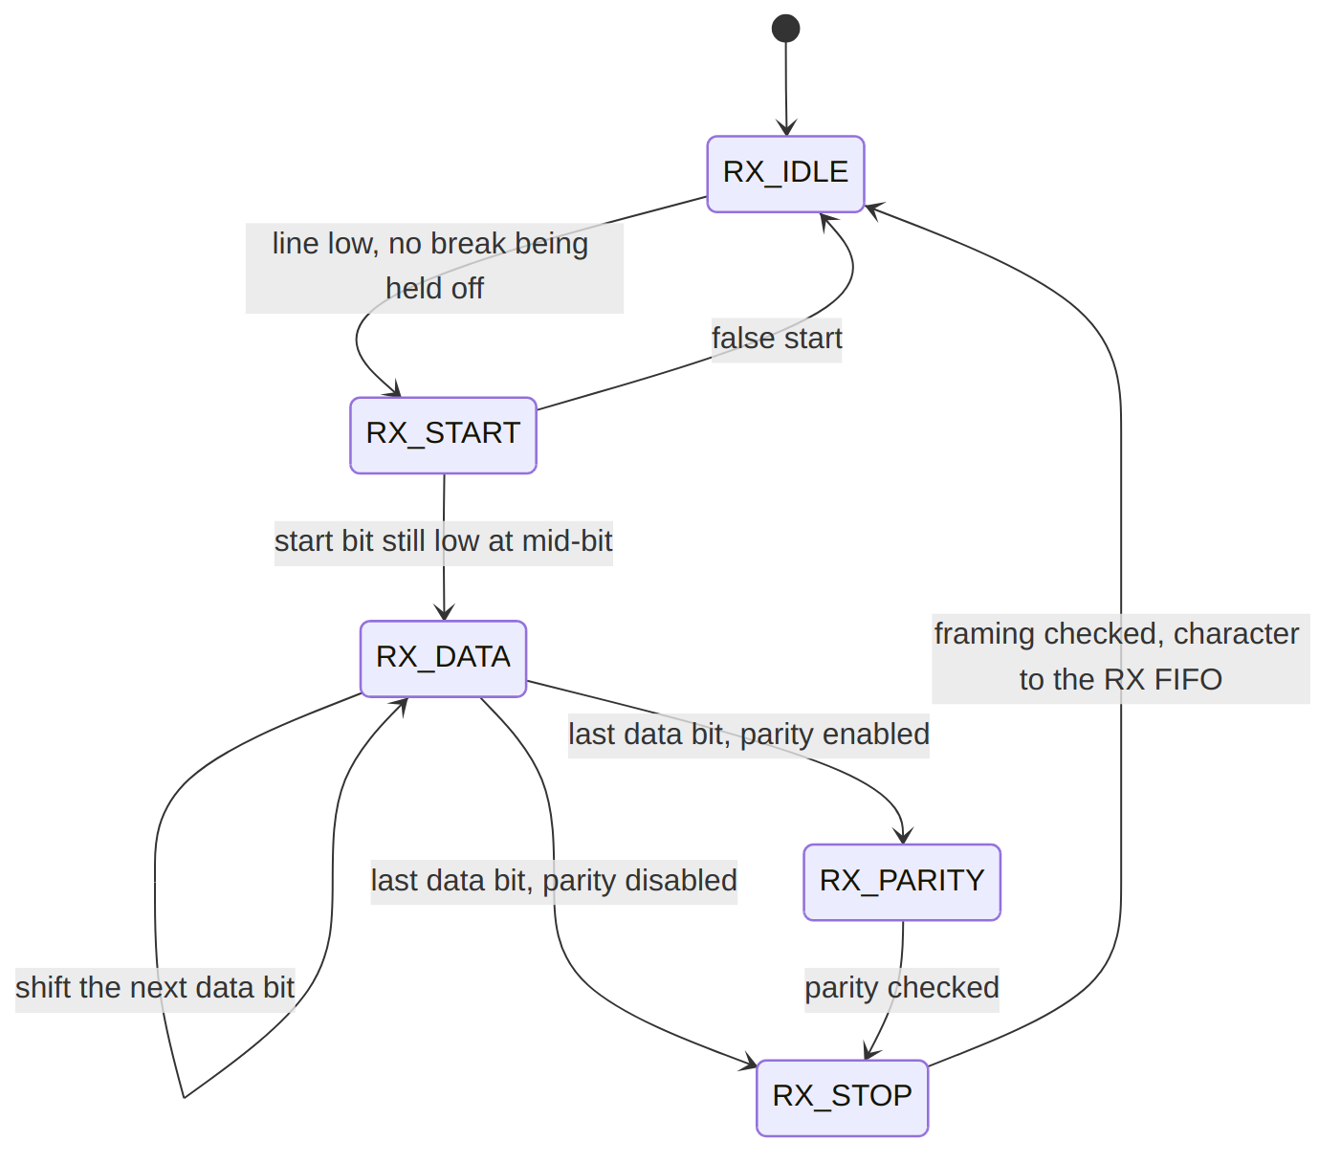
Frame Reception

13.2.6 RX FIFO

13.2.6.1 Characteristics
Parameter | Value
Depth | 16 entries
Width | 11 bits (8 data + 3 error)
Write | Deserializer complete
Read | RBR register read

13.2.6.2 FIFO Entry Format
Bits | Content
[7:0] | Received data
[8] | Parity Error (PE)
[9] | Framing Error (FE)
[10] | Break Indicator (BI)

13.2.6.3 Trigger Levels (FCR)
FCR[7:6] | Trigger Level
00 | 1 byte
01 | 4 bytes
10 | 8 bytes
11 | 14 bytes

13.2.7 Error Detection

13.2.7.1 Parity Error (PE)
- Calculated parity vs received parity
- Set in LSR when the errored character is received (written into the RX FIFO), not when it is later read out

13.2.7.2 Framing Error (FE)
- Stop bit not at expected logic 1
- Indicates baud rate mismatch or noise

13.2.7.3 Break Indicator (BI)
- RXD low for entire character time
- Start + data + parity + stop all zero
- Used for attention signaling
FE and BI are computed as combinational nets sampled at the stop bit, so they are stable when the FIFO entry is written and when the sticky flags are set. Both reach LSR and both tag the FIFO entry in bits [10:9], and the line-status interrupt fires from any of overrun, parity, framing or break. (Until the #60 fix they could never assert: the computed values were overwritten by same-cycle cleanup assignments and the FIFO write sampled the pre-edge, already-cleared flags.)
Received data is right-justified and zero-filled at every word length, so a 5-bit character reads in bits [4:0] with [7:5] clear, matching what the transmitter sends.

13.2.7.4 Overrun Error (OE)
- RX FIFO full when new character arrives
- Previous data preserved, new data lost
- Set immediately in LSR (not FIFO-based)

13.2.8 Timeout Detection

13.2.8.1 Character Timeout
A counter in the baud-tick domain runs whenever the RX FIFO is non-empty and restarts on any activity: a character arriving, a character read out, or a FIFO reset. Four character times without any of those sets the timeout, IIR reads 0x0C, and the flag clears on the next activity. FIFO mode only.

13.3 Waveforms

13.3.1 Waveform 2.4: RX Byte Reception
The following diagram shows the complete RX path from serial input to FIFO.
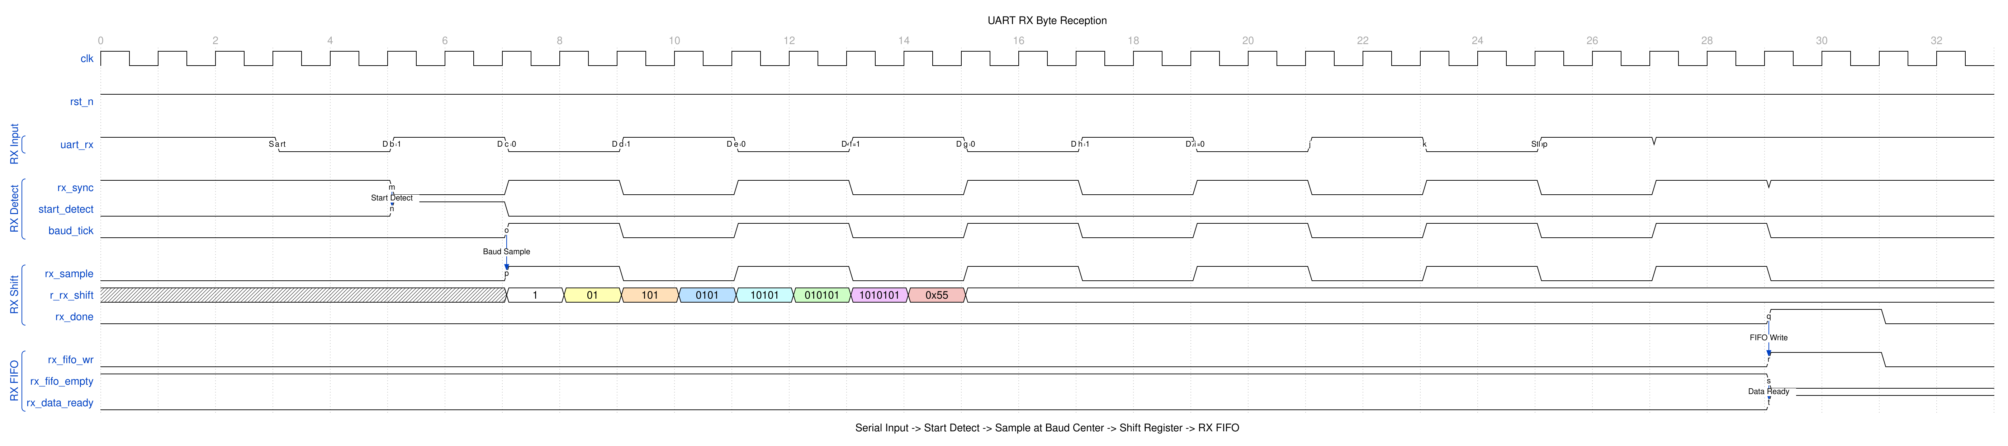
UART RX Byte
The reception sequence: 1. Start bit detected (falling edge on rx_sync) 2. 16x oversampling locates bit center 3. Data sampled at mid-bit on each baud tick 4. After stop bit, byte written to RX FIFO 5. rx_data_ready signals data available

13.4 Navigation
Next: 05_baud_generator.md - Baud Generator

RTL Design Sherpa · Learning Hardware Design Through Practice GitHub · Documentation Index · MIT License

14 APB UART 16550 — Baud Generator Block

14.1 Overview
The baud generator turns your input clock into the 16x oversampled clock the TX and RX engines run on, divided down by the programmable {DLM, DLL} divisor. Get the divisor wrong and everything downstream is garbage — this is the one register pair you should double-check first.

14.2 Functional Description

14.2.1 Figure 2.5: Baud Generator Block
Baud Generator Block

14.2.2 Operation

14.2.2.1 Clock Division
Figure 2.5 shows the division: a 16-bit counter wraps at the {DLM, DLL} divisor and emits one baud tick per wrap, and each engine counts 16 ticks per bit.

14.2.2.2 Formula
16x_baud_clk = input_clk / divisor
where divisor = (DLM << 8) | DLL
Actual baud rate = 16x_baud_clk / 16 = input_clk / (16 * divisor)

14.2.3 Divisor Calculation

14.2.3.1 Standard Formula
Divisor = Input_Clock / (16 * Desired_Baud_Rate)

14.2.3.2 Rounding
For best accuracy, round to nearest integer:
Divisor = (Input_Clock + 8 * Baud_Rate) / (16 * Baud_Rate)

14.2.3.3 Example Tables
48 MHz Input Clock:
Baud Rate | Divisor | DLM | DLL | Actual Rate | Error
9600 | 312 | 0x01 | 0x38 | 9615.4 | +0.16%
19200 | 156 | 0x00 | 0x9C | 19230.8 | +0.16%
38400 | 78 | 0x00 | 0x4E | 38461.5 | +0.16%
57600 | 52 | 0x00 | 0x34 | 57692.3 | +0.16%
115200 | 26 | 0x00 | 0x1A | 115384.6 | +0.16%
50 MHz Input Clock:
Baud Rate | Divisor | DLM | DLL | Actual Rate | Error
9600 | 326 | 0x01 | 0x46 | 9585.9 | -0.15%
19200 | 163 | 0x00 | 0xA3 | 19171.8 | -0.15%
38400 | 81 | 0x00 | 0x51 | 38580.2 | +0.47%
57600 | 54 | 0x00 | 0x36 | 57870.4 | +0.47%
115200 | 27 | 0x00 | 0x1B | 115740.7 | +0.47%

14.2.4 Divisor Latch Registers

14.2.4.1 DLL (Divisor Latch LSB)
Address | 0x24
Bits | [7:0]
Access | RW
Reset | 0x01

14.2.4.2 DLM (Divisor Latch MSB)
Address | 0x28
Bits | [7:0]
Access | RW
Reset | 0x00

14.3 Usage Example

14.3.1 Programming Sequence
DLL/DLM have dedicated offsets (0x24/0x28) AND are reached at 0x00/0x04 while DLAB is set; the dedicated offsets remap no address, so no DLAB toggle is required.
- Write DLL at 0x24 (divisor low byte)
- Write DLM at 0x28 (divisor high byte)
void set_baud_rate(uint16_t divisor) {
DLL = divisor & 0xFF; // Low byte (0x24)
DLM = divisor >> 8; // High byte (0x28)
}

14.4 Design Notes

14.4.1 Special Cases

14.4.1.1 Divisor = 0
- Invalid configuration; should be avoided
- In this RTL there is no divisor=0 guard: the baud tick asserts every clock (as if dividing by 1), so bit timing runs at the input clock rate
Note: DLL resets to 0x01, so the power-on divisor is 1 (not 0).

14.4.1.2 Divisor = 1
- Maximum baud rate
- Rate = input_clk / 16
- 48 MHz -> 3 Mbps

14.4.1.3 Clock Enable
The baud counter free-runs; there is no divisor!=0 or TX/RX-active gating in this RTL. The generated baud tick is used by the TX/RX engines when they are active.

14.5 Navigation
Next: 06_fifo.md - FIFO Subsystem

RTL Design Sherpa · Learning Hardware Design Through Practice GitHub · Documentation Index · MIT License

15 APB UART 16550 — FIFO Subsystem

15.1 Overview
Both directions get a 16-byte FIFO between software and the serial line, and the FCR register is how you manage them. One thing to internalize early: FCR[0] changes the buffering. With FCR[0]=1 each FIFO holds FIFO_DEPTH entries; with FCR[0]=0 each side is a single holding register (16450 character mode), a second THR write overwrites the waiting byte, and a second received character is an overrun.

15.2 Functional Description

15.2.1 Figure 2.6: FIFO Block
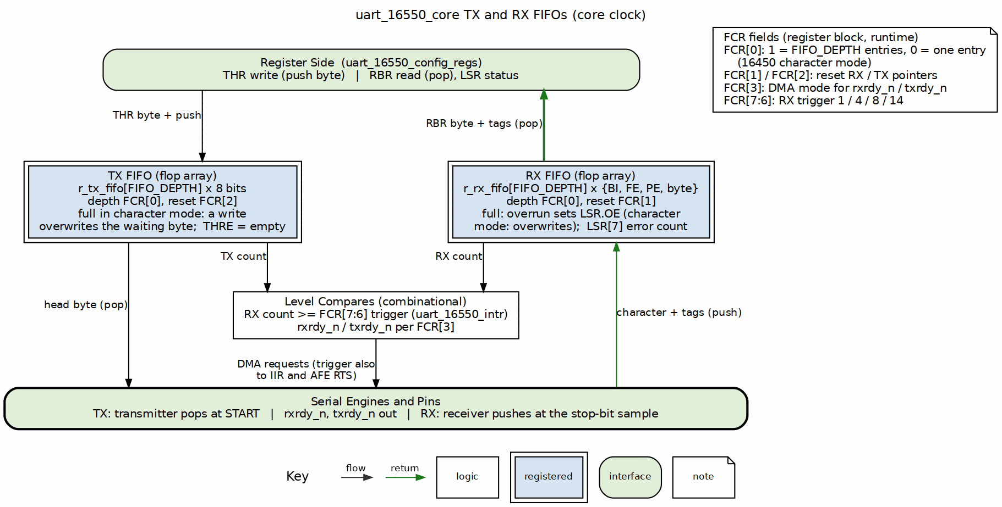
FIFO Block

15.2.2 FIFO Configuration

15.2.2.1 FCR (FIFO Control Register)
Bit | Name | Description
0 | FE | FIFO Enable
1 | RFR | RX FIFO Reset
2 | TFR | TX FIFO Reset
3 | DMS | DMA Mode Select: 0 = per character, 1 = per block, on rxrdy_n/txrdy_n
5:4 | Reserved
7:6 | RTL | RX Trigger Level

15.2.2.2 Trigger Levels
RTL[1:0] | RX FIFO Trigger
00 | 1 byte
01 | 4 bytes
10 | 8 bytes
11 | 14 bytes

15.2.3 TX FIFO

15.2.3.1 Characteristics
Parameter | Value
Depth | 16 bytes
Width | 8 bits

15.2.3.2 Operations
Operation | Trigger
Write | THR register write
Read | TX serializer ready
Reset | FCR.TFR write

15.2.3.3 Status
Signal | LSR Bit | Condition
THRE | 5 | TX FIFO empty (sts_tx_holding_empty = tx_fifo_empty)
TEMT | 6 | FIFO empty AND shift register empty

15.2.4 RX FIFO

15.2.4.1 Characteristics
Parameter | Value
Depth | 16 entries
Width | 11 bits

15.2.4.2 Entry Format
[10] [9] [8] [7:0]
BI FE PE DATA

15.2.4.3 Operations
Operation | Trigger
Write | RX deserializer complete
Read | RBR register read
Reset | FCR.RFR write

15.2.4.4 Status
Signal | LSR Bit | Condition
DR | 0 | Data Ready (FIFO not empty)
OE | 1 | Overrun Error
PE | 2 | Parity Error (per character)
FE | 3 | Framing Error (per character)
BI | 4 | Break Indicator (per character)
FIFOERR | 7 | Error in the RX FIFO head entry (PE, FE, or BI) - not “any entry”

15.2.5 FIFO vs Non-FIFO Mode

15.2.5.1 FCR.FE = 0
- Both FIFOs remain physically 16 deep in this RTL (there is no true single-byte 8250 mode); THR writes still queue up to 16 bytes
- FCR.FE=0 only changes IIR[7:6] to 00 and makes the RX-data interrupt condition DR-based rather than trigger-level based

15.2.5.2 FCR.FE = 1 (16550 Mode)
- 16-byte FIFOs, trigger-level RX interrupt
- IIR[7:6] = 11
- (Character-timeout interrupt: four character times of inactivity, IIR 0x0C)

15.2.6 Error Handling

15.2.6.1 Per-Character Errors
Each RX FIFO entry carries its own PE, FE and BI tags in bits [10:8]. LSR[4:2] are loaded from the tags of the character the CPU is being handed, so an error is reported on the read that returns the character it belongs to, and LSR[7] aggregates the tags over the whole FIFO. Entry format: - Sticky LSR error flags are set at RECEIVE time (when the character enters the FIFO), not when it is later read out - LSR[7] reflects an error on the FIFO HEAD entry only, not ‘any entry’

15.2.6.2 Overrun Error
OE set immediately when: - RX FIFO full - New character received - New character discarded

15.2.7 FIFO Reset

15.2.7.1 TX FIFO Reset (FCR.TFR)
- Write FCR with TFR=1
- TX FIFO cleared immediately
- The TX state machine is forced to IDLE - the character in progress is aborted
- THRE and TEMT updated

15.2.7.2 RX FIFO Reset (FCR.RFR)
- Write FCR with RFR=1
- RX FIFO cleared immediately
- The RX state machine is forced to IDLE - the character in progress is aborted
- DR cleared

15.2.7.3 Full Reset
// Reset both FIFOs, enable with trigger=14
FCR = 0xC7; // 11000111b

15.3 Waveforms

15.3.1 Waveform 2.5: FIFO Trigger Timing
The following diagram shows RX FIFO filling to the trigger threshold and generating an interrupt.
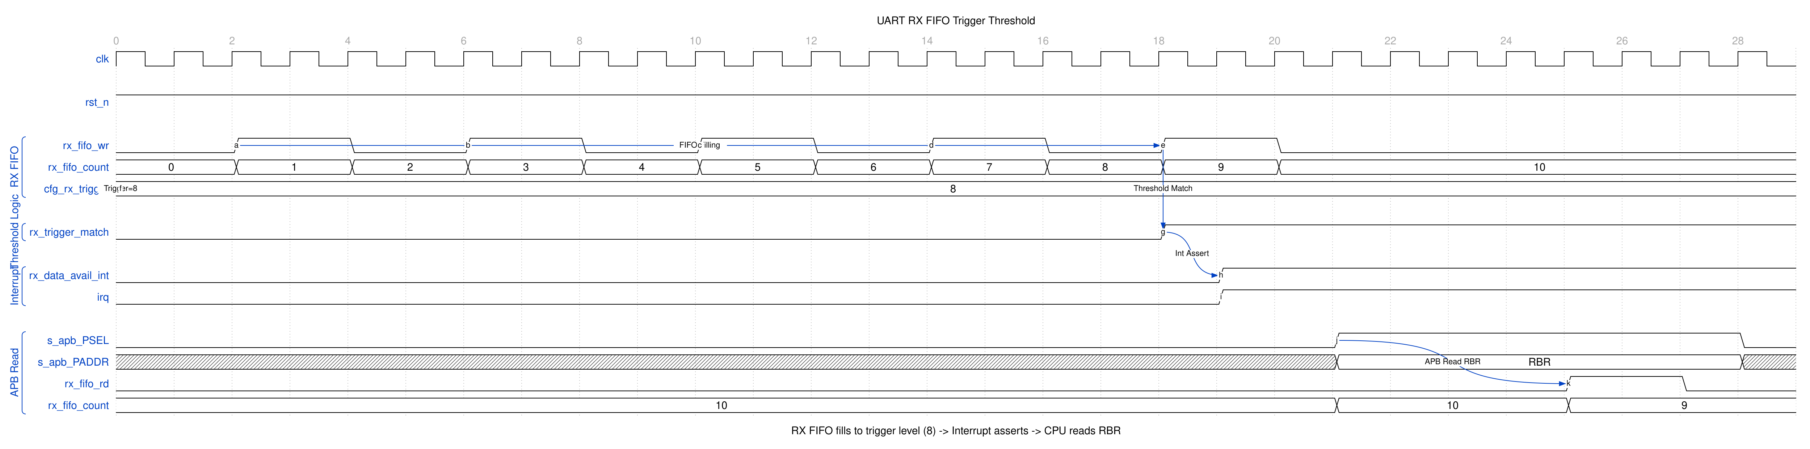
UART FIFO Threshold
The interrupt sequence: 1. RX data arrives, rx_fifo_wr pulses 2. FIFO count increments with each byte 3. When count reaches trigger level (8 in example), rx_trigger_match asserts 4. RX Data Available interrupt (rx_data_avail_int) triggers 5. CPU reads RBR to retrieve data, decrementing FIFO count

15.4 Navigation
Back to: 00_overview.md - Block Descriptions Overview
Next Chapter: Chapter 3: Interfaces

RTL Design Sherpa · Learning Hardware Design Through Practice GitHub · Documentation Index · MIT License

16 APB UART 16550 — Interfaces

16.1 Overview
Five external interfaces define how this block talks to the rest of your system: the APB slave port, the serial pins, the modem pins, the interrupt output, and the clock/reset inputs. This chapter specifies each one.

16.2 Ports

16.2.1 External Interfaces
Interface | Type | Description
APB Slave | Bus | Configuration and data access
Serial | I/O | TXD/RXD serial data
Modem | I/O | CTS, RTS, DTR, DSR, DCD, RI
Interrupt | Signal | IRQ output
Clocks/Reset | System | Clock and reset inputs

16.3 Functional Description

16.3.1 Figure 3.1: UART Interface Summary
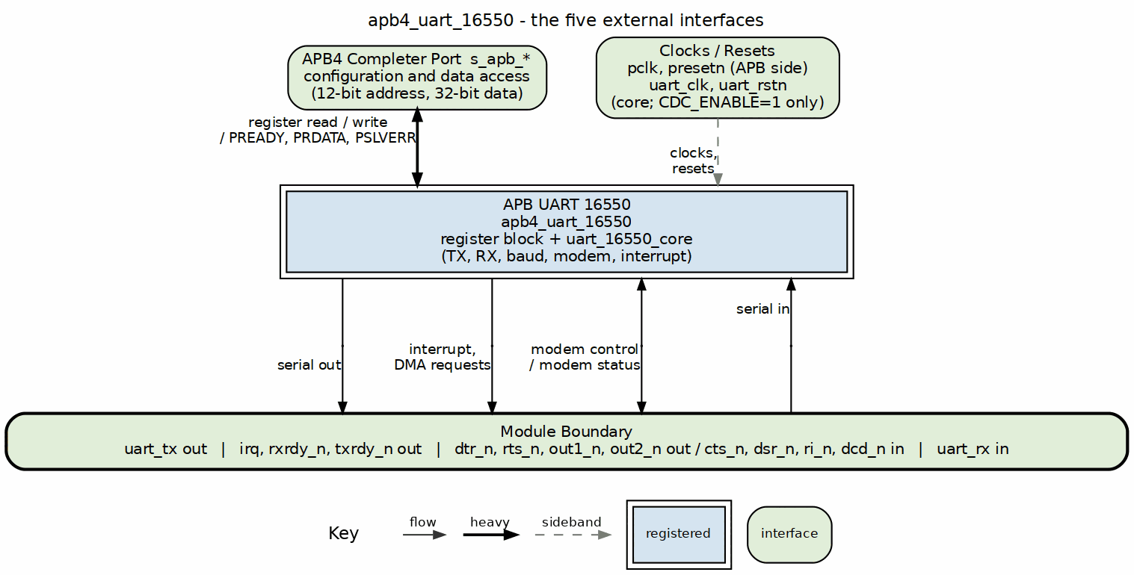
UART Interfaces

16.4 Navigation

16.4.1 Chapter Contents

16.4.1.1 APB Slave Interface
Complete APB protocol interface for register access.
See: 01_apb4_slave.md

16.4.1.2 Serial Interface
TXD and RXD serial data connections.
See: 02_serial.md

16.4.1.3 Modem Interface
Hardware flow control and modem signals.
See: 03_modem.md

16.4.1.4 Interrupt Interface
Interrupt request output signal.
See: 04_interrupt.md

16.4.1.5 System Interface
Clock and reset signal requirements.
See: 05_system.md

Next: 01_apb4_slave.md - APB Slave Interface

RTL Design Sherpa · Learning Hardware Design Through Practice GitHub · Documentation Index · MIT License

17 APB UART 16550 — APB Slave Interface

17.1 Overview
This is the bus-level view of the block: the APB signals, the address map they reach, and the side effects each register access triggers. The side-effect table is the part worth memorizing — reads and writes here are not always free of consequences.

17.2 Ports

17.2.1 APB Slave Signals
Signal | Width | Dir | Description
pclk | 1 | I | APB clock
presetn | 1 | I | APB reset (active low)
s_apb_psel | 1 | I | Peripheral select
s_apb_penable | 1 | I | Enable phase
s_apb_pwrite | 1 | I | Write transaction
s_apb_paddr | 12 | I | Address bus
s_apb_pwdata | 32 | I | Write data
s_apb_pstrb | 4 | I | Byte strobes
s_apb_prdata | 32 | O | Read data
s_apb_pready | 1 | O | Ready response
s_apb_pslverr | 1 | O | Slave error

17.3 Functional Description

17.3.1 Address Map
Each register has a unique offset, and LCR[7] (DLAB) additionally remaps 0x00/0x04 to DLL/DLM while it is set; DLL/DLM keep their dedicated offsets either way. The decode is strict: only the mapped offsets, with paddr[11:6] zero, reach the register block, and any other address in the window reads 0 with PSLVERR; nothing aliases.
Offset | Read | Write
0x00 | RBR | THR
0x04 | IER | IER
0x08 | IIR | -
0x0C | FCR | FCR
0x10 | LCR | LCR
0x14 | MCR | MCR
0x18 | LSR | LSR (error bits clear on read)
0x1C | MSR | MSR (delta bits clear on read)
0x20 | SCR | SCR
0x24 | DLL | DLL
0x28 | DLM | DLM

17.3.2 Protocol Compliance

17.3.2.1 APB3/APB4 Features
Feature | Support
PSEL | Yes
PENABLE | Yes
PWRITE | Yes
PADDR | 12-bit
PWDATA | 32-bit
PRDATA | 32-bit
PREADY | Yes (inserts wait states – see Access Timing above)
PSLVERR | Yes - asserted on any unmapped offset in the window
PSTRB | Yes
PPROT | Present (s_apb_PPROT[2:0], accepted and unused)

17.3.3 Register Access

17.3.3.1 Byte Access
32-bit APB with 8-bit registers: - pstrb[0]: Access register at paddr - Other strobes: No effect (registers are 8-bit)

17.3.3.2 Side Effects
Some registers have read/write side effects:
Register | Read Side Effect | Write Side Effect
RBR | Pops RX FIFO | N/A
THR | N/A | Pushes TX FIFO
IIR | None (reading IIR does not clear any interrupt) | N/A
FCR | None (FCR is readable) | Can reset FIFOs
LSR | Clears error bits [4:1] | –
MSR | Clears delta bits [3:0] | –
Note: LSR error bits [4:1] and MSR delta bits [3:0] clear when their own register is read, as a standard 16550 does, and the line-status and modem-status interrupts deassert with them. Any read clears them, including one that was only checking data-ready, so software must work from the value the read returned.

17.4 Timing

17.4.1 Access Timing
PREADY inserts wait states: the apb4_slave bridge is a small FSM that issues the command and returns the response over a registered cmd/rsp handshake, so an access takes several pclk beyond the 2-cycle APB minimum (more when CDC_ENABLE=1). The register block itself never stalls.

17.5 Navigation
Next: 02_serial.md - Serial Interface

RTL Design Sherpa · Learning Hardware Design Through Practice GitHub · Documentation Index · MIT License

18 APB UART 16550 — Serial Interface

18.1 Overview
Two pins, uart_tx and uart_rx, carry everything. This page defines what those pins do electrically and logically — frame formats, sampling behavior, break handling — including the places where this RTL falls short of what the waveform diagrams were drawn to show.

18.2 Ports

18.2.1 Signal Description
Signal | Width | Dir | Description
uart_tx | 1 | O | Serial transmit data
uart_rx | 1 | I | Serial receive data

18.2.2 Electrical Interface

18.2.2.1 TTL Level
State | Voltage
Logic 0 (Space) | 0V
Logic 1 (Mark) | VCC (3.3V/5V)

18.2.2.2 RS-232 Level (External Transceiver)
State | Voltage
Logic 0 (Space) | +3V to +15V
Logic 1 (Mark) | -3V to -15V

18.3 Functional Description

18.3.1 TXD (Transmit Data)

18.3.1.1 Characteristics
Parameter | Value
Idle State | Logic 1 (Mark)
Start Bit | Logic 0 (Space)
Stop Bit | Logic 1 (Mark)
Bit Order | LSB first

18.3.1.2 Frame Format
IDLE START D0 D1 D2 D3 D4 D5 D6 D7 PAR STOP IDLE
1 0 |<-------- Data Bits -------->| P 1 1
|<-------- LSB first -------->|

18.3.1.3 Output Timing
Event | Timing
Bit transition | On baud clock edge
Bit duration | 16 x (16x_clk period)
Start to first data | 1 bit time

18.3.2 RXD (Receive Data)

18.3.2.1 Characteristics
Parameter | Value
Idle State | Logic 1 (Mark)
Break | Extended Logic 0
Sampling | Mid-bit (8th of 16 clocks)

18.3.2.2 Input Synchronization
RXD --> FF1 --> FF2 --> Synchronized RXD
(clk) (clk)
- Two-stage synchronizer
- Prevents metastability
- 2 clock cycle latency

18.3.2.3 Start Bit Detection
- Detect falling edge (1 to 0)
- Wait 8 clocks (half bit)
- Verify still 0
- Begin data sampling

18.3.3 Data Formats

18.3.3.1 Configurable Parameters (LCR)
Parameter | Options
Data bits | 5, 6, 7, or 8
Stop bits | 1 or 2 (no 1.5; and STB=1 with a 5-bit word still sends ONE stop bit)
Parity | None, Even, Odd, Mark, Space

18.3.3.2 Frame Examples
8N1 (8 data, No parity, 1 stop):
START | D0 D1 D2 D3 D4 D5 D6 D7 | STOP
0 |<------ 8 bits -------->| 1
7E1 (7 data, Even parity, 1 stop):
START | D0 D1 D2 D3 D4 D5 D6 | EP | STOP
0 |<---- 7 bits ------->| P | 1
5N1 (5 data, No parity, 1 stop) – note 5N2 does not exist in this RTL (a 5-bit word always gets one stop bit regardless of STB):
START | D0 D1 D2 D3 D4 | STOP
0 |<-- 5 bits --->| 1

18.3.4 Break Condition

18.3.4.1 Transmit Break
When LCR.BC=1: - TXD forced to Logic 0 - Maintained until BC cleared - Minimum duration: 1 frame time

18.3.4.2 Receive Break
Detected when: - RXD = 0 for entire frame - Start + all data + parity + stop = 0 - Sets the BI bit in LSR and tags the FIFO entry. Exactly one zero character is loaded per break; the receiver then stays off until the line returns to marking and a genuine new start bit arrives

18.4 Waveforms

18.4.1 Waveform 3.1: Line Status Error Detection
The following diagram shows framing error detection when a stop bit is sampled as 0.
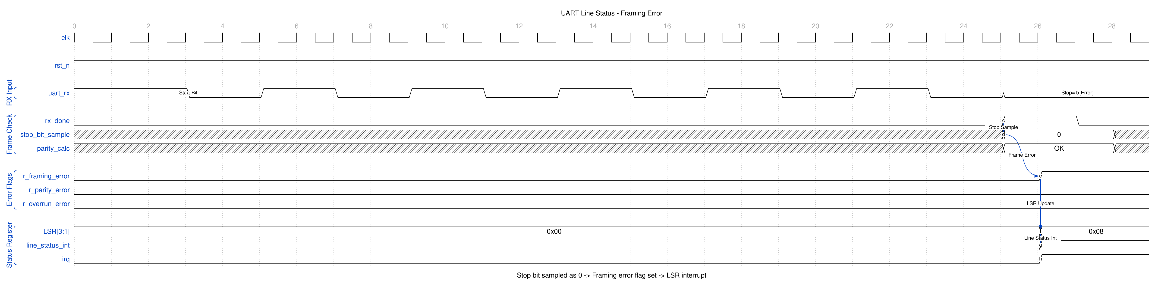
UART Line Status
Error detection sequence: 1. RX frame received normally (start, data bits) 2. Stop bit expected to be 1, but sampled as 0 3. Framing error flag set, and the character’s FIFO entry tagged 4. LSR[3] (FE) reads 1 on the read that returns that character 5. Line status interrupt asserts, if enabled in IER[2]
Error types: - Framing Error (FE): Stop bit not 1 - indicates baud rate mismatch or noise - Parity Error (PE): Calculated vs received parity mismatch - Overrun Error (OE): RX FIFO full when new character arrives - Break Indicator (BI): All bits including stop are 0

18.5 Navigation
Next: 03_modem.md - Modem Interface

RTL Design Sherpa · Learning Hardware Design Through Practice GitHub · Documentation Index · MIT License

19 APB UART 16550 — Modem Interface

19.1 Overview
The modem interface carries the classic flow-control and status pins: RTS/DTR/OUT1/OUT2 out, CTS/DSR/DCD/RI in. Manage your expectations here — the automatic flow control you’d get from a real TL16C550C does not exist in this RTL, so software does the work.

19.2 Ports

19.2.1 Modem Control Outputs (Active Low)
Signal | Width | Dir | Description
rts_n | 1 | O | Request To Send
dtr_n | 1 | O | Data Terminal Ready
out1_n | 1 | O | User output 1
out2_n | 1 | O | User output 2

19.2.2 Modem Status Inputs (Active Low)
Signal | Width | Dir | Description
cts_n | 1 | I | Clear To Send
dsr_n | 1 | I | Data Set Ready
dcd_n | 1 | I | Data Carrier Detect
ri_n | 1 | I | Ring Indicator

19.3 Functional Description

19.3.1 Modem Control Register (MCR)

19.3.1.1 Output Control
Bit | Name | Signal | Active When
0 | DTR | dtr_n | MCR[0] = 1
1 | RTS | rts_n | MCR[1] = 1
2 | OUT1 | out1_n | MCR[2] = 1
3 | OUT2 | out2_n | MCR[3] = 1 (also gates the irq pin)
4 | LOOP | - | Loopback mode
MCR is 6 bits wide: bit 5 is AFE (auto flow control, see below). OUT2 additionally gates the irq output: the pin can assert only when MCR.OUT2 = 1.

19.3.1.2 Auto Flow Control (AFE)
MCR[5] enables auto flow control. With it set, the transmitter starts a character only while CTS is asserted - the character already in the shifter always finishes, AFE gates the start and not the frame - and RTS is driven from the RX FIFO level rather than from MCR[1]: it deasserts at the trigger level and reasserts once software has read the FIFO back below it. MCR[1] must still be set for RTS to be asserted at all. Leave AFE clear for manual flow control: drive MCR.RTS and check MSR.CTS in software.

19.3.2 Modem Status Register (MSR)

19.3.2.1 Current State (Read-Only)
Bit | Name | Source | Meaning
4 | CTS | cts_n | Current CTS state
5 | DSR | dsr_n | Current DSR state
6 | RI | ri_n | Current RI state
7 | DCD | dcd_n | Current DCD state

19.3.2.2 Delta Bits (Clear on Read)
These bits clear when MSR is read, and the modem-status interrupt deasserts with them. Any read clears them, so work from the value the read returned rather than reading MSR a second time.
Bit | Name | Meaning
0 | DCTS | CTS changed since last cleared
1 | DDSR | DSR changed since last cleared
2 | TERI | RI changed from low to high
3 | DDCD | DCD changed since last cleared

19.3.3 Hardware Flow Control

19.3.3.1 RTS/CTS Flow Control

19.3.4 Figure 3.2: RTS/CTS Flow Control Connections
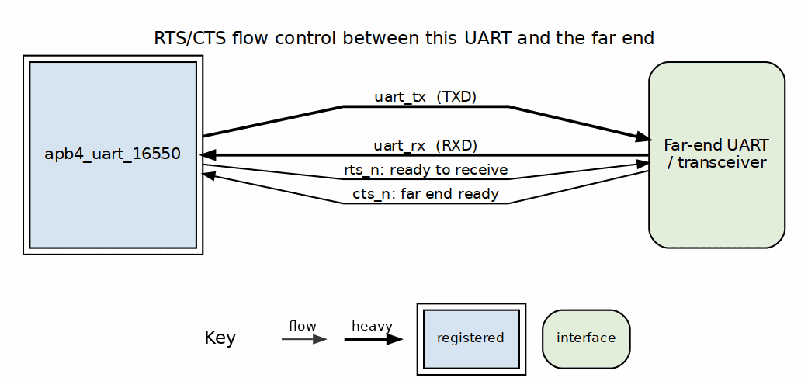
RTS/CTS Flow Control Connections
With AFE clear, RTS/CTS flow control is handled in software: 1. Software asserts MCR.RTS when ready to receive 2. Software checks MSR.CTS before sending 3. Hardware does not auto-pause TX on CTS
With AFE set, the hardware does all three.

19.3.4.1 Manual Flow Control
Software controls RTS directly:
// Ready to receive
MCR |= 0x02; // Assert RTS
// Stop receiving
MCR &= ~0x02; // Deassert RTS

19.3.5 Loopback Mode
When MCR.LOOP = 1: - TXD internally connected to RXD - Modem outputs connected to inputs: - DTR -> DSR - RTS -> CTS - OUT1 -> RI - OUT2 -> DCD - External signals disconnected
Used for: - Self-test - UART verification - Driver testing

19.3.6 Input Synchronization
All modem inputs pass through 2-stage synchronizer:
cts_n --> FF1 --> FF2 --> synced_cts_n
(clk) (clk)

19.3.7 Interrupt Generation
MSR delta bits can generate the modem-status interrupt: - Any delta bit set generates the interrupt, gated by IER[3] - The irq pin is gated by MCR.OUT2 as well - Delta bits clear when MSR is read

19.4 Waveforms

19.4.1 Waveform 3.2: Modem Status Change Detection
The following diagram shows how modem input changes are detected and reported.
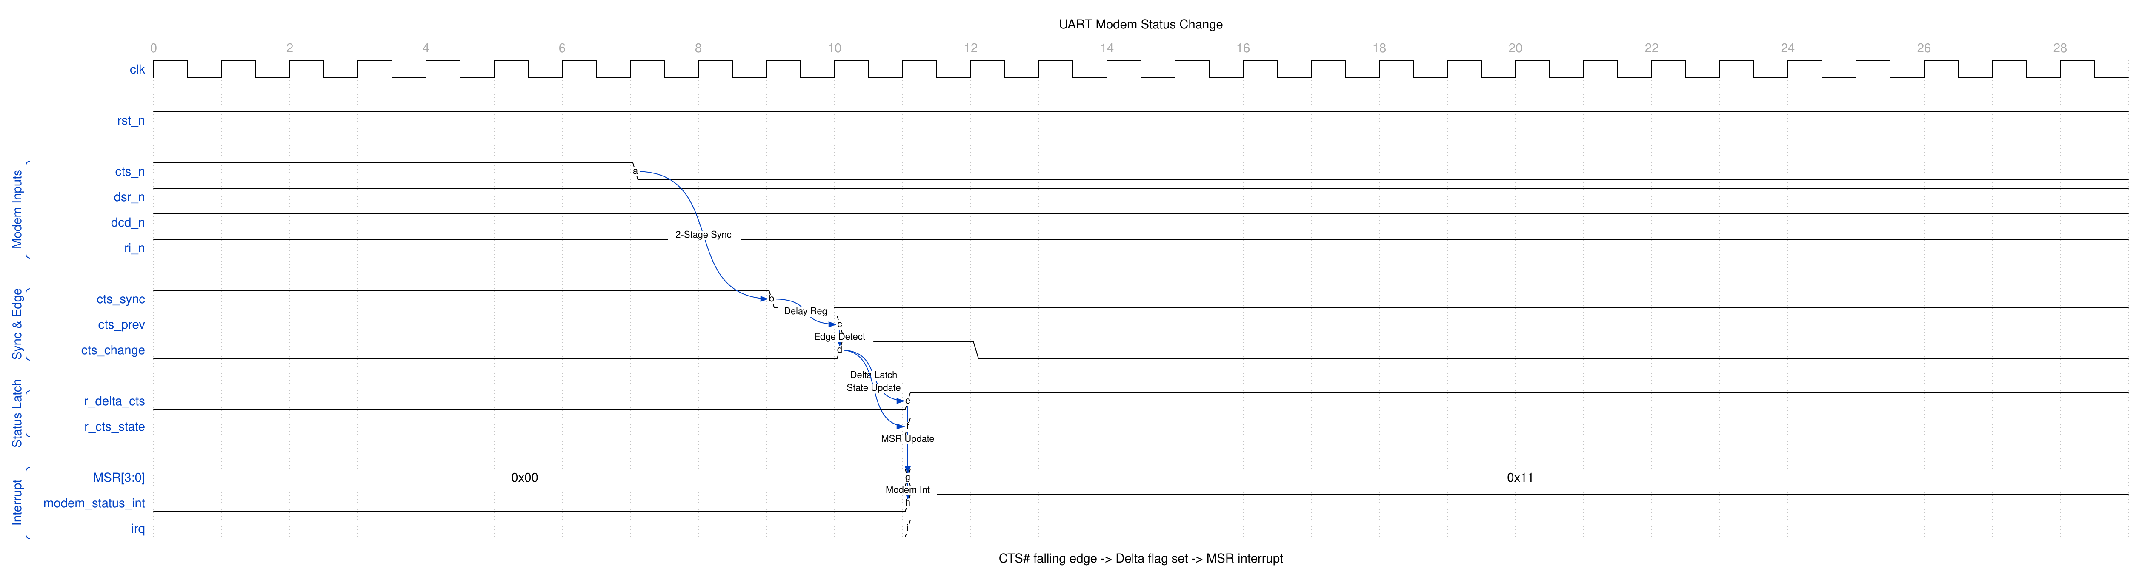
UART Modem Status
The detection sequence: 1. External CTS# falls (device ready to receive) 2. 2-stage synchronizer captures the change 3. Edge detector compares current vs. previous state 4. Delta flag (r_delta_cts) latched 5. Current state (r_cts_state) updated 6. MSR updated, modem status interrupt asserted

19.5 Navigation
Next: 04_interrupt.md - Interrupt Interface

RTL Design Sherpa · Learning Hardware Design Through Practice GitHub · Documentation Index · MIT License

20 APB UART 16550 — Interrupt Interface

20.1 Overview
Before you write a line of ISR code, read the notes below. This RTL’s interrupt path does not behave like the 16550 your driver author probably had in mind — the enables don’t enable, the timeout doesn’t exist, and the pin is gated by a modem output bit.
Implementation notes for this RTL: - Each of the four sources is gated by its own IER bit. A disabled source still sets its status bit; it simply is not an interrupt, does not raise irq, and is not reported by IIR. - The irq pin is gated by MCR.OUT2 (irq = pending & MCR.OUT2). With the reset MCR = 0x00 the pin is masked; software must set OUT2 to route interrupts. - The character timeout fires after four character times with a non-empty RX FIFO and no activity; IIR reads 0x0C. It shares the received-data slot and is gated by IER[0]. - Reading IIR clears the THR-empty interrupt when THR empty is the source it reported, as a standard 16550 does. - LSR[4:1] clear on a read of LSR, and MSR[3:0] on a read of MSR.

20.2 Ports

20.2.1 Signal Description
Signal | Width | Dir | Description
irq | 1 | O | Interrupt request (active high, gated by MCR.OUT2)

20.3 Functional Description

20.3.1 Interrupt Sources

20.3.1.1 Priority Order (Highest to Lowest)
Priority | IIR[3:0] | Source | Clear Method
1 | 0110 | Receiver Line Status | Read LSR
2 | 0100 | Received Data Available | Read RBR until DR clears
3 | 0010 | THR Empty | Write THR (fill TX FIFO)
4 | 0000 | Modem Status | Read MSR
Character Timeout reads IIR = 1100 (0x0C) and shares priority 2 with received-data-available.

20.3.1.2 IIR Encoding
IIR[3:0] | IIR[0] | Meaning
xxx0 | 0 | Interrupt pending
xxx1 | 1 | No interrupt

20.3.2 Interrupt Enable Register (IER)
These bits are stored and read back but are not connected to the interrupt logic in this RTL - they do not enable or mask any interrupt.
Bit | Name | Nominal Source (not enforced)
0 | ERBFI | Received data available
1 | ETBEI | THR empty
2 | ELSI | Receiver line status
3 | EDSSI | Modem status

20.3.3 Interrupt Identification Register (IIR)

20.3.3.1 Read Format
Bits | Name | Description
0 | IPEND | 0=interrupt pending, 1=none
3:1 | IID | Interrupt ID
5:4 | Reserved
7:6 | FIFOEN | 11 if FIFOs enabled

20.3.4 Interrupt Conditions

20.3.4.1 Receiver Line Status (Priority 1)
Triggered by: - Overrun Error (OE) - Parity Error (PE) - Framing Error (FE) - Break Indicator (BI)
Cleared by reading LSR.

20.3.4.2 Received Data Available (Priority 2)
- FCR.FE=1: triggered when RX FIFO >= trigger level
- FCR.FE=0: triggered when data present (DR=1)
- Cleared by reading RBR until the level falls below the trigger / DR clears

20.3.4.3 Character Timeout (Priority 2)
Four character times with the RX FIFO non-empty and neither a new character nor a read. IIR reads 0x0C. Any FIFO activity restarts the timer, and the source exists only in FIFO mode.

20.3.4.4 THR Empty (Priority 3)
Triggered when the TX FIFO is empty (this is a level, THRE = TX FIFO empty).
Cleared by writing THR to refill the TX FIFO. Reading IIR does not clear it.

20.3.4.5 Modem Status (Priority 4)
Triggered by any MSR delta bit: - DCTS (Delta CTS) - DDSR (Delta DSR) - TERI (Trailing Edge RI) - DDCD (Delta DCD)
Cleared by reading MSR.

20.4 Timing

20.4.1 Interrupt Timing
IIR and irq are purely COMBINATIONAL from the core status flags: the cycle a condition’s flag sets, IIR reflects it and irq asserts (gated by MCR.OUT2); the cycle the condition clears, both deassert. There are no pipeline stages in the interrupt path.
Event --> flag sets --> IIR + IRQ reflect it (same cycle, combinational)
Clear --> flag clears --> IIR + IRQ deassert (same cycle)

20.5 Usage Example

20.5.1 Software Handling

20.5.1.1 ISR Flow
void uart_isr(void) {
uint8_t iir = IIR;
while ((iir & 0x01) == 0) { // While interrupt pending
switch (iir & 0x0E) {
case 0x06: // Line status
handle_line_status(LSR);
break;
case 0x04: // RX data available
case 0x0C: // Character timeout
handle_rx_data();
break;
case 0x02: // THR empty
handle_tx_empty();
break;
case 0x00: // Modem status
handle_modem_status(MSR);
break;
}
iir = IIR; // Re-read for next pending
}
}

20.6 Navigation
Next: 05_system.md - System Interface

RTL Design Sherpa · Learning Hardware Design Through Practice GitHub · Documentation Index · MIT License

21 APB UART 16550 — System Interface

21.1 Overview
The system-level plumbing: clocks, resets, what everything resets to, and what the block looks like from the outside when you drop it into a design. The power-management section is short — because the block gives you nothing to work with there.

21.2 Ports

21.2.1 Clock Signals

21.2.1.1 pclk - APB Clock
Parameter | Value
Purpose | APB interface and UART logic
Frequency | 50-200 MHz typical
Domain | All internal logic

21.2.1.2 Baud Rate Derivation
Baud rate is derived from pclk:
Baud Rate = pclk / (16 * Divisor)

21.2.2 Reset Signals

21.2.2.1 presetn - APB Reset
Parameter | Value
Polarity | Active low
Type | Asynchronous assert, synchronous deassert (hand-written logic; the generated register file resets synchronously)
Scope | All UART logic

21.3 Functional Description

21.3.1 Reset Behavior

21.3.1.1 Register Reset Values
Register | Reset | Notes
RBR | Undefined | FIFO content
THR | N/A | Write-only
IER | 0x00 | Interrupt enables, all four sources
IIR | 0x02 | THR-empty pending at reset
FCR | 0x00 | FIFO-enable interface bit clear
LCR | 0x03 | 8N1 format
MCR | 0x00 | Outputs deasserted (irq masked - OUT2=0)
LSR | 0x60 | TX empty
MSR | 0x00 | Inputs low
SCR | 0x00 | Cleared
DLL | 0x01 | Divisor LSB = 1
DLM | 0x00 | Divisor MSB = 0

21.3.1.2 Signal States During Reset
Signal | Reset State
uart_tx | 1 (Mark/Idle)
rts_n | 1 (Deasserted)
dtr_n | 1 (Deasserted)
out1_n | 1 (Deasserted)
out2_n | 1 (Deasserted)
irq | 0 (No interrupt)

21.3.1.3 Post-Reset Initialization
- Set baud rate (write DLL at 0x24, DLM at 0x28 directly - no DLAB toggle)
- Configure line format (LCR at 0x10)
- Enable FIFOs if desired (FCR at 0x0C)
- Configure modem control (MCR at 0x14); set OUT2 to enable the irq pin
- (IER at 0x04 gates each of the four interrupt sources independently)

21.4 Timing

21.4.1 Reset Sequence

21.4.2 Figure 3.3: Reset Sequence
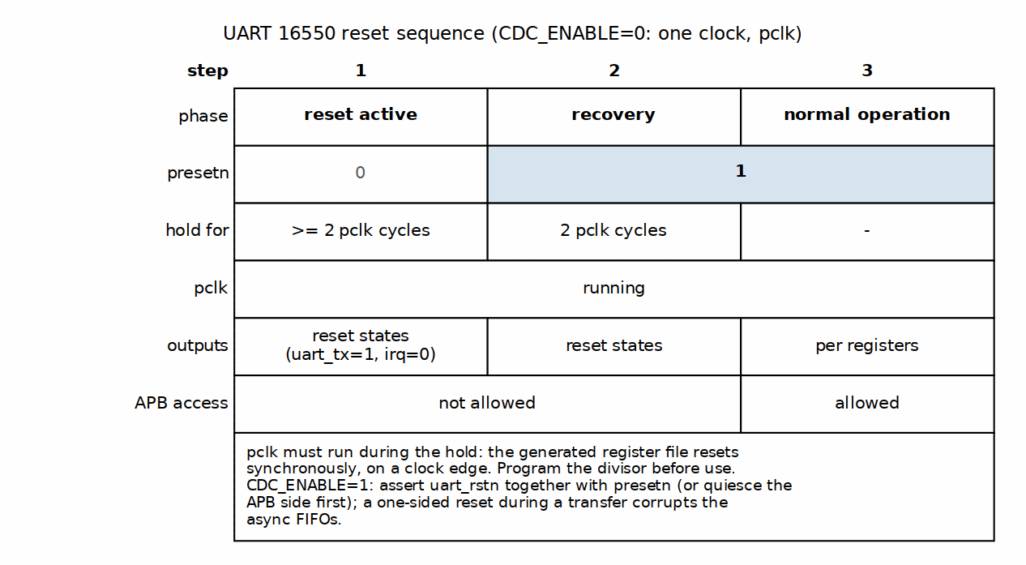
Reset Sequence

21.4.2.1 Requirements
- Hold reset low for minimum 2 pclk cycles
- Allow 2 cycles after reset before first APB access
- Divisor must be programmed before operation

21.5 Design Notes

21.5.1 Power Management

21.5.1.1 Clock Gating
The block provides NO gating or wake hooks: there are no power-management ports, and the baud counter free-runs unconditionally. Any clock gating is the integrator’s, done OUTSIDE the block – and gating pclk kills the APB interface while gating uart_clk kills RX sampling. There is no wake-on-activity path.

21.5.1.2 Low Power Hints
- Use FIFO mode to reduce interrupt rate
- Set a higher RX trigger level to reduce interrupt frequency
(Set MCR[5] for auto flow control, which paces the far end from the RX FIFO level.)

21.5.2 External Connections

21.5.2.1 Typical System

21.5.3 Figure 3.4: UART 16550 in a System
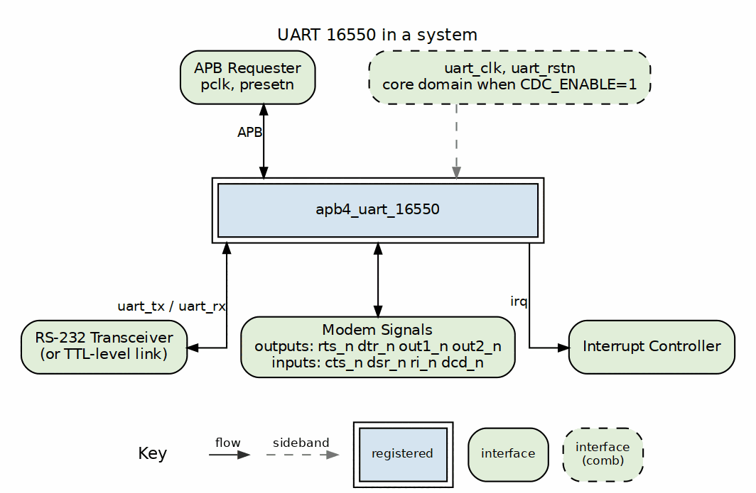
UART 16550 in a System

21.5.3.1 Direct Connection (TTL)
For TTL-level serial: - Connect uart_tx/uart_rx directly to 3.3V/5V logic - No level conversion needed - Short cable runs recommended

21.6 Navigation
Back to: 00_overview.md - Interfaces Overview
Next Chapter: Chapter 4: Programming Model

RTL Design Sherpa · Learning Hardware Design Through Practice GitHub · Documentation Index · MIT License

22 APB UART 16550 — Programming Model

22.1 Overview
This chapter is the software view of the block: how to initialize it, move data through it, and live with its interrupt behavior. The register summary below is the quick reference; the quick-start snippet will get characters on the wire.

22.1.1 Register Summary
Each register has a unique offset, and DLAB additionally remaps 0x00/0x04 to the divisor latches.
Offset | Register | Access | Description
0x00 | RBR / THR | R / W | Receive Buffer (read) / Transmit Holding (write)
0x04 | IER | RW | Interrupt Enable
0x08 | IIR | RO | Interrupt Identification
0x0C | FCR | RW | FIFO Control
0x10 | LCR | RW | Line Control
0x14 | MCR | RW | Modem Control
0x18 | LSR | RO, clear on read | Line Status
0x1C | MSR | RO, clear on read | Modem Status
0x20 | SCR | RW | Scratch
0x24 | DLL | RW | Divisor Latch LSB
0x28 | DLM | RW | Divisor Latch MSB

22.2 Usage Example

22.2.1 Quick Start

22.2.1.1 Minimal Setup (115200 8N1)
// Assuming 48 MHz clock
#define DIVISOR 26 // 48MHz / (16 * 115200) = 26
void uart_init(void) {
// Set baud rate divisor directly - no DLAB toggle (DLL=0x24, DLM=0x28)
DLL = DIVISOR & 0xFF;
DLM = DIVISOR >> 8;
// 8N1
LCR = 0x03;
// Enable FIFOs, reset, trigger=14
FCR = 0xC7;
// Set MCR.OUT2 to ungate the irq pin. It gates the pin in addition to
// IER, and resets to 0, so interrupts stay masked until this is set.
MCR = 0x08;
}

22.3 Navigation

22.3.1 Chapter Contents

22.3.1.1 Initialization
Complete UART initialization sequence.
See: 01_initialization.md

22.3.1.2 Data Transfer
Sending and receiving data.
See: 02_data_transfer.md

22.3.1.3 Interrupts
Interrupt configuration and handling.
See: 03_interrupts.md

22.3.1.4 Examples
Complete programming examples.
See: 04_examples.md

Next: 01_initialization.md - Initialization

RTL Design Sherpa · Learning Hardware Design Through Practice GitHub · Documentation Index · MIT License

23 APB UART 16550 — Initialization

23.1 Overview
Four steps stand between reset and a working serial link: baud rate, line format, FIFOs, and interrupts. Each step below is short, and each has at least one place where this RTL differs from a textbook 16550 — the comments call those out.

23.2 Functional Description

23.2.1 Baud Rate Calculation

23.2.1.1 Formula
Divisor = Clock_Frequency / (16 * Baud_Rate)

23.2.1.2 Divisor Calculator Function
uint16_t uart_calculate_divisor(uint32_t clock_hz, uint32_t baud) {
// Round to nearest
return (clock_hz + (8 * baud)) / (16 * baud);
}

23.2.1.3 Common Clock Frequencies
Clock | 9600 | 19200 | 38400 | 57600 | 115200
48 MHz | 312 | 156 | 78 | 52 | 26
50 MHz | 326 | 163 | 81 | 54 | 27
100 MHz | 651 | 326 | 163 | 109 | 54

23.3 Usage Example

23.3.1 Basic Initialization Sequence

23.3.1.1 Step 1: Set Baud Rate
void uart_set_baud(uint16_t divisor) {
// DLL (0x24) and DLM (0x28) have dedicated offsets - no DLAB toggle needed.
DLL = divisor & 0xFF;
DLM = (divisor >> 8) & 0xFF;
}

23.3.1.2 Step 2: Configure Line Format
void uart_set_format(uint8_t data_bits, uint8_t parity, uint8_t stop_bits) {
uint8_t lcr = 0;
// Data bits: 5=0, 6=1, 7=2, 8=3
lcr |= (data_bits - 5) & 0x03;
// Stop bits: 1=0, 2=1. STB=1 gives 2 stop bits for 6/7/8-bit words.
// 1.5 stop bits: a 5-bit word with LCR[2] set sends a half-length second stop bit.
if (stop_bits == 2) lcr |= 0x04;
// Parity: 0=none, 1=odd, 2=even, 3=mark, 4=space
switch (parity) {
case 1: lcr |= 0x08; break; // Odd
case 2: lcr |= 0x18; break; // Even
case 3: lcr |= 0x28; break; // Mark
case 4: lcr |= 0x38; break; // Space
}
LCR = lcr;
}

23.3.1.3 Step 3: Configure FIFOs
void uart_configure_fifo(uint8_t trigger_level) {
uint8_t fcr = 0x01; // Enable FIFOs
// Trigger level: 0=1, 1=4, 2=8, 3=14
fcr |= (trigger_level & 0x03) << 6;
// Reset both FIFOs
fcr |= 0x06;
FCR = fcr;
}

23.3.1.4 Step 4: Enable Interrupts
void uart_enable_interrupts(uint8_t mask) {
// Bits: 0=RX, 1=TX, 2=Line, 3=Modem
// Each bit gates its own source. The irq pin is gated by MCR.OUT2 as
// well, so set OUT2 before expecting an interrupt.
IER = mask & 0x0F;
}

23.3.2 Complete Initialization Example
// Common baud rate divisors for 48 MHz clock
#define BAUD_9600 312
#define BAUD_19200 156
#define BAUD_38400 78
#define BAUD_57600 52
#define BAUD_115200 26
void uart_init_115200_8n1(void) {
// 1. Set baud rate (DLL=0x24, DLM=0x28 - no DLAB toggle)
DLL = BAUD_115200; // Low byte
DLM = 0x00; // High byte
// 2. Line format: 8 data bits, no parity, 1 stop bit
LCR = 0x03;
// 3. Enable and reset FIFOs, trigger at 14 bytes
FCR = 0xC7; // 11000111b
// 4. Modem control: set OUT2 (bit 3) to ungate the irq pin
MCR = 0x08;
// 5. Drain any pending RX data (received byte is in RBR bits [7:0])
while (LSR & 0x01)
(void)RBR;
// NOTE: LSR[4:1] and MSR[3:0] clear when their own register is read,
// so the drain loop above consumes any error bits it passes over.
}

23.3.3 Flow Control Setup (manual)
Auto flow control (AFE, MCR[5]) is implemented. For manual control leave AFE clear and assert RTS in software and monitor MSR.CTS to gate transmission manually.
void uart_assert_rts(void) {
uint8_t mcr = MCR;
mcr |= 0x02; // RTS (bit 1); set bit 5 as well for auto flow control
MCR = mcr;
}

23.3.4 Loopback Mode Setup
void uart_enable_loopback(void) {
uint8_t mcr = MCR;
mcr |= 0x10; // LOOP bit
MCR = mcr;
}

23.4 Navigation
Next: 02_data_transfer.md - Data Transfer

RTL Design Sherpa · Learning Hardware Design Through Practice GitHub · Documentation Index · MIT License

24 APB UART 16550 — Data Transfer

24.1 Overview
Moving bytes in and out of this UART is ordinary 16550 fare with three local twists, summarized below and repeated wherever they bite. The examples in this page already account for all three.
Implementation notes for this RTL: reading offset 0x00 (RBR) returns the received byte in bits [7:0] and pops the RX FIFO; LSR[4:1] and MSR[3:0] clear on a read of their own register, so a poll of LSR consumes the error bits it reports; and irq is gated by MCR.OUT2 as well as by IER, so interrupt-driven code must set OUT2 = 1. See Chapter 5 for detail.

24.2 Usage Example

24.2.1 Transmitting Data

24.2.1.1 Polling Mode
void uart_putchar(uint8_t c) {
// Wait for THR empty
while ((LSR & 0x20) == 0);
// Write data
THR = c;
}
void uart_puts(const char *s) {
while (*s) {
uart_putchar(*s++);
}
}

24.2.1.2 Interrupt-Driven TX
volatile uint8_t tx_buffer[256];
volatile uint8_t tx_head = 0;
volatile uint8_t tx_tail = 0;
void uart_send(const uint8_t *data, size_t len) {
for (size_t i = 0; i < len; i++) {
// Add to buffer
tx_buffer[tx_head++] = data[i];
}
// Enable TX interrupt
IER |= 0x02;
}
// In ISR when THRE interrupt:
void uart_tx_isr(void) {
while ((LSR & 0x20) && (tx_head != tx_tail)) {
THR = tx_buffer[tx_tail++];
}
if (tx_head == tx_tail) {
IER &= ~0x02; // Disable TX interrupt
}
}

24.2.1.3 Waiting for TX Complete
void uart_flush(void) {
// Wait for TEMT (both FIFO and shift register empty)
while ((LSR & 0x40) == 0);
}

24.2.2 Receiving Data

24.2.2.1 Polling Mode
int uart_getchar(void) {
// Check for data available
if ((LSR & 0x01) == 0) {
return -1; // No data
}
// Read data (received byte is in [7:0]
// chapter header note)
return RBR & 0xFF;
}
int uart_getchar_blocking(void) {
// Wait for data
while ((LSR & 0x01) == 0);
return RBR & 0xFF;
}

24.2.2.2 Interrupt-Driven RX
volatile uint8_t rx_buffer[256];
volatile uint8_t rx_head = 0;
volatile uint8_t rx_tail = 0;
// In ISR when RX data available:
void uart_rx_isr(void) {
while (LSR & 0x01) {
rx_buffer[rx_head++] = RBR & 0xFF;
}
}
int uart_read(uint8_t *data, size_t max_len) {
size_t count = 0;
while ((rx_head != rx_tail) && (count < max_len)) {
data[count++] = rx_buffer[rx_tail++];
}
return count;
}

24.2.3 Error Handling

24.2.3.1 Checking Line Status
uint8_t uart_check_errors(void) {
uint8_t lsr = LSR;
uint8_t errors = 0;
if (lsr & 0x02) errors |= ERR_OVERRUN;
if (lsr & 0x04) errors |= ERR_PARITY;
if (lsr & 0x08) errors |= ERR_FRAMING;
if (lsr & 0x10) errors |= ERR_BREAK;
return errors;
}

24.2.3.2 Handling Errors in RX ISR
void uart_rx_error_isr(void) {
uint8_t lsr = LSR; // Read status once; the read clears the error bits
if (lsr & 0x02) {
// Overrun - data lost
stats.overrun_count++;
}
if (lsr & 0x04) {
// Parity error
stats.parity_count++;
}
if (lsr & 0x08) {
// Framing error
stats.framing_count++;
}
if (lsr & 0x10) {
// Break received
handle_break_condition();
}
}

24.2.4 FIFO Management

24.2.4.1 FIFO Status
bool uart_tx_fifo_empty(void) {
return (LSR & 0x20) != 0; // THRE
}
bool uart_tx_complete(void) {
return (LSR & 0x40) != 0; // TEMT
}
bool uart_rx_data_ready(void) {
return (LSR & 0x01) != 0; // DR
}
bool uart_rx_fifo_error(void) {
return (LSR & 0x80) != 0; // FIFO error
}

24.2.4.2 FIFO Reset
void uart_reset_fifos(void) {
// Reset both FIFOs while keeping enabled
uint8_t fcr = FCR;
FCR = fcr | 0x06; // RFR + TFR
}

24.2.5 Bulk Transfer

24.2.5.1 Efficient TX (FIFO-aware)
size_t uart_write(const uint8_t *data, size_t len) {
size_t sent = 0;
while (sent < len) {
// Wait for FIFO space
if (LSR & 0x20) {
// Fill FIFO (up to 16 bytes)
size_t chunk = (len - sent < 16) ? (len - sent) : 16;
for (size_t i = 0; i < chunk; i++) {
THR = data[sent++];
}
}
}
return sent;
}

24.2.5.2 Efficient RX (FIFO-aware)
size_t uart_read_available(uint8_t *data, size_t max_len) {
size_t count = 0;
while ((LSR & 0x01) && (count < max_len)) {
data[count++] = RBR & 0xFF; // received byte is at [7:0]
}
return count;
}

24.3 Navigation
Next: 03_interrupts.md - Interrupts

RTL Design Sherpa · Learning Hardware Design Through Practice GitHub · Documentation Index · MIT License

25 APB UART 16550 — Interrupt Handling

25.1 Overview
Interrupt handling follows the 16550 datasheet, with one gap. The note below is the contract; everything else on this page follows from it.
Implementation note: each of the four sources is gated by its own IER bit, and irq is additionally gated by MCR.OUT2 (set OUT2 = 1 to route the pin). LSR[4:1] clear on a read of LSR and MSR[3:0] on a read of MSR; reading IIR clears the THR-empty interrupt when that is the source it reported. The character timeout shares the received-data slot, reads IIR = 0x0C and is gated by IER[0].

25.2 Functional Description

25.2.1 Interrupt Identification Register (IIR)

25.2.1.1 IIR Values
Value | Priority | Interrupt Source | Clear Method
0x01 | - | No interrupt | -
0x06 | 1 | Line status error | Read LSR to clear the error bits
0x04 | 2 | RX data available | Read RBR until DR clears
0x02 | 3 | THR empty | Write THR (fills TX FIFO)
0x00 | 4 | Modem status | Read MSR to clear the delta bits
Note: Character timeout (IIR = 0x0C) fires after four character times of inactivity with a non-empty RX FIFO. Reading IIR has no side effect (it does not clear the THR-empty condition).

25.3 Usage Example

25.3.1 Interrupt Enable Register (IER)
// Enable specific interrupts
#define IER_RDA 0x01 // Received Data Available
#define IER_THRE 0x02 // THR Empty
#define IER_RLS 0x04 // Receiver Line Status
#define IER_MS 0x08 // Modem Status
void uart_enable_rx_interrupt(void) {
IER |= IER_RDA;
}
void uart_enable_tx_interrupt(void) {
IER |= IER_THRE;
}
void uart_disable_tx_interrupt(void) {
IER &= ~IER_THRE;
}

25.3.2 Complete ISR Example
void uart_isr(void) {
uint8_t iir;
// Loop while interrupts pending
while (((iir = IIR) & 0x01) == 0) {
switch (iir & 0x0E) {
case 0x06: // Receiver Line Status (highest priority)
uart_handle_line_status();
break;
case 0x04: // Received Data Available
uart_handle_rx_data();
break;
case 0x0C: // Character Timeout
uart_handle_timeout();
break;
case 0x02: // THR Empty
uart_handle_tx_empty();
break;
case 0x00: // Modem Status (lowest priority)
uart_handle_modem_status();
break;
}
}
}

25.3.3 Individual Interrupt Handlers

25.3.3.1 Line Status Handler
void uart_handle_line_status(void) {
uint8_t lsr = LSR; // Read status; this read also clears the error bits
if (lsr & 0x02) {
// Overrun Error - FIFO overflow
stats.overrun++;
}
if (lsr & 0x04) {
// Parity Error
stats.parity_err++;
}
if (lsr & 0x08) {
// Framing Error
stats.framing_err++;
}
if (lsr & 0x10) {
// Break Indicator
handle_break();
}
// Nothing to write back: LSR[4:1] were cleared by the read above.
// That is also why this handler must work from `lsr`, the value the
// read returned, and must not read LSR again.
}

25.3.3.2 RX Data Handler
void uart_handle_rx_data(void) {
// Read all available data from FIFO
while (LSR & 0x01) {
uint8_t data = RBR & 0xFF; // received byte is at [7:0]
rx_buffer[rx_head++] = data;
if (rx_head >= RX_BUFFER_SIZE) {
rx_head = 0;
}
}
// Signal waiting thread/task
signal_rx_available();
}

25.3.3.3 Character Timeout Handler
// Called when IIR reads 0x0C: four character times with data sitting in
// the RX FIFO below the trigger level.
void uart_handle_timeout(void) {
// Same as RX data - flush remaining FIFO data
uart_handle_rx_data();
// May want to signal "end of packet" condition
signal_rx_timeout();
}

25.3.3.4 TX Empty Handler
void uart_handle_tx_empty(void) {
// Fill TX FIFO from buffer
while ((LSR & 0x20) && (tx_tail != tx_head)) {
THR = tx_buffer[tx_tail++];
if (tx_tail >= TX_BUFFER_SIZE) {
tx_tail = 0;
}
}
// If buffer empty, disable TX interrupt
if (tx_tail == tx_head) {
IER &= ~IER_THRE;
signal_tx_complete();
}
}

25.3.3.5 Modem Status Handler
void uart_handle_modem_status(void) {
uint8_t msr = MSR; // Read status; this read also clears the delta bits
if (msr & 0x01) { // Delta CTS
// CTS changed - update flow control
}
if (msr & 0x02) { // Delta DSR
// DSR changed - device status
}
if (msr & 0x04) { // Trailing Edge RI
// Ring detected
}
if (msr & 0x08) { // Delta DCD
// Carrier changed - connection status
}
// Nothing to write back: MSR[3:0] were cleared by the read above,
// which is why this handler works from `msr` and does not re-read.
}

25.3.4 Disabling/Enabling Interrupts
IER = 0x00 disables all four sources. MCR.OUT2 gates the pin as well, so clearing it masks the pin whatever IER says:
// Mask the irq pin via the OUT2 gate
uint8_t saved_mcr = MCR;
MCR = saved_mcr & ~0x08; // OUT2 = 0 -> irq pin held deasserted
// ... critical section ...
// Restore
MCR = saved_mcr;

25.4 Design Notes

25.4.1 Interrupt Latency Considerations

25.4.1.1 Trigger Level Selection
Trigger | Bytes in FIFO | Latency Budget | Best For
1 | 1 | 1 char time | Low latency
4 | 4 | 4 char times | Balanced
8 | 8 | 8 char times | Higher rates
14 | 14 | 2 char times* | Maximum efficiency
*Only 2 characters before overflow at 16-byte FIFO

25.4.1.2 Character Timeout
- Implemented: four character times with a non-empty RX FIFO and no activity, IIR reads 0x0C.
- For variable-length packets, poll LSR.DR and apply a software inactivity timeout instead.

25.5 Navigation
Next: 04_examples.md - Examples

RTL Design Sherpa · Learning Hardware Design Through Practice GitHub · Documentation Index · MIT License

26 APB UART 16550 — Programming Examples

26.1 Overview
Complete, working examples that pull together everything from the previous pages: a polled debug console, an interrupt-driven ring buffer, a small command-line interface, a loopback self-test, and manual flow control. All of them already account for this RTL’s quirks — RBR at [7:0], no DLAB remap — so you can lift them directly.

26.2 Usage Example

26.2.1 Debug Console

26.2.1.1 Simple Polling Implementation
#define UART_BASE 0xFEC08000
// Each register has its own offset; this example uses those flat offsets.
// (LCR[7]/DLAB additionally remaps 0x00/0x04 to DLL/DLM when set.)
// RBR read returns the received byte in bits [7:0], so read RBR as 16-bit.
#define RBR (*(volatile uint16_t *)(UART_BASE + 0x00))
#define THR (*(volatile uint8_t *)(UART_BASE + 0x00))
#define IER (*(volatile uint8_t *)(UART_BASE + 0x04))
#define IIR (*(volatile uint8_t *)(UART_BASE + 0x08))
#define FCR (*(volatile uint8_t *)(UART_BASE + 0x0C))
#define LCR (*(volatile uint8_t *)(UART_BASE + 0x10))
#define MCR (*(volatile uint8_t *)(UART_BASE + 0x14))
#define LSR (*(volatile uint8_t *)(UART_BASE + 0x18))
#define MSR (*(volatile uint8_t *)(UART_BASE + 0x1C))
#define SCR (*(volatile uint8_t *)(UART_BASE + 0x20))
#define DLL (*(volatile uint8_t *)(UART_BASE + 0x24))
#define DLM (*(volatile uint8_t *)(UART_BASE + 0x28))
// Received byte is in RBR bits [7:0].
#define RBR_BYTE() ((uint8_t)(RBR & 0xFF))
void debug_uart_init(void) {
// 115200 baud, 8N1. No DLAB toggle - DLL/DLM have their own offsets.
DLL = 26; // 48MHz / (16 * 115200)
DLM = 0;
LCR = 0x03; // 8N1
FCR = 0x07; // Enable FIFOs, reset
// IER left at 0: this console polls LSR rather than taking interrupts.
}
void debug_putchar(char c) {
while ((LSR & 0x20) == 0);
THR = c;
}
void debug_puts(const char *s) {
while (*s) {
if (*s == '\n')
debug_putchar('\r');
debug_putchar(*s++);
}
}
int debug_getchar(void) {
if (LSR & 0x01)
return RBR_BYTE(); // received byte is in RBR bits [7:0]
return -1;
}

26.2.2 Ring Buffer Implementation
#define RX_BUF_SIZE 256
#define TX_BUF_SIZE 256
typedef struct {
volatile uint8_t buffer[RX_BUF_SIZE];
volatile uint16_t head;
volatile uint16_t tail;
} ring_buffer_t;
static ring_buffer_t rx_buf;
static ring_buffer_t tx_buf;
void uart_isr(void) {
uint8_t iir;
while (((iir = IIR) & 0x01) == 0) {
switch (iir & 0x0E) {
case 0x0C: // character timeout - fall through, drain the FIFO
case 0x04: // RX data available
while (LSR & 0x01) {
uint16_t next = (rx_buf.head + 1) % RX_BUF_SIZE;
if (next != rx_buf.tail) {
rx_buf.buffer[rx_buf.head] = RBR_BYTE();
rx_buf.head = next;
} else {
(void)RBR; // Discard if full (still pops the FIFO)
}
}
break;
case 0x02: // TX empty
while ((LSR & 0x20) && (tx_buf.tail != tx_buf.head)) {
THR = tx_buf.buffer[tx_buf.tail];
tx_buf.tail = (tx_buf.tail + 1) % TX_BUF_SIZE;
}
if (tx_buf.tail == tx_buf.head) {
IER &= ~0x02; // Disable TX int
}
break;
}
}
}
size_t uart_write(const uint8_t *data, size_t len) {
size_t written = 0;
while (written < len) {
uint16_t next = (tx_buf.head + 1) % TX_BUF_SIZE;
if (next == tx_buf.tail) break; // Buffer full
tx_buf.buffer[tx_buf.head] = data[written++];
tx_buf.head = next;
}
IER |= 0x02; // Enable TX interrupt
return written;
}
size_t uart_read(uint8_t *data, size_t max) {
size_t count = 0;
while ((rx_buf.tail != rx_buf.head) && (count < max)) {
data[count++] = rx_buf.buffer[rx_buf.tail];
rx_buf.tail = (rx_buf.tail + 1) % RX_BUF_SIZE;
}
return count;
}

26.2.3 Command Line Interface
#define CMD_BUF_SIZE 128
static char cmd_buf[CMD_BUF_SIZE];
static uint8_t cmd_pos = 0;
void cli_process_char(char c) {
switch (c) {
case '\r':
case '\n':
debug_puts("\r\n");
cmd_buf[cmd_pos] = '\0';
cli_execute(cmd_buf);
cmd_pos = 0;
debug_puts("> ");
break;
case '\b':
case 0x7F: // DEL
if (cmd_pos > 0) {
cmd_pos--;
debug_puts("\b \b");
}
break;
default:
if (cmd_pos < CMD_BUF_SIZE - 1) {
cmd_buf[cmd_pos++] = c;
debug_putchar(c);
}
break;
}
}
void cli_execute(const char *cmd) {
if (strcmp(cmd, "help") == 0) {
debug_puts("Available commands:\r\n");
debug_puts(" help - Show this help\r\n");
debug_puts(" status - Show UART status\r\n");
}
else if (strcmp(cmd, "status") == 0) {
char buf[64];
sprintf(buf, "LSR: 0x%02X MSR: 0x%02X\r\n", LSR, MSR);
debug_puts(buf);
}
else if (cmd[0] != '\0') {
debug_puts("Unknown command: ");
debug_puts(cmd);
debug_puts("\r\n");
}
}

26.2.4 Loopback Test
bool uart_loopback_test(void) {
uint8_t test_data[] = {0x00, 0x55, 0xAA, 0xFF};
// Enable loopback mode
MCR |= 0x10;
// Clear FIFOs
FCR = 0x07;
// Send test data
for (int i = 0; i < sizeof(test_data); i++) {
THR = test_data[i];
}
// Wait for transmission
while ((LSR & 0x40) == 0);
// Short delay for internal loopback
for (volatile int i = 0; i < 100; i++);
// Read back and verify
for (int i = 0; i < sizeof(test_data); i++) {
if (!(LSR & 0x01)) {
MCR &= ~0x10;
return false; // No data received
}
uint8_t received = RBR_BYTE(); // received byte is in RBR bits [7:0]
if (received != test_data[i]) {
MCR &= ~0x10;
return false; // Data mismatch
}
}
// Disable loopback
MCR &= ~0x10;
return true;
}

26.2.5 Flow Control (manual)
void uart_init_flow_control(void) {
// Standard init - no DLAB toggle; DLL/DLM have their own offsets.
DLL = 26; DLM = 0; LCR = 0x03;
FCR = 0xC7; // Enable FIFOs, trigger=14
// Assert RTS (bit 1) and set OUT2 (bit 3) so the irq pin is ungated.
MCR = 0x0A;
}
// NOTE: this example does flow control by hand. Set MCR[5] (AFE) instead
// and the hardware does it: CTS gates the start of a character and RTS
// follows the RX FIFO level. MCR[1] must still be set for RTS to assert.

26.3 Navigation
Back to: 00_overview.md - Programming Model Overview
Next Chapter: Chapter 5: Registers

RTL Design Sherpa · Learning Hardware Design Through Practice GitHub · Documentation Index · MIT License

27 APB UART 16550 — Register Map

27.1 Overview
This is the definitive register reference, and it documents what the RTL actually does — not what a 16550 datasheet says it should do. The address map is additive: every register has its own unique offset, AND the Divisor Latch Access Bit (LCR[7]) remaps 0x00/0x04 to DLL/DLM while it is set, as a classic 16550 does. DLL/DLM also keep their dedicated offsets (0x24/0x28), so both access styles work (RLB TASK-012, was RLB-013). Register offsets are byte offsets; the decode is strict, so an unmapped offset reads 0 with PSLVERR (see Address Calculation).

27.2 Functional Description

27.2.1 Register Summary
Offset | Register | Access | Reset | Description
0x00 | RBR / THR | R / W | - | Receive Buffer (read) / Transmit Holding (write)
0x04 | IER | RW | 0x00 | Interrupt Enable
0x08 | IIR | RO | 0x02 | Interrupt Identification
0x0C | FCR | RW | 0x00 | FIFO Control (readable in this implementation)
0x10 | LCR | RW | 0x03 | Line Control (8N1 at reset)
0x14 | MCR | RW | 0x00 | Modem Control
0x18 | LSR | RO, clear on read | 0x60 | Line Status
0x1C | MSR | RO, clear on read | 0x00 | Modem Status
0x20 | SCR | RW | 0x00 | Scratch
0x24 | DLL | RW | 0x01 | Divisor Latch LSB
0x28 | DLM | RW | 0x00 | Divisor Latch MSB
Offsets 0x2C-0x3F are unused and acknowledge reads as zero.

27.2.2 RBR - Receiver Buffer Register (0x00, Read)
Bits | Name | Access | Description
7:0 | DATA | RO | Received data byte
15:8 | DATA_ALIAS | RO | The same byte again (see note)
Note: Reading offset 0x00 pops one entry from the RX FIFO and returns the received byte in bits [7:0], as a standard 16550 does. THR shares the offset and is write-only: it has no storage and does not read back anywhere. Bits [15:8] mirror the same received byte and exist only for testbench helpers that predate the fix; do not write new software against them.

27.2.3 THR - Transmitter Holding Register (0x00, Write)
Bits | Name | Access | Description
7:0 | DATA | WO | Data to transmit
Note: Writing offset 0x00 pushes data to the TX FIFO. The written value is also stored and is what appears in bits [7:0] of a subsequent RBR read (see RBR note); it is not otherwise software-visible.

27.2.4 IER - Interrupt Enable Register (0x04, R/W)
Bit | Name | Access | Reset | Description
0 | ERBFI | RW | 0 | Enable Received Data Available Interrupt
1 | ETBEI | RW | 0 | Enable Transmitter Holding Register Empty
2 | ELSI | RW | 0 | Enable Receiver Line Status Interrupt
3 | EDSSI | RW | 0 | Enable Modem Status Interrupt
7:4 | Reserved | RO | 0 | Reserved
Note: Each bit gates its own source. A disabled source still sets its status bit in LSR or MSR; it simply is not an interrupt, does not raise irq and is not reported by IIR. The irq pin is additionally gated by MCR.OUT2, which resets to 0. See ch03_interfaces/04_interrupt.md.

27.2.5 IIR - Interrupt Identification Register (0x08, Read Only)
Bits | Name | Access | Description
0 | IPEND | RO | 0=Interrupt pending, 1=No interrupt
3:1 | IID | RO | Interrupt ID (see table below)
5:4 | Reserved | RO | Reserved
7:6 | FIFOEN | RO | 11=FIFOs enabled, 00=disabled

27.2.5.1 Interrupt ID Encoding
IIR[0]=IPEND (0 = interrupt pending). IIR[3:1]=IID. IIR[3] (timeout) is always 0 in this implementation.
IIR[3:0] | Priority | Source | Clear Method
0110 | 1 | Line Status | Read LSR to clear the error bits
0100 | 2 | RX Data Available | Read RBR until DR clears
0010 | 3 | THR Empty | Write THR (fills TX FIFO)
0000 | 4 | Modem Status | Read MSR to clear the delta bits
Note: The Character Timeout interrupt (IIR = 0x0C, IIR[3]) is implemented. Reading IIR has no side effect; it does not clear the THR-empty condition. The THR-empty source is the level “TX FIFO empty” and clears only when the FIFO is refilled. Because interrupt enables are unimplemented (see IER), IIR reflects pending sources regardless of IER, and the irq pin is additionally gated by MCR.OUT2 (see MCR note).

27.2.6 FCR - FIFO Control Register (0x0C, R/W)
FCR is fully readable in this implementation (a standard 16550 FCR is write-only).
Bit | Name | Access | Description
0 | FE | RW | FIFO Enable
1 | RFR | RW | RX FIFO Reset (self-clearing)
2 | TFR | RW | TX FIFO Reset (self-clearing)
3 | DMS | RW | DMA Mode Select (stored; no effect - no DMA signals exist)
5:4 | Reserved | RO | Reserved (read as 0)
7:6 | RTL | RW | RX Trigger Level

27.2.6.1 RX Trigger Level
RTL[1:0] | Trigger Level
00 | 1 byte
01 | 4 bytes
10 | 8 bytes
11 | 14 bytes

27.2.7 LCR - Line Control Register (0x10, R/W)
Reset value is 0x03 (8 data bits, 1 stop bit, no parity - 8N1).
Bits | Name | Access | Reset | Description
1:0 | WLS | RW | 11 | Word Length Select (reset = 8 bits)
2 | STB | RW | 0 | Stop Bits (see note)
3 | PEN | RW | 0 | Parity Enable
4 | EPS | RW | 0 | Even Parity Select
5 | SP | RW | 0 | Stick Parity
6 | BC | RW | 0 | Break Control
7 | DLAB | RW | 0 | Divisor Latch Access Bit: while set, 0x00 and 0x04 are DLL and DLM
Note (DLAB): LCR[7] remaps 0x00 to DLL and 0x04 to DLM, as a standard 16550 does. The dedicated offsets 0x24 and 0x28 reach the same latches whatever DLAB says, so either form works. Note (STB): STB=1 selects 2 stop bits for 6/7/8-bit words; 1.5 stop bits (for 5-bit words) is not implemented - a 5-bit word with STB=1 still produces 1 stop bit.

27.2.7.1 Word Length
WLS[1:0] | Data Bits
00 | 5
01 | 6
10 | 7
11 | 8
At every word length the received byte is right-justified and zero-filled: a 5-bit character reads in bits [4:0] with [7:5] clear. The transmitter sends bits [N-1:0] LSB-first, so TX and RX agree.

27.2.7.2 Parity Selection
PEN | EPS | SP | Parity
0 | X | X | None
1 | 0 | 0 | Odd
1 | 1 | 0 | Even
1 | 0 | 1 | Mark (1)
1 | 1 | 1 | Space (0)

27.2.8 MCR - Modem Control Register (0x14, R/W)
Bit | Name | Access | Reset | Description
0 | DTR | RW | 0 | Data Terminal Ready
1 | RTS | RW | 0 | Request To Send
2 | OUT1 | RW | 0 | User Output 1 (active low)
3 | OUT2 | RW | 0 | User Output 2 / interrupt gate (active low) - see note
4 | LOOP | RW | 0 | Loopback Mode
5 | AFE | RW | 0 | Auto Flow Control Enable
7:6 | Reserved | RO | 0 | Reserved (read as 0)
Note: Bit 5 (AFE) gates the transmitter with CTS and drives RTS from the RX FIFO level; MCR[1] must still be set for RTS to assert. Writes above bit 5 are dropped. There is no CTS-gated transmit and RTS is not auto-driven by RX FIFO level. Additionally, OUT2 gates the irq output pin: irq can assert only when MCR.OUT2 = 1. With the reset value MCR = 0x00, the irq pin is masked; software must set MCR.OUT2 to route interrupts to the pin.

27.2.9 LSR - Line Status Register (0x18, Read; error bits clear on read)
Bit | Name | Access | Description
0 | DR | RO | Data Ready
1 | OE | RO | Overrun Error (clears when the register is read)
2 | PE | RO | Parity Error (clears when the register is read)
3 | FE | RO | Framing Error (clears when the register is read)
4 | BI | RO | Break Interrupt (clears when the register is read)
5 | THRE | RO | Transmitter Holding Register Empty (TX FIFO empty)
6 | TEMT | RO | Transmitter Empty (FIFO and shift register empty)
7 | FIFOERR | RO | At least one parity error, framing error or break indication in the RX FIFO (FIFO mode only)
Note: The error bits [4:1] clear when LSR is read, as PC16550D specifies. Any read clears them, including one that was only looking at DR, so a polling loop consumes the error it is polling for - capture the value the poll returned rather than reading LSR twice. PE, FE and BI are the tags of the character the CPU is being handed, not a running OR over everything received; OE is a port-level flag. FIFOERR (bit 7) aggregates over the whole FIFO and is defined only in FIFO mode.

27.2.10 MSR - Modem Status Register (0x1C, Read; delta bits clear on read)
Bit | Name | Access | Description
0 | DCTS | RO | Delta Clear To Send (clears when the register is read)
1 | DDSR | RO | Delta Data Set Ready (clears when the register is read)
2 | TERI | RO | Trailing Edge Ring Indicator (clears when the register is read)
3 | DDCD | RO | Delta Data Carrier Detect (clears when the register is read)
4 | CTS | RO | Clear To Send
5 | DSR | RO | Data Set Ready
6 | RI | RO | Ring Indicator
7 | DCD | RO | Data Carrier Detect
Note: The delta bits [3:0] clear when MSR is read, as PC16550D specifies, and the modem-status interrupt deasserts with them. As with LSR, any read clears them, so work from the value the read returned rather than reading MSR twice.

27.2.11 SCR - Scratch Register (0x20, R/W)
Bits | Name | Access | Reset | Description
7:0 | DATA | RW | 0x00 | General-purpose storage

27.2.12 DLL - Divisor Latch LSB (0x24, R/W)
Bits | Name | Access | Reset | Description
7:0 | DLL | RW | 0x01 | Baud rate divisor low byte
Note: Reset value is 0x01 (not 0x00). Accessed directly at 0x24 - no DLAB toggle required.

27.2.13 DLM - Divisor Latch MSB (0x28, R/W)
Bits | Name | Access | Reset | Description
7:0 | DLM | RW | 0x00 | Baud rate divisor high byte
Note: Accessed directly at 0x28 - no DLAB toggle required.

27.2.14 Address Calculation
Register_Address = BASE_ADDR + Register_Offset
Where:
BASE_ADDR = RLB/UART base address (system-integration dependent)
Register_Offset = value from the Register Summary table above
Only the eleven mapped offsets decode (paddr[11:6] must be zero); every
other address in the window reads 0 and returns PSLVERR, so nothing aliases.
Example (BASE_ADDR = 0xFEC08000):
LSR = 0xFEC08000 + 0x18 = 0xFEC08018

27.3 Implemented for RLB TASK-012 (was RLB-013)
The five 16550 features this block used to leave out are now built:
Feature | Behaviour
Character-timeout interrupt | Four character times with the RX FIFO non-empty and no activity; IIR reads 0x0C, sharing the received-data slot and distinguished by IIR[3]. Gated by IER[0], FIFO mode only
Auto flow control (AFE) | MCR[5]. CTS gates the start of a character; RTS follows the RX FIFO level, deasserting at the trigger and reasserting once read below it. MCR[1] must still be set for RTS to assert at all
1.5 stop bits | LCR[2] with a 5-bit character sends a half-length second stop bit: 7.5 bit times against 7
DLAB remapping | While LCR[7] is set, 0x00 and 0x04 are the divisor latches. The flat offsets 0x24 and 0x28 keep working, so both forms reach the same latches
DMA mode select | FCR[3] picks the handshake on the rxrdy_n / txrdy_n pins: mode 0 per character, mode 1 per block
Two items still constrain integration rather than function. The block instantiates no reset synchronizer, so presetn and uart_rstn must arrive already synchronized, and resetting one domain with a transfer in flight corrupts the asynchronous FIFOs - quiesce the bus first, or assert both together. An illegal parameter fails in simulation at time 0 rather than at elaboration, because the guards are initial blocks and synthesis ignores them.

