
RTL Design Sherpa
Reed-Solomon UART Harness Genesys 2 FPGA board evidence
October 2026

Table of Contents
1 Document Information 7
1.1 Revision History 7
1.2 Scope 8
1.3 Provenance 9
2 Purpose and Geometry 10
3 What Is In It 11
3.1 RTL blocks 11
3.2 Host scripts 13
3.3 Build and validation flow 15
4 How The Pieces Connect 16
4.1 Register path and datapath 16
4.1.1 Figure 2.1: Reed-Solomon AXIS datapath and register path 16
4.2 Clock and reset 18
5 Harness Address Map 19
5.1 Figure 2.2: UART harness address map 20
5.2 Window summary 21
5.3 rs_loop_apb register offsets 23
5.4 By-name access 25
6 AXI4 Memory-to-Memory Datapath 26
6.1 Figure 2.3: AXI4 datapath 27
6.2 Job chain 29
6.3 Memories 30
6.4 Observer 31
6.5 Verdict path 32
7 The FPGA-Testing Choices, And Why 33
7.1 The dual-solver loop as mutual oracle 33
7.2 Determinism makes the riBM and Euclid images cross-oracles 34
7.3 Injector modes map to real failure mechanisms 35
7.4 Post-encoder injection protects parity symbols 36
7.5 UART over a debug core, with a lock/readback safety pair 37
7.6 Genesys 2 over Nexys A7 38
7.7 AXIS and AXI4 flavors cover both integration styles 39
8 Operating It 40
9 What Is Deliberately Not Board-Tested 41

List of Figures
Figure 2.1: Reed-Solomon AXIS datapath and register path 16
Figure 2.2: UART harness address map 20
Figure 2.3: AXI4 datapath 27

List of Tables
Table 1: Table 0.1: Revision history. 7

RTL Design Sherpa · Learning Hardware Design Through Practice GitHub · Documentation Index · MIT License

1 Document Information

1.1 Revision History
Table 0.1: Revision history.
Revision | Date | Author | Description
0.1 | 2026-10-06 | RTL Design Sherpa | Initial harness guide for the Reed-Solomon Genesys 2 UART loop.
0.2 | 2026-10-20 | RTL Design Sherpa | Block diagrams redrawn to the repo element key (v3): class fills, double-bordered registered blocks, green return paths and a generated key under each figure. No technical content changed.

1.2 Scope
This book describes the RS(252,236) t=8 UART harness on the Digilent Genesys 2: its contents, connectivity, and the motivations behind the FPGA testing choices. It is the harness guide that pairs with the Reed-Solomon Board Validation Report, which carries the run evidence.

1.3 Provenance
The harness description comes from docs/UART_HARNESS.md, the living markdown copy in the harness directory. Build facts come from stable/MANIFEST.md and stable/reports/. The board used for the runs is Digilent Genesys 2 serial 200300B818A0 (Kintex-7 xc7k325t-2), programmed and measured with Vivado 2025.1.

2 Purpose and Geometry
This is the Genesys 2 board harness for the RS(252,236) t=8 Reed-Solomon codec. The same loop subjects both key-equation solvers — riBM and Euclid — to a regenerated LFSR pattern that never saw the injected errors, so a corrected block is proven against a reference rather than against the other decoder. You drive the whole thing from a laptop over a 115200-baud UART, and it reports per-block verdicts, bandwidth meters, and a beat-by-beat comparator when both solvers are present.
The geometry is frozen in build-loop/rtl/rs_loop_cfg_pkg.sv: RS(252,236), 4 symbols/beat, shortened so n and k are multiples of the beat. That package is the single source of the geometry, the UART baud, and the build identity, so the clock constant and the register map cannot drift apart.
The harness directory moved from projects/fpga-systems/NexysA7/reed-solomon/ to projects/fpga-systems/Genesys2/ecc-ip/reed-solomon/ on 2026-10-05. Set RS_TARGET=genesys2 to build for the Kintex-7 XC7K325T-2; the default nexys_a7_100t keeps the original names and report layout byte-identical. Since 2026-10-07 the same tree also carries a small profile for the A7 (RS_PROFILE=small, issue #83): RS(64,56) t=4 at 50 MHz, distinct BUILD_ID “RSLS”. The Genesys 2 image matrix is four bitstreams: rs_loop_genesys2_{axis_ribm,axis_euclid,axi4_ribm,axi4_euclid}.bit — two integration flavours times two solvers, one solver per bitstream.

3 What Is In It

3.1 RTL blocks
Every path is relative to projects/fpga-systems/Genesys2/ecc-ip/reed-solomon/ unless it lives in a shared area.
Module | File | Role
uart_axil_bridge | projects/components/utility-ip/converters/rtl/uart_to_axil4/uart_axil_bridge.sv | UART 115200 8N1 to AXI4-Lite master.
bridge_rs_loop_axil | rtl/bridges/generated/bridge_rs_loop_axil/bridge_rs_loop_axil.sv | Generated 1-master x 3-slave AXI4-Lite/APB fabric.
rs_loop_genesys2_top / rs_loop_top | build-loop/rtl/rs_loop_genesys2_top.sv / build-loop/rtl/rs_loop_top.sv | Board top: Genesys 2 MMCM wrapper, or Nexys A7 100 MHz direct clock.
rs_loop_harness | build-loop/rtl/rs_loop_harness.sv | Codec loop, register decode, bandwidth meters, observers, verdict tallies.
rs_loop_cfg_pkg | build-loop/rtl/rs_loop_cfg_pkg.sv | Single source of geometry: RS(252,236), 4 symbols/beat, shortened so n and k are multiples of the beat.
rs_loop_regs | Generated from build-loop/rtl/rs_loop_regs.rdl via the shared apb4_to_peakrdl shim | Host-visible register block: BUILD_ID RSLP, SCRATCH, PROFILE, TOPOLOGY, INJ_CFG, INJ_SEED, etc.
axis4_master_injector | rtl/amba/shared/axis4_master_injector.sv | LFSR data source plus expected CRC-32, one packet per block.
axis4_slave_pattern_check | rtl/amba/shared/axis4_slave_pattern_check.sv | Regenerates the same LFSR pattern and compares beats per decoder.
rs_encoder_core | projects/components/ecc-ip/reed-solomon/rtl/macro/rs_encoder_core.sv | RS(252,236) encoder.
error_injector | projects/components/utility-ip/misc/rtl/error_injector.sv | Post-encoder corruption: modes 0 none, 1 exact count, 2 burst, 3 rate, 4 clusters, 5 localized, 6 badblock, 7 debug.
rs_decoder_core | projects/components/ecc-ip/reed-solomon/rtl/macro/rs_decoder_core.sv | Decoder with selectable KES_ALGO and erasure path.
rs_erasure_unit | projects/components/ecc-ip/reed-solomon/rtl/fub/rs_erasure_unit.sv | Erasure locator / transform used when ERASURE_SUPPORT=1.
rs_axi4_pipeline | build-loop/rtl/rs_axi4_pipeline.sv | Memory-to-memory job chain for the AXI4 flavor.
axis4_intf_observer | projects/components/utility-ip/misc/rtl/axis4_intf_observer.sv | Four AXIS seam observer on window 0x20000.
axi4_intf_master_observer | projects/components/utility-ip/misc/rtl/axi4_intf_master_observer.sv | Four codec AXI4 master-port observer on window 0x10000.

3.2 Host scripts
The host side is layered so the same programs run in cocotb simulation and on the board.
Script | File | Role
rs_env | bin/rs_env.py | One place this area learns the repo root and puts shared projects/fpga-systems/bin plus build-loop/host on sys.path.
run_smoke.py | bin/run_smoke.py | Campaign runner: resolves sequences, opens the UART, and runs them through SequenceRunner.
init | bin/seq_init.py | Proves the link and bitstream: BUILD_ID, SCRATCH round-trip, PROFILE, TOPOLOGY.
smoke | bin/seq_smoke.py | Bypass, clean run, e = t, e = t + 1, deterministic debug walk.
sweep | bin/seq_sweep.py | Exact-count table for e = 0 .. 2t + 2.
random | bin/seq_random.py | Fresh data/error seeds, mixed modes and counts. Also hosts the clusters, localized, and badblock campaign classes.
soak | bin/seq_soak.py | Million-block random soak, run by run, with replayable seeds.
erasure | bin/seq_erasure.py | Marked runs at f = t, 2t, 2t + 1.
RsLoopDriver | build-loop/host/rs_loop.py | By-name register access, status, bandwidth meters, observer readout.
rs_loop_programs | build-loop/host/rs_loop_programs.py | The authored-once programs shared by sim and board: smoke, bypass, run, sweep, verdict.
host_rs_loop.py | build-loop/host/host_rs_loop.py | CLI front-end: smoke, bypass, run, sweep, random, bw, obs, soak, erasure.

3.3 Build and validation flow
Target / artifact | File | Role
Top-level dispatcher | Makefile | Delegates to build-loop/Makefile for bitstream, lint, sim, etc.; make regmap regenerates CSRs.
Per-build flow | build-loop/Makefile | Vivado project, constraints, and report handling; consumes make/fpga_flow.mk.
Four-image matrix | bin/build_image_matrix.sh | Builds {axis,axi4} x {riBM,Euclid} with one solver per bitstream.
Bandwidth matrix | bin/measure_image_matrix.sh | Programs and measures each image in turn.
Genesys 2 constraints | build-loop/fpga/constraints/rs_loop_genesys2.xdc | 200 MHz LVDS input, MMCM, UART pins, LEDs.
Validation record | stable/MANIFEST.md | Timing slack, board campaigns, and known issues for the kept images.

4 How The Pieces Connect

4.1 Register path and datapath
The host register path is: Python over pyserial to the UART, into uart_axil_bridge, through the generated bridge_rs_loop_axil 1x3 fabric, and out as three APB windows.

4.1.1 Figure 2.1: Reed-Solomon AXIS datapath and register path
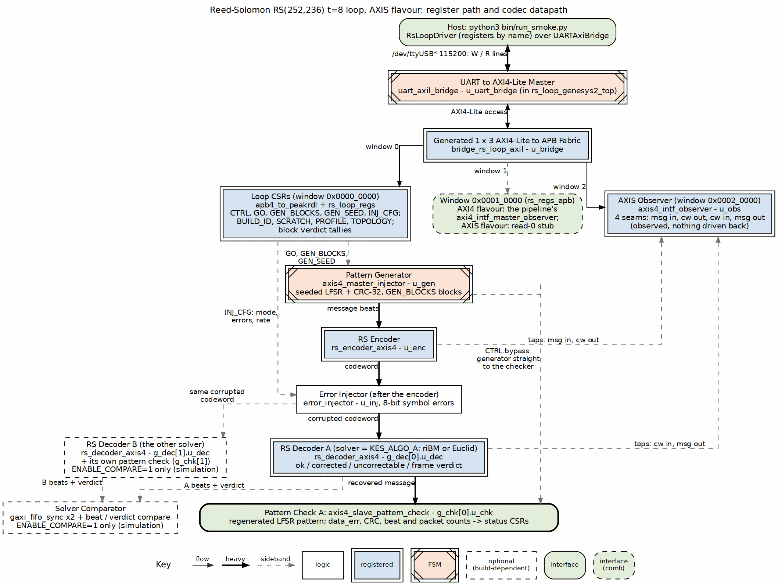
Reed-Solomon AXIS datapath and register path
Source: 01_rs_axis_loop.dot
Window 0 at 0x00000000 is rs_loop_apb, which feeds the shared apb4_to_peakrdl shim and then the generated rs_loop_regs block — that is where BUILD_ID, SCRATCH, PROFILE, TOPOLOGY, INJ_CFG, and the status/counter registers live. Window 1 at 0x00010000 is rs_regs_apb; on the AXI4 flavor it hosts the axi4_intf_master_observer watching the codec’s four AXI4 master ports, while on AXIS flavors it is a read-zero stub so the host bus never hangs. Window 2 at 0x00020000 is obs_apb, always live, where an axis4_intf_observer watches the four AXIS seams in codeword order: message-in, codeword-out, codeword-in, message-out. The fabric definition is frozen in rtl/bridges/generated/bridge_rs_loop_axil/bridge_rs_loop_axil.toml, so adding a new window is a bridge regeneration rather than a harness rewrite.

4.2 Clock and reset
Clock and reset differ only at the board top. On the Genesys 2 the 200 MHz LVDS system clock passes through IBUFDS into an MMCME2_BASE with VCO = 1200 MHz and CLKOUT0_DIVIDE_F = 12, producing the 100 MHz harness clock (build-loop/rtl/rs_loop_genesys2_top.sv). The Nexys A7 top uses the on-board 100 MHz clock directly (build-loop/rtl/rs_loop_top.sv). Both synchronize the active-low pushbutton reset into the 100 MHz domain before it reaches rs_loop_harness. All of the downstream geometry — including the UART divisor — comes from rs_loop_cfg_pkg.sv, so the clock constant and the MMCM output cannot drift apart.

RTL Design Sherpa · Learning Hardware Design Through Practice GitHub · Documentation Index · MIT License

5 Harness Address Map
The host sees one flat 32-bit AXI4-Lite address space. The UART bridge (uart_axil_bridge) is the master, and the generated bridge_rs_loop_axil fabric decodes it into three 4 KB APB windows. Everything the host can reach is in those windows; adding a new window is a bridge regeneration, not a harness rewrite.

5.1 Figure 2.2: UART harness address map
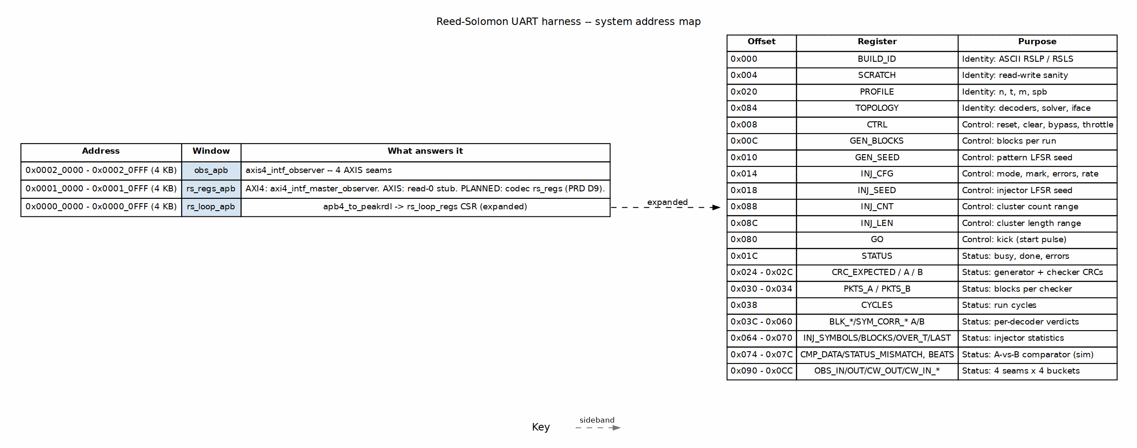
UART harness address map
Source: 02_rs_uart_address_map.dot

5.2 Window summary
Base | Size | Window | What answers it
0x0000_0000 | 4 KB | rs_loop_apb | The harness CSR block rs_loop_regs, reached through the shared apb4_to_peakrdl shim. This is where BUILD_ID, SCRATCH, PROFILE, TOPOLOGY, control, status, verdict tallies and bandwidth meters live.
0x0001_0000 | 4 KB | rs_regs_apb | As built today: on the AXI4 flavour the pipeline’s axi4_intf_master_observer answers this window; on the AXIS flavour it is tied to PRDATA=0, PREADY=1 so a stray access cannot hang the host bus. PLANNED: the codec’s own rs_regs block from PRD D9 (standalone codec ID, PROFILE, CTRL, job fields, statistics, interrupts).
0x0002_0000 | 4 KB | obs_apb | Always live. An axis4_intf_observer watches the four AXIS seams in codeword order: message-in, codeword-out-of-encoder, codeword-into-decoder, message-out. On the AXI4 flavour the seams are tied off and the observer reads zero, but it still responds.
The fabric definition is frozen in rtl/bridges/generated/bridge_rs_loop_axil/bridge_rs_loop_axil.toml. bin/regen_bridges.sh regenerates the RTL if the windows move.

5.3 rs_loop_apb register offsets
The register block is generated from build-loop/rtl/rs_loop_regs.rdl. The host accesses every register by name through UartRegisterMap over the generated build-loop/dv/tbclasses/rs_loop_regs_regmap.py; no Python code hard-codes an offset.
Offset | Register(s) | Purpose
0x000 | BUILD_ID | Identity: ASCII RSLP (board profile) or RSLS (small Nexys A7 profile).
0x004 | SCRATCH | Read-write sanity register.
0x020 | PROFILE | {n[15:0], t[23:16], m[27:24], spb[31:28]}.
0x084 | TOPOLOGY | What the bitstream built: decoders, solver, comparator, datapath, erasure support.
0x008 | CTRL | soft_reset, clear, bypass, throttle_a, throttle_b, inj_seed_on_start.
0x00C | GEN_BLOCKS | Blocks per run.
0x010 | GEN_SEED | Pattern generator LFSR seed.
0x014 | INJ_CFG | Injector mode, erasure mark, error count, rate.
0x018 | INJ_SEED | Injector LFSR seed.
0x088 | INJ_CNT | Cluster count range (mode 4).
0x08C | INJ_LEN | Cluster length range (mode 4).
0x080 | GO | Single-pulse kick; every consumer starts off the same cycle.
0x01C | STATUS | busy, done flags, error flags, AXI4 stage/overflow.
0x024–0x02C | CRC_EXPECTED, CRC_A, CRC_B | Generator and checker CRC-32s.
0x030–0x034 | PKTS_A, PKTS_B | Blocks received by each checker.
0x038 | CYCLES | Cycles from start until both checkers have every block.
0x03C–0x060 | BLK_OK_A/B, BLK_CORR_A/B, BLK_UNC_A/B, BLK_FRAME_A/B, SYM_CORR_A/B | Per-decoder verdict tallies.
0x064–0x070 | INJ_SYMBOLS, INJ_BLOCKS, INJ_OVER_T, INJ_LAST | Injector statistics.
0x074–0x07C | CMP_DATA_MISMATCH, CMP_STATUS_MISMATCH, CMP_BEATS | A-vs-B comparator (simulation / ENABLE_COMPARE=1 only).
0x090–0x0CC | OBS_IN_*, OBS_OUT_*, OBS_CW_OUT_*, OBS_CW_IN_* | Four seams, four buckets each (productive, backpressure, starvation, idle).
The complete generated register documentation is at build-loop/rtl/generated/rs_loop_regs/docs/rs_loop_regs.md.

5.4 By-name access
The host driver (build-loop/host/rs_loop.py) opens three UartRegisterMap instances:
- regs at HARNESS_BASE = 0x0 using rs_loop_regs_regmap.py.
- obs_axi4 at OBS_AXI4_BASE = 0x0001_0000 using obs_regs_top_regmap.py.
- obs_axis at OBS_AXIS_BASE = 0x0002_0000 using obs_regs_top_regmap.py.
Because the bridge is injectable, the same driver runs over pyserial on the board and over the cocotb UART in simulation.

RTL Design Sherpa · Learning Hardware Design Through Practice GitHub · Documentation Index · MIT License

6 AXI4 Memory-to-Memory Datapath
The default board-validated flavour is the AXIS stream pipe shown in How The Pieces Connect. The same harness also builds an AXI4 flavour (IFACE="AXI4") that replaces the middle of the pipe with a memory-to-memory job chain. The generator, checkers, CSRs and verdict logic are unchanged, so a run reports itself identically whichever middle is built.

6.1 Figure 2.3: AXI4 datapath
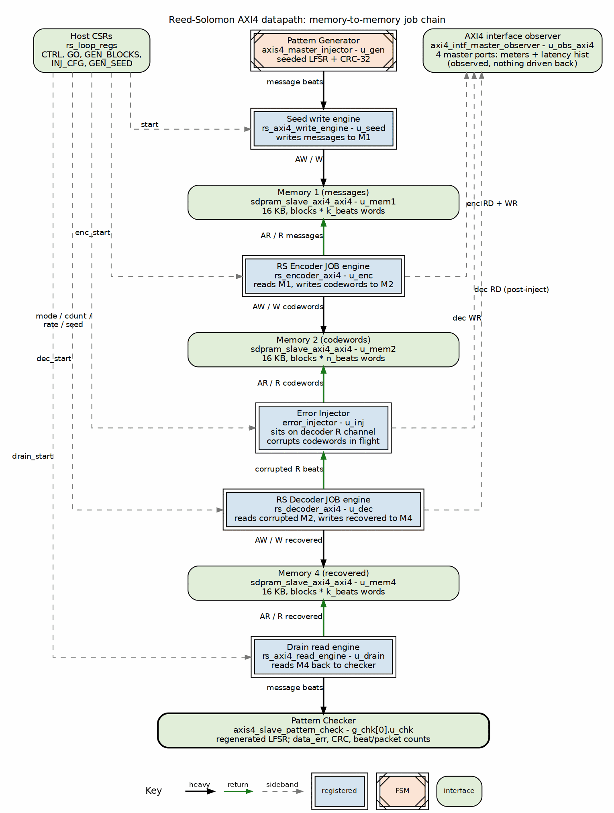
Reed-Solomon AXI4 datapath
Source: 03_rs_axi4_pipeline.dot

6.2 Job chain
The chain is four sequential jobs over three dual-port memories:
- Seed write — the generator’s message stream is written to M1.
- Encode — the encoder reads M1 and writes codewords to M2.
- Decode — the decoder reads M2 and writes recovered messages to M4. The injector sits on the decoder’s read channel, so the codewords are corrupted in flight; no extra memory hop is needed.
- Drain read — the drain engine reads M4 and feeds the pattern checker.
Stage sequencing is done by rising-edge detectors on each stage’s cfg_done, not by a state machine. Each memory has exactly one writer and one reader, so there is no arbitration on the AXI4 channels.

6.3 Memories
All three memories are sdpram_slave_axi4_axi4 instances with MEM_DEPTH = 4096 32-bit words (16 KB each). A single AXI4 run cannot exceed what one memory holds; STATUS.axi4_overflow refuses the kick rather than clamping or silently wrapping.

6.4 Observer
The AXI4 flavour’s rs_regs_apb window (0x0001_0000) hosts an axi4_intf_master_observer instantiated inside rs_axi4_pipeline. It watches the codec’s four master ports:
Port | Direction | What it carries
encoder RD | read | M1 message read
encoder WR | write | M2 codeword write
decoder RD | read | M2 codeword read, after the injector
decoder WR | write | M4 recovered write
The observer provides the same bus-meter cycle buckets as the AXIS observer, plus log2 latency histograms. ENABLE_MON_TAPS = 0 keeps it purely passive so it cannot throttle the datapath.

6.5 Verdict path
Because the decoder reaches its verdict during the decode stage while the beats arrive at the checker later, during the drain stage, the per-block tally cannot follow the AXI4 data path. The pipeline accumulates its own verdict totals (blk_ok, blk_corr, blk_unc, blk_frame, sym_corr) and the CSR block selects those sources when TOPOLOGY.iface indicates AXI4.

7 The FPGA-Testing Choices, And Why

7.1 The dual-solver loop as mutual oracle
The AXIS datapath feeds the same corrupted blocks to two rs_decoder_core instances, one with KES_ALGO=RIBM and one with KES_ALGO=EUCLID. Each decoder’s output is compared beat-by-beat against the generator’s regenerated LFSR pattern in its own axis4_slave_pattern_check, so a correction is judged by a reference that never saw the errors — not by the other decoder. A separate comparator then requires the two decoders to agree on every beat and on every block’s verdict. That makes a solver bug visible as a disagreement even when both decoders “correct.” On the board images this comparator is present only in simulation (ENABLE_COMPARE=1); the production board matrix carries one solver per bitstream to save area and keep the handshake clean for the bandwidth meters. The cross-solver check then happens by running the identical deterministic campaign on the riBM and Euclid images and requiring matching numbers.

7.2 Determinism makes the riBM and Euclid images cross-oracles
The host-side RNG seed defaults to 1. With that default, the random, soak, clusters, localized, and badblock campaigns are fully deterministic: the riBM and Euclid images run bit-identical workloads. On the 2026-10-05 Genesys 2 battery all four single-decoder images passed 7/7 campaigns, and the matching verdict counts between riBM and Euclid are themselves the cross-check. You do not need the on-chip comparator to know the two solvers agree — the campaigns prove it.

7.3 Injector modes map to real failure mechanisms
The shared error_injector operates on 8-bit symbols, because that is RS’s natural unit. Mode 1 exact-count places exactly e errors per block at uniformly random distinct positions, which is what makes the e = t / e = t + 1 boundary sharp. Mode 2 burst and mode 3 rate model raw channel bit-error behavior. Modes 4 clusters and 5 localized model spatially correlated faults — a bad DRAM row, a disturbed NAND page, or a failed symbol column. Mode 6 badblock models the tail of NAND retention: most blocks clean, a hard minority very bad. Mode 7 debug is the deterministic bring-up walk. When INJ_CFG.mark is set, the injector’s hit mask rides the decoder in_erasure sideband, turning any of these placement modes into an erasure run where the decoder is told which symbols were corrupted.

7.4 Post-encoder injection protects parity symbols
Errors are injected after the encoder, not in the generator. An error in the generator’s data would be encoded faithfully and would be invisible to the code. Placing the injector on the coded stream means parity symbols are corrupted too, which is the workload the decoder actually has to handle. That is why the generator has no error-injection mode and the injector is a separate block.

7.5 UART over a debug core, with a lock/readback safety pair
The harness uses a plain UART instead of a proprietary debug core, so the host side is just pyserial and Python scripts. Board safety is a pair: board_lock.sh serializes programming flows by the board’s JTAG serial, and fpga_board.py reads the JTAG chain through jtag_readback.tcl before programming to confirm the expected Genesys 2 serial (200300B818A0) is present with a device behind it. A lock prevents collisions; a readback detects misattribution. When the hw_server deviceless-enumeration race refused about half of programming attempts, the readback path was changed to bounce hw_server and retry, bounded at five. The verdict is recorded beside the bitstream sha256 so a result file cannot be mistaken for verified if the identity check was inconclusive.

7.6 Genesys 2 over Nexys A7
The Kintex-7 XC7K325T-2 was chosen because it has room for the full harness plus observers and still closes timing with positive slack. The four Genesys 2 images routed with WNS from +0.875 ns to +1.822 ns. The Nexys A7-100T flow is kept as a target option (RS_TARGET=nexys_a7_100t) and the original image names and report layout stay byte-identical, but the Genesys 2 is the primary target for harness-class work.

7.7 AXIS and AXI4 flavors cover both integration styles
The AXIS flavor is a single streaming pipe: generator, encoder, injector, decoder, checker. The AXI4 flavor replaces the middle with rs_axi4_pipeline, a memory-to-memory job chain over block RAM. Both use the same generator, checker, CSRs, and verdict logic, so a run reports itself identically whichever middle is built. The AXI4 flavor refuses a GEN_BLOCKS value that would exceed the job memories — it declines rather than clamps, because clamping would answer a question the host did not ask. Running the same deterministic campaign on both flavors is a free sanity check: at e = 8 the AXI4 flavor takes 381.0 cycles/block against 199.2 on AXIS. The two numbers must be consistent for the same workload, and they are. The million-block soak ran on axi4_ribm; an earlier plan to prefer AXIS for soaks proved unnecessary.

8 Operating It
To run on the Genesys 2:
cd projects/fpga-systems/Genesys2/ecc-ip/reed-solomon
bin/run_smoke.py --board genesys2 --port /dev/ttyUSB0 --sequences init smoke sweep
For the Nexys A7 small profile, build the bitstream with make -C build-loop bitstream RS_TARGET=nexys_a7_100t RS_PROFILE=small and drive the same sequences over the A7’s UART; init proves the “RSLS” BUILD_ID and the PROFILE CSR reports n=64, t=4, so the host programs pick up the geometry from the board.
See README.md and Makefile for the full target list (bitstream, lint, sim, regmap) and build-loop/host/host_rs_loop.py for the lower-level CLI. Build evidence and the board-validation record live in stable/MANIFEST.md and the four stable/reports/genesys2_* directories. Campaign transcripts turn into reports with projects/fpga-systems/bin/report_battery.py (JSON artifacts, correction-boundary / decode-cost / soak-timeline figures, and a generated FINDINGS.md); published runs live under stable/results/. The run evidence — the 2026-10-05 four-image battery and the one-million-block soak — is rolled up in the companion Reed-Solomon Board Validation Report (docs/Reed_Solomon_Board_Validation_v0.1.pdf). The math behind the codec is in the component HAS chapter 7 at projects/components/ecc-ip/reed-solomon/docs/reed_solomon_has/ch07_understanding_the_math/. The sister BCH harness has the matching guide at ../../bch/docs/Binary_BCH_UART_Harness_v0.1.pdf.

9 What Is Deliberately Not Board-Tested
A few things are intentionally left in simulation or are still open:
- The 2026-10-05 board battery ran the four single-decoder images. The dual-decoder comparator with ENABLE_COMPARE=1 is the sim/DV domain; it caught real harness bugs (dropped/duplicated beats under skewed drains) without costing a bitstream.
- The erasure f = 2t boundary is a known open bug, filed as vault/tracking/projects/components/ecc-ip/reed-solomon/task/open/TASK-005.md. f = t corrects and f = 2t + 1 refuses on the board; f = 2t is flagged uncorrectable even though the design intent says it should correct.
- The component DV matrix — 195 cells per TASK-001.md — exercises the codec in ways the board harness does not replicate.
- The board validates two profiles: RS(252,236) t=8, S=4 on the Genesys 2, and the small RS(64,56) t=4 on the Nexys A7 (RS_PROFILE=small, issue #83); profiles outside those two are covered in simulation and component DV.
- The 2026-10-05 million-block soak is statistical, not exhaustive; its counters, the 2-of-74,240 mis-decodes, and the bounded-rate pass criterion are reported in the Board Validation Report.

