
RTL Design Sherpa
pumice on the Nexys A7 The FPGA System: Harness, Builds, Flow -- Version 1.0
September 2026

Table of Contents
1 Document Information 9
1.1 Related documents 9
1.2 Terminology 10
1.3 Revision History 10
1.4 How to read this book 11
2 The System 12
2.1 What is on the bench 12
2.1.1 Figure 1.1: The bench 12
2.2 The board and the part 13
2.3 The single USB connector 13
2.4 The clock chain, and why it fixes every later number 14
2.5 Where the DUT ends and the harness begins 14
3 The Harness 15
3.1 The shape of it 15
3.1.1 Figure 2.1: The harness block map 16
3.2 The host front-end 16
3.3 harness_csr: the registers that define a run 18
3.4 The engine spine, and why it is a separate block 20
3.5 The DFI tail 21
3.6 Observability, and one honest compromise 21
3.7 Why the APB CDC is an async FIFO and not a handshake 22
4 Address Map 23
4.0.1 Figure 2.2: pumice build-perf UART/AXI4-Lite address map 23
4.1 Bridge slave windows 23
4.2 harness_csr register map 25
4.3 What is as-built vs. not used 28
4.4 See also 28
5 One Harness, Five Targets 29
5.1 The short answer 29
5.1.1 Figure 3.1: One harness source, five targets 29
5.2 The five targets 30
5.3 What the ILA builds change, and what they do not 31
5.4 The LiteDRAM build is the point of the whole structure 31
5.5 The simulation twin 32
5.6 The frequency define is part of the build identity 32
5.7 What is parameterized, and the one that bites 32
6 Host Tools and Flow 34
6.1 The shared transport 34
6.2 From a command to a number 35
6.2.1 Figure 4.1: From host command to a row of the CSV 35
6.3 Step 1: bring-up, once per bitstream 35
6.4 Steps 2 to 5: configure, run, measure, read back 36
6.5 Step 6: recording, and the arithmetic that has already gone wrong once 36
6.6 Integrity is what makes throughput mean anything 36
6.7 One program, two targets 37
6.8 The bench programs worth knowing 37

List of Figures
Figure 1.1: The bench 12
Figure 2.1: The harness block map 16
Figure 2.2: pumice build-perf UART/AXI4-Lite address map 23
Figure 3.1: One harness source, five targets 29
Figure 4.1: From host command to a row of the CSV 35

List of Tables
Table 1: Table 0.1: Document information 9
Table 2: Table 0.2: Related documents 9
Table 3: Table 0.3: Revision history 10
Table 4: Table 1.1: Board and memory device 13
Table 5: Table 2.1: The bridge address map 17
Table 6: Table 2.2: harness_csr, the registers that define a run 18
Table 7: Table 2.3: The engine spine 20
Table 8: Table 2.4: Bridge address decode for the pumice build 23
Table 9: Table 2.5: harness_csr register offsets for the pumice build 25
Table 10: Table 3.1: The five targets built from one harness source 30
Table 11: Table 3.2: Build-time and run-time parameters 32
Table 12: Table 4.1: The shared host transport 34
Table 13: Table 4.2: The cached leveling result for this board 35
Table 14: Table 4.3: The host programs 37

List of Waveforms
No waveforms in this document.

RTL Design Sherpa · Learning Hardware Design Through Practice GitHub · Documentation Index · MIT License

RTL Design Sherpa · Learning Hardware Design Through Practice GitHub · Documentation Index · MIT License

1 Document Information
Table 0.1: Document information
Field | Value
Title | pumice on the Nexys A7 – The FPGA System
Version | 1.1
Date | 2026-10-20
Scope | The DDR2 characterization system: board, the harness around the controller, the five things built from one harness source, and the host flow
Not in scope | The pumice controller itself (HAS/MAS under projects/components/mem-ctrl-ip/research-ip/pumice-ddr2-lpddr2/docs/); the measured results (build-perf/results/, ddr2-characterization/char_results/)
Status | Current; written against the tree after the mem-ctrl-ip and fabric-gen-ip family moves

1.1 Related documents
Table 0.2: Related documents
Document | Where | What it gives you
pumice HAS / MAS | projects/components/mem-ctrl-ip/research-ip/pumice-ddr2-lpddr2/docs/ | the controller’s own architecture; this book treats it as the DUT
Harness address map | build-perf/host/ADDRESS_MAP.md | the authoritative register decode, mirrored from the RTL
LiteDRAM flow README | ddr2-characterization/flows-litedram-uart/README.md | the A/B reference build and its config
DDR2 char guide | ddr2-characterization/docs/ddr2_char_guide/ | the older operator guide (v0.90)
STREAM / RAPIDS system books | projects/fpga-systems/Genesys2/*/docs/*_fpga_system/ | the same book for the Genesys 2 boards

1.2 Terminology
DFI DDR PHY Interface. The boundary between the controller and the PHY, and the same boundary the DV repo’s BFM drives in simulation.
a7ddrphy LiteDRAM’s Artix-7 DDR PHY, reused verbatim. It owns the IOB serdes, bitslip and IDELAY training that are FPGA-specific and deliberately out of the controller’s scope.
Harness Everything in the bitstream that is not the DUT: the UART bridge, the address bridge, the CSR block, the stimulus generators, the meters and the displays.
Engine spine char_engine_block.sv – the DUT-agnostic part of the harness: generator registers, generator array, AXI merge, bus meters and latency histograms.
Design point 75 MHz system clock (PUMICE_SYS_75), 1:2 gear to a 150 MHz DDR2 clock, 300 MT/s, BL4 on a 16-bit bus: 600 MB/s theoretical peak.

1.3 Revision History
Table 0.3: Revision history
Version | Date | Change
1.0 | 2026-09-29 | First edition. Written after the family-directory moves, so every path in it is mem-ctrl-ip/ and fabric-gen-ip/.
1.1 | 2026-10-20 | Block diagrams redrawn to the repo element key (v3): class fills, double-bordered registered blocks, green return paths and a generated key under each figure. No technical content changed.

1.4 How to read this book
Chapter 1 is the bench: one USB connector, one DRAM part, and the clock chain that fixes the peak every later number is measured against. Chapter 2 is the bitstream around the DUT, block by block, with the address map every host tool depends on – and, for each block, why it is shaped the way it is. Chapter 3 is the chapter that answers the question people actually ask: the harness RTL does not change per build, and the chapter says what does. Chapter 4 is the measurement loop, including two traps that have each cost a wrong conclusion.
Every diagram is a Graphviz source under assets/graphviz/, rendered to PNG by regenerate_all_graphviz.sh. Edit the .dot, re-run the script, never hand-edit a PNG.

RTL Design Sherpa · Learning Hardware Design Through Practice GitHub · Documentation Index · MIT License

2 The System

2.1 What is on the bench
One Nexys A7-100T, one USB cable, one DDR2 part soldered to the board, and a host program on a Linux workstation. The device under test is the pumice DDR2/LPDDR2 memory controller; everything else in the bitstream exists to put traffic through it and count what comes back.
The split matters and this book keeps to it. The controller’s architecture – its AXI front end, its scheduler, its CAMs, its DFI layer – is the subject of the pumice HAS and MAS. What follows is the apparatus: the part you would have to rebuild if you wanted to measure some other controller, which is exactly what the LiteDRAM comparison build does.

2.1.1 Figure 1.1: The bench
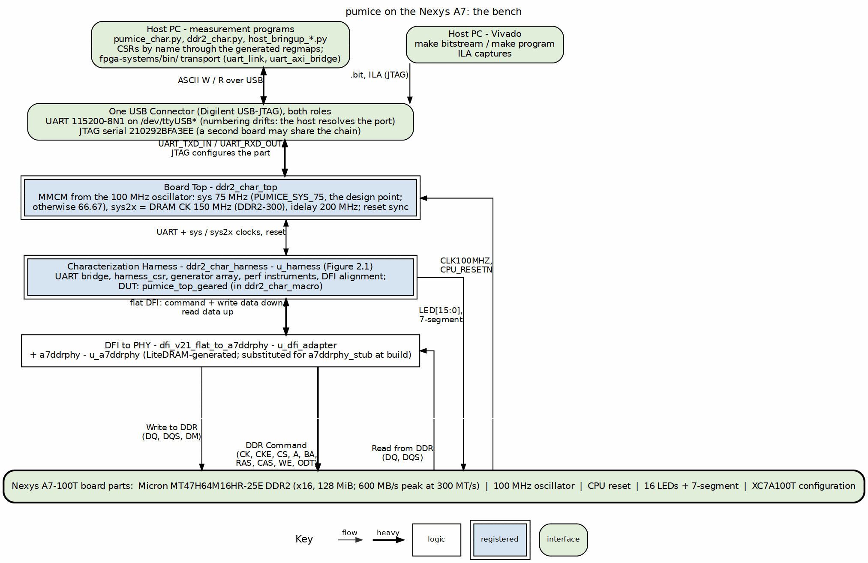
The bench: host, one USB connector, the Artix-7 and the DDR2 part
Source: 01_board_and_host.dot

2.2 The board and the part
Table 1.1: Board and memory device
Item | Value | Source
Board | Digilent Nexys A7-100T | projects/fpga-systems/boards/nexys_a7_100t/board_info.md
FPGA | Xilinx Artix-7 XC7A100T-1CSG324C | same
Oscillator | 100 MHz, single | same
DRAM | Micron MT47H64M16HR-25E, DDR2, x16, single rank, 128 MiB | ddr2-characterization/README.md
DDR2 banks | Bank 34 at 3.3 V LVCMOS33, Bank 35 at 1.5 V SSTL15 | board_info.md
Note: board_info.md records the DRAM as “128 Mb”, which is the bit count of the wrong generation of part. MT47H64M16 is 64 M addresses by 16 bits = 1 Gbit = 128 MiB, which is what the characterization README states and what the address map assumes. Where the two disagree, the part number wins.

2.3 The single USB connector
One connector does both jobs: it carries the JTAG chain that programs the device and drives the ILA, and it carries the UART the host talks to. The practical consequences are what the tooling has to cope with:
- JTAG is addressed by serial number, 210292BFA3EE, because both this board and the Genesys 2 sit on the same chain on this bench.
- The UART is not addressed by a constant. It appears as some /dev/ttyUSB*, the numbering drifts between plug-ins, and a second board may be present. The host resolves the port rather than hardcoding it; the cdc_demo driver on the same board carries the same comment for the same reason.
This is the one place where the Nexys A7 is simpler than its sibling. The Genesys 2 needs two chips – an FT2232 for JTAG and a separate FT232R for the UART, each enumerating independently – and its system book has a whole section on telling them apart.

2.4 The clock chain, and why it fixes every later number
The board has one 100 MHz oscillator. From it the design derives a 75 MHz system clock and, through a 1:2 gear, a 150 MHz DDR2 clock giving 300 MT/s on the bus. With BL4 on a 16-bit bus that is:
300 MT/s x 2 bytes = 600 MB/s theoretical peak
That 600 MB/s is the denominator of every percentage in every findings page. It is not a target, it is arithmetic; quoting a throughput without it is how a number stops meaning anything, which is why the house rule is that a bandwidth table carries the measured figure and the peak.
The 75 MHz profile is selected by the PUMICE_SYS_75 define. It is the design point, and build-perf/fpga/tcl/create_project.tcl says so in as many words – it prints the frequency profile at build time and labels the alternative, PUMICE_SYS_75=0 at 66.67 MHz, as not the board design point. A bitstream built without the define will work and will report lower numbers, and a reader comparing those against the design-point results would draw a false conclusion.
Important: the timing margin at 75 MHz is deliberately thin. A positive worst-negative-slack of a few tens of picoseconds is the design point being met, not a near miss – the most recent measurement build closed at WNS +0.031 ns. Report the sign and the value; do not “fix” a thin positive margin.

2.5 Where the DUT ends and the harness begins
The boundary is DFI v2.1, and it was chosen so that the same boundary is exercised in three places: by the DV repo’s DFI BFM in simulation, by the a7ddrphy_stub in the harness’s own cosim, and by LiteDRAM’s real a7ddrphy on the board. Code that passes in cocotb against the BFM should pass on hardware against the PHY, modulo PHY-side training – and PHY training is precisely what Chapter 4’s bring-up sweeps exist to settle.
The PHY itself is out of scope for the controller family on purpose. IOB serdes, bitslip, IDELAY tap calibration: all FPGA-specific, none of it something a DDR2 controller should own. So the harness reuses LiteDRAM’s a7ddrphy verbatim rather than reimplementing it.

RTL Design Sherpa · Learning Hardware Design Through Practice GitHub · Documentation Index · MIT License

3 The Harness

3.1 The shape of it
The harness is a host front-end, a DUT-agnostic engine spine, the DUT, the DFI tail, and two kinds of observability. Read the figure left to right and the whole apparatus is one sentence: UART bytes become register writes, register writes start generators, generators put AXI traffic through the controller, meters count what the controller did with it, and the host reads the counters back.

3.1.1 Figure 2.1: The harness block map
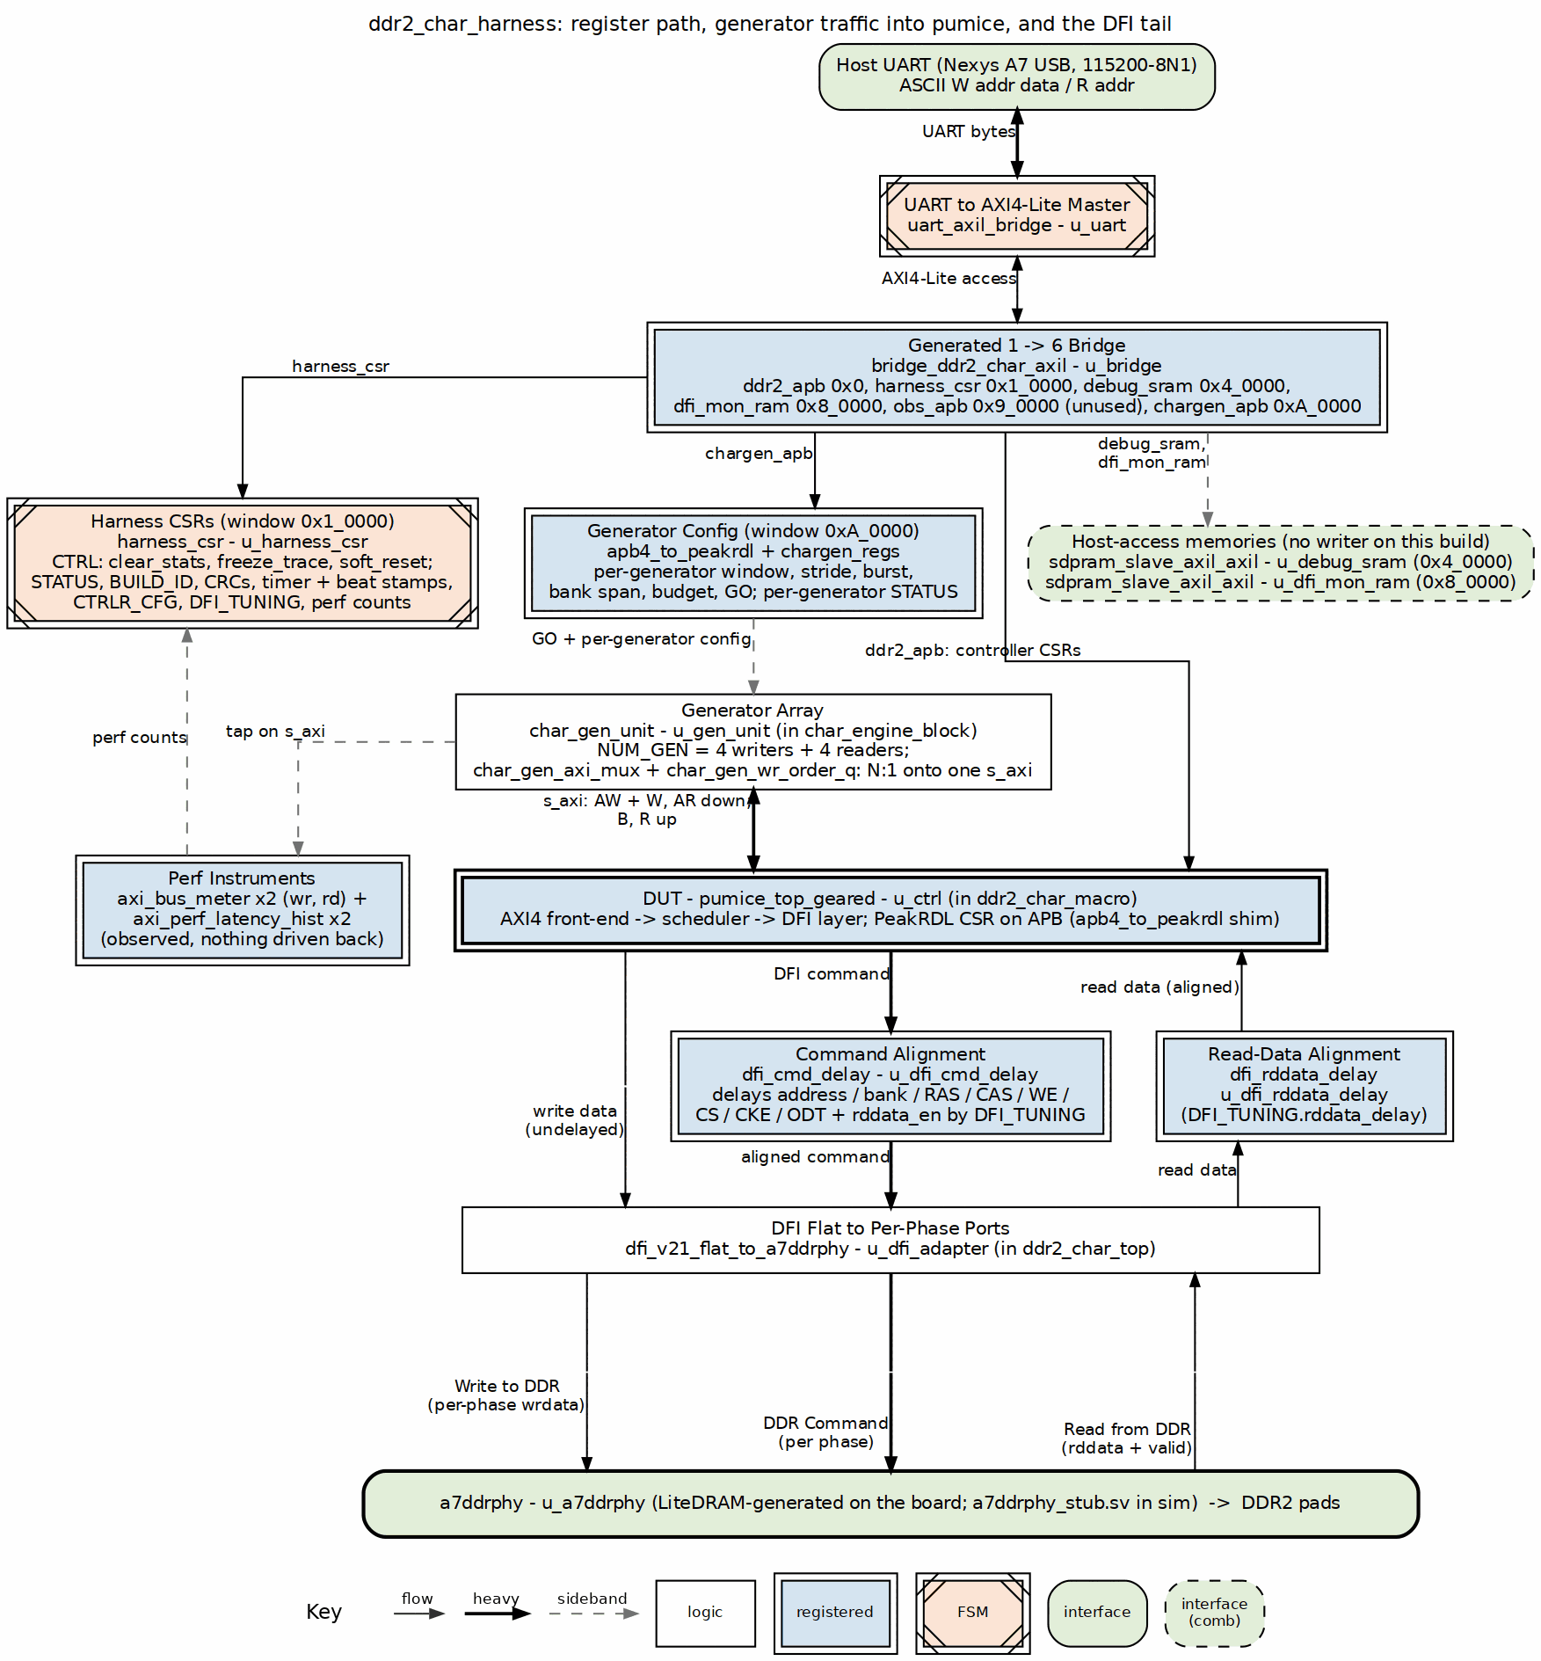
ddr2_char_harness: the blocks around the DUT, and the address map
Source: 02_harness_blocks.dot

3.2 The host front-end
uart_axil_bridge turns the UART byte stream into a 32-bit AXIL master. bridge_ddr2_char_axil – a generated bridge, from ddr2_char_framework/rtl/bridges/configs/bridge_ddr2_char_axil.toml – fans that one master out to six slaves at fixed bases.
Table 2.1: The bridge address map
Slave | Base | Size | Protocol | Purpose
ddr2_apb | 0x0000_0000 | 4 KB | APB | pumice controller CSR (PeakRDL-generated)
harness_csr | 0x0001_0000 | 4 KB | AXIL | harness control, timer, engine cfg, perf readback
debug_sram | 0x0004_0000 | 256 KB | AXIL 64b | host-access memory; no writer on this build (the trace ring is unused, see below)
dfi_mon_ram | 0x0008_0000 | 4 KB | AXIL | placeholder for DFI command observability; no writer on this build, host access only
obs_apb | 0x0009_0000 | 4 KB | APB | expansion slot for an interface observer; unused on this build
chargen_apb | 0x000A_0000 | 4 KB | APB | chargen_regs: per-generator configuration, status and GO
Two details in that map are deliberate rather than accidental. The 256 KB debug_sram window spans 0x4_0000..0x7_FFFF, which is why dfi_mon_ram sits at 0x8_0000 and not at 0x5_0000 – placing it lower would have overlapped. And the slot at 0x2_0000..0x3_FFFF is unallocated: it used to hold a desc_ram, which became unnecessary once the pattern-generator engines covered the workload class the descriptor mode was reserved for.
Important: build-perf/host/ADDRESS_MAP.md mirrors this decode for convenience, and says outright that the RTL is authoritative. If the two disagree, the fix is to the document, not to the hardware.

3.3 harness_csr: the registers that define a run
Table 2.2: harness_csr, the registers that define a run
Off | Register | R/W | What it does
0x00 | CTRL | RW | clear_stats, freeze_trace (latch), soft_reset; bits 0/1 (start_wr, start_rd) are retired – launch is chargen_regs.GO
0x04 | STATUS | R | per-direction done/error, any_error, init_done, init_fail
0x10/0x14 | CRC_EXPECTED / CRC_ACTUAL | R | write-engine expected CRC, read-engine actual CRC
0x18 | CRC_MATCH | R | exp==act, both valid bits, and beats_mism != 0
0x24 | BEATS_MISM | R | mismatched beat count from the read engine
0x20 | BUILD_ID | R | 0x44445232, the ASCII DDR2 – proves you are talking to this build
0x28-0x5C | timer block | RW/R | 64-bit cycle counter, beat-count stop trigger, and first/last R and W beat stamps
0x60 | CTRLR_CFG | RW | memtype (DDR2/LPDDR2), t_phy_wrlat, t_rddata_en, rd_in_order
0x64 | CTRLR_CAP | RW | scheduler lookahead and synth-mask caps
0x80-0x8C | PHY CSR passthrough | RW/R | indirect access to the a7ddrphy leveling knobs
The first/last beat stamps are what make a throughput number defensible: they bound the window the bytes actually moved in, so the host divides by a measured interval rather than by “however long the host thought the run took”.
BUILD_ID exists because the cheapest way to waste an afternoon is to measure a stale bitstream. A host that cannot read DDR2 back is talking to something else.
Note: RESP_DELAY at 0x3C is present and documented as unwired. axi_response_delay.sv is committed under ddr2_char_framework/rtl/ and carried in the filelist but not instantiated, so that adding programmable memory latency later is a one-line swap-in rather than a new dependency. A register that reads back what you wrote and changes nothing is a trap unless it is labelled, which is why it is labelled here and in the address map.

3.4 The engine spine, and why it is a separate block
char_engine_block.sv is the part of the harness that does not know what the DUT is. It holds the generator registers, the generator array, the AXI merge, and the instruments:
Table 2.3: The engine spine
Block | Role | Why it is shaped this way
chargen_regs (PeakRDL) | per-generator address window, stride, burst length, bank span, transaction budget | the stimulus is described, not compiled in, so a sweep is a host loop and not a rebuild
char_gen_unit | NUM_GEN = 4 write and 4 read generator blocks (the default; no build overrides it) | each spans NUM_BANKS / NUM_GEN banks, so bank concurrency is a property of the stimulus, not of the controller – that is what makes the bank/gap knee measurable
char_gen_axi_mux + char_gen_wr_order_q | N:1 merge onto the DUT’s single s_axi | see below
axi_bus_meter | per cycle: productive, backpressure, starvation, idle | four states that account for every cycle; this is where “the arbiter is idle 33% of the time” came from
axi_perf_latency_hist | response-time histograms | a mean hides a bimodal distribution, which is exactly what a page-policy change produces
The merge deserves its own paragraph because it replaced something. It used to be two generated 2x1 bridges. They were not removed because their routing was wrong – at 2x1 that routing is a combinational grant-lock round robin and the replacement works the same way. They were removed because of the four generated adapters wrapped around them, which imposed a bridge_cam DEPTH(16) cap on outstanding transactions and two skid stages per direction. On a harness whose measurement is latency, the apparatus was setting the answer. The generated configurations are still in the tree so both paths can be built and compared; nothing in this build reads them.

3.5 The DFI tail
Between the controller and the pads sit three things, and all three are harness, not DUT:
- dfi_cmd_delay and dfi_rddata_delay – programmable command and read-data alignment. These are the knobs the bring-up sweeps turn, and the reason a working board configuration is a tuple rather than a single number.
- dfi_v21_flat_to_a7ddrphy – flat DFI to the PHY’s per-phase ports.
- the PHY itself: a7ddrphy_stub.sv for verilator and cocotb, and LiteDRAM’s generated a7ddrphy on hardware. Vivado excludes the stub and substitutes the real PHY at build time. The generated PHY is never hand-edited – when the PHY DQ tristate had to be observed, the ILA was marked on the synthesized netlist instead, which is what the ila_phy build is.
The PHY leveling knobs are driven by firmware, not by a hardware state machine: there are 13 of them, reached indirectly through the four PHY_CSR_* registers, with the knob map in rtl-vivado/a7ddrphy/a7ddrphy_csr_map.txt. Only meaningful on hardware; the sim stub ignores the writes.

3.6 Observability, and one honest compromise
dfi_mon_ram is reserved for DFI command observability but has no writer on this build – only the host reads and writes it – and seven_seg_4digit plus led_status_driver give state at the bench with no host attached – a heartbeat and a pass/fail byte are enough to tell “hung” from “running” across the room.
debug_sram is the compromise. The full-size 256 KB trace ring would have needed roughly 44 K LUT-as-distributed-RAM cells against the 100T’s 19 K sites – 2.4x over the device – and it blocked place_design outright. The backing store is therefore shrunk to DEBUG_SRAM_WORDS=512 (256 x 64-bit = 2 KB) and the trace ring is not used on this build. The 256 KB address window is unchanged, so accesses above 2 KB alias back into the ring rather than erroring.
Important: that aliasing is the dangerous part. A reader who downloads the window and finds plausible-looking repeated data has not found a trace; they have found the same 2 KB four hundred times over. Raise DEBUG_SRAM_WORDS in ddr2_char_harness.sv on a device with headroom before trusting a trace from this window.

3.7 Why the APB CDC is an async FIFO and not a handshake
The controller’s CSR window reaches it through apb4_slave_cdc and peakrdl_to_cmdrsp. The CDC inside apb4_slave_cdc is a gray-pointer async FIFO (gaxi_fifo_async), deliberately not a toggle handshake, and the reason is a reset asymmetry specific to this harness: the APB side runs on presetn and the core side on aresetn, and CTRL.soft_reset pulses only the core side. A toggle-parity handshake desynchronizes across that asymmetric reset and leaves the response stream permanently offset by one transaction – every readback returns the answer to the previous question. An async FIFO with gray pointers re-synchronizes instead of latching a parity error.
This is recorded in the filelist that pulls the CDC in, next to the dependency it justifies, which is the right place for it: the next person to “simplify” that CDC reads the reason before they do it.

RTL Design Sherpa · Learning Hardware Design Through Practice GitHub · Documentation Index · MIT License

4 Address Map
The host sees one 32-bit address space. The UART bridge (uart_axil_bridge) turns the ASCII command stream into AXI4-Lite transactions, and the generated bridge_ddr2_char_axil decodes that master into the six slave windows below. Every base and size comes from the bridge TOML; every harness_csr offset comes from harness_csr.sv.

4.0.1 Figure 2.2: pumice build-perf UART/AXI4-Lite address map
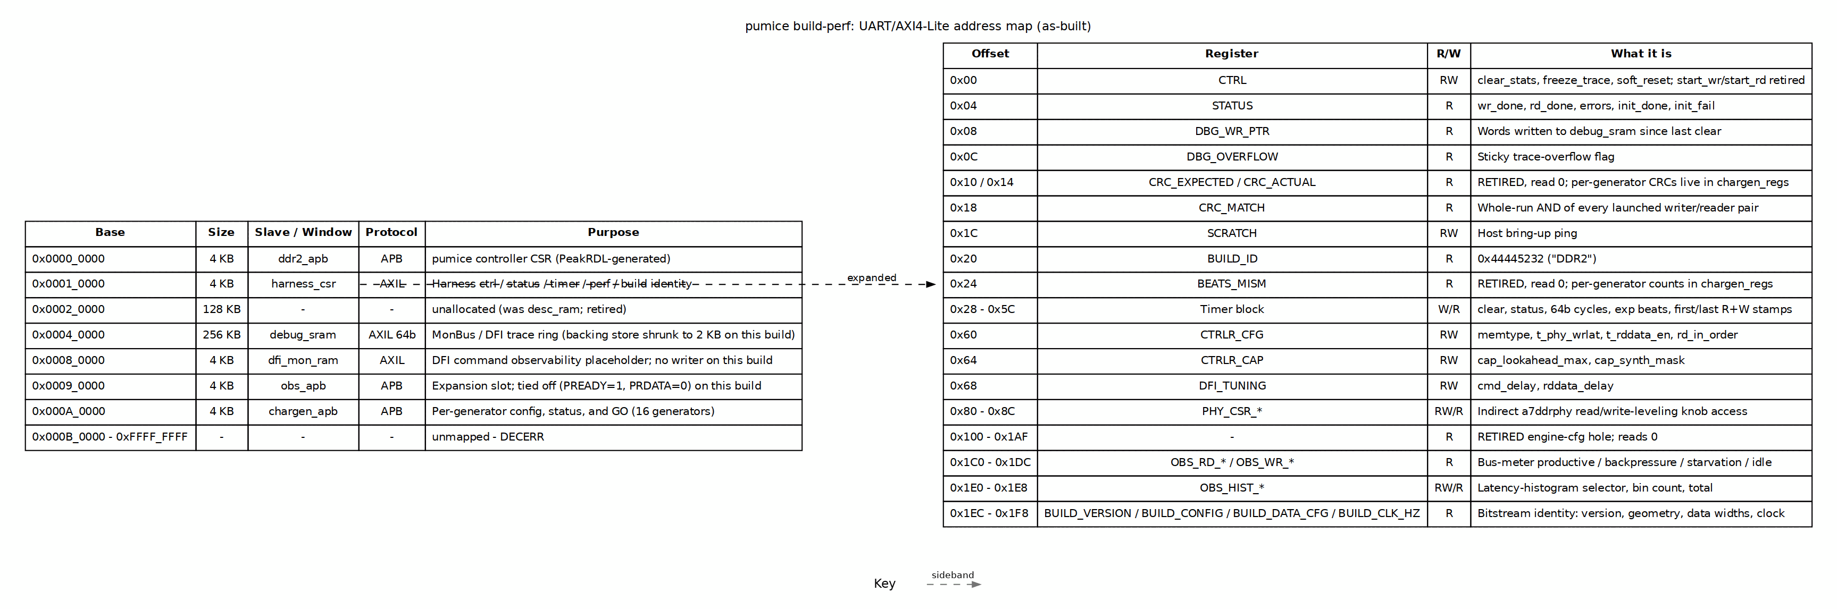
pumice build-perf UART/AXI4-Lite address map
Source: 05_address_map.dot

4.1 Bridge slave windows
Table 2.4: Bridge address decode for the pumice build
Slave | Base | Size | Protocol | Purpose
ddr2_apb | 0x0000_0000 | 4 KB | APB | pumice controller CSR (PeakRDL-generated)
harness_csr | 0x0001_0000 | 4 KB | AXIL | Harness control / status / timer / perf / build identity
unallocated | 0x0002_0000 | 128 KB | - | Former desc_ram slot; retired
debug_sram | 0x0004_0000 | 256 KB | AXIL 64b | MonBus / DFI trace ring (backing store shrunk to 2 KB on this build)
dfi_mon_ram | 0x0008_0000 | 4 KB | AXIL | DFI command observability placeholder; no writer on this build
obs_apb | 0x0009_0000 | 4 KB | APB | Expansion slot for axi4_intf_master_observer; tied off on this build
chargen_apb | 0x000A_0000 | 4 KB | APB | chargen_regs: per-generator config, status, and GO
The 256 KB debug_sram window intentionally occupies 0x4_0000..0x7_FFFF, so dfi_mon_ram sits at 0x8_0000 rather than 0x5_0000 to avoid overlap.

4.2 harness_csr register map
All offsets are relative to HARNESS_CSR_BASE (0x0001_0000). The host accesses these by name through the PeakRDL-generated regmap; offsets are shown here only for debug.
Table 2.5: harness_csr register offsets for the pumice build
Offset | Register | R/W | What it does
0x00 | CTRL | RW | clear_stats, freeze_trace (latch), soft_reset; bits 0/1 (start_wr/start_rd) are retired
0x04 | STATUS | R | wr_done, rd_done, wr_error, rd_error, any_error, dbg_clear_busy, init_done, init_fail
0x08 | DBG_WR_PTR | R | Words written to debug_sram since last clear
0x0C | DBG_OVERFLOW | R | Sticky trace-overflow flag
0x10 / 0x14 | CRC_EXPECTED / CRC_ACTUAL | R | Retired — read 0; per-generator CRCs live in chargen_regs
0x18 | CRC_MATCH | R | Whole-run AND of every launched writer/reader pair
0x1C | SCRATCH | RW | Host bring-up ping
0x20 | BUILD_ID | R | 0x44445232 (ASCII DDR2)
0x24 | BEATS_MISM | R | Retired — read 0; per-generator counts live in chargen_regs
0x28 | TIMER_CTRL | W | Clear-pulse for timer
0x2C | TIMER_STATUS | R | done, running, pass
0x30 / 0x34 | TIMER_CYCLES_LO / HI | R | 64-bit cycle counter
0x38 | TIMER_EXP_BEATS | RW | Beat-count stop trigger (0 = disable)
0x3C | RESP_DELAY | RW | Present but unwired on this build
0x40–0x5C | TIMER_R/W_FIRST/LAST_LO/HI | R | First/last R and W beat timestamps
0x60 | CTRLR_CFG | RW | memtype, t_phy_wrlat, t_rddata_en, rd_in_order
0x64 | CTRLR_CAP | RW | cap_lookahead_max, cap_synth_mask
0x68 | DFI_TUNING | RW | cmd_delay, rddata_delay
0x80–0x8C | PHY_CSR_* | RW/R | Indirect access to the a7ddrphy leveling knobs
0x100–0x1AF | — | R | Retired engine-config hole; reads 0
0x1C0–0x1DC | OBS_RD_* / OBS_WR_* | R | Bus-meter buckets: productive, backpressure, starvation, idle
0x1E0–0x1E8 | OBS_HIST_* | RW/R | Latency-histogram selector, bin count, total
0x1EC | BUILD_VERSION | R | Functional build number
0x1F0 | BUILD_CONFIG | R | dfi_rate, gear_ratio, dram_bl, row_width, bank_width
0x1F4 | BUILD_DATA_CFG | R | axi_data_width, dram_beat_width, dram_device_width
0x1F8 | BUILD_CLK_HZ | R | Sys/AXI clock this bitstream was compiled for

4.3 What is as-built vs. not used
- The bridge and harness_csr are fully live.
- ddr2_apb is live and reaches the pumice controller CSR.
- obs_apb is as-built but tied off (PREADY=1, PRDATA=0, PSLVERR=0). A stray access will complete instead of hanging the bus, but it does nothing.
- debug_sram is a live AXIL SRAM, but the trace-ring writer is disabled and the backing store is DEBUG_SRAM_WORDS=512 (2 KB). Accesses above 2 KB alias into the ring.
- dfi_mon_ram is a live AXIL SRAM with no writer on this build.
- The 0x100–0x1AF region in harness_csr is intentionally retired; reads return 0 so an old host that expects the single-engine config fails visibly.

4.4 See also
- build-perf/host/ADDRESS_MAP.md — the same map in text form.
- Chapter 2 harness block diagram (Figure 2.1) — the UART path and the blocks behind each window.

RTL Design Sherpa · Learning Hardware Design Through Practice GitHub · Documentation Index · MIT License

5 One Harness, Five Targets

5.1 The short answer
The harness RTL does not change per build. There is one copy of the engine spine, the CSR block, the DFI delays and the LED driver, in projects/fpga-systems/rtl/mem_char_framework/rtl/ (shared with the LiteDRAM flow), plus the pumice macro, the DFI-to-PHY adapter, the PHY stub and the 7-segment driver in ddr2_char_framework/rtl/, and every target compiles that same source. There are no per-build copies and no ifdef forks of the engine.
What changes between targets is one of exactly three things: the debug cores added after synthesis, the DUT behind the AXI port, or the PHY model. Each is worth a section, because each answers a different question.

5.1.1 Figure 3.1: One harness source, five targets
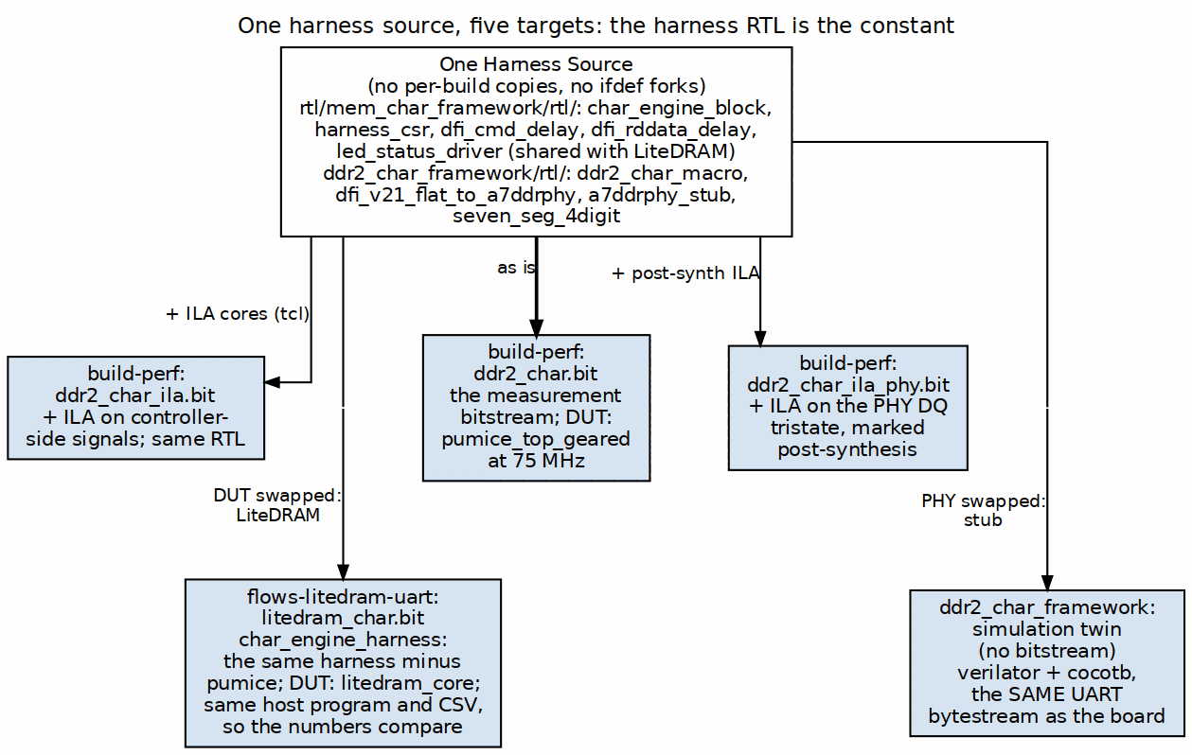
One harness source, five targets. The harness RTL is the constant.
Source: 03_build_variants.dot

5.2 The five targets
Table 3.1: The five targets built from one harness source
Target | Artifact | What differs | What it is for
build-perf base | ddr2_char.bit | nothing – this is the reference | the measurement build; every published number comes from here
build-perf + ILA | ddr2_char_ila.bit | ILA cores added by tcl | watching controller-side signals when a number is surprising
build-perf + PHY ILA | ddr2_char_ila_phy.bit | ILA marked on the synthesized netlist | watching the PHY’s DQ tristate, which has no RTL you may edit
LiteDRAM A/B | litedram_char.bit | the DUT, and the PHY comes with it | is our controller good, compared to what?
simulation twin | none (verilator/cocotb) | the PHY is a stub | validating a host program before it touches hardware
ddr2-characterization/flows-ours-uart/ was the retired “ours over UART” flow and is deleted as of 2026-09-30. It is described here because references to the path outlive the directory, and because what happened to it is a worked example of a real hazard.
Its RTL had already moved to build-perf/. What remained was 203 MB of build output, two bitstreams, and 42 CSVs of ILA captures and timing scans from the July 2026 bring-up – none of it tracked in git, and 41 of those CSVs existing nowhere else in the tree.
Important, and the reason this paragraph is longer than the directory deserves: an earlier edition of this book called that directory “vestigial: 0 tracked files, only __pycache__”. The tracked count was right and the rest was wrong – it was written after listing two of its subdirectories and generalising from them. On that description the directory was very nearly deleted as build detritus, and what would have gone with it were the captures behind the three x16 bugs and the read-valid skew fix.
The captures were removed deliberately once they had served their purpose, which is the right ending. The wrong ending was available and close. “Nothing tracked” is not “nothing there”, and a directory listing of two subdirectories is not an inventory.

5.3 What the ILA builds change, and what they do not
Neither ILA build edits the harness. ddr2_char_ila.bit adds debug cores to controller-side signals through tcl at build time.
ddr2_char_ila_phy.bit is the more interesting one, and the reason it exists is a constraint rather than a preference. The signal worth watching for read/write turnaround is the PHY’s DQ output enable – whether the FPGA is driving the DQ wires while the DRAM is returning data. That signal lives inside LiteDRAM’s generated a7ddrphy_generated.v, which must not be hand-edited: it is generated output, and editing it plants a change that the next regeneration silently reverts. So the ILA is marked on the synthesized netlist instead, matching *a7ddrphy_dq_oe_delay* and *a7ddrphy_dqs_oe_delay* after synthesis rather than instrumenting the source.
Note: the DFI-boundary signal w_dfi_rddata_valid is not the same thing. It is a post-capture signal: it tells you a read has been captured, not that the wires were contended. Arming a trigger on it and finding nothing proves nothing about the tristate. The distinction cost a whole ILA campaign before it was understood.
Important: a trigger that never fires is not evidence. When the PHY contention build was brought up, the first three captures came back empty because the trigger armed during the prefill’s write phase. The discipline that came out of it: arm each half of the condition separately first and confirm those fire, and only then believe a silent combined trigger.

5.4 The LiteDRAM build is the point of the whole structure
The reason the engine spine is a separate, DUT-agnostic module is this build. flows-litedram-uart puts LiteDRAM’s DDR2 controller behind the same AXI port that pumice normally sits on. Its harness, char_engine_harness.sv, is described in its own README as build-perf’s harness minus pumice – and everything else is the same file:
- the same uart_axil_bridge
- the same generated address bridge
- the same harness_csr
- the same char_engine_block (generator registers, generator array, meters, histograms)
- the same host program and the same CSV schema
Only the controller differs. That is what makes a number from this build and a number from build-perf directly comparable, and it is why the comparison is worth anything at all. An A/B where the apparatus also changed measures the apparatus.
The LiteDRAM core is configured to match the pumice design point deliberately: MT47H64M16 x16, the Xilinx A7DDRPHY, 75 MHz system with 1:2 gearing to DDR2-300 – the same profile PUMICE_SYS_75 selects – cmd_buffer_depth 16, and one 64-bit AXI user port. Matching the configuration is part of matching the experiment.
LiteDRAM brings its own PLL, its own PHY and its own initialization, which is why this build’s top (litedram_char_top.sv) puts the harness on LiteDRAM’s user_clk and wires m_axi to user_port_axi_0. It also vendors a VexRiscv.v alongside the core, because LiteDRAM’s self-initialization BIOS runs on a soft CPU.
Note: this build also proves the board itself. When pumice could not bring DDR2 up, a LiteDRAM memtest passing on the same board and the same part is what separated “our controller is wrong” from “the pins, the PHY or the DRAM are wrong”. A reference build that works is a diagnostic instrument, not just a competitor.

5.5 The simulation twin
ddr2_char_framework builds no bitstream. It compiles the same harness with a7ddrphy_stub.sv in place of the PHY and verilator_xilinx_stubs supplying primitives like BUFG, and drives it from cocotb.
Its value is that it speaks the same UART byte stream as the board. The host program is not rewritten for simulation; it is pointed at the simulator. A program that works in cosim and fails on hardware has isolated the difference to the PHY or the DRAM, which is a small search space. That equivalence is the reason the framework exists and the reason it is the gate that runs before any controller RTL change is committed.

5.6 The frequency define is part of the build identity
PUMICE_SYS_75 is not a tuning knob to be left at whatever it happened to be. create_project.tcl prints the frequency profile at build time and labels the alternative explicitly as not the design point. Two bitstreams that differ only in that define produce two sets of numbers that must never be compared, and the only defence is that the build says which one it is.

5.7 What is parameterized, and the one that bites
Table 3.2: Build-time and run-time parameters
Parameter | Where | Why it is not a constant
PUMICE_SYS_75 | build define | 75 MHz design point vs the 66.67 MHz alternative
DEBUG_SRAM_WORDS | ddr2_char_harness.sv | shrunk to 512 to fit the 100T; raise it on a bigger device
NUM_GEN / bank span | chargen_regs at runtime | bank concurrency is stimulus, so it must be a host-settable sweep
generator window, stride, burst, budget | chargen_regs at runtime | a sweep should be a host loop, never a rebuild
The last two rows are the design decision that makes the system usable: almost everything a characterization run wants to vary is a runtime register, so a full sweep is one bitstream and a host loop. Only the things that cannot be runtime – the clock profile and the size of a memory – are build-time.

RTL Design Sherpa · Learning Hardware Design Through Practice GitHub · Documentation Index · MIT License

6 Host Tools and Flow

6.1 The shared transport
Nothing about the byte-level transport is specific to this project. It lives in projects/fpga-systems/bin/ and every board on this bench uses it:
Table 4.1: The shared host transport
Module | Role
uart_link.py | frame and checksum the serial link
uart_axi_bridge.py | the host end of uart_axil_bridge: reads and writes become AXIL transactions
board.py, fpga_board.py | port discovery, programming, board identity
sequence.py | scripted register sequences, replayable
One transport shared across boards is the reason a new project starts at the register map rather than at the serial protocol. It is also why the same --port auto discovery logic protects both this project and the CDC demo from the drifting ttyUSB numbering described in Chapter 1.
On top of it sit the project-specific layers: pumice_device.py and pumice_master.py present the controller, and ddr2_char.py presents the harness.
Important: these access registers by name, resolved through the PeakRDL-generated regmap, never by a hardcoded offset. Offsets churn every time the RDL changes, and a host that hardcodes them fails silently by reading a neighbouring register that happens to decode. test_harness_regmap_consistency.py exists to keep the host’s view and the generated map from drifting apart.

6.2 From a command to a number

6.2.1 Figure 4.1: From host command to a row of the CSV
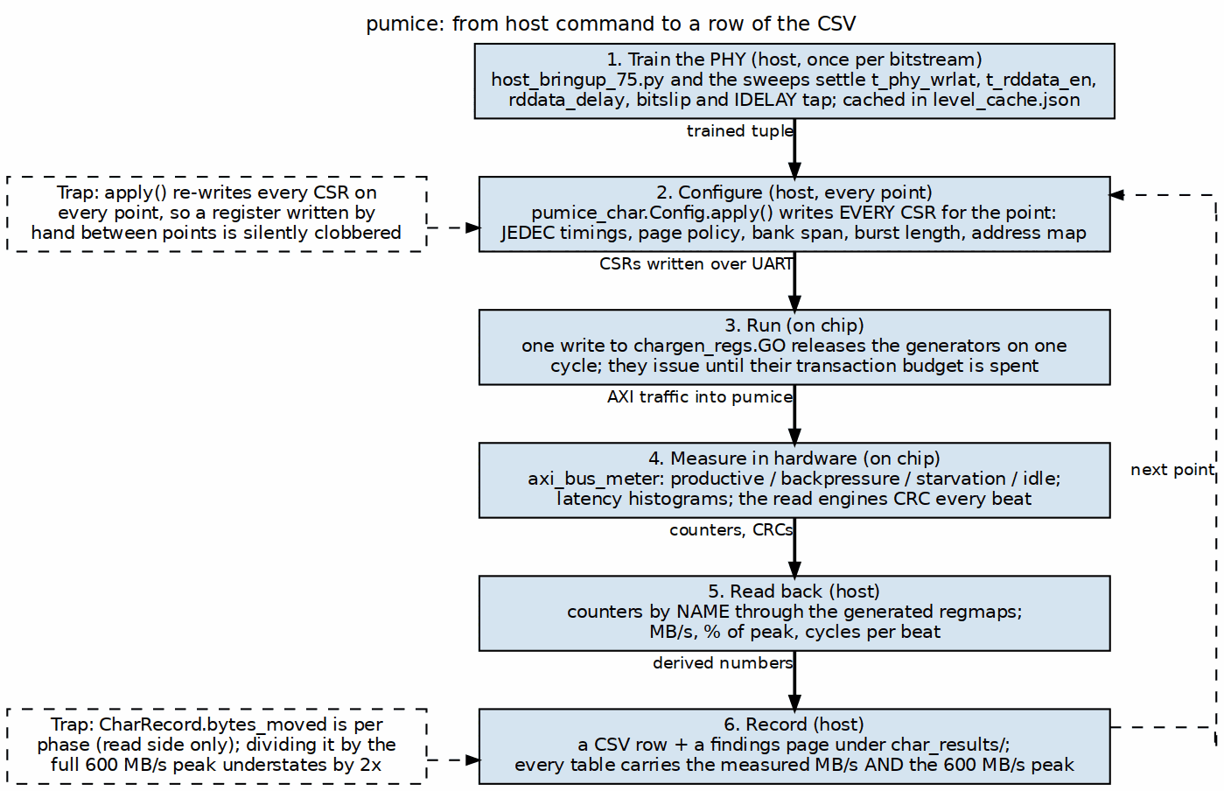
From host command to a row of the CSV
Source: 04_measurement_path.dot
The loop is six steps, and the interesting parts are the first and the last.

6.3 Step 1: bring-up, once per bitstream
Before any measurement, the PHY has to be levelled. This is firmware-driven – there is no hardware leveling FSM – so it is a host job, done through the PHY_CSR_* passthrough, by host_bringup_75.py and the sweep scripts beside it (host_sweep_rddata_delay.py, host_bringup_cmd_delay_sweep.py, host_train_per_lane.py, host_eye_margin_ab.py).
The settled result is cached in level_cache.json, and the current board records:
Table 4.2: The cached leveling result for this board
Field | Value
ok | true
bitslip | 0
rd_tap | 8
rd_window | 0 to 16
A working configuration is a tuple, not a single number: bitslip, IDELAY tap, read-data delay and the command/read-enable timings all have to agree. The rd_window is the part worth reading – a window of 0 to 16 with the tap at 8 means the chosen tap sits in the middle of a wide passing region, which is what a healthy leveling result looks like. A tap that only works at the edge of a narrow window is a result that will not survive a temperature change.

6.4 Steps 2 to 5: configure, run, measure, read back
pumice_char.Config.apply() writes every CSR that defines a measurement point: JEDEC timings, page policy, bank span, burst length, address mapping. Then a single write to chargen_regs.GO releases the generators on one cycle, they run until their transaction budgets are spent, and the instruments count in hardware while they do.
Important: apply() re-programs every CSR on every measurement point. A register written by hand between points is therefore silently clobbered on the next one. This is not hypothetical: a tRTW override appeared to take effect and did not, and the only reason it was caught was that the printed configuration line still showed the old value. When overriding something for an experiment, override it where apply() will carry it, not after.

6.5 Step 6: recording, and the arithmetic that has already gone wrong once
Results become a CSV row and a findings page under ddr2-characterization/char_results/ or build-perf/results/.
Important: CharRecord.bytes_moved is per phase – the read side only. Dividing it by the full 600 MB/s peak understates the result by a factor of two. This is not a theoretical hazard: a whole conclusion (“concurrent read plus write is bounded at about 47% of peak by the controller”) was published and then retracted, because the real figure was 95% and 95% is the design point rather than a defect. Every percentage in this system is a chance to make that mistake again, which is why the house rule is that a bandwidth table shows the measured MB/s and the theoretical peak, so the division is visible and checkable.

6.6 Integrity is what makes throughput mean anything
The write engine computes an expected CRC and the read engine computes an actual one; CRC_MATCH and BEATS_MISM are read back with the performance counters. A throughput number from a run that corrupted data is not a throughput number.
Important: a detector that has never fired is not evidence that data is clean. This one had never fired, and proving it worked took deliberately corrupting the analog eye – forcing the read window off its centre – at which point it reported every beat mismatched. Two earlier attempts to inject a fault failed for uninteresting reasons and looked like the detector working. If you add a checker to this harness, make it fail on purpose before you trust it passing.

6.7 One program, two targets
The same host program drives the simulation twin and the board, because the framework speaks the same UART byte stream in both. That equivalence is the system’s main defence against wasted board time:
- a host program is debugged in cosim, where a failure is inspectable;
- a difference between cosim and board isolates to the PHY or the DRAM, because everything above DFI is the same source;
- the cosim run is the gate that must pass before controller RTL is committed.
The reverse of that discipline also holds, and it is recorded here because it has bitten: a test run against a stale build directory reports green for the old design. A sub-second “1 passed” is fiction. make clean-all before any run that you intend to believe.

6.8 The bench programs worth knowing
Table 4.3: The host programs
Program | What it is for
pumice_char.py | the characterization sweeps; produces the CSVs
ddr2_char.py | direct harness driver: CSRs, engines, timer, trace
host_ddr2_smoke.py | is the board alive and is this the right bitstream
host_bringup_*.py | PHY leveling and the timing sweeps behind level_cache.json
host_capture_read.py, host_wide_rd_sweep.py | read-path diagnosis when a number is wrong
test_pumice_page_stats.py | checks the page-hit/miss statistics the host derives
host_ddr2_smoke.py first, always. It reads BUILD_ID and proves the link before anything expensive depends on it.

