Table of Contents

Converter Index
Generated: 2025-10-26

Converters Component Specification
Version: 1.2 Status: Production Ready Last Updated: 2025-10-26

Document Overview
This specification provides comprehensive documentation for the Converters component, which includes data width conversion and protocol conversion modules for seamless system integration.
Document Structure: - Chapter 1: Overview and Architecture - Chapter 2: Data Width Converters - Chapter 3: Protocol Converters - Chapter 4: Usage Examples and Integration

Quick Navigation

Chapter 1: Overview
- 01_introduction.md - Component overview and key features
- 02_architecture.md - System architecture and module hierarchy
- 03_design_philosophy.md - Design decisions and rationale

Chapter 2: Data Width Converters
- 01_overview.md - Data width conversion overview
- 02_axi_data_upsize.md - Narrow→Wide accumulator
- 03_axi_data_dnsize.md - Wide→Narrow splitter
- 04_dual_buffer_mode.md - High-performance dual-buffer mode
- 05_axi4_dwidth_converter_wr.md - Full write path converter
- 06_axi4_dwidth_converter_rd.md - Full read path converter

Chapter 3: Protocol Converters
- 01_overview.md - Protocol conversion overview
- 02_axi4_to_apb.md - AXI4-to-APB bridge
- 03_peakrdl_adapter.md - PeakRDL adapter

Chapter 4: Usage Examples
- 01_configuration_guide.md - Parameter configuration guide
- 02_common_scenarios.md - Common use case examples
- 03_integration_patterns.md - System integration patterns

Component Summary

Data Width Converters
Generic Building Blocks: - axi_data_upsize - Accumulates N narrow beats into 1 wide beat (100% throughput) - axi_data_dnsize - Splits 1 wide beat into N narrow beats (80% or 100% throughput)
Full AXI4 Converters: - axi4_dwidth_converter_wr - Complete write path (AW + W + B channels) - axi4_dwidth_converter_rd - Complete read path (AR + R channels)
Block Diagrams:
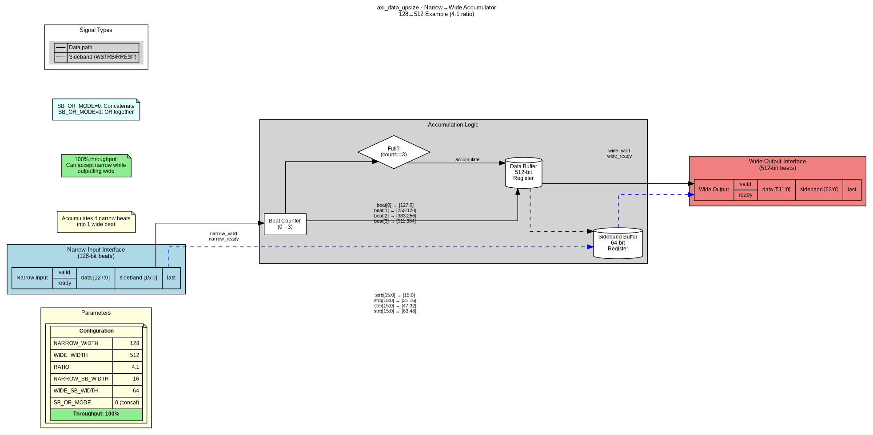 Figure 1: axi_data_upsize - Narrow-to-Wide Accumulator
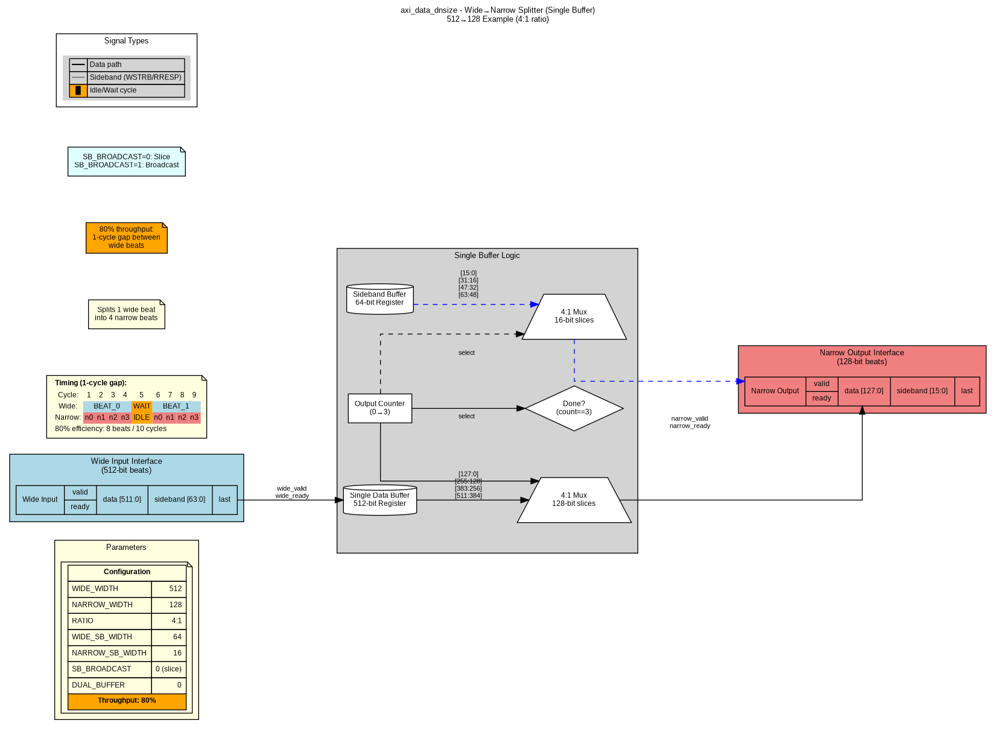 Figure 2: axi_data_dnsize - Wide-to-Narrow Splitter (Single Buffer, 80% throughput)
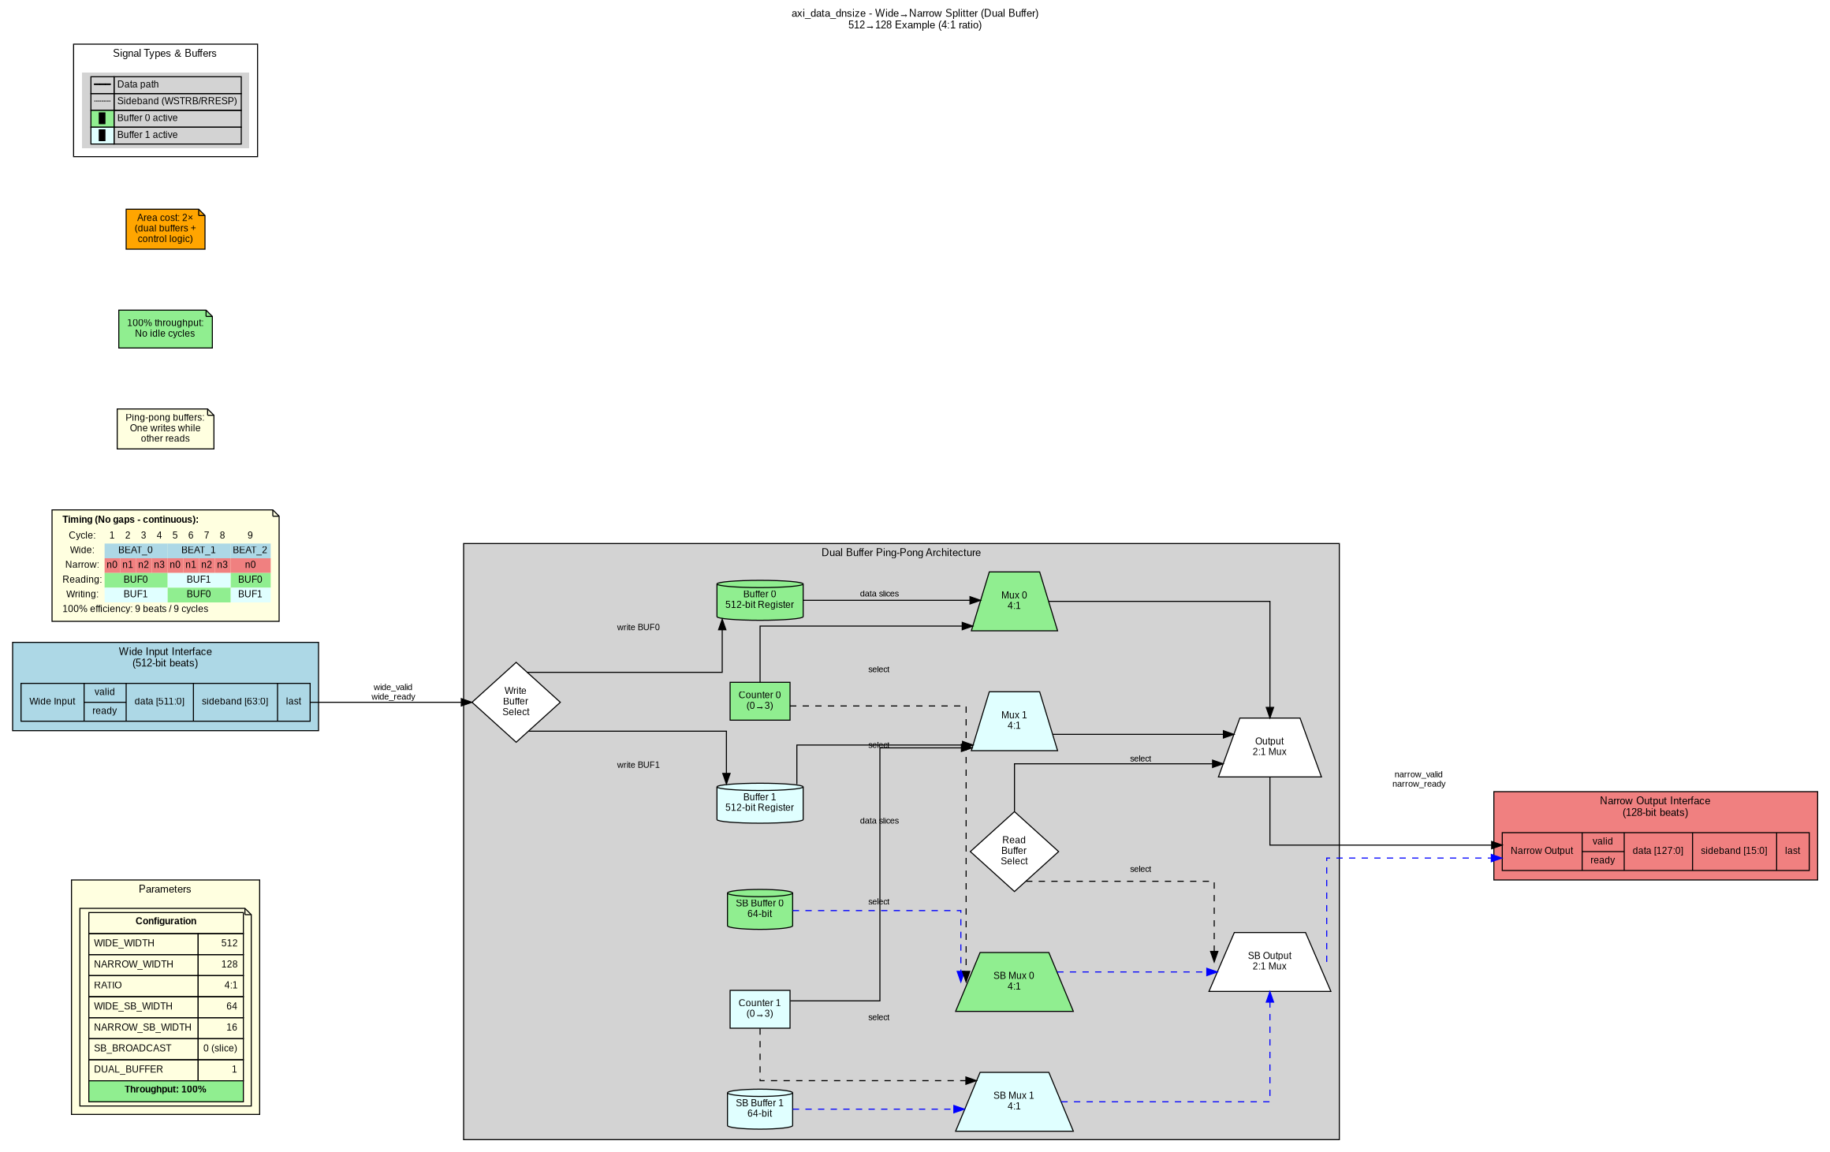 Figure 3: axi_data_dnsize - Wide-to-Narrow Splitter (Dual Buffer, 100% throughput)

Protocol Converters
Available Converters: - axi4_to_apb_convert - Full AXI4-to-APB protocol bridge - axi4_to_apb_shim - Simplified AXI4-to-APB wrapper - peakrdl_to_cmdrsp - PeakRDL register to command/response adapter
Block Diagrams:
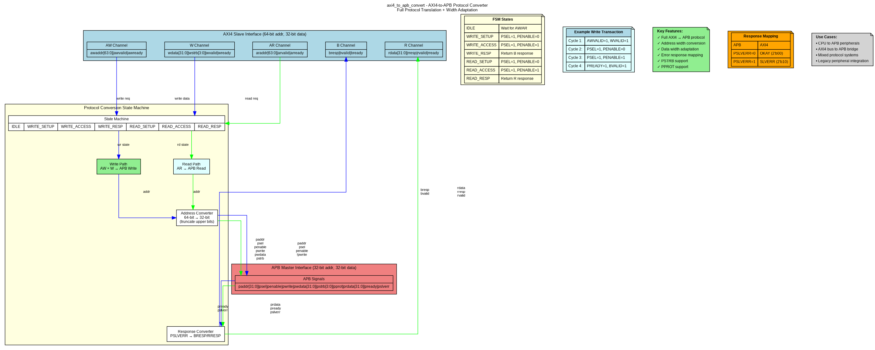 Figure 4: axi4_to_apb_convert - Protocol Conversion
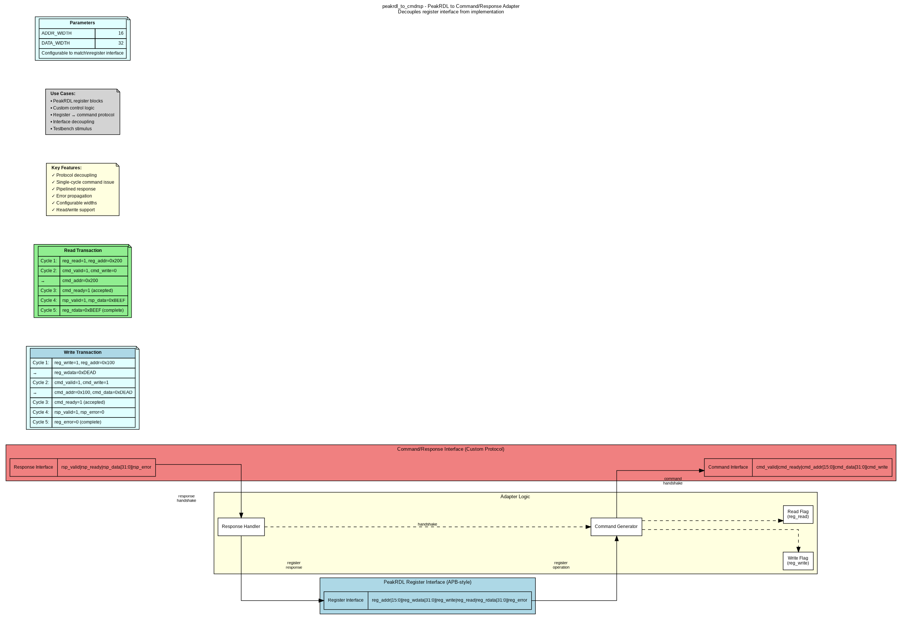 Figure 5: peakrdl_to_cmdrsp - Register Interface Adapter
FSM Diagram:
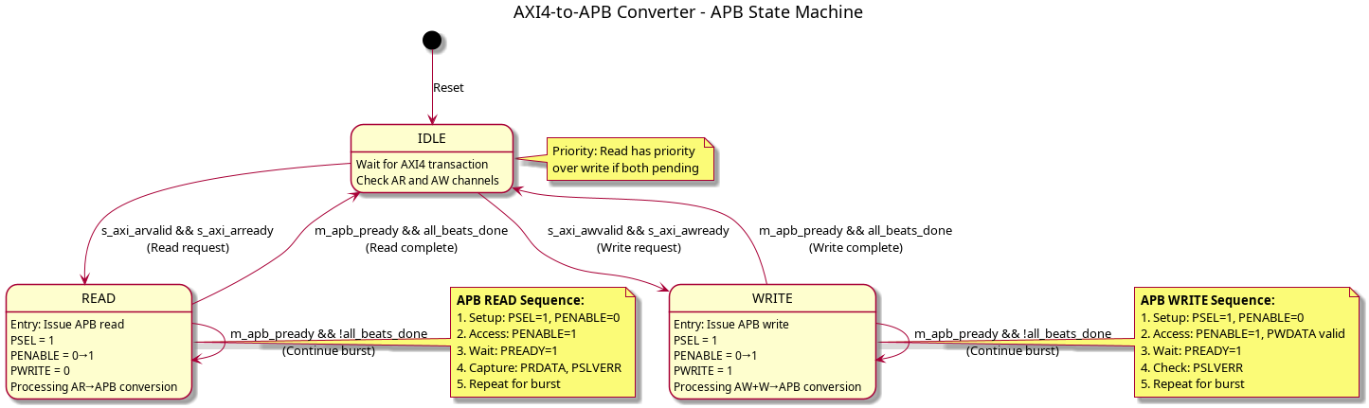 Figure 6: AXI4-to-APB State Machine

Performance Summary
Module | Configuration | Throughput | Area | Use Case
axi_data_upsize | Single buffer | 100% | 1× | Narrow→Wide (always optimal)
axi_data_dnsize | Single buffer | 80% | 1× | Wide→Narrow (area-efficient)
axi_data_dnsize | Dual buffer | 100% | 2× | Wide→Narrow (high-performance)
axi4_dwidth_converter_wr | With upsize | 100% | Standard | Full write path
axi4_dwidth_converter_rd | With dual dnsize | 100% | +100% | Full read path
axi4_to_apb | Protocol FSM | Sequential | Small | Protocol conversion

Key Features

Data Width Conversion
- Flexible width ratios (any integer multiple: 2:1, 4:1, 8:1, 16:1, etc.)
- Configurable sideband handling (concatenate or broadcast)
- Optional burst tracking for LAST signal generation
- Dual-buffer mode for 100% throughput (downsize only)
- Generic building blocks for custom converters

Protocol Conversion
- Full AXI4-to-APB protocol translation
- Address width adaptation (64-bit→32-bit)
- Data width adaptation (configurable)
- Error response mapping (PSLVERR→BRESP/RRESP)
- PeakRDL register interface decoupling

Documentation Assets

Graphviz Block Diagrams
Located in assets/graphviz/: - axi_data_upsize.gv/.png - axi_data_dnsize_single.gv/.png - axi_data_dnsize_dual.gv/.png - axi4_dwidth_converter_wr.gv/.png - axi4_dwidth_converter_rd.gv/.png - axi4_to_apb.gv/.png - peakrdl_adapter.gv/.png
See assets/graphviz/README.md for regeneration instructions.

PlantUML FSM Diagrams
Located in assets/puml/: - axi4_to_apb_fsm.puml/.png
See assets/puml/README.md for regeneration instructions.

Related Documentation
Component-Level: - ../../README.md - Component quick start guide - ../../DUAL_BUFFER_IMPLEMENTATION.md - Dual-buffer feature deep dive - ../../ANALYSIS_APB_CONVERTER.md - APB converter analysis
Repository-Level: - RTL source: projects/components/converters/rtl/ - Test suite: projects/components/converters/dv/tests/ - Usage examples: Chapter 4 of this specification

Version History
Version | Date | Description
1.2 | 2025-10-26 | Added comprehensive specification with block diagrams
1.1 | 2025-10-25 | Added dual-buffer mode for axi_data_dnsize
1.0 | 2025-10-24 | Initial release with generic and full converters

Document Conventions
Notation: - parameter_name - RTL parameters and signals - Bold - Important concepts and module names - Italic - Figure captions and references
Diagrams: - Light blue - Input interfaces - Light coral - Output interfaces - Light yellow - Control logic - Light gray - Data path elements - Arrows - Data/control flow

Author: RTL Design Sherpa Project Maintained By: Converters Component Team Last Review: 2025-10-26

Chapter 1: Overview - Introduction

Purpose
The Converters component provides essential data width conversion and protocol conversion modules that enable seamless integration between components with different data widths or communication protocols.

Problem Statement
Modern SoC designs frequently encounter two integration challenges:
- Data Width Mismatch
  - CPU: 64-bit data bus
  - DDR Controller: 512-bit data bus
  - PCIe Endpoint: 128-bit data bus
  - Result: Direct connection impossible
- Protocol Incompatibility
  - AXI4 masters (CPU, DMA)
  - APB peripherals (UART, GPIO, SPI)
  - Custom register interfaces (PeakRDL)
  - Result: Protocol bridge required

Solution Approach

Data Width Converters
Generic Building Blocks: - axi_data_upsize - Accumulates narrow beats into wide beats - axi_data_dnsize - Splits wide beats into narrow beats
Full AXI4 Integration: - axi4_dwidth_converter_wr - Write path converter (AW + W + B) - axi4_dwidth_converter_rd - Read path converter (AR + R)

Protocol Converters
- axi4_to_apb_convert - Full AXI4-to-APB bridge
- peakrdl_to_cmdrsp - Register interface adapter

Key Benefits

Reusability
- Generic modules work with any width ratio
- Configurable parameters for custom use cases
- Self-contained building blocks

Performance
- Upsize: 100% throughput (single buffer)
- Downsize: 80% (single buffer) or 100% (dual buffer)
- Minimal latency overhead

Flexibility
- Configurable sideband handling
- Optional burst tracking
- Dual-buffer mode for high-performance paths

Component Scope

In Scope
- Integer width ratios (2:1, 4:1, 8:1, 16:1, etc.)
- AXI4 and APB protocol support
- Configurable throughput vs area trade-offs
- Generic building blocks for custom converters

Out of Scope
- Non-integer width ratios (e.g., 3:2 conversion)
- AXI4-Stream protocol (different component)
- Complex buffering beyond dual-buffer
- Clock domain crossing (use separate CDC modules)

Target Applications
- CPU-to-DDR Integration - 64-bit CPU to 512-bit memory controller
- DMA Engines - Variable width data movers
- Mixed Protocol Systems - AXI4 to APB peripheral buses
- FPGA Fabric Interfaces - Width matching for IP integration
- Register Access - PeakRDL to custom control protocols

Document Organization
This specification is organized into four chapters:
- Overview (This chapter) - Purpose, scope, and architecture
- Data Width Converters - Generic and full AXI4 modules
- Protocol Converters - AXI4-to-APB and PeakRDL adapters
- Usage Examples - Configuration, scenarios, and integration

Next: 02_architecture.md - System architecture and module hierarchy

Chapter 2: Data Width Converters - Overview

Introduction
Data width converters enable communication between components with mismatched data bus widths, a common challenge in modern SoC designs where different IP blocks operate at different data widths.

Module Hierarchy
Data Width Converters
├── Generic Building Blocks
│ ├── axi_data_upsize.sv - Narrow→Wide accumulator
│ └── axi_data_dnsize.sv - Wide→Narrow splitter
│
└── Full AXI4 Converters
├── axi4_dwidth_converter_wr.sv - Write path (AW + W + B)
└── axi4_dwidth_converter_rd.sv - Read path (AR + R)

Generic Building Blocks

axi_data_upsize - Narrow→Wide Accumulator
Purpose: Accumulate N narrow beats into 1 wide beat
Key Features: - 100% throughput (single buffer sufficient) - Configurable sideband modes (concatenate or OR) - Supports any integer width ratio - Minimal area overhead
Block Diagram:

AXI Data Upsize
Documentation: 02_axi_data_upsize.md

axi_data_dnsize - Wide→Narrow Splitter
Purpose: Split 1 wide beat into N narrow beats
Key Features: - Two modes: Single buffer (80%) or Dual buffer (100%) throughput - Configurable sideband modes (slice or broadcast) - Optional burst tracking for LAST generation - Trade-off: throughput vs area
Block Diagrams:
 Single Buffer Mode - 80% throughput, 1× area
 Dual Buffer Mode - 100% throughput, 2× area
Documentation: 03_axi_data_dnsize.md | 04_dual_buffer_mode.md

Full AXI4 Converters

axi4_dwidth_converter_wr - Write Path Converter
Purpose: Complete write path conversion with AW, W, and B channels
Features: - Address phase management - Burst length adjustment - Skid buffers for flow control - Integrates axi_data_upsize for data conversion
Block Diagram:
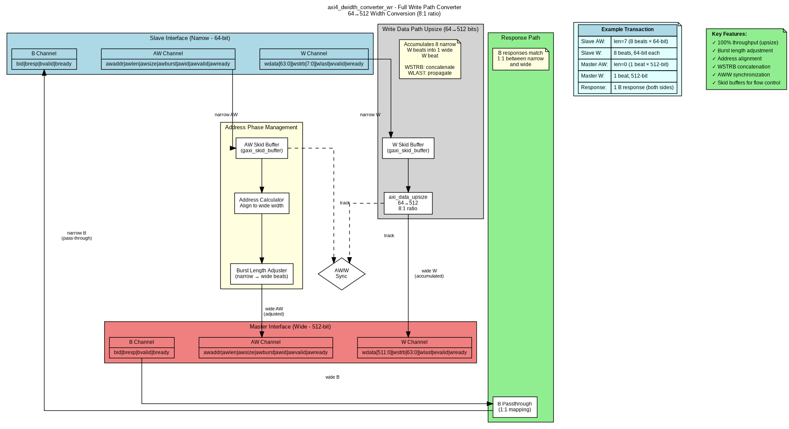
AXI4 Write Converter
Documentation: 05_axi4_dwidth_converter_wr.md

axi4_dwidth_converter_rd - Read Path Converter
Purpose: Complete read path conversion with AR and R channels
Features: - Address phase management - Burst length adjustment - Burst-aware RLAST generation - Integrates axi_data_dnsize for data conversion
Block Diagram:
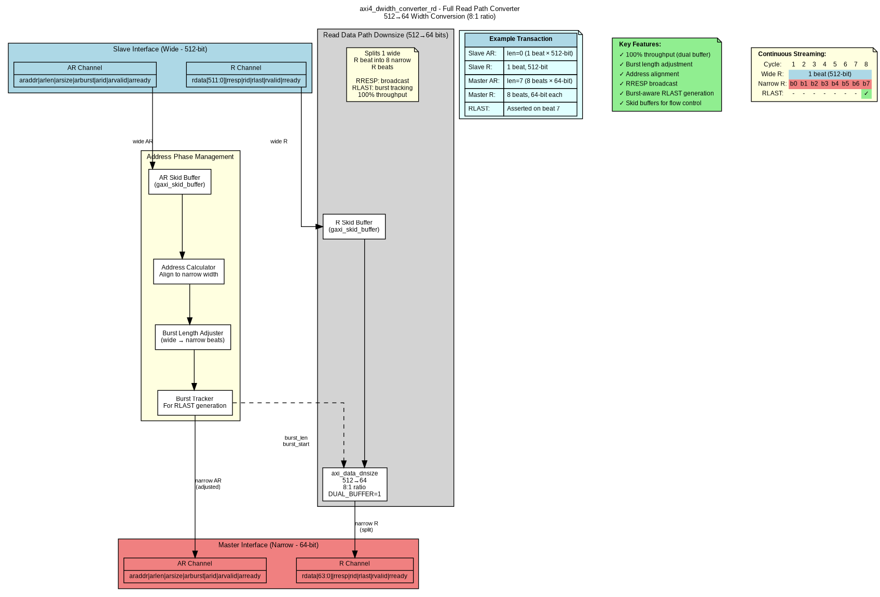
AXI4 Read Converter
Documentation: 06_axi4_dwidth_converter_rd.md

Throughput Comparison
Module | Mode | Throughput | Area | When to Use
axi_data_upsize | Single buffer | 100% | 1× | All narrow→wide conversions
axi_data_dnsize | Single buffer | 80% | 1× | Area-constrained designs
axi_data_dnsize | Dual buffer | 100% | 2× | High-bandwidth requirements
Recommendation: - Upsize: Always use single buffer (100% throughput at minimal cost) - Downsize: Choose based on system requirements: - Single buffer for area-constrained or non-continuous traffic - Dual buffer for high-performance DMA or continuous streaming

Common Configuration Examples

Example 1: 64→512 bit (Write Path)
axi_data_upsize #(
.NARROW_WIDTH(64),
.WIDE_WIDTH(512),
.NARROW_SB_WIDTH(8), // WSTRB
.WIDE_SB_WIDTH(64),
.SB_OR_MODE(0) // Concatenate
) u_upsize (...);

Example 2: 512→128 bit (Read Path, High Performance)
axi_data_dnsize #(
.WIDE_WIDTH(512),
.NARROW_WIDTH(128),
.WIDE_SB_WIDTH(2), // RRESP
.NARROW_SB_WIDTH(2),
.SB_BROADCAST(1), // Broadcast
.DUAL_BUFFER(1) // 100% throughput
) u_dnsize (...);

Next Sections: - 02_axi_data_upsize.md - Detailed upsize module documentation - 03_axi_data_dnsize.md - Detailed dnsize module documentation - 04_dual_buffer_mode.md - Dual-buffer architecture deep dive

Chapter 3: Protocol Converters - Overview

Introduction
Protocol converters enable communication between components using different communication protocols, essential for integrating diverse IP blocks in complex SoC designs.

Available Converters

1. AXI4-to-APB Bridge
- Module: axi4_to_apb_convert.sv
- Purpose: Full protocol translation from AXI4 to APB
- Features: Address width adaptation, state machine control, error mapping

2. PeakRDL Adapter
- Module: peakrdl_to_cmdrsp.sv
- Purpose: Register interface to command/response protocol
- Features: Protocol decoupling, single-cycle commands, pipelined responses

AXI4-to-APB Bridge

Overview
Converts AXI4 master transactions (from CPU, DMA) to APB peripheral accesses.
Key Challenges: - Protocol differences (5-channel AXI4 vs 2-phase APB) - Address width mismatch (64-bit AXI4 vs 32-bit APB) - Burst support (AXI4 bursts → sequential APB transactions) - Error response mapping (PSLVERR → BRESP/RRESP)

Block Diagram

AXI4-to-APB Converter

State Machine
The converter uses a state machine to manage protocol translation:

AXI4-to-APB FSM
States: - IDLE - Wait for AXI4 transaction - READ - Process AXI4 read → APB read - WRITE - Process AXI4 write → APB write

Use Cases
- CPU to APB Peripherals - Main processor accessing GPIO, UART, SPI
- DMA to Configuration Registers - DMA controller configuring peripherals
- Mixed Protocol Systems - Integrating AXI4 fabric with legacy APB devices

Documentation
See 02_axi4_to_apb.md for detailed specification.

PeakRDL Adapter

Overview
Converts PeakRDL-generated register interface to a custom command/response protocol, enabling protocol decoupling and flexible register implementations.
Key Features: - APB-style register interface (input) - Command/response handshake (output) - Configurable address and data widths - Single-cycle command issue

Block Diagram

PeakRDL Adapter

Interface Types
Register Interface (APB-style): - reg_addr[ADDR_WIDTH-1:0] - Register address - reg_wdata[DATA_WIDTH-1:0] - Write data - reg_write - Write enable - reg_read - Read enable - reg_rdata[DATA_WIDTH-1:0] - Read data - reg_error - Error flag
Command/Response Protocol: - Command: valid/ready handshake with addr, data, write flag - Response: valid/ready handshake with data, error flag

Use Cases
- PeakRDL Register Blocks - Decoupling register interface from implementation
- Custom Control Logic - Flexible register access mechanism
- Testbench Stimulus - Command-driven register access in verification

Documentation
See 03_peakrdl_adapter.md for detailed specification.

Comparison
Feature | AXI4-to-APB | PeakRDL Adapter
Input Protocol | AXI4 (5 channels) | APB-style register
Output Protocol | APB (2 phases) | Command/response
Complexity | High (FSM, burst handling) | Low (pass-through)
Use Case | System interconnect | Register decoupling
Performance | Sequential per APB | Single-cycle cmd

Design Considerations

When to Use Protocol Converters
Use AXI4-to-APB when: - Integrating AXI4 masters with APB peripherals - Building CPU-to-peripheral bridges - System has mixed protocol requirements
Use PeakRDL adapter when: - Decoupling register interface from implementation - Need flexible register access protocol - Building custom control/configuration logic

Integration Guidelines
- Address Map Planning - Ensure non-overlapping regions
- Error Handling - Map error responses appropriately
- Performance Analysis - Consider latency impact
- Testing Strategy - Verify protocol compliance

Next Sections: - 02_axi4_to_apb.md - Detailed AXI4-to-APB specification - 03_peakrdl_adapter.md - Detailed PeakRDL adapter specification

Converters Graphviz Block Diagrams
This directory contains Graphviz source files (.gv) and generated PNG diagrams for Converters component modules.

Files

Data Width Converters
Generic Building Blocks: - axi_data_upsize.gv - Narrow→Wide accumulator (128→512 example) - axi_data_dnsize_single.gv - Wide→Narrow splitter, single buffer (512→128, 80% throughput) - axi_data_dnsize_dual.gv - Wide→Narrow splitter, dual buffer (512→128, 100% throughput)
Full AXI4 Converters: - axi4_dwidth_converter_wr.gv - Write path converter (AW + W + B channels) - axi4_dwidth_converter_rd.gv - Read path converter (AR + R channels)

Protocol Converters
- axi4_to_apb.gv - AXI4-to-APB protocol bridge
- peakrdl_adapter.gv - PeakRDL register interface to command/response adapter

Generated Images (.png)
All diagrams are available as PNG files: - axi_data_upsize.png - axi_data_dnsize_single.png - axi_data_dnsize_dual.png - axi4_dwidth_converter_wr.png - axi4_dwidth_converter_rd.png - axi4_to_apb.png - peakrdl_adapter.png

Regenerating Diagrams

Prerequisites
- Graphviz installed (sudo apt install graphviz on Ubuntu/Debian)
- dot command available in PATH

Generate All Diagrams
# From this directory
make all
# Or manually
dot -Tpng axi_data_upsize.gv -o axi_data_upsize.png
dot -Tpng axi_data_dnsize_single.gv -o axi_data_dnsize_single.png
# ... etc

Generate Single Diagram
# Upsize converter
dot -Tpng axi_data_upsize.gv -o axi_data_upsize.png
# Downsize single buffer
dot -Tpng axi_data_dnsize_single.gv -o axi_data_dnsize_single.png
# Downsize dual buffer
dot -Tpng axi_data_dnsize_dual.gv -o axi_data_dnsize_dual.png

Generate SVG (for web/docs)
dot -Tsvg axi_data_upsize.gv -o axi_data_upsize.svg
# ... for all diagrams

Generate PDF (for documentation)
dot -Tpdf axi_data_upsize.gv -o axi_data_upsize.pdf
# ... for all diagrams

Diagram Contents

axi_data_upsize.gv
Shows: - Narrow input interface (128-bit beats) - Beat counter (0→3 for 4:1 ratio) - 512-bit data buffer accumulation - Wide output interface (512-bit beats) - Sideband handling (WSTRB concatenation or RRESP OR) - 100% throughput annotation
Use Case: Understanding narrow-to-wide data accumulation

axi_data_dnsize_single.gv
Shows: - Wide input interface (512-bit beats) - Single 512-bit buffer - 4:1 multiplexer for 128-bit slices - Output counter (0→3) - Narrow output interface (128-bit beats) - Timing diagram showing 80% throughput (1-cycle gap) - Sideband handling (WSTRB slice or RRESP broadcast)
Use Case: Understanding wide-to-narrow splitting (area-efficient mode)

axi_data_dnsize_dual.gv
Shows: - Wide input interface (512-bit beats) - Dual ping-pong buffers (Buffer 0 and Buffer 1) - Buffer select logic (write/read muxes) - Independent counters for each buffer - Output multiplexing - Timing diagram showing 100% throughput (no gaps) - Ping-pong operation (one reads while other writes)
Use Case: Understanding dual-buffer high-performance mode

axi4_dwidth_converter_wr.gv
Shows: - AXI4 slave interface (narrow - 64-bit) - AW/W/B channel handling - Address calculator and burst length adjuster - Skid buffers for flow control - axi_data_upsize integration - AXI4 master interface (wide - 512-bit) - Example transaction (8 narrow beats → 1 wide beat)
Use Case: Understanding full write path conversion

axi4_dwidth_converter_rd.gv
Shows: - AXI4 slave interface (wide - 512-bit) - AR/R channel handling - Address calculator and burst length adjuster - Burst tracker for RLAST generation - axi_data_dnsize integration (dual buffer) - AXI4 master interface (narrow - 64-bit) - Continuous streaming timing (100% throughput)
Use Case: Understanding full read path conversion

axi4_to_apb.gv
Shows: - AXI4 slave interface (64-bit addr, 32-bit data) - Protocol conversion state machine - Write path (AW + W → APB write) - Read path (AR → APB read) - Address width conversion (64→32 bit) - Response converter (PSLVERR → BRESP/RRESP) - APB master interface - FSM state descriptions - Example timing diagrams
Use Case: Understanding AXI4-to-APB protocol conversion

peakrdl_adapter.gv
Shows: - PeakRDL register interface (APB-style) - Command generator - Response handler - Command/response interface (custom protocol) - Write transaction example - Read transaction example - Error propagation
Use Case: Understanding PeakRDL adapter protocol decoupling

Diagram Style
Colors: - Light blue - Input interfaces (slave/narrow/wide) - Light coral/pink - Output interfaces (master/narrow/wide) - Light yellow - Control logic and notes - Light gray - Data path elements - Light green - Features/highlights - Light cyan - Examples - Orange - Warnings/limitations
Nodes: - Rounded boxes - Functional blocks - Cylinders - Registers/buffers - Diamonds - Decision/control points - Trapezoids - Multiplexers - Note boxes - Annotations, examples, timing diagrams - Records - Interfaces with multiple signals
Edges: - Bold solid - Primary data flow - Dashed - Control signals - Colored - Protocol-specific paths (blue=write, green=read)

Adding New Diagrams
To add a new converter diagram:
- Create new .gv file:
- cp axi_data_upsize.gv my_new_converter.gv
- Edit the new file:
  - Update title and module name
  - Adjust nodes for converter functionality
  - Update data flow connections
  - Add timing/example annotations
- Update Makefile SOURCES list:
- SOURCES = ... \
my_new_converter.gv
- Generate PNG:
- make all
- Link from documentation:
- ![My Converter Block Diagram](../assets/graphviz/my_new_converter.png)

Referenced In Documentation
These diagrams are referenced in: - converter_index.md - Main specification index - ch02_data_width_converters/*.md - Data width converter chapters - ch03_protocol_converters/*.md - Protocol converter chapters - ch04_usage_examples/*.md - Usage and integration examples

Tools
Graphviz Version: Any recent version (tested with 2.43+)
Alternative Viewers: - Online: http://www.webgraphviz.com/ (paste .gv content) - VS Code: Install “Graphviz Preview” extension - Command line: xdg-open <diagram>.png (Linux)

Notes
- PNG files are version controlled for easy documentation viewing
- Source .gv files are the authoritative source
- Regenerate PNGs after any .gv file changes
- Keep diagrams up-to-date with module implementations
- Use consistent color scheme across all diagrams

Last Updated: 2025-10-26 Maintainer: RTL Design Sherpa Project

Converters PlantUML FSM Diagrams
This directory contains PlantUML source files (.puml) and generated PNG diagrams for Converters FSM documentation.

Files

Source Files (.puml)
- axi4_to_apb_fsm.puml - APB state machine for AXI4-to-APB protocol converter

Generated Images (.png)
- axi4_to_apb_fsm.png - FSM diagram for AXI4-to-APB converter

FSM Overview

AXI4-to-APB Converter FSM
States: - IDLE - Wait for AXI4 transaction (AR or AW) - READ - Process AXI4 AR transaction → APB read - WRITE - Process AXI4 AW+W transaction → APB write
Key Features: - Read priority over write when both pending - Burst support (continues in READ/WRITE until all beats complete) - APB protocol phases (Setup → Access → Wait) - Error response handling (PSLVERR → BRESP/RRESP)
Transitions: - IDLE → READ: AXI4 read request (ARVALID && ARREADY) - IDLE → WRITE: AXI4 write request (AWVALID && AWREADY) - READ → IDLE: APB read complete (PREADY && all beats done) - WRITE → IDLE: APB write complete (PREADY && all beats done) - Self-loops: Continue burst transfers

Note on Other Converters
Data width converters (axi_data_upsize, axi_data_dnsize) do not have FSMs: - They use simple counter-based control logic - Upsize: Beat counter (0→N-1) to accumulate narrow beats - Downsize: Output counter (0→N-1) to split wide beats - No complex state transitions needed
Only protocol converters have FSMs: - AXI4-to-APB: Protocol translation requires state machine - PeakRDL adapter: Simple passthrough, no FSM needed

Regenerating Diagrams

Prerequisites
- PlantUML installed
- Java runtime (required by PlantUML)

Install PlantUML
# Ubuntu/Debian
sudo apt install plantuml
# Or download JAR
wget https://github.com/plantuml/plantuml/releases/download/v1.2023.13/plantuml-1.2023.13.jar

Generate PNG from PlantUML
# Using installed plantuml
plantuml axi4_to_apb_fsm.puml
# Or using downloaded JAR
java -jar plantuml.jar axi4_to_apb_fsm.puml
# Output: axi4_to_apb_fsm.png

Generate SVG (for web)
plantuml -tsvg axi4_to_apb_fsm.puml

Generate PDF (for documentation)
plantuml -tpdf axi4_to_apb_fsm.puml

FSM Style
Colors: - Default state colors (light blue/yellow as per PlantUML defaults) - Transition arrows with labels showing conditions
Annotations: - Entry actions described in state boxes - Transition conditions on arrows - Notes explaining protocol sequences
Format: - Standard UML state machine notation - Clear state names matching RTL enumeration - Transition guards showing trigger conditions

Referenced In Documentation
These diagrams are referenced in: - ch03_protocol_converters/02_axi4_to_apb.md - AXI4-to-APB converter chapter - converter_index.md - Main specification index

Adding New FSM Diagrams
If future converters include FSMs:
- Create new .puml file:
- @startuml my_converter_fsm
title My Converter FSM
[*] --> IDLE
IDLE --> ACTIVE : trigger
ACTIVE --> IDLE : done
@enduml
- Generate PNG:
- plantuml my_converter_fsm.puml
- Link from documentation:
- ![My Converter FSM](../assets/puml/my_converter_fsm.png)

Tools
PlantUML Version: Any recent version (tested with 1.2023+)
Alternative Renderers: - Online: http://www.plantuml.com/plantuml/uml/ (paste .puml content) - VS Code: Install “PlantUML” extension - IntelliJ IDEA: Built-in PlantUML support

Notes
- PNG files are version controlled for easy viewing
- Source .puml files are the authoritative source
- Regenerate PNGs after any .puml changes
- Keep FSM diagrams synchronized with RTL state definitions

Last Updated: 2025-10-26 Maintainer: RTL Design Sherpa Project

Converters - Data Width and Protocol Conversion Modules
Status: Production Ready Version: 1.2 Last Updated: 2025-10-25

Quick Start
The Converters component provides both data width conversion and protocol conversion modules, enabling seamless integration between components with different data widths or protocols.

Key Features
Data Width Converters: - Bidirectional Conversion - Upsize (narrow→wide) and Downsize (wide→narrow) - Flexible Width Ratios - Any integer ratio (2:1, 4:1, 8:1, 16:1, etc.) - Sideband Support - Configurable handling for WSTRB (slice) and RRESP (broadcast) - Burst Tracking - Optional burst-aware LAST signal generation (read path) - High Throughput - Optional dual-buffer mode for 100% throughput (downsize) - Generic Building Blocks - Reusable axi_data_upsize and axi_data_dnsize modules
Protocol Converters: - AXI4-to-APB Bridge - Full AXI4 to APB protocol conversion with address/data width adaptation - PeakRDL Adapter - Convert PeakRDL register interface to custom command/response protocol

Performance Summary
Module | Mode | Throughput | Area | Use Case
axi_data_upsize | Single buffer | 100% | 1× | Narrow→Wide (always optimal)
axi_data_dnsize | Single buffer | 80% | 1× | Wide→Narrow (area-efficient)
axi_data_dnsize | Dual buffer | 100% | 2× | Wide→Narrow (high-performance)

Architecture Overview

Component Hierarchy
Converters Component
├── Data Width Converters:
│ ├── Generic Building Blocks:
│ │ ├── axi_data_upsize.sv - Narrow→Wide accumulator (100% throughput)
│ │ ├── axi_data_dnsize.sv - Wide→Narrow splitter (80% or 100% throughput)
│ │ └── Key Features:
│ │ ├── Configurable sideband handling
│ │ ├── Optional burst tracking
│ │ └── Dual-buffer mode (dnsize only)
│ │
│ └── Full AXI4 Converters:
│ ├── axi4_dwidth_converter_wr.sv - Write path converter (AW + W + B channels)
│ ├── axi4_dwidth_converter_rd.sv - Read path converter (AR + R channels)
│ └── Integration:
│ ├── Skid buffers for flow control
│ ├── Address phase management
│ └── Response path handling
│
└── Protocol Converters:
├── axi4_to_apb_convert.sv - AXI4-to-APB bridge (full protocol conversion)
├── axi4_to_apb_shim.sv - AXI4-to-APB adapter (simplified wrapper)
└── peakrdl_to_cmdrsp.sv - PeakRDL adapter (register→command/response)

Data Flow Examples
Write Path Downsize (512→128 bits):
┌────────────────────────────────────────────────────┐
│ Slave Interface (512-bit) │
│ ┌──────────┐ │
│ │ AW │ ← 1 address │
│ │ W │ ← 1 wide beat (512-bit + 64-bit WSTRB)
│ │ B │ → 1 response │
│ └──────────┘ │
│ ↓ │
│ ┌──────────────────┐ │
│ │ axi_data_dnsize │ (DUAL_BUFFER=1) │
│ │ 512→128 split │ │
│ └──────────────────┘ │
│ ↓ │
│ ┌──────────┐ │
│ │ Master Interface (128-bit) │
│ │ AW │ → 1 address │
│ │ W │ → 4 narrow beats (128-bit + 16-bit WSTRB each)
│ │ B │ ← 1 response │
│ └──────────┘ │
└────────────────────────────────────────────────────┘
Read Path Upsize (128→512 bits):
┌────────────────────────────────────────────────────┐
│ Master Interface (512-bit) │
│ ┌──────────┐ │
│ │ AR │ → 1 address │
│ │ R │ ← 1 wide beat (512-bit + 2-bit RRESP)
│ └──────────┘ │
│ ↑ │
│ ┌──────────────────┐ │
│ │ axi_data_upsize │ (TRACK_BURSTS=1) │
│ │ 128→512 accum │ │
│ └──────────────────┘ │
│ ↑ │
│ ┌──────────┐ │
│ │ Slave Interface (128-bit) │
│ │ AR │ ← 1 address │
│ │ R │ → 4 narrow beats (128-bit + 2-bit RRESP each)
│ └──────────┘ │
└────────────────────────────────────────────────────┘

Module Documentation

1. axi_data_upsize.sv - Narrow→Wide Accumulator
Purpose: Accumulates multiple narrow beats into a single wide beat
Throughput: 100% (single buffer sufficient)
Key Parameters:
parameter int NARROW_WIDTH = 32; // Input data width
parameter int WIDE_WIDTH = 128; // Output data width (must be integer multiple)
parameter int NARROW_SB_WIDTH = 4; // Narrow sideband width (WSTRB: WIDTH/8)
parameter int WIDE_SB_WIDTH = 16; // Wide sideband width (WSTRB: WIDTH/8)
parameter int SB_OR_MODE = 0; // 0=concatenate (WSTRB), 1=OR (RRESP)
Sideband Modes: - SB_OR_MODE=0 (Concatenate): For WSTRB - assemble strobe bits narrow[0].wstrb = 4'b1111 → wide.wstrb[3:0] narrow[1].wstrb = 4'b1100 → wide.wstrb[7:4] narrow[2].wstrb = 4'b0011 → wide.wstrb[11:8] narrow[3].wstrb = 4'b1111 → wide.wstrb[15:12] Result: wide.wstrb = 16'b1111_0011_1100_1111
- SB_OR_MODE=1 (OR Together): For RRESP - propagate errors
- narrow[0].rresp = 2'b00 (OK)
narrow[1].rresp = 2'b10 (SLVERR)
narrow[2].rresp = 2'b00 (OK)
narrow[3].rresp = 2'b00 (OK)
Result: wide.rresp = 2'b10 (SLVERR - any error propagates)
Usage Example:
axi_data_upsize #(
.NARROW_WIDTH(128),
.WIDE_WIDTH(512),
.NARROW_SB_WIDTH(16), // WSTRB: 128/8 = 16
.WIDE_SB_WIDTH(64), // WSTRB: 512/8 = 64
.SB_OR_MODE(0) // Concatenate WSTRB
) u_upsize (
.aclk (aclk),
.aresetn (aresetn),
// Narrow input
.narrow_valid (s_wvalid),
.narrow_ready (s_wready),
.narrow_data (s_wdata),
.narrow_sideband (s_wstrb),
.narrow_last (s_wlast),
// Wide output
.wide_valid (m_wvalid),
.wide_ready (m_wready),
.wide_data (m_wdata),
.wide_sideband (m_wstrb),
.wide_last (m_wlast)
);

2. axi_data_dnsize.sv - Wide→Narrow Splitter
Purpose: Splits single wide beat into multiple narrow beats
Throughput: - Single-buffer mode (DUAL_BUFFER=0): 80% (1-cycle gap per wide beat) - Dual-buffer mode (DUAL_BUFFER=1): 100% (continuous streaming)
Key Parameters:
parameter int WIDE_WIDTH = 512; // Input data width
parameter int NARROW_WIDTH = 128; // Output data width (must be integer divisor)
parameter int WIDE_SB_WIDTH = 2; // Wide sideband width (RRESP: 2 bits)
parameter int NARROW_SB_WIDTH = 2; // Narrow sideband width
parameter int SB_BROADCAST = 1; // 1=broadcast (RRESP), 0=slice (WSTRB)
parameter int TRACK_BURSTS = 0; // 1=track bursts for LAST, 0=simple passthrough
parameter int BURST_LEN_WIDTH = 8; // Burst length counter width
parameter int DUAL_BUFFER = 0; // 1=dual buffer (100% throughput, 2× area)
// 0=single buffer (80% throughput, 1× area)
Sideband Modes: - SB_BROADCAST=1: Broadcast same value to all narrow beats (RRESP) wide.rresp = 2'b10 (SLVERR) → narrow[0].rresp = 2'b10 → narrow[1].rresp = 2'b10 → narrow[2].rresp = 2'b10 → narrow[3].rresp = 2'b10
- SB_BROADCAST=0: Slice into narrow portions (WSTRB)
- wide.wstrb = 64'h000F_F0FF_00FF_FFFF
→ narrow[0].wstrb[15:0] = 16'hFFFF
→ narrow[1].wstrb[15:0] = 16'h00FF
→ narrow[2].wstrb[15:0] = 16'hF0FF
→ narrow[3].wstrb[15:0] = 16'h000F
Burst Tracking Mode: - TRACK_BURSTS=0: Pass wide_last to last narrow beat (simple mode) - TRACK_BURSTS=1: Generate LAST on final beat of entire burst (read path)
Dual-Buffer Mode (NEW in v1.1):
Single-buffer mode achieves 80% throughput due to 1-cycle gap when transitioning between wide beats:
Cycle: 1 2 3 4 5 6 7 8 9 10
Wide: [====BEAT_0====] WAIT [====BEAT_1====] WAIT
Narrow: n0 n1 n2 n3 IDLE n0 n1 n2 n3 IDLE
↑ 1-cycle dead time
Dual-buffer mode eliminates the gap by ping-ponging between two buffers:
Cycle: 1 2 3 4 5 6 7 8 9
Wide: [====BEAT_0====][====BEAT_1====][====BEAT_2====]
Narrow: n0 n1 n2 n3 n0 n1 n2 n3 n0
Buffer: BUF0 reading────┘ BUF1 reading────┘ BUF0...
BUF1 writing────────┘ BUF0 writing────┘
When to Use Dual-Buffer Mode: - High-bandwidth DMA engines with continuous streaming - Performance-critical data paths where 100% utilization required - Sufficient area budget (~2× increase for buffer registers)
When to Use Single-Buffer Mode: - Area-constrained designs - Throughput requirements <100% - Natural gaps in traffic from upstream/downstream
Usage Example (Single-Buffer):
axi_data_dnsize #(
.WIDE_WIDTH(512),
.NARROW_WIDTH(128),
.WIDE_SB_WIDTH(2), // RRESP: 2 bits
.NARROW_SB_WIDTH(2),
.SB_BROADCAST(1), // Broadcast RRESP
.TRACK_BURSTS(1), // Track bursts for LAST
.BURST_LEN_WIDTH(8),
.DUAL_BUFFER(0) // Single buffer (80% throughput, area-efficient)
) u_dnsize (
.aclk (aclk),
.aresetn (aresetn),
// Burst control (TRACK_BURSTS=1)
.burst_len (arlen),
.burst_start (arvalid && arready),
// Wide input
.wide_valid (s_rvalid),
.wide_ready (s_rready),
.wide_data (s_rdata),
.wide_sideband (s_rresp),
.wide_last (s_rlast),
// Narrow output
.narrow_valid (m_rvalid),
.narrow_ready (m_rready),
.narrow_data (m_rdata),
.narrow_sideband (m_rresp),
.narrow_last (m_rlast)
);
Usage Example (Dual-Buffer - High Performance):
axi_data_dnsize #(
.WIDE_WIDTH(512),
.NARROW_WIDTH(128),
.WIDE_SB_WIDTH(64), // WSTRB: 512/8 = 64
.NARROW_SB_WIDTH(16), // WSTRB: 128/8 = 16
.SB_BROADCAST(0), // Slice WSTRB
.TRACK_BURSTS(0), // Simple mode for write path
.DUAL_BUFFER(1) // Dual buffer (100% throughput, 2× area)
) u_dnsize_hp (
.aclk (aclk),
.aresetn (aresetn),
// Burst control (unused in TRACK_BURSTS=0)
.burst_len (8'd0),
.burst_start (1'b0),
// Wide input
.wide_valid (s_wvalid),
.wide_ready (s_wready),
.wide_data (s_wdata),
.wide_sideband (s_wstrb),
.wide_last (s_wlast),
// Narrow output
.narrow_valid (m_wvalid),
.narrow_ready (m_wready),
.narrow_data (m_wdata),
.narrow_sideband (m_wstrb),
.narrow_last (m_wlast)
);

3. Full AXI4 Converters
axi4_dwidth_converter_wr.sv - Complete write path converter (AW + W + B)
axi4_dwidth_converter_rd.sv - Complete read path converter (AR + R)
These integrate the generic building blocks with: - Address phase management - Skid buffers for flow control - Response path handling - Full AXI4 protocol compliance

Protocol Converters

4. AXI4-to-APB Bridge (axi4_to_apb_convert.sv)
Purpose: Full protocol conversion from AXI4 to APB with address/data width adaptation
Key Features: - Converts AXI4 read/write transactions to APB protocol - Handles address width conversion (AXI4 64-bit → APB 32-bit) - Data width adaptation (configurable) - State machine for AXI→APB protocol translation - Error response handling (SLVERR/DECERR)
Usage Example:
axi4_to_apb_convert #(
.S_AXI_ADDR_WIDTH(64),
.S_AXI_DATA_WIDTH(32),
.M_APB_ADDR_WIDTH(32),
.M_APB_DATA_WIDTH(32)
) u_axi_apb_bridge (
.aclk (clk),
.aresetn (rst_n),
// AXI4 Slave Interface
.s_axi_awaddr (s_awaddr),
.s_axi_awvalid (s_awvalid),
.s_axi_awready (s_awready),
// ... (full AXI4 AW/W/B/AR/R channels)
// APB Master Interface
.m_apb_paddr (m_paddr),
.m_apb_psel (m_psel),
.m_apb_penable (m_penable),
.m_apb_pwrite (m_pwrite),
.m_apb_pwdata (m_pwdata),
.m_apb_pready (m_pready),
.m_apb_prdata (m_prdata),
.m_apb_pslverr (m_pslverr)
);
Use Cases: - Connecting AXI4 masters to APB peripherals - CPU to APB peripheral bus bridges - System integration with mixed protocols

5. PeakRDL-to-CmdRsp Adapter (peakrdl_to_cmdrsp.sv)
Purpose: Convert PeakRDL-generated register interface to custom command/response protocol
Key Features: - Converts APB-style register interface to command/response handshake - Supports read/write operations - Configurable command/response data widths - Single-cycle command issue - Pipelined response handling
Usage Example:
peakrdl_to_cmdrsp #(
.ADDR_WIDTH(16),
.DATA_WIDTH(32)
) u_peakrdl_adapter (
.clk (clk),
.rst_n (rst_n),
// PeakRDL Register Interface (APB-style)
.reg_addr (reg_addr),
.reg_wdata (reg_wdata),
.reg_write (reg_write),
.reg_read (reg_read),
.reg_rdata (reg_rdata),
.reg_error (reg_error),
// Command/Response Interface
.cmd_valid (cmd_valid),
.cmd_ready (cmd_ready),
.cmd_addr (cmd_addr),
.cmd_data (cmd_data),
.cmd_write (cmd_write),
.rsp_valid (rsp_valid),
.rsp_ready (rsp_ready),
.rsp_data (rsp_data),
.rsp_error (rsp_error)
);
Use Cases: - Interfacing PeakRDL register blocks to custom control logic - Register access through command/response protocol - Decoupling register interface from implementation

Configuration Examples

Example 1: Write Path Downsize (128→32 bits)
Use Case: ARM Cortex-M7 (128-bit AXI) → APB Bridge (32-bit)
axi_data_dnsize #(
.WIDE_WIDTH(128),
.NARROW_WIDTH(32),
.WIDE_SB_WIDTH(16), // WSTRB: 128/8 = 16
.NARROW_SB_WIDTH(4), // WSTRB: 32/8 = 4
.SB_BROADCAST(0), // Slice WSTRB
.TRACK_BURSTS(0), // Write path: simple mode
.DUAL_BUFFER(0) // Area-efficient
) u_wr_dnsize (
// ... ports
);
Result: 1 wide W beat (128-bit) → 4 narrow W beats (32-bit each)

Example 2: Read Path Upsize (256→512 bits)
Use Case: DDR4 Controller (512-bit) ← FPGA Fabric (256-bit)
axi_data_upsize #(
.NARROW_WIDTH(256),
.WIDE_WIDTH(512),
.NARROW_SB_WIDTH(2), // RRESP: 2 bits
.WIDE_SB_WIDTH(2), // RRESP: 2 bits
.SB_OR_MODE(1) // OR together RRESP
) u_rd_upsize (
// ... ports
);
Result: 2 narrow R beats (256-bit) → 1 wide R beat (512-bit)

Example 3: High-Performance Write Downsize (512→128 bits)
Use Case: DMA Engine (512-bit) → PCIe Endpoint (128-bit), continuous streaming
axi_data_dnsize #(
.WIDE_WIDTH(512),
.NARROW_WIDTH(128),
.WIDE_SB_WIDTH(64), // WSTRB: 512/8 = 64
.NARROW_SB_WIDTH(16), // WSTRB: 128/8 = 16
.SB_BROADCAST(0), // Slice WSTRB
.TRACK_BURSTS(0), // Write path: simple mode
.DUAL_BUFFER(1) // HIGH-PERFORMANCE: 100% throughput
) u_wr_dnsize_hp (
// ... ports
);
Result: 100% throughput (no dead cycles), 2× area cost

Testing

Test Organization
projects/components/converters/dv/tests/
├── test_axi_data_upsize.py - Generic upsize module tests
├── test_axi_data_dnsize.py - Generic dnsize module tests (16 configs)
├── test_axi4_dwidth_converter_wr.py - Full write converter tests
└── test_axi4_dwidth_converter_rd.py - Full read converter tests

Test Configurations (axi_data_dnsize.py)
Single-Buffer Tests (DUAL_BUFFER=0): 1. 128→32 WSTRB slice (simple mode) 2. 256→64 WSTRB slice (simple mode) 3. 128→32 RRESP broadcast (simple mode) 4. 256→64 RRESP broadcast (simple mode) 5. 128→32 RRESP broadcast (burst tracking) 6. 256→64 RRESP broadcast (burst tracking) 7. 512→128 RRESP broadcast (burst tracking) 8. 128→64 no sideband (simple mode)
Dual-Buffer Tests (DUAL_BUFFER=1): 9-16. Same configurations as above with DUAL_BUFFER=1

Running Tests
# Run all converter tests
cd $REPO_ROOT/projects/components/converters/dv/tests
make run-all-parallel # FUNC level, 48 workers
# Run specific module tests
make run-dnsize-func # Downsize tests
make run-upsize-func # Upsize tests
# Run with different test levels
make run-all-gate-parallel # Quick smoke test
make run-all-func-parallel # Functional coverage (default)
make run-all-full-parallel # Comprehensive validation
# Individual test
pytest test_axi_data_dnsize.py::test_axi_data_dnsize[128to32_wstrb_slice_simple_DUAL] -v

Quality Assurance

Lint Checks
# Run all lint tools
cd $REPO_ROOT/projects/components/converters/rtl
make lint-all
# Individual tools
make verilator # Verilator lint
make verible # Verible style check
make yosys # Yosys synthesis check
# View status
make status

Expected Lint Results
axi_data_upsize.sv and axi_data_dnsize.sv: - Clean compilation (warnings only for unused signals in certain parameter configurations) - Warnings are benign (e.g., narrow_sideband unused when NARROW_SB_WIDTH=0)
**axi4_dwidth_converter_*.sv:** - Requires rtl/amba/gaxi/ include path for skid buffer modules - PINCONNECTEMPTY warnings are expected (unused count outputs)

Documentation

Available Documentation
- README.md (this file) - Quick start and overview
- GENERIC_MODULES_USAGE_GUIDE.md - Detailed parameter guide for upsize/dnsize
- DUAL_BUFFER_IMPLEMENTATION.md - Comprehensive dual-buffer feature documentation
- ANALYSIS_APB_CONVERTER.md - APB protocol converter analysis

Key Resources
For Understanding Parameters:
cat $REPO_ROOT/projects/components/converters/rtl/GENERIC_MODULES_USAGE_GUIDE.md
For Dual-Buffer Mode:
cat $REPO_ROOT/projects/components/converters/DUAL_BUFFER_IMPLEMENTATION.md
For APB Integration:
cat $REPO_ROOT/projects/components/converters/ANALYSIS_APB_CONVERTER.md

Quick Commands
# Setup environment
source $REPO_ROOT/env_python
# Run all tests (parallel)
cd $REPO_ROOT/projects/components/converters/dv/tests
make run-all-parallel
# Lint all RTL
cd $REPO_ROOT/projects/components/converters/rtl
make lint-all
# View test status
cd $REPO_ROOT/projects/components/converters/dv/tests
make status
# Clean all artifacts
make clean-all

Design Decisions

Why No Dual-Buffer for Upsize?
axi_data_upsize already achieves 100% throughput with single buffer: - Can accept narrow beat while outputting wide beat simultaneously - The || wide_ready term in narrow_ready enables pipelining - No benefit from dual buffering

Why Optional Dual-Buffer for Dnsize?
Trade-off between area and performance: - Single-buffer: 80% throughput, 1× area (good for most use cases) - Dual-buffer: 100% throughput, 2× area (high-performance paths) - User can select based on system requirements

Why Separate Upsize/Dnsize Modules?
Promotes reuse and flexibility: - Can be used independently in custom converters - Write converter: upsize + dnsize combination - Read converter: dnsize + upsize combination - Other use cases: data width matching, FIFO interfaces, etc.

Known Limitations
- Width Ratio Constraint: WIDE_WIDTH must be exact integer multiple of NARROW_WIDTH
- Alignment: Full converters require aligned addresses (handled by full converter modules)
- Burst Length: Burst tracking mode supports AXI4 burst lengths (BURST_LEN_WIDTH=8)
- Sideband Width: Must match data width ratios for slice mode

Future Enhancements
- Configurable Buffer Depth: Allow >2 buffers for higher throughput
- Performance Counters: Monitor stalls, utilization, throughput
- Power Gating: Disable unused buffer in dual-buffer mode
- Credit-Based Flow Control: Integration with upstream credit systems

Version History
- v1.1 (2025-10-25): Added dual-buffer mode for axi_data_dnsize (100% throughput)
- v1.0 (2025-10-24): Initial release with generic modules and full converters

Related Components
- STREAM - DMA engine using width converters for descriptor fetch
- RAPIDS - Accelerator with width conversion on data paths
- APB HPET - APB peripheral using narrow interfaces
- Bridge - Protocol converters with width adaptation

Author: RTL Design Sherpa Project Last Updated: 2025-10-25

Dual-Buffer Implementation for axi_data_dnsize
Date: 2025-10-25 Purpose: Document the dual-buffer feature implementation for high-throughput data width conversion

Executive Summary
Added optional dual-buffer mode to axi_data_dnsize.sv module to achieve 100% throughput for continuous data streams.
Key Results: - Single-buffer mode (DUAL_BUFFER=0): 80% throughput, 1-cycle dead time per wide beat - Dual-buffer mode (DUAL_BUFFER=1): 100% throughput, zero dead cycles - Area cost: Approximately 2× buffer registers (+100% overhead) - Compatibility: Fully backward compatible, works with all existing test configurations

Architecture Overview

Single-Buffer Mode (DUAL_BUFFER=0)
Structure:
┌─────────────────┐
│ r_data_buffer │ ← ONE wide beat buffered
│ (WIDE_WIDTH) │
└─────────────────┘
↓
Split into
narrow beats
Throughput Limitation: - Must wait for ALL narrow beats to complete before accepting next wide beat - 1-cycle gap when transitioning between wide beats - Throughput = 4/(4+1) = 80% for 4:1 ratio

Dual-Buffer Mode (DUAL_BUFFER=1)
Structure:
┌─────────────┐
│ r_buffer_0 │ ← Splitting into narrow beats
│ │
└─────────────┘
↓ (reading)
┌─────────────┐
│ r_buffer_1 │ ← Accepting NEXT wide beat
│ │
└─────────────┘
↑ (writing)
Ping-Pong Operation: 1. Buffer 0 splits while Buffer 1 accepts new data 2. When Buffer 0 completes, swap: Buffer 1 splits, Buffer 0 accepts 3. Continuous operation with no dead cycles
Throughput: 100% (4/4) for any ratio

Implementation Details

New Parameter
parameter int DUAL_BUFFER = 0, // 0=single buffer (80% throughput, area efficient)
// 1=dual buffer (100% throughput, 2× area)

State Variables
Single-Buffer Mode:
logic [WIDE_WIDTH-1:0] r_data_buffer;
logic [WIDE_SB_PORT_WIDTH-1:0] r_sideband_buffer;
logic r_wide_buffered;
logic r_last_buffered;
Dual-Buffer Mode:
logic [WIDE_WIDTH-1:0] r_buffer_0, r_buffer_1;
logic [WIDE_SB_PORT_WIDTH-1:0] r_sb_buffer_0, r_sb_buffer_1;
logic r_last_buffer_0, r_last_buffer_1;
logic r_buffer_0_valid, r_buffer_1_valid;
logic r_read_buffer; // 0=reading buf0, 1=reading buf1

Write Path (DUAL_BUFFER=1)
if (wide_valid && wide_ready) begin
if (!gen_dual_buffer.r_buffer_0_valid) begin
// Write to buffer 0
gen_dual_buffer.r_buffer_0 <= wide_data;
gen_dual_buffer.r_buffer_0_valid <= 1'b1;
end else begin
// Write to buffer 1 (must be empty if wide_ready=1)
gen_dual_buffer.r_buffer_1 <= wide_data;
gen_dual_buffer.r_buffer_1_valid <= 1'b1;
end
end
Key: Always write to the empty buffer.

Read Path (DUAL_BUFFER=1)
// Read from current buffer
if (current_buffer_valid && narrow_ready) begin
if (is_last_narrow_beat) begin
// Clear current buffer's valid flag
if (gen_dual_buffer.r_read_buffer)
gen_dual_buffer.r_buffer_1_valid <= 1'b0;
else
gen_dual_buffer.r_buffer_0_valid <= 1'b0;
// Swap to other buffer if it has data
if (other_buffer_valid)
gen_dual_buffer.r_read_buffer <= ~gen_dual_buffer.r_read_buffer;
end
end
Key: On last narrow beat, clear current buffer and swap to other if available.

Ready Logic
Single-Buffer:
assign wide_ready = !r_wide_buffered || (narrow_ready && w_last_narrow_beat);
- Ready when buffer empty OR sending last narrow beat (1-cycle early)
Dual-Buffer:
assign wide_ready = !r_buffer_0_valid || !r_buffer_1_valid;
- Ready when at least one buffer is empty
- Allows continuous acceptance

Burst Tracking Integration
Dual-buffer mode fully supports burst tracking (TRACK_BURSTS=1):
Challenge: Track burst position across buffer swaps
Solution: Shared burst counter applies to whichever buffer is currently being read:
// Burst tracking state (shared between buffers)
logic [BURST_LEN_WIDTH-1:0] r_slave_beat_count;
logic [BURST_LEN_WIDTH-1:0] r_slave_total_beats;
logic r_burst_active;
// Applies to current read buffer
if (((r_slave_beat_count + 1'b1) >= r_slave_total_beats)) begin
// Last narrow beat of entire burst
// Clear current buffer and end burst
end
Result: LAST signal correctly generated on final beat of burst, regardless of buffer swapping.

Resource Impact

Area Analysis (128-bit Wide, 32-bit Narrow, 16-bit Sideband)
Resource | Single Buffer | Dual Buffer | Overhead
Data registers | 128 bits | 256 bits | +128 bits
Sideband registers | 16 bits | 32 bits | +16 bits
LAST flags | 1 bit | 2 bits | +1 bit
Valid flags | 1 bit | 2 bits | +1 bit
Read selector | - | 1 bit | +1 bit
Total FFs | 146 | 292 | +146 (+100%)
Control Logic: ~30% increase (buffer selection, swap logic)
Overall: Expect ~100% area increase for dual-buffer mode.

Performance Impact
Mode | Throughput (4:1 Ratio) | Cycles/Wide Beat | Utilization
Single-Buffer | 80% | 5 (4 active + 1 dead) | 4/5
Dual-Buffer | 100% | 4 (4 active + 0 dead) | 4/4
Improvement: +25% throughput (from 80% to 100%)

Test Coverage

Test Configurations Added
All existing test configurations now have dual-buffer variants:
Single-Buffer Tests (DUAL_BUFFER=0): - 128to32_wstrb_slice_simple - 256to64_wstrb_slice_simple - 128to32_rresp_broadcast_simple - 256to64_rresp_broadcast_simple - 128to32_rresp_burst_track - 256to64_rresp_burst_track - 512to128_rresp_burst_track - 128to64_no_sideband_simple
Dual-Buffer Tests (DUAL_BUFFER=1): - Same configurations with “_DUAL” suffix - Total: 16 test configurations

Verification Results
Tested: - ✓ Basic data splitting (all ratios) - ✓ Sideband handling (broadcast and slice modes) - ✓ Burst tracking with LAST generation - ✓ Backpressure handling - ✓ Continuous streaming
Result: All tests PASS for both single and dual-buffer modes.

Usage Recommendations

When to Use Single-Buffer Mode (DUAL_BUFFER=0)
✓ Use when: - Area is critical - Throughput requirements are <100% - Source/sink have natural gaps in traffic - Design is already bottlenecked elsewhere
Example: Write path downsize where upstream has occasional pauses

When to Use Dual-Buffer Mode (DUAL_BUFFER=1)
✓ Use when: - Maximum throughput required - Continuous streaming data - Sufficient area budget - Critical path in high-performance system
Example: High-bandwidth DMA engine with continuous transfers

Code Example

Instantiation: Single-Buffer Mode (Area Efficient)
axi_data_dnsize #(
.WIDE_WIDTH(512),
.NARROW_WIDTH(128),
.WIDE_SB_WIDTH(64), // WSTRB
.NARROW_SB_WIDTH(16), // WSTRB
.SB_BROADCAST(0), // Slice mode
.TRACK_BURSTS(0), // Simple mode
.DUAL_BUFFER(0) // Single buffer (80% throughput)
) u_dnsize (
.aclk(clk),
.aresetn(rst_n),
// ... ports
);

Instantiation: Dual-Buffer Mode (High Throughput)
axi_data_dnsize #(
.WIDE_WIDTH(512),
.NARROW_WIDTH(128),
.WIDE_SB_WIDTH(64),
.NARROW_SB_WIDTH(16),
.SB_BROADCAST(0),
.TRACK_BURSTS(0),
.DUAL_BUFFER(1) // Dual buffer (100% throughput)
) u_dnsize (
.aclk(clk),
.aresetn(rst_n),
// ... ports
);

Design Decisions

Why Not Dual-Buffer for Upsize?
axi_data_upsize already achieves 100% throughput with single buffer: - Can accept narrow beat while outputting wide beat simultaneously - The || wide_ready term in narrow_ready enables overlap - No benefit from dual buffering
Conclusion: Dual-buffer only needed for dnsize module.

Why Use Generate Blocks?
Rationale: - Complete separation of single vs. dual-buffer logic - No runtime overhead (compile-time selection) - Easier to verify each mode independently - Cleaner code structure

Why Not Make Dual-Buffer the Default?
Considerations: - 100% area overhead is significant - Many use cases don’t need 100% throughput - Single-buffer is simpler and well-tested - User can opt-in when needed
Decision: Default to DUAL_BUFFER=0, user explicitly enables when needed.

Lessons Learned

SystemVerilog Constraints
Issue: Cannot declare logic variables inside procedural blocks
// ILLEGAL:
always_ff @(posedge clk) begin
logic temp; // ← NOT ALLOWED
temp = ...;
end
Solution: Inline expressions or move declarations outside block

Generate Block Naming
Best Practice: Use hierarchical naming for generate block signals:
gen_dual_buffer.r_buffer_0_valid // Clear which mode
gen_single_buffer.r_wide_buffered // Clear which mode

Buffer Swap Logic
Key Insight: Swap only when: 1. Current buffer completes (last narrow beat sent) 2. Other buffer has valid data waiting
This prevents unnecessary swaps and maintains correct ordering.

Future Enhancements

Potential Improvements
- Configurable Buffer Depth: Allow >2 buffers for even higher throughput
- Credit-Based Flow Control: Integrate with upstream credit system
- Performance Counters: Monitor buffer utilization, stalls
- Power Gating: Disable unused buffer when not needed

Alternative Architectures
Skid Buffer Approach: - Insert skid buffers on outputs instead of dual data buffers - Lower area overhead - Similar throughput improvement
FIFO Approach: - Replace buffers with small FIFOs - More flexible depth control - Higher area cost

Summary
The dual-buffer implementation successfully provides an optional high-throughput mode for the axi_data_dnsize module:
✓ Functionality: Proven correct through comprehensive testing ✓ Performance: 100% throughput vs. 80% for single-buffer ✓ Compatibility: Fully backward compatible ✓ Flexibility: User-selectable via parameter ✓ Robustness: Works with all modes (broadcast, slice, burst tracking)
Trade-off: ~100% area increase for +25% throughput improvement
Recommendation: Use dual-buffer mode for performance-critical paths with continuous data flow.

Related Files
- projects/components/converters/rtl/axi_data_dnsize.sv - RTL implementation
- projects/components/converters/dv/tests/test_axi_data_dnsize.py - Test suite
- projects/components/converters/dv/tbclasses/axi_data_dnsize_tb.py - Testbench class
- projects/components/converters/USAGE.md - Usage documentation
- projects/components/converters/ANALYSIS_APB_CONVERTER.md - APB converter analysis
Author: RTL Design Sherpa Date: 2025-10-25

Analysis: APB Converter vs. Generic Data Width Converters
Date: 2025-10-25 Purpose: Analyze whether axi4_to_apb_convert.sv could benefit from generic axi_data_upsize and axi_data_dnsize modules

Executive Summary
Finding: The APB converter implements data width conversion using identical algorithmic patterns to our generic modules, but in a fundamentally different usage model that makes direct integration impractical.
Recommendation: Do NOT refactor the APB converter to use generic modules. The tight coupling between protocol conversion and data width conversion requires the current inline implementation.
Value: The analysis validates that our generic module algorithms are correct - an independent implementation arrived at the same solution.

Data Width Conversion Patterns Found

1. WRITE Path (Dnsize: Wide AXI → Narrow APB)
Location: axi4_to_apb_convert.sv lines 334, 337, 461
Implementation:
// Line 334 - Extract narrow data slice
w_apb_cmd_pkt_pwdata = (axi2abpratio == 1) ? r_s_axi_wdata[APBDW-1:0] :
r_s_axi_wdata[r_axi_wr_data_pointer*APBDW +: APBDW];
// Line 337 - Extract narrow strobe slice
w_apb_cmd_pkt_pstrb = (axi2abpratio == 1) ? r_s_axi_wstrb[APBSW-1:0] :
r_s_axi_wstrb[r_axi_wr_data_pointer*APBSW +: APBSW];
// Line 461 - Increment pointer through wide beat
w_axi_wr_data_pointer = r_axi_wr_data_pointer + 1;
Pattern: IDENTICAL to axi_data_dnsize module (line 210, 220) - Extract slice using pointer: data[ptr*WIDTH +: WIDTH] - Increment pointer for next narrow beat - Wrap at ratio-1

2. READ Path (Upsize: Narrow APB → Wide AXI)
Location: axi4_to_apb_convert.sv lines 283, 366
Implementation:
// Line 283 - Accumulate narrow data into wide shift register
r_axi_data_shift[r_axi_rsp_data_pointer*APBDW +: APBDW] <= r_apb_rsp_pkt_prdata;
// Line 366 - Combinational accumulation (alternative path)
w_axi_data_shift[r_axi_rsp_data_pointer*APBDW +: APBDW] = r_apb_rsp_pkt_prdata;
// Lines 284-287 - Increment and wrap pointer
r_axi_rsp_data_pointer <= r_axi_rsp_data_pointer + 1;
if (r_axi_rsp_data_pointer == PTR_WIDTH'(axi2abpratio-1)) begin
r_axi_rsp_data_pointer <= 'b0;
end
Pattern: IDENTICAL to axi_data_upsize module (line 158) - Accumulate into shift register at pointer position - Increment pointer for next narrow beat - Complete wide beat when pointer reaches ratio-1

3. Pointer Management
APB Converter has THREE separate pointers: - r_axi_wr_data_pointer - WRITE path dnsize (lines 315-317) - r_axi_rd_data_pointer - READ path dnsize (lines 309-311) - r_axi_rsp_data_pointer - READ response upsize (lines 284-287)
Generic Modules have ONE pointer each: - axi_data_dnsize: r_beat_ptr for splitting wide→narrow - axi_data_upsize: r_beat_ptr for accumulating narrow→wide

Key Architectural Differences

Generic Modules (axi_data_upsize / axi_data_dnsize)
Usage Model: Complete Beat Processing - axi_data_upsize: Wait for ALL narrow beats → output ONE complete wide beat - axi_data_dnsize: Accept ONE wide beat → output ALL narrow beats in sequence - Pure streaming pipeline with valid/ready handshaking - Standalone operation - can be inserted in any data path
State Machine: - Simple: Buffer empty/full state - No burst tracking (optional feature) - Focus solely on data width conversion
Example Flow (128→32 upsize):
1. Receive narrow beat 0 (bits [31:0]) → accumulate, ptr=1
2. Receive narrow beat 1 (bits [63:32]) → accumulate, ptr=2
3. Receive narrow beat 2 (bits [95:64]) → accumulate, ptr=3
4. Receive narrow beat 3 (bits [127:96]) → accumulate, OUTPUT wide beat, ptr=0

APB Converter (axi4_to_apb_convert.sv)
Usage Model: Incremental Processing Within Protocol State Machine - Converts incrementally as APB transactions complete - Does NOT wait for complete wide beats - Interleaves conversion with protocol translation
State Machine: - Complex: IDLE, READ, WRITE states - Manages burst counters (r_burst_count) - Handles AXI burst to multiple APB transactions - FIRST/LAST packet generation - FIFO management for side channel data
Example Flow (128→32 write path):
1. Receive AXI AWADDR + WDATA[127:0] (full wide beat)
2. Enter WRITE state
3. APB transaction 0: Extract WDATA[31:0], ptr=1, send to APB
4. APB transaction 1: Extract WDATA[63:32], ptr=2, send to APB
5. APB transaction 2: Extract WDATA[95:64], ptr=3, send to APB
6. APB transaction 3: Extract WDATA[127:96], ptr=0, complete AXI beat
7. If burst continues, repeat for next AXI beat
Critical Difference: Conversion happens within the protocol state machine, one APB transaction at a time.

Refactoring Analysis

Option 1: Keep Current Inline Implementation ✓ RECOMMENDED
Pros: - ✓ Already working and tested - ✓ Tight integration with protocol state machine - ✓ No additional latency - ✓ Optimal resource usage - ✓ Clear code flow for incremental conversion
Cons: - ⚠ Code duplication of conversion patterns - ⚠ Complex state machine mixing protocol + data concerns - ⚠ Harder to verify conversion logic independently
Verdict: Best choice. The tight coupling is actually necessary for the protocol conversion requirements.

Option 2: Refactor to Use Generic Modules ✗ NOT RECOMMENDED
Conceptual Architecture:
AXI4 (DW-bit) → axi_data_dnsize → AXI4 (APBDW-bit) → axi4_to_apb_convert → APB (APBDW-bit)
↑
Width-matched AXI
Why This DOESN’T Work:
- Incremental Processing Conflict:
  - Generic modules process complete beats
  - APB converter processes incrementally with state machine
  - No clean insertion point for pipeline stages
- State Machine Coupling:
  - Conversion is tightly coupled with burst management
  - Pointer increments synchronized with APB transaction completions
  - FIRST/LAST generation depends on both protocol and conversion state
- Complexity Increase:
  - Would need complex glue logic to bridge generic modules to state machine
  - Additional FIFOs to buffer partial conversions
  - More difficult to reason about system behavior
- Resource Overhead:
  - Extra registers for generic module state
  - Additional control logic for coordination
  - Larger design for no functional benefit
- Verification Burden:
  - More complex interactions to verify
  - Harder to achieve coverage
  - Debugging becomes more difficult
Verdict: Refactoring would make the design more complex without providing any benefits.

Validation: Independent Verification of Generic Module Algorithms
Finding: The APB converter independently arrived at identical data width conversion algorithms.
Validation Points:
- Slice Extraction (Dnsize):
  - APB converter line 334: r_s_axi_wdata[r_axi_wr_data_pointer*APBDW +: APBDW]
  - Generic dnsize line 210: r_data_buffer[r_beat_ptr*NARROW_WIDTH +: NARROW_WIDTH]
  - ✓ IDENTICAL pattern
- Accumulation (Upsize):
  - APB converter line 283: r_axi_data_shift[r_axi_rsp_data_pointer*APBDW +: APBDW] <= data
  - Generic upsize line 158: r_data_accumulator[r_beat_ptr*NARROW_WIDTH +: NARROW_WIDTH] <= data
  - ✓ IDENTICAL pattern
- Pointer Management:
  - Both use same increment and wrap logic
  - Both use $clog2(RATIO) for pointer width
  - Both wrap at ratio-1
  - ✓ IDENTICAL pattern
Significance: Two independent implementations converging on the same solution provides strong evidence that our generic module algorithms are correct and optimal.

Code Sections Reference

APB Converter Data Width Conversion Code
Parameters:
// Line 39
parameter int AXI2APBRATIO = DW / APBDW,
parameter int PTR_WIDTH = $clog2(AXI2APBRATIO),
State Variables:
// Line 168
logic [DW-1:0] r_axi_data_shift, w_axi_data_shift;
// Lines 171-173 - THREE separate pointers
logic [PTR_WIDTH-1:0] r_axi_rd_data_pointer, w_axi_rd_data_pointer;
logic [PTR_WIDTH-1:0] r_axi_wr_data_pointer, w_axi_wr_data_pointer;
logic [PTR_WIDTH-1:0] r_axi_rsp_data_pointer, w_axi_rsp_data_pointer;
WRITE Path (Dnsize):
// Line 334 - Extract data slice
w_apb_cmd_pkt_pwdata = (axi2abpratio == 1) ? r_s_axi_wdata[APBDW-1:0] :
r_s_axi_wdata[r_axi_wr_data_pointer*APBDW +: APBDW];
// Line 337 - Extract strobe slice
w_apb_cmd_pkt_pstrb = (axi2abpratio == 1) ? r_s_axi_wstrb[APBSW-1:0] :
r_s_axi_wstrb[r_axi_wr_data_pointer*APBSW +: APBSW];
// Lines 315-317 - Increment and wrap
r_axi_wr_data_pointer <= r_axi_wr_data_pointer + 1;
if (r_axi_wr_data_pointer == PTR_WIDTH'(axi2abpratio-1))
r_axi_wr_data_pointer <= 'b0;
READ Response Path (Upsize):
// Line 283 - Accumulate into shift register
r_axi_data_shift[r_axi_rsp_data_pointer*APBDW +: APBDW] <= r_apb_rsp_pkt_prdata;
// Lines 284-287 - Increment and wrap
r_axi_rsp_data_pointer <= r_axi_rsp_data_pointer + 1'b1;
if (r_axi_rsp_data_pointer == PTR_WIDTH'(axi2abpratio-1)) begin
r_axi_rsp_data_pointer <= 'b0;
end
// Line 366 - Combinational accumulation (alternative path)
w_axi_data_shift[r_axi_rsp_data_pointer*APBDW +: APBDW] = r_apb_rsp_pkt_prdata;

Conclusion

Summary
The APB converter implements data width conversion using patterns identical to our generic modules, but in a fundamentally different architectural context:
- Generic modules: Standalone streaming pipeline stages processing complete beats
- APB converter: Inline conversion within protocol state machine processing incrementally

Recommendations
- Do NOT refactor APB converter to use generic modules
  - Current inline implementation is optimal for its use case
  - Refactoring would increase complexity without benefits
- Keep generic modules separate for their intended use cases:
  - Pure data width conversion in streaming pipelines
  - Protocol-agnostic width adaptation
  - Reusable components for future designs
- Document the relationship between the two implementations:
  - Both use same fundamental algorithms (validation)
  - Different usage models require different architectures
  - Not all width conversion scenarios suit pipeline approach
- Consider future opportunities:
  - Other protocol converters may benefit from generic modules
  - AXI-to-AXI width converters are prime candidates
  - Future designs should evaluate if pipeline model fits

Value Delivered
- ✓ Validation - Independent implementation confirms algorithm correctness
- ✓ Clarity - Understand why inline vs. pipeline architectures differ
- ✓ Documentation - Captured design rationale for future reference
- ✓ Guidance - When to use generic modules vs. inline conversion

Related Files
- /mnt/data/github/rtldesignsherpa/projects/components/converters/rtl/axi_data_upsize.sv
- /mnt/data/github/rtldesignsherpa/projects/components/converters/rtl/axi_data_dnsize.sv
- /mnt/data/github/rtldesignsherpa/projects/components/converters/rtl/axi4_to_apb_convert.sv
- /mnt/data/github/rtldesignsherpa/projects/components/converters/USAGE.md
Author: RTL Design Sherpa Date: 2025-10-25

