
RTL Design Sherpa
Binary BCH Codec Micro-Architecture Specification 0.1 (draft)
October 3, 2026

Table of Contents
1 Bch Mas Index 9
2 Document Information 10
2.1 Binary BCH Codec Micro-Architecture Specification 10
2.2 Revision History 11
2.3 Document Purpose 12
2.4 Intended Audience 13
2.5 Related Documents 14
3 Methodology 15
3.1 HAS to MAS relationship 15
3.2 FSM policy 16
3.3 Prove-by-design / kmap philosophy 17
3.4 Carrying open PRD decisions 18
4 Block Inventory 19
5 Encoder Core (bch_encoder_core) 21
5.1 Purpose 22
5.1.1 Figure 2.1: Encoder core block diagram 22
5.2 Parameters 23
5.3 Interface 24
5.4 Microarchitecture internals 26
5.4.1 Beat-parallel LFSR parity generator 26
5.4.2 Parity mux 26
5.4.3 Output skid 26
5.5 FSM policy 27
5.6 Timing 28
5.7 Notes 29
6 Syndrome Unit (bch_syndrome_unit) 30
6.1 Purpose 31
6.1.1 Figure 2.2: Syndrome unit block diagram 31
6.2 Parameters 32
6.3 Interface 33
6.4 Microarchitecture internals 35
6.4.1 Odd-syndrome recurrence 35
6.4.2 All-zero bypass qualifier 35
6.4.3 Completion qualifier 35
6.5 FSM policy 36
6.6 Timing 37
6.7 Notes 38
7 Key Equation Solver (bch_key_equation_solver) 39
7.1 Purpose 40
7.2 Parameters 41
7.3 Interface 42
7.4 Candidate algorithms 43
7.5 Microarchitecture internals 45
7.5.1 "RIBM" and "EUCLID" — fixed-iteration arrays 45
7.5.2 "SMALL_T" — conditional minimal control FSM 45
7.6 FSM policy 46
7.7 Timing 47
7.8 Notes 48
8 Chien Search (bch_chien_search) 49
8.1 Purpose 50
8.1.1 Figure 2.3: Chien search block diagram 50
8.2 Parameters 51
8.3 Interface 52
8.4 Microarchitecture internals 53
8.4.1 Parallel Horner cells 53
8.4.2 Direct bit-flip accumulation 53
8.4.3 Root count (the verdict lives in the decoder core) 53
8.5 FSM policy 54
8.6 Timing 55
8.7 Notes 56
9 Decoder Core Integration (bch_decoder_core) 57
9.1 Purpose 58
9.1.1 Figure 2.4: Decoder core block diagram 59
9.2 Parameters 60
9.3 Interface 62
9.4 Microarchitecture internals 63
9.4.1 Block buffer 63
9.4.2 Stage sequencer 63
9.4.3 Corrected-stream re-check 63
9.4.4 Correctability verdict 63
9.5 FSM policy 64
9.6 Timing 65
9.7 Notes 66
10 Core Signals 67
10.1 Reset strategy 68
10.2 bch_encoder_core signal contract 69
10.3 bch_decoder_core signal contract 72
10.4 Timing rules 75
11 Signal Contracts and K-maps 76
11.1 What a contract is 76
11.2 Which signals have contracts 77
11.3 Pre-RTL citation posture 78
11.4 Regenerating the workbook 79
11.5 Workbook contents 80

List of Figures
Figure 2.1: Encoder core block diagram 22
Figure 2.2: Syndrome unit block diagram 31
Figure 2.3: Chien search block diagram 50
Figure 2.4: Decoder core block diagram 59

List of Tables
Table 1: Table 0.1: Related documents 14
Table 2: Table 1.1: MAS block inventory 19
Table 3: Table 1.2: Imported GF primitives 20
Table 4: Table 2.1: Encoder core parameters 23
Table 5: Table 2.2: Encoder core ports 24
Table 6: Table 2.3: Syndrome unit parameters 32
Table 7: Table 2.4: Syndrome unit ports 33
Table 8: Table 2.5: Key-equation solver parameters 41
Table 9: Table 2.6: Key-equation solver ports 42
Table 10: Table 2.7: Key-equation solver candidates 43
Table 11: Table 2.8: Chien search parameters 51
Table 12: Table 2.9: Chien search ports 52
Table 13: Table 2.10: Decoder core parameters 60
Table 14: Table 2.11: Decoder core ports 62
Table 15: Table 3.1: bch_encoder_core signal contract 69
Table 16: Table 3.2: bch_decoder_core signal contract 72

List of Waveforms
No waveforms in this document.

1 Bch Mas Index
Generated: 2026-10-20

RTL Design Sherpa · Learning Hardware Design Through Practice GitHub · Documentation Index · MIT License

2 Document Information

2.1 Binary BCH Codec Micro-Architecture Specification
Property | Value
Document Title | Binary BCH Codec Micro-Architecture Specification
Version | 0.3 (draft)
Date | October 3, 2026
Status | Draft — no RTL exists; every structural choice is either carried from the PRD or open and tied to a PRD decision ID
Classification | Open Source - MIT License

2.2 Revision History
Version | Date | Author | Description
0.1 | 2026-10-03 | RTL Design Sherpa | First draft, written before any RTL exists. Carries the HAS architecture one level down: per-block signal-level intent, FSM policy, timing, and signal-contract references. Numbers are analytic placeholders derived from parameters; none are measured.
0.2 | 2026-10-20 | RTL Design Sherpa | Block diagrams redrawn to the repo element key (v3): class fills, double-bordered registered blocks, green return paths and a generated key under each figure. No technical content changed.
0.3 | 2026-10-20 | RTL Design Sherpa | Section (h2) headings now open a new page, the pipeline default. No technical content changed.

2.3 Document Purpose
This Micro-Architecture Specification (MAS) is the implementation-level view of the Binary BCH codec — the HAS (../bch_has/) taken one level down. It is the document an RTL author reads before writing SystemVerilog and a verification engineer reads before writing assertions.
It covers:
- each functional block’s internal structure, signals, and parameters
- the FSM policy for every block: where a state machine is forbidden, where one minimal control FSM is permitted, and what replaces FSMs elsewhere
- cycle-level timing and throughput placeholders tied to the open PRD decisions
- the signal-contract posture that will be checked by the generated kmap workbook

2.4 Intended Audience
- RTL implementers writing the encoder, decoder, and GF-datapath blocks
- Verification engineers checking the golden-model equivalence and the formal properties in formal/
- Architects reviewing whether a candidate D6 throughput or D11 solver choice fits a consumer’s area/latency target

2.5 Related Documents
Table 0.1: Related documents
Document | Location | Content
Product Requirements | ../../PRD.md | the decision table (D1-D12) and the candidate profiles
Hardware Architecture Specification | ../bch_has/bch_has_index.md | high-level block diagram, data flow, solver options, interfaces, parameters
Signal-contract workbook | ../../bch_signal_contracts.xlsx | generated contract sheets and kmap decision tables
Signal-contract generator | ../../gen_bch_signal_contracts_kmaps.py | Python generator for the workbook
References | ../../References/README.md | the standards and papers, with source and licence
CLAUDE.md | ../../CLAUDE.md | area facts for a session working here
Handbook | vault/handbook/design/ | streaming-no-fsm, minimal-fsm, signal-contracts-and-kmaps, valid-ready contracts

RTL Design Sherpa · Learning Hardware Design Through Practice GitHub · Documentation Index · MIT License

3 Methodology

3.1 HAS to MAS relationship
The Hardware Architecture Specification (../bch_has/) records what the BCH codec is, where it sits, what it presents at its boundaries, and what parameters configure it. This Micro-Architecture Specification carries that architecture one level down: per-block signal tables, cycle behavior, FSM policy, and the signal-contract references that became the contract workbook cited against landed RTL (ch04_contracts/01_signal_contracts.md).
The rule in this repo is one source per fact. The MAS does not restate the PRD decision table or the HAS block diagram; it cross-references them and adds the implementation detail that belongs at this level. Parameters and throughput numbers that are not yet fixed are marked TBD and tied to the PRD decision ID that fixes them, following the convention in ../bch_has/ch06_integration/02_parameters.md.

3.2 FSM policy
The repo’s datapath FSM rule, taken from the design handbook, is:
No FSM in the per-beat data path. Not a minimal one, not a two-state one. FSMs belong to control: descriptor lifecycle, schedulers, init sequencers, error recovery. If a state machine can observe a data beat, it is in the wrong place. — vault/handbook/design/streaming-no-fsm.md
What replaces a datapath FSM in this block:
Instead of a state that… | Write
counts beats, or waits N cycles | a counter plus a comparator
remembers “I am mid-burst” | a r_valid flag on the pipeline stage
serializes because a resource is shared | an arbiter and a qualifier, not a turn-taking machine
gates until a condition holds | a qualifier ANDed into the handshake
Where a state machine is genuinely justified, the handbook requires:
Fewest states that carry the real distinctions. A state that only waits one fixed cycle, or that differs from a sibling only by a datapath value, is a register, not a state. Merge states whose outputs and successors are identical. Idiom: typedef enum logic [N-1:0] {...} state_t; + two-process form - registered r_state, combinational w_next_state with a default-hold first line and a default arm. One FSM per module; nested/communicating FSMs are a smell that the block wants splitting. Outputs: prefer registered (Moore) at module boundaries; combinational decode of r_state internally is fine but belongs in the K-maps. — vault/handbook/design/minimal-fsm.md
Every block page in this chapter states its FSM policy explicitly and cites this page. Blocks that are purely datapath carry no FSM; the one block that sequences decoder stages carries exactly one minimal control FSM.

3.3 Prove-by-design / kmap philosophy
The signal-contract and kmap discipline in this repo treats the act of mirroring RTL expressions in a computed workbook as a design review in itself:
The act of mirroring expressions IS a design review. The stream workbook’s first generation surfaced six findings the test suite had not… — vault/handbook/design/signal-contracts-and-kmaps.md
For the BCH MAS the posture was adopted pre-RTL (the contracts first cited the MAS pages verbatim) and completed post-RTL: on 2026-10-08 (TASK-003 close) every citation in bch_signal_contracts.xlsx moved to the landed RTL file:line, where verify_citations gates the build against drift. The workbook is generated by gen_bch_signal_contracts_kmaps.py; it is never hand-edited.

3.4 Carrying open PRD decisions
Every undecided item in the PRD is carried as TBD with the decision ID that resolves it. Examples in this document:
Parameter / choice | PRD decision
field dimension m | D1
correctable bits t | D2
block length N_BITS | D3
encoder/decoder build mix | D4
erasure support | D5
throughput architecture and cycle counts | D6
bits per beat BITS_PER_BEAT | D9
key-equation solver algorithm | D11
No numeric value is invented. Cycle-count formulas are stated in terms of the parameters above (for example, N_BITS cycles per syndrome pass in the serial case), and throughput trade-offs are placeholders tied to D6.

RTL Design Sherpa · Learning Hardware Design Through Practice Documentation Index · MIT License

4 Block Inventory
The MAS documents the target blocks below. Each page follows the FUB-page skeleton from the pumice MAS: header metadata, purpose, parameters, interface, microarch internals, timing, and notes. The GF(2^m) primitives are imported from the reed-solomon component per PRD D7 and are not re-documented here.
Table 1.1: MAS block inventory
Block | RTL target | Role | MAS page
bch_encoder_core | rtl/bch_encoder_core.sv | Systematic encoder: bit serialiser, GF LFSR parity generator, parity mux, bit packer | 01_encoder.md
bch_syndrome_unit | rtl/bch_syndrome_unit.sv | Computes the t odd syndromes S_1 ... S_2t-1 over the serial bit stream using t parallel GF MAC lanes | 02_syndrome_unit.md
bch_key_equation_solver | rtl/bch_key_equation_solver.sv | Inverts the key equation from odd syndromes to error-locator Lambda(x); D11 selects riBM, Euclid, or step-by-step/PGZ | 03_key_equation_solver.md
bch_chien_search | rtl/bch_chien_search.sv | Evaluates Lambda(x) at all N_BITS bit positions, flags roots, flips bits; no Forney stage | 04_chien_search.md
bch_decoder_core | rtl/bch_decoder_core.sv | Block buffer + stage sequencer between syndrome, solver, Chien, and corrector; exactly one minimal control FSM | 05_decoder_core.md
The GF layer is imported, not duplicated:
Table 1.2: Imported GF primitives
Primitive | Source in projects/components/ecc-ip/reed-solomon/rtl/fub/gf/ | Used by
gf_pkg | gf_pkg.sv | all blocks (tables, constants, generator polynomial)
gf_mul | gf_mul.sv | syndrome unit, key-equation solver, Chien search
gf_mul_const | gf_mul_const.sv | LFSR encoder taps, Chien Horner cells
gf_inv | gf_inv.sv | Euclidean solver only (if D11 selects EUCLID)
The adapter blocks (axis_adapter, axi4_job_adapter, register block) are specified in ../bch_has/ch04_interfaces/ and are not taken to the signal level in this MAS.

RTL Design Sherpa · Learning Hardware Design Through Practice Documentation Index · MIT License

5 Encoder Core (bch_encoder_core)
Module: bch_encoder_core.sv Location: rtl/macro/ Category: streaming datapath Parent: bch_top / standalone encoder wrapper Status: landed — rtl/macro/bch_encoder_core.sv, gate DV green on the three standing profiles

5.1 Purpose
bch_encoder_core systematically encodes a K_BITS-bit data block into an N_BITS-bit BCH codeword. Data bits pass through unchanged; the block then appends the N_BITS - K_BITS parity bits produced by a GF(2^m) LFSR whose taps come from the generator polynomial computed by gf_pkg. The output stream is longer than the input stream, so the encoder is not a pure back-to-back pipeline: it holds in_ready low while parity drains.

5.1.1 Figure 2.1: Encoder core block diagram
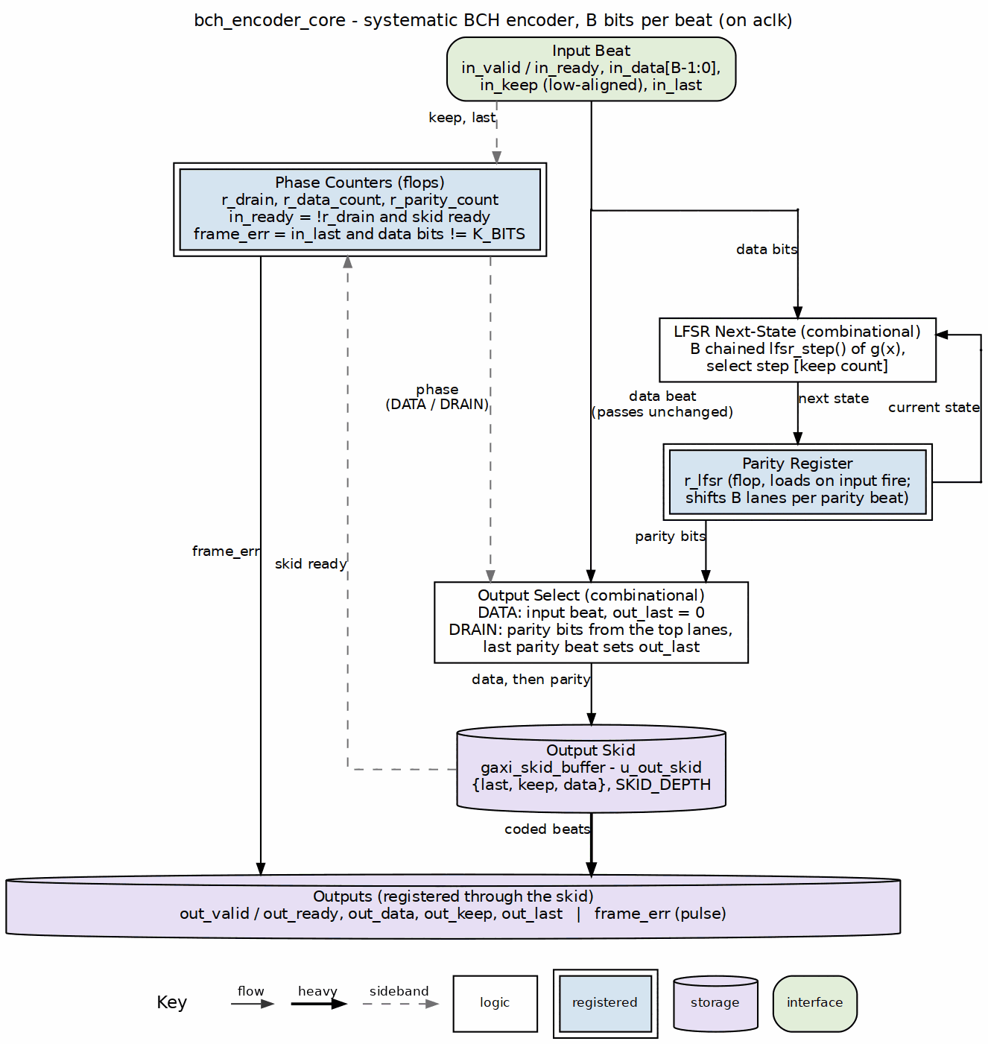
Encoder core block diagram

5.2 Parameters
Table 2.1: Encoder core parameters
Parameter | Type | Range | Default | Meaning | PRD
FIELD_DIM | int | 3..16 | TBD | m; field is GF(2^m) | D1
T_BITS | int | 1..(2^m-1)/2 | TBD | correctable bit errors | D2
N_BITS | int | 2t+1 .. 2^m-1 | TBD | codeword length in bits | D3
BITS_PER_BEAT | int | 1 .. K_BITS | TBD | bits per valid/ready beat | D9
Derived: K_BITS = N_BITS - DEGREE_G, where DEGREE_G is the degree of the generator polynomial computed by gf_pkg from m, t, and the profile parameters. DEGREE_G is at most m * T_BITS and equals N_BITS - K_BITS.

5.3 Interface
Table 2.2: Encoder core ports
Signal | Direction | Width | Description
aclk | in | 1 | one clock for the whole core
aresetn | in | 1 | active-low synchronous reset
in_valid | in | 1 | a beat of data bits is offered
in_ready | out | 1 | the core takes it this cycle
in_data | in | BITS_PER_BEAT | data bits, bit 0 in the low bit; partial final beat uses in_keep
in_keep | in | BITS_PER_BEAT | present-bit mask, low-aligned; partial only on the block’s final beat
in_last | in | 1 | this beat carries the K_BITS-th data bit
out_valid | out | 1 | a beat of coded bits is offered
out_ready | in | 1 | the consumer takes it
out_data | out | BITS_PER_BEAT | data bits while !w_parity_phase, parity bits while w_parity_phase
out_keep | out | BITS_PER_BEAT | present-bit mask; partial at the end of data and at the end of parity
out_last | out | 1 | this beat carries the N_BITS-th coded bit
frame_err | out | 1 | pulse: a block ended with other than K_BITS data bits

5.4 Microarchitecture internals

5.4.1 Beat-parallel LFSR parity generator
The core works on whole B-bit beats; there is no serialiser. The parity register r_lfsr holds deg(g) lanes of m bits over GF(2^m), with the generator polynomial’s coefficients (computed by bch_pkg from FIELD_DIM, PRIM_POLY, T_BITS and FIRST_ROOT) on its taps. Its next-state logic is a chain of B lfsr_step() evaluations, one per bit of the beat (bit 0 first), built as an unpacked array w_chain[0..B]; the keep count of the beat selects w_chain[keep count], so a partial final data beat advances the register by exactly the bits present. The multiplies use gf_mul_fn from the imported gf_pkg; no gf_lfsr_encoder instance is used.
The register loads on every accepted data beat. During the parity drain it shifts left by one beat’s worth of lanes each emitted beat, so it is all-zero again when the drain ends and the next block needs no explicit clear.

5.4.2 Parity mux
The output mux selects data bits while the block is in the data phase and parity bits once the data phase completes:
w_parity_phase = (r_bit_count >= K_BITS) && w_beat_is_parity
w_beat_is_parity is true whenever the current output position is inside the parity region; it is derived from the same bit counter:
w_beat_is_parity = (r_bit_count + BITS_PER_BEAT - 1) >= K_BITS
The mux output is out_data = w_parity_phase ? w_parity_bits : w_data_bits.

5.4.3 Output skid
There is no bit packer. {last, keep, data} from the output select goes into one gaxi_skid_buffer (u_out_skid, depth SKID_DEPTH, 2..8), whose read side is the output port. out_keep is full except on the final data beat and the final parity beat, where it marks the partial beat. out_last raises on the beat that carries the N_BITS-th coded bit:
w_enc_out_last = w_parity_phase &&
(r_parity_count + w_par_beat_len - 1 == N_BITS - K_BITS - 1)

5.5 FSM policy
This block carries no FSM (per vault/handbook/design/streaming-no-fsm.md). The sequencing that another design might put in a state machine is replaced by:
- r_bit_count: counts input/output bit position in the block, 0 .. N_BITS-1
- r_parity_count: counts parity bits emitted, 0 .. N_BITS-K_BITS-1
- r_drain: set by the accepted in_last beat, cleared by the last parity beat
- w_parity_phase: combinational qualifier selecting parity vs data
- w_last: combinational qualifier marking the final output beat
in_ready is combinational: !r_drain && w_skid_wr_ready, the output skid’s write-side ready qualified by the drain flag.

5.6 Timing
- One input beat is accepted per cycle while in_ready is high.
- The data phase is ceil(K_BITS / BITS_PER_BEAT) beats.
- The parity phase is ceil((N_BITS - K_BITS) / BITS_PER_BEAT) beats.
- in_ready is held low during the parity phase; back-to-back blocks need an upstream FIFO sized for at least N_BITS - K_BITS bits.
- The exact blocks-per-cycle numbers are placeholders tied to PRD D6 and D9.

5.7 Notes
- Wrong-length block handling: If in_last arrives before or after the K_BITS-th data bit, frame_err pulses and the block is still encoded as given (systematic data pass-through with parity appended to whatever data arrived). This is the encoder-side analog of the decoder’s out_status_frame_err (R1/R2):
- w_frame_err = in_last && (r_data_count + keep_count != K_BITS)
- OFF-state testing convention: For tests that need to verify the core tolerates idle cycles, the LFSR drains to zero with the last parity beat and the output skid stalls cleanly when out_ready is low.
- The LFSR is configured by the same FIELD_DIM, T_BITS, N_BITS, PRIM_POLY, and FIRST_ROOT parameters as the rest of the codec; its generator polynomial comes from bch_pkg (PRD D3/D8).

RTL Design Sherpa · Learning Hardware Design Through Practice Documentation Index · MIT License

6 Syndrome Unit (bch_syndrome_unit)
Module: bch_syndrome_unit.sv Location: rtl/fub/ Category: streaming datapath Parent: bch_decoder_core Status: landed — rtl/fub/bch_syndrome_unit.sv, gate DV green on the three standing profiles

6.1 Purpose
bch_syndrome_unit computes the t odd syndromes S_1, S_3, ..., S_2t-1 of the received BCH codeword as the bits arrive. The even syndromes are not computed directly; they are recovered from the odd ones through the binary BCH evenness shortcut S_2j = S_j^2 (PRD §2). The unit contains t parallel GF(2^m) multiply-accumulate lanes, one per odd syndrome.

6.1.1 Figure 2.2: Syndrome unit block diagram
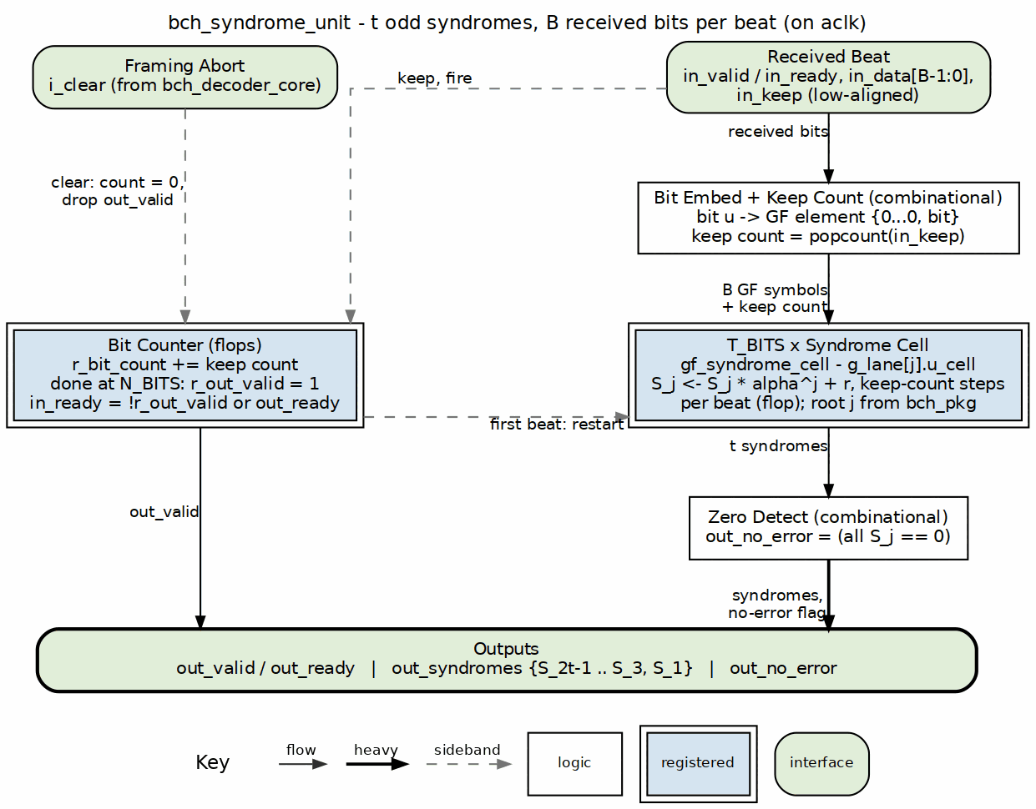
Syndrome unit block diagram

6.2 Parameters
Table 2.3: Syndrome unit parameters
Parameter | Type | Range | Default | Meaning | PRD
FIELD_DIM | int | 3..16 | TBD | m; field is GF(2^m) | D1
T_BITS | int | 1..(2^m-1)/2 | TBD | correctable bit errors | D2
N_BITS | int | 2t+1 .. 2^m-1 | TBD | codeword length in bits | D3
BITS_PER_BEAT | int | 1 .. K_BITS | TBD | bits per valid/ready beat | D9

6.3 Interface
Table 2.4: Syndrome unit ports
Signal | Direction | Width | Description
aclk | in | 1 | one clock
aresetn | in | 1 | active-low synchronous reset
in_valid | in | 1 | received bits are offered
in_ready | out | 1 | unit takes them this cycle
in_data | in | BITS_PER_BEAT | received bits, low-aligned
in_keep | in | BITS_PER_BEAT | present-bit mask for partial final beat
in_last | in | 1 | this beat carries the N_BITS-th received bit
out_valid | out | 1 | t odd syndromes are valid
out_ready | in | 1 | downstream accepts the syndromes
out_syndromes | out | T_BITS * m | {S_2t-1, ..., S_3, S_1} packed GF values
out_no_error | out | 1 | all odd syndromes are zero
i_clear | in | 1 | abort the in-flight accumulation: bit counter and any pending out_valid drop, and the next accepted beat starts a fresh block. Asserted by the decoder core on a framing violation (a block past N_BITS, issue #90) so the garbage count cannot leak into the next block

6.4 Microarchitecture internals

6.4.1 Odd-syndrome recurrence
For a received polynomial r(x) = sum_{i=0}^{N_BITS-1} r_i x^i, the odd syndromes are:
S_j = r(alpha^j) = sum_i r_i * (alpha^j)^i for j = 1, 3, ..., 2t-1
As bits arrive one at a time, each lane accumulates by Horner’s rule:
S_j <- S_j * alpha^j + r_i
The multiplier by the constant alpha^j is a gf_mul_const instance (imported from projects/components/ecc-ip/reed-solomon/rtl/fub/gf/gf_mul_const.sv). No per-position power table is stored; the constant alpha^j is wired once per lane.
With BITS_PER_BEAT = B > 1, each lane performs B Horner steps per cycle:
S_j <- (((S_j * alpha^j) + r_i0) * alpha^j + r_i1) * alpha^j + ... + r_iB-1
This is a short feed-forward chain of B constant multiplies and adds.

6.4.2 All-zero bypass qualifier
The no-error bypass is a combinational qualifier, not a state:
w_no_error = (S_1 == 0) && (S_3 == 0) && ... && (S_2t-1 == 0)
When w_no_error is true on the cycle w_syndrome_done raises, the decoder core skips the key-equation solver and Chien search and drains the block buffer unchanged.

6.4.3 Completion qualifier
The syndromes are complete once the last received bit has been accumulated:
w_syndrome_done = (r_bit_count == N_BITS - 1) && in_valid && in_ready
out_valid is a registered flag set by w_syndrome_done and cleared by the handshake with the downstream solver.

6.5 FSM policy
This block carries no FSM (per vault/handbook/design/streaming-no-fsm.md). Control is reduced to:
- r_bit_count: counts received bits, 0 .. N_BITS-1
- r_lane_valid: registered output valid flag
- w_syndrome_done: combinational completion qualifier
- w_no_error: combinational all-zero qualifier
Each lane is a pure multiply-accumulate datapath; the lane count and the output valid flag replace any state machine.

6.6 Timing
- One received bit advances every lane by one Horner step.
- Serial case (BITS_PER_BEAT = 1): N_BITS cycles per block.
- Parallel-beat case: ceil(N_BITS / BITS_PER_BEAT) cycles per block, with B chained GF constant multiplies per lane per cycle.
- The exact cycle count is a placeholder tied to PRD D6.

6.7 Notes
- A shortened code (N_BITS < 2^m - 1) is handled by treating the missing leading bits as zero: the Horner recurrence naturally accumulates starting from S_j = 0, which is equivalent to zero-padding the high-order coefficients.
- The evenness shortcut means the formal proof targets include S_2j == gf_square(S_j) for every odd j; the square in GF(2^m) is a linear bit-permutation and is cheap to verify.
- out_no_error is a combinational decode of the syndrome registers; it is stable from w_syndrome_done until the output handshake clears it.

RTL Design Sherpa · Learning Hardware Design Through Practice Documentation Index · MIT License

7 Key Equation Solver (bch_key_equation_solver)
Module: bch_key_equation_solver.sv Location: rtl/fub/ Category: datapath + conditional control FSM Parent: bch_decoder_core Status: landed — rtl/fub/bch_key_equation_solver.sv implements “RIBM” (the documented default when no consumer names a small-t profile); KES_ALGO values other than “RIBM” raise an elaboration error rather than silently falling back. PRD D11 stays open for EUCLID / SMALL_T.

7.1 Purpose
bch_key_equation_solver inverts the key equation from the t odd syndromes S_1, S_3, ..., S_2t-1 to the error-locator polynomial Lambda(x). The choice of algorithm is PRD D11; this page documents all three candidates and their microarchitectural implications. Nothing outside the solver knows which algorithm produced Lambda: the Chien search, block buffer, and corrector are identical in every build.

7.2 Parameters
Table 2.5: Key-equation solver parameters
Parameter | Type | Range | Default | Meaning | PRD
FIELD_DIM | int | 3..16 | TBD | m; field is GF(2^m) | D1
T_BITS | int | 1..(2^m-1)/2 | TBD | correctable bit errors | D2
KES_ALGO | string | "RIBM", "EUCLID", "SMALL_T" | TBD | solver algorithm | D11

7.3 Interface
Table 2.6: Key-equation solver ports
Signal | Direction | Width | Description
aclk | in | 1 | one clock
aresetn | in | 1 | active-low synchronous reset
in_valid | in | 1 | odd syndromes are valid
in_ready | out | 1 | solver accepts syndromes
in_syndromes | in | T_BITS * m | {S_2t-1, ..., S_3, S_1} packed GF values
out_valid | out | 1 | Lambda(x) coefficients are valid
out_ready | in | 1 | downstream accepts Lambda
out_lambda | out | (T_BITS + 1) * m | locator coefficients Lambda_0 .. Lambda_T_BITS
out_lambda_degree | out | $clog2(T_BITS + 1) | actual degree of Lambda (clamped to T_BITS when out_more_than_t)
out_more_than_t | out | 1 | any Lambda_i above index T_BITS is nonzero — more than t errors; the decoder core folds it into the R2 verdict

7.4 Candidate algorithms
The trade-off table below is copied from ../bch_has/ch03_architecture/03_solver_options.md.
Table 2.7: Key-equation solver candidates
 | inversionless BM ("RIBM") | modified Euclidean ("EUCLID") | step-by-step / PGZ ("SMALL_T")
Algorithm | reformulated inversionless Berlekamp-Massey, Sarwate and Shanbhag 2001; seeded with the t odd syndromes | Sugiyama’s Euclidean algorithm with cross-multiplication in place of division (Shao et al. 1985) | Massey 1965 step-by-step correction, or the Peterson-Gorenstein-Zierler direct matrix solve for small t
Array | 3t + 1 processing elements, 2 registers each | four register arrays: R and Q of 2t + 1 symbols, the shifted locator pair of 2t + 3 | control-heavy but small datapath: one or a few GF multipliers and a syndrome update loop
GF multipliers | 2 per element: 6t + 2 | 2 per coefficient of each pair: 8t + 8 | O(t^2) logic or a single iterative multiplier
Iterations | exactly 2t | data-dependent, t + 1 .. 2t | one per located error position, up to t
Critical path per iteration | one multiply and one XOR, no feedback across the array | cross-multiply feeding a degree comparison that drives the swap: longer | depends on implementation; often dominated by syndrome-update MUX tree
Control | discrepancy select and gamma update | two nominal degree counters, the normalise / cross / swap rule | position counter, syndrome-test loop, error-counter update
Readability | dense; the reformulation is not obvious from the textbook | the textbook algorithm, recognisable step by step | the simplest conceptually for very small t
Best fit | general t; the default if no consumer names a small-t profile | a cross-check and a readable alternative | t <= 8 (flash pages often sit here); smallest area at tiny t
No default is selected at MAS v0.1. The choice is PRD D11.

7.5 Microarchitecture internals

7.5.1 "RIBM" and "EUCLID" — fixed-iteration arrays
Both the reformulated inversionless Berlekamp-Massey array and the modified Euclidean array are pure datapath structures. They need:
- an iteration counter, 0 .. 2 * T_BITS
- a start pulse from in_valid && in_ready
- a completion qualifier when the iteration count reaches its target
Neither implementation has a state machine in the data path. The control signals (discrepancy select, gamma update, degree comparison, swap) are combinational or registered qualifiers derived from the iteration counter and the array registers.

7.5.2 "SMALL_T" — conditional minimal control FSM
The step-by-step and PGZ approaches are control-heavy. If D11 selects "SMALL_T", this block is the one place in the decoder datapath where a minimal control FSM is permitted (per vault/handbook/design/minimal-fsm.md). The target state list is the fewest states that carry real distinctions:
IDLE -> wait for in_valid
RUN -> execute one iteration / error-position test
TEST -> evaluate the discrepancy / matrix determinant
DONE -> out_valid raised, hold until out_ready
The IDLE/RUN/TEST/DONE list is conditional on KES_ALGO == "SMALL_T" and is marked as such in the RTL. States that only wait one fixed cycle are merged into RUN with a sub-counter.

7.6 FSM policy
- For "RIBM" and "EUCLID": no FSM in the data path; only an iteration counter and completion qualifier.
- For "SMALL_T": one minimal control FSM is permitted, conditional on D11, with the state list above.

7.7 Timing
- "RIBM": exactly 2 * T_BITS iterations.
- "EUCLID": between T_BITS + 1 and 2 * T_BITS iterations, data-dependent.
- "SMALL_T": up to T_BITS error-position tests, plus setup cycles.
- Exact cycle counts are placeholders tied to PRD D11 and D6.

7.8 Notes
- Two solvers agreeing as a cross-check is the recommended verification posture from the HAS: the golden model runs every candidate on every block and requires identical roots, and the RTL is built with whichever algorithm the first consumer prefers.
- The locator degree out_lambda_degree is produced by the solver and is used by the Chien search to determine correctability.
- Lambda_0 is always 1 for a valid locator; the formal targets include this invariant and the relationship to the odd syndromes.

RTL Design Sherpa · Learning Hardware Design Through Practice Documentation Index · MIT License

8 Chien Search (bch_chien_search)
Module: bch_chien_search.sv Location: rtl/fub/ Category: streaming datapath Parent: bch_decoder_core Status: landed — rtl/fub/bch_chien_search.sv. The flip-enable qualification below is resolved: out_flip_en carries the raw root flags per beat; the w_correctable && !w_release_passthrough qualification is a decoder-core output function (release-on-verdict), applied where the verdict is final, not in this walk.

8.1 Purpose
bch_chien_search evaluates the error-locator polynomial Lambda(x) at every one of the N_BITS bit positions of the received codeword. Where Lambda has a root, the corresponding bit is in error. Because the code is binary, every error value is 1 (PRD §2); the block therefore flips the bit directly and needs no Forney evaluator. The block also feeds the uncorrectability verdict by comparing the root count to the locator degree.

8.1.1 Figure 2.3: Chien search block diagram
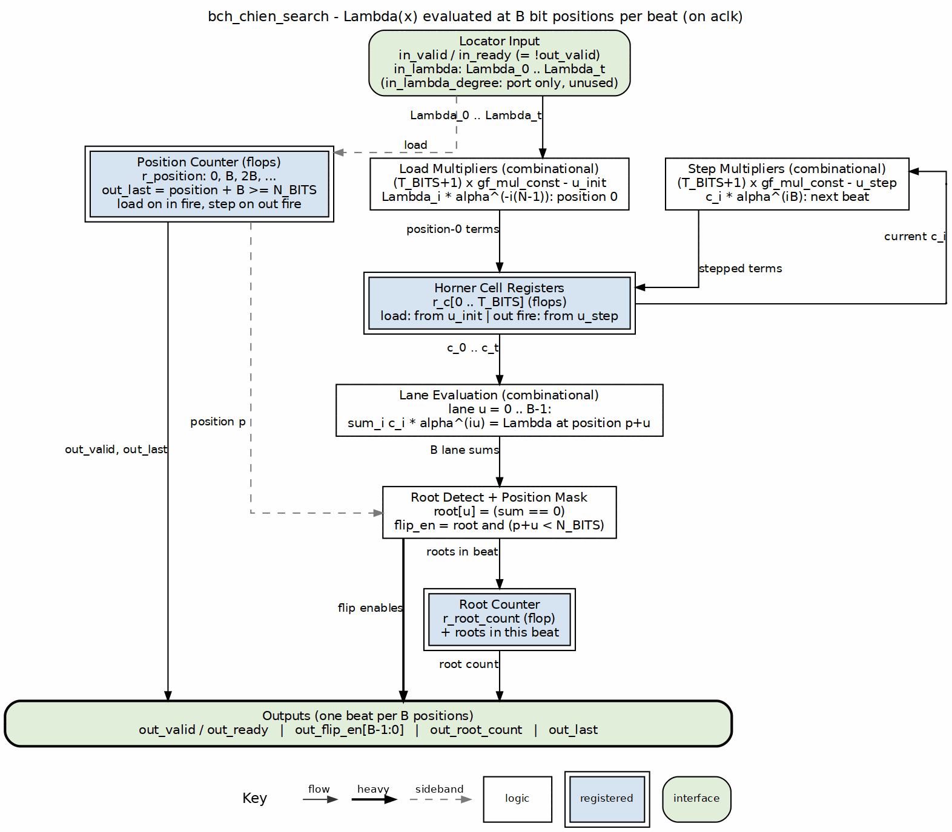
Chien search block diagram

8.2 Parameters
Table 2.8: Chien search parameters
Parameter | Type | Range | Default | Meaning | PRD
FIELD_DIM | int | 3..16 | TBD | m; field is GF(2^m) | D1
T_BITS | int | 1..(2^m-1)/2 | TBD | correctable bit errors | D2
N_BITS | int | 2t+1 .. 2^m-1 | TBD | codeword length in bits | D3
BITS_PER_BEAT | int | 1 .. K_BITS | TBD | bits per valid/ready beat | D9

8.3 Interface
Table 2.9: Chien search ports
Signal | Direction | Width | Description
aclk | in | 1 | one clock
aresetn | in | 1 | active-low synchronous reset
in_valid | in | 1 | Lambda(x) coefficients are valid
in_ready | out | 1 | unit accepts Lambda
in_lambda | in | (T_BITS + 1) * m | locator coefficients Lambda_0 .. Lambda_T_BITS
in_lambda_degree | in | $clog2(T_BITS + 1) | actual degree of Lambda
out_valid | out | 1 | a beat of correction flags is offered
out_ready | in | 1 | downstream accepts correction flags
out_flip_en | out | BITS_PER_BEAT | one-hot bit-flip enable per position in the beat
out_root_count | out | $clog2(T_BITS + 1) | roots found so far
out_last | out | 1 | final position of the block

8.4 Microarchitecture internals

8.4.1 Parallel Horner cells
Lambda(x) is evaluated at consecutive powers of alpha using Horner cells. For position i, the evaluation is:
Lambda(alpha^-i) = Lambda_0 + Lambda_1*alpha^-i + Lambda_2*alpha^-2i + ... + Lambda_t*alpha^-ti
Each cell holds a running partial sum and multiplies by a constant factor each cycle, stepping from one position to the next. With BITS_PER_BEAT = B > 1, each lane evaluates B positions per cycle by chaining B constant multiplies from the same starting register.
The root flag per position is:
w_root[i] = (w_lambda_at_pos[i] == 0)

8.4.2 Direct bit-flip accumulation
At this fub level out_flip_en[i] is the raw root flag for position i (gated only by position validity in the final partial beat). The qualifier w_root[i] && w_correctable && !w_release_passthrough lives in bch_decoder_core, which owns w_correctable (root count matches locator degree, degree within T_BITS) and w_release_passthrough (uncorrectable and frame-err blocks pass through unchanged, R2). There is no error-value computation anywhere; every root means flip.

8.4.3 Root count (the verdict lives in the decoder core)
The block keeps a running root count, r_root_count, and presents out_root_count = r_root_count + roots in this beat on every beat; on the last beat it is the block’s total. The block makes no verdict of its own. bch_decoder_core compares the count with the locator degree it captured from the solver:
correctable = !more_than_t && (root_count == lambda_degree) && recheck_zero
The in_lambda_degree port is declared but not read inside this block; the decoder core uses its own registered copy of the degree.

8.5 FSM policy
This block carries no FSM (per vault/handbook/design/streaming-no-fsm.md). The Chien walk is driven by:
- r_position: counts bit positions, 0 .. N_BITS-1
- r_root_count: running count of roots
- out_valid: registered pipeline flag
- w_last: combinational qualifier for the final position
The position counter replaces any state machine.

8.6 Timing
- Serial case (BITS_PER_BEAT = 1): N_BITS cycles per block to evaluate all positions.
- Parallel-beat case: ceil(N_BITS / BITS_PER_BEAT) cycles per block, with B Horner evaluations per lane per cycle.
- The exact cycle count and throughput trade-off are placeholders tied to PRD D6.

8.7 Notes
- A shortened code (N_BITS < 2^m - 1) is handled by starting the Chien walk at the appropriate offset so that the first emitted position corresponds to bit 0 of the shortened codeword.
- The no-Forney structure is a key formal target: prove that every root of Lambda in a correctable block corresponds to exactly one bit flip and that the resulting corrected block has zero syndrome.
- out_flip_en is a beat-wide vector; the corrector XORs it with the corresponding beat from the block buffer.

RTL Design Sherpa · Learning Hardware Design Through Practice Documentation Index · MIT License

9 Decoder Core Integration (bch_decoder_core)
Module: bch_decoder_core.sv Location: rtl/macro/ Category: integration block + one minimal control FSM Parent: bch_top / standalone decoder wrapper Status: landed — rtl/macro/bch_decoder_core.sv. The sequencer has a sixth state RECHECK (IDLE/SYND/SOLVE/CHIEN/RECHECK/RELEASE): the verdict is computed only after the optional re-check syndrome unit finishes, because the re-check result is not known until the corrected stream’s last beat. Corrections are applied at the output read, not during the Chien walk (release-on-verdict, mirroring rs_decoder_core), so the MAS timing note “first corrected beat leaves as soon as the Chien walk starts” is corrected: the corrected image is computed during the walk but released only after the verdict. Single outstanding block; pipelining is PRD D6 open work. Framing violations cannot deadlock the input (issue #90): a block that reaches N_BITS without in_last, or overshoots it, is buffered up to BEATS_N beats, released with frame_err, and the syndrome unit is cleared for the next block.

9.1 Purpose
bch_decoder_core integrates the received-block buffer, syndrome unit, key-equation solver, Chien search, and corrector into one valid/ready streaming block. It is the only block in the decoder datapath that is allowed to contain a control FSM, because the sequencing of distinct algorithmic stages is genuine control, not per-beat datapath.

9.1.1 Figure 2.4: Decoder core block diagram
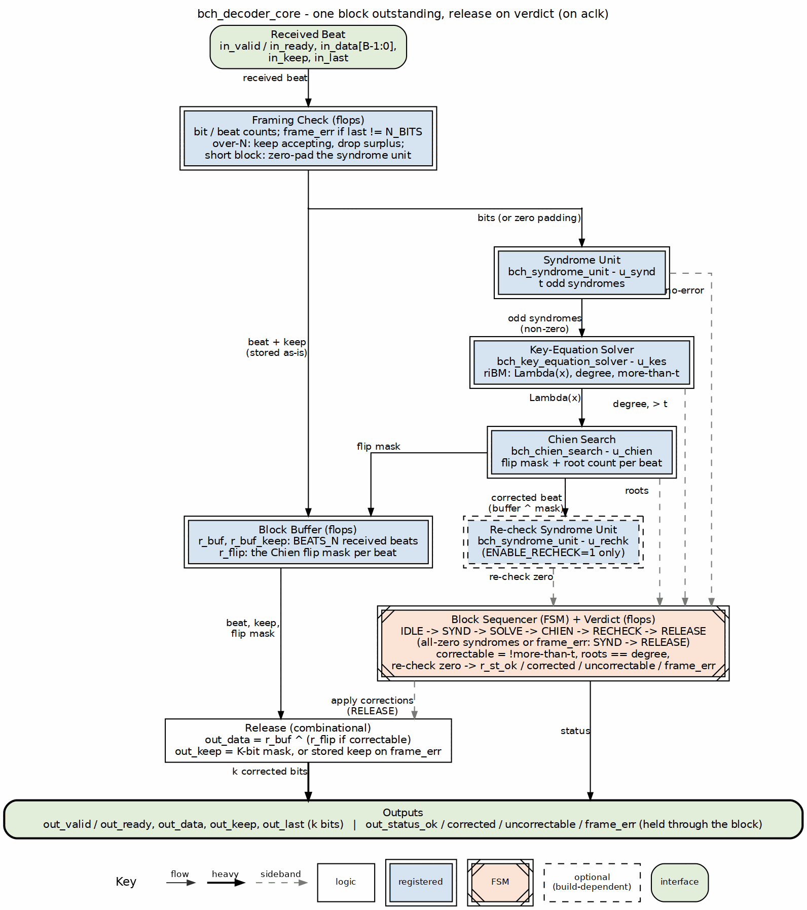
Decoder core block diagram

9.2 Parameters
Table 2.10: Decoder core parameters
Parameter | Type | Range | Default | Meaning | PRD
FIELD_DIM | int | 3..16 | TBD | m; field is GF(2^m) | D1
T_BITS | int | 1..(2^m-1)/2 | TBD | correctable bit errors | D2
N_BITS | int | 2t+1 .. 2^m-1 | TBD | codeword length in bits | D3
BITS_PER_BEAT | int | 1 .. K_BITS | TBD | bits per valid/ready beat | D9
PRIM_POLY | int | irreducible of degree m | TBD | primitive polynomial | D8
FIRST_ROOT | int | 0 .. 2^m-2 | TBD | b, first root of g(x) | D8
K_BITS | int | derived | N_BITS - deg g(x) | message bits; exposed for convenience, do not override | –
ENABLE_RECHECK | bit | 0, 1 | 1 | run a second syndrome unit over the corrected stream and fold its zero-syndrome result into the verdict | –
bch_decoder_core has no ENABLE_ERASURES or KES_ALGO parameter. Erasure decoding is not implemented (PRD D5 is open, and the imported solver is instantiated with ERASURE_SUPPORT = 0). KES_ALGO is a parameter of bch_key_equation_solver only, left at its default "RIBM" by the core; any other value is an elaboration error (Section 2.3).

9.3 Interface
Table 2.11: Decoder core ports
Signal | Direction | Width | Description
aclk | in | 1 | one clock
aresetn | in | 1 | active-low synchronous reset
in_valid / in_ready | in / out | 1 | valid/ready for received bits
in_data | in | BITS_PER_BEAT | received bits
in_keep | in | BITS_PER_BEAT | present-bit mask
in_last | in | 1 | this beat carries the N_BITS-th received bit
out_valid / out_ready | out / in | 1 | valid/ready for corrected data
out_data | out | BITS_PER_BEAT | corrected data bits; parity lanes dropped
out_keep | out | BITS_PER_BEAT | present-bit mask
out_last | out | 1 | this beat carries the K_BITS-th data bit
out_status_ok | out | 1 | block had no errors
out_status_corrected | out | $clog2(T_BITS + 1) | bits corrected (0 .. T_BITS)
out_status_uncorrectable | out | 1 | correction failed
out_status_frame_err | out | 1 | block length was not N_BITS

9.4 Microarchitecture internals

9.4.1 Block buffer
The received block is written into a register buffer as it arrives: r_buf and r_buf_keep hold BEATS_N = ceil(N_BITS / BITS_PER_BEAT) beats, and r_flip holds the Chien flip mask for each beat, written during CHIEN. The buffer is read out in RELEASE, after the verdict. For an uncorrectable block, the buffer passes the received bits through unchanged (R2):
w_release_passthrough = w_uncorrectable || w_frame_err

9.4.2 Stage sequencer
The decoder core contains exactly one minimal control FSM (per vault/handbook/design/minimal-fsm.md). Stage sequencing is control, not per-beat datapath. The proposed state list merges any state that only waits one fixed cycle into its successor with a counter:
IDLE -> wait for a new block to begin arriving
SYND -> receiving the block into the buffer and the syndrome unit
SOLVE -> key-equation solver running
CHIEN -> Chien search; flip masks stored beside the buffered beats
RECHECK -> wait for the re-check syndrome unit (skipped if ENABLE_RECHECK=0)
RELEASE -> outputting the corrected (or passthrough) block
A state like “wait one cycle for solver start” is killed: it becomes a registered r_solver_start pulse inside SYND or SOLVE.

9.4.3 Corrected-stream re-check
As an R2 mechanism, a second syndrome unit (u_rechk, present when ENABLE_RECHECK = 1, the default) accumulates over the corrected stream, r_buf ^ flip mask, beat by beat during CHIEN. If any odd syndrome is non-zero after correction, the block is flagged uncorrectable even if the Chien root count matched the locator degree. This mirrors the release-on-verdict discipline in the sibling rs_decoder_core architecture. The re-check is gated by a build parameter and is an implementation detail, not part of the locator search.

9.4.4 Correctability verdict
The per-block uncorrectable verdict is:
w_uncorrectable = !w_correctable || (w_recheck_enabled && !w_recheck_zero)
w_correctable = (r_root_count == r_lambda_degree) && (r_lambda_degree <= T_BITS)
out_status_uncorrectable is held for every beat of the released block.

9.5 FSM policy
This block is the one place in the decoder datapath where a minimal control FSM is permitted. The FSM has the six states above; any state that only waits one fixed cycle is merged with its successor. All per-beat operations inside the stages (syndrome accumulation, solver array stepping, Chien evaluation) remain FSM-free pipelines.

9.6 Timing
- SYND phase: ceil(N_BITS / BITS_PER_BEAT) beats.
- SOLVE phase: depends on KES_ALGO and T_BITS (PRD D11).
- CHIEN / RELEASE phase: ceil(N_BITS / BITS_PER_BEAT) beats, overlapped so that the first corrected beat leaves as soon as the Chien walk starts.
- Total latency and throughput trade-offs are placeholders tied to PRD D6.

9.7 Notes
- This whole page is conditional on the build including the decoder (PRD D4) and on the throughput architecture (PRD D6) and solver choice (PRD D11).
- Frame error: a block whose in_last arrives before or after the N_BITS-th bit is flagged with out_status_frame_err and passes through unchanged. The first length - (N_BITS - K_BITS) bits of a too-long block are treated as data.
- Status outputs describe the block being emitted and are valid on every beat of it; a consumer may sample them with out_last.

RTL Design Sherpa · Learning Hardware Design Through Practice Documentation Index · MIT License

10 Core Signals
This page presents the valid/ready core signals as a contract table rather than restating the prose interface description in ../bch_has/ch04_interfaces/01_core_interface.md. The direction, reset value, and creator block for each signal are the source of truth here.

10.1 Reset strategy
All core logic uses synchronous active-low reset (aresetn), the house clocking convention. Reset clears block state, counters, the LFSR, syndrome registers, solver arrays, and the Chien position counter. The block buffer itself is not reset; its read/write pointers are reset, which makes the buffer contents logically invalid until overwritten.

10.2 bch_encoder_core signal contract
Table 3.1: bch_encoder_core signal contract
Signal | Dir | Width | Reset value | Creates / consumes | Contract | Source block page
aclk | in | 1 | — | clock source | one clock for the whole core | —
aresetn | in | 1 | — | reset source | synchronous active-low reset | —
in_valid | in | 1 | — | upstream | stable until in_ready high | encoder core
in_ready | out | 1 | 0 | encoder core | combinational !r_valid || m_ready gated by parity-drain | encoder core
in_data | in | BITS_PER_BEAT | — | upstream | data bits, low-aligned; partial final beat qualified by in_keep | encoder core
in_keep | in | BITS_PER_BEAT | — | upstream | present-bit mask, low-aligned; partial only on final beat | encoder core
in_last | in | 1 | — | upstream | this beat carries the K_BITS-th data bit | encoder core
out_valid | out | 1 | 0 | encoder core | registered pipeline flag; data beats then parity beats | encoder core
out_ready | in | 1 | — | downstream | may depend on out_valid | encoder core
out_data | out | BITS_PER_BEAT | 0 | encoder core | data while !w_parity_phase, parity while w_parity_phase | encoder core
out_keep | out | BITS_PER_BEAT | 0 | encoder core | full except on final data and final parity beats | encoder core
out_last | out | 1 | 0 | encoder core | this beat carries the N_BITS-th coded bit | encoder core
frame_err | out | 1 | 0 | encoder core | pulse when in_last does not coincide with K_BITS data bits | encoder core

10.3 bch_decoder_core signal contract
Table 3.2: bch_decoder_core signal contract
Signal | Dir | Width | Reset value | Creates / consumes | Contract | Source block page
in_valid | in | 1 | — | upstream | stable until in_ready high | decoder core
in_ready | out | 1 | 0 | decoder core | high while buffer has space; drops when full | decoder core
in_data | in | BITS_PER_BEAT | — | upstream | received bits, low-aligned | decoder core
in_keep | in | BITS_PER_BEAT | — | upstream | present-bit mask; partial only on final beat | decoder core
in_last | in | 1 | — | upstream | this beat carries the N_BITS-th received bit | decoder core
in_erase | in | BITS_PER_BEAT | — | upstream | (only with ENABLE_ERASURES) known-bad bits | decoder core
out_valid | out | 1 | 0 | decoder core | high once the block verdict is final | decoder core
out_ready | in | 1 | — | downstream | may depend on out_valid | decoder core
out_data | out | BITS_PER_BEAT | 0 | decoder core | corrected data bits; parity lanes dropped | decoder core
out_keep | out | BITS_PER_BEAT | 0 | decoder core | present-bit mask; partial only on final beat | decoder core
out_last | out | 1 | 0 | decoder core | this beat carries the K_BITS-th data bit | decoder core
out_status_ok | out | 1 | 0 | decoder core | held for every beat: block had no errors | syndrome unit, decoder core
out_status_corrected | out | $clog2(T_BITS+1) | 0 | decoder core | held for every beat: bits corrected (0 .. T_BITS) | Chien search, decoder core
out_status_uncorrectable | out | 1 | 0 | decoder core | held for every beat: correction failed; data pass through unchanged | Chien search, decoder core
out_status_frame_err | out | 1 | 0 | decoder core | held for every beat: block length was not N_BITS | decoder core

10.4 Timing rules
- in_last is the sole block boundary; the cores do not infer boundaries by counting.
- out_status_* describe the block being emitted and are valid on every beat of it, first to last. A consumer may sample them with out_last or with the first beat.
- An uncorrectable block leaves exactly as received; the corrector is disabled by w_release_passthrough.

RTL Design Sherpa · Learning Hardware Design Through Practice Documentation Index · MIT License

11 Signal Contracts and K-maps

11.1 What a contract is
A signal contract in this repo is a machine-checkable statement of what a signal is allowed to do. Each contract has three parts, in order:
- Term list: every signal or expression in play, with its defining expression and file:line citation.
- Invariants: the strict relationships between terms, each cited, each stating which rows of the decision table it renders impossible.
- Decision table: one row per combination of the terms. Rows the invariants forbid are marked ILLEGAL; legal rows carry the resulting output.
The canonical methodology is in vault/handbook/design/signal-contracts-and-kmaps.md; the shared generator machinery is in bin/kmaps/.

11.2 Which signals have contracts
The BCH workbook documents the control/qualifier signals whose correctness is non-obvious: parity-phase select, block-boundary and frame-error qualifiers, syndrome completion, no-error bypass, correctability verdict, Chien root-position enables, and uncorrectable pass-through. The complete list is in the generated workbook.

11.3 Pre-RTL citation posture
At MAS v0.1 there is no RTL, so the contracts cite the MAS pages where the intended expressions are written verbatim. When the first RTL lands, every MAS citation is re-pointed at the corresponding .sv file and line. The generator’s citation gate then enforces that the workbook and the RTL agree; a drift fails the run.

11.4 Regenerating the workbook
python3 projects/components/ecc-ip/bch/docs/gen_bch_signal_contracts_kmaps.py
The generator writes:
projects/components/ecc-ip/bch/docs/bch_signal_contracts.xlsx
Do not hand-edit the .xlsx; it is a build artifact of the generator.

11.5 Workbook contents
The generated workbook contains:
- a contract sheet for the core signals
- a kmap sheet per block with the key combinational decisions
- term lists, invariants, decision tables, depends_only_on sufficiency arguments, and rtl_sop expressions for review against the landed RTL
Since the 2026-10-08 citation migration (TASK-003 close) every citation points at the landed RTL file:line and the generator’s verify_citations gate fails the build if an RTL edit moves a quoted line. For every kmap the verdict is the derived minimal cover diffed against rtl_sop (IDENTICAL or DIFFERS); all eight maps of the landed design render IDENTICAL.

