
RTL Design Sherpa
Reed-Solomon Codec Micro-Architecture Specification 0.1 (draft)
October 4, 2026

Table of Contents
1 Reed Solomon Mas Index 11
2 Document Information 12
2.1 Reed-Solomon Codec Micro-Architecture Specification 12
2.2 Revision History 13
2.3 Document Purpose 14
2.4 Intended Audience 15
2.5 Related Documents 16
3 Methodology 17
3.1 HAS to MAS relationship 17
3.2 Retroactive posture: the RTL is the ground truth 18
3.3 FSM policy 19
3.4 Verification posture 20
3.5 Carrying open PRD decisions 21
4 Block Inventory 22
4.1 Drift from the pre-RTL catalog 26
5 Encoder Core (rs_encoder_core) 28
5.1 Purpose 29
5.1.1 Figure 2.1: Encoder core block diagram 29
5.2 Parameters 30
5.3 Interface 32
5.4 Microarchitecture internals 34
5.4.1 GF(2^m) LFSR parity generator 34
5.4.2 Output parity select 34
5.4.3 Output skid buffer 35
5.4.4 Frame-length check 35
5.5 FSM policy 36
5.6 Timing 37
5.7 Notes 38
6 Syndrome Unit (syndrome_unit) 39
6.1 Purpose 40
6.1.1 Figure 2.2: Syndrome unit block diagram 40
6.2 Parameters 41
6.3 Interface 42
6.4 Microarchitecture internals 43
6.4.1 Syndrome recurrence 43
6.4.2 Parallel cells 43
6.4.3 All-zero flag 43
6.4.4 Combinational next outputs 43
6.5 FSM policy 44
6.6 Timing 45
6.7 Notes 46
7 Key Equation Solver — riBM (key_equation_solver_ribm) 47
7.1 Purpose 48
7.1.1 Figure 2.3: riBM solver block diagram 48
7.2 Parameters 49
7.3 Interface 50
7.4 Microarchitecture internals 52
7.5 FSM policy 53
7.6 Timing 54
7.7 Notes 55
8 Key Equation Solver — Euclidean (key_equation_solver_euclid) 56
8.1 Purpose 57
8.1.1 Figure 2.4: Euclid solver block diagram 57
8.2 Parameters 58
8.3 Interface 59
8.4 Microarchitecture internals 61
8.5 FSM policy 63
8.6 Timing 64
8.7 Notes 65
9 Chien Search (chien_search) 66
9.1 Purpose 67
9.1.1 Figure 2.5: Chien search block diagram 67
9.2 Parameters 68
9.3 Interface 69
9.4 Microarchitecture internals 70
9.4.1 t + 1 Chien cells 70
9.4.2 Lane structure 70
9.4.3 Constant-multiply implementation 70
9.5 FSM policy 71
9.6 Timing 72
9.7 Notes 73
10 Forney Evaluator (forney_evaluator) 74
10.1 Purpose 75
10.1.1 Figure 2.6: Forney evaluator block diagram 75
10.2 Parameters 76
10.3 Interface 77
10.4 Microarchitecture internals 78
10.4.1 t Omega cells 78
10.4.2 Lane numerator 78
10.4.3 Per-lane inverse and multiply 78
10.5 FSM policy 80
10.6 Timing 81
10.7 Notes 82
11 Erasure Unit (rs_erasure_unit) 83
11.1 Purpose 84
11.1.1 Figure 2.7: Erasure unit block diagram 85
11.2 Parameters 86
11.3 Interface 87
11.4 Microarchitecture internals 89
11.4.1 Receive half — recording the flagged locations 89
11.4.2 Transform half — Gamma and the Forney syndrome 89
11.4.3 Solver input window 89
11.4.4 Combine — building the walk polynomials 90
11.4.5 Correction bound 90
11.4.6 Elaboration guard 90
11.5 FSM policy 91
11.6 Timing 92
11.7 Notes 93
12 Decoder Core Integration (rs_decoder_core) 94
12.1 Purpose 95
12.1.1 Figure 2.8: Decoder core block diagram 96
12.2 Parameters 98
12.3 Interface 100
12.4 Microarchitecture internals 102
12.4.1 Stage A — receive 102
12.4.2 Stage B — solve 102
12.4.3 Stage C — correct 102
12.4.4 Descriptor records 103
12.4.5 FIFO sizing 104
12.4.6 Status encodings 104
12.5 FSM policy 106
12.6 Timing 107
12.7 Notes 108
13 Core Signals 109
13.1 Reset strategy 110
13.2 rs_encoder_core signal contract 111
13.3 rs_decoder_core signal contract 114
13.4 Timing rules 117
14 Signal Contracts and Golden Model 118
14.1 What a contract is 118
14.2 Which signals carry the contracts 119
14.3 Citation posture 121
14.4 The golden-model contract 122
14.5 Where formal verification stands 123

List of Figures
Figure 2.1: Encoder core block diagram 29
Figure 2.2: Syndrome unit block diagram 40
Figure 2.3: riBM solver block diagram 48
Figure 2.4: Euclid solver block diagram 57
Figure 2.5: Chien search block diagram 67
Figure 2.6: Forney evaluator block diagram 75
Figure 2.7: Erasure unit block diagram 85
Figure 2.8: Decoder core block diagram 96

List of Tables
Table 1: Table 0.1: Related documents 16
Table 2: Table 1.1: MAS block inventory 22
Table 3: Table 1.2: GF leaf primitives 24
Table 4: Table 1.3: Support blocks covered elsewhere 24
Table 5: Table 1.4: Catalog-to-RTL drift 26
Table 6: Table 2.1: Encoder core parameters 30
Table 7: Table 2.2: Encoder core ports 32
Table 8: Table 2.3: Syndrome unit parameters 41
Table 9: Table 2.4: Syndrome unit ports 42
Table 10: Table 2.5: riBM solver parameters 49
Table 11: Table 2.6: riBM solver ports 50
Table 12: Table 2.7: Euclidean solver parameters 58
Table 13: Table 2.8: Euclidean solver ports 59
Table 14: Table 2.9: Chien search parameters 68
Table 15: Table 2.10: Chien search ports 69
Table 16: Table 2.11: Forney evaluator parameters 76
Table 17: Table 2.12: Forney evaluator ports 77
Table 18: Table 2.13: Erasure unit parameters 86
Table 19: Table 2.14: Erasure unit ports 87
Table 20: Table 2.15: Decoder core parameters 98
Table 21: Table 2.16: Decoder core ports 100
Table 22: Table 2.17: Descriptor record layouts (DAB_W and DBC_W) 103
Table 23: Table 2.18: Decoder core FIFO sizing 104
Table 24: Table 2.19: Decoder core status outputs 104
Table 25: Table 3.1: rs_encoder_core signal contract 111
Table 26: Table 3.2: rs_decoder_core signal contract 114
Table 27: Table 4.1: Contract areas in the landed RTL 119

List of Waveforms
No waveforms in this document.

1 Reed Solomon Mas Index
Generated: 2026-10-20

RTL Design Sherpa · Learning Hardware Design Through Practice GitHub · Documentation Index · MIT License

2 Document Information

2.1 Reed-Solomon Codec Micro-Architecture Specification
Property | Value
Document Title | Reed-Solomon Codec Micro-Architecture Specification
Version | 0.3 (draft)
Date | October 4, 2026
Status | Draft — written retroactively against landed RTL (encoder and decoder cores, both solvers, gate DV green); the .sv files cited in this document are the ground truth
Classification | Open Source - MIT License

2.2 Revision History
Version | Date | Author | Description
0.1 | 2026-10-04 | RTL Design Sherpa | First draft, written after the RTL landed. Documents the landed micro-architecture block by block: signal-level structure, FSM policy, cycle behavior, and the verification posture. Where the FUB catalog (docs/rs_fub_catalog.md, 2026-09-29) and the RTL disagree, the RTL wins and the catalog is noted as the plan this MAS checks.
0.2 | 2026-10-20 | RTL Design Sherpa | Block diagrams redrawn to the repo element key (v3): class fills, double-bordered registered blocks, green return paths and a generated key under each figure. No technical content changed.
0.3 | 2026-10-20 | RTL Design Sherpa | Section (h2) headings now open a new page, the pipeline default. No technical content changed.

2.3 Document Purpose
This Micro-Architecture Specification (MAS) is the implementation-level view of the Reed-Solomon codec — the HAS (../reed_solomon_has/) taken one level down. It is the document a verification engineer reads before writing assertions and the document an integrator reads before instantiating a core.
It covers:
- each functional block’s internal structure, signals, and parameters, cited to the .sv source
- the FSM policy for every block: where a state machine is forbidden, where one minimal control FSM is permitted, and what replaces FSMs elsewhere
- cycle-level timing and measured throughput per block
- the verification posture: golden-model equivalence, the dual-solver cross-check, and the contract discipline

2.4 Intended Audience
- Verification engineers extending the cocotb gate suite or writing formal properties
- Integrators wiring the cores or the standalone tops into a consumer
- Architects weighing a KES_ALGO switch, an erasure enable, or an S > 1 throughput profile

2.5 Related Documents
Table 0.1: Related documents
Document | Location | Content
Product Requirements | ../../PRD.md | the decision table (D1-D12) and the candidate profiles
Hardware Architecture Specification | ../reed_solomon_has/reed_solomon_has_index.md | high-level block diagram, data flow, solver options, interfaces, parameters
FUB catalog | ../../rs_fub_catalog.md | the bottom-up build plan this MAS checks the landed tree against
Golden model | ../../../dv/tbclasses/rs_model.py | the Python reference, itself validated against reedsolo/galois
References | ../../References/README.md | the standards and papers, with source and licence
CLAUDE.md | ../../../CLAUDE.md | area facts for a session working here
Handbook | vault/handbook/design/ | streaming-no-fsm, minimal-fsm, signal-contracts-and-kmaps, valid-ready contracts

RTL Design Sherpa · Learning Hardware Design Through Practice GitHub · Documentation Index · MIT License

3 Methodology

3.1 HAS to MAS relationship
The Hardware Architecture Specification (../reed_solomon_has/) records what the RS codec is, where it sits, what it presents at its boundaries, and what parameters configure it. This Micro-Architecture Specification carries that architecture one level down: per-block signal tables, cycle behavior, FSM policy, and the verification references a checker needs.
The rule in this repo is one source per fact. The MAS does not restate the PRD decision table or the HAS block diagram; it cross-references them and adds the implementation detail that belongs at this level. Parameters that remain open are marked TBD and tied to the PRD decision ID that fixes them, following the convention in ../reed_solomon_has/ch06_integration/02_parameters.md.

3.2 Retroactive posture: the RTL is the ground truth
The BCH MAS was written before its RTL existed; its signal contracts cite MAS pages with the promise to re-point them at .sv lines later. This MAS is written retroactively, after the RS RTL landed and its gate DV went green, so it takes the other posture from the start:
- every block page cites the .sv file it documents, and expressions in the text mirror the RTL rather than an intent the RTL must catch up to
- where the pre-RTL FUB catalog (docs/rs_fub_catalog.md) predicted a different decomposition — it planned an erasure_locator leaf, a symbol_unpack/symbol_pack pair, and a separate parity_mux; the landed tree routes those jobs differently — the block page says what actually happened and the inventory (chapter 1.2) collects the drift
- nothing here invents a numeric value; measured cycle counts come from the gate logs cited on the block pages

3.3 FSM policy
The repo’s datapath FSM rule, taken from the design handbook, is:
No FSM in the per-beat data path. Not a minimal one, not a two-state one. FSMs belong to control: descriptor lifecycle, schedulers, init sequencers, error recovery. If a state machine can observe a data beat, it is in the wrong place. — vault/handbook/design/streaming-no-fsm.md
What replaces a datapath FSM in this block:
Instead of a state that… | Write
counts beats, or waits N cycles | a counter plus a comparator
remembers “I am mid-burst” | a r_valid flag on the pipeline stage
serializes because a resource is shared | an arbiter and a qualifier, not a turn-taking machine
gates until a condition holds | a qualifier ANDed into the handshake
Where a state machine is genuinely justified, the handbook requires:
Fewest states that carry the real distinctions. A state that only waits one fixed cycle, or that differs from a sibling only by a datapath value, is a register, not a state. Merge states whose outputs and successors are identical. Idiom: typedef enum logic [N-1:0] {...} state_t; + two-process form - registered r_state, combinational w_next_state with a default-hold first line and a default arm. One FSM per module; nested/communicating FSMs are a smell that the block wants splitting. Outputs: prefer registered (Moore) at module boundaries; combinational decode of r_state internally is fine but belongs in the K-maps. — vault/handbook/design/minimal-fsm.md
Every block page in chapter 2 states its FSM policy explicitly and cites this page. Most blocks are pure datapath and carry no FSM; the control FSMs that do exist — the Euclid solver’s iterate/normalise/swap loop and the standalone tops’ job engines — are documented with their state enumerations.

3.4 Verification posture
Three layers, all live today:
- Golden-model equivalence. Every block is bit-exact against dv/tbclasses/rs_model.py, which is itself validated against the reedsolo (and galois) packages — never a hand-rolled GF table in the test.
- Dual-solver cross-check. KES_ALGO = "RIBM" (default) or "EUCLID"; both solvers decode the same injected stream and must produce identical Chien root sets and identical Forney values for every corrected block (error_injector feeds both, per CLAUDE.md).
- Contract discipline. The repo’s machine-checkable contract methodology (vault/handbook/design/signal-contracts-and-kmaps.md) has no generated workbook for RS yet; chapter 4 states what the contracts are, where they live in the RTL, and what generating a workbook would take. The BCH component’s generator (projects/components/ecc-ip/bch/docs/gen_bch_signal_contracts_kmaps.py) is the pattern.

3.5 Carrying open PRD decisions
Every undecided item in the PRD is carried as TBD with the decision ID that resolves it. As of this revision:
Parameter / choice | PRD decision | Where it lands in the RTL
erasure support (ENABLE_ERASURES) | D5 | rs_erasure_unit, generated only when enabled; default 0 leaves it out of the tree
first root / dual basis (FIRST_ROOT, DUAL_BASIS) | D8 | gf_pkg generator construction; defaults b = 0, no dual basis
encoder-only vs both cores | D4 | both cores built; a consumer instantiates what it needs
first consumer | D10 | none of the above changes until one appears
Everything else — m, t, n (D1-D3), throughput architecture (D6), interface mix (D9), the solver default (D11), the scrambler (D12) — is decided and stated as fact on the block pages.
No numeric value is invented. Cycle-count formulas are stated in terms of the parameters (for example, n/S cycles to absorb a block), and measured numbers cite the gate log that produced them.

RTL Design Sherpa · Learning Hardware Design Through Practice GitHub · Documentation Index · MIT License

4 Block Inventory
The MAS documents the landed blocks below. Each page follows the FUB-page skeleton from the pumice and BCH MASes: header metadata, purpose, parameters, interface, microarchitecture internals, FSM policy, timing, and notes. The landed RTL is the ground truth; the pre-RTL FUB catalog is the plan this inventory checks it against (drift collected in Table 1.3).
Table 1.1: MAS block inventory
Block | RTL | Role | MAS page
rs_encoder_core | rtl/macro/rs_encoder_core.sv | Systematic encoder core, valid/ready at both ends: data beats pass through, gf_lfsr_encoder computes parity, parity drains behind the data | 01_encoder.md
syndrome_unit | rtl/fub/syndrome_unit.sv | The 2t syndromes S_i = r(alpha^(b+i)) computed by gf_syndrome_cell Horner lanes as the block streams in; all-zero flag | 02_syndrome_unit.md
key_equation_solver_ribm | rtl/fub/key_equation_solver_ribm.sv | Default solver (D11): 3t+1 ribm_pe cells, 2t iterations, locator + evaluator out | 03_key_equation_solver_ribm.md
key_equation_solver_euclid | rtl/fub/key_equation_solver_euclid.sv | Alternative solver (D11): inversionless modified Euclidean, top-aligned polynomials, early stop | 04_key_equation_solver_euclid.md
chien_search | rtl/fub/chien_search.sv | Locator root search over the n positions, S lanes per cycle; root flags and the odd-index derivative sum for Forney | 05_chien_search.md
forney_evaluator | rtl/fub/forney_evaluator.sv | Error magnitude per lane: Omega and the derivative at each located root, one inverse and multiply per lane | 06_forney_evaluator.md
rs_erasure_unit | rtl/fub/rs_erasure_unit.sv | Erasure support (D5): builds the erasure locator during receive and combines it with the syndrome locator for the solver; generated only when ERASURE_SUPPORT = 1 | 07_erasure_unit.md
rs_decoder_core | rtl/macro/rs_decoder_core.sv | Decoder integration: block buffer, descriptor skids, solve bypass, Chien/Forney correct walk, second syndrome unit, verdict and release | 08_decoder_core.md
The GF(2^m) leaf primitives are documented inside their parent pages rather than given pages of their own; they are collected here so the inventory is complete:
Table 1.2: GF leaf primitives
Primitive | RTL | Used by
gf_pkg | rtl/fub/gf/gf_pkg.sv | all blocks (constant functions: multiply, powers, inverse, log, primitivity check)
gf_mul | rtl/fub/gf/gf_mul.sv | riBM/Euclid solver arrays, Forney
gf_mul_const | rtl/fub/gf/gf_mul_const.sv | syndrome cells, encoder taps, Chien load/step, Forney constants
gf_inv | rtl/fub/gf/gf_inv.sv | Forney (log/negate/antilog tables; Itoh-Tsujii above m = 12)
gf_syndrome_cell | rtl/fub/gf/gf_syndrome_cell.sv | syndrome_unit (2t instances)
gf_lfsr_encoder | rtl/fub/gf/gf_lfsr_encoder.sv | rs_encoder_core
ribm_pe | rtl/fub/gf/ribm_pe.sv | key_equation_solver_ribm (3t+1 instances)
Support blocks that are not taken to the signal level in this MAS:
Table 1.3: Support blocks covered elsewhere
Block | RTL | Why it has no page here
rs_beat_packer | rtl/fub/rs_beat_packer.sv | Adapter-side repacker; the HAS (chapter 4.2/4.3) specifies its job, its header documents its own contract
error_injector | projects/components/utility-ip/misc/rtl/error_injector.sv | DV stimulus (shared with BCH), documented in its header; not part of the deliverable datapath
rs_pkg | rtl/fub/rs_pkg.sv | shared types/parameters package
AXIS/AXI4 tops and engines | rtl/top/*.sv | specified at the interface level in ../reed_solomon_has/ch04_interfaces/

4.1 Drift from the pre-RTL catalog
The FUB catalog (docs/rs_fub_catalog.md, 2026-09-29) was the build plan. The landed tree decomposed a few planned blocks differently:
Table 1.4: Catalog-to-RTL drift
Catalog plan | Landed reality | Where
erasure_locator leaf building the erasure polynomial | rs_erasure_unit: erasure locator and solver combination in one generated block riding the A→B descriptor | chapter 2.7
symbol_unpack / symbol_pack / parity_mux leaves | beat slicing, keep handling, and the parity append are inline in the two cores; contiguous repacking is the separate rs_beat_packer at the adapter boundary | chapters 2.1, 2.8
chien_cell leaf, euclid_pe as generate-loop logic | same structure as planned: per-coefficient cells live inside chien_search and key_equation_solver_euclid as generate loops | chapters 2.5, 2.4
line_randomizer scrambler (D12, decided) | not landed yet; no scrambler RTL exists in the tree as of this revision | —
Where a block page and the catalog disagree on internals, the page wins — it was written against the .sv file.

RTL Design Sherpa · Learning Hardware Design Through Practice GitHub · Documentation Index · MIT License

5 Encoder Core (rs_encoder_core)
Module: rs_encoder_core.sv Location: rtl/macro/ Category: streaming datapath Parent: rs_encoder / standalone encoder wrapper Status: landed — rtl/macro/rs_encoder_core.sv, gate DV green on the standing profiles

5.1 Purpose
rs_encoder_core systematically encodes a K_SYMBOLS-symbol data block into an N_SYMBOLS-symbol Reed-Solomon codeword. Data symbols pass through unchanged; the block then appends the 2 * T_SYMBOLS parity symbols produced by a GF(2^m) LFSR whose taps come from the generator polynomial computed by gf_pkg. The output stream is longer than the input stream, so the encoder is not a pure back-to-back pipeline: it holds in_ready low while parity drains.

5.1.1 Figure 2.1: Encoder core block diagram
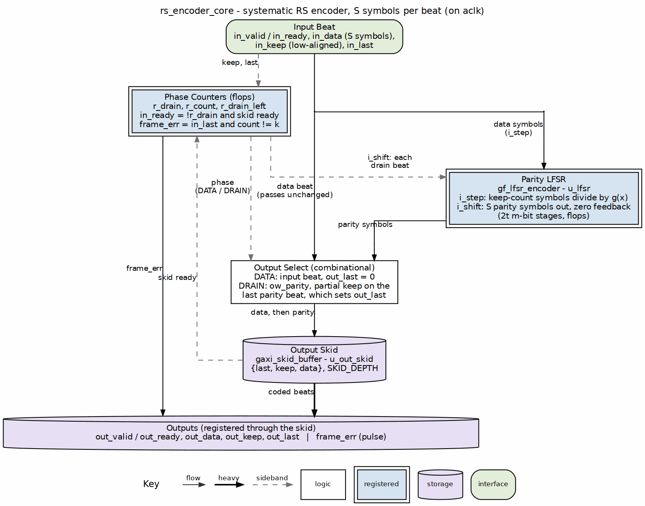
Encoder core block diagram

5.2 Parameters
Table 2.1: Encoder core parameters
Parameter | Type | Range | Default | Meaning | PRD
SYMBOL_WIDTH | int | 2..GF_MAX_M | 8 | m; field is GF(2^m) | D1
PRIM_POLY | int | primitive of degree m | 0x11D | primitive polynomial; selects the field representation | D8 per profile
T_SYMBOLS | int | 1..(2^m-1)/2 | 8 | correctable symbols per block; 2t parity symbols | D2
N_SYMBOLS | int | 2t+1 .. 2^m-1 | 2^m - 1 | codeword length in symbols; < 2^m-1 is a shortened code | D3
FIRST_ROOT | int | 0 .. 2^m-2 | 0 | b, first root of g(x) | D8
DATA_WIDTH | int | multiple of SYMBOL_WIDTH | SYMBOL_WIDTH | beat width | D9
SKID_DEPTH | int | 2..8 | 2 | output skid-buffer depth | D9
K_SYMBOLS | derived | N_SYMBOLS - 2*T_SYMBOLS | — | data symbols per block | D3
SYMBOLS_PER_BEAT | derived | DATA_WIDTH / SYMBOL_WIDTH | 1 | symbols per valid/ready beat | D6
K_SYMBOLS and SYMBOLS_PER_BEAT are derived but exposed in the module header for the consumer’s convenience. Elaboration fails if DATA_WIDTH is not a multiple of SYMBOL_WIDTH, if N_SYMBOLS does not exceed 2*T_SYMBOLS, or if SKID_DEPTH is outside 2..8.

5.3 Interface
Table 2.2: Encoder core ports
Signal | Direction | Width | Description
aclk | in | 1 | one clock for the whole core
aresetn | in | 1 | active-low synchronous reset
in_valid | in | 1 | a beat of data symbols is offered
in_ready | out | 1 | the core takes it this cycle
in_data | in | DATA_WIDTH | data symbols, symbol 0 in the low lane
in_keep | in | SYMBOLS_PER_BEAT | present-symbol mask, low-aligned; partial only on the block’s final beat
in_last | in | 1 | this beat carries the K_SYMBOLS-th data symbol
out_valid | out | 1 | a beat of coded symbols is offered
out_ready | in | 1 | the consumer takes it
out_data | out | DATA_WIDTH | data symbols while !r_drain, parity symbols while r_drain
out_keep | out | SYMBOLS_PER_BEAT | present-symbol mask; partial at the end of data and at the end of parity
out_last | out | 1 | this beat carries the N_SYMBOLS-th coded symbol
frame_err | out | 1 | one-cycle pulse: a block ended with other than K_SYMBOLS data symbols

5.4 Microarchitecture internals

5.4.1 GF(2^m) LFSR parity generator
The parity generator is gf_lfsr_encoder in projects/components/ecc-ip/reed-solomon/rtl/fub/gf/gf_lfsr_encoder.sv. It is a 2 * T_SYMBOLS-stage shift register over GF(2^m) whose tap coefficients are the generator polynomial g(x) built at elaboration from gf_pkg:
g(x) = prod_{i=0}^{2t-1} (x - alpha^(b+i))
The LFSR instance receives:
- i_step: high on every accepted input beat (w_in_fire)
- i_data: the input beat’s S symbols
- i_count: how many symbols are present in the beat (1 .. S)
- i_shift: high on every drain beat (w_drain_fire)
One symbol step is polynomial division by g(x):
fb = data ^ r[2t-1]
r[j] = r[j-1] ^ fb * g[j] (j = 1 .. 2t-1)
r[0] = fb * g[0]
The core unrolls S single-symbol steps and selects the state after i_count of them, so a partial final beat costs only a mux. The constant tap multiplies fold to XOR networks; the unrolled chain is one XOR network per register whatever S is.

5.4.2 Output parity select
The output mux selects data beats while r_drain is low and parity beats once parity starts draining:
in_ready = !r_drain && w_skid_wr_ready
w_in_fire = in_valid && in_ready
w_drain_fire = r_drain && w_skid_wr_ready
While draining, the next S parity symbols come from the LFSR register in transmission order:
ow_parity lane u = r_reg[2t-1-u] (u = 0 .. S-1)
The final parity beat is partial when S does not divide 2t. w_par_keep marks the valid lanes:
w_par_keep[u] = (r_drain_left != 1) || (u < PREM)
where PREM = 2t - (PB-1)*S is the number of symbols in the last parity beat and PB = ceil(2t / S) is the total parity beats.

5.4.3 Output skid buffer
A gaxi_skid_buffer (projects/components/ecc-ip/reed-solomon/rtl/fub/ does not own it; the block is in rtl/amba/gaxi) sits on the output. It decouples the consumer’s out_ready from the LFSR step, so the encoder can take one input symbol per cycle when the consumer keeps up, and the ceil(2t/S)-cycle parity gap is the only stall it introduces.

5.4.4 Frame-length check
r_count tracks how many data symbols have been accepted in the current block. On in_last the core compares the expected K_SYMBOLS against the actual count plus the last beat’s symbol count:
frame_err = in_last && (w_count_next != K_SYMBOLS)
A block that is shorter or longer than K_SYMBOLS still gets encoded as given (systematic data pass-through with parity appended to whatever data arrived); frame_err is just the one-cycle pulse that tells the consumer the block was mis-framed.

5.5 FSM policy
This block carries no FSM (per vault/handbook/design/streaming-no-fsm.md). The sequencing that another design might put in a state machine is replaced by:
- r_drain: registered flag, 0 in the DATA phase, 1 in the parity DRAIN phase
- r_count: counts data symbols accepted in the block, 0 .. N_SYMBOLS-1
- r_drain_left: counts parity beats still to emit, PB down to 0
- w_in_count: combinational count of valid symbols in the current input beat
- w_skid_wr_valid / w_skid_wr_ready: output skid handshake
- w_in_fire / w_drain_fire: combinational qualifiers for LFSR step and shift
in_ready is combinational !r_drain && w_skid_wr_ready.

5.6 Timing
- One input beat is accepted per cycle while in_ready is high.
- The data phase is ceil(K_SYMBOLS / SYMBOLS_PER_BEAT) beats.
- The parity phase is ceil(2*T_SYMBOLS / SYMBOLS_PER_BEAT) beats.
- in_ready is held low during the parity phase; back-to-back blocks need an upstream FIFO sized for at least 2*T_SYMBOLS symbols.
- Measured: one beat per cycle plus the ceil(2t/S) parity gap.

5.7 Notes
- Wrong-length block handling: If in_last arrives before or after the K_SYMBOLS-th data symbol, frame_err pulses and the block is still encoded as given. This is the encoder-side analog of the decoder’s framing-error status (HAS chapter 3.2).
- Partial beats: The encoder passes data beats through as received, so a partial data beat can occur at the end of the data phase. It then appends parity in PB beats, the last of which is partial when S does not divide 2t. A consumer that needs contiguous packing puts a beat packer at the outlet (HAS chapter 4.2 / 4.3).
- No separate LFSR clear: After the last parity beat the LFSR has shifted itself to all zeros, so the next block starts clean with no explicit reset cycle.

RTL Design Sherpa · Learning Hardware Design Through Practice GitHub · Documentation Index · MIT License

6 Syndrome Unit (syndrome_unit)
Module: syndrome_unit.sv Location: rtl/fub/ Category: streaming datapath Parent: rs_decoder_core Status: landed — rtl/fub/syndrome_unit.sv, gate DV green on the standing profiles

6.1 Purpose
syndrome_unit computes the 2t syndromes S_0 .. S_2t-1 of a received Reed-Solomon codeword as the symbols arrive. Syndrome S_i is the received polynomial evaluated at alpha^(b+i):
S_i = r(alpha^(b+i)) = sum_{j=0}^{n-1} r_j * alpha^((b+i)*j)
The unit contains 2t parallel GF(2^m) multiply-accumulate lanes, one per syndrome. It also supplies combinational ow_*_next versions of the outputs so a caller can capture the finished syndromes in the same cycle as the last symbol.

6.1.1 Figure 2.2: Syndrome unit block diagram
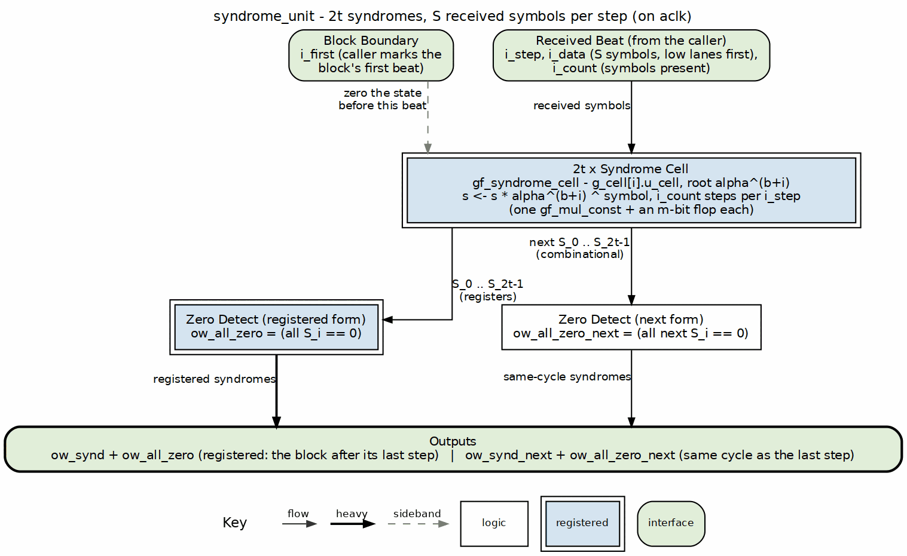
Syndrome unit block diagram

6.2 Parameters
Table 2.3: Syndrome unit parameters
Parameter | Type | Range | Default | Meaning | PRD
SYMBOL_WIDTH | int | 2..GF_MAX_M | 8 | m; field is GF(2^m) | D1
PRIM_POLY | int | primitive of degree m | 0x11D | primitive polynomial; selects the field representation | D8 per profile
T_SYMBOLS | int | 1..(2^m-1)/2 | 8 | correctable symbols per block; 2t syndromes | D2
FIRST_ROOT | int | 0 .. 2^m-2 | 0 | b, exponent of the first root alpha^b | D8
SYMBOLS_PER_BEAT | int | >= 1 | 1 | S, symbols per i_step | D6

6.3 Interface
Table 2.4: Syndrome unit ports
Signal | Direction | Width | Description
aclk | in | 1 | one clock
aresetn | in | 1 | active-low synchronous reset
i_step | in | 1 | advance every lane by i_count symbols
i_first | in | 1 | zero the accumulators first (block’s first beat)
i_data | in | SYMBOLS_PER_BEAT * SYMBOL_WIDTH | received symbols, low lanes first
i_count | in | $clog2(SYMBOLS_PER_BEAT+1) | valid symbols in this beat, 1 .. S
ow_synd | out | 2*T_SYMBOLS*SYMBOL_WIDTH | packed syndromes, S_0 in the low m bits
ow_all_zero | out | 1 | all 2t syndromes are zero
ow_synd_next | out | 2*T_SYMBOLS*SYMBOL_WIDTH | combinational next value of ow_synd
ow_all_zero_next | out | 1 | combinational next value of ow_all_zero

6.4 Microarchitecture internals

6.4.1 Syndrome recurrence
Each lane accumulates by Horner’s rule as symbols arrive in transmission order:
S_i <- S_i * alpha^(b+i) + r_j
The multiplier by the constant alpha^(b+i) is a gf_mul_fn call on a constant operand; synthesis folds it to a fixed XOR network. No per-position power table is stored; the constant root is wired once per lane.
With SYMBOLS_PER_BEAT = S > 1, each lane performs S Horner steps per cycle:
S_i <- (((S_i * alpha^(b+i)) + r_j0) * alpha^(b+i) + r_j1) * alpha^(b+i) + ... + r_jS-1
This is a short feed-forward chain of S constant multiplies and adds. The state after i_count steps is selected by a mux, so a partial final beat costs nothing extra in area or timing.

6.4.2 Parallel cells
syndrome_unit instantiates 2t copies of gf_syndrome_cell from projects/components/ecc-ip/reed-solomon/rtl/fub/gf/gf_syndrome_cell.sv. Each cell is parameterized with ROOT_EXP = FIRST_ROOT + i and exposes ow_synd (the registered value) and ow_next (the combinational value after the current i_step). The parent module concatenates the per-cell outputs into the packed ow_synd and ow_synd_next buses.

6.4.3 All-zero flag
The no-error bypass is a combinational qualifier, not a state:
ow_all_zero = (ow_synd == 0)
ow_all_zero_next = (ow_synd_next == 0)
When ow_all_zero_next is true on the cycle the last symbol is stepped, the decoder core can skip the key-equation solver and Chien search and drain the block buffer unchanged.

6.4.4 Combinational next outputs
ow_synd_next and ow_all_zero_next are the values the registers would take if i_step is high now. A caller that knows the current beat is the last one can latch the finished syndromes immediately instead of waiting a clock for the flop update. The decoder core uses this to close timing on the re-check path (HAS chapter 3.2).

6.5 FSM policy
This block carries no FSM (per vault/handbook/design/streaming-no-fsm.md). Control is reduced to:
- i_step: combinational step qualifier from the caller
- i_first: combinational zero-and-step qualifier for the block’s first beat
- i_count: combinational valid-symbol count for this beat
- one m-bit register per syndrome lane (r_s in gf_syndrome_cell)
- combinational ow_*_next outputs derived from the unrolled chain
Each lane is a pure multiply-accumulate datapath; the lane count and the input qualifiers replace any state machine.

6.6 Timing
- One received symbol advances every lane by one Horner step.
- Serial case (SYMBOLS_PER_BEAT = 1): N_SYMBOLS cycles per block.
- Parallel-beat case: ceil(N_SYMBOLS / SYMBOLS_PER_BEAT) cycles per block, with S chained GF constant multiplies per lane per cycle.
- The exact cycle count scales with S but not with t; the solver downstream is unaffected by S.

6.7 Notes
- A shortened code (N_SYMBOLS < 2^m - 1) is handled by treating the missing leading symbols as zero: the Horner recurrence naturally accumulates starting from S_i = 0, which is equivalent to zero-padding the high-order coefficients.
- No separate clear cycle: i_first zeroes the accumulator state first, then applies the first beat’s symbols, so the cell is ready for the next block the cycle after the previous block ends.
- This block is an FUB. In rs_decoder_core it appears twice — once on the received stream and once on the corrected stream for the re-check verdict — driven by the core’s own block counters and i_step/i_first qualifiers.

RTL Design Sherpa · Learning Hardware Design Through Practice GitHub · Documentation Index · MIT License

7 Key Equation Solver — riBM (key_equation_solver_ribm)
Module: key_equation_solver_ribm.sv Location: rtl/fub/ Category: datapath + iteration counter Parent: rs_decoder_core Status: landed — rtl/fub/key_equation_solver_ribm.sv, gate DV green; default KES_ALGO = "RIBM" (D11)

7.1 Purpose
key_equation_solver_ribm inverts the key equation from the 2t syndromes S_0 .. S_{2t-1} to the error-locator polynomial Lambda(x) and a companion evaluator polynomial Omega(x) in a fixed number of cycles. It is the default key-equation solver selected by KES_ALGO = "RIBM" in the decoder core; the alternative is the Euclidean solver documented in chapter 2.4.
The implementation is the reformulated inversionless Berlekamp-Massey (riBM) array from Sarwate and Shanbhag, 2001. Every coefficient cell is identical, so the array is a pure datapath with a single broadcast control path. The critical path is one GF multiply and one XOR, independent of t.

7.1.1 Figure 2.3: riBM solver block diagram
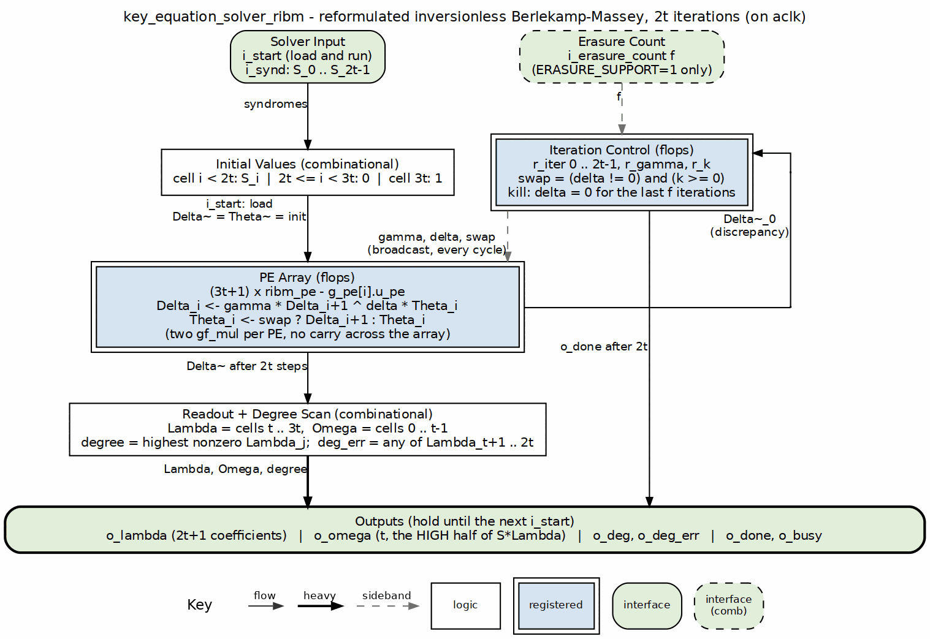
riBM solver block diagram

7.2 Parameters
Table 2.5: riBM solver parameters
Parameter | Type | Range | Default | Meaning | PRD
SYMBOL_WIDTH | int | 3..16 | 8 | m; field is GF(2^m) | D1
PRIM_POLY | int | — | 0x11D | primitive polynomial for GF(2^m) | D1
T_SYMBOLS | int | 1..(2^m-2)/2 | 8 | correctable symbol errors t | D2
ERASURE_SUPPORT | bit | 0, 1 | 0 | accept i_erasure_count and kill the last f updates | D5

7.3 Interface
Table 2.6: riBM solver ports
Signal | Direction | Width | Description
aclk | in | 1 | clock
aresetn | in | 1 | active-low synchronous reset
i_start | in | 1 | load syndromes and begin the 2t iterations
i_synd | in | 2*T_SYMBOLS*SYMBOL_WIDTH | packed syndromes {S_{2t-1}, ..., S_0}
i_erasure_count | in | $clog2(2*T_SYMBOLS+1) | number of erasures f; only used when ERASURE_SUPPORT = 1
o_busy | out | 1 | solver is iterating
o_done | out | 1 | single-cycle pulse when the result is valid
o_lambda | out | (2*T_SYMBOLS+1)*SYMBOL_WIDTH | locator coefficients Lambda_0 .. Lambda_{2t}
o_omega | out | T_SYMBOLS*SYMBOL_WIDTH | evaluator coefficients Omega_0 .. Omega_{t-1}
o_deg | out | $clog2(2*T_SYMBOLS+1) | degree of Lambda (highest nonzero index)
o_deg_err | out | 1 | any of Lambda_{t+1..2t} is nonzero — more than t errors

7.4 Microarchitecture internals
The array contains 3t + 1 identical ribm_pe cells. Cell i holds the pair Delta~_i / Theta~_i. On i_start both registers in every cell load the same initial value:
i_init[i] = S_i for i = 0 .. 2t-1
= 0 for i = 2t .. 3t-1
= 1 for i = 3t
The control state is gamma = 1 and k = 0. Each of the next 2t cycles is one iteration:
delta = Delta~_0
swap = (delta != 0) && (k >= 0)
gamma <= swap ? delta : gamma
k <= swap ? -k - 1 : k + 1
Each cell computes the Sarwate-Shanbhag recurrence:
Delta_i(r+1) = gamma(r) * Delta_{i+1}(r) ^ delta(r) * Theta_i(r)
Theta_i(r+1) = swap ? Delta_{i+1}(r) : Theta_i(r)
The leaf ribm_pe instantiates two gf_mul modules and two SYMBOL_WIDTH registers. The Delta_{i+1} value comes from the neighbouring cell on the right; gamma, delta, and swap are broadcast to all cells. There is no feedback from the end of the array back to the beginning, so the critical path is one GF multiplier followed by one XOR at any t.
After exactly 2t iterations o_done pulses. The outputs are combinational slices off the array:
o_omega = Delta~_0 .. Delta~_{t-1}
o_lambda = Delta~_t .. Delta~_{3t}
o_lambda therefore contains 2t + 1 coefficients Lambda_0 .. Lambda_{2t}; the top t coefficients are the degree-error check. The degree logic scans Lambda_0 .. Lambda_{2t} and raises o_deg_err if any coefficient above index t is nonzero.
With ERASURE_SUPPORT = 1, i_erasure_count carries f erasures. The input is the Forney syndrome list T zero-padded to 2t values; the last f of the fixed 2t iterations are killed by forcing w_delta = 0 when r_iter >= 2t - f. The array still shifts every cycle, so the readout cells are unchanged and the result matches textbook BM on T.

7.5 FSM policy
There is no control FSM. The only state registers in the control path are r_busy, r_iter, r_gamma, and r_k. r_busy is set by i_start and cleared when r_iter == 2t - 1; o_done is raised on that same edge. The swap, gamma, and k updates are combinational or simple registered qualifiers driven by the iteration counter and the array output Delta~_0.

7.6 Timing
- Latency from i_start to o_done is exactly 2t cycles.
- o_done is a single-cycle pulse; o_lambda, o_omega, o_deg, and o_deg_err are valid in that cycle.
- i_start may be asserted in the same cycle as o_done to begin a new block immediately.

7.7 Notes
- The evaluator produced here is the high half of S(x) * Lambda(x) (coefficients 2t .. 3t-1), not the textbook Omega = S*Lambda mod x^2t. The decoder core sets the Forney evaluator’s OMEGA_HIGH_HALF constant from KES_ALGO: 1 for riBM, 0 for Euclid. dv/tbclasses/rs_model.py is the bit-exact reference for both forms.
- The solver is bit-exact against dv/tbclasses/rs_model.py; the verification posture runs both solvers on the same blocks and checks identical Chien root sets and Forney values. See chapter 2.4 for the Euclidean implementation.
- Trade-off: riBM pays for a 3t + 1 cell array and a fixed 2t cycle count in exchange for a short, t-independent critical path and no degree counters. That short path is why riBM is the default at high t.

RTL Design Sherpa · Learning Hardware Design Through Practice GitHub · Documentation Index · MIT License

8 Key Equation Solver — Euclidean (key_equation_solver_euclid)
Module: key_equation_solver_euclid.sv Location: rtl/fub/ Category: datapath + cycle-rule controller Parent: rs_decoder_core Status: landed — rtl/fub/key_equation_solver_euclid.sv, gate DV green; selected by KES_ALGO = "EUCLID" (D11)

8.1 Purpose
key_equation_solver_euclid computes the same error-locator and error-evaluator polynomials as the riBM solver, but by the inversionless extended Euclidean algorithm. It is the alternative selected by KES_ALGO = "EUCLID" in the decoder core; the default is the riBM solver documented in chapter 2.3.
The implementation keeps every polynomial top-aligned, so the cross-multiply step needs no shifter. The number of cycles is data-dependent and can stop as soon as the remainder degree drops below t.

8.1.1 Figure 2.4: Euclid solver block diagram
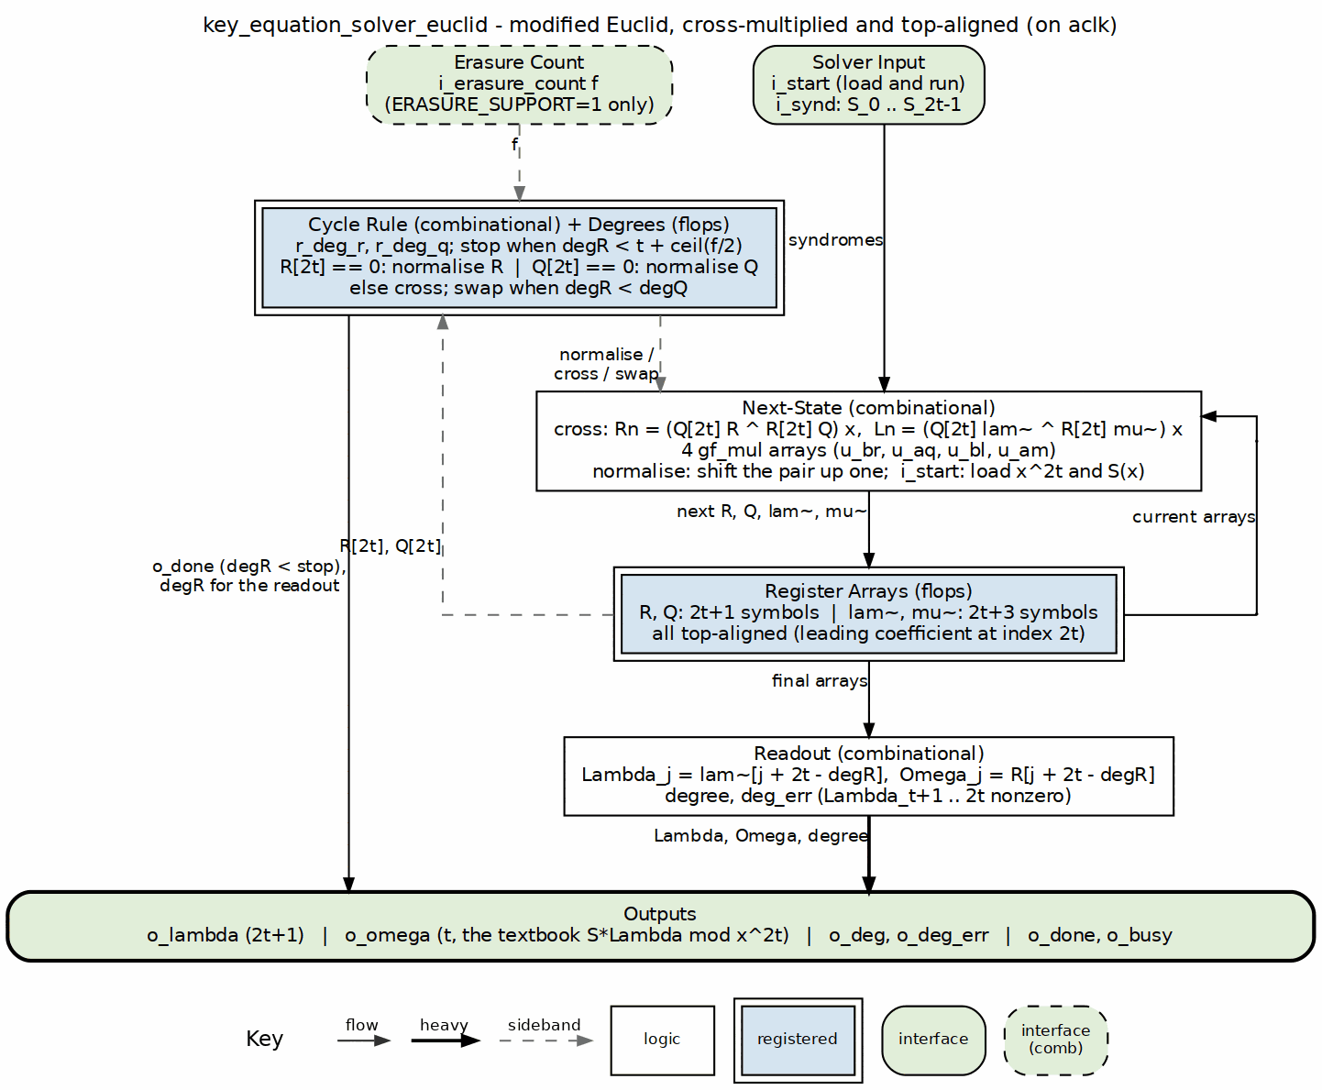
Euclid solver block diagram

8.2 Parameters
Table 2.7: Euclidean solver parameters
Parameter | Type | Range | Default | Meaning | PRD
SYMBOL_WIDTH | int | 3..16 | 8 | m; field is GF(2^m) | D1
PRIM_POLY | int | — | 0x11D | primitive polynomial for GF(2^m) | D1
T_SYMBOLS | int | 1..(2^m-2)/2 | 8 | correctable symbol errors t | D2
ERASURE_SUPPORT | bit | 0, 1 | 0 | accept i_erasure_count and raise the stop threshold | D5

8.3 Interface
Table 2.8: Euclidean solver ports
Signal | Direction | Width | Description
aclk | in | 1 | clock
aresetn | in | 1 | active-low synchronous reset
i_start | in | 1 | load syndromes and begin the Euclidean loop
i_synd | in | 2*T_SYMBOLS*SYMBOL_WIDTH | packed syndromes {S_{2t-1}, ..., S_0}
i_erasure_count | in | $clog2(2*T_SYMBOLS+1) | number of erasures f; only used when ERASURE_SUPPORT = 1
o_busy | out | 1 | solver is iterating
o_done | out | 1 | single-cycle pulse when the result is valid
o_lambda | out | (2*T_SYMBOLS+1)*SYMBOL_WIDTH | locator coefficients Lambda_0 .. Lambda_{2t}
o_omega | out | T_SYMBOLS*SYMBOL_WIDTH | evaluator coefficients Omega_0 .. Omega_{t-1}
o_deg | out | $clog2(2*T_SYMBOLS+1) | degree of Lambda (highest nonzero index)
o_deg_err | out | 1 | any of Lambda_{t+1..2t} is nonzero, or the safety stop fired

8.4 Microarchitecture internals
The solver keeps four top-aligned register arrays:
R[0 .. 2t] remainder, length 2t + 1
Q[0 .. 2t] divisor, length 2t + 1
lam~[0 .. 2t+2] Lambda * x^(2t - degR), length 2t + 3
mu~[0 .. 2t+2] Mu * x^(2t - degQ), length 2t + 3
On i_start:
R = x^(2t) (R[2t] = 1, rest 0)
Q = S(x) top-aligned (Q[i] = S_{i-1} for i = 1 .. 2t, Q[0] = 0)
lam~ = 0
mu~ = x (mu~[1] = 1, rest 0)
degR = 2t
degQ = 2t - 1
Each busy cycle selects one of three actions from the leading coefficients w_a = R[2t] and w_b = Q[2t]:
normalise R: R[2t] == 0 R <- R * x, lam~ <- lam~ * x, degR--
normalise Q: R[2t] != 0, Q[2t] == 0 Q <- Q * x, mu~ <- mu~ * x, degQ--
cross: R[2t] != 0, Q[2t] != 0
Rn = (Q[2t]*R ^ R[2t]*Q) * x
Ln = (Q[2t]*lam~ ^ R[2t]*mu~) * x
if degR < degQ:
swap (R, lam~, degR) with (Q, mu~, degQ)
degR = max(degR, degQ) - 1
The cross step is built from two independent GF multiply/XOR banks. For each i in 0 .. 2t:
w_rn[i] = Q[2t] * R[i] ^ R[2t] * Q[i]
and for each i in 0 .. 2t+2:
w_ln[i] = Q[2t] * lam~[i] ^ R[2t] * mu~[i]
After the cross, R[1 .. 2t] and lam~[1 .. 2t+2] load w_rn[0 .. 2t-1] and w_ln[0 .. 2t+1], which is the * x shift. A normalise step does the same shift using the existing array contents.
The stop condition is:
finished = (degR < stop) || (degQ < 0) || (r_cycles == all-ones)
stop = t when ERASURE_SUPPORT = 0
stop = t + ceil(f / 2) when ERASURE_SUPPORT = 1
To avoid spending a cycle merely noticing completion, the RTL computes the next degrees (w_deg_r_nxt, w_deg_q_nxt) combinationally and asserts o_done on the same clock edge as the final array write whenever w_finished_nxt is true.
The output stage un-shifts by 2t - degR:
Lambda_j = lam~[j + 2t - degR] for j = 0 .. 2t
Omega_j = R[j + 2t - degR] for j = 0 .. t-1
degR is in 0 .. t-1 for a clean stop; anything else means the safety counter retired the run and o_deg_err is raised. As in the riBM solver, the top t locator coefficients are the more-than-t-errors check.
Omega here is the textbook S(x) * Lambda(x) mod x^(2t), so the decoder core sets the Forney evaluator’s OMEGA_HIGH_HALF = 0 for this solver.

8.5 FSM policy
There is no explicit state-machine enum. The active operation is selected each cycle by combinational qualifiers:
- w_norm_r — shift R / lam~ because R[2t] == 0
- w_norm_q — shift Q / mu~ because R[2t] != 0 and Q[2t] == 0
- w_cross — perform the cross-multiply because both leading coefficients are nonzero
- w_swap — exchange the (R, lam~) and (Q, mu~) roles when degR < degQ
The controller’s state is therefore held in the four register arrays plus r_deg_r, r_deg_q, r_busy, and the safety counter r_cycles. The degree comparisons are part of the datapath, which makes the per-iteration critical path longer than riBM’s.

8.6 Timing
- Latency from i_start to o_done is data-dependent, between t + 1 and 2t iterations. The final update and o_done share the same clock edge.
- A zero leading syndrome at small t can force an extra normalise step; at t <= 2 this produces the observed 2t + 1 cycle count.
- The safety counter r_cycles is ceil(log2(4t + 8)) bits wide and stops the run before it wraps.

8.7 Notes
- The Euclidean solver is bit-exact against dv/tbclasses/rs_model.py::euclid. The verification posture runs both solvers on the same blocks and requires identical Chien roots and Forney values.
- Trade-off: Euclid uses shorter arrays (2t + 1 and 2t + 3 symbols) and can stop early, but the cross-multiply feeds a degree comparison that drives the swap decision, giving a longer per-iteration critical path than riBM. That longer path is why riBM is the default and Euclid is kept as a readable cross-check.
- The actual RTL arrays give 8t + 8 GF multipliers and 8t + 8 symbol registers, not the 8t the catalog rounds to. For the reference profile (t = 8) this is 72 multipliers and 72 symbol registers, compared with riBM’s 50.

RTL Design Sherpa · Learning Hardware Design Through Practice GitHub · Documentation Index · MIT License

9 Chien Search (chien_search)
Module: chien_search.sv Location: rtl/fub/ Category: streaming datapath Parent: rs_decoder_core Status: landed — rtl/fub/chien_search.sv, gate DV green on the standing profiles

9.1 Purpose
chien_search walks the error-locator polynomial Lambda(x) across every symbol position of the received block. A root at position j means the symbol at that position is in error. Because this is a Reed-Solomon decoder, the root flag is not enough — the block also emits the odd-index partial sum X^-1 * Lambda'(X^-1) for each lane, which the Forney evaluator needs to compute the actual error magnitude. The math is in HAS chapter 7.3 (../reed_solomon_has/ch07_understanding_the_math/03_decoding.md); this page is the signal-level implementation.

9.1.1 Figure 2.5: Chien search block diagram
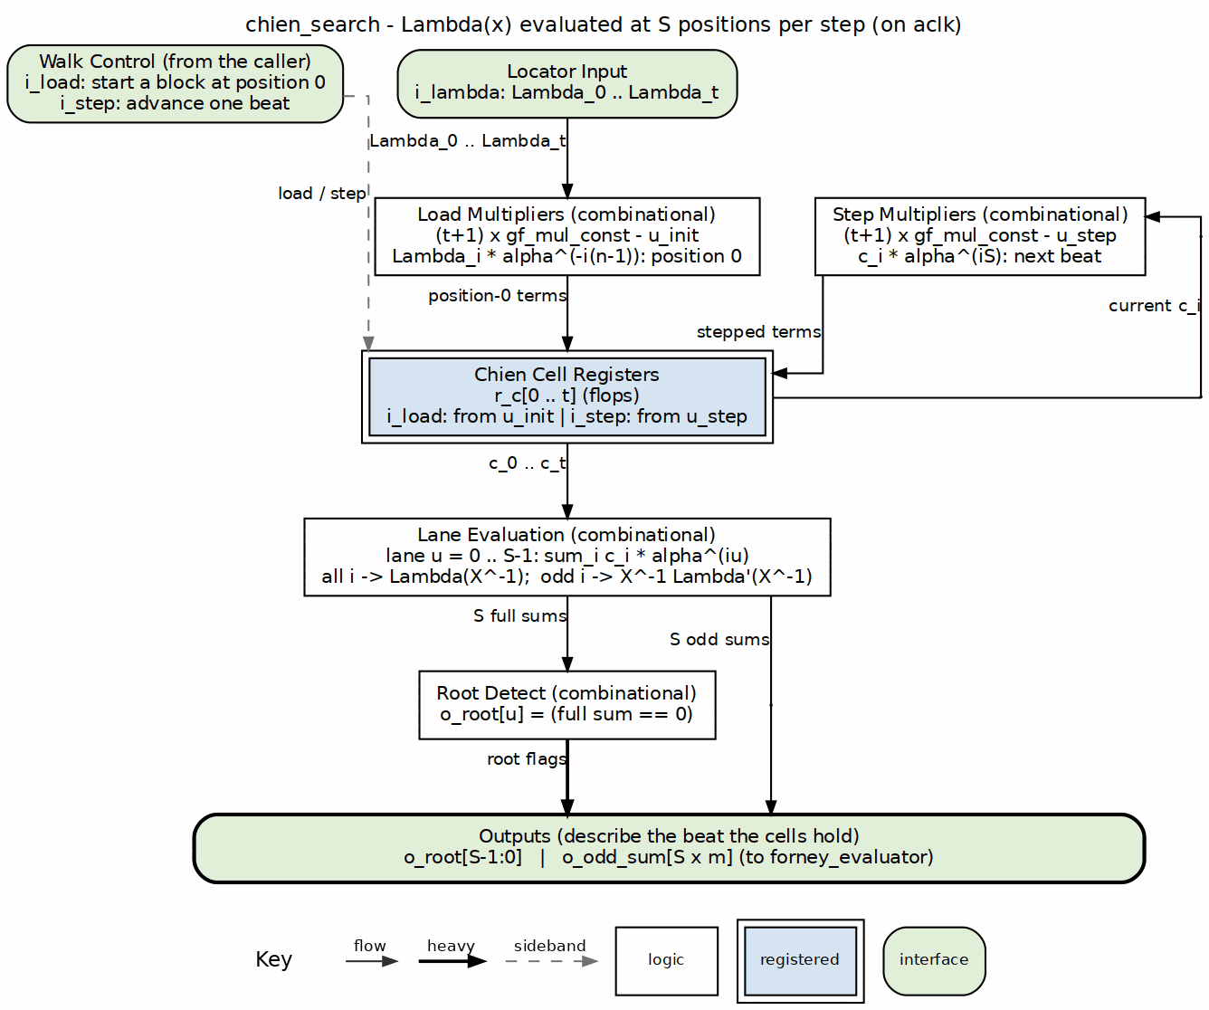
Chien search block diagram

9.2 Parameters
Table 2.9: Chien search parameters
Parameter | Type | Range | Default | Meaning | PRD
SYMBOL_WIDTH | int | 3..16 | 8 | m; field is GF(2^m) | D1
PRIM_POLY | int | — | 'h11D | primitive polynomial | —
T_SYMBOLS | int | 1..(2^m-1)/2 | 8 | correctable symbol errors t | D2
N_SYMBOLS | int | 2t+1 .. 2^m-1 | 2^m-1 | codeword length n in symbols | D3
SYMBOLS_PER_BEAT | int | 1 .. K_SYMBOLS | 1 | symbols evaluated per beat S | D6

9.3 Interface
Table 2.10: Chien search ports
Signal | Direction | Width | Description
aclk | in | 1 | one clock
aresetn | in | 1 | active-low synchronous reset
i_load | in | 1 | load Lambda and reset cells to position 0
i_lambda | in | (T_SYMBOLS + 1) * SYMBOL_WIDTH | locator coefficients Lambda_0 .. Lambda_t
i_step | in | 1 | advance cells to the next beat
o_root | out | SYMBOLS_PER_BEAT | root flag per lane
o_odd_sum | out | SYMBOLS_PER_BEAT * SYMBOL_WIDTH | X^-1 * Lambda'(X^-1) per lane

9.4 Microarchitecture internals

9.4.1 t + 1 Chien cells
Symbol j (transmission order, j = 0 first) has location X_j = alpha^(n-1-j). It is in error when Lambda(X_j^-1) = 0. Cell i holds Lambda_i * X_j^-i for the beat’s first position j:
load (position 0):
r_c[i] <- Lambda_i * alpha^(-i(n-1))
step to next beat:
r_c[i] <- r_c[i] * alpha^(iS)
The load constant absorbs the shortening offset: N_SYMBOLS is the shortened block length, so alpha^(-i(n-1)) already points at the first transmitted position.

9.4.2 Lane structure
Lane u (position j+u) evaluates sum_i r_c[i] * alpha^(iu):
sum[u] = sum_{i=0..t} r_c[i] * alpha^(i u)
odd[u] = sum_{i odd} r_c[i] * alpha^(i u)
o_root[u] = (sum[u] == 0)
o_odd_sum[u] = odd[u] = X_j^-1 * Lambda'(X_j^-1)
o_root[u] is the root flag. o_odd_sum[u] is the formal derivative in characteristic 2, handed to forney_evaluator as i_odd_sum so the derivative costs nothing extra.

9.4.3 Constant-multiply implementation
Every multiply in this block is by a constant. The load and step use gf_mul_const instances, one per cell per direction:
(t + 1) cells * 2 constants = 2(t + 1) gf_mul_const instances
The lane constants alpha^(iu) are built at elaboration by build_lane_consts and applied as (t + 1)S generate-loop calls to gf_mul_fn on a constant. Total constant multiplies: (t + 1)(S + 2). For the reference profile t = 8, S = 1 that is 27 constant multiplies. With S > 1 the lane count scales linearly.

9.5 FSM policy
This block carries no FSM (per vault/handbook/design/streaming-no-fsm.md). The Chien walk is driven by:
- i_load: starts the walk at position 0
- i_step: moves to the next beat
- the register array r_c[0..t]: holds the current beat’s cell values
The parent decoder core owns the position counter and the load/step sequence.

9.6 Timing
- Serial case (SYMBOLS_PER_BEAT = 1): N_SYMBOLS cycles per block to evaluate every position.
- Parallel-beat case (SYMBOLS_PER_BEAT = S): ceil(N_SYMBOLS / S) cycles per block, with S independent lane evaluations per cycle.
- o_root and o_odd_sum are combinational from the registered cell array, so the critical path is one lane constant multiply plus the t + 1 input XOR tree.

9.7 Notes
- The t + 1 coefficient order is Lambda_0 (constant term) through Lambda_t. Cell 0 therefore holds Lambda_0 unchanged and contributes the same value to every lane.
- Shortening is handled entirely by the load constants; there is no separate counter or offset register.
- The trade-off here is load-vs-step constant multiplies. Each cell carries two dedicated gf_mul_const instances because the initial value (position 0) and the beat-to-beat step use different constants alpha^(-i(n-1)) and alpha^(iS). A shared multiplier would need a mux and an extra cycle; the RTL pays the area to keep the walk single-cycle per beat.
- The odd-index sum is only valid when the corresponding lane has a root, but the block computes it for every lane anyway — it is the same partial sum the zero test already needs.
- Both o_root and o_odd_sum describe the beat the cells currently hold. The decoder core counts beats and pairs these outputs with the block buffer’s replayed symbols. See chapter 2.6 (forney_evaluator) for where o_odd_sum goes, and chapter 2.8 (rs_decoder_core) for how the load/step sequence is driven.

RTL Design Sherpa · Learning Hardware Design Through Practice GitHub · Documentation Index · MIT License

10 Forney Evaluator (forney_evaluator)
Module: forney_evaluator.sv Location: rtl/fub/ Category: streaming datapath Parent: rs_decoder_core Status: landed — rtl/fub/forney_evaluator.sv, gate DV green on the standing profiles

10.1 Purpose
forney_evaluator turns a located Chien root into the actual error magnitude for that symbol. The block walks the error-evaluator polynomial Omega(x) in lockstep with chien_search, divides by the formal derivative of Lambda(x), and emits one error value per lane per beat. The math is in HAS chapter 7.3 (../reed_solomon_has/ch07_understanding_the_math/03_decoding.md); this page is the signal-level implementation.

10.1.1 Figure 2.6: Forney evaluator block diagram
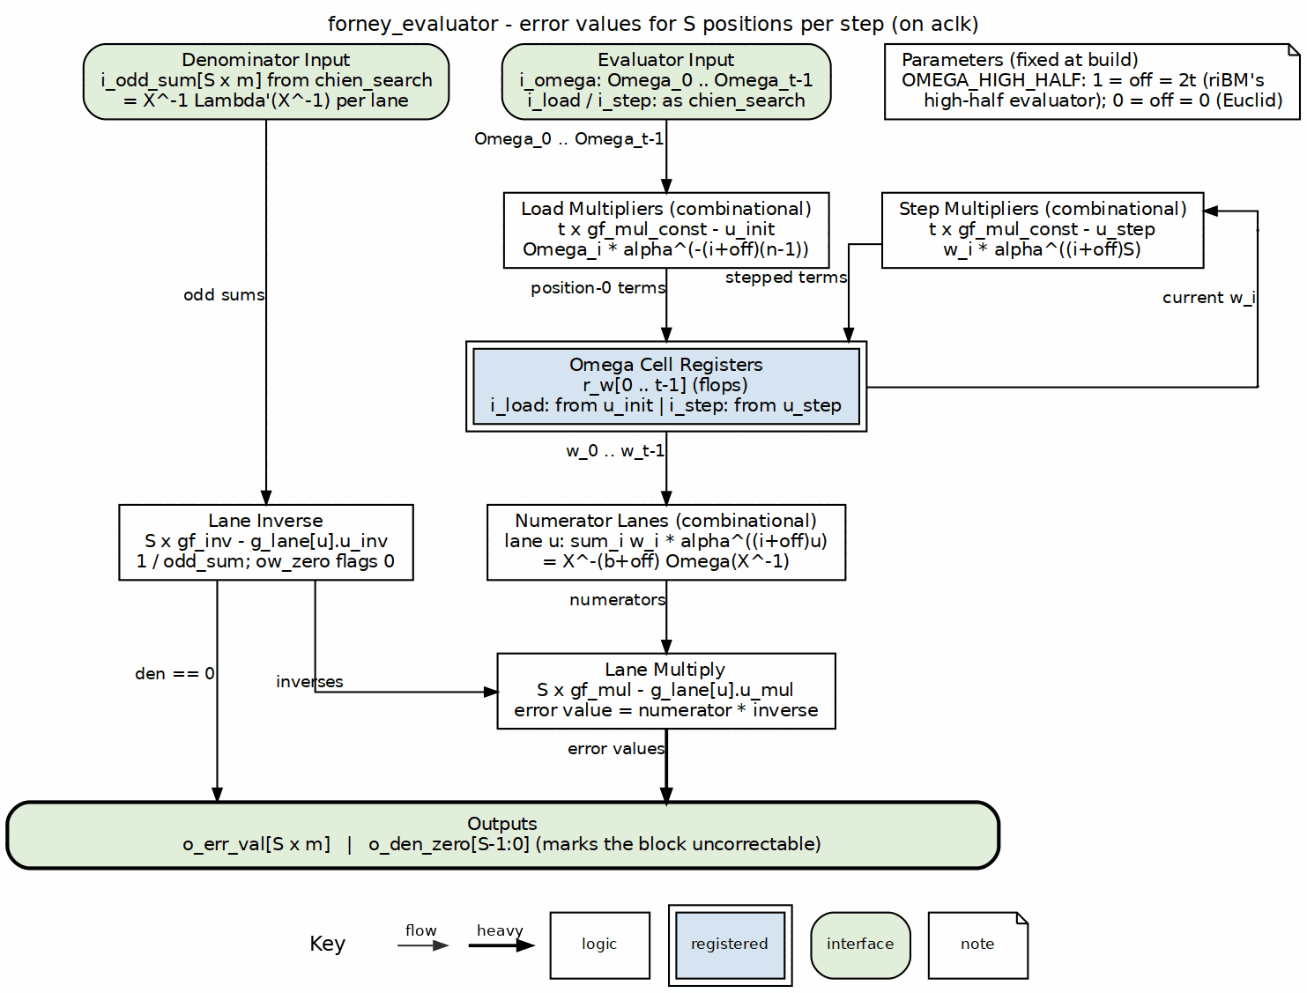
Forney evaluator block diagram

10.2 Parameters
Table 2.11: Forney evaluator parameters
Parameter | Type | Range | Default | Meaning | PRD
SYMBOL_WIDTH | int | 3..16 | 8 | m; field is GF(2^m) | D1
PRIM_POLY | int | — | 'h11D | primitive polynomial | —
T_SYMBOLS | int | 1..(2^m-1)/2 | 8 | correctable symbol errors t | D2
N_SYMBOLS | int | 2t+1 .. 2^m-1 | 2^m-1 | codeword length n in symbols | D3
FIRST_ROOT | int | 0..2^m-2 | 0 | b, first consecutive root of g(x) | —
OMEGA_HIGH_HALF | bit | 0/1 | 1 | 1 = riBM high-half Omega, 0 = Euclid textbook Omega | —
SYMBOLS_PER_BEAT | int | 1 .. K_SYMBOLS | 1 | symbols corrected per beat S | D6

10.3 Interface
Table 2.12: Forney evaluator ports
Signal | Direction | Width | Description
aclk | in | 1 | one clock
aresetn | in | 1 | active-low synchronous reset
i_load | in | 1 | load Omega and reset cells to position 0
i_omega | in | T_SYMBOLS * SYMBOL_WIDTH | evaluator coefficients Omega_0 .. Omega_{t-1}
i_step | in | 1 | advance cells to the next beat
i_odd_sum | in | SYMBOLS_PER_BEAT * SYMBOL_WIDTH | X^-1 * Lambda'(X^-1) per lane from Chien
o_err_val | out | SYMBOLS_PER_BEAT * SYMBOL_WIDTH | error magnitude per lane
o_den_zero | out | SYMBOLS_PER_BEAT | denominator zero flag per lane

10.4 Microarchitecture internals

10.4.1 t Omega cells
The error value at position j is:
e_j = X_j^(1-b-off) * Omega(X_j^-1) / Lambda'(X_j^-1)
off depends on which solver produced Omega:
OMEGA_HIGH_HALF = 1 (riBM): off = 2t
OMEGA_HIGH_HALF = 0 (Euclid): off = 0
The effective exponent offset used in the RTL is:
OFF = b + off = FIRST_ROOT + (OMEGA_HIGH_HALF ? 2*T_SYMBOLS : 0)
chien_search already supplies odd_sum = X_j^-1 * Lambda'(X_j^-1), so the formula becomes:
e_j = [ X_j^-(b+off) * Omega(X_j^-1) ] / odd_sum
= [ sum_i Omega_i * X_j^-(i+OFF) ] / odd_sum
Cell i holds Omega_i * X_j^-(i+OFF) for the beat’s first position j:
load (position 0):
r_w[i] <- Omega_i * alpha^(-(i+OFF)(n-1))
step to next beat:
r_w[i] <- r_w[i] * alpha^((i+OFF)S)

10.4.2 Lane numerator
Lane u (position j+u) sums r_w[i] * alpha^((i+OFF)u):
num[u] = sum_{i=0..t-1} r_w[i] * alpha^((i+OFF)u)
These lane constants are built at elaboration by build_lane_consts and applied as tS generate-loop calls to gf_mul_fn on a constant, exactly like the Chien lane constants.

10.4.3 Per-lane inverse and multiply
Each lane finishes the Forney formula with one gf_inv and one gf_mul:
w_den_inv[u] = inv(i_odd_sum[u])
o_err_val[u] = num[u] * w_den_inv[u]
o_den_zero[u] = (i_odd_sum[u] == 0)
o_den_zero[u] cannot be true at a genuine root; when it is, the block is uncorrectable. The decoder core uses this in the final verdict.
Total primitives in the block: 2t gf_mul_const instances (t load + t step), tS lane constants applied as gf_mul_fn, S gf_inv, and S gf_mul. For the reference profile t = 8, S = 1 that is 16 + 8 + 1 + 1 = 26. With S > 1 the lane count scales linearly and the inverse/multiply pair is replicated per lane.

10.5 FSM policy
This block carries no FSM (per vault/handbook/design/streaming-no-fsm.md). The evaluator walk is driven by:
- i_load: starts the walk at position 0
- i_step: moves to the next beat
- the register array r_w[0..t-1]: holds the current beat’s cell values
The parent decoder core owns the position counter and the load/step sequence, and keeps i_step aligned with the matching step on chien_search.

10.6 Timing
- Serial case (SYMBOLS_PER_BEAT = 1): N_SYMBOLS cycles per block, one error value per cycle.
- Parallel-beat case (SYMBOLS_PER_BEAT = S): ceil(N_SYMBOLS / S) cycles per block, with S independent lane evaluations per cycle.
- The critical path is the lane summer XOR tree feeding gf_mul, after the gf_inv lookup. The inverse is a table lookup (log / negate / antilog), not a combinational recursion, so the path stays manageable.

10.7 Notes
- OMEGA_HIGH_HALF is normally driven from the parent core’s KES_ALGO parameter. The RTL does not decide which solver is correct; it exposes the offset choice and the core sets it.
- The X^-(b+off) factor is folded into the load and step constants, not applied as a separate post-multiplication. That keeps the per-lane path to one general multiply after the inverse.
- Shortening is handled by the load constants, just like chien_search: N_SYMBOLS is the shortened block length, so alpha^(-(i+OFF)(n-1)) already points at the first transmitted position.
- The trade-off here is S inverses per beat. Every lane gets its own gf_inv and gf_mul so that all S positions in a beat can be corrected in the same cycle. Sharing one inverse across lanes would require either serialization or a crossbar, which would break the single-cycle-per-beat contract the decoder core relies on.
- o_den_zero is generated by the same gf_inv instance that produces the reciprocal; there is no separate zero comparator.
- The lane constants and the cell constants are all built by calling gf_alpha_pow at elaboration, so no runtime log/antilog tables are needed inside this block apart from the gf_inv tables. See chapter 2.5 (chien_search) for the source of i_odd_sum, and chapter 2.8 (rs_decoder_core) for how the two walks are kept aligned.

RTL Design Sherpa · Learning Hardware Design Through Practice GitHub · Documentation Index · MIT License

11 Erasure Unit (rs_erasure_unit)
Module: rs_erasure_unit.sv
Location: rtl/fub/
Category: erasure pre-processor (two halves joined by a packed A→B descriptor)
Parent: rs_decoder_core (instantiated only when ERASURE_SUPPORT = 1)
Status: landed — rtl/fub/rs_erasure_unit.sv, generated only under ERASURE_SUPPORT = 1 (PRD D5, default 0)

11.1 Purpose
rs_erasure_unit is the erasure half of the decoder. It records the positions of flagged symbols as the block arrives, turns the receive-side syndromes into the window the key-equation solver consumes, and builds the combined locator and evaluator the Chien/Forney walk consumes. The unit is split into a receive half (stage A) and a solve half (stage B), joined by a packed record that rides the decoder core’s A→B descriptor. See HAS chapter 3.2 for the surrounding data flow and chapter 2.8 for how the core pipelines the unit.

11.1.1 Figure 2.7: Erasure unit block diagram
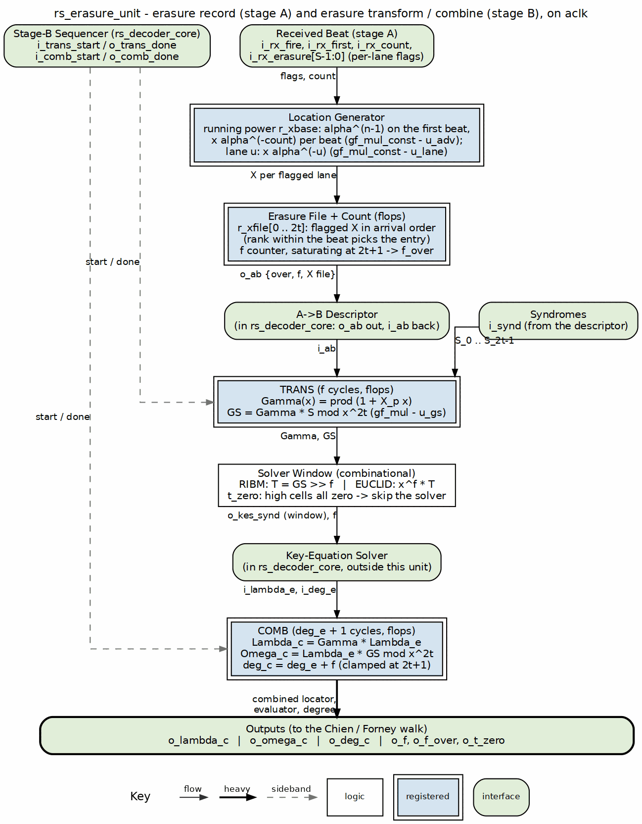
Erasure unit block diagram

11.2 Parameters
Table 2.13: Erasure unit parameters
Parameter | Type | Range | Default | Meaning | PRD
SYMBOL_WIDTH | int | 3..12 | 8 | m; field is GF(2^m) | D1
PRIM_POLY | int | primitive | 'h11D | field primitive polynomial | D1
T_SYMBOLS | int | 1..(2^m-2)/2 | 8 | correctable symbol errors | D2
N_SYMBOLS | int | 2t+1 .. 2^m-1 | 2^SYMBOL_WIDTH - 1 | codeword length in symbols | D3
SYMBOLS_PER_BEAT | int | 1 .. DATA_WIDTH/SYMBOL_WIDTH | 1 | symbols per valid/ready beat | D6
KES_ALGO | string | "RIBM", "EUCLID" | "RIBM" | solver algorithm; selects the syndrome window | D11
AB_W | int | derived | 1 + clog2(2t+1) + (2t+1)*SYMBOL_WIDTH | width of the packed A→B record | —

11.3 Interface
Table 2.14: Erasure unit ports
Signal | Direction | Width | Description
aclk | in | 1 | clock
aresetn | in | 1 | active-low synchronous reset
i_rx_fire | in | 1 | a beat is accepted on the intake
i_rx_first | in | 1 | the accepted beat starts a new block
i_rx_count | in | $clog2(SYMBOLS_PER_BEAT+1) | valid symbols in the accepted beat
i_rx_erasure | in | SYMBOLS_PER_BEAT | per-lane erasure flags, valid with the beat
o_ab | out | AB_W | packed A→B record {f_over, f, xfile[0..2t]}
i_ab | in | AB_W | same packed record from the A→B descriptor
i_synd | in | 2*T_SYMBOLS*SYMBOL_WIDTH | receive-side syndromes from the descriptor
i_trans_start | in | 1 | load and run the Gamma/transform step
o_trans_done | out | 1 | TRANS finished
i_comb_start | in | 1 | start the combine step over Lambda_e
o_comb_done | out | 1 | COMB finished
i_lambda_e | in | (2*T_SYMBOLS+1)*SYMBOL_WIDTH | error locator from the solver
i_deg_e | in | $clog2(2*T_SYMBOLS+1) | degree of i_lambda_e
o_kes_synd | out | 2*T_SYMBOLS*SYMBOL_WIDTH | solver input syndrome window
o_f | out | $clog2(2*T_SYMBOLS+1) | erasure count f for this block
o_f_over | out | 1 | more than 2t erasures were flagged
o_t_zero | out | 1 | erasures alone explain the syndromes; solver can be skipped
o_lambda_c | out | (2*T_SYMBOLS+1)*SYMBOL_WIDTH | combined locator Gamma * Lambda_e
o_omega_c | out | 2*T_SYMBOLS*SYMBOL_WIDTH | combined evaluator Lambda_e * GS mod x^2t
o_deg_c | out | $clog2(2*T_SYMBOLS+1)+1 | combined degree, clamped at 2t+1

11.4 Microarchitecture internals

11.4.1 Receive half — recording the flagged locations
On every accepted beat the unit keeps a running power register holding alpha^(n-1-pos) for the first symbol of the beat. It is loaded with alpha^(n-1) on i_rx_first and advanced by alpha^(-count) each beat, so each lane’s location is X_j = alpha^(n-1-j). Per lane a constant multiply by alpha^(-u) gives the lane location without a per-symbol counter. A lane is recorded only when i_rx_erasure[u] is set and u is inside i_rx_count and i_rx_fire is high.
Flagged locations are written into a 2t+1-entry file in arrival order. The rank of a flagged lane within its beat selects the entry, and the per-block erasure count f saturates at 2t+1. The f_over flag is raised as soon as f would exceed 2t; such a block is uncorrectable by inspection. The packed record o_ab = {f_over, f, xfile[2t] ... xfile[0]} is the next value of the file and count, because the core samples it on the block-end edge before that edge’s own flags have landed in the registers.

11.4.2 Transform half — Gamma and the Forney syndrome
When the core pops the descriptor it asserts i_trans_start. The unit latches the unpacked record (f and the xfile) and loads the syndrome cells with S_0..S_{2t-1}. TRANS then walks the f recorded positions, updating:
Gamma(x) = prod_p (1 + X_p * x)
GS = Gamma * S mod x^(2t)
Each cycle does one gf_mul per coefficient; the latency is f cycles (zero when f = 0 beyond the load cycle). After TRANS the high cells of GS hold T = GS >> f, the Forney syndrome window the solver consumes.
If every high cell of GS is zero, the erasures alone explain every syndrome. The unit raises o_t_zero, which lets the core skip the solver entirely: Lambda_e = 1, so Lambda_c = Gamma and Omega_c = GS are already in the registers.

11.4.3 Solver input window
KES_ALGO selects how the 2t-cell solver window is presented. This is the same distinction the golden model uses in dv/tbclasses/rs_model.py:
riBM: o_kes_synd[i] = GS[i + f] (crossbar; cells below the shift are zero)
Euclid: o_kes_synd[i] = GS[i] when i >= f, else 0
riBM consumes the dropped window T; Euclid consumes the zeroed-low polynomial x^f * T. The two are equivalent because Euclid treats the polynomial as a whole, while a forward-iterating BM would be contaminated by the zero padding at the tail.

11.4.4 Combine — building the walk polynomials
After the solver returns Lambda_e and deg_e, the core asserts i_comb_start. COMB performs a Horner multiply over Lambda_e’s coefficients, high to low, producing:
Lambda_c = Gamma * Lambda_e
Omega_c = Lambda_e * GS mod x^(2t)
Both are exactly what the Chien/Forney walk needs. The combined degree is deg_e + f, clamped at 2t+1:
o_deg_c = r_t_zero ? f : min(deg_e + f, 2t + 1)
A clean solve always lands at or below 2t.

11.4.5 Correction bound
With f erasures and mu unknown errors the decoder is bounded-distance when:
2 * mu + f <= 2t
dv/tbclasses/rs_model.py (decode() erasure path) is the bit-exact reference for this bound and for every intermediate value; the RTL was verified against it on every matrix profile.

11.4.6 Elaboration guard
The unit is instantiated only inside the decoder core generate block:
if (ERASURE_SUPPORT) begin : g_erasure
rs_erasure_unit #(...) u_erasure (...);
end
When ERASURE_SUPPORT = 0 every declaration and signal is tied off; the errors-only core is bit-identical to the pre-erasure version.

11.5 FSM policy
rs_erasure_unit has no control FSM of its own. The receive half is a set of counters and rank muxes; the solve half is two step counters (TRANS and COMB) driven by the core’s i_trans_start and i_comb_start pulses. The core’s solve-stage FSM (chapter 2.8) sequences those pulses and waits on o_trans_done and o_comb_done.

11.6 Timing
- Receive work: one constant multiply per lane per beat, plus the rank muxes. No extra cycle.
- i_trans_start to o_trans_done: f cycles when f > 0, one load cycle when f = 0.
- i_comb_start to o_comb_done: deg_e + 1 cycles, at most t + 1.
- Both TRANS and COMB are one gf_mul deep per coefficient; the critical path is a single field multiply plus an XOR tree.

11.7 Notes
- dv/tbclasses/rs_model.py is the bit-exact reference. Its decode() erasure path uses the Forney-syndrome method (Gamma * S mod x^2t, drop the low f cells for riBM, zero the low f cells for Euclid), then multiplies Gamma * Lambda_e for the Chien/Forney walk. The RTL follows the same shape.
- The INJ_CFG.mark erasure-marking path is test-side only: projects/components/utility-ip/misc/rtl/error_injector.sv drives out_erasure with the beat’s hit mask when cfg_mark_erasure is set, and CLAUDE.md records that this is how RAID-stripe maps or memory-controller bad-column information reach the decoder. The unit itself sees only in_erasure on the core port.
- With KES_ALGO = "RIBM" the unit shifts GS down by f; with "EUCLID" it zeroes the low f cells. Choosing the wrong window for the wrong solver is the classic erasure + BM pitfall the model caught early.

RTL Design Sherpa · Learning Hardware Design Through Practice GitHub · Documentation Index · MIT License

12 Decoder Core Integration (rs_decoder_core)
Module: rs_decoder_core.sv
Location: rtl/macro/
Category: integration block + stage control FSMs
Parent: rs_decoder / standalone decoder wrapper
Status: landed — rtl/macro/rs_decoder_core.sv, gate DV green; KES_ALGO selects riBM (default) or Euclid at elaboration

12.1 Purpose
rs_decoder_core integrates the received-block buffer, syndrome unit, key-equation solver, Chien search, Forney evaluator, corrected-stream re-check, and output release into one valid/ready streaming block. Three stages — receive, solve, and correct — are joined by descriptor skids, so a block can be received while the previous one is solved and the one before that is corrected. The block is released only once its verdict exists, and corrections are applied at the output, not during the walk. See HAS chapter 3.2 for the overall decoder data flow.

12.1.1 Figure 2.8: Decoder core block diagram
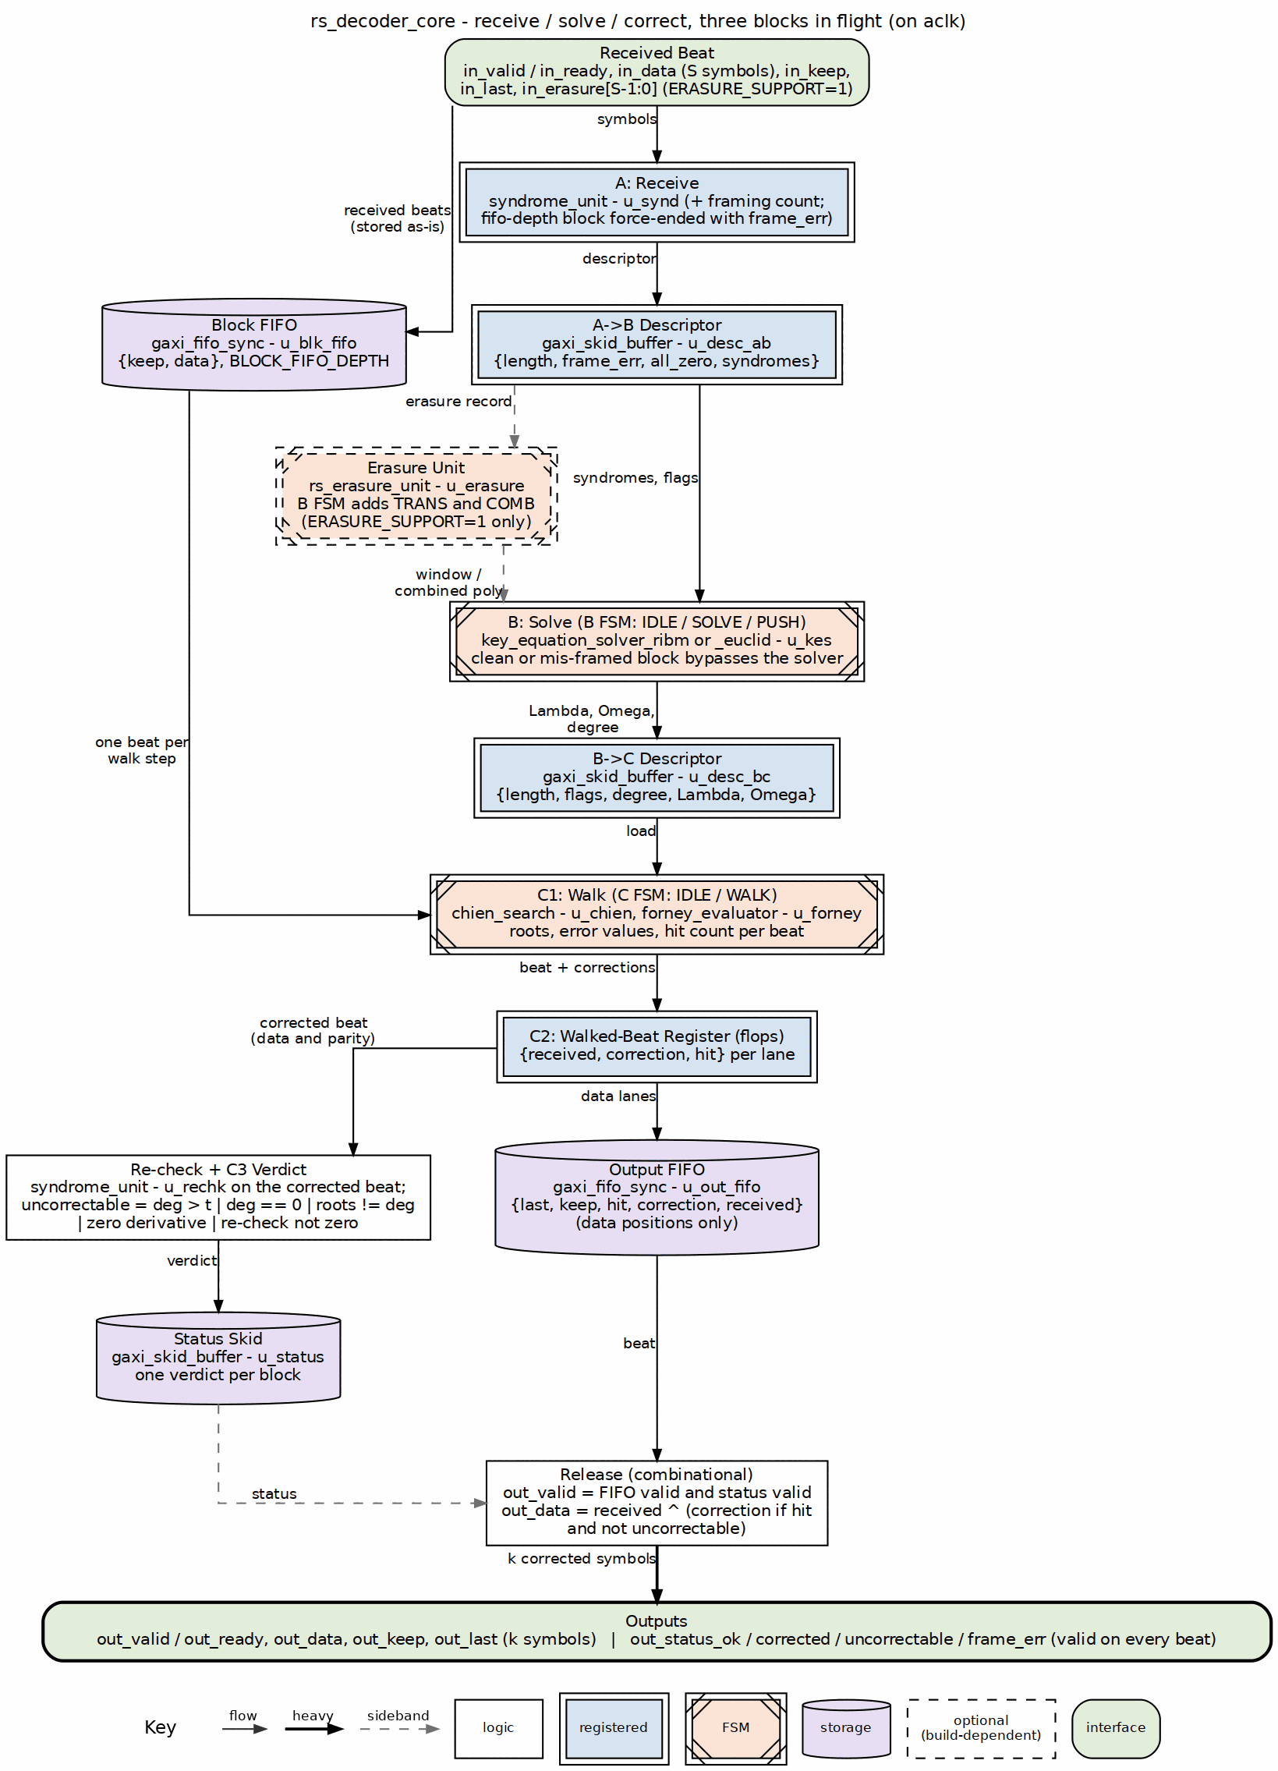
Decoder core block diagram

12.2 Parameters
Table 2.15: Decoder core parameters
Parameter | Type | Range | Default | Meaning | PRD
SYMBOL_WIDTH | int | 3..12 | 8 | m; field is GF(2^m) | D1
PRIM_POLY | int | primitive | 'h11D | field primitive polynomial | D1
T_SYMBOLS | int | 1..(2^m-2)/2 | 8 | correctable symbol errors | D2
N_SYMBOLS | int | 2t+1 .. 2^m-1 | 2^SYMBOL_WIDTH - 1 | codeword length in symbols | D3
FIRST_ROOT | int | 0 .. 2^m-2 | 0 | first consecutive root b of the generator | D1
DATA_WIDTH | int | SYMBOL_WIDTH .. | SYMBOL_WIDTH | bus width; must be a multiple of SYMBOL_WIDTH | D9
SKID_DEPTH | int | 2..8 | 2 | depth of descriptor skid buffers | D9
BLOCK_FIFO_DEPTH | int | power of two | 2^ceil(log2((n+2t)/S+8)) | block buffer depth in beats | HAS 5.2
KES_ALGO | string | "RIBM", "EUCLID" | "RIBM" | key-equation solver algorithm | D11
ERASURE_SUPPORT | bit | 0, 1 | 0 | per-lane erasure flags and erasure decode | D5
K_SYMBOLS | int | derived | N_SYMBOLS - 2*T_SYMBOLS | data symbols per block | —
SYMBOLS_PER_BEAT | int | derived | DATA_WIDTH / SYMBOL_WIDTH | symbols per beat S | —
STATUS_CNT_WIDTH | int | derived | clog2(2t+1) if erasures else clog2(t+1) | width of out_status_corrected | —

12.3 Interface
Table 2.16: Decoder core ports
Signal | Direction | Width | Description
aclk | in | 1 | clock
aresetn | in | 1 | active-low synchronous reset
in_valid / in_ready | in / out | 1 | valid/ready for received beats
in_data | in | DATA_WIDTH | received symbols, lane 0 in the low bits
in_keep | in | SYMBOLS_PER_BEAT | present-symbol mask; low-aligned, partial only on a block’s last beat
in_last | in | 1 | this beat carries the block’s last received symbol
in_erasure | in | SYMBOLS_PER_BEAT | per-lane erasure flags; dead unless ERASURE_SUPPORT = 1
out_valid / out_ready | out / in | 1 | valid/ready for corrected data beats
out_data | out | DATA_WIDTH | corrected data symbols; parity lanes dropped
out_keep | out | SYMBOLS_PER_BEAT | present-symbol mask for the data beats
out_last | out | 1 | this beat carries the block’s k-th data symbol
out_status_ok | out | 1 | block had no errors
out_status_corrected | out | STATUS_CNT_WIDTH | number of symbols corrected (0 .. 2t with erasures, 0 .. t without)
out_status_uncorrectable | out | 1 | correction failed; block passes through unchanged
out_status_frame_err | out | 1 | block length was not N_SYMBOLS or a partial beat preceded the last

12.4 Microarchitecture internals

12.4.1 Stage A — receive
Every accepted beat is written to the block FIFO as {in_keep, in_data} and fed to the receive syndrome_unit. On the block’s last symbol (in_last) a descriptor is pushed to stage B. The descriptor carries length, a frame-error flag, an all-zero-syndrome flag, and the syndromes; when ERASURE_SUPPORT = 1 it also carries the erasure unit’s packed A→B record. A block that reaches the FIFO depth without seeing in_last is force-ended there with frame_err, so a runaway input stream cannot deadlock the core. The next in_last resynchronizes the receiver.
A partial beat on any beat other than the last is also flagged as a framing error, because in_keep is only allowed to be partial on the block’s final beat.

12.4.2 Stage B — solve
A clean block (all_zero) or a mis-framed block bypasses the solver. Otherwise the selected key-equation solver runs on the syndrome window from the descriptor (or from the erasure unit when erasures are enabled). When the solver finishes, {Lambda, Omega, degree} join a new B→C descriptor. With erasures the descriptor carries the combined locator and evaluator from rs_erasure_unit and the combined degree, which can reach 2t.
The B stage is the only place in the core that holds a control FSM; the solver itself has its own FSM on its own page (chapter 2.3 for riBM, chapter 2.4 for Euclid). The two generate branches are:
if (!ERASURE_SUPPORT) begin : g_b_err
typedef enum logic [1:0] {B_IDLE, B_SOLVE, B_PUSH} b_state_t;
...
end else begin : g_b_erasure
typedef enum logic [2:0] {BE_IDLE, BE_TRANS, BE_SOLVE, BE_COMB, BE_PUSH} be_state_t;
...
end

12.4.3 Stage C — correct
Stage C is split into three pipeline phases to close timing at 100 MHz on Artix-7:
- C1 loads the Chien/Forney cells and walks the block one beat per cycle, reading the block FIFO. Each cycle produces root flags, odd sums, Forney values, and per-lane hit flags.
- C2 captures that result into a pipeline register. From that register the corrected symbol stream is fed to a second syndrome_unit (the re-check), and the received symbols together with their corrections and hit flags are pushed into the output FIFO.
- C3 computes the verdict one cycle later, reading the re-check’s registered all_zero output. That extra cycle ends the S-fold Horner chain at the syndrome cells’ own flops instead of carrying it into the status path; it costs one cycle per block.
The verdict is final on the last beat:
uncorrectable = correct && ( bad
|| roots != degree
|| den_zero_hit
|| !rechk_zero )
where bad already covers deg > t, deg == 0 (errors-only), and solver degree-error. A block is released only with its verdict; if the verdict is uncorrectable the received data pass through unchanged.

12.4.4 Descriptor records
Table 2.17: Descriptor record layouts (DAB_W and DBC_W)
Descriptor | Field | Width | Source / meaning
A→B | len | CNT_W = clog2(BFD*S+1) | number of received symbols in the block
A→B | frame_err | 1 | length != n, partial beat before last, or FIFO force-end
A→B | all_zero | 1 | receive syndromes all zero
A→B | syndromes | 2t*M | receive-side syndrome vector S_0..S_{2t-1}
A→B | erasure record | ERAB_W | {f_over, f, xfile[0..2t]}; present only if ERASURE_SUPPORT = 1
B→C | len | CNT_W | number of received symbols in the block
B→C | frame_err | 1 | passed from A→B
B→C | all_zero | 1 | passed from A→B
B→C | correct | 1 | block will be corrected (not bypassed)
B→C | bad | 1 | pre-computed solver failure or f_over
B→C | deg | DEGC_W | locator degree; up to 2t with erasures
B→C | lambda | LAM_N*M | locator coefficients
B→C | omega | OM_N*M | evaluator coefficients
LAM_N is 2t+1 with erasures, t+1 without. OM_N is 2t with erasures, t without. DEGC_W is clog2(2t+1)+1 with erasures, clog2(2t+1) without.

12.4.5 FIFO sizing
Table 2.18: Decoder core FIFO sizing
FIFO | Depth | Width | Contents
Block FIFO | 2^ceil(log2((n+2t)/S+8)) beats | S + S*M | {keep[S], received[S*M]}
Output FIFO | 2^ceil(log2(2*ceil(k/S)+8)) beats | 1 + 2S + 2S*M | {last_data_beat, keep_data[S], hit[S], correction[S*M], received[S*M]}
The block FIFO default depth is the first power of two at or above (n + 2t)/S + 8. The output FIFO depth is the first power of two at or above 2*ceil(k/S) + 8.

12.4.6 Status encodings
Table 2.19: Decoder core status outputs
Signal | Meaning
out_status_ok | all_zero was true and no frame error occurred
out_status_corrected | Number of corrected symbols when correct = 1 and the block is not uncorrectable; saturates at the width’s maximum
out_status_uncorrectable | Solver failure, root/degree mismatch, zero derivative at a root, or re-check syndromes non-zero
out_status_frame_err | Block framing violated; block passes through uncorrected
All four status signals are valid on every beat of the released block; a consumer may sample them with out_last.

12.5 FSM policy
The decoder core contains two minimal stage FSMs; every algorithmic block inside a stage is FSM-free.
- B solve FSM sequences the solver and, when erasures are enabled, the erasure unit’s TRANS and COMB steps. Errors-only states: B_IDLE, B_SOLVE, B_PUSH. Erasure states: BE_IDLE, BE_TRANS, BE_SOLVE, BE_COMB, BE_PUSH. B_PUSH / BE_PUSH exist only to cover the backpressured case where the next descriptor skid is not ready on the cycle the result is produced.
- C walk FSM has two states: C_IDLE and C_WALK. The load into C_WALK can happen straight off the previous block’s last step, so block boundaries do not add a dead cycle.
The descriptor skid buffers (gaxi_skid_buffer) decouple the stages and absorb backpressure. The Euclid solver’s internal control is documented in chapter 2.4, not here.

12.6 Timing
- Receive phase: ceil(N_SYMBOLS / SYMBOLS_PER_BEAT) beats.
- Solve phase:
  - Bypass: one cycle.
  - Errors-only: 2t solver iterations (riBM) or t+1 to 2t+1 cycles (Euclid can stop early).
  - With erasures: f TRANS cycles + solver iterations + deg_e + 1 COMB cycles, plus a bubble per block boundary because the next block’s TRANS cannot start until the current one pushes.
- Correct phase:
  - Walk: ceil(N_SYMBOLS / SYMBOLS_PER_BEAT) beats.
  - Verdict: one additional cycle after the last beat leaves C2.
- Measured sustained throughput: N_SYMBOLS/SYMBOLS_PER_BEAT + 1 cycles per block at S = 4 and S = 8 for the reference profiles.
The extra verdict cycle is the price of registering the re-check result. It closed the 100 MHz timing path on Artix-7 that the unregistered S-fold Horner chain could not meet.

12.7 Notes
- dv/tbclasses/rs_model.py is the bit-exact reference for the whole decoder. The model’s decode() method, with erasures set, was used to validate the erasure path against reedsolo on every profile.
- A mis-framed block has its first length - 2t symbols emitted as data; when length <= 2t all symbols are emitted as data. The block is not corrected.
- KES_ALGO selects only the solver and the Forney evaluator-form constant; Chien, the buffer, the corrector, and the re-check are identical for both algorithms.
- ERASURE_SUPPORT = 0 removes the erasure unit, ties off in_erasure, and keeps the errors-only core bit-for-bit. ERASURE_SUPPORT = 1 widens the status counter to clog2(2t+1) and changes the B-stage occupancy; see chapter 2.7 for the unit itself.
- The output FIFO is sized to absorb the k/S data beats plus margin; the status skid holds one entry per block. A block leaves only when both the output FIFO entry and the status entry are valid, which is why an uncorrectable block still leaves exactly as it arrived.

RTL Design Sherpa · Learning Hardware Design Through Practice GitHub · Documentation Index · MIT License

13 Core Signals
This page presents the valid/ready core signals as a contract table rather than restating the prose interface description in ../reed_solomon_has/ch04_interfaces/01_core_interface.md. The direction, reset value, and creator block for each signal are the source of truth here.

13.1 Reset strategy
All core logic uses synchronous active-low reset (aresetn), the house clocking convention. Reset clears block state, counters, and control flags; the data-carrying arrays themselves are not reset. In rs_encoder_core.sv the reset block clears r_drain, r_count, r_drain_left, and frame_err (rs_encoder_core.sv:191-195); the LFSR parity registers and the output skid buffer contents are not reset, and their pointers make the old contents logically invalid until overwritten. In rs_decoder_core.sv reset clears the stage-A receive counters, the descriptor skid and FIFO control flags, the stage-B solver handshake state, and the stage-C walk/output/status pipeline (rs_decoder_core.sv:279-290, 461-484, 538-566, 735-754, 799-843, 849-862); the block FIFO and output FIFO data arrays are not reset.

13.2 rs_encoder_core signal contract
Table 3.1: rs_encoder_core signal contract
Signal | Dir | Width | Reset value | Creates / consumes | Contract | Source block page
aclk | in | 1 | — | clock source | one clock for the whole core | —
aresetn | in | 1 | — | reset source | synchronous active-low reset | —
in_valid | in | 1 | — | upstream | stable until in_ready high | encoder core
in_ready | out | 1 | 0 | encoder core | combinational !r_drain && w_skid_wr_ready; low during parity drain | encoder core
in_data | in | DATA_WIDTH | — | upstream | data symbols, low-aligned; partial final beat qualified by in_keep | encoder core
in_keep | in | SYMBOLS_PER_BEAT | — | upstream | present-symbol mask, low-aligned; partial only on final beat | encoder core
in_last | in | 1 | — | upstream | this beat carries the k-th data symbol | encoder core
out_valid | out | 1 | 0 | encoder core | registered skid output; data beats then parity beats | encoder core
out_ready | in | 1 | — | downstream | may depend on out_valid | encoder core
out_data | out | DATA_WIDTH | 0 | encoder core | data while !r_drain, parity while r_drain | encoder core
out_keep | out | SYMBOLS_PER_BEAT | 0 | encoder core | full except on final data and final parity beats | encoder core
out_last | out | 1 | 0 | encoder core | this beat carries the n-th coded symbol | encoder core
frame_err | out | 1 | 0 | encoder core | pulse when in_last does not coincide with k data symbols | encoder core

13.3 rs_decoder_core signal contract
Table 3.2: rs_decoder_core signal contract
Signal | Dir | Width | Reset value | Creates / consumes | Contract | Source block page
in_valid | in | 1 | — | upstream | stable until in_ready high | decoder core
in_ready | out | 1 | 0 | decoder core | high while block FIFO and A->B descriptor skid have space | decoder core
in_data | in | DATA_WIDTH | — | upstream | received symbols, low-aligned | decoder core
in_keep | in | SYMBOLS_PER_BEAT | — | upstream | present-symbol mask; partial only on final beat | decoder core
in_last | in | 1 | — | upstream | this beat carries the n-th received symbol | decoder core
in_erasure | in | SYMBOLS_PER_BEAT | — | upstream | per-lane known-bad symbol flags; dead unless ERASURE_SUPPORT | erasure unit, decoder core
out_valid | out | 1 | 0 | decoder core | high once the block verdict is final | decoder core
out_ready | in | 1 | — | downstream | may depend on out_valid | decoder core
out_data | out | DATA_WIDTH | 0 | decoder core | corrected data symbols; parity lanes dropped | decoder core
out_keep | out | SYMBOLS_PER_BEAT | 0 | decoder core | present-symbol mask; partial only on final beat, data lanes only | decoder core
out_last | out | 1 | 0 | decoder core | this beat carries the k-th data symbol | decoder core
out_status_ok | out | 1 | 0 | decoder core | held for every beat: block had no errors | syndrome unit, decoder core
out_status_corrected | out | STATUS_CNT_WIDTH | 0 | decoder core | held for every beat: symbols corrected (0 .. t, or 0 .. 2t with erasures) | Chien search, Forney evaluator, decoder core
out_status_uncorrectable | out | 1 | 0 | decoder core | held for every beat: correction failed; data pass through unchanged | Chien search, Forney evaluator, decoder core
out_status_frame_err | out | 1 | 0 | decoder core | held for every beat: block length was not n | decoder core
STATUS_CNT_WIDTH is ERASURE_SUPPORT ? $clog2(2*T_SYMBOLS+1) : $clog2(T_SYMBOLS+1) (rs_decoder_core.sv:133-134).

13.4 Timing rules
- in_last is the sole block boundary; the cores do not infer boundaries by counting.
- out_status_* describe the block being emitted and are valid on every beat of it, first to last. A consumer may sample them with out_last or with the first beat.
- An uncorrectable block leaves exactly as received; the corrector is disabled by out_status_uncorrectable at the output mux (rs_decoder_core.sv:931-933).

RTL Design Sherpa · Learning Hardware Design Through Practice GitHub · Documentation Index · MIT License

14 Signal Contracts and Golden Model

14.1 What a contract is
A signal contract in this repo is a machine-checkable statement of what a signal is allowed to do. Each contract has three parts, in order:
- Term list: every signal or expression in play, with its defining expression and file:line citation.
- Invariants: the strict relationships between terms, each cited, each stating which rows of the decision table it renders impossible.
- Decision table: one row per combination of the terms. Rows the invariants forbid are marked ILLEGAL; legal rows carry the resulting output.
The canonical methodology is in vault/handbook/design/signal-contracts-and-kmaps.md; the shared generator machinery is in bin/kmaps/.

14.2 Which signals carry the contracts
The landed RTL concentrates the non-obvious control and qualifier decisions in the decoder core, the solver interface, and the erasure unit. The contracts for these areas are cited directly against the .sv source today.
Table 4.1: Contract areas in the landed RTL
Contract area | Signals | RTL citation
Stage A boundary / frame error | w_in_count, w_force_end, w_block_end, w_len, w_frame_err | rs_decoder_core.sv:228-232
A->B descriptor valid | w_dab_wr_valid, w_dab_wr_data | rs_decoder_core.sv:271-276
Syndrome all-zero / frame-error bypass | w_b_all_zero, w_b_frame_err, w_b_bypass | rs_decoder_core.sv:322-324, 421
Erasure mux into solver | w_kes_synd | rs_decoder_core.sv:338-339
Solver start and handshake | w_kes_start, w_kes_done, w_kes_busy, w_kes_deg_err | rs_decoder_core.sv:330, 443-446; key_equation_solver_ribm.sv:84-89; key_equation_solver_euclid.sv:94-99
Solve-bypass bad verdict | w_b_bad (errors-only), w_b_bad_final (erasures) | rs_decoder_core.sv:432, 498-506
B->C descriptor valid | w_dbc_wr_valid, w_dbc_wr_data | rs_decoder_core.sv:449-458, 514-535
Final uncorrectable verdict | w_uncorrectable_final | rs_decoder_core.sv:624, 790-794
Status hold / output pack | r_st_data, out_status_ok, out_status_corrected, out_status_uncorrectable, out_status_frame_err | rs_decoder_core.sv:658, 836-839, 926-927
Erasure unit transforms | o_trans_done, o_comb_done, o_f_over, o_t_zero, o_kes_synd, o_lambda_c, o_omega_c, o_deg_c | rs_erasure_unit.sv:104-117, 245-247

14.3 Citation posture
The RTL has already landed, so the contracts cite .sv file and line today; no re-pointing is needed. There is no generated workbook for RS yet (unlike BCH’s bch_signal_contracts.xlsx produced by projects/components/ecc-ip/bch/docs/gen_bch_signal_contracts_kmaps.py). The natural follow-up is to clone that generator: the expressions are concentrated and cited in Table 4.1, the shared machinery lives in bin/kmaps/, and the BCH generator is the working pattern to adapt.

14.4 The golden-model contract
dv/tbclasses/rs_model.py is the bit-exact reference for every decoder block. It mirrors the RTL algorithms step for step (Horner syndromes in transmission order, the riBM key-equation solver, Chien search from the first transmitted position, Forney evaluation with first root b), and it is validated against the reedsolo package before any RTL is scored against it. The area rule is explicit: field arithmetic comes from reedsolo or galois, never a hand-rolled GF table in a test (CLAUDE.md, README.md).
Two additional equivalence checks are part of the contract:
- Dual-solver equivalence. The decoder core is built with KES_ALGO selectable between "RIBM" and "EUCLID". The Nexys A7 loop harness runs both solvers on the same injected stream and compares their Chien roots and Forney values per block; the measured result is bit-identical corrected output and identical verdicts across the error range (CLAUDE.md).
- Erasures path. With ERASURE_SUPPORT = 1 the error injector can mark per-lane erasures through INJ_CFG.mark (PRD D5, TASK-002). The erasure unit transforms the syndromes, drives the solver window, and combines the erasure locator with the error locator so the Chien/Forney walk operates on the combined polynomial (rs_decoder_core.sv:362-408, rs_erasure_unit.sv).

14.5 Where formal verification stands
No formal verification directory or .sby files exist under projects/components/ecc-ip/reed-solomon/ today. Coverage is by directed and randomized cocotb tests against rs_model.py; formal contracts and SVA assertions have not been added yet.

