
RTL Design Sherpa
Lattice Hardware Architecture Specification 1.2
October 13, 2026

Table of Contents
Lattice Has Index 15
Lattice Hardware Architecture Specification Index 16
Document Organization 17
Front Matter 17
Chapter 1: Introduction 17
Chapter 2: System Overview 17
Chapter 3: Architecture 17
Chapter 4: Interfaces 17
Chapter 5: Performance 17
Chapter 6: Integration 17
Related Documentation 19
Document Information 20
Lattice Hardware Architecture Specification 20
Document Purpose 21
References 22
Terminology 23
Revision History 24
Purpose and Scope 26
Document Purpose 26
Component Overview 27
Document Scope 28
In Scope 28
Out of Scope 28
Specification Level 29
Document Conventions 30
Notation 30
Signal Naming 30
Parameter Naming 30
Diagrams 31
Block Diagrams 31
Address Notation 31
Table Captions 32
Requirement References 33
Definitions and Acronyms 34
Acronyms 34
Terms 35
APB Protocol Signals 36
Use Cases 37
Primary Use Cases 37
UC-1: Simple Peripheral Interconnect (1x4) 37
UC-2: Multi-Master System (2x4) 37
UC-3: Protocol Conversion (1x1) 37
Variant Selection Guide 38
Key Features 39
Feature Summary 39
F1: Parametric MxN Configuration 39
F2: Automatic Address-Based Routing 39
F3: Round-Robin Arbitration 39
F4: Back-to-Back Transactions 39
F5: Proven Building Blocks 40
Feature Comparison 41
Design Philosophy 42
Composition Over Complexity 42
Scalability 42
System Context 43
System Context Diagram 43
Figure 2.1: System Context Diagram 43
Typical Integration Topology 44
Master-Side Connections 44
Slave-Side Connections 44
Interface Boundaries 45
Input Boundary (Master-Side) 45
Output Boundary (Slave-Side) 45
Clock and Reset 45
System Integration Considerations 46
Address Map Planning 46
Multi-Master Considerations 46
Block Diagram 47
Top-Level Architecture 47
Figure 3.1: Lattice Block Diagram 47
Functional Blocks 48
Master-Side Protocol Conversion 48
Internal Crossbar Fabric 48
Slave-Side Protocol Conversion 48
Module Hierarchy 49
Data Path Width 50
Data Flow 51
Transaction Flow Overview 51
Figure 3.2: Transaction Data Flow 51
Write Transaction Flow 52
Stage 1: Master Request 52
Stage 2: Protocol Conversion (Master-Side) 52
Stage 3: Address Decode 52
Stage 4: Arbitration (if needed) 52
Stage 5: Protocol Conversion (Slave-Side) 52
Stage 6: Response Return 52
Read Transaction Flow 53
Timing Summary 54
Back-to-Back Transactions 55
Address Mapping 56
Address Map Structure 56
Figure 3.3: Address Mapping Structure 56
Default Address Map 57
Address Decode Logic 58
Example Decode 58
Customizing Base Address 59
Address Map Constraints 60
Fixed Slave Region Size 60
Maximum Configuration 60
Address Width Requirement 60
Master-Side APB Interfaces 61
Interface Overview 61
Signal Definition 62
APB5 Sideband (mixed-version variants only) 62
Signal Descriptions 64
PSEL (Input) 64
PENABLE (Input) 64
PADDR (Input) 64
PWRITE (Input) 64
PWDATA (Input) 64
PSTRB (Input) 64
PPROT (Input) 64
PRDATA (Output) 64
PSLVERR (Output) 64
PREADY (Output) 65
Transaction Timing 66
Uncontended Write (No Arbitration Wait) 66
Figure 4.1: Uncontended Write at a Master Port 66
Contended Transaction (Arbitration Wait) 66
Figure 4.2: Contended Transfer 67
Slave-Side APB Interfaces 68
Interface Overview 68
Signal Definition 69
APB5 Sideband (mixed-version variants only) 69
Signal Behavior 71
Output Signals (Crossbar to Slave) 71
Input Signals (Slave to Crossbar) 71
Slave Response Handling 72
Wait States 72
Figure 4.3: Slave Wait States 72
Error Response 72
Multi-Slave Considerations 73
Address Overlap Prevention 73
Independent Operation 73
Clock and Reset 74
Clock Interface 74
Signal Definition 74
Clock Requirements 74
Reset Interface 75
Signal Definition 75
Reset Behavior 75
Reset Safe Values 75
Clock-Reset Relationship 76
Reset Assertion 76
Reset Deassertion 76
Figure 4.4: Reset Sequence 76
Integration Notes 77
Clock Domain Crossing 77
Clock Gating 77
Throughput Characteristics 78
Maximum Throughput 78
Single Master 78
Multi-Master (Uncontended) 78
Multi-Master (Contended) 78
Arbitration Handoff 80
Grant Persistence 80
Back-to-Back Timing 80
Throughput Factors 81
Factors That Reduce Throughput 81
Optimal Usage Pattern 81
Latency Analysis 82
Transaction Latency 82
Uncontended Access 82
Contended Access 83
Latency Breakdown 85
Forward Path (Master to Slave) 85
Response Path (Slave to Master) 86
Latency Timing Diagram 87
Best Case (No Waits, No Contention) 87
Figure 5.1: Best-Case Latency Timeline 87
Worst Case (Contention + Slave Wait States) 87
Figure 5.2: Arbitration and Slave Wait States 87
Latency Optimization 88
Design Recommendations 88
Resource Estimates 89
FPGA Resource Usage 89
Pre-Generated Variants 89
Scaling Factors 89
Lines of Code 91
Power Considerations 92
Static Power 92
Dynamic Power 92
Power Optimization 92
Area Comparison 93
Custom Configuration Estimation 94
System Requirements 95
Hardware Requirements 95
Clock and Reset 95
APB Compliance 95
Software Requirements 96
Address Map Configuration 96
Driver Considerations 96
Constraints 97
Address Map Constraints 97
Transaction Constraints 97
Integration Checklist 98
Pre-Integration 98
Post-Integration 98
Parameter Configuration 99
Module Parameters 99
Core Parameters 99
Derived Parameters 100
Parameter Usage Examples 101
Default Configuration 101
Custom Base Address 101
64-bit Data Width 101
Wide Address 101
Parameter Validation 102
Address Width Check 102
Data Width Constraints 102
Custom Generation Parameters 103
Verification Strategy 104
Pre-Verified Component 104
Test Categories 105
Basic Connectivity 105
Address Decode Verification 105
Arbitration Testing 105
Stress Testing 105
APB5 Sideband Gating (mixed variant) 105
Timing and Protocol Compliance 105
Integration Testing Recommendations 106
Level 1: Basic Integration 106
Level 2: Functional Integration 106
Level 3: System Integration 106
Verification Collateral 107
Available Test Infrastructure 107
Running Verification 107
Known Limitations 108
Not Tested 108
Related Documentation 109

List of Figures
Figure 2.1: System Context Diagram 43
Figure 3.1: Lattice Block Diagram 47
Figure 3.2: Transaction Data Flow 51
Figure 3.3: Address Mapping Structure 56
Figure 4.1: Uncontended Write at a Master Port 66
Figure 4.2: Contended Transfer 67
Figure 4.3: Slave Wait States 72
Figure 4.4: Reset Sequence 76
Figure 5.1: Best-Case Latency Timeline 87
Figure 5.2: Arbitration and Slave Wait States 87

List of Tables
Table 1: Reference Documents 22
Table 2: Terminology and Definitions 23
Table 3: Document Revision History 24
Table 4: HAS vs MAS Coverage Comparison 29
Table 5: Signal Naming Conventions 30
Table 6: Parameter Naming Conventions 30
Table 7: Acronym Definitions 34
Table 8: Term Definitions 35
Table 9: APB Protocol Signal Definitions 36
Table 10: Variant Selection Guide 38
Table 11: Pre-Generated Variant Comparison 41
Table 12: Typical Master Connections 44
Table 13: Typical Slave Connections (1to4 example) 44
Table 14: Data Path Width Parameters 50
Table 15: Transaction Timing Summary 54
Table 16: Default Address Map (4-slave example) 57
Table 17: Address Decode Example 58
Table 18: Master Port Signal Definition 62
Table 19: APB5 Master Sideband Signals 62
Table 20: Slave Port Signal Definition 69
Table 21: APB5 Slave Sideband Signals 69
Table 22: Clock Signal 74
Table 23: Reset Signal 75
Table 24: Reset Safe Values 75
Table 25: Single-Master-Active Throughput, by Variant Class 78
Table 26: Contended Access Throughput 79
Table 27: Throughput Reduction Factors 81
Table 28: Uncontended Transaction Latency 82
Table 29: Measured Timing, Always-Ready Slave 83
Table 30: Arbitration Latency 83
Table 31: Forward Path Latency 85
Table 32: Response Path Latency 86
Table 33: Latency Optimization Recommendations 88
Table 34: FPGA Resource Estimates (32-bit) 89
Table 35: Resource Scaling Factors 89
Table 36: Source Code Metrics 91
Table 37: Power Optimization Techniques 92
Table 38: Relative Area Comparison 93
Table 39: Clock and Reset Requirements 95
Table 40: APB Compliance Requirements 95
Table 41: Driver Considerations 96
Table 42: Address Map Constraints 97
Table 43: Transaction Constraints 97
Table 44: Core Parameter Definition 99
Table 45: Derived Parameters 100
Table 46: Valid Data Width Configurations 102
Table 47: Generator Command Line Options 103
Table 48: Pre-Verification Status 104
Table 49: Level 1 Integration Tests 106
Table 50: Level 2 Integration Tests 106
Table 51: Level 3 Integration Tests 106
Table 52: Test Infrastructure 107
Table 53: Known Limitations 108

Lattice Has Index
Generated: 2026-10-20

RTL Design Sherpa · Learning Hardware Design Through Practice GitHub · Documentation Index · MIT License

Lattice Hardware Architecture Specification Index
Version: 1.4 Date: 2026-10-20 Purpose: High-level hardware architecture specification for Lattice component

Document Organization
Note: All chapters are linked below; this index doubles as the manifest for automated document generation.

Front Matter
- Document Information

Chapter 1: Introduction
- Purpose and Scope
- Document Conventions
- Definitions and Acronyms

Chapter 2: System Overview
- Use Cases
- Key Features
- System Context

Chapter 3: Architecture
- Block Diagram
- Data Flow
- Address Mapping

Chapter 4: Interfaces
- Master-Side APB Interfaces
- Slave-Side APB Interfaces
- Clock and Reset

Chapter 5: Performance
- Throughput Characteristics
- Latency Analysis
- Resource Estimates

Chapter 6: Integration
- System Requirements
- Parameter Configuration
- Verification Strategy

Related Documentation
- Lattice MAS - Micro-Architecture Specification (detailed block-level)
- PRD.md - Product requirements and overview
- CLAUDE.md - AI development guide

Last Updated: 2026-10-12 Maintained By: RTL Design Sherpa Project

RTL Design Sherpa · Learning Hardware Design Through Practice GitHub · Documentation Index · MIT License

Document Information

Lattice Hardware Architecture Specification
Document Number: LATTICE-HAS-001 Version: 1.4 Status: Production Ready Classification: Open Source - MIT License (matches the SPDX tags on every RTL file)

Document Purpose
This Hardware Architecture Specification (HAS) is the high-level architectural view of the Lattice: system-level design, external interfaces, performance characteristics, and integration requirements. Internal implementation specifics are deliberately left to the MAS.
Target Audience: - System architects evaluating Lattice for SoC integration - Hardware engineers planning peripheral interconnect design - Software engineers developing drivers and firmware - Verification engineers planning system-level testing
Companion Documents: - Lattice Micro-Architecture Specification (MAS) - Detailed block-level implementation - Lattice Product Requirements Document (PRD) - Requirements and rationale

References
Reference Documents
ID | Document | Description
[REF-1] | Lattice MAS v1.2 | Micro-Architecture Specification
[REF-2] | Lattice PRD | Product Requirements Document
[REF-3] | ARM AMBA APB | APB Protocol Specification (IHI 0024C)

Terminology
Terminology and Definitions
Term | Definition
APB | Advanced Peripheral Bus - ARM AMBA low-power peripheral bus
Arbiter | Logic that selects between competing requests using round-robin
Crossbar | NxM interconnect fabric connecting multiple masters to multiple slaves
Master | APB initiator device that initiates read/write transactions
PSEL | APB peripheral select signal indicating slave selection
PENABLE | APB enable signal indicating data phase of transaction
PREADY | APB ready signal indicating slave response completion
Slave | APB target device that responds to master transactions
Transaction | Complete APB read or write operation (setup + data phase)

Revision History
Document Revision History
Version | Date | Author | Description
1.0 | 2026-01-03 | seang | Initial HAS release
1.1 | 2026-10-12 | seang | Refresh: update LOC counts, verification status, and generator CLI options
1.2 | 2026-10-13 | seang | Rebrand: component codename lattice, directory lattice-apbx-xbar; book titles and document number (LATTICE-HAS-001) updated; RTL module names unchanged (apbx_xbar_*)
1.3 | 2026-10-20 | seang | Block diagrams redrawn to the repo element key (v3): class fills, double-bordered registered blocks, green return paths and a generated key under each figure. No technical content changed.
1.4 | 2026-10-20 | seang | Section (h2) headings now open a new page, the pipeline default. No technical content changed.

Last Updated: 2026-10-13

RTL Design Sherpa · Learning Hardware Design Through Practice GitHub · Documentation Index · MIT License

Purpose and Scope

Document Purpose
This Hardware Architecture Specification (HAS) describes the Lattice at the system integration level, with enough detail for:
- System architects to evaluate the component for SoC integration
- Hardware engineers to plan interconnect topology and address mapping
- Software engineers to understand register access paths and address spaces
- Verification engineers to develop system-level test plans

Component Overview
The Lattice is a parametric MxN interconnect fabric connecting multiple APB masters to multiple APB slaves:
- Automatic address-based routing to the appropriate slave
- Fair round-robin arbitration when multiple masters access the same slave
- Back-to-back transactions with no master-side idle cycles (they do not overlap inside the fabric – 10 pclk cycles each PREADY-to-PREADY with one master, 11 on an arbitrated variant, where the round-robin grant is registered; see 5.1)
- Scalable configuration from 1x1 to 16x16

Document Scope

In Scope
- System-level architecture and block organization
- External interface specifications (all APB signals)
- Address mapping and routing strategy
- Arbitration policy and fairness guarantees
- Performance characteristics (latency, throughput)
- Integration requirements and parameters

Out of Scope
- Internal RTL implementation details (see MAS)
- Detailed timing diagrams for internal signals
- Synthesis and implementation guidance
- Test infrastructure details

Specification Level
This HAS is a black-box view of the Lattice:
HAS vs MAS Coverage Comparison
Aspect | HAS Coverage | MAS Coverage
External ports | Complete | Complete
Functional behavior | Complete | Complete
Internal architecture | Overview only | Detailed
FSM states | - | Complete
Timing paths | Interface only | All paths
RTL structure | - | Complete

Next: Document Conventions

RTL Design Sherpa · Learning Hardware Design Through Practice GitHub · Documentation Index · MIT License

Document Conventions

Notation

Signal Naming
Signal Naming Conventions
Convention | Meaning | Example
m<i>_apb_* | Master-side APB port i – BOTH directions: requests in (PSEL, PADDR, …), responses out (PRDATA, PREADY, PSLVERR) | m0_apb_PSEL (in), m0_apb_PREADY (out)
s<j>_apb_* | Slave-side APB port j – BOTH directions: requests out, responses in | s2_apb_PSEL (out), s2_apb_PREADY (in)
P* | APB protocol signal prefix | PADDR, PWRITE, PRDATA
<i>, <j> | Master/slave index placeholder | m0, s3

Parameter Naming
Parameter Naming Conventions
Convention | Meaning | Example
UPPER_CASE | Module parameters | ADDR_WIDTH, DATA_WIDTH
NUM_* | Count parameters | NUM_MASTERS, NUM_SLAVES
*_WIDTH | Bit width parameters | DATA_WIDTH = 32
BASE_* | Base address parameters | BASE_ADDR = 0x10000000

Diagrams

Block Diagrams
Block diagrams here use:
- Rectangles for functional blocks
- Arrows showing data flow direction
- Dashed lines for configuration/control paths
- Labels on connections indicating signal groups

Address Notation
Addresses appear in hexadecimal with the 0x prefix:
- 0x1000_0000 - Underscores separate 16-bit groups for readability
- [31:0] - Bit range notation (MSB:LSB)
- 64KB - Size notation using standard abbreviations

Table Captions
Tables are numbered sequentially within each chapter. A colon (:) followed by the caption text appears below each table.

Requirement References
Requirements from the PRD are referenced as:
- FR-n - Functional Requirement number n
- PR-n - Performance Requirement number n
- IR-n - Interface Requirement number n

Next: Definitions and Acronyms

RTL Design Sherpa · Learning Hardware Design Through Practice GitHub · Documentation Index · MIT License

Definitions and Acronyms

Acronyms
Acronym Definitions
Acronym | Definition
AMBA | Advanced Microcontroller Bus Architecture
APB | Advanced Peripheral Bus
CPU | Central Processing Unit
DMA | Direct Memory Access
FSM | Finite State Machine
GPIO | General Purpose Input/Output
HAS | Hardware Architecture Specification
I2C | Inter-Integrated Circuit
LOC | Lines of Code
LUT | Lookup Table (FPGA resource)
MAS | Micro-Architecture Specification
PRD | Product Requirements Document
RTL | Register Transfer Level
SoC | System on Chip
SPI | Serial Peripheral Interface
UART | Universal Asynchronous Receiver/Transmitter

Terms
Term Definitions
Term | Definition
Address Decode | Logic that determines which slave should receive a transaction based on address
Arbitration | Process of selecting one request when multiple masters compete for the same slave
Back-to-back | Consecutive transactions with no idle cycles between them
Crossbar | Interconnect topology allowing any master to communicate with any slave
Grant Persistence | Maintaining arbitration grant through entire transaction duration
Master | Device that initiates APB transactions (CPU, DMA, etc.)
Round-Robin | Arbitration scheme that rotates priority among requesters
Slave | Device that responds to APB transactions (peripherals)
Starvation | Condition where a requester is indefinitely denied access
Transaction | Complete APB read or write operation including setup and data phases
Back-to-Back | Consecutive transactions with no master-side idle cycles. Note this crossbar does not OVERLAP them, and cadence is one cycle longer than single-transfer latency: 10 PREADY-to-PREADY against 9 SETUP-to-PREADY with one master, 11 against 10 when arbitrated (see 5.2)

APB Protocol Signals
APB Protocol Signal Definitions
Signal | Direction | Description
PCLK | Input | APB clock (all signals synchronous to rising edge)
PRESETn | Input | Active-low reset. Assertion is asynchronous in every build; deassertion must be synchronised to PCLK (see 4.3)
PADDR | Master to Slave | Address bus
PSEL | Master to Slave | Peripheral select (one per slave)
PENABLE | Master to Slave | Enable signal (high during data phase)
PWRITE | Master to Slave | Write/read direction (1=write, 0=read)
PWDATA | Master to Slave | Write data bus
PSTRB | Master to Slave | Write strobes (byte enables)
PPROT | Master to Slave | Protection attributes
PRDATA | Slave to Master | Read data bus
PREADY | Slave to Master | Ready signal (can extend transaction)
PSLVERR | Slave to Master | Slave error response

Next: Chapter 2: System Overview

RTL Design Sherpa · Learning Hardware Design Through Practice GitHub · Documentation Index · MIT License

Use Cases

Primary Use Cases

UC-1: Simple Peripheral Interconnect (1x4)
Scenario: Single CPU accessing multiple peripherals
A microcontroller reaches UART, GPIO, Timer, and SPI peripherals through a single APB master interface.
Configuration: - 1 Master (CPU) - 4 Slaves (UART, GPIO, Timer, SPI) - Variant: apbx_xbar_1to4
Address Map:
0x1000_0000 - 0x1000_FFFF : UART (64KB)
0x1001_0000 - 0x1001_FFFF : GPIO (64KB)
0x1002_0000 - 0x1002_FFFF : Timer (64KB)
0x1003_0000 - 0x1003_FFFF : SPI (64KB)

UC-2: Multi-Master System (2x4)
Scenario: CPU and DMA both accessing peripherals
An SoC where both the CPU and a DMA controller share the same peripherals.
Configuration: - 2 Masters (CPU, DMA) - 4 Slaves (peripherals) - Variant: apbx_xbar_2to4
Key Behavior: - Round-robin arbitration when both masters access same peripheral - No master starvation guaranteed - Back-to-back transactions on uncontended access (10 pclk cycles each for M = 1, 11 when arbitrated; they do not overlap – see 5.1)

UC-3: Protocol Conversion (1x1)
Scenario: APB timing boundary or clock domain preparation
Insert the APB crossbar as a timing stage, or as preparation for clock domain crossing.
Configuration: - 1 Master - 1 Slave - Variant: apbx_xbar_1to1
Benefits: - Isolates master from slave timing - Consistent transaction buffering - Lowest resource footprint of the family

Variant Selection Guide
Variant Selection Guide
Use Case | Recommended Variant | Rationale
Simple peripheral bus | apbx_xbar_1to4 | Most common SoC configuration
CPU + DMA system | apbx_xbar_2to4 | Fair access for both masters
Timing isolation | apbx_xbar_1to1 | Registered command and response paths on a single pairing
Multi-master arbitration | apbx_xbar_2to1 | Focus on arbitration only
Custom topology | Generator | Any MxN configuration

Next: Key Features

RTL Design Sherpa · Learning Hardware Design Through Practice GitHub · Documentation Index · MIT License

Key Features

Feature Summary

F1: Parametric MxN Configuration
- Any combination of M masters and N slaves
- Pre-generated variants for common configurations (1x1, 2x1, 1x4, 2x4, and the mixed-version 2x2)
- Python generator for custom configurations up to 16x16
- A single GENERATOR serves all configurations – not a single RTL source. Each variant is a distinct file with its M×N baked into the module name and port list; only ADDR_WIDTH, DATA_WIDTH, STRB_WIDTH and BASE_ADDR are elaboration parameters (see 6.2). The parameterized-core reading was true of the retired apbx_xbar_thin and has not been true since 2026-08-27.

F2: Automatic Address-Based Routing
- Parallel address decode for all slaves
- Fixed 64KB address space per slave
- Configurable base address via BASE_ADDR parameter
- Zero-decode-latency routing
Address Calculation:
slave_index = ((PADDR - BASE_ADDR) >> 16)[$clog2(S)-1:0]

F3: Round-Robin Arbitration
- Independent arbiter per slave
- Fair rotation of master priority
- No master starvation guaranteed
- Grant persistence through transaction completion

F4: Back-to-Back Transactions
- Accepted with no master-side idle cycles required
- Grant held for the duration of one transaction, released at the response handshake
- They do NOT overlap inside the fabric: apb4_slave is one-command-at-a-time. Sustained cadence measures 10 pclk cycles PREADY-to-PREADY, one more than the 9-cycle SETUP-to-PREADY single transfer, the extra cycle being the next transfer’s mandatory SETUP phase (see 5.1/5.2)

F5: Proven Building Blocks
- Built from production-tested apb4_slave.sv and apb4_master.sv modules
- No new protocol logic - pure composition
- Each component independently verified

Feature Comparison
Pre-Generated Variant Comparison
Feature | apbx_xbar_1to1 | apbx_xbar_2to1 | apbx_xbar_1to4 | apbx_xbar_2to4 | apbx_xbar_2to2_mixed
Masters | 1 | 2 | 1 | 2 | 2
Slaves | 1 | 1 | 4 | 4 | 2
Arbitration | No | Yes | No | Yes | Yes
Address Decode | No | No | Yes | Yes | Yes
APB5 sideband | No | No | No | No | Yes – per-port version gating
All five are generator output. LOC per variant is in HAS ch05_performance/03_resources.md, the single source of truth for it – the row that used to sit in this table drifted stale within two days of being reconciled. apbx_xbar_thin, a hand-written parameterized core that once occupied a sixth column here, was retired and deleted on 2026-08-27 along with its tests, formal harnesses and testplan; nothing in the tree depends on it.

Design Philosophy

Composition Over Complexity
The crossbar is a composition of well-tested building blocks:
- APB Slaves (M instances) - Convert incoming APB to internal cmd/rsp
- Arbiters (N instances) - Select winning master per slave
- Address Decode - Route commands to appropriate slave
- Response Routing - Return responses to originating masters
- APB Masters (N instances) - Convert internal cmd/rsp back to APB

Scalability
Resource usage scales predictably: - M x N routing paths - N independent arbiters - Linear growth with configuration size

Next: System Context

RTL Design Sherpa · Learning Hardware Design Through Practice GitHub · Documentation Index · MIT License

System Context

System Context Diagram
The Lattice in a typical SoC context:

Figure 2.1: System Context Diagram
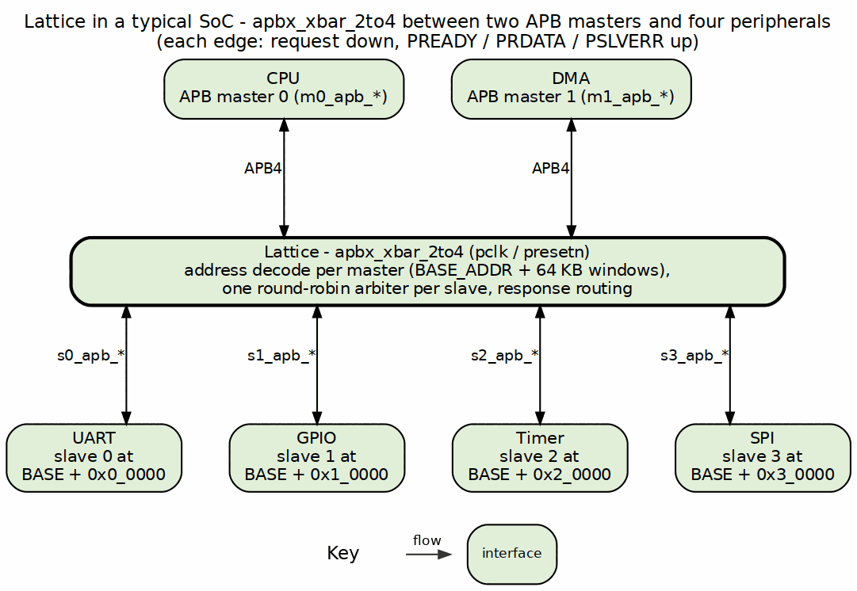
System Context Diagram

Typical Integration Topology

Master-Side Connections
The crossbar’s master ports face upstream APB masters:
Typical Master Connections
Master Type | Typical Source | Connection Point
CPU | AHB-to-APB Bridge | m0_apb_*
DMA | DMA Controller APB Port | m1_apb_*
Debug | Debug Access Port | m2_apb_* (if present)

Slave-Side Connections
The crossbar’s slave ports face downstream APB peripherals:
Typical Slave Connections (1to4 example)
Slave Type | Address Offset | Connection Point
UART | +0x0_0000 | s0_apb_*
GPIO | +0x1_0000 | s1_apb_*
Timer | +0x2_0000 | s2_apb_*
SPI | +0x3_0000 | s3_apb_*

Interface Boundaries

Input Boundary (Master-Side)
Each master port presents a complete APB slave interface:
- Receives PSEL, PENABLE, PADDR, PWRITE, PWDATA, PSTRB, PPROT
- Returns PRDATA, PSLVERR, PREADY

Output Boundary (Slave-Side)
Each slave port presents a complete APB master interface:
- Drives PSEL, PENABLE, PADDR, PWRITE, PWDATA, PSTRB, PPROT
- Receives PRDATA, PSLVERR, PREADY

Clock and Reset
Single clock domain: - pclk - APB clock (all signals synchronous) - presetn - Active-low asynchronous reset

System Integration Considerations

Address Map Planning
The fixed 64KB per-slave allocation requires planning:
- Peripheral fit: Ensure each peripheral needs <= 64KB address space
- Base address: Set BASE_ADDR to avoid conflicts with other subsystems
- Address width: ADDR_WIDTH must accommodate BASE_ADDR + (NUM_SLAVES x 64KB)

Multi-Master Considerations
When using multiple masters:
- Arbitration overhead: a contended access waits a FULL transaction, not 1-2 cycles. The grant is held to the response handshake (WAIT_GNT_ACK(1)), so each master ahead in the round-robin costs ~11 cycles (the arbitrated back-to-back period). Uncontended, the registered grant still costs exactly 1 cycle – see HAS 5.2.
- Priority: All masters have equal priority (round-robin)
- Bandwidth: Shared access reduces per-master bandwidth

Next: Chapter 3: Architecture

RTL Design Sherpa · Learning Hardware Design Through Practice GitHub · Documentation Index · MIT License

Block Diagram

Top-Level Architecture
The Lattice has three functional layers:

Figure 3.1: Lattice Block Diagram
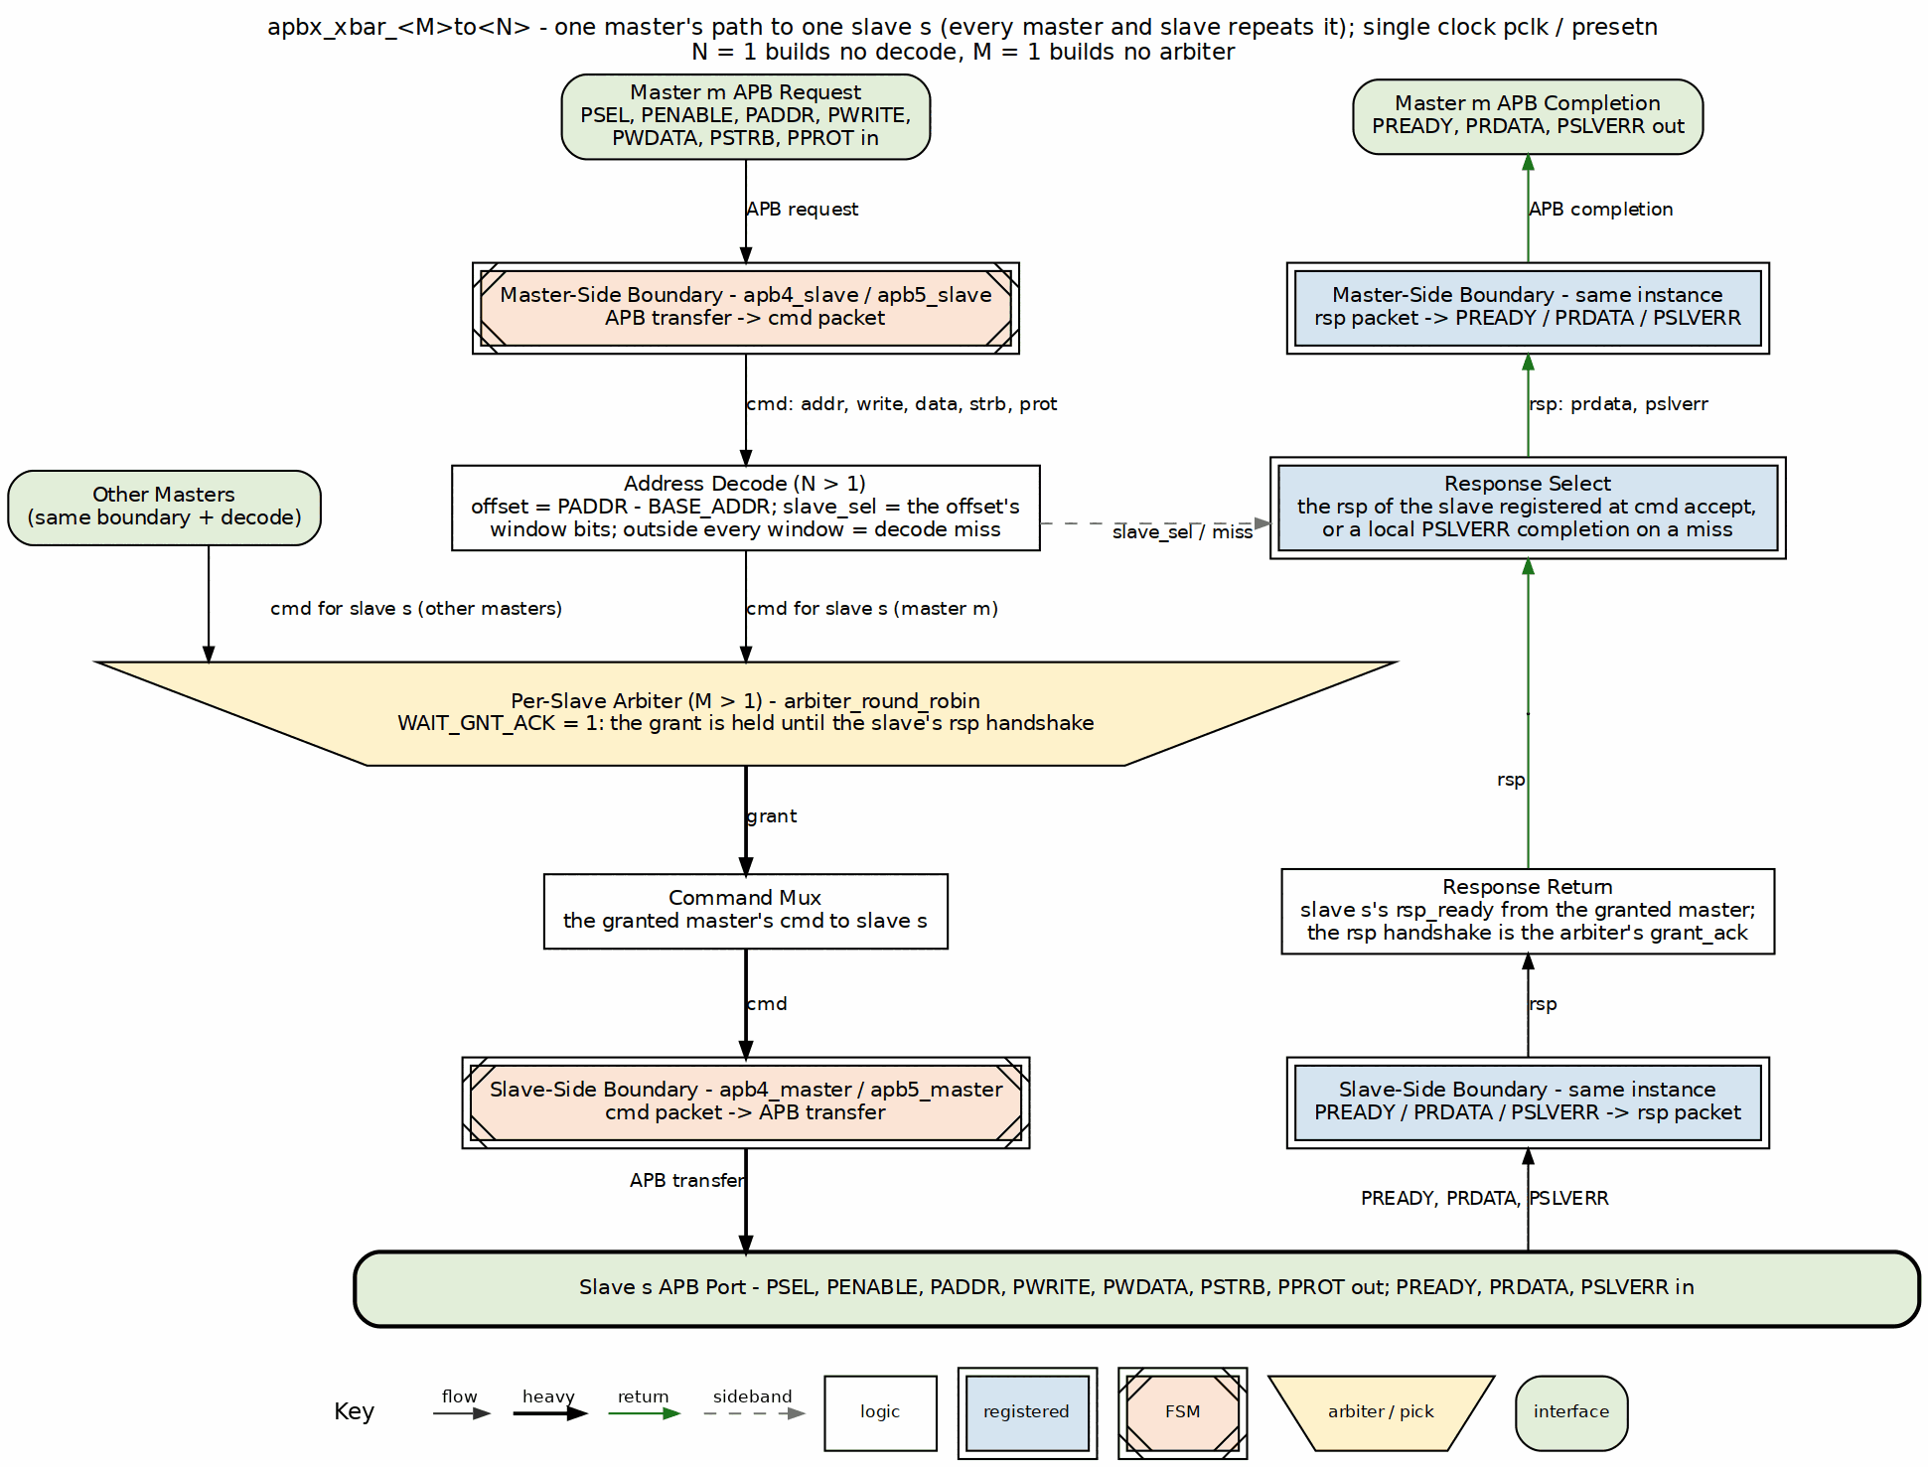
Block Diagram
One master’s path to one slave; every master and slave repeats it. The request takes the center column: the master-side apb4_slave turns the APB transfer into a cmd packet, the address decode picks the slave window, and the slave’s round-robin arbiter (the trapezium, where every master’s cmd for that slave contends) grants one master and holds the grant until the response handshake. The completion climbs the right column, routed back by the slave index registered when the command was accepted; an address outside every window completes locally with PSLVERR.

Functional Blocks

Master-Side Protocol Conversion
Component: apb4_slave[M] instances (one per master)
Each APB slave instance: - Accepts incoming APB transactions from a master - Converts the APB protocol to the internal command/response format - Buffers the transaction - Generates the response timing
Interface: - Input: Complete APB slave signals from external master - Output: Internal cmd/rsp bus to crossbar fabric

Internal Crossbar Fabric
Components: - Address Decode - Parallel decode logic - Per-Slave Arbiters - Round-robin arbiter per slave (N instances) - Response Routing - Combinational response mux (the registers on this path live in the boundary IP’s skid buffers, not the mux)
The crossbar fabric: 1. Decodes transaction address to determine target slave 2. Arbitrates when multiple masters request the same slave 3. Routes commands to the selected slave 4. Routes responses back to the originating master

Slave-Side Protocol Conversion
Component: apb4_master[N] instances (one per slave)
Each APB master instance: - Accepts internal cmd/rsp from crossbar fabric - Generates compliant APB transactions to the slave - Handles wait states via PREADY - Propagates error responses via PSLVERR
Interface: - Input: Internal cmd/rsp bus from crossbar fabric - Output: Complete APB master signals to external slave

Module Hierarchy
apbx_xbar_MxN
+-- apb4_slave[0..M-1] # Master-side conversion
+-- addr_decode # Parallel address decode
+-- arbiter[0..N-1] # Per-slave round-robin
+-- response_mux # Response routing
+-- apb4_master[0..N-1] # Slave-side conversion

Data Path Width
Data path widths are consistent throughout:
Data Path Width Parameters
Parameter | Default | Range | Description
ADDR_WIDTH | 32 | 18-64 (decoding variants: the slave-index part-select reads bit 17); 1-64 for 1to1/2to1 | Address bus width
DATA_WIDTH | 32 | 8-64 | Data bus width
STRB_WIDTH | 4 | 1-8 | Byte strobe width (DATA_WIDTH/8)

Next: Data Flow

RTL Design Sherpa · Learning Hardware Design Through Practice GitHub · Documentation Index · MIT License

Data Flow

Transaction Flow Overview

Figure 3.2: Transaction Data Flow
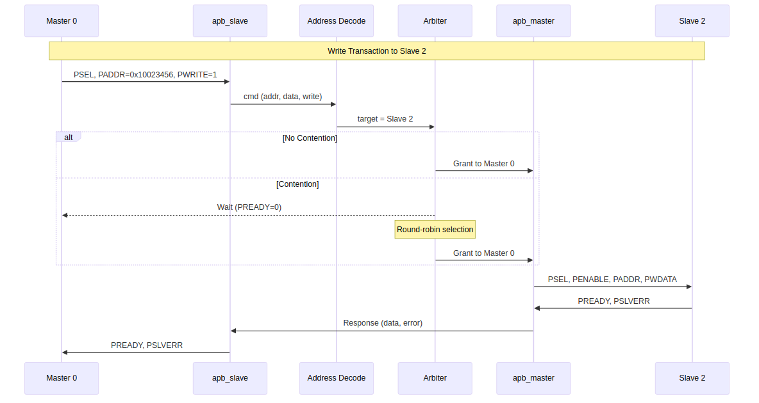
Data Flow Diagram

Write Transaction Flow
A write transaction passes through six stages:

Stage 1: Master Request
The external master initiates an APB write: 1. Master asserts PSEL and PADDR with target address 2. Master sets PWRITE=1 and provides PWDATA 3. Next cycle: Master asserts PENABLE

Stage 2: Protocol Conversion (Master-Side)
The apb4_slave module converts to internal format: 1. Captures transaction parameters (address, data, write) 2. Generates internal command 3. Routes to address decode

Stage 3: Address Decode
Parallel decode determines target slave:
slave_index = offset[16 +: $clog2(S)] // offset = PADDR - BASE_ADDR
A part-select, not a mask. & (S-1) appeared here until 2026-08-30 and is only equivalent when S is a power of two – for a generated 3-slave variant the mask would make slave 1 unreachable. The generator emits a part-select (slave_sel = m0_cmd_offset[13:12] for S = 3 at the generator’s default 4KB window; the shipped 64KB variants read offset[16 +: $clog2(S)]), and the sibling formulas in ch02/ch03 always did.

Stage 4: Arbitration (if needed)
If multiple masters target the same slave: 1. Arbiter selects one master (round-robin priority) 2. Other masters wait (PREADY low) 3. Grant held until transaction completes

Stage 5: Protocol Conversion (Slave-Side)
The apb4_master module generates the APB transaction: 1. Asserts PSEL to selected slave 2. Provides PADDR, PWRITE, PWDATA 3. Asserts PENABLE next cycle 4. Waits for slave PREADY

Stage 6: Response Return
The response flows back to the originating master: 1. Slave asserts PREADY (with optional PSLVERR) 2. apb4_master captures response 3. Response routed to correct apb4_slave 4. apb4_slave asserts PREADY to original master

Read Transaction Flow
Read transactions follow the same flow with these differences:
- PWRITE=0 indicates read operation
- No PWDATA on forward path
- PRDATA returned on response path

Timing Summary
Transaction Timing Summary
Transaction Phase | Clock Cycles | Notes
Setup phase | 1 | PSEL asserted, PENABLE low
Data phase | 1+ | PENABLE high, wait for PREADY
Decode | 0 | Combinational (parallel decode)
Arbitration | 0 or 1 | 0 when M = 1 – the generator emits no arbiter at all. 1 when M > 1, even uncontended, because the grant is REGISTERED

Back-to-Back Transactions
The crossbar accepts back-to-back transactions – but they do NOT overlap:
- A master may hold PSEL and start the next SETUP the cycle after PREADY
- apb4_slave is one-command-at-a-time, so the next command is not captured until the previous transaction completes
- Sustained cadence is therefore one cycle LONGER than single-transfer latency: measured PREADY-to-PREADY = 10 pclk cycles at the earliest legal turnaround, against 9 cycles SETUP-to-PREADY for one transfer (M = 1; 11 and 10 on an arbitrated variant). The extra cycle is the next transfer’s mandatory SETUP phase, which cannot overlap the previous ACCESS (see 5.1/5.2)

Next: Address Mapping

RTL Design Sherpa · Learning Hardware Design Through Practice GitHub · Documentation Index · MIT License

Address Mapping

Address Map Structure
The shipped Lattice variants use a 64KB address region per slave. The size is chosen at generation (--slave-size, generator default 4KB) and then baked into the decode part-select, so it is fixed for a given generated module:

Figure 3.3: Address Mapping Structure
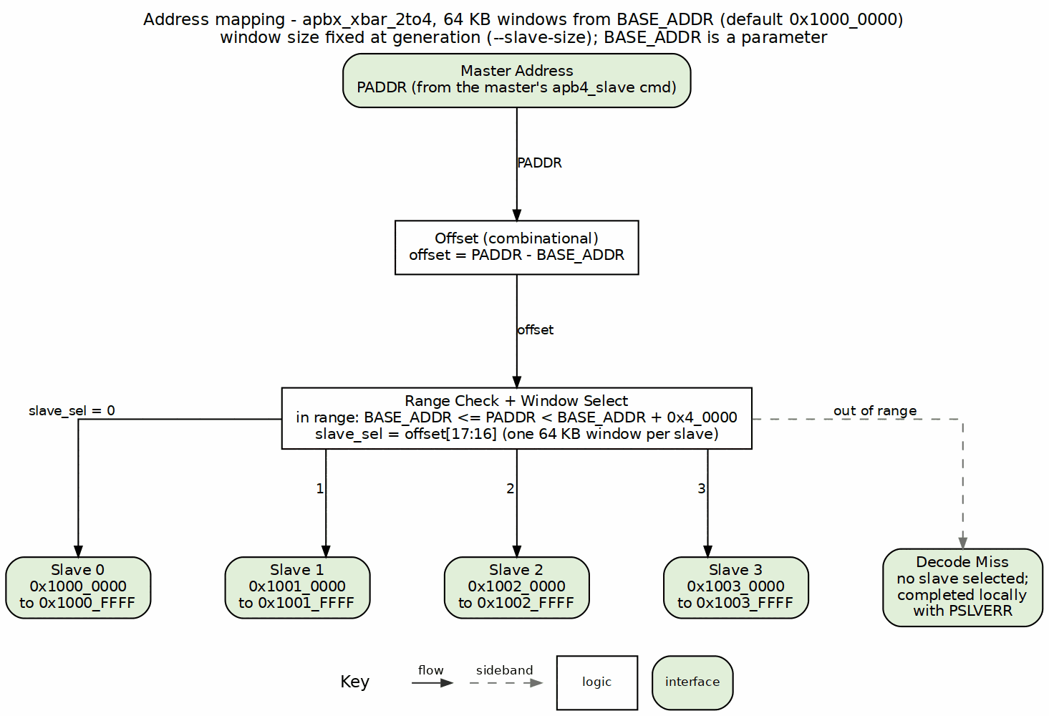
Address Mapping

Default Address Map
With default BASE_ADDR = 0x1000_0000:
Default Address Map (4-slave example)
Slave Index | Start Address | End Address | Size
0 | 0x1000_0000 | 0x1000_FFFF | 64KB
1 | 0x1001_0000 | 0x1001_FFFF | 64KB
2 | 0x1002_0000 | 0x1002_FFFF | 64KB
3 | 0x1003_0000 | 0x1003_FFFF | 64KB
… | … | … | …
N-1 | BASE + (N-1)*64KB | BASE + N*64KB - 1 | 64KB

Address Decode Logic
The target slave comes from simple bit extraction:
offset = PADDR - BASE_ADDR
slave_index = offset[16 +: $clog2(S)] // ceil(log2(S)) bits: [17:16] for S=4
local_addr = offset[15:0] // Bits 15:0 are local address within slave

Example Decode
For address 0x1002_3456 with BASE_ADDR = 0x1000_0000:
Address Decode Example
Step | Calculation | Result
1. Compute offset | 0x1002_3456 - 0x1000_0000 | 0x0002_3456
2. Extract slave index | offset[17:16] (S=4) | 0x2 (Slave 2)
3. Extract local address | offset[15:0] | 0x3456

Customizing Base Address
The BASE_ADDR parameter shifts the entire address map:
// Peripheral space at 0x4000_0000
apbx_xbar_1to4 #(
.BASE_ADDR(32'h4000_0000)
) u_xbar (...);
// Resulting map:
// Slave 0: 0x4000_0000 - 0x4000_FFFF
// Slave 1: 0x4001_0000 - 0x4001_FFFF
// Slave 2: 0x4002_0000 - 0x4002_FFFF
// Slave 3: 0x4003_0000 - 0x4003_FFFF

Address Map Constraints

Fixed Slave Region Size
Each slave occupies exactly 64KB (0x10000 bytes). This is a current design constraint.
Implications: - Peripherals requiring more than 64KB need multiple slave ports - Peripherals using less than 64KB have unused address space

Maximum Configuration
With 4-bit slave index extraction: - Maximum 16 slaves - Total address space: 16 x 64KB = 1MB

Address Width Requirement
The ADDR_WIDTH parameter must be sufficient to address: - BASE_ADDR + (NUM_SLAVES x 64KB)
Example: For 4 slaves at BASE_ADDR = 0x8000_0000, need: - 0x8000_0000 + 0x4_0000 = 0x8004_0000 - Minimum ADDR_WIDTH: 32 bits

Next: Chapter 4: Interfaces

RTL Design Sherpa · Learning Hardware Design Through Practice GitHub · Documentation Index · MIT License

Master-Side APB Interfaces

Interface Overview
Each master port presents a complete APB slave interface, accepting transactions from an external APB master (CPU, DMA, etc.).

Signal Definition
For each master index i (0 to M-1):
Master Port Signal Definition
Signal | Width | Direction | Description
m<i>_apb_PSEL | 1 | Input | Peripheral select
m<i>_apb_PENABLE | 1 | Input | Transfer enable
m<i>_apb_PADDR | ADDR_WIDTH | Input | Address bus
m<i>_apb_PWRITE | 1 | Input | Write/read direction
m<i>_apb_PWDATA | DATA_WIDTH | Input | Write data bus
m<i>_apb_PSTRB | STRB_WIDTH | Input | Write strobes
m<i>_apb_PPROT | 3 | Input | Protection attributes
m<i>_apb_PRDATA | DATA_WIDTH | Output | Read data bus
m<i>_apb_PSLVERR | 1 | Output | Slave error response
m<i>_apb_PREADY | 1 | Output | Transfer ready

APB5 Sideband (mixed-version variants only)
An APB5 master port carries five additional pins. They exist ONLY on ports the generator was told are APB5 – in the shipped apbx_xbar_2to2_mixed that is m1 alone, and m0 has none of them. That structural absence IS the version gate; there is no mask to set.
APB5 Master Sideband Signals
Signal | Width | Direction | Description
m<i>_apb_PAUSER | 1 | Input | Request user attributes; forwarded only to an APB5 slave
m<i>_apb_PWUSER | 1 | Input | Write-data user attributes; likewise
m<i>_apb_PRUSER | 1 | Output | Completer read-data user attributes, from an APB5 slave
m<i>_apb_PBUSER | 1 | Output | Completer response user attributes, from an APB5 slave
m<i>_apb_PWAKEUP | 1 | Input | Requester wake; forwarded to every APB5 slave port – see below
Reading from an APB4 slave returns '0 on PRUSER/PBUSER rather than a stale or fabricated value, and that is proven, not just tested (formal/apbx_xbar/apbx_xbar_2to2_mixed/, ap_gate_no_fab_*).
PWAKEUP is an input here. AMBA APB (IHI 0024E section 3.7.2, Table 3-7) defines PWAKEUP as a Requester output, and the external master is the Requester on this port. The crossbar ORs it into PWAKEUP on every APB5 slave port, without registering it, so a wake raised a cycle ahead of PSEL reaches the completer a cycle ahead of PSEL. An APB4 master has no PWAKEUP. Its transfers to an APB5 slave are still covered by the crossbar’s own wake, as described in Slave Side. The forwarding is proven (ap_pwakeup_forwarded in formal/apbx_xbar/apbx_xbar_2to2_mixed/). Earlier crossbars drove this pin as an output tied to '0, under the old reversed direction. That was corrected in issue #102 item 7.
The user-signal widths are fixed at 1 bit, not parameterised. This table previously named AUSER_WIDTH/WUSER_WIDTH/RUSER_WIDTH/BUSER_WIDTH as though an integrator could size them. There are no such parameters: the whole module takes only ADDR_WIDTH, BASE_ADDR, DATA_WIDTH and STRB_WIDTH, and the generator hardcodes AUSER_WIDTH(1) .. BUSER_WIDTH(1) at each boundary shim. Widening a user field means regenerating the crossbar, not overriding a parameter.
Parity pins are absent entirely: every shipped variant is generated with parity off. A variant generated with enable_parity=True adds the IHI 0024E chapter 5 check signals on each APB5 port. Inputs are PADDRCHK, PCTRLCHK, PSELCHK, PENABLECHK, PWDATACHK, PSTRBCHK, PAUSERCHK, PWUSERCHK and PWAKEUPCHK. Outputs are PRDATACHK, PREADYCHK, PSLVERRCHK, PRUSERCHK and PBUSERCHK. All are odd parity, plus m<i>_parity_error_wdata and m<i>_parity_error_ctrl. See the GAS chapter Mixed APB4/APB5 and Parity for the widths.

Signal Descriptions

PSEL (Input)
Peripheral select signal. When asserted: - Indicates the master wants to access the crossbar - Must remain asserted throughout the transaction - Combined with PADDR determines target slave

PENABLE (Input)
Transfer enable signal. APB state machine: - PSEL=1, PENABLE=0: Setup phase - PSEL=1, PENABLE=1: Access phase (data transfer)

PADDR (Input)
Address bus. Used for: - Target slave selection (upper bits) - Local address within slave (lower bits) - Must be stable while PSEL asserted

PWRITE (Input)
Transfer direction: - PWRITE=1: Write transaction (data from master) - PWRITE=0: Read transaction (data to master)

PWDATA (Input)
Write data bus: - Valid during write transactions - Sampled when PREADY and PENABLE both high - Width set by DATA_WIDTH parameter

PSTRB (Input)
Write byte strobes: - One bit per byte of DATA_WIDTH - Indicates which bytes are valid in PWDATA - Ignored during read transactions

PPROT (Input)
Protection attributes (3 bits): - Bit 0: Privileged/normal access - Bit 1: Secure/non-secure access - Bit 2: Instruction/data access

PRDATA (Output)
Read data bus: - Valid during read transactions when PREADY high - Undefined during write transactions - Width matches DATA_WIDTH parameter

PSLVERR (Output)
Slave error response: - Sampled when PREADY and PENABLE both high - PSLVERR=1 indicates error condition - Propagated from the downstream slave, or generated locally by this port when the address decodes outside the map: on the decoding variants a miss completes here with PSLVERR=1 and never reaches a slave (projects/components/fabric-gen-ip/lattice-apbx-xbar BUG-002, was APBX-005). The 1to1 and 2to1 variants have no decode and so never generate it locally.

PREADY (Output)
Transfer ready signal: - PREADY=1 allows the transaction to complete - PREADY=0 inserts wait states - Reflects downstream slave PREADY (or arbitration wait)

Transaction Timing

Uncontended Write (No Arbitration Wait)
Drawn to scale for a single-master variant: 9 pclk edges SETUP-to-PREADY, 10 on an arbitrated one (see 5.2).

Figure 4.1: Uncontended Write at a Master Port
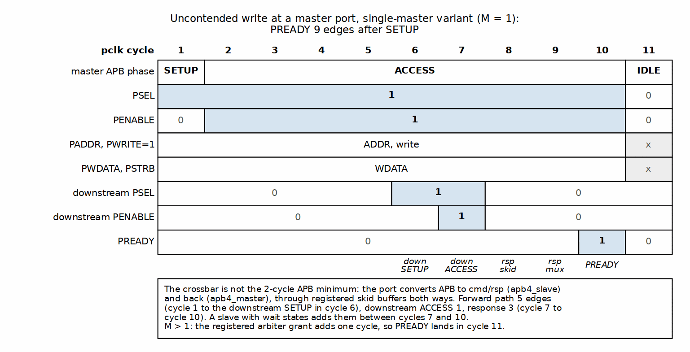
Uncontended Write at a Master Port

Contended Transaction (Arbitration Wait)
When another master holds the target slave:

Figure 4.2: Contended Transfer
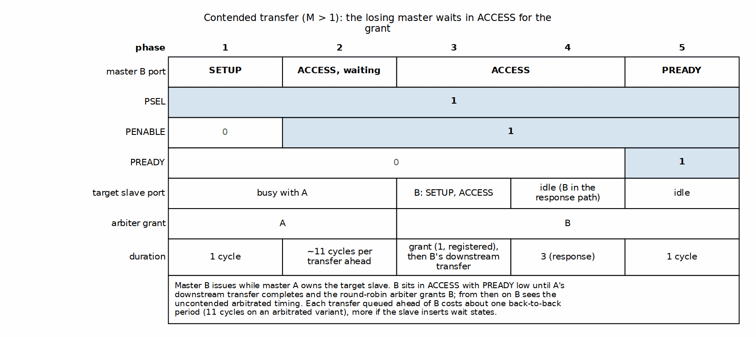
Contended Transfer

Next: Slave-Side Interfaces

RTL Design Sherpa · Learning Hardware Design Through Practice GitHub · Documentation Index · MIT License

Slave-Side APB Interfaces

Interface Overview
Each slave port presents a complete APB master interface, driving transactions to an external APB slave (peripheral).

Signal Definition
For each slave index j (0 to N-1):
Slave Port Signal Definition
Signal | Width | Direction | Description
s<j>_apb_PSEL | 1 | Output | Peripheral select
s<j>_apb_PENABLE | 1 | Output | Transfer enable
s<j>_apb_PADDR | ADDR_WIDTH | Output | Address bus
s<j>_apb_PWRITE | 1 | Output | Write/read direction
s<j>_apb_PWDATA | DATA_WIDTH | Output | Write data bus
s<j>_apb_PSTRB | STRB_WIDTH | Output | Write strobes
s<j>_apb_PPROT | 3 | Output | Protection attributes
s<j>_apb_PRDATA | DATA_WIDTH | Input | Read data bus
s<j>_apb_PSLVERR | 1 | Input | Slave error response
s<j>_apb_PREADY | 1 | Input | Transfer ready

APB5 Sideband (mixed-version variants only)
Symmetric with the master side, and equally structural: these pins exist ONLY on slave ports the generator was told are APB5. In the shipped apbx_xbar_2to2_mixed that is s0 alone – s1 has none of them – so the absence IS the version gate, with no mask to set. Note the pairing in that variant is crosswise: the APB5 port is m1 on the master side and s0 here.
APB5 Slave Sideband Signals
Signal | Width | Direction | Description
s<j>_apb_PAUSER | 1 | Output | Request user attributes, forwarded from an APB5 master
s<j>_apb_PWUSER | 1 | Output | Write-data user attributes, likewise
s<j>_apb_PRUSER | 1 | Input | Read-data user attributes returned by the slave
s<j>_apb_PBUSER | 1 | Input | Response user attributes returned by the slave
s<j>_apb_PWAKEUP | 1 | Output | Crossbar wake toward the slave – see below
Widths are fixed at 1 bit. The generator hardcodes AUSER_WIDTH(1) .. BUSER_WIDTH(1) on the boundary shim and exposes no parameter for them.
s<j>_apb_PWAKEUP is driven by the crossbar. On this interface the crossbar is the Requester, and PWAKEUP is a Requester output (IHI 0024E section 3.7.2, Table 3-7). It is the OR of two terms:
- The boundary apb5_master IP’s own registered wake. It is high while a command for this slave is pending or a transfer is in flight, it leads PSEL by a cycle, and it holds through PREADY. This term covers transfers from APB4 masters, which have no PWAKEUP. 3.7.2 lets a slave wait for PWAKEUP before PREADY, so a PSEL without it could deadlock.
- Every APB5 master’s m<i>_apb_PWAKEUP. All masters can address all slaves, so the wake goes to every APB5 slave port, not to the decoded one. The address is not known until PSEL, and 3.7.2 recommends the wake lead PSEL.
3.7.2 names a glitch-free OR tree as a valid construction. Three properties are proven in formal/apbx_xbar/apbx_xbar_2to2_mixed/:
- ap_pwakeup_forwarded: a master’s wake always reaches the slave.
- ap_pwakeup_covers_psel: the slave is never selected without PWAKEUP.
- ap_pwakeup_not_fabricated: from reset, with no master wake and no traffic, the wake stays low.
The slave’s own wake is not forwarded to any master. Earlier crossbars took this pin as an input and dropped it, under the old reversed direction. That was corrected in issue #102 item 7. With parity on, the port’s PWAKEUPCHK is ~s<j>_apb_PWAKEUP, computed over the OR.
Reading from an APB4 slave returns '0 on PRUSER/PBUSER rather than a stale or fabricated value, proven by ap_gate_no_fab_* in formal/apbx_xbar/apbx_xbar_2to2_mixed/.

Signal Behavior

Output Signals (Crossbar to Slave)
PSEL: Asserted when a transaction targets this slave. Remains high throughout the transaction.
PENABLE: Follows standard APB timing – exactly one setup cycle (PSEL high, PENABLE low) before ACCESS, on every transfer.
Until 2026-08-28 apb4_master/apb5_master drove two setup cycles when launching out of IDLE, measured [2,2,2] at a downstream port; only back-to-back transfers taking the ACCESS->SETUP shortcut were compliant. Fixed as AMBA TASK-071 by not asserting PSEL in the IDLE launch cycle, which cost no latency because the state sequence was unchanged. Now measured [1,1,1,1,1] downstream, asserted by val/amba/test_apb_master_setup_phase.py and by the downstream check in dv/tests/test_apbx_xbar_timing.py.
- Low during setup phase
- High during access phase
PADDR: Contains the full address from the master. The local address within a 64KB region is offset[15:0] – note this is the OFFSET’s low bits, not PADDR’s, so it only equals PADDR[15:0] when BASE_ADDR is 64KB-aligned (which is permitted but not required).
PWRITE, PWDATA, PSTRB, PPROT: Passed through from the winning master without modification.

Input Signals (Slave to Crossbar)
PRDATA: Captured by crossbar when both PREADY and PENABLE are high. Routed to originating master.
PSLVERR: Captured with PRDATA. Propagated to originating master as error indication.
PREADY: Controls transaction completion: - PREADY=1: Transaction completes this cycle - PREADY=0: Insert wait states

Slave Response Handling

Wait States
Slaves can insert wait states by holding PREADY low:

Figure 4.3: Slave Wait States
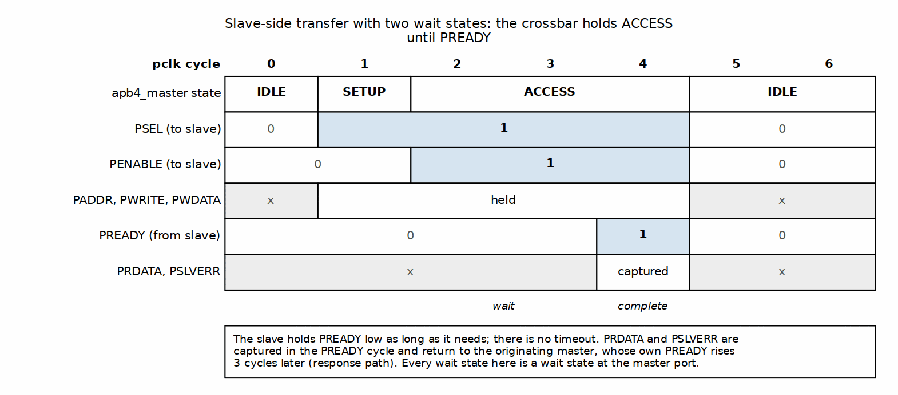
Slave Wait States
The crossbar: - Holds master PREADY low while waiting - Does not timeout (assumes slaves always respond) - Passes through all wait states to master

Error Response
When slave asserts PSLVERR:
- Crossbar captures PSLVERR with PRDATA
- Routes PSLVERR to originating master
- Master sees PSLVERR=1 when its PREADY goes high
No error handling or recovery - error indication only.

Multi-Slave Considerations

Address Overlap Prevention
Each slave port is mutually exclusive: - Only one slave receives PSEL for any given address - No overlapping address regions - Address decode is deterministic

Independent Operation
Each slave operates independently: - Own PREADY timing - No synchronization between slaves - Concurrent transactions to different slaves allowed (different masters)

Next: Clock and Reset

RTL Design Sherpa · Learning Hardware Design Through Practice GitHub · Documentation Index · MIT License

Clock and Reset

Clock Interface

Signal Definition
Clock Signal
Signal | Width | Direction | Description
pclk | 1 | Input | APB clock

Clock Requirements
Single Clock Domain: - All crossbar logic operates on the pclk rising edge - All APB signals sampled/driven synchronous to pclk - No internal clock generation or division
Frequency: - No minimum frequency requirement - Maximum frequency set by the critical path - Typical: 100-250 MHz (depends on target technology)
Duty Cycle: - No specific duty cycle requirement - Standard 50% duty cycle recommended

Reset Interface

Signal Definition
Reset Signal
Signal | Width | Direction | Description
presetn | 1 | Input | Active-low asynchronous reset

Reset Behavior
Assertion (presetn goes low): - All internal state cleared immediately - All output signals driven to safe values - Master ports: PREADY=0, PRDATA=0, PSLVERR=0 - Slave ports: PSEL=0, PENABLE=0, PADDR=0, etc.
Deassertion (presetn goes high): - Internal state begins normal operation - Reset release is NOT synchronized internally – presetn is applied directly as an asynchronous reset (ALWAYS_FF_RST) in every module. The integrator must synchronize reset DEASSERTION to pclk externally (recovery/removal timing) - Ready to accept transactions from the first pclk edge after a correctly synchronized deassertion – NOT “immediately” in the sense of the deassertion instant. Until that externally synchronized removal lands cleanly, the fabric’s state is not defined; the “Reset Deassertion” guidance later on this page (wait 1 cycle before the first transaction) is the operative rule.

Reset Safe Values
Reset Safe Values
Signal Group | Reset Value | Rationale
Master PREADY | 0 | apb4_slave asserts PREADY only in BUSY
Master PRDATA | 0 | No false data
Master PSLVERR | 0 | No false errors
Slave PSEL | 0 | No false transactions
Slave PENABLE | 0 | No false enables
Arbiter grants | 0 | No master selected

Clock-Reset Relationship

Reset Assertion
Reset can be asserted at any time: - Asynchronous assertion (immediate effect), in every build. This comes from ALWAYS_FF_RST in rtl/amba/includes/reset_defs.svh, which is unconditionally async; the old USE_ASYNC_RESET switch is a no-op. - Deassertion must be synchronous to pclk – see “Reset Deassertion” below. This bullet previously also permitted asynchronous deassertion, contradicting that section three lines later. - All in-flight transactions aborted

Reset Deassertion
For clean operation: 1. Assert reset for minimum 2 pclk cycles 2. Deassert reset synchronous to pclk rising edge 3. Wait 1 cycle before first transaction

Figure 4.4: Reset Sequence
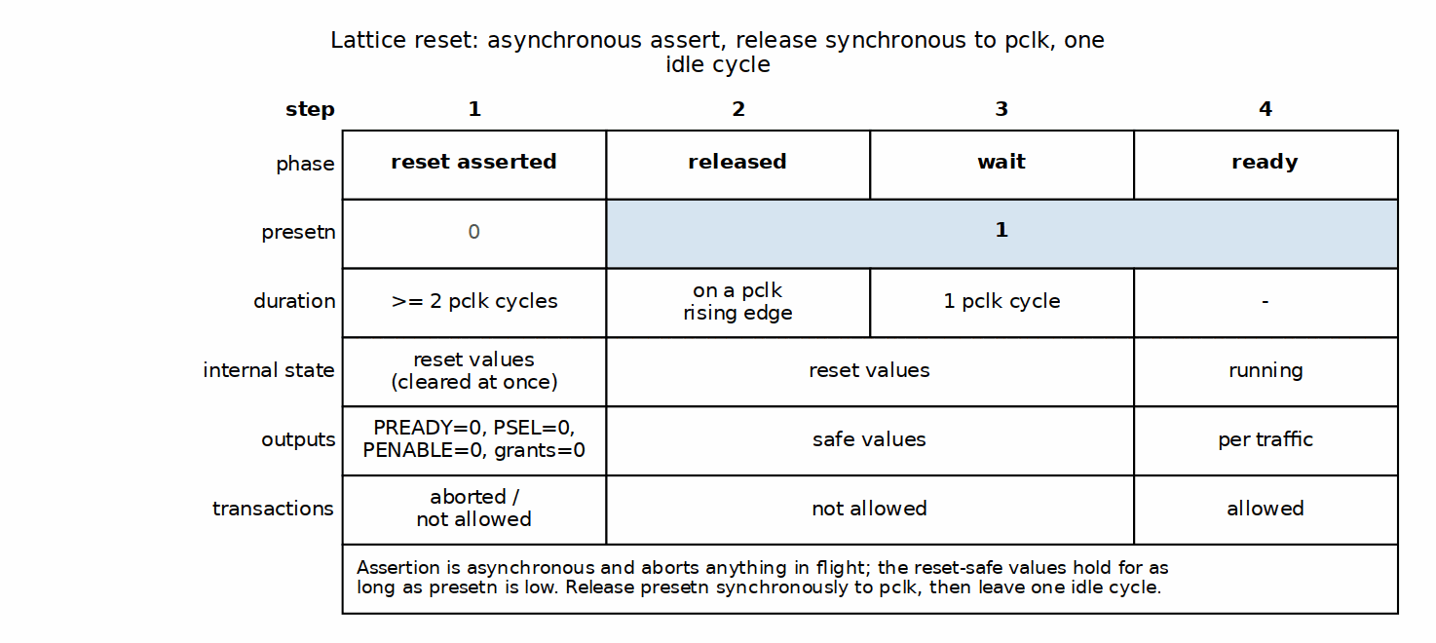
Reset Sequence

Integration Notes

Clock Domain Crossing
If masters or slaves are in different clock domains: - Insert CDC logic external to the crossbar - The crossbar assumes a single clock domain - Consider an APB clock bridge if needed

Clock Gating
The crossbar supports clock gating: - No internal activity when idle - Safe to gate pclk when no transactions pending - All registers use standard flip-flops (no clock gating cells)

Next: Chapter 5: Performance

RTL Design Sherpa · Learning Hardware Design Through Practice GitHub · Documentation Index · MIT License

Throughput Characteristics

Maximum Throughput

Single Master
With a single master accessing any slave, the figures split by arbiter presence: the generator emits an arbiter only when M > 1, and its registered grant costs a cycle on every one of them. See 5.2.
Single-Master-Active Throughput, by Variant Class
Metric | M = 1 | M > 1 | Notes
Cycles per transaction (uncontended) | 9 SETUP->PREADY; 8 fabric | 10 SETUP->PREADY; 9 fabric | measured, zero-wait slave
Sustained cycles per transaction | 10 (PREADY->PREADY) | 11 (PREADY->PREADY) | measured back-to-back, one active master
Maximum transactions per cycle | ~0.100 | ~0.091 | 1 transaction / 10 or 11 cycles
Data throughput (32-bit @ 100MHz) | ~40 MB/s | ~36 MB/s | 4 B per period
Data throughput (32-bit @ 250MHz) | ~100 MB/s | ~91 MB/s | 4 B per period
M = 1: apbx_xbar_1to1, apbx_xbar_1to4. M > 1: apbx_xbar_2to1, apbx_xbar_2to4, apbx_xbar_2to2_mixed – so the 2x4 the PRD calls the typical SoC case is the slower column. This table published the M = 1 figures unconditionally until 2026-08-29.

Multi-Master (Uncontended)
When masters access different slaves: - Each master achieves single-master throughput - Aggregate throughput = M x single-master throughput - No CONTENTION overhead – but the registered grant still costs one cycle on every M > 1 variant, contended or not (see 5.2). Only the single-master variants have no arbiter at all.

Multi-Master (Contended)
When masters compete for the same slave:
Contended Access Throughput
Masters | Effective Throughput | Notes
2 | 50% per master | Round-robin sharing
3 | 33% per master | Round-robin sharing
4 | 25% per master | Round-robin sharing

Arbitration Handoff

Grant Persistence
The crossbar implements grant persistence: - A master holds the grant for the duration of ONE transaction - The grant is released at the RESPONSE handshake, not when PSEL drops (grant_ack = grant && rsp_valid && rsp_ready, arbiter instantiated with WAIT_GNT_ACK(1)), after which the round-robin mask rotates – holding PSEL does not keep the grant if another master is requesting - A single master with no competitor re-wins immediately, so its transactions still stream back-to-back – at the fabric’s own cadence, not at APB’s 2-cycle minimum

Back-to-Back Timing
A “zero-bubble” 4-cycle two-transaction diagram appeared here in earlier revisions. It described a pipeline this RTL does not have: the apb4_slave front end is a one-command-at-a-time FSM (IDLE -> BUSY -> WAIT), so the next command is not captured until the previous transaction completes. But sustained cadence is not equal to single-transfer latency either – it is one cycle longer. A master holding PSEL high and dropping PENABLE for exactly one cycle after each PREADY (the earliest LEGAL turnaround) measures PREADY-to-PREADY = 10 pclk cycles, against a 9-cycle SETUP-to-PREADY single transfer. The extra cycle is the next transfer’s mandatory SETUP phase, which cannot overlap the previous transfer’s ACCESS. See 5.2 for the convention and the cycle-by-cycle breakdown. There is still no overlap between consecutive transactions to draw.

Throughput Factors

Factors That Reduce Throughput
Throughput Reduction Factors
Factor | Impact | Mitigation
Slave wait states | Variable | Choose faster peripherals
Arbitration conflicts | ~11 cycles per master ahead in the round-robin | Distribute access across slaves
Slave response time | Variable | Design slaves for quick response

Optimal Usage Pattern
For maximum throughput: 1. Distribute master access across different slaves 2. Minimize slave wait states 3. Use burst-like access patterns (same master, same slave) 4. Avoid rapid master switching on same slave

Next: Latency Analysis

RTL Design Sherpa · Learning Hardware Design Through Practice GitHub · Documentation Index · MIT License

Latency Analysis

Transaction Latency

Uncontended Access
When a master has exclusive access to a slave:
Uncontended Transaction Latency
Phase | Cycles | Description
Master SETUP | 1 | PSEL high, PENABLE low
apb4_slave capture + cmd skid | 2 | command registered out
apb4_master IDLE-launch / SETUP / ACCESS | 3 | downstream PSEL then PENABLE
Response + rsp skid | 2 | slave PREADY through the return skid
apb4_slave BUSY -> PREADY | 1 | master-visible completion
Total | 9 | PSEL to PREADY (8 of them ACCESS to PREADY)
These are measured numbers, not protocol minimums. A crossbar transfer is NOT the 2-cycle APB minimum: the fabric converts APB to an internal cmd/rsp protocol through apb4_slave and back through apb4_master, and both directions cross REGISTERED skid buffers.
Measurement convention. Every figure below counts rising pclk edges and names the two edges it spans. State the edges or the number means nothing – this page has been wrong twice from not doing so.
The numbers depend on whether the variant has an arbiter, and the generator only emits one when there is more than one master. A single-master variant has no arbiter_round_robin at all; a multi-master variant has one per slave, and its grant is a flop (grant <= w_next_grant), which costs exactly one cycle on every quantity below.
Measured Timing, Always-Ready Slave
Quantity | M = 1 | M > 1 | Spans
Fabric latency | 8 | 9 | first ACCESS edge -> edge where PREADY is high
Single-transfer latency | 9 | 10 | SETUP edge -> edge where PREADY is high
Back-to-back period | 10 | 11 | PREADY edge -> next PREADY edge
M = 1 is apbx_xbar_1to1 and apbx_xbar_1to4 (0 arbiters). M > 1 is apbx_xbar_2to1, apbx_xbar_2to4 and apbx_xbar_2to2_mixed (1, 4 and 2 arbiters). All six columns are measured, not derived – see dv/tests/test_apbx_xbar_timing.py, which asserts both classes.
Until 2026-08-29 this page published the M = 1 numbers unconditionally, under the heading “Uncontended Access”, having measured only apbx_xbar_1to1. They were one cycle optimistic for every arbitrated variant – including the 2x4 that the PRD calls the typical SoC case.
The period is 10, not 9, and the difference is structural. After PREADY at cycle N the bus is still in ACCESS for that cycle, so the next transfer’s mandatory SETUP cycle cannot begin before N+1; its ACCESS follows at N+2 and its PREADY at N+2+8 = N+10. Reaching 9 would require a SETUP cycle overlapping the previous transfer’s ACCESS, which is not a legal APB waveform. So sustained cadence does not equal single-transfer latency here – it is exactly one cycle longer.
Earlier revisions of this page claimed 2 cycles (the bare APB minimum for a directly-attached slave, which does not apply through this fabric), and later claimed a 9-cycle sustained cadence, which came from a probe whose turnaround was not legal APB. A qc reviewer flagged the 9-cycle cadence and was told it was a false positive; the reviewer was right. dv/tests/test_apbx_xbar_timing.py now asserts all three numbers against the RTL so the question is settled by the suite rather than by argument.

Contended Access
When multiple masters compete for the same slave:
Arbitration Latency
Scenario | Additional Latency | Description
Win arbitration | 1 cycle | grant is REGISTERED in arbiter_round_robin
Lose to 1 master | ~10+ cycles | wait one full transaction (see above)
Lose to N masters | ~10N+ cycles | wait N transactions

Latency Breakdown

Forward Path (Master to Slave)
Forward Path Latency
Component | M = 1 | M > 1 | Type
apb4_slave capture | 1 | 1 | Registered
apb4_slave cmd skid out | 1 | 1 | Registered
Address decode | 0 | 0 | Combinational
Arbitration | 0 | 1 | No arbiter is emitted when M = 1; when one is, its grant is a flop
apb4_master cmd skid in | 1 | 1 | Registered
apb4_master cmd skid out | 1 | 1 | Registered
apb4_master IDLE -> SETUP | 1 | 1 | FSM
Total | 5 | 6 | master SETUP edge to downstream PSEL edge
Both columns measured: 5 on apbx_xbar_1to1, 6 on apbx_xbar_2to1. The arbitration row is the whole difference between the two variant classes. This table carried a single unconditional column with a 1-cycle arbitration row and a 5-cycle total until 2026-08-29 – which cannot both be true, since the 5 was measured on the variant that has no arbiter.
The three numbers on this page must sum, and now do:
M = 1 M > 1 5 forward 6 forward + 1 downstream SETUP -> ACCESS + 1 downstream SETUP -> ACCESS + 3 response + 3 response = 9 SETUP-to-PREADY = 10 SETUP-to-PREADY
(With a zero-wait slave the downstream ACCESS and PREADY edges are the same cycle, which is why the response row can be read from either. A slave with wait states adds its own cycles between them and shifts the total.)
This table read 4 until 2026-08-29, which could not be reconciled with the page’s own 9-cycle total – 4 + 3 left two cycles unaccounted for. Measured on apbx_xbar_1to1 with an always-ready slave: master SETUP at cycle 1, downstream PSEL at cycle 6, downstream ACCESS at cycle 7, master PREADY at cycle 10.

Response Path (Slave to Master)
Response Path Latency
Component | Cycles | Type
Slave response | Variable | The slave’s own PREADY timing, excluded below
apb4_master captures into rsp skid | 1 | Registered
rsp skid out, through the response mux | 1 | Skid registered; the mux itself is combinational
apb4_slave drives PREADY | 1 | Registered
Total | 3 | downstream PREADY edge to master PREADY edge
Same on both variant classes – arbitration is on the command path only. The rows read “0-1 cycle” each until 2026-08-29, which could not sum to the stated 3.

Latency Timing Diagram

Best Case (No Waits, No Contention)

Figure 5.1: Best-Case Latency Timeline
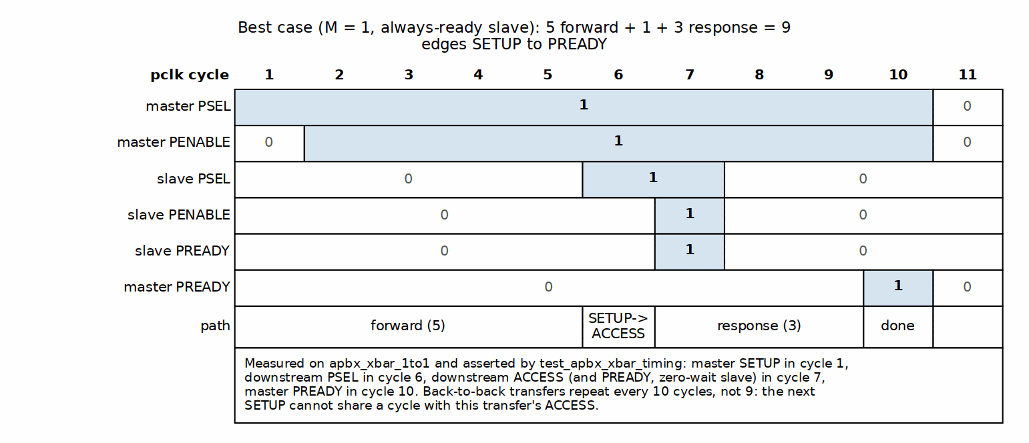
Best-Case Latency Timeline

Worst Case (Contention + Slave Wait States)

Figure 5.2: Arbitration and Slave Wait States
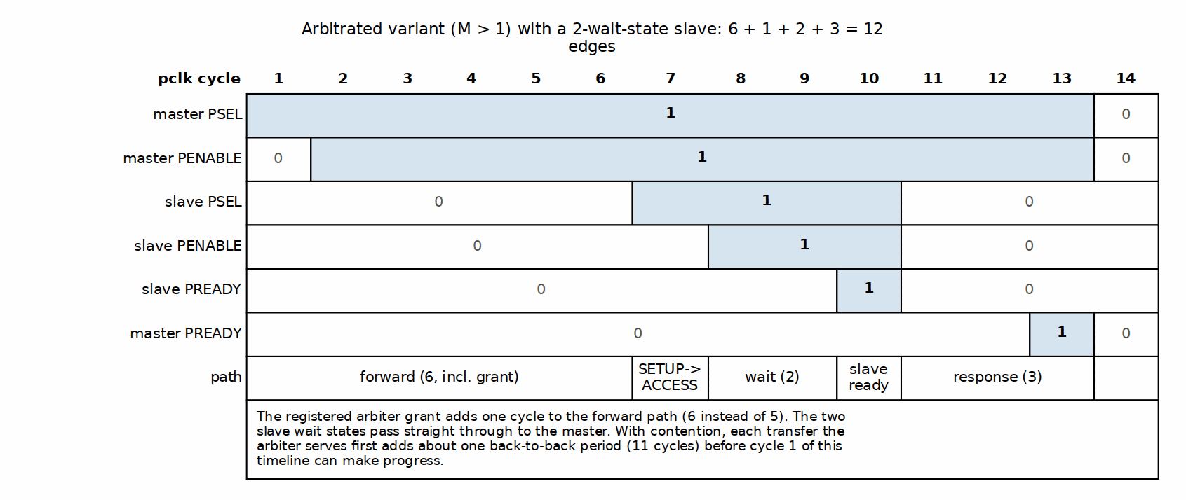
Arbitration and Slave Wait States

Latency Optimization

Design Recommendations
Latency Optimization Recommendations
Goal | Recommendation
Minimize contention | Use more slaves, spread access
Reduce arbitration wait | Lower master count per slave
Reduce slave latency | Design slaves with quick PREADY

Next: Resource Estimates

RTL Design Sherpa · Learning Hardware Design Through Practice GitHub · Documentation Index · MIT License

Resource Estimates

FPGA Resource Usage

Pre-Generated Variants
Estimated resource usage for common configurations (32-bit data width):
FPGA Resource Estimates (32-bit)
Variant | LUTs | FFs | Description
apbx_xbar_1to1 | ~150 | ~80 | Full 1x1 with buffering
apbx_xbar_2to1 | ~300 | ~150 | 2 masters, arbitration
apbx_xbar_1to4 | ~400 | ~200 | 4 slaves, decode
apbx_xbar_2to4 | ~800 | ~400 | Full 2x4 crossbar
Hand estimates, not synthesis results, and the single source of truth for this component. PRD §9.3 previously carried a second, different set of numbers (2-3x smaller in every cell); that table now refers here rather than competing with it. Nothing in the repo has been synthesized to confirm either set – treat these as order-of-magnitude only.

Scaling Factors
Resource usage scales approximately as:
Resource Scaling Factors
Component | Scaling | Notes
apb4_slave instances | M x base | Linear with masters
apb4_master instances | N x base | Linear with slaves
Arbiters | N x log2(M) | Per slave, sized for masters
Address decode | N | Comparators per slave
Response mux | N x M | Full crosspoint for responses

Lines of Code
Source code metrics for pre-generated variants:
Source Code Metrics
Variant | Lines of Code | Complexity
apbx_xbar_1to1 | 165 | Low
apbx_xbar_2to1 | 314 | Medium
apbx_xbar_1to4 | 417 | Medium
apbx_xbar_2to2_mixed | 625 | Medium
apbx_xbar_2to4 | 806 | Medium-High
This table is the single source of truth for LOC, as it already is for the LUT/FF estimates above. Exact wc -l of rtl/*.sv, measured 2026-10-12; the PRD and the key-features page point here rather than carrying their own copies.
Three tables disagreed before that – by up to 33% on the same file (2to4 as ~1000, ~751 and 751) – because each was corrected on a different day. Even the most precise-looking set was stale: 165/314/384/751/570 was right when reconciled on 2026-08-27 and wrong two days later, once the projects/components/fabric-gen-ip/lattice-apbx-xbar BUG-002 (was APBX-005) decode-miss logic added lines. Numbers that must be hand-synced across three pages will desync; keeping one and pointing at it is the fix.

Power Considerations

Static Power
Static power scales with: - Total register count (FFs) - Routing resources used - Technology node

Dynamic Power
Dynamic power depends on: - Transaction rate (activity factor) - Data width (toggling bits) - Clock frequency

Power Optimization
Power Optimization Techniques
Technique | Benefit | Trade-off
Clock gating | Reduce idle power | Adds gating logic
Lower data width | Fewer toggling bits | Reduced throughput
Fewer slaves | Less decode logic | Reduced flexibility

Area Comparison
Relative area comparison (normalized to apbx_xbar_1to1):
Relative Area Comparison
Variant | Relative Area
apbx_xbar_1to1 | 1.0x (baseline)
apbx_xbar_2to1 | 2.0x
apbx_xbar_1to4 | 2.5x
apbx_xbar_2to4 | 5.0x

Custom Configuration Estimation
For custom MxN configuration:
Estimated LUTs ~= 50 + (M * 75) + (N * 50) + (M * N * 10)
Estimated FFs ~= 20 + (M * 40) + (N * 30)
Example: 4x8 crossbar - LUTs: 50 + (475) + (850) + (4810) = 50 + 300 + 400 + 320 = ~1070 - FFs: 20 + (440) + (830) = 20 + 160 + 240 = ~420

Next: Chapter 6: Integration

RTL Design Sherpa · Learning Hardware Design Through Practice GitHub · Documentation Index · MIT License

System Requirements

Hardware Requirements

Clock and Reset
Clock and Reset Requirements
Requirement | Specification
Clock input | Single clock (pclk)
Clock frequency | No minimum, technology-dependent maximum
Reset input | Active-low (presetn); asynchronous assertion, synchronous deassertion
Reset duration | Minimum 2 clock cycles

APB Compliance
The crossbar requires APB-compliant masters and slaves:
APB Compliance Requirements
Requirement | Description
Protocol version | APB4 (with PSTRB, PPROT); APB5 sideband supported only on mixed-version variants such as apbx_xbar_2to2_mixed
Wait states | Supported (PREADY-based)
Error response | Supported (PSLVERR)
Slave timeout | Not handled internally

Software Requirements

Address Map Configuration
Software must be configured with the correct address map:
// Example address definitions
#define PERIPHERAL_BASE 0x10000000
#define UART_BASE (PERIPHERAL_BASE + 0x00000)
#define GPIO_BASE (PERIPHERAL_BASE + 0x10000)
#define TIMER_BASE (PERIPHERAL_BASE + 0x20000)
#define SPI_BASE (PERIPHERAL_BASE + 0x30000)

Driver Considerations
Driver Considerations
Consideration | Recommendation
Polling vs interrupt | Both supported
Atomic operations | Not guaranteed across arbitration
Cache coherency | APB typically uncached

Constraints

Address Map Constraints
Address Map Constraints
Constraint | Value | Notes
Slave region size | 64KB in the shipped variants | Set at generation via --slave-size; fixed once generated
Maximum slaves | 16 | Generator limit
Maximum masters | 16 | Generator limit
Address alignment | Byte aligned | No alignment requirement

Transaction Constraints
Transaction Constraints
Constraint | Value | Notes
Outstanding transactions | 1 per master | APB protocol limit
Transaction interleaving | Not supported | APB is non-pipelined
Burst transactions | Not supported | APB single-beat only

Integration Checklist

Pre-Integration
- ☐ Verify BASE_ADDR does not conflict with other subsystems
- ☐ Confirm all slaves fit within 64KB regions
- ☐ Validate ADDR_WIDTH is sufficient for address map
- ☐ Check DATA_WIDTH matches system data width

Post-Integration
- ☐ Verify address decode routing to correct slaves
- ☐ Test all master-to-slave paths
- ☐ Validate arbitration behavior (if multi-master)
- ☐ Check reset behavior

Next: Parameter Configuration

RTL Design Sherpa · Learning Hardware Design Through Practice GitHub · Documentation Index · MIT License

Parameter Configuration

Module Parameters

Core Parameters
Core Parameter Definition
Parameter | Type | Default | Range | Description
ADDR_WIDTH | int | 32 | 18-64 for decoding variants; 1-64 for 1to1/2to1 | Address bus width in bits. The decode part-select reads bits 16 +: $clog2(S), so a 2-slave variant needs only bit 16 – but the generator emits the range-check span as a fixed 32-bit constant (paddr < BASE_ADDR + 32'h...), so anything below 18 width-expands and fails a warnings-fatal build. 17 lints clean only with -Wno-fatal; it is not usable.
DATA_WIDTH | int | 32 | 8, 16, 32, 64 | Data bus width in bits
STRB_WIDTH | int | DATA_WIDTH/8 | derived | Write strobe width. Declared as a parameter, but it is computed from DATA_WIDTH and overriding it is not supported
BASE_ADDR | logic[ADDR_WIDTH-1:0] | 0x10000000 | any address; the slave index is decoded from the OFFSET, so no span alignment is required | Base of the slave map. UNUSED on 1to1 and 2to1 – they have a single slave and no decode, so the parameter is declared only for interface uniformity and setting it changes nothing (see those modules’ RTL headers)

Derived Parameters
These are calculated automatically:
Derived Parameters
Parameter | Derivation | Description
STRB_WIDTH | DATA_WIDTH / 8 | Byte strobe width
(none) | — | Each variant declares only the four parameters above; master/slave counts are baked into the module name and port list, NOT exposed as parameters.

Parameter Usage Examples

Default Configuration
apbx_xbar_2to4 u_xbar (
.pclk(apb_clk),
.presetn(apb_rst_n),
// ... port connections
);
// Uses defaults: ADDR_WIDTH=32, DATA_WIDTH=32, BASE_ADDR=0x10000000

Custom Base Address
apbx_xbar_2to4 #(
.BASE_ADDR(32'h4000_0000)
) u_xbar (
.pclk(apb_clk),
.presetn(apb_rst_n),
// ... port connections
);
// Slaves at 0x4000_0000, 0x4001_0000, 0x4002_0000, 0x4003_0000

64-bit Data Width
apbx_xbar_2to4 #(
.DATA_WIDTH(64)
) u_xbar (
.pclk(apb_clk),
.presetn(apb_rst_n),
// ... port connections with 64-bit data buses
);
// STRB_WIDTH automatically becomes 8

Wide Address
apbx_xbar_2to4 #(
.ADDR_WIDTH(40),
.BASE_ADDR(40'h80_0000_0000)
) u_xbar (
.pclk(apb_clk),
.presetn(apb_rst_n),
// ... port connections with 40-bit address buses
);

Parameter Validation

Address Width Check
Ensure ADDR_WIDTH can accommodate the full address range:
Required minimum: log2(BASE_ADDR + NUM_SLAVES * 64KB)
Example: 4 slaves at BASE_ADDR=0x1000_0000 - Max address: 0x1000_0000 + 4*0x10000 = 0x1004_0000 - Required: 29 bits minimum - ADDR_WIDTH=32 is sufficient

Data Width Constraints
Valid Data Width Configurations
DATA_WIDTH | STRB_WIDTH | Valid APB Widths
8 | 1 | Yes
16 | 2 | Yes
32 | 4 | Yes (most common)
64 | 8 | Yes

Custom Generation Parameters
When using the Python generator for custom configurations:
python generate_xbars.py \
--masters 3 \
--slaves 6 \
--base-addr 0x80000000 \
--slave-size 0x10000
Generator Command Line Options
Option | Description | Default
–masters | Number of master ports | Required
–slaves | Number of slave ports | Required
–base-addr | Base address (hex) | 0x10000000
–slave-size | Address space per slave (0x1000 = 4KB, 0x10000 = 64KB) | 0x10000
--slave-size decides which address bits select the slave: the crossbar decodes offset[log2(slave_size) +: ceil(log2(S))], so 64KB windows give offset[16 +: n] and 4KB windows give offset[12 +: n]. Until 2026-09-07 this script did not pass the value through on the custom path, so a custom variant silently came out with 4KB windows while all four shipped variants had 64KB – one family, two address maps. It now defaults to 64KB to match them.
The lower-level apbx_xbar_generator.py takes the same flag but keeps its own historical default of 4KB; prefer generate_xbars.py so the family stays consistent.

Next: Verification Strategy

RTL Design Sherpa · Learning Hardware Design Through Practice GitHub · Documentation Index · MIT License

Verification Strategy

Pre-Verified Component
The Lattice is pre-verified:
Pre-Verification Status
Test / Variant | Transactions | Status | Coverage
apbx_xbar_1to1 | 100+ | Pass | Basic connectivity
apbx_xbar_2to1 | 130+ | Pass | Arbitration stress
apbx_xbar_1to4 | 200+ | Pass | Address decode
apbx_xbar_2to4 | 350+ | Pass | Full crossbar stress
apbx_xbar_2to2_mixed | 8 directed | Pass | All four APB4/APB5 pairings, sideband gating, decode miss, structural pin check
apbx_xbar_timing | 2 variants | Pass | Published latency/cadence figures, both variant classes
Overall: 100% passing (9/9), >750 transactions plus the directed mixed-version and timing checks. apbx_xbar_2to2_mixed also has a formal harness (formal/apbx_xbar/apbx_xbar_2to2_mixed/).

Test Categories

Basic Connectivity
Tests for each variant include: - Single read transaction to each slave - Single write transaction to each slave - Read-modify-write sequences - All address regions exercised

Address Decode Verification
For multi-slave variants: - Verify each slave selected by correct address range - Boundary address testing - Invalid address behavior (decoding variants complete the access with PSLVERR; they do not hang – see 4.1)

Arbitration Testing
For multi-master variants: - Round-robin fairness verification - Contention handling - Grant persistence validation - No starvation testing

Stress Testing
High-intensity scenarios: - Back-to-back transactions - Random delays - Mixed read/write patterns - Concurrent multi-master access

APB5 Sideband Gating (mixed variant)
For apbx_xbar_2to2_mixed: - All four APB4/APB5 master/slave pairings exercised - Sideband signals flow only where both ends are APB5 - APB4 ports carry no sideband pins (structural check) - Decode-miss completes with PSLVERR

Timing and Protocol Compliance
test_apbx_xbar_timing asserts the published figures against the RTL: - Single-transfer latency for single-master and arbitrated classes - Back-to-back cadence (PREADY-to-PREADY) - Forward-path and response-path breakdown - Downstream setup-phase count ([1,1,1,1,1])

Integration Testing Recommendations

Level 1: Basic Integration
Level 1 Integration Tests
Test | Description | Pass Criteria
Reset test | Apply reset, verify outputs | All outputs at safe values
Single transaction | Read from each slave | Correct data returned
Write verify | Write and readback | Data matches

Level 2: Functional Integration
Level 2 Integration Tests
Test | Description | Pass Criteria
All masters | Each master accesses each slave | No errors
Arbitration | Concurrent master access | Fair grant rotation
Error propagation | Force PSLVERR from slave | Error reaches master

Level 3: System Integration
Level 3 Integration Tests
Test | Description | Pass Criteria
CPU access | Software reads/writes peripherals | Correct behavior
DMA access | DMA transfers via crossbar | Data integrity
Mixed traffic | CPU and DMA concurrent | No deadlock, fair access

Verification Collateral

Available Test Infrastructure
Test Infrastructure
Item | Location | Description
CocoTB tests | dv/tests/ | Python testbenches
Wave configs | dv/tests/GTKW/ | GTKWave configurations
Coverage | dv/tests/coverage_reports/ | Merged functional coverage reports
Build orchestration | dv/tests/Makefile | Area Makefile delegating to make/tests.mk
Formal harness (mixed variant) | formal/apbx_xbar/apbx_xbar_2to2_mixed/ | Sideband-gating proofs

Running Verification
Tests are run through the area Makefile (which delegates to the shared make/tests.mk infrastructure); bare pytest is not the supported entry point because the Makefile supplies filelists, levels, and coverage options.
cd projects/components/fabric-gen-ip/lattice-apbx-xbar/dv/tests/
# Run all crossbar tests -- clean-all first for a run you intend to trust
make clean-all && make run-all-gate
# Run specific variant
make run-apbx_xbar_2to4-gate
# Run with waveforms (WAVES=1 via the target)
make run-apbx_xbar_2to4-gate-waves
# create_view_cmd() writes the gtkwave command beside the log

Known Limitations

Not Tested
Known Limitations
Scenario | Reason | Recommendation
Slave timeout | Not implemented | Add external watchdog
>16 masters/slaves | Generator limit | Custom modification needed
Non-64KB regions | Not supported | Use multiple crossbars

End of Hardware Architecture Specification

Related Documentation
- Lattice MAS - Detailed implementation
- PRD.md - Product requirements
- README.md - Quick start guide

