
RTL Design Sherpa
APB HPET Micro-Architecture Specification 1.0
January 4, 2026

Table of Contents
1 Hpet Mas Index 16
2 APB HPET 17
2.1 Overview 17
2.1.1 Introduction 17
2.1.2 Figure 1.1: APB HPET Block Diagram 17
2.1.3 Key Features 18
2.1.4 Applications 18
2.2 Timing 19
2.2.1 Timing Accuracy 19
2.2.2 Register Access Latency 19
2.3 Design Notes 20
2.3.1 Design Philosophy 20
2.3.2 Comparison with IA-PC HPET 20
2.3.3 Resource Utilization (Post-Synthesis Estimates) 21
2.3.4 Scalability 21
2.3.5 Development Status 21
2.4 Related Modules 22
2.5 Testing 23
2.5.1 Verification Status 23
2.6 Navigation 24
3 APB HPET Architecture 25
3.1 Overview 25
3.1.1 High-Level Block Diagram 25
3.1.2 Module Hierarchy 25
3.2 Parameters 27
3.2.1 Compile-Time Parameters 27
3.3 Ports 29
3.3.1 Interface Summary 29
3.4 Functional Description 30
3.4.1 Data Flow 30
3.4.2 Clock Domains 31
3.4.3 Figure 1.2: Clocking with CDC_ENABLE = 0 32
3.4.4 Figure 1.3: Clocking with CDC_ENABLE = 1 33
3.4.5 Reset Domains 33
3.5 Usage Example 36
3.5.1 Configuration Examples 36
3.6 Design Notes 37
3.6.1 Per-Timer Data Bus Architecture 37
3.7 Navigation 39
4 APB HPET Clocks and Reset 40
4.1 Overview 40
4.1.1 Single Clock Domain (CDC_ENABLE = 0) 40
4.1.2 Dual Clock Domains (CDC_ENABLE = 1) 40
4.2 Functional Description 41
4.2.1 Clock Specifications 41
4.2.2 Reset Domains 41
4.2.3 Clock Domain Crossing Details 44
4.2.4 Counter Read Atomicity 44
4.2.5 Clock Gating Considerations 45
4.3 Timing 47
4.3.1 Reset Coordination 47
4.3.2 Figure 1.4: Reset Sequence with CDC_ENABLE = 1 47
4.3.3 Timing Constraints 48
4.4 Navigation 49
5 APB HPET Acronyms and Terminology 50
5.1 Overview 50
5.2 Functional Description 52
5.2.1 Terminology 52
5.2.2 Register Field Access Types 52
5.3 Design Notes 54
5.3.1 Signal Naming Conventions 54
5.3.2 Common Abbreviations in Code 54
5.4 Navigation 55
6 APB HPET References 56
6.1 References 57
6.1.1 External Standards and Specifications 57
6.1.2 Internal Project Documentation 57
6.1.3 Repository-Wide Documentation 58
6.1.4 Related RTL Components 58
6.1.5 Design Tools 59
6.1.6 Industry Best Practices References 59
6.1.7 Version Control and Issue Tracking 59
6.1.8 Related Projects 59
6.2 Navigation 61
7 APB HPET Blocks 62
7.1 Overview 62
7.1.1 Block Hierarchy 62
7.2 Functional Description 63
7.2.1 Module Responsibilities 63
7.2.2 Data Flow Overview 64
7.2.3 Clock Domain Organization 65
7.2.4 Module Communication 65
7.3 Waveforms 67
7.3.1 Timer Operation Waveforms 67
7.3.2 Waveform 2.1: HPET Config Write 67
7.3.3 Waveform 2.2: HPET Counter Read 67
7.3.4 Waveform 2.3: HPET One-Shot Timer Fire 68
7.3.5 Waveform 2.4: HPET Periodic Timer Fire 68
7.3.6 Waveform 2.5: HPET Interrupt Clear 69
7.3.7 Waveform 2.6: HPET Timer Setup 69
7.3.8 Waveform 2.7: HPET CDC Crossing 70
7.4 Design Notes 71
7.4.1 Resource Allocation 71
7.5 Testing 73
7.5.1 Integration Checklist 73
7.6 Navigation 74
8 hpet_core 75
8.1 Overview 75
8.1.1 Figure 2.8: HPET Core Block Diagram 75
8.1.2 Key Features 76
8.2 Parameters 77
8.3 Ports 78
8.3.1 Clock and Reset 78
8.3.2 Configuration Interface (from hpet_config_regs) 78
8.3.3 Status Interface (to hpet_config_regs) 80
8.3.4 Interrupt Interface 81
8.4 Functional Description 82
8.4.1 Per-Timer State Machine 82
8.4.2 Figure 2.9: Timer FSM 82
8.4.3 Main Counter Logic 84
8.4.4 Figure 2.10: Main Counter Start Timing 85
8.4.5 Timer Comparator Logic 85
8.4.6 Waveform 2.11: Comparator Match Behavior 88
8.4.7 Timer Fire Logic 88
8.4.8 Figure 2.12: Timer Fire Timing 93
8.4.9 Interrupt Generation 94
8.4.10 Waveform 2.13: Interrupt Generation 94
8.4.11 Periodic Mode Details 95
8.4.12 Waveform 2.14: Periodic Timer Operation 95
8.4.13 Figure 2.15: Periodic Mode Timing Example 96
8.4.14 One-Shot Mode Details 96
8.4.15 Waveform 2.16: One-Shot Mode Operation 97
8.4.16 Figure 2.17: One-Shot Mode Timing Example 98
8.5 Design Notes 99
8.5.1 Resource Utilization 99
8.6 Navigation 100
9 hpet_config_regs 101
9.1 Overview 101
9.1.1 Figure 2.18: HPET Config Registers Block Diagram 101
9.1.2 Key Responsibilities 101
9.2 Parameters 103
9.3 Ports 104
9.3.1 Clock and Reset 104
9.3.2 Command/Response Interface (from APB Slave) 104
9.3.3 HPET Core Interface (to hpet_core.sv) 105
9.4 Functional Description 108
9.4.1 Internal Architecture 108
9.4.2 Mapping Logic Details 109
9.4.3 Figure 2.19: Counter Write Strobe Timing 110
9.4.4 Figure 2.20: HPET_STATUS Mirror and W1C Clear Timing 113
9.4.5 Register-to-Core Signal Summary 113
9.5 Design Notes 115
9.5.1 Resource Utilization 115
9.6 Navigation 116
10 hpet_regs 117
10.1 Overview 117
10.2 Parameters 118
10.3 Ports 119
10.3.1 Clock and Reset 119
10.3.2 CPU Interface (Passthrough Protocol) 119
10.3.3 Hardware Interface (Structs) 120
10.4 Functional Description 123
10.4.1 Register Implementation 123
10.4.2 Field Access Semantics 128
10.4.3 SystemRDL Specification 129
10.5 Usage Example 132
10.5.1 Regeneration Procedure 132
10.6 Navigation 133
11 apb4_hpet 134
11.1 Overview 134
11.1.1 Figure 2.21: APB HPET Top-Level Block Diagram 134
11.1.2 Module Hierarchy 135
11.2 Parameters 136
11.3 Ports 137
11.3.1 Clock and Reset - Dual Domain 137
11.3.2 APB4 Slave Interface (Low Frequency Domain) 137
11.3.3 Timer Interrupt Outputs (High Frequency Domain) 138
11.4 Functional Description 139
11.4.1 Internal Signal Interfaces 139
11.4.2 APB Slave Conditional Generation 140
11.4.3 Clock Domain Assignment 142
11.5 Usage Example 144
11.5.1 Example 1: Synchronous Configuration (CDC_ENABLE=0) 144
11.5.2 Example 2: Asynchronous Configuration (CDC_ENABLE=1) 144
11.6 Design Notes 146
11.6.1 Resource Utilization Summary 146
11.7 Testing 147
11.7.1 Verification Checklist 147
11.8 Navigation 148
12 APB HPET FSM Summary 149
12.1 Overview 149
12.1.1 FSM Inventory 149
12.2 Functional Description 150
12.2.1 1. APB Slave Protocol FSM 150
12.2.2 Figure 2.22: APB Access Timing 151
12.2.3 2. APB Slave CDC (async-FIFO crossing) 151
12.2.4 3. HPET Core Per-Timer FSM 151
12.2.5 Figure 2.23: One-Shot Mode State Timeline 154
12.2.6 Figure 2.24: Periodic Mode State Timeline 154
12.2.7 FSM Interaction Summary 155
12.3 Design Notes 156
12.3.1 State Machine Design Patterns 156
12.4 Testing 159
12.4.1 FSM Verification Considerations 159
13 Claude Code Guide: Retro Legacy Blocks 160
13.1 Quick Context 161
13.2 Critical Rules for All Blocks 162
13.2.1 Rule #0.1: Reset Macro Standards - MANDATORY FOR ALL BLOCKS 162
13.2.2 Rule #0.2: FPGA Synthesis Attributes - MANDATORY 162
13.2.3 Rule #0.3: Testbench Architecture - MANDATORY SEPARATION 162
13.2.4 Rule #0.4: Test Hierarchy - 3 Levels Required 162
13.2.5 Rule #0.5: Register Generation - Use PeakRDL 163
13.3 Block Development Workflow 164
13.3.1 Adding a New Block 164
13.4 HPET-Specific Guidance 165
13.4.1 HPET Quick Reference 165
13.4.2 Critical HPET Rules 165
13.4.3 HPET Common Issues 166
13.5 Common User Questions 168
13.5.1 Q: “Which blocks are implemented?” 168
13.5.2 Q: “How do I integrate a block in my design?” 169
13.5.3 Q: “What’s the RLB wrapper goal?” 169
13.5.4 Q: “Why ‘Retro Legacy Blocks’?” 170
13.6 Quick Commands 171
13.7 PDF Generation Location 172
14 APB HPET Register Map 173
14.1 Overview 174
14.1.1 Figure 5.1: APB HPET Block Diagram 174
14.2 Functional Description 176
14.2.1 Register Address Map Summary 176
14.2.2 Global Register Descriptions 178
14.2.3 Per-Timer Register Descriptions 183
14.2.4 Timer Operation Modes 188
14.2.5 Figure 5.2: One-Shot Timer Operation 188
14.2.6 Figure 5.3: Periodic Timer Operation 189
14.2.7 Register Access Conventions 191
14.2.8 Figure 5.4: HPET Register Memory Map 193
14.3 Waveforms 194
14.3.1 Waveform 5.1: APB Write Timer Config 194
14.3.2 Waveform 5.2: APB Read Counter 194
14.3.3 Waveform 5.3: Interrupt W1C Sequence 195
14.3.4 Waveform 5.4: Timer Setup Sequence 195
14.4 Usage Example 196
14.4.1 Initialization Sequence 196
14.4.2 Figure 5.5: Software Initialization Flow 196
14.4.3 Reading Capabilities 197
14.4.4 Interrupt Handling 198
14.4.5 Figure 5.6: Interrupt Handling Flow 198
14.5 Related Modules 200
14.5.1 Additional Diagrams 200

List of Figures
Figure 1.1: APB HPET Block Diagram 17
Figure 1.2: Clocking with CDC_ENABLE = 0 32
Figure 1.3: Clocking with CDC_ENABLE = 1 33
Figure 1.4: Reset Sequence with CDC_ENABLE = 1 47
Figure 2.8: HPET Core Block Diagram 75
Figure 2.9: Timer FSM 82
Figure 2.10: Main Counter Start Timing 85
Figure 2.12: Timer Fire Timing 93
Figure 2.15: Periodic Mode Timing Example 96
Figure 2.17: One-Shot Mode Timing Example 98
Figure 2.18: HPET Config Registers Block Diagram 101
Figure 2.19: Counter Write Strobe Timing 110
Figure 2.20: HPET_STATUS Mirror and W1C Clear Timing 113
Figure 2.21: APB HPET Top-Level Block Diagram 134
Figure 2.22: APB Access Timing 151
Figure 2.23: One-Shot Mode State Timeline 154
Figure 2.24: Periodic Mode State Timeline 154
Figure 5.1: APB HPET Block Diagram 174
Figure 5.2: One-Shot Timer Operation 188
Figure 5.3: Periodic Timer Operation 189
Figure 5.4: HPET Register Memory Map 193
Figure 5.5: Software Initialization Flow 196
Figure 5.6: Interrupt Handling Flow 198

List of Tables
No tables in this document.

List of Waveforms
Waveform 2.1: HPET Config Write 67
Waveform 2.2: HPET Counter Read 67
Waveform 2.3: HPET One-Shot Timer Fire 68
Waveform 2.4: HPET Periodic Timer Fire 68
Waveform 2.5: HPET Interrupt Clear 69
Waveform 2.6: HPET Timer Setup 69
Waveform 2.7: HPET CDC Crossing 70
Waveform 2.11: Comparator Match Behavior 88
Waveform 2.13: Interrupt Generation 94
Waveform 2.14: Periodic Timer Operation 95
Waveform 2.16: One-Shot Mode Operation 97
Waveform 5.1: APB Write Timer Config 194
Waveform 5.2: APB Read Counter 194
Waveform 5.3: Interrupt W1C Sequence 195
Waveform 5.4: Timer Setup Sequence 195

1 Hpet Mas Index
Generated: 2026-10-20

RTL Design Sherpa · Learning Hardware Design Through Practice GitHub · Documentation Index · MIT License

2 APB HPET

2.1 Overview

2.1.1 Introduction
The APB High Precision Event Timer (HPET) is a configurable multi-timer peripheral built for precise timing and event generation in embedded systems. You get up to 8 independent hardware timers with one-shot and periodic modes, an APB register interface, and optional clock domain crossing for the cases where your timer clock doesn’t come from the bus clock.

2.1.2 Figure 1.1: APB HPET Block Diagram
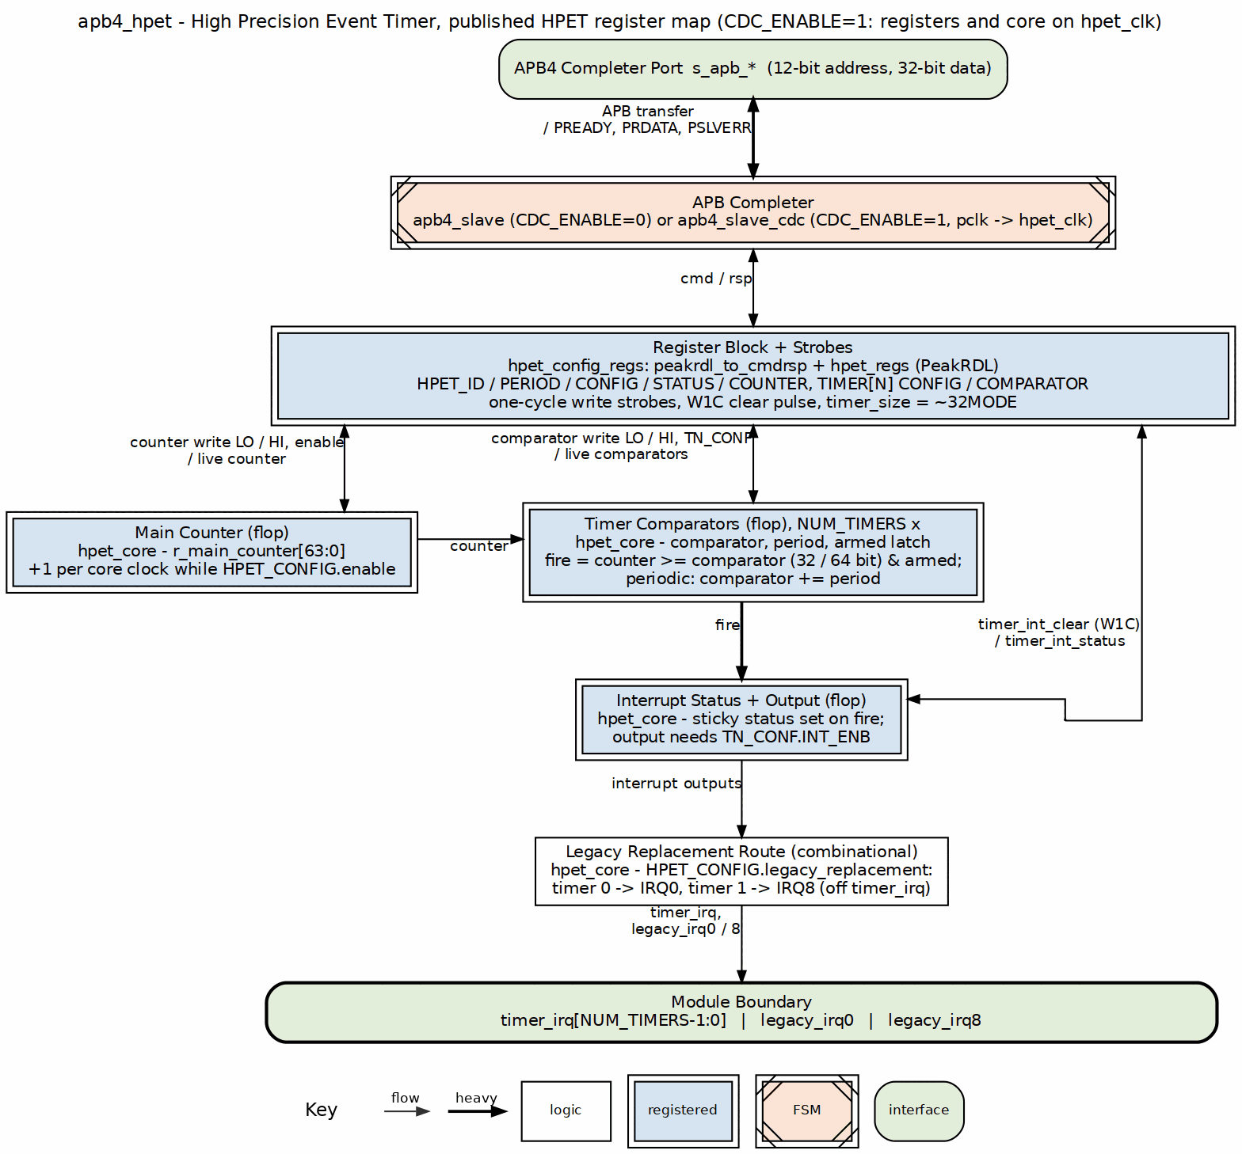
APB HPET Block Diagram

2.1.3 Key Features
- Multiple Independent Timers: 2, 3, or 8 configurable hardware timers per instance
- 64-bit Main Counter: High-resolution timestamp with configurable clock source
- 64-bit Comparators: Long-duration timing support (up to 2^64-1 clock cycles)
- Dual Operating Modes:
  - One-shot: Timer fires once when counter reaches comparator value
  - Periodic: Timer auto-reloads and fires repeatedly at fixed intervals
- Dynamic Mode Switching: Switch between one-shot and periodic modes without reset
- APB Interface: Standard AMBA APB4 compliant register interface
- Clock Domain Crossing: Optional CDC support for independent APB and timer clocks
- PeakRDL Integration: Register map generated from SystemRDL specification
- Per-Timer Write Data Buses: Dedicated data paths prevent timer corruption
- Individual Interrupts: Separate interrupt output per timer with W1C status clearing

2.1.4 Applications
Real-Time Operating Systems: - System tick generation for RTOS schedulers - Watchdog timer implementation - Task deadline enforcement - Periodic interrupt generation
Performance Profiling: - High-resolution timestamp source - Code execution timing - Cache miss profiling - Inter-event timing measurement
Multi-Rate Timing: - Multiple simultaneous timing domains - Independent periodic tasks - Asynchronous event generation - Programmable pulse generation
Industrial Control: - PWM generation base timer - Motor control timing - Sensor sampling intervals - Control loop timing

2.2 Timing

2.2.1 Timing Accuracy
- Counter increment: Every HPET clock cycle (deterministic)
- Timer fire latency: 1 HPET clock cycle from counter match
- Interrupt assertion: Registered, one HPET clock after the fire event (timer_irq is a flop in hpet_core, gated by timer_int_enable sampled at fire time)

2.2.2 Register Access Latency
- No CDC: 2 APB clock cycles (APB protocol minimum)
- With CDC: 4-6 APB clock cycles (handshake synchronization overhead)

2.3 Design Notes

2.3.1 Design Philosophy
Every block makes trade-offs; here’s where this one landed.
Configurability: The HPET component prioritizes configurability to support diverse use cases. Timer count and CDC enablement are parameterizable at synthesis time, so you can tailor an instance for your application without touching the RTL. (The VENDOR_ID/REVISION_ID parameters reach HPET_ID through the register block’s hardware interface. vendor_id is the published spec’s full 16 bits at GCAP_ID[31:16], so a PCI-style value such as 0x4747 reads back complete; rev_id is 8 bits at GCAP_ID[7:0]. See Chapter 5.)
Reliability: Extensive testing (5/6 configurations at 100% pass rate) validates core functionality. The design includes per-timer data buses to prevent corruption. (Note: the register block never raises PSLVERR – unmapped addresses alias or read 0.)
Standards Compliance: - APB Protocol: Full AMBA APB4 specification compliance - PeakRDL: Industry-standard SystemRDL for register generation - Reset Convention: Consistent active-low asynchronous reset (presetn)
Reusability: Clean module hierarchy and well-defined interfaces enable easy integration. Optional CDC support allows flexible clock domain configuration without design changes.

2.3.2 Comparison with IA-PC HPET
The APB HPET draws architectural inspiration from the IA-PC HPET specification but is not a drop-in replacement. Key differences:
Feature | IA-PC HPET | APB HPET
Interface | Memory-mapped | AMBA APB4
Timer Count | Up to 256 | 2, 3, or 8 (configurable)
FSB Delivery | Supported | Not supported
Legacy Replacement | PIT/RTC emulation | Supported: timer 0 -> IRQ0, timer 1 -> IRQ8 (leg_rt_cap = 1)
Counter Size | 64-bit mandatory | 64-bit
Comparator Size | 64-bit or 32-bit | 64-bit or 32-bit (per-timer timer_size)
Clock Source | 10 MHz minimum | User-configurable
Vendor ID | 16-bit, read from capability | 16-bit at GCAP_ID[31:16], from the VENDOR_ID parameter
Retained Concepts: - 64-bit free-running counter - One-shot and periodic timer modes - Write-1-to-clear interrupt status - Capability register for hardware discovery
Removed Features: - FSB interrupt delivery (use dedicated IRQ signals) - Legacy PIT/RTC replacement (not needed in modern designs) - Main counter period configuration (use clock divider instead)

2.3.3 Resource Utilization (Post-Synthesis Estimates)
- 2-timer (no CDC): ~500 LUTs, ~300 flip-flops
- 3-timer (no CDC): ~650 LUTs, ~400 flip-flops
- 8-timer (with CDC): ~1200 LUTs, ~800 flip-flops

2.3.4 Scalability
The design scales linearly with timer count. Each additional timer adds approximately: - 150 LUTs (comparator, control logic, interrupt generation) - 100 flip-flops (timer state, configuration registers) - Minimal timing impact (no critical path through timer array)

2.3.5 Development Status
Status: RTL Functional - the issue #46 register-side defects were fixed on 2026-09-08; see the index
Completed Features: - One-shot timer mode - Periodic timer mode - Timer mode switching - 64-bit counter read/write - 64-bit comparators - Multiple independent timers - Clock domain crossing (optional) - PeakRDL register generation - Per-timer write data buses (corruption fix) - Comprehensive test suite (3-level hierarchy) - Live comparator readback – reads return hpet_core’s working comparator, including the periodic advance (RLB/hpet TASK-002) - Published-spec register interface: spec offsets (GEN_CONF 0x010, GINTR_STA 0x020, MAIN_CNT 0x0F0, timer N at 0x100+0x20N with the comparator at +0x08), GCAP_ID and TN_CONF field positions, a 16-bit vendor field, and HPET_PERIOD reporting the counter tick period in femtoseconds (RLB/hpet TASK-006)
Outstanding Items: - 8-timer stress test timeout (minor, likely test configuration)
Future Enhancements (Not Planned): - FSB interrupt delivery (use dedicated IRQ signals) - Legacy mode emulation (not needed in modern designs) - 64-bit atomic counter reads – NOT a shortfall and not planned: the counter is 64 bits behind a 32-bit APB, so two reads are structural, and a non-atomic read is the IA-PC HPET behaviour, and a deliberate design ruling here. Software uses the hi/lo/hi retry loop; see ch01_overview/03_clocks_and_reset.md

2.4 Related Modules
Related Documentation: - ../../PRD.md - Product Requirements Document - ../../CLAUDE.md - AI integration guide - vault/tracking/projects/components/legacy-ip/retro_legacy_blocks/hpet/ - HPET task tracking (vault/tracking/projects/components/legacy-ip/retro_legacy_blocks/ for cross-block) - ../IMPLEMENTATION_STATUS.md - Test results and validation status

2.5 Testing

2.5.1 Verification Status
Test Coverage: 5 of 6 configurations achieve 100% test pass rate
Configuration | Basic | Medium | Full | Overall
2-timer v4747 (no CDC) | 4/4 | 5/5 | 3/3 | 12/12
3-timer AMD-like (no CDC) | 4/4 | 5/5 | 3/3 | 12/12
8-timer custom (no CDC) | 4/4 | 5/5 | 2/3 (known issue) | 11/12 (known issue)
2-timer v4747 (CDC) | 4/4 | 5/5 | 3/3 | 12/12
3-timer AMD-like (CDC) | 4/4 | 5/5 | 3/3 | 12/12
8-timer custom (CDC) | 4/4 | 5/5 | 3/3 | 12/12
Known Issue: 8-timer non-CDC “All Timers Stress” test has timeout issue (minor, likely test configuration)
Test Levels: - Basic (4 tests): Register access, enable/disable, counter operation, interrupt generation - Medium (5 tests): Periodic mode, multiple timers, 64-bit features, mode switching - Full (3 tests): All timers stress, CDC validation, edge case coverage
See: IMPLEMENTATION_STATUS.md for complete test results

2.6 Navigation
This specification document is organized as follows:
- Chapter 1 (this chapter): Overview, features, applications
- Chapter 2: Detailed block specifications (hpet_core, config_regs, PeakRDL integration)
- Chapter 3: Interface specifications (planned, not yet written)
- Chapter 4: Programming model (planned, not yet written)
- Chapter 5: Register definitions (address map, field descriptions)
Next: Chapter 1.2 - Architecture

RTL Design Sherpa · Learning Hardware Design Through Practice GitHub · Documentation Index · MIT License

3 APB HPET Architecture

3.1 Overview
Three blocks do the work: an APB slave (with or without CDC), a register wrapper that adapts the PeakRDL register file to the core, and the timer core itself. Figure 1.1 in the overview shows how they fit together.

3.1.1 High-Level Block Diagram
The whole unit is Figure 1.1 (APB HPET Block Diagram). Read top to bottom:
- APB slave. apb4_slave, or apb4_slave_cdc when CDC_ENABLE = 1, turns APB transfers into the cmd/rsp handshake. With CDC the crossing is inside this block (Figure 1.3); there is no separate CDC stage after it.
- Register wrapper. hpet_config_regs adapts cmd/rsp to the PeakRDL hpet_regs file through peakrdl_to_cmdrsp, and turns register writes into the one-cycle strobes and per-timer configuration the core consumes.
- Timer core. hpet_core holds the 64-bit main counter and, per timer, the comparator, the period and the fire logic. Its outputs are timer_irq[NUM_TIMERS-1:0] and, for the LegacyReplacement Route, legacy_irq0 and legacy_irq8.

3.1.2 Module Hierarchy
apb4_hpet (Top Level)
+-- apb4_slave (OR apb4_slave_cdc if CDC_ENABLE=1)
| +-- APB protocol handling
| +-- Read/write transaction management
| +-- Optional clock domain crossing
|
+-- hpet_config_regs (Register Wrapper)
| +-- hpet_regs (PeakRDL Generated)
| | +-- HPET_CONFIG register
| | +-- HPET_STATUS register (W1C)
| | +-- HPET_COUNTER_LO/HI registers
| | +-- HPET_ID register (RO, capabilities/identification)
| | +-- TIMER[i]_* registers (per-timer)
| |
| +-- Write-strobe alignment (swmod rising edge, one per 32-bit half)
| +-- HPET_STATUS W1C decode (per-bit clear mask from the write)
| +-- Per-timer data bus routing (corruption prevention)
|
+-- hpet_core (Timer Logic)
+-- 64-bit main counter (r_main_counter)
+-- Timer array [NUM_TIMERS-1:0]
| +-- 64-bit comparator (r_timer_comparator[i])
| +-- 64-bit period storage (r_timer_period[i])
| +-- Timer control FSM (one-shot vs periodic)
| +-- Armed latch and fire pulse (r_timer_armed[i])
| +-- Next-epoch hold bit (r_comp_next_epoch[i])
+-- Counter increment logic
+-- Comparator match detection
+-- Interrupt generation

3.2 Parameters

3.2.1 Compile-Time Parameters
Parameter | Type | Default | Range | Description
NUM_TIMERS | int | 2 | 2, 3, 8 | Number of independent timers
VENDOR_ID | int | 1 | 0-65535 | Drives HPET_ID[31:16] – GCAP_ID’s full 16-bit vendor field, so 0x4747 reads back complete
REVISION_ID | int | 1 | 0-255 | Drives HPET_ID[7:0] – GCAP_ID’s revision field
COUNTER_CLK_PERIOD_FS | int | 10000000 | non-zero, <= 0x05F5E100 | Femtoseconds per main-counter tick, published at HPET_PERIOD (0x004). MUST match the clock the counter ticks on: CDC_ENABLE[0] ? hpet_clk : pclk
CDC_ENABLE | int | 0 | 0, 1 | Enable clock domain crossing
USE_JOHNSON | int | 0 | 0, 1 | CDC FIFO pointer encoding (0 = Gray, 1 = Johnson)
The APB address bus is fixed at 12 bits and the data bus at 32 bits; they are not parameters.
Address-map constants (values from the generated decode in hpet_regs.sv – there are no such localparams in the RTL):
- Timer stride: 0x20 bytes per timer
- Timer register base: 0x100

3.3 Ports

3.3.1 Interface Summary
APB Interface: Standard AMBA APB4 - Address width: Fixed 12-bit (4KB space) - Data width: Fixed 32-bit - Protocol: APB4 (with PREADY support)
HPET Clock Interface: Separate timer clock domain - Independent from APB clock (if CDC enabled) - Free-running 64-bit counter - Configurable clock frequency
Interrupt Interface: Per-timer dedicated outputs - timer_irq[NUM_TIMERS-1:0] - Active-high interrupt signals - Registered output from core state (one hpet_clk after fire) - W1C clearing via HPET_STATUS register
See: Chapter 3 - Interface Specifications for detailed signal descriptions

3.4 Functional Description

3.4.1 Data Flow

3.4.1.1 Write Transaction Flow (APB -> HPET Core)
A write walks Figure 1.1 top to bottom:
- APB master issues the write.
- APB slave (apb4_slave, or apb4_slave_cdc) handles the protocol and, with CDC_ENABLE = 1, carries the command across to hpet_clk (Figure 1.3).
- hpet_regs (PeakRDL) decodes the register, updates the field, and raises the software-access flags (swacc, swmod).
- hpet_config_regs:
  - detects the rising edge of each swmod level, aligned to the written value;
  - generates the per-half write strobes (counter_write_lo/hi, timer_comp_write_lo/hi[i]);
  - decodes an HPET_STATUS write into a per-bit clear mask;
  - routes the per-timer data buses.
- hpet_core:
  - loads one counter half (HPET_COUNTER_LO or _HI write);
  - loads one comparator half, re-arming only if the counter is halted (TIMER_COMPARATOR write);
  - updates control (TIMER_CONFIG write);
  - clears the status bits written with 1 (HPET_STATUS write).

3.4.1.2 Read Transaction Flow (HPET Core -> APB)
A read walks the same path and returns:
- APB master issues the read.
- APB slave handles the protocol; with CDC the response crosses back to pclk.
- hpet_regs (PeakRDL) decodes the address and multiplexes the read data from the hardware interface (hwif).
- hpet_config_regs connects the hpet_core signals to the hwif read ports.
- hpet_core provides the counter value, the timer configuration and the status flags.
- APB slave returns PRDATA to the master.

3.4.1.3 Timer Operation Flow
- Counter increment, every tick of the core clock: r_main_counter <= r_main_counter + 1.
- Comparator match detection, for each timer i: timer_match[i] = (r_main_counter >= r_timer_comparator[i]) && !r_comp_next_epoch[i], at the compare width. The hold bit forces the match off while the comparator sits in the counter’s next epoch.
- Timer fire logic. A match fires only while the timer is ARMED, and firing clears the armed latch. The latch sets when the match falls (or is held off by the epoch bit), when a comparator half is written on a STOPPED timer, or when a periodic catch-up step lands at or ahead of the counter.
  - One-shot mode: fire once on the armed match, then stay un-armed until the comparator is written with the counter halted, or the match falls (comparator written above the counter, or the counter written back).
  - Periodic mode: fire on the armed match and auto-increment the comparator, r_timer_comparator[i] <= r_timer_comparator[i] + r_timer_period[i]; the match drops, which re-arms the timer.
    - If the advanced comparator is still at or below the counter, keep advancing one boundary per cycle WITHOUT firing until it is at or ahead, then re-arm. Missed periods are skipped, never burst; at period 1 the step is to counter + 1.
    - If an advance carries out of the compare width, set the next-epoch hold bit: no fire and no catch-up until the counter wraps at that width, or software writes the comparator or the counter half the compare reads, or changes timer_size.
- Interrupt status update. r_interrupt_status[i] <= 1 in hpet_core, sticky until software clears it by W1C; HPET_STATUS[i] mirrors it.
- Interrupt output. timer_irq[i] is a flop in hpet_core, set one core clock after the fire when timer_int_enable[i] was set at fire time, and cleared by the same W1C that clears the status. It is core state, not a combinational copy of HPET_STATUS.

3.4.2 Clock Domains
CDC_ENABLE selects one of two clockings at build time. In both, the register block and the timer core share a single clock and reset; only the APB front-end changes.
Synchronous mode (CDC_ENABLE = 0). The front-end is the plain apb4_slave, and the register block and core run on pclk / presetn. hpet_clk and hpet_resetn are not connected to anything, so the main counter ticks on pclk and HPET_PERIOD must state pclk’s period.

3.4.3 Figure 1.2: Clocking with CDC_ENABLE = 0
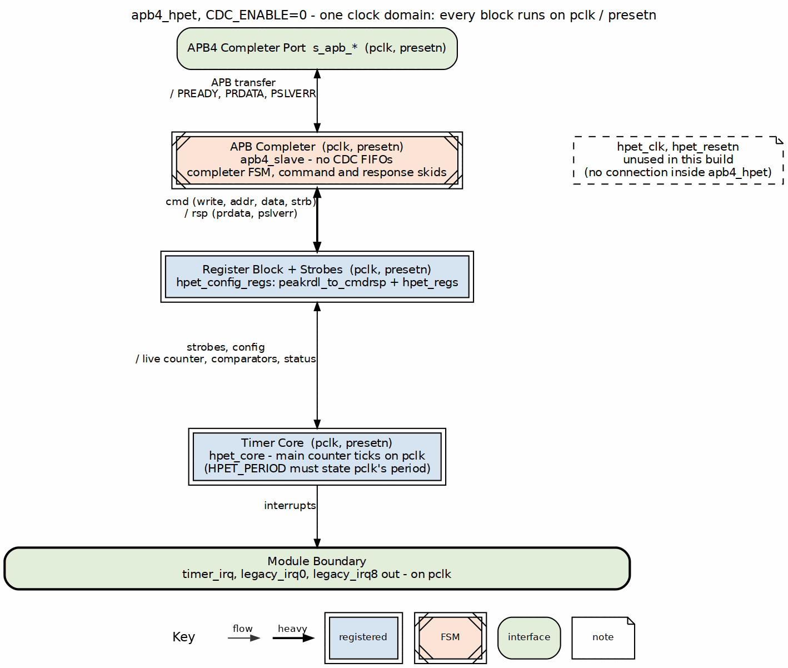
Clocking with CDC_ENABLE = 0
Asynchronous mode (CDC_ENABLE = 1). The front-end is apb4_slave_cdc: the APB completer stays on pclk, and the command and response cross through a pair of asynchronous FIFOs. The register block, core and interrupt outputs run on hpet_clk / hpet_resetn; the interrupts are not synchronized back to pclk.

3.4.4 Figure 1.3: Clocking with CDC_ENABLE = 1
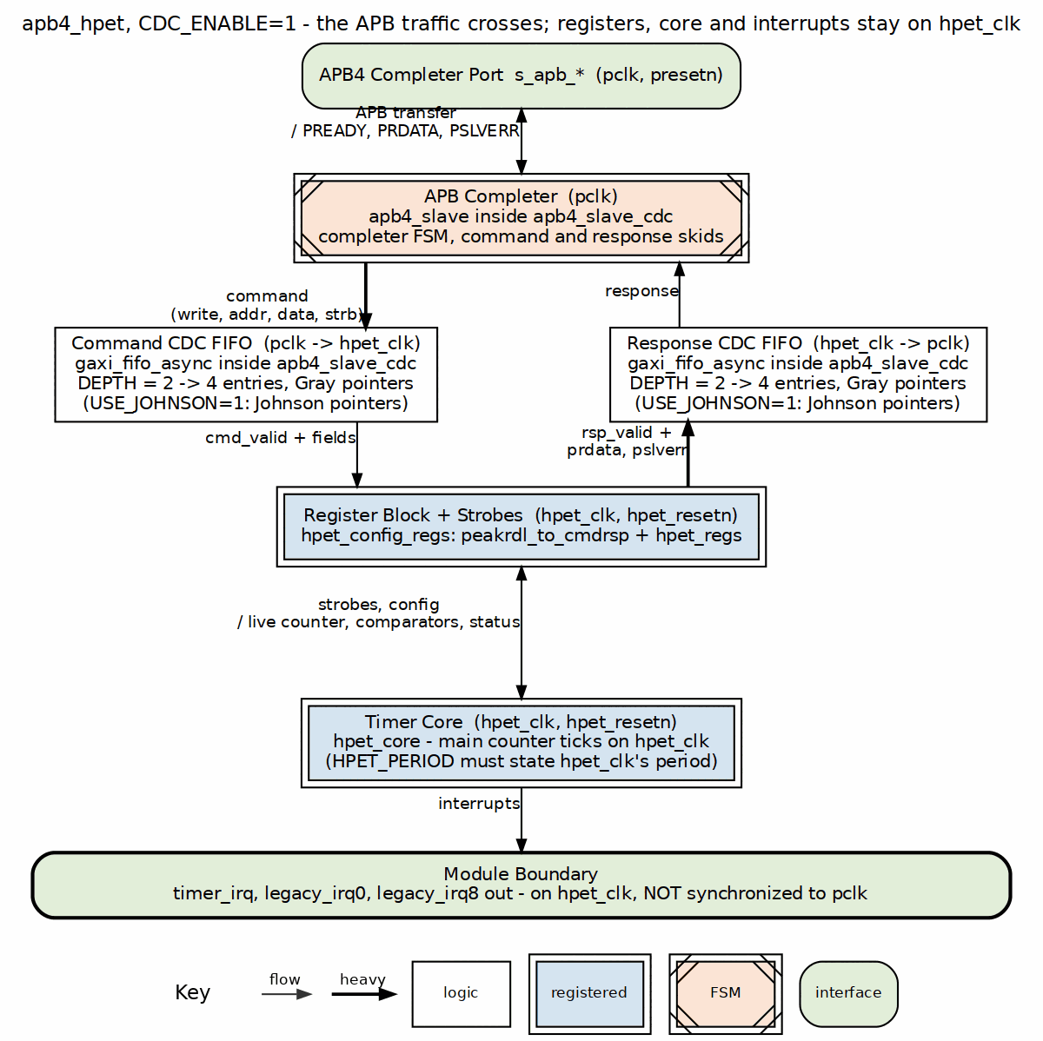
Clocking with CDC_ENABLE = 1

3.4.5 Reset Domains
Reset Signals: - presetn - APB reset (active-low, asynchronous) - hpet_resetn - HPET reset (active-low, asynchronous)
Reset Behavior:
The register file and the timer core always share ONE clock/reset domain, selected by CDC_ENABLE: with CDC_ENABLE=0 both run on pclk/presetn; with CDC_ENABLE=1 both run on hpet_clk/hpet_resetn and only the APB front-end stays on pclk. There is no configuration in which the registers and the core reset from different domains.
Signal | Reset Value | Notes
r_main_counter | 64’h0 | Counter reset to zero
r_timer_comparator[i] | 64’h0 | Comparators reset to zero
r_timer_period[i] | 64’h0 | Period storage reset
HPET_CONFIG | 32’h0 | Global enable cleared
HPET_STATUS | 8’h0 | Mirror of the core’s r_interrupt_status, which also resets to 0
TIMER[i]_CONFIG | 32’h0 | All timers disabled
Reset Sequence:
// Illustrative only. clk/rst_n are the selected domain:
// CDC_ENABLE=0 -> pclk/presetn; CDC_ENABLE=1 -> hpet_clk/hpet_resetn.
always_ff @(posedge clk or negedge rst_n) begin
if (!rst_n) begin
// Register file
HPET_CONFIG <= '0;
HPET_STATUS <= '0; // mirror field; the state lives in the core
for (int i = 0; i < NUM_TIMERS; i++) begin
TIMER_CONFIG[i] <= '0;
end
// Timer core
r_main_counter <= 64'h0;
for (int i = 0; i < NUM_TIMERS; i++) begin
r_timer_comparator[i] <= 64'h0;
r_timer_period[i] <= 64'h0;
r_timer_armed[i] <= 1'b1; // counter == comparator == 0 already matches
r_interrupt_status[i] <= 1'b0;
end
end
end
CDC Reset Coordination: When CDC is enabled, both reset signals must be properly synchronized and coordinated to prevent metastability and ensure clean initialization.

3.5 Usage Example

3.5.1 Configuration Examples
2-Timer Configuration (synchronous clocks):
apb4_hpet #(
.NUM_TIMERS(2),
.CDC_ENABLE(0)
) u_hpet_2t (...);
8-Timer Configuration with CDC:
apb4_hpet #(
.NUM_TIMERS(8),
.CDC_ENABLE(1) // Asynchronous clocks
) u_hpet_8t (...);
VENDOR_ID/REVISION_ID reach HPET_ID through the register block’s hardware interface – the generated block is built once for the maximum configuration, so nothing about it is per-instance. vendor_id is the published spec’s full 16 bits at GCAP_ID[31:16] and rev_id is 8 bits at GCAP_ID[7:0], so a PCI-style VENDOR_ID(16'h4747) reads back complete (see Chapter 5). The same path carries COUNTER_CLK_PERIOD_FS to HPET_PERIOD, which is GCAP_ID[63:32].

3.6 Design Notes

3.6.1 Per-Timer Data Bus Architecture
Problem: Initial implementation had timer corruption due to shared data bus
Root Cause:
// WRONG: Shared data bus for all timers
wire [63:0] timer_comp_wdata; // Single 64-bit bus
// Multiple timers try to sample from same bus
always_ff @(posedge hpet_clk) begin
if (timer_comp_write[0]) r_timer_comparator[0] <= timer_comp_wdata;
if (timer_comp_write[1]) r_timer_comparator[1] <= timer_comp_wdata;
if (timer_comp_write[2]) r_timer_comparator[2] <= timer_comp_wdata;
// If write strobes overlap, wrong timer gets wrong data!
end
Solution: Per-timer dedicated data buses
// CORRECT: Dedicated data bus per timer
wire [63:0] timer_comp_wdata [NUM_TIMERS-1:0]; // Array of 64-bit buses
// Each timer has dedicated data path
always_ff @(posedge hpet_clk) begin
if (timer_comp_write[0]) r_timer_comparator[0] <= timer_comp_wdata[0];
if (timer_comp_write[1]) r_timer_comparator[1] <= timer_comp_wdata[1];
if (timer_comp_write[2]) r_timer_comparator[2] <= timer_comp_wdata[2];
// Each timer reads from its own dedicated bus - no corruption possible
end
Implementation in hpet_config_regs.sv:
// Dedicated data buses prevent corruption
assign timer_comp_wdata[0] = {hwif.timer0_comparator_hi.value,
hwif.timer0_comparator_lo.value};
assign timer_comp_wdata[1] = {hwif.timer1_comparator_hi.value,
hwif.timer1_comparator_lo.value};
assign timer_comp_wdata[2] = {hwif.timer2_comparator_hi.value,
hwif.timer2_comparator_lo.value};
// ... one data bus per timer
Verification: All timer corruption issues resolved after per-timer bus implementation

3.7 Navigation
Next: Chapter 1.3 - Clocks and Reset

RTL Design Sherpa · Learning Hardware Design Through Practice GitHub · Documentation Index · MIT License

4 APB HPET Clocks and Reset

4.1 Overview
The APB HPET operates in one or two clock domains depending on CDC configuration. Pick the mode that matches your system; the trade is latency versus clock freedom.

4.1.1 Single Clock Domain (CDC_ENABLE = 0)
Configuration: - pclk = hpet_clk (same physical clock) - No clock domain crossing required - Lower latency (2 APB clock cycles for register access) - Simpler timing analysis
Use Cases: - System where APB and timer clocks are guaranteed synchronous - Resource-constrained designs (CDC overhead not needed) - Minimal latency requirements

4.1.2 Dual Clock Domains (CDC_ENABLE = 1)
Configuration: - pclk and hpet_clk are independent, asynchronous clocks - CDC synchronization required - Higher latency (4-6 APB clock cycles for register access) - More complex timing analysis
Use Cases: - System where APB runs at different frequency than timer clock - HPET clock derived from external crystal/oscillator - Power management scenarios (clock gating one domain)

4.2 Functional Description

4.2.1 Clock Specifications

4.2.1.1 APB Clock (pclk)
Purpose: APB interface protocol clock
Constraints: - Frequency: Typically 10-200 MHz (application-dependent) - Duty cycle: 50% ±10% - Jitter: < 5% of period - No specific minimum/maximum frequency enforced in RTL
Driven Blocks: - APB slave (or the pclk side of the APB CDC wrapper) - PeakRDL register file and register configuration logic ONLY when CDC_ENABLE=0 (with CDC_ENABLE=1 they run on hpet_clk)

4.2.1.2 HPET Clock (hpet_clk)
Purpose: Timer counter increment and comparator evaluation
Constraints: - Frequency: User-configurable (typically 1-100 MHz) - Duty cycle: 50% ±10% - Jitter: < 2% of period (affects timer accuracy) - Must be stable and continuous when HPET enabled
Driven Blocks: - Main counter increment - Comparator match detection - Timer control FSMs - Interrupt generation logic
Timer Accuracy: Directly proportional to hpet_clk frequency and stability - 10 MHz -> 100ns resolution - 1 MHz -> 1µs resolution - 1 kHz -> 1ms resolution

4.2.2 Reset Domains

4.2.2.1 APB Reset (presetn)
Type: Asynchronous active-low reset
Scope: The APB front-end always; with CDC_ENABLE=0 also the register file and timer core (everything runs on pclk in that mode)
Reset Behavior (illustrative; with CDC_ENABLE=1 the register file resets from hpet_clk/hpet_resetn instead):
always_ff @(posedge pclk or negedge presetn) begin
if (!presetn) begin
// Global configuration
HPET_CONFIG <= 32'h0; // HPET disabled
HPET_STATUS <= 32'h0; // mirror of the core's status (also reset there)
// Per-timer configuration
for (int i = 0; i < NUM_TIMERS; i++) begin
TIMER_CONFIG[i] <= 32'h0; // writable bits; reads 0x30 (RO size_cap/per_int_cap = 1)
end
end
end
Reset Values:
Register | Reset Value | Description
HPET_CONFIG | 32’h0 | Global disable, no legacy mapping
HPET_STATUS | 32’h0 | Mirror of the core’s r_interrupt_status; both reset to 0
HPET_COUNTER_LO | 32’h0 | Read/write; reads return the live counter
HPET_COUNTER_HI | 32’h0 | Read/write; reads return the live counter
HPET_ID | Constant | RO GCAP_ID[31:0]: vendor_id = VENDOR_ID (16 bits, [31:16]), rev_id = REVISION_ID ([7:0]), num_tim_cap = NUM_TIMERS-1 ([12:8]), count_size_cap = 1 ([13]), leg_rt_cap = 1 ([15])
HPET_PERIOD | Constant | RO GCAP_ID[63:32]: femtoseconds per counter tick, from COUNTER_CLK_PERIOD_FS
TIMER[i]_CONFIG | 32’h30 | Interrupt disabled, one-shot, 64-bit; the RO per_int_cap [4] and size_cap [5] read 1
TIMER[i]_COMPARATOR_LO | 32’h0 | Read/write; reads return the live comparator (includes the periodic advance)
TIMER[i]_COMPARATOR_HI | 32’h0 | Read/write; reads return the live comparator (includes the periodic advance)

4.2.2.2 HPET Reset (hpet_resetn)
Type: Asynchronous active-low reset
Scope: With CDC_ENABLE=1, the register file and timer core (both run on hpet_clk in that mode). With CDC_ENABLE=0 this reset is unused by the core logic, which runs on pclk/presetn.
Reset Behavior:
always_ff @(posedge hpet_clk or negedge hpet_resetn) begin
if (!hpet_resetn) begin
// Main counter
r_main_counter <= 64'h0;
// Per-timer state
for (int i = 0; i < NUM_TIMERS; i++) begin
r_timer_comparator[i] <= 64'h0;
r_timer_period[i] <= 64'h0;
r_timer_armed[i] <= 1'b1;
r_comp_next_epoch[i] <= 1'b0;
r_interrupt_status[i] <= 1'b0;
end
end
end
Reset Values:
Signal | Reset Value | Description
r_main_counter | 64’h0 | Counter starts at zero
r_timer_comparator[i] | 64’h0 | Comparators cleared
r_timer_period[i] | 64’h0 | Period storage cleared
r_timer_armed[i] | 1’b1 | Armed: counter == comparator == 0 is already a match, and the enables gate it until software is ready
r_comp_next_epoch[i] | 1’b0 | Next-epoch hold clear: the comparator is in the counter’s current epoch, so the match is not held off
r_interrupt_status[i] | 1’b0 | Interrupt status cleared

4.2.3 Clock Domain Crossing Details

4.2.3.1 CDC Synchronization
When CDC_ENABLE = 1, the apb4_slave_cdc module handles all clock domain crossing:
Write Path (pclk -> hpet_clk):
1. APB write on pclk
2. Command written to APB-side holding registers
3. Command crosses to the hpet_clk domain through the async command FIFO
(gaxi_fifo_async inside apb4_slave_cdc)
4. hpet_clk-side logic applies write to timer registers
5. Response crosses back through the async response FIFO
6. APB PREADY asserted (transaction complete)
Latency: 4-6 pclk cycles
Read Path (hpet_clk -> pclk):
1. APB read on pclk
2. Read request synchronized to hpet_clk
3. hpet_clk-side logic captures register data
4. Data synchronized back to pclk domain
5. APB PRDATA driven
6. APB PREADY asserted (transaction complete)
Latency: 4-6 pclk cycles
Metastability Protection: - The crossing is a pair of async FIFOs (Gray/Johnson-coded pointers); only the FIFO pointers are synchronized – data words never cross combinationally - No toggle handshake exists; ordering and stability come from the FIFO

4.2.4 Counter Read Atomicity
Problem: 64-bit counter spans two 32-bit APB registers
Non-Atomic Read Sequence:
1. Read HPET_COUNTER_LO -> captures lower 32 bits
2. Counter increments (may overflow from 0xFFFFFFFF to 0x00000000)
3. Read HPET_COUNTER_HI -> captures upper 32 bits (now incremented!)
4. Result: Lower 32 bits from time T, upper 32 bits from time T+1
Software Workaround (Overflow Detection):
uint64_t read_hpet_counter(void) {
uint32_t hi1, hi2, lo;
do {
hi1 = read_reg(HPET_COUNTER_HI);
lo = read_reg(HPET_COUNTER_LO);
hi2 = read_reg(HPET_COUNTER_HI);
} while (hi1 != hi2); // Retry if overflow detected
return ((uint64_t)hi2 << 32) | lo;
}
Note: A hardware atomic read is deliberately NOT implemented. Two reads are structural for a 64-bit counter on a 32-bit APB, and the retry loop above is the IA-PC HPET software contract – latching the counter on a LO read would depart from a real HPET rather than improve on it. (RLB/hpet TASK-004, dropped 2026-09-27.)

4.2.5 Clock Gating Considerations
APB Clock Gating: - Safe to gate pclk when no APB transactions pending - Must ensure APB master deasserts PSEL before gating - Gating has no effect on HPET timer operation (hpet_clk independent)
HPET Clock Gating: - DO NOT gate hpet_clk while HPET enabled (HPET_CONFIG[0] = 1) - Counter will stop incrementing -> timers will not fire - Safe to gate only when HPET_CONFIG[0] = 0 (disabled state)
Power Saving Strategy:
1. Disable HPET: Write HPET_CONFIG[0] = 0
2. Wait for any pending timer operations to complete
3. Gate hpet_clk
4. APB registers remain accessible (pclk still running)
5. To resume: Ungate hpet_clk, then write HPET_CONFIG[0] = 1
Re-enabling does not re-fire expired timers. The fire pulse is a raw counter >= comparator match qualified by a per-timer armed latch that clears when the timer fires and sets again only when the match falls (or is held off by the next-epoch bit), when a comparator half is written with the counter halted, or when a periodic catch-up step lands at or ahead of the counter. A one-shot that completed before step 1 is still un-armed when step 5 runs, so the 0->1 of HPET_CONFIG[0] (or of a timer’s own enable) while counter >= comparator produces nothing. The one case that does fire on enable is the intended one: a timer whose comparator was written while everything was disabled – even to a value the counter has already passed – is armed, and fires once as soon as both enables are on. A periodic timer left behind by a counter write during the halt catches up silently at step 5: one fire at the next boundary still ahead, the missed periods skipped rather than burst. The silence has a length. A catch-up advances the comparator once per cycle and closes the deficit by period - 1 counts each time (period 1 jumps to counter + 1 in one), so it costs cycles in proportion to the deficit – a period-2 timer left 2^52 counts behind catches up for ~2^52 cycles with no interrupt. That bound is a contract, not a defect, and it is why the HPET specification and this book require the counter halted (HPET_CONFIG[0] = 0) before it is written – a torn or stale half on a running counter is exactly how a 2^52 deficit appears – and a periodic comparator programmed near or ahead of the counter.

4.3 Timing

4.3.1 Reset Coordination

4.3.1.1 Synchronous Mode (CDC_ENABLE = 0)
Requirement: presetn and hpet_resetn should be asserted/deasserted together
Recommended Connection:
assign hpet_resetn = presetn; // Same reset for both domains
Reset Sequence:
1. Assert presetn = 0 (also asserts hpet_resetn = 0)
2. Hold for >= 10 clock cycles
3. Deassert presetn = 1 (also deasserts hpet_resetn = 1)
4. Wait >= 5 clock cycles before first register access

4.3.1.2 Asynchronous Mode (CDC_ENABLE = 1)
Requirement: Both resets can be independent but must overlap during power-on
Recommended Sequence:
1. Assert both presetn = 0 and hpet_resetn = 0
2. Hold presetn for >= 10 pclk cycles
3. Hold hpet_resetn for >= 10 hpet_clk cycles
4. Deassert resets (order not critical, but both must be stable)
5. Wait for CDC handshake to stabilize (>= 6 pclk cycles)
6. Begin register accesses

4.3.2 Figure 1.4: Reset Sequence with CDC_ENABLE = 1
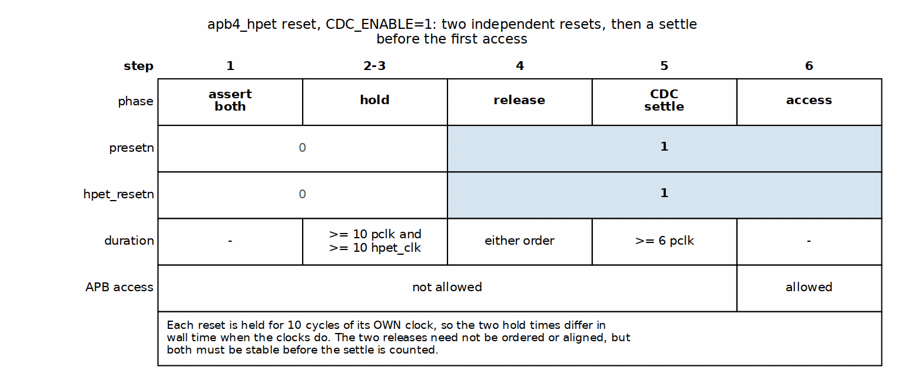
Reset Sequence with CDC_ENABLE = 1

4.3.3 Timing Constraints

4.3.3.1 Setup/Hold Requirements
APB Interface (Synchronous):
Setup time: 2ns typical (technology-dependent)
Hold time: 1ns typical (technology-dependent)
HPET Clock (Asynchronous with CDC):
No setup/hold requirements between pclk and hpet_clk
CDC synchronizers handle all timing

4.3.3.2 Maximum Operating Frequencies
Technology-Dependent Estimates (Post-Synthesis): - APB clock: 200+ MHz (typical modern process) - HPET clock: 100+ MHz (limited by counter/comparator logic) - Clock domain crossing: Synchronizers support arbitrary frequency ratios
Recommended Operating Points: - APB clock: 10-100 MHz (typical SoC bus speeds) - HPET clock: 1-50 MHz (sufficient for most timing applications)

4.4 Navigation
Next: Chapter 1.4 - Acronyms and Terminology

RTL Design Sherpa · Learning Hardware Design Through Practice GitHub · Documentation Index · MIT License

5 APB HPET Acronyms and Terminology

5.1 Overview
The vocabulary used across this MAS, collected in one place so the rest of the chapters can stay terse.
Acronym | Full Term | Description
AMBA | Advanced Microcontroller Bus Architecture | ARM’s on-chip interconnect specification
APB | Advanced Peripheral Bus | AMBA low-complexity peripheral bus protocol
CDC | Clock Domain Crossing | Synchronization between asynchronous clock domains
FSB | Front Side Bus | Legacy PC architecture bus (not supported in APB HPET)
FSM | Finite State Machine | Sequential logic controller
HPET | High Precision Event Timer | Multi-timer peripheral for precise timing
IA-PC | Industry-standard PC architecture | PC platform specification (architectural reference)
IRQ | Interrupt Request | Hardware interrupt signal
PIT | Programmable Interval Timer | Legacy PC timer (8254-compatible)
RO | Read-Only | Register field cannot be written by software
RTC | Real-Time Clock | Calendar/time-of-day clock (not emulated by HPET)
RW | Read-Write | Register field can be read and written
SystemRDL | System Register Description Language | Industry-standard register specification language
W1C | Write-1-to-Clear | Register field cleared by writing 1, writing 0 has no effect
WO | Write-Only | Register field can only be written, reads return undefined

5.2 Functional Description

5.2.1 Terminology
64-bit Counter: The main free-running counter that increments on every HPET clock cycle. Provides high-resolution timestamp and comparison base for all timers.
Comparator: Per-timer 64-bit value that defines when a timer should fire. Timer fires when main counter value becomes greater than or equal to comparator value.
Fire / Fired: Event when a timer’s comparator matches the main counter value. In one-shot mode, timer fires once. In periodic mode, timer fires repeatedly.
One-Shot Mode: Timer operating mode where the timer fires once when the counter reaches the comparator value, then remains idle until reconfigured.
Periodic Mode: Timer operating mode where the timer fires repeatedly at fixed intervals. After each fire event, the comparator is automatically incremented by the period value.
Period: In periodic mode, the interval (in HPET clock cycles) between timer fires. Stored internally and used for auto-incrementing the comparator.
PeakRDL: Industry-standard toolchain for generating register files from SystemRDL specifications. Used to generate hpet_regs.sv from hpet_regs.rdl.
Per-Timer Data Bus: Dedicated 64-bit data path for each timer to prevent corruption when multiple timer registers are written in rapid succession.
Timer Corruption: Historical bug where shared data bus allowed one timer’s configuration to overwrite another timer’s configuration. Fixed by implementing per-timer dedicated data buses.
Write Strobe: Edge-detected pulse generated when software writes to a timer configuration register. Used to sample comparator and configuration data atomically.

5.2.2 Register Field Access Types
RO (Read-Only): - Software can read the field - Software writes are ignored - Hardware controls the value - Example: HPET_ID register
RW (Read-Write): - Software can read and write the field - Hardware may also update the value - Example: HPET_CONFIG[0] (enable bit)
WO (Write-Only): - Software can write the field - Software reads return undefined value - Hardware uses written value internally - Example: none in this block – HPET_COUNTER_LO/HI are RW with live readback; the HPET has no write-only registers
W1C (Write-1-to-Clear): - Software writes 1 to clear the bit - Software writes 0 have no effect - Hardware can set the bit - Example: HPET_STATUS interrupt flags

5.3 Design Notes

5.3.1 Signal Naming Conventions
APB Signals: All APB signals use standard AMBA naming with p prefix: - pclk - APB clock - presetn - APB reset (active-low) - paddr - APB address bus - psel - APB select - penable - APB enable - pwrite - APB write enable - pwdata - APB write data - pready - APB ready - prdata - APB read data - pslverr - APB slave error
HPET Domain Signals: Timer-related signals use descriptive names: - hpet_clk - HPET timer clock - hpet_resetn - HPET reset (active-low) - timer_irq[N] - Timer interrupt outputs - r_main_counter - Internal 64-bit counter - r_timer_comparator[i] - Per-timer comparator value - r_timer_period[i] - Per-timer period value
Prefix Conventions: - r_ - Registered (flip-flop) signal - w_ - Wire (combinational) signal - cfg_ - Configuration input - hwif_ - PeakRDL hardware interface signal

5.3.2 Common Abbreviations in Code
Abbreviation | Meaning | Example
cfg | Configuration | cfg_initial_credit
cmp | Comparator | timer_cmp_data
wr | Write | timer_comp_write_lo
rd | Read | counter_rd_data
hi | High (upper 32 bits) | HPET_COUNTER_HI
lo | Low (lower 32 bits) | HPET_COUNTER_LO
en | Enable | timer_en
irq | Interrupt Request | timer_irq
clr | Clear | status_clr

5.4 Navigation
Next: Chapter 1.5 - References

RTL Design Sherpa · Learning Hardware Design Through Practice GitHub · Documentation Index · MIT License

6 APB HPET References
Everything this MAS leaned on, plus the pointers you’ll want when you need to go deeper than the spec itself.

6.1 References

6.1.1 External Standards and Specifications
AMBA Protocol Specifications: - AMBA APB Protocol Specification v2.0 - Publisher: ARM Limited - Document ID: IHI 0024C - URL: https://developer.arm.com/documentation/ihi0024/latest - Relevance: APB interface protocol specification
SystemRDL: - SystemRDL 2.0 Specification - Publisher: Accellera Systems Initiative - URL: https://www.accellera.org/downloads/standards/systemrdl - Relevance: Register description language for hpet_regs.rdl
- PeakRDL Documentation
  - Project: PeakRDL Register Description Language Compiler
  - URL: https://peakrdl.readthedocs.io/
  - Relevance: SystemRDL to SystemVerilog compiler tool
Architectural Reference (Not Specification Compliant): - IA-PC HPET Specification 1.0a - Publisher: (see specification) - Date: October 2004 - Relevance: Architectural inspiration (APB HPET is NOT IA-PC HPET compliant) - Note: Used as reference for timer concepts only. APB HPET uses APB interface (not memory-mapped), different register layout, and does not support legacy modes or FSB delivery.

6.1.2 Internal Project Documentation
Component-Specific Documentation: - PRD.md - Product Requirements Document - Complete functional requirements - Parameter specifications - Verification status
- CLAUDE.md - AI Integration Guide
  - Component architecture overview
  - Known issues and workarounds
  - Test methodology
- RLB/hpet tasks - Development Task Tracking
  - Active work items
  - Completed milestones
  - Future enhancements
- IMPLEMENTATION_STATUS.md - Test Results
  - Detailed test results per configuration
  - Pass/fail statistics
  - Root cause analysis
RTL Source Files: - rtl/hpet/apb4_hpet.sv - Top-level wrapper module - rtl/hpet/hpet_core.sv - Core timer logic - rtl/hpet/hpet_config_regs.sv - Register wrapper - rtl/hpet/hpet_regs.sv - PeakRDL generated register file (from hpet_regs.rdl) - rtl/hpet/hpet_regs_pkg.sv - PeakRDL generated package
SystemRDL Specification: - rdl/hpet/hpet_regs.rdl - Register description - rdl/hpet/README.md - PeakRDL generation instructions
Testbench Files: - dv/tbclasses/hpet/hpet_tb.py - Main testbench class - dv/tbclasses/hpet/hpet_tests_basic.py - Basic test suite - dv/tbclasses/hpet/hpet_tests_medium.py - Medium test suite - dv/tbclasses/hpet/hpet_tests_full.py - Full test suite - dv/tests/test_apb4_hpet.py - Test runner with pytest integration
Known Issues Documentation: - known_issues/README.md - Issue tracking overview - Timer counter-cleanup fix details: see TASK-001 in RLB/hpet tasks (the old standalone known_issues/resolved/timer_cleanup_issue.md page was not carried over into retro_legacy_blocks)

6.1.3 Repository-Wide Documentation
Root Documentation: - /README.md - Repository overview and setup - /PRD.md - Master project requirements - /CLAUDE.md - Repository-wide AI guidance
Framework Documentation: - bin/TBClasses/ - In-repo shared testbench utilities (import as from TBClasses. ...; APB helpers under bin/TBClasses/apb/) - RTLDesignSherpa-DV repository - Full CocoTBFramework (components, BFMs, tbclasses), editable-installed into the venv
Verification Architecture: - docs/user-guides/VERIFICATION_ARCHITECTURE_GUIDE.md - Complete verification patterns - Three-layer architecture (TB + Scoreboard + Test) - Queue-based vs memory model verification - Mandatory testbench methods

6.1.4 Related RTL Components
APB Infrastructure: - rtl/amba/apb4/apb4_slave.sv - Standard APB slave - rtl/amba/apb4/apb4_slave_cdc.sv - APB slave with clock domain crossing - projects/components/utility-ip/converters/rtl/peakrdl_to_cmdrsp.sv - PeakRDL adapter
Clock Domain Crossing: - rtl/amba/cdc/cdc_4_phase_handshake.sv - CDC handshake synchronizer (renamed from cdc_handshake.sv) - rtl/amba/cdc/cdc_synchronizer.sv - Multi-stage bit synchronizer (replaces the old sync_2ff.sv) - rtl/cdc/sync_pulse.sv - Pulse synchronizer
Common Utilities: - Edge detection for write strobes is implemented inline in rtl/hpet/hpet_config_regs.sv (the old standalone rtl/common/edge_detect.sv module no longer exists) - rtl/common/counter_bin.sv - Binary counter (similar to HPET main counter)

6.1.5 Design Tools
Simulation: - Verilator 5.0+ - RTL simulator - CocoTB 1.9+ - Python testbench framework - pytest 7.0+ - Test runner and parametrization
Register Generation: - PeakRDL-regblock 0.17+ - SystemRDL to SystemVerilog compiler - PeakRDL 1.0+ - SystemRDL front-end
Waveform Viewing: - GTKWave - VCD waveform viewer - GTKW files available in dv/GTKW/ directory

6.1.6 Industry Best Practices References
RTL Coding: - Synthesis and Simulation Design Guide - Xilinx UG901 - Best practices for RTL coding style - Clock domain crossing guidelines - Reset strategies
- RTL Modeling with SystemVerilog for Simulation and Synthesis - Stuart Sutherland
  - SystemVerilog coding guidelines
  - Finite state machine design patterns
Verification: - Writing Testbenches using SystemVerilog - Janick Bergeron - Testbench architecture patterns - Functional coverage methodology
- Verification Methodology Manual for SystemVerilog - Janick Bergeron et al.
  - UVM-like verification patterns
  - Coverage-driven verification
AMBA Protocols: - AMBA Design Kit (ADK) - ARM - Reference implementations - Protocol checkers - Example testbenches

6.1.7 Version Control and Issue Tracking
Git Repository: - Main branch: Production-ready code - Feature branches: Active development - Commit history: Detailed change log
Issue Labels: - bug - Functional defects - enhancement - New features - documentation - Documentation updates - testing - Test infrastructure improvements

6.1.8 Related Projects
RTL Design Sherpa Components: - APB HPET (this component) - AMBA AXI4 Monitors (rtl/amba/) - RAPIDS DMA Engine (projects/components/dma-ip/rapids/) - Delta Network Arbiter (projects/components/fabric-gen-ip/delta/)
External Dependencies: - None - APB HPET is fully self-contained within RTL Design Sherpa

6.2 Navigation
Next: Chapter 2 - Blocks

RTL Design Sherpa · Learning Hardware Design Through Practice GitHub · Documentation Index · MIT License

7 APB HPET Blocks

7.1 Overview
The APB HPET component consists of four primary SystemVerilog modules organized in a hierarchical structure. This chapter walks through what each one owns and how they talk to each other.

7.1.1 Block Hierarchy
apb4_hpet (Top Level)
+-- APB Slave Interface
| +-- apb4_slave.sv (CDC_ENABLE=0) OR
| +-- apb4_slave_cdc.sv (CDC_ENABLE=1)
|
+-- hpet_config_regs (Register Wrapper)
| +-- hpet_regs (PeakRDL Generated)
| | +-- Register File Logic
| |
| +-- Mapping Logic
| +-- Per-Timer Data Buses
| +-- Write-Strobe Alignment (swmod rising edge, per half)
| +-- HPET_STATUS Mirror and W1C Decode
|
+-- hpet_core (Timer Logic)
+-- 64-bit Free-Running Counter
+-- Per-Timer Comparators [NUM_TIMERS]
+-- Armed Latch and Fire Pulse [NUM_TIMERS]
+-- Next-Epoch Hold Bit [NUM_TIMERS]
+-- Interrupt Generation [NUM_TIMERS]

7.2 Functional Description

7.2.1 Module Responsibilities

7.2.1.1 1. apb4_hpet (Top Level Integration)
File: rtl/hpet/apb4_hpet.sv Purpose: System integration and CDC selection
Responsibilities: - Instantiates APB slave with or without CDC based on CDC_ENABLE parameter - Routes signals between APB interface and configuration registers - Exposes timer interrupts to system - Provides unified external interface
Key Features: - Conditional CDC instantiation (generate block) - Clock domain management - Parameter propagation to child modules - Single-point configuration

7.2.1.2 2. hpet_config_regs (Register Wrapper)
File: rtl/hpet/hpet_config_regs.sv Purpose: Bridge between PeakRDL registers and HPET core
Responsibilities: - Instantiates PeakRDL-generated register file - Maps PeakRDL hardware interface to HPET core signals - Implements per-timer dedicated data buses (corruption fix) - Turns the register block’s swmod levels into aligned one-cycle write strobes, one per 32-bit half - Combines the LO/HI fields into 64-bit data buses - Mirrors the core’s interrupt status into HPET_STATUS and decodes the W1C write into a per-bit clear - Drives HPET_ID’s vendor, revision and timer-count fields from the parameters
Key Features: - Per-timer data buses prevent configuration corruption - Strobe-driven loads: a write is the event, not a change in the stored value, so rewriting the same comparator still reloads it (whether it also re-arms the timer is the core’s call: only while the counter is halted) - Per-bit W1C clear mask from the write data and byte enables - One clear pulse per write, so a same-cycle fire is never undone

7.2.1.3 3. hpet_regs (PeakRDL Generated)
File: rtl/hpet/hpet_regs.sv Purpose: Auto-generated register file from SystemRDL specification
Responsibilities: - Implements all HPET registers from RDL specification - Provides CPU interface (passthrough protocol) - Generates hardware interface structs - Handles field access types (RO, RW, W1C)
Key Features: - Single source of truth (hpet_regs.rdl) - Regeneratable from specification - Comprehensive field control - Standard passthrough CPU interface

7.2.1.4 4. hpet_core (Timer Logic)
File: rtl/hpet/hpet_core.sv Purpose: Core timer functionality and comparison logic
Responsibilities: - Implements 64-bit free-running counter - Manages per-timer comparators and periods - Detects counter match conditions - Generates timer fire events and interrupts - Handles one-shot vs periodic mode differences
Key Features: - Fully synchronous timer logic - Per-timer FSM (conceptual) - Automatic period reload (periodic mode) - Armed-latch fire detection: one fire per arm, no re-fire on enable, comparator writes re-arm only while the counter is halted - Periodic catch-up: missed periods are skipped, never burst (period 1 steps to counter + 1) - Next-epoch hold: an advance that carries out of the compare width is held off until the counter wraps at that width - Configurable timer count (2, 3, or 8 timers)

7.2.2 Data Flow Overview

7.2.2.1 APB Write Transaction Flow
APB Master
↓ PSEL, PENABLE, PADDR, PWDATA
APB Slave (or APB Slave CDC)
↓ cmd_valid, cmd_pwrite, cmd_paddr, cmd_pwdata
peakrdl_to_cmdrsp Adapter
↓ regblk_req, regblk_req_is_wr, regblk_addr, regblk_wr_data
hpet_regs (PeakRDL)
↓ hwif_out (register values)
hpet_config_regs (Mapping)
↓ timer_int_enable/type/size, timer_comp_write_lo/hi, timer_comp_wdata[i]
hpet_core (Timer Logic)
-> Counter/Comparator update

7.2.2.2 APB Read Transaction Flow
APB Master
↓ PSEL, PENABLE, PADDR, PWRITE=0
APB Slave (or APB Slave CDC)
↓ cmd_valid, cmd_pwrite=0, cmd_paddr
peakrdl_to_cmdrsp Adapter
↓ regblk_req, regblk_req_is_wr=0, regblk_addr
hpet_regs (PeakRDL)
← hwif_in (live counter, status)
↓ regblk_rd_data
peakrdl_to_cmdrsp Adapter
↓ rsp_prdata
APB Slave (or APB Slave CDC)
↓ PRDATA
APB Master

7.2.2.3 Timer Fire Flow
- hpet_core: the counter increments. A raw match (counter >= comparator) while the timer is armed fires it: timer_int_status[i] asserts (sticky, owned here) and the armed latch clears. timer_irq[i] asserts one clock later if int_enable was set at the fire.
- hpet_config_regs drives hwif_in.HPET_STATUS.timer_int_status.next from that live level every cycle.
- hpet_regs (PeakRDL): HPET_STATUS reads the mirrored level.
- Software reads HPET_STATUS, then writes 1 to bit i.
- hpet_config_regs pulses timer_int_clear[i] for ONE cycle. The mask is write data AND byte enables: bits written 0 are untouched, and a write of 0x0 clears nothing.
- hpet_core: timer_int_status[i] clears (a fire of the same bit in that cycle wins) and timer_irq[i] deasserts.

7.2.3 Clock Domain Organization

7.2.3.1 Synchronous Mode (CDC_ENABLE=0)
APB Clock Domain (pclk)
+-- apb4_slave
+-- hpet_config_regs
+-- hpet_regs
+-- hpet_core
All modules use pclk
No clock domain crossing required

7.2.3.2 Asynchronous Mode (CDC_ENABLE=1)
APB Clock Domain (pclk)
+-- apb4_slave_cdc (pclk side)
+-- [CDC boundary]
HPET Clock Domain (hpet_clk)
+-- apb4_slave_cdc (hpet_clk side)
+-- hpet_config_regs
+-- hpet_regs
+-- hpet_core
CDC synchronization between pclk and hpet_clk

7.2.4 Module Communication

7.2.4.1 hpet_config_regs -> hpet_core Interface
Control Signals (hpet_config_regs -> hpet_core):
output logic hpet_enable; // Global enable
output logic counter_write_lo; // Counter[31:0] write strobe
output logic counter_write_hi; // Counter[63:32] write strobe
output logic [63:0] counter_wdata; // Counter write data
output logic legacy_replacement; // HPET_CONFIG[1]
output logic [NUM_TIMERS-1:0] timer_int_enable; // TN_CONF[2]; gates the irq only (no per-timer run enable)
output logic [NUM_TIMERS-1:0] timer_type; // Per-timer mode (0=one-shot, 1=periodic)
output logic [NUM_TIMERS-1:0] timer_size; // ~TN_CONF[8] (32MODE): 0=32-bit, 1=64-bit
output logic [NUM_TIMERS-1:0] timer_comp_write_lo; // Per-timer comparator[31:0] write strobe
output logic [NUM_TIMERS-1:0] timer_comp_write_hi; // Per-timer comparator[63:32] write strobe
output logic [63:0] timer_comp_wdata[NUM_TIMERS]; // Per-timer data buses
Status Signals (hpet_core -> hpet_config_regs):
input logic [63:0] counter_rdata; // Live counter value
input logic [NUM_TIMERS-1:0] timer_int_status; // Per-timer fire status
Interrupt Clearing (hpet_config_regs -> hpet_core):
output logic [NUM_TIMERS-1:0] timer_int_clear; // Per-bit clear of the sticky status

7.2.4.2 hpet_config_regs -> hpet_regs Interface
Uses PeakRDL-generated structs:
// From config regs to PeakRDL
input hpet_regs_pkg::hpet_regs__in_t hwif_in;
// From PeakRDL to config regs
output hpet_regs_pkg::hpet_regs__out_t hwif_out;

7.3 Waveforms

7.3.1 Timer Operation Waveforms

7.3.1.1 Configuration Write
When software writes to HPET_CONFIG to start the counter, the enable signal propagates through the register file to the core.

7.3.2 Waveform 2.1: HPET Config Write
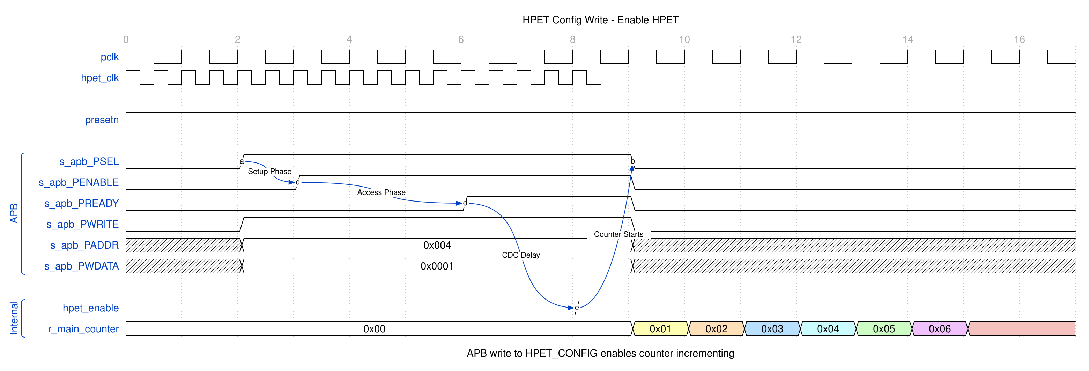
HPET Config Write
The APB write to address 0x010 (HPET_CONFIG) sets hpet_enable, which starts the main counter incrementing.

7.3.2.1 Counter Read
Reading the main counter returns the current 64-bit counter value.

7.3.3 Waveform 2.2: HPET Counter Read
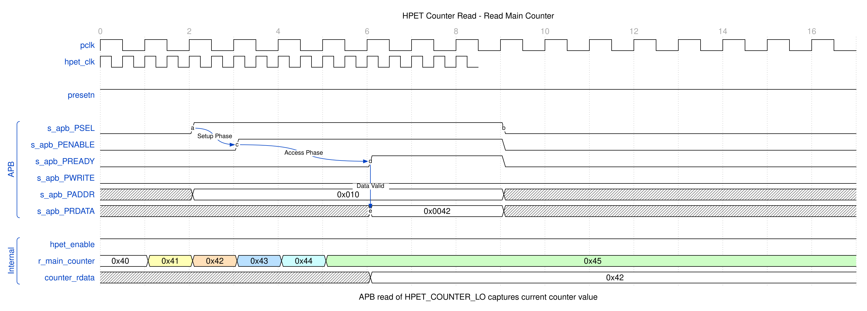
HPET Counter Read
The counter value is captured during the APB read transaction and returned on PRDATA.

7.3.3.1 One-Shot Timer Fire
In one-shot mode, the timer fires once when the counter reaches the comparator value.

7.3.4 Waveform 2.3: HPET One-Shot Timer Fire
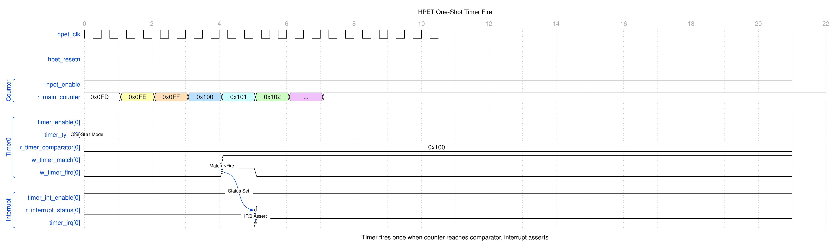
HPET One-Shot Timer Fire
When r_main_counter equals r_timer_comparator[0], the match signal asserts, triggering w_timer_fire[0]. The interrupt output timer_irq[0] asserts and remains active until software clears it.

7.3.4.1 Periodic Timer Fire
In periodic mode, the timer fires repeatedly, automatically adding the period to the comparator.

7.3.5 Waveform 2.4: HPET Periodic Timer Fire
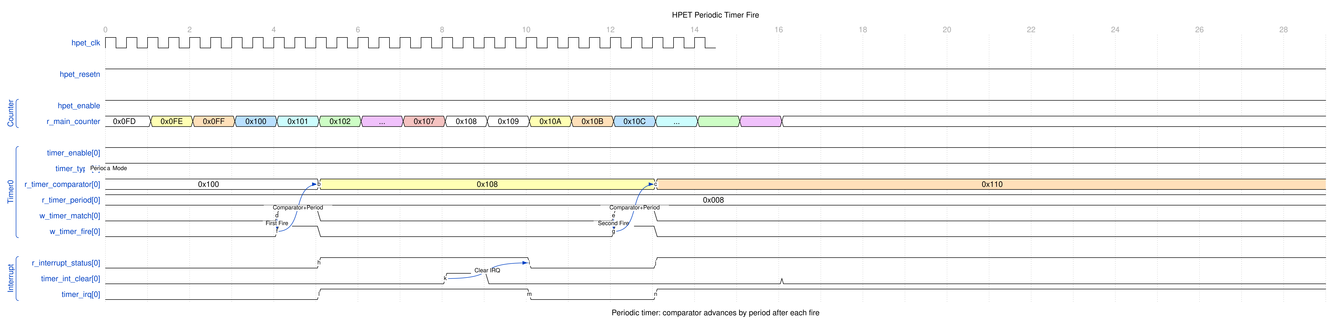
HPET Periodic Timer Fire
After each fire event, the comparator is updated: comparator += period. This allows continuous periodic interrupts without software intervention.

7.3.5.1 Interrupt Clear (W1C)
Software clears timer interrupts by writing 1 to the corresponding bit in HPET_STATUS.

7.3.6 Waveform 2.5: HPET Interrupt Clear
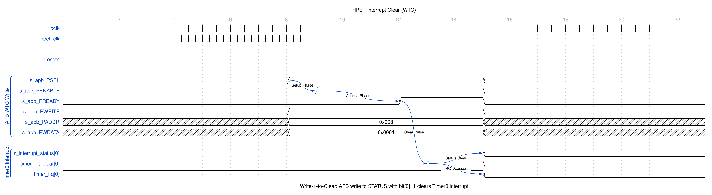
HPET Interrupt Clear
The W1C (Write-1-to-Clear) write clears only the bits written with 1: the wrapper decodes the write data and byte enables into a per-bit mask, pulses timer_int_clear for one cycle, and hpet_core drops just those bits. Writing 0 – to a bit or to the whole register – changes nothing.

7.3.6.1 Timer Setup Sequence
Configuring a timer requires multiple APB writes: config register, then comparator low/high words.

7.3.7 Waveform 2.6: HPET Timer Setup
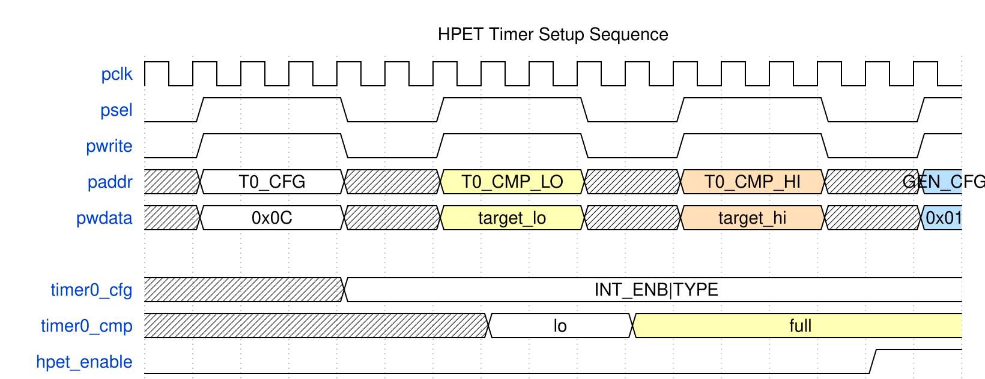
HPET Timer Setup
The sequence shows three consecutive writes: 1. TIMER_CONFIG (0x100): interrupt enable (bit 2), periodic mode (bit 3) 2. TIMER_COMPARATOR_LO (0x108): Lower 32 bits of comparator 3. TIMER_COMPARATOR_HI (0x10C): Upper 32 bits of comparator
Each comparator half loads hpet_core on its own write strobe, so between writes 2 and 3 the core holds {old HI, new LO}. A write re-arms the timer only while the counter is halted, so that torn value can never fire on a running timer – but a running timer then re-arms only when the completed value is above the counter. Write the comparator before starting the counter, or halt it (HPET_CONFIG.hpet_enable = 0) around the pair, whenever the new value may already be behind the counter; a write with the counter halted re-arms the timer to any value. There is no per-timer stop.

7.3.7.1 Clock Domain Crossing (CDC Mode)
When CDC_ENABLE=1, APB transactions cross from pclk to hpet_clk through a pair of async FIFOs inside apb4_slave_cdc (Gray/Johnson pointers per USE_JOHNSON) – not per-signal synchronizers.

7.3.8 Waveform 2.7: HPET CDC Crossing
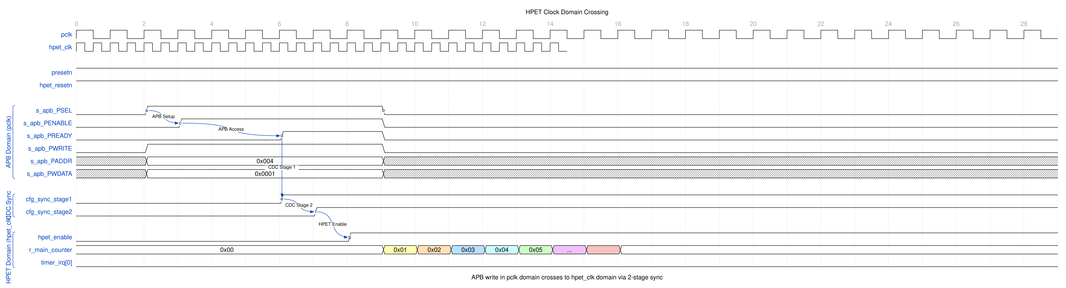
HPET CDC Crossing
The diagram shows the latency introduced by CDC synchronization. Configuration changes in the APB domain take 2-3 hpet_clk cycles to affect the timer core

7.4 Design Notes

7.4.1 Resource Allocation
Per-Configuration Estimates (Post-Synthesis):
Component | NUM_TIMERS=2 | NUM_TIMERS=3 | NUM_TIMERS=8
hpet_core
- Main counter | 64 FF, 70 LUTs | (same) | (same)
- Per-timer logic | 256 FF, 170 LUTs | 384 FF, 255 LUTs | 1024 FF, 680 LUTs
- Subtotal | 320 FF, 240 LUTs | 448 FF, 325 LUTs | 1088 FF, 750 LUTs
hpet_config_regs
- Mapping logic | ~50 FF, ~100 LUTs | ~75 FF, ~150 LUTs | ~150 FF, ~300 LUTs
- Edge detect | ~10 FF, ~20 LUTs | ~15 FF, ~30 LUTs | ~30 FF, ~60 LUTs
- Subtotal | 60 FF, 120 LUTs | 90 FF, 180 LUTs | 180 FF, 360 LUTs
hpet_regs
- Register storage | ~128 FF, ~100 LUTs | ~160 FF, ~125 LUTs | ~256 FF, ~200 LUTs
apb4_slave (no CDC)
- APB protocol | ~20 FF, ~50 LUTs | (same) | (same)
apb4_slave_cdc (with CDC)
- CDC logic | ~100 FF, ~150 LUTs | (same) | (same)
Total (no CDC) | ~528 FF, ~510 LUTs | ~718 FF, ~680 LUTs | ~1544 FF, ~1360 LUTs
Total (with CDC) | ~608 FF, ~610 LUTs | ~798 FF, ~780 LUTs | ~1624 FF, ~1460 LUTs
Scaling: Resource usage is primarily driven by NUM_TIMERS parameter. Each additional timer adds ~128 FF and ~85 LUTs.

7.5 Testing

7.5.1 Integration Checklist
When integrating APB HPET:
1. Parameter Selection: - [ ] NUM_TIMERS: 2, 3, or 8 timers - [ ] VENDOR_ID: reported in HPET_ID[31:16]; the spec’s full 16-bit field - [ ] REVISION_ID: reported in HPET_ID[7:0] - [ ] COUNTER_CLK_PERIOD_FS: femtoseconds per counter tick, at HPET_PERIOD (0x004). Must match CDC_ENABLE[0] ? hpet_clk : pclk - [ ] CDC_ENABLE: 0 for synchronous, 1 for asynchronous clocks
2. Clock Configuration: - [ ] Connect pclk (APB clock domain) - [ ] Connect hpet_clk (timer clock domain) - [ ] If CDC_ENABLE=0: Ensure pclk = hpet_clk - [ ] If CDC_ENABLE=1: Clocks can be asynchronous
3. Reset Coordination: - [ ] Assert presetn (APB reset, active-low) - [ ] Assert hpet_resetn (HPET reset, active-low) - [ ] If CDC_ENABLE=1: Ensure both resets overlap at power-on - [ ] Hold resets for >=10 clock cycles
4. APB Interface: - [ ] Connect all APB signals (PSEL, PENABLE, PADDR, etc.) - [ ] PADDR width = 12 bits (supports up to 4KB address space) - [ ] PWDATA/PRDATA width = 32 bits (fixed)
5. Interrupt Outputs: - [ ] Connect timer_irq[NUM_TIMERS-1:0] to interrupt controller - [ ] Each timer has independent interrupt output - [ ] Interrupts are active-high, level-sensitive
6. Verification: - [ ] Test register access via APB - [ ] Verify timer operation (one-shot and periodic modes) - [ ] Test interrupt generation and clearing - [ ] Validate CDC if enabled

7.6 Navigation
Next: Chapter 2.2 - hpet_config_regs

RTL Design Sherpa · Learning Hardware Design Through Practice GitHub · Documentation Index · MIT License

8 hpet_core

8.1 Overview
The HPET core (hpet_core.sv) is where the timing actually happens: a 64-bit free-running counter, per-timer comparators, and interrupt generation. This module runs entirely on the core clock (hpet_clk when CDC_ENABLE=1, pclk otherwise) and contains all timing-critical logic.

8.1.1 Figure 2.8: HPET Core Block Diagram
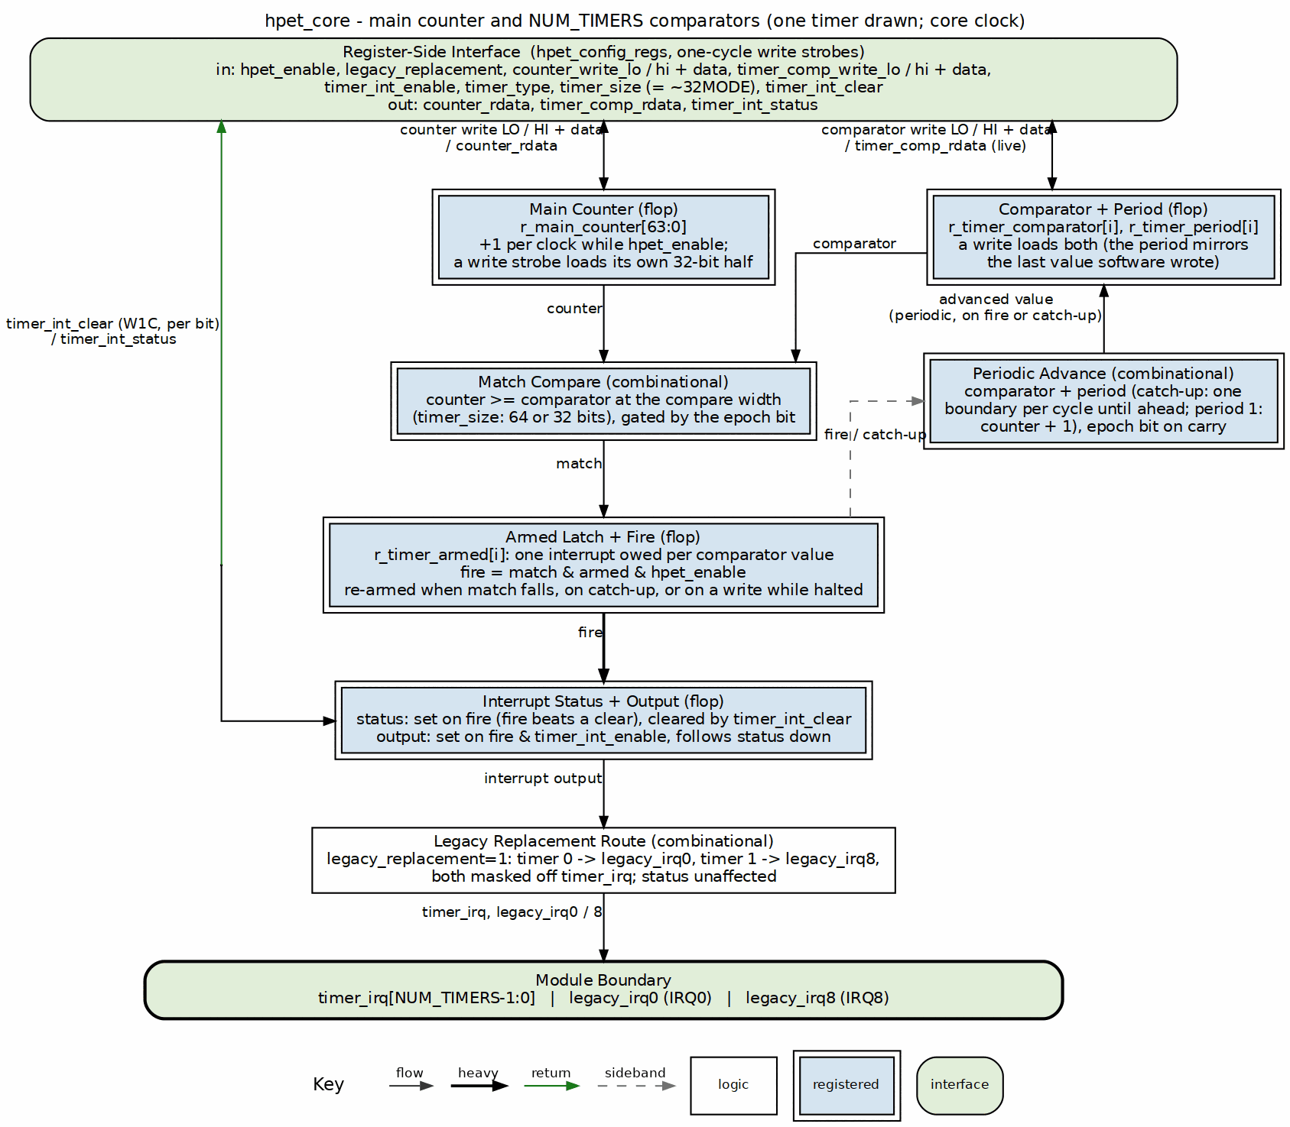
HPET Core Block Diagram
HPET Core architecture showing main counter, timer comparators, match detection, and interrupt generation.

8.1.2 Key Features
- 64-bit Free-Running Counter: Increments every HPET clock cycle, provides timestamp base
- Configurable Timer Array: 2, 3, or 8 independent timers (compile-time parameter)
- 64-bit Comparators: Per-timer comparison values with full counter range
- Dual Operating Modes: One-shot and periodic modes per timer
- Automatic Period Reload: Periodic mode auto-increments comparator after each fire
- Individual Interrupts: Separate fire flag and interrupt output per timer
- Counter Read/Write Access: Software can read and write the counter via the config registers, one 32-bit half per write

8.2 Parameters
Parameter | Type | Default | Range | Description
NUM_TIMERS | int | 3 | 2, 3, 8 | Number of independent timers in array (the apb4_hpet top-level default is 2)

8.3 Ports

8.3.1 Clock and Reset
Signal Name | Type | Width | Direction | Description
clk | logic | 1 | Input | Core clock (hpet_clk or pclk, selected by CDC_ENABLE at the top level)
rst_n | logic | 1 | Input | Active-low asynchronous reset

8.3.2 Configuration Interface (from hpet_config_regs)
Signal Name | Type | Width | Direction | Description
hpet_enable | logic | 1 | Input | Global HPET enable (from HPET_CONFIG[0])
counter_write_lo | logic | 1 | Input | One-cycle strobe: load counter[31:0] from counter_wdata[31:0]
counter_write_hi | logic | 1 | Input | One-cycle strobe: load counter[63:32] from counter_wdata[63:32]
counter_wdata | logic | 64 | Input | Counter write data (from HPET_COUNTER_LO/HI; only the strobed half is used)
legacy_replacement | logic | 1 | Input | LegacyReplacement Route (from HPET_CONFIG[1]): timers 0/1 leave on legacy_irq0/legacy_irq8 instead of timer_irq
timer_int_enable[NUM_TIMERS-1:0] | logic | NUM_TIMERS | Input | Per-timer interrupt enable (from TIMER_CONFIG[2], TN_CONF.INT_ENB). Gates only the interrupt output; there is NO per-timer run enable
timer_type[NUM_TIMERS-1:0] | logic | NUM_TIMERS | Input | Per-timer mode: 0=One-shot, 1=Periodic (from TIMER_CONFIG[3])
timer_size[NUM_TIMERS-1:0] | logic | NUM_TIMERS | Input | Per-timer compare width: 0=32-bit, 1=64-bit. Driven as ~TIMER_CONFIG[8] (32MODE forces 32-bit, so the polarity is inverted); a change clears the timer’s next-epoch hold bit – change it only with the counter halted, then rewrite the comparator
timer_comp_write_lo[NUM_TIMERS-1:0] | logic | NUM_TIMERS | Input | Per-timer strobe: load comparator[31:0]; re-arms only while the counter is halted
timer_comp_write_hi[NUM_TIMERS-1:0] | logic | NUM_TIMERS | Input | Per-timer strobe: load comparator[63:32]; re-arms only while the counter is halted
timer_comp_wdata[NUM_TIMERS] | logic [63:0] | NUM_TIMERS x 64 | Input | Per-timer comparator write data

8.3.3 Status Interface (to hpet_config_regs)
Signal Name | Type | Width | Direction | Description
counter_rdata | logic | 64 | Output | Current main counter value (to HPET_COUNTER_LO/HI)
timer_comp_rdata[NUM_TIMERS] | logic [63:0] | NUM_TIMERS x 64 | Output | Live comparator, periodic advance included (to TIMER_COMPARATOR_LO/HI readback)
timer_int_status[NUM_TIMERS-1:0] | logic | NUM_TIMERS | Output | Per-timer sticky interrupt status, owned here (mirrored into HPET_STATUS)
timer_int_clear[NUM_TIMERS-1:0] | logic | NUM_TIMERS | Input | Per-bit one-cycle clear pulses from the register wrapper (W1C)

8.3.4 Interrupt Interface
Signal Name | Type | Width | Direction | Description
timer_irq[NUM_TIMERS-1:0] | logic | NUM_TIMERS | Output | Per-timer interrupt outputs (active-high); timers 0/1 suppressed while legacy_replacement is set
legacy_irq0 | logic | 1 | Output | Timer 0 on the LegacyReplacement Route (IRQ0); 0 unless legacy_replacement is set
legacy_irq8 | logic | 1 | Output | Timer 1 on the LegacyReplacement Route (IRQ8); 0 unless legacy_replacement is set

8.4 Functional Description

8.4.1 Per-Timer State Machine
Each timer instance implements an identical FSM controlling its operation:

8.4.2 Figure 2.9: Timer FSM
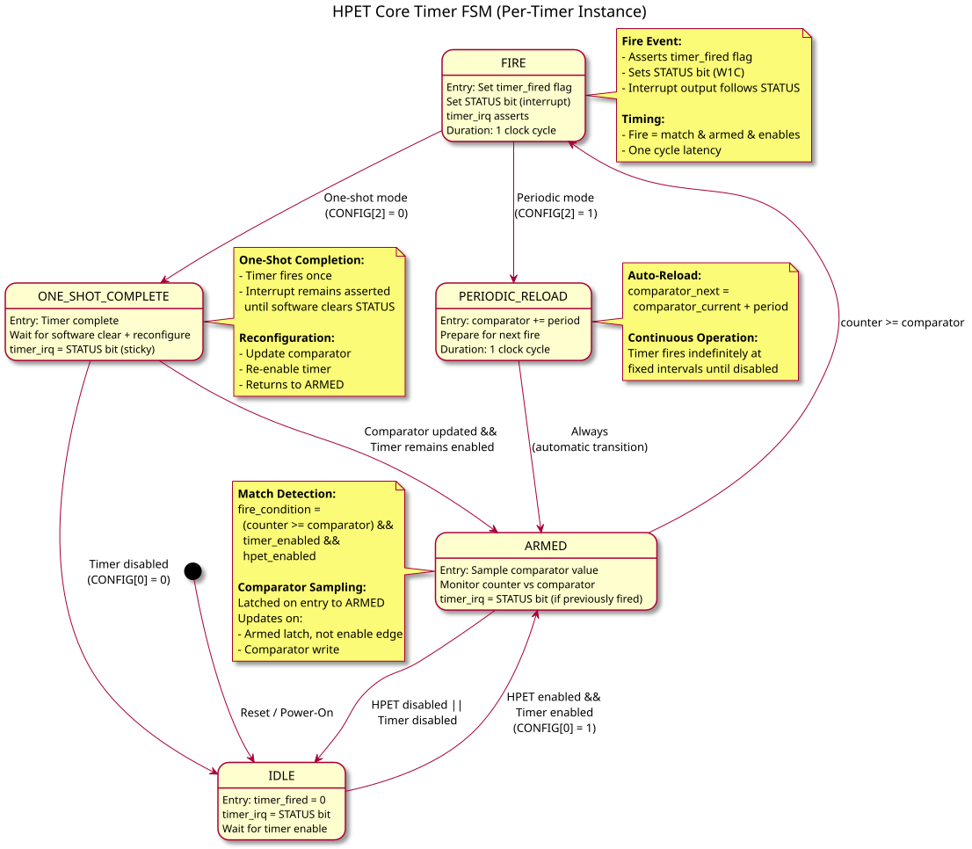
Timer FSM

8.4.2.1 FSM States
State | Encoding | Description
IDLE | Default | Counter halted (hpet_enable = 0), waiting for it to run
ARMED | Active | Timer enabled, monitoring counter vs comparator
FIRE | Transient | Timer match detected, asserting interrupt (1 cycle)
PERIODIC_RELOAD | Transient | Periodic mode: auto-increment comparator (1 cycle; one boundary per cycle while catching up, counter + 1 at period 1)
ONE_SHOT_COMPLETE | Sticky | One-shot mode: fired, armed latch clear, waiting for a comparator write with the counter halted or for the match to fall
Note: FSM is conceptual - the implementation is a raw comparator plus two state bits per timer, the armed latch (r_timer_armed[i]) and the next-epoch hold bit (r_comp_next_epoch[i]), rather than an explicit state register. A timer whose advance carried out of the compare width is epoch-held: it looks ARMED-but-not-matching (the latch is set, the match is forced off) until the counter wraps at that width, and none of the transitions below happen for it in the meantime.

8.4.2.2 State Transitions
IDLE -> ARMED: - Condition: hpet_enable (block-wide – the published spec defines no per-timer run enable, so every timer runs whenever the counter does) - Action: Latch current comparator value - Duration: Immediate (next clock cycle)
ARMED -> FIRE: - Condition: counter_value >= timer_comparator[i] with the armed latch set - Action: Assert timer_int_status[i] (sticky) on EVERY fire, whatever timer_int_enable[i] says; clear the armed latch - Duration: 1 clock cycle (the fire is a one-cycle pulse)
FIRE -> PERIODIC_RELOAD: - Condition: timer_type[i] == 1 (periodic mode) - Action: timer_comparator[i] <= timer_comparator[i] + timer_period[i] - Duration: 1 clock cycle
FIRE -> ONE_SHOT_COMPLETE: - Condition: timer_type[i] == 0 (one-shot mode) - Action: Hold timer_int_status[i] until software clears - Duration: Until STATUS cleared or the counter halted
PERIODIC_RELOAD -> ARMED: - Condition: Always (automatic) - Action: Resume monitoring with new comparator value - Duration: Immediate
ONE_SHOT_COMPLETE -> ARMED: - Condition: a comparator write, LO or HI half (timer_comp_write_lo/hi[i]), while the counter is HALTED (hpet_enable = 0), even with the value it already holds; or the raw match falling (a comparator written above the counter, or the counter written back below the comparator) - Action: Set the armed latch; resume monitoring - Duration: Immediate on the write strobe or on the match falling - A comparator written with the counter halted does NOT have to exceed the counter. A value at or below the counter fires on the first cycle the counter runs – that is the explicit re-arm, and it is how software fires a timer “now”. - A comparator write on a RUNNING timer loads the half but does not re-arm. Written above the counter, the match falls and the timer re-arms naturally, firing at the new value. Anything else is outside the contract: a torn 64-bit value above the counter re-arms through that same path and fires at the final value once it is written, and a same-value rewrite on a running periodic timer drags the comparator back from its advanced position and can add one off-lattice fire. To reprogram a running timer, halt the counter first.
ARMED/ONE_SHOT_COMPLETE -> IDLE: - Condition: !hpet_enable (clearing timer_int_enable[i] does NOT stop a timer; it only masks the interrupt) - Action: Stop firing. A pending interrupt status/output is NOT cleared by halting – it holds until software W1C or reset. - Duration: Immediate - The enable does not touch the armed latch, so a completed one-shot stays complete across a halt/restart cycle: restarting with an expired comparator does not re-fire it.

8.4.3 Main Counter Logic

8.4.3.1 Counter Increment
// 64-bit free-running counter
logic [63:0] r_main_counter;
always_ff @(posedge clk or negedge rst_n) begin
if (!rst_n) begin
r_main_counter <= 64'h0;
end else if (counter_write_lo || counter_write_hi) begin
// Software write: each half loads on its own strobe, the other
// half holds, and the write cycle does not increment
if (counter_write_lo) r_main_counter[31:0] <= counter_wdata[31:0];
if (counter_write_hi) r_main_counter[63:32] <= counter_wdata[63:32];
end else if (hpet_enable) begin
// Continuous increment when HPET enabled
r_main_counter <= r_main_counter + 64'd1;
end
// else: Hold value when HPET disabled
end
// Output current counter value
assign counter_rdata = r_main_counter;
Key Behavior: - Reset: Counter initializes to 0 - Software Write: each HPET_COUNTER_LO/HI write loads its own half on the write itself; the halves are independent, as on a real HPET, so a 64-bit load is two writes and the intermediate state is visible – write with the counter halted (hpet_enable = 0) - Increment: Counter increments every clock when hpet_enable = 1 - Overflow: Counter wraps from 64’hFFFF_FFFF_FFFF_FFFF to 64’h0 naturally

8.4.4 Figure 2.10: Main Counter Start Timing
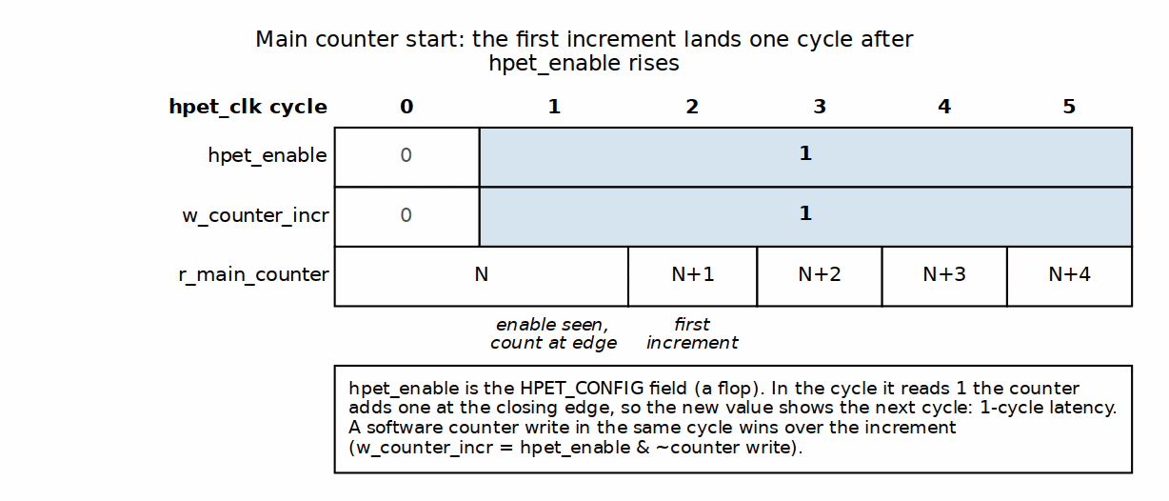
Main Counter Start Timing

8.4.5 Timer Comparator Logic

8.4.5.1 Comparator Storage (Per-Timer)
// Per-timer comparator and period storage
logic [63:0] r_timer_comparator [NUM_TIMERS-1:0];
logic [63:0] r_timer_period [NUM_TIMERS-1:0];
for (genvar i = 0; i < NUM_TIMERS; i++) begin : gen_timer_advance
// One advanced value, shared by the fire advance, the catch-up
// advance, the ahead-of-counter test and the epoch carry. A period-1
// catch-up step jumps to counter + 1 (every integer is on the
// period-1 lattice); everything else is comparator + period.
assign w_adv_base[i] = (w_timer_catchup[i] && w_timer_period_one[i]) ?
r_main_counter : r_timer_comparator[i];
assign w_adv_addend[i] = (w_timer_catchup[i] && w_timer_period_one[i]) ?
64'd1 : r_timer_period[i];
assign w_adv_sum_64[i] = {1'b0, w_adv_base[i]} + {1'b0, w_adv_addend[i]};
assign w_adv_sum_32[i] = {1'b0, w_adv_base[i][31:0]} + {1'b0, w_adv_addend[i][31:0]};
// {carry, sum} at the compare width. The carry is what the epoch bit
// records; in 32-bit mode the advance never touches comparator[63:32].
always_comb begin
if (timer_size[i]) begin
w_comp_advance[i] = w_adv_sum_64[i][63:0];
w_comp_adv_carry[i] = w_adv_sum_64[i][64];
w_comp_adv_ahead[i] = w_adv_sum_64[i][64] ||
(w_adv_sum_64[i][63:0] >= r_main_counter);
end else begin
w_comp_advance[i] = {r_timer_comparator[i][63:32], w_adv_sum_32[i][31:0]};
w_comp_adv_carry[i] = w_adv_sum_32[i][32];
w_comp_adv_ahead[i] = w_adv_sum_32[i][32] ||
(w_adv_sum_32[i][31:0] >= r_main_counter[31:0]);
end
end
end
// An advance happens on a periodic fire or a catch-up step, never in a
// cycle software is writing the comparator (software wins, below)
assign w_comp_advance_en = ~w_timer_comp_write &
((w_timer_fire & timer_type) | w_timer_catchup);
for (genvar i = 0; i < NUM_TIMERS; i++) begin : gen_timer_comparators
always_ff @(posedge clk or negedge rst_n) begin
if (!rst_n) begin
r_timer_comparator[i] <= 64'h0;
r_timer_period[i] <= 64'h0;
end else if (timer_comp_write_lo[i] || timer_comp_write_hi[i]) begin
// Software write: one 32-bit half per strobe. Period mirrors
// the written value so periodic mode advances by the
// programmed interval while the comparator walks ahead of it.
// SOFTWARE WINS: this branch outranks both advances below, so
// a write landing in a fire (or catch-up) cycle loads the
// software value and the advance is skipped that cycle.
if (timer_comp_write_lo[i]) begin
r_timer_comparator[i][31:0] <= timer_comp_wdata[i][31:0];
r_timer_period[i][31:0] <= timer_comp_wdata[i][31:0];
end
if (timer_comp_write_hi[i]) begin
r_timer_comparator[i][63:32] <= timer_comp_wdata[i][63:32];
r_timer_period[i][63:32] <= timer_comp_wdata[i][63:32];
end
end else if (w_comp_advance_en[i]) begin
// Periodic advance: one period per fire, or one boundary per
// CYCLE while catching up (see Fire Detection). Width-masked;
// the carry goes to the epoch bit, not the comparator
r_timer_comparator[i] <= w_comp_advance[i];
end
// else: Hold value
end
end
Key Behavior: - Reset: Comparator and period clear to 0 - Initial Write: Both comparator and period latched from the same write, one half per strobe - Rewrite: a write is the event, not a change of value – writing the comparator with the value it already holds reloads the internal comparator (discarding any periodic advance). It re-arms the timer only while the counter is halted; on a running timer the reload lands and the timer re-arms when the match next falls - Periodic Mode: Comparator auto-increments by period value on each fire - Periodic catch-up: while a periodic timer is running, un-armed and its comparator is still at or below the counter, the comparator keeps advancing by one period per cycle WITHOUT firing until it is at or ahead of the counter, then the timer re-arms (see Fire Detection) - Period 1: a catch-up step sets the comparator to counter + 1, not comparator + 1 – adding 1 to both sides can never close a gap, and every integer is on the period-1 lattice - Catch-up cost: one comparator advance per cycle, so a catch-up closes its deficit at period - 1 counts per cycle (period 1 is the special lattice jump that closes in one) and a large deficit costs a proportional catch-up – a period-2 timer left 2^52 counts behind by a counter write rewrites its comparator every cycle for ~2^52 cycles with no interrupt. This is the contract behind halting the counter before writing it, and behind programming a periodic comparator near or ahead of the counter - Advance overflow: an advance that carries out of the compare width keeps the wrapped low bits and sets the next-epoch hold bit; in 32-bit mode bits [63:32] are never disturbed - Same-cycle write and fire: exactly one fire; the software value wins and the periodic advance is skipped that cycle - One-Shot Mode: Comparator remains constant after initial write

8.4.5.2 Match Detection
64-bit Comparator Match Waveform:

8.4.6 Waveform 2.11: Comparator Match Behavior
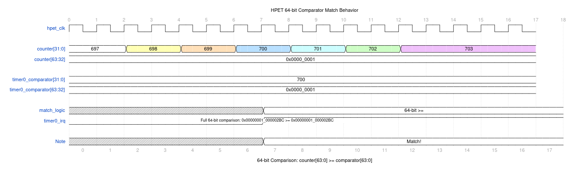
Comparator Match Behavior
Use WaveDrom Editor to view/edit, or generate SVG with wavedrom-cli
// Per-timer match detection (combinational, RAW -- no enable terms)
logic [NUM_TIMERS-1:0] w_timer_match_raw;
logic [NUM_TIMERS-1:0] w_timer_match;
for (genvar i = 0; i < NUM_TIMERS; i++) begin : gen_timer_terms
// timer_size (= ~TIMER_CONFIG[8], 32MODE) selects 64-bit or 32-bit compare
assign w_timer_match_raw[i] = timer_size[i]
? (r_main_counter >= r_timer_comparator[i])
: (r_main_counter[31:0] >= r_timer_comparator[i][31:0]);
end
// Held off while the comparator sits in the counter's NEXT epoch. Every
// consumer (fire, catch-up, natural re-arm) reads this gated match.
assign w_timer_match = w_timer_match_raw & ~r_comp_next_epoch;
Match Conditions: - Counter value >= comparator value (full 64 bits when timer_size=1, low 32 bits only when timer_size=0) - And the next-epoch hold bit is clear. When an advance has carried out of the compare width the comparator belongs to the counter’s next epoch, and the raw comparison says nothing useful until the counter wraps at that width; the bit forces the match off until then. - That is all. The enable (hpet_enable) is deliberately NOT in the match: it gates the fire pulse instead (next section), so that turning it on cannot manufacture a match edge.

8.4.7 Timer Fire Logic

8.4.7.1 Fire Detection (Armed Latch)
A per-timer armed latch decides whether the raw match may still produce a fire. It holds “this timer still owes one interrupt for this comparator” as state, which is what a plain rising-edge detect cannot do: an edge on (match && hpet_enable) re-fires every expired one-shot the moment the counter is started, while an edge on the raw match is consumed at the comparator write, before the counter runs, and then never fires at all.
// Per-timer armed latch and next-epoch hold bit. Reset ARMED: out of
// reset counter == comparator == 0 is already a match, and hpet_enable
// holds the fire off until then. Reset epoch clear.
logic [NUM_TIMERS-1:0] r_timer_armed;
logic [NUM_TIMERS-1:0] r_comp_next_epoch;
logic [NUM_TIMERS-1:0] w_timer_comp_write; // LO or HI half of timer i written
logic [NUM_TIMERS-1:0] w_timer_running; // = hpet_enable (block-wide)
logic [NUM_TIMERS-1:0] w_comp_write_rearm; // comparator write with the counter HALTED
logic [NUM_TIMERS-1:0] w_timer_catchup; // advance a boundary, do NOT fire
logic [NUM_TIMERS-1:0] w_catchup_rearm; // catch-up landed at or ahead of the counter
assign w_timer_comp_write = timer_comp_write_lo | timer_comp_write_hi;
assign w_timer_running = {NUM_TIMERS{hpet_enable}};
assign w_comp_write_rearm = w_timer_comp_write & ~w_timer_running;
// Periodic catch-up: periodic, NOT armed, comparator still at or behind
// the counter (epoch-gated match), no software write this cycle, a
// period that can actually move the compare (period 0 behaves as
// one-shot), and running.
assign w_timer_catchup = timer_type & ~r_timer_armed & w_timer_match &
~w_timer_comp_write & w_timer_period_nz &
w_timer_running;
// Finished the cycle the advance lands AT OR AHEAD of the counter
// (w_comp_adv_ahead[i] = carry || advance >= counter, at the compare
// width; see gen_timer_advance). >= not >: the comparator takes the
// advance while the counter takes counter+1, so a tie is a boundary one
// count behind next cycle, and at period 1 the advance can only tie.
assign w_catchup_rearm = w_timer_catchup & w_comp_adv_ahead;
// Next-epoch hold: set when an advance carries out of the compare width;
// cleared, with priority, by the counter wrapping at that width (E1), a
// comparator write (E2), a counter write (E3) or a timer_size change (E4).
// E2 and E3 are taken at the compare width, in the gen_timer_terms mux
// alongside the match: with timer_size = 0 only a LO-half write clears
// (w_epoch_clr_comp = timer_comp_write_lo, w_epoch_clr_ctr =
// counter_write_lo); a HI-half write moves no bit the 32-bit comparison
// reads, so it leaves the hold in place. With timer_size = 1 either half
// clears.
assign w_epoch_set = w_comp_advance_en & w_comp_adv_carry;
assign w_epoch_clr = w_counter_wrap | w_epoch_clr_comp | w_epoch_clr_ctr |
w_timer_size_chg;
always_ff @(posedge clk or negedge rst_n) begin
if (!rst_n) begin
r_comp_next_epoch <= '0;
end else begin
for (int t = 0; t < NUM_TIMERS; t++) begin
if (w_epoch_clr[t]) r_comp_next_epoch[t] <= 1'b0;
else if (w_epoch_set[t]) r_comp_next_epoch[t] <= 1'b1;
end
end
end
always_ff @(posedge clk or negedge rst_n) begin
if (!rst_n) begin
r_timer_armed <= {NUM_TIMERS{1'b1}};
end else begin
for (int t = 0; t < NUM_TIMERS; t++) begin
if (w_comp_write_rearm[t] || !w_timer_match[t] ||
w_catchup_rearm[t]) begin
r_timer_armed[t] <= 1'b1; // explicit, natural or catch-up re-arm
end else if (w_timer_fire[t]) begin
r_timer_armed[t] <= 1'b0; // one fire per arm
end
end
end
end
// Fire: epoch-gated match, still armed, and the counter running
assign w_timer_fire = w_timer_match & r_timer_armed &
{NUM_TIMERS{hpet_enable}};
The latch is set by exactly three things and cleared only by a fire:
- Natural re-arm – the gated match is LOW: the counter is behind the comparator again after a periodic advance, a comparator write that moved the target forward, or a counter reload – or the next-epoch hold bit is forcing the match off.
- Catch-up re-arm – a periodic catch-up step (below) lands the comparator at or ahead of the counter (>=, or a carry out of the compare width). This is the only re-arm path for a period of 1, where the advance never pulls away from the counter and the match therefore never falls on its own.
- Explicit re-arm – a comparator half is written while the counter is HALTED (hpet_enable = 0; there is no per-timer stop). This is what lets software arm to a value the counter has already passed: a zero comparator, or restarting a periodic phase after a counter reset.
A comparator write on a RUNNING timer deliberately does NOT re-arm. The 64-bit comparator arrives as two 32-bit halves, so between them the register holds the torn value {old HI, new LO}; a re-arm on either strobe would fire on that value, which software never programmed. The half still loads – only the re-arm is withheld – so a running timer re-arms naturally, through the first rule, once the completed value is ahead of the counter. Written above the counter it fires at the new value.
The contract that follows: to reprogram a running timer’s 64-bit comparator without a spurious or a missed event, halt the counter first (hpet_enable = 0 – there is no per-timer stop), write both halves, then restart it – it fires once, at the value programmed, and a value at or below the counter fires as soon as the counter restarts (the >= match, the same rule that makes a deficit fire rather than be missed; there is no wait for a wrap). The real HPET has the same requirement. Two consequences of reprogramming a running timer anyway are outside the contract, not defects: a torn 64-bit value ABOVE the counter re-arms the timer through the natural path and it fires at the final value once the second half is written – the completed value fires it, not the tear – and a same-value rewrite on a running periodic timer drags the comparator back from its auto-advanced position and can add one off-lattice fire.
Periodic catch-up. A fire advances a periodic comparator by one period. If the counter was already more than a period past it – programmed late, or the counter written forward – one advance is not enough: the comparator is still at or below the counter, the match never falls, and with only the natural re-arm the timer would fire once and go silent. So a periodic timer that is running, un-armed and still matching advances its comparator by the period every cycle WITHOUT firing until the advance lands at or ahead of the counter; the catch-up re-arm then sets the latch and the timer fires at that next boundary. The test is >=, not >: the comparator takes the advance in the same cycle the counter takes counter+1, so an advance that ties with the counter is one count behind it next cycle and a legal boundary to fire at. Missed periods are skipped, never burst: a large deficit yields exactly one fire, at the next boundary still in the future. Two degenerate periods are worth knowing. Period 0 behaves as one-shot – a zero period can never get ahead of the counter, so the catch-up is suppressed and the timer fires once and stays quiescent rather than rewriting its own value forever. Period 1 gains nothing on the counter per cycle – both step by exactly 1, so the deficit is an invariant and comparator + period could never close it – so a period-1 catch-up step sets the comparator to counter + 1 instead. Every integer is on the period-1 lattice, so that is a legal next boundary, and it re-arms immediately. The cadence is one fire every other tick, the fastest the one-cycle fire/re-arm loop allows, regardless of how large the deficit is; a live counter write that opens a gap recovers on the next catch-up cycle. Any other period pays for its deficit in cycles. The comparator advances once per cycle, so a catch-up closes the gap at period - 1 counts per cycle – period 1 is the special lattice jump that closes it in one – and the time to close is proportional to the deficit. A period-2 timer left 2^52 counts behind by a counter write catches up for ~2^52 cycles, the comparator rewritten every cycle and no interrupt raised. That bound is a contract, not a defect: it is why the HPET specification and this book require the main counter to be HALTED (HPET_CONFIG.hpet_enable = 0) before it is written, and why a periodic timer should be programmed with a comparator near or ahead of the counter.
Next-epoch hold. An advance – on a fire or a catch-up step – can carry out of the compare width: past bit 31 in 32-bit mode, past bit 63 in 64-bit mode. The comparator keeps the wrapped low bits and now belongs to the counter’s NEXT epoch, where a plain counter >= comparator would read as an immediate match and either fire early or churn the catch-up. The core records the carry in a per-timer hold bit, r_comp_next_epoch[i] (reset 0), that forces the gated match to 0: no fire, no catch-up, no rewrite loop, and the armed latch simply re-sets through the natural rule and waits. The bit clears when the counter wraps at the compare width by incrementing (E1 – a software counter write is not a wrap), when software writes the comparator (E2), when software writes the counter (E3 – the write re-bases the epoch, so the ordinary counter >= comparator rule applies immediately and a comparator now behind the counter fires promptly), or when timer_size[i] changes (E4 – the carry was taken at a width that no longer applies). E2 and E3 are evaluated at the compare width, the same width the carry was taken at. In 32-bit mode (timer_size[i] = 0) only a write to HPET_COUNTER_LO or TIMERn_COMPARATOR_LO clears the hold; a write to either HI half changes nothing the comparison reads and leaves the hold in place. In 64-bit mode either half clears it. Clear beats set, because the two coincide exactly at the counter’s own wrap and taking the set there would hold the comparator for a whole extra epoch. E4 carries a contract of its own: change timer_size only with the counter halted, and rewrite the comparator afterwards. The hold clears on the change, but a comparator that was advanced at the old width is not on the new width’s lattice, and a live 0->1 switch can leave the timer catching up for ~2^32 cycles. What software sees: a 32-bit periodic timer whose comparator + period passes 2^32 fires at that boundary and then stays quiet until the low 32 bits of the counter wrap – up to about 2^32 ticks, though never longer than the period that caused the carry, so the next fire still lands on the programmed lattice; a 64-bit timer whose advance carries out of bit 63 waits for the 64-bit counter to wrap – up to 2^64 counts, roughly 5800 years at 100 MHz – so in practice it fires once and never again until reprogrammed. Both are the arithmetic of the register width, not defects, and in 32-bit mode the advance never disturbs comparator[63:32].
Same-cycle write and fire. A software comparator write landing in the same cycle as a fire (or a catch-up step) on a running timer produces exactly one fire; the software value wins and the periodic advance is skipped that cycle, so the comparator holds what software programmed, not that value plus a period.

8.4.8 Figure 2.12: Timer Fire Timing
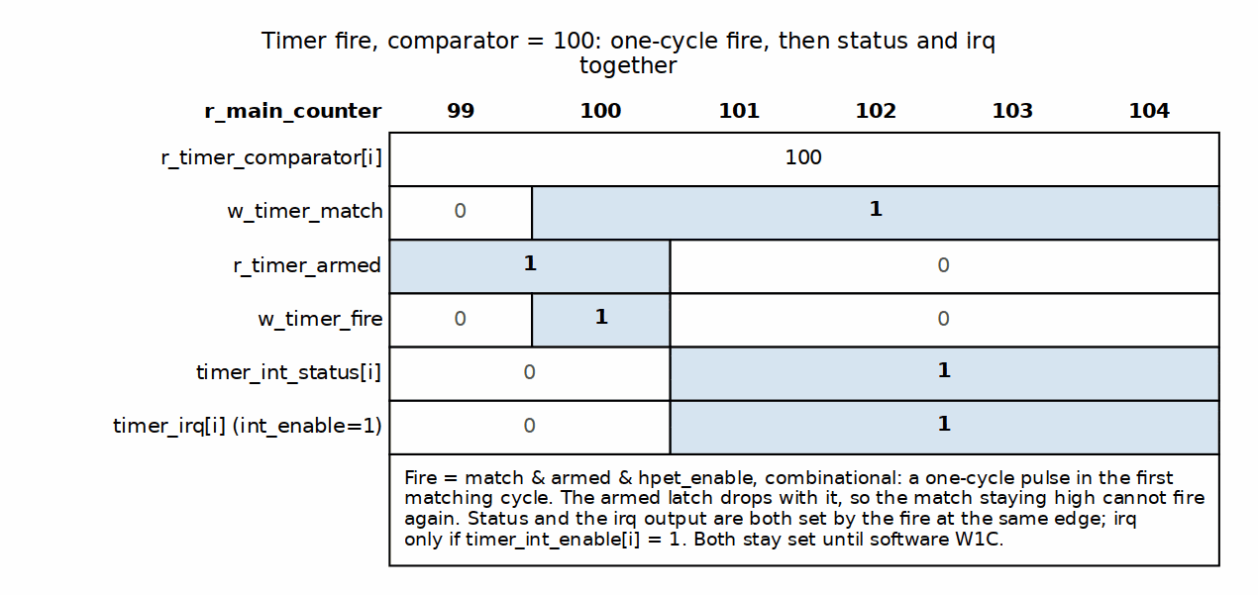
Timer Fire Timing

8.4.8.1 Fire Flag Management
// Per-timer sticky interrupt status -- identical in BOTH modes
logic [NUM_TIMERS-1:0] r_interrupt_status;
for (genvar i = 0; i < NUM_TIMERS; i++) begin : gen_interrupt_logic
always_ff @(posedge clk or negedge rst_n) begin
if (!rst_n) begin
r_interrupt_status[i] <= 1'b0;
end else if (w_timer_fire[i]) begin
r_interrupt_status[i] <= 1'b1; // Set on fire (wins over a clear)
end else if (timer_int_clear[i]) begin
r_interrupt_status[i] <= 1'b0; // Software W1C, this bit only
end
end
end
// Sticky status to the register wrapper (mirrored into HPET_STATUS)
assign timer_int_status = r_interrupt_status;
Fire Flag Behavior: - Both modes are sticky: the status bit sets on the fire and holds until software clears it via HPET_STATUS W1C (or reset). There is no timer_type term in the interrupt logic – periodic mode does NOT pulse the status per period; from the first fire it stays asserted until W1C, while the comparator keeps auto-advancing in the background. - Fire beats clear: a fire and a software clear landing on the same bit in the same cycle leave the bit SET. A clear can be repeated; a lost fire is gone for good, so the new event takes priority. The wrapper narrows the clear to one cycle so there is no trailing cycle that could undo a fire the core just accepted. - Per bit: timer_int_clear[i] touches only timer i; the other timers’ status and irq are unaffected.

8.4.9 Interrupt Generation
Interrupt Generation and Acknowledgment Waveform:

8.4.10 Waveform 2.13: Interrupt Generation
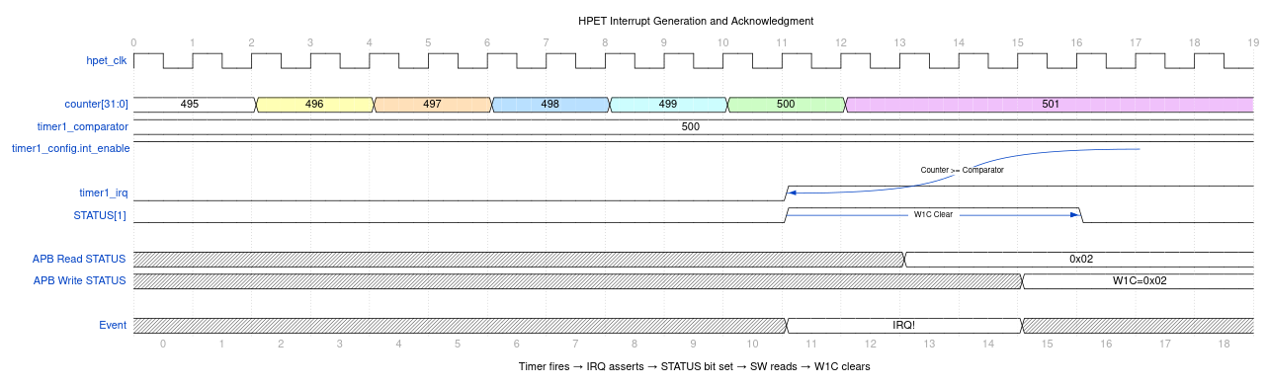
Interrupt Generation
Use WaveDrom Editor to view/edit, or generate SVG with wavedrom-cli

8.4.10.1 Interrupt Output Logic
// Per-timer interrupt output -- a flop, gated by int_enable AT FIRE TIME
for (genvar i = 0; i < NUM_TIMERS; i++) begin : gen_interrupt_output
always_ff @(posedge clk or negedge rst_n) begin
if (!rst_n) begin
r_interrupt_output[i] <= 1'b0;
end else if (w_timer_fire[i] && timer_int_enable[i]) begin
r_interrupt_output[i] <= 1'b1; // Fire wins over a same-cycle clear
end else if (timer_int_clear[i]) begin
r_interrupt_output[i] <= 1'b0;
end else if (!r_interrupt_status[i]) begin
r_interrupt_output[i] <= 1'b0; // Follows status clear
end
end
end
// LegacyReplacement Route REPLACES timers 0/1 on timer_irq (TASK-003)
assign timer_irq = r_interrupt_output &
~(legacy_replacement ? LEGACY_MASK : {NUM_TIMERS{1'b0}});
assign legacy_irq0 = legacy_replacement & r_interrupt_output[0];
assign legacy_irq8 = legacy_replacement & r_interrupt_output[1]; // 0 if NUM_TIMERS < 2
Interrupt Behavior: - Registered: timer_irq asserts one core clock after the fire event - Gated at fire time: timer_int_enable[i] is sampled only when the fire edge occurs. Enabling interrupts AFTER a timer has fired does not retroactively assert timer_irq, even though the status bit is set. - Sticky in both modes: asserted from (fire + 1 cycle) until the W1C
Interrupt Clearing: Software clears an interrupt by writing 1 to its HPET_STATUS bit (W1C). The sticky status lives in hpet_core (r_interrupt_status); the wrapper mirrors it into the PeakRDL HPET_STATUS register every cycle and turns the software write into a one-cycle timer_int_clear[i] pulse for exactly the bits written with 1. Bits written 0 – and a write of 0x0 – clear nothing.

8.4.11 Periodic Mode Details
Periodic Timer Waveform:

8.4.12 Waveform 2.14: Periodic Timer Operation
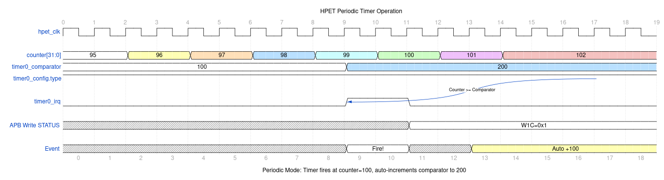
Periodic Timer Operation
Use WaveDrom Editor to view/edit, or generate SVG with wavedrom-cli

8.4.12.1 Period Storage and Auto-Reload
Initial Comparator Write:
Software writes: TIMER0_COMPARATOR = 1000
Result:
r_timer_comparator[0] = 1000
r_timer_period[0] = 1000 (also latched)
First Fire (at counter = 1000):
Armed match: timer fires
-> timer_int_status[0] asserts
-> Comparator auto-reloads:
r_timer_comparator[0] = 1000 + 1000 = 2000
Second Fire (at counter = 2000):
Armed match (re-armed when the advance dropped the match): timer fires
-> timer_int_status[0] asserts
-> Comparator auto-reloads:
r_timer_comparator[0] = 2000 + 1000 = 3000
Process repeats indefinitely until the counter is halted or the timer is switched to one-shot
Late Start (counter already at 3500 when the timer is programmed):
- An armed match with comparator = 1000 fires the timer once.
- The comparator advances 1000 -> 2000; that is still <= 3500, so the timer stays un-armed.
- Catch-up, no fire: 2000 -> 3000 (still behind), 3000 -> 4000 (ahead).
- Catch-up re-arms; the next fire is at counter = 4000, then 5000, 6000, … The 2000 and 3000 boundaries are skipped, not burst.

8.4.13 Figure 2.15: Periodic Mode Timing Example
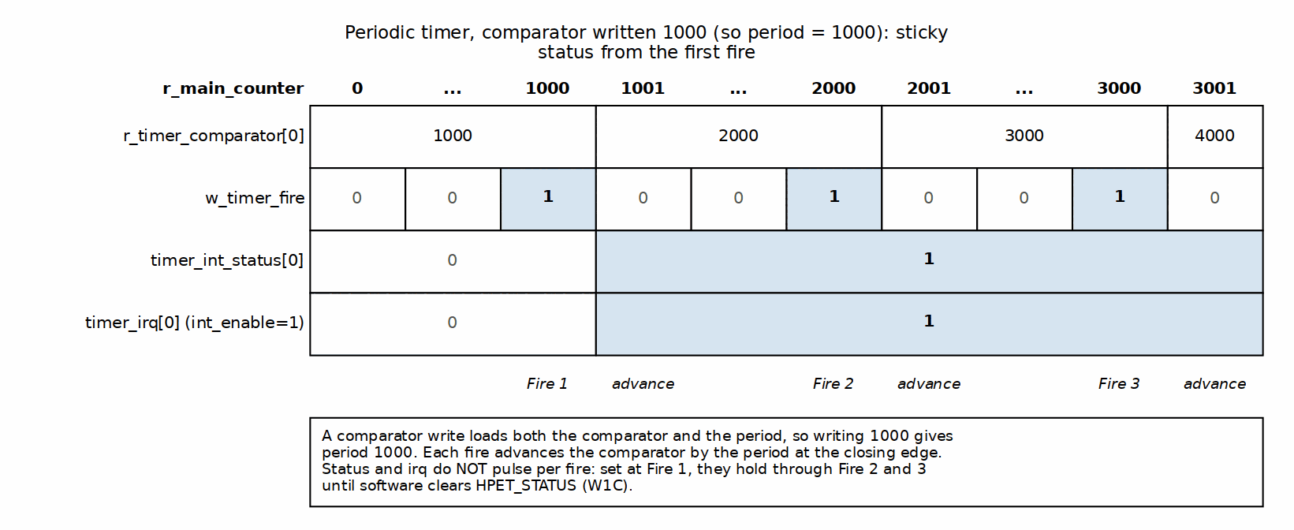
Periodic Mode Timing Example

8.4.14 One-Shot Mode Details
One-Shot Timer Waveform:

8.4.15 Waveform 2.16: One-Shot Mode Operation
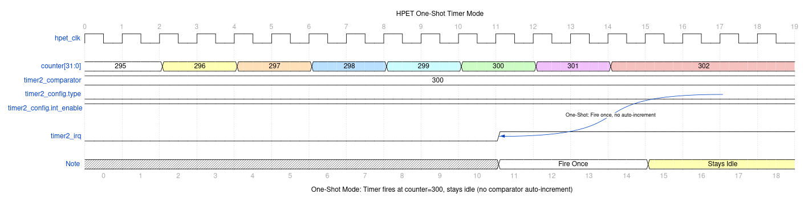
One-Shot Mode Operation
Use WaveDrom Editor to view/edit, or generate SVG with wavedrom-cli

8.4.15.1 Fire-Once Behavior
Initial Comparator Write:
Software writes: TIMER0_COMPARATOR = 5000
Result:
r_timer_comparator[0] = 5000
(period not used in one-shot mode)
Fire Event (at counter = 5000):
- The armed match fires the timer and clears the armed latch.
- timer_int_status[0] asserts (sticky).
- The comparator stays at 5000 (no auto-reload).
- The status stays set until software clears it.
- Halting and restarting the counter does NOT fire it again.
Interrupt Clearing:
Software writes: HPET_STATUS[0] = 1 (W1C)
Result:
timer_int_status[0] clears
timer_irq[0] clears
Reconfiguration:
Software writes: TIMER0_COMPARATOR = 10000
Result:
r_timer_comparator[0] = 10000
10000 is above the counter, so the match falls and the timer re-arms
naturally; it waits for counter = 10000
(to re-arm to a value the counter has already passed, disable the
timer around the write -- a write on a running timer does not re-arm)

8.4.16 Figure 2.17: One-Shot Mode Timing Example
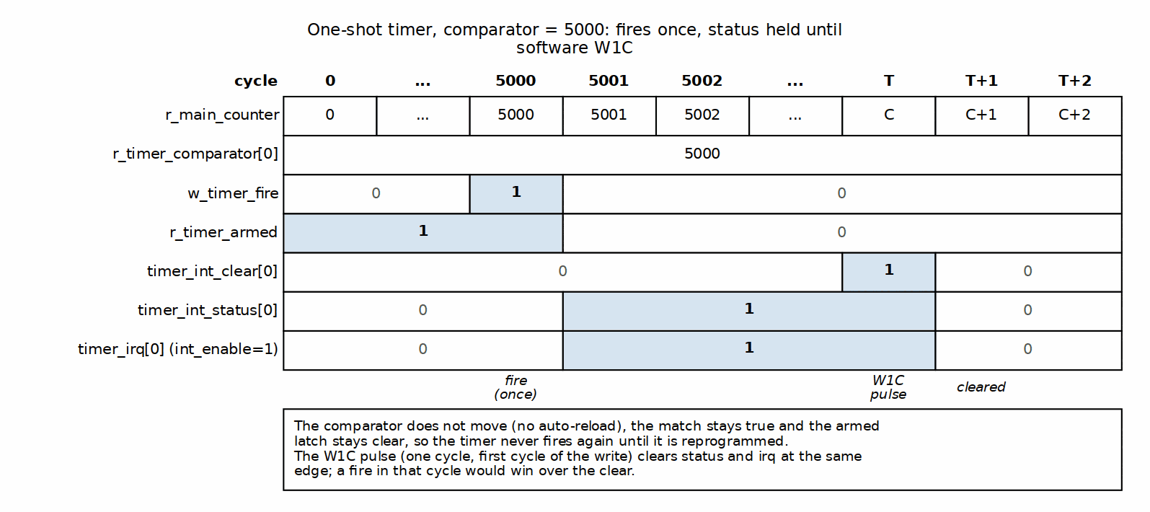
One-Shot Mode Timing Example

8.5 Design Notes

8.5.1 Resource Utilization
Per-Timer Resources (Estimated): - 64-bit comparator register: 64 flip-flops - 64-bit period register: 64 flip-flops - Match comparator: 64-bit >= comparison (~80 LUTs) - Armed latch, next-epoch hold bit, catch-up and fire pulse: 3 flip-flops (armed, epoch, timer_size delay) + a second 64-bit compare (advance >= counter, with carry, ~80 LUTs) + a few gates - Total per timer: ~131 flip-flops, ~165 LUTs
Shared Resources: - 64-bit main counter: 64 flip-flops + 64-bit adder (~70 LUTs) - Global enable logic: ~10 LUTs
Total (NUM_TIMERS = 3): - Flip-flops: 64 + (131 × 3) = 457 FF - LUTs: 80 + (165 × 3) = 575 LUTs

8.6 Navigation
Next: Chapter 2.2 - hpet_config_regs

RTL Design Sherpa · Learning Hardware Design Through Practice GitHub · Documentation Index · MIT License

9 hpet_config_regs

9.1 Overview
The hpet_config_regs module is the bridge between the PeakRDL-generated register file (hpet_regs.sv) and the HPET core timer logic (hpet_core.sv). The wrapper exists because the generated register interface and the core’s expectations don’t line up on their own: it handles interface adaptation, per-timer data bus isolation, and turning the register block’s write indications into the one-cycle strobes the core expects.

9.1.1 Figure 2.18: HPET Config Registers Block Diagram
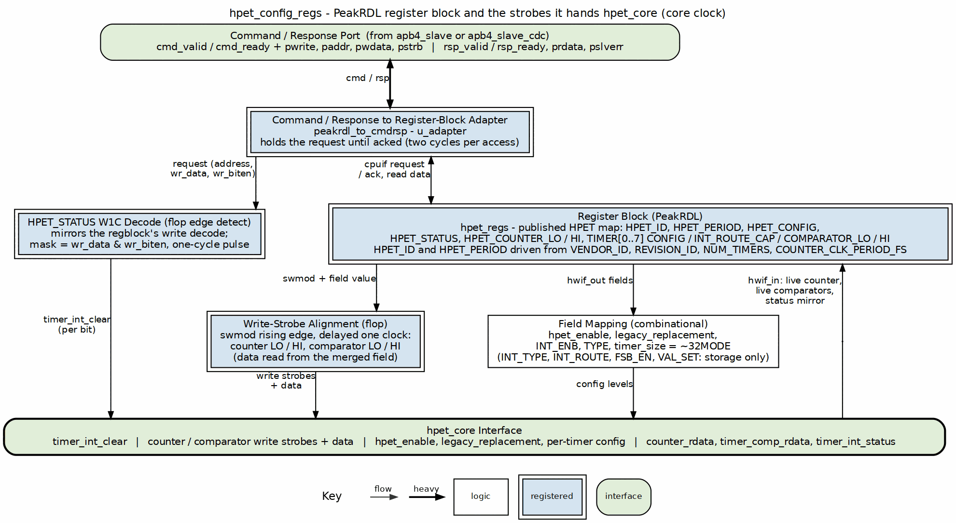
HPET Config Registers Block Diagram
Figure: HPET Config Registers architecture showing APB interface, PeakRDL registers, edge detection, per-timer data buses, and W1C logic. Source: assets/graphviz/hpet_config_regs.dot

9.1.2 Key Responsibilities
- PeakRDL Integration: Instantiates hpet_regs.sv and peakrdl_to_cmdrsp adapter
- Interface Mapping: Converts PeakRDL hardware interface to HPET core signals
- Per-Timer Data Buses: Implements dedicated 64-bit data paths per timer (prevents corruption)
- Write Strobes: Rising-edge detects the register block’s swmod levels and aligns each to the cycle the field presents the written value – one strobe per 32-bit half
- Counter Write Handling: Hands the just-written counter half to the core, byte strobes already merged by the register block
- Interrupt Management: Mirrors the core’s sticky status into HPET_STATUS and decodes the W1C write into a per-bit, one-cycle clear
- Identification: Drives HPET_ID’s vendor, revision and timer-count fields from the module parameters

9.2 Parameters
Parameter | Type | Default | Range | Description
VENDOR_ID | int | 1 | 0-65535 | Drives HPET_ID[31:16] via hwif_in – the spec’s full 16-bit vendor field
REVISION_ID | int | 1 | 0-255 | Drives HPET_ID[7:0] via hwif_in
COUNTER_CLK_PERIOD_FS | int | 10000000 | non-zero, <= 0x05F5E100 | Drives HPET_PERIOD (GCAP_ID[63:32]) via hwif_in, in femtoseconds
NUM_TIMERS | int | 2 | 2, 3, 8 | Number of independent timers in array

9.3 Ports

9.3.1 Clock and Reset
Signal Name | Type | Width | Direction | Description
clk | logic | 1 | Input | Configuration clock (pclk or hpet_clk based on CDC_ENABLE)
rst_n | logic | 1 | Input | Active-low asynchronous reset

9.3.2 Command/Response Interface (from APB Slave)
Signal Name | Type | Width | Direction | Description
cmd_valid | logic | 1 | Input | Command valid
cmd_ready | logic | 1 | Output | Command ready
cmd_pwrite | logic | 1 | Input | Command write (1) or read (0)
cmd_paddr | logic | 12 | Input | Command address
cmd_pwdata | logic | 32 | Input | Command write data
cmd_pstrb | logic | 4 | Input | Command write byte strobes
rsp_valid | logic | 1 | Output | Response valid
rsp_ready | logic | 1 | Input | Response ready
rsp_prdata | logic | 32 | Output | Response read data
rsp_pslverr | logic | 1 | Output | Response error flag

9.3.3 HPET Core Interface (to hpet_core.sv)
Global Configuration:
Signal Name | Type | Width | Direction | Description
hpet_enable | logic | 1 | Output | Global HPET enable (from HPET_CONFIG[0])
legacy_replacement | logic | 1 | Output | LegacyReplacement Route enable (from HPET_CONFIG[1]); hpet_core routes timer 0 to legacy_irq0 and timer 1 to legacy_irq8 and suppresses both on timer_irq
Counter Interface:
Signal Name | Type | Width | Direction | Description
counter_write_lo | logic | 1 | Output | One-cycle strobe: HPET_COUNTER_LO was written
counter_write_hi | logic | 1 | Output | One-cycle strobe: HPET_COUNTER_HI was written
counter_wdata | logic | 64 | Output | Counter write data ({HI, LO} field values; the strobed half is the just-written value)
counter_rdata | logic | 64 | Input | Live counter value (from hpet_core)
Per-Timer Configuration:
Signal Name | Type | Width | Direction | Description
timer_int_enable[NUM_TIMERS-1:0] | logic | NUM_TIMERS | Output | Per-timer interrupt enable (from TIMER_CONFIG[2]). The ONLY per-timer enable the spec defines – there is no per-timer RUN enable
timer_type[NUM_TIMERS-1:0] | logic | NUM_TIMERS | Output | Per-timer mode: 0=One-shot, 1=Periodic (from TIMER_CONFIG[3])
timer_size[NUM_TIMERS-1:0] | logic | NUM_TIMERS | Output | Compare WIDTH for hpet_core: 1=64-bit. Derived as ~TIMER_CONFIG[8] – the spec’s 32MODE bit FORCES 32-bit, so its polarity is the inverse
timer_value_set[NUM_TIMERS-1:0] | logic | NUM_TIMERS | Output | From TIMER_CONFIG[6]. Currently unconsumed: the wire dead-ends at the top level (hpet_core has no such input), so the bit stores and reads back with no hardware effect
Per-Timer Comparator (Dedicated Buses):
Signal Name | Type | Width | Direction | Description
timer_comp_write_lo[NUM_TIMERS-1:0] | logic | NUM_TIMERS | Output | Per-timer one-cycle strobe: TIMER_COMPARATOR_LO written
timer_comp_write_hi[NUM_TIMERS-1:0] | logic | NUM_TIMERS | Output | Per-timer one-cycle strobe: TIMER_COMPARATOR_HI written
timer_comp_wdata[NUM_TIMERS] | logic [63:0] | NUM_TIMERS×64 | Output | Per-timer comparator data (LO/HI combined)
Interrupt Status:
Signal Name | Type | Width | Direction | Description
timer_int_status[NUM_TIMERS-1:0] | logic | NUM_TIMERS | Input | Per-timer sticky status (from hpet_core; mirrored into HPET_STATUS)
timer_int_clear[NUM_TIMERS-1:0] | logic | NUM_TIMERS | Output | Per-bit one-cycle clear pulse (the bits written with 1)

9.4 Functional Description

9.4.1 Internal Architecture

9.4.1.1 Component Instantiation
1. Protocol Adapter:
peakrdl_to_cmdrsp #(
.ADDR_WIDTH(12),
.DATA_WIDTH(32)
) u_adapter (
.aclk(clk), .aresetn(rst_n),
// cmd/rsp interface (external)
.cmd_valid, .cmd_ready, .cmd_pwrite, .cmd_paddr, .cmd_pwdata, .cmd_pstrb,
.rsp_valid, .rsp_ready, .rsp_prdata, .rsp_pslverr,
// PeakRDL passthrough interface (to register block)
.regblk_req, .regblk_req_is_wr, .regblk_addr, .regblk_wr_data, .regblk_wr_biten,
.regblk_req_stall_wr, .regblk_req_stall_rd,
.regblk_rd_ack, .regblk_rd_err, .regblk_rd_data,
.regblk_wr_ack, .regblk_wr_err
);
2. PeakRDL Register Block:
hpet_regs u_hpet_regs (
.clk(clk),
.rst(~rst_n), // PeakRDL uses active-high reset
// Passthrough CPU interface
.s_cpuif_req(regblk_req),
.s_cpuif_req_is_wr(regblk_req_is_wr),
.s_cpuif_addr(regblk_addr[8:0]), // 9-bit internal addressing
.s_cpuif_wr_data(regblk_wr_data),
.s_cpuif_wr_biten(regblk_wr_biten),
.s_cpuif_req_stall_wr(regblk_req_stall_wr),
.s_cpuif_req_stall_rd(regblk_req_stall_rd),
.s_cpuif_rd_ack(regblk_rd_ack),
.s_cpuif_rd_err(regblk_rd_err),
.s_cpuif_rd_data(regblk_rd_data),
.s_cpuif_wr_ack(regblk_wr_ack),
.s_cpuif_wr_err(regblk_wr_err),
// Hardware interface
.hwif_in(hwif_in),
.hwif_out(hwif_out)
);

9.4.2 Mapping Logic Details

9.4.2.1 Global Configuration Mapping
Direct assignment from PeakRDL outputs:
assign hpet_enable = hwif_out.HPET_CONFIG.hpet_enable.value;
assign legacy_replacement = hwif_out.HPET_CONFIG.legacy_replacement.value;
legacy_replacement reaches hardware since RLB/hpet TASK-003; it is no longer storage, and HPET_ID.leg_rt_cap reads 1 to advertise it.

9.4.2.2 Counter Write Strobes
Everything this block hands to hpet_core is driven by the register WRITE, never by a change in a stored value. The register block exports swmod for HPET_COUNTER_LO/HI and every TIMER_COMPARATOR_LO/HI, and two corrections are needed before it can be used as an operation pulse:
- It is a level, not a pulse. peakrdl_to_cmdrsp deliberately holds regblk_req from the accept cycle through its wait-for-ack state, so swmod is asserted for the whole transaction – two cycles.
- It leads the field by one cycle. swmod is high while the field is still taking the written value.
So each strobe is a rising-edge detect on the swmod level (one transaction, one pulse) delayed one flop, which lands it in the cycle where the field presents the newly written value. The strobe’s data is then read straight out of the field, which is what makes byte strobes work: the register block has already merged (value & ~biten) | (wr_data & biten), where sampling regblk_wr_data raw would write whole 32-bit words on a partial-byte write. That value is the field’s own mirror, which on a running counter is a cycle behind the live count – so a partial (PSTRB != 0xF) counter write is only exact with the counter halted (chapter 5, HPET_COUNTER_LO usage notes).
The upstream cpuif must drop regblk_req between transactions, or two back-to-back writes to one register would look like one long level and produce a single strobe. apb4_slave and apb4_slave_cdc are both strictly one-outstanding, so it holds; simulation-only assertions in the module trip if a swmod level ever spans three cycles.
Counter write strobes: each half is loaded on its OWN aligned strobe, from its OWN field, so a “write LO then write HI” sequence lands both halves and the core never sees a stale partner:
assign w_counter_lo_swmod = hwif_out.HPET_COUNTER_LO.counter_lo.swmod;
assign w_counter_hi_swmod = hwif_out.HPET_COUNTER_HI.counter_hi.swmod;
always_ff @(posedge clk or negedge rst_n) begin
if (!rst_n) begin
r_counter_lo_swmod_d <= 1'b0;
r_counter_hi_swmod_d <= 1'b0;
counter_write_lo <= 1'b0;
counter_write_hi <= 1'b0;
end else begin
r_counter_lo_swmod_d <= w_counter_lo_swmod;
r_counter_hi_swmod_d <= w_counter_hi_swmod;
counter_write_lo <= w_counter_lo_swmod & ~r_counter_lo_swmod_d;
counter_write_hi <= w_counter_hi_swmod & ~r_counter_hi_swmod_d;
end
end
// In the aligned strobe cycle the field holds the value the write just
// committed; one cycle later the hardware write-back resumes mirroring
// the live counter.
assign counter_wdata = {hwif_out.HPET_COUNTER_HI.counter_hi.value,
hwif_out.HPET_COUNTER_LO.counter_lo.value};

9.4.3 Figure 2.19: Counter Write Strobe Timing
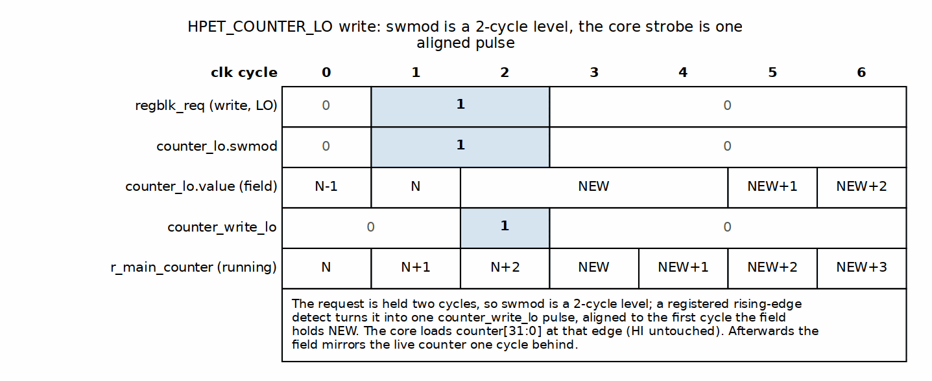
Counter Write Strobe Timing

9.4.3.1 Timer Configuration Mapping
Per-timer array mapping:
generate
for (genvar i = 0; i < NUM_TIMERS; i++) begin : g_timer_mapping
assign timer_int_enable[i] = hwif_out.TIMER[i].TIMER_CONFIG.timer_int_enable.value;
assign timer_type[i] = hwif_out.TIMER[i].TIMER_CONFIG.timer_type.value;
// POLARITY INVERSION: 32MODE = 1 FORCES 32-bit, timer_size = 1 means 64-bit
assign timer_size[i] = ~hwif_out.TIMER[i].TIMER_CONFIG.timer_32mode.value;
assign timer_value_set[i] = hwif_out.TIMER[i].TIMER_CONFIG.timer_value_set.value;
end
endgenerate

9.4.3.2 Per-Timer Data Bus Architecture (Corruption Fix)
The Problem: Early designs shared a single 64-bit bus for all timer comparators. Rapid writes to different timers caused corruption when one timer’s data overwrote another timer’s registers.
The Solution: Each timer gets a dedicated 64-bit data bus, preventing any possibility of cross-timer corruption:
// CORRECT: Per-timer dedicated data buses
generate
for (genvar i = 0; i < NUM_TIMERS; i++) begin : g_timer_wdata
assign timer_comp_wdata[i] = {
hwif_out.TIMER[i].TIMER_COMPARATOR_HI.timer_comp_hi.value,
hwif_out.TIMER[i].TIMER_COMPARATOR_LO.timer_comp_lo.value
};
end
endgenerate
// Per-timer write strobes: the same swmod rising-edge-plus-one-flop
// alignment as the counter, one strobe per half. The comparator fields
// are hw = r, so the value is simply whatever software last wrote; the
// STROBE is what tells the core to reload it, which is what makes
// rewriting the same value reload it. Whether the reload also re-arms
// the timer is the core's decision (only while the counter is halted).
generate
for (genvar i = 0; i < NUM_TIMERS; i++) begin : g_timer_mapping
assign w_comp_lo_swmod[i] = hwif_out.TIMER[i].TIMER_COMPARATOR_LO.timer_comp_lo.swmod;
assign w_comp_hi_swmod[i] = hwif_out.TIMER[i].TIMER_COMPARATOR_HI.timer_comp_hi.swmod;
end
endgenerate
always_ff @(posedge clk or negedge rst_n) begin
if (!rst_n) begin
r_comp_lo_swmod_d <= '0;
r_comp_hi_swmod_d <= '0;
timer_comp_write_lo <= '0;
timer_comp_write_hi <= '0;
end else begin
r_comp_lo_swmod_d <= w_comp_lo_swmod;
r_comp_hi_swmod_d <= w_comp_hi_swmod;
timer_comp_write_lo <= w_comp_lo_swmod & ~r_comp_lo_swmod_d;
timer_comp_write_hi <= w_comp_hi_swmod & ~r_comp_hi_swmod_d;
end
end
Architecture Benefit: each timer has its own comparator write-data bus, so a write to one timer can never land in another:
- Timer 0: hwif.TIMER[0].COMP_LO/HI -> timer_comp_wdata[0] -> hpet_core timer 0 only
- Timer 1: hwif.TIMER[1].COMP_LO/HI -> timer_comp_wdata[1] -> hpet_core timer 1 only
- Timer 2: hwif.TIMER[2].COMP_LO/HI -> timer_comp_wdata[2] -> hpet_core timer 2 only

9.4.3.3 Interrupt Status Handling
HPET_STATUS is a mirror. hpet_core owns the sticky interrupt status. The register’s field is driven from the core’s live level every cycle (hw = w), and the software write is turned into a per-bit clear pulse into the core. The field is a fixed 8 bits wide regardless of NUM_TIMERS; zero-extending here is what keeps the bits with no timer behind them reading 0 forever.
// Mirror out: the core's level, zero-extended to the 8-bit field
always_comb begin
w_timer_int_status_reg = '0;
w_timer_int_status_reg[NUM_TIMERS-1:0] = timer_int_status;
end
assign hwif_in.HPET_STATUS.timer_int_status.next = w_timer_int_status_reg;
Interrupt Clearing (W1C, per bit):
The clear mask comes from the write itself – regblk_wr_data & regblk_wr_biten, masked to NUM_TIMERS bits – so a bit clears only if software wrote a 1 to it, and a write of 0x0 is the no-op W1C requires. The write is detected by mirroring the register block’s own address decode rather than through swmod (whose extra |biten term makes it a different decode); a simulation-only assertion guards the two against drifting apart.
// Mirror of the regblock's decode for HPET_STATUS (offset 0x020)
assign w_status_sw_wr = regblk_req && regblk_req_is_wr &&
(regblk_addr[8:0] == ADDR_HPET_STATUS);
// One event per transaction: the request is held for two cycles, and a
// clear that spanned both would undo a fire the core accepted in the first
assign w_status_wr_event = w_status_sw_wr & ~r_status_sw_wr_d;
// Per-bit W1C mask from the write being committed
assign w_status_w1c_mask = regblk_wr_data[NUM_TIMERS-1:0] &
regblk_wr_biten[NUM_TIMERS-1:0];
assign timer_int_clear = w_status_wr_event ? w_status_w1c_mask : '0;
The clear is narrowed to ONE cycle even though the mask makes it idempotent: a two-cycle level would eat a fire that landed in its first cycle (the core sets the bit, the level’s second cycle clears it again). One cycle here plus fire-over-clear priority in the core closes that window.

9.4.4 Figure 2.20: HPET_STATUS Mirror and W1C Clear Timing
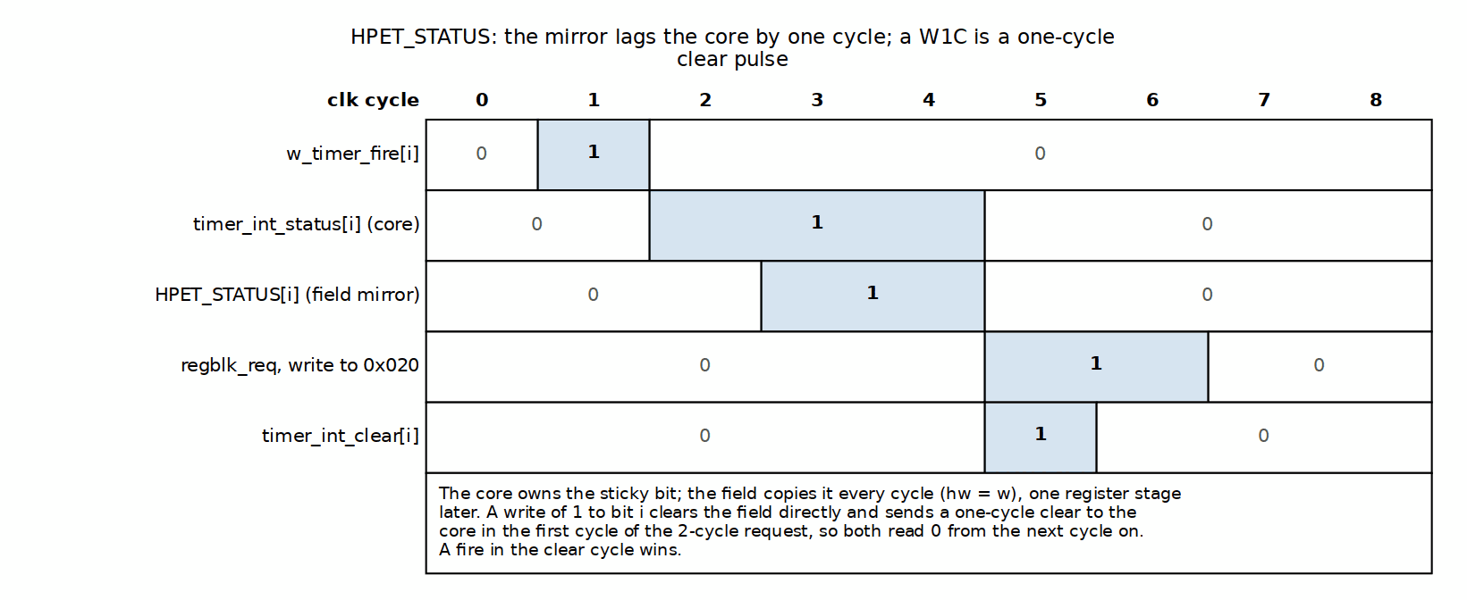
HPET_STATUS Mirror and W1C Clear Timing

9.4.5 Register-to-Core Signal Summary
Critical Signals:
- hpet_enable: Level signal, directly gates counter incrementing
- counter_write_lo / counter_write_hi: Pulse (1 cycle) per counter half written
- counter_wdata: The field values, valid for the strobed half in the strobe cycle
- timer_int_enable[i]: Level signal per timer (no per-timer RUN enable exists)
- timer_comp_write_lo/hi[i]: Pulse (1 cycle) per comparator half written
- timer_comp_wdata[i]: Per-timer dedicated data bus (corruption-proof)
- timer_int_clear[i]: Pulse (1 cycle) for the status bits written with 1
Signal Types: - Level Signals: Direct PeakRDL .value outputs (enable, type, size) - Pulse Signals: Rising-edge detects on the swmod write levels (strobes) or on the mirrored HPET_STATUS write decode (clear) – never on a value change - Data Buses: Combined register field values (counter, comparators)

9.5 Design Notes

9.5.1 Resource Utilization
Configuration Register Logic (hpet_config_regs only, excluding hpet_regs):
Component | NUM_TIMERS=2 | NUM_TIMERS=3 | NUM_TIMERS=8
Mapping Logic | ~50 FF, ~100 LUTs | ~75 FF, ~150 LUTs | ~150 FF, ~300 LUTs
Edge Detect | ~10 FF, ~20 LUTs | ~15 FF, ~30 LUTs | ~30 FF, ~60 LUTs
Interrupt Handling | ~10 FF, ~20 LUTs | ~15 FF, ~30 LUTs | ~30 FF, ~60 LUTs
Total | ~70 FF, ~140 LUTs | ~105 FF, ~210 LUTs | ~210 FF, ~420 LUTs
Scaling: Primarily driven by number of timers. Each additional timer adds ~35 FF and ~70 LUTs for mapping and edge detection logic.

9.6 Navigation
Next: Chapter 2.3 - hpet_regs (PeakRDL)

RTL Design Sherpa · Learning Hardware Design Through Practice GitHub · Documentation Index · MIT License

10 hpet_regs

10.1 Overview
The hpet_regs module is auto-generated from the SystemRDL specification (rdl/hpet/hpet_regs.rdl) using the PeakRDL toolchain. It implements the complete HPET register file with proper field access semantics (RO, RW, W1C), hardware interface integration, and CPU interface protocol handling.
Single Source of Truth: All register definitions, addresses, field widths, and access properties are specified in the SystemRDL file. The generated RTL is deterministic and regeneratable – which means the .rdl file is where you make changes, never the generated output.
Generation Command:
cd projects/components/legacy-ip/retro_legacy_blocks/rtl/hpet/peakrdl
peakrdl regblock hpet_regs.rdl --cpuif passthrough -o ../
Generated Files: - hpet_regs.sv - Register implementation - hpet_regs_pkg.sv - Package with structs and parameters

10.2 Parameters
No user-configurable parameters. All configuration is baked into the generated code from SystemRDL.
Compile-Time Constants (from SystemRDL):
localparam VENDOR_ID = 1; // From RDL: vendor_id reset default
localparam REVISION_ID = 1; // From RDL: rev_id reset default
localparam NUM_TIMERS = 8; // From RDL: TIMER[0:7] array size
Note: These are fixed at generation time, but none of them decides what an instance reports. The block is generated once for 8 timer slots, and num_tim_cap, vendor_id and rev_id are all hw = w fields driven through hwif_in from the wrapper’s NUM_TIMERS/VENDOR_ID/REVISION_ID parameters – so the same generated RTL serves every instantiation.

10.3 Ports

10.3.1 Clock and Reset
Signal Name | Type | Width | Direction | Description
clk | wire | 1 | Input | Register clock (pclk or hpet_clk based on CDC_ENABLE)
rst | wire | 1 | Input | Active-high reset (PeakRDL convention)
Caveat: PeakRDL uses active-high reset. The wrapper (hpet_config_regs.sv) inverts rst_n before connecting.

10.3.2 CPU Interface (Passthrough Protocol)
Signal Name | Type | Width | Direction | Description
s_cpuif_req | wire | 1 | Input | CPU request valid
s_cpuif_req_is_wr | wire | 1 | Input | Request is write (1) or read (0)
s_cpuif_addr | wire | 9 | Input | Address (byte-aligned, bits [8:0])
s_cpuif_wr_data | wire | 32 | Input | Write data
s_cpuif_wr_biten | wire | 32 | Input | Write byte enable (bit-level)
s_cpuif_req_stall_wr | wire | 1 | Output | Stall write request (always 0 for HPET)
s_cpuif_req_stall_rd | wire | 1 | Output | Stall read request (always 0 for HPET)
s_cpuif_rd_ack | wire | 1 | Output | Read acknowledgment
s_cpuif_rd_err | wire | 1 | Output | Read error (decoding error)
s_cpuif_rd_data | wire | 32 | Output | Read data
s_cpuif_wr_ack | wire | 1 | Output | Write acknowledgment
s_cpuif_wr_err | wire | 1 | Output | Write error (always 0 for HPET)
Protocol Characteristics: - Latency: 1 cycle for both reads and writes - Stalls: Never stall (HPET registers have single-cycle access) - Errors: None – both error outputs are tied to 0 (cpuif_wr_err = 0, readback_err = 0); no address raises PSLVERR, and addresses above 0x1FF alias the map (only addr[8:0] is decoded)

10.3.3 Hardware Interface (Structs)
input hpet_regs_pkg::hpet_regs__in_t hwif_in; // From hardware to registers
output hpet_regs_pkg::hpet_regs__out_t hwif_out; // From registers to hardware
Structure Definitions (in hpet_regs_pkg.sv):
The package defines comprehensive structs for all registers and fields. Key excerpts:
package hpet_regs_pkg;
// ILLUSTRATIVE SKETCH -- the generated package uses UNPACKED structs
// with per-field typedef names (hpet_regs__<REG>__<field>__in_t); see
// rtl/hpet/hpet_regs_pkg.sv for the literal shapes. One notable
// difference from this sketch: the timer array is
// hpet_regs__timer_regfile__out_t TIMER[8].
typedef struct {
struct packed {
logic [4:0] next; // num_tim_cap field value
} num_tim_cap;
struct packed {
logic [7:0] next; // rev_id, from the REVISION_ID parameter
} rev_id;
struct packed {
logic [15:0] next; // vendor_id, from the VENDOR_ID parameter (GCAP_ID[31:16])
} vendor_id;
} HPET_ID__in_t;
typedef struct packed {
logic [7:0] next; // Live status level from hpet_core (mirror)
} timer_int_status__in_t;
typedef struct packed {
logic [31:0] next; // Next counter value
} counter_lo__in_t;
// ... additional field structs ...
// Complete input struct
typedef struct packed {
HPET_ID__in_t HPET_ID;
timer_int_status__in_t HPET_STATUS.timer_int_status;
counter_lo__in_t HPET_COUNTER_LO.counter_lo;
counter_hi__in_t HPET_COUNTER_HI.counter_hi;
// ... additional register fields ...
} hpet_regs__in_t;
// Hardware output struct (registers -> hardware)
typedef struct packed {
struct packed {
logic value; // Current field value
} hpet_enable;
struct packed {
logic value;
} legacy_replacement;
} HPET_CONFIG__out_t;
typedef struct packed {
logic swmod; // Software modified (write detected)
} timer_int_status__out_t;
typedef struct packed {
logic [31:0] value; // Current register value
logic swmod; // Software modified
} counter_lo__out_t;
// ... additional field structs ...
// Complete output struct
typedef struct packed {
HPET_CONFIG__out_t HPET_CONFIG;
timer_int_status__out_t HPET_STATUS.timer_int_status;
counter_lo__out_t HPET_COUNTER_LO.counter_lo;
counter_hi__out_t HPET_COUNTER_HI.counter_hi;
TIMER__out_t TIMER[7:0]; // Timer array
// ... additional registers ...
} hpet_regs__out_t;
endpackage

10.4 Functional Description

10.4.1 Register Implementation

10.4.1.1 Address Decoding
PeakRDL generates a decoded register strobe struct:
typedef struct {
logic HPET_ID;
logic HPET_CONFIG;
logic HPET_STATUS;
logic RESERVED_0C;
logic HPET_COUNTER_LO;
logic HPET_COUNTER_HI;
struct {
logic TIMER_CONFIG;
logic TIMER_COMPARATOR_LO;
logic TIMER_COMPARATOR_HI;
logic RESERVED;
} TIMER[8];
} decoded_reg_strb_t;
decoded_reg_strb_t decoded_reg_strb;
Decoding Logic:
always_comb begin
decoded_reg_strb.HPET_ID = cpuif_req_masked & (cpuif_addr == 9'h0);
decoded_reg_strb.HPET_CONFIG = cpuif_req_masked & (cpuif_addr == 9'h4);
decoded_reg_strb.HPET_STATUS = cpuif_req_masked & (cpuif_addr == 9'h8);
decoded_reg_strb.RESERVED_0C = cpuif_req_masked & (cpuif_addr == 9'hc);
decoded_reg_strb.HPET_COUNTER_LO = cpuif_req_masked & (cpuif_addr == 9'h10);
decoded_reg_strb.HPET_COUNTER_HI = cpuif_req_masked & (cpuif_addr == 9'h14);
for(int i0=0; i0<8; i0++) begin
decoded_reg_strb.TIMER[i0].TIMER_CONFIG =
cpuif_req_masked & (cpuif_addr == 9'h100 + (9)'(i0) * 9'h20);
decoded_reg_strb.TIMER[i0].TIMER_COMPARATOR_LO =
cpuif_req_masked & (cpuif_addr == 9'h104 + (9)'(i0) * 9'h20);
decoded_reg_strb.TIMER[i0].TIMER_COMPARATOR_HI =
cpuif_req_masked & (cpuif_addr == 9'h108 + (9)'(i0) * 9'h20);
decoded_reg_strb.TIMER[i0].RESERVED =
cpuif_req_masked & (cpuif_addr == 9'h10c + (9)'(i0) * 9'h20);
end
end

10.4.1.2 Field Logic
Each field is implemented with: - Combo Logic: Determines next value based on SW write, HW input, or current value - Sequential Logic: Stores field value in flip-flops - Output Assignment: Drives hwif_out struct
Example - HPET_CONFIG.hpet_enable Field:
// Field: hpet_regs.HPET_CONFIG.hpet_enable
always_comb begin
automatic logic [0:0] next_c;
automatic logic load_next_c;
next_c = field_storage.HPET_CONFIG.hpet_enable.value; // Default: hold
load_next_c = '0;
if(decoded_reg_strb.HPET_CONFIG && decoded_req_is_wr) begin // SW write
next_c = (field_storage.HPET_CONFIG.hpet_enable.value & ~decoded_wr_biten[0:0]) |
(decoded_wr_data[0:0] & decoded_wr_biten[0:0]);
load_next_c = '1;
end
field_combo.HPET_CONFIG.hpet_enable.next = next_c;
field_combo.HPET_CONFIG.hpet_enable.load_next = load_next_c;
end
always_ff @(posedge clk) begin
if(rst) begin
field_storage.HPET_CONFIG.hpet_enable.value <= 1'h0; // Reset value
end else begin
if(field_combo.HPET_CONFIG.hpet_enable.load_next) begin
field_storage.HPET_CONFIG.hpet_enable.value <= field_combo.HPET_CONFIG.hpet_enable.next;
end
end
end
assign hwif_out.HPET_CONFIG.hpet_enable.value = field_storage.HPET_CONFIG.hpet_enable.value;
Example - HPET_STATUS.timer_int_status Field (W1C mirror of a hardware level):
// Field: hpet_regs.HPET_STATUS.timer_int_status
always_comb begin
automatic logic [7:0] next_c;
automatic logic load_next_c;
next_c = field_storage.HPET_STATUS.timer_int_status.value;
load_next_c = '0;
if(decoded_reg_strb.HPET_STATUS && decoded_req_is_wr) begin // SW write 1 to clear
next_c = field_storage.HPET_STATUS.timer_int_status.value &
~(decoded_wr_data[7:0] & decoded_wr_biten[7:0]);
load_next_c = '1;
end else begin // HW write: follow the core's live level
next_c = hwif_in.HPET_STATUS.timer_int_status.next;
load_next_c = '1;
end
field_combo.HPET_STATUS.timer_int_status.next = next_c;
field_combo.HPET_STATUS.timer_int_status.load_next = load_next_c;
end
always_ff @(posedge clk) begin
if(rst) begin
field_storage.HPET_STATUS.timer_int_status.value <= 8'h0;
end else begin
if(field_combo.HPET_STATUS.timer_int_status.load_next) begin
field_storage.HPET_STATUS.timer_int_status.value <= field_combo.HPET_STATUS.timer_int_status.next;
end
end
end
// swmod: the write decode with an extra |biten term. The wrapper mirrors
// the decode itself for the W1C clear and uses swmod only as a drift guard.
assign hwif_out.HPET_STATUS.timer_int_status.swmod =
decoded_reg_strb.HPET_STATUS && decoded_req_is_wr && |(decoded_wr_biten[7:0]);
There is no sticky/hwset in this field, on purpose. PeakRDL renders a multi-bit sticky field as “load next only while the register reads all-zero, otherwise set ALL bits on hwset”, which sets every bit whenever a second timer fires with an earlier one still pending. hpet_core owns the sticky state instead, and this field mirrors it – note the software W1C branch still wins over the mirror in its own cycle (precedence = sw), and the core drops the bit the cycle after, so the two agree from then on.
Example - HPET_COUNTER_LO Field (HW write with SW precedence):
// Field: hpet_regs.HPET_COUNTER_LO.counter_lo
always_comb begin
automatic logic [31:0] next_c;
automatic logic load_next_c;
next_c = field_storage.HPET_COUNTER_LO.counter_lo.value;
load_next_c = '0;
if(decoded_reg_strb.HPET_COUNTER_LO && decoded_req_is_wr) begin // SW write
next_c = (field_storage.HPET_COUNTER_LO.counter_lo.value & ~decoded_wr_biten[31:0]) |
(decoded_wr_data[31:0] & decoded_wr_biten[31:0]);
load_next_c = '1;
end else begin // HW write (precedence=sw means HW writes unless SW writes)
next_c = hwif_in.HPET_COUNTER_LO.counter_lo.next;
load_next_c = '1;
end
field_combo.HPET_COUNTER_LO.counter_lo.next = next_c;
field_combo.HPET_COUNTER_LO.counter_lo.load_next = load_next_c;
end
always_ff @(posedge clk) begin
if(rst) begin
field_storage.HPET_COUNTER_LO.counter_lo.value <= 32'h0;
end else begin
if(field_combo.HPET_COUNTER_LO.counter_lo.load_next) begin
field_storage.HPET_COUNTER_LO.counter_lo.value <= field_combo.HPET_COUNTER_LO.counter_lo.next;
end
end
end
assign hwif_out.HPET_COUNTER_LO.counter_lo.value = field_storage.HPET_COUNTER_LO.counter_lo.value;
assign hwif_out.HPET_COUNTER_LO.counter_lo.swmod =
decoded_reg_strb.HPET_COUNTER_LO && decoded_req_is_wr && |(decoded_wr_biten[31:0]);

10.4.1.3 Read Response Logic
PeakRDL generates readback arrays for all registers:
// Assign readback values to a flattened array
logic [31:0] readback_array[38];
// Global registers
assign readback_array[0][7:0] = (decoded_reg_strb.HPET_ID && !decoded_req_is_wr) ?
hwif_in.HPET_ID.rev_id.next : '0;
assign readback_array[0][12:8] = (decoded_reg_strb.HPET_ID && !decoded_req_is_wr) ?
hwif_in.HPET_ID.num_tim_cap.next : '0;
assign readback_array[0][13:13] = (decoded_reg_strb.HPET_ID && !decoded_req_is_wr) ? 1'h1 : '0; // count_size_cap
assign readback_array[0][14:14] = (decoded_reg_strb.HPET_ID && !decoded_req_is_wr) ? 1'h0 : '0; // reserved
assign readback_array[0][15:15] = (decoded_reg_strb.HPET_ID && !decoded_req_is_wr) ? 1'h1 : '0; // leg_rt_cap
assign readback_array[0][31:16] = (decoded_reg_strb.HPET_ID && !decoded_req_is_wr) ?
hwif_in.HPET_ID.vendor_id.next : '0;
// Config/status registers
assign readback_array[2][0:0] = (decoded_reg_strb.HPET_CONFIG && !decoded_req_is_wr) ?
field_storage.HPET_CONFIG.hpet_enable.value : '0;
assign readback_array[3][7:0] = (decoded_reg_strb.HPET_STATUS && !decoded_req_is_wr) ?
field_storage.HPET_STATUS.timer_int_status.value : '0;
// Counter registers
assign readback_array[4][31:0] = (decoded_reg_strb.HPET_COUNTER_LO && !decoded_req_is_wr) ?
field_storage.HPET_COUNTER_LO.counter_lo.value : '0;
assign readback_array[5][31:0] = (decoded_reg_strb.HPET_COUNTER_HI && !decoded_req_is_wr) ?
field_storage.HPET_COUNTER_HI.counter_hi.value : '0;
// Per-timer registers
for(genvar i0=0; i0<8; i0++) begin
assign readback_array[i0 * 4 + 6][2:2] = (decoded_reg_strb.TIMER[i0].TIMER_CONFIG && !decoded_req_is_wr) ?
field_storage.TIMER[i0].TIMER_CONFIG.timer_int_enable.value : '0;
// ... additional timer fields ...
end
// Reduce array via OR (only one element active at a time)
always_comb begin
automatic logic [31:0] readback_data_var;
readback_done = decoded_req & ~decoded_req_is_wr;
readback_err = '0;
readback_data_var = '0;
for(int i=0; i<38; i++) readback_data_var |= readback_array[i];
readback_data = readback_data_var;
end
assign cpuif_rd_ack = readback_done;
assign cpuif_rd_data = readback_data;
assign cpuif_rd_err = readback_err;

10.4.2 Field Access Semantics

10.4.2.1 Read-Only (RO)
Characteristics: - Software reads return hardware-driven value - Software writes are ignored (no effect) - Hardware controls value via hwif_in
Example: HPET_ID register
// RO fields: vendor_id, rev_id, num_tim_cap are hw = w, driven from the
// wrapper's parameters; leg_rt_cap and count_size_cap are constants
// Software can read, but writes have no effect

10.4.2.2 Read-Write (RW)
Characteristics: - Software can read and write - Default next value is current value - Software write updates value - Reset value specified in RDL
Example: HPET_CONFIG.hpet_enable
// RW field: Software can enable/disable HPET
// Reset value: 0 (disabled)

10.4.2.3 Write-1-to-Clear (W1C)
Characteristics: - Software writes 1 to clear bit - Software writes 0 have no effect - Hardware drives the live level via hwif_in.next; the field mirrors it - The sticky state itself lives in hpet_core, not here
Example: HPET_STATUS.timer_int_status
// W1C mirror: software writes 1 to clear the bit; the wrapper forwards
// that write to hpet_core as a per-bit clear, and hardware re-drives the
// field from the core's level every cycle

10.4.2.4 Hardware Write with Software Precedence
Characteristics: - Hardware continuously writes value via hwif_in.next - Software write takes precedence - Used for live counter readback
Example: HPET_COUNTER_LO/HI
// hw=w, precedence=sw
// Hardware writes counter value every cycle
// Software write overrides hardware write

10.4.3 SystemRDL Specification
Source File: rdl/hpet/hpet_regs.rdl
Key RDL Properties Used:
addrmap hpet_regs {
name = "HPET Register Block";
desc = "High Precision Event Timer registers";
default regwidth = 32; // All registers 32-bit
default accesswidth = 32; // Single-beat access
// Read-only identification
reg {
field {
hw = w; // Driven from the VENDOR_ID parameter
sw = r; // Software read-only
} vendor_id[31:16] = VENDOR_ID; // spec's full 16-bit vendor field
field {
hw = w; sw = r; // Driven from the REVISION_ID parameter
} rev_id[7:0] = REVISION_ID;
field {
hw = w; // Hardware controls value
sw = r; // Software can only read
} num_tim_cap[12:8];
field {
hw = na; sw = r; // Reads 1: legacy replacement IS routed
} leg_rt_cap[15:15] = 1'b1;
} HPET_ID @ 0x000;
// Read-write configuration
reg {
field {
sw = rw; // Software read-write
hw = r; // Hardware reads value
} hpet_enable[0:0] = 1'b0;
field {
sw = rw; hw = r;
} legacy_replacement[1:1] = 1'b0;
} HPET_CONFIG @ 0x010;
// Write-1-to-clear status: a MIRROR of hpet_core's sticky status
reg {
field {
sw = rw;
hw = w; // Hardware writes the core's live level
precedence = sw; // The W1C write wins in its cycle
onwrite = woclr; // Write 1 to clear
swmod; // Drift guard for the wrapper's decode
} timer_int_status[NUM_TIMERS-1:0] = 0; // no sticky, no hwset
} HPET_STATUS @ 0x020;
// Hardware-written counter with software override
reg {
field {
sw = rw; // Software can write
hw = rw; // Hardware writes every cycle, reads it back
precedence = sw; // Software write takes priority
swmod; // Write STROBE into hpet_core
} counter_lo[31:0] = 32'h0;
} HPET_COUNTER_LO @ 0x0F0;
// Per-timer array
regfile {
reg {
field { sw = rw; hw = r; } timer_int_type[1:1] = 1'b0;
field { sw = rw; hw = r; } timer_int_enable[2:2] = 1'b0;
field { sw = rw; hw = r; } timer_type[3:3] = 1'b0;
field { sw = r; hw = na; } per_int_cap[4:4] = 1'b1; // RO capability
field { sw = r; hw = na; } size_cap[5:5] = 1'b1; // RO capability
field { sw = rw; hw = r; } timer_value_set[6:6] = 1'b0;
field { sw = rw; hw = r; } timer_32mode[8:8] = 1'b0; // 1 FORCES 32-bit
field { sw = rw; hw = r; } timer_int_route[13:9] = 5'h0;
field { sw = rw; hw = r; } timer_fsb_en[14:14] = 1'b0;
field { sw = r; hw = na; } fsb_int_del_cap[15:15] = 1'b0; // RO, no FSB
} TIMER_CONFIG @ 0x00;
reg {
field { sw = rw; hw = rw; precedence = sw; swmod; } timer_comp_lo[31:0] = 32'h0; // live readback + write strobe
} TIMER_COMPARATOR_LO @ 0x08;
reg {
field { sw = rw; hw = rw; precedence = sw; swmod; } timer_comp_hi[31:0] = 32'h0;
} TIMER_COMPARATOR_HI @ 0x0C;
} TIMER[NUM_TIMERS] @ 0x100 += 0x20; // 32-byte spacing
};

10.5 Usage Example

10.5.1 Regeneration Procedure
When to Regenerate: 1. Changing register addresses 2. Adding/removing fields 3. Modifying field access properties 4. Changing the constant capability bits (leg_rt_cap, count_size_cap)
NUM_TIMERS, VENDOR_ID and REVISION_ID do NOT require regeneration: the block is generated with 8 slots, and all three ID fields are driven through hwif_in from the wrapper’s parameters at instantiation.
Steps:
cd projects/components/legacy-ip/retro_legacy_blocks/rtl/hpet/peakrdl
# 1. Edit SystemRDL specification
vim hpet_regs.rdl
# 2. Generate RTL
peakrdl regblock hpet_regs.rdl --cpuif passthrough -o ../
# 3. Verify generated files
ls -l ../hpet_regs.sv ../hpet_regs_pkg.sv
# 4. Review changes (if in version control)
git diff ../hpet_regs.sv ../hpet_regs_pkg.sv
# 5. Run tests to verify
pytest projects/components/legacy-ip/retro_legacy_blocks/dv/tests/test_apb4_hpet.py -v
Caveat: Do not manually edit generated files! All changes must be made in hpet_regs.rdl and regenerated.

10.6 Navigation
Next: Chapter 2.4 - apb4_hpet (Top Level)

RTL Design Sherpa · Learning Hardware Design Through Practice GitHub · Documentation Index · MIT License

11 apb4_hpet

11.1 Overview
The apb4_hpet module is the top-level system integration point. It combines the APB slave interface, configuration registers, and timer core into a complete HPET peripheral, provides parameterized clock domain crossing (CDC) support, and exposes a unified external interface. It’s mostly wiring – but wiring with opinions, particularly about which clock each block runs on.

11.1.1 Figure 2.21: APB HPET Top-Level Block Diagram
APB HPET Top-Level Block Diagram
Figure: APB HPET top-level integration showing dual clock domains (PCLK and HPET_CLK), optional CDC, configuration registers, HPET core, and interrupt outputs. Source: assets/graphviz/hpet_whole_unit.dot; the CDC_ENABLE=1 crossings are in hpet_cdc_crossings
Key Integration Features: - Conditional APB slave instantiation (CDC or non-CDC) - Clock domain management - Parameter propagation to all child modules - Timer interrupt aggregation - Single-point system configuration

11.1.2 Module Hierarchy
apb4_hpet
+-- APB Slave Interface (conditional generation)
| +-- apb4_slave (CDC_ENABLE=0)
| | +-- Synchronous APB protocol
| +-- apb4_slave_cdc (CDC_ENABLE=1)
| +-- APB protocol (pclk domain)
| +-- CDC handshake (pclk ↔ hpet_clk)
|
+-- HPET Configuration Registers
| +-- peakrdl_to_cmdrsp (protocol adapter)
| +-- hpet_regs (PeakRDL generated)
| +-- Interface mapping logic
|
+-- HPET Core
+-- 64-bit counter
+-- Timer comparators [NUM_TIMERS]
+-- Interrupt generation [NUM_TIMERS]

11.2 Parameters
Parameter | Type | Default | Range | Description
VENDOR_ID | int | 1 | 0-65535 | Reported in HPET_ID[31:16] – GCAP_ID’s full 16-bit vendor field, so 0x4747 reads back complete
REVISION_ID | int | 1 | 0-255 | Reported in HPET_ID[7:0] – GCAP_ID’s revision field
COUNTER_CLK_PERIOD_FS | int | 10000000 | non-zero, <= 0x05F5E100 | Femtoseconds per counter tick, published at HPET_PERIOD (0x004)
NUM_TIMERS | int | 2 | 2, 3, 8 | Number of independent timers in array
USE_JOHNSON | int | 0 | 0, 1 | CDC counter encoding (forwarded to apb4_slave_cdc)
CDC_ENABLE | int | 0 | 0, 1 | Clock domain crossing: 0=synchronous, 1=asynchronous
Parameter Notes: - VENDOR_ID and REVISION_ID: forwarded to hpet_config_regs, which drives them into HPET_ID through the register block’s hardware interface – no regeneration involved. vendor_id is the published spec’s full 16 bits at HPET_ID[31:16] and rev_id is 8 bits at HPET_ID[7:0], so a PCI-style vendor reads back complete (RLB/hpet TASK-006). - NUM_TIMERS: Instantiation-time choice (2, 3, or 8). The generated register block is fixed at 8 timer slots and reports the instantiated count through HPET_ID.num_tim_cap – no regeneration needed - CDC_ENABLE: Critical for system integration - determines clock relationship

11.3 Ports

11.3.1 Clock and Reset - Dual Domain
Signal Name | Type | Width | Direction | Description
pclk | logic | 1 | Input | APB clock domain (always used for APB interface)
presetn | logic | 1 | Input | APB reset (active-low)
hpet_clk | logic | 1 | Input | HPET clock domain (used for timer logic)
hpet_resetn | logic | 1 | Input | HPET reset (active-low)
Clock Constraints: - CDC_ENABLE=0: pclk and hpet_clk must be the same or synchronous - CDC_ENABLE=1: pclk and hpet_clk can be fully asynchronous
Reset Constraints: - CDC_ENABLE=0: presetn and hpet_resetn should be asserted/deasserted together - CDC_ENABLE=1: Both resets must overlap during power-on, can be independent afterward

11.3.2 APB4 Slave Interface (Low Frequency Domain)
Signal Name | Type | Width | Direction | Description
s_apb_PSEL | logic | 1 | Input | Peripheral select
s_apb_PENABLE | logic | 1 | Input | Enable signal
s_apb_PREADY | logic | 1 | Output | Ready signal
s_apb_PADDR | logic | 12 | Input | Address bus (fixed 12-bit addressing)
s_apb_PWRITE | logic | 1 | Input | Write enable (1=write, 0=read)
s_apb_PWDATA | logic | 32 | Input | Write data bus
s_apb_PSTRB | logic | 4 | Input | Write strobe (byte enables)
s_apb_PPROT | logic | 3 | Input | Protection type
s_apb_PRDATA | logic | 32 | Output | Read data bus
s_apb_PSLVERR | logic | 1 | Output | Slave error
Address Space: 12-bit addressing supports up to 4KB (0x000-0xFFF) - Global registers: 0x000-0x0FF - Timer registers: 0x100-0x1FF (32-byte spacing per timer) - 0x200-0xFFF: ALIASES of the 0x000-0x1FF map. Only address bits [8:0] reach the register block, so e.g. a read at 0x200 returns HPET_ID. No address ever raises PSLVERR – the register block ties both error outputs to 0.

11.3.3 Timer Interrupt Outputs (High Frequency Domain)
Signal Name | Type | Width | Direction | Description
timer_irq[NUM_TIMERS-1:0] | logic | NUM_TIMERS | Output | Per-timer interrupt outputs (active-high); timers 0/1 suppressed while HPET_CONFIG.legacy_replacement is set
legacy_irq0 | logic | 1 | Output | Timer 0 on the LegacyReplacement Route (IRQ0); 0 unless legacy_replacement is set
legacy_irq8 | logic | 1 | Output | Timer 1 on the LegacyReplacement Route (IRQ8); 0 unless legacy_replacement is set
Interrupt Characteristics: - Active-high level-sensitive - One interrupt per timer (independent) - Core interrupt state, NOT a copy of HPET_STATUS: set at fire time when int_enable is 1, cleared by the per-bit W1C clear or when the core status falls. HPET_STATUS mirrors the same core status, so the two agree; the one legitimate difference is a timer that fired with int_enable = 0, whose status bit reads 1 while timer_irq stays 0 - W1C clearing (software writes 1 to the timer’s HPET_STATUS bit; other timers’ bits and irq outputs are untouched)

11.4 Functional Description

11.4.1 Internal Signal Interfaces

11.4.1.1 CDC Command/Response Interface
Between APB Slave and Configuration Registers:
logic w_cmd_valid;
logic w_cmd_ready;
logic w_cmd_pwrite;
logic [11:0] w_cmd_paddr;
logic [31:0] w_cmd_pwdata;
logic [3:0] w_cmd_pstrb;
logic [2:0] w_cmd_pprot;
logic w_rsp_valid;
logic w_rsp_ready;
logic [31:0] w_rsp_prdata;
logic w_rsp_pslverr;
Clock Domain: - CDC_ENABLE=0: Runs on pclk - CDC_ENABLE=1: Runs on hpet_clk (synchronized from pclk)

11.4.1.2 Configuration Register Interface
Between hpet_config_regs and hpet_core:
// Global configuration
logic w_hpet_enable;
logic w_legacy_replacement; // -> hpet_core (TASK-003)
// Counter interface (one strobe per 32-bit half)
logic w_counter_write_lo;
logic w_counter_write_hi;
logic [63:0] w_counter_wdata;
logic [63:0] w_counter_rdata;
// Per-timer configuration
logic [NUM_TIMERS-1:0] w_timer_int_enable; // no per-timer run enable (TASK-006)
logic [NUM_TIMERS-1:0] w_timer_type;
logic [NUM_TIMERS-1:0] w_timer_size;
logic [NUM_TIMERS-1:0] w_timer_value_set;
// Per-timer comparator (dedicated buses, one strobe per half)
logic [NUM_TIMERS-1:0] w_timer_comp_write_lo;
logic [NUM_TIMERS-1:0] w_timer_comp_write_hi;
logic [63:0] w_timer_comp_wdata [NUM_TIMERS];
// Interrupt status
logic [NUM_TIMERS-1:0] w_timer_int_status;
logic [NUM_TIMERS-1:0] w_timer_int_clear;

11.4.2 APB Slave Conditional Generation
The top-level module uses a SystemVerilog generate block to conditionally instantiate the appropriate APB slave variant:

11.4.2.1 Non-CDC Configuration (CDC_ENABLE=0)
generate
if (CDC_ENABLE != 0) begin : g_apb4_slave_cdc
// ... CDC variant instantiation ...
end else begin : g_apb4_slave_no_cdc
// Non-CDC version for same clock domain (pclk == hpet_clk)
apb4_slave #(
.ADDR_WIDTH(12),
.DATA_WIDTH(32),
.STRB_WIDTH(4),
.PROT_WIDTH(3)
) u_apb4_slave (
// Single clock domain (use pclk for both APB and cmd/rsp)
.pclk (pclk),
.presetn (presetn),
// APB Interface
.s_apb_PSEL (s_apb_PSEL),
.s_apb_PENABLE (s_apb_PENABLE),
.s_apb_PREADY (s_apb_PREADY),
.s_apb_PADDR (s_apb_PADDR),
.s_apb_PWRITE (s_apb_PWRITE),
.s_apb_PWDATA (s_apb_PWDATA),
.s_apb_PSTRB (s_apb_PSTRB),
.s_apb_PPROT (s_apb_PPROT),
.s_apb_PRDATA (s_apb_PRDATA),
.s_apb_PSLVERR (s_apb_PSLVERR),
// Command Interface (same pclk domain)
.cmd_valid (w_cmd_valid),
.cmd_ready (w_cmd_ready),
.cmd_pwrite (w_cmd_pwrite),
.cmd_paddr (w_cmd_paddr),
.cmd_pwdata (w_cmd_pwdata),
.cmd_pstrb (w_cmd_pstrb),
.cmd_pprot (w_cmd_pprot),
// Response Interface (same pclk domain)
.rsp_valid (w_rsp_valid),
.rsp_ready (w_rsp_ready),
.rsp_prdata (w_rsp_prdata),
.rsp_pslverr (w_rsp_pslverr)
);
end
endgenerate
Characteristics: - Latency: 2 APB clock cycles (SETUP + ACCESS phases) - Clock: Single pclk domain - Resources: ~20 FF, ~50 LUTs

11.4.2.2 CDC Configuration (CDC_ENABLE=1)
generate
if (CDC_ENABLE != 0) begin : g_apb4_slave_cdc
// Clock Domain Crossing version for async clocks
apb4_slave_cdc #(
.ADDR_WIDTH(12),
.DATA_WIDTH(32),
.STRB_WIDTH(4),
.PROT_WIDTH(3),
.DEPTH (2),
.USE_JOHNSON(USE_JOHNSON)
) u_apb4_slave_cdc (
// APB Clock Domain
.pclk (pclk),
.presetn (presetn),
// HPET Clock Domain
.aclk (hpet_clk),
.aresetn (hpet_resetn),
// APB Interface (pclk domain)
.s_apb_PSEL (s_apb_PSEL),
.s_apb_PENABLE (s_apb_PENABLE),
.s_apb_PREADY (s_apb_PREADY),
.s_apb_PADDR (s_apb_PADDR),
.s_apb_PWRITE (s_apb_PWRITE),
.s_apb_PWDATA (s_apb_PWDATA),
.s_apb_PSTRB (s_apb_PSTRB),
.s_apb_PPROT (s_apb_PPROT),
.s_apb_PRDATA (s_apb_PRDATA),
.s_apb_PSLVERR (s_apb_PSLVERR),
// Command Interface (hpet_clk domain)
.cmd_valid (w_cmd_valid),
.cmd_ready (w_cmd_ready),
.cmd_pwrite (w_cmd_pwrite),
.cmd_paddr (w_cmd_paddr),
.cmd_pwdata (w_cmd_pwdata),
.cmd_pstrb (w_cmd_pstrb),
.cmd_pprot (w_cmd_pprot),
// Response Interface (hpet_clk domain)
.rsp_valid (w_rsp_valid),
.rsp_ready (w_rsp_ready),
.rsp_prdata (w_rsp_prdata),
.rsp_pslverr (w_rsp_pslverr)
);
end else begin : g_apb4_slave_no_cdc
// ... non-CDC variant instantiation ...
end
endgenerate
Characteristics: - Latency: 4-6 APB clock cycles (CDC handshake overhead) - Clocks: Dual domains (pclk and hpet_clk) - Resources: ~100 FF, ~150 LUTs (additional CDC logic)

11.4.3 Clock Domain Assignment
Configuration registers and HPET core run in a clock domain determined by CDC_ENABLE:
// HPET Configuration Registers
hpet_config_regs #(
.VENDOR_ID (VENDOR_ID),
.REVISION_ID (REVISION_ID),
.NUM_TIMERS (NUM_TIMERS)
) u_hpet_config_regs (
// Clock and Reset - conditional based on CDC_ENABLE
.clk (CDC_ENABLE[0] ? hpet_clk : pclk),
.rst_n (CDC_ENABLE[0] ? hpet_resetn : presetn),
// ... interface connections ...
);
// HPET Timer Core
hpet_core #(
.NUM_TIMERS(NUM_TIMERS)
) u_hpet_core (
// Clock and Reset - conditional based on CDC_ENABLE
.clk (CDC_ENABLE[0] ? hpet_clk : pclk),
.rst_n (CDC_ENABLE[0] ? hpet_resetn : presetn),
// ... interface connections ...
);
Clock Assignment Logic: - CDC_ENABLE=0: Both use pclk and presetn - CDC_ENABLE=1: Both use hpet_clk and hpet_resetn
Rationale: Configuration registers and timer core must run in the same domain. APB slave handles the clock crossing (if needed).

11.5 Usage Example

11.5.1 Example 1: Synchronous Configuration (CDC_ENABLE=0)
apb4_hpet #(
.NUM_TIMERS(2), // VENDOR_ID/REVISION_ID left at their 0x01 defaults
.CDC_ENABLE(0) // ← Synchronous clocks
) u_hpet (
// Use same clock for both domains
.pclk (system_clk),
.presetn (system_rst_n),
.hpet_clk (system_clk), // ← Same clock as pclk
.hpet_resetn (system_rst_n), // ← Same reset as presetn
// APB Interface
.s_apb_PSEL (apb_psel),
.s_apb_PENABLE (apb_penable),
.s_apb_PREADY (apb_pready),
.s_apb_PADDR (apb_paddr[11:0]),
.s_apb_PWRITE (apb_pwrite),
.s_apb_PWDATA (apb_pwdata),
.s_apb_PSTRB (apb_pstrb),
.s_apb_PPROT (apb_pprot),
.s_apb_PRDATA (apb_prdata),
.s_apb_PSLVERR (apb_pslverr),
// Timer Interrupts
.timer_irq (hpet_irq[1:0])
);
// Connect interrupts to system interrupt controller
assign irq_sources[31:30] = hpet_irq[1:0];

11.5.2 Example 2: Asynchronous Configuration (CDC_ENABLE=1)
apb4_hpet #(
.NUM_TIMERS(3), // VENDOR_ID/REVISION_ID left at their 0x01 defaults
.CDC_ENABLE(1) // ← Asynchronous clocks
) u_apb4_hpet (
.pclk (pclk),
.presetn (presetn),
.hpet_clk (hpet_clk),
.hpet_resetn (hpet_resetn),
.s_apb_PSEL (s_apb_PSEL),
.s_apb_PENABLE (s_apb_PENABLE),
.s_apb_PREADY (s_apb_PREADY),
.s_apb_PADDR (s_apb_PADDR),
.s_apb_PWRITE (s_apb_PWRITE),
.s_apb_PWDATA (s_apb_PWDATA),
.s_apb_PSTRB (s_apb_PSTRB),
.s_apb_PPROT (s_apb_PPROT),
.s_apb_PRDATA (s_apb_PRDATA),
.s_apb_PSLVERR (s_apb_PSLVERR),
.timer_irq (timer_irq)
);

11.6 Design Notes

11.6.1 Resource Utilization Summary
Total Resource Usage by Configuration:
Configuration | NUM_TIMERS | CDC_ENABLE | Flip-Flops | LUTs | BRAM
2-timer sync | 2 | 0 | ~528 FF | ~510 LUTs | 0
3-timer sync | 3 | 0 | ~718 FF | ~680 LUTs | 0
8-timer sync | 8 | 0 | ~1544 FF | ~1360 LUTs | 0
2-timer CDC | 2 | 1 | ~608 FF | ~610 LUTs | 0
3-timer CDC | 3 | 1 | ~798 FF | ~780 LUTs | 0
8-timer CDC | 8 | 1 | ~1624 FF | ~1460 LUTs | 0
Resource Breakdown: - APB Slave (no CDC): ~20 FF, ~50 LUTs - APB Slave CDC: ~100 FF, ~150 LUTs - Config Registers: Scales with NUM_TIMERS (~35 FF + ~70 LUTs per timer) - HPET Core: Scales with NUM_TIMERS (~128 FF + ~85 LUTs per timer)

11.7 Testing

11.7.1 Verification Checklist
Integration Validation:
- ☐ Clock Configuration:
  - ☐ If CDC_ENABLE=0: Verify pclk = hpet_clk
  - ☐ If CDC_ENABLE=1: Verify independent clock sources
- ☐ Reset Coordination:
  - ☐ Both resets overlap at power-on
  - ☐ Both resets held for >=10 cycles
  - ☐ Reset deasserted cleanly
- ☐ APB Interface:
  - ☐ Read/write to all registers functional
  - ☐ Address decoding correct
  - ☐ PREADY timing appropriate (2 cycles sync, 4-6 cycles CDC)
- ☐ Timer Operation:
  - ☐ All NUM_TIMERS functional
  - ☐ One-shot mode works
  - ☐ Periodic mode works
  - ☐ Counter increments correctly
- ☐ Interrupt Generation:
  - ☐ All timer_irq outputs functional
  - ☐ W1C clearing works, per bit (a write of 0x0 clears nothing)
  - ☐ Sticky behavior correct
  - ☐ Re-enabling with an expired comparator does not re-fire
- ☐ CDC (if enabled):
  - ☐ No metastability issues
  - ☐ Data integrity across domains
  - ☐ Proper handshake protocol

11.8 Navigation
Next: Chapter 2.5 - FSM Summary

RTL Design Sherpa · Learning Hardware Design Through Practice GitHub · Documentation Index · MIT License

12 APB HPET FSM Summary

12.1 Overview
The APB HPET component contains multiple state machines across different modules. This chapter collects all of them – states, transitions, and interactions – in one place so you don’t have to chase them across the block pages.

12.1.1 FSM Inventory
Module | FSM Name | Type | States | Purpose
apb4_slave | APB Protocol FSM | Explicit | 2-3 | APB handshake protocol
apb4_slave_cdc | CDC Handshake FSM | Explicit | 4 | Clock domain crossing protocol
hpet_core | Per-Timer FSM | Conceptual | 5 | Timer operation and fire control
Note: The hpet_config_regs and hpet_regs modules use combinational and sequential logic without explicit state machines.

12.2 Functional Description

12.2.1 1. APB Slave Protocol FSM
Module: apb4_slave.sv Clock Domain: pclk Implementation: Explicit state register

12.2.1.1 States
State | Encoding | Description
IDLE | 2’b00 | Waiting for PSEL assertion
SETUP | 2’b01 | PSEL asserted, waiting for PENABLE
ACCESS | 2’b10 | PENABLE asserted, transaction active

12.2.1.2 State Transitions
IDLE -> SETUP: - Condition: PSEL = 1 - Action: Latch address, write data, and control signals - Duration: 1 clock cycle
SETUP -> ACCESS: - Condition: PENABLE = 1 (always follows SETUP in next cycle) - Action: Assert cmd_valid to downstream, wait for rsp_valid - Duration: Variable (1 cycle minimum, waits for rsp_valid)
ACCESS -> IDLE: - Condition: rsp_valid = 1 (response received) - Action: Assert PREADY, complete transaction - Duration: Immediate return to IDLE
ACCESS -> IDLE (Early Termination): - Condition: PSEL = 0 (transaction aborted) - Action: Deassert cmd_valid, return to IDLE - Duration: Immediate

12.2.2 Figure 2.22: APB Access Timing
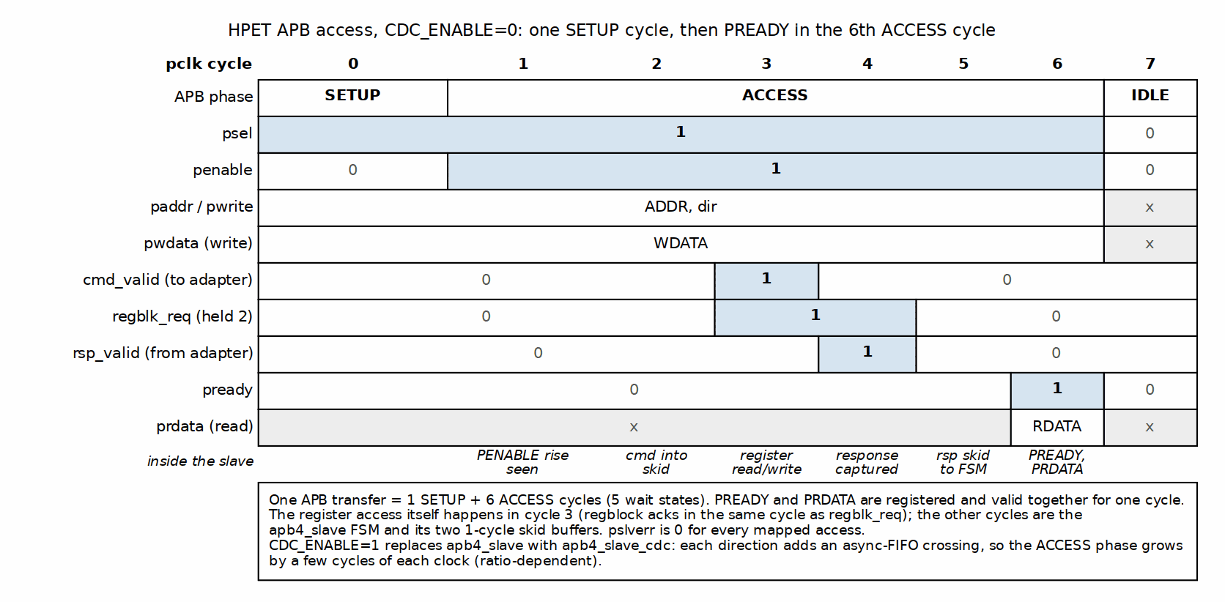
APB Access Timing

12.2.3 2. APB Slave CDC (async-FIFO crossing)
Module: apb4_slave_cdc.sv Clock Domains: pclk (APB side) and aclk (application side) Implementation: NOT a handshake FSM. The wrapper instantiates the plain apb4_slave in the pclk domain and crosses its command and response streams through two gaxi_fifo_async instances (u_cmd_cdc_fifo, u_rsp_cdc_fifo, DEPTH=2 here), with Gray- or Johnson-coded pointers selected by the USE_JOHNSON parameter. There are no request/acknowledge toggle FSMs and no per-signal 2-stage synchronizers on the data path – the FIFO pointer synchronizers are the only crossing logic.
Latency per access spans the apb4_slave FSM plus one FIFO traversal each way (a few cycles of each clock domain, ratio-dependent).

12.2.4 3. HPET Core Per-Timer FSM
Module: hpet_core.sv Clock Domain: hpet_clk (or pclk if CDC_ENABLE=0) Implementation: Conceptual FSM (implemented as combinational logic, not explicit state register)
Note: The HPET core uses a conceptual FSM model for specification clarity, but the actual implementation is a raw comparator plus two state bits per timer – the armed latch and the next-epoch hold bit – rather than an explicit state register. This provides simpler timing and resource usage while maintaining the same functional behavior.

12.2.4.1 States
State | Description | Duration
IDLE | Counter halted (hpet_enable = 0); there is no per-timer run enable | Until the counter runs
ARMED | Counter running, monitoring counter vs comparator | Until counter match
FIRE | Armed match detected, asserting interrupt | 1 cycle (one-cycle pulse)
PERIODIC_RELOAD | Periodic mode: auto-increment comparator | 1 cycle, or one boundary per cycle while catching up (counter + 1 at period 1)
ONE_SHOT_COMPLETE | One-shot mode: fired, armed latch clear, waiting for a comparator write with the counter halted or for the match to fall | Until the comparator is rewritten (counter halted) or written above the counter, or the counter halted
An epoch-held timer – one whose advance carried out of the compare width, setting r_comp_next_epoch[i] – is not a state of its own. It looks ARMED-but-not-matching: the latch is set, the match is forced off, and it sits there with no fire and no catch-up until the counter wraps at that width (or software writes the comparator or counter half the comparison reads – LO only in 32-bit mode, either half in 64-bit – or changes timer_size).

12.2.4.2 State Transition Conditions
IDLE -> ARMED: - Condition: hpet_enable = 1 (block-wide; the published spec defines no per-timer run enable, and timer_int_enable[i] gates only the interrupt) - Action: Latch current comparator value, begin monitoring - Trigger: Rising edge of hpet_enable
ARMED -> FIRE: - Condition: counter >= comparator[i] with the armed latch set - Action: Assert timer_int_status[i] (sticky, on every fire whatever timer_int_enable[i] says), clear the armed latch; the interrupt output is set at the same edge, only if timer_int_enable[i] = 1 - Trigger: Counter comparison (combinational), gated by hpet_enable and the latch
FIRE -> PERIODIC_RELOAD: - Condition: timer_type[i] = 1 (periodic mode) - Action: comparator[i] <= comparator[i] + period[i] at the compare width; a carry out of that width sets the next-epoch hold bit instead of reaching the comparator - Trigger: Immediate (next clock cycle after fire)
FIRE -> ONE_SHOT_COMPLETE: - Condition: timer_type[i] = 0 (one-shot mode) - Action: Hold timer_int_status[i], interrupt remains asserted - Trigger: Immediate (next clock cycle after fire)
PERIODIC_RELOAD -> ARMED: - Condition: The advanced comparator is ahead of the counter (the usual case: the match falls and the latch re-arms) - Action: Resume monitoring with new comparator value - Trigger: Immediate (next clock cycle) - Catch-up: if the advanced comparator is still at or below the counter, the timer stays in RELOAD, advancing one boundary per cycle WITHOUT firing, until the advance lands at or ahead of the counter (>=, or a carry); that step re-arms the latch. Missed periods are skipped, never burst. Period 0 cannot get ahead and is treated as one-shot (fires once, no churn). Period 1 gains nothing on the counter per cycle, so its catch-up step sets the comparator to counter + 1 (every integer is on the period-1 lattice) and re-arms at once: one fire every other tick, at any deficit. Any other period closes its deficit at period - 1 counts per cycle, one advance per cycle, so the catch-up is proportional to the deficit – a period-2 timer left 2^52 behind by a counter write catches up for ~2^52 cycles with no interrupt, which is why the counter is written halted - Epoch hold: an advance that carries out of the compare width leaves the timer ARMED-but-not-matching until the counter wraps at that width; no fire and no further catch-up in between
ONE_SHOT_COMPLETE -> ARMED: - Condition: timer_comp_write_lo[i] or timer_comp_write_hi[i] while the counter is HALTED (hpet_enable = 0; software writes the LO or HI half, even with the value it already holds), or the raw match falling (comparator written above the counter, or the counter reloaded below it) - Action: Set the armed latch and resume monitoring. A comparator written with the counter halted need not exceed the counter: a value already passed fires on the first cycle the counter runs - Trigger: Comparator write strobe with the counter halted, or the match falling
A 0->1 of hpet_enable while counter >= comparator does NOT re-enter FIRE: the armed latch is the fired-state memory, and the enable cannot set it. A completed one-shot stays complete across a halt/restart cycle.
A comparator write on a RUNNING timer does not re-arm either: the half loads, and the timer re-arms only when the completed value moves the match low. That keeps the torn {old HI, new LO} between two half-writes from ever firing. The contract is to halt the counter before reprogramming it; a write with the counter HALTED always re-arms, and a value at or below the counter fires as soon as the counter restarts. Reprogramming a running timer anyway has two consequences that are outside the contract, not bugs: a torn 64-bit value above the counter re-arms through the natural path and fires at the final value once it is written, and a same-value rewrite on a running periodic timer drags the comparator back and can add one off-lattice fire.
ARMED -> IDLE: - Condition: hpet_enable = 0 - Action: Stop match generation. A pending interrupt status/output is NOT cleared by halting – it holds until software W1C or reset. - Trigger: Falling edge of hpet_enable
ONE_SHOT_COMPLETE -> IDLE: - Condition: hpet_enable = 0 - Action: Stop monitoring (pending status, if any, holds until W1C) - Trigger: Counter halt. Clearing timer_int_enable[i] is not a stop

12.2.4.3 FSM Timing Examples

12.2.5 Figure 2.23: One-Shot Mode State Timeline
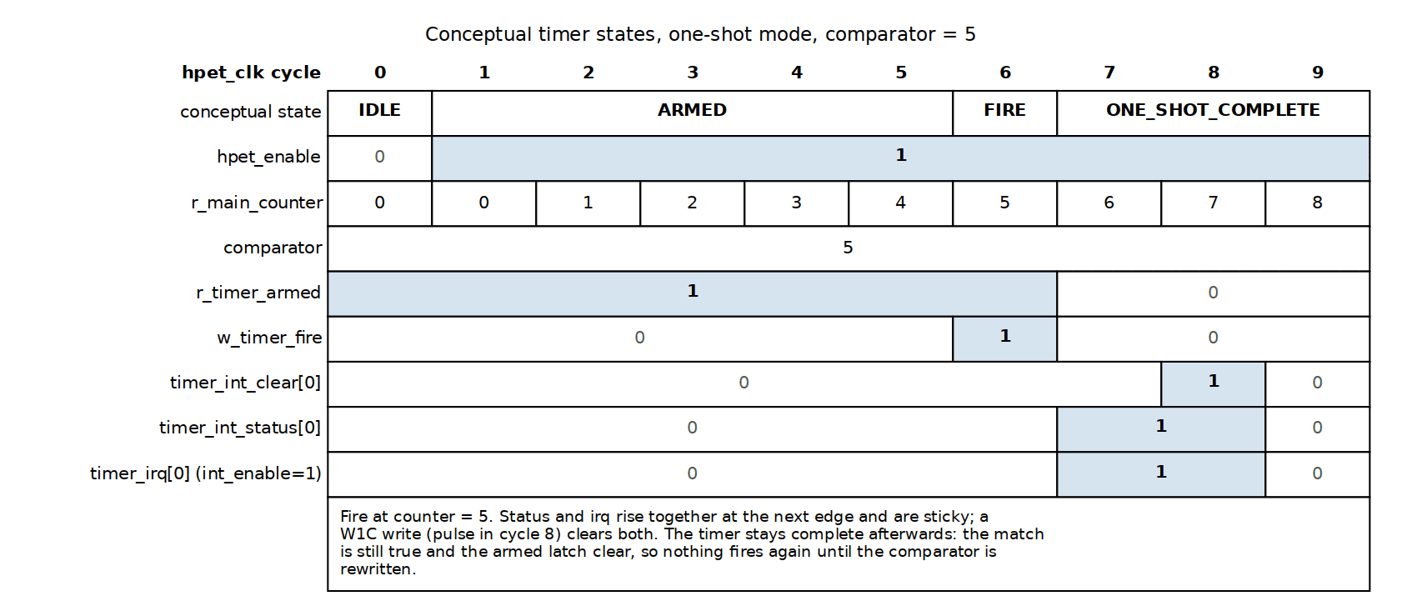
One-Shot Mode State Timeline

12.2.6 Figure 2.24: Periodic Mode State Timeline
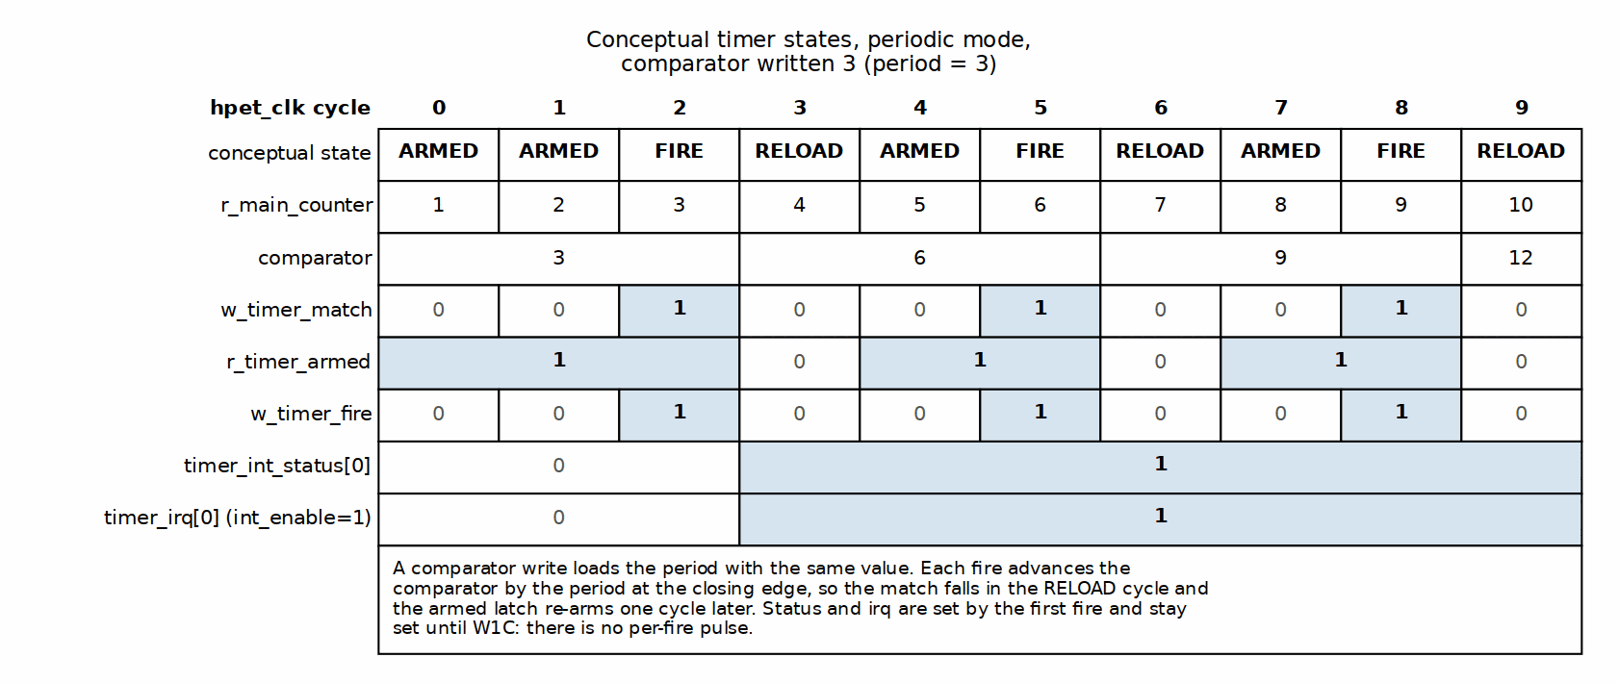
Periodic Mode State Timeline

12.2.7 FSM Interaction Summary

12.2.7.1 Cross-Module State Dependencies
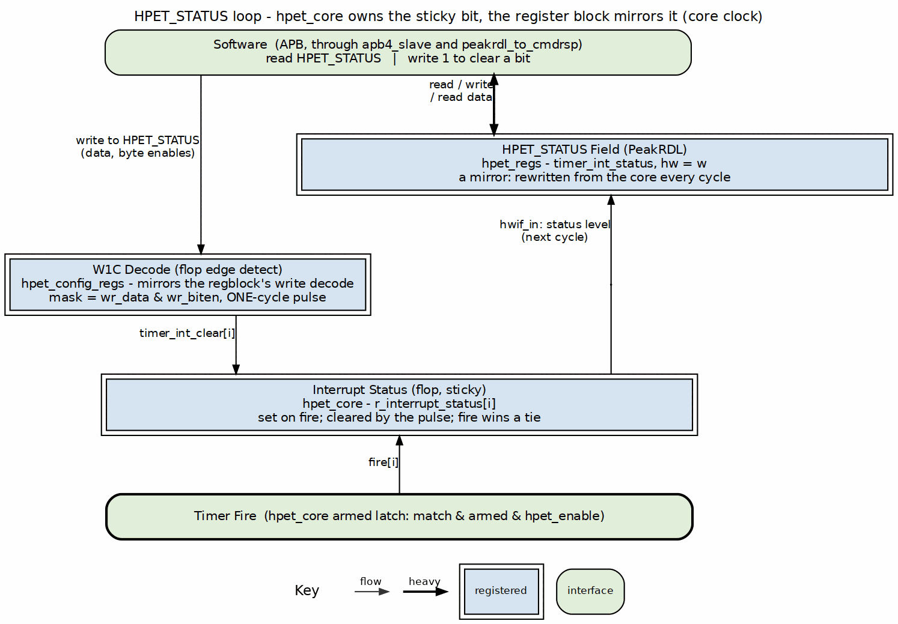
HPET_STATUS loop

12.2.7.2 Clock Domain Considerations
Synchronous Mode (CDC_ENABLE=0): - All FSMs run on pclk - No synchronization required - Direct signal propagation
Asynchronous Mode (CDC_ENABLE=1): - APB Slave CDC FSM bridges pclk and hpet_clk - Configuration registers and timers run on hpet_clk - Handshake protocol ensures data stability

12.3 Design Notes

12.3.1 State Machine Design Patterns

12.3.1.1 Pattern 1: Explicit State Register (APB Slave)
typedef enum logic [1:0] {
IDLE = 2'b00,
SETUP = 2'b01,
ACCESS = 2'b10
} state_t;
state_t r_state, w_next_state;
always_ff @(posedge pclk or negedge presetn) begin
if (!presetn) r_state <= IDLE;
else r_state <= w_next_state;
end
always_comb begin
w_next_state = r_state; // Default: hold state
case (r_state)
IDLE: if (PSEL) w_next_state = SETUP;
SETUP: if (PENABLE) w_next_state = ACCESS;
ACCESS: if (rsp_valid || !PSEL) w_next_state = IDLE;
endcase
end
Characteristics: - Explicit state storage - Separate combo/sequential blocks - Easy to verify and debug - Standard FSM coding style

12.3.1.2 Pattern 2: Combinational Match with an Armed Latch (Timer FSM)
// No explicit state register - a raw comparator plus two state bits
// Raw match: deliberately NO enable terms; held off by the epoch bit
assign w_timer_match_raw[i] = (counter >= comparator[i]); // at the compare width
assign w_timer_match[i] = w_timer_match_raw[i] && !r_comp_next_epoch[i];
// Periodic catch-up: running, periodic, un-armed, still matching, no
// software write this cycle, period able to move the compare. Advances
// the comparator a boundary per cycle without firing (counter + 1 at
// period 1); re-arms the cycle the advance lands at or ahead of the
// counter (w_comp_adv_ahead[i] = carry || advance >= counter).
assign w_comp_write_rearm[i] = w_timer_comp_write[i] && !w_timer_running[i];
assign w_timer_catchup[i] = timer_type[i] && !r_timer_armed[i] && w_timer_match[i] &&
!w_timer_comp_write[i] && w_timer_period_nz[i] &&
w_timer_running[i];
assign w_catchup_rearm[i] = w_timer_catchup[i] && w_comp_adv_ahead[i];
// Next-epoch hold: set when an advance carries out of the compare width;
// cleared (clear beats set) by the counter wrapping at that width, a
// comparator write, a counter write or a timer_size change. The write
// clears are taken at the compare width (w_epoch_clr_comp/w_epoch_clr_ctr,
// built in the same mux as the match): in 32-bit mode only a LO-half write
// clears, a HI-half write leaves the hold in place. Reset 0.
assign w_epoch_set[i] = w_comp_advance_en[i] && w_comp_adv_carry[i];
assign w_epoch_clr[i] = w_counter_wrap[i] || w_epoch_clr_comp[i] ||
w_epoch_clr_ctr[i] || w_timer_size_chg[i];
always_ff @(posedge clk or negedge rst_n) begin
if (!rst_n) r_comp_next_epoch[i] <= 1'b0;
else if (w_epoch_clr[i]) r_comp_next_epoch[i] <= 1'b0;
else if (w_epoch_set[i]) r_comp_next_epoch[i] <= 1'b1;
end
// Armed latch: set on a comparator write with the counter HALTED, when the
// gated match drops, or when a catch-up step lands at or ahead of the
// counter; cleared when the timer fires. Reset armed.
always_ff @(posedge clk or negedge rst_n) begin
if (!rst_n) r_timer_armed[i] <= 1'b1;
else if (w_comp_write_rearm[i] || !w_timer_match[i] ||
w_catchup_rearm[i]) r_timer_armed[i] <= 1'b1;
else if (w_timer_fire[i]) r_timer_armed[i] <= 1'b0;
end
// Fire: match, still armed, counter running (no per-timer run enable)
assign w_timer_fire[i] = w_timer_match[i] && r_timer_armed[i] &&
hpet_enable;
// Sticky interrupt status -- identical in BOTH modes (no timer_type term)
always_ff @(posedge clk or negedge rst_n) begin
if (!rst_n) begin
r_interrupt_status[i] <= 1'b0;
end else if (w_timer_fire[i]) begin
r_interrupt_status[i] <= 1'b1; // Set on fire (wins over a clear)
end else if (timer_int_clear[i]) begin
r_interrupt_status[i] <= 1'b0; // Software W1C, this bit only
end
end
Characteristics: - No explicit state register; the armed latch and the next-epoch hold bit are the only state bits - One fire per arm, so hpet_enable cannot manufacture a fire - A comparator write re-arms only with the counter halted, so a half-written 64-bit comparator cannot fire on the torn value - Periodic catch-up skips missed periods without bursting; period 1 steps to counter + 1 and keeps its every-other-tick cadence at any deficit - An advance that carries out of the compare width is held off until the counter wraps there, instead of matching early or churning - Simpler implementation - Lower resource usage - Same functional behavior as FSM

12.4 Testing

12.4.1 FSM Verification Considerations

12.4.1.1 State Coverage
APB Slave FSM: - [ ] IDLE state entry and exit - [ ] SETUP state timing (1 cycle) - [ ] ACCESS state with response wait - [ ] ACCESS state early termination (PSEL deassert)
CDC Handshake FSM: - [ ] Request synchronization (pclk -> aclk) - [ ] Response synchronization (aclk -> pclk) - [ ] Concurrent requests handling - [ ] Clock ratio corner cases (fast pclk, slow aclk and vice versa)
Timer FSM: - [ ] IDLE -> ARMED transition - [ ] ARMED -> FIRE on match - [ ] FIRE -> PERIODIC_RELOAD path - [ ] FIRE -> ONE_SHOT_COMPLETE path - [ ] PERIODIC_RELOAD -> ARMED auto-transition - [ ] ONE_SHOT_COMPLETE -> ARMED on reconfigure - [ ] Return to IDLE on counter halt

12.4.1.2 Transition Coverage
Edge Cases: - [ ] Counter halt/restart during active timer - [ ] Comparator write during countdown - [ ] Counter write during active timer - [ ] Multiple timers firing simultaneously - [ ] Interrupt clear during fire event (the fire wins) - [ ] Counter restart with counter >= comparator (must NOT re-fire) - [ ] Comparator rewritten with the same value (reloads the comparator; re-arms only if the counter is halted or the match falls) - [ ] 64-bit comparator reprogrammed on a running timer (the torn {old HI, new LO} never fires; halt-write-restart fires once) - [ ] Comparator write in the same cycle as a fire (exactly one fire, software value wins, no periodic advance that cycle) - [ ] Periodic timer more than one period behind the counter (catch-up: exactly one fire, missed periods skipped) - [ ] Period 0 (fires once, no churn) and period 1 (every other tick) - [ ] Period-1 timer with a deficit (catch-up steps to counter + 1 and recovers within a cycle; a live counter write that opens a gap) - [ ] Comparator advance carrying out of the compare width (32- and 64-bit: epoch hold, no fire and no churn until the counter wraps; comparator[63:32] untouched in 32-bit mode; clear beats set at the wrap) - [ ] Counter write while epoch-held (re-base: a comparator now at or below the counter fires promptly; in 32-bit mode a HI-half write to counter or comparator leaves the hold in place), and a timer_size change while epoch-held (hold cleared) - [ ] Mode switch (one-shot ↔ periodic) mid-operation

RTL Design Sherpa · Learning Hardware Design Through Practice GitHub · Documentation Index · MIT License

13 Claude Code Guide: Retro Legacy Blocks
Version: 2.0 Last Updated: 2025-10-29 Purpose: AI-specific guidance for working with Retro Legacy Blocks (RLB) peripheral blocks

13.1 Quick Context
What: Collection of production-quality retro-compatible legacy peripherals Status: Active Development - HPET Production Ready, 12 more blocks planned Your Role: Help users develop new legacy blocks, integrate existing blocks, understand RLB architecture
Complete Documentation: - projects/components/legacy-ip/retro_legacy_blocks/PRD.md ← Master requirements for all blocks - projects/components/legacy-ip/retro_legacy_blocks/README.md ← Component overview and usage guide - docs/hpet_mas/hpet_mas_index.md ← HPET complete specification
RLB Address Map: Single APB entry point at 0xFEC0_0000 (the BASE_ADDR parameter default), ten 4KB windows decoded by the generated apbx_xbar_1to10

13.2 Critical Rules for All Blocks

13.2.1 Rule #0.1: Reset Macro Standards - MANDATORY FOR ALL BLOCKS
Use ALWAYS_FF_RST / RST_ASSERTED from reset_defs.svh; a hand-written always_ff @(posedge clk or negedge rst_n) is rejected. Enforced repo-wide – /GLOBAL_REQUIREMENTS.md 1.1 is the authority, the rationale and the failures behind it are vault/handbook/design/reset-and-clocking.md, and bin/update_resets.py converts existing code.

13.2.2 Rule #0.2: FPGA Synthesis Attributes - MANDATORY
Every memory array carries vendor synthesis hints (ram_style / ramstyle) or a large memory synthesises into logic. Enforced repo-wide: /GLOBAL_REQUIREMENTS.md 1.2; see vault/handbook/design/sram-and-memories.md.

13.2.3 Rule #0.3: Testbench Architecture - MANDATORY SEPARATION
A TB class never lives in a test runner; /GLOBAL_REQUIREMENTS.md 2.1 is the authority. What is specific to this component is the layout and the tier names:
projects/components/legacy-ip/retro_legacy_blocks/dv/
├── tbclasses/{block}/ # block-specific TB classes
│ ├── {block}_tb.py
│ ├── {block}_tests_basic.py # runs at TEST_LEVEL=gate
│ ├── {block}_tests_medium.py # runs at TEST_LEVEL=func
│ └── {block}_tests_full.py # runs at TEST_LEVEL=full
└── tests/ # runners, FLAT: test_apb4_{block}.py, conftest.py
The tier FILENAMES are historical; the LEVELS are gate/func/full. {block}_tests_basic.py defines {Block}BasicTests and runs at TEST_LEVEL=gate; _medium.py / {Block}MediumTests runs at func. The files and classes really are named that way on disk – do not rename them to match the level, and do not read the filename as the level.

13.2.4 Rule #0.4: Test Hierarchy - 3 Levels Required
Every block carries all three levels. The gate/func/full convention is repo-wide (vault/handbook/dv/running-regressions.md); the per-block targets here are:
Level | Tests | Pass rate | Per-test duration
gate | 4-6 | 100% | <30 s
func | 5-8 | 100% | 30-90 s
full | 3-5 | >=95% | 90 s+

13.2.5 Rule #0.5: Register Generation - Use PeakRDL
Registers come from SystemRDL via bin/peakrdl_generate.py only – never raw peakrdl, which skips the docs and regmap the wrapper emits in lockstep (vault/handbook/design/generated-rtl-discipline.md).
Run it from the block’s RDL directory and point --copy-rtl at the block’s RTL directory, since the two are no longer parent and child (RLB TASK-007, was RLB-007):
cd rdl/{block}
python $REPO_ROOT/bin/peakrdl_generate.py {block}_regs.rdl --copy-rtl ../../rtl/{block}
See rdl/hpet/ for a complete example.

13.3 Block Development Workflow

13.3.1 Adding a New Block
1. Directory structure:
cd projects/components/legacy-ip/retro_legacy_blocks
mkdir -p rdl/{block} # SystemRDL: the source of truth
mkdir -p rtl/{block}/filelists # component + integration filelists
mkdir -p dv/tbclasses/{block} # TB classes; runners stay flat in dv/tests/
mkdir -p docs/{block}_mas
rtl/{block}/
├── apb_{block}.sv # top-level wrapper
├── {block}_core.sv # core logic
├── {block}_config_regs.sv # register wrapper
├── {block}_regs_pkg.sv # PeakRDL generated
├── {block}_regs.sv # PeakRDL generated
├── filelists/{component,integration}
└── Makefile
The RDL lives outside rtl/ on purpose: every SystemRDL source in the repo belongs in an rdl area rather than scattered under the RTL it generates (RLB TASK-007 (was RLB-007), and projects/components/utility-ip/misc TASK-001 (was MISC-001) repo-wide). There is no README beside it – a file next to a tool restating how to run the tool is the copy nobody edits.
2. RTL, TB classes, test suites and runner take the standard shapes: Pattern B (cocotb_test_* functions behind pytest wrappers), the three mandatory TB methods, and the tier files named in Rule #0.3. Templates are the test-patterns skill and /GLOBAL_REQUIREMENTS.md 2.2 / 3.2. A filelist lands in the same commit as the module (vault/handbook/design/filelists.md).
3. Documentation: add the block to PRD.md, create docs/{block}_mas/{block}_mas_index.md, update the README.md status table.

13.4 HPET-Specific Guidance

13.4.1 HPET Quick Reference
Status: Production Ready (5/6 configurations 100% passing) RTL Location: rtl/hpet/ Test Location: dv/tests/test_apb4_hpet.py

13.4.2 Critical HPET Rules

13.4.2.1 Rule #1: Timer Cleanup is MANDATORY
ALWAYS Reset Counter Between Tests
# CORRECT: Clean up at end of test
async def test_64bit_counter(self):
await self.tb.write_register(HPET_COUNTER_LO, 0xFFFFFFFF)
# ... test logic ...
# MANDATORY cleanup
await self.tb.write_register(HPET_COUNTER_LO, 0x0)
await self.tb.write_register(HPET_COUNTER_HI, 0x0)
return True
Why: Test leaves counter at high value, next test expects counter at 0. Timer 2+ won’t fire if counter starts high.

13.4.2.2 Rule #2: Timer Timeout Calculations
Account for counter starting value when setting timeouts:
# Calculate timeout based on timer periods
timer_configs = [
{"period": 100}, # Timer 0 fires at 100
{"period": 200}, # Timer 1 fires at 200
{"period": 700}, # Timer 2 fires at 700 (needs most time)
]
# 3x safety margin for latest timer
timeout_ns = max(cfg["period"] for cfg in timer_configs) * 3
timeout_us = (timeout_ns + 999) // 1000

13.4.2.3 Rule #3: HPET Register Map
The PUBLISHED spec map (RLB/hpet TASK-006); rdl/hpet/hpet_regs.rdl is the source of truth. Reserved offsets read 0 with no PSLVERR.
0x000: HPET_ID GCAP_ID[31:0] RO: rev_id[7:0], num_tim_cap[12:8] (N-1),
count_size_cap[13]=1, leg_rt_cap[15]=1, vendor_id[31:16] (16 bits)
0x004: HPET_PERIOD GCAP_ID[63:32] RO: femtoseconds per tick (COUNTER_CLK_PERIOD_FS)
0x010: HPET_CONFIG GEN_CONF: hpet_enable[0], legacy_replacement[1] (T0->IRQ0, T1->IRQ8)
0x020: HPET_STATUS GINTR_STA: timer interrupt status, W1C; set on EVERY fire
0x0F0: HPET_COUNTER_LO main counter bits [31:0], RW
0x0F4: HPET_COUNTER_HI main counter bits [63:32], RW
Per-Timer Registers (i = 0 to NUM_TIMERS-1):
0x100 + i*0x20: TIMER[i]_CONFIG TN_CONF[31:0]; reads 0x30 out of reset
0x104 + i*0x20: TIMER[i]_INT_ROUTE_CAP TN_CONF[63:32], RO, reads 0
0x108 + i*0x20: TIMER[i]_COMPARATOR_LO bits [31:0], RW
0x10C + i*0x20: TIMER[i]_COMPARATOR_HI bits [63:32], RW
TIMER_CONFIG (TN_CONF): int_type[1] (storage), int_enable[2], type[3] (1=periodic),
per_int_cap[4]=1 RO, size_cap[5]=1 RO, value_set[6] (storage), 32mode[8],
int_route[13:9] (storage), fsb_en[14] (storage), fsb_int_del_cap[15]=0 RO
Two traps: there is NO per-timer run enable – int_enable masks only the interrupt, and the only stop is HPET_CONFIG.hpet_enable (halt it before reprogramming a comparator). And 32mode FORCES 32-bit, so 64-bit operation is the bit CLEAR – the inverse of the retired timer_size.

13.4.2.4 Rule #4: HPET Timer Modes
One-Shot: - Timer fires once when counter >= comparator - Does NOT automatically reload - Must reconfigure for next fire
Periodic: - Timer fires repeatedly - Comparator auto-increments by period value - Fires indefinitely until the counter is halted or the timer is switched to one-shot (there is no per-timer stop)

13.4.3 HPET Common Issues
Issue: Timer Not Firing 1. HPET enabled? (HPET_CONFIG bit 0 – the only run control) 2. Comparator set correctly? (LO at +0x08, HI at +0x0C) 3. Counter incrementing? 4. Counter will reach comparator? 5. Interrupt enable set? (TIMER_CONFIG bit 2) – without it the HPET_STATUS bit still sets but timer_irq stays low 6. Legacy replacement on? (HPET_CONFIG bit 1 moves timers 0/1 off timer_irq)
Issue: Tests Failing Inconsistently - Most common cause: Missing test cleanup (counter not reset) - Solution: Add cleanup at end of EVERY test
See: Complete HPET guidance in docs/hpet_mas/hpet_mas_index.md

13.5 Common User Questions

13.5.1 Q: “Which blocks are implemented?”
A: Current status:
Block | Priority | Status | Address | Documentation
HPET | High | Production | 0xFEC0_0000-0x0FFF | Complete
8259 PIC (master) | High | Implemented | 0xFEC0_1000-0x1FFF | MAS (docs/pic_8259_mas)
8254 PIT | High | Implemented | 0xFEC0_2000-0x2FFF | MAS (docs/pit_8254_mas)
RTC | Medium | Implemented | 0xFEC0_3000-0x3FFF | MAS (docs/rtc_mas)
SMBus | Medium | Implemented | 0xFEC0_4000-0x4FFF | MAS (docs/smbus_mas)
PM/ACPI | Medium | Implemented | 0xFEC0_5000-0x5FFF | MAS (docs/pm_acpi_mas)
IOAPIC | Medium | Implemented | 0xFEC0_6000-0x6FFF | MAS (docs/ioapic_mas)
GPIO | Medium | Implemented | 0xFEC0_7000-0x7FFF | MAS (docs/gpio_mas)
UART 16550 | Medium | Implemented | 0xFEC0_8000-0x8FFF | MAS (docs/uart_16550_mas)
8259 PIC (cascade slave) | High | Implemented | 0xFEC0_9000-0x9FFF | MAS (docs/pic_8259_mas)
SPI | Low | Planned | unallocated | N/A
I2C | Low | Planned | unallocated | N/A
Watchdog | Low | Planned | unallocated | N/A
Interconnect | Low | Planned | unallocated – all ten windows are assigned | N/A
See: PRD.md Section 3 for planned block details and Section 4.2 for complete address map

13.5.2 Q: “How do I integrate a block in my design?”
A: Each block has APB interface, example:
apb4_hpet #(
.NUM_TIMERS(3),
.VENDOR_ID(16'h4747), // hardware-driven into GCAP_ID[31:16] (TASK-006)
.REVISION_ID(8'h01), // hardware-driven into GCAP_ID[7:0]
.CDC_ENABLE(0)
) u_hpet (
// APB interface
.pclk (apb_clk),
.presetn (apb_rst_n),
.s_apb_PADDR (paddr),
.s_apb_PSEL (psel_hpet),
.s_apb_PENABLE (penable),
.s_apb_PWRITE (pwrite),
.s_apb_PWDATA (pwdata),
.s_apb_PRDATA (prdata_hpet),
.s_apb_PREADY (pready_hpet),
.s_apb_PSLVERR (pslverr_hpet),
// Block-specific signals
.hpet_clk (timer_clk),
.hpet_resetn (timer_rst_n),
.timer_irq (timer_irq[2:0]),
// LegacyReplacement Route (TASK-003): asserted only while
// HPET_CONFIG.legacy_replacement is set, and timers 0/1 are then
// SUPPRESSED on timer_irq. Consuming these also means silencing the
// 8254 and the RTC, and timer 0 belongs on IRQ0 / IOAPIC pin 2 --
// never PIC IRQ2, which is the cascade input.
.legacy_irq0 (hpet_legacy_irq0),
.legacy_irq8 (hpet_legacy_irq8)
);
See: README.md for integration examples

13.5.3 Q: “What’s the RLB wrapper goal?”
A: Create unified subsystem combining all blocks with single APB entry point:
RLB Wrapper Architecture:
Single APB Slave → APB Decoder/Bridge → Individual Blocks
(0xFEC0_0000) (4KB window decode) (HPET, 8259, 8254, etc.)
Address Map (4KB windows): - 0xFEC0_0000-0x0FFF: HPET - 0xFEC0_1000-0x1FFF: 8259 PIC (master) - 0xFEC0_2000-0x2FFF: 8254 PIT - 0xFEC0_3000-0x3FFF: RTC - 0xFEC0_4000-0x4FFF: SMBus - 0xFEC0_5000-0x5FFF: PM/ACPI - 0xFEC0_6000-0x6FFF: IOAPIC - 0xFEC0_7000-0x7FFF: GPIO - 0xFEC0_8000-0x8FFF: UART 16550 - 0xFEC0_9000-0x9FFF: 8259 PIC (cascade slave) - All others → decode-miss agent, answered locally with PSLVERR
Benefits: - Single APB slave port (easy integration) - Drop-in retro-compatible peripheral subsystem - Clean power-of-2 decode (4KB = bits [15:12]) - 32KB reserved space for expansion
See: PRD.md Section 4.2 for complete RLB wrapper specification and decoder implementation

13.5.4 Q: “Why ‘Retro Legacy Blocks’?”
A: - Retro: Implements proven architectures from older platforms - Legacy: Based on time-tested peripheral interface specifications - Blocks: Collection of independent peripherals
Not experimental - production-ready implementations of time-tested designs.

13.6 Quick Commands
# Always through the area Makefile -- a bare pytest drops the level, the derived
# worker count and the reruns, and skips clean-all.
cd projects/components/legacy-ip/retro_legacy_blocks/dv/tests
make list # the roots discovered by glob
make clean-all && make run-all-full-parallel
make run-apb4_hpet-gate # one block, one level
make run-apb4_hpet-gate-waves # same with waves (never --vcd)
Grammar and rationale: vault/handbook/dv/running-regressions.md.

13.7 PDF Generation Location
IMPORTANT: PDF files should be generated in the docs directory:
$REPO_ROOT/projects/components/legacy-ip/retro_legacy_blocks/docs/
Quick Command: Use the MAS script. The books live in *_mas/ directories and generate_mas_pdf.sh is what knows about them:
cd $REPO_ROOT/projects/components/legacy-ip/retro_legacy_blocks/docs
./generate_mas_pdf.sh # every book
./generate_mas_pdf.sh --component smbus # one book
generate_pdf.sh in the same directory is the OLDER script and targets *_spec/ directories that no longer exist here. It used to answer a missing index with “generated successfully” while writing nothing; that is fixed, and it now fails loudly, but it still has nothing to build in this component.

Version: 2.0 Last Updated: 2025-10-29 Maintained By: RTL Design Sherpa Project

RTL Design Sherpa · Learning Hardware Design Through Practice GitHub · Documentation Index · MIT License

14 APB HPET Register Map
Chapter: 5.1 Title: Complete Register Address Map Version: 1.1 Last Updated: 2026-10-13

14.1 Overview
The APB HPET provides a memory-mapped register interface accessible via the APB slave port. The register space is organized into two main sections:
- Global Registers (0x000-0x0FF): Configuration, status, and main counter
- Per-Timer Registers (0x100-0x1FF): Timer-specific configuration and comparators
Each timer occupies a 32-byte (0x20) register block, supporting up to 8 timers.

14.1.1 Figure 5.1: APB HPET Block Diagram
APB HPET Block Diagram
APB HPET top-level architecture showing APB interface, configuration registers, HPET core, and timer outputs.

14.2 Functional Description

14.2.1 Register Address Map Summary

14.2.1.1 Global Registers
Offset | Register Name | Access | Width | Description
0x000 | HPET_ID | RO | 32b | GCAP_ID[31:0] - identification and capabilities
0x004 | HPET_PERIOD | RO | 32b | GCAP_ID[63:32] - main counter period in femtoseconds
0x008-0x00F | RESERVED | RO | - | Reserved
0x010 | HPET_CONFIG | RW | 32b | GEN_CONF - global configuration and control
0x014-0x01F | RESERVED | RO | - | Reserved
0x020 | HPET_STATUS | RW/W1C | 32b | GINTR_STA - interrupt status (write-1-to-clear)
0x024-0x0EF | RESERVED | RO | - | Reserved
0x0F0 | HPET_COUNTER_LO | RW | 32b | MAIN_CNT bits [31:0]
0x0F4 | HPET_COUNTER_HI | RW | 32b | MAIN_CNT bits [63:32]
0x0F8-0x0FF | RESERVED | RO | - | Reserved
These are the PUBLISHED SPEC offsets (RLB/hpet TASK-006). Reserved space is not decoded: a read returns 0 and a write is dropped, and neither raises PSLVERR (the generated register block ties its read and write error responses to 0). See the address-aliasing note under the Memory Map Diagram below.

14.2.1.2 Per-Timer Registers
Each timer (N = 0 to NUM_TIMERS-1) has a 32-byte register block at base address 0x100 + N*0x20.
Timer N Base Address: 0x100 + N * 0x20
Offset | Register Name | Access | Width | Description
+0x00 | TIMER_CONFIG | RW | 32b | TN_CONF[31:0] - configuration and control
+0x04 | TIMER_INT_ROUTE_CAP | RO | 32b | TN_CONF[63:32] - legal I/O APIC inputs (reads 0: general per-timer routing is not implemented). INDEPENDENT of leg_rt_cap = 1 – legacy replacement OVERRIDES timer_int_route rather than selecting through this mask
+0x08 | TIMER_COMPARATOR_LO | RW | 32b | Timer comparator bits [31:0]
+0x0C | TIMER_COMPARATOR_HI | RW | 32b | Timer comparator bits [63:32]
+0x10-0x1F | RESERVED | RO | - | The spec’s FSB route registers live here; not implemented, and fsb_int_del_cap reads 0 to say so
Example Timer Addresses:
Timer | Base Address | CONFIG | COMPARATOR_LO | COMPARATOR_HI
0 | 0x100 | 0x100 | 0x108 | 0x10C
1 | 0x120 | 0x120 | 0x128 | 0x12C
2 | 0x140 | 0x140 | 0x148 | 0x14C
3 | 0x160 | 0x160 | 0x168 | 0x16C
4 | 0x180 | 0x180 | 0x188 | 0x18C
5 | 0x1A0 | 0x1A0 | 0x1A8 | 0x1AC
6 | 0x1C0 | 0x1C0 | 0x1C8 | 0x1CC
7 | 0x1E0 | 0x1E0 | 0x1E8 | 0x1EC

14.2.2 Global Register Descriptions

14.2.2.1 HPET_ID (0x000) - Identification Register
Access: Read-Only Reset Value: (VENDOR_ID[15:0] << 16) | 0x8000 | 0x2000 | ((NUM_TIMERS-1) << 8) | REVISION_ID[7:0] – 0x8000 is leg_rt_cap, 0x2000 is count_size_cap
Contains capability information and identification fields. vendor_id, rev_id and num_tim_cap are all driven from the top-level parameters through the register block’s hardware interface, so one generated block serves every instantiation. This is GCAP_ID[31:0] at the published spec field positions (RLB/hpet TASK-006); vendor_id is the spec’s full 16 bits, so a PCI-style VENDOR_ID(16'h4747) now reads back complete rather than truncated to its low byte. GCAP_ID[63:32] is the counter clock period, at 0x004.
Bits | Field | Access | Reset | Description
[31:16] | vendor_id | RO | VENDOR_ID | Vendor identifier, full 16 bits per the spec
[15] | leg_rt_cap | RO | 1 | Legacy-replacement capability. Reads 1: the LegacyReplacement Route IS implemented (RLB/hpet TASK-003) – timer 0 leaves on legacy_irq0 (IRQ0) and timer 1 on legacy_irq8 (IRQ8), both suppressed on timer_irq. The POSITION matters – drivers gate on this bit, so a 0 here would mean legacy mode is never used
[14] | reserved | RO | 0 | Reserved
[13] | count_size_cap | RO | 1 | Counter size capability (1 = 64-bit counter)
[12:8] | num_tim_cap | RO | NUM_TIMERS-1 | Number of timers minus 1 (e.g., 7 for 8 timers)
[7:0] | rev_id | RO | REVISION_ID | Revision identifier
Example Values, computed for the parameters the DV grid actually passes (the previous table claimed the parameter DEFAULT of 1 while the suite has always driven 0x4747/0x1022/0xABCD, so those constants never matched a real readback):
Config | VENDOR_ID | REVISION_ID | HPET_ID reads
2 timers | 0x4747 | 0x01 | 0x4747A101
3 timers | 0x1022 | 0x02 | 0x1022A202
8 timers | 0xABCD | 0x10 | 0xABCDA710
Decoding the 8-timer value: vendor 0xABCD, leg_rt_cap 1 (bit 15), count_size_cap 1 (bit 13), num_tim_cap 7 (bits 12:8), rev_id 0x10.
These words each carry 0x8000 because leg_rt_cap reads 1 since RLB/hpet TASK-003; before the legacy routing existed they read 0x47472101, 0x10222202 and 0xABCD2710.

14.2.2.2 HPET_CONFIG (0x010) - Configuration Register
Access: Read-Write Reset Value: 0x00000000
Global enable and configuration control.
Bits | Field | Access | Reset | Description
[31:2] | reserved | RO | 0 | Reserved
[1] | legacy_replacement | RW | 0 | Enables the LegacyReplacement Route: timer 0 is delivered as IRQ0 and timer 1 as IRQ8, and BOTH stop being delivered on timer_irq. Timers 2+ are unaffected. HPET_ID.leg_rt_cap reads 1 to advertise it
[0] | hpet_enable | RW | 0 | HPET main counter enable (0=stopped, 1=running)
Usage Notes: - Write hpet_enable=1 to start the main counter - Write hpet_enable=0 to stop the main counter (value preserved) - legacy_replacement REPLACES the delivery of timers 0 and 1 rather than adding to it: setting it moves timer 0 to legacy_irq0 and timer 1 to legacy_irq8 and holds both off timer_irq. HPET_ID.leg_rt_cap reads 1 - The sticky HPET_STATUS bit is deliberately NOT affected by legacy mode: only the delivery path moves, so software that polls status instead of taking the interrupt behaves identically either way - Consuming the legacy routes also means silencing the 8254 PIT tick and the RTC periodic interrupt. That is an integration duty at rlb_top, not this block’s, and note timer 0 belongs on master IRQ0 and I/O APIC pin 2 – never PIC IRQ2, which is the 8259 cascade input - Counter must be enabled for any timer to fire
Example Configuration Sequence:
// Disable HPET
WRITE(HPET_CONFIG, 0x0);
// Reset counter
WRITE(HPET_COUNTER_LO, 0x0);
WRITE(HPET_COUNTER_HI, 0x0);
// Configure timers...
// Enable HPET
WRITE(HPET_CONFIG, 0x1);

14.2.2.3 HPET_STATUS (0x020) - Interrupt Status Register
Access: Read-Write (Write-1-to-Clear) Reset Value: 0x00000000
Interrupt status bits for all timers. The register is a mirror of the sticky status held in hpet_core: hardware re-drives it from the core’s level every cycle, and a software write is forwarded to the core as a per-bit clear. Write 1 to a bit to clear the corresponding interrupt.
Bits | Field | Access | Reset | Description
[31:8] | reserved | RO | 0 | Hard zero
[7:NUM_TIMERS] | (unused timer bits) | RO | 0 | The field is a fixed 8 bits wide; bits with no timer behind them read 0 and cannot be set
[NUM_TIMERS-1:0] | timer_int_status | RW/W1C | 0 | Timer interrupt status bits, mirrored from hpet_core
Per-Timer Status Bit: - Bit[N] = Timer N interrupt status - 0 = No interrupt pending - 1 = Timer N has fired, interrupt pending
Write-1-to-Clear (W1C) Behavior: - Write 1 to bit[N] to clear Timer N interrupt status (and its irq) - Write 0 to a bit leaves it alone; a write of 0x00000000 is a no-op - Clearing one timer’s bit does not touch the other timers’ bits or irq outputs - A timer that fires in the same cycle its own bit is being cleared keeps the bit set: the new event wins, and the clear can simply be repeated - Reading returns the current interrupt status
Example Interrupt Handling:
// Read interrupt status
uint32_t status = READ(HPET_STATUS);
// Check if Timer 0 fired
if (status & 0x1) {
// Handle Timer 0 interrupt
// Clear Timer 0 interrupt
WRITE(HPET_STATUS, 0x1); // Write 1 to clear bit 0 only
}

14.2.2.4 HPET_COUNTER_LO (0x0F0) - Main Counter Low
Access: Read-Write Reset Value: 0x00000000
Lower 32 bits of the 64-bit free-running main counter.
Bits | Field | Access | Reset | Description
[31:0] | counter_lo | RW | 0 | Main counter bits [31:0]
Behavior: - Read: Returns current counter value [31:0] - Write: Loads counter bits [31:0] on the write itself, byte enables respected; bits [63:32] are untouched (see the 64-bit write ordering note below) - Counter increments every hpet_clk cycle when HPET_CONFIG.hpet_enable=1 - Software can write to reset or set counter to specific value
Usage Notes: - Writing counter is useful for test/debug or implementing periodic reset - Write the counter with it halted (HPET_CONFIG.hpet_enable=0), as on a real HPET: the two halves load independently, so a running timer could see the intermediate {old HI, new LO} value. The halt also bounds what a periodic timer has to catch up: a catch-up advances the comparator once per cycle and closes period - 1 counts each time, so a timer left far behind – a torn or stale half on a running counter is exactly how a 2^52 deficit appears – is silent for cycles in proportion to the deficit. A contract, not a defect; see Periodic Mode - Partial (byte-strobed, PSTRB != 0xF) counter writes REQUIRE a halted counter, which is the stricter rule: the register block merges the bytes software did not write from its own mirror of the field, and on a running counter that mirror is a cycle old, so the preserved bytes come back behind the counter they were meant to keep. Halted, the mirror is stable and the merge exact. Full-word writes never read the mirror and are unaffected - Counter write takes effect immediately (on next hpet_clk) - All timers compare against this counter value

14.2.2.5 HPET_COUNTER_HI (0x0F4) - Main Counter High
Access: Read-Write Reset Value: 0x00000000
Upper 32 bits of the 64-bit free-running main counter.
Bits | Field | Access | Reset | Description
[31:0] | counter_hi | RW | 0 | Main counter bits [63:32]
Behavior: - Same as HPET_COUNTER_LO but for upper 32 bits - Forms complete 64-bit counter value: {counter_hi, counter_lo}
Reading 64-bit Counter:
// LO-then-HI gives NO rollover protection (a carry between the reads
// yields old-LO with new-HI). Use the HI/LO/HI retry loop from
// ch01_overview/03_clocks_and_reset.md:
uint32_t hi1, lo, hi2;
do {
hi1 = READ(HPET_COUNTER_HI);
lo = READ(HPET_COUNTER_LO);
hi2 = READ(HPET_COUNTER_HI);
} while (hi1 != hi2);
uint64_t counter = ((uint64_t)hi1 << 32) | lo;
Writing 64-bit Counter:
// Halt the counter first; each write loads only its own half
WRITE(HPET_CONFIG, 0x0);
WRITE(HPET_COUNTER_LO, 0x00000000);
WRITE(HPET_COUNTER_HI, 0x00000000);

14.2.3 Per-Timer Register Descriptions
Each timer has a dedicated 32-byte register block. The following descriptions apply to Timer N at base address 0x100 + N*0x20.

14.2.3.1 TIMER_CONFIG (Timer Base + 0x00) - Timer Configuration
Access: Read-Write Reset Value: 0x00000030 (the read-only size_cap and per_int_cap read 1; every writable bit resets to 0)
Configuration and control for individual timer.
Bits | Field | Access | Reset | Description
[31:16] | reserved | RO | 0 | Reserved
[15] | fsb_int_del_cap | RO | 0 | FSB (message) delivery capability. Reads 0, so the spec’s FSB route registers at +0x10/+0x14 are not implemented
[14] | timer_fsb_en | RW | 0 | FSB delivery enable. Storage only – see fsb_int_del_cap
[13:9] | timer_int_route | RW | 0 | I/O APIC input to drive, as a bit NUMBER chosen from TIMER_INT_ROUTE_CAP. STORAGE ONLY: general route selection is not implemented, and the spec has legacy replacement OVERRIDE this field for timers 0/1 rather than select through it
[8] | timer_32mode | RW | 0 | FORCE 32-bit operation. Note the polarity: 1 = 32-bit, so 64-bit operation is this bit CLEAR. The retired timer_size meant the opposite
[7] | reserved | RO | 0 | Reserved
[6] | timer_value_set | RW | 0 | Stores and reads back, but has NO hardware effect: this core always loads both the accumulator and the period, so the bit has nothing to select
[5] | size_cap | RO | 1 | READ-ONLY capability: this timer is 64-bit capable
[4] | per_int_cap | RO | 1 | READ-ONLY capability: this timer supports periodic mode
[3] | timer_type | RW | 0 | Timer mode (0=one-shot, 1=periodic)
[2] | timer_int_enable | RW | 0 | Interrupt enable. The ONLY per-timer enable the spec defines
[1] | timer_int_type | RW | 0 | 0=edge, 1=level. Storage only: this core always delivers the sticky level-plus-W1C behaviour HPET_STATUS implements
[0] | reserved | RO | 0 | Reserved
These are the published spec’s TN_CONF positions (RLB/hpet TASK-006). There is no per-timer RUN enable – the spec defines none, so a timer’s comparator is live whenever the main counter runs and timer_int_enable gates only the interrupt.
Field Descriptions:
timer_int_enable (bit 2): - 0 = Interrupt delivery disabled: the timer still fires and still sets its HPET_STATUS bit, but timer_irq (or the legacy route) stays low - 1 = Interrupt delivery enabled: a fire sets the HPET_STATUS bit AND raises the interrupt - hpet_core sets the sticky status bit on EVERY fire, whatever this bit says; it gates only the interrupt output, sampled at fire time
timer_type (bit 3): - 0 = One-shot mode: Timer fires once when counter >= comparator, then stays idle - 1 = Periodic mode: Timer fires repeatedly, auto-increments comparator by period
timer_32mode (bit 8): - 1 = FORCE 32-bit (uses only COMPARATOR_LO, ignores COMPARATOR_HI) - 0 = 64-bit (uses the full 64-bit comparator) – the DEFAULT - The polarity is the spec’s and is the inverse of the retired timer_size - APB HPET supports 64-bit by default - Change it only with the counter halted, and rewrite the comparator afterwards. The change clears the next-epoch hold, but a comparator advanced at the old width is not on the new width’s lattice, and a live 0->1 switch can leave the timer catching up for ~2^32 cycles
timer_value_set (bit 6): - No hardware effect: the register bit stores and reads back, but nothing consumes it (hpet_core has no such input; the wire dead-ends at the top level). Documented for completeness only.
Common Configurations:
// One-shot timer with interrupt (64-bit compare: 32MODE clear)
WRITE(TIMER0_CONFIG, 0x004); // bit 2 = INT_ENB
// Periodic timer with interrupt
WRITE(TIMER0_CONFIG, 0x00C); // bits 3, 2 = TYPE (periodic) | INT_ENB
// One-shot timer, forced 32-bit compare, with interrupt
WRITE(TIMER0_CONFIG, 0x104); // bits 8, 2 = 32MODE | INT_ENB

14.2.3.2 TIMER_COMPARATOR_LO (Timer Base + 0x08) - Comparator Low
Access: Read-Write Reset Value: 0x00000000
Lower 32 bits of the 64-bit timer comparator value.
Bits | Field | Access | Reset | Description
[31:0] | timer_comp_lo | RW | 0 | Timer comparator bits [31:0]
Behavior: - Timer fires when main_counter >= comparator - For one-shot mode: Comparator value stays unchanged after fire - For periodic mode: the CORE’s working comparator auto-increments by the period on each fire, and a read returns that live value (RLB/hpet TASK-002): the field is hw=rw with precedence = sw (the same idiom the main counter uses), so hardware continuously publishes its working comparator into the register while a software write still wins in its own cycle - Each half loads the core on its own write; writing the value the register already holds still counts (the internal comparator reloads, discarding any periodic advance) - The write re-arms the timer only while the COUNTER IS HALTED (HPET_CONFIG.hpet_enable=0). There is no per-timer stop: the published spec defines no per-timer run enable. On a running counter the half loads but the timer re-arms only when the completed value moves the match low – see Reprogramming a Running Timer below - Software writes to set initial comparator value
Usage:
// Set Timer 0 to fire at 1000 cycles (assuming HPET_clk = counter increment)
WRITE(TIMER0_COMPARATOR_LO, 1000);
WRITE(TIMER0_COMPARATOR_HI, 0);

14.2.3.3 TIMER_COMPARATOR_HI (Timer Base + 0x0C) - Comparator High
Access: Read-Write Reset Value: 0x00000000
Upper 32 bits of the 64-bit timer comparator value.
Bits | Field | Access | Reset | Description
[31:0] | timer_comp_hi | RW | 0 | Timer comparator bits [63:32]
Behavior: - Forms complete 64-bit comparator: {timer_comp_hi, timer_comp_lo} - Same behavior as COMPARATOR_LO but for upper 32 bits
64-bit Timer Example:
// Set Timer 1 to fire at 0x0000_0001_0000_0000 (4.3 billion cycles)
WRITE(TIMER1_COMPARATOR_LO, 0x00000000);
WRITE(TIMER1_COMPARATOR_HI, 0x00000001);

14.2.3.4 Reprogramming a Running Timer
A comparator write re-arms the timer only while the COUNTER IS HALTED (HPET_CONFIG.hpet_enable=0 – there is no per-timer run enable in the spec), and then it always re-arms, whatever the value: a comparator at or below the counter fires as soon as the counter restarts (the >= match, the same rule that makes a deficit fire rather than be missed – there is no wait for a wrap). That is how software arms to an already-passed target: a zero comparator, or a periodic phase restarted after a counter reset.
On a running timer the write still loads the half it names, but does not re-arm; the timer re-arms only when the completed value moves the match low. Written above the counter, the match falls, the timer re-arms and fires at the new value, so the usual “next deadline = now + interval” one-shot restart works with the timer running.
The reason is the 64-bit comparator arriving as two 32-bit halves. Between the two writes the core holds the torn value {old HI, new LO}, which software never programmed; withholding the re-arm on a running timer is what guarantees that value can never fire.
The contract: to reprogram a running timer’s comparator, halt the counter first (HPET_CONFIG.hpet_enable=0 – the only stop the published map has), write both halves, then restart it. It fires once, at the programmed value – even one the counter has already passed. Clearing timer_int_enable does NOT stop a timer; it only masks the interrupt. The real HPET has the same requirement. Two consequences of reprogramming a running timer anyway are outside the contract, not defects:
- A torn 64-bit value that lands above the counter re-arms the timer through the natural path, and the timer then fires at the final value once the second half is written. The completed value fires it, not the tear.
- A same-value rewrite on a running periodic timer drags the comparator back from its auto-advanced position to the originally programmed value, and can add one off-lattice fire.
// Move a running 64-bit timer to a new deadline, any value
WRITE(HPET_CONFIG, 0x0); // halt the counter (block-wide stop)
WRITE(TIMER1_COMPARATOR_LO, new_lo);
WRITE(TIMER1_COMPARATOR_HI, new_hi);
WRITE(HPET_CONFIG, 0x1); // restart; TIMER1_CONFIG untouched
A software write landing in the same cycle as a fire on a running timer yields exactly one fire; the software value wins, and the periodic advance is skipped that cycle.
The same rule covers timer_32mode: change it only while the counter is halted, and rewrite the comparator afterwards. The next-epoch hold clears on the change, but a comparator that was advanced at the old width is not on the new width’s lattice, and a live 0->1 switch can leave the timer catching up for ~2^32 cycles before it fires again.

14.2.4 Timer Operation Modes

14.2.4.1 One-Shot Mode (timer_type = 0)

14.2.5 Figure 5.2: One-Shot Timer Operation
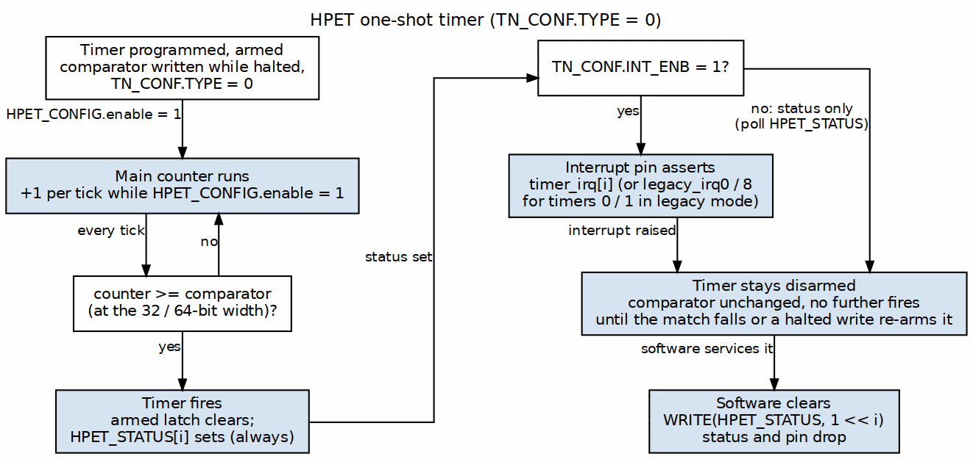
One-Shot Timer Operation
One-shot timer operation flow showing counter increment, comparator match, and idle state after fire.
Behavior: 1. Counter increments: 0 → 1 → 2 → … → comparator 2. When counter >= comparator and the timer is armed: Timer fires, and the armed latch clears 3. Sets the HPET_STATUS bit; if timer_int_enable=1, also raises timer_irq 4. Timer stays complete until the comparator is rewritten with the counter halted (HPET_CONFIG.hpet_enable = 0), or written above the counter while it runs – halting and restarting the counter alone does not re-fire
Comparator Behavior: - Stays unchanged after fire - Software re-arms the timer by writing the comparator (either half, any value – even the same one) with the counter halted, or by writing a value above the counter while it runs (there is no per-timer stop)
Use Cases: - Single timeout events - Software-initiated timing - Watchdog timers (with software reload)
Example:
// Configure Timer 0: One-shot, 1000 cycles
WRITE(TIMER0_COMPARATOR_LO, 1000);
WRITE(TIMER0_CONFIG, 0x04); // INT_ENB; TYPE = 0 (one-shot)
// Enable HPET
WRITE(HPET_CONFIG, 0x1);
// Wait for interrupt
while (!(READ(HPET_STATUS) & 0x1));
// Clear interrupt
WRITE(HPET_STATUS, 0x1);
// Re-arm for the next fire at 2000 cycles. Halt the counter around the
// write: a comparator write re-arms only while HPET_CONFIG.hpet_enable = 0 (the
// published map has no per-timer stop), so this works for any value, even
// one the counter has already passed (which then fires on the first enabled
// cycle). Writing 2000 with the counter running would also work here -- but
// only because 2000 is above the counter, so the match falls and the timer
// re-arms naturally.
WRITE(HPET_CONFIG, 0x0);
WRITE(TIMER0_COMPARATOR_LO, 2000);
WRITE(HPET_CONFIG, 0x1);

14.2.5.1 Periodic Mode (timer_type = 1)

14.2.6 Figure 5.3: Periodic Timer Operation
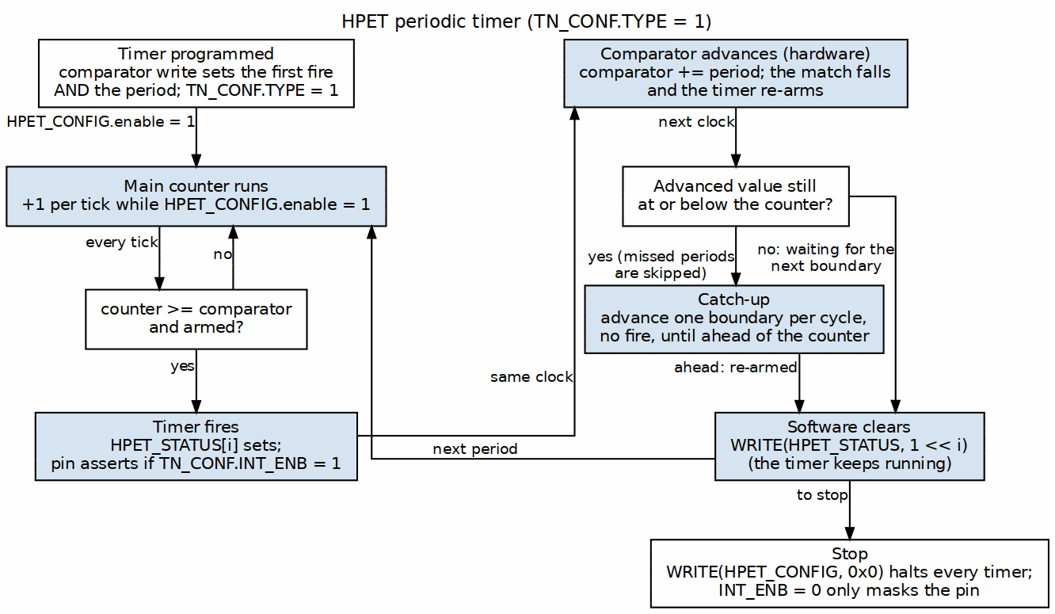
Periodic Timer Operation
Periodic timer operation flow showing counter increment, comparator match, auto-increment, and continuous firing.
Behavior: 1. Counter increments: 0 → 1 → 2 → … → comparator 2. When counter >= comparator and the timer is armed: Timer fires 3. Sets the HPET_STATUS bit; if timer_int_enable=1, also raises timer_irq 4. Comparator auto-increments: comparator = comparator + period (the match drops, which re-arms the timer for the next period) 5. Catch-up: if the advanced comparator is still at or below the counter (timer programmed late, or the counter written forward), it keeps advancing one boundary per cycle WITHOUT firing until it is at or ahead of the counter, then re-arms. Missed periods are skipped, never burst: one interrupt for the whole batch, at the next boundary still in the future. The catch-up closes the deficit at period - 1 counts per cycle, one comparator advance per cycle (period 1 is the special lattice jump to counter + 1, closed in one), so its length is proportional to the deficit: a period-2 timer left 2^52 counts behind by a counter write catches up for ~2^52 cycles, the comparator rewritten every cycle and no interrupt raised. That bound is why the HPET specification and this book require the main counter halted (HPET_CONFIG.hpet_enable=0) before it is written, and why a periodic comparator is programmed near or ahead of the counter 6. Epoch hold: if an advance carries out of the compare width (past bit 31 for a 32-bit timer, bit 63 for a 64-bit one), the comparator keeps the wrapped low bits and the timer is held – no fire, no catch-up – until the counter wraps at that width, or software writes the comparator, the counter (which re-bases the epoch, so a comparator now behind the counter fires promptly) or timer_32mode. The write clears are evaluated at the compare width: a 32-bit timer is released only by a write to HPET_COUNTER_LO or TIMERn_COMPARATOR_LO, and a write to either HI half leaves it held; a 64-bit timer is released by either half 7. Timer repeats indefinitely (fires at 1×period, 2×period, 3×period, …)
Comparator Auto-Increment: - Hardware automatically adds period value to comparator - Period = initial comparator value written by software - Example: Initial comparator = 1000 → Fires at 1000, 2000, 3000, … - Period 0 behaves as one-shot: it can never get ahead of the counter, so the timer fires once and stays quiescent (no churn) - Period 1 gains nothing on the counter per cycle (both step by 1), so a catch-up step sets the comparator to counter + 1 – every integer is on the period-1 lattice – and re-arms at once. It delivers on every other tick, the fastest the one-cycle fire/re-arm loop allows, at any deficit; a live counter write that opens a gap recovers within a cycle - The advance is evaluated at the compare width. A 32-bit periodic timer whose comparator + period passes 2^32 fires at that boundary and then stays quiet until the low 32 bits of the counter wrap – up to about 2^32 ticks, though never longer than the period that caused the carry, so the next fire still lands on the programmed lattice. A 64-bit timer whose advance carries out of bit 63 waits for the 64-bit counter to wrap – in practice it fires once and never again until reprogrammed (chapter 2 puts a number on the wait). Both are the arithmetic of the register width, not defects; in 32-bit mode the advance never disturbs TIMER_COMPARATOR_HI’s half of the comparator ([63:32])
Use Cases: - Periodic interrupts (e.g., 1 kHz tick) - PWM generation - Periodic data sampling - Heartbeat signals
Example:
// Configure Timer 1: Periodic, 2000 cycle period
WRITE(TIMER1_COMPARATOR_LO, 2000); // Initial comparator = period
WRITE(TIMER1_CONFIG, 0x0C); // TYPE (periodic) | INT_ENB
// Enable HPET
WRITE(HPET_CONFIG, 0x1);
// Timer fires at:
// - 2000 cycles (counter >= 2000)
// - 4000 cycles (counter >= 4000) [comparator auto-incremented to 4000]
// - 6000 cycles (counter >= 6000) [comparator auto-incremented to 6000]
// - ... indefinitely
// Interrupt handler
void timer1_isr(void) {
// Clear interrupt
WRITE(HPET_STATUS, 0x2); // Clear bit 1 (Timer 1)
// Handle periodic event
// ...
// No need to reconfigure - timer continues automatically
}

14.2.7 Register Access Conventions

14.2.7.1 Access Types
Type | Description | Behavior
RO | Read-Only | Software can read, writes ignored
RW | Read-Write | Software can read and write
W1C | Write-1-to-Clear | Write 1 to clear bit, write 0 has no effect
RW/W1C | Read-Write with W1C | Readable, writable, with W1C clear behavior

14.2.7.2 Reset Values
- Global registers: Reset to 0x00000000 (except HPET_ID)
- HPET_ID: Constant GCAP_ID[31:0]: vendor_id = VENDOR_ID (full 16 bits at [31:16]), rev_id = REVISION_ID ([7:0]), num_tim_cap = NUM_TIMERS-1 ([12:8]), count_size_cap = 1 ([13]), leg_rt_cap = 1 ([15])
- HPET_PERIOD: Constant GCAP_ID[63:32]: COUNTER_CLK_PERIOD_FS femtoseconds
- All timers: TIMER_CONFIG resets to 0x00000030 (every writable bit 0; the read-only per_int_cap and size_cap read 1); comparators reset to 0
- Main counter: Reset to 0x00000000_00000000

14.2.7.3 Read/Write Ordering
64-bit Register Writes: Each 32-bit write lands its own half on the write itself, so the order is free, but the value is not atomic: between the two writes the hardware holds {old HI, new LO} (or the reverse). Halt the counter (HPET_CONFIG[0] = 0) before writing it, as on a real HPET – and always for a partial, byte-strobed write, whose merge reads a cycle-old mirror. The mixed comparator value can never fire, because a comparator write does not re-arm a running timer; the flip side is that a running timer re-arms only when the completed value is above the counter, so halt the counter around the pair whenever the new value may already be behind it (see Reprogramming a Running Timer).
64-bit Register Reads: Use the HI/LO/HI retry sequence (read HI, read LO, re-read HI; retry if the two HI reads differ). A plain LO-then-HI read has no rollover protection.

14.2.8 Figure 5.4: HPET Register Memory Map
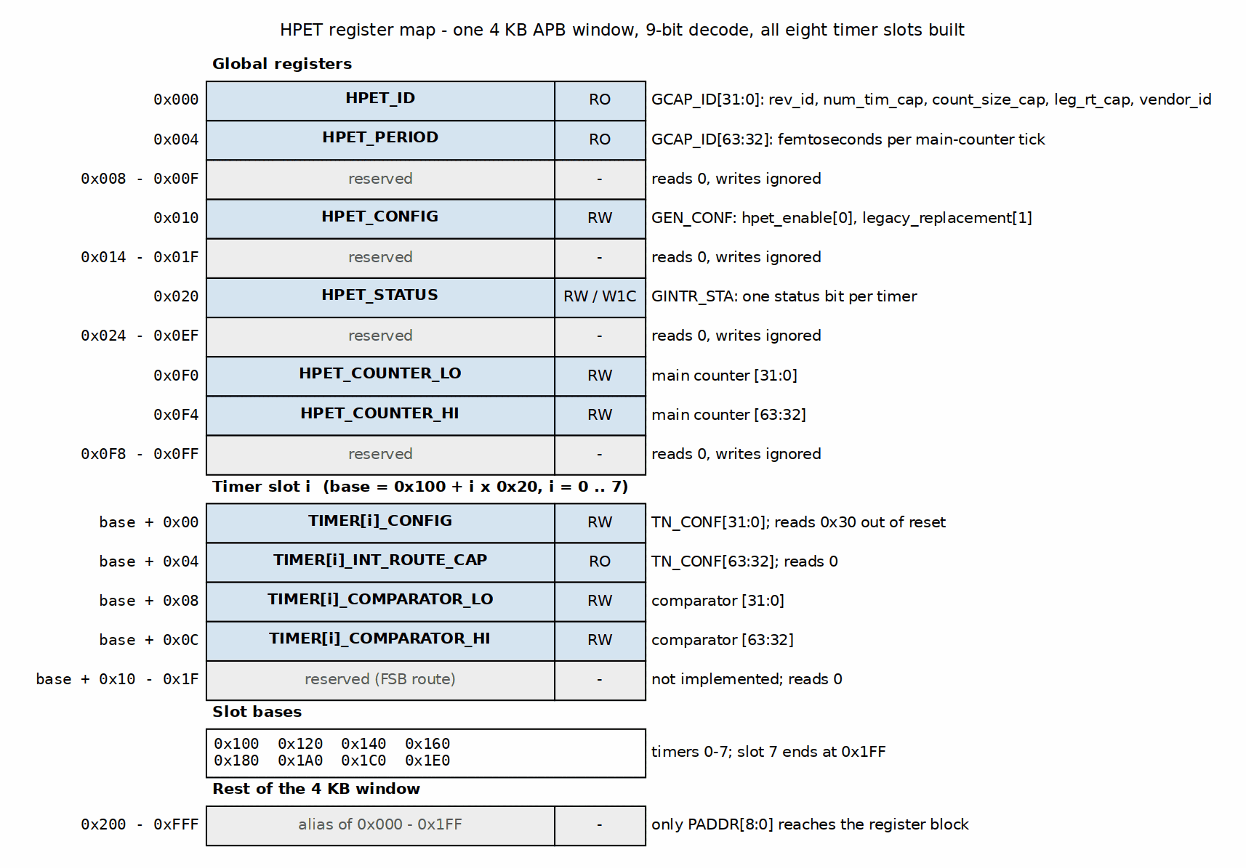
HPET Register Memory Map
Only address bits [8:0] reach the register block, so 0x200-0xFFF alias back onto 0x000-0x1FF (0x200 reads HPET_ID, and so on). No error is raised for any address: reserved offsets inside the window read 0 and ignore writes.
Timer slots at or above NUM_TIMERS (e.g. 0x140-0x1FF on a 2-timer build) are REAL decoded storage: they read back written values but reach no core timer. Probe HPET_ID.num_tim_cap, not register writability, to discover the timer count.

14.3 Waveforms
The following timing diagrams illustrate key register access sequences:

14.3.1 Waveform 5.1: APB Write Timer Config
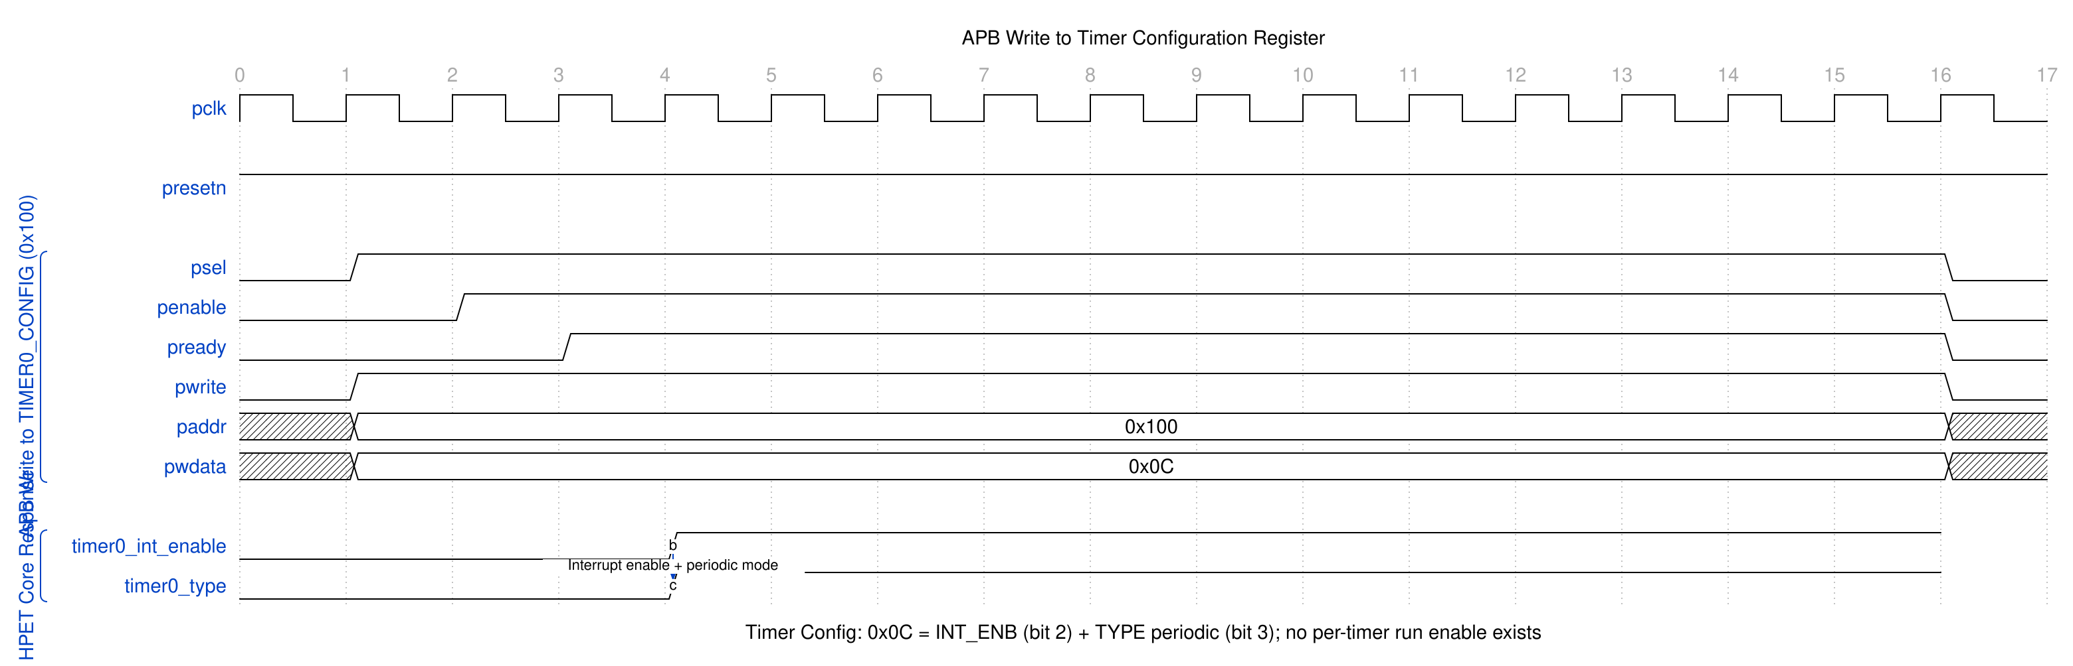
APB Write Timer Config
APB write to TIMER0_CONFIG register (0x100). Source: assets/wavedrom/apb_write_timer_config.json

14.3.2 Waveform 5.2: APB Read Counter
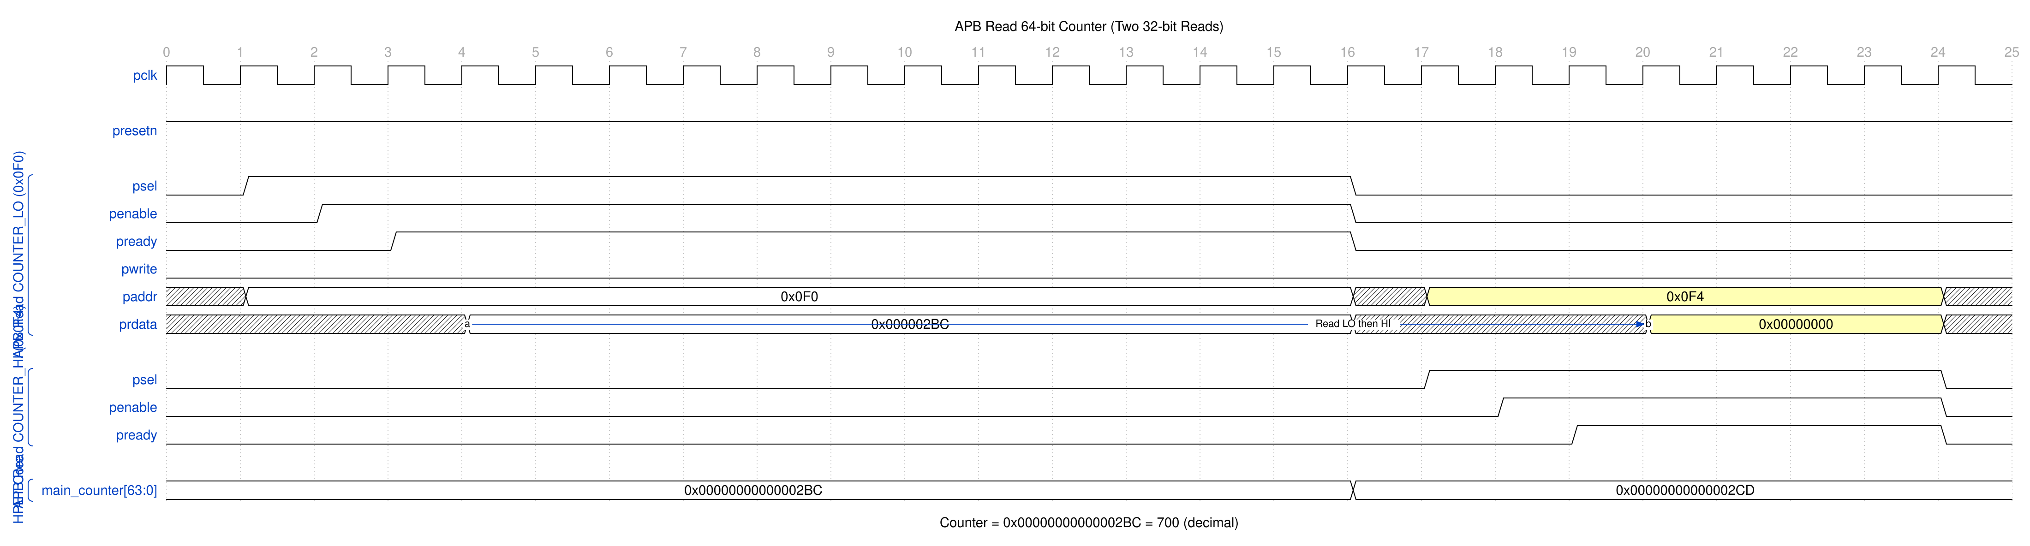
APB Read Counter
APB read of 64-bit counter (two 32-bit reads from COUNTER_LO and COUNTER_HI). Source: assets/wavedrom/apb_read_counter.json

14.3.3 Waveform 5.3: Interrupt W1C Sequence
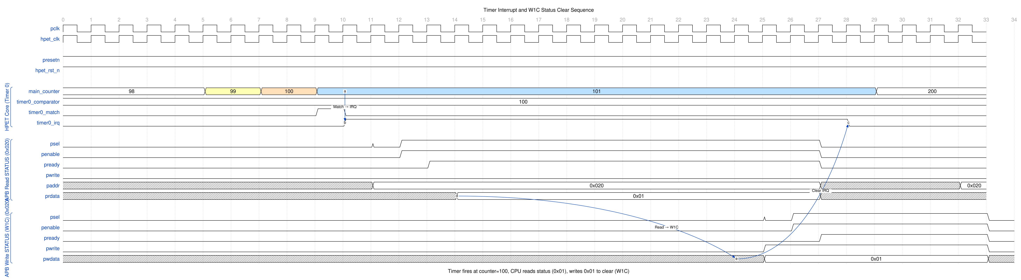
Interrupt W1C Sequence
Timer interrupt generation and W1C (Write-1-to-Clear) status clearing sequence. Source: assets/wavedrom/interrupt_w1c_sequence.json

14.3.4 Waveform 5.4: Timer Setup Sequence
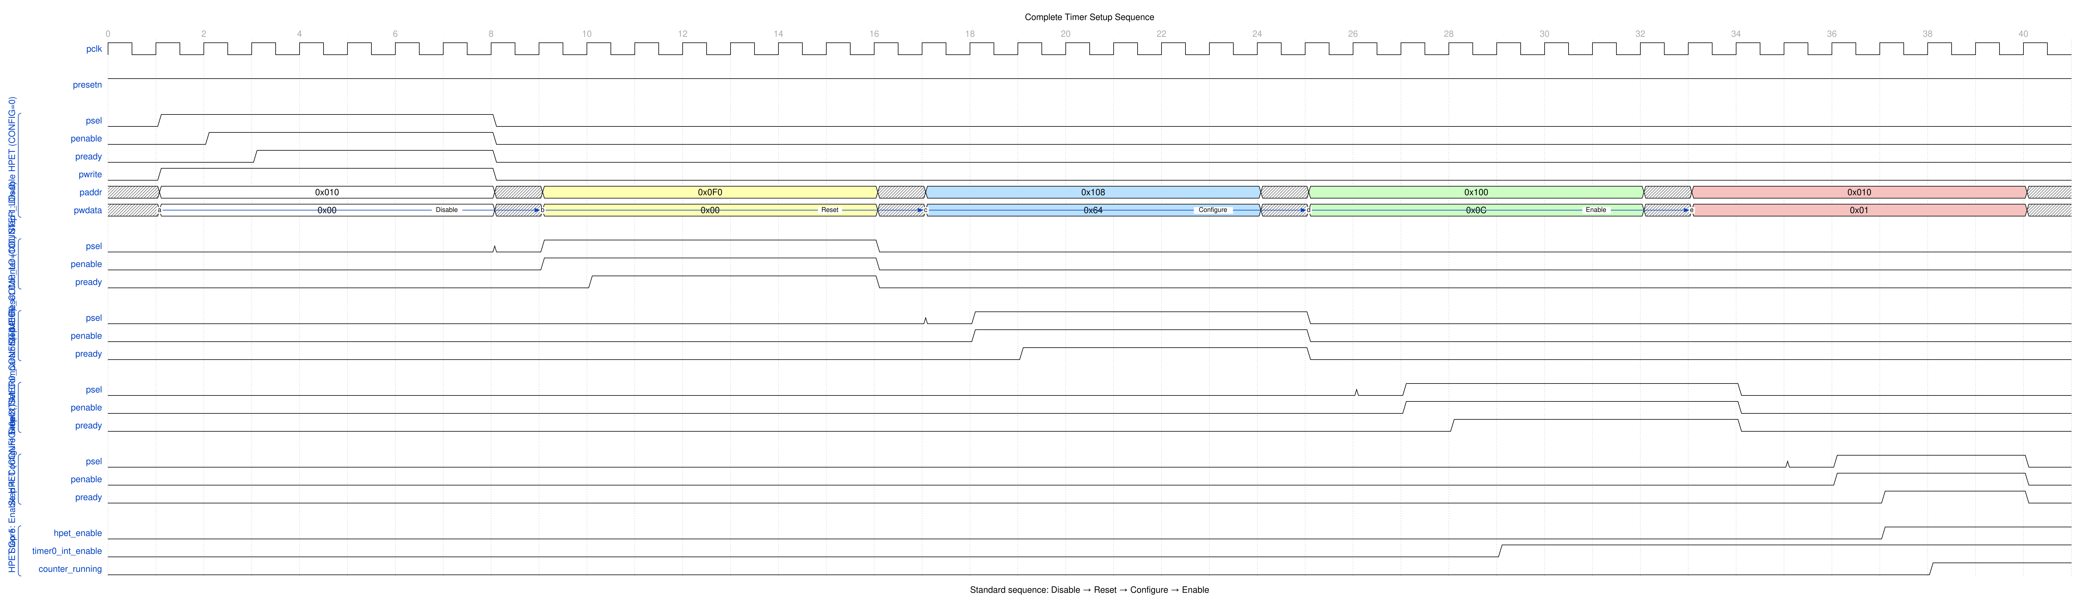
Timer Setup Sequence
Complete timer setup sequence: disable HPET, reset counter, configure comparator, configure timer (INT_ENB | TYPE), enable HPET. Source: assets/wavedrom/timer_setup_sequence.json

14.4 Usage Example

14.4.1 Initialization Sequence

14.4.2 Figure 5.5: Software Initialization Flow
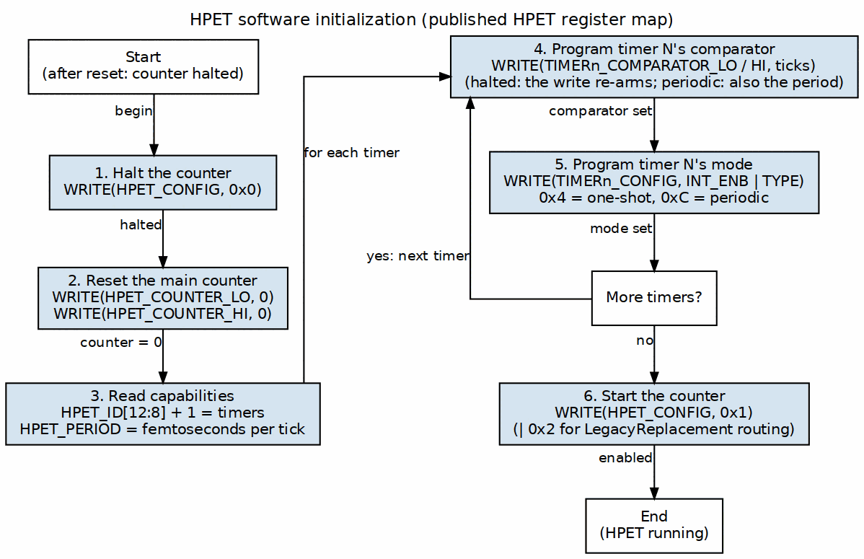
Software Initialization Flow
Software initialization sequence showing configuration steps from disable to enable.
// 1. Disable HPET
WRITE(HPET_CONFIG, 0x0);
// 2. Reset main counter
WRITE(HPET_COUNTER_LO, 0x0);
WRITE(HPET_COUNTER_HI, 0x0);
// 3. Configure Timer 0 (one-shot, 10ms @ 10MHz)
WRITE(TIMER0_COMPARATOR_LO, 100000); // 100,000 cycles = 10ms
WRITE(TIMER0_COMPARATOR_HI, 0x0);
WRITE(TIMER0_CONFIG, 0x04); // INT_ENB; TYPE = 0 (one-shot)
// 4. Configure Timer 1 (periodic, 1ms @ 10MHz)
WRITE(TIMER1_COMPARATOR_LO, 10000); // 10,000 cycles = 1ms period
WRITE(TIMER1_COMPARATOR_HI, 0x0);
WRITE(TIMER1_CONFIG, 0x0C); // TYPE (periodic) | INT_ENB
// 5. Enable HPET
WRITE(HPET_CONFIG, 0x1);

14.4.3 Reading Capabilities
// Read identification register
uint32_t id = READ(HPET_ID);
// Extract fields
uint16_t vendor_id = (id >> 16) & 0xFFFF; // GCAP_ID[31:16]
uint8_t rev_id = id & 0xFF; // GCAP_ID[7:0]
uint8_t num_timers = ((id >> 8) & 0x1F) + 1; // num_tim_cap + 1
uint8_t is_64bit = (id >> 13) & 0x1; // count_size_cap
uint8_t leg_cap = (id >> 15) & 0x1; // leg_rt_cap
uint32_t period_fs = READ(HPET_PERIOD); // femtoseconds per tick
printf("HPET: Vendor=0x%04X, Rev=%d, Timers=%d, 64-bit=%d\n",
vendor_id, rev_id, num_timers, is_64bit);

14.4.4 Interrupt Handling

14.4.5 Figure 5.6: Interrupt Handling Flow
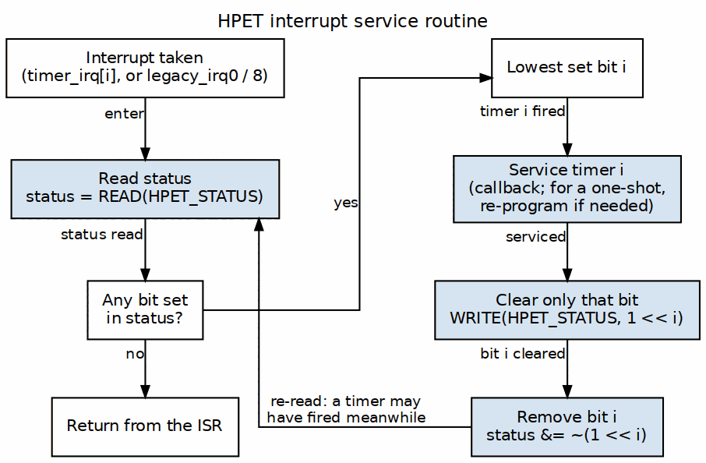
Interrupt Handling Flow
Interrupt handling flow showing status check, handler dispatch, and W1C clear sequence.
// Generic interrupt handler
void hpet_interrupt_handler(void) {
// Read status register
uint32_t status = READ(HPET_STATUS);
// Check which timers fired
if (status & (1 << 0)) {
// Timer 0 fired
handle_timer0();
WRITE(HPET_STATUS, (1 << 0)); // Clear Timer 0 interrupt
}
if (status & (1 << 1)) {
// Timer 1 fired
handle_timer1();
WRITE(HPET_STATUS, (1 << 1)); // Clear Timer 1 interrupt
}
// Each write clears only the bit(s) written with 1; a timer that
// fires after the READ keeps its bit for the next pass.
}

14.5 Related Modules
- Chapter 2: Blocks - Block-level architecture
- Chapters 3 (Interfaces) and 4 (Programming Model) are planned and not yet written – see the index
- PeakRDL Specification - SystemRDL register definition

14.5.1 Additional Diagrams
- Block Diagram - Top-level architecture
- One-Shot Timer - One-shot mode operation
- Periodic Timer - Periodic mode operation
- Software Init - Initialization sequence
- Interrupt Handling - Interrupt flow
- Timer Mode Switch - Mode switching
- Multi-Timer Concurrent - Concurrent operation
- CDC Crossings - Clock domain crossing (CDC_ENABLE=1)

Document Version: 1.1 Generated: 2026-09-08 Based on: hpet_regs.rdl v2

