
RTL Design Sherpa
APB PIC 8259 Micro-Architecture Specification 1.0
January 4, 2026

Table of Contents
1 Pic 8259 Mas Index 7
2 pic_8259 – Overview 8
2.1 Overview 8
2.1.1 Parameters 9
2.1.2 Applications 9
2.2 Functional Description 10
2.2.1 Figure 1.1: PIC 8259 Block Diagram 10
2.2.2 Register Summary 10
2.2.3 Interrupt Priority 11
2.2.4 Priority Modes 12
2.3 Waveforms 13
2.3.1 Waveform 1.1: Interrupt Request 13
2.3.2 Waveform 1.2: Interrupt Acknowledge Sequence 13
2.3.3 Waveform 1.3: End-of-Interrupt (EOI) 14
2.3.4 Waveform 1.4: Cascade Mode 15
2.3.5 Waveform 1.5: Priority Rotation 15
2.4 Navigation 17
3 pic_8259 – Register Map 18
3.1 Overview 18
3.2 Functional Description 19
3.2.1 Register Map 19
3.2.2 Global Configuration 20
3.2.3 Initialization Command Words (ICW) 21
3.2.4 Operation Command Words (OCW) 23
3.2.5 Status / Readback Registers 26
3.3 Design Notes 29
3.4 Navigation 30

List of Figures
Figure 1.1: PIC 8259 Block Diagram 10

List of Tables
No tables in this document.

List of Waveforms
Waveform 1.1: Interrupt Request 13
Waveform 1.2: Interrupt Acknowledge Sequence 13
Waveform 1.3: End-of-Interrupt (EOI) 14
Waveform 1.4: Cascade Mode 15
Waveform 1.5: Priority Rotation 15

1 Pic 8259 Mas Index
Generated: 2026-10-20

RTL Design Sherpa · Learning Hardware Design Through Practice GitHub · Documentation Index · MIT License

2 pic_8259 – Overview

2.1 Overview
The pic_8259 is an 8259A-compatible Programmable Interrupt Controller with an APB interface. It handles interrupt management for legacy PC-compatible systems: eight request lines in, one interrupt line out, with masking, priority resolution, and an initialization sequence in between.
Implemented in the current RTL:
- 8 interrupt inputs (irq_in[7:0]) with a single int_out line. irq_in may be asynchronous – it passes a SYNC_STAGES-flop synchronizer (default 2) before the edge detector, so a pin transition costs SYNC_STAGES + 1 clocks before int_out reflects it
- Fully-decoded 32-bit APB register file (no legacy A0 two-port model). Only 0x00-0x2C are decoded; everything else in the 4 KB window is dropped with PSLVERR
- Acknowledge by read: a read of PIC_INTA (0x2C) stands in for the INTA bus cycle. It returns {vector_base[7:3], irq} with a valid bit, sets the ISR bit, and clears an edge-mode IRR bit
- Live IRR and ISR with the fully nested rule: an in-service level blocks itself and every lower-priority level until its EOI; a higher-priority level preempts
- All eight OCW2 commands: non-specific, specific and rotating EOI, set-priority, rotate-on-AEOI arm/disarm, and automatic EOI (ICW4 AEOI)
- Special mask mode (OCW3)
- Edge or level triggering
- Interrupt masking (IMR / OCW1)
Now the other half of the story. The following register bits are software-visible storage with no hardware effect – they are kept so a classic ICW/OCW sequence runs unchanged, and that is all they do (see the register map design notes):
- Special fully nested mode (ICW4 SFNM)
- Buffered mode (ICW4 BUF)
- OCW3 read-register-select and poll. IRR and ISR have dedicated read-only registers, and PIC_INTA answers the poll question with the acknowledge folded in
- auto_reset_init (PIC_CONFIG bit 2) affects only whether init_mode clears itself after ICW4
This is the block after the 2026-09-09 fixes (issue #50); before them there was no acknowledge path at all.

2.1.1 Parameters
Parameter | Type | Default | Description
SYNC_STAGES | int | 2 | irq_in synchronizer depth in flops. Minimum 2 (a simulation-time guard rejects less)

2.1.2 Applications
- PC-compatible interrupt management
- Legacy device support
- x86 system integration

2.2 Functional Description

2.2.1 Figure 1.1: PIC 8259 Block Diagram
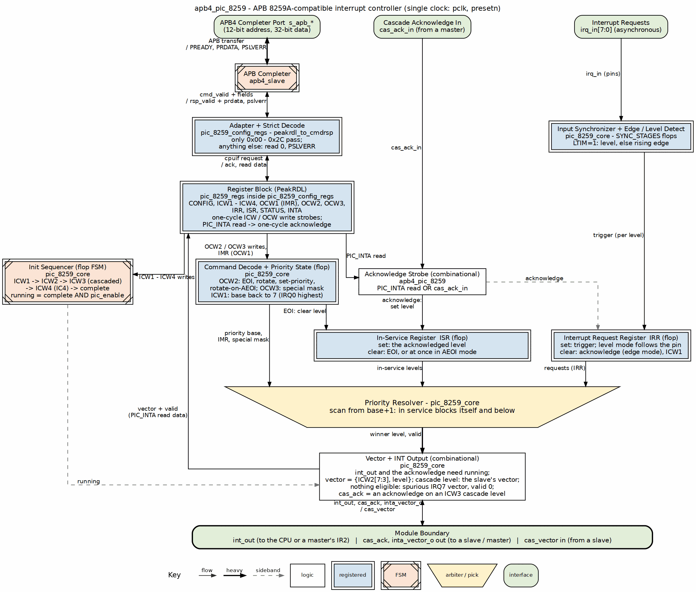
PIC 8259 Block Diagram

2.2.2 Register Summary
The block uses a fully-decoded 32-bit register file, not the legacy A0 two-port model. See Chapter 5: Register Map for full field definitions.
Offset | Register | Access | Description
0x00 | PIC_CONFIG | RW | Global configuration (pic_enable, init_mode, auto_reset_init)
0x04 | PIC_ICW1 | WO | Initialization Command Word 1
0x08 | PIC_ICW2 | WO | Initialization Command Word 2 (vector base)
0x0C | PIC_ICW3 | WO | Initialization Command Word 3 (cascade config)
0x10 | PIC_ICW4 | WO | Initialization Command Word 4
0x14 | PIC_OCW1 | RW | Interrupt Mask Register (IMR)
0x18 | PIC_OCW2 | WO | EOI / priority command
0x1C | PIC_OCW3 | WO | Special mask (read-select and poll are storage only)
0x20 | PIC_IRR | RO | Interrupt Request Register
0x24 | PIC_ISR | RO | In-Service Register
0x28 | PIC_STATUS | RO | Initialization state / diagnostics
0x2C | PIC_INTA | RO | Interrupt acknowledge by read (side-effecting)
The PIC is disabled at reset - firmware must BOTH complete the ICW initialization sequence (ICW1 -> ICW2 -> ICW3 if cascaded -> ICW4 if requested; PIC_STATUS.init_complete=1) AND set pic_enable (PIC_CONFIG bit 0) before any interrupt can be requested or delivered – out of reset the init FSM sits in INIT_IDLE and IRR never updates. OCW2 and OCW3 commands are ignored until both conditions hold.

2.2.3 Interrupt Priority
IRQ | Default Priority
IR0 | Highest (0)
IR1 | 1
IR2 | 2 (the conventional cascade input on a master)
IR3 | 3
IR4 | 4
IR5 | 5
IR6 | 6
IR7 | Lowest (7)

2.2.4 Priority Modes
- Fixed Priority: IR0 highest, IR7 lowest (the reset and post-ICW1 order)
- Rotating Priority: the level just retired becomes lowest – rotate on non-specific EOI (0xA0), rotate on specific EOI (0xE0-0xE7), or once per acknowledge with rotate-on-AEOI armed (0x80) in AEOI mode
- Specific Priority: set-priority (0xC0-0xC7) names the lowest level
In every mode an in-service level blocks itself and all lower-priority levels until its EOI, and int_out asserts only for an unmasked request that outranks everything in service. Special mask mode (OCW3) relaxes that for an in-service level that software has also masked.

2.3 Waveforms

2.3.1 Waveform 1.1: Interrupt Request
Shows an IRQ input assertion triggering the interrupt process.
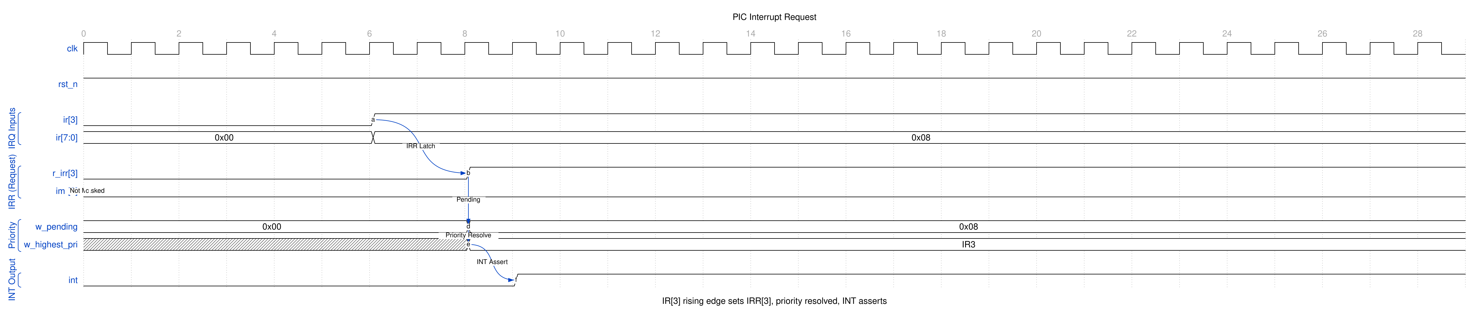
PIC Interrupt Request
When an IR pin asserts, the synchronized input sets the corresponding IRR bit (on the rising edge in edge mode; for as long as the pin is high in level mode). The priority resolver selects the highest priority unmasked request that outranks every in-service level and asserts INT to the CPU. A masked request stays in the IRR and never reaches INT until it is unmasked.

2.3.2 Waveform 1.2: Interrupt Acknowledge Sequence
The acknowledge, as an APB read of PIC_INTA.
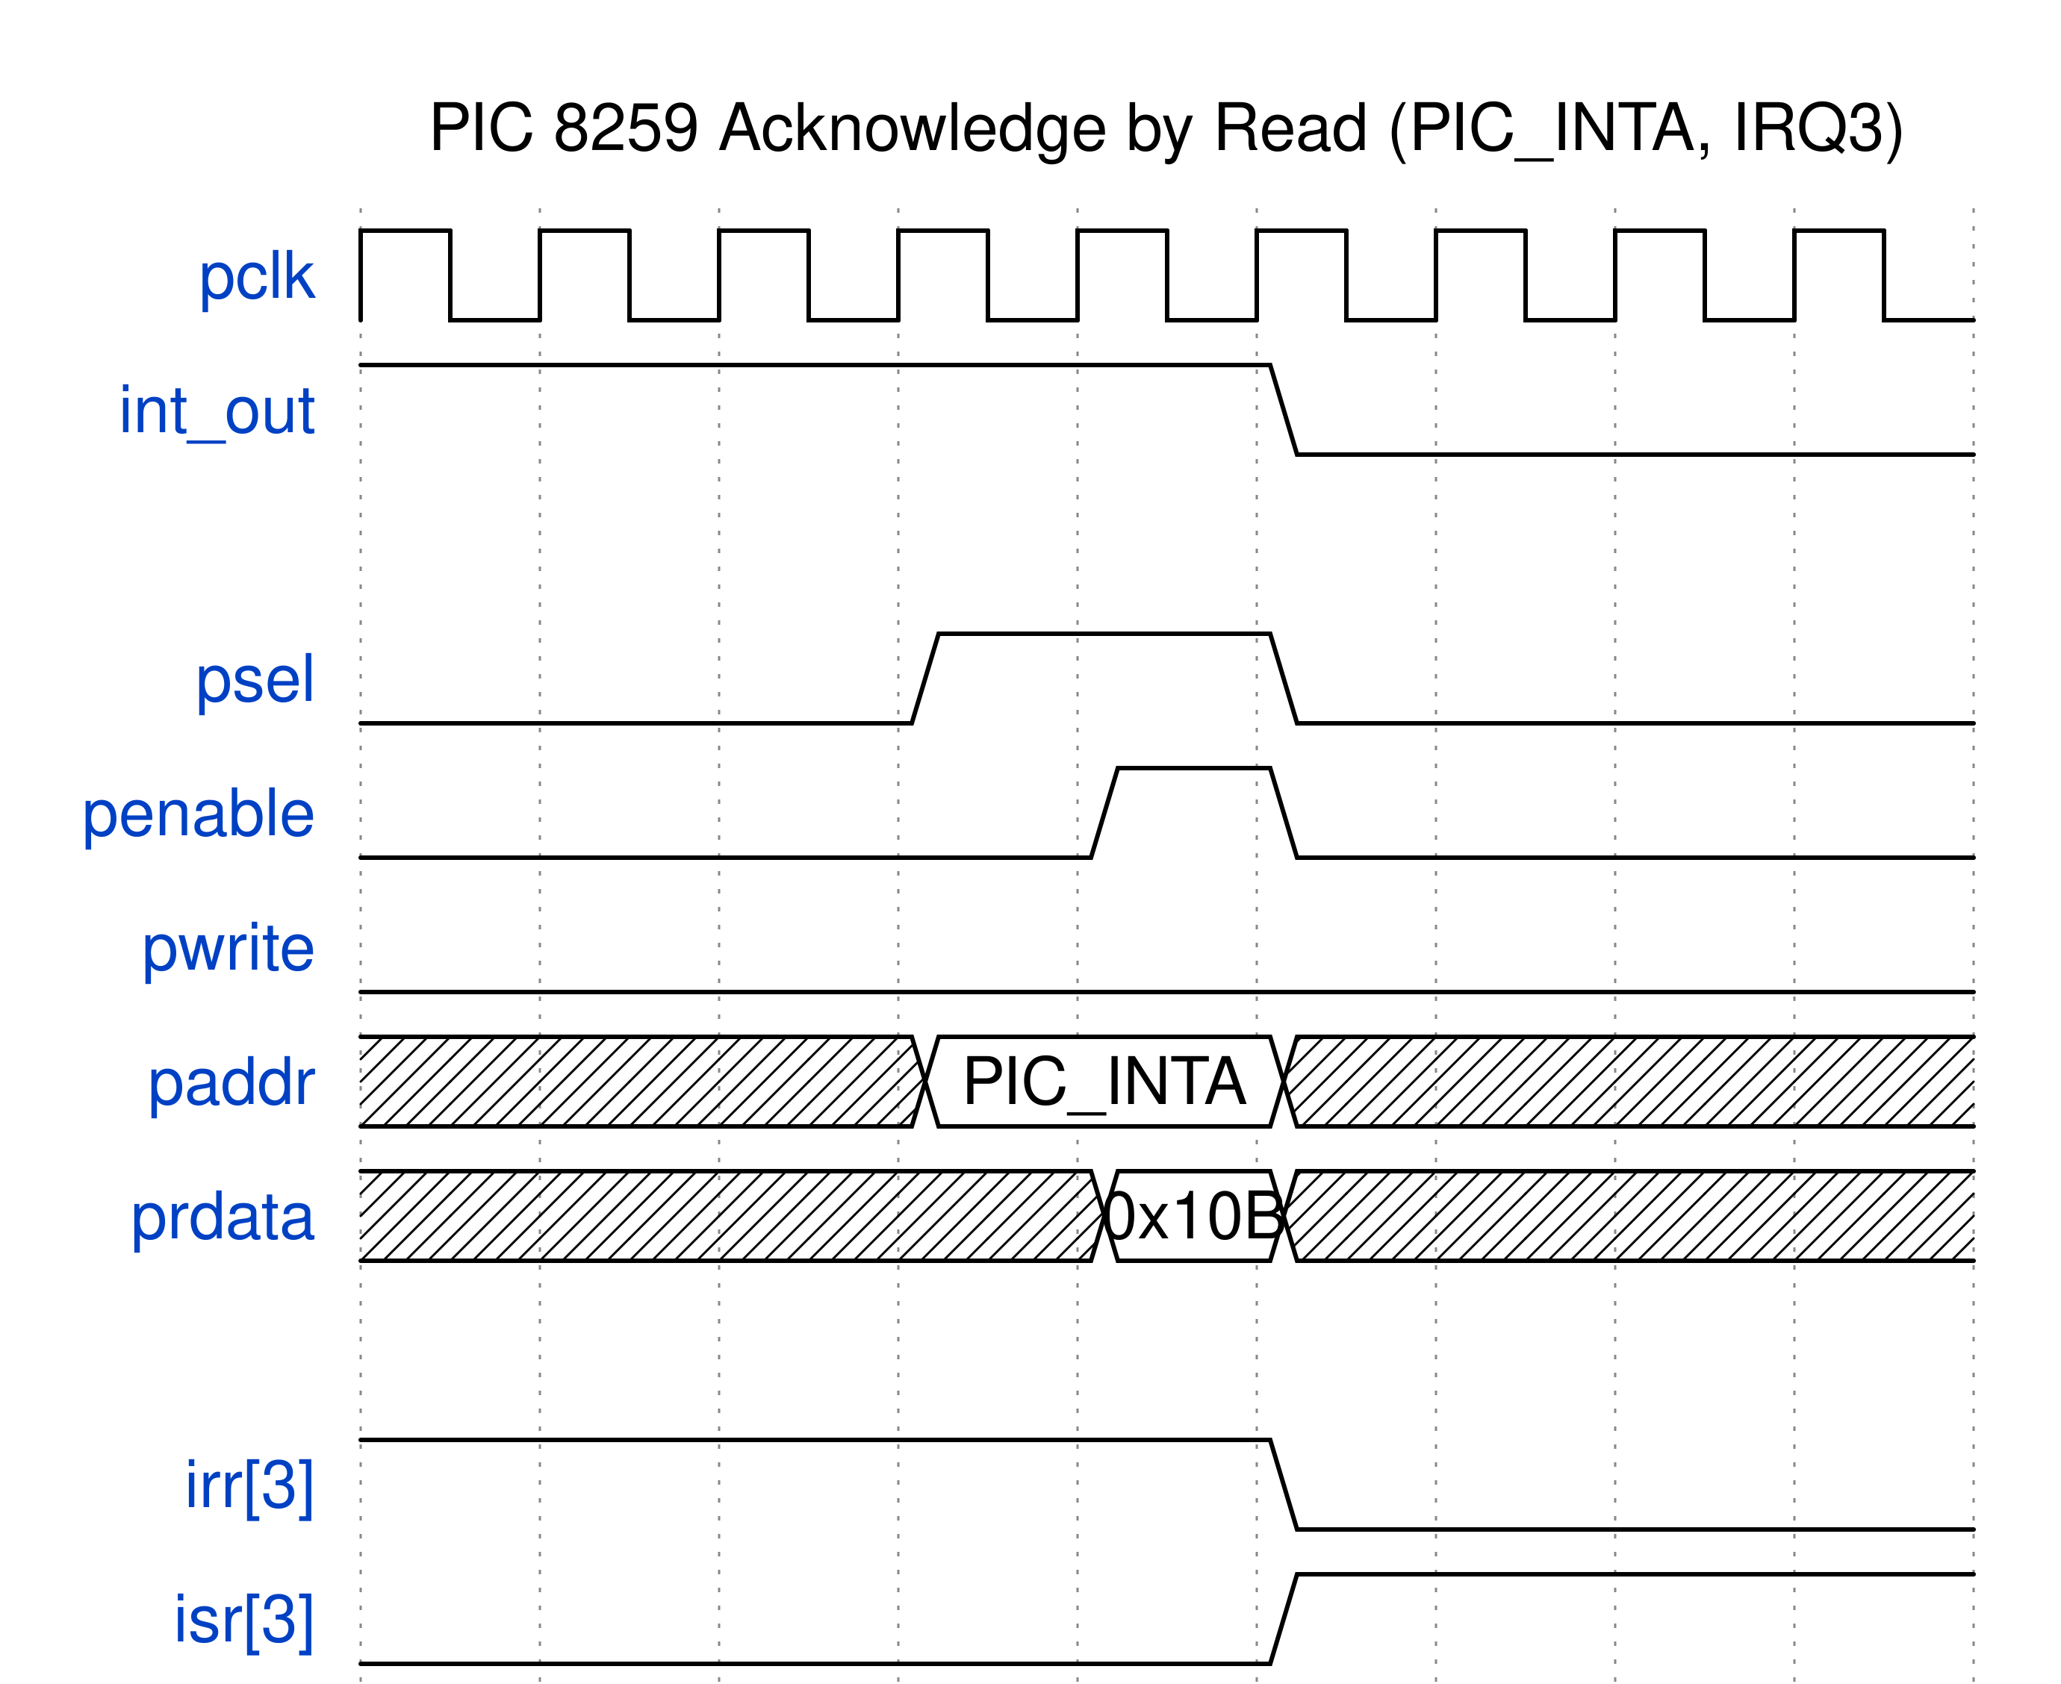
PIC Interrupt Acknowledge
This block has no INTA pin; a single APB read of PIC_INTA (0x2C) does the work of both classic INTA pulses. In the access cycle the read data carries the vector (base + IR number) with bit 8 set to say a request was acknowledged, and at the end of that same cycle the core transfers the level from IRR to ISR (in edge mode the IRR bit clears; in level mode it keeps following the pin). The data returned is the pre-acknowledge state. INT drops in the next cycle unless a higher-priority request is still waiting. With nothing pending the read returns valid=0 and the spurious IRQ7 vector, and changes nothing.

2.3.3 Waveform 1.3: End-of-Interrupt (EOI)
Software clears the in-service bit with an EOI command.
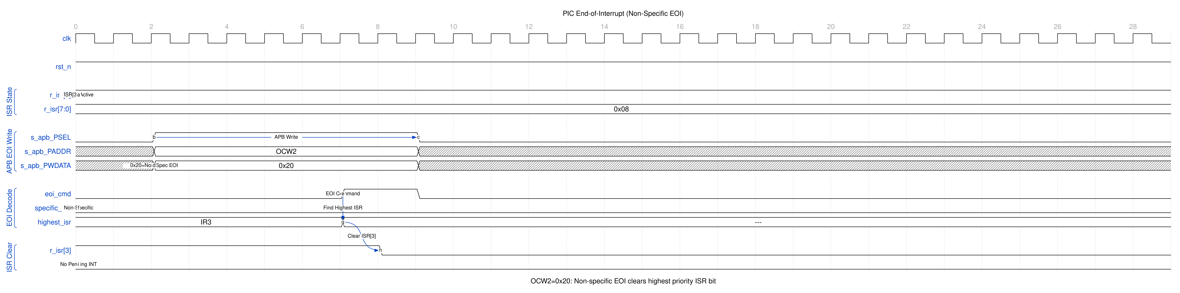
PIC EOI
Non-specific EOI (0x20) clears the highest priority ISR bit – under the fully nested rule, the level acknowledged most recently; under special mask mode, the highest in-service level that is not masked. Specific EOI (0x60-0x67) clears a designated IR. Either is a no-op when nothing is in service. Once the bit clears, the levels it was blocking become eligible again, so INT reasserts if a lower-priority request was waiting; in AEOI mode the acknowledge itself retires the level and no EOI is written.

2.3.4 Waveform 1.4: Cascade Mode
Master-slave configuration for 15 IRQ sources.
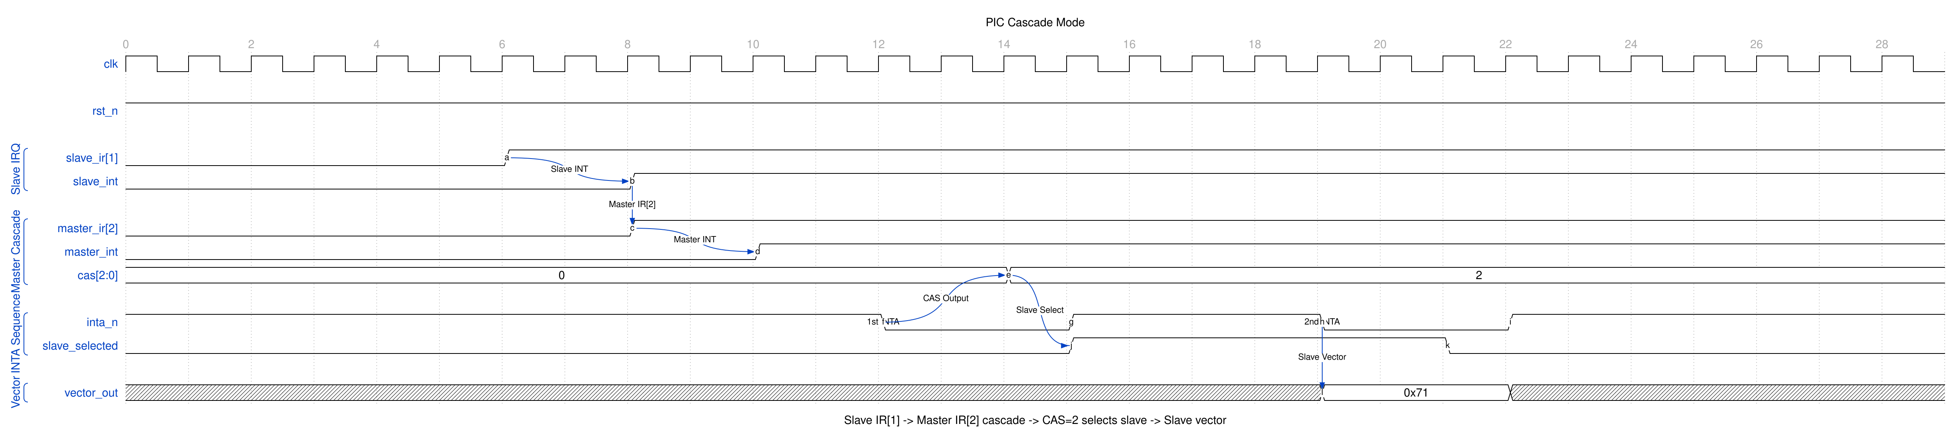
PIC Cascade
Slave INT connects to master IR2. During INTA, master outputs cascade select (CAS) lines. Slave with matching ID provides the interrupt vector.
Note: cascade IS implemented (RLB/pic_8259 TASK-001), but this block has no CAS or SP/EN pins, so the cascade_sel step above is architectural rather than literal. Acknowledge here is an APB read of PIC_INTA, not an INTA pulse pair, so there is no second pulse on which to broadcast a slave ID. The equivalent, and what the RTL does: when the acknowledged level is one ICW3 marks as cascaded, the master returns the SLAVE’s vector and forwards the acknowledge down. Covered by dv/tests/test_pic_8259_cascade.py (RLB/pic_8259 TASK-001).

2.3.5 Waveform 1.5: Priority Rotation
Automatic priority rotation for equal-service scheduling.
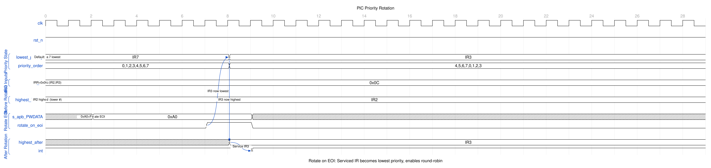
PIC Priority Rotation
Rotate-on-EOI (0xA0) retires the highest-priority in-service level and makes it the lowest priority, implementing round-robin scheduling among interrupt sources. Rotate on specific EOI (0xE0-0xE7) does the same for a named level, set-priority (0xC0-0xC7) moves the base without an EOI, and with rotate-on-AEOI armed (0x80) each acknowledge in AEOI mode rotates exactly once. ICW1 restores the fixed IR0-highest order.

2.4 Navigation
Next: 02_architecture.md (planned, not yet written)

RTL Design Sherpa · Learning Hardware Design Through Practice GitHub · Documentation Index · MIT License

3 pic_8259 – Register Map

3.1 Overview
Forget the legacy two-port, A0-based interface of the original 8259A – this block doesn’t have one. What you get is a fully-decoded, 32-bit-aligned APB register file: each ICW/OCW and every status register sits at its own dedicated offset, with no A0 pin and no OCW3 read-select multiplexing. The one thing APB cannot give you is an INTA bus cycle, so the acknowledge is a READ of PIC_INTA (0x2C) – the same trick the ARM PL190 VIC plays with VICVectAddr. Reading that register has side effects; its section below spells them out.
Decode is strict. Only the twelve offsets 0x000 through 0x02C exist. Every other address in the 4 KB window is dropped – a write is ignored, a read returns 0x0000_0000 – and the transfer completes with PSLVERR asserted. There is no aliasing: 0x044 is not ICW1 and 0x054 is not the IMR, they are errors. (Earlier RTL decoded six address bits for storage while the side-effect strobes compared all twelve, so an aliased write landed in storage and fired nothing; fixed 2026-09-09, issue #50.)

3.2 Functional Description

3.2.1 Register Map
Offset | Register | Access | Reset | Description
0x00 | PIC_CONFIG | RW | 0x0000_0004 | Global configuration and control (gates all operation)
0x04 | PIC_ICW1 | WO | — | Initialization Command Word 1 (edge/level, single, ICW4-needed)
0x08 | PIC_ICW2 | WO | — | Initialization Command Word 2 (interrupt vector base)
0x0C | PIC_ICW3 | WO | — | Initialization Command Word 3 (cascade config)
0x10 | PIC_ICW4 | WO | — | Initialization Command Word 4 (mode bits)
0x14 | PIC_OCW1 | RW | 0x0000_00FF | Operation Command Word 1 - Interrupt Mask Register (IMR)
0x18 | PIC_OCW2 | WO | — | Operation Command Word 2 (EOI / priority command)
0x1C | PIC_OCW3 | WO | — | Operation Command Word 3 (special mask; read-select and poll are storage only)
0x20 | PIC_IRR | RO | 0x0000_0000 | Interrupt Request Register
0x24 | PIC_ISR | RO | 0x0000_0000 | In-Service Register
0x28 | PIC_STATUS | RO | — | Initialization state and diagnostics
0x2C | PIC_INTA | RO | — | Interrupt acknowledge by read – reading it acknowledges the pending interrupt
Anything else in the window: dropped with PSLVERR.
Access notes: PIC_ICW1-ICW4, PIC_OCW2, and PIC_OCW3 are write-only in the RTL - their read-back paths are tied to zero, so reading these offsets returns 0x0000_0000. PIC_CONFIG, PIC_OCW1 (IMR), PIC_IRR, PIC_ISR, PIC_STATUS and PIC_INTA return meaningful data on a read. PIC_INTA and the two status registers are wires, not storage – what you read is the core’s state in that cycle.

3.2.2 Global Configuration

3.2.2.1 PIC_CONFIG (Offset 0x00, RW)
The PIC is disabled out of reset. Firmware must complete the ICW initialization sequence (through PIC_STATUS.init_complete=1) AND set pic_enable before any interrupt request can propagate - IRR only updates once the init FSM reaches INIT_COMPLETE. pic_enable gates delivery, not observation: while it is 0 the core forces int_out low and refuses to acknowledge, but IRR keeps capturing requests and ISR keeps whatever was in service, so a disable/enable cycle mid-handler neither loses a request nor silently retires a level. The edge detector tracks the synchronized inputs at all times, so a request that drops and rises again inside a disabled window is seen, and enabling never manufactures an edge from a line that was already high. A line that rises between ICW1 and ICW4 is not latched (IRR capture waits for INIT_COMPLETE, and ICW1 clears IRR anyway) and is not manufactured either. OCW2 and OCW3 commands are gated the same way: a write issued before initialization completes, or with pic_enable=0, changes the register storage and nothing else – it cannot rotate the priority base or set special mask mode ahead of time.
Bits | Name | Access | Reset | Description
0 | pic_enable | RW | 0 | Master enable (0=disabled, 1=enabled)
1 | init_mode | RW | 0 | Initialization request. Taken on its 0 -> 1 edge; consumed by the next ICW1 write
2 | auto_reset_init | RW | 1 | Hardware clears init_mode when ICW4 is written
31:3 | Reserved | RO | 0 | Reserved
init_mode is a start REQUEST, not a mode level. The core takes it on its rising edge and arms a re-initialization; the next ICW1 write consumes the request and begins the sequence. If the PIC was already initialized, arming drops the init FSM from INIT_COMPLETE back to INIT_IDLE (so PIC_STATUS.init_complete reads 0 until the new sequence finishes), which is the bit’s practical use – letting software watch a re-initialization from step 0. Initialization does not otherwise need it: an ICW1 write from INIT_IDLE or INIT_COMPLETE starts the sequence on its own. Holding the bit at 1 afterwards changes nothing, so auto_reset_init=0 is a legal configuration and INIT_COMPLETE holds with init_mode still set.
With auto_reset_init=1 the hardware clears init_mode in the cycle the ICW4 write takes effect. The clear is a hardware-precedence hwclr in the register block, so a PIC_CONFIG write landing in that same cycle cannot swallow it: the software write still takes for pic_enable and auto_reset_init, and the clear still wins for bit 1. auto_reset_init has no other effect.
Re-initialization: an ICW1 write clears IRR, ISR and special mask mode, disarms rotate-on-AEOI and restores the priority base to 7 (IRQ0 highest), as it does on a real 8259A. Two departures from the datasheet remain. First, only INIT_IDLE and INIT_COMPLETE honor ICW1 as a sequence start – an ICW1 write while the FSM is mid-sequence (WAIT_ICW2/3/4) clears the state above but does not restart the step counter. Second, ICW1 does not touch the ICW4 storage, so an IC4=0 re-initialization keeps whatever ICW4 last held (reset value uPM=1, AEOI=0) where a real part would assume zeros; write ICW4 explicitly if AEOI must be off.

3.2.3 Initialization Command Words (ICW)
All ICW registers are write-only; reading them returns 0.

3.2.3.1 PIC_ICW1 (Offset 0x04, WO)
Bit | Name | Reset | Description
0 | IC4 | 0 | 1 = ICW4 needed, 0 = ICW4 not needed
1 | SNGL | 0 | 1 = single mode (no ICW3 in the sequence), 0 = cascade mode (ICW3 expected)
2 | ADI | 0 | Call address interval (8080/8085 mode only; storage)
3 | LTIM | 0 | 1 = level triggered, 0 = edge triggered
4 | ICW1 Marker | 1 | Resets to 1 (8259A ICW1 identifier); plain writable storage – hardware does not enforce or check it
31:5 | Reserved | 0 | Reserved (the RTL implements no bits above bit 4)
Note: the RTL stores only bits [4:0]. The legacy A7-A5 vector bits of an MCS-80 8259A are not implemented here. SNGL’s only hardware effect is whether the init FSM waits for ICW3.

3.2.3.2 PIC_ICW2 (Offset 0x08, WO)
Bits | Name | Reset | Description
7:0 | vector_base | 0x00 | Interrupt vector base. The vector returned by PIC_INTA is {vector_base[7:3], irq[2:0]}; bits [2:0] written here never reach it
31:8 | Reserved | 0 | Reserved

3.2.3.3 PIC_ICW3 (Offset 0x0C, WO)
Cascade configuration, and it is READ by the core (RLB/pic_8259 TASK-001). Write-only to software, which is the real 8259A behaviour – a read returns 0.
This block has no CAS or SP/EN pins: it acknowledges by an APB read of PIC_INTA, so there is no second INTA pulse on which a master could broadcast a slave ID. The equivalent is that a master whose acknowledged level is marked here returns the SLAVE’s vector and forwards the acknowledge down. Covered by dv/tests/test_pic_8259_cascade.py (RLB/pic_8259 TASK-001).
Master mode:
Bits | Description
7:0 | Bitmap of IR lines that have a slave attached (1 = slave present)
Slave mode:
Bits | Description
2:0 | Slave ID (cascade input number 0-7)

3.2.3.4 PIC_ICW4 (Offset 0x10, WO)
Bit | Name | Reset | Description
0 | uPM | 1 | 1 = 8086/8088 mode, 0 = 8080/8085 mode (storage; the vector is always the 8086 form)
1 | AEOI | 0 | Automatic EOI: the acknowledge retires the level at once (see PIC_INTA)
3:2 | BUF (M/S) | 00 | Buffered-mode select: 00=non-buffered, 10=buffered slave, 11=buffered master. Storage only
4 | SFNM | 0 | Special fully nested mode. Storage only – the ordinary fully nested rule runs regardless
31:5 | Reserved | 0 | Reserved

3.2.4 Operation Command Words (OCW)

3.2.4.1 PIC_OCW1 - Interrupt Mask Register (Offset 0x14, RW)
Bits | Name | Access | Reset | Description
7:0 | imr | RW | 0xFF | Interrupt mask for IRQ0-7: 1 = masked (disabled), 0 = unmasked (enabled)
31:8 | Reserved | RO | 0 | Reserved
Reset masks all eight interrupts.
The register field is the ONE copy of the mask – the core reads it directly, there is no mirror – so readback is exact from the cycle after the write and the new mask reaches the priority resolver in the same cycle. A masked request stays in the IRR (edge mode) or keeps following its pin (level mode) and is delivered once unmasked; int_out never asserts for a masked level. The IMR is not written by the init sequence; program it after ICW4.

3.2.4.2 PIC_OCW2 (Offset 0x18, WO)
Bits | Name | Reset | Description
2:0 | irq_level (L2-L0) | 0 | IRQ level for specific EOI or set-priority
4:3 | Reserved | 0 | Reserved (OCW2 identifier field in a legacy 8259A)
7:5 | eoi_cmd (R,SL,EOI) | 0 | EOI / rotation command (see table)
31:8 | Reserved | 0 | Reserved
EOI / rotation command encodings (bits [7:5] = R, SL, EOI), as executed by the RTL. Every command takes effect on the write and only while the PIC is initialized and enabled:
R | SL | EOI | Command | Effect
0 | 0 | 0 | Rotate on auto EOI (clear) | Disarms rotate-on-AEOI
0 | 0 | 1 | Non-specific EOI | Clears the highest-priority in-service bit (in the current rotated order); under special mask mode, the highest-priority in-service bit among the levels that are not masked. No-op when nothing qualifies
0 | 1 | 1 | Specific EOI | Clears ISR[L2-L0]
0 | 1 | 0 | No operation | Same as a real 8259A
1 | 0 | 0 | Rotate on auto EOI (set) | Arms rotate-on-AEOI: in AEOI mode each acknowledge then makes the acknowledged level lowest priority
1 | 0 | 1 | Rotate on non-specific EOI | Clears the highest-priority in-service bit AND makes that level lowest priority. No-op when ISR is empty – the base does not move
1 | 1 | 0 | Set priority | L2-L0 becomes lowest priority; ISR untouched
1 | 1 | 1 | Rotate on specific EOI | Clears ISR[L2-L0] and makes L2-L0 lowest priority
“Lowest priority” is the priority base: with base = b the order, highest first, is b+1, b+2, … , 7, 0, … , b (mod 8). The reset and post-ICW1 base is 7, giving the familiar IRQ0-highest order. This is a rotation of the level index, not a reflection – with base = 3 the order is 4,5,6,7,0,1,2,3, so IRQ4 outranks IRQ2.
Under the fully nested rule the highest-priority in-service level is the one acknowledged most recently, so a non-specific EOI from a nested handler retires the right level without the handler knowing which one it is. Special mask mode is the one place that ordering breaks – a lower-priority level can be acknowledged on top of a masked in-service one – so the non-specific EOI scan skips in-service levels whose IMR bit is set, exactly the levels SMM has stopped blocking. A handler that masked itself and set SMM is not retired by the EOI of the interrupt it let in.
A write with no byte enables asserted (PSTRB = 0) changes nothing and executes nothing: the command strobes are qualified by the byte enables, so such a write cannot replay the command already stored in OCW2 or ICW1.

3.2.4.3 PIC_OCW3 (Offset 0x1C, WO)
Bits | Name | Reset | Description
1:0 | read_reg_cmd (RIS,RR) | 00 | Read-register select: 00=no action, 10=read IRR, 11=read ISR. Storage only – IRR and ISR have dedicated registers
2 | P | 0 | Poll command. Storage only – PIC_INTA supersedes it
4:3 | OCW3 Marker | 01 | Resets to 01 (OCW3 identifier); plain writable storage – not enforced or checked
6:5 | ESMM,SMM | 00 | Special mask mode: 10=reset special mask, 11=set special mask; 0x = no change
31:7 | Reserved | 0 | Reserved
Special mask mode changes what an in-service level blocks. Normally a level in service blocks itself and every lower-priority level until its EOI. With SMM set, an in-service level whose IMR bit is also set stops blocking – requests from every other unmasked level, lower as well as higher, are delivered while it is in service. An in-service level that is NOT masked still blocks as usual. So the idiom is the datasheet one: a handler that wants to let other interrupts in while it runs masks its own level and sets SMM; clearing SMM (or unmasking the level) restores the fully nested rule. SMM takes effect on the write, while the PIC is initialized and enabled, and ICW1 clears it.

3.2.5 Status / Readback Registers

3.2.5.1 PIC_IRR - Interrupt Request Register (Offset 0x20, RO)
Bits | Name | Reset | Description
7:0 | irr | 0 | Pending interrupt requests for IRQ0-7 (1 = request pending)
31:8 | Reserved | 0 | Reserved
IRR reflects requests before masking. In level mode each bit follows its (synchronized) IRQ pin, and the acknowledge leaves it alone – a pin held high re-requests as soon as the level is retired, which is what level-triggered means. In edge mode a bit sets on the rising edge of the synchronized input and clears when that level is acknowledged through PIC_INTA; a fresh edge landing in the acknowledge cycle is kept, not swallowed. An EOI never touches the IRR. Both modes clear the whole register on an ICW1 write or when pic_enable drops.

3.2.5.2 PIC_ISR - In-Service Register (Offset 0x24, RO)
Bits | Name | Reset | Description
7:0 | isr | 0 | In-service bits for IRQ0-7 (1 = interrupt being serviced)
31:8 | Reserved | 0 | Reserved
The live in-service register. A bit sets when its level is acknowledged by a PIC_INTA read and clears on the matching EOI (non-specific, specific, or either rotate variant), on an ICW1 write, or when pic_enable drops. In AEOI mode the acknowledge sets and clears the bit in the same cycle, so it is never observable. Several bits may be set at once when handlers nest.

3.2.5.3 PIC_STATUS (Offset 0x28, RO)
Initialization-state and diagnostic readback. This register is the only way to observe the init sequence progress from software.
Bits | Name | Reset | Description
0 | init_complete | - | 1 = initialization complete, 0 = in init sequence
3:1 | icw_step | - | Current ICW step (0 = not initialized, 4 = complete)
4 | int_output | - | Current state of the INT output pin
7:5 | highest_priority | - | Highest-priority pending unmasked request in the current rotated order, ignoring the ISR – “which level is next”, not “which level may interrupt now”. Reads 0 when nothing is pending
31:8 | Reserved | 0 | Reserved

3.2.5.4 PIC_INTA - Interrupt Acknowledge (Offset 0x2C, RO, side-effecting)
The 8259A moves a request from the IRR to the ISR during the CPU’s INTA bus cycle and puts the vector on the data bus in the second pulse. APB has neither pulse, so a read of PIC_INTA does both jobs in one transfer. Writes are ignored (no side effect, no error).
Bits | Name | Reset | Description
7:0 | vector | - | {ICW2.vector_base[7:3], irq[2:0]} of the acknowledged level when valid=1; {vector_base[7:3], 3'b111} (spurious IRQ7) when valid=0
8 | valid | - | 1 = a request was acknowledged and vector names it; 0 = nothing was pending, the read had no side effects
31:9 | Reserved | 0 | Reserved
If an unmasked, unblocked request is pending – the same condition that drives int_out, so a read can never acknowledge something the pin was not offering – the read:
- returns valid = 1 and that level’s vector. The data is the state BEFORE the acknowledge: PIC_INTA is a wire in the register block and the bridge captures it in the same cycle the core registers the side effect;
- sets ISR[irq], which from the next cycle blocks that level and every lower-priority one until EOI;
- clears IRR[irq] in edge mode. In level mode the IRR follows the pin and is left alone;
- in AEOI mode also clears ISR[irq] in the same cycle, and if rotate-on-AEOI is armed (OCW2 0x80) moves the priority base to the acknowledged level – exactly once per acknowledge.
If nothing is pending the read returns valid = 0 with the spurious vector and changes nothing. That is the 8259A’s spurious-IRQ7 convention; check valid rather than decoding the vector.
int_out drops in the cycle after the acknowledge unless another request of higher priority than everything now in service is waiting – with the in-service block, that means a HIGHER-priority level. A second edge on the level just acknowledged sets its IRR bit again but is held off until its EOI.
Programming sequence. With pic_enable=1 and initialization complete:
- int_out asserts (PIC_STATUS.int_output reads 1).
- Read PIC_INTA. If valid=0, the interrupt was spurious – return without an EOI. Otherwise vector[2:0] is the level and vector is the full interrupt number.
- Service the device. A higher-priority request can assert int_out during this step; a handler that re-enables CPU interrupts may re-enter at step 2 for it, and that nested handler’s EOI retires the nested level first.
- Write PIC_OCW2: non-specific EOI (0x20) or specific EOI (0x60 | level), or the rotate variants (0xA0, 0xE0 | level) for round-robin service. In AEOI mode skip this step – the acknowledge already retired the level.

3.3 Design Notes
The register file above matches the RTL exactly. The behaviors that follow are the ones a datasheet reader would otherwise assume or overlook:
- Priority and the INT pin. A level is eligible when it is requesting, unmasked, and no level of equal or higher priority is in service. int_out is the OR of eligible levels (while initialized and enabled); the same predicate chooses what PIC_INTA acknowledges. An in-service level blocks itself and everything below it until its EOI; a higher-priority level still preempts. Special mask mode is the one exception, described under OCW3.
- Timing. irq_in may be asynchronous. It passes a SYNC_STAGES-flop synchronizer (default 2, minimum 2) before the edge detector, so a pin transition reaches the IRR SYNC_STAGES + 1 clocks later and int_out, which is combinational from the IRR, IMR and ISR, follows in that cycle – about three pclk periods at the default. Register writes (IMR, OCW2, OCW3) act one cycle after the APB access phase; PIC_INTA acts in the access cycle.
- Software-visible storage with no hardware effect. ICW4 BUF and SFNM, OCW3 read-register-select and poll, and ICW1 ADI are stored and never read by the core. There is no special fully nested mode. ICW3 is NO LONGER in this list (RLB/pic_8259 TASK-001): it is read by the core and selects the cascade level. There are still no CAS or SP/EN pins – see the PIC_ICW3 notes above for the acknowledge-by-read equivalent. IRR and ISR are dedicated registers, so the read-select command has nothing to select; the poll command is superseded by PIC_INTA, which returns the same “is there an interrupt, and which” answer with the acknowledge folded in. auto_reset_init affects only the clearing of init_mode.
- History. The acknowledge-by-read path, live ISR, EOI/nesting/SMM semantics, one-shot rotate-on-AEOI, single-copy IMR, gated OCW2/OCW3, edge- taken init_mode, strict decode with PSLVERR and the input synchronizer all landed together on 2026-09-09 (issue #50). Before that the block had no acknowledge at all, so the ISR never set and an edge request never cleared.

3.4 Navigation
Back to: PIC 8259 Specification Index

