
RTL Design Sherpa
RAPIDS beats: the AXIS4 Side Stream Interfaces, Stimulus, Observers -- Version 1.0
September 2026

Table of Contents
1 Document Information 8
1.1 Revision History 9
1.2 How to read this book 10
2 Why rapids Is Not STREAM 11
2.1 Two engines, two stream ports 11
2.1.1 Figure 1.1: Two harnesses, one methodology 11
2.2 What that changes in the harness 12
2.3 Two directions, measured separately 14
3 The AXIS4 Interfaces 15
3.0.1 Figure 2.1: The two links and what stands on them 15
3.1 The wires 16
3.2 Sink ingress: a beat becomes a write burst 19
3.2.1 Figure 2.2: Sink ingress 19
3.3 Source egress 21
3.4 The AXIS monitor-lites 22
4 Stream Stimulus and Checking 23
4.1 The generator: axis4_master_injector 24
4.2 The checker: axis4_slave_pattern_check 26
4.3 The golden model and PASS 27
4.4 GO 28
5 Measuring a Stream 29
5.0.1 Figure 4.1: Meters, windows and observers on the stream side 29
5.1 The AXIS meters 30
5.2 The ingress window is its own 31
5.3 What the report reads from them 32
5.4 The AXIS observer 33

List of Figures
Figure 1.1: Two harnesses, one methodology 11
Figure 2.1: The two links and what stands on them 15
Figure 2.2: Sink ingress 19
Figure 4.1: Meters, windows and observers on the stream side 29

List of Tables
Table 1: Table 0.1: Document information 8
Table 2: Table 0.2: Revision history 9
Table 3: Table 1.1: What the streams change 12
Table 4: Table 2.1: The AXIS4 signals as built 16
Table 5: Table 3.1: Generator configuration 24
Table 6: Table 4.1: The cycle classification, shared with the AXI meters 30
Table 7: Table 4.2: The four columns 32
Table 8: Table 4.3: The AXIS tap’s packet vocabulary 33

List of Waveforms
Waveform 4.1: The ingress window, before and after 31

RTL Design Sherpa · Learning Hardware Design Through Practice GitHub · Documentation Index · MIT License

RTL Design Sherpa · Learning Hardware Design Through Practice GitHub · Documentation Index · MIT License

1 Document Information
Table 0.1: Document information
Field | Value
Title | RAPIDS beats on the Genesys 2 – The AXIS4 Side
Version | 1.2
Date | 2026-10-20
Scope | The stream side of the rapids-beats characterization system: the two AXIS4 links, their stimulus and checking, their meters and observers, and what differs from STREAM’s memory-to-memory harness
Companion | rapids_fpga_system (board, harness, build variants, flow)
Not in scope | The RAPIDS core architecture (HAS/MAS); the measured results (reports/perf/README.md)
Status | Current; written against the tree at the BUG-009 close (commit 37455c992)

1.1 Revision History
Table 0.2: Revision history
Version | Date | Change
1.0 | 2026-09-29 | First edition. Written after the AXIS monitor-lites (rapids TASK-015), the ingress window rework (ISSUE-001), the interleaved generator schedule (TASK-018), the 256-bit design point (report v2.0) and the ingress findings of BUG-009.
1.1 | 2026-10-20 | Block diagrams redrawn to the repo element key (v3): class fills, double-bordered registered blocks, green return paths and a generated key under each figure. No technical content changed.
1.2 | 2026-10-20 | Section (h2) headings now open a new page, the pipeline default. No technical content changed.

1.2 How to read this book
Chapter 1 says why the rapids system is a different build from STREAM’s and what that changed in the harness. Chapter 2 is the DUT’s two stream ports as the harness sees them. Chapter 3 is the stream stimulus and checking, which STREAM has no equivalent of. Chapter 4 is how a stream is measured: the AXIS meters, why the ingress window is its own, and what the AXIS observers add. Every diagram is a Graphviz source under assets/graphviz/.

RTL Design Sherpa · Learning Hardware Design Through Practice GitHub · Documentation Index · MIT License

2 Why rapids Is Not STREAM

2.1 Two engines, two stream ports
STREAM moves memory to memory: one DMA, one descriptor with a source and a destination address, two AXI4 data masters. Its harness is therefore a memory model on each side, an LFSR read source behind the read master and a CRC write sink behind the write master, and everything measured is on an AXI4 bus.
RAPIDS beats is two engines that share nothing but an APB and a MonBus egress. The SINK takes an AXI4-Stream in and writes memory; the SOURCE reads memory and puts an AXI4-Stream out. Each descriptor has one memory address and one stream. So the rapids harness needs what STREAM’s never did: a stream producer that the sink can be fed from, and a stream consumer that can check what the source emits, both deterministic, both seeded, both on chip. Half of the DUT’s data ports are streams, and half of the characterization is about them.

2.1.1 Figure 1.1: Two harnesses, one methodology
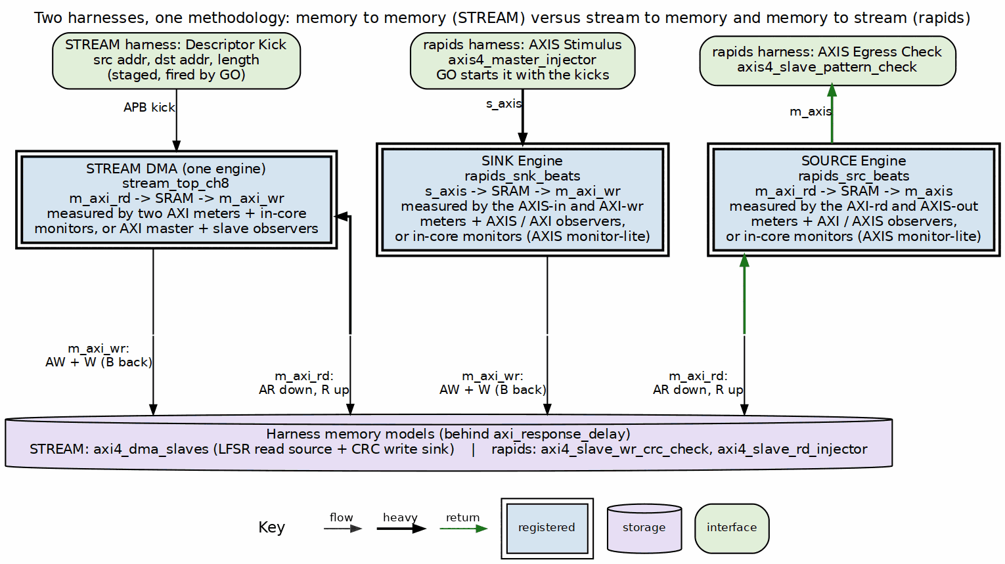
STREAM harness and rapids harness side by side
Source: 04_rapids_vs_stream.dot

2.2 What that changes in the harness
Table 1.1: What the streams change
Aspect | STREAM | rapids
Data ports on the DUT | two AXI4 masters | two AXI4 masters, one AXIS slave, one AXIS master
Directions under test | one, memory to memory | two, independent: stream to memory (SINK) and memory to stream (SOURCE)
What starts the data | the descriptor kick | GO starts the AXIS generator and fires the kicks in the same few cycles; the sink cannot move until its stream arrives
Channel on the wire | the AXI id | tid; the generator sets it, the sink routes on it, the checker demuxes on it, the observer attributes on it
Packet boundary | none; the descriptor length is the unit | tlast, placed by the generator every GEN_BPP beats and carried by the sink into its fill interface
Backpressure knob | the write slave’s readiness | the checker’s chk_ready_en on the egress stream, and the DUT’s own s_axis_tready on ingress
Meters | two, on the AXI masters | four: the two AXI meters plus an AXIS meter on each stream, which also count exact bytes and packets
Ingress window | the shared window | the stream’s own window, opened by the first offered beat and closed by the last accepted one
Observers | AXI master and AXI slave observers | the AXI master observer and a two-port AXIS observer with per-tid attribution
In-core monitors | AXI and descriptor monitors | the same, plus an AXIS monitor-lite in each half
Everything else is the same methodology, and deliberately so: the same axi_bus_meter, the same axi_response_delay latency model, the same observer register map, the same uart_axil_bridge, the same stage-all-then-GO launch, the same golden-CRC pass criterion. The host code and the report generator run on both DMAs. What this book covers is the part that could not be shared.

2.3 Two directions, measured separately
Because the two engines are independent, the campaign runs each direction as its own self-check. The sink self-check is the generator into s_axis, through the SINK, out of m_axi_wr into the CRC sink; the source self-check is the LFSR memory behind m_axi_rd, through the SOURCE, out of m_axis into the checker. A configuration row carries both verdicts and both sets of meters, and --sink-only or --source-only runs one. When a knob affects only one side (an AxLEN change reaches both engines; chk_ready_en reaches only the source), the report says which column moved.
The two directions also do not cost the same. The SOURCE pre-allocates SRAM for every read burst, so under memory latency its in-flight reads are bounded by the per-channel buffer and the read column is the one that falls first. The SINK frees SRAM on the write handshake, not on the write response, so its window is the outstanding count times the burst and memory latency costs it nothing until that window is exhausted. Those are report findings (section 7.7); the point here is that a stream-fed engine and a stream-producing engine are different machines, and the harness has to be able to tell them apart.

RTL Design Sherpa · Learning Hardware Design Through Practice GitHub · Documentation Index · MIT License

3 The AXIS4 Interfaces

3.0.1 Figure 2.1: The two links and what stands on them
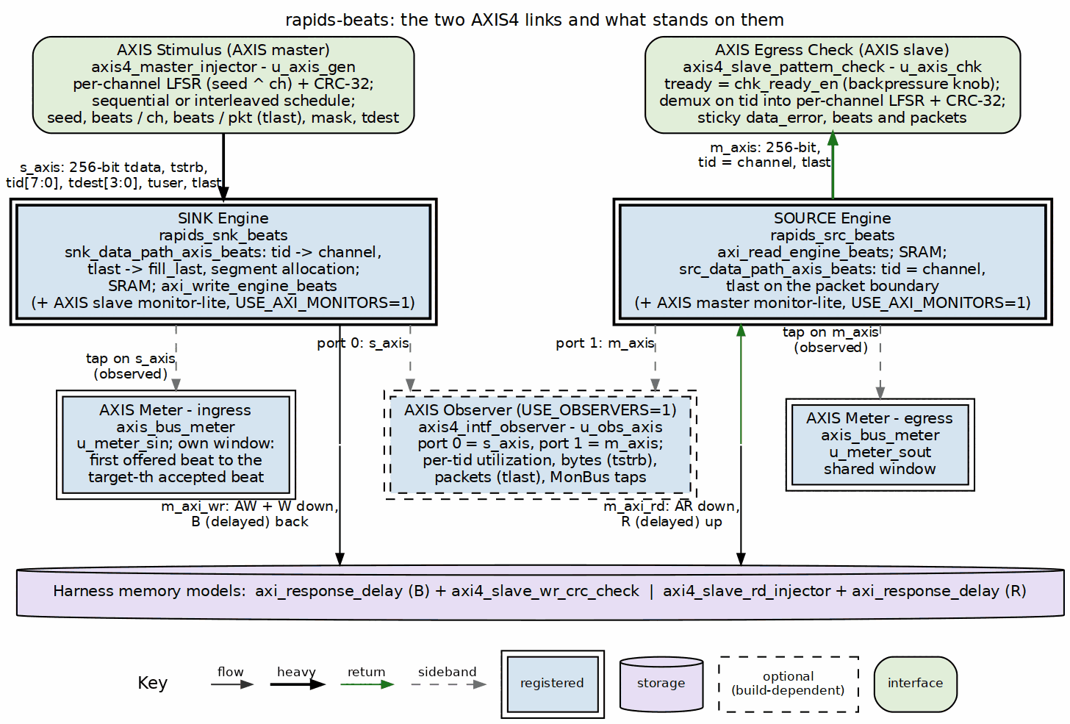
The two AXIS4 links
Source: 01_two_axis_links.dot

3.1 The wires
Both links are full AXI4-Stream with the sideband the DUT is parameterized for. DATA_WIDTH is the one width RAPIDS has, so the stream is as wide as the memory bus: 256 bits and a 32-bit tstrb since the v2.0 design point.
Table 2.1: The AXIS4 signals as built
Signal | Sink ingress s_axis_* | Source egress m_axis_* | Width | Meaning
tvalid, tready | in, out | out, in | 1 | the handshake; every meter and observer classifies a cycle by these two bits
tdata | in | out | DATA_WIDTH | payload
tstrb | in | out | DATA_WIDTH/8 | byte enables; the AXIS meter’s byte count is the popcount of this on productive beats
tlast | in | out | 1 | packet boundary; becomes fill_last inside the sink, is generated on the packet boundary by the source
tid | in | out | AXIS_ID_WIDTH = 8 | the channel: the low bits select the SRAM channel on ingress and identify the producing channel on egress
tdest | in | out | AXIS_DEST_WIDTH = 4 | routing sideband, carried through; the harness sets it from GEN_TDEST
tuser | in | out | AXIS_USER_WIDTH = 1 | user sideband, carried through
The DUT is the AXIS slave on ingress and the AXIS master on egress. That is why the harness has an AXIS master generator and an AXIS slave checker, and why the in-core monitor-lites are an AXIS slave monitor in the sink half and an AXIS master monitor in the source half.

3.2 Sink ingress: a beat becomes a write burst

3.2.1 Figure 2.2: Sink ingress
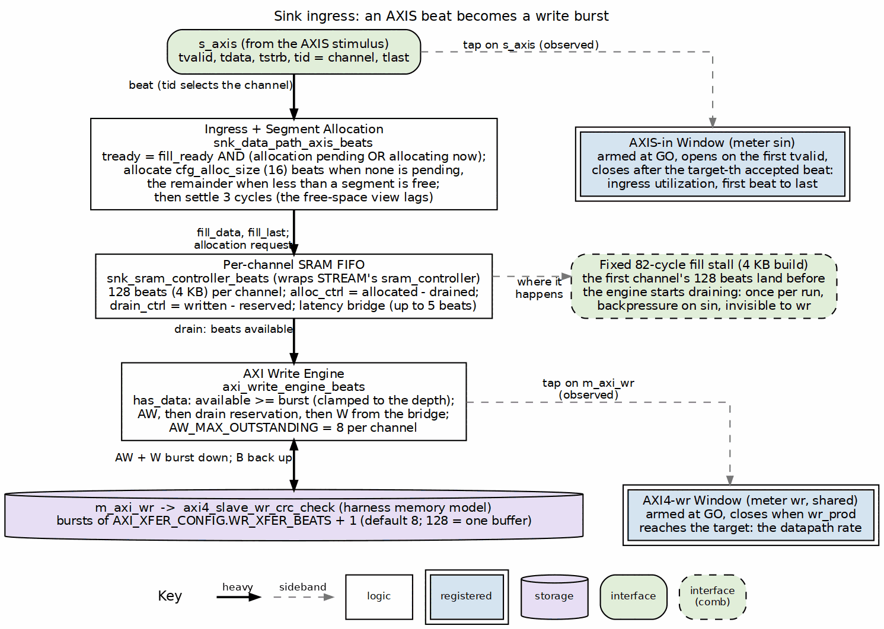
Sink ingress: allocation, SRAM, write engine, and the two windows
Source: 02_sink_ingress.dot
snk_data_path_axis_beats turns the stream into the fill interface of the sink data path. tid selects the channel, the beat goes straight through as fill_data, tlast becomes fill_last. What makes ingress more than a wire is SRAM allocation: the sink reserves space before it accepts data, in segments of cfg_alloc_size beats (16, AXI_XFER_CONFIG.ALLOC_SIZE), and s_axis_tready is high only while the beat’s channel holds an allocation or is allocating this cycle, and the FIFO can take the beat.
Three properties of that allocation were established this month and are worth knowing when reading an ingress number:
- A packet that ends mid-segment leaves the rest of its segment allocated for the channel’s next packet. The next packet consumes it before it allocates anything new, so per-channel accounting stays consistent across packets and runs.
- When less than a segment is free, the ingress allocates the remainder, so the buffer can always be filled to the top. Without that, a write burst equal to the buffer depth could never be satisfied after a short packet (rapids BUG-009, second finding).
- After any allocation a channel settles three cycles before allocating again, because the free-space view it reads lags an allocation by that much. A one- or two-beat remainder consumed before the view moved once let the allocator over-commit (BUG-009, third finding).
Backpressure on s_axis_tready therefore means one of: the channel’s buffer is full, no space is allocated yet, or the pipeline is stalled. On the 4 KB build the first of those happens once per run in a fixed way: the generator lands the first channel’s 128 beats before the write engine has started draining, and the ingress waits 82 cycles. It is the same 82 at every transfer size, a startup cost and not a throughput one, and the 16 KB buffers of the earlier design point absorbed it entirely.

3.3 Source egress
src_data_path_axis_beats is the mirror: the read engine fills the per-channel SRAM from m_axi_rd, and the egress side drains it onto m_axis with tid set to the channel and tlast on the packet boundary. The source’s throughput under memory latency is bounded by that SRAM, since the read engine allocates the whole burst before issuing the AR; the egress link itself, being a master into an always-ready checker, is never the limit unless the host asks for backpressure.

3.4 The AXIS monitor-lites
With USE_AXI_MONITORS=1 each half carries an AXIS monitor-lite on its stream port (rapids TASK-015, “Option B”): an AXIS slave monitor in rapids_snk_beats on s_axis, an AXIS master monitor in rapids_src_beats on m_axis, each a third client of its half’s MonBus arbiter beside the descriptor and scheduler emitters. They keep the one-monitor-stream-per-half contract and let the half-level tests see the packets. Their filtering is configured through the MonBus group’s AXIS slot, and they carry agent ids next to the AXI descriptor monitor’s. The monitors-in build of the companion book is where they are built and measured; the bare and observer builds leave them out, which is why those builds have no in-core view of the streams and the AXIS observer of Chapter 4 exists.

RTL Design Sherpa · Learning Hardware Design Through Practice GitHub · Documentation Index · MIT License

4 Stream Stimulus and Checking
STREAM’s harness needs memory models. The rapids harness needs those and two stream endpoints, and the endpoints have to be as deterministic as the memory models so that a CRC can be predicted in software. Both are rtl/amba/shared blocks, built for this harness and reused by STREAM’s generator since the interleave work.

4.1 The generator: axis4_master_injector
An AXIS master with no address channel. Per channel it runs an independent LFSR seeded with seed ^ channel and a CRC-32 over what it emits, the same LFSR and CRC as axi4_slave_rd_injector, so a stream integrity check and a memory integrity check produce comparable numbers. The LFSR and the CRC advance only on accepted beats: beat N of channel C is a function of (seed ^ C, N) regardless of how tready stalled it, which is what makes the pattern predictable under backpressure and under the interleaved schedule.
Table 3.1: Generator configuration
Register (harness CSR) | Field | Effect
GEN_CTRL | cfg_gen_start | arm one run; the actual start comes from GO
GEN_LFSR_SEED | 32 bits | the base seed; 0xDEADBEEF is the campaign default, --base-seed overrides it for the sink half
GEN_NUM_BEATS | 32 bits | beats per channel
GEN_BEATS_PPKT | 32 bits | tlast cadence; 0 means one packet per channel
GEN_CH_MASK | one bit per channel | active channels; 0 means all
GEN_TDEST | AXIS_DEST_WIDTH | the tdest value on every beat
GEN_MODE | INTERLEAVE | the channel schedule, below
Two schedules. Sequential finishes one channel’s beats, then the next: each channel’s stream is contiguous, and only one sink channel holds data at a time. Interleaved (GEN_MODE.INTERLEAVE, --interleave, rapids TASK-018) hands the bus to the next active channel after every accepted beat, so tid changes every beat and every sink channel holds data at once. A channel’s LFSR and CRC still advance only on its own beats, so the per-channel data, CRCs and packet boundaries are identical under both schedules and the golden model does not care which ran. The difference is what the sink column measures: one channel’s window under the sequential schedule, the DUT’s aggregate window under the interleaved one (report Tables 7.5 and 7.5b).
The generator reports per-channel expected CRCs and beat counts, and an aggregate total, as corroboration. PASS never rests on them.

4.2 The checker: axis4_slave_pattern_check
An AXIS slave and a pure sink. Its tready is the ready_en input, which the harness exposes as CHK_CTRL.chk_ready_en: the campaign’s source-backpressure knob (--backpressure, --suite-bp) is this bit held low in a pattern, and it reaches only the source half since the sink’s egress is AXI. Incoming beats are demuxed by tid into the matching channel context, compared beat by beat against the locally regenerated pattern with the same seed ^ channel LFSR, and accumulated into a per-channel CRC-32. A mismatch sets a sticky data_error; the aggregate beat and packet counters (CHK_BEATS_TOTAL, PKT_COUNT) are what the host polls for completion of the source half.
Because the check is local and per beat, it is independent of upstream stalls and of cross-channel interleave: the source may emit its channels in any order the scheduler chooses.

4.3 The golden model and PASS
host/rapids_char_golden.py runs the same LFSR and CRC in software. For the sink half, PASS is the write CRC the memory-side checker computed equal to the model’s; for the source half, it is the read CRC the memory-side generator produced and the checker’s egress CRC both equal to the model’s. The generator’s own expected CRC and the checker’s own count are read as corroboration and logged, never as the verdict.

4.4 GO
The stream is the one stimulus STREAM’s harness does not have to start. In rapids the kick sequencer’s GO does three things within a few aclk cycles: arms the meter windows, fires every staged descriptor kick, and starts the generator. Nothing on the sink side moves until the generator’s first beat is offered, which is why the ingress window is defined by that beat and not by GO (Chapter 4).

RTL Design Sherpa · Learning Hardware Design Through Practice GitHub · Documentation Index · MIT License

5 Measuring a Stream

5.0.1 Figure 4.1: Meters, windows and observers on the stream side
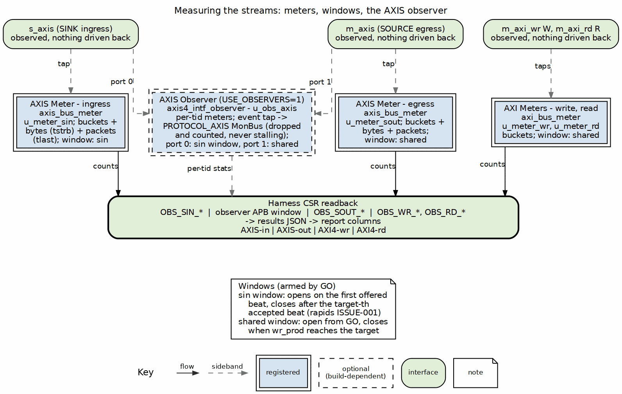
Meters, windows, observers
Source: 03_axis_measurement.dot

5.1 The AXIS meters
axis_bus_meter is the AXIS analogue of axi_bus_meter, one instance per stream, snooping tvalid, tready, tlast, tstrb and tid and driving nothing. Every cycle of its window goes into one bucket:
Table 4.1: The cycle classification, shared with the AXI meters
tvalid | tready | Bucket | Meaning
1 | 1 | productive | a beat transferred
1 | 0 | backpressure | the master wants to send, the slave stalls
0 | 1 | starvation | the slave is ready, the master is not producing
0 | 0 | idle | both quiet
On top of the buckets the AXIS meter counts what an AXI meter cannot: the exact number of payload bytes moved, as the popcount of tstrb on each productive beat, and packets, as tlast handshakes. Those two are window-independent, so a throughput computed from bytes over busy time is robust to the idle and backpressure padding that distorts a pure cycle utilization when a window is held open too long. The host reports both: utilization from the buckets and the byte-derived figure beside it.

5.2 The ingress window is its own
Every AXI-side meter and the egress meter share one window: armed at GO, closed the cycle after the write beat count reaches the staged target. For the ingress stream that definition measured the wrong thing. The stream starts at the kick, before the sink’s write side is busy, and after the last beat is accepted the ingress sits ready and idle while the sink drains to memory, about 200 cycles on the board regardless of transfer size. With the shared window, ingress starvation was a constant, ingress utilization was the minimum of the direction on nearly every row, and the reported sink throughput was launch latency, not datapath rate (rapids ISSUE-001).
So sin has its own window. It arms at GO, opens on the first cycle the generator offers tvalid (a sink not yet ready then shows as backpressure, which is ingress behaviour), and closes the cycle after the target-th ingress beat is accepted: first beat to last beat, which is what ingress utilization means. The open is combinational so that first handshake is counted rather than lost to a register delay; the close falls back to the shared window when no target is staged. The AXIS observer’s port 0 uses the same window, so the bare meter and the observer agree to the beat.

5.2.0.1 Waveform 4.1: The ingress window, before and after
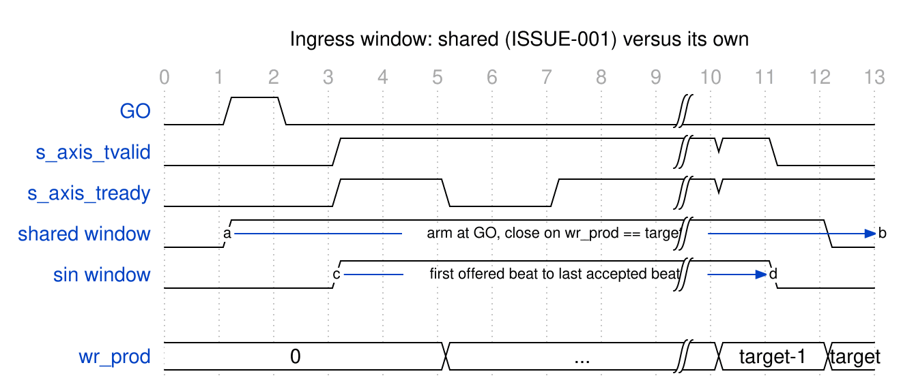
Ingress window: shared versus its own
Source: 01_ingress_window.json

5.3 What the report reads from them
Table 4.2: The four columns
Column | Meter | Window
AXIS-in (sin) | axis_bus_meter on s_axis | its own: first offered beat to last accepted beat
AXI4-wr (wr) | axi_bus_meter on m_axi_wr W | shared
AXI4-rd (rd) | axi_bus_meter on m_axi_rd R | shared
AXIS-out (sout) | axis_bus_meter on m_axis | shared
The one AXIS-specific residue in the headline rows is on sin: a single starvation cycle, the registered close landing one cycle after the last accepted beat, and on the 4 KB build the fixed 82-cycle fill stall as backpressure. Everything else on the stream side reads at line rate once transfers are descriptor-sized.

5.4 The AXIS observer
axis4_intf_observer (USE_OBSERVERS=1) is the AXIS sibling of the AXI interface observers: the same APB window layout, the same register map, the same MonBus egress and telemetry readback, so one host decoder serves all three and the report generator runs unchanged on STREAM’s harness and on this one. The harness instantiates it with two ports, port 0 on s_axis and port 1 on m_axis, every pin an input, both halves of the handshake included: attaching it cannot change the stream it measures.
Per port it builds an axis_bus_meter of its own with per-tid channel attribution, read through OBS_STAT_SEL and OBS_STAT_DATA, and an event tap that emits PROTOCOL_AXIS MonBus packets. There is no AXIS monitor in the AMBA monitor library, so the tap was written in the monitor-lite’s discipline: no CAM, no timer pool, stamps rather than counters, and an event the MonBus cannot take is dropped and counted (OBS_STICKY.TAP_BLOCKED) rather than allowed to stall anything.
Table 4.3: The AXIS tap’s packet vocabulary
Class | Event | Fires when
Error | VALID_TIMING | tvalid dropped before tready accepted
Error | STRB_INVALID | a beat handshook with tstrb all zero
Timeout | HANDSHAKE, PACKET | a stall, or an in-packet gap, reached MON_TIMEOUT
Completion | STREAM_END | tlast handshook
Credit | BACKPRESSURE | a stall reached MON_LATENCY cycles (there is no Threshold class for AXIS)
Channel | ID_CHANGE, DEST_CHANGE | tid or tdest changed inside a packet
Stream | START, PAUSE, RESUME | first beat of a packet; tvalid dropped or returned mid-packet
Runtime gating reuses MON_CTRL bit for bit with the AXI observers, the address-range checker is inert because a stream has no address, and OBS_ENABLE_MON_TAPS decides at build time whether the tap logic exists at all; the meters and the histograms count without it.
What the observers add over the bare meters, measured: the same utilization numbers to the beat, plus exact bytes and packets per port with per-tid attribution, the tap’s own packet count as a cross-check, and a sticky bit that says when a number undercounts (report section 7.6). What they cost: the observers build closes at less margin than the bare build, and that difference is the instrument’s price, not the datapath’s.

