
RTL Design Sherpa
RAPIDS Beats DMA Engine Phase 1 Characterization Report
July 4, 2026

Table of Contents
1 RAPIDS Beats DMA Engine — Phase 1 Characterization Report 7
1.1 0. Resource footprint 8
1.1.1 Figure 0.1: Post-route utilization — 4-channel board build 8
1.1.2 0.1 The BRAM board-fit trim 9
1.2 1. What we set out to do 10
1.3 2. Test platform 11
1.4 3. Architecture — two wholly-separate engines 12
1.4.1 Figure 3.1: Split architecture 12
1.4.2 Figure 3.2: The two data paths are wholly separate 13
1.4.3 Figure 3.3: Monitor-bus hierarchy — 3-level merge to one egress 14
1.5 4. Timing closure at 100 MHz 15
1.5.1 Figure 4.1: 100 MHz setup WNS — closure trajectory 15
1.5.2 Figure 4.2: The critical path — a config CSR into the monbus window math 15
1.6 5. Vivado bring-up fixes (found vs. Verilator) 17
1.7 6. The characterization harness 18
1.7.1 Figure 6.1: rapids_char_harness block diagram 18
1.8 7. CRC validation on both paths against a golden model 20
1.9 8. A real harness bug, root-caused 21
1.10 9. On-silicon results 22
1.10.1 Figure 9.1: On-silicon suite — 48/48 configurations PASS 22
1.11 10. Tooling 24
1.12 11. What we learned 25

List of Figures
Figure 0.1: Post-route utilization — 4-channel board build 8
Figure 3.1: Split architecture 12
Figure 3.2: The two data paths are wholly separate 13
Figure 3.3: Monitor-bus hierarchy — 3-level merge to one egress 14
Figure 4.1: 100 MHz setup WNS — closure trajectory 15
Figure 4.2: The critical path — a config CSR into the monbus window math 15
Figure 6.1: rapids_char_harness block diagram 18
Figure 9.1: On-silicon suite — 48/48 configurations PASS 22

List of Tables
No tables in this document.

RTL Design Sherpa · Learning Hardware Design Through Practice GitHub · Documentation Index · MIT License

RTL Design Sherpa · Learning Hardware Design Through Practice GitHub · Documentation Index · MIT License

1 RAPIDS Beats DMA Engine — Phase 1 Characterization Report
Component: RAPIDS beats DMA (rapids_beats_top) Platform: Digilent Nexys A7-100T (Xilinx Artix-7 100T, 100 MHz, 4-channel build, -1 speed grade) Status: Phase 1 complete — the engine was split into two wholly-separate data paths, characterized on real silicon, timing-closed at 100 MHz, and both paths CRC-validated against a deterministic golden model across a full config sweep.
Headline: the RAPIDS beats DMA was refactored into two wholly-separate engines — a write-only sink and a read-only source — driven by a directional scheduler. It was characterized on a Nexys A7-100T, closed timing at 100 MHz with +0.007 ns of setup slack and zero failing endpoints, and both data paths were CRC-validated on silicon across a 48/48-PASS sweep of channels, beat counts, backpressure, and seeds.

1.1 0. Resource footprint
Before any dynamic behavior, the static cost. The numbers below are post-route on xc7a100tcsg324-1, NUM_CHANNELS = 4, SRAM_DEPTH = 256, DESC_RAM_ENTRIES = 256, all monitors enabled, harness included.
Resource | Used | Available | Utilization
Slice LUTs | 37,555 | 63,400 | 59.2 %
Slice Registers (FF) | 28,683 | 126,800 | 22.6 %
Block RAM tiles | 22 | 135 | 16.3 %
DSP | 0 | 240 | 0 %

1.1.1 Figure 0.1: Post-route utilization — 4-channel board build
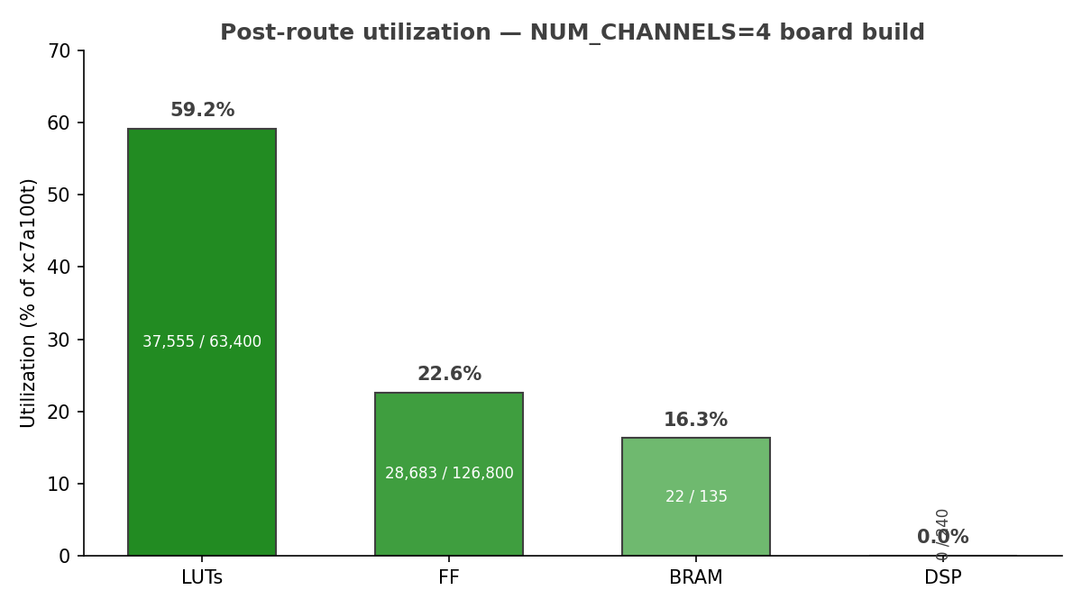
post-route utilization
LUTs are the tight resource at 59.2 %; the two SRAMs plus the two descriptor RAMs plus the harness pattern-memory account for the BRAM. There is no DSP in the design — the beats engine is pure control and datapath movement, no arithmetic reduction.

1.1.2 0.1 The BRAM board-fit trim
The harness ships with generous simulation defaults — SRAM_DEPTH = 4096 and DESC_RAM_ENTRIES = 2048 — chosen so the cocotb testbench never has to think about buffer pressure. On the 100T those defaults are not synthesizable as-is: the SRAMs and descriptor RAMs inflate to 148 BRAM tiles, which overflows the 135-tile device. For the board build the depths were trimmed to 256 each, which drops the footprint to 22 tiles (16.3 %) with comfortable headroom. This is a build-time parameter only; the RTL is unchanged, and the sweep in Section 9 confirms the trimmed depths cover every characterized transfer size.

1.2 1. What we set out to do
RAPIDS is a descriptor-driven accelerator DMA. The beats variant moves fixed “beat” quanta between an AXIS network interface and system memory. Before declaring the split-engine refactor ready, we wanted to measure what it actually does on real silicon — not just pass simulation. Specifically:
- Prove the split is clean. The engine was refactored from a single bidirectional block into two wholly-separate engines — a write-only sink and a read-only source. Does the split hold on silicon, with no hidden coupling between the two paths?
- Close timing at 100 MHz on the -1 part. The shared monitor-bus core carries a config-CSR path that had been the chronic critical path on this family. Can we close it without pipelining the datapath?
- Validate both data paths end-to-end. Sink (network to memory) and source (memory to network) each need independent, deterministic correctness checking that survives multi-channel interleave.
- Establish a reproducible on-silicon regression. A smoke test and a full config sweep, driven over UART, with machine-readable results — the same flow shape STREAM already uses.
The headline answer: the split is clean, timing closes with +0.007 ns of slack, and both paths CRC-match a golden model across all 48 swept configurations. The rest of this document is the work behind those results.

1.3 2. Test platform
FPGA | Xilinx Artix-7 100T (xc7a100tcsg324-1, -1 speed grade)
Clock | aclk = 100 MHz (10 ns period)
Build | rapids_char_top wrapping rapids_beats_top, NUM_CHANNELS = 4
Buffer depths (board) | SRAM_DEPTH = 256, DESC_RAM_ENTRIES = 256
Network interface | AXIS4 (s_axis sink in, m_axis source out), tid = channel
Register map | one APB slave, SRC @ 0x0000, SNK @ 0x1000
Monitor egress | single m_axil_mon after a 3-level monbus merge
Post-route timing | setup WNS +0.007 ns, hold WHS +0.011 ns, 0 failing endpoints
Bitstream resources | 37.6k LUTs (59.2 %), 28.7k FFs (22.6 %), 22 BRAM (16.3 %), 0 DSP
Host link | UART, board ID "RAP1" (0x52415031)
The DUT is rapids_beats_top. Everything around it is characterization harness — not part of the IP, but instrumented to make the engine measurable and self-checking on real silicon.

1.4 3. Architecture — two wholly-separate engines
The defining change in this generation is that the beats DMA is no longer one bidirectional block. It is two engines that share nothing but a register decode and a monitor egress.

1.4.1 Figure 3.1: Split architecture
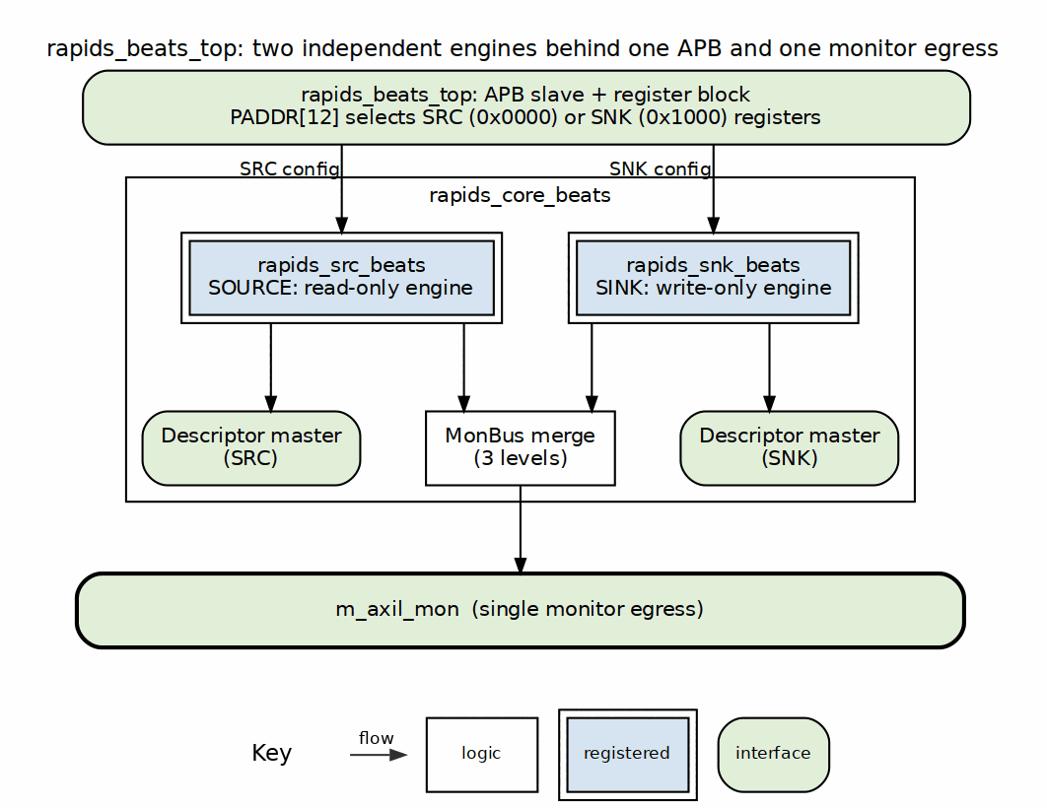
split architecture
rapids_beats_top instantiates rapids_core_beats, which contains exactly two data engines:
- rapids_snk_beats — write-only. It receives from the network and writes to memory. It never issues an AXI read.
- rapids_src_beats — read-only. It reads from memory and sends to the network. It never issues an AXI write.
The two are driven by a directional scheduler parameterized by EN_READ / EN_WRITE, so each engine is compiled with only the half of the scheduler it needs. A single APB decode fans configuration to both halves — SRC at 0x0000, SNK at 0x1000 — and each engine drives its own descriptor master. Monitoring from both halves is merged down to a single m_axil_mon egress.

1.4.2 Figure 3.2: The two data paths are wholly separate
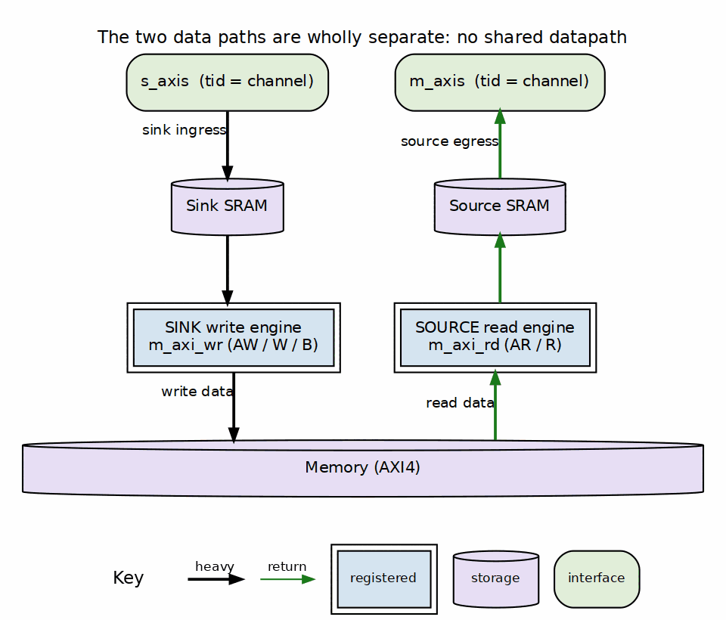
data paths
The sink path is s_axis (with tid = channel) into the sink SRAM, then out m_axi_wr (AW/W/B) to memory. The source path is memory in via m_axi_rd (AR/R), into the source SRAM, then out m_axis (with tid = channel). There is no shared datapath, no shared buffer, and no shared AXI master between the two directions. This is what “wholly separate” means in practice: a change to one engine cannot introduce a datapath hazard in the other.

1.4.3 Figure 3.3: Monitor-bus hierarchy — 3-level merge to one egress
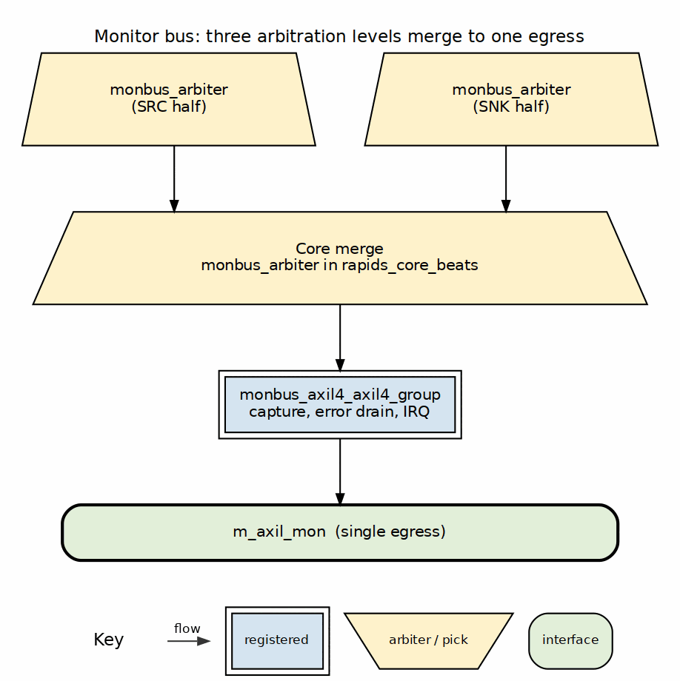
monbus hierarchy
Observability is built in and merges in three levels: a per-half monbus_arbiter inside each of the source and sink engines, a core-level monbus_arbiter that merges the two halves, and finally monbus_axil4_axil4_group, which drains the merged stream to the single m_axil_mon egress. One wire off-chip carries every monitor packet from both directions.

1.5 4. Timing closure at 100 MHz
Post-route, the build closes with setup WNS = +0.007 ns, 0 failing endpoints, and hold met (WHS = +0.011 ns). Getting there was not free.

1.5.1 Figure 4.1: 100 MHz setup WNS — closure trajectory
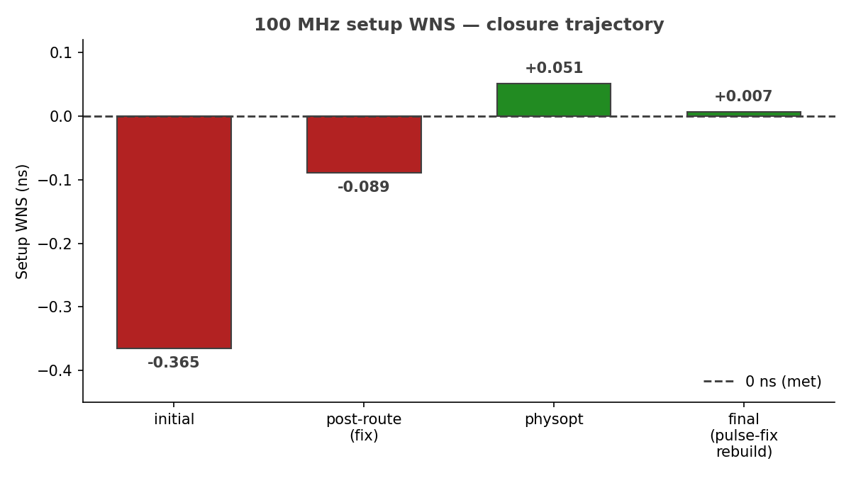
WNS closure trajectory
The closure trajectory ran through four points: an initial post-route WNS of -0.365 ns (failing), -0.089 ns after the fix landed at post-route, +0.051 ns after phys-opt, and a final +0.007 ns on the rebuild that also folded in the harness pulse-fix of Section 8.

1.5.2 Figure 4.2: The critical path — a config CSR into the monbus window math
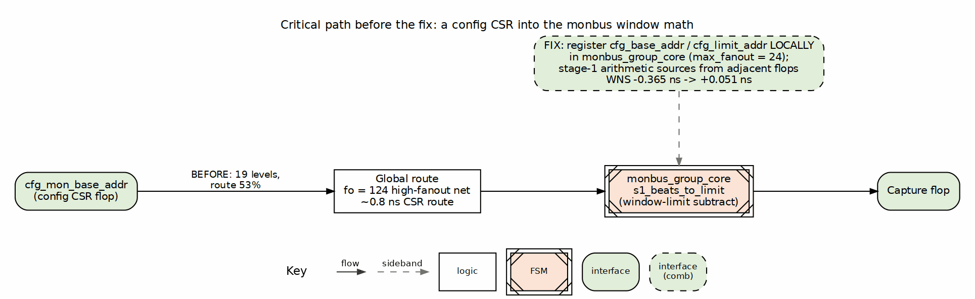
critical path
The critical path was not in the datapath. It ran from cfg_mon_base_addr — a configuration CSR that essentially never changes at runtime — into monbus_group_core’s s1_beats_to_limit, the stage-1 window-limit subtract. At 19 logic levels it looked like a logic-depth problem, but it was route-dominated: route delay was 53 % of the path, including a high-fanout net (fo = 124) and roughly 0.8 ns of pure CSR route just to reach the arithmetic.
The fix was to register cfg_base_addr / cfg_limit_addr locally inside monbus_group_core with max_fanout = 24, so the stage-1 subtract sources its operands from flops physically adjacent to the arithmetic rather than from a CSR on the far side of the die. That change alone moved the endpoint from -0.365 ns to +0.051 ns — no datapath pipelining required. Because monbus_group_core is shared collateral, STREAM benefits from the same fix.

1.6 5. Vivado bring-up fixes (found vs. Verilator)
The design simulated cleanly under Verilator but Vivado elaboration surfaced a class of issue Verilator does not: package-symbol collisions under $unit wildcard imports. Vivado merges all import pkg::*; into one $unit scope, and guarded imports only apply to the first file that imports them — so a symbol defined in two packages becomes ambiguous the moment a second file pulls both in. The fixes, all in the RTL’s package qualification (no logic change):
- rapids_pkg vs. stream_pkg enum-label collisions. Both packages define RD_* and CH_* enum labels. Ambiguous references were qualified with rapids_pkg::.
- Type collisions. channel_state_t, descriptor_t, and read_engine_state_t exist in both packages; each use site was qualified with rapids_pkg::.
- Monitor response codes. ocelus_amba4_pkg::AXI_ERR_RESP_* was qualified in the control engines, where it otherwise clashed under the merged $unit scope.
None of these are visible under Verilator’s per-file import handling; they only appear once Vivado flattens the import scope. They are documented here so the next engine that reuses these packages qualifies from the start.

1.7 6. The characterization harness

1.7.1 Figure 6.1: rapids_char_harness block diagram
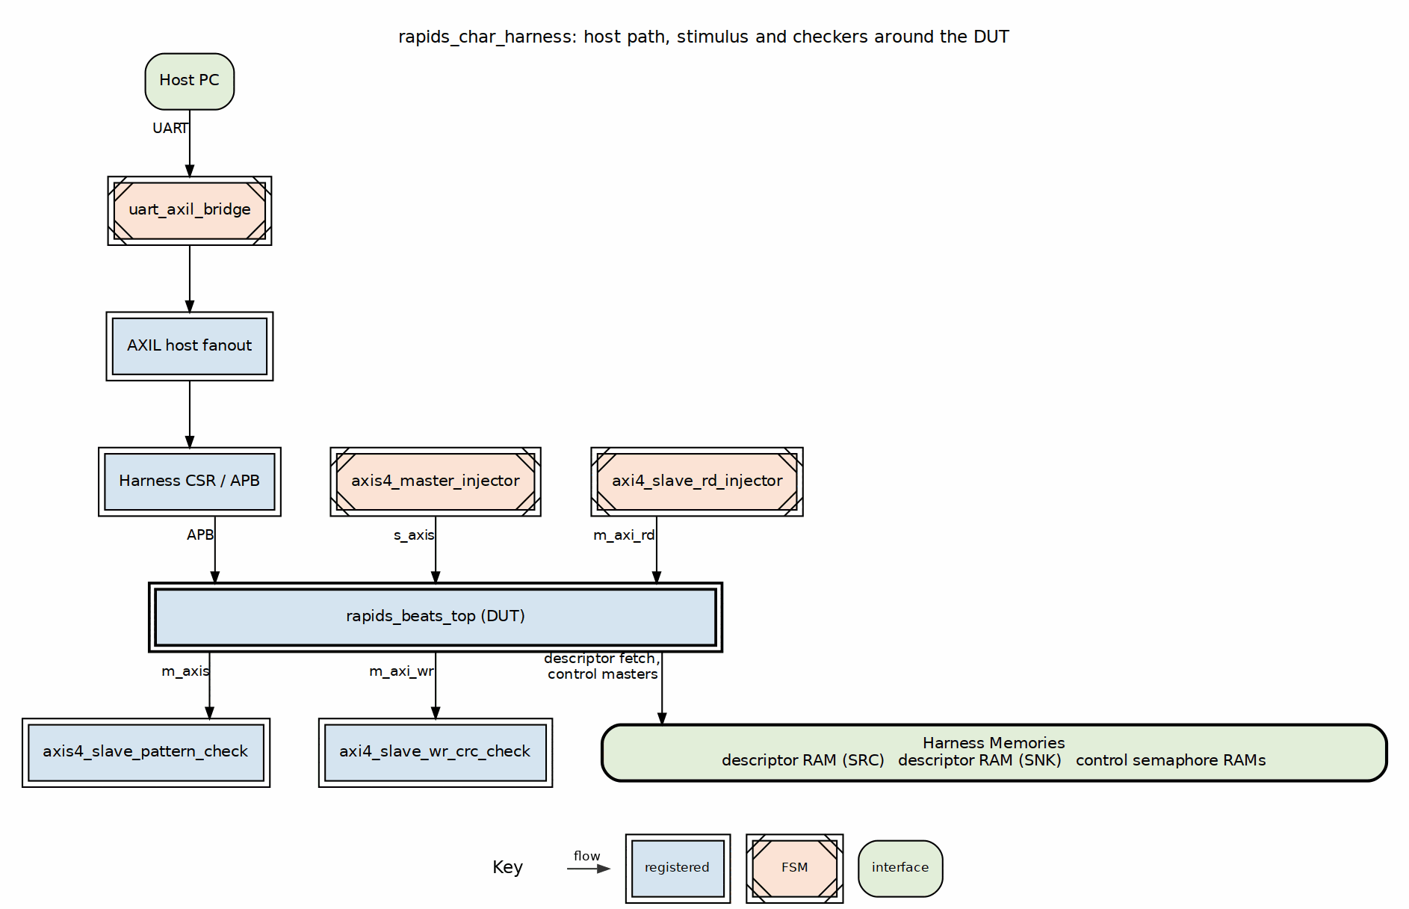
harness block diagram
The harness wraps rapids_beats_top with everything needed to drive it from a host PC and check both directions on-chip, while leaving the DUT untouched:
- On-chip AXIS pattern generator and checker. axis4_master_injector drives s_axis for the sink path; axis4_slave_pattern_check consumes m_axis on the source path. Both are multi-channel with a per-channel LFSR seeded seed ^ ch and a CRC-32 computed over the actual beats, so the data is deterministic and independently reproducible per channel.
- Memory-side pattern / CRC. axi4_slave_rd_injector backs m_axi_rd with the same deterministic LFSR stream (this is the source path’s memory), and axi4_slave_wr_crc_check CRCs everything written on m_axi_wr (the sink path’s memory).
- Dual descriptor RAMs. One descriptor RAM per engine, feeding the two independent descriptor masters.
- Semaphore RAMs on the control masters, backing the engines’ control-plane accesses.
- Host link. A uart_axil_bridge fans the single UART into the AXIL host bus, reaching the harness CSRs and the DUT’s APB. The board announces itself with ID "RAP1" (0x52415031) so the host script can confirm it is talking to the right bitstream.
Every block earned its place: the split engines mean the sink and source each need their own traffic source and their own checker, and the per-channel LFSR / CRC keeps correctness meaningful under multi-channel tid interleave.

1.8 7. CRC validation on both paths against a golden model
Both directions are checked against a deterministic software golden model, flows-rapids-beats/host/rapids_char_golden.py, which computes the reflected CRC-32 over the per-channel LFSR stream. The model is the single source of truth: the same expected value is asserted on the write side (sink), the read side (source), and the on-chip checker.
For an 8-beat transfer the golden model reproduces, per channel:
Channel | Golden CRC-32
ch0 | 0x8C023372
ch1 | 0x3FB81189
ch2 | 0xD64B4EEC
ch3 | 0x65F16C17
These were validated in two independent places:
- In simulation — the cocotb harness testbench asserts that the sink write CRC, the source read CRC, and the on-chip checker CRC all equal the golden value (2/2 checks pass).
- On the host — rapids_char_golden.py reproduces the same per-channel values standalone, so a mismatch on hardware points at the RTL, not at a disagreement between the checker and the model.
Because the golden model is deterministic in (seed, channel, beats), the sweep in Section 9 can assert exact per-channel CRC equality for every one of its 48 configurations rather than just “no error flagged.”

1.9 8. A real harness bug, root-caused
The most instructive find of the campaign was only visible on hardware, not in simulation.
The AXIS pattern generator’s start control was implemented as a held level — assert the CSR bit, the generator runs. In simulation that is harmless: the testbench edge-arms the generator and resets it between runs, so the level is asserted for exactly one controlled window. Over UART it is not harmless. A single host write holds that level for the ~1–2 ms it takes the next UART transaction to arrive, and the generator re-arms and re-runs repeatedly for the entire duration of the held level. Each spurious re-run pushes more beats into the sink than the checker expects, and the sink desyncs — a failure that never reproduced in sim because sim never holds the level across real UART timing.
The fix was to make the generator and checker start controls one-cycle pulses (the same pattern already used by cam_clear elsewhere in the harness) rather than held levels. One arm equals exactly one run, independent of how long the host leaves the CSR bit set. This is a textbook example of a bug that a simulation-only flow cannot catch: it lives entirely in the interaction between a held CSR level and real-world host timing.

1.10 9. On-silicon results
The engine ships with two on-silicon regression targets driven over UART, both producing machine-readable JSON results.
- make smoke — a quick both-paths run, golden-validated. PASS.
- make suite — the full sweep. 48/48 PASS, both paths CRC-verified against the golden model on every configuration.

1.10.1 Figure 9.1: On-silicon suite — 48/48 configurations PASS
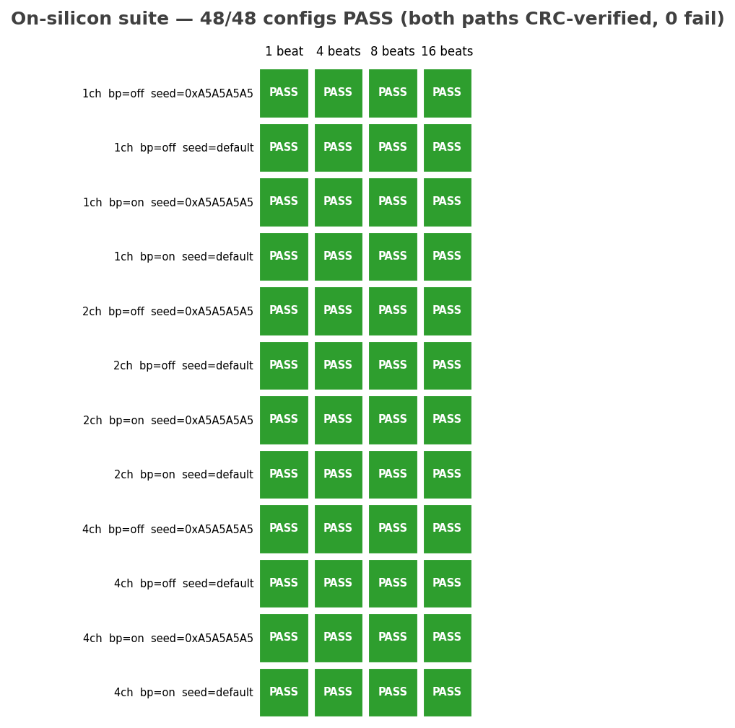
suite result grid
The suite sweeps a clean cross product:
Axis | Values
Active channels | 1, 2, 4
Beats per transfer | 1, 4, 8, 16
Source backpressure | off, on
Base seed | default (0xDEADBEEF), 0xA5A5A5A5
That is 3 x 4 x 2 x 2 = 48 configurations. Every cell in Figure 9.1 is green: for each configuration, both the sink path (network to memory) and the source path (memory to network) were exercised, and the per-channel write, read, and generator/checker CRCs were compared against the golden model. There were zero mismatches and zero errors across the entire grid.

1.11 10. Tooling
The RAPIDS beats flow deliberately mirrors STREAM’s characterization flow so the two engines share operator muscle memory and result tooling:
- make smoke / make suite drive the board over UART and emit timestamped JSON (reports/rapids_char_suite_*.json) with per-configuration, per-channel golden/measured CRCs and pass flags.
- flows-rapids-beats/host/rapids_char_golden.py is the standalone golden model, usable independently of the board for offline expected-value generation.
- The DOCX/PDF report pipeline (this document) uses the same house md_to_docx.py recipe and corporate style sheet STREAM uses, so both characterization reports render identically.

1.12 11. What we learned
- The split is clean on silicon. Two wholly-separate engines — write-only sink, read-only source — with no shared datapath, driven by one directional scheduler and merged only at the monitor egress. The 48/48 sweep confirms neither path perturbs the other.
- The chronic critical path was route, not logic. The cfg_mon_base_addr into s1_beats_to_limit path looked like 19 levels of logic but was 53 % route. Registering the config operands locally in monbus_group_core (max_fanout = 24) closed it — from -0.365 ns to +0.051 ns — with no datapath pipelining, and the fix carries over to STREAM.
- Timing closes at 100 MHz with margin to spare in the datapath. Final setup WNS +0.007 ns, hold met, zero failing endpoints on the -1 part.
- Vivado catches package collisions Verilator hides. rapids_pkg / stream_pkg enum-label and type clashes only surface once Vivado flattens $unit imports; qualifying at the use site is the durable fix.
- Both data paths are golden-validated, not just error-free. A deterministic reflected-CRC-32 model checks exact per-channel values on the sink write side, the source read side, and the on-chip checker — in sim and on the host.
- Some bugs only exist on hardware. The held-level AXIS start CSR re-ran the generator for the whole UART inter-transaction gap and desynced the sink; converting start to a one-cycle pulse fixed it. A simulation-only flow would never have seen it.

