
RTL Design Sherpa
Binary BCH UART Harness Genesys 2 FPGA board evidence
October 2026

Table of Contents
1 Document Information 7
1.1 Revision History 7
1.2 Scope 8
1.3 Provenance 9
2 Purpose and Geometry 10
3 What Is In It 11
3.1 RTL blocks 11
3.2 Host scripts 13
3.3 Make targets and build flow 14
4 How The Pieces Connect 15
4.1 Register path 15
4.1.1 Figure 2.1: BCH AXIS datapath and register path 16
4.1.2 Figure 2.3: UART harness control path 17
4.2 AXI4 flavour datapath 18
4.2.1 Figure 2.2: BCH AXI4 memory-to-memory datapath 19
4.3 Clock and reset 21
5 Address Map 22
5.1 Figure 2.4: UART harness address map 23
5.2 Window summary 24
5.3 Loop CSR registers (window 0) 25
5.3.1 Identification and control 25
5.3.2 Status and profile 26
5.3.3 Bandwidth meters 26
5.4 Observer windows (windows 1 and 2) 28
6 The FPGA-Testing Choices, And Why 29
6.1 Deterministic campaigns 29
6.2 Injector modes mapped to real failure mechanisms 30
6.3 Post-encoder injection protecting parity bits too 31
6.4 Recheck + flip-only verdict as the on-chip oracle 32
6.5 UART over a debug core, plus the safety pair 33
6.6 AXIS vs AXI4 flavours covering both integration styles 34
7 Operating It 35
8 What Is Deliberately Not Board-Tested 36

List of Figures
Figure 2.1: BCH AXIS datapath and register path 16
Figure 2.3: UART harness control path 17
Figure 2.2: BCH AXI4 memory-to-memory datapath 19
Figure 2.4: UART harness address map 23

List of Tables
Table 1: Table 0.1: Revision history. 7

RTL Design Sherpa · Learning Hardware Design Through Practice GitHub · Documentation Index · MIT License

1 Document Information

1.1 Revision History
Table 0.1: Revision history.
Revision | Date | Author | Description
0.1 | 2026-10-06 | RTL Design Sherpa | Initial harness guide for the BCH Genesys 2 UART loop.
0.2 | 2026-10-20 | RTL Design Sherpa | Block diagrams redrawn to the repo element key (v3): class fills, double-bordered registered blocks, green return paths and a generated key under each figure. No technical content changed.
0.3 | 2026-10-20 | RTL Design Sherpa | Section (h2) headings now open a new page, the pipeline default. No technical content changed.

1.2 Scope
This book describes the BCH(4224,4120) t=8 UART harness on the Digilent Genesys 2: its contents, connectivity, and the motivations behind the FPGA testing choices. It is the harness guide that pairs with the Binary BCH Board Validation Report, which carries the run evidence.

1.3 Provenance
The harness description comes from docs/UART_HARNESS.md, the living markdown copy in the harness directory. Build facts come from stable/MANIFEST.md and stable/reports/. The board used for the runs is Digilent Genesys 2 serial 200300B818A0 (Kintex-7 xc7k325t-2), programmed and measured with Vivado 2025.1.

2 Purpose and Geometry
This is the BCH(4224,4120) t=8 codec on the Digilent Genesys 2, wrapped in a UART-controlled loop that runs the same campaigns in cocotb simulation and on the board. The geometry is frozen in build-loop/rtl/bch_loop_cfg_pkg.sv: GF(2^13), primitive polynomial 0x201B, first root b=1, n=4224 shortened from 8191 = 2^13 - 1, parity degree 104 = m*t. The component core defaults to BITS_PER_BEAT = 8; this harness widens the AXI-Stream/AXI4 wrappers to 32-bit beats.
The whole point of the loop is that errors are injected after the encoder. The checker regenerates the expected LFSR pattern independently and compares it against the decoder’s output, so the verdict comes from a reference that never saw the errors.
The harness directory moved from NexysA7/ to Genesys2/ on 2026-10-05. BCH_TARGET still accepts nexys_a7_100t as a build option, and since 2026-10-07 the same tree carries a first-class small profile for it (issue #82): BCH_PROFILE=small builds BCH(248,224) t=3 for the A7-100T at 50 MHz (WNS +7.8 ns, 38% LUT). The Genesys 2 remains the primary target for the full profile: the k325t-2 has the room and timing margin to hold the full BCH(4224,4120) loop at 100 MHz with both AXIS and AXI4 flavours, and both images came out timing-clean on the board build with positive slack.
Two bitstreams are built: bch_loop_genesys2_axis.bit and bch_loop_genesys2_axi4.bit. The AXIS flavour is a single streaming pipe; the AXI4 flavour is a memory-to-memory job chain across four AXI4 memories. The AXI4 flavour refuses runs whose GEN_BLOCKS exceed the job-memory capacity rather than letting regions wrap, so long soaks belong on the AXIS image. The host reads TOPOLOGY to discover which datapath is loaded, so the same campaign scripts drive both without a command-line flag.

3 What Is In It

3.1 RTL blocks
Module | File | Role
bch_loop_genesys2_top | build-loop/rtl/bch_loop_genesys2_top.sv | Genesys 2 board top: 200 MHz LVDS input, MMCM to 100 MHz, UART, LEDs.
bch_loop_top | build-loop/rtl/bch_loop_top.sv | Nexys A7-100T board top, kept as the nexys_a7_100t target option.
bch_loop_harness | build-loop/rtl/bch_loop_harness.sv | Board-agnostic datapath, CSR wiring, observer mux, status aggregation.
bch_axi4_pipeline | build-loop/rtl/bch_axi4_pipeline.sv | AXI4 flavour: memory-to-memory codec chain over three job memories.
bch_loop_cfg_pkg | build-loop/rtl/bch_loop_cfg_pkg.sv | One source of geometry, UART baud, build ID 0x4243_4850 (“BCHP”).
bch_loop_regs / bch_loop_regs_pkg | build-loop/rtl/generated/bch_loop_regs/rtl/bch_loop_regs.sv, bch_loop_regs_pkg.sv | PeakRDL-generated CSR block from build-loop/rtl/bch_loop_regs.rdl.
bridge_bch_loop_axil | rtl/bridges/generated/bridge_bch_loop_axil/bridge_bch_loop_axil.sv | Generated 1-master x 3-slave AXIL-to-APB fabric.
uart_axil_bridge | projects/components/utility-ip/converters/rtl/uart_to_axil4/uart_axil_bridge.sv | UART byte stream to AXI4-Lite master.
apb4_to_peakrdl | projects/components/utility-ip/converters/rtl/apb4_to_peakrdl.sv | APB4 slave to PeakRDL cpuif shim.
axis4_master_injector | rtl/amba/shared/axis4_master_injector.sv | LFSR data source, one packet per block, per-channel CRC-32.
bch_encoder_axis4 / bch_encoder_core | projects/components/ecc-ip/bch/rtl/top/bch_encoder_axis4.sv, rtl/macro/bch_encoder_core.sv | BCH encoder, AXIS wrapper around the core.
bch_beat_packer | projects/components/ecc-ip/bch/rtl/fub/bch_beat_packer.sv | Repacks encoder output into ceil(n/BITS_PER_BEAT) codeword beats.
error_injector | projects/components/utility-ip/misc/rtl/error_injector.sv | Shared bit-granular injector, modes 0..7, sits after the encoder.
bch_decoder_axis4 / bch_decoder_core | projects/components/ecc-ip/bch/rtl/top/bch_decoder_axis4.sv, rtl/macro/bch_decoder_core.sv | riBM decoder, AXIS wrapper around the core.
axis4_slave_pattern_check | rtl/amba/shared/axis4_slave_pattern_check.sv | Independent reference checker, byte-granular CRC-32.
axis4_intf_observer | projects/components/utility-ip/misc/rtl/axis4_intf_observer.sv | APB-programmable observer on the four AXIS seams.
axi4_intf_master_observer | projects/components/utility-ip/misc/rtl/axi4_intf_master_observer.sv | APB-programmable observer on the AXI4 pipeline ports (AXI4 flavour only).
axi_bus_meter | rtl/amba/shared/axi_bus_meter.sv | Four windowed bandwidth meters inside the harness.

3.2 Host scripts
Script | File | Role
bch_env.py | bin/bch_env.py | Path anchor: puts the shared projects/fpga-systems/bin and build-loop/host on sys.path.
run_smoke.py | bin/run_smoke.py | Campaign runner: resolves sequences, opens BchLoopDriver, prints report.
Init | bin/seq_init.py | Proves BUILD_ID, SCRATCH round-trip, PROFILE, TOPOLOGY.
Smoke | bin/seq_smoke.py | Bypass, clean, e=t, e=t+1, DEBUG walk.
Sweep | bin/seq_sweep.py | Exact count for e = 0 .. 2t+2.
RandomCampaign | bin/seq_random.py | Fresh data/error seeds, mixed modes.
Soak | bin/seq_soak.py | Long-running random-pattern stress.
BchLoopDriver / RunResult | build-loop/host/bch_loop.py | By-name register access, status collection, observer readers.
bch_loop_programs | build-loop/host/bch_loop_programs.py | The authored-once programs: smoke, bypass, run, sweep, verdict.
host_bch_loop.py | build-loop/host/host_bch_loop.py | CLI front-end over the same programs.
bch_loop_regs_regmap.py | build-loop/dv/tbclasses/bch_loop_regs_regmap.py | PeakRDL-generated by-name register map.

3.3 Make targets and build flow
Make target | File | Role
make help | Makefile | Area dispatcher; delegates every target to build-loop/.
make -C build-loop bitstream | build-loop/Makefile | Vivado build; set BCH_TARGET=genesys2 and BCH_IFACE={AXIS,AXI4}.
make -C build-loop program | build-loop/Makefile → make/fpga_board.mk → projects/fpga-systems/bin/fpga_board.py | Programs the board after JTAG identity verification.
make regmap | Makefile | Regenerates the CSR RTL and dv/tbclasses/bch_loop_regs_regmap.py from the RDL.
bin/regen_bridges.sh | bin/regen_bridges.sh | Regenerates the 1x3 fabric from rtl/bridges/configs/bridge_bch_loop_axil.toml.
bin/build_image_matrix.sh | bin/build_image_matrix.sh | Serial build of both bch_loop_genesys2_axis.bit and bch_loop_genesys2_axi4.bit.

4 How The Pieces Connect

4.1 Register path
The host talks by name, not by offset: BchLoopDriver wraps UARTAxiBridge with UartRegisterMap over bch_loop_regs_regmap.py. The diagram shows the path from the laptop to the three APB windows.

4.1.1 Figure 2.1: BCH AXIS datapath and register path
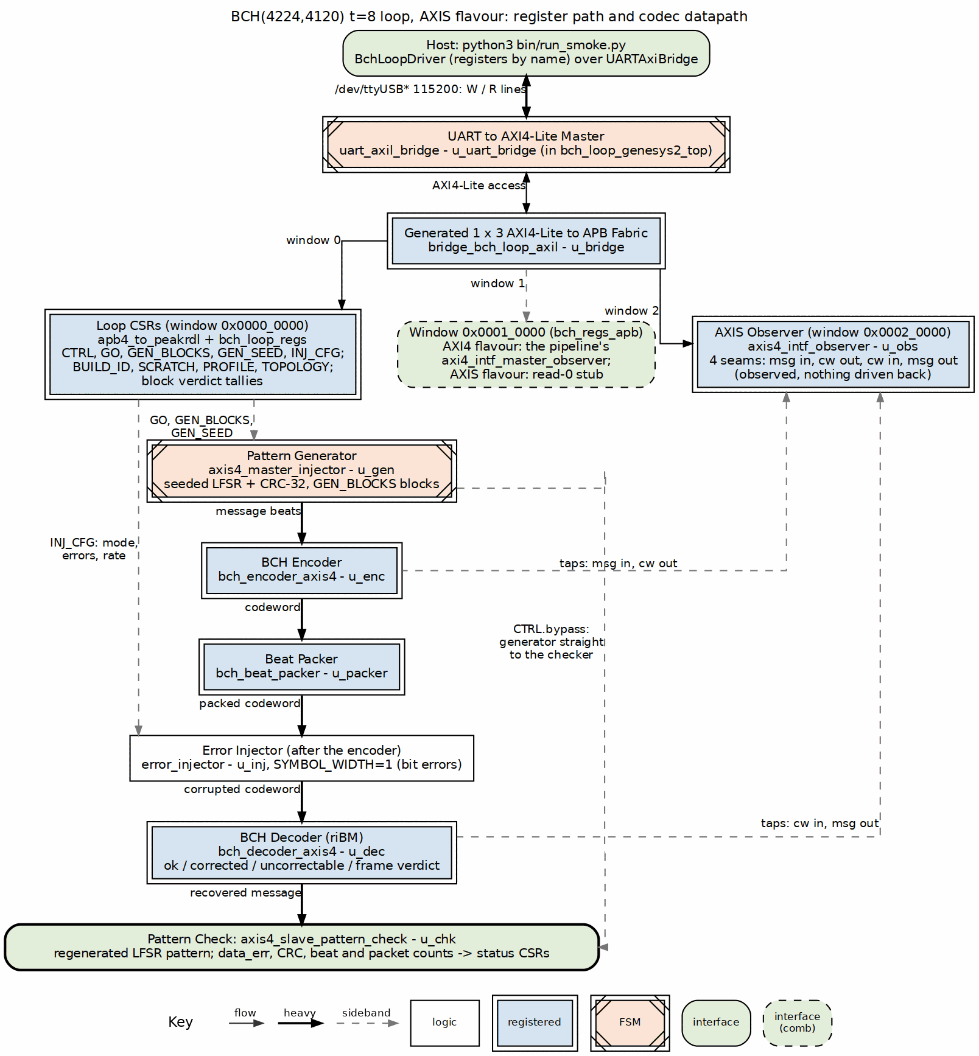
BCH AXIS datapath and register path
Source: 01_bch_axis_loop.dot
The register path is the same in both flavours. The only raw addresses in the host code are the two expansion-window bases used to attach observer register maps: OBS_AXI4_BASE = 0x00010000 and OBS_AXIS_BASE = 0x00020000 in build-loop/host/bch_loop.py. Those bases match rtl/bridges/generated/bridge_bch_loop_axil/bridge_bch_loop_axil.toml; if a window moves, the bridge is regenerated and the host picks it up in one place.

4.1.2 Figure 2.3: UART harness control path
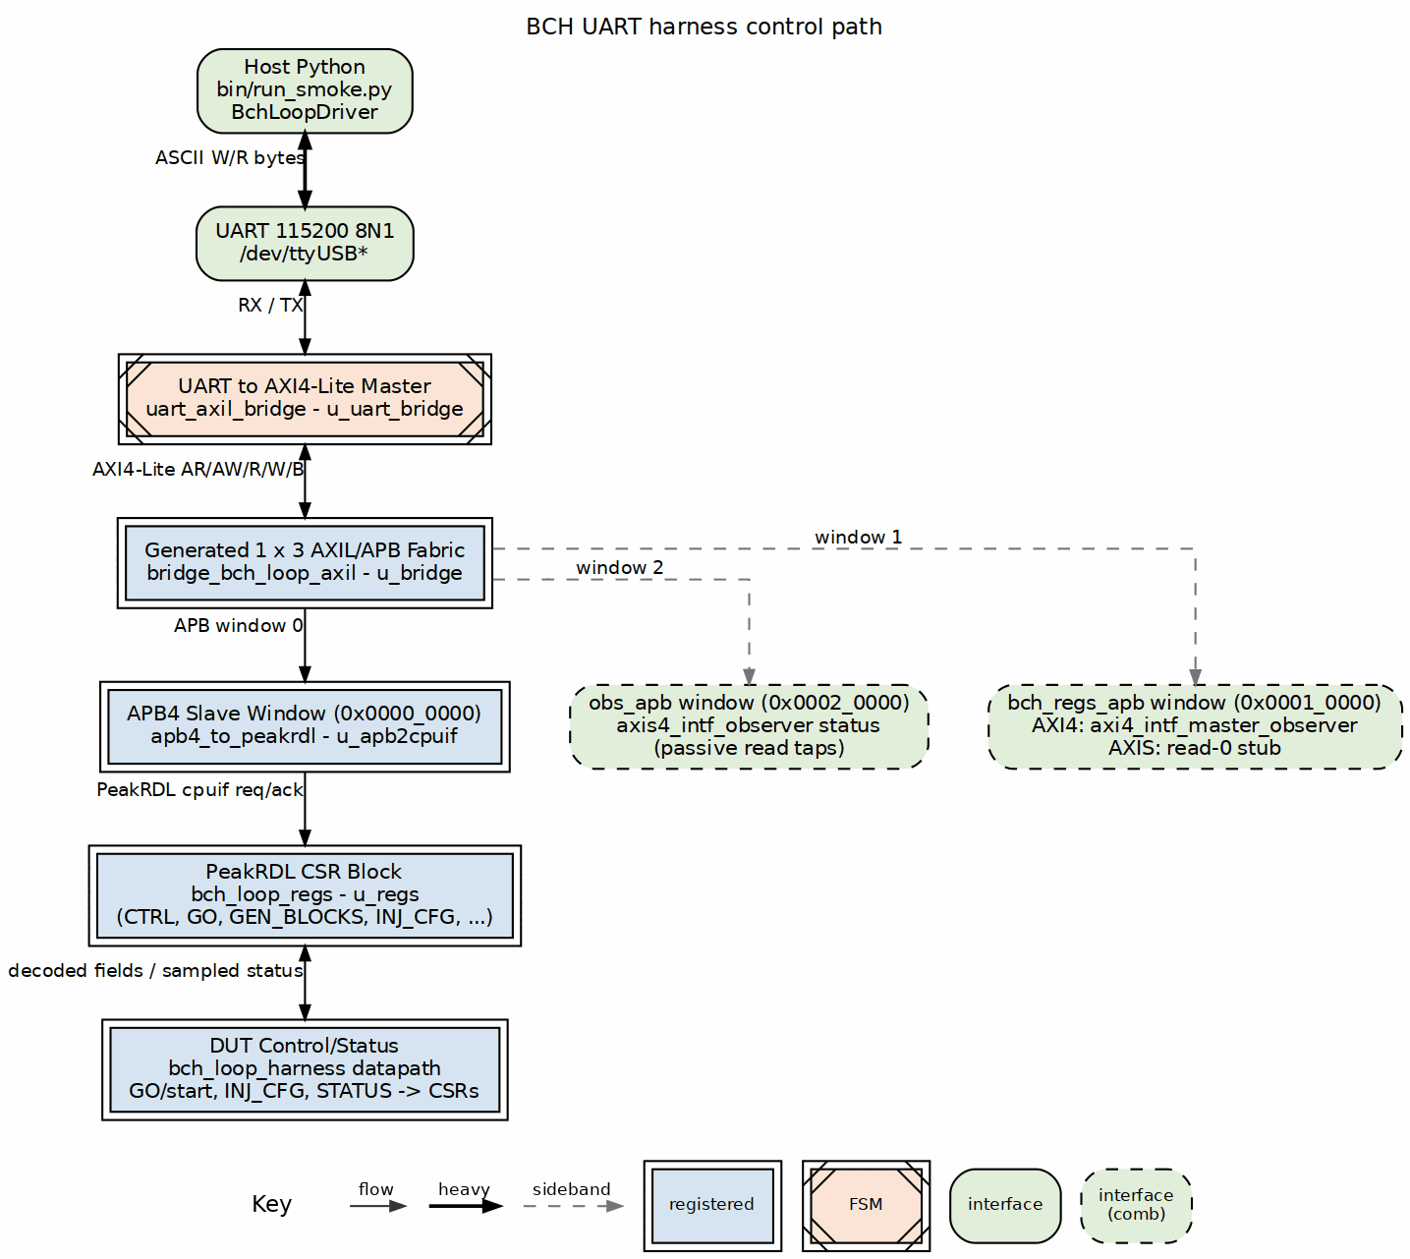
UART harness control path
Source: 03_uart_harness_control.dot
This diagram isolates the command/status path: host Python → UART → uart_axil_bridge → bridge_bch_loop_axil → APB window → apb4_to_peakrdl → bch_loop_regs → harness control and status. The datapath blocks drawn in Figure 2.1 and Figure 2.2 receive their control from this path and write sampled status back into it.

4.2 AXI4 flavour datapath
The AXI4 flavour replaces the streaming middle with a memory-to-memory job chain across three job memories.

4.2.1 Figure 2.2: BCH AXI4 memory-to-memory datapath
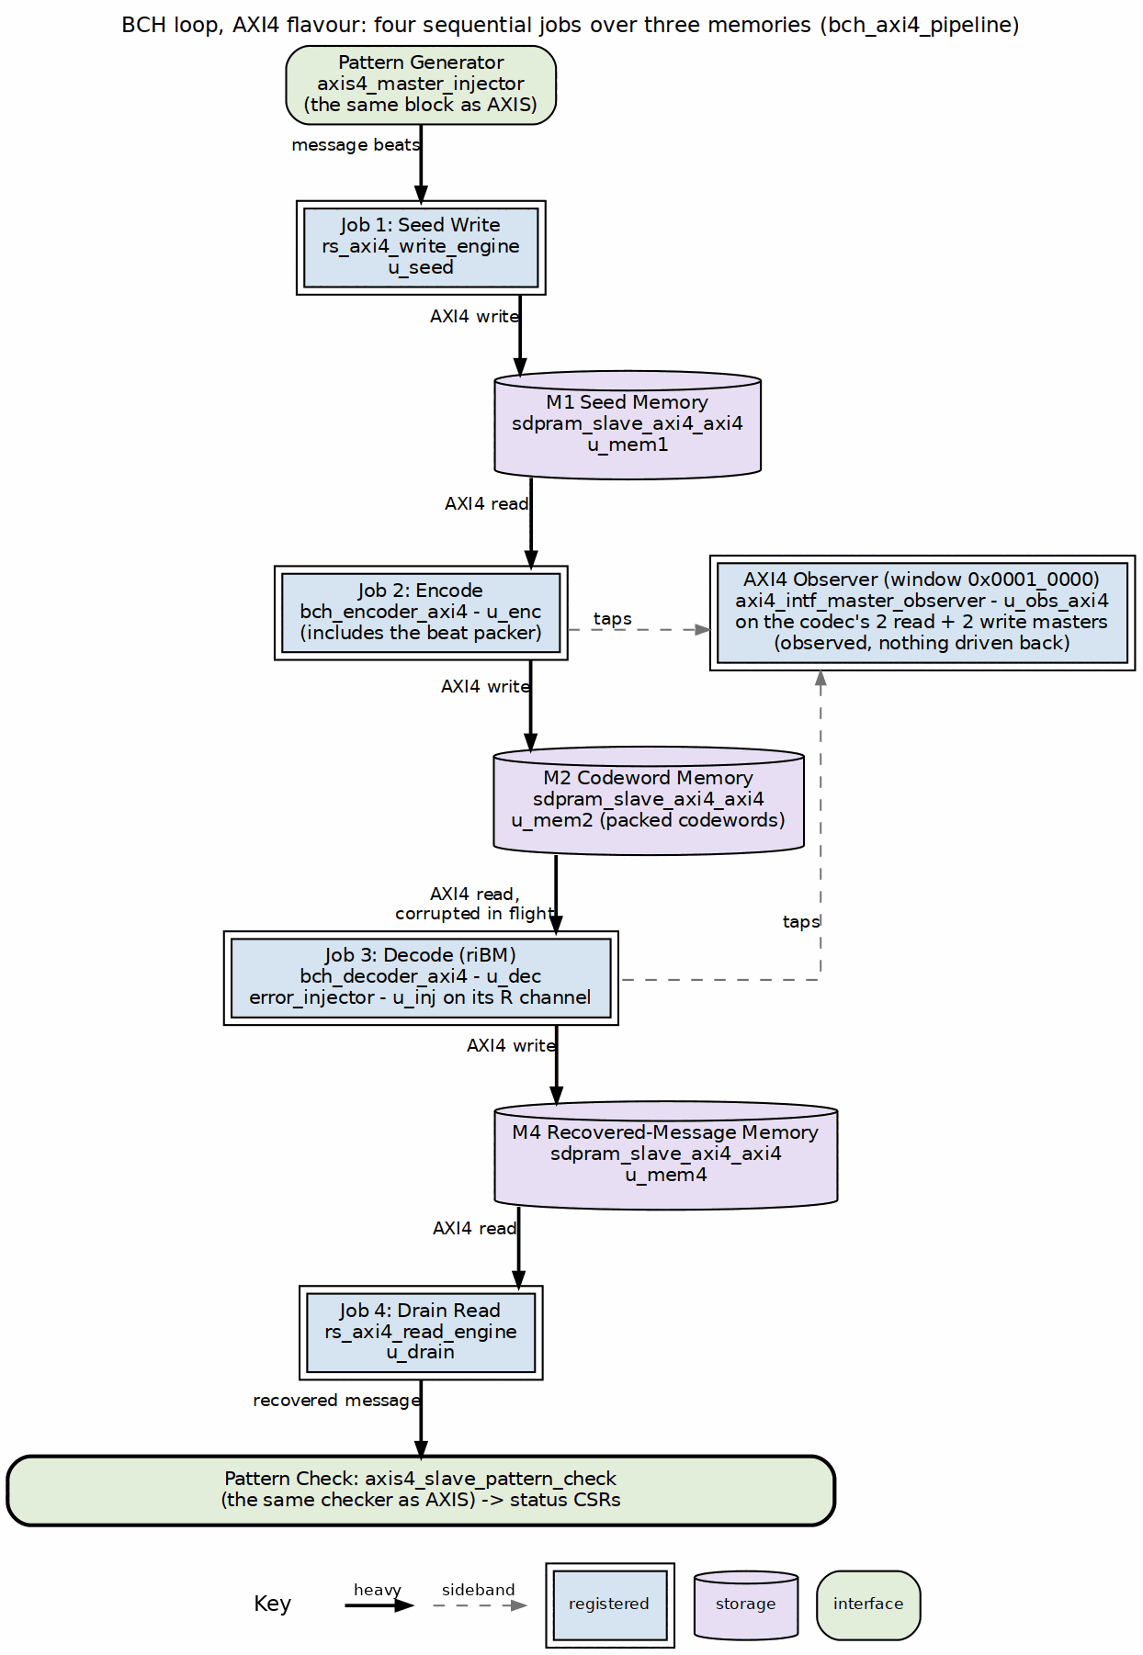
BCH AXI4 memory-to-memory datapath
Source: 02_bch_axi4_loop.dot

4.3 Clock and reset
Clock and reset come from bch_loop_genesys2_top: the 200 MHz LVDS system clock passes through IBUFDS and an MMCME2_BASE with CLKFBOUT_MULT_F = 6 and CLKOUT0_DIVIDE_F = 12, giving a 100 MHz harness clock. The Nexys A7 top runs the same 100 MHz directly. That frequency was chosen because the BCH loop and the UART divisor both close timing comfortably at 100 MHz on the k325t-2, and it keeps the AXIS and AXI4 flavours interchangeable from the host’s point of view.

RTL Design Sherpa · Learning Hardware Design Through Practice GitHub · Documentation Index · MIT License

5 Address Map
The harness exposes one 32-bit AXI4-Lite slave through the UART bridge. The generated bridge_bch_loop_axil fabric decodes three APB windows; the first window holds the loop’s own CSR block. The host code in build-loop/host/bch_loop.py knows only two raw addresses — OBS_AXI4_BASE = 0x00010000 and OBS_AXIS_BASE = 0x00020000 — everything else is by-name access through the PeakRDL-generated bch_loop_regs_regmap.py.

5.1 Figure 2.4: UART harness address map
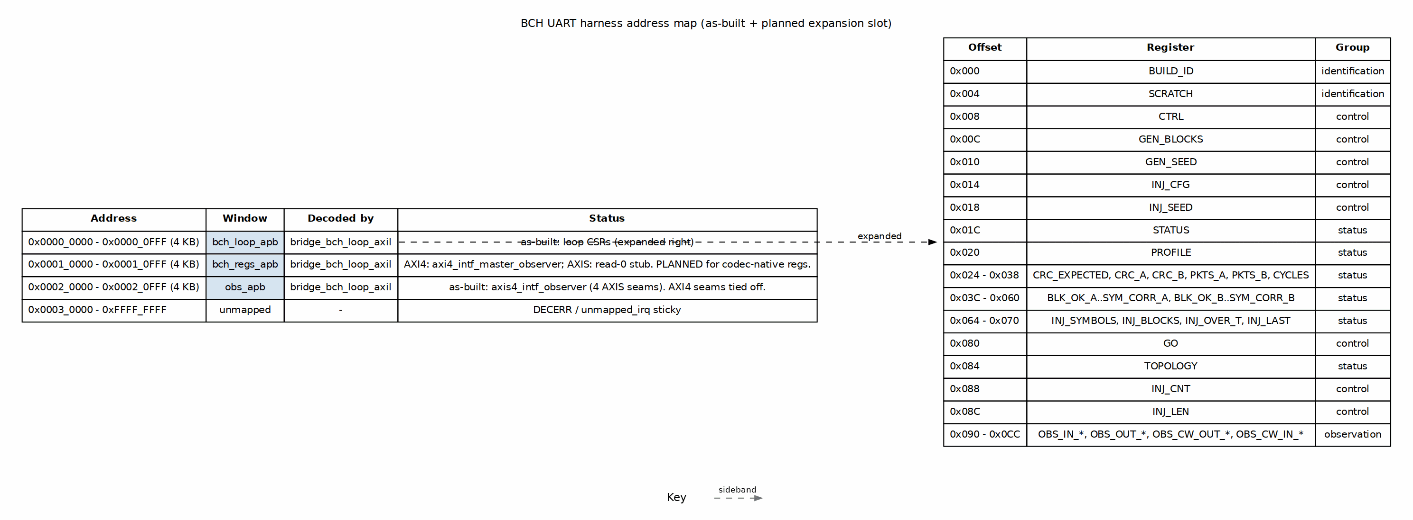
BCH UART harness address map
Source: 04_address_map.dot

5.2 Window summary
Base | Range | Size | Window | As-built use
0x0000_0000 | 0x0000_0000 - 0x0000_0FFF | 4 KB | bch_loop_apb | Loop CSRs (bch_loop_regs) — expanded below.
0x0001_0000 | 0x0001_0000 - 0x0001_0FFF | 4 KB | bch_regs_apb | PLANNED: codec-native register block. As-built: AXI4 flavour hosts axi4_intf_master_observer; AXIS flavour returns read-0.
0x0002_0000 | 0x0002_0000 - 0x0002_0FFF | 4 KB | obs_apb | axis4_intf_observer on the four AXIS seams. On the AXI4 flavour the seams are tied off and reads return 0.
0x0003_0000+ | — | — | unmapped | Sticky unmapped_irq in the bridge.

5.3 Loop CSR registers (window 0)
All registers are 32 bits and word-aligned. The address space is defined in build-loop/rtl/bch_loop_regs.rdl and generated into build-loop/rtl/generated/bch_loop_regs/rtl/bch_loop_regs.sv plus build-loop/dv/tbclasses/bch_loop_regs_regmap.py.

5.3.1 Identification and control
Offset | Register | Access | Purpose
0x000 | BUILD_ID | R | ASCII identifier: 0x4243_4850 “BCHP” (board) or 0x4243_4853 “BCHS” (small).
0x004 | SCRATCH | RW | Host link sanity.
0x008 | CTRL | W / RW | soft_reset, clear, bypass, throttle_a/b, inj_seed_on_start.
0x080 | GO | W | Pulse start to run GEN_BLOCKS blocks.
0x00C | GEN_BLOCKS | RW | Blocks per run.
0x010 | GEN_SEED | RW | Pattern generator LFSR seed.
0x014 | INJ_CFG | RW | Injector mode (0..7), error count, rate.
0x018 | INJ_SEED | RW | Injector LFSR seed.
0x088 | INJ_CNT | RW | Cluster mode min/max cluster count.
0x08C | INJ_LEN | RW | Cluster mode min/max cluster length.

5.3.2 Status and profile
Offset | Register | Access | Purpose
0x084 | TOPOLOGY | R | decoders, kes_a, iface (AXIS vs AXI4).
0x020 | PROFILE | R | n, t, m, spb (bytes per beat).
0x01C | STATUS | R | busy, gen_done, chk_a_done, data_err_a, crc_a_ok, AXI4 stage/overflow.
0x024 - 0x038 | CRC_EXPECTED, CRC_A, CRC_B, PKTS_A, PKTS_B, CYCLES | R | Run-level CRC, packet and cycle counts.
0x03C - 0x060 | BLK_OK_A..SYM_CORR_A, BLK_OK_B..SYM_CORR_B | R | Decoder verdict tallies; B-side tied off.
0x064 - 0x070 | INJ_SYMBOLS, INJ_BLOCKS, INJ_OVER_T, INJ_LAST | R | Injector statistics.

5.3.3 Bandwidth meters
Offset | Register | Purpose
0x090 - 0x09C | OBS_IN_* | Codec input end: productive / backpressure / starvation / idle cycles.
0x0A0 - 0x0AC | OBS_OUT_* | Codec output end meters.
0x0B0 - 0x0BC | OBS_CW_OUT_* | Codeword out of encoder meters.
0x0C0 - 0x0CC | OBS_CW_IN_* | Codeword into decoder meters.

5.4 Observer windows (windows 1 and 2)
The observer blocks run their own copy of the shared obs_regs register block (projects/components/utility-ip/misc/rtl/regs/generated/obs_regs_top_regmap.py). The host attaches a second UartRegisterMap instance at each window base to read observer statistics by name. See BchLoopDriver.axis_observer() and BchLoopDriver.axi4_observer() in build-loop/host/bch_loop.py.

6 The FPGA-Testing Choices, And Why

6.1 Deterministic campaigns
Every board campaign is deterministic: the default gen_seed and inj_seed are 1, and the sequences in bin/seq_*.py produce the same bit-exact runs in cocotb simulation and on the board. That matters because a failure you can replay is a failure you can fix; a non-deterministic board-only failure is just a scary story. seq_random.py still varies its draws, but those draws come from a host-side random.Random(seed) seeded by the caller, so the variation is reproducible when you need it.

6.2 Injector modes mapped to real failure mechanisms
The shared error_injector exposes eight modes, and each one answers a different physical question. Exact-count mode proves the correction boundary: at e <= t every block must correct with exactly e bits flipped, and at e > t the decoder must flag uncorrectable. Burst and rate modes model raw bit-error behaviour on a noisy channel. Clusters and localized mode stand in for spatially correlated faults — a bad DRAM row, a disturbed NAND page, a half-plane failure — because real errors are rarely uniform. Badblock mode models retention tails and worn blocks: most of the stream stays clean while a hard minority runs at a much higher error rate. Debug mode is the bring-up helper, a deterministic walking pattern that closes by inspection.

6.3 Post-encoder injection protecting parity bits too
The injector sits after the encoder, not inside the generator. That is not an accident: an error in the generator data would be encoded faithfully and the code would never see it. By corrupting the codeword, the parity bits are exposed to the same errors as the data, which is what happens when a real packet is stored, transmitted, or read back from memory. The bch_loop_harness.sv header comment calls this out explicitly, and the layout follows from it.

6.4 Recheck + flip-only verdict as the on-chip oracle
The BCH decoder uses riBM with odd-syndrome computation and even syndromes by squaring. It runs a second-syndrome recheck (ENABLE_RECHECK) and performs flip-only correction — there is no Forney, because binary values are always 1. The checker independently regenerates the expected stream and reports data_err on any mismatched beat. Together they form the on-chip oracle: the decoder decides whether it thinks it corrected the block, and the checker decides whether the recovered bytes actually match the reference.

6.5 UART over a debug core, plus the safety pair
The host link is a plain UART at 115200 baud, driven by uart_axil_bridge. That choice keeps the harness scriptable from Python without a debug core licence and without vendor-specific probes. But scriptable does not mean careless. Two pieces of shared tooling guard the board: projects/fpga-systems/bin/board_lock.sh serializes programming flows by JTAG serial, and projects/fpga-systems/bin/fpga_board.py refuses to program until a JTAG readback confirms the expected Genesys 2 serial 200300B818A0 on the chain with a device behind it. The readback also bounces hw_server and retries up to five times on the deviceless-enumeration race that otherwise refused roughly half of programming attempts when a second Digilent board shared the chain.

6.6 AXIS vs AXI4 flavours covering both integration styles
Two bitstreams are built and both are exercised. The AXIS flavour is a single streaming pipe; the AXI4 flavour is a memory-to-memory job chain. The AXI4 flavour refuses runs whose GEN_BLOCKS exceed the job-memory capacity rather than letting regions wrap, so long soaks belong on the AXIS image. The host reads TOPOLOGY to discover which datapath is loaded, so the same campaign scripts drive both without a command-line flag.

7 Operating It
Start with make help in projects/fpga-systems/Genesys2/ecc-ip/bch/ and the per-build help under build-loop/. A typical board run looks like:
bin/run_smoke.py --board genesys2 --port /dev/ttyUSB0 --sequences init smoke sweep
For the Nexys A7 small profile, build the bitstream with make -C build-loop bitstream BCH_TARGET=nexys_a7_100t BCH_PROFILE=small and drive the same sequences over the A7’s UART; init proves the “BCHS” BUILD_ID and the PROFILE CSR reports n=248, t=3, so the host programs pick up the geometry from the board.
Board timing, utilisation, and the matrix summary are recorded in stable/MANIFEST.md and stable/reports/{genesys2_axis,genesys2_axi4}/. Campaign transcripts turn into reports with projects/fpga-systems/bin/report_battery.py (JSON artifacts, correction-boundary / decode-cost / soak-timeline figures, and a generated FINDINGS.md); published runs live under stable/results/. The run evidence — the 2026-10-05 battery and the one-million-block soak — is rolled up in the companion Binary BCH Board Validation Report (docs/Binary_BCH_Board_Validation_v0.1.pdf). For the Galois-field math behind the profile, see the component HAS chapter 7 under projects/components/ecc-ip/bch/docs/. The sister harness has the matching guide at ../../reed-solomon/docs/Reed_Solomon_UART_Harness_v0.1.pdf.

8 What Is Deliberately Not Board-Tested
Some things are out of scope, and it is worth saying so plainly.
- BCH has no erasure path in this harness: the injector’s out_erasure is tied off and cfg_mark_erasure is held low.
- The board validates only the BCH(4224,4120) t=8 profile; smaller profiles like (63,57) t=1 are covered in simulation and component DV, not on the board.
- The component DV matrix exercises the codec in ways the board harness does not replicate.
- The 2026-10-05 million-block soak is statistical, not exhaustive; its counters and the bounded mis-decode criterion are reported in the Board Validation Report.

