
RTL Design Sherpa
DDR2/LPDDR2 Characterization Nexys A7 Project Guide 0.90
July 2026

Table of Contents
1 Document Information 10
1.1 References 11
1.2 Terminology 12
1.3 Revision History 13
2 Overview 14
2.1 What it characterizes 14
2.2 The three flows 15
2.3 Board and tools 16
2.4 Workload families 17
3 How It Works 18
3.1 The transport spine 18
3.1.1 Figure 2.1: DDR2 Characterization Harness Spine 18
3.2 The 1→6 AXIL bridge 20
3.3 Key RTL blocks 21
3.4 The characterization engines 23
3.5 The controller, DFI, and PHY (black boxes) 24
4 Test Methodology 25
4.1 What is under test 26
4.2 What is measured, and how 27
4.3 Workloads 28
4.4 The oracle 29
4.5 Measurement pitfalls 30
5 Build and Run 31
5.1 build-perf make targets 32
5.2 The host programs (build-perf/host/) 34
5.3 The performance sweeps (build-perf/bin/) 35
5.4 Typical bring-up sequence 36
6 Harness CSR Configuration 37
6.1 Bridge address map 37
6.2 By-name access (RDL → regmap) 38
6.2.1 Waveform 5.1: Engine Kick and Poll 38
6.3 Control / status (offsets relative to HARNESS_CSR_BASE) 39
6.4 Timer 41
6.5 Runtime controller cfg + DFI tuning 42
6.6 a7ddrphy calibration passthrough (hardware only) 43
6.7 Engine config (WR 0x100–0x128, RD 0x180–0x1A8) 44
6.8 Perf observability (0x1C0–0x1E8) 45
7 Address Map 46
7.0.1 Figure 5.1: LiteDRAM UART/AXI4-Lite address map 46
7.1 Bridge slave windows 47
7.2 harness_csr register map 49
7.3 As-built vs. not used 52
7.4 Differences from the pumice build 53
8 Simulation / Silicon Equivalence 54
8.1 Testbenches 55
8.2 How the same program runs in sim 56
8.3 Match the board’s exact DFI config 57
8.4 What the sim can and cannot reproduce 58
9 Troubleshooting 59
9.1 Current board state 59
9.2 Sticky errors look like a wedge 60
9.3 Known bugs / bounds 61
9.4 Cannot find the board 62
9.5 a7ddrphy is not simulatable 63
9.6 debug_sram trace ring is disabled on this build 64
9.7 LiteDRAM baseline flow 65
10 Measured Results 66
10.1 8.1 Streaming bandwidth, and why short bursts fall short 67
10.2 8.2 How much idle the controller absorbs 69
10.2.1 Figure 8.1: Read Bandwidth vs Gap, Row-Major 70
10.2.2 Figure 8.2: Read Bandwidth vs Gap, Cacheline 70
10.2.3 Figure 8.3: Read Bandwidth vs Gap, Col-Major 71
10.2.4 Figure 8.4: Bus Bandwidth Across Gap and Generator Count 72
10.3 8.3 Where the cycles went 73
10.3.1 Figure 8.5: Cycle Breakdown at 1+1 — the Bend and its Cause 73
10.3.2 Figure 8.6: Cycle Breakdown at 4+4 — Saturated at Every Gap 74
10.4 8.4 Integrity, and one configuration that must not be quoted 76
10.5 8.5 What the three runtime modes are worth (2026-09-26) 77
10.5.1 Axis 1 — scheduling order 77
10.5.2 Axis 2 — page policy 78
10.5.3 Axis 3 — refresh 78
10.5.4 Multi-ID traffic 78
10.6 8.6 Reproducing these numbers 79

List of Figures
Figure 2.1: DDR2 Characterization Harness Spine 18
Figure 5.1: LiteDRAM UART/AXI4-Lite address map 46
Figure 8.1: Read Bandwidth vs Gap, Row-Major 70
Figure 8.2: Read Bandwidth vs Gap, Cacheline 70
Figure 8.3: Read Bandwidth vs Gap, Col-Major 71
Figure 8.4: Bus Bandwidth Across Gap and Generator Count 72
Figure 8.5: Cycle Breakdown at 1+1 — the Bend and its Cause 73
Figure 8.6: Cycle Breakdown at 4+4 — Saturated at Every Gap 74

List of Tables
Table 1: Reference documents 11
Table 2: Revision history 13
Table 3: The characterization flows 15
Table 4: Board and tool requirements 16
Table 5: Access-pattern families 17
Table 6: Key RTL blocks 21
Table 7: What is measured 27
Table 8: Characterization workloads 28
Table 9: build-perf make targets 32
Table 10: Bridge slave address map 37
Table 11: Control / status registers 39
Table 12: Characterization timer registers 41
Table 13: Runtime controller config and live DFI tuning 42
Table 14: a7ddrphy calibration passthrough 43
Table 15: Write-engine config (read engine identical at +0x80) 44
Table 16: Perf observability (bin b covers [2^b, 2^(b+1)) cycles) 45
Table 17: Table 5.3: Bridge address decode for the LiteDRAM flow 47
Table 18: Table 5.4: harness_csr register offsets for the LiteDRAM flow 49
Table 19: Simulation testbenches 55
Table 20: Known issues and bounds 61
Table 21: Read bandwidth against AXI burst length, at 8 bursts outstanding 67
Table 22: The short-burst shortfall recovers completely when more reads are in flight 67
Table 23: Where bandwidth reaches its plateau, measured against the model 68
Table 24: Gap knee by address order and generator count (re-measured 2026-09-26) 69
Table 25: Read cycle breakdown, row-major, 1+1 generators 73
Table 26: pumice BUG-014 (was PUMICE-037) — narrowing the failing configuration 76
Table 27: Read MB/s against 600 MB/s peak, order_mode at equal page policy 77
Table 28: Read MB/s against 600 MB/s peak 78

List of Waveforms
Waveform 5.1: Engine Kick and Poll 38

RTL Design Sherpa · Learning Hardware Design Through Practice GitHub · Documentation Index · MIT License

1 Document Information
This is the operator / developer guide for the Nexys A7 DDR2/LPDDR2 Characterization project (projects/fpga-systems/NexysA7/mem-ctrl-ip-ddr2/ddr2-characterization). It explains what the project characterizes, how the harness works, how to build / simulate / program / run it, how the harness CSR is configured, and what the board measured (Chapter 8, added at v0.95).
The memory controller under test — pumice — is separate IP (projects/components/mem-ctrl-ip/research-ip/pumice-ddr2-lpddr2). This guide treats it as a black box driven by the characterization harness; it does not document the controller’s internals.

1.1 References
Reference documents
Source | Title
RTL Design Sherpa | build-perf/host/ADDRESS_MAP.md (bridge + CSR map)
RTL Design Sherpa | build-perf/bin/README_a7ddrphy.md (PHY regen)
RTL Design Sherpa | flows-litedram-uart/HARNESS_PLAN.md (baseline flow)
RTL Design Sherpa | bin/TBClasses/harness/ (shared UART-char collateral)
RTL Design Sherpa | docs/DDR2_BANDWIDTH_MEASUREMENT.md (what “bandwidth” means here)
RTL Design Sherpa | build-perf/reports/ (the raw records behind Chapter 8)
Micron | MT47H64M16HR-25E DDR2 SDRAM datasheet
ARM | AMBA AXI4 / AXI4-Lite / APB Protocol Specifications

1.2 Terminology
DFI
DDR PHY Interface. The command/data protocol between the memory controller and the PHY. Here pumice emits a phase-packed flat DFI v2.1 bus.
a7ddrphy
LiteDRAM’s Artix-7 DDR2 PHY (4:1 serdes, 800 Mbps). Uses Xilinx OSERDESE2/ISERDESE2/IDELAYE2 and therefore does not simulate in Verilator.
GEAR / DFI_RATE
The DFI phase count. GEAR_RATIO = log2(DFI_RATE). Must match between the RTL build and the sim model or reads corrupt.
Engine
A master-side AXI4 traffic generator: the write engine emits an LFSR data pattern; the read engine re-reads and CRC-checks it.
Leveling
Firmware-driven a7ddrphy read/write training over the PHY-CSR passthrough window; there is no hardware leveling FSM.

1.3 Revision History
Revision history
Version | Date | Notes
0.90 | 2026-07-18 | Initial project guide
0.96 | 2026-10-20 | Block diagrams redrawn to the repo element key (v3): class fills, double-bordered registered blocks, green return paths and a generated key under each figure. No technical content changed.
0.97 | 2026-10-20 | Section (h2) headings now open a new page, the pipeline default. No technical content changed.

2 Overview

2.1 What it characterizes
This project performs end-to-end, board-level performance, latency, and data-integrity characterization of a DDR2/LPDDR2 memory controller on real silicon. It drives the onboard Micron MT47H64M16HR-25E DDR2 (x16, single-rank, 128 MiB, up to 800 Mbps) through the controller against the real device, and reports throughput (MB/s), latency histograms, and per-workload CRC integrity across burst-length / stride / gap / page-policy / scheme sweeps.
There is no soft CPU in the FPGA — an off-board Python host drives the harness over the FTDI USB-UART (115200 8N1). The same host programs run against a cocotb simulation (Chapter 6).

2.2 The three flows
The project is organized as sibling “flows” plus a shared framework:
The characterization flows
Flow | Controller (DUT) | What it is
build-perf/ | pumice DDR2 (black box) + DFI + a7ddrphy | Primary flow: UART-driven host + Vivado build of the pumice harness on the Nexys A7.
flows-litedram-uart/ | LiteDRAM litedram_core | Apples-to-apples baseline: LiteDRAM’s own DDR2 controller (self-initializing, own PLL/PHY) driven by the same engines/taps/host.
ddr2_char_framework/ | — | Shared instrumentation: harness RTL, the engine spine (char_engine_block) and its pumice wrapper (ddr2_char_macro), the 1→6 AXIL bridge, and the cocotb DV.
The naming convention is flows-<controller>-uart/ for on-Nexys builds (host over UART, no CPU). pumice is separate IP under projects/components/mem-ctrl-ip/research-ip/pumice-ddr2-lpddr2/.

2.3 Board and tools
Board and tool requirements
Item | Detail
Board | Digilent Nexys A7-100T, Artix-7 xc7a100tcsg324-1
DRAM | Onboard Micron MT47H64M16 DDR2 x16, ROW_WIDTH = 13
Build | Vivado (batch mode)
Host | Python 3 + pyserial
Sim | Verilator + cocotb / cocotb_test / pytest
PHY regen (only) | Python 3.10 + migen / litex 2024.12 / litedram 2024.12

2.4 Workload families
The characterization sweeps four access-pattern families (build-perf/host/pumice_char.py):
Access-pattern families
Family | Access | Purpose
incremental | contiguous linear | best-case sequential
row_major | bounded to one page | guaranteed page HIT
col_major | stride = one row, same bank | guaranteed page MISS (worst case)
col_major_interleaved | stride = one bank | activates the bank pipeline
Controller-config presets (baseline, bank_interleave, open_page, inorder, reorder, happy_hybrid, fast_refresh, slow_refresh) each flip one lever from baseline; they are driven over the pumice APB slave (black box). Run profiles smoke / matrix / full are shared by sim and board.

3 How It Works

3.1 The transport spine
Host commands reach the DUT over one UART link that fans out to four AXI4-Lite slaves:

3.1.1 Figure 2.1: DDR2 Characterization Harness Spine
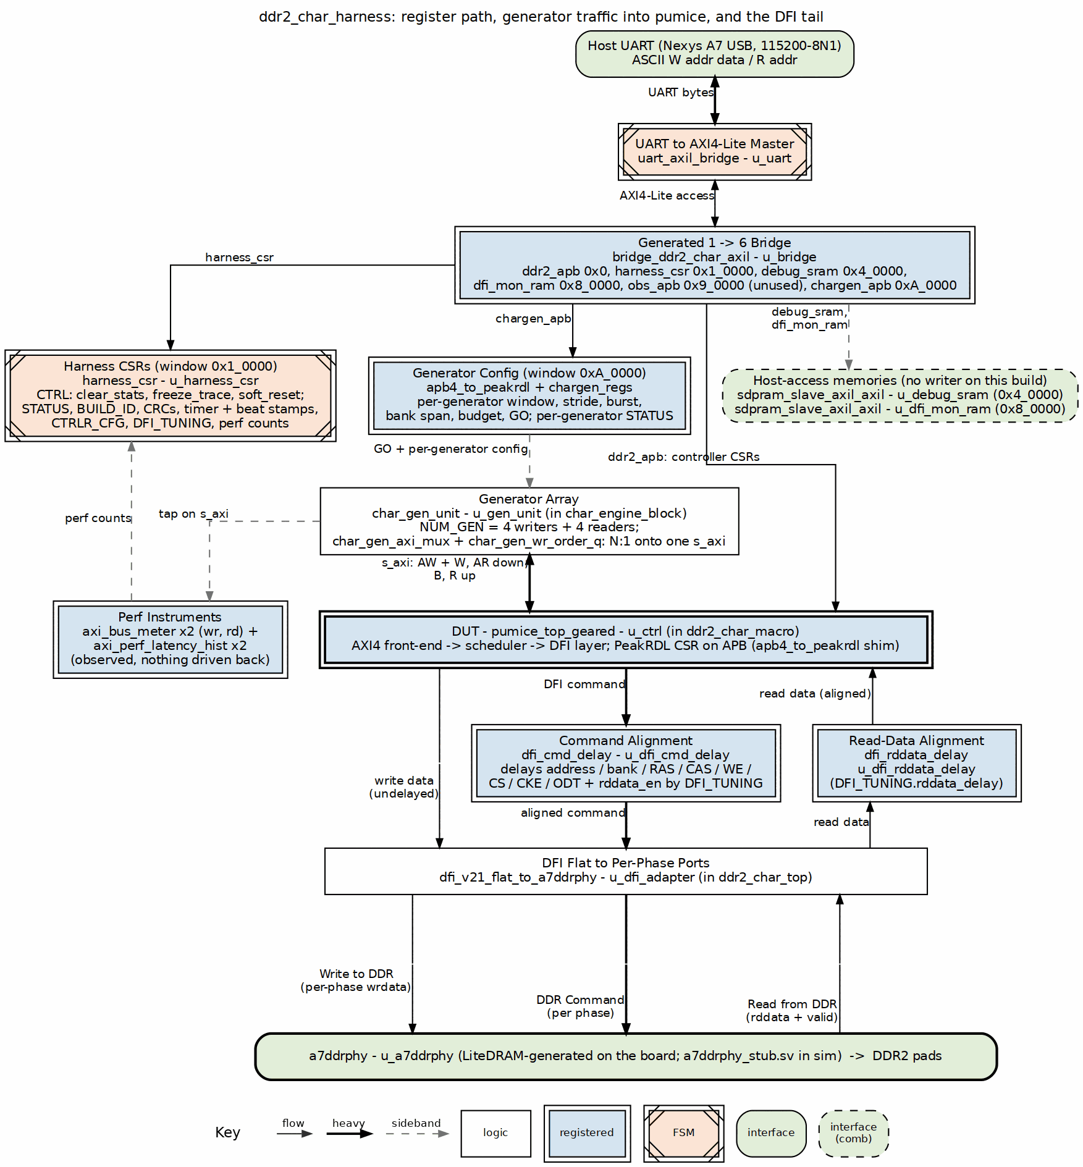
DDR2 characterization harness spine
Source: 01_harness_spine.dot
The UART wire protocol is ASCII, line-based, 115200 8N1: a write is W <hex-addr32> <hex-data32>\n → the FPGA replies OK\n; a read is R <hex-addr32>\n → replies 0x<hex-data32>\n. The bridge RTL is projects/components/utility-ip/converters/rtl/uart_to_axil4/uart_axil_bridge.sv; the host framing is UARTAxiBridge (projects/components/utility-ip/converters/bin/uart_axi_bridge.py).

3.2 The 1→6 AXIL bridge
bridge_ddr2_char_axil is generated from ddr2_char_framework/rtl/bridges/configs/bridge_ddr2_char_axil.toml (one master host, six slaves: ddr2_apb, harness_csr, debug_sram, dfi_mon_ram, the unused obs_apb expansion slot, and chargen_apb). It decodes those windows and routes each host transaction to the right slave via per-slave adapters.

3.3 Key RTL blocks
Key RTL blocks
File | Role
build-perf/rtl/ddr2_char_top.sv | FPGA pin-level top: wraps the harness, the flat-DFI→per-phase adapter, and the a7ddrphy black box; MMCM clock synthesis (sys / sys2x / sys4x / sys4x_dqs), IDELAYCTRL, DDR2 pads.
build-perf/rtl/ddr2_char_harness.sv | Internal integration: uart_axil_bridge + bridge_ddr2_char_axil + harness_csr + debug_sram + dfi_mon_ram + ddr2_char_macro + char timer + LED / 7-seg.
projects/fpga-systems/rtl/mem_char_framework/rtl/char_engine_block.sv | The DUT-agnostic spine: chargen_regs (per-generator config behind the chargen_apb window), the generator arrays (axi4_master_wr_injector / axi4_master_rd_crc_check), the N:1 merge (char_gen_axi_mux + char_gen_wr_order_q, inside char_gen_unit) onto one AXI4 master, and the perf taps (bus meters + latency histograms) on that port. Shared by the pumice and LiteDRAM flows.
ddr2_char_framework/rtl/ddr2_char_macro.sv | Wraps char_engine_block around pumice: the block’s AXI4 master drives the controller’s s_axi, and the APB CSR / DFI / runtime controls pass through.
projects/fpga-systems/rtl/mem_char_framework/rtl/harness_csr.sv | The AXIL CSR slave (Chapter 5). Hand-written (self-clearing pulses, latches, PHY passthrough).
ddr2_char_framework/rtl/dfi_v21_flat_to_a7ddrphy.sv | Combinational adapter: pumice’s phase-packed flat DFI v2.1 → a7ddrphy per-phase ports (NPHASES = 4).
ddr2_char_framework/rtl/a7ddrphy_stub.sv | Port-shape black box of a7ddrphy for Verilator (real body swapped in by Vivado).

3.4 The characterization engines
Inside char_engine_block (instantiated by ddr2_char_macro, and by the LiteDRAM flow’s char_engine_harness), master-side AXI4 engines generate and check traffic against the controller’s s_axi port:
- Write engine (axi4_master_wr_injector) — emits an LFSR data pattern across the programmed address pattern, and latches an expected CRC.
- Read engine (axi4_master_rd_crc_check) — re-reads the same pattern and computes an actual CRC, plus a per-beat mismatch count.
Alongside them, perf taps — axi_bus_meter (write and read) and axi_perf_latency_hist — observe the internal AXI wires to produce the producer/backpressure/starve/idle buckets and the latency histogram read back in Chapter 5.

3.5 The controller, DFI, and PHY (black boxes)
The controller (pumice) sits inside ddr2_char_macro between the AXI engines and the flat DFI output. Its configuration registers are reached over the ddr2_apb bridge slave at base 0x0. This guide documents only that the harness drives it — not its internals.
pumice’s flat DFI v2.1 bus is adapted to the a7ddrphy per-phase interface, then to the DDR2 pads. a7ddrphy does not simulate in Verilator (it uses Xilinx SERDES/IDELAY primitives); the sim connects at the DFI level with a behavioral model instead (Chapter 6). On hardware, a7ddrphy calibration is driven by firmware (the host) over the PHY-CSR passthrough window — there is no hardware leveling FSM.

4 Test Methodology
This chapter describes what is exercised on the FPGA block (Figure 2.1) and how throughput, latency, and data integrity are measured.

4.1 What is under test
The pumice memory controller (black box) driving the real onboard DDR2, stimulated by the two master-side AXI4 engines. Every measurement is taken on the internal AXI wires between the engines and the controller, so the numbers reflect the controller + PHY + device as a whole.

4.2 What is measured, and how
What is measured
Quantity | How it is obtained
Throughput | beats × bytes_per_beat / (TIMER_CYCLES × 10 ns) — the timer bounds the run in sys_clk cycles
Latency histogram | OBS_HIST_SEL selects bus (rd/wr) + metric (AR→firstR / AR→RLAST) + bin; OBS_HIST_COUNT / OBS_HIST_TOTAL read it back. Bin b covers [2^b, 2^(b+1)) cycles
Data integrity | CRC_ACTUAL vs CRC_EXPECTED (CRC_MATCH), plus BEATS_MISM
Utilization | OBS_{RD,WR}_{PROD,BP,STARV,IDLE} bus-meter buckets
A measurement run: program the engine config (address pattern, burst length, txn count, LFSR seed), clear_stats, kick with CTRL.start_wr / start_rd, poll STATUS.wr_done / rd_done, then read the timer, CRC, histogram, and meters. The write engine latches the expected CRC as it generates the pattern; the read engine re-reads and computes the actual CRC.

4.3 Workloads
Characterization workloads
Axis | Values
Access pattern | incremental, row_major, col_major, col_major_interleaved
Controller preset | baseline, bank_interleave, open_page, inorder, reorder, … (over the pumice APB slave)
Burst / count / stride | swept per --char-profile (smoke / matrix / full)

4.4 The oracle
Integrity is judged against a deterministic LFSR pattern + CRC-32: the write engine’s CRC_EXPECTED must equal the read engine’s CRC_ACTUAL with BEATS_MISM = 0. The same golden logic runs in sim (Chapter 6).

4.5 Measurement pitfalls
The full treatment — the four candidate denominators, how to choose the measurement window, the bounds a number should be checked against, and the complete pitfall list — is docs/DDR2_BANDWIDTH_MEASUREMENT.md in this area. Read it before publishing a bandwidth figure. What follows is only the operational short list.
- STATUS.any_error is sticky — clear it with clear_stats between phases or every later run looks wedged.
- The mismatch counter is PER READER. beats_mismatched() with no argument checks reader 0 only; on a 4+4 run that leaves three readers unverified and reports them clean. Sum across the active engines.
- Sweep points are not independent unless you re-fill. A point that leaves wrong data in cells is inherited by every later point that reads the region, and the inherited damage is reported as the later point’s own result. This made the first 192-point gap sweep unreadable (pumice BUG-014 (was PUMICE-037)).
- A constant repeated across runs is stale state, not a race. A race varies. An identical mismatch count at eight consecutive gaps means one artifact is being re-read eight times.
- Writers and readers on disjoint banks means nobody verifies the writers’ banks. A defect can sit there for a whole run and surface only when a later configuration happens to put a reader on a bank earlier points wrote — which is exactly how pumice BUG-014 (was PUMICE-037) appeared, in the last block of a 192-point sweep.
- Keep board runs txn ≤ 1024 (read-engine CAM ceiling) for clean completion; the rate stays valid at scale.
- col_major stride × large txn can alias past the 128 MB device — bound it.
- The sim must be built at the board’s exact DFI_RATE / GEAR or it passes while the board fails (Chapter 6).

5 Build and Run
All commands assume the Python environment is sourced (sets REPO_ROOT, SIM=verilator, PATH, PYTHONPATH):
cd /path/to/RTLDesignSherpa && source env_python
cd projects/fpga-systems/NexysA7/mem-ctrl-ip-ddr2/build-perf

5.1 build-perf make targets
UART ?= /dev/ttyUSB1, BAUD ?= 115200, VIVADO ?= vivado.
build-perf make targets
Target | Action
make lint | Verilator lint of ddr2_char_top via the harness filelist
make project / make synth | create Vivado project / synth-only + reports
make bitstream | full synth + impl + bitgen (~10–30 min) → bitstream/ddr2_char.bit
make bitstream-ila | same, plus an ILA on the DFI boundary → .bit + .ltx
make program | flash the board
make utilization / make timing | print the latest reports
make smoke | host/run_smoke.py — link + one linear WR/RD integrity pass
make status | host/ddr2_char.py — one-shot BUILD_ID + status dump
make level | host/pumice_master.py --level-only — a7ddrphy leveling
make simple | host/pumice_master.py --simple — init + one write→read pass
make characterize | host/pumice_master.py --full — full workload sweep
make sweep-rddly / make train-deskew | PHY timing sweeps
make host-test | pytest host/test_pumice_master.py (mock UART, no board)
make sim / sim-smoke / sim-simple / sim-level | run the same host programs in cocotb sim
make clean / clean-all | remove build artifacts
The other Makefiles: flows-litedram-uart/Makefile (make regen / make bitstream / make program for the LiteDRAM baseline) and ddr2_char_framework/dv/tests/Makefile (the cocotb macro suite: make run, run-smoke, run-<shape>, and parallel run-{gate,func,full}-parallel).

5.2 The host programs (build-perf/host/)
The port defaults to --port auto, which probes every /dev/ttyUSB* and keeps the board that answers BUILD_ID == 0x44445232 (“DDR2”).
run_smoke.py — the first thing to run after flashing. Programs a linear WR+RD workload, kicks both engines, and checks CRC / cycles / perf.
python3 host/run_smoke.py --port /dev/ttyUSB1 --txn 1024 --blen 8 --seed 0xDEADBEEF
Pass = BUILD_ID matches, both engines done, CRC_ACTUAL == CRC_EXPECTED, BEATS_MISMATCHED == 0, and TIMER.pass.
pumice_master.py — the orchestration program; one mode is required:
python3 host/pumice_master.py --port /dev/ttyUSB1 --level-only # PHY read/write leveling
python3 host/pumice_master.py --port /dev/ttyUSB1 --simple # init + one write→read pass
python3 host/pumice_master.py --port /dev/ttyUSB1 --full # full workload sweep
python3 host/pumice_master.py --port /dev/ttyUSB1 --char --char-profile matrix --char-scale 1000 --csv out.csv
Useful options: --no-level, --rd-phase, --rd-delay, --char-configs, --char-scale N (≈1000 on FPGA), --level-cache JSON, --clk-mhz.
ddr2_char.py — the driver library plus a one-shot status CLI (python3 host/ddr2_char.py --port auto). It exports DDR2CharDriver, the base-address constants, and the enum constants used throughout.

5.3 The performance sweeps (build-perf/bin/)
Three scripts, each isolating one axis. Run them from build-perf/ after make program; all three write JSON or a table and none need arguments.
axlen_sweep.py — bandwidth against AXI burst length at a fixed outstanding budget. This is the headline read/write figure and the Little’s-law fit.
outstanding_sweep.py — bandwidth against the number of bursts in flight, at a fixed AxLEN. This is the DIRECT test of the latency-bound claim: if a shortfall is Little’s law, the knee sits near latency/AxLEN and moves as 1/AxLEN. A knee well before that names whatever the real limit is instead. The runtime max_outstanding dial and the 32-deep ceiling exist for this sweep.
bank_gap_sweep.py (plot with plot_bank_gap.py) — N writers and N readers running CONCURRENTLY, one bank apiece, across inter-burst gap 0..15, three address orders, at 4+4 / 3+3 / 2+2 / 1+1 engines. It answers how much idle the controller absorbs before bandwidth falls.
python3 bin/axlen_sweep.py
python3 bin/outstanding_sweep.py
python3 bin/bank_gap_sweep.py && python3 bin/plot_bank_gap.py reports/bank_gap_sweep.json
Useful env: GENS, GAPS (a named sweep — full, knee, ends — or a literal list), TXN, and PREFILL. Leave PREFILL at its default point. It re-fills the whole device before every measurement so points are independent; PREFILL=once exists only for a deliberate damage-accumulation experiment, not to go faster. The gap range stops at 15 because the CSR field is four bits — asking for 16 programs 0 and silently re-measures back-to-back under a different label.
Reading the output: the knee column is the largest gap still within 3% of the gap-0 value. A FLAT curve at high generator counts is a result, not a broken axis — a gap only bends the curve once aggregate demand drops below what the controller can deliver, and four generators at gap 15 are still over-subscribing it. Points whose data failed verification are ringed in the plots and listed as FAIL: lines with their stray-beat count; their bandwidth is still a real measurement, but the configuration is not a clean operating point.

5.4 Typical bring-up sequence
make bitstream
make program
make smoke UART=/dev/ttyUSB1 # link + integrity
make level # find the read/write eye
make simple # one clean write→read
make characterize # full sweep -> CSV
# no board? prove the same programs in sim:
make sim

6 Harness CSR Configuration

6.1 Bridge address map
The UART bridge fans out to four AXI4-Lite slaves. Bases come from bridge_ddr2_char_axil.toml (mirrored in build-perf/host/ADDRESS_MAP.md and as constants in ddr2_char.py):
Bridge slave address map
Constant | Slave | Base | Size | Protocol
DDR2_APB_BASE | ddr2_apb | 0x0000_0000 | 4 KB | APB — pumice controller CSR (black box)
HARNESS_CSR_BASE | harness_csr | 0x0001_0000 | 4 KB | AXIL — this chapter
DEBUG_SRAM_BASE | debug_sram | 0x0004_0000 | 256 KB | AXIL 64b — MonBus/DFI trace ring
DFI_MON_RAM_BASE | dfi_mon_ram | 0x0008_0000 | 4 KB | AXIL — DFI cmd observability

6.2 By-name access (RDL → regmap)
harness_csr.sv is hand-written; harness_csr.rdl is a descriptor of it, from which the by-name host regmap is generated. Registers are accessed by name via UartRegisterMap, never by hardcoded offset. Regenerate after editing either:
python3 bin/peakrdl_generate.py \
projects/fpga-systems/rtl/mem_char_framework/rtl/harness_csr.rdl \
--regmap --docs-only --no-html --no-markdown \
--regmap-output projects/fpga-systems/rtl/mem_char_framework/dv/tbclasses/harness_csr_regmap.py
A consistency test (build-perf/host/test_harness_regmap_consistency.py) asserts the generated regmap matches the SV header table.

6.2.1 Waveform 5.1: Engine Kick and Poll
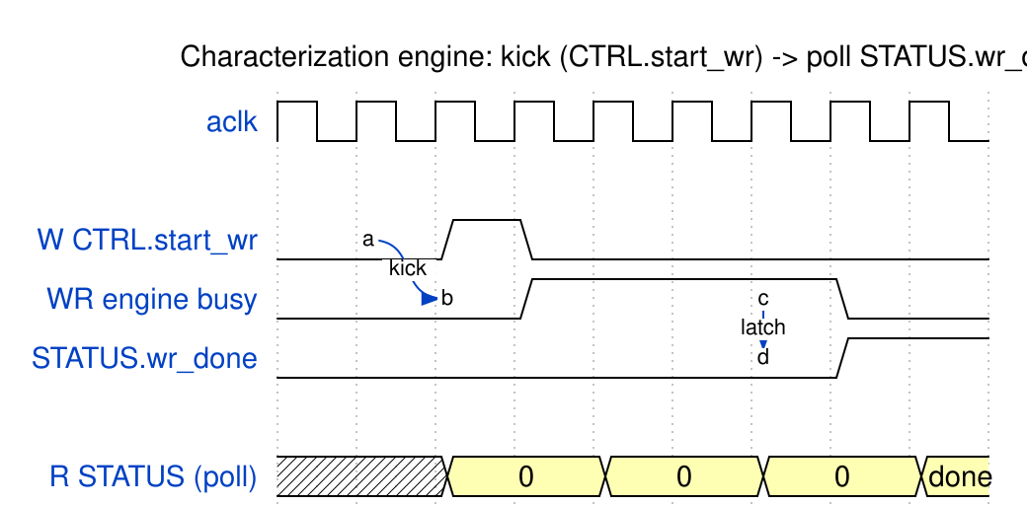
Engine kick and poll
Source: 01_engine_kick.json

6.3 Control / status (offsets relative to HARNESS_CSR_BASE)
Control / status registers
Register | Offset | Field | Bits | Access | Description
CTRL | 0x00 | start_wr | [0] | W | Pulse: kick the write engine
CTRL | 0x00 | start_rd | [1] | W | Pulse: kick the read engine
CTRL | 0x00 | clear_stats | [2] | W | Pulse: clear perf + sticky errors
CTRL | 0x00 | freeze_trace | [3] | RW | Latch: freeze perf counters
CTRL | 0x00 | soft_reset | [4] | W | Pulse: soft reset (does not clear sticky errors)
STATUS | 0x04 | wr_done / rd_done | [0] / [1] | R | Engine completion
STATUS | 0x04 | wr_error / rd_error | [2] / [3] | R | Per-engine error
STATUS | 0x04 | any_error | [4] | R | Sticky OR of errors — cleared by clear_stats
STATUS | 0x04 | init_done / init_fail | [6] / [7] | R | Controller init status
DBG_WR_PTR | 0x08 | value | [31:0] | R | Words written to debug_sram since clear
DBG_OVERFLOW | 0x0C | overflow | [0] | R | Sticky trace-overflow
CRC_EXPECTED | 0x10 | value | [31:0] | R | Write-engine expected CRC
CRC_ACTUAL | 0x14 | value | [31:0] | R | Read-engine actual CRC
CRC_MATCH | 0x18 | match | [0] | R | CRC_ACTUAL == CRC_EXPECTED
CRC_MATCH | 0x18 | exp_valid / act_valid | [1] / [2] | R | CRC captured
CRC_MATCH | 0x18 | beats_mism_nz | [3] | R | Any beat mismatched
SCRATCH | 0x1C | value | [31:0] | RW | Host link ping
BUILD_ID | 0x20 | value | [31:0] | R | 0x44445232 (“DDR2”)
BEATS_MISM | 0x24 | value | [31:0] | R | Beats mismatched

6.4 Timer
Characterization timer registers
Register | Offset | Bits | Access | Description
TIMER_CTRL | 0x28 | [0] clear | W | Pulse: clear the cycle counter
TIMER_STATUS | 0x2C | [0] done, [1] running, [2] pass | R | Timer state
TIMER_CYCLES_LO/HI | 0x30 / 0x34 | [31:0] | R | 64-bit cycle count (10 ns/cycle)
TIMER_EXP_BEATS | 0x38 | [31:0] | RW | Beat-count stop trigger (0 = disable)
TIMER_{R,W}_{FIRST,LAST}_{LO,HI} | 0x40–0x5C | [31:0] | R | First/last R/W beat timestamps (64-bit each)

6.5 Runtime controller cfg + DFI tuning
Runtime controller config and live DFI tuning
Register | Offset | Field | Bits | Access | Description
CTRLR_CFG | 0x60 | memtype | [0] | RW | 0 = DDR2, 1 = LPDDR2
CTRLR_CFG | 0x60 | t_phy_wrlat | [15:8] | RW | PHY write latency (see Chapter 7 — board wants 0)
CTRLR_CFG | 0x60 | t_rddata_en | [23:16] | RW | Read-data-enable latency
CTRLR_CFG | 0x60 | rd_in_order | [24] | RW | Force in-order reads
CTRLR_CAP | 0x64 | cap_lookahead_max | [3:0] | RW | Advertised OOO look-ahead depth
CTRLR_CAP | 0x64 | cap_synth_mask | [7:4] | RW | Advertised feature mask
DFI_TUNING | 0x68 | cmd_delay | [3:0] | RW | Live DFI cmd delay (reset 1) — no rebuild
DFI_TUNING | 0x68 | rddata_delay | [7:4] | RW | Live DFI read-data delay (reset 0)

6.6 a7ddrphy calibration passthrough (hardware only)
Indirect access to the a7ddrphy’s read/write-leveling knobs; firmware-driven, no HW FSM. Meaningless in sim (the stub ignores it). Knob map: rtl-vivado/a7ddrphy/a7ddrphy_csr_map.txt.
a7ddrphy calibration passthrough
Register | Offset | Bits | Access | Description
PHY_CSR_ADDR | 0x80 | [9:0] | RW | a7ddrphy CSR word index
PHY_CSR_WDATA | 0x84 | [31:0] | RW | Value to write
PHY_CSR_CTRL | 0x88 | [0] pulse | W | Drive one CSR-bus write
PHY_CSR_RDATA | 0x8C | [31:0] | R | dat_r for the current PHY_CSR_ADDR

6.7 Engine config (WR 0x100–0x128, RD 0x180–0x1A8)
The read block mirrors the write block at +0x80.
Write-engine config (read engine identical at +0x80)
Register | Offset | Field | Bits | Description
WR_START_ADDR | 0x100 | value | [31:0] | Start address
WR_STRIDE_0/1 | 0x104 / 0x108 | value | [23:0] | Signed strides
WR_WRAP_MASK_0/1 | 0x10C / 0x110 | value | [31:0] | Address wrap masks
WR_BLEN_TXN | 0x114 | burst_len | [7:0] | AXI burst length
WR_BLEN_TXN | 0x114 | txn_count | [23:8] | Transaction count
WR_BLEN_TXN | 0x114 | gap | [27:24] | Inter-burst gap
WR_AXI_ATTR | 0x118 | axi_id | [7:0] | AXI ID
WR_AXI_ATTR | 0x118 | id_mode | [9:8] | 0 fixed / 1 counter / 2 LFSR
WR_AXI_ATTR | 0x118 | axi_size | [12:10] | AXI size (AXI_SIZE_8 = 3)
WR_AXI_ATTR | 0x118 | axi_burst | [14:13] | 0 fixed / 1 incr / 2 wrap
WR_AXI_ATTR | 0x118 | data_mode | [15] | Data pattern mode
WR_LFSR_SEED | 0x11C | value | [31:0] | Pattern seed (must match RD for CRC)
WR_HASH_SEED0/1/2 | 0x120–0x128 | value | [31:0] | Hash seeds

6.8 Perf observability (0x1C0–0x1E8)
All 32-bit; cleared by CTRL.clear_stats, frozen by CTRL.freeze_trace.
Perf observability (bin b covers [2^b, 2^(b+1)) cycles)
Register | Offset | Field | Bits | Description
OBS_RD_{PROD,BP,STARV,IDLE} | 0x1C0–0x1CC | value | [31:0] | Read data-channel meter buckets
OBS_WR_{PROD,BP,STARV,IDLE} | 0x1D0–0x1DC | value | [31:0] | Write meter buckets
OBS_HIST_SEL | 0x1E0 | bus | [0] | 0 = read, 1 = write
OBS_HIST_SEL | 0x1E0 | metric | [1] | 0 = AR→firstR / AW→B, 1 = AR→RLAST
OBS_HIST_SEL | 0x1E0 | bin | [5:2] | Histogram bin index (0–15)
OBS_HIST_COUNT | 0x1E4 | value | [31:0] | Count in the selected bin
OBS_HIST_TOTAL | 0x1E8 | value | [31:0] | Total txns on the selected metric

RTL Design Sherpa · Learning Hardware Design Through Practice GitHub · Documentation Index · MIT License

7 Address Map
The LiteDRAM flow (ddr2-characterization/flows-litedram-uart/) uses the same generated bridge_ddr2_char_axil and the same char_engine_harness as the pumice build, so the host address space is identical at the top level. What changes is what sits behind three of the windows: the pumice controller CSR window is terminated, the controller-tuning registers in harness_csr are present but unwired, and the BUILD_ID reads LDR2 instead of DDR2.

7.0.1 Figure 5.1: LiteDRAM UART/AXI4-Lite address map
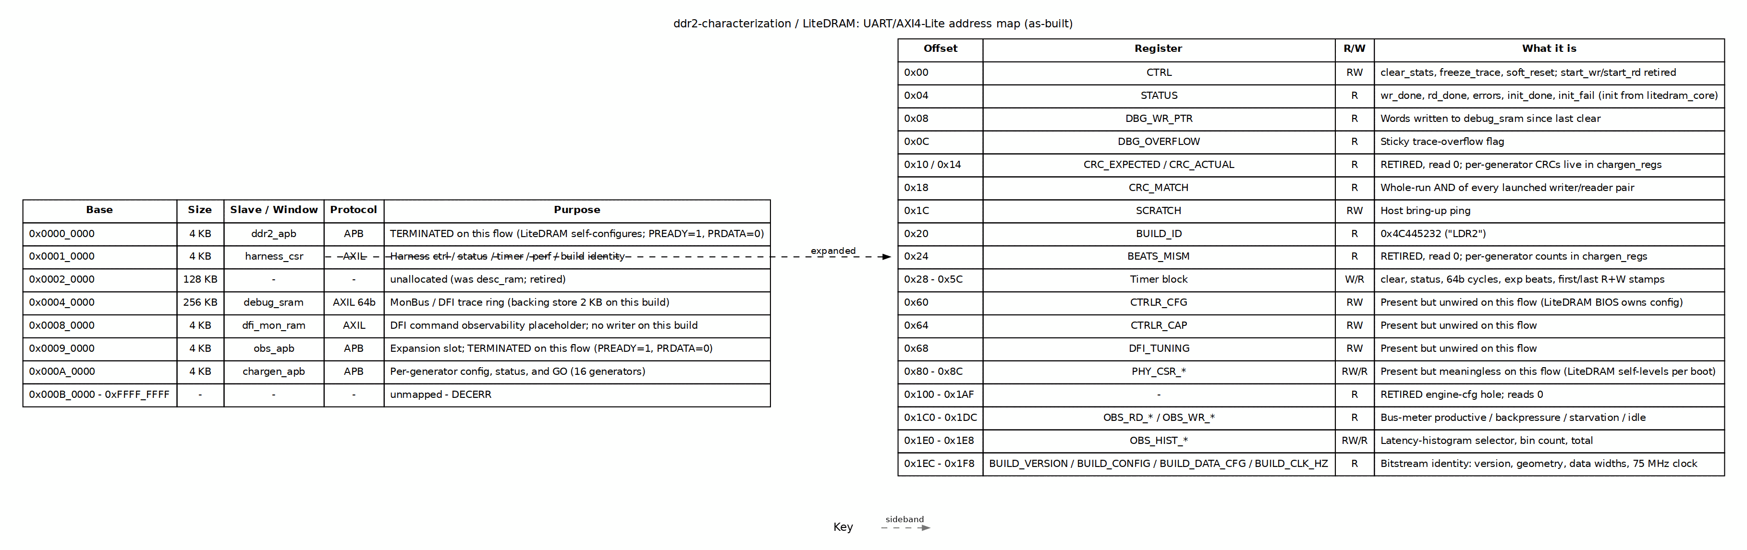
LiteDRAM UART/AXI4-Lite address map
Source: 02_address_map.dot

7.1 Bridge slave windows
Table 5.3: Bridge address decode for the LiteDRAM flow
Slave | Base | Size | Protocol | Purpose
ddr2_apb | 0x0000_0000 | 4 KB | APB | Terminated on this flow (LiteDRAM self-configures; PREADY=1, PRDATA=0)
harness_csr | 0x0001_0000 | 4 KB | AXIL | Harness control / status / timer / perf / build identity
unallocated | 0x0002_0000 | 128 KB | - | Former desc_ram slot; retired
debug_sram | 0x0004_0000 | 256 KB | AXIL 64b | MonBus / DFI trace ring (backing store 2 KB on this build)
dfi_mon_ram | 0x0008_0000 | 4 KB | AXIL | DFI command observability placeholder; no writer on this build
obs_apb | 0x0009_0000 | 4 KB | APB | Expansion slot; terminated on this flow
chargen_apb | 0x000A_0000 | 4 KB | APB | chargen_regs: per-generator config, status, and GO

7.2 harness_csr register map
All offsets are relative to 0x0001_0000. The same harness_csr.sv module is used; fields that are physically present but do not affect LiteDRAM are marked below.
Table 5.4: harness_csr register offsets for the LiteDRAM flow
Offset | Register | R/W | What it does
0x00 | CTRL | RW | clear_stats, freeze_trace (latch), soft_reset; start bits retired
0x04 | STATUS | R | wr_done, rd_done, errors, init_done/init_fail from litedram_core
0x08 | DBG_WR_PTR | R | Words written to debug_sram since last clear
0x0C | DBG_OVERFLOW | R | Sticky trace-overflow flag
0x10 / 0x14 | CRC_EXPECTED / CRC_ACTUAL | R | Retired — read 0; per-generator CRCs in chargen_regs
0x18 | CRC_MATCH | R | Whole-run AND of every launched writer/reader pair
0x1C | SCRATCH | RW | Host bring-up ping
0x20 | BUILD_ID | R | 0x4C445232 (ASCII LDR2)
0x24 | BEATS_MISM | R | Retired — read 0; per-generator counts in chargen_regs
0x28–0x5C | Timer block | W/R | clear, status, 64b cycles, exp beats, first/last R+W stamps
0x60 | CTRLR_CFG | RW | Present but unwired on this flow (LiteDRAM BIOS owns configuration)
0x64 | CTRLR_CAP | RW | Present but unwired on this flow
0x68 | DFI_TUNING | RW | Present but unwired on this flow
0x80–0x8C | PHY_CSR_* | RW/R | Present but meaningless; LiteDRAM self-levels per boot
0x100–0x1AF | — | R | Retired engine-config hole; reads 0
0x1C0–0x1DC | OBS_RD_* / OBS_WR_* | R | Bus-meter buckets: productive, backpressure, starvation, idle
0x1E0–0x1E8 | OBS_HIST_* | RW/R | Latency-histogram selector, bin count, total
0x1EC–0x1F8 | Build identity | R | BUILD_VERSION, BUILD_CONFIG, BUILD_DATA_CFG, BUILD_CLK_HZ

7.3 As-built vs. not used
- harness_csr, chargen_apb, and the engine/timer/perf path are fully live.
- ddr2_apb is terminated inside char_engine_harness so a host script that still tries to write pumice controller registers completes harmlessly.
- CTRLR_CFG, CTRLR_CAP, DFI_TUNING, and PHY_CSR_* are physical registers that read back what was written, but nothing consumes them on this flow.
- debug_sram is a live AXIL SRAM with the same 2 KB backing-store limitation as the pumice build.
- dfi_mon_ram has no writer on this build.
- BUILD_CLK_HZ reports 75_000_000 because char_engine_harness runs on the LiteDRAM user_clk.

7.4 Differences from the pumice build
The pumice address map is documented in the pumice_fpga_system book (docs/pumice_fpga_system/ch02_harness/02_address_map.md). The only meaningful differences here are behind ddr2_apb and in the controller-tuning fields of harness_csr; the generator, timer, and performance register surfaces are the same, which is what makes the A/B comparison valid.

8 Simulation / Silicon Equivalence
This project follows the shared UART-characterization methodology (bin/TBClasses/harness/): one authored-once host program runs byte-for-byte identically on the FPGA and in a cocotb simulation. The equivalence boundary is the ASCII W/R byte stream on the UART wire; only the bottom ByteChannel differs — SerialChannel (pyserial) on the board vs CocotbUartChannel on the DUT pins in sim.

8.1 Testbenches
Simulation testbenches
tb_top | Wraps | Drives cfg via
ddr2_char_uart_tb_top.sv | the full ddr2_char_harness (real UART bridge + harness_csr + 1→N bridge + engines + pumice) | the real UART pins (cocotb UARTMaster/Monitor)
ddr2_char_macro_tb_top.sv | the inner ddr2_char_macro | direct ports + an APB BFM
The UART tb is the equivalence vehicle: it exposes real UART pins so the sim consumes the identical byte stream the host sends to silicon. The DFI side is wired to internal phy_dfi_* nets so the framework’s DFISlavePHY + MemoryModel loopback auto-binds by prefix. There is no a7ddrphy in sim — it reproduces the digital DFI handshake, not the analog eye.

8.2 How the same program runs in sim
test_ddr2_char_uart.py builds the DFISlavePHY + MemoryModel backend, then:
r = await cocotb.external(prog)() # prog is an UNMODIFIED pumice_master routine
make_uart_channel(dut, clock, clks_per_bit) returns a CocotbUartChannel that drives the UART pins; the synchronous host program runs in a worker thread under cocotb.external, and the channel’s read/write are cocotb.function wrappers that step the sim. The baud is lowered for sim (UART_BAUD = 6_250_000 → CLKS_PER_BIT = 16 vs 868 on board) — bit-timing only, the byte stream is unchanged. make sim / sim-smoke / sim-simple / sim-level run the same programs the board runs.

8.3 Match the board’s exact DFI config
GEAR_RATIO = log2(DFI_RATE) and must match the compile-time DFI_RATE or reads corrupt. The test threads TEST_DFI_RATE / TEST_GEAR_RATIO / TEST_DRAM_BEAT_BYTES into both the SV parameters={...} and the host via drv.set_dfi_phase(...). The board is built at DFI_RATE = 4 (GEAR = 2, AXI 64 / DRAM beat 32); a rate-2 / GEAR-1 sim will pass while the board fails — it skips the very paths that break. Named variants (..._smoke_rate4, ..._smoke_rate4_x16, ..._pagehit_rate4_x16, …) exist to run the board’s real geometry.

8.4 What the sim can and cannot reproduce
- CAN: everything digital — the controller/engines, the bridge RTL, DFI-level handshakes, register logic. This is where it earns its keep.
- CANNOT: analog PHY behavior. Xilinx SERDES/IDELAY in a7ddrphy do not simulate, so read-eye / DQS-gate / pin-LOC problems are silicon-only.

9 Troubleshooting

9.1 Current board state
Sim timing is closed; on-board DDR2 runs but is gated by PHY calibration. A clean read-leveling eye is found only at t_phy_wrlat = 0 (bitslip 0, taps 0–11, centre tap 5). The default of t_phy_wrlat = 4 used by --simple / --char breaks the write path (“no passing tap”).
Known-good board config: t_phy_wrlat = 0, t_rddata_en = 6, rd_phase = 0, rddata_delay = 8, cmd_delay = 1.
After the runtime page-policy fix, OPEN vs CLOSE page policy moved read throughput from ~12.7 MB/s to ~112 MB/s (8.8×) and write to ~44 MB/s (3.5×) (measured 2026-07, pre-sdpram-fix). For reference, LiteDRAM on the same board reaches ~600 MB/s peak (300 MT/s memtest).

9.2 Sticky errors look like a wedge
STATUS.any_error is sticky and is cleared by CTRL.clear_stats, not soft_reset. A single failed read latches rd_error; every subsequent engine wait then returns False and looks like a hardware wedge that isn’t one. Clear stats between phases. Note pumice_master.wait_engine() waits on one engine (write-then-read is phased); a “wait for both” would hang.

9.3 Known bugs / bounds
Known issues and bounds
Symptom | Cause / workaround
Read engine wedges at ~4790 txns | rd_cmd_cam ceiling — keep board runs txn ≤ 1024 for clean completion; the perf rate is still valid at scale
row_major wedges immediately | every burst is a row-miss — needs the wedge fix before it can be characterized
Intermittent 1–11 beat mismatches at scale | clean at txn ≤ 1024
col_major stride overflow | stride 16 KB × txn > 8192 exceeds 128 MB → address alias; host bounds col_major to txn ≤ 8192
synth_mask_obs / lookahead_max_obs read 0 | init never set CTRLR_CAP — advertise capability first

9.4 Cannot find the board
The USB-UART re-enumerates across reboots/replugs. --port auto (default) probes each /dev/ttyUSB*, reads BUILD_ID, and picks the one answering 0x44445232. If none respond it raises “no pumice DDR2 char harness responded … is the board powered and programmed?” — confirm the bitstream is flashed and the FTDI cable is free.

9.5 a7ddrphy is not simulatable
Verilator cannot model OSERDESE2 / ISERDESE2 / IDELAYE2, so sim connects at the DFI level with DFISlavePHY + MemoryModel. Read-eye / DQS-gate / pin-LOC problems are silicon-only. Regenerating the real PHY requires Python 3.10 only (migen’s CSR-name tracer breaks on 3.11/3.12):
uv venv --python 3.10 /tmp/litex-venv310 && source /tmp/litex-venv310/bin/activate
uv pip install migen "litex==2024.12" "litedram==2024.12" pyyaml
cd projects/fpga-systems/NexysA7/mem-ctrl-ip-ddr2/build-perf
python3 bin/elaborate_a7ddrphy.py --out rtl-vivado/a7ddrphy/a7ddrphy_generated.v
python3 bin/elaborate_a7ddrphy.py --dump-csr-map # CSR offsets for firmware

9.6 debug_sram trace ring is disabled on this build
DEBUG_SRAM_WORDS was shrunk 32768 → 512 — the full ring needed ~44 K distributed-RAM cells (2.4× over the 100T budget) and blocked place_design. The 256-KB address window is unchanged (accesses > 2 KB alias into the ring); the ring is effectively unused here. Raise it on a larger device.

9.7 LiteDRAM baseline flow
flows-litedram-uart is wired and lint-clean but board bring-up is gated. The default ./regen.sh builds an empty BIOS ROM (--no-compile-software) so the core never asserts init_done — use ./regen.sh --bios (needs riscv-gcc). The host variant (harness_csr at base 0, no pumice APB cfg) is still TODO.

10 Measured Results
Every number in this chapter is from the Nexys A7, not simulation: 75 MHz controller clock, DDR2-300, BL4 on the x16 MT47H64M16, open_page policy, the 4+4 generator bitstream. Peak is 600 MB/s — 8 bytes per controller cycle. Measured 2026-09-14; sections 8.2 and 8.5 re-measured 2026-09-26 on the post-RBL-removal bitstream; the page-friendly and page-thrash rows re-verified 2026-10-03 on the post-sdpram-fix image (char_postfix_2026-10-03.csv — the fix is on the harness UART/debug SRAM, off this datapath: row_major bl16 read 572.3 MB/s, close_page col_major bl8 read 195.2 MB/s to the digit of the 2026-09-26 campaign). The AxLEN/outstanding sweeps of 8.1/8.2 were not re-run post-fix; treat them as pre-fix dated.
The figures and the raw records are in the repository, so nothing here has to be taken on trust: build-perf/reports/bank_gap_sweep.json (192 records), axlen_sweep.json, outstanding_sweep.json, and the plots under build-perf/reports/plots/.

10.1 8.1 Streaming bandwidth, and why short bursts fall short
Reads and writes both reach about 95% of peak once bursts are long enough. They do not at short burst lengths, and the reason is latency, not overhead.
Read bandwidth against AXI burst length, at 8 bursts outstanding
AxLEN | read MB/s | % peak | read latency (cycles) | Little’s-law prediction
1 | 98.7 | 16.4% | 50.6 | 93.1
2 | 196.6 | 32.8% | 48.0 | 192.0
4 | 367.9 | 61.3% | 50.0 | 355.5
8 | 575.0 | 95.8% | 49.8 | 570.0
16 | 575.8 | 96.0% | 96.0 | 570.0
The model is min(outstanding x AxLEN / (latency + AxLEN), 0.95) x peak. With 8 bursts in flight against a ~49-cycle read, a one-beat burst simply cannot fill the pipe — the requester runs out of things to have asked for.
That is an inference from one curve, so it was tested directly from the other axis: hold AxLEN and sweep the number of bursts in flight instead.
The short-burst shortfall recovers completely when more reads are in flight
AxLEN | at 8 outstanding | best reached | at
1 | 98.7 MB/s (16.4%) | 390.6 MB/s (65.1%) | 32, still climbing
2 | 196.6 MB/s (32.8%) | 573.1 MB/s (95.5%) | 24
4 | 367.9 MB/s (61.3%) | 574.6 MB/s (95.8%) | 16
8 | 575.0 MB/s (95.8%) | 575.6 MB/s (95.9%) | 12
This is the decisive result. AxLEN 2 and 4 reach the same ceiling as AxLEN 8 once enough reads are in flight. A per-transaction penalty could not behave that way — it would scale with the number of transactions and never go away. So nothing in the controller’s datapath limits short bursts; the read latency and the requester’s budget are the whole story. AxLEN 1 needs roughly 49 bursts in flight and the harness ceiling is 32, which is why it alone is still climbing rather than a different mechanism.
The knee confirms the shape too. It is the smallest number of bursts in flight at which bandwidth reaches 95% of the plateau, and the model puts it at 0.95 x (latency + AxLEN) / AxLEN:
Where bandwidth reaches its plateau, measured against the model
AxLEN | model knee | measured knee | ratio
1 | 47.7 | none inside 32 (still climbing) | —
2 | 24.1 | 24 | 0.99x
4 | 12.7 | 12 | 0.95x
8 | 6.9 | 8 | 1.17x
Scaling and constant both hold. The 1.17x at AxLEN 8 is the sweep grid rather than a discrepancy — the model wants 6.9 and the available steps are 4 and 8. The per-point agreement is as good: at AxLEN 4 the model tracks all eight points from -0.1% to +4.4%, with measured bandwidth sitting slightly above the prediction throughout, which says the effective latency is marginally better than the sampled average rather than worse.
A note on how this knee is scored, because the obvious way is wrong. Reading the knee as “the first point that stopped improving” names the point after saturation — one sweep step late, every time. Scored that way these same measurements read 32 / 24 / 12 and appear to sit 1.3-2x above the model, which is exactly what an earlier draft of this chapter reported as an open anomaly. There was no anomaly. The knee is where bandwidth arrives at the plateau, not where it first fails to climb.

10.2 8.2 How much idle the controller absorbs
The gap sweep runs N writers and N readers concurrently, one bank apiece, inserting 0 to 15 idle clocks between bursts, across three address orders and at 4+4 / 3+3 / 2+2 / 1+1 engines. It answers a different question from the bandwidth sweeps: not “how fast can it go” but “how much slack does it have”.
The knee is the largest gap whose read bandwidth is still within 3% of the gap-0 value.
Gap knee by address order and generator count (re-measured 2026-09-26)
address order | 4+4 | 3+3 | 2+2 | 1+1
cacheline | 15 | 15 | 10 | 1
row-major | 15 | 15 | 10 | 0
col-major | 15 | 15 | 10 | 1
Bus bandwidth from gap 0 to gap 15, all three address orders agreeing within 2 MB/s: 1+1 570.5 -> 237.2 (42% retained), 2+2 564.8 -> 442.7 (78%), 3+3 560.7 -> 560.8 (100%), 4+4 549.9 -> 549.8 (100%).
Two corrections to the 2026-09-14 version of this table.
col-major is no longer flat. It previously read 15 at every generator count — insensitive to injected idle — and now tracks the other two orders exactly. Nothing about the gap changed; col-major got FASTER. It used to be DRAM-bound, slow enough that idle cycles inserted between bursts were absorbed by work the controller was already behind on. The read-ceiling fix and the bank-timer lookahead removed that slack, so col-major now runs close enough to the bus limit to feel a gap like anything else. A knee that appears when a controller improves is the normal direction of travel, not a regression.
The figures quoted below the table were labelled “read bandwidth” and are BUS bandwidth — both directions’ bytes over the measurement window. The distinction matters because rd and wr in the JSON are each measured over their OWN active cycles, so bus is NOT rd + wr: at 1+1 gap 15 the read engine finishes in 46,034 cycles while the write engine needs 80,989, and subtracting the two per-direction figures to “recover” the other invents an asymmetry that is not there.

10.2.1 Figure 8.1: Read Bandwidth vs Gap, Row-Major
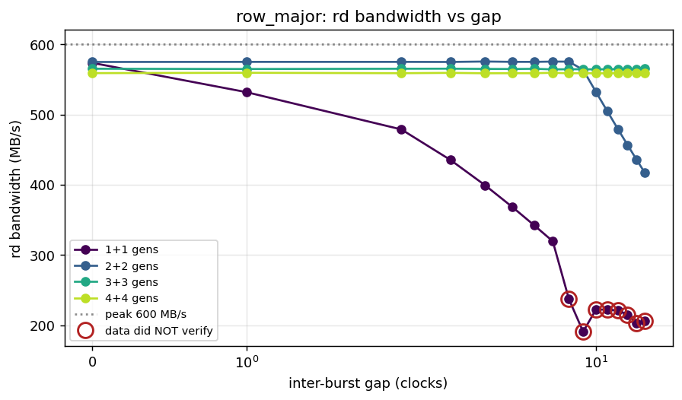
Read bandwidth against inter-burst gap, row-major, one line per generator count

10.2.2 Figure 8.2: Read Bandwidth vs Gap, Cacheline
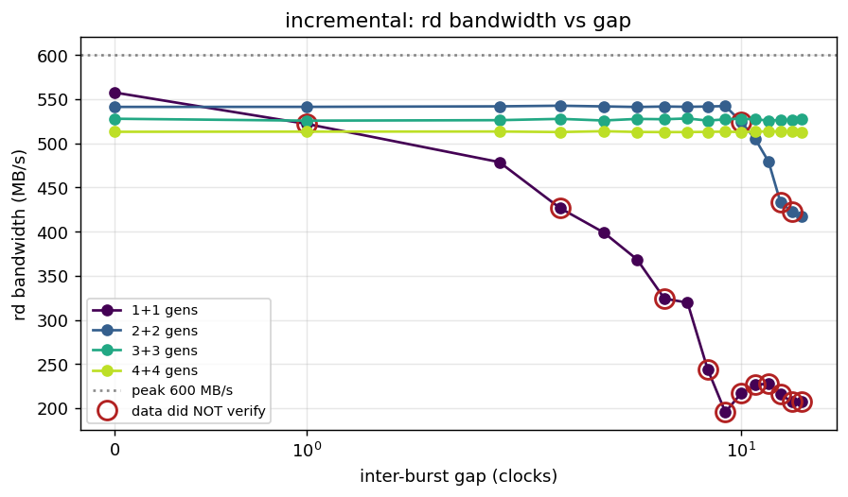
Read bandwidth against inter-burst gap, cacheline order

10.2.3 Figure 8.3: Read Bandwidth vs Gap, Col-Major
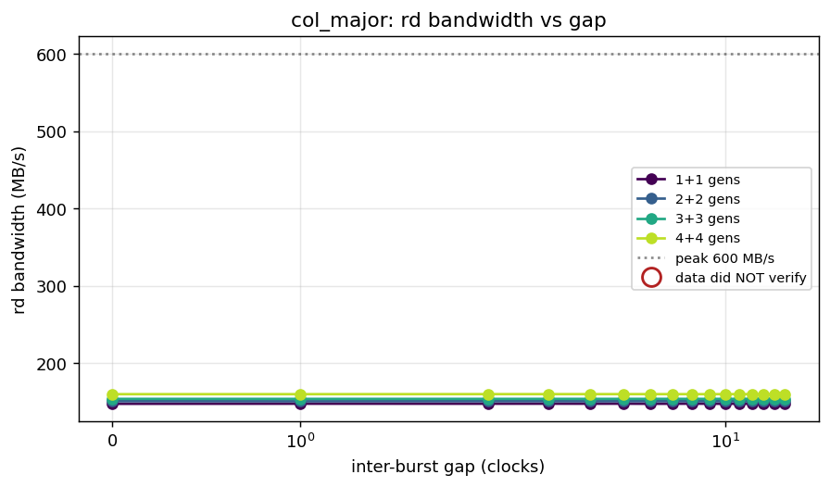
Read bandwidth against inter-burst gap, col-major order
Reading these curves. Two things look wrong at first glance and are not:
The high generator counts are flat. A gap only bends the curve once aggregate demand falls below what the controller can deliver. At 4+4, gap 15 still leaves each generator at roughly a 52% duty cycle, and four of those together still out-demand the controller — so nothing moves. A flat curve there is a result, not a broken axis. It also means the 4-bit gap field cannot inject enough idle to starve four generators: at high counts the lever is the outstanding dial, not the gap.
Col-major is flat at every generator count. It is page-miss bound at about 150 MB/s, 25% of peak. The DRAM is the limit, so generator pacing never becomes the binding constraint. Compare it against row-major’s 575 MB/s on the same silicon and the same settings: a 3.8x spread from the address pattern alone, which remains the single most useful fact in this guide. Tune the address map before tuning anything else.

10.2.4 Figure 8.4: Bus Bandwidth Across Gap and Generator Count
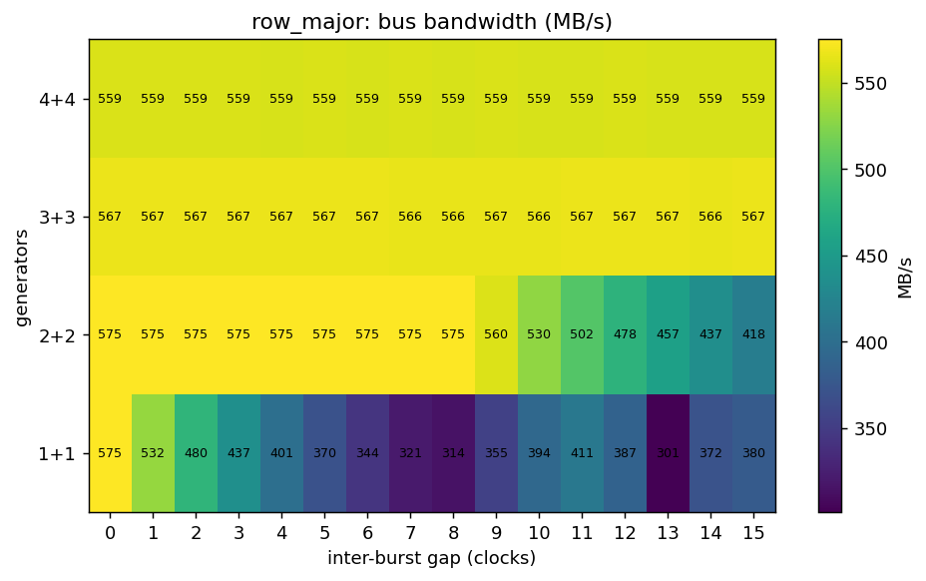
Heatmap of total bus bandwidth against gap and generator count, row-major

10.3 8.3 Where the cycles went
Bandwidth says a point was slow. The cycle classification says who stopped, which is the difference between a finding and a number.
Read cycle breakdown, row-major, 1+1 generators
gap | read MB/s | productive | consumer not ready | other
0 | 574 | 95.6% | 0.0% | 4.4%
4 | 399 | 66.5% | 33.2% | 0.2%
8 | 237 | 39.5% | 28.0% | 32.5%
15 | 206 | 34.3% | 63.1% | 2.6%

10.3.1 Figure 8.5: Cycle Breakdown at 1+1 — the Bend and its Cause
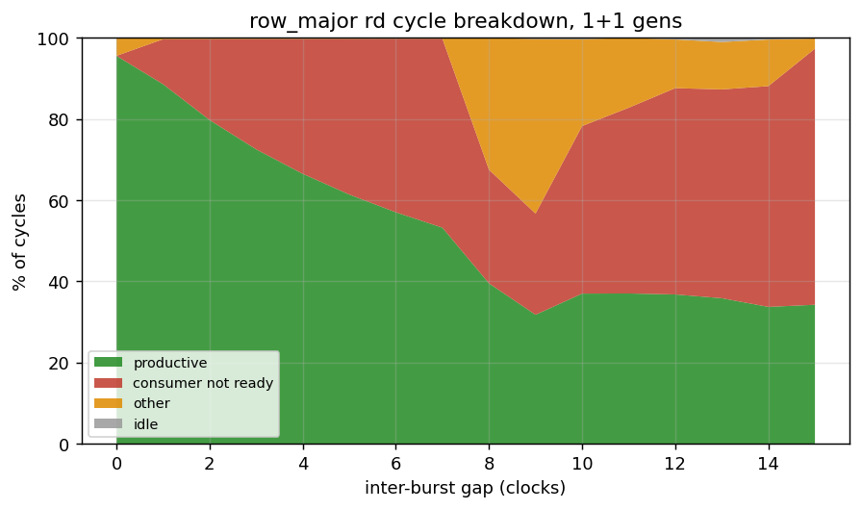
Read cycle breakdown against gap at one generator per direction

10.3.2 Figure 8.6: Cycle Breakdown at 4+4 — Saturated at Every Gap
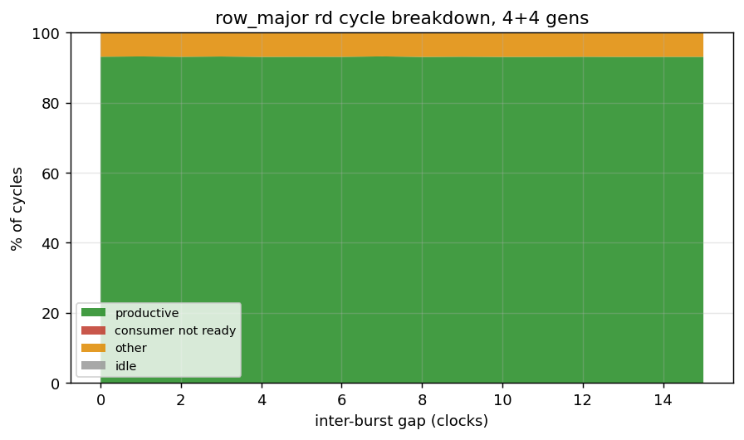
Read cycle breakdown against gap at four generators per direction
At 1+1 the productive fraction falls from 95.6% to 34.3% while “consumer not ready” climbs from nothing to 63.1%. That is the engine’s own inter-burst gap deasserting rready, so the bandwidth went to generator-induced idle, not to anything the controller did. At 4+4 the productive fraction sits at 93.1% regardless of gap — the controller is saturated everywhere on that axis, which is the same fact Figure 8.1 shows as a flat line, seen from the cause side.
Two traps in this instrument, both of which produced published nonsense before they were caught.
The bus meter free-runs from clear_stats() until it is read, so its own total spans the host’s UART chatter as well as the transfer — 7.2M cycles against a 16.7k-cycle window on a 1+1 point, a factor of 430. Fractions taken against that total made a point moving 95% of peak report “0.2% productive, 99.8% starvation”. The counts are sound — productive lands on exactly the beats moved — so the fix is the denominator: normalise against the timer’s first-to-last stamp for that direction. The meter’s own starvation bucket is where the host idle lands and is not reported as a fraction at all.
On a read, the engine is the consumer, so its own pacing gap shows up as rvalid && !rready — the bucket a write would call backpressure. It is generator-induced idle, the opposite of the controller refusing. The label in Figure 8.5 says “consumer not ready” for exactly this reason; do not read the read and write breakdowns with the same vocabulary.

10.4 8.4 Integrity, and one configuration that must not be quoted
All 192 gap-sweep points completed. 22 of them returned mismatching data, and they are not scattered: they are a specific configuration, tracked as pumice BUG-014 (was PUMICE-037).
Concurrent read+write with the reader’s gap at 8 or above returns wrong data, and when the two address ranges overlap it leaves genuinely corrupted cells behind. The boundary was narrowed by elimination on the board, each line its own run from a verified-clean 128 MiB prefill:
pumice BUG-014 (was PUMICE-037) — narrowing the failing configuration
configuration | result
prefill, then read every bank read-only, all three orders | clean
reader alone, gap 0-15 | clean at every gap
writer alone, gap 0-15 | cells clean
writer gap 0-15, reader gap 0 | clean at every writer gap
reader gap 0-7 with a concurrent writer | clean
reader gap >= 8 with a concurrent writer | 1.5k-7k of 32000 beats wrong
4+4 concurrent at gap 0 and gap 4 | clean, cells clean
Neither engine alone does it at any gap, and the writer’s own gap never does it. Everything in this chapter is at gap 0-7 and is unaffected, but no gap >= 8 concurrent point may be quoted as a clean operating point. The plots ring those points, and plot_bank_gap.py refuses any record file whose bandwidth exceeds its own stored ceiling.
Whether the defect is in the controller or in the harness read engine is not yet settled. The stray-beat counter is zero on all 22 failing points, which rules out the read engine’s stray-drain path and points at the data itself; against that, a read engine cannot corrupt cells, and cells are corrupted. The next step is a simulation reproduction with waves — and the reason this reached the board at all is that both gap-bearing simulation suites drain the writer before starting the reader, so concurrency with a gap has never been simulated.

10.5 8.5 What the three runtime modes are worth (2026-09-26)
Chapters 8.1-8.4 measure the controller at its default settings. This section measures the runtime surface itself — the three orthogonal axes that exist so a scheduling policy can be switched on and compared on real hardware. 169 points, txn_scale=1000, all integrity-clean.
The headline is a negative result, and it is worth more than a positive one would be: reordering is the only thing in this controller that pays. Everything layered on top of it is inert or harmful.

10.5.1 Axis 1 — scheduling order
Measured at equal page policy, which had never been done. The stock inorder preset also pins CLOSE page, so the axis used to read as a ~16x deficit that was mostly the page policy rather than the ordering.
Read MB/s against 600 MB/s peak, order_mode at equal page policy
config | cacheline | col-major
open_page (FR-FCFS) | 561.3 | 195.2
inorder_open | 143.0 | 102.4
FR-FCFS is worth 3.9x on streaming and 1.9x page-hostile. That is the reorder CAM earning its area, and it is the largest single effect in the design.
The axis-1 sub-policies are a different matter. Measured single-direction so that read/write turnaround is not the limiter, eight of ten land within ±0.3% of the default. row_most_pending is the only lever with a real effect and it is a net loss: +1.1% on sequential traffic, −19.4% on page-hostile, +7,300 activates, and 2.4x read latency in the concurrent run. It selects the bank with the most queued work rather than the one whose row is already open, so it works against the page policy. The default oldest-first wins on both families.
Why the first attempt at this measured nothing. Run concurrently at 4w+4r, all ten sub-policies returned identical bandwidth. The stall counters showed why: limiter = turnaround at 84% blocked. An arbiter sub-policy chooses WHICH COMMAND, not which direction, so no tie-break can move a workload bound by a global DQ constraint. The sweep was flat for a reason that had nothing to do with the knobs. A policy sweep on a workload that cannot express the policy measures nothing, and looks exactly like a policy that does nothing.

10.5.2 Axis 2 — page policy
Every predictor lands within ±0.1% of plain open page, on all four address families, sequential and concurrent.
Modes 6/7 (rbl_static / rbl_dyn) were retired 2026-09-26 after being measured on a workload built specifically to suit them: three generators confined inside a row against one striding across rows, all on the same bank, which is the per-row locality variation a per-row predictor needs and which no uniform pattern provides. The mechanism worked — thrash fell 100% -> 57.8%, conflict-activates becoming empty-activates — and it still lost, because mode 6 paid +22,827 activates to save precharges that never materialised (−26% bandwidth) and mode 7’s hill-climb drove its threshold to “never close early”, landing bit-identical to plain open page.
Modes 4/5 (adapt_time, adapt_access) are kept but unproven. They show no benefit, but that is not the same finding: their triggers may never have fired. adapt_time closes on an idle timeout and every workload here saturates the generators; adapt_access needs its 2-bit counters to learn. Retiring them on absence-of-benefit would repeat the error that made RBL unmeasurable for months.

10.5.3 Axis 3 — refresh
Measured on open page. The stock refresh profile pins close page (~46 MB/s), which measures refresh in the regime where it matters least.
Read MB/s against 600 MB/s peak
config | row-major | vs default
default tREFI | 572.0 | —
refresh_credit_open | 575.3 | +0.6%
fast_refresh_open | 536.6 | −6.2%
slow_refresh_open | 599.0 | +4.7%
Refresh costs 4.7% of streaming bandwidth. Relaxing tREFI recovers it and reaches 599.0 MB/s — 99.8% of the 600 MB/s ceiling, the highest number this controller has produced on hardware. Refresh credit is inert.
This is the one tunable on any axis that pays, and it is a JEDEC timing parameter rather than a scheduling policy.

10.5.4 Multi-ID traffic
col_major_bl8_multiid (LFSR-driven IDs) is bit-identical to single-ID on every controller config. FR-FCFS already reorders across the whole CAM regardless of ID, so ID diversity exposes no additional opportunity.

10.6 8.6 Reproducing these numbers
cd build-perf
make bitstream && make program
python3 bin/axlen_sweep.py # 8.1, first table
python3 bin/outstanding_sweep.py # 8.1, second table
python3 bin/bank_gap_sweep.py # 8.2-8.4, ~12 minutes
python3 bin/plot_bank_gap.py reports/bank_gap_sweep.json
# 8.5, the runtime axes -- pass the clock EXPLICITLY, see the warning below
cd host
for p in order sched_sub paging pairs_refresh_open matrix; do
python3 pumice_master.py --char --char-scale 1000 --char-profile $p \
--no-level --clk-mhz 75 --csv ../reports/axis_$p.csv
done
--clk-mhz defaults to 66.667 and this build runs at 75. Bandwidth is computed as (bytes / cycles) * clk_mhz, so the default silently scales every number by 0.889 and mis-states the ceiling as 533 MB/s. Pass it, or let pumice_char.resolve_clk_mhz() read clk_hz out of the bitstream. The same class of error in the other direction once reported open-page reads at 123% of what the port can physically carry.
Read section 8.5 with the limiter column, not only the bandwidth column. A policy sweep on a workload that cannot express the policy returns a flat table that is indistinguishable from a policy with no effect.
Leave PREFILL at its default (point). It re-fills the whole device before every measurement so that points are independent; without it, a point that corrupts cells is inherited by every later point that reads the region and reported as that point’s result. Chapter 3 lists the rest of the pitfalls, and docs/DDR2_BANDWIDTH_MEASUREMENT.md carries the full treatment.

