
RTL Design Sherpa
CDC Counter Display Nexys A7 Project Guide 0.90
July 2026

Table of Contents
1 Document Information 9
1.1 References 10
1.2 Conventions 11
1.3 Revision History 12
2 Overview 13
2.1 What it is 13
2.1.1 Figure 1.1: CDC Demo Harness Spine 13
2.2 What it demonstrates 15
2.3 What you need 16
2.4 Where things live 17
3 How It Works 18
3.1 Top-level structure (cdc_demo_top) 18
3.2 Clocking and the four source clocks 19
3.3 One counter domain (cdc_counter_domain) 20
3.4 The five CDC modes (CDC_MODE) 21
3.5 Display 22
4 Test Methodology 23
4.1 What is under test 24
4.2 What is measured, and how 25
4.3 Workloads 26
4.4 The oracle, and what sim can/can’t show 27
4.5 Measurement pitfalls 28
5 Build and Run 29
5.1 The workflow at a glance 30
5.2 Make targets 31
5.2.1 Simulation 31
5.2.2 Register collateral 31
5.2.3 Bitstream 31
5.3 The host CLI (build-demo/host/host_cdc_demo.py) 33
5.3.1 The “watch it fail” procedure 33
6 Harness CSR Configuration 34
6.1 Global registers 36
6.2 Per-counter block 37
6.3 By-name access 38
6.4 Regenerating the regmap 39
7 Simulation / Silicon Equivalence 40
7.1 The layered stack (only the bottom layer differs) 41
7.2 How the sim runs the same program 42
7.3 What the sim can and cannot reproduce 43
7.4 Gotchas worth keeping 44
8 Troubleshooting 45
8.1 The host CLI cannot find the board 45
8.2 Values look scrambled / never settle 46
8.3 make lint — Xilinx primitive errors 47
8.4 make sim BUILD=phase1 fails to compile 48
8.5 make consistency fails after editing registers 49
8.6 Sim runs but nothing advances 50

List of Figures
Figure 1.1: CDC Demo Harness Spine 13

List of Tables
Table 1: Document references 10
Table 2: Revision history 12
Table 3: Project file layout 17
Table 4: Per-counter clock sources 19
Table 5: The five CDC modes for the VALUE readback path 21
Table 6: What is measured 25
Table 7: Demonstration workloads 26
Table 8: Simulation make targets 31
Table 9: Register-collateral make targets 31
Table 10: Bitstream make targets 31
Table 11: Global CSR registers — register / field / offset / bit slice 36
Table 12: Per-counter CSR block — counter i absolute offset = 0x40 + i*0x40 + column 37

List of Waveforms
Waveform 5.1: AXI4-Lite Single-Beat Write 35

RTL Design Sherpa · Learning Hardware Design Through Practice GitHub · Documentation Index · MIT License

1 Document Information
This is the operator / developer guide for the Nexys A7 CDC Counter Display project (projects/fpga-systems/NexysA7/misc-ip/cdc_counter_display). It explains what the project is, how it works, how to build / simulate / program / run it, and how the UART characterization harness is configured. It is a practical guide, not a formal architecture specification.
The project ships in two phases that coexist in the same tree:
- Phase 1 — a standalone, button-driven CDC counter (cdc_counter_display_top).
- Phase 2 — a UART-controlled, four-counter CDC demonstrator (cdc_demo_top) with a host program that runs byte-for-byte identically on the FPGA and in a cocotb simulation. This guide focuses on Phase 2.

1.1 References
Document references
Source | Title
RTL Design Sherpa | projects/fpga-systems/NexysA7/misc-ip/cdc_counter_display/README.md
RTL Design Sherpa | docs/HARNESS.md (CSR map + wiring)
RTL Design Sherpa | docs/RUNBOOK.md (operator procedures)
RTL Design Sherpa | bin/TBClasses/harness/ (shared UART-char collateral)
Digilent | Nexys A7 Reference Manual
ARM | AMBA AXI and APB Protocol Specifications

1.2 Conventions
- Registers are accessed by name, never by hardcoded offset (see Chapter 4).
- Clock: sys_clk = 100 MHz on-board oscillator. Per-counter source clocks (ctr_clk[i]) are asynchronous to sys_clk and to each other.
- Reset: CPU_RESETN (board button BTNR, active-low) or CTRL.soft_reset.
- Register/signal prefixes: r_ registered, w_ combinational.

1.3 Revision History
Revision history
Version | Date | Notes
0.90 | 2026-07-18 | Initial project guide
0.91 | 2026-10-20 | Block diagrams redrawn to the repo element key (v3): class fills, double-bordered registered blocks, green return paths and a generated key under each figure. No technical content changed.
0.92 | 2026-10-20 | Section (h2) headings now open a new page, the pipeline default. No technical content changed.

2 Overview

2.1 What it is
CDC Counter Display is an educational Nexys A7 project that demonstrates clock domain crossing (CDC) — both done correctly and broken on purpose — on real silicon. Four independent counters each run in their own asynchronous clock domain; a host program over UART configures them, reads their values back across the CDC boundary, and can deliberately select an unsafe crossing to watch CDC fail on the 7-segment display.
Phase 2 (cdc_demo_top) is wired on the standard Nexys A7 characterization spine: a single USB-UART link feeds a uart_axil_bridge that converts an ASCII W/R command protocol into AXI4-Lite, which drives the cdc_demo_harness CSR block. The harness fans configuration out to four cdc_counter_domain instances and collects their CDC’d status back.

2.1.1 Figure 1.1: CDC Demo Harness Spine
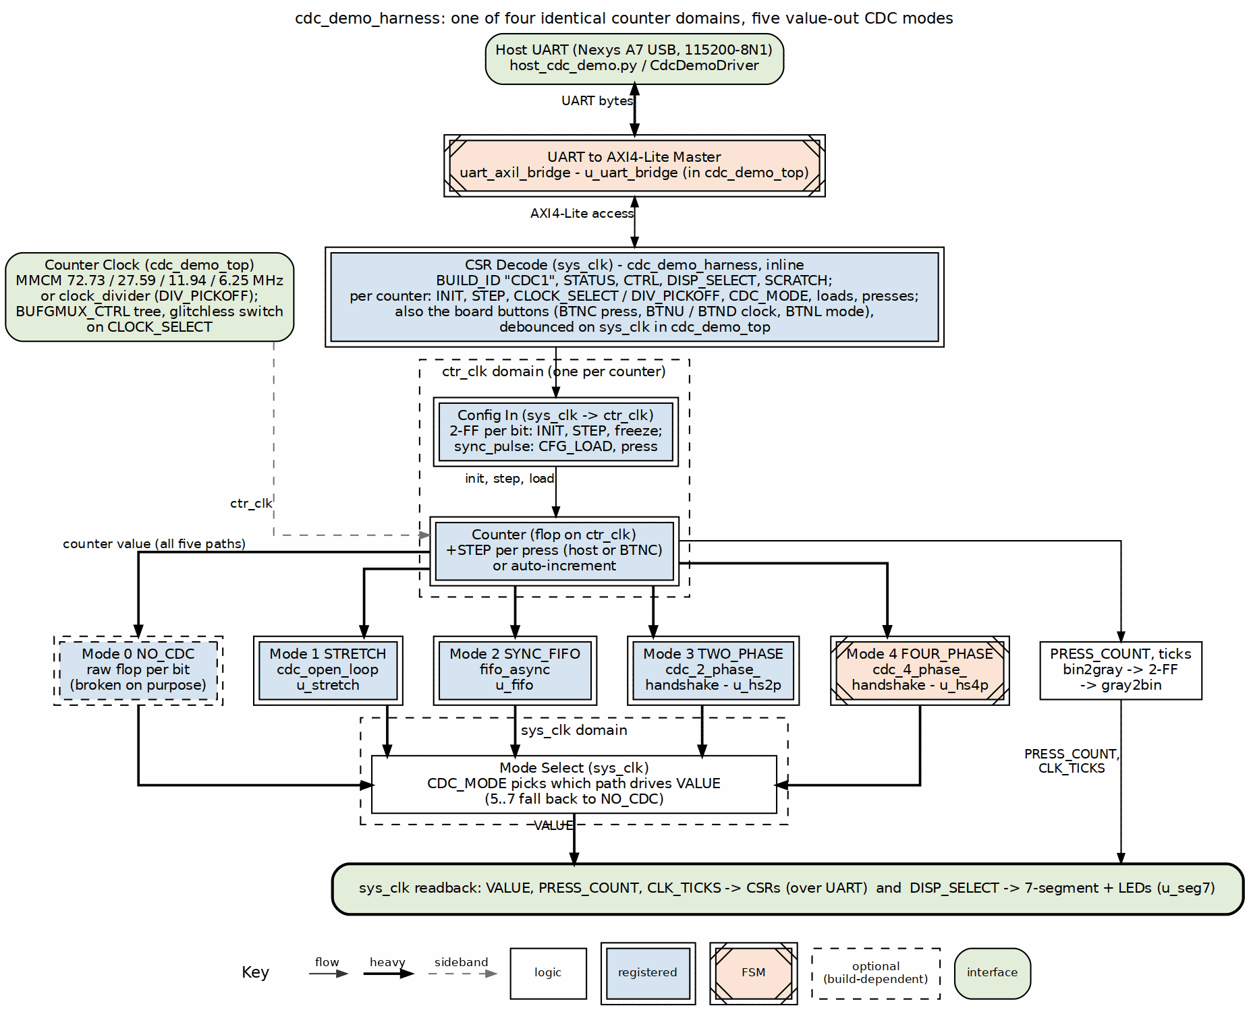
CDC demo harness spine
Source: 01_harness_spine.dot

2.2 What it demonstrates
- Safe multi-bit CDC. With a Gray-coded or FIFO-based crossing, the host reads coherent counter values at any source-clock speed.
- Broken CDC, visibly. Put a counter in NO-CDC mode with auto-increment, then sweep its source clock from slow to fast: the display stays clean at low speeds and visibly scrambles at high speeds (multi-bit bus skew), while the other counters — in a safe mode — stay clean the whole time.
- Five selectable CDC strategies per counter: NO-CDC, stretch, sync-FIFO, two-phase handshake, four-phase handshake.
- Sim / silicon equivalence. The same host program drives the FPGA and a cocotb simulation over the identical UART byte stream (Chapter 6).

2.3 What you need
- Nexys A7-100T board (XC7A100T-1CSG324C) + USB cable.
- Xilinx Vivado (for make bitstream / make program).
- A Python environment sourced from env_python (for the host CLI and sim).

2.4 Where things live
Project file layout
Path | Contents
build-demo/rtl/cdc_demo_top.sv | Board top: clocking tree, buttons, harness, display
build-demo/rtl/cdc_demo_harness.sv | AXI4-Lite CSR + per-counter fan-out
build-demo/rtl/cdc_counter_domain.sv | One counter + its CDC paths (5 modes)
build-demo/rtl/cdc_demo_csr.rdl | Register descriptor (generates the by-name regmap)
build-demo/host/ | cdc_demo.py driver, cdc_programs.py, host_cdc_demo.py CLI
build-demo/dv/ | UART-equivalence cocotb sim (tb, tests, filelist, regmap)
Makefile | Build / sim / program / host targets

3 How It Works

3.1 Top-level structure (cdc_demo_top)
The board top instantiates, from UART inward:
- uart_axil_bridge — decodes the ASCII W <addr> <data> / R <addr> protocol into single-beat AXI4-Lite. CLKS_PER_BIT is derived from SYS_CLK_HZ / 115200.
- cdc_demo_harness — the AXI4-Lite CSR slave (Chapter 5). Stores per-counter config, exposes CDC’d status, and generates single-cycle pulses (CFG_LOAD, HOST_PRESS).
- Clocking tree — an MMCME2_BASE produces four co-prime divided clocks; per counter a BUFGMUX_CTRL tree glitchlessly selects one of five sources.
- Four cdc_counter_domain instances — the counters and their CDC paths.
- Display — DISP_SELECT picks which counter’s value drives the 7-seg.

3.2 Clocking and the four source clocks
The MMCM synthesizes four mutually asynchronous clocks from the 100 MHz reference using pairwise co-prime divisors, plus a per-counter sys_clk-derived divided clock:
Per-counter clock sources
clock_select | Source | Frequency
0 | MMCM CLKOUT0 (÷11) | 72.7 MHz
1 | MMCM CLKOUT1 (÷29) | 27.6 MHz
2 | MMCM CLKOUT2 (÷67) | 11.9 MHz
3 | MMCM CLKOUT3 (÷128) | 6.25 MHz
4 | clock_divider (uses div_pickoff) | sys_clk / 2^(pickoff+1)
The co-prime divisors {11, 29, 67, 128} mean no two outputs share an edge alignment for a very long time — for CDC purposes, truly asynchronous. The divided-clock branch (select 4) keeps a slow, visibly-counting rate available for the “watch it count” demo; div_pickoff = 23 gives roughly 6 Hz.

3.3 One counter domain (cdc_counter_domain)
Each counter lives entirely in its ctr_clk[i] domain and crosses two ways:
- sys_clk → ctr_clk (config in): INIT / INCREMENT as quasi-static 2-FF synchronized buses; CFG_LOAD / HOST_PRESS as single-shot pulses through a sync_pulse module.
- ctr_clk → sys_clk (status out): VALUE, PRESS_COUNT, CTR_CLK_TICKS crossed back for readback. The VALUE path is where CDC_MODE selects the crossing strategy — this is the heart of the demo.
On each ctr_clk edge the counter loads INIT on a CFG_LOAD pulse, otherwise advances by INCREMENT when a press event occurs. A press event is a debounced button, a HOST_PRESS pulse, or — when AUTO_INC = 1 — every ctr_clk edge.

3.4 The five CDC modes (CDC_MODE)
The five CDC modes for the VALUE readback path
Mode | Name | Primitive | Safe?
0 | NO-CDC | raw flop per bit | No (multi-bit skew at fast clocks)
1 | STRETCH | cdc_open_loop (pulse stretch + sync) | Up to a tuned cliff (~25 MHz)
2 | SYNC-FIFO | fifo_async (Gray pointers) | Yes
3 | TWO-PHASE | cdc_2_phase_handshake | Yes
4 | FOUR-PHASE | cdc_4_phase_handshake | Yes
Mode 0 (NO-CDC) samples the multi-bit value with plain flops — at a fast source clock the bits arrive skewed and the host reads transient garbage. That is the intended failure. In Verilator (no metastability model) mode 0 reads the true value deterministically, which is why the simulation asserts on mode 0 for exact values (Chapter 6) but the board shows scramble at speed.

3.5 Display
DISP_SELECT chooses which counter’s 16-bit VALUE drives the 7-segment digits; the upper digits show the selected counter’s CDC_MODE and clock-select so the operator can read the current configuration off the board.

4 Test Methodology
This chapter describes what is exercised on the FPGA block (Figure 2.1) and how the results are judged. CDC Counter Display is a demonstration, so the “measurement” is a coherence test of the clock-domain-crossing readback rather than a throughput sweep.

4.1 What is under test
The four cdc_counter_domain value-readback paths, each selectable among five CDC strategies (CDC_MODE 0–4) and driven by an asynchronous source clock whose rate the host can sweep. The question under test: does the multi-bit counter value cross into sys_clk coherently?

4.2 What is measured, and how
What is measured
Quantity | How it is obtained
Value coherence | Read VALUE by name N times; compute min / max / number of unique samples
Press determinism | After count HOST_PRESS pulses, check VALUE == INIT + count*INCREMENT and PRESS_COUNT delta
Reload | CFG_LOAD reloads VALUE to INIT without disturbing PRESS_COUNT
Mode selection | Each CDC_MODE code round-trips through the CSR and selects a distinct path
A run configures a counter (mode, init, increment, clock), injects stimulus (HOST_PRESS or AUTO_INC), then samples VALUE/PRESS_COUNT over the by-name bridge. In the “watch-fail” workload the counter is put in NO-CDC with AUTO_INC = 1 and its source clock is swept slow→fast; the spread and unique count of the VALUE samples is the metric — a few unique values means clean crossing, a wide 0x00–0xFF spread means multi-bit skew.

4.3 Workloads
Demonstration workloads
Workload | Purpose
press | Deterministic increment check (safe CDC mode)
cfg_load | Reload semantics
cdc_mode | All five mode codes round-trip
watch_fail | Sweep an unsafe crossing slow→fast and watch it break

4.4 The oracle, and what sim can/can’t show
The oracle is the arithmetic expectation (INIT + presses*INCREMENT) for the safe modes. In Verilator the NO-CDC path reads the true value (no metastability model), so the sim asserts exact values even in mode 0 — the analog “garbage” is a silicon-only effect. That asymmetry is the point of the demo, not a defect (Chapter 6, Sim Equivalence).

4.5 Measurement pitfalls
- NO-CDC garbage at speed is expected — use a safe CDC_MODE (2/3/4) before asserting exact values.
- PRESS_COUNT always uses Gray-coded CDC and stays coherent regardless of mode; prefer it when you need a trustworthy count.

5 Build and Run
All commands are run from projects/fpga-systems/NexysA7/misc-ip/cdc_counter_display/ after sourcing the Python environment:
cd /path/to/RTLDesignSherpa
source env_python # sets SIM=verilator, PATH, PYTHONPATH, REPO_ROOT
cd projects/fpga-systems/NexysA7/misc-ip/cdc_counter_display

5.1 The workflow at a glance
make regmap -> make consistency -> make sim (prove it in simulation)
|
v
make bitstream -> make program -> make host-cdc_demo (on the board)
Targets go to build-demo by default; add BUILD=phase1 for the button-only build. All flow logic lives in the global make/fpga_flow.mk (make targets lists what was discovered).

5.2 Make targets

5.2.1 Simulation
Simulation make targets
Target | What it does
make sim BUILD=phase1 | Phase-1 CocoTB sim of cdc_counter_display_top.
make sim | UART-equivalence sim: wraps the real uart_axil_bridge + harness and runs the host programs over a cocotb UART master (build-demo/dv/tests/test_cdc_demo_uart.py). Four tests: smoke, press, cfg_load, cdc_mode.

5.2.2 Register collateral
Register-collateral make targets
Target | What it does
make regmap | Regenerate build-demo/dv/tbclasses/cdc_demo_csr_regmap.py from build-demo/rtl/cdc_demo_csr.rdl. Run after editing the RDL — never hand-edit the regmap.
make consistency | Guard test: the generated regmap must match the hand-written cdc_demo_harness.sv (offsets + per-counter block).

5.2.3 Bitstream
Bitstream make targets
Target | What it does
make bitstream | Build the demo bitstream build-demo/fpga/bitstream/cdc_demo.bit with Vivado (~5–10 min). make project creates the Vivado project only; make synth stops after synthesis.
make program | Flash the board (shared board layer, registry-pinned JTAG serial). make ports / make board-info inspect the board.
make lint | Verilator lint of the build’s filelist closure (Xilinx clocking primitives are stubbed — see Chapter 7).
make utilization / make timing | Print the latest report summaries.
make keep | Promote the current bitstream + reports out of the clean blast radius.

5.3 The host CLI (build-demo/host/host_cdc_demo.py)
The CLI builds a CdcDemoDriver, resolves the serial port through the shared board layer (narrows to this board’s ports by USB serial, then probes for the CDC1 build ID unless --port is given), and dispatches to the authored-once programs in cdc_programs.py. Run it as make host-cdc_demo ARGS=... or directly:
# Verify the link and dump all four counters' defaults
make host-cdc_demo ARGS=smoke
# Inject 1000 host presses to counter 2; checks VALUE = INIT + 1000*INCREMENT
make host-cdc_demo ARGS="press --counter 2 --count 1000"
# CFG_LOAD reload check / CDC_MODE round-trip
make host-cdc_demo ARGS="cfg-load --counter 1"
make host-cdc_demo ARGS="cdc-mode --counter 0"
# Real-time monitor of all four counters
make host-cdc_demo ARGS=monitor
# The headline demo: NO-CDC + auto-increment, sweep the clock slow -> fast
make host-cdc_demo ARGS="watch-fail --counter 2"
# Force a specific port instead of autodetect (direct invocation)
python3 build-demo/host/host_cdc_demo.py --port /dev/ttyUSB1 smoke
Each subcommand prints a human-readable result and returns a non-zero exit code on failure, so the CLI doubles as a board bring-up smoke test.

5.3.1 The “watch it fail” procedure
- Program the board (make program).
- make host-cdc_demo ARGS="watch-fail --counter 2" sets counter 2 to NO-CDC + auto-increment, sets DISP_SELECT to 2, and sweeps div_pickoff from slow to fast, sampling VALUE at each step.
- Read the on-board 7-seg: clean counting at slow pickoffs, visible scramble at fast pickoffs. Compare against a counter left in a safe mode — it stays clean.

6 Harness CSR Configuration
The cdc_demo_harness is a single flat AXI4-Lite slave. The host reaches it through the UART bridge at harness base 0x0. Every register is 32 bits, word-addressable.
Registers are accessed by name, never by offset. The layout is authoritative in rtl/cdc_demo_harness.sv, described in rtl/cdc_demo_csr.rdl, and compiled to dv/tbclasses/cdc_demo_csr_regmap.py (PeakRDL). The driver, the host programs, and the sim all resolve names through that regmap; the consistency test guards the three against drift.
Every named write becomes a single AXI4-Lite beat that the UART bridge drives into the harness (a named read is the mirror AR/R exchange):

6.0.0.1 Waveform 5.1: AXI4-Lite Single-Beat Write
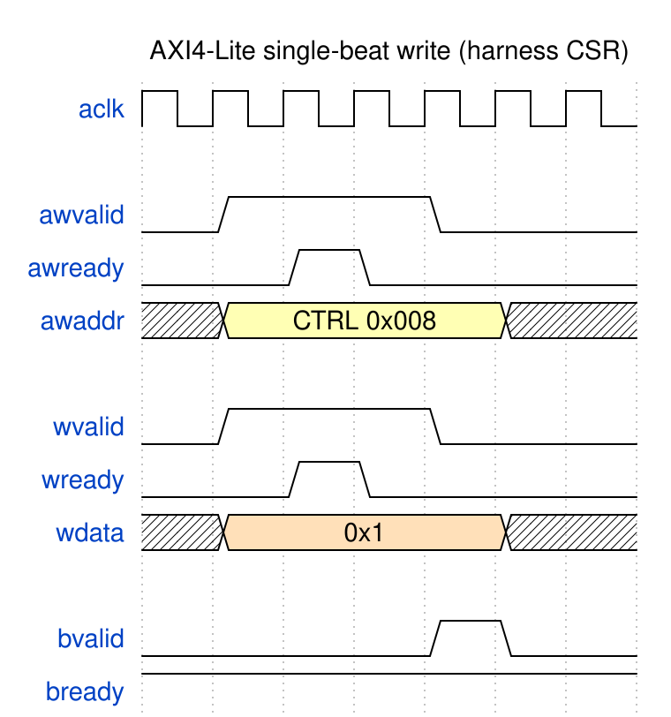
AXI4-Lite single-beat write
Source: 01_axil_write.json

6.1 Global registers
Global CSR registers — register / field / offset / bit slice
Register | Offset | Field | Bits | Access | Description
BUILD_ID | 0x000 | value | [31:0] | R | ASCII “CDC1” (0x43434331) — read first to confirm the bitstream
STATUS | 0x004 | alive0–alive3 | [3:0] | R | Counter i toggled within the last ~1 s window
STATUS | 0x004 | uart_rx | [4] | R | UART RX activity
STATUS | 0x004 | uart_tx | [5] | R | UART TX activity
STATUS | 0x004 | any_written | [6] | R | Any CSR written since reset
STATUS | 0x004 | reset_ok | [31] | R | Reset deasserted / harness alive
CTRL | 0x008 | soft_reset | [0] | RW | Pulse: full sys_clk reset
CTRL | 0x008 | freeze | [1] | RW | Freeze all counters
CTRL | 0x008 | ignore_btn | [2] | RW | Ignore physical buttons (host-press only)
DISP_SELECT | 0x00C | sel | [1:0] | RW | Which counter drives the 7-seg
SCRATCH | 0x010 | value | [31:0] | RW | Link-sanity scratch (write, read back)

6.2 Per-counter block
Counter i (0–3) occupies 0x040 + i*0x40. The regmap keys are COUNTER{i}_<REG> (e.g. COUNTER2_DIVISOR).
Per-counter CSR block — counter i absolute offset = 0x40 + i*0x40 + column
Register | +Offset | Field | Bits | Access | Description
DIVISOR | +0x00 | clock_select | [2:0] | RW | Clock source (0–3 MMCM, 4 = divided)
DIVISOR | +0x00 | div_pickoff | [12:8] | RW | Divided-clock pickoff (when clock_select=4)
INIT | +0x04 | value | [15:0] | RW | Value loaded by CFG_LOAD
INCREMENT | +0x08 | value | [15:0] | RW | Advance amount per press
CFG_LOAD | +0x0C | strobe | [0] | W | Pulse: load INIT into the counter
HOST_PRESS | +0x10 | strobe | [0] | W | Pulse: inject one virtual press
VALUE | +0x14 | value | [15:0] | R | Current value, CDC’d per CDC_MODE
PRESS_COUNT | +0x18 | value | [15:0] | R | Debounced press count (always Gray-CDC’d)
CTR_CLK_TICKS | +0x1C | value | [31:0] | R | Free-running ctr_clk tick count
CDC_MODE | +0x20 | mode | [2:0] | RW | CDC strategy for VALUE (0–4; see Chapter 2)
AUTO_INC | +0x24 | en | [0] | RW | 1 = advance every ctr_clk edge

6.3 By-name access
The driver (host/cdc_demo.py) wraps UartRegisterMap. Whole-register and individual-field access both work:
from cdc_demo import CdcDemoDriver
d = CdcDemoDriver(port="/dev/ttyUSB1") # or bridge=... for sim
d.build_id() # -> 0x43434331
d.scratch(0xDEADBEEF) # write + read back
d.disp_select(2) # DISP_SELECT.sel = 2
c = d.counter(2)
c.set_cdc_mode(2) # COUNTER2_CDC_MODE.mode = 2
c.set_div_pickoff(23) # DIVISOR.{clock_select=4, div_pickoff=23}
c.set_init(0x10); c.set_increment(3); c.load() # load INIT
c.press() # HOST_PRESS
c.value(), c.press_count() # CDC'd status readback
Packed fields are spliced by name with a read-modify-write, so setting div_pickoff never disturbs clock_select. Write-only strobes (CFG_LOAD, HOST_PRESS) are writable by name but read back as 0 by design.

6.4 Regenerating the regmap
rtl/cdc_demo_harness.sv is hand-written; the RDL is a descriptor of it. After editing either the SV or the RDL:
make regmap # regenerate dv/tbclasses/cdc_demo_csr_regmap.py from the RDL
make consistency # assert regmap == SV (globals + reconstructed per-counter)
Never hand-edit the generated regmap — it is regenerated from the RDL.

7 Simulation / Silicon Equivalence
This project follows the shared Nexys A7 UART-characterization methodology (bin/TBClasses/harness/): one authored-once host program runs byte-for-byte identically on the FPGA and in a cocotb simulation. The equivalence boundary is the ASCII W/R byte stream on the UART wire — if the same program emits the same bytes, the same uart_axil_bridge RTL decodes them the same way on silicon and in sim.

7.1 The layered stack (only the bottom layer differs)
Programs cdc_programs.py authored once, unchanged FPGA/sim
Driver CdcDemoDriver + UartRegisterMap by-name registers
Protocol UARTAxiBridge (W/R ASCII) same code both sides
-- byte stream ---------------------------------------------------------
Channel SerialChannel (pyserial) | CocotbUartChannel (cocotb)
Wire FTDI/USB UART | UARTMaster/Monitor on DUT pins
The bridge is injectable: CdcDemoDriver(port=...) opens a real serial port; CdcDemoDriver(bridge=UARTAxiBridge(channel=cocotb_channel)) drives the sim. Nothing above the wire forks.

7.2 How the sim runs the same program
dv/tb/cdc_demo_uart_tb_top.sv wraps the real uart_axil_bridge + cdc_demo_harness + four cdc_counter_domain instances. dv/tests/test_cdc_demo_uart.py:
- Starts aclk and reset, and drives the four ctr_clk[i] at co-prime periods.
- Builds a CocotbUartChannel via make_uart_channel(dut, dut.aclk, CLKS_PER_BIT).
- Constructs CdcDemoDriver(bridge=UARTAxiBridge(channel=chan)).
- Runs the unmodified cdc_programs.* functions inside cocotb.external(...).
The synchronous host program runs in a worker thread; the channel’s read/write are cocotb.function wrappers that drive the UART master and advance simulation time. The four cocotb tests (smoke, press, cfg_load, cdc_mode) assert the same results the CLI checks on the board.

7.3 What the sim can and cannot reproduce
- CAN: everything digital — the bridge RTL, CSR decode, per-counter CDC datapaths, register logic. The sim proves the byte protocol and the harness contract before you ever touch the board.
- CANNOT: the analog clock tree. cdc_demo_top’s MMCME2_BASE / BUFGMUX_CTRL / IBUF / BUFG do not simulate in Verilator, so the tb_top drives ctr_clk[i] behaviorally instead. Consequently the NO-CDC “garbage read” is a silicon-only effect — in Verilator (no metastability) mode 0 reads the true value, so the sim asserts exact values in NO-CDC while the board shows scramble at speed.

7.4 Gotchas worth keeping
- Lower CLKS_PER_BIT in sim (16, in both the tb_top param and the BFM) — bit-timing only, the byte stream is unchanged, so equivalence holds.
- Wrap the full harness, not the inner block — the real uart_axil_bridge + cdc_demo_harness must be in the DUT, or the two flows are only “vaguely similar,” not equivalent.
- Use cocotb.function, not a free-running pump — a pump coroutine plus thread queues stalls the scheduler; cocotb.function is what steps the sim from worker-thread calls.

8 Troubleshooting

8.1 The host CLI cannot find the board
The USB-UART re-enumerates across reboots and replugs, so the port number drifts. The CLI defaults to --port auto, which resolves the port through the shared board layer: it narrows to this board’s ports by USB serial (the board registry in projects/fpga-systems/bin/boards/ knows the FTDI serial) and keeps the one that answers BUILD_ID == 0x43434331 (“CDC1”). If autodetect fails:
- Confirm the board is powered and programmed with the demo bitstream (make program), not build-phase1.
- Run make ports to see which ttyUSB this board is on right now, and make board-info for the registry’s serial. A swapped board unit shows up as “no UART ports found” quoting a serial that is no longer attached.
- Check the FTDI cable and that no other program holds the port.
- Force a specific device with --port /dev/ttyUSB1 (still probed, so a stale path fails loudly instead of driving the wrong board).

8.2 Values look scrambled / never settle
Expected in NO-CDC mode at a fast clock — that is the demonstration. For coherent reads, put the counter in a safe CDC_MODE (2 = SYNC-FIFO, or 3/4 for the handshakes) before reading VALUE. PRESS_COUNT always uses Gray-coded CDC and is coherent regardless of mode.

8.3 make lint — Xilinx primitive errors
cdc_demo_top instantiates MMCME2_BASE / BUFGMUX_CTRL / IBUF / BUFG, which Verilator cannot find. The shared stub file (projects/components/utility-ip/misc/rtl/verilator_xilinx_stubs.sv, pulled in through its filelist by build-demo/rtl/filelists/cdc_demo_top.f) provides `ifdef VERILATOR-guarded pass-through stubs (Vivado uses the real unisims at synthesis; the create_project tcl drops the stub file from the project). If lint fails with “Cannot find module” for one of these, confirm the stub filelist is still included in the build’s .f closure.

8.4 make sim BUILD=phase1 fails to compile
Phase 1 uses clock_divider.sv, which relies on the `ALWAYS_FF_RST macro from rtl/amba/includes/reset_defs.svh. The build’s filelist (build-phase1/rtl/filelists/cdc_counter_display_top.f) carries the +incdir and the reset-defs sub-filelist; the test resolves its sources from that same closure. If you see “Define or directive not defined: ALWAYS_FF_RST”, that include entry is missing from the filelist.

8.5 make consistency fails after editing registers
The generated regmap drifted from the hand-written SV. Regenerate and re-check:
make regmap
make consistency
If it still fails, the SV header table or the CTR_OFF_* localparams in cdc_demo_harness.sv disagree with build-demo/rtl/cdc_demo_csr.rdl — reconcile the three.

8.6 Sim runs but nothing advances
If a UART-equivalence test hangs, the transport is almost certainly using a pump instead of cocotb.function, or CLKS_PER_BIT was left at the silicon value (868), making each command hundreds of thousands of clocks. Both are covered in Chapter 6.

