
RTL Design Sherpa
CDC Counter Display on the Nexys A7 The FPGA System: Harness, Builds, Flow -- Version 1.0
September 2026

Table of Contents
1 Document Information 8
1.1 Related documents 9
1.2 Terminology 10
1.3 Revision History 11
1.4 How to read this book 12
2 The System 13
2.1 What this project is for 13
2.1.1 Figure 1.1: The bench 13
2.2 The board 14
2.3 The asymmetry between the two builds 15
2.4 Why a demonstration needs the broken version 16
3 The Harness 17
3.1 The shape of it 17
3.1.1 Figure 2.1: The harness block map 17
3.2 The front end is borrowed, deliberately 18
3.3 The global registers 19
3.4 The per-counter block, times four 20
3.5 The clock tree 22
3.6 The five crossings 23
4 Two Builds, Two Designs 25
4.1 The short answer, and it is the opposite of the pumice system’s 25
4.1.1 Figure 3.1: Two builds, two designs 25
4.2 What each build actually compiles 26
4.3 Why that is the right structure here 27
4.4 The dispatcher, and where the flow logic lives 28
4.5 One compile closure per build, and it is the filelist 29
5 Host Tools and Flow 30
5.1 The tools 30
5.2 The watch-fail flow 31
5.2.1 Figure 4.1: Breaking a CDC on purpose, and watching the display say so 31
5.3 Step 0: prove the link before anything else 32
5.4 Step 1: the control group is not optional 33
5.5 Step 2: break exactly one thing 34
5.6 Step 3: the sweep is what makes the failure appear 35
5.7 Steps 4 and 5: two views of the same failure 36
5.8 Reproducibility 37

List of Figures
Figure 1.1: The bench 13
Figure 2.1: The harness block map 17
Figure 3.1: Two builds, two designs 25
Figure 4.1: Breaking a CDC on purpose, and watching the display say so 31

List of Tables
Table 1: Table 0.1: Document information 8
Table 2: Table 0.2: Related documents 9
Table 3: Table 0.3: Revision history 11
Table 4: Table 1.1: The two builds are two designs 15
Table 5: Table 2.1: The global registers 19
Table 6: Table 2.2: One counter’s registers (four identical blocks) 20
Table 7: Table 2.3: The five clock sources per counter 22
Table 8: Table 2.4: The five value-out crossings 23
Table 9: Table 3.1: The two compile closures 26
Table 10: Table 4.1: The host tools 30

List of Waveforms
No waveforms in this document.

RTL Design Sherpa · Learning Hardware Design Through Practice GitHub · Documentation Index · MIT License

RTL Design Sherpa · Learning Hardware Design Through Practice GitHub · Documentation Index · MIT License

1 Document Information
Table 0.1: Document information
Field | Value
Title | CDC Counter Display on the Nexys A7 – The FPGA System
Version | 1.2
Date | 2026-10-20
Scope | The CDC demonstration system: the board, the two builds and how far apart they are, the harness around the counters, the five CDC modes, and the watch-it-fail flow
Not in scope | The CDC primitives themselves (rtl/cdc/, documented per module under docs/markdown/); the operator procedure (docs/cdc_demo_guide/, docs/HARNESS.md)
Status | Current

1.1 Related documents
Table 0.2: Related documents
Document | Where | What it gives you
CDC demo operator guide | docs/cdc_demo_guide/ | the chaptered guide for someone at the board
Harness procedure | docs/HARNESS.md | CSR map plus the scripted demo procedure
CDC failure taxonomy | docs/CDC_DEMO_TODO.md | the modes of CDC failure, and “why it sometimes works anyway”
Project README | README.md | the two-build table and the build/program commands
pumice system book | ../../pumice/docs/pumice_fpga_system/ | the same book for the other Nexys A7 project, where the harness is shared rather than per-build

1.2 Terminology
CDC Clock domain crossing. Moving a signal from one clock to another where the two have no fixed phase relationship.
Harness Everything in the bitstream that exists to drive and observe the thing being demonstrated. build-demo has one; build-phase1 deliberately does not.
Counter domain cdc_counter_domain.sv – one counter on its own clock, with a selectable value-out crossing. Instantiated four times.
Mode 0 / NO_CDC The value-out path built wrong on purpose: a raw flop per bit, no Gray coding, no ASYNC_REG. The subject of the headline demonstration.
Control group The counters left in a correct mode during an experiment, so that a visible failure cannot be blamed on the board.

1.3 Revision History
Table 0.3: Revision history
Version | Date | Change
1.0 | 2026-09-29 | First edition.
1.1 | 2026-10-20 | Block diagrams redrawn to the repo element key (v3): class fills, double-bordered registered blocks, green return paths and a generated key under each figure. No technical content changed.
1.2 | 2026-10-20 | Section (h2) headings now open a new page, the pipeline default. No technical content changed.

1.4 How to read this book
Chapter 1 is the bench, and its one surprise: only one of the two builds needs the host at all. Chapter 2 is the harness – the CSR map, the four counter domains, the clock tree, and the five crossings you can select per counter. Chapter 3 is the comparison this project exists to support, and it answers the harness-RTL question in the opposite direction from the pumice system on the same board. Chapter 4 is the watch-it-fail flow and why each step of it is shaped the way it is.
Every diagram is a Graphviz source under assets/graphviz/, rendered to PNG by regenerate_all_graphviz.sh.

RTL Design Sherpa · Learning Hardware Design Through Practice GitHub · Documentation Index · MIT License

2 The System

2.1 What this project is for
This is a teaching instrument. It demonstrates clock domain crossing done correctly and done incorrectly, on real hardware, with the incorrect version failing visibly on demand. The thing being demonstrated is a counter whose value has to cross from its own clock into the clock that drives the display.
That framing matters for the rest of the book, because it makes the display the measuring instrument. There is no CRC and no performance counter here. The experimental result is what the 7-segment digits show.

2.1.1 Figure 1.1: The bench
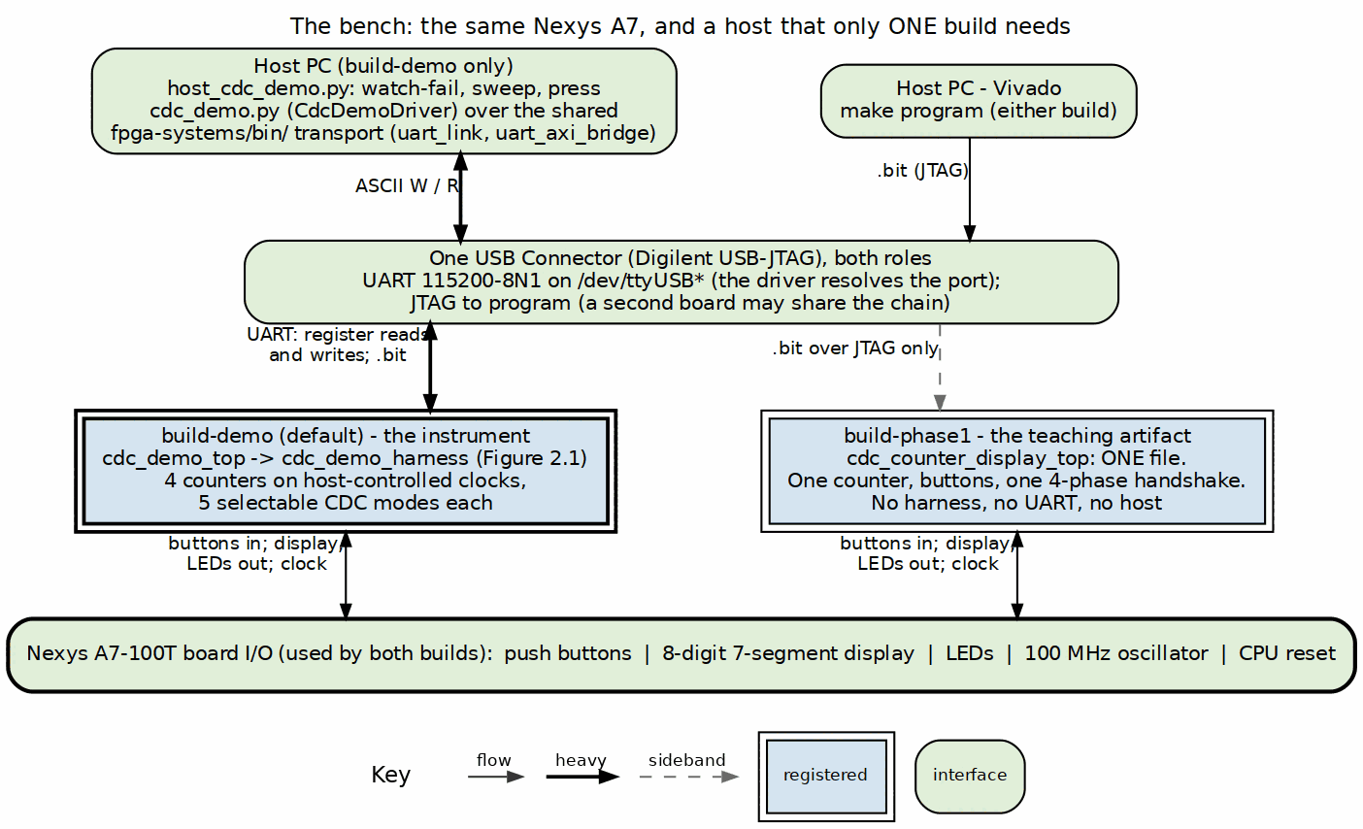
The bench: the same Nexys A7, and a host that only one build needs
Source: 01_board_and_host.dot

2.2 The board
The same Nexys A7-100T as the pumice DDR2 system: Artix-7 XC7A100T-1CSG324C, one 100 MHz oscillator, one USB connector carrying both the JTAG chain and the UART. What this project uses that the DDR2 system does not is the human interface – five push buttons and the 7-segment display – and what it does not use at all is the DDR2 part.
Port discovery is the same problem and has the same answer: the ttyUSB numbering drifts and a second board may share the chain, so the host driver resolves the port rather than trusting a constant. The driver carries that comment where the logic lives.

2.3 The asymmetry between the two builds
The one structural fact to take from this chapter is that the two builds are not two configurations of one design. They are two designs:
Table 1.1: The two builds are two designs
 | build-phase1 | build-demo (default)
Top | cdc_counter_display_top | cdc_demo_top
RTL files in the build | one | three, plus a generated CSR block
Counters | one | four, each on its own clock
CDC crossings available | one, fixed | five, selectable per counter
Host | none – nothing to drive | required
Stimulus | a human pressing BTNC | buttons or injected register writes
What it shows | a correct crossing working | a correct crossing and a broken one, side by side
build-phase1 is the original: a debounced button in a 10 Hz domain, a counter, and a 4-phase handshake carrying the value into a 1 kHz display domain. You walk up to the board, press a button, and the number goes up. It needs no host because there is nothing to configure.
build-demo is the instrument. It has four counters so that three of them can be a control group; it has host-settable clocks so a crossing can be pushed until it breaks; and it has five selectable crossings so the broken one can be compared against four correct ones without rebuilding.
Note: the project Makefile is a dispatcher, not a build. Targets go to build-demo by default and BUILD=phase1 selects the other. All flow logic lives in the repo-wide make/fpga_flow.mk; the per-build Makefiles set variables and nothing else. That is why adding a third build would not mean copying a build system.

2.4 Why a demonstration needs the broken version
A correct CDC is invisible. It works, and a reader learns nothing from watching it work, because they cannot tell a correct crossing from a lucky one.
The failure is the content. But an unsafe crossing is not reliably broken – it is probabilistically broken, and at low clock rates it mostly works. A demo that shows mode 0 at 6 MHz demonstrates that the wrong design is fine, which is worse than showing nothing. Making the failure appear on demand is the actual engineering problem this system solves, and Chapter 4 is how.

RTL Design Sherpa · Learning Hardware Design Through Practice GitHub · Documentation Index · MIT License

3 The Harness

3.1 The shape of it
cdc_demo_harness is a UART bridge, a generated CSR block, four identical counter domains on four different clocks, and a display multiplexer. The host writes configuration, the counters count, and the crossings under test carry their values into the system clock where the host and the display can see them.

3.1.1 Figure 2.1: The harness block map
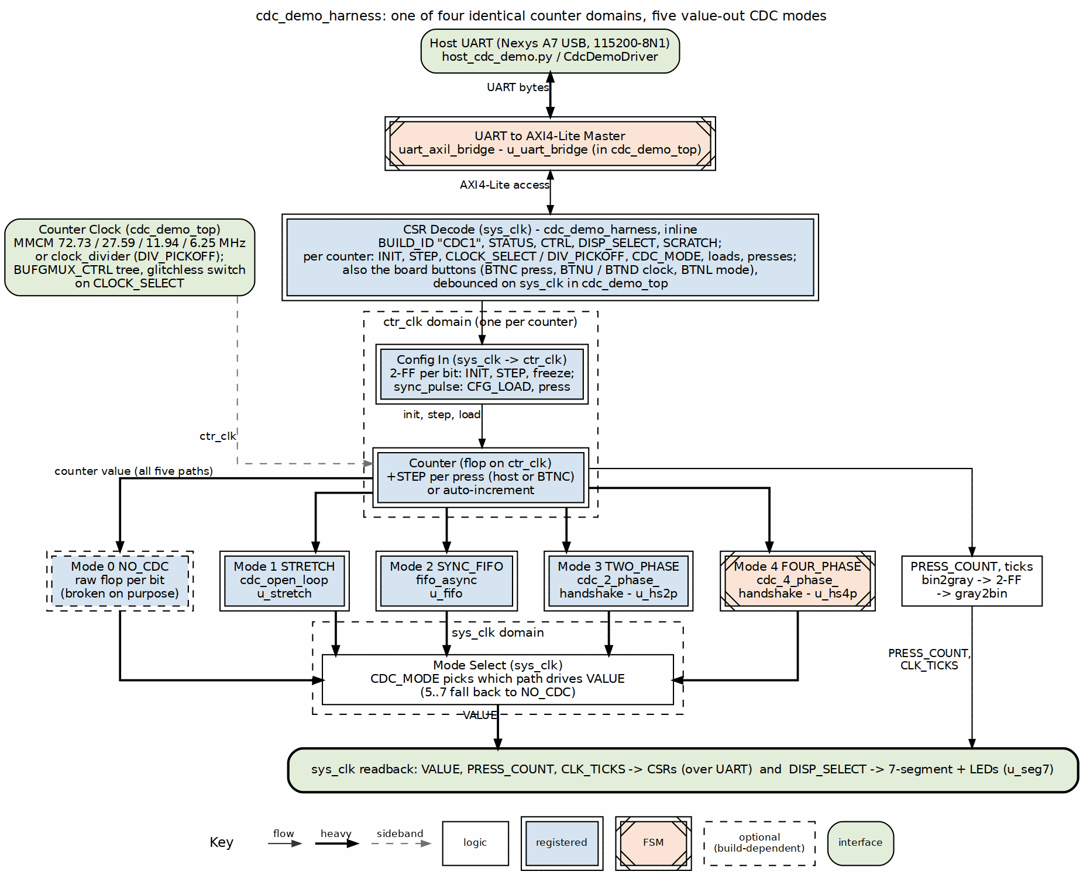
cdc_demo_harness: four identical counter domains, five CDC modes each
Source: 02_harness_blocks.dot

3.2 The front end is borrowed, deliberately
uart_axil_bridge is the same component the pumice DDR2 harness uses, and the host-side transport in projects/fpga-systems/bin/ is the same too. Nothing about the serial link is specific to CDC.
That reuse is the point: a project whose subject is clock domain crossing should not also be inventing a serial protocol. It also means the port-discovery and framing bugs are fixed once, for every board on the bench.

3.3 The global registers
cdc_demo_csr.rdl generates the CSR block. The global half is small:
Table 2.1: The global registers
Register | Fields | Purpose
BUILD_ID | 0x43434331 | ASCII CDC1. Proves which bitstream you are talking to
STATUS | alive0..3, uart_rx, uart_tx, any_written, reset_ok | liveness per counter, link activity, and whether anything has been configured since reset
CTRL | soft_reset, freeze, ignore_btn | pulse a reset, stop all counters, or lock out the physical buttons
DISPLAY | sel[1:0] | which counter’s value drives the 7-segment display
SCRATCH | 32 bits | read-write, host link sanity
Three of those exist because of specific failure modes at the bench:
- BUILD_ID – the cheapest wasted afternoon is measuring a stale bitstream. If CDC1 does not read back, stop.
- any_written – distinguishes “the demo is showing defaults” from “the demo is showing what I configured”. Without it, a host script that silently failed to write looks identical to one that worked.
- ignore_btn – a physical button press during a scripted sweep is an uncontrolled input. ignore_btn makes the experiment reproducible by taking the human out of it.
freeze is the other quiet one: it stops every counter at once so a displayed value can be read carefully rather than glimpsed.

3.4 The per-counter block, times four
Each of the four counters has an identical register block:
Table 2.2: One counter’s registers (four identical blocks)
Register | Fields | Purpose
CLK | clock_select[2:0], div_pickoff[12:8] | which clock this counter runs on; 0..3 select an MMCM output, 4 selects the divided clock, and div_pickoff then chooses the divisor tap
INIT | value[15:0] | the value CFG_LOAD will load
STEP | value[15:0] | how much a press advances the counter
CFG_LOAD | strobe | pulse: load INIT
HOST_PRESS | strobe | pulse: inject one virtual button press
VALUE | value[15:0] | the counter’s current value, crossed into sys_clk by the mode under test
PRESS_COUNT | value[15:0] | debounced press count, crossed Gray-coded
Two design decisions are worth drawing out.
STEP is not always 1. A counter advancing by 1 changes one or two bits per press, and a multi-bit crossing hazard needs many bits changing at once to show itself. A STEP that flips several bits at a time makes the failure far more likely per event, which is the difference between a demo that fails in seconds and one that fails in an hour.
HOST_PRESS exists so the stimulus is not a finger. A scripted press is repeatable, can be issued thousands of times, and can be issued faster than a human can press. The physical buttons remain for the walk-up demonstration.
Important: VALUE and PRESS_COUNT cross differently on purpose. VALUE crosses by whatever mode is selected – including the broken one – while PRESS_COUNT always crosses Gray-coded. During a failure the press count stays trustworthy while the value does not, and that contrast within one counter is what shows the reader the bug is in the crossing and not in the counting.

3.5 The clock tree
The clocks are the experiment’s independent variable, so they are generated deliberately rather than divided down casually:
Table 2.3: The five clock sources per counter
Index | Source | Frequency
0 | MMCM CLKOUT0, divide 11 | 72.73 MHz (fastest)
1 | MMCM CLKOUT1, divide 29 | 27.59 MHz
2 | MMCM CLKOUT2, divide 67 | 11.9 MHz
3 | MMCM CLKOUT3, divide 128 | 6.25 MHz (slowest MMCM output)
4 | clock_divider, DIV_PICKOFF 0..31 | host-selectable, the fine-grained sweep
The MMCM runs at a VCO of 800 MHz from the 100 MHz input with a feedback multiplier of 8.0 and DIVCLK_DIVIDE of 1. The four outputs are chosen to be mutually unrelated rather than neat multiples: a crossing between clocks with a simple integer relationship can pass by luck, and luck is exactly what this project is trying to remove.
Important: per counter, a tree of four BUFGMUX_CTRL instances selects the source, and that switching is glitchless by the primitive’s guarantee. This is what allows the host to change a counter’s clock while it is running, which the sweep in Chapter 4 depends on. A naive clock mux would produce a runt pulse on every change and the resulting corruption would be indistinguishable from the CDC failure being demonstrated – the apparatus would be generating the result.

3.6 The five crossings
The value-out path is the thing under test, and it is selectable:
Table 2.4: The five value-out crossings
Mode | Name | Implementation | Why it is here
0 | NO_CDC | a raw flop per bit; no Gray, no ASYNC_REG | broken on purpose – the demonstration
1 | STRETCH | cdc_open_loop: source holds data and valid long enough for the destination to sample | the cheapest correct answer when the source can be made to wait
2 | SYNC_FIFO | fifo_async, FIFO_DEPTH = 16 | the general answer: every event survives, in order
3 | TWO_PHASE | cdc_2_phase_handshake, toggle / NRZ | correct, and cheaper per transfer than 4-phase
4 | FOUR_PHASE | cdc_4_phase_handshake, classic return-to-zero | the conservative textbook crossing; the one build-phase1 uses
Modes 3 and 4 snapshot the counter every HANDSHAKE_INTERVAL = 256 counter-clock cycles. A handshake has a round-trip cost, so it cannot forward every increment; it forwards a consistent sample. That is the right trade for a displayed value and the wrong one for an event count – which is why the press count does not use it.
Note: modes 1 through 4 are all correct, and they are not interchangeable. Their differences are throughput, latency and whether every event or only the latest value survives. Selecting between four correct answers and seeing that they all display the same number is a quieter lesson than mode 0, and it is available in the same bitstream.

RTL Design Sherpa · Learning Hardware Design Through Practice GitHub · Documentation Index · MIT License

4 Two Builds, Two Designs

4.1 The short answer, and it is the opposite of the pumice system’s
Yes – the harness RTL is different per build here, completely. build-phase1 has no harness at all. It is one RTL file with no UART, no CSR block and no host interface. build-demo is three files plus a generated CSR block, and the dependency closures of the two builds overlap in three modules.
This is worth stating plainly because the other Nexys A7 project answers the same question the other way. The pumice DDR2 system has one harness source that every one of its five targets compiles; only the DUT, the PHY or the debug cores change. Both answers are right for their project, and the reason they differ is the reason this chapter exists.

4.1.1 Figure 3.1: Two builds, two designs
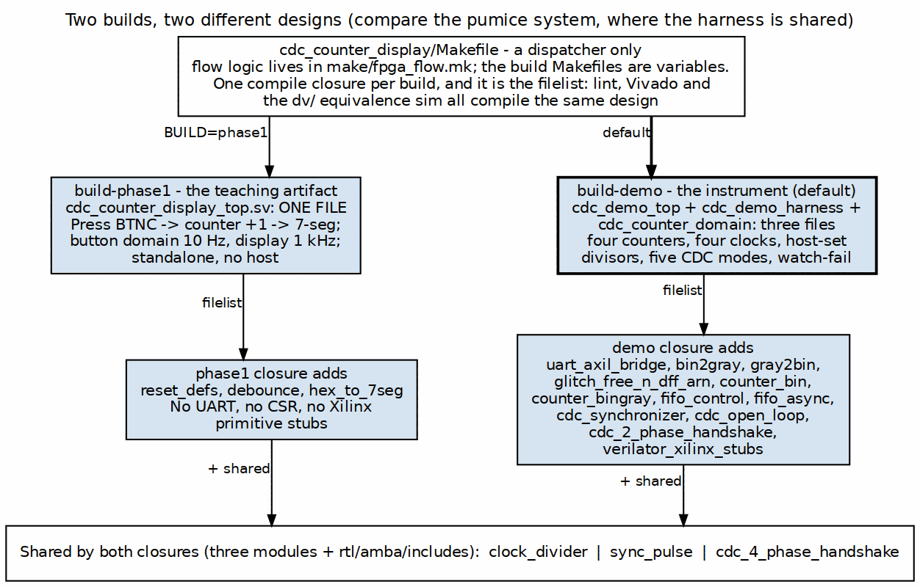
Two builds, two different designs
Source: 03_build_variants.dot

4.2 What each build actually compiles
Table 3.1: The two compile closures
 | build-phase1 | build-demo
Build RTL | cdc_counter_display_top.sv | cdc_demo_top.sv, cdc_demo_harness.sv, cdc_counter_domain.sv
Generated | none | cdc_demo_csr from cdc_demo_csr.rdl
Repo closure | reset_defs, clock_divider, debounce, hex_to_7seg, sync_pulse, cdc_4_phase_handshake | uart_axil_bridge, bin2gray, gray2bin, sync_pulse, glitch_free_n_dff_arn, counter_bin, counter_bingray, fifo_control, fifo_async, cdc_synchronizer, cdc_open_loop, cdc_2_phase_handshake, cdc_4_phase_handshake, clock_divider
Xilinx primitive stubs | none needed – the top instantiates none | IBUF, BUFG, BUFGMUX_CTRL, MMCME2_BASE
The shared part is three modules – clock_divider, sync_pulse and cdc_4_phase_handshake – plus the AMBA include directory. Everything else is disjoint. These are two designs that share a project directory, a board and a build flow, and nothing else.

4.3 Why that is the right structure here
The pumice system shares its harness because its builds are the same experiment on different subjects: swap pumice for LiteDRAM and the numbers must stay comparable, so the apparatus must not move. Sharing is what makes the comparison valid.
Here the two builds are different experiments:
- build-phase1 answers “can a beginner see a correct CDC work on real hardware, with nothing but a board and a USB cable for power?” Adding a UART harness to it would make it worse. The absence of a host is the feature: there is no configuration to get wrong and nothing between the button and the display.
- build-demo answers “can we make an unsafe CDC fail on demand, visibly, with a control group?” That needs four counters, host-settable clocks and selectable crossings, none of which phase 1 can express.
Forcing one harness onto both would compromise both: phase 1 would stop being a standalone artifact, and the demo would inherit constraints from a teaching example. Keeping them separate costs one extra top-level file and a dispatcher.
Note: this is why build-phase1 is kept rather than deleted as superseded. It is not an earlier version of build-demo; it is the simplest thing that demonstrates the concept, and that has its own value.

4.4 The dispatcher, and where the flow logic lives
cdc_counter_display/Makefile selects a build and does nothing else. Targets go to build-demo by default; BUILD=phase1 selects the other:
make bitstream # build-demo
make program # build-demo
make bitstream BUILD=phase1 # build-phase1
make program BUILD=phase1
All flow logic – synthesis, programming, lint, cleaning – lives in the repo-wide make/fpga_flow.mk. The per-build Makefiles set variables only.
That split is what keeps two builds from becoming two build systems. The same fpga_flow.mk drives the pumice builds on this board and the STREAM and RAPIDS builds on the Genesys 2, so a fix to the flow reaches every project at once.

4.5 One compile closure per build, and it is the filelist
Each build has exactly one filelist, and three different tools consume it:
- make lint flattens it;
- Vivado’s create_project.tcl expands it, dropping the verilator-only primitive stubs so synthesis sees the real unisims;
- the dv/ equivalence simulation -f includes it.
Important: that is deliberate and it is the whole defence against the classic FPGA failure of linting one design, simulating a second and synthesizing a third. Because all three read the same list, they cannot disagree about what the design is. Both build filelists carry that statement in their header comment, which is the right place for it – the next person tempted to add a source directly to the Vivado project reads why not.
The stub handling is the one subtlety. verilator_xilinx_stubs provides IBUF, BUFG, BUFGMUX_CTRL and MMCME2_BASE so that lint and simulation can elaborate the top. They are guarded by ifdef VERILATOR and dropped by the Vivado tcl – belt and braces, because a stub reaching synthesis would silently replace a real clock primitive.

RTL Design Sherpa · Learning Hardware Design Through Practice GitHub · Documentation Index · MIT License

5 Host Tools and Flow

5.1 The tools
Table 4.1: The host tools
Program | Role
host_cdc_demo.py | the CLI: watch-fail, sweeps, presses, per-counter configuration
cdc_demo.py | CdcDemoDriver – the register-level API the CLI drives
fpga-systems/bin/ | uart_link, uart_axi_bridge, board – the shared transport, identical to the pumice system’s
The headline invocation is one line:
make host-cdc_demo ARGS="watch-fail --counter 2"

5.2 The watch-fail flow

5.2.1 Figure 4.1: Breaking a CDC on purpose, and watching the display say so
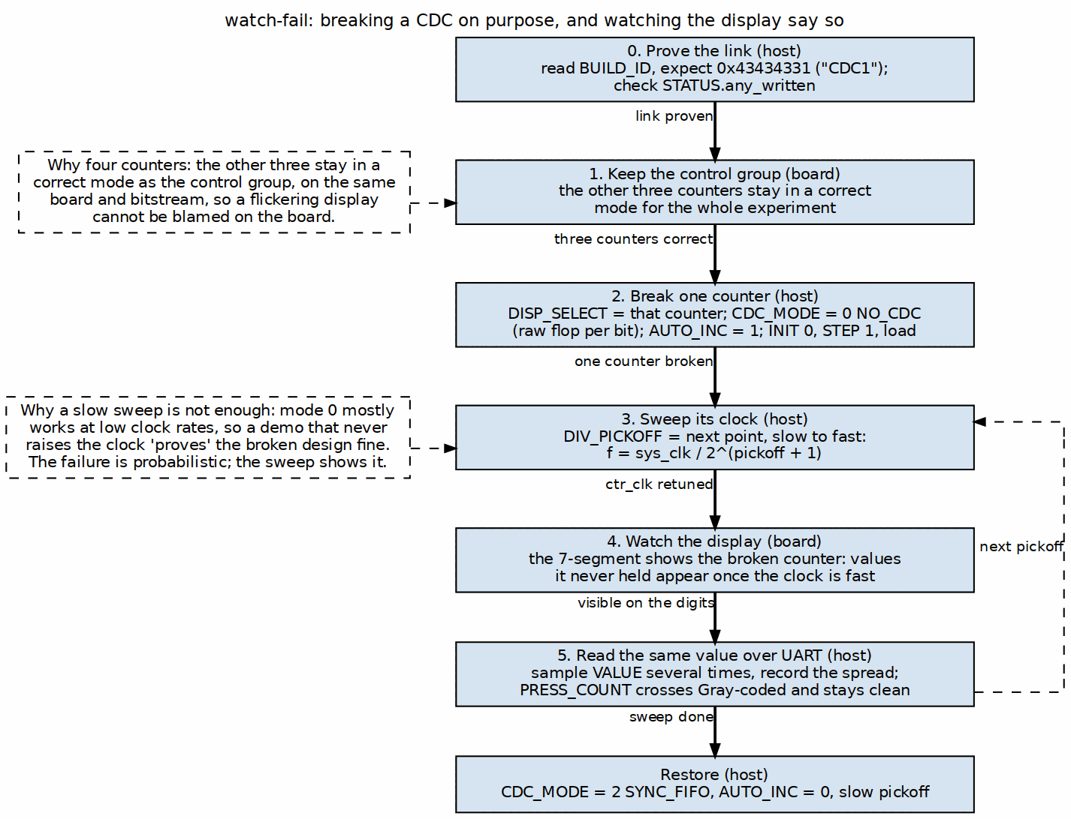
watch-fail: breaking a CDC on purpose, and watching the display say so
Source: 04_measurement_path.dot
The sequence is: prove the link, leave three counters correct, break one, sweep its clock, watch the display, and read the same value back over UART. Each step is there for a reason, and the reasons are the content of this chapter.

5.3 Step 0: prove the link before anything else
Read BUILD_ID and expect 0x43434331. A host that cannot read CDC1 back is talking to a different bitstream, and every subsequent observation is fiction. Then check any_written in STATUS: it distinguishes a demo showing configured values from one showing power-on defaults, which look identical on the display.

5.4 Step 1: the control group is not optional
Three counters stay in a correct mode for the whole experiment. This is the step most likely to be skipped and the one that makes the result mean anything.
Without it, “the display is flickering” has many explanations: a marginal board, a bad USB cable, a power supply, a timing failure somewhere else entirely, or the CDC bug being demonstrated. With three correct counters running in the same bitstream, on the same die, at the same temperature, at the same instant, all of those explanations are eliminated at once. Three clean digit groups beside one scrambled group is evidence; one scrambled group alone is an anecdote.

5.5 Step 2: break exactly one thing
Set the chosen counter’s value-out path to mode 0, NO_CDC: a raw flop per bit, no Gray coding, no ASYNC_REG attribute. Nothing else changes.
It is worth being precise about what is wrong with it. The flops will mostly settle; the problem is that the counter’s bits do not all change at the same instant, and a destination clock that samples during the transition captures a mixture of old and new bits. The result is a value the counter never held. With no Gray coding, a single increment can change many bits, so the window for a corrupt sample is wide.

5.6 Step 3: the sweep is what makes the failure appear
This is the step that distinguishes a working demonstration from a misleading one.
Important: mode 0 is a real design that mostly works. At 6.25 MHz against a system clock, the raw flops usually have time to settle and the value reads back correctly. A demonstration that sets mode 0 and stops has just shown the audience that the unsafe design is fine – the most damaging possible outcome for a teaching tool.
So the host sweeps that counter’s clock from slow to fast through clock_select and div_pickoff, while the other three hold. The failure is probabilistic in the ratio of the two clock rates and in how many bits changed, so the sweep walks the probability up until the failure is continuous and obvious. This is also why the clock mux has to be glitchless: if changing the clock itself produced a runt pulse, the sweep would generate corruption indistinguishable from the corruption being studied.

5.7 Steps 4 and 5: two views of the same failure
The display shows the broken counter’s value – DISPLAY.sel points the 7-segment at it – and at the fast end of the sweep the digits show values the counter never held.
Reading the same counter over UART adds the part that identifies the bug rather than just exhibiting it. VALUE crosses by the selected (broken) mode; PRESS_COUNT always crosses Gray-coded. During the failure the press count remains correct while the value does not. The counter is therefore counting correctly and the crossing is losing information – which is the conclusion the demonstration exists to support, and it is visible in two registers of the same block.
CTRL.freeze is useful here: stopping every counter lets a corrupt value be read carefully instead of glimpsed, and confirms that the corrupt value was sampled rather than merely displayed too briefly to read.

5.8 Reproducibility
Two features exist only to make a scripted run repeatable:
- ignore_btn locks out the physical buttons, so a bystander pressing BTNC cannot perturb a sweep.
- HOST_PRESS replaces the finger: presses become register writes, issued as fast and as often as needed, identically every run.
Note: the same discipline that applies to the DDR2 system applies here. A simulation run against a stale build directory reports success for the previous design; make clean-all before a run whose result you intend to believe. The dv/ equivalence simulation shares the build’s filelist for exactly this reason – so what you simulated is what you will program.

