
RTL Design Sherpa
FPGA Systems Host Layer Specification 1.0
September 30, 2026

Table of Contents
1 Fpga Systems Mas Index 10
2 Overview 11
2.1 What this book covers 12
2.2 What this book does not cover 13
2.3 The one property worth protecting 14
3 Layering 15
3.0.1 Figure 1.1: Layering of the host-side stack 15
3.1 Entry point 16
3.2 Area layer 17
3.3 Shared layer 18
3.4 Transport and silicon 19
3.5 The direction rule 20
4 Acronyms and terminology 21
4.1 Terms used precisely in this book 22
5 References 23
5.1 In this repository 23
5.2 Tracker 24
5.3 External 25
5.4 A note on register documentation 26
6 Port discovery 27
6.0.1 Figure 2.1: The UART flow, host to silicon 27
6.1 The problem 28
6.2 What identifies a board 29
6.3 Matching is prefix-tolerant in both directions 30
6.4 The Genesys 2 exception 31
6.5 Listing what is attached 32
7 Probes 33
7.1 register_probe – read-only 34
7.2 scratch_probe – round-trips a scratch register 35
7.3 The resolution order 36
8 The link and the bridge 37
8.1 UartLink 38
8.2 UARTAxiBridge 39
8.3 The injection point 40
8.4 Resolving the bridge’s location 41
9 The wire protocol 42
9.1 Write 43
9.2 Read 44
9.3 Defaults 45
9.4 A read of None is ambiguous, and that is worth knowing 46
9.5 Addressing 47
10 Sim and silicon equivalence 48
10.1 The mechanism 49
10.2 What differs, and what must not 50
10.3 The constraint that follows 51
10.4 The anti-pattern 52
11 The sequence model 53
11.1 Two rules, enforced rather than recommended 54
11.1.1 1. A sequence never opens its own port 54
11.1.2 2. Names are declared and resolved up front 54
11.2 Anatomy 55
11.3 The decorator form 56
11.4 A real example 57
12 Context and results 58
12.1 What a sequence is given 59
12.2 What it is deliberately NOT given 60
12.3 Helpers 61
12.4 Passing data between steps 62
13 The runner 63
13.0.1 Figure 3.1: Resolve, then run 63
13.1 Registration 64
13.2 Resolution happens before any traffic 65
13.3 Execution 66
13.3.1 stop_on_fail defaults to True, and that default is load-bearing 66
13.4 The report 67
13.5 Introspection 68
14 Writing a sequence 69
14.1 The skeleton 69
14.2 The file goes in the area’s bin/ 70
14.3 Checklist 71
14.4 What does NOT belong in a sequence 72
15 The board registry 73
15.1 BoardSpec 74
15.2 The two boards in this lab 75
15.3 Using it 76
15.4 The CLI 77
16 Programming 78
16.0.1 Figure 4.1: The program path 78
16.1 Order of checks 79
16.2 The environment handed to Tcl 80
16.3 From a Makefile 81
17 Locking and identity 82
17.1 The lock 83
17.2 Why a lock is not sufficient 84
17.3 The identity readback 85
17.4 The record 86
17.5 Status 87
18 Naming, and why the prefixes are load-bearing 88
18.0.1 Figure 5.1: Where each kind of file lives 88
18.1 The table, and the two things that read it 89
18.2 The prefix marks the file, not the directory 90
18.3 Measured status, 2026-09-30 91
19 Resolving paths 92
19.1 What happened 93
19.2 The pattern 94
19.3 Using it 95
19.4 Why an entry point still needs it 96
19.5 The corollary for generators 97
19.6 One name, one thing 98
20 Standing up a new flow 99
20.1 1. Register the board, if it is new 100
20.2 2. Confirm the board is visible before writing any code 101
20.3 3. Create the directory skeleton 102
20.4 4. Add the area’s environment module 103
20.5 5. Give the harness an identity register 104
20.6 6. Write the init sequence first 105
20.7 7. Write the entry point 106
20.8 8. Make it run in simulation 107
20.9 9. Lock the board paths 108
20.10 10. Record what you programmed 109
20.11 Checklist 110

List of Figures
Figure 1.1: Layering of the host-side stack 15
Figure 2.1: The UART flow, host to silicon 27
Figure 3.1: Resolve, then run 63
Figure 4.1: The program path 78
Figure 5.1: Where each kind of file lives 88

List of Tables
No tables in this document.

List of Waveforms
No waveforms in this document.

1 Fpga Systems Mas Index
Generated: 2026-10-20

2 Overview
projects/fpga-systems/bin/ is the shared host-side layer that every board flow in this repository imports by bare module name. It answers four questions that every flow used to answer for itself:
- Which serial port is my board on?
- How do I read and write its registers?
- What order do my test steps run in, and what did the previous one produce?
- Which FPGA am I about to program, and is anyone else using it?
Before this layer existed, each flow grew its own answer. Four near-identical autodetect_port() functions globbed /dev/ttyUSB*; seven copies of program_fpga.tcl each hardcoded a JTAG serial and invented their own environment variable to override it. Those copies did not drift because anyone was careless – they drifted because nothing made them one thing.

2.1 What this book covers
The shared layer, the conventions that govern code built on it, and the path from a host program down to a register write landing on silicon.
Chapter | Subject
2 | The UART flow: port discovery, probes, the link, the wire protocol
3 | Sequences: the model, the context, the runner
4 | Boards: the registry, programming, locking, identity
5 | Naming and layout conventions, and how paths are resolved
6 | Standing up a new flow

2.2 What this book does not cover
- Method. How to run a regression, how to write a testbench, how to debug a board. That lives in vault/handbook/, which is the repository’s memory. Where this book touches a method note it links to it rather than restating it; a second copy is how documentation rots.
- The RTL on the other side of the UART. The FPGA-side bridge that turns the ASCII protocol into AXI4-Lite transactions is specified with the RTL.
- Per-area flows. What pumice’s seq_char measures, or what the stream monitor campaign proves, belongs to those areas.

2.3 The one property worth protecting
Everything in this layer is arranged so that the same host code runs against the FPGA and against a simulation. The byte stream is identical; only the object carrying the bytes differs.
That is not an elegance argument. A harness whose sim path and silicon path are different code has two chances to be wrong and no way to tell which one is. When a board result and a sim result disagree here, the disagreement is about the design, because nothing else differs.
Chapter 2 explains the mechanism (an injected byte channel), and Chapter 3 explains the rule that keeps it true (a sequence never opens its own port).

3 Layering

3.0.1 Figure 1.1: Layering of the host-side stack
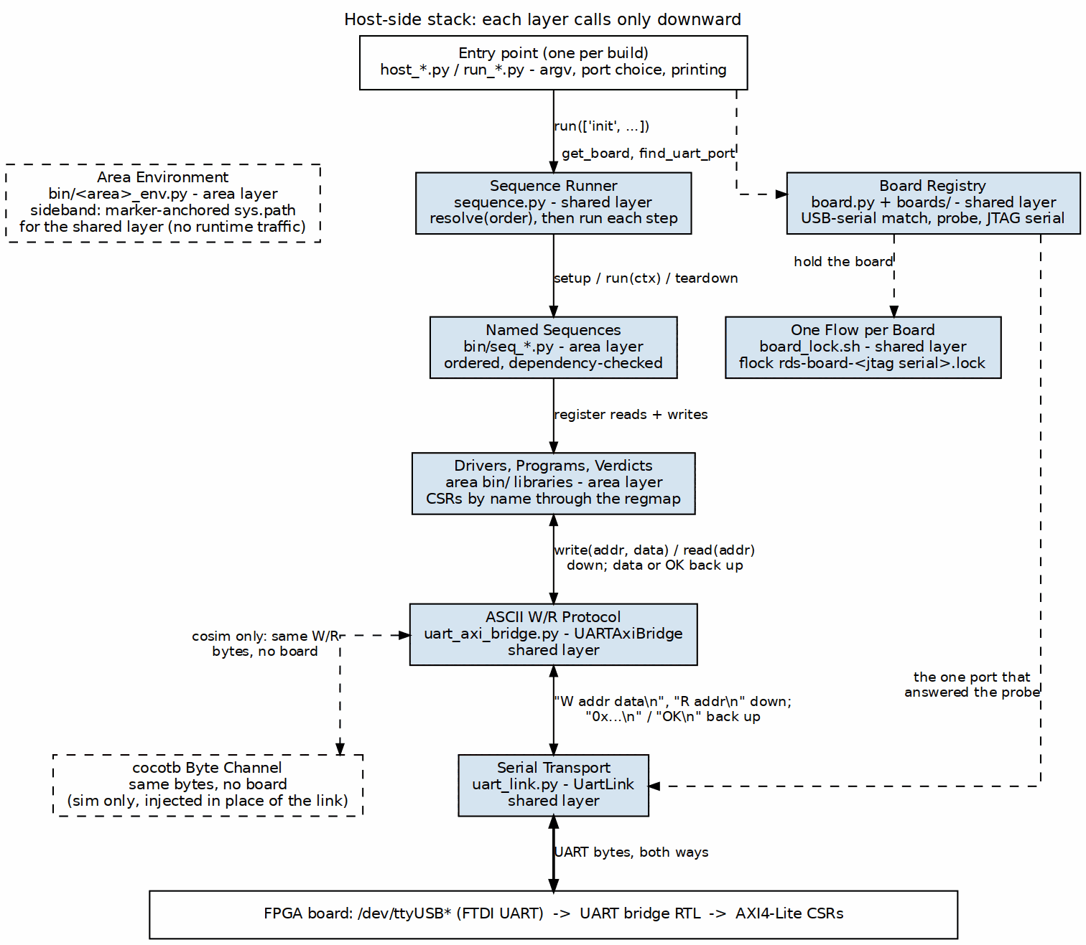
Layering of the host-side stack
Four layers, each of which may only reach downward.

3.1 Entry point
One per build: a host_*.py or run_*.py that parses argv, decides which port and which board, constructs the transport once, and prints results. It is the only layer that knows a command line exists.
Entry points are deliberately thin. The work belongs in a sequence or a library, because those are reusable and an entry point is not.

3.2 Area layer
Owned by a unit (pumice, rapids, stream, reed-solomon, cdc). It holds:
- Sequences (seq_*.py) – named, ordered, dependency-checked steps.
- Libraries – drivers, program builders, verdict functions.
- An environment module (<area>_env.py) – the one place the area records where the shared layers are, described in Chapter 5.

3.3 Shared layer
projects/fpga-systems/bin/, specified by this book:
Module | Responsibility
uart_link.py | Port enumeration, USB-serial matching, the probe loop, UartLink
uart_axi_bridge.py | The ASCII W/R protocol over any byte pipe
sequence.py | Sequence, SequenceContext, SequenceRunner
board.py, boards/ | The board registry, programming, identity readback
board_lock.sh | One flow per physical board
program_fpga.tcl, jtag_readback.tcl | The two Vivado entry points
It depends on nothing above it, which is what lets a unit be added without touching it.

3.4 Transport and silicon
A /dev/ttyUSB* character device on an FTDI part, and the FPGA behind it. The dashed edge in the diagram is the substitution that matters: UARTAxiBridge accepts an injected channel, so a cocotb simulation can receive the identical byte stream with no board present.

3.5 The direction rule
A layer may call downward and must not call upward. The one that gets violated in practice is a sequence reaching for a port – which is why the runner enforces it rather than merely recommending it (Chapter 3).

4 Acronyms and terminology
Term | Meaning
AXI4-Lite | The simple AMBA bus the FPGA-side bridge drives. One 32-bit transfer per transaction, no bursts.
BFM | Bus Functional Model. A simulation driver standing in for real traffic.
Byte channel | Any object with write, read_until, reset_input_buffer, reset_output_buffer, close, is_open. A UartLink is one; so is a cocotb channel.
CSR | Control and Status Register.
Entry point | A host_*.py or run_*.py: the file a person or Makefile invokes.
FT2232, FT232R | FTDI USB parts. The FT2232 carries two interfaces (JTAG and UART on one chip); the FT232R carries one.
hw_server | Xilinx’s JTAG daemon. Vivado talks to the cable through it.
IDCODE | The JTAG identification register of a device on the chain.
JTAG serial | The USB serial number Vivado uses to pin a hw_target.
Probe | A predicate handed an open link that answers “is this the board I want?”.
Sequence | A named, dependency-declaring unit of work (Chapter 3).
SequenceContext | What a sequence is given: a bus, a board, parameters, earlier results.
USB serial | The serial number the USB descriptor reports. On a Nexys A7 this is also the JTAG serial.

4.1 Terms used precisely in this book
Port always means a character device path (/dev/ttyUSB3), never an RTL port. The RTL sense does not appear in this book.
Board means a Board object from the registry – the software handle – unless the text says “physical board”.
Sequence means a Sequence subclass, not “a sequence of bytes”. Where the byte sense is meant the text says “byte stream”.
Entry point and host program are the same thing. The convention names it by prefix: a file named host_* is an entry point. The directory it sits in is not what makes it one (Chapter 5).

5 References

5.1 In this repository
Path | What it is
projects/fpga-systems/bin/ | The layer this book specifies
vault/handbook/fpga/cmn-infra/uart-harness.md | Method: one host program for sim and silicon
vault/handbook/fpga/cmn-infra/boards.md | Method: board mechanics and gotchas
vault/handbook/fpga/cmn-infra/host-stack.md | Method: the shared py transport stack
vault/handbook/fpga/cmn-infra/sequences.md | Method: campaign structure
vault/handbook/fpga/cmn-infra/flow-layout.md | Authority for the directory skeleton and filename conventions
vault/handbook/fpga/cmn-infra/flow-migration.md | Method: migrating a pre-migration flows-* flow
vault/handbook/fpga/cmn-infra/area-structure.md | Method: where an FPGA project lives
make/fpga_flow.mk | The make targets discovered from the filename prefixes
vault/handbook/dv/registers-by-name.md | Method: never address a register by offset
vault/handbook/dv/running-regressions.md | Method: clean builds, and why a fast pass is fiction
bin/DOC_GENERATION.md | How this book becomes a PDF
bin/TBClasses/harness/ | The simulation-side transport spine the bridge plugs into
The handbook is the authority on method. This book is the authority on the layer. Where they meet, the handbook wins and this book links to it.

5.2 Tracker
Item | Subject
tooling TASK-022 | The board lock, the identity readback, and the identity record
tooling TASK-024 | This book

5.3 External
- Xilinx UG908, Vivado Design Suite User Guide: Programming and Debugging – hw_server, hw_target, and the JTAG object model the Tcl scripts use.
- FTDI device datasheets (FT2232H, FT232R) – the USB descriptor fields that carry the serial numbers port matching depends on.
- Digilent board reference manuals (Nexys A7-100T, Genesys 2) – which FTDI part is fitted and how its interfaces are wired.

5.4 A note on register documentation
This book does not list any area’s registers. Registers are addressed by name through a generated register map, never by a literal offset, so a register table copied into this book would be a second source that nothing keeps in step. The generated map for an area is the authority; see vault/handbook/dv/registers-by-name.md for why this is a rule rather than a preference.

6 Port discovery

6.0.1 Figure 2.1: The UART flow, host to silicon
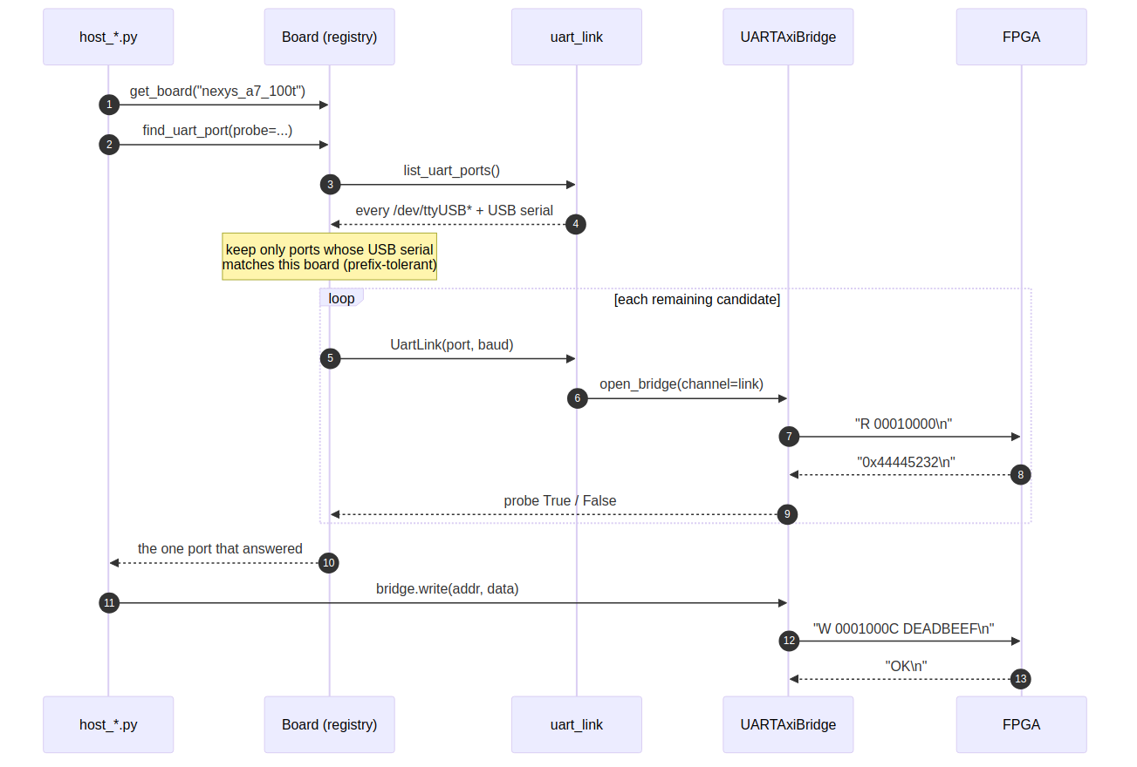
The UART flow, host to silicon

6.1 The problem
A USB-UART re-enumerates. Unplug a cable, reboot the host, or power-cycle a board and /dev/ttyUSB3 becomes /dev/ttyUSB5. Two boards on one desk makes it worse: the index that worked yesterday now addresses the other board, and a harness that writes to it will be perfectly happy about it.
So a port is never hardcoded, and never merely guessed at by index. It is resolved, every run, by asking which device answers.

6.2 What identifies a board
list_uart_ports() enumerates candidates from serial.tools.list_ports, falling back to a bare glob of /dev/ttyUSB* when pyserial is absent. The fallback matters for board-less callers and minimal environments; the preferred path matters because only pyserial carries the field that identifies the board:
@dataclass(frozen=True)
class UartPort:
device: str # /dev/ttyUSB3
usb_serial: Optional[str] = None # the field that says WHICH BOARD
vid: Optional[int] = None
pid: Optional[int] = None
description: Optional[str] = None
manufacturer: Optional[str] = None
location: Optional[str] = None
On a Digilent board with an FT2232, the USB-UART and the JTAG interface are on the same part, so the USB serial number and the Vivado JTAG target serial are the same string. That coincidence is what lets Board.find_uart_ports() return only the ports belonging to the board you are about to program.

6.3 Matching is prefix-tolerant in both directions
def matches_serial(self, serial): ...
An FT2232 exposes one EEPROM serial across its interfaces, and the tooling on either side may or may not append the interface letter – ...D46F against ...D46FB. Both strings are normalised (upper-cased, punctuation stripped) and then compared with startswith in both directions.
An exact-match test here silently finds nothing on some hosts. That failure presents as “board not attached” while the board sits plugged in on the desk, which is precisely the hour this tolerance exists to save.

6.4 The Genesys 2 exception
The Genesys 2 does not share one FTDI part. Its UART is a separate FT232R, so matching UART ports against the JTAG serial finds nothing – the same symptom as above, from a different cause. The registry records the FT232R’s own serial in uart_serial, and BoardSpec.uart_usb_serial returns it in preference to the JTAG serial:
@property
def uart_usb_serial(self):
return self.uart_serial or self.jtag_serial
Both cables must be plugged in for a UART to exist at all, whatever the bitstream does. See Chapter 4 for the registry, and the [[boards]] handbook note for the full gotcha list.

6.5 Listing what is attached
python3 projects/fpga-systems/bin/uart_link.py
python3 projects/fpga-systems/bin/uart_link.py --all # not just ttyUSB*
prints each device with its USB serial and description. This is the first thing to run when a flow says it cannot find its board.

7 Probes
Narrowing by USB serial says which ports belong to a board. It does not say which of them is the one the harness is listening on, nor whether the board is running the bitstream you think it is. A probe answers that.
Probe = Callable[[UartLink], bool]
A probe is handed an open link and returns True or False. It must not raise on a wrong-but-healthy board – returning False is enough, because the loop is going to try the next candidate either way.
The probe stays a caller concern because each harness identifies itself differently. Two shapes occur in this repository, and both ship.

7.1 register_probe – read-only
register_probe(addr=0x1_0000, magic=0x44445232)
Reads one register and compares it to an identity constant. Used by the rapids (CSR_ID), cdc (BUILD_ID) and pumice (BUILD_ID) harnesses.
Read-only, so it is safe to aim at a board running someone else’s bitstream. Prefer this shape when you have the choice.

7.2 scratch_probe – round-trips a scratch register
scratch_probe(addr=0x1_0004, magic=0xC0FFEE5A)
For harnesses whose identity register is a plain scratchpad rather than a build-ID constant. Used by the stream characterization harness.
This one WRITES, and that makes it dangerous in a way the other is not. Every harness in this lab speaks the same ASCII protocol, so a write lands wherever addr points in that board’s map. It does not bounce off a board that is not yours.
Two mitigations are built in, and neither removes the need to narrow candidates first:
- The original value is read before the write and restored on a mismatch, so a probe that hits someone else’s board does not abandon a magic number in one of its registers.
- On a match the scratch is zeroed, which is its resting state.
Narrow the candidate set before probing – Board.find_uart_port(probe=...) filters by USB serial first – rather than scanning every ttyUSB on the host.

7.3 The resolution order
find_port(probe=None, want=None, candidates=None, baudrate=..., timeout=0.4,
label="harness", pattern="/dev/ttyUSB*", verbose=True) -> str
- An explicit want (the caller’s --port) is tried first but still probed. A stale path in a script therefore fails loudly instead of quietly driving the wrong board. The string "auto" means “no preference”.
- Then every remaining candidate, in order.
- The first that answers wins.
A probe of None means “take the first port that opens”, which is only sensible when exactly one board is attached.
When nothing answers, find_port raises SystemExit carrying the candidate list and the question worth asking:
[autodetect] no <label> responded on any of: ['/dev/ttyUSB0', '/dev/ttyUSB3'].
Is the board powered and programmed with the right bitstream?
SystemExit rather than an exception because every caller of this is a CLI, and a traceback helps nobody.

8 The link and the bridge
Two objects sit between a host program and a register: UartLink carries bytes, UARTAxiBridge turns register operations into bytes. They are separate so that the second can be driven by something other than the first.

8.1 UartLink
A pyserial client that is also a byte channel: it satisfies the same protocol as the simulation-side SerialChannel in bin/TBClasses/harness/.
Method | Purpose
write(data) -> int | Send bytes
read_until(expected=b"\n", size=None) -> bytes | Read to a delimiter
reset_input_buffer() | Discard buffered input
reset_output_buffer() | Discard buffered output
close() | Close the port
is_open | Property
Construction opens the port, sleeps a short settle interval, and flushes both buffers – a USB-UART that has just been opened will otherwise hand you fragments of whatever was in flight before.
with UartLink("/dev/ttyUSB3", baudrate=115200) as link:
bridge = link.bridge()
bridge.write(0x1_0000, 0xDEADBEEF)
UartLink is a context manager, and bridge() is a convenience for open_bridge(channel=self).
pyserial is imported lazily, inside __init__ rather than at module scope, so a machine without it can still import uart_link for port enumeration and for the unit tests. The sim path never touches a real port.

8.2 UARTAxiBridge
Turns 32-bit register reads and writes into the ASCII protocol of the next chapter.
Method | Returns
write(addr, data) | True when the board answered OK
read(addr) | The 32-bit value, or None on a malformed reply
write_verify(addr, data) | True when a readback matches
dump_memory(start, num_words=16) | List of (addr, data)
fill_memory(start, values) | Writes a list of words
addr and data accept an int or a hex string ("0x44A00000").

8.3 The injection point
def __init__(self, port='/dev/ttyUSB1', baudrate=115200, timeout=1.0,
channel=None):
if channel is not None:
self.ser = channel
return
import serial
...
When channel is given, no serial port is opened and port, baudrate and timeout are ignored. Anything satisfying the byte-channel protocol works: a UartLink, a cocotb driver, or a tracing wrapper that records the wire for later comparison.
This single branch is what makes the sim and silicon paths one piece of code. It is the subject of 05_sim_equivalence.md.

8.4 Resolving the bridge’s location
open_bridge(port=None, baudrate=..., timeout=..., channel=None)
uart_axi_bridge is a sibling module in the same directory, and open_bridge inserts that directory on sys.path before importing it. The bridge used to live beside the converter RTL it talks to, and every host tool re-derived that location by hand – through $REPO_ROOT, or a parent walk whose depth broke the moment the layer moved. There is no path derivation left to get wrong here; see Chapter 5 for the general rule.

9 The wire protocol
Line-oriented ASCII, one request per line, one reply per line. Deliberately trivial: it is readable in a terminal, it costs the FPGA almost nothing to parse, and a human debugging a dead board can type it by hand into screen.

9.1 Write
host -> board : "W <addr:08X> <data:08X>\n"
board -> host : "OK\n"
cmd = f"W {addr:08X} {data:08X}\n"
self.ser.write(cmd.encode('ascii'))
response = self.ser.read_until(b'\n', size=10)
return response.strip() == b'OK'
write returns a bool. Anything that is not exactly OK is False, including a timeout, which arrives as an empty read.

9.2 Read
host -> board : "R <addr:08X>\n"
board -> host : "0x<value:X>\n"
cmd = f"R {addr:08X}\n"
self.ser.write(cmd.encode('ascii'))
response = self.ser.read_until(b'\n', size=20).strip()
if response.startswith(b'0x'):
return int(response[2:], 16)
return None # malformed or absent
Both fields are fixed-width uppercase hex with no 0x prefix on the request; the reply to a read does carry 0x. That asymmetry is in the protocol as implemented and is what the parser keys on.

9.3 Defaults
Parameter | Value
Baud | 115200 (DEFAULT_BAUD)
Data bits | 8
Parity | none
Stop bits | 1
Flow control | none
Read timeout | 1.0 s default, 0.4 s while probing
The baud must match the FPGA’s configuration. In simulation it does not: see the next chapter.

9.4 A read of None is ambiguous, and that is worth knowing
read() returns None both for “the board sent something I could not parse” and for “the board sent nothing”. Callers that need to distinguish a dead board from a bad address must do so at a higher level – typically by probing a known-good identity register first, which is exactly what the probes in 02_probes.md are for.
Both failure shapes print the offending response, so the distinction is visible in a log even though it is not in the return value.

9.5 Addressing
Addresses are 32-bit and byte-addressed; a 32-bit register at word index n sits at base + 4*n. Host code should not compute these by hand: use the generated register map for the area and address registers by name. See vault/handbook/dv/registers-by-name.md for why offsets written into host code are a recurring source of silent breakage after an RDL change.

10 Sim and silicon equivalence
The property this layer is arranged to protect: the same host code runs against the FPGA and against a simulation, and the bytes on the wire are identical.

10.1 The mechanism
One branch, in UARTAxiBridge.__init__:
if channel is not None:
self.ser = channel
return
import serial
self.ser = serial.Serial(port, baudrate, timeout=timeout)
On silicon the channel is a UartLink wrapping a /dev/ttyUSB*. In simulation it is a cocotb UART driver attached to the DUT’s RX and TX pins. The protocol code above that branch does not know which it has, because nothing above the branch can tell.
Three channel implementations are in use:
Channel | Where
UartLink | Silicon, over pyserial
cocotb UART channel | Simulation, driving the DUT pins
TracingChannel | Either, wrapping another channel and recording the wire
TracingChannel is what turns “should be identical” into something checkable: run the same host program both ways, compare the recorded byte streams.

10.2 What differs, and what must not
Differs | Must not differ
Baud divider (CLKS_PER_BIT) | The byte stream
Wall-clock duration | The register addresses touched
Presence of a board | The order of operations
ctx.board (a Board, or None) | The host code path
The baud divider is the interesting one. rs_loop_top.sv derives the board value from the system clock:
localparam int UART_CLKS_PER_BIT = (CFG_SYS_CLK_HZ + CFG_UART_BAUD / 2) / CFG_UART_BAUD;
which at 100 MHz and 115200 baud is about 868 clocks per bit. The simulation testbench sets CLKS_PER_BIT = 4. Same bytes, two orders of magnitude less simulated time.

10.3 The constraint that follows
A sim-harness test is bounded in simulated time – in this tree, 100 ms. UART traffic at a realistic divider blows that budget immediately, which creates a standing temptation: shorten the campaign so it fits.
That is the wrong lever. Shrinking the campaign changes what is under test, and the shortened version is no longer the thing that runs on the board. Raising the sim baud changes only how fast the identical byte stream is carried.
The reed-solomon harness states this at the point of temptation, in the test that would otherwise be shortened:
CLKS_PER_BIT = 4
# ... if the campaign does not fit, the lever is the sim baud
# (CLKS_PER_BIT above), not the parameters and not the campaign.

10.4 The anti-pattern
A testbench that builds its own private bridge – speaking the protocol directly to the DUT rather than running the host program – is not an equivalence test. It is a second implementation, and it will agree with the first right up until it matters.
The handbook note [[uart-harness]] documents this failure and the flows it has been found in. The rule in Chapter 3 (a sequence never opens its own port) is what keeps the host side substitutable in the first place.

11 The sequence model
A campaign is an init sequence followed by one or more test sequences. sequence.py provides the container; an area provides the sequences.
runner = SequenceRunner(ctx)
runner.discover("projects/fpga-systems/NexysA7/mem-ctrl-ip-ddr2/bin")
report = runner.run(["init", "write_read"])

11.1 Two rules, enforced rather than recommended
Both of the failure modes these prevent are silent, which is why they are checked in code rather than written in a style guide.

11.1.1 1. A sequence never opens its own port
A sequence is handed a SequenceContext carrying an already-built bus. It does not take a --port, does not call find_port, and does not construct a bridge.
That is what makes the identical sequence run against the FPGA and against a cocotb simulation – only the injected bus differs. A sequence that resolved its own transport would break the equivalence of Chapter 2, which is the one property the whole stack exists to preserve.

11.1.2 2. Names are declared and resolved up front
Every sequence declares a name. The runner resolves the entire requested order, plus every requires, before any traffic reaches the board.
A misspelled name therefore raises immediately instead of skipping a step. This matters more than it sounds: a skipped init looks exactly like a DDR2 timing bug, and costs the same hour to chase.

11.2 Anatomy
class Sequence:
name: str = ""
description: str = ""
requires: Seq[str] = ()
def run(self, ctx) -> Any: ...
def setup(self, ctx) -> None: ... # optional, default no-op
def teardown(self, ctx) -> None: ... # optional, default no-op
The return value of run is stored in ctx.results[name], which is how a later sequence consumes an earlier one’s output without either knowing the other’s internals.
Returning False explicitly marks the step failed. Any other value – including None – is a pass.

11.3 The decorator form
For steps needing no setup or teardown:
@sequence("write_read", requires=("init",))
def write_read(ctx):
"""One-line description, taken from this docstring."""
...
This builds the same Sequence subclass. The description defaults to the first line of the docstring.

11.4 A real example
class Smoke(Sequence):
name = "smoke"
requires = ("init",)
description = "bypass, clean, e = t, e = t + 1"
def run(self, ctx):
drv = ctx.bus
t = ctx.result("init").profile["t"]
blocks = ctx.param("blocks", 16)
...
Note what it touches: ctx.bus for the device, ctx.result("init") for the previous step’s output, ctx.param for a run-level knob. No port, no baud rate, no board.

12 Context and results
@dataclass
class SequenceContext:
bus: Any = None
board: Any = None
params: Dict[str, Any] = field(default_factory=dict)
results: Dict[str, Any] = field(default_factory=dict)
log: Optional[Callable[[str], None]] = None

12.1 What a sequence is given
Field | What it carries
bus | The by-name register interface – a DeviceBus, a Device, or an area driver. Sequences address registers by name only.
board | The Board this is running against, or None in simulation.
params | Run-level knobs from the entry point’s command line.
results | What earlier sequences returned, keyed by sequence name.
log | Where ctx.say() writes; defaults to print.

12.2 What it is deliberately NOT given
No port. No baud rate. No bitstream path. Transport is already resolved by the time a sequence runs, by the entry point that built the context.
board being None in simulation is the tell that a sequence must not depend on it for anything load-bearing. A sequence that needs the board object to work cannot run in sim, and has given up the property of Chapter 2.

12.3 Helpers
ctx.say("message") # to ctx.log, or print
ctx.param("blocks", 16) # with a default
ctx.result("init") # RAISES if init has not run
ctx.result raising rather than returning None is deliberate. Asking for another sequence’s result is asserting a dependency; if that dependency did not run, silence would let the sequence proceed on a default and report a number that means nothing. The fix is one word in requires.

12.4 Passing data between steps
class Init(Sequence):
name = "init"
def run(self, ctx):
return {"levelled": True, "taps": taps}
class Measure(Sequence):
name = "measure"
requires = ("init",)
def run(self, ctx):
taps = ctx.result("init")["taps"]
Neither sequence imports the other. The contract is the dictionary and the declared requires, which is what lets an area reorder or replace a step without editing its neighbours.

13 The runner

13.0.1 Figure 3.1: Resolve, then run
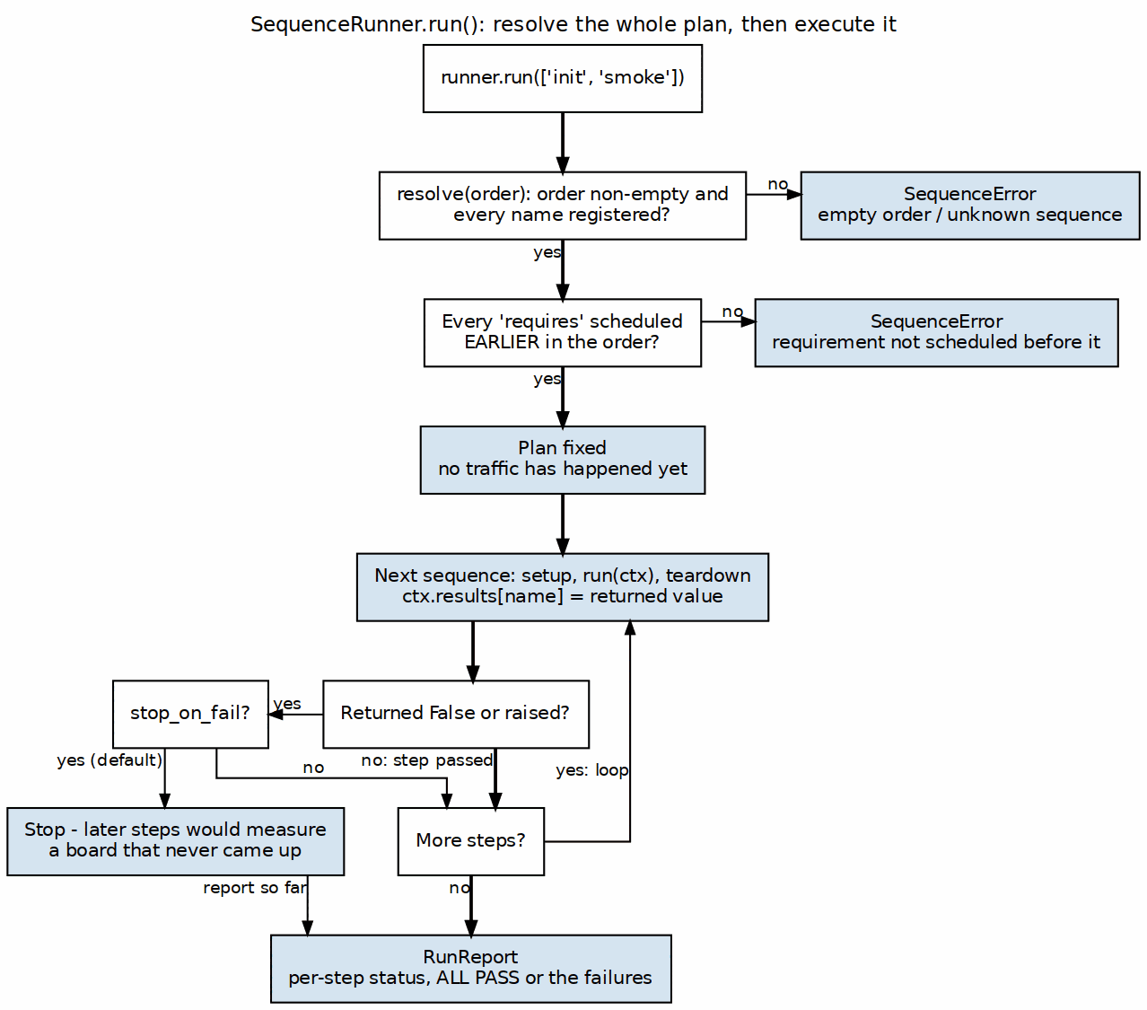
Resolve, then run
SequenceRunner holds the registry for one area and runs a requested order against a context.

13.1 Registration
runner.add(SomeSequence) # class or instance
runner.discover(path, pattern="seq_*.py")
add rejects three things outright: an object that is not a Sequence, one with no name, and a name already registered. The duplicate check names both classes, because two files claiming one name is otherwise found only by noticing that a step ran once when you expected it twice.
discover imports every file matching seq_*.py in a directory and registers the Sequence subclasses it finds. Discovery is by content, not by filename: a class in an oddly named file still registers, and a filename typo shows up at resolve time as a missing name rather than as a silently absent step.
If a discover call finds nothing it raises rather than returning an empty registry – an empty registry means nothing would run, which is not a state worth proceeding from.

13.2 Resolution happens before any traffic
plan = runner.resolve(["init", "smoke"])
Two checks, both before the board is touched:
- Every requested name exists. Unknown names raise SequenceError listing what is registered.
- Every requires is satisfied by something EARLIER in the order.
The second is checked against what has actually been scheduled, not against the set of names you typed, so ["smoke", "init"] is an error rather than a coin flip.
Missing dependencies are reported, never auto-inserted. Quietly running an init the caller did not ask for is its own surprise, and the fix is one word in the run script.

13.3 Execution
report = runner.run(order, stop_on_fail=True)
For each sequence: setup, run, store the result, teardown. Teardown runs in a finally, so it happens even when run raised.
An exception is caught, recorded in the StepResult with its traceback logged, and treated as a failure – the run reports rather than masks.

13.3.1 stop_on_fail defaults to True, and that default is load-bearing
These run against hardware. Once init fails, every later step measures a controller that was never brought up. Their numbers are worse than useless, because they look like data: plausible magnitudes, plausible shapes, and entirely meaningless.
[run] stopping: later sequences would measure a board that never came up

13.4 The report
@dataclass
class StepResult:
name: str
ok: bool
value: Any = None
seconds: float = 0.0
error: Optional[BaseException] = None
RunReport.summary() prints one line per step with status and duration, and RunReport.__bool__ is the overall verdict, so if not report: works.
Durations are per step. That is not decoration: a step that completes far faster than its known-good time has not done what it claims, which is the standing tell for a stale build or a skipped campaign.

13.5 Introspection
runner.names # sorted registered names
runner.catalog() # name, description, and requires, one per line
catalog() is what a --list flag should print. It reads the registry, so it cannot drift from what would actually run.

14 Writing a sequence

14.1 The skeleton
# <area>/bin/seq_measure.py
from __future__ import annotations
import <area>_env # noqa: F401 -- side effect: sets sys.path
from sequence import Sequence
class Measure(Sequence):
name = "measure"
requires = ("init",)
description = "sweep the delay line and record the eye"
def run(self, ctx):
width = ctx.param("width", 32)
taps = ctx.result("init")["taps"]
ctx.say(f"[measure] sweeping {width} points from tap {taps[0]}")
...
return {"eye": eye}
Three things to copy exactly:
- import <area>_env first, for its side effect. Chapter 5 explains what it does and why it is not a sys.path hack written inline.
- requires names every earlier step whose result you read. If you call ctx.result("init"), declare it – otherwise the runner cannot tell you scheduled them wrongly, and ctx.result will raise at the worst moment instead of at resolve time.
- Return something. It lands in ctx.results[name] for later steps. Return False only to mean “this step failed”.

14.2 The file goes in the area’s bin/
seq_*.py lives in <area>/bin/, not in a build directory, because sequences are shared by every build in that area and by the simulation harness. The prefix is how both SequenceRunner.discover and make find it – see Chapter 5.

14.3 Checklist
- ☐ Does it touch ctx.bus only, never a port or a bridge constructor?
- ☐ Does it work with ctx.board as None, so it runs in simulation?
- ☐ Does requires list every result it reads?
- ☐ Does it address registers by name rather than by offset?
- ☐ Is the name unique within the area?
- ☐ Does description say what it does in one line, for catalog()?
The first two are the ones that matter. A sequence failing either has quietly become board-only, and the sim half of the equivalence stops testing anything.

14.4 What does NOT belong in a sequence
Not this | Where it goes
argparse | The entry point
Port resolution | The entry point
Board programming | The entry point, or make program
Reusable drivers and verdict logic | A library in the area’s bin/
Printing a final report | The entry point, from the RunReport
A sequence that has grown an ArgumentParser is an entry point wearing the wrong prefix, and it has lost the ability to be composed with others.

15 The board registry
boards/ holds one file per board. It is the source of truth for the facts host tooling needs, and it exists because those facts were previously spread across seven copies of a Tcl script, each with its own hardcoded serial and its own environment variable to override it.

15.1 BoardSpec
@dataclass
class BoardSpec:
name: str # registry key
display_name: str
part: str # xc7a100tcsg324-1
jtag_serial: Optional[str] = None # Vivado hw_target serial
uart_serial: Optional[str] = None # only when UART != JTAG FTDI
uart_baud: int = DEFAULT_BAUD
uart_glob: str = "/dev/ttyUSB*"
notes: Sequence[str] = field(default_factory=tuple)
jtag_serial pins JTAG when several Digilent boards share a chain and – when uart_serial is None – doubles as the USB serial of the UART, because both interfaces are on one FTDI part. uart_serial exists for boards where that is not true.
notes is not decoration. It carries the board-specific traps that cost an afternoon, and it is printed by fpga_board.py info.

15.2 The two boards in this lab
 | Nexys A7-100T | Genesys 2
Part | xc7a100tcsg324-1 | xc7k325tffg900-2
JTAG serial | 210292BFA3EE | 200300B818A0
UART | Same FT2232HQ as JTAG | Separate FT232R, serial AU05X8RM
uart_serial | None | AU05X8RM
They share a JTAG chain, which is why the serial and not the board name is what distinguishes them.
Recorded traps, from the specs themselves:
- Nexys A7: Digilent Adept steals the UART ttyUSB; do not power-cycle after programming or the port binding is lost. ftdi_sio does not block Vivado programming – no driver dance is needed.
- Nexys A7: the lab has had two A7-100T units on this desk. If make ports reports nothing, check udevadm info /dev/ttyUSB* – a swapped unit presents as exactly that symptom.
- Genesys 2: both the FT232R and the JTAG FT2232 must be enumerated or there is no UART, whatever the bitstream does.

15.3 Using it
from boards import get_board
b = get_board("nexys_a7_100t") # or $FPGA_BOARD, else the default
b.find_uart_ports() # only THIS board's ports
port = b.find_uart_port(probe=my_probe)
b.program("bitstream/ddr2_char.bit")
Subclass Board only when a board needs different behaviour; most need only a BoardSpec. boards/genesys2.py is a subclass because of its split UART.

15.4 The CLI
fpga_board.py list # known boards
fpga_board.py info --board genesys2 # the spec, including notes
fpga_board.py ports --board genesys2 # this board's UART ports
fpga_board.py serial --board genesys2 # the JTAG serial, for Tcl
fpga_board.py readback # what is on the JTAG chain
fpga_board.py program --bitstream x.bit
serial prints nothing and exits 0 when the board has no serial, so a caller can substitute it unconditionally and get “any target” rather than the literal string None used as a match pattern.

16 Programming

16.0.1 Figure 4.1: The program path
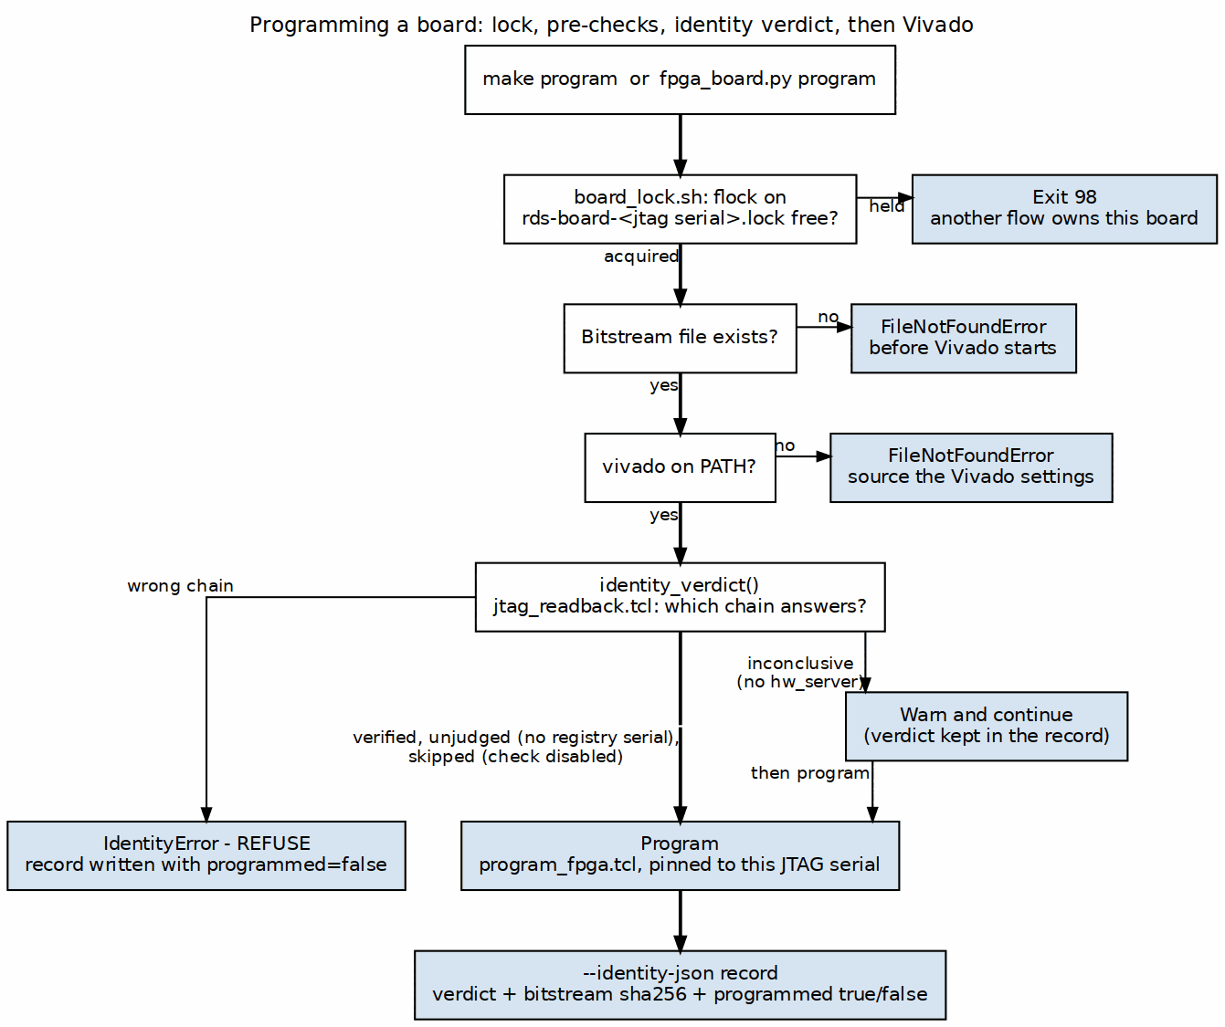
The program path
fpga_board.py program --board nexys_a7_100t --bitstream build/top.bit
replaces each flow’s own vivado -source tcl/program_fpga.tcl recipe. The board facts come from the registry, so a flow’s Makefile carries neither a serial nor its own copy of the Tcl.

16.1 Order of checks
Cheap and local first, because a thirty-second Vivado startup to be told the file is missing is pure waste:
- Bitstream exists – FileNotFoundError naming the path, suggesting make bitstream.
- --dry-run – prints the environment and the command, runs nothing.
- Vivado on PATH – FileNotFoundError suggesting the settings script.
- Identity – the subject of 03_locking_and_identity.md.
- Program – program_fpga.tcl, pinned to this board’s JTAG serial.

16.2 The environment handed to Tcl
Variable | Meaning
FPGA_BITSTREAM | Absolute path to the .bit
FPGA_JTAG_SERIAL | The serial to pin, absent for “any target”
FPGA_BOARD | The registry key
A single parameterised Tcl reading these replaces the per-flow copies.

16.3 From a Makefile
make/fpga_board.mk wraps the CLI:
BOARD_LOCK ?= $(FPGA_BIN)/board_lock.sh
BOARD_LOCKED = $(BOARD_LOCK) --board $(BOARD) --
and the program recipe runs under $(BOARD_LOCKED). A flow gets locking by using the standard recipe rather than by remembering to.

17 Locking and identity
Two mechanisms, and they are complements rather than alternatives: a lock prevents a collision, a readback detects one that happened anyway.

17.1 The lock
board_lock.sh is a command prefix:
board_lock.sh --board nexys_a7_100t -- make program
It resolves the board’s JTAG serial through fpga_board.py serial, falls back to the board name when there is none, sanitises the result, and takes a non-blocking flock on $RDS_BOARD_LOCK_DIR/rds-board-<key>.lock (default /tmp). On conflict it prints a hint and exits 98; otherwise it execs the payload.
Keyed on the JTAG serial, not the build directory. Two different build directories drive the same physical board, so a build-keyed lock lets them collide while reporting success. Two boards sharing one JTAG chain still get separate keys, because their serials differ.
The lock is held for the life of the payload: exec 9> the lock file, flock -n 9, then exec the command. The descriptor survives exec, the lock lives on the open file description, and the kernel releases it when the process dies – including when it is killed.
A consequence worth knowing: a Python BoardLock nested inside a shell-locked payload would be refused by the kernel, since the tree already holds the lock. The Python side therefore detects an inherited descriptor and re-locks to prove ownership; an adopted descriptor is never closed on exit.

17.2 Why a lock is not sufficient
A harness records the sha256 of the bitstream it programmed. That describes the file it sent, not the device that received it. If a board is reprogrammed or re-enumerates mid-run, the results file carries no error, no timeout and no mismatch – it is simply someone else’s measurements under your name.
fuser /dev/ttyUSB* does not close this gap either: it sees only the UART half of a board. Measured on this bench, the Genesys 2’s JTAG serial appears on zero tty nodes.

17.3 The identity readback
jtag_readback.tcl lists the chain read-only. parse_readback turns its output into targets and devices, and is pure, so it is unit-testable without Vivado and without a board.
identity_verdict() returns the check as data and never raises:
Status | Meaning | Effect on program
verified | This board is on the chain with a device behind it | Proceed
wrong | The chain does not hold this board | Refuse
inconclusive | The chain could not be read | Warn, proceed
unjudged | This board has no registry serial | Proceed
skipped | --no-verify-identity was passed | Proceed
The asymmetry is deliberate. A proven wrong chain refuses. An inconclusive readback only warns, because refusing when hw_server is unreachable would break every flow where programming works but the daemon is not running – and this sits on thirteen board paths at once. A board with no registry serial is returned unjudged rather than passed; claiming success there would be a checker that cannot fail.
A wedged hw_server is inconclusive, not an exception: the readback carries a 240 s timeout, and letting TimeoutExpired escape would take program down, converting the warn-only path into the refusal the asymmetry exists to avoid.

17.4 The record
A warning printed to a terminal is indistinguishable from a pass once it scrolls. So the verdict is written beside the evidence:
fpga_board.py program --bitstream top.bit --identity-json run/identity.json
{
"when": "2026-09-30T14:22:05-0700",
"board": "nexys_a7_100t",
"expected_serial": "210292BFA3EE",
"bitstream": "/abs/path/top.bit",
"bitstream_sha256": "...",
"programmed": true,
"identity": {"status": "verified", "detail": "", "chain": {...}}
}
Two fields exist for reasons that are easy to miss:
- programmed – the record is written on the refusal path too, where the sha256 describes a bitstream that never reached the device. Without this flag the file reads as “this bitstream is on that board”, which is exactly the false claim the mechanism exists to prevent. It is also false on a non-zero Vivado exit.
- identity.status including skipped – --no-verify-identity still writes the file. A missing file is not a statement; it is an absence a harness tolerates without noticing.
Without this record a run that could not look writes exactly what a run that looked and approved writes, and six weeks later nobody can tell which one they are holding.

17.5 Status
The hardware path is unexercised. The parser and the decision logic are covered by hardware-free tests, deliberately, because opening the hardware manager to test this would violate the very lock discipline it accompanies. The first real make program on a free board remains the outstanding verification; see tooling TASK-022.

18 Naming, and why the prefixes are load-bearing

18.0.1 Figure 5.1: Where each kind of file lives
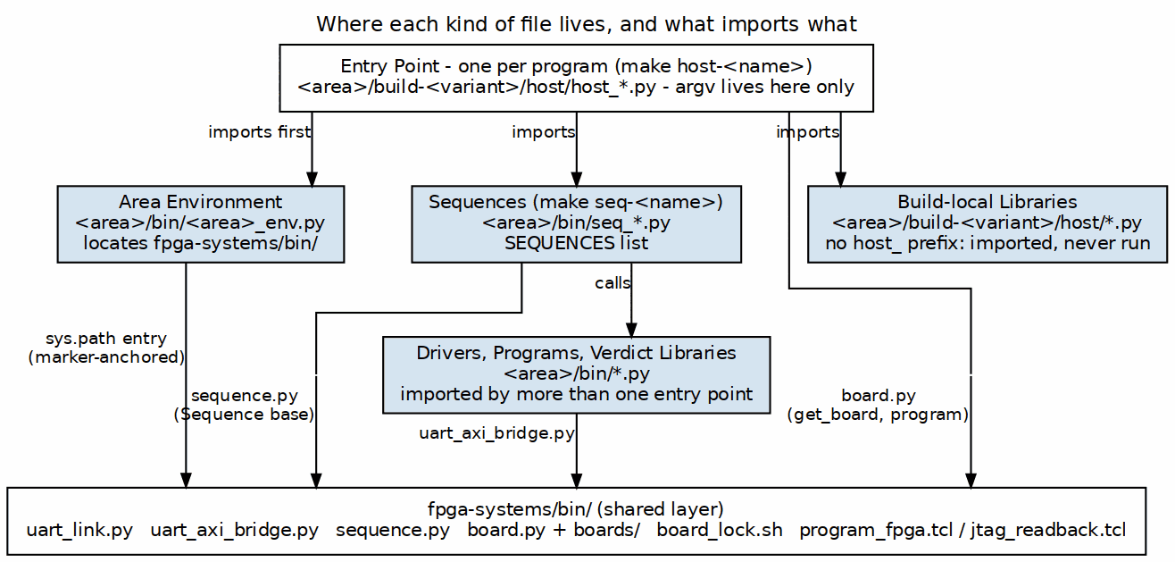
Where each kind of file lives
The authority for the directory skeleton and the filename conventions is the handbook note [[flow-layout]], not this chapter. This chapter records only what binds those conventions to the layer specified in this book: the prefixes are not a style preference, they are how two separate mechanisms find files.

18.1 The table, and the two things that read it
Pattern | Role | Discovered as
bin/run_*.py | A runner: drives a whole plan | make run-<name>
bin/seq_*.py | One sequence | make seq-<name>
host/host_*.py | A standalone host program | make host-<name>
host/test_*.py | pytest | Via SIM_TESTS, never a make target
host/<other>.py | A library: imported, never run | Nothing
fpga/tcl/*.tcl | A Vivado script | make tcl-<name>
Two mechanisms depend on this, and both are plain globs:
# make/fpga_flow.mk
RUN_SCRIPTS := $(sort $(wildcard $(SEQ_DIR)/run_*.py))
SEQ_SCRIPTS := $(sort $(wildcard $(SEQ_DIR)/seq_*.py))
HOST_PROGRAMS := $(sort $(wildcard $(HOST_DIR)/host_*.py))
# sequence.py
def discover(self, path, pattern: str = "seq_*.py"): ...
So a misnamed file is not merely untidy – it is invisible. A sequence not matching seq_*.py is never registered; a host program not matching host_*.py never becomes a make target. make targets prints exactly what was found on disk, so “what can I run here” is never a guess, but it can only print what the glob matched.

18.2 The prefix marks the file, not the directory
host_* identifies an entry point. It does not mean “everything in host/ is a program”, and the distinction is load-bearing in both directions:
- build-loop/host/ holds host_rs_loop.py (the entry point, carrying the ArgumentParser) beside rs_loop.py and rs_loop_programs.py. Those two parse no arguments and are correctly libraries that happen to sit next to the entry point using them.
- Four stream entry points are 21 to 33 line shims that bootstrap sys.path and call main() from a same-named library in the area’s bin/. The entry point is the shim; the ArgumentParser is in the library.
host_bus_meters.py states the rule at the point where someone would get it wrong:
The implementation is bin/bus_meters.py, at COMPONENT level because it is a LIBRARY as well as a program – host_ext_char and the cosim tests import its readers. Entry points are host_* and live in a build; anything imported by more than one of them lives in bin/.
Renaming a library to host_* is therefore wrong. If a file is imported by anything, it is a library that happens to be runnable, not a program. [[flow-layout]] records why discovery uses the prefix rather than scanning for a __main__ guard: the guard made the role invisible in ls and swept up library modules carrying a debug CLI.

18.3 Measured status, 2026-09-30
Nine build directories follow the skeleton (build-<name>/). Two do not: Genesys2/rapids/flows-rapids/ and Genesys2/rapids_beats/flows-rapids-beats/.
Those two are pre-migration flows, not a competing convention. flows-*/ is the layout [[flow-migration]] names as the thing being migrated away from, and neither includes make/fpga_flow.mk at all – so none of the discovery above applies to them. Their run_*.py sitting in host/ rather than bin/ is a consequence of that, not a second opinion about where runners go.
The practical reading: there is one convention, it is documented in two places that agree, and the exceptions are a tracked migration backlog.

19 Resolving paths
Anchor to a marker; never count directory levels. This has a date and a cost attached, recorded in [[flow-layout]].

19.1 What happened
The shared board and UART layer moved from fpga/bin to projects/fpga-systems/bin, and every hand-counted path broke at once:
- pumice_env.py counted five levels to the repo root.
- ddr2_char.py carried its own copy of the same walk.
- uart_link.py counted three and silently resolved to <root>/projects/projects/....
- A test asserted the literal string fpga/bin/program_fpga.tcl.
Four independent copies of one fact, each broken separately, none of which told you what was wrong – a wrong path produces an ImportError naming a module, not a layout.

19.2 The pattern
Each area keeps exactly one module that knows where the shared layer is. It searches upward for a marker file, honouring REPO_ROOT first:
_MARKER = os.path.join("projects", "fpga-systems", "bin", "uart_link.py")
def _repo_root() -> str:
env = os.environ.get("REPO_ROOT")
if env and os.path.isfile(os.path.join(env, _MARKER)):
return env
here = os.path.dirname(os.path.abspath(__file__))
while True:
if os.path.isfile(os.path.join(here, _MARKER)):
return here
parent = os.path.dirname(here)
if parent == here:
raise RuntimeError("cannot find the repo root")
here = parent
then puts the shared directory, and any area-local directory, on sys.path:
FPGA_BIN = os.path.join(REPO_ROOT, "projects", "fpga-systems", "bin")
for p in (FPGA_BIN, HOST_DIR):
if p not in sys.path:
sys.path.insert(0, p)
Cost is one os.path.isfile per level. Benefit is that the next move breaks nothing.

19.3 Using it
Import it first, for its side effect, before importing anything shared:
import rs_env # noqa: F401
from sequence import Sequence
from boards import get_board
The noqa is load-bearing documentation: a linter would otherwise remove an import whose only purpose is the side effect, and the file would fail at the next line.

19.4 Why an entry point still needs it
env_python puts projects/fpga-systems/bin on PYTHONPATH, so sequence, boards and uart_link import by bare name in a properly configured shell. That does not cover the area’s own bin/, where its drivers and sequences live. A host program under build-<variant>/host/ importing an area library therefore still needs the environment module, and omitting it produces an ImportError on a first board run – found exactly that way in the reed-solomon flow.
If the chapter’s skeleton (Chapter 6) looks like it has a redundant import at the top, that is the one.

19.5 The corollary for generators
A tool that writes output must anchor its default output path to its own location, not the current directory. elaborate_a7ddrphy.py defaulted to a bare relative path and, run from the wrong directory, produced rtl-vivado/rtl-vivado/a7ddrphy/.

19.6 One name, one thing
Two files called run_smoke.py once lived in one flow – the sequence runner in bin/ and an older end-to-end program in host/. Different code, same name, and make run-smoke could only ever mean one of them.

20 Standing up a new flow
The order below is the one that fails earliest. Each step is checkable before the next becomes possible.

20.1 1. Register the board, if it is new
Add boards/<name>.py with a BoardSpec. The fields that matter are part, jtag_serial, and – only when the UART is not on the JTAG FTDI – uart_serial. Put every board-specific trap in notes; that is what fpga_board.py info prints.
python3 projects/fpga-systems/bin/fpga_board.py list
python3 projects/fpga-systems/bin/fpga_board.py info --board <name>

20.2 2. Confirm the board is visible before writing any code
python3 projects/fpga-systems/bin/uart_link.py # ports and USB serials
python3 projects/fpga-systems/bin/fpga_board.py ports --board <name>
python3 projects/fpga-systems/bin/fpga_board.py readback
If ports prints nothing, the problem is the registry’s serial or the cabling, not your code. On a Genesys 2 both cables must be enumerated.

20.3 3. Create the directory skeleton
Follow [[flow-layout]]; it is the authority. The shape is <area>/bin/ for sequences and area libraries, and <area>/build-<name>/ per bitstream. Use build-, not flows- – see Chapter 5.

20.4 4. Add the area’s environment module
<area>/bin/<area>_env.py, anchored to the marker as in Chapter 5. Write this before the first sequence; everything imports it.

20.5 5. Give the harness an identity register
Pick a probe shape (Chapter 2) and make the FPGA answer it. Prefer a read-only build-ID constant over a writable scratch register: register_probe is safe to aim at a board running someone else’s bitstream and scratch_probe is not.

20.6 6. Write the init sequence first
<area>/bin/seq_init.py. Everything else will declare requires = ("init",). It returns what later steps need – taps, a profile, a topology.
Read the build’s topology from a register rather than assuming it. A single-decoder build once failed every run because the host was faithfully scoring a checker that was tied off. The host should ask the hardware what it is, not be told at the command line.

20.7 7. Write the entry point
<area>/build-<name>/host/host_<thing>.py. It parses argv, resolves the board and port, builds the bus, constructs a SequenceContext, discovers the area’s bin/, and calls runner.run([...]). It should be thin.

20.8 8. Make it run in simulation
This is the step that is easiest to skip and most expensive to add later. Drive the same host code through a cocotb byte channel with ctx.board = None. If a sequence resolves its own port or needs the board object, it will fail here – which is the point.
Raise the sim baud (CLKS_PER_BIT) to fit the time budget. Do not shrink the campaign; the shortened version is no longer what runs on the board.

20.9 9. Lock the board paths
Use the standard program recipe so board_lock.sh wraps it. A flow that invokes Vivado directly gets no lock, and nothing will tell it so.

20.10 10. Record what you programmed
Pass --identity-json from any flow whose results are evidence, so the identity verdict lands beside the bitstream sha256.

20.11 Checklist
- ☐ fpga_board.py info, ports, readback all answer
- ☐ An environment module anchored to the marker, not to a level count
- ☐ An identity register, read-only if possible
- ☐ seq_init.py returning what later steps need
- ☐ Sequences touch ctx.bus only
- ☐ The same host code runs in sim with ctx.board = None
- ☐ Board-touching make targets run under the lock
- ☐ --identity-json wherever results are kept

