
RTL Design Sherpa
RAPIDS Characterization Nexys A7 Project Guide 0.90
July 2026

Table of Contents
1 Document Information 8
1.1 References 8
1.2 Terminology 8
1.3 Revision History 9
2 Overview 10
2.1 What it characterizes 10
2.2 Boards and tools 10
2.3 Datapath geometry 10
2.4 Status 11
3 How It Works 12
3.1 The spine and region decode 12
3.1.1 Figure 2.1: RAPIDS Characterization Harness Spine 12
3.2 Key RTL blocks 13
3.3 The DUT and the on-chip harness 14
3.4 Atomic launch 15
4 Test Methodology 16
4.1 What is under test 16
4.2 What is measured, and how 16
4.2.1 Figure 3.1: Measurement Pipeline 17
4.3 Workloads 17
4.4 The oracle 18
4.5 Measurement pitfalls 18
5 Build and Run 19
5.1 Make targets (flows-rapids-beats/Makefile) 19
5.2 The host campaign (flows-rapids-beats/host/) 20
5.3 Typical sequence 21
6 Harness CSR Configuration 22
6.1 Regions and by-name access 22
6.1.1 Waveform 5.1: Atomic Launch 23
6.2 DESC-LOAD region (region 1, byte offsets) 23
6.3 HARNESS CSR — control (region 2) 23
6.4 Atomic-launch staging (region 2) 25
6.5 HARNESS CSR — status and observability 26
7 Simulation vs Silicon 28
7.1 The two paths 28
7.2 The cocotb testbench 28
7.3 Why no UART-in-sim here 29
8 Troubleshooting 30
8.1 Current state 30
8.2 Known gotchas 30
8.3 Cannot find the board 30
8.4 Board-fit vs sim geometry 31
8.5 Three different “0x1000”s 31
8.6 Vivado-only package collisions 31

List of Figures
Figure 2.1: RAPIDS Characterization Harness Spine 12
Figure 3.1: Measurement Pipeline 17

List of Tables
Table 1: Reference documents 8
Table 2: Revision history 9
Table 3: Boards and tool requirements 10
Table 4: Datapath geometry 10
Table 5: Host address regions 12
Table 6: Key RTL blocks 13
Table 7: On-chip harness stimulus and checkers 14
Table 8: What is measured 16
Table 9: Characterization workloads 17
Table 10: flows-rapids-beats make targets 19
Table 11: Host address regions 22
Table 12: DESC-LOAD registers 23
Table 13: Harness CSR — control registers 23
Table 14: Atomic-launch staging registers 25
Table 15: Harness CSR — status and observability 26
Table 16: The two characterization paths 28
Table 17: Known issues and workarounds 30

List of Waveforms
Waveform 5.1: Atomic Launch 23

RTL Design Sherpa · Learning Hardware Design Through Practice GitHub · Documentation Index · MIT License

1 Document Information
This is the operator / developer guide for the Nexys A7 RAPIDS Characterization project (projects/fpga-systems/Genesys2/dma-ip/rapids_beats). It explains what the project characterizes, how the harness works, how to build / simulate / program / run it, and how the harness CSR is configured.
The device under test is the RAPIDS beats DMA (rapids_beats_top, from projects/components/dma-ip/rapids/). This guide documents how the harness drives it and the harness control surface — not the DMA core’s internals.

1.1 References
Reference documents
Source | Title
RTL Design Sherpa | README.md (project overview + quick start)
RTL Design Sherpa | docs/rapids_beats_findings.md (architecture, timing, golden CRC)
RTL Design Sherpa | flows-rapids-beats/host/README.md (AXIL word map + campaign semantics)
RTL Design Sherpa | reports/perf/README.md (8-channel line-rate performance)
RTL Design Sherpa | bin/TBClasses/ (shared harness / RegisterMap collateral)
ARM | AMBA AXI4 / AXI4-Stream / APB Protocol Specifications

1.2 Terminology
SRC / SNK
The two wholly-separate RAPIDS engines: rapids_src_beats reads memory and emits to the AXIS network; rapids_snk_beats receives from the network and writes memory. They share one APB decode (SRC @ 0x0000, SNK @ 0x1000).
Beats
The fixed-quantum transfer variant of RAPIDS. The Genesys 2 build is DATA_WIDTH = 256 (32 bytes per beat, AXI4 and AXIS alike) since 2026-09-29; peak per-direction bandwidth = 32 B × 100 MHz = 3.2 GB/s. Perf reports v1.0 to v1.5 measured the earlier 512-bit build (64 B/beat, 6.4 GB/s). The bitstream reports its own geometry in the harness BUILD register and the host takes its byte and bandwidth math from there.
Region
The top 4 bits of the host word address (addr[19:16]) select one of three regions: DUT-REG (0), DESC-LOAD (1), HARNESS CSR (2).
Golden CRC
The deterministic CRC-32 (Ethernet 0x04C11DB7, LFSR seed 0xDEADBEEF) that both the on-chip checkers and the host golden model compute; a pass is a CRC match.

1.3 Revision History
Revision history
Version | Date | Notes
0.90 | 2026-07-18 | Initial project guide

2 Overview

2.1 What it characterizes
This project performs on-silicon characterization of the split RAPIDS beats DMA (rapids_beats_top) — refactored into two wholly-separate engines behind one shared APB decode:
- rapids_src_beats — read-only: memory → AXIS network
- rapids_snk_beats — write-only: AXIS network → memory
The harness drives both data paths on real hardware over UART and validates every beat against a deterministic golden CRC-32. It reports per-direction throughput and channel scaling, with an all-on-chip stimulus/checker so the board runs at line rate without a host bottleneck.
There is a single flow, flows-rapids-beats/ (the “beats” fixed-quantum variant of RAPIDS).

2.2 Boards and tools
Boards and tool requirements
Item | Detail
Default board | Digilent Nexys A7-100T (xc7a100tcsg324-1), 100 MHz, NUM_CHANNELS = 4
Optional board | Genesys 2 (xc7k325tffg900-2) via BOARD=genesys2, 8 channels (200→100 MHz MMCM)
Build | Vivado (synth / impl / bitgen / program)
Host | Python 3 + pyserial
Sim | Verilator + cocotb / cocotb_test / pytest

2.3 Datapath geometry
Datapath geometry
Parameter | Value
Data width | 256 bits (32 B/beat), AXI4 and AXIS; 512 bits (64 B) through perf report v1.5
Address width | 64 bits
Descriptor | fixed 256-bit
SRAM per channel | 128 beats = 4 KB (was 256 x 64 B = 16 KB)
Peak per direction | 3.2 GB/s (32 B × 100 MHz)
Peak full-duplex | 6.4 GB/s

2.4 Status
Silicon-validated: make smoke passes both paths; make suite passes 48/48 (channels {1,2,4} × beats {1,4,8,16} × backpressure {off,on} × 2 seeds). Timing closes at 100 MHz (WNS +0.007 ns, 0 failing endpoints) at the board-fit geometry NUM_CHANNELS = 4, SRAM_DEPTH = 256. On Genesys 2 the 8-channel 512-bit build reached 99.8–100% line rate (6.40 GB/s per direction, perf report v1.5); the 256-bit / 4 KB-per-channel build is the current design point (Makefile DATA_WIDTH / SRAM_DEPTH, exported to the build and to verify-sim) — see reports/perf/.

3 How It Works

3.1 The spine and region decode
Host commands arrive over one UART link and are steered by the top 4 bits of the word address (addr[19:16]) into four regions:

3.1.1 Figure 2.1: RAPIDS Characterization Harness Spine
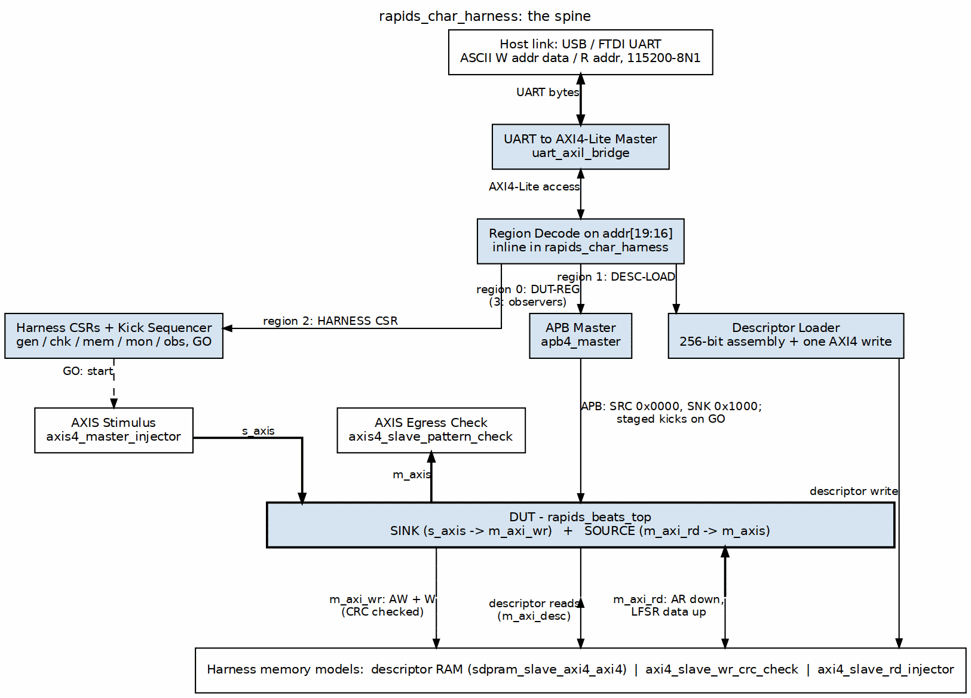
RAPIDS characterization harness spine
Source: 01_harness_spine.dot
Host address regions
Region | Base | Contents
0 — DUT-REG | 0x0_0000 | AXIL → apb4_master → the DUT’s APB (SRC @ 0x0000, SNK @ 0x1000)
1 — DESC-LOAD | 0x1_0000 | 256-bit descriptor assembly + single-beat AXI4 write into descriptor RAM
2 — HARNESS CSR | 0x2_0000 | gen / chk / mem / mon / obs control + status readback
3 — OBSERVERS | 0x3_0000 | USE_OBSERVERS=1 only: the shared interface observers’ obs_regs maps, AXI observer @ 0x0000, AXIS observer @ 0x1000 (paddr[12]); reads 0 with PSLVERR when not built
The UART wire protocol is ASCII (W <addr> <data>\n / R <addr>\n), 115200 8N1, decoded by uart_axil_bridge.

3.2 Key RTL blocks
Key RTL blocks
File | Role
flows-rapids-beats/rtl/rapids_char_top.sv | FPGA pin-level top: pins to harness ports, LEDs and 7-seg. It no longer owns the host front-end: that moved into rapids_char_harness on 2026-09-23, so the harness simulation drives the board’s own launch path.
flows-rapids-beats/rtl/rapids_char_harness.sv | Synthesizable harness: the host front-end (uart_axil_bridge, the region decode, apb4_master, the DESC-LOAD path, the harness CSR register file and the atomic-launch kick sequencer; all CSR/DESC offsets are localparams here, the single source of truth for the host regmaps), the DUT rapids_beats_top, and the on-chip stimulus / checkers / memories. This is the cocotb DUT top.
flows-rapids-beats/rtl/rapids_char_genesys2_top.sv | Genesys 2 wrapper (MMCM 200→100 MHz) around rapids_char_top, default 8 channels.

3.3 The DUT and the on-chip harness
The DUT is rapids_beats_top (u_dut), from projects/components/dma-ip/rapids/. Two build-time overrides matter for the char build: USE_AXI_MONITORS = 0 and GEN_MON = 0 — the in-core AXI/descriptor monitors and MonBus egress are compiled out so utilization is metered externally and 8-channel timing closes. Two more knobs, also default off, add the shared interface observers beside the DUT’s data ports (rapids TASK-001): USE_OBSERVERS = 1 builds axi4_intf_master_observer on the rd/wr data masters and axis4_intf_observer on s_axis / m_axis (port 0 sink ingress, port 1 source egress), each on its own 4 KB obs_regs window in region 3; OBS_ENABLE_MON_TAPS = 1 arms their monbus event taps (the meters and latency histograms count without them). Their monbus egress lands in an always-accept responder, like the DUT’s own; the bare axi_bus_meter / axis_bus_meter instances and the region-2 OBS_* CSRs the host tools read are unchanged. The harness also carries STREAM’s memory-latency model: axi_response_delay on the source read’s R channel and the sink write’s B channel, programmed by the RESP_DELAY CSR (region 2, 0xC4) in aclk cycles, so the same latency-vs-throughput knee STREAM reports can be swept here (--suite-delay).
Measured 2026-09-27 (synth, 8ch, 100 MHz): the pair adds 10,943 LUTs as instruments and 18,733 with the taps armed over the 60,651-LUT bare build, and timing closes in every variant (+3.703 / +0.869 ns synth WNS vs +3.683).
Because all data paths are on-chip, the board runs at line rate with no host bottleneck. The harness instantiates (all sharing LFSR 0xDEADBEEF, taps {32,22,2,1}, CRC-32 0x04C11DB7):
On-chip harness stimulus and checkers
Block | Role
axis4_master_injector | drives the DUT s_axis (sink ingress stimulus)
axis4_slave_pattern_check | checks the DUT m_axis (source egress)
axi4_slave_rd_injector | backs the DUT m_axi_rd (DATA_WIDTH-bit source data; 256 on the Genesys 2 build)
axi4_slave_wr_crc_check | backs the DUT m_axi_wr (DATA_WIDTH-bit sink data verify)
sdpram_slave_axi4_axi4 ×4 | descriptor + control RAM per half (DUT reads, host writes)
axi_bus_meter / axis_bus_meter | prod/bp/starv/idle buckets + exact AXIS byte/packet counters

3.4 Atomic launch
To start a measured run coherently, the host stages the kick parameters (CSR_KICK_MASK, CSR_KICK_BASE_*, CSR_KICK_STRIDE) and then writes a single CSR_GO, which arms the bus meters, starts the generator, and fires the channel kicks together (Chapter 5). A run latches PASS (0x0123) or FAIL (0x9999) on the LEDs and 7-seg once gen_done & src_idle & snk_idle.

4 Test Methodology
This chapter describes what is exercised on the FPGA block (Figure 2.1) and how throughput and data integrity are measured.

4.1 What is under test
The split RAPIDS beats DMA — the rapids_src_beats (read → AXIS) and rapids_snk_beats (AXIS → write) engines. Because all stimulus, checking, and memory are on-chip, the board runs at line rate and every measurement is taken at the DUT’s own AXI/AXIS ports.

4.2 What is measured, and how
What is measured
Quantity | How it is obtained
Data integrity | Per-channel golden CRC-32: SINK WR_CRC[ch] vs GEN_EXP_CRC[ch]; SOURCE CHK_ACT_CRC[ch] vs RD_CRC[ch]; plus STATUS.data_error
Throughput | AXIS/AXI bus meters + exact byte/packet counters (OBS_SIN/SOUT_BYTES/PKTS) over the timed window
Utilization | OBS_{RD,WR,SIN,SOUT}_{PROD,BP,STARV,IDLE} buckets
Scaling | Repeat across the active-channel mask
Observer telemetry (USE_OBSERVERS=1) | Region-3 obs_regs by name: per-port cycle buckets, AXIS bytes/packets, AXI burst counts and latency histograms, tap drop counts (OBS_STICKY)
Sweep axes | --suite-channels, --suite-beats, --suite-descs (chains), --suite-xfer (burst AxLEN), --suite-delay (RESP_DELAY) – STREAM’s five knobs
A measurement run uses atomic launch (Waveform 5.1): configure the DUT by name over APB, load descriptors into the per-half descriptor RAM, stage the kick parameters (CSR_KICK_MASK, CSR_KICK_BASE_*, CSR_KICK_STRIDE), then write a single CSR_GO that arms the bus meters, starts the generator, and fires the channel kicks together. CSR_OBS_TARGET = channels × beats freezes the meter window deterministically; the host then reads the CRCs and counters.

4.2.1 Figure 3.1: Measurement Pipeline
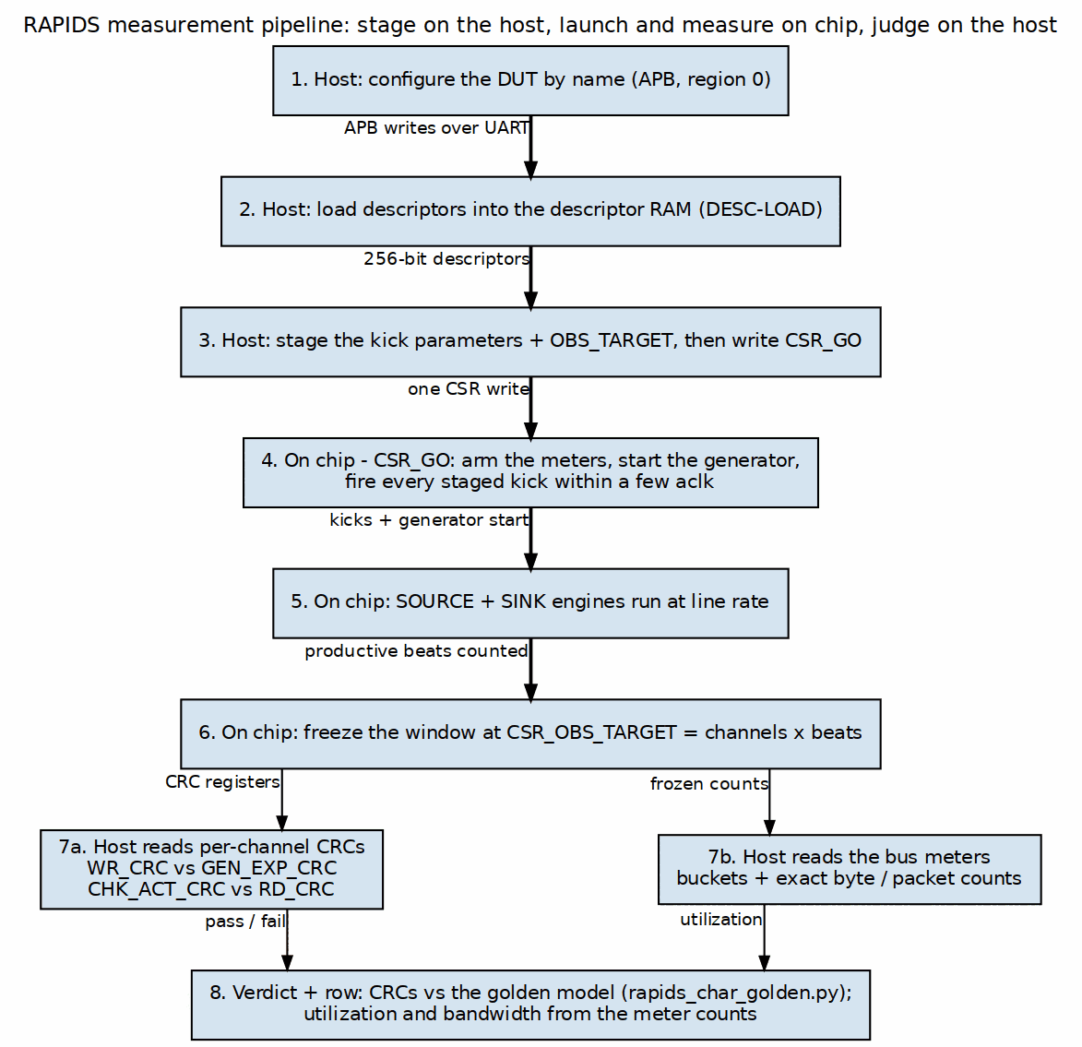
Measurement pipeline
Source: 02_measurement_pipeline.dot

4.3 Workloads
Characterization workloads
Axis | Values
Channels | 1, 2, 4 (Nexys) / up to 8 (Genesys 2)
Beats | 1, 4, 8, 16
Backpressure | off, on (SOURCE only, via chk_ready_en)
Seed | default, alternate (SINK only — SOURCE read-gen is fixed 0xDEADBEEF)

4.4 The oracle
Every beat is checked against a deterministic golden CRC-32 (LFSR seed 0xDEADBEEF, taps {32,22,2,1}, poly 0x04C11DB7). The host’s rapids_char_golden.py computes the same value the on-chip checkers do; a pass is a match on both paths (make suite = 48/48).

4.5 Measurement pitfalls
- Arm every run — the bus meters have no auto-reset; use OBS_CTRL.arm or the CSR_GO write, or the window stays frozen on the first capture.
- SINK re-arm — the sink is fully trustworthy only on the first arm after a board reset; the runner pulses CHANNEL_RESET before each run.
- The generator self-CRC (GEN_EXP_VLD) is corroboration only; PASS anchors on the data-path CRC (WR_CRC).

5 Build and Run
All commands assume the Python environment is sourced (the Makefile hard-fails without REPO_ROOT):
cd /path/to/RTLDesignSherpa && source env_python
cd projects/fpga-systems/Genesys2/dma-ip/rapids_beats/flows-rapids-beats

5.1 Make targets (flows-rapids-beats/Makefile)
flows-rapids-beats make targets
Target | What it does
make sim | cocotb harness self-check (sink + source, multi-channel)
make verify-sim | pre-bitstream sim gate (-k sink); bypass with BITSTREAM_SKIP_VERIFY=1
make project / make synth | create Vivado project / synth-only + utilization
make bitstream | full synth + impl + bitgen (depends on verify-sim)
make program | flash the board over JTAG
make smoke | fast golden-validated UART confidence check
make suite | full UART sweep → JSON under reports/
make characterize | full UART campaign on PORT
make flow | sim → bitstream → program → characterize
make utilization / make timing | print the latest reports
make clean / make clean-all | remove artifacts
Knobs: CHANNELS (4 on nexys, 8 on genesys2 — passed as both the build generic and the host --channels, kept in lockstep), BEATS=8, PORT=/dev/ttyUSB1, BOARD=nexys|genesys2, BITSTREAM_SKIP_VERIFY=1.
make sim # cocotb self-check
make bitstream # Nexys A7, 4 channels
make bitstream BOARD=genesys2 CHANNELS=8 # Genesys 2, 8 channels
make program
make smoke PORT=/dev/ttyUSB1
make suite CHANNELS=4
The Vivado build targets part xc7a100tcsg324-1, top rapids_char_top, with board-fit generics NUM_CHANNELS=4, SRAM_DEPTH=256, DESC_RAM_ENTRIES=256. The Genesys 2 build (BOARD=genesys2) is 8 channels at the 256-bit / 4 KB per channel design point: Makefile DATA_WIDTH=256 SRAM_DEPTH=128, exported as the RAPIDS_DATA_WIDTH / RAPIDS_SRAM_DEPTH generics and handed to verify-sim, so the sim gate builds the same geometry as the bitstream. Override both on the make line to build another point; the host reads the result back from the harness BUILD register and refuses a --channels that disagrees with it. Programming is pinned to a specific JTAG serial so the flash and the UART campaign land on the same board (override RAPIDS_CHAR_JTAG_SERIAL).

5.2 The host campaign (flows-rapids-beats/host/)
The port defaults to --port auto, which probes each /dev/ttyUSB* and keeps the board whose region-2 CTRL/ID reads 0x52415031 (“RAP1”).
run_characterization.py — the campaign runner (sink then source):
# Full campaign, verbose
./run_characterization.py --port /dev/ttyUSB1 --channels 4 --active 4 --beats 8 -v
# One path only
./run_characterization.py --sink-only --channels 4
./run_characterization.py --source-only --channels 4
# Sink with the generator round-robining the active channels beat by beat
# (GEN_MODE.INTERLEAVE): every sink channel holds data at once, so the
# measured write window is the DUT's, not one channel's (rapids TASK-018)
./run_characterization.py --sink-only --interleave --channels 8 --active 8
# Smoke (both paths, quick) and full suite (matrix → JSON)
./run_characterization.py --smoke --channels 4
./run_characterization.py --suite --suite-channels 1,2,4 --suite-beats 1,4,8,16 \
--suite-bp off,on --suite-seeds default,0x12345678
Exit codes: 0 all pass, 1 a self-check failed, 2 no UART link / wrong ID.
dump_status.py — a STATUS / totals / CRC snapshot (./dump_status.py --port /dev/ttyUSB1 --channels 4). Other host modules: descriptor_builder.py (256-bit descriptor builder), rapids_char_golden.py (standalone golden CRC), rapids_char_io.py (transport + autodetect).

5.3 Typical sequence
make sim # prove the harness self-check
make bitstream # (runs verify-sim first)
make program
make smoke PORT=/dev/ttyUSB1 # golden-validated link check
make suite CHANNELS=4 # full sweep -> reports/*.json

6 Harness CSR Configuration

6.1 Regions and by-name access
The host address splits into four regions by addr[19:16]:
Host address regions
Region | Base | Contents
DUT-REG | 0x0_0000 | APB into the RAPIDS DUT (SRC 0x0000, SNK 0x1000)
DESC-LOAD | 0x1_0000 | descriptor holding registers + kick
HARNESS CSR | 0x2_0000 | gen / chk / mem / mon / obs + status
OBSERVERS | 0x3_0000 | USE_OBSERVERS=1 builds only: obs_regs of the AXI observer @ 0x0000 and of the AXIS observer @ 0x1000 (projects/components/utility-ip/misc/rdl/obs/obs_regs.rdl, by name through obs_regs_top_regmap.py); PSLVERR + 0 when not built
No PeakRDL RDL exists for the harness CSR. The registers are decoded by hand in rapids_char_top.sv (localparams) and mirrored by two hand-maintained Python regmaps, regenerated from the SV by flows-rapids-beats/bin/gen_rapids_harness_regmap.py:
- flows-rapids-beats/rtl/rapids_harness_csr_regmap.py
- flows-rapids-beats/rtl/rapids_harness_desc_regmap.py
The DUT (RAPIDS core) does use PeakRDL — projects/components/dma-ip/rapids/rtl/rapids_regmap.py — loaded by the host as two RegisterMap instances (SRC start_address=0x0000, SNK 0x1000, 13-bit APB) for by-name DUT config.
The identity register: region-2 CTRL/ID @ 0x000 reads 0x5241_5031 (“RAP1”) — the BUILD_ID equivalent used for ping() and port autodetect.

6.1.1 Waveform 5.1: Atomic Launch
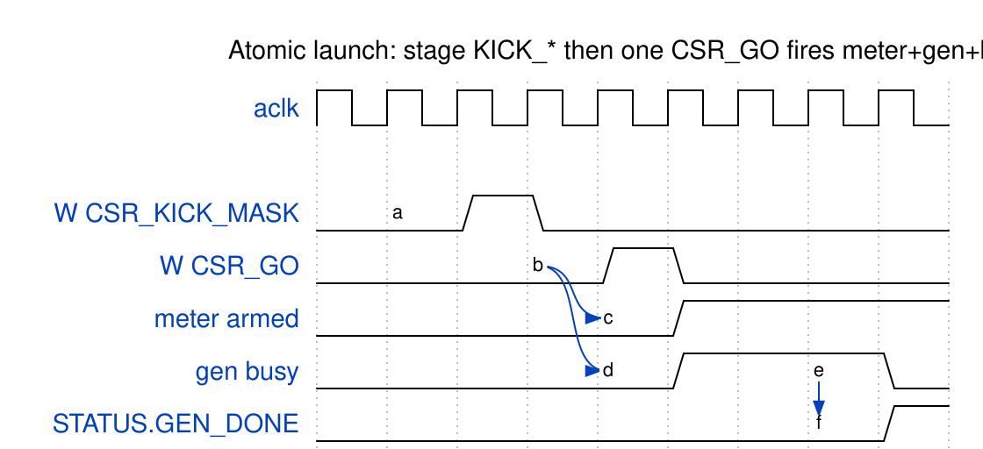
Atomic launch sequence
Source: 01_atomic_launch.json

6.2 DESC-LOAD region (region 1, byte offsets)
DESC-LOAD registers
Register | Offset | Field | Bits | Access | Description
DESC_WORD0..7 | 0x00–0x1C | value | [31:0] | RW | Words of the 256-bit descriptor
DESC_ADDR | 0x20 | value | [31:0] | RW | Target byte address in descriptor RAM
DESC_KICK | 0x24 | half | [0] | W | 0 = SRC, 1 = SNK — write issues one AXI4 write
DESC_STATUS | 0x28 | ok | [0] | R | Last BRESP was OKAY

6.3 HARNESS CSR — control (region 2)
Harness CSR — control registers
Register | Offset | Field | Bits | Access | Description
CTRL | 0x00 | cam_clear | [0] | W | Pulse: clear the sticky-error CAM
GEN_CTRL | 0x10 | gen_start | [0] | W | Pulse: start the AXIS generator
GEN_SEED | 0x14 | value | [31:0] | RW | LFSR seed (SINK honors it)
GEN_NBEATS | 0x18 | value | [31:0] | RW | Beats per channel
GEN_BPP | 0x1C | value | [31:0] | RW | Beats per packet
GEN_CHMASK | 0x20 | value | [N-1:0] | RW | Active-channel mask
GEN_TDEST | 0x24 | value | — | RW | AXIS TDEST
GEN_MODE | 0x28 | interleave | [0] | RW | 1: round-robin the active channels beat by beat (every sink channel holds data at once); 0: one channel’s whole run, then the next
CHK_CTRL | 0x30 | chk_start | [0] | RW | Pulse: start the checker
CHK_CTRL | 0x30 | chk_ready_en | [1] | RW | Level: checker backpressure enable
CHK_SEED | 0x34 | value | [31:0] | RW | Checker seed
MEM_CTRL | 0x40 | rd_crc_lfsr_reset | [0] | W | Pulse: reset read-CRC LFSR
MEM_CTRL | 0x40 | wr_crc_reset | [1] | W | Pulse: reset write-CRC
MON_BASE / MON_LIMIT | 0x50 / 0x54 | value | [31:0] | RW | DUT monitor egress window (host default 0x1000 / 0x4FFF)
MON_FLUSHWM | 0x58 | value | [15:0] | RW | Monitor flush watermark
CH_SEL | 0x60 | value | — | RW | Selects the channel for indexed CRC reads
OBS_CTRL | 0xC0 | arm | [0] | W | Pulse: re-arm the bus meters
RESP_DELAY | 0xC4 | rd_delay / wr_delay | [15:0] / [31:16] | RW | Memory-latency model (STREAM knob 5): per-beat hold, in aclk cycles, injected by axi_response_delay on the source read’s R channel and the sink write’s B channel. 0 = one register stage.

6.4 Atomic-launch staging (region 2)
These raw offsets are declared in rapids_char_top.sv and mirrored in run_characterization.py (they are not in the by-name regmap):
Atomic-launch staging registers
Register | Offset | Field | Bits | Description
CSR_KICK_CFG | 0x64 | half / start_gen_on_go | [0] / [1] | Which half; start gen on GO
CSR_KICK_MASK | 0x68 | mask | [N-1:0] | Kick channel mask
CSR_KICK_BASE_LO/HI | 0x6C / 0x70 | value | [31:0] | Descriptor base address
CSR_KICK_STRIDE | 0x74 | value | [31:0] | Per-channel byte stride
CSR_GO | 0x78 | go | [0] | Pulse: arm meter + start gen + fire kicks
CSR_OBS_TARGET | 0x7C | value | [31:0] | Freeze window at N productive beats (0 = off)

6.5 HARNESS CSR — status and observability
Harness CSR — status and observability
Register | Offset | Field | Bits | Description
STATUS | 0x80 | mon_irq, src_idle, snk_idle, gen_busy, gen_done, data_error, rd_mem_busy, wr_mem_busy | [0]…[7] | Harness state
GEN_BEATS_T / CHK_BEATS_T | 0x84 / 0x88 | value | [31:0] | Gen / checker beat totals
PKT_CNT | 0x8C | value | [31:0] | Packet count
RD_BEATS_T / WR_BEATS_T | 0x90 / 0x94 | value | [31:0] | Read / write beat totals
SRC_SCHERR / SNK_SCHERR | 0x98 / 0x9C | value | [N-1:0] | Per-channel scheduler error
GEN_EXP_CRC / CHK_ACT_CRC | 0xA0 / 0xA4 | value | [31:0] | CRC for the CH_SEL channel
RD_CRC / WR_CRC | 0xA8 / 0xAC | value | [31:0] | Read / write CRC for CH_SEL
*_VLD | 0xB0–0xBC | value | [N-1:0] | Per-channel CRC valid masks
OBS_RD_* / OBS_WR_* | 0x100–0x11C | value | [31:0] | AXI4 read / write meter buckets
OBS_SIN_* / OBS_SOUT_* | 0x120–0x13C | value | [31:0] | AXIS in / out meter buckets
OBS_SIN_BYTES_LO/HI, OBS_SIN_PKTS | 0x140–0x148 | value | [31:0] | Exact AXIS-in bytes / packets
OBS_SOUT_BYTES_LO/HI, OBS_SOUT_PKTS | 0x14C–0x154 | value | [31:0] | Exact AXIS-out bytes / packets
Meter buckets and byte/packet counters are cleared by CTRL.cam_clear and each run must be armed (via OBS_CTRL.arm or the CSR_GO write) or the window stays frozen on the first capture.

7 Simulation vs Silicon
RAPIDS characterization reaches the same golden CRC two ways — but, unlike the ddr2/stream siblings, the simulation does not run the host over a simulated UART. The UART bridge and CSR router live only in the board top (rapids_char_top.sv); the cocotb DUT top is the harness (rapids_char_harness), and the testbench drives its control surface directly.

7.1 The two paths
The two characterization paths
 | Silicon | Simulation
Config | host RegisterMap over UART → APB | cocotb RegisterMap over the harness APB port
Descriptors | host DESC-LOAD region → descriptor RAM | cocotb 256-bit AXI4 host-write port
Kick | host CSR_GO atomic launch | cocotb per-half kick windows
Data paths | all on-chip (harness gen/check/mem) | the same on-chip blocks, elaborated in Verilator
Pass criterion | golden CRC match (host rapids_char_golden.py) | golden CRC match (checker CRC == expected)
The equivalence is by shared logic, not a shared transport: the same by-name DUT config (rapids_regmap.py), the same descriptor bytes (the TB’s create_descriptor() mirrors flows-rapids-beats/host/descriptor_builder.py), and the same golden CRC-32 asserted in both places.

7.2 The cocotb testbench
- DUT top: rapids_char_harness (Verilator). Runner flows-rapids-beats/dv/test_rapids_char_harness.py; TB class RapidsCharHarnessTB (flows-rapids-beats/dv/rapids_char_harness_tb.py).
- Two self-checks:
  - cocotb_test_sink_selfcheck — s_axis → sink → m_axi_wr; asserts wr_crc[ch] == gen_expected_crc[ch] for each active channel.
  - cocotb_test_source_selfcheck — m_axi_rd → source → m_axis; asserts chk_actual_crc[ch] == rd_crc[ch] and data_error == 0.
- Params: NUM_CHANNELS=8 (env TEST_NUM_CHANNELS), NUM_ACTIVE=4, NUM_BEATS=8, DATA_WIDTH=512, SRAM_DEPTH=512 when run bare; make sim / make verify-sim pass the build’s DATA_WIDTH / SRAM_DEPTH (256 / 128 on the Genesys 2) as TEST_DATA_WIDTH / TEST_SRAM_DEPTH. Waves via WAVES=1.
- Gate: make verify-sim runs the sink self-check before a bitstream build, so a broken elaboration is caught before a long Vivado run.

7.3 Why no UART-in-sim here
The harness data paths are entirely on-chip, so there is nothing for a simulated host to drive beyond the control surface — the TB pokes that surface directly (APB + descriptor RAM + kick) and reads back the same CRCs the board’s host reads over UART. If a UART-level equivalence sim is wanted later, the shared make_uart_channel / CocotbUartChannel collateral in bin/TBClasses/harness/ (used by ddr2/stream) can wrap the board top — but it is not wired today.

8 Troubleshooting

8.1 Current state
Silicon-validated. make smoke passes both paths; make suite passes 48/48 (3 channels × 4 beats × 2 backpressure × 2 seeds). Timing closes at 100 MHz (setup WNS +0.007 ns, 0 failing endpoints; hold WHS +0.011 ns). Post-route utilization (4-channel, xc7a100t-1): 37,555 LUTs (59.2%), 28,683 FF (22.6%), 22 BRAM (16.3%), 0 DSP. There is no separate KNOWN_ISSUES file — the known-state material lives in docs/rapids_beats_findings.md.

8.2 Known gotchas
Known issues and workarounds
Symptom | Cause / workaround
SINK over-produces / desyncs | The generator start must be a one-cycle pulse, not a held level (a UART-held level runs the generator repeatedly). Fixed in RTL; residual: SINK is fully trustworthy only on the first arm after a board reset — a full SINK sweep needs a per-config reset. SOURCE re-arms cleanly.
Stale scheduler/descriptor state | reset_channels() pulses CHANNEL_RESET on both halves before each run — the sink does not self-clean after a transfer.
Meter reads 0 / frozen | The bus meters have no per-run auto-reset. Arm each run via OBS_CTRL.arm or the CSR_GO write; use CSR_OBS_TARGET = channels × beats for a deterministic freeze window.
gen_expected_crc_valid intermittently 0 | Non-fatal — PASS anchors on the data-path CRC (WR_CRC vs golden); the generator self-CRC is corroboration only.
Spurious read failure | csr_read() retries up to 3× on malformed/short UART frames.

8.3 Cannot find the board
The USB-UART re-enumerates across reboots/replugs. --port auto (default) probes each /dev/ttyUSB* and picks the board whose region-2 CTRL/ID reads 0x52415031 (“RAP1”). make program and the UART campaign are pinned to the same board by JTAG serial (override RAPIDS_CHAR_JTAG_SERIAL) so the flash and the run land together.

8.4 Board-fit vs sim geometry
The harness sim defaults (SRAM_DEPTH = 4096, DESC_RAM_ENTRIES = 2048) inflate to ~148 BRAM tiles — over the 100T’s 135 — so the board build trims both to 256 (~22 tiles). This is a build-time generic only; the RTL is unchanged. Set CHANNELS once (it drives both the build generic and the host --channels) so the two never drift.

8.5 Three different “0x1000”s
Do not conflate them: the SNK APB half is at APB 0x1000; the host default MON_BASE is 0x1000; and the in-core DUT monitors (which would live in a 0x1000 monitor window) are compiled out (GEN_MON = 0) for this build.

8.6 Vivado-only package collisions
rapids_pkg vs stream_pkg enum-label/type clashes (RD_*, CH_*, channel_state_t, descriptor_t, …) surface only under Vivado’s flattened $unit scope — Verilator does not catch them. They are resolved by rapids_pkg:: qualification; if a Vivado elaboration errors on a duplicate enum label, look here first.

