
RTL Design Sherpa
Binary BCH Board Validation Report Genesys 2 FPGA board evidence
October 2026

Table of Contents
1 Document Information 7
1.1 Revision History 7
1.2 Scope 8
1.3 Provenance 9
2 Scope and Claims 10
2.1 What this book is 10
2.2 What is claimed 11
2.3 What is not claimed 12
3 Images and Codec Profile 13
3.1 Image matrix 13
3.2 Codec profile 14
4 Harness Architecture 15
4.1 RTL inventory 15
4.2 Host and build inventory 17
4.3 Datapath diagram 18
4.3.1 Figure 2.1: BCH AXIS datapath and register path. 18
4.3.2 Figure 2.2: BCH AXI4 memory-to-memory datapath. 19
4.4 Register path, clock, and reset 20
5 Campaigns and the Oracle Argument 21
5.1 Campaign inventory 21
5.2 Determinism 22
5.3 The on-chip oracle 23
6 Testing Choices 24
6.1 Injector modes mapped to failure mechanisms 24
6.2 Post-encoder injection 25
6.3 UART and the safety pair 26
6.4 Genesys 2 vs Nexys A7 27
6.5 AXIS vs AXI4 28
6.6 Deliberately not board-tested 29
7 Soak Results 30
7.1 One million blocks on the AXIS image 30
7.2 Soak timeline 31
7.2.1 Figure 4.1: BCH soak timeline over one million blocks. 31
7.3 What 31 blk/s means 32
8 Honest Limits 33
8.1 What the board evidence does not cover 33
8.2 Traceability 34

List of Figures
Figure 2.1: BCH AXIS datapath and register path. 18
Figure 2.2: BCH AXI4 memory-to-memory datapath. 19
Figure 4.1: BCH soak timeline over one million blocks. 31

List of Tables
Table 1: Table 0.1: Revision history. 7
Table 2: Table 1.1: BCH Genesys 2 image matrix. 13
Table 3: Table 2.1: RTL blocks in the BCH harness. 15
Table 4: Table 2.2: Host scripts and build flow. 17
Table 5: Table 3.1: BCH board campaign inventory. 21
Table 6: Table 3.2: Injector modes and the physical questions they answer. 24
Table 7: Table 4.1: BCH soak final counters. 30
Table 8: Table 5.1: Traceability from claim to stable artifact. 34

RTL Design Sherpa · Learning Hardware Design Through Practice GitHub · Documentation Index · MIT License

1 Document Information

1.1 Revision History
Table 0.1: Revision history.
Revision | Date | Author | Description
0.1 | 2026-10-05 | RTL Design Sherpa | Initial board validation roll-up for the BCH Genesys 2 harness.

1.2 Scope
This book covers the BCH(4224,4120) t=8 codec as exercised on the Digilent Genesys 2 board. It describes the harness, the campaign methodology, and the soak result that produced one million decoded blocks of board evidence.

1.3 Provenance
All timing and campaign results in this book come from stable/MANIFEST.md and stable/results/2026-10-05_soak/. The board used for the runs is Digilent Genesys 2 serial 200300B818A0 (Kintex-7 xc7k325t-2), programmed and measured with Vivado 2025.1.

2 Scope and Claims

2.1 What this book is
This report is the board’s statement about the BCH(4224,4120) t=8 codec. The Genesys 2 harness runs the same campaigns in cocotb simulation and on real silicon, so when the board passes we have evidence that simulation matches hardware at 100 MHz with real I/O, real clocks, and real register traffic.

2.2 What is claimed
The soak run demonstrates that the codec, as built into the genesys2_axis bitstream, corrects up to the design boundary and flags everything past it:
- 1,000,000 blocks were decoded.
- 0 blocks were silently mis-decoded.
- 74,560 blocks carried more than t=8 errors; every one was reported as uncorrectable.
- 3,119,679 bits were corrected across the run.
That is a statistical, not exhaustive, proof that the decoder’s correction and uncorrectable verdicts hold under continuous random traffic on the board.

2.3 What is not claimed
This book does not replace the component DV matrix. It does not prove every possible error pattern, every smaller BCH profile, or every corner of the AXI4 flavour at million-block depth. It also does not cover erasure decoding; the BCH harness has no erasure path by design. The limits in Chapter 5 say exactly what is left outside the board evidence.

3 Images and Codec Profile

3.1 Image matrix
Two Genesys 2 bitstreams were built and kept in stable/reports/:
Table 1.1: BCH Genesys 2 image matrix.
Flavor | Bitstream | WNS (ns) | Failing endpoints | LUTs | Notes
AXIS | bch_loop_genesys2_axis.bit | +0.586 | 0 | 39,953 | Streaming pipe; used for the million-block soak.
AXI4 | bch_loop_genesys2_axi4.bit | +0.493 | 0 | 47,490 | Memory-to-memory chain; refuses runs that exceed job memory.
Both images are timing-clean at 100 MHz on the k325t-2. The WNS values were read from stable/reports/genesys2_axis/timing_summary.txt and stable/reports/genesys2_axi4/timing_summary.txt.

3.2 Codec profile
The geometry is frozen in build-loop/rtl/bch_loop_cfg_pkg.sv:
- Code: BCH(4224,4120), t=8, m=13.
- Shortened from n=8191 so the codeword fits the target block size.
- Parity: 104 bits.
- Beat width: 32 bits (4 symbols per beat).
The AXIS flavour streams a full codeword in ceil(4224/32) = 132 beats; the AXI4 flavour moves the same codeword through job memories. The host reads PROFILE to discover the geometry and TOPOLOGY to discover which datapath is loaded, so the same campaign scripts drive both images without a command-line flag.

4 Harness Architecture

4.1 RTL inventory
Table 2.1: RTL blocks in the BCH harness.
Module | File | Role
bch_loop_genesys2_top | build-loop/rtl/bch_loop_genesys2_top.sv | Genesys 2 board top: 200 MHz LVDS input, MMCM to 100 MHz, UART, LEDs.
bch_loop_top | build-loop/rtl/bch_loop_top.sv | Nexys A7-100T board top, kept as the nexys_a7_100t target option.
bch_loop_harness | build-loop/rtl/bch_loop_harness.sv | Board-agnostic datapath, CSR wiring, observer mux, status aggregation.
bch_axi4_pipeline | build-loop/rtl/bch_axi4_pipeline.sv | AXI4 flavour: memory-to-memory codec chain over three job memories.
bch_loop_cfg_pkg | build-loop/rtl/bch_loop_cfg_pkg.sv | One source of geometry, UART baud, build ID 0x4243_4850 (“BCHP”).
bch_loop_regs / bch_loop_regs_pkg | Generated from build-loop/rtl/bch_loop_regs.rdl | PeakRDL-generated CSR block.
bridge_bch_loop_axil | Generated fabric | 1-master x 3-slave AXIL-to-APB fabric.
uart_axil_bridge | projects/components/utility-ip/converters/rtl/uart_to_axil4/uart_axil_bridge.sv | UART byte stream to AXI4-Lite master.
apb4_to_peakrdl | projects/components/utility-ip/converters/rtl/apb4_to_peakrdl.sv | APB4 slave to PeakRDL cpuif shim.
axis4_master_injector | rtl/amba/shared/axis4_master_injector.sv | LFSR data source, one packet per block, per-channel CRC-32.
bch_encoder_axis4 / bch_encoder_core | Component BCH RTL | BCH encoder, AXIS wrapper around the core.
bch_beat_packer | Component BCH RTL | Repacks encoder output into ceil(n/BITS_PER_BEAT) codeword beats.
error_injector | projects/components/utility-ip/misc/rtl/error_injector.sv | Shared bit-granular injector, modes 0..7, sits after the encoder.
bch_decoder_axis4 / bch_decoder_core | Component BCH RTL | RIBM decoder, AXIS wrapper around the core.
axis4_slave_pattern_check | rtl/amba/shared/axis4_slave_pattern_check.sv | Independent reference checker, byte-granular CRC-32.
axis4_intf_observer | Shared utility RTL | APB-programmable observer on the four AXIS seams.
axi4_intf_master_observer | Shared utility RTL | APB-programmable observer on the AXI4 pipeline ports (AXI4 flavour only).
axi_bus_meter | rtl/amba/shared/axi_bus_meter.sv | Four windowed bandwidth meters inside the harness.

4.2 Host and build inventory
Table 2.2: Host scripts and build flow.
Script / target | File | Role
bch_env.py | bin/bch_env.py | Path anchor for shared host code.
run_smoke.py | bin/run_smoke.py | Campaign runner.
Init / Smoke / Sweep / RandomCampaign / Soak | bin/seq_*.py | Deterministic campaign sequences.
BchLoopDriver / RunResult | build-loop/host/bch_loop.py | By-name register access and status collection.
bch_loop_programs | build-loop/host/bch_loop_programs.py | Shared authored-once programs.
host_bch_loop.py | build-loop/host/host_bch_loop.py | CLI front-end.
make -C build-loop bitstream | build-loop/Makefile | Vivado build; set BCH_TARGET=genesys2 and BCH_IFACE={AXIS,AXI4}.
bin/build_image_matrix.sh | bin/build_image_matrix.sh | Serial build of both Genesys 2 bitstreams.

4.3 Datapath diagram
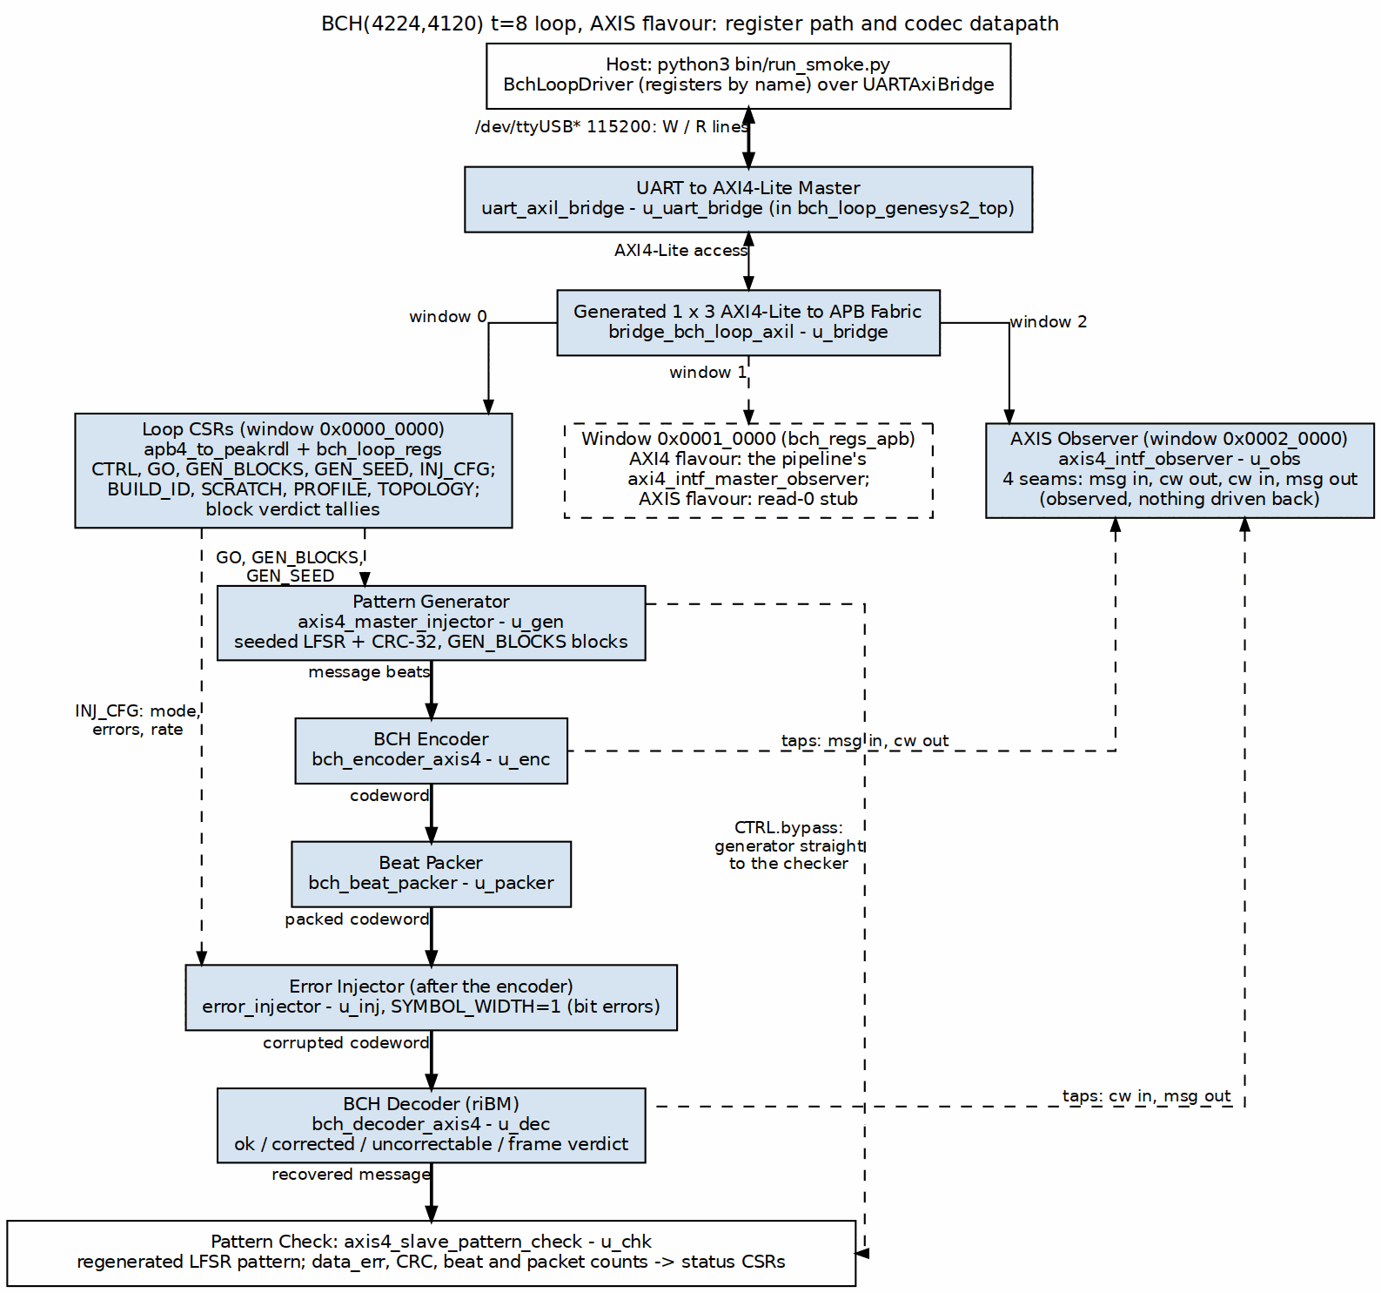
BCH AXIS datapath and register path

4.3.1 Figure 2.1: BCH AXIS datapath and register path.
Source: 01_bch_axis_loop.dot
The AXI4 flavour replaces the streaming seams with job memories; the codec itself is identical.
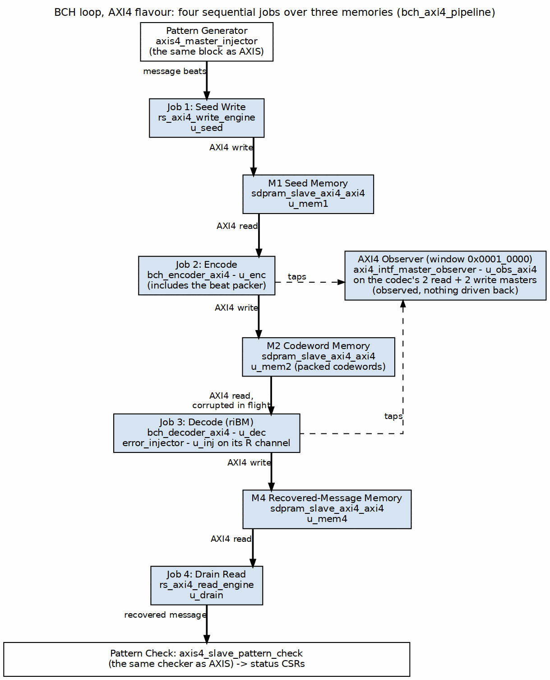
BCH AXI4 memory-to-memory datapath

4.3.2 Figure 2.2: BCH AXI4 memory-to-memory datapath.
Source: 02_bch_axi4_loop.dot

4.4 Register path, clock, and reset
The host talks by name, not by offset: BchLoopDriver wraps UARTAxiBridge with UartRegisterMap over the generated bch_loop_regs_regmap.py. The only raw addresses are the two expansion-window bases (OBS_AXI4_BASE = 0x00010000 and OBS_AXIS_BASE = 0x00020000), which match the bridge fabric definition.
Clock and reset come from bch_loop_genesys2_top: the 200 MHz LVDS system clock passes through IBUFDS and an MMCME2_BASE with CLKFBOUT_MULT_F = 6 and CLKOUT0_DIVIDE_F = 12, giving a 100 MHz harness clock. That frequency was chosen because the BCH loop and the UART divisor both close timing comfortably at 100 MHz on the k325t-2.

5 Campaigns and the Oracle Argument

5.1 Campaign inventory
Table 3.1: BCH board campaign inventory.
Campaign | What it proves | Determinism
init | BUILD_ID, SCRATCH round-trip, PROFILE, TOPOLOGY. | Deterministic.
smoke | Bypass, clean, e=t, e=t+1, deterministic DEBUG walk. | Deterministic.
sweep | Exact correction counts for e = 0 .. 2t+2. | Deterministic.
random | Fresh seeds, mixed injector modes, 64 runs x 16 blocks. | Host-seeded random.Random; reproducible on demand.
clusters | Spatially correlated errors model a bad DRAM row or NAND page. | Deterministic combo matrix.
localized | Windowed errors model a half-plane failure. | Deterministic combo matrix.
badblock | Most blocks clean, a hard minority very bad. | Deterministic combo matrix.
soak | Long-running mixed-mode stress; the million-block run. | Host-seeded; replayable.

5.2 Determinism
Every board campaign is deterministic by default: gen_seed and inj_seed start at 1, and the seq_*.py scripts produce bit-exact runs in cocotb simulation and on the board. A failure you can replay is a failure you can fix. seq_random.py still varies its draws, but those draws come from a host-side random.Random(seed) seeded by the caller, so the variation is reproducible when needed.

5.3 The on-chip oracle
The decoder uses riBM with odd-syndrome computation and even syndromes by squaring. It runs a second-syndrome recheck (ENABLE_RECHECK) and performs flip-only correction. The checker independently regenerates the expected LFSR pattern and reports data_err on any mismatched beat. Together they form the on-chip oracle: the decoder decides whether it thinks it corrected the block, and the checker decides whether the recovered bytes actually match the reference. That pairing is what makes a silent mis-decode detectable.

6 Testing Choices

6.1 Injector modes mapped to failure mechanisms
The shared error_injector exposes eight modes, and each one answers a different physical question:
Table 3.2: Injector modes and the physical questions they answer.
Mode | Failure mechanism exercised
0 | None: clean run baseline.
1 | Exact count: the e <= t / e > t correction boundary.
2 | Burst: raw bit-error behaviour on a noisy channel.
3 | Rate: continuous random bit-error rate.
4 | Clusters: spatially correlated faults (bad DRAM row, disturbed NAND page).
5 | Localized: windowed half-plane failure.
6 | Badblock: retention tails and worn blocks.
7 | Debug: deterministic walking bring-up pattern.

6.2 Post-encoder injection
The injector sits after the encoder, not inside the generator. An error in the generator data would be encoded faithfully and the code would never see it. By corrupting the codeword, the parity bits are exposed to the same errors as the data, which is what happens when a real packet is stored, transmitted, or read back from memory.

6.3 UART and the safety pair
The host link is a plain UART at 115200 baud, driven by uart_axil_bridge. That keeps the harness scriptable from Python without a debug-core licence. Two pieces of shared tooling guard the board:
- projects/fpga-systems/bin/board_lock.sh serializes programming flows by JTAG serial.
- projects/fpga-systems/bin/fpga_board.py refuses to program until a JTAG readback confirms the expected Genesys 2 serial 200300B818A0 is present with a device behind it.

6.4 Genesys 2 vs Nexys A7
The harness directory moved from NexysA7/ to Genesys2/ on 2026-10-05. BCH_TARGET still accepts nexys_a7_100t as a build option, but the Genesys 2 is the primary target. The k325t-2 has the room and timing margin to hold the full BCH(4224,4120) loop at 100 MHz with both AXIS and AXI4 flavours.

6.5 AXIS vs AXI4
Two bitstreams are built: bch_loop_genesys2_axis.bit and bch_loop_genesys2_axi4.bit. The AXIS flavour is a single streaming pipe; the AXI4 flavour is a memory-to-memory job chain across four AXI4 memories. The AXI4 flavour refuses runs whose GEN_BLOCKS exceed the job-memory capacity rather than letting regions wrap, so long soaks belong on the AXIS image. The host reads TOPOLOGY to discover which datapath is loaded.

6.6 Deliberately not board-tested
Some things are out of scope. The soak campaign ran to its default time budget and passed 1,000,000 mixed-mode blocks with zero mis-decodes, but that is a statistical sample, not every pattern. BCH has no erasure path in this harness: the injector’s out_erasure is tied off and cfg_mark_erasure is held low. The board validates only the BCH(4224,4120) t=8 profile; smaller profiles are covered in simulation and component DV.

7 Soak Results

7.1 One million blocks on the AXIS image
The 2026-10-05 soak ran the genesys2_axis image on board serial 200300B818A0. Final counters from stable/results/2026-10-05_soak/battery.json:
Table 4.1: BCH soak final counters.
Metric | Value
blocks_final | 1,000,000
wall_s | 31,910
blk_per_s | 31.0
clean | 111,957
corrected | 768,922
uncorrectable | 119,121
bits_corrected | 3,119,679
failing_runs | 0
over_t_blocks | 74,560
misdecoded | 0
misdecode_rate | 0.00e+00 (1 in 74,560)
The confidence statement is:
1,000,000 blocks, 0 mis-decodes, 74,560 over-t blocks all flagged, 3,119,679 bits corrected, 8h52m at 31 blk/s UART-bound.

7.2 Soak timeline
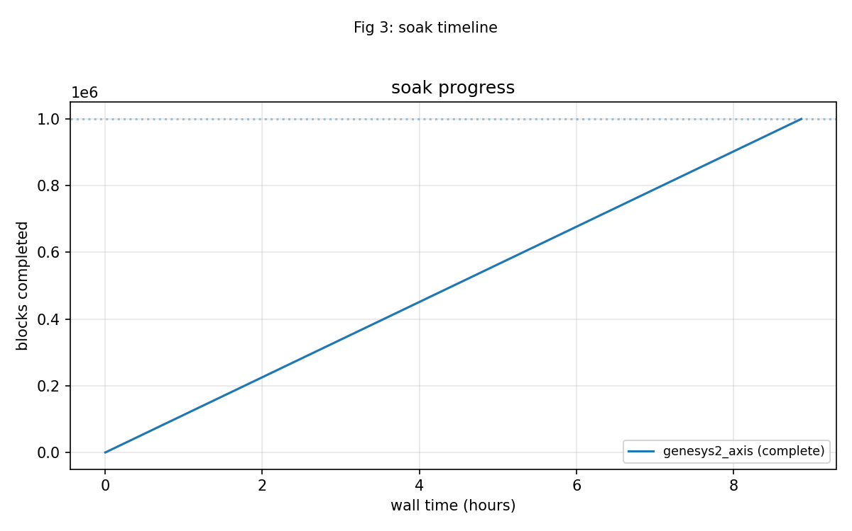
fig_3_soak_timeline.png

7.2.1 Figure 4.1: BCH soak timeline over one million blocks.

7.3 What 31 blk/s means
The codec itself can run at roughly 500k blocks per second at 100 MHz. The soak measured 31 blocks per second because the host poll loop, running over a 115200-baud UART, is the bottleneck. That is not a hardware limit; it is a fixture limit. Any future soak that wants to go deeper or faster should size the host interaction accordingly, or move to a faster host interface, rather than inferring decoder throughput from the soak rate.

8 Honest Limits

8.1 What the board evidence does not cover
- The soak is statistical, not exhaustive. One million blocks is large, but it does not visit every possible error pattern.
- The AXI4 flavour was not run to million-block depth. It refuses large runs because of job-memory capacity, so long soaks belong on AXIS.
- BCH has no erasure path in this harness by design; the injector’s out_erasure is tied off.
- The board validates only the BCH(4224,4120) t=8 profile. Smaller profiles like (63,57) t=1 are covered in simulation and component DV.
- The component DV matrix exercises the codec in ways the board harness does not replicate.

8.2 Traceability
Every quantitative claim in this book can be traced to an artifact under stable/:
Table 5.1: Traceability from claim to stable artifact.
Claim | Artifact
Timing-clean at 100 MHz | stable/reports/genesys2_axis/timing_summary.txt, WNS +0.586 ns, 0 failing endpoints.
AXI4 timing-clean | stable/reports/genesys2_axi4/timing_summary.txt, WNS +0.493 ns, 0 failing endpoints.
One million blocks, zero mis-decodes | stable/results/2026-10-05_soak/battery.json and FINDINGS.md.
74,560 over-t blocks all flagged | stable/results/2026-10-05_soak/battery.json, soak_final.over_t_blocks.
3,119,679 bits corrected | stable/results/2026-10-05_soak/battery.json, soak_final.bits_corrected.

