
RTL Design Sherpa
Reed-Solomon Board Validation Report Genesys 2 FPGA board evidence
October 2026

Table of Contents
1 Document Information 8
1.1 Revision History 8
1.2 Scope 9
1.3 Provenance 10
2 Scope and Claims 11
2.1 What this book is 11
2.2 What is claimed 12
2.3 What is not claimed 13
3 Images and Codec Profile 14
3.1 Image matrix 14
3.2 Codec profile 15
4 Harness Architecture 16
4.1 RTL inventory 16
4.2 Host and build inventory 18
4.3 Datapath diagram 19
4.3.1 Figure 2.1: Reed-Solomon AXIS datapath and register path. 19
4.4 Register path, clock, and reset 20
5 Campaigns and the Oracle Argument 21
5.1 Campaign inventory 21
5.2 Determinism and cross-solver agreement 22
5.3 The dual-solver loop as oracle 23
6 Testing Choices 24
6.1 Injector modes mapped to failure mechanisms 24
6.2 Post-encoder injection protects parity symbols 25
6.3 UART and the safety pair 26
6.4 Genesys 2 vs Nexys A7 27
6.5 AXIS and AXI4 flavors cover both integration styles 28
6.6 Deliberately not board-tested 29
7 Erasure Campaign 30
7.1 What erasure decoding adds 30
7.2 Board findings 31
7.3 TASK-005 boundary 32
8 Battery Results 33
8.1 Per-image campaign status 33
8.2 Correction boundary 34
8.2.1 Figure 4.1: Reed-Solomon correction boundary across all four images. 34
8.3 Decode cost 35
8.3.1 Figure 4.2: Reed-Solomon decode cost across all four images. 35
8.4 Sweep verdict table 36
8.5 Solver agreement 38
8.5.1 Figure 4.3: Reed-Solomon solver agreement matrix (riBM vs Euclid). 38
9 Soak Results 39
9.1 One million blocks on the AXI4 image 39
9.2 Mis-decodes versus the model 40
9.3 Soak timeline 41
9.3.1 Figure 4.4: RS soak timeline over one million blocks. 41
9.4 What 29 blk/s means 42
9.5 Image notes 43
10 Honest Limits 44
10.1 What the board evidence does not cover 44
10.2 Traceability 45

List of Figures
Figure 2.1: Reed-Solomon AXIS datapath and register path. 19
Figure 4.1: Reed-Solomon correction boundary across all four images. 34
Figure 4.2: Reed-Solomon decode cost across all four images. 35
Figure 4.3: Reed-Solomon solver agreement matrix (riBM vs Euclid). 38
Figure 4.4: RS soak timeline over one million blocks. 41

List of Tables
Table 1: Table 0.1: Revision history. 8
Table 2: Table 1.1: Reed-Solomon Genesys 2 image matrix. 14
Table 3: Table 2.1: RTL blocks in the Reed-Solomon harness. 16
Table 4: Table 2.2: Host scripts and build flow. 18
Table 5: Table 3.1: Reed-Solomon board campaign inventory. 21
Table 6: Table 3.2: Reed-Solomon erasure boundary results. 31
Table 7: Table 4.1: Reed-Solomon 2026-10-05 battery per-image status. 33
Table 8: Table 4.2: Reed-Solomon sweep verdicts. 36
Table 9: Table 4.1: RS soak final counters. 39
Table 10: Table 5.1: Traceability from claim to artifact. 45

RTL Design Sherpa · Learning Hardware Design Through Practice GitHub · Documentation Index · MIT License

1 Document Information

1.1 Revision History
Table 0.1: Revision history.
Revision | Date | Author | Description
0.1 | 2026-10-05 | RTL Design Sherpa | Initial board validation roll-up for the Reed-Solomon Genesys 2 harness.

1.2 Scope
This book covers the RS(252,236) t=8 codec as exercised on the Digilent Genesys 2 board. It describes the harness, the campaign methodology, the 2026-10-05 battery, the erasure boundary finding, and the completed million-block soak.

1.3 Provenance
All timing and campaign results in this book come from stable/MANIFEST.md, stable/results/2026-10-05_battery/, and stable/results/2026-10-05_soak/. The board used for the runs is Digilent Genesys 2 serial 200300B818A0 (Kintex-7 xc7k325t-2), programmed and measured with Vivado 2025.1.

2 Scope and Claims

2.1 What this book is
This report is the board’s statement about the RS(252,236) t=8 codec. The Genesys 2 harness runs the same campaigns in cocotb simulation and on real silicon, so when the board passes we have evidence that simulation matches hardware at 100 MHz with real I/O, real clocks, and real register traffic.

2.2 What is claimed
The 2026-10-05 battery demonstrates that four single-decoder bitstreams (two flavours times two solvers) pass the same deterministic campaign set:
- init, smoke, sweep, random, clusters, localized, and badblock all PASS on axis_ribm, axis_euclid, axi4_ribm, and axi4_euclid.
- The sweep shows e <= 8 corrected, e = 9 .. 18 uncorrectable, on every image.
- The random campaign recorded 64 runs x 16 blocks with 0 failing runs across all images.
- The matching verdict counts between riBM and Euclid images are themselves a cross-solver check.
- The 2026-10-05 million-block soak on axi4_ribm passed: 0 failing runs, and 2 mis-decodes out of 74,240 over-t blocks, below the model’s approximately 1-in-20,000 bound at e = t + 1.
That is board evidence that both key-equation solvers behave identically under the same workload and that the codec honours the correction boundary.

2.3 What is not claimed
This book does not replace the component DV matrix. It does not prove every possible error pattern or every smaller RS profile. The dual-decoder on-chip comparator is present in simulation but not in the production board matrix; agreement is proven by running identical deterministic campaigns on the two single-decoder images. The erasure f = 2t boundary is a known open issue (TASK-005) and is called out in Chapter 3 and Chapter 5. The million-block soak completed on 2026-10-06; Chapter 4 reports its counters.

3 Images and Codec Profile

3.1 Image matrix
Four Genesys 2 bitstreams were built and kept in stable/reports/:
Table 1.1: Reed-Solomon Genesys 2 image matrix.
Image | Solver | Bitstream | WNS (ns) | Failing endpoints | Notes
axis_ribm | riBM | rs_loop_genesys2_axis_ribm.bit | +1.072 | 0 | Streaming pipe.
axis_euclid | Euclid | rs_loop_genesys2_axis_euclid.bit | +0.875 | 0 | Streaming pipe.
axi4_ribm | riBM | rs_loop_genesys2_axi4_ribm.bit | +1.822 | 0 | Memory-to-memory chain.
axi4_euclid | Euclid | rs_loop_genesys2_axi4_euclid.bit | +1.431 | 0 | Memory-to-memory chain.
All four images are timing-clean at 100 MHz on the k325t-2. The WNS values were read from the four stable/reports/genesys2_*/timing_summary.txt files.

3.2 Codec profile
The geometry is frozen in build-loop/rtl/rs_loop_cfg_pkg.sv:
- Code: RS(252,236), t=8, m=8.
- Symbols per beat: 4 (S=4), so a 32-bit beat carries four 8-bit symbols.
- Shortened from the natural 255-symbol RS block so that n=252 and k=236 are both multiples of the beat size. A full codeword is 63 beats; the message is 59 beats.
The shortening was deliberate: it makes the AXIS datapath line-rate at 63 cycles per block and keeps the AXI4 memory alignment clean. The host reads PROFILE to discover the geometry and TOPOLOGY to discover which datapath and solver are loaded.

4 Harness Architecture

4.1 RTL inventory
Table 2.1: RTL blocks in the Reed-Solomon harness.
Module | File | Role
uart_axil_bridge | projects/components/utility-ip/converters/rtl/uart_to_axil4/uart_axil_bridge.sv | UART 115200 8N1 to AXI4-Lite master.
bridge_rs_loop_axil | Generated fabric | 1-master x 3-slave AXI4-Lite/APB fabric.
rs_loop_genesys2_top / rs_loop_top | build-loop/rtl/rs_loop_genesys2_top.sv / build-loop/rtl/rs_loop_top.sv | Genesys 2 MMCM wrapper, or Nexys A7 100 MHz direct clock.
rs_loop_harness | build-loop/rtl/rs_loop_harness.sv | Codec loop, register decode, bandwidth meters, observers, verdict tallies.
rs_loop_cfg_pkg | build-loop/rtl/rs_loop_cfg_pkg.sv | Single source of geometry: RS(252,236), 4 symbols/beat.
rs_loop_regs | Generated from build-loop/rtl/rs_loop_regs.rdl | Host-visible CSR block.
axis4_master_injector | rtl/amba/shared/axis4_master_injector.sv | LFSR data source plus expected CRC-32, one packet per block.
axis4_slave_pattern_check | rtl/amba/shared/axis4_slave_pattern_check.sv | Regenerates the same LFSR pattern and compares beats per decoder.
rs_encoder_core | Component RS RTL | RS(252,236) encoder.
error_injector | Shared utility RTL | Post-encoder corruption: modes 0..7 plus erasure mark.
rs_decoder_core | Component RS RTL | Decoder with selectable KES_ALGO and erasure path.
rs_erasure_unit | Component RS RTL | Erasure locator / transform used when ERASURE_SUPPORT=1.
rs_axi4_pipeline | build-loop/rtl/rs_axi4_pipeline.sv | Memory-to-memory job chain for the AXI4 flavor.
axis4_intf_observer | Shared utility RTL | Four AXIS seam observer on window 0x20000.
axi4_intf_master_observer | Shared utility RTL | Four codec AXI4 master-port observer on window 0x10000.

4.2 Host and build inventory
Table 2.2: Host scripts and build flow.
Script / target | File | Role
rs_env.py | bin/rs_env.py | Path anchor for shared host code.
run_smoke.py | bin/run_smoke.py | Campaign runner.
init / smoke / sweep / random / soak / erasure | bin/seq_*.py | Deterministic campaign sequences.
RsLoopDriver | build-loop/host/rs_loop.py | By-name register access and status collection.
rs_loop_programs | build-loop/host/rs_loop_programs.py | Shared authored-once programs.
host_rs_loop.py | build-loop/host/host_rs_loop.py | CLI front-end.
make -C build-loop bitstream | build-loop/Makefile | Vivado build; set RS_TARGET=genesys2.
bin/build_image_matrix.sh | bin/build_image_matrix.sh | Builds {axis,axi4} x {riBM,Euclid}.

4.3 Datapath diagram
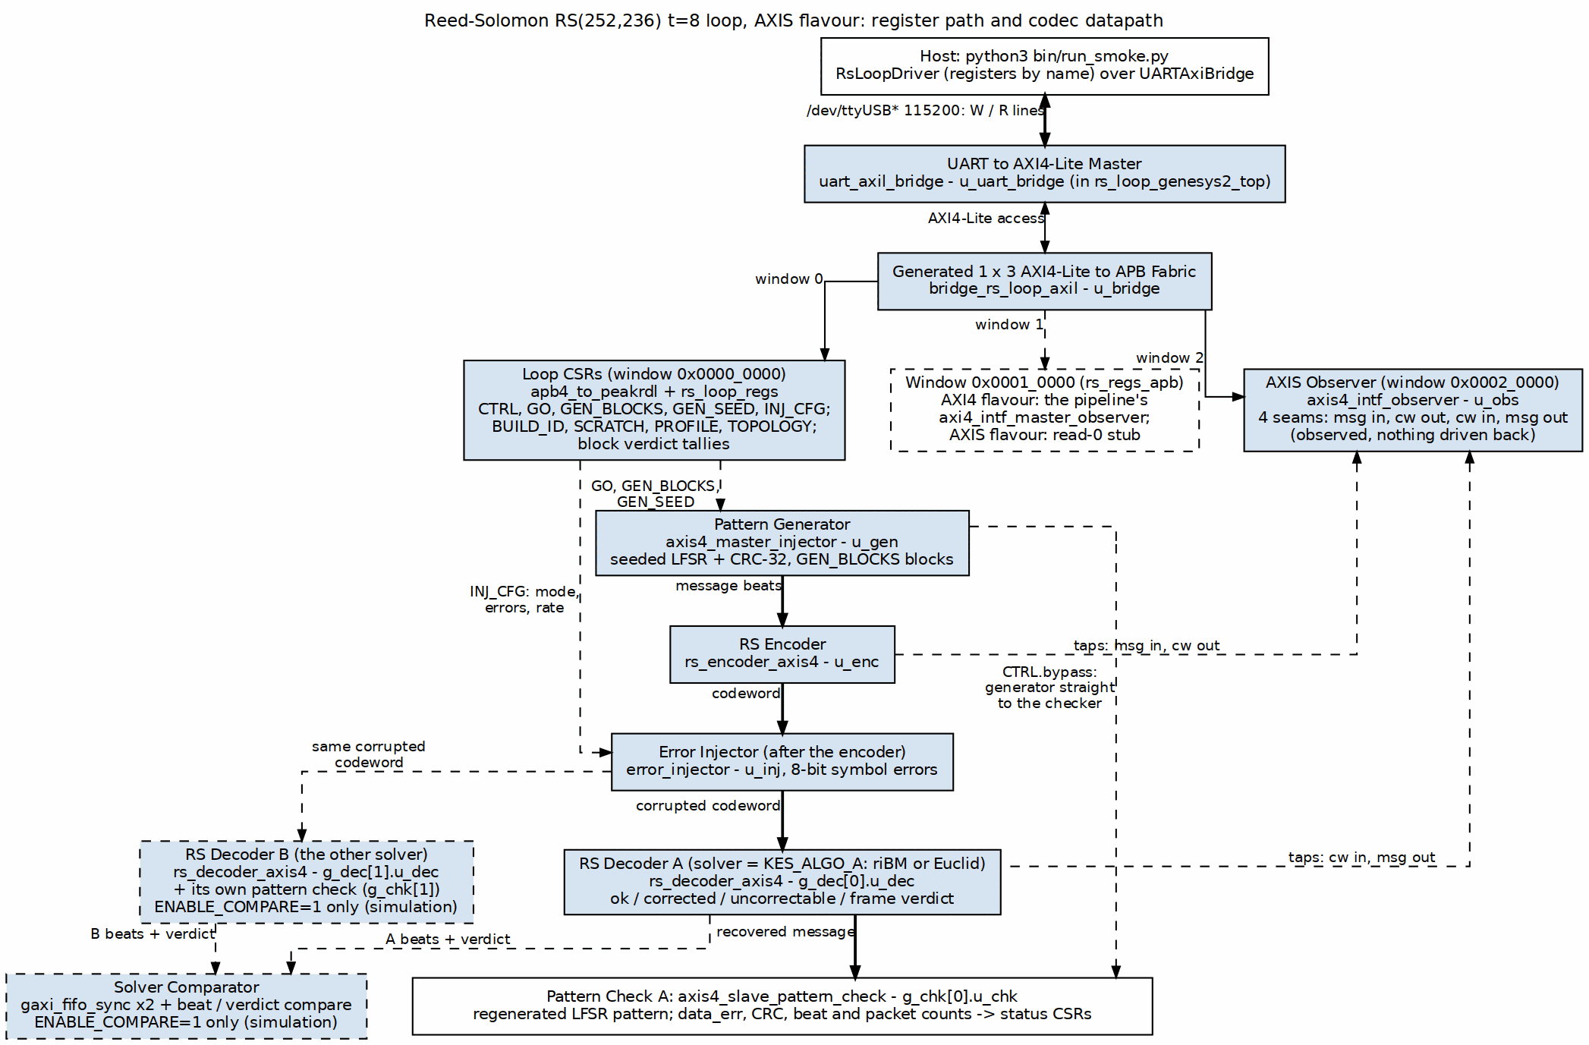
Reed-Solomon AXIS datapath and register path

4.3.1 Figure 2.1: Reed-Solomon AXIS datapath and register path.
Source: 01_rs_axis_loop.dot

4.4 Register path, clock, and reset
The host register path is Python over pyserial to the UART, into uart_axil_bridge, through the generated bridge_rs_loop_axil 1x3 fabric, and out as three APB windows. Window 0 at 0x00000000 holds rs_loop_regs (BUILD_ID, SCRATCH, PROFILE, TOPOLOGY, INJ_CFG, etc.). Window 1 at 0x00010000 hosts the AXI4 master observer on AXI4 flavours and is a read-zero stub on AXIS. Window 2 at 0x00020000 is always live and hosts the AXIS seam observer.
On the Genesys 2 the 200 MHz LVDS system clock passes through IBUFDS into an MMCME2_BASE with VCO = 1200 MHz and CLKOUT0_DIVIDE_F = 12, producing the 100 MHz harness clock. The Nexys A7 top uses the on-board 100 MHz clock directly.

5 Campaigns and the Oracle Argument

5.1 Campaign inventory
Table 3.1: Reed-Solomon board campaign inventory.
Campaign | What it proves | Determinism
init | BUILD_ID, SCRATCH round-trip, PROFILE, TOPOLOGY. | Deterministic.
smoke | Bypass, clean, e=t, e=t+1, deterministic DEBUG walk. | Deterministic.
sweep | Exact correction counts for e = 0 .. 2t+2. | Deterministic.
random | Fresh seeds, mixed injector modes, 64 runs x 16 blocks. | Host-seeded; reproducible on demand.
clusters | Spatially correlated errors. | Deterministic combo matrix.
localized | Windowed errors. | Deterministic combo matrix.
badblock | Retention-tail / worn-block behaviour. | Deterministic combo matrix.
erasure | Marked-symbol runs at f = t, 2t, 2t+1. | Deterministic.
soak | Long-running mixed-mode stress; the million-block run. | Host-seeded; replayable.

5.2 Determinism and cross-solver agreement
The host-side RNG seed defaults to 1. With that default, the random, soak, clusters, localized, and badblock campaigns are fully deterministic. Because the riBM and Euclid images run bit-identical workloads, the matching verdict counts between them are the cross-check. You do not need the on-chip comparator to know the two solvers agree; the campaigns prove it.

5.3 The dual-solver loop as oracle
The AXIS datapath in simulation feeds the same corrupted blocks to two rs_decoder_core instances, one with KES_ALGO=RIBM and one with KES_ALGO=EUCLID. Each decoder’s output is compared beat-by-beat against the generator’s regenerated LFSR pattern in its own axis4_slave_pattern_check, so a correction is judged by a reference that never saw the errors. A separate comparator then requires the two decoders to agree on every beat and on every block’s verdict. On the board images this comparator is absent by construction; the cross-check is the deterministic campaign battery.

6 Testing Choices

6.1 Injector modes mapped to failure mechanisms
The shared error_injector operates on 8-bit symbols. Mode 1 exact-count places exactly e errors per block at uniformly random distinct positions, which is what makes the e = t / e = t + 1 boundary sharp. Mode 2 burst and mode 3 rate model raw channel bit-error behaviour. Modes 4 clusters and 5 localized model spatially correlated faults. Mode 6 badblock models the tail of NAND retention. Mode 7 debug is the deterministic bring-up walk.

6.2 Post-encoder injection protects parity symbols
Errors are injected after the encoder, not in the generator. An error in the generator’s data would be encoded faithfully and would be invisible to the code. Placing the injector on the coded stream means parity symbols are corrupted too, which is the workload the decoder actually has to handle.

6.3 UART and the safety pair
The harness uses a plain UART instead of a proprietary debug core, so the host side is just pyserial and Python scripts. Board safety is a pair: board_lock.sh serializes programming flows by JTAG serial, and fpga_board.py reads the JTAG chain before programming to confirm the expected Genesys 2 serial (200300B818A0) is present with a device behind it.

6.4 Genesys 2 vs Nexys A7
The Kintex-7 XC7K325T-2 was chosen because it has room for the full harness plus observers and still closes timing with positive slack. The Nexys A7-100T flow is kept as a target option (RS_TARGET=nexys_a7_100t) but the Genesys 2 is the primary target for harness-class work.

6.5 AXIS and AXI4 flavors cover both integration styles
The AXIS flavor is a single streaming pipe; the AXI4 flavor replaces the middle with rs_axi4_pipeline, a memory-to-memory job chain over block RAM. Both use the same generator, checker, CSRs, and verdict logic, so a run reports itself identically whichever middle is built. Running the same deterministic campaign on both flavours is a free sanity check. The AXI4 flavor refuses a GEN_BLOCKS value that would exceed the job memories.

6.6 Deliberately not board-tested
The dual-decoder comparator with ENABLE_COMPARE=1 is the sim/DV domain. The soak campaign runs separately from the battery because of its wall time — hours at UART rates; it completed on 2026-10-06 and is reported in Chapter 4. The component DV matrix exercises the codec in ways the board harness does not replicate. The erasure f = 2t boundary is a known open issue, detailed in the next section.

7 Erasure Campaign

7.1 What erasure decoding adds
When INJ_CFG.mark is set, the injector’s hit mask rides the decoder in_erasure sideband. The decoder is then told which symbols were corrupted, so the correction bound doubles: the decoder can correct e errors plus f erasures whenever 2e + f <= 2t. For RS(252,236) t=8, that means:
- f = t = 8 erasures alone should correct.
- f = 2t = 16 erasures alone should correct.
- f = 2t + 1 = 17 erasures should be refused by inspection.

7.2 Board findings
The erasure sequence was run on the Genesys 2 board:
Table 3.2: Reed-Solomon erasure boundary results.
f | Expected | Observed
8 (t) | Correct | Correct: 16/16 blocks corrected, A=B solver agreement.
16 (2t) | Correct | Flagged uncorrectable: ok/corr/unc = 0/0/16.
17 (2t+1) | Refuse by inspection | Refused: 16/16 blocks uncorrectable.

7.3 TASK-005 boundary
The f = 2t case is the known open issue TASK-005 (vault/Tasks/projects/components/ecc-ip/reed-solomon/task/open/TASK-005.md): the B-stage t_zero bypass intends to pass f = 16, but the final verdict fires downstream. The f = t and f = 2t+1 paths are correct; the f = 2t path must be fixed in the component DV and then re-run on the board. This report documents the finding exactly as measured and does not fabricate a corrected result.

8 Battery Results

8.1 Per-image campaign status
All four images passed every campaign in the 2026-10-05 battery:
Table 4.1: Reed-Solomon 2026-10-05 battery per-image status.
Image | Solver | Init | Smoke | Sweep | Random | Clusters | Localized | Badblock
axis_ribm | riBM | PASS | PASS | PASS | PASS | PASS | PASS | PASS
axis_euclid | Euclid | PASS | PASS | PASS | PASS | PASS | PASS | PASS
axi4_ribm | riBM | PASS | PASS | PASS | PASS | PASS | PASS | PASS
axi4_euclid | Euclid | PASS | PASS | PASS | PASS | PASS | PASS | PASS

8.2 Correction boundary
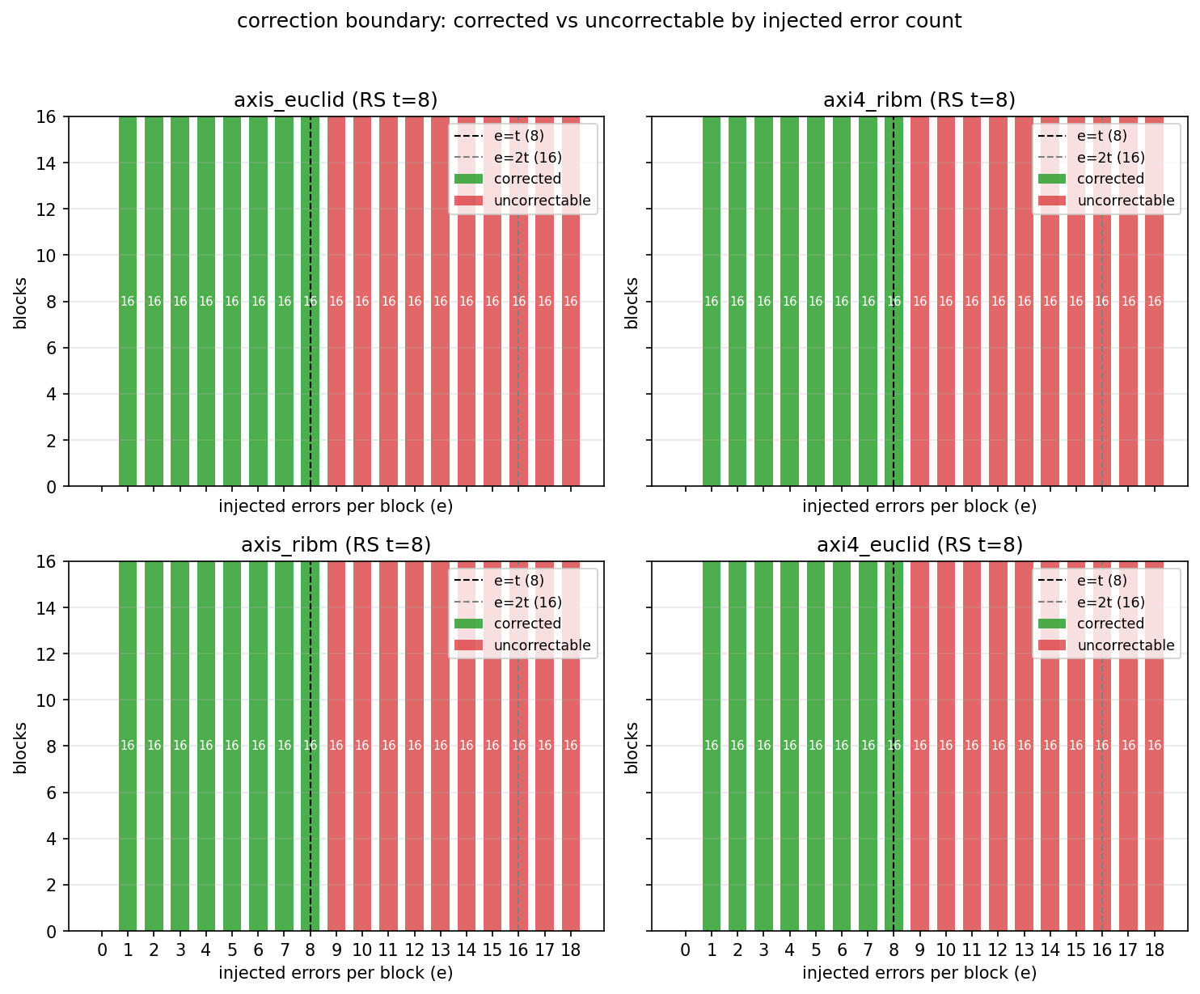
fig_1_correction_boundary.png

8.2.1 Figure 4.1: Reed-Solomon correction boundary across all four images.

8.3 Decode cost
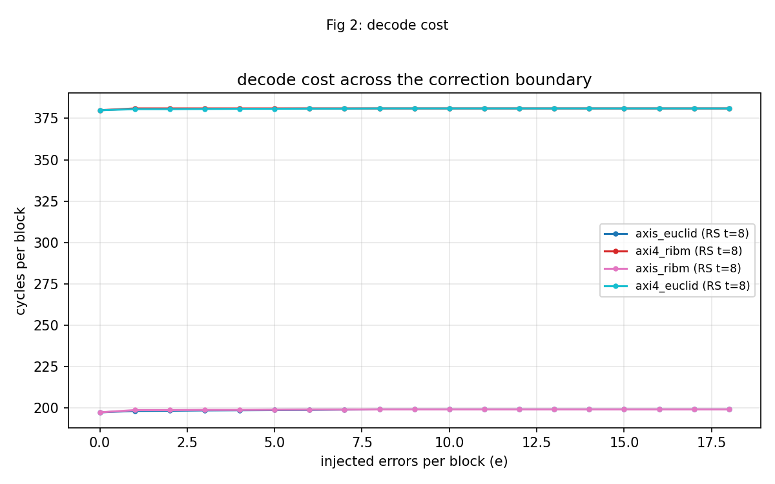
fig_2_decode_cost.png

8.3.1 Figure 4.2: Reed-Solomon decode cost across all four images.

8.4 Sweep verdict table
The sweep ran e = 0 .. 18 with 16 blocks per count on every image:
Table 4.2: Reed-Solomon sweep verdicts.
e | Verdict | Blocks | Notes
0 | Correct | 16 | Clean decode.
1 | Correct | 16 | 16 symbols corrected.
2 | Correct | 16 | 32 symbols corrected.
3 | Correct | 16 | 48 symbols corrected.
4 | Correct | 16 | 64 symbols corrected.
5 | Correct | 16 | 80 symbols corrected.
6 | Correct | 16 | 96 symbols corrected.
7 | Correct | 16 | 112 symbols corrected.
8 | Correct | 16 | 128 symbols corrected.
9 | Uncorrectable | 16 | Past correction boundary.
10 | Uncorrectable | 16 | Past correction boundary.
11 | Uncorrectable | 16 | Past correction boundary.
12 | Uncorrectable | 16 | Past correction boundary.
13 | Uncorrectable | 16 | Past correction boundary.
14 | Uncorrectable | 16 | Past correction boundary.
15 | Uncorrectable | 16 | Past correction boundary.
16 | Uncorrectable | 16 | Past correction boundary.
17 | Uncorrectable | 16 | Past correction boundary.
18 | Uncorrectable | 16 | Past correction boundary.

8.5 Solver agreement
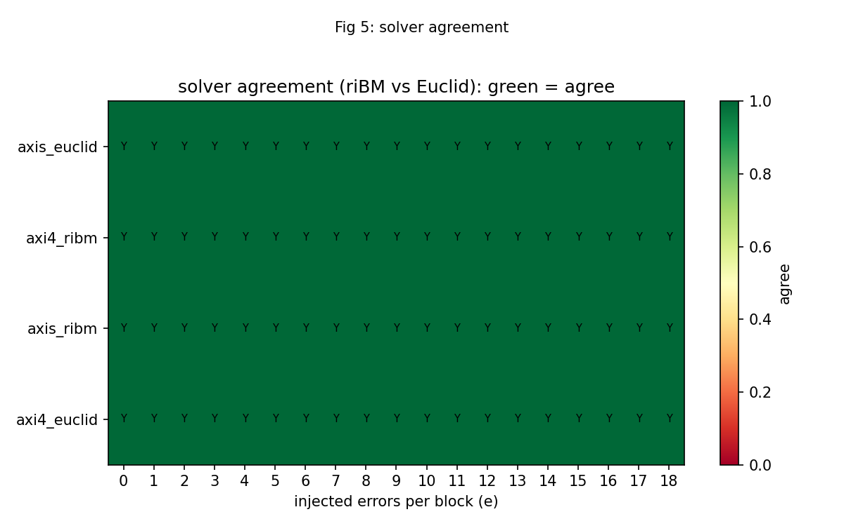
fig_5_solver_agreement.png

8.5.1 Figure 4.3: Reed-Solomon solver agreement matrix (riBM vs Euclid).
The matrix is entirely green with a Y in every cell. That means no image, at any injected error count from 0 to 18, disagreed with its sibling solver on the same deterministic workload. The absence of any red cell is the board evidence that the two key-equation solvers are consistent.

9 Soak Results

9.1 One million blocks on the AXI4 image
The 2026-10-05 soak ran the axi4_ribm image on board serial 200300B818A0. Final counters from stable/results/2026-10-05_soak/battery.json:
Table 4.1: RS soak final counters.
Metric | Value
blocks_final | 1,000,000
wall_s | 34,902
blk_per_s | 29.0
clean | 113,143
corrected | 768,077
uncorrectable | 118,780
symbols_corrected | 3,119,170
failing_runs | 0
over_t_blocks | 74,240
misdecoded | 2
misdecode_rate | 2.69e-05 (1 in 37,120)
The confidence statement is:
1,000,000 blocks, 3,119,170 symbols corrected, 0 failing runs, 9h42m at 29 blk/s UART-bound. Of the 74,240 blocks pushed past the correction limit, 2 were accepted and silently mis-decoded — a rate of 1 in 37,120, which is below the model’s predicted roughly 1-in-20,000 mis-decode rate at e = t + 1 for this profile.

9.2 Mis-decodes versus the model
The soak’s pass criterion is a bounded mis-decode rate, not zero mis-decodes. A block carrying more than t = 8 symbol errors is beyond the code’s guaranteed radius; the decoder is mathematically permitted to return a codeword other than the transmitted one. The harness counts every such event, and the acceptance bound is the analytic failure rate for the profile. The observed 2 of 74,240 sits under the model bound, which is what “soak PASS” means here. Every other over-t block was flagged uncorrectable, and all 768,077 corrected blocks matched the oracle.

9.3 Soak timeline
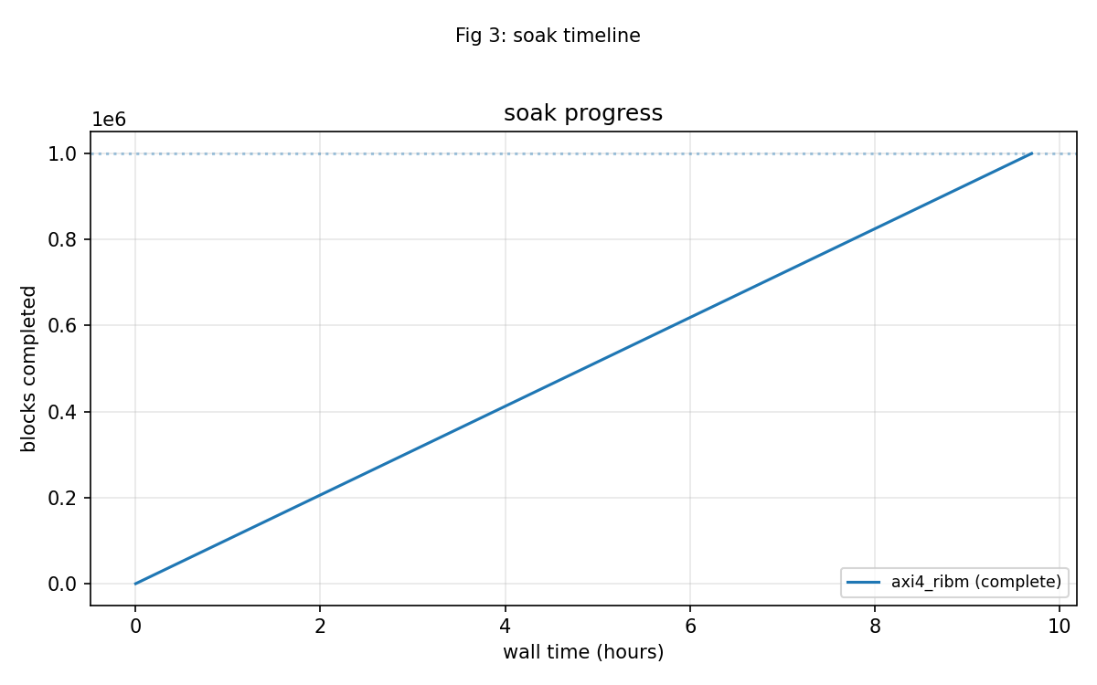
fig_3_soak_timeline.png

9.3.1 Figure 4.4: RS soak timeline over one million blocks.

9.4 What 29 blk/s means
The codec itself can run at roughly 500k blocks per second at 100 MHz. The soak measured 29 blocks per second because the host poll loop, running over a 115200-baud UART, is the bottleneck. That is not a hardware limit; it is a fixture limit. Any future soak that wants to go deeper or faster should size the host interaction accordingly, or move to a faster host interface, rather than inferring decoder throughput from the soak rate.

9.5 Image notes
The soak ran on the memory-to-memory AXI4 image. The earlier plan to prefer the AXIS flavour for soaks turned out to be unnecessary: the AXI4 job memories accept the soak’s per-block job pattern without issue. The axi4_ribm image is single-decoder, so the riBM-versus-Euclid comparator counters read 0 by design; solver agreement on the board is covered by the deterministic cross-image campaigns in the battery chapter.

10 Honest Limits

10.1 What the board evidence does not cover
- The soak is statistical, not exhaustive. One million blocks is large, but it does not visit every possible error pattern. Two blocks out of 74,240 pushed past the correction limit were silently mis-decoded (1 in 37,120), below the model’s predicted roughly 1-in-20,000 rate at e = t + 1; the soak’s pass criterion is the bounded rate, not zero.
- The erasure f = 2t boundary is an open issue (TASK-005). f = t corrects and f = 2t+1 refuses on the board; f = 2t is flagged uncorrectable even though the design intent says it should correct.
- The dual-decoder comparator with ENABLE_COMPARE=1 is sim-only on the board matrix. Solver agreement on the board is proven by running identical deterministic campaigns on the single-decoder images.
- BCH has no erasure path by design; that comparison is RS-only.
- The board validates only the RS(252,236) t=8, S=4 profile. Other profiles are covered in simulation and component DV.
- The component DV matrix exercises the codec in ways the board harness does not replicate.

10.2 Traceability
Every quantitative claim in this book can be traced to an artifact under stable/:
Table 5.1: Traceability from claim to artifact.
Claim | Artifact
Four images timing-clean at 100 MHz | stable/reports/genesys2_{axis_ribm,axis_euclid,axi4_ribm,axi4_euclid}/timing_summary.txt, all WNS positive, 0 failing endpoints.
7/7 campaigns PASS on all images | stable/results/2026-10-05_battery/battery.json and FINDINGS.md.
e <= 8 corrected, e > 8 uncorrectable | stable/results/2026-10-05_battery/battery.json, sweep array.
Solver agreement matrix all green | stable/results/2026-10-05_battery/fig_5_solver_agreement.png.
Million-block soak PASS on axi4_ribm | stable/results/2026-10-05_soak/battery.json and FINDINGS.md.
f = 2t erasure boundary open | vault/Tasks/projects/components/ecc-ip/reed-solomon/task/open/TASK-005.md.

