
RTL Design Sherpa
RAPIDS Beats Hardware Architecture Specification 0.6
July 2, 2026

Table of Contents
1 Rapids Beats Has Index 27
2 Document Information 28
2.1 Purpose 28
2.2 Scope 28
2.3 Audience 28
2.4 Document Conventions 29
2.4.1 Requirement Levels 29
2.4.2 Signal Directions 29
2.4.3 Timing Diagrams 29
2.5 References 29
3 Revision History 31
3.1 Change Summary 32
3.1.1 Version 0.8 (2026-07-13) 32
3.1.2 Version 0.7 (2026-07-13) 32
3.1.3 Version 0.6 (2026-07-02) 33
3.1.4 Version 1.0 (2026-01-17) 33
4 Acronyms and Definitions 34
4.1 Acronyms 34
4.2 Definitions 34
4.3 Signal Naming Conventions 35
5 Product Overview 36
5.1 Introduction 36
5.2 System Context 36
5.2.1 Figure 1.1.1: RAPIDS Beats in Its System 36
5.3 Target Applications 36
5.4 Architecture Highlights 37
5.4.1 Phase 1 “Beats” Simplifications 37
5.4.2 Key Capabilities 37
6 Key Features 38
6.1 Feature Summary 38
6.1.1 Multi-Channel Architecture 38
6.1.2 Descriptor-Based Control 38
6.1.3 High-Performance Data Paths 38
6.1.4 Monitoring and Debug 38
6.2 Feature Details 39
6.2.1 SRAM Buffering 40
6.2.2 AXI Burst Optimization 40
6.2.3 Error Handling 41
7 System Context 42
7.1 Integration Overview 42
7.2 System Block Diagram 42
7.2.1 Figure 1.3.1: System Integration 42
7.3 Interface Connections 42
7.3.1 Memory Interface 42
7.3.2 Network Interface 43
7.3.3 Configuration Interface 44
7.4 Clock and Reset 44
7.4.1 Clock Domains 44
7.4.2 Reset Requirements 44
7.5 Power Considerations 45
7.5.1 Clock Gating 45
7.5.2 Power States 45
8 Block Diagram 46
8.1 Top-Level Architecture 46
8.1.1 Figure 2.1.1: RAPIDS Beats Whole Unit 46
8.2 Top-Level Integration (rapids_beats_top) 46
8.2.1 Figure 2.1.2: rapids_beats_top Integration 47
8.3 Component Summary 47
8.3.1 Scheduler Group Array 47
8.3.2 Sink Data Path 48
8.3.3 Source Data Path 48
8.4 Hierarchy 48
8.5 Internal Buses 49
9 Data Flow 50
9.1 Overview 50
9.2 Sink Path Data Flow 50
9.3 Concurrent Operation 52
9.3.1 Deadlock Prevention 53
10 Channel Architecture 54
10.1 Multi-Channel Design 54
10.2 Channel Resource Allocation 54
10.2.1 Figure 2.3.1: Per-Channel and Shared Resources 54
10.3 Per-Channel Resources 54
10.4 Shared Resources 55
10.5 Channel Scheduling 55
10.5.1 Arbitration Policy 55
10.5.2 Figure 2.3.2: Channel Arbitration onto a Shared AXI Port 55
10.6 Channel State Machine 56
10.7 Channel Isolation 58
10.7.1 Per-Channel Error Handling 58
11 Interface Summary 60
11.1 External Interface Overview 60
11.1.1 Figure 3.1.1: External Interfaces 60
11.2 Interface Port Summary 60
11.3 Clock and Reset 61
11.4 Interface Feature Matrix 61
11.5 Signal Count Summary 62
12 AXI4 Interface Specification 63
12.1 Overview 63
12.2 Descriptor AXI Master 63
12.2.1 Purpose 63
12.2.2 Configuration 63
12.2.3 Signal List 63
12.3 Sink AXI Master (Write) 65
12.3.1 Purpose 65
12.3.2 Configuration 65
12.3.3 Signal List 65
12.4 Source AXI Master (Read) 67
12.4.1 Purpose 67
12.4.2 Configuration 67
12.4.3 Signal List 68
12.5 AXI Protocol Constraints 69
12.5.1 Address Alignment 69
12.5.2 4KB Boundary Handling 69
12.5.3 Response Handling 70
13 AXIS Interface Specification 71
13.1 Overview 71
13.2 Sink AXIS Slave 71
13.2.1 Purpose 71
13.2.2 Configuration 71
13.2.3 Signal List 71
13.2.4 Backpressure Behavior 72
13.3 Source AXIS Master 73
13.3.1 Purpose 73
13.3.2 Configuration 73
13.3.3 Signal List 73
13.3.4 Data Availability 74
13.4 AXIS Protocol Notes 74
13.4.1 Handshake Rules 74
13.4.2 TLAST Semantics 75
13.4.3 TKEEP Usage 75
13.4.4 Channel Multiplexing via TID 75
14 APB Configuration Interface 76
14.1 Overview 76
14.2 APB Slave and Address Routing 76
14.2.1 APB Slave Signal List 77
14.2.2 Descriptor Kick-Off 77
14.3 Status Interface 78
14.3.1 Per-Channel Status Signals 78
14.3.2 Channel State Encoding 78
14.4 Configuration Registers 78
14.4.1 Address Range Validation 78
14.4.2 Configuration Registers 79
14.5 Programming Sequence 79
14.5.1 Initialization 79
14.5.2 Descriptor Kick-Off 80
15 Monitor Bus Interface 81
15.1 Overview 81
15.2 MonBus Packet Format 81
15.2.1 64-bit Packet Structure 81
15.2.2 Signal List 81
15.3 Packet Types 82
15.4 Agent IDs 82
15.5 Event Codes 83
15.5.1 Scheduler Events (Agent 0x30-0x37) 83
15.5.2 Descriptor Engine Events (Agent 0x10-0x17) 83
15.6 Event Data Encoding 84
15.6.1 Completion Event Data 84
15.6.2 Error Event Data 84
15.6.3 State Transition Event Data 84
15.7 MonBus Arbitration 84
15.7.1 Figure 3.5.1: MonBus Arbitration Tree 85
15.7.2 Arbitration Policy 85
15.8 Top-Level MonBus Delivery (monbus_axil4_axil4_group) 85
15.9 Integration Notes 86
15.9.1 Downstream Connection 86
15.9.2 Packet Rate 86
16 Use Case: Network to Memory (Sink Path) 88
16.1 Overview 88
16.2 Buffer Management 89
16.2.1 SRAM Buffering Strategy 89
16.2.2 Figure 4.1.1: Sink Channel Buffer 89
16.2.3 Flow Control 90
16.3 Performance Considerations 90
16.3.1 Throughput 90
16.3.2 Latency 90
16.4 Error Handling 91
16.4.1 Error Sources 91
17 Use Case: Memory to Network (Source Path) 94
17.1 Overview 94
17.2 Buffer Management 95
17.2.1 SRAM Buffering Strategy 95
17.2.2 Figure 4.2.1: Source Channel Buffer 95
17.2.3 Flow Control 96
17.3 Concurrent Operation 96
17.3.1 Read-Ahead Pipeline 96
17.4 Performance Considerations 97
17.4.1 Throughput 97
17.4.2 Latency 97
17.5 Error Handling 97
17.5.1 Error Sources 97
18 Use Case: Descriptor Chaining 99
18.1 Overview 99
18.2 Chain Structure 99
18.2.1 Figure 4.3.1: Descriptor Chain Structure 99
18.3 Descriptor Fields for Chaining 101
18.3.1 Relevant Fields 101
18.3.2 Chain Termination 101
18.4 Prefetch Optimization 103
18.4.1 Descriptor Prefetching 103
18.5 Multi-Channel Chaining 103
18.5.1 Figure 4.3.2: Independent Per-Channel Chains 104
18.6 Error During Chain 104
18.6.1 Error Handling 104
18.6.2 Recovery 105
19 Use Case: Multi-Channel Operation 106
19.1 Overview 106
19.2 Channel Independence 106
19.2.1 Figure 4.4.1: Independent Channels 106
19.3 Resource Arbitration 107
19.3.1 Descriptor Port Arbitration 107
19.3.2 Sink/Source Arbitration 107
19.3.3 Figure 4.4.2: Data-Path AXI Arbitration 107
19.4 Channel Isolation 108
19.4.1 Error Isolation 108
19.4.2 Per-Channel Soft Reset 108
19.5 Use Case Examples 108
19.5.1 Mixed Traffic Pattern 108
19.5.2 Bidirectional Transfer 109
19.5.3 Figure 4.4.3: Bidirectional Transfer 109
19.5.4 Load Balancing 109
19.5.5 Figure 4.4.4: Load Balancing by tid 110
19.6 Performance Considerations 110
19.6.1 Bandwidth Sharing 110
19.6.2 Latency Impact 111
19.7 MonBus Events 111
20 Descriptor Format 112
20.1 Overview 112
20.2 Descriptor Layout 112
20.2.1 256-Bit Structure 112
20.3 Field Descriptions 113
20.3.1 Control Bits [195:192] 113
20.3.2 Direction 114
20.3.3 Transfer Length [159:128] 114
20.3.4 Next Pointer [191:160] 114
20.3.5 Address Fields [127:0] 114
20.4 Descriptor Opcodes (DATA / CTRL_READ / CTRL_WRITE) 114
20.5 Extended Descriptors (row/col-major addressing) 115
20.6 Alignment Requirements 117
20.7 Descriptor Examples 118
20.7.1 Sink Descriptor (Network to Memory) 118
20.7.2 Source Descriptor (Memory to Network) 118
20.8 Software Construction 119
20.8.1 C Structure Example 119
20.8.2 Descriptor Ring Setup 119
21 Register Map 121
21.1 Overview 121
21.2 Address Space Layout 121
21.3 Base Registers (0x100-0x3FF) 122
21.4 Monitor Registers (+0x800 within each half) 123
21.5 Key Register Fields 124
21.5.1 GLOBAL_CTRL (0x100) - Read/Write 124
21.5.2 SCHED_TIMEOUT_LIMIT (0x208) - Read/Write 125
21.5.3 DESCENG_CONFIG (0x220) - Read/Write 125
21.6 Channel Kick Sequence 126
21.7 Address Decoding 127
22 Initialization Sequence 128
22.1 Overview 128
22.2 Boot Sequence 129
22.2.1 Figure 5.3.1: Bring-Up Sequence 129
22.3 What the Hardware Requires 130
22.4 Detailed Steps 130
22.4.1 Step 1: Verify Hardware Presence 130
22.4.2 Step 2: Optional Reset 131
22.4.3 Step 3: Configure the Engine 131
22.4.4 Step 4: Optional Monitor and Interrupt Egress 132
22.4.5 Step 5: Build Descriptors 132
22.4.6 Step 6: Enable 133
22.5 Starting Transfers 133
22.5.1 Kick a Channel 133
22.6 Completion and Interrupt Handling 134
22.7 Reset and Recovery 135
22.7.1 Per-Channel Reset 135
22.7.2 Global Reset 135
23 Error Handling 136
23.1 Overview 136
23.2 Error Categories 136
23.2.1 Figure 5.4.1: Error Sources 136
23.3 Error Detection 136
23.3.1 AXI Response Errors 136
23.3.2 Descriptor Errors 137
23.3.3 Timeout Detection 138
23.4 Error Reporting 140
23.4.1 Status Registers 140
23.4.2 MonBus Error Events 140
23.4.3 Interrupt Generation 141
23.4.4 Figure 5.4.2: Error Reporting 142
23.5 Error Recovery 143
23.5.1 Recovery Flow 143
23.5.2 Figure 5.4.3: Error Recovery 143
23.5.3 Finding the Faulted Channel 143
23.5.4 AXI Error Recovery 144
23.5.5 Descriptor Error Recovery 144
23.5.6 Timeout Recovery 145
23.6 Error Prevention 145
23.6.1 Best Practices 145
23.6.2 Descriptor Validation Example 145
24 Throughput Targets 147
24.1 Theoretical Maximum 147
24.1.1 Per-Interface Bandwidth 147
24.1.2 Aggregate Bandwidth 147
24.2 Practical Throughput 148
24.2.1 Single-Channel Performance 148
24.2.2 Multi-Channel Performance 148
24.3 Throughput Limiting Factors 148
24.3.1 Memory / Network System Factors 148
24.3.2 RAPIDS Internal Factors 149
24.4 Performance Targets 150
24.4.1 Design Targets 150
24.4.2 Verification Criteria 150
24.5 On-Silicon Validation 150
25 Latency Characteristics 152
25.1 Latency Components 152
25.1.1 Kick-to-First-Beat Breakdown 152
25.1.2 Total Latency Formula 153
25.2 First-Beat Latency 153
25.3 Control-Descriptor Latency 153
25.4 Latency Variability 154
25.4.1 Sources of Variability 154
25.4.2 Worst-Case Latency 154
25.5 Latency Optimization 154
25.5.1 Software Recommendations 154
25.5.2 Hardware Configuration 154
26 Resource Estimates 156
26.1 FPGA Resource Summary 156
26.2 Resource Breakdown by Block 156
26.2.1 APB Configuration Slave + Register Block 156
26.2.2 Scheduler Group (per direction) 157
26.2.3 Control Engines (per direction) 157
26.2.4 AXI Read / Write Engines 157
26.2.5 SRAM Buffers (sink + source) 157
26.2.6 MonBus / AXI Monitors (USE_AXI_MONITORS) 157
26.3 SRAM Sizing 158
26.4 Scaling Notes 158
27 RAPIDS Beats Architecture MAS 159
27.1 Document Organization 159
27.1.1 Front Matter 159
27.1.2 Chapter 1: Overview 159
27.1.3 Chapter 2: FUB (Functional Unit Blocks) 159
27.1.4 Chapter 3: Macro (Integration Blocks) 159
27.1.5 Chapter 4: Interfaces 160
27.2 Quick Reference 160
27.2.1 FUB Modules (fub_beats/) 160
27.2.2 Macro Modules (macro_beats/) 161
27.3 Architecture Comparison: RAPIDS vs STREAM 162
27.4 Clock and Reset Summary 163
27.4.1 Clock Domains 163
27.4.2 Reset Signals 163
27.5 Interface Summary 164
27.5.1 External Interfaces 164
27.5.2 Internal Buses 164
27.6 Related Documentation 164
27.7 Specification Conventions 165
27.7.1 Signal Naming 165
27.7.2 Parameter Naming 165
27.7.3 Figure and Table Numbering 165
28 Product Requirements Document (PRD) 166
28.1 RAPIDS - Rapid AXI Programmable In-band Descriptor System 166
28.2 1. Executive Summary 166
28.2.1 1.1 Quick Stats 166
28.2.2 1.2 Subsystem Goals 167
28.3 2. Documentation Structure 167
28.3.1 Complete RAPIDS Specification 167
28.3.2 Known Issues 168
28.3.3 Other Documentation 168
28.4 2.4 Organizational Standards - RAPIDS Code Location 168
28.4.1 Code Organization Principle 168
28.4.2 RAPIDS Directory Structure 168
28.4.3 What Goes Where? 169
28.4.4 Import Pattern for RAPIDS Tests 169
28.4.5 Benefits of This Organization 170
28.4.6 Compliance Status 170
28.5 3. Architecture Overview 171
28.5.1 3.1 Top-Level Block Diagram 171
28.5.2 3.2 Data Flow 171
28.6 4. Key Features 172
28.6.1 4.1 Descriptor-Based Operation 172
28.6.2 4.2 Data Path Features 172
28.6.3 4.3 Scheduler Features 172
28.6.4 4.4 Monitoring Integration 173
28.7 5. Interfaces 173
28.7.1 5.1 External Interfaces 173
28.7.2 5.2 Configuration Parameters 174
28.8 6. Use Cases 174
28.8.1 6.1 DMA-Style Transfers 174
28.8.2 6.2 Network Packet Processing 174
28.8.3 6.3 Custom Data Path Acceleration 174
28.9 7. Test Coverage 175
28.9.1 7.1 Current Status 175
28.9.2 7.2 Test Strategy 176
28.10 8. Known Issues Summary 176
28.10.1 8.1 Critical Issues 176
28.10.2 8.2 Medium Priority Issues 177
28.11 9. Integration Guidelines 177
28.11.1 9.1 Quick Start 177
28.11.2 9.2 Configuration Steps 177
28.12 10. Development Status 178
28.12.1 10.1 Current Phase 178
28.12.2 10.2 Roadmap 178
28.13 11. Performance Characteristics 179
28.13.1 11.1 Throughput 179
28.13.2 11.2 Latency 179
28.13.3 11.3 Resource Utilization 179
28.14 12. Verification Infrastructure 179
28.14.1 12.1 Test Organization 179
28.14.2 12.2 CocoTB Framework 179
28.14.3 12.2.1 MANDATORY: BFM Usage for FUB Tests 180
28.14.4 12.3 Test File Structure (Standard Pattern) 181
28.15 13. Quick Reference 186
28.15.1 13.1 Key Files 186
28.15.2 13.2 Commands 186
28.16 14. Success Criteria 187
28.16.1 14.1 Functional 187
28.16.2 14.2 Quality 187
28.16.3 14.3 Documentation 187
28.17 15. Educational Value 187
28.18 16. Documentation Generation 188
28.18.1 16.1 Generating PDF/DOCX from Specification 188
28.19 16.2 PDF Generation Location 189
28.20 17. References 189
28.20.1 16.1 Internal Documentation 189
28.20.2 16.2 Related Subsystems 190
28.20.3 16.3 External References 190
28.21 Navigation 190
29 Address Increment Patterns for DMA and Descriptor-Based Data Movement 191
29.1 Table of Contents 191
29.2 1. Executive Summary 191
29.2.1 Pattern Categories 192
29.3 2. RAPIDS Current Implementation 192
29.3.1 2.1 Descriptor Format (256-bit) 192
29.3.2 2.2 Current Address Increment Modes 192
29.3.3 2.3 Alignment Information Structure 193
29.3.4 2.4 AXI Translation 193
29.4 3. AXI Protocol Burst Modes 194
29.4.1 3.1 FIXED Burst (AxBURST = 2’b00) 194
29.4.2 3.2 INCREMENT Burst (AxBURST = 2’b01) 194
29.4.3 3.3 WRAP Burst (AxBURST = 2’b10) 194
29.5 4. Linear Address Increment Patterns 195
29.5.1 4.1 Simple Contiguous 195
29.5.2 4.2 Unaligned Start/End 195
29.5.3 4.3 Size-Constrained Bursts 195
29.6 5. 2D Transfer Patterns (Stride-Based) 196
29.6.1 5.1 Concept 196
29.6.2 5.2 Descriptor Fields (Extended) 196
29.6.3 5.3 Address Calculation 196
29.6.4 5.4 Use Cases 196
29.6.5 5.5 Analog Devices AXI DMAC Implementation 197
29.7 6. 3D Transfer Patterns 197
29.7.1 6.1 Concept 197
29.7.2 6.2 Descriptor Fields (Extended) 197
29.7.3 6.3 Address Calculation 198
29.7.4 6.4 Use Cases 198
29.8 7. Scatter-Gather Patterns 198
29.8.1 7.1 Concept 198
29.8.2 7.2 SG Descriptor Fields 198
29.8.3 7.3 Operation Modes 199
29.8.4 7.4 AMD/Xilinx AXI DMA SG Descriptor Format 199
29.8.5 7.5 Use Cases 199
29.9 8. Circular and Ring Buffer Patterns 200
29.9.1 8.1 Concept 200
29.9.2 8.2 Descriptor Fields (Extended) 200
29.9.3 8.3 Address Calculation 200
29.9.4 8.4 Ping-Pong Double Buffering 200
29.9.5 8.5 Use Cases 200
29.10 9. Tensor Accelerator Memory Access Patterns (PRIORITY 0) 201
29.10.1 9.1 Systolic Array Dataflow Fundamentals 201
29.10.2 9.2 Data Cube Model (NVDLA Reference) 202
29.10.3 9.3 Tensor Memory Accelerator (TMA) - NVIDIA Hopper 203
29.10.4 9.4 Convolution Address Patterns 203
29.10.5 9.5 Gemmini Accelerator Architecture (UC Berkeley Reference) 205
29.10.6 9.6 Tiling for Large Matrices 206
29.10.7 9.7 Sparse Tensor Patterns 207
29.10.8 9.8 Transformer/Attention Patterns 208
29.10.9 9.9 Programmable Address Generation Unit (PAGU) 209
29.11 10. Implementation Comparison Matrix 210
29.11.1 10.1 Pattern Complexity vs. Capability 210
29.11.2 10.2 Use Case Mapping 211
29.11.3 10.3 RAPIDS Current vs. Extended Capability 211
29.12 11. RAPIDS Extension Recommendations 211
29.12.1 11.0 PRIORITY 0: Tensor Accelerator Addressing (CRITICAL) 211
29.12.2 11.1 Priority 1: 2D Stride Support 217
29.12.3 11.2 Priority 2: Circular Buffer Mode 217
29.12.4 11.3 Priority 3: Enhanced Scatter-Gather 218
29.13 12. References 219
29.13.1 Industry Documentation 219
29.13.2 GPU and Accelerator Patterns 219
29.13.3 DMA Architecture 219
29.13.4 Neural Network Accelerators 219
29.13.5 Convolution and Tensor Operations 219
29.13.6 Sparse Tensor Formats 219
29.14 Document History 220

List of Figures
Figure 1.1.1: RAPIDS Beats in Its System 36
Figure 1.3.1: System Integration 42
Figure 2.1.1: RAPIDS Beats Whole Unit 46
Figure 2.1.2: rapids_beats_top Integration 47
Figure 2.3.1: Per-Channel and Shared Resources 54
Figure 2.3.2: Channel Arbitration onto a Shared AXI Port 55
Figure 3.1.1: External Interfaces 60
Figure 3.5.1: MonBus Arbitration Tree 85
Figure 4.1.1: Sink Channel Buffer 89
Figure 4.2.1: Source Channel Buffer 95
Figure 4.3.1: Descriptor Chain Structure 99
Figure 4.3.2: Independent Per-Channel Chains 104
Figure 4.4.1: Independent Channels 106
Figure 4.4.2: Data-Path AXI Arbitration 107
Figure 4.4.3: Bidirectional Transfer 109
Figure 4.4.4: Load Balancing by tid 110
Figure 5.3.1: Bring-Up Sequence 129
Figure 5.4.1: Error Sources 136
Figure 5.4.2: Error Reporting 142
Figure 5.4.3: Error Recovery 143

List of Tables
Table 1: Target Audience 28
Table 2: Reference Documents 29
Table 3: Document Revision History 31
Table 4: Acronym Definitions 34
Table 5: Term Definitions 34
Table 6: Signal Naming Conventions 35
Table 7: Target Applications 36
Table 8: Phase 1 Simplifications 37
Table 9: Data Path Summary 38
Table 10: SRAM Buffer Parameters 40
Table 11: AXI Optimization Features 40
Table 12: Error Handling Summary 41
Table 13: AXI Memory Interface Requirements 43
Table 14: AXIS Network Interface 43
Table 15: Configuration Methods 44
Table 16: Clock Domains 44
Table 17: Reset Signals 44
Table 18: Power States 45
Table 19: Scheduler Array Components 47
Table 20: Sink Path Components 48
Table 21: Source Path Components 48
Table 22: Internal Bus Summary 49
Table 23: Resource Isolation 53
Table 24: Per-Channel Resources 54
Table 25: Shared Resources 55
Table 26: Channel Isolation Features 58
Table 27: External Interface Summary 60
Table 28: Clock and Reset Signals 61
Table 29: Interface Feature Matrix 61
Table 30: Signal Count Summary 62
Table 31: Descriptor AXI Configuration 63
Table 32: Descriptor AXI Signals 63
Table 33: Sink AXI Configuration 65
Table 34: Sink AXI Signals 65
Table 35: Source AXI Configuration 67
Table 36: Source AXI Signals 68
Table 37: Address Alignment Requirements 69
Table 38: AXI Response Handling 70
Table 39: Sink AXIS Configuration 71
Table 40: Sink AXIS Signals 71
Table 41: Source AXIS Configuration 73
Table 42: Source AXIS Signals 73
Table 43: TLAST Usage 75
Table 44: TKEEP Examples 75
Table 45: APB Address Routing 76
Table 46: APB Slave Signals 77
Table 47: Status Signals 78
Table 48: Scheduler State Encoding 78
Table 49: Key Configuration Registers 79
Table 50: MonBus Signals 81
Table 51: MonBus Packet Types 82
Table 52: RAPIDS Agent IDs 82
Table 53: Scheduler Event Codes 83
Table 54: Descriptor Engine Event Codes 83
Table 55: Top-Level MonBus AXI-Lite Group 86
Table 56: MonBus Packet Rates 86
Table 57: Sink Path Flow Control 90
Table 58: Sink Path Throughput Factors 90
Table 59: Sink Path Latency Breakdown 90
Table 60: Sink Path Error Handling 91
Table 61: Source Path Flow Control 96
Table 62: Source Path Throughput Factors 97
Table 63: Source Path Latency Breakdown 97
Table 64: Source Path Error Handling 97
Table 65: Chaining-Related Descriptor Fields 101
Table 66: Mixed Traffic Channel Assignment 108
Table 67: Bandwidth Distribution 110
Table 68: Arbitration Latency 111
Table 69: Control Bits 113
Table 70: Address Alignment Requirements 117
Table 71: Base Registers 122
Table 72: Monitor Registers (+0x800 within each half; SRC at 0x0800, SNK at 0x1800) 123
Table 73: GLOBAL_CTRL Register 124
Table 74: SCHED_TIMEOUT_LIMIT Register 125
Table 75: DESCENG_CONFIG Register 125
Table 76: Conditions for a Channel to Run 130
Table 77: AXI Response Codes 137
Table 78: Descriptor Checks 137
Table 79: Timeout Mechanisms 138
Table 80: Error-Related Status Registers 140
Table 81: MonBus Error Packets 140
Table 82: Error Prevention Best Practices 145
Table 83: FUB Module Summary 160
Table 84: Macro Module Summary 161
Table 85: RAPIDS Beats vs STREAM Comparison 162
Table 86: Clock Domains 163
Table 87: Reset Signals 163
Table 88: External Interfaces 164
Table 89: Internal Buses 164

1 Rapids Beats Has Index
Generated: 2026-10-16

RTL Design Sherpa · Learning Hardware Design Through Practice GitHub · Documentation Index · MIT License

2 Document Information
Document Title: RAPIDS Beats Hardware Architecture Specification (HAS) Document Number: RAPIDS-HAS-001 Version: 0.9 Date: 2026-09-21 Status: Released

2.1 Purpose
This Hardware Architecture Specification (HAS) defines the external interfaces, system integration requirements, and high-level architecture of the RAPIDS Beats accelerator. It is intended for system architects and integration engineers who need to understand RAPIDS Beats from an external perspective without requiring knowledge of internal implementation details.

2.2 Scope
This document covers:
- External interface specifications (AXI4, AXIS, APB, MonBus)
- System-level block diagrams and data flows
- Programming model and descriptor format
- Use cases and operational sequences
- Performance characteristics and constraints
This document does NOT cover:
- Internal module architecture (see MAS)
- RTL implementation details (see MAS)
- Verification test plans
- Physical design constraints

2.3 Audience
Target Audience
Role | Relevance
System Architect | Primary - system integration
Hardware Integration Engineer | Primary - interface connection
Software Engineer | Primary - driver development
Verification Engineer | Reference - interface protocols
RTL Designer | Reference - external constraints

2.4 Document Conventions

2.4.1 Requirement Levels
Term | Meaning
SHALL | Mandatory requirement
SHOULD | Recommended but not mandatory
MAY | Optional feature

2.4.2 Signal Directions
- Input: Signal driven by external logic into RAPIDS
- Output: Signal driven by RAPIDS to external logic
- Bidirectional: Signal can be driven by either side (rare)

2.4.3 Timing Diagrams
All timing diagrams use WaveDrom format with the following conventions:
- p = Positive clock edge
- n = Negative clock edge
- 0/1 = Logic low/high
- x = Unknown/don’t care
- = = Data value (with label)
- . = Previous value continues

2.5 References
Reference Documents
Document | Description
RAPIDS Beats MAS | Module Architecture Specification
ARM AMBA AXI4 Specification | AXI4 protocol reference
ARM AMBA AXI-Stream Specification | AXIS protocol reference
RAPIDS PRD | Product Requirements Document

RTL Design Sherpa · Learning Hardware Design Through Practice GitHub · Documentation Index · MIT License

3 Revision History
Document Revision History
Version | Date | Author | Changes
1.0 | 2026-01-17 | RTL Design Sherpa | Initial release
0.6 | 2026-07-02 | RTL Design Sherpa | Resynced to RTL top-level integration
0.7 | 2026-07-13 | RTL Design Sherpa | Added the control-descriptor feature (CTRL_READ consumer gate / CTRL_WRITE producer doorbell)
0.8 | 2026-07-13 | RTL Design Sherpa | Added Chapter 6: Performance (throughput targets, latency characteristics, measured resource estimates)
0.9 | 2026-09-21 | RTL Design Sherpa | Removed a vestigial diagram-asset layer: 19 image references and 35 **Source:** links pointed at assets/mermaid/ and assets/wavedrom/ files that were never created, while a live fenced mermaid or wavedrom block sat immediately below each one carrying the same diagram. No diagram content changed – all 31 mermaid and 39 wavedrom fences render as before.

3.1 Change Summary

3.1.1 Version 0.8 (2026-07-13)
Performance Chapter
- Added Chapter 6: Performance, mirroring the STREAM HAS performance chapter:
  - Section 6.1 Throughput Targets – per-interface and aggregate bandwidth (512-bit @ 100 MHz = 6.4 GB/s per direction, 12.8 GB/s full-duplex with concurrent sink + source), practical single/multi-channel efficiency, limiting factors, design targets, and on-silicon golden-CRC validation (48/48 configs).
  - Section 6.2 Latency Characteristics – kick-to-first-beat breakdown, control-descriptor latency (CTRL_READ retry budget, CTRL_WRITE doorbell), variability, and worst-case bounds.
  - Section 6.3 Resource Estimates – measured post-implementation utilization from the Nexys A7-100T characterization build (37,555 LUT / 28,683 FF / 22 BRAM / 0 DSP at NUM_CHANNELS=4, timing met at 100 MHz), per-block breakdown, and scaling notes.

3.1.2 Version 0.7 (2026-07-13)
Control-Descriptor Feature
- Documented the control-descriptor opcodes in Descriptor Format (Section 5.1): CTRL_READ (consumer gate – poll a memory location until (read & mask) == expected) and CTRL_WRITE (producer doorbell – single 32-bit write), for in-memory producer/consumer synchronization without moving payload. Added the per-opcode field layouts.
- Added CTRL_CONFIG @ 0x240 (CTRLRD_MAX_TRY[8:0], the control-read poll retry budget) to the register map (Section 5.2) and a Key Features entry.

3.1.3 Version 0.6 (2026-07-02)
RTL Resync
- Documented the rapids_beats_top integration: single APB slave routed to descriptor kick-off (0x000-0x03F) and the rapids_regs register block (base 0x100-0x3FF plus monitor regfile @ 0x1000).
- Refreshed the register map with the actual PeakRDL-generated addresses, including the monitor regfile at 0x1000 and SCHED_TIMEOUT_LIMIT at 0x208.
- Added the MonBus AXI-Lite group (error-drain slave s_axil_err_*, capture master m_axil_mon_*, mon_irq) and the USE_AXI_MONITORS-gated rd/wr AXI monitors to the block diagram, APB, and MonBus interface chapters.
- Reflected scheduler recoverable write-progress timeout + B-response commit gating and functional descriptor prefetch.

3.1.4 Version 1.0 (2026-01-17)
Initial Release
- Complete HAS for RAPIDS Beats Phase 1 architecture
- External interface specifications (AXI4, AXIS, APB, MonBus)
- System block diagrams with Mermaid
- Timing diagrams with WaveDrom
- Programming model and descriptor format
- Use case documentation

RTL Design Sherpa · Learning Hardware Design Through Practice GitHub · Documentation Index · MIT License

4 Acronyms and Definitions

4.1 Acronyms
Acronym Definitions
Acronym | Definition
AXI | Advanced eXtensible Interface
AXIS | AXI-Stream
APB | Advanced Peripheral Bus
DMA | Direct Memory Access
FIFO | First-In First-Out
FSM | Finite State Machine
HAS | Hardware Architecture Specification
MAS | Module Architecture Specification
MonBus | Monitor Bus
RAPIDS | Rapid AXI Programmable In-band Descriptor System
SRAM | Static Random Access Memory

4.2 Definitions
Term Definitions
Term | Definition
Beat | Single data transfer unit (512 bits = 64 bytes in default configuration)
Channel | Independent DMA context with dedicated descriptor processing
Descriptor | 256-bit control structure defining a single DMA transfer
Descriptor Chain | Linked list of descriptors for multi-transfer operations
Sink Path | Data flow from network (AXIS slave) to memory (AXI write)
Source Path | Data flow from memory (AXI read) to network (AXIS master)
Fill | Operation writing data into SRAM buffer (sink path input)
Drain | Operation reading data from SRAM buffer (source path output)

4.3 Signal Naming Conventions
Signal Naming Conventions
Prefix/Suffix | Meaning
m_axi_* | AXI Master signals
s_axis_* | AXIS Slave signals
m_axis_* | AXIS Master signals
cfg_* | Configuration signals
*_valid | Handshake valid signal
*_ready | Handshake ready signal
*_n | Active-low signal

RTL Design Sherpa · Learning Hardware Design Through Practice GitHub · Documentation Index · MIT License

5 Product Overview

5.1 Introduction
RAPIDS Beats is a high-performance network-to-memory accelerator designed for descriptor-based data movement operations. It bridges network interfaces (AXI-Stream) with system memory (AXI4), enabling efficient DMA transfers without CPU intervention.
The “Beats” architecture represents Phase 1 of the RAPIDS family, optimized for simplicity and throughput in streaming applications.

5.2 System Context

5.2.1 Figure 1.1.1: RAPIDS Beats in Its System
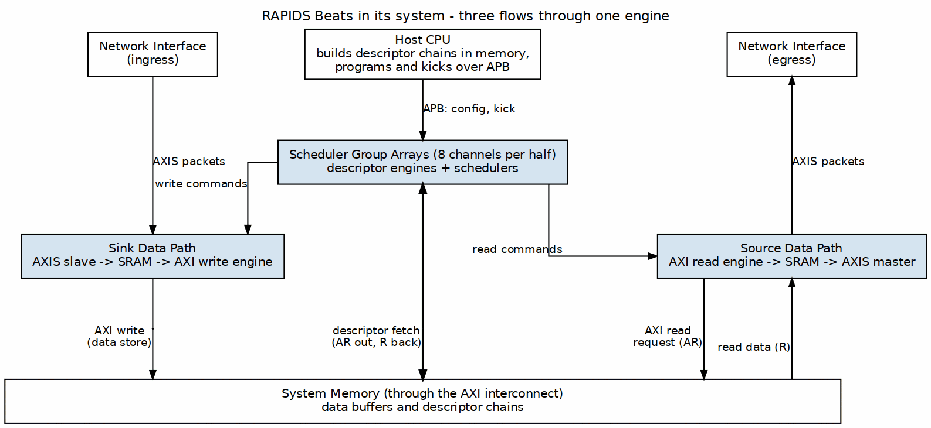
RAPIDS Beats in Its System
Source: ch01_product_context.dot

5.3 Target Applications
Target Applications
Application | Description | Key Requirements
Network Offload | Receive packets from network, store to memory | Low latency, high throughput
Scatter-Gather DMA | Multi-descriptor data movement | Descriptor chaining
Streaming Accelerator | Front-end for compute engines | Continuous data flow
Protocol Processing | Header/payload separation | Multi-channel isolation

5.4 Architecture Highlights

5.4.1 Phase 1 “Beats” Simplifications
The Beats architecture prioritizes simplicity over feature completeness:
Phase 1 Simplifications
Feature | Beats (Phase 1) | Future Phases
Transfer Unit | Full beats only | Chunk-level alignment
Flow Control | Backpressure-based | Credit management
Address Alignment | Pre-aligned required | Hardware alignment fixup
Network Interface | Direct AXIS | Protocol conversion

5.4.2 Key Capabilities
- 8 Independent Channels - Concurrent transfers with dedicated resources
- Descriptor Chaining - Automatic next-descriptor fetch
- Dual Data Paths - Simultaneous sink (write) and source (read)
- Monitor Integration - Real-time event reporting via MonBus
- Error Detection - Address range checking, AXI error propagation

RTL Design Sherpa · Learning Hardware Design Through Practice GitHub · Documentation Index · MIT License

6 Key Features

6.1 Feature Summary

6.1.1 Multi-Channel Architecture
- 8 Independent Channels with dedicated schedulers
- Per-Channel State Machines for concurrent operation
- Shared AXI Infrastructure with arbitrated access
- Channel Isolation prevents cross-channel interference

6.1.2 Descriptor-Based Control
- 256-bit Descriptor Format with all transfer parameters
- Automatic Chaining follows next_descriptor_ptr links
- Last Descriptor Flag terminates chain processing
- IRQ Generation via gen_irq descriptor flag
- Control Descriptors (CTRL_READ consumer gate / CTRL_WRITE producer doorbell) for in-memory producer/consumer synchronization without moving payload – see Descriptor Format (Section 5.1)

6.1.3 High-Performance Data Paths
Data Path Summary
Path | Direction | Bandwidth | Features
Sink | Network to Memory | 512-bit @ clock | SRAM buffering, AXI burst writes
Source | Memory to Network | 512-bit @ clock | AXI burst reads, SRAM buffering

6.1.4 Monitoring and Debug
- 64-bit MonBus Packets for all significant events
- State Transition Reports track FSM activity
- Error Event Codes for fault diagnosis
- Performance Metrics for throughput analysis

6.2 Feature Details
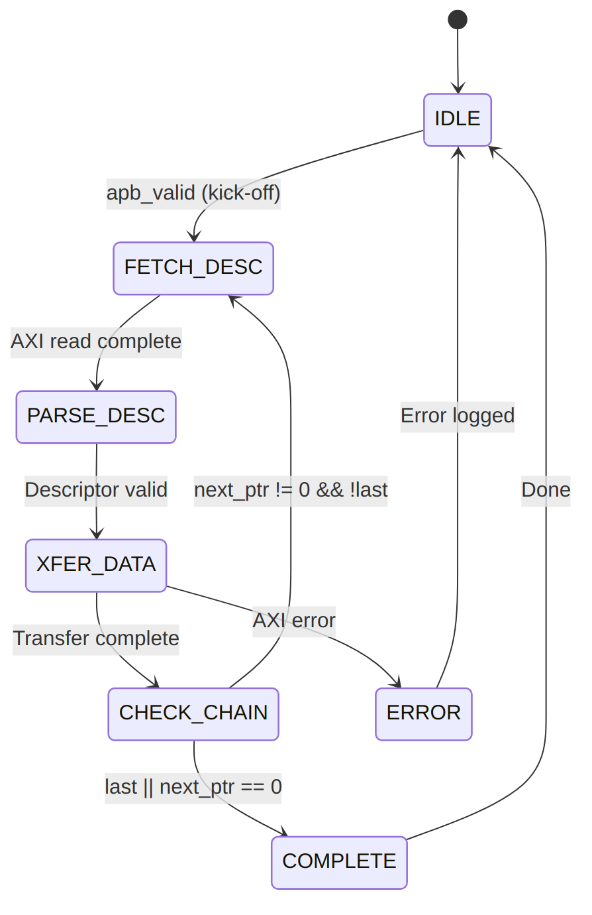
Descriptor Processing

6.2.1 SRAM Buffering
Each channel has its own buffer in each data path (sink and source), SRAM_DEPTH beats deep:
SRAM Buffer Parameters
Parameter | Default | Range | Description
SRAM_DEPTH | 4096 | 64-4096 | Beats per channel, per direction (parameter of rapids_beats_top)
Data Width | 512 | 256 / 512 | Bits per beat (DATA_WIDTH)
Buffer size | 256 KB | 2 KB-256 KB | Per channel, per direction: SRAM_DEPTH x DATA_WIDTH/8
The defaults are a simulation size. The Genesys 2 builds use 128 beats of 32 bytes, 4 KB per channel.
Buffer Operation:
- Sink Path: Fill from AXIS, drain to AXI write engine
- Source Path: Fill from AXI read engine, drain to AXIS
- Flow Control: Backpressure when buffer full/empty

6.2.2 AXI Burst Optimization
RAPIDS optimizes AXI transactions for maximum bandwidth:
AXI Optimization Features
Feature | Implementation
Burst Length | Up to 256 beats (AXI4 max)
Outstanding Transactions | Configurable (default 8)
Address Alignment | 64-byte aligned (beat size)
4KB Boundary | Automatic burst splitting

6.2.3 Error Handling
Error Handling Summary
Error Type | Detection | Response
Address Range | Pre-fetch validation | Descriptor rejected
AXI SLVERR | Response check | Transfer aborted
AXI DECERR | Response check | Transfer aborted
Timeout | Watchdog timer | Channel reset

RTL Design Sherpa · Learning Hardware Design Through Practice GitHub · Documentation Index · MIT License

7 System Context

7.1 Integration Overview
RAPIDS Beats integrates into a system as a DMA engine bridging network interfaces and system memory. This section describes the external connections and system-level requirements.

7.2 System Block Diagram

7.2.1 Figure 1.3.1: System Integration
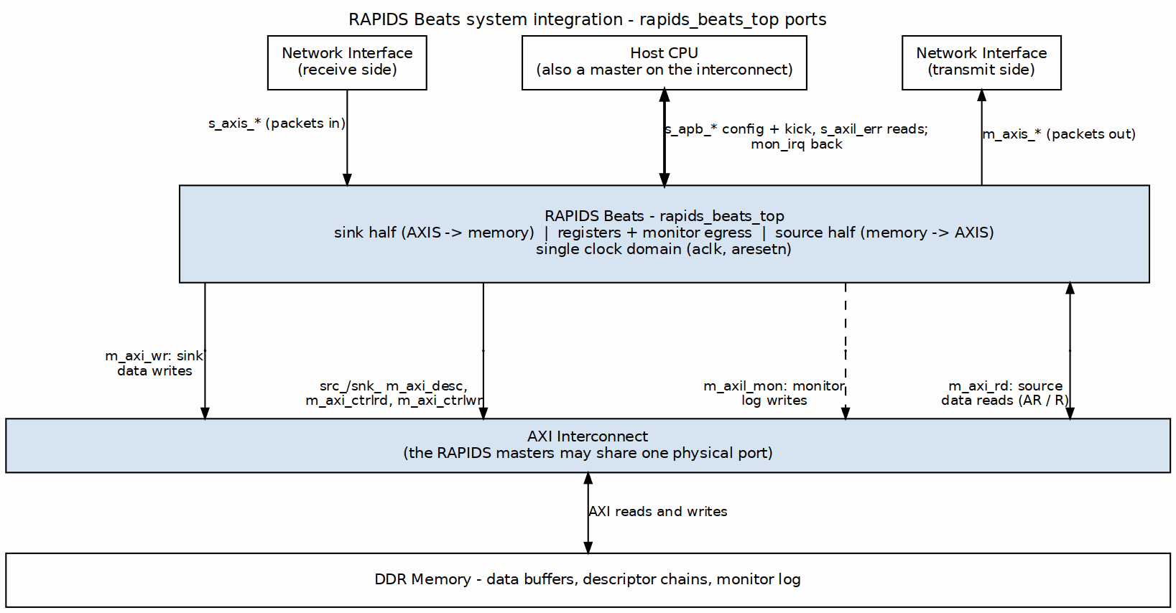
System Integration
Source: ch01_system_integration.dot

7.3 Interface Connections

7.3.1 Memory Interface
RAPIDS Beats reaches system memory through the AXI4 masters below. Each half (src_, snk_) has its own descriptor master and its own two control masters, so the descriptor and control rows are two ports each. With monitors built, an AXI-Lite master (m_axil_mon) also writes the monitor log:
AXI Memory Interface Requirements
Port | Access Pattern | Typical Bandwidth
Descriptor AXI (m_axi_desc) | Random read (256-bit) | Low (<100 MB/s)
Control AXI (m_axi_ctrlrd, m_axi_ctrlwr) | Single 32-bit reads and writes | Very low
Sink AXI | Sequential write (512-bit) | High (up to interface max)
Source AXI | Sequential read (512-bit) | High (up to interface max)
Interconnect Requirements:
- All of these ports MAY share a single physical AXI port with arbitration
- Descriptor port has lowest bandwidth requirement
- Sink and Source ports should have balanced bandwidth allocation

7.3.2 Network Interface
RAPIDS uses standard AXI-Stream for network connectivity:
AXIS Network Interface
Interface | Role | Signals
Sink AXIS | Receives data from network | TDATA, TVALID, TREADY, TLAST
Source AXIS | Sends data to network | TDATA, TVALID, TREADY, TLAST
Protocol Notes:
- Beat-granular: the beats design drives every byte valid (m_axis_tstrb all ones) and does not use the ingress s_axis_tstrb; a transfer is a whole number of beats. Partial beats (packed bytes, a contiguous tstrb on the last beat) are the byte-granular RAPIDS in rtl/top/rapids_top.sv (rapids TASK-019), which this document does not describe.
- TID/TDEST may be used for channel routing (optional)
- TUSER available for sideband information

7.3.3 Configuration Interface
Software configures RAPIDS through register writes:
Configuration Methods
Method | Interface | Usage
Direct Write | Memory-mapped | Register configuration
Descriptor Kick | APB-style | Start descriptor processing

7.4 Clock and Reset

7.4.1 Clock Domains
Clock Domains
Clock | Frequency | Usage
aclk | 100-500 MHz | All RAPIDS logic
Note: RAPIDS Beats uses a single clock domain. CDC (clock domain crossing) to different frequency domains must be handled externally.

7.4.2 Reset Requirements
Reset Signals
Signal | Type | Description
aresetn | Active-low | Async assert, sync deassert
Reset Sequence:
- Assert aresetn low for minimum 4 clock cycles
- Ensure all AXI interfaces are idle before reset
- Release reset synchronously to aclk rising edge
- Wait 16 clock cycles before initiating transfers

7.5 Power Considerations

7.5.1 Clock Gating
RAPIDS supports optional clock gating for power reduction:
- Idle Detection: Automatic when no transfers pending
- Per-Channel Gating: Individual channels can be clock-gated
- External Control: cfg_clock_enable override available

7.5.2 Power States
Power States
State | Description | Exit Latency
Active | Normal operation | 0 cycles
Idle | No pending transfers | 1 cycle
Gated | Clock disabled | 4 cycles

RTL Design Sherpa · Learning Hardware Design Through Practice GitHub · Documentation Index · MIT License

8 Block Diagram

8.1 Top-Level Architecture

8.1.1 Figure 2.1.1: RAPIDS Beats Whole Unit
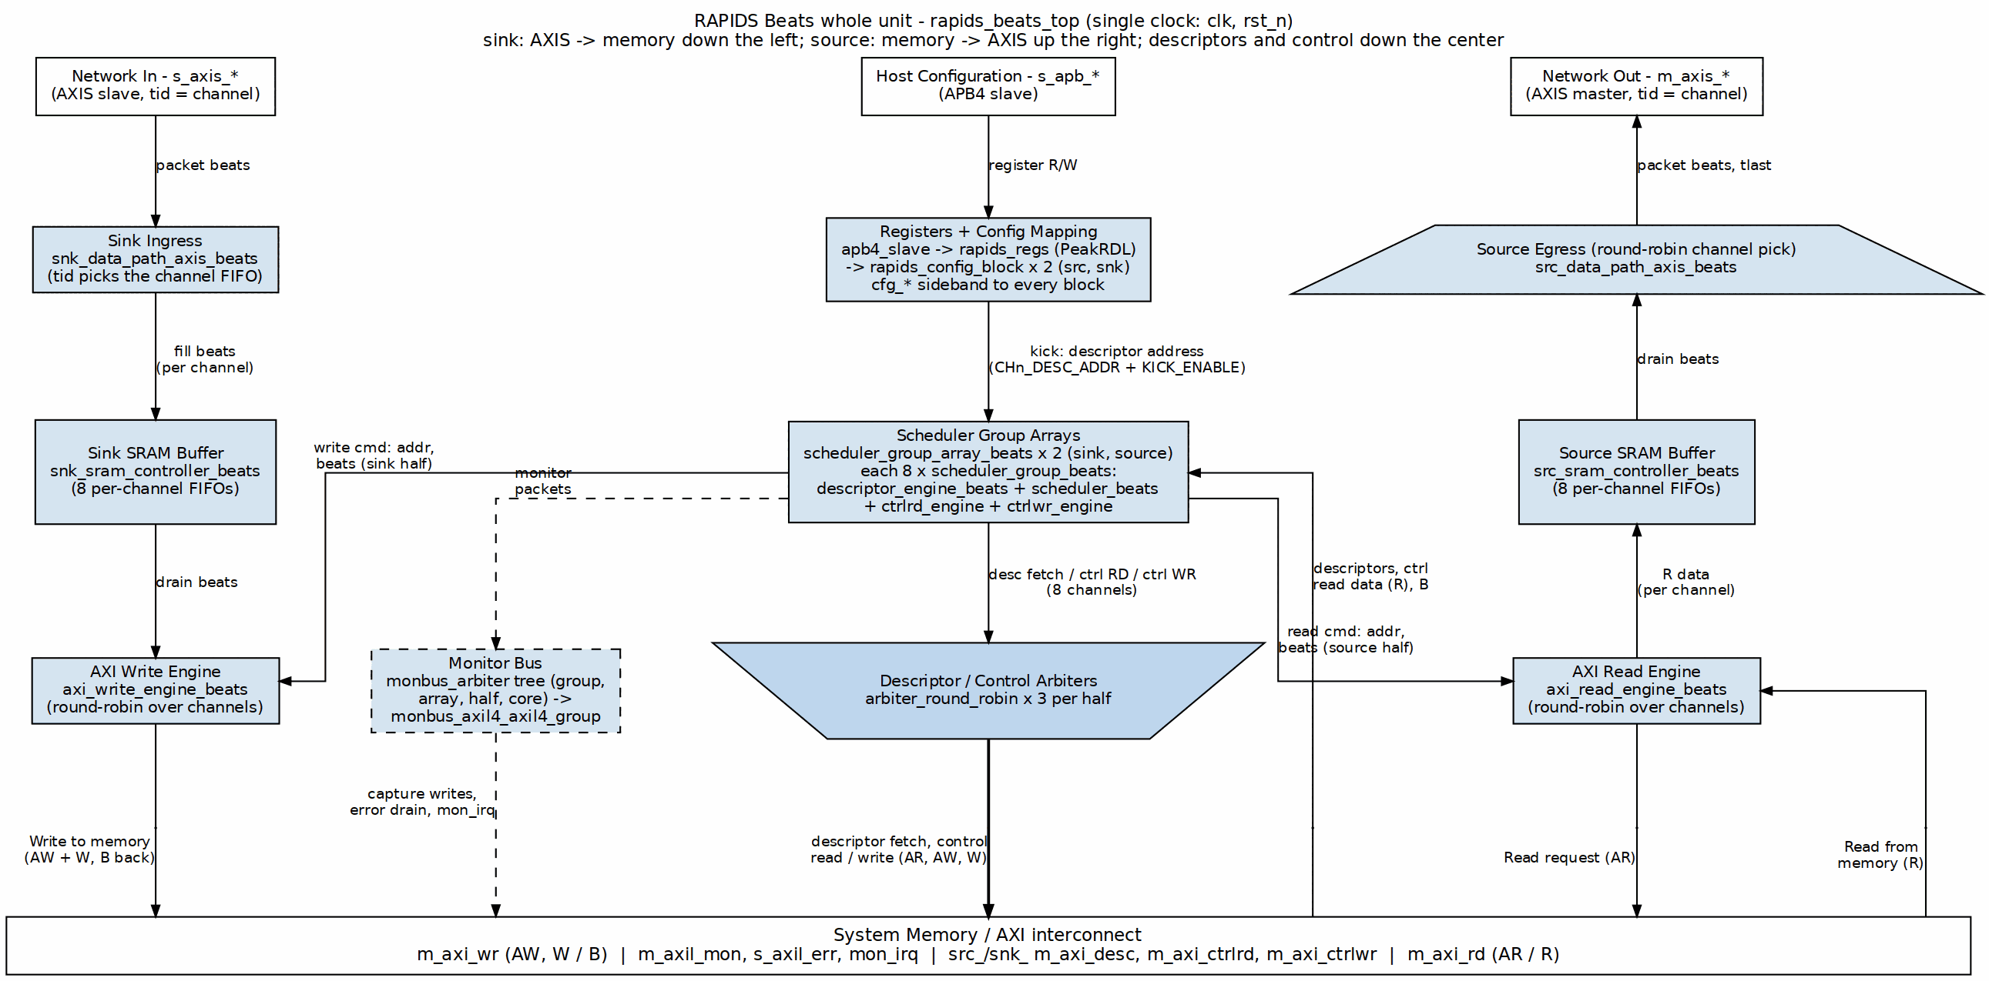
RAPIDS Beats Whole Unit
Source: ch02_whole_unit.dot

8.2 Top-Level Integration (rapids_beats_top)
rapids_core_beats is wrapped by rapids_beats_top, which adds the software register interface, configuration mapping, and monitoring infrastructure. A single APB slave feeds a command/response router into the rapids_regs register block (base config at 0x100-0x3FF, monitor regfile at 0x1000); the per-channel kick registers live at 0x000-0x03F inside that same block. rapids_config_block translates the register hwif_out into the core/monitor cfg_* signals.
When USE_AXI_MONITORS = 1, each half carries two monitor-lites: axi4_master_rd_monlite on its descriptor read master and an AXIS monitor-lite on its network port (axis4_slave_monlite on the sink’s s_axis_*, axis4_master_monlite on the source’s m_axis_*; rapids TASK-015). Their descriptor-monitor packets join the eight scheduler groups in the array’s 9:1 monbus_arbiter, the AXIS-monitor packets join the array output in the half’s 3:1 monbus_arbiter (third input reserved), the core merges the two halves, and the top delivers the stream through a monbus_axil4_axil4_group to an AXI-Lite error-drain slave, an AXI-Lite capture master, and a mon_irq interrupt. The data masters m_axi_rd and m_axi_wr carry no monitors.

8.2.1 Figure 2.1.2: rapids_beats_top Integration
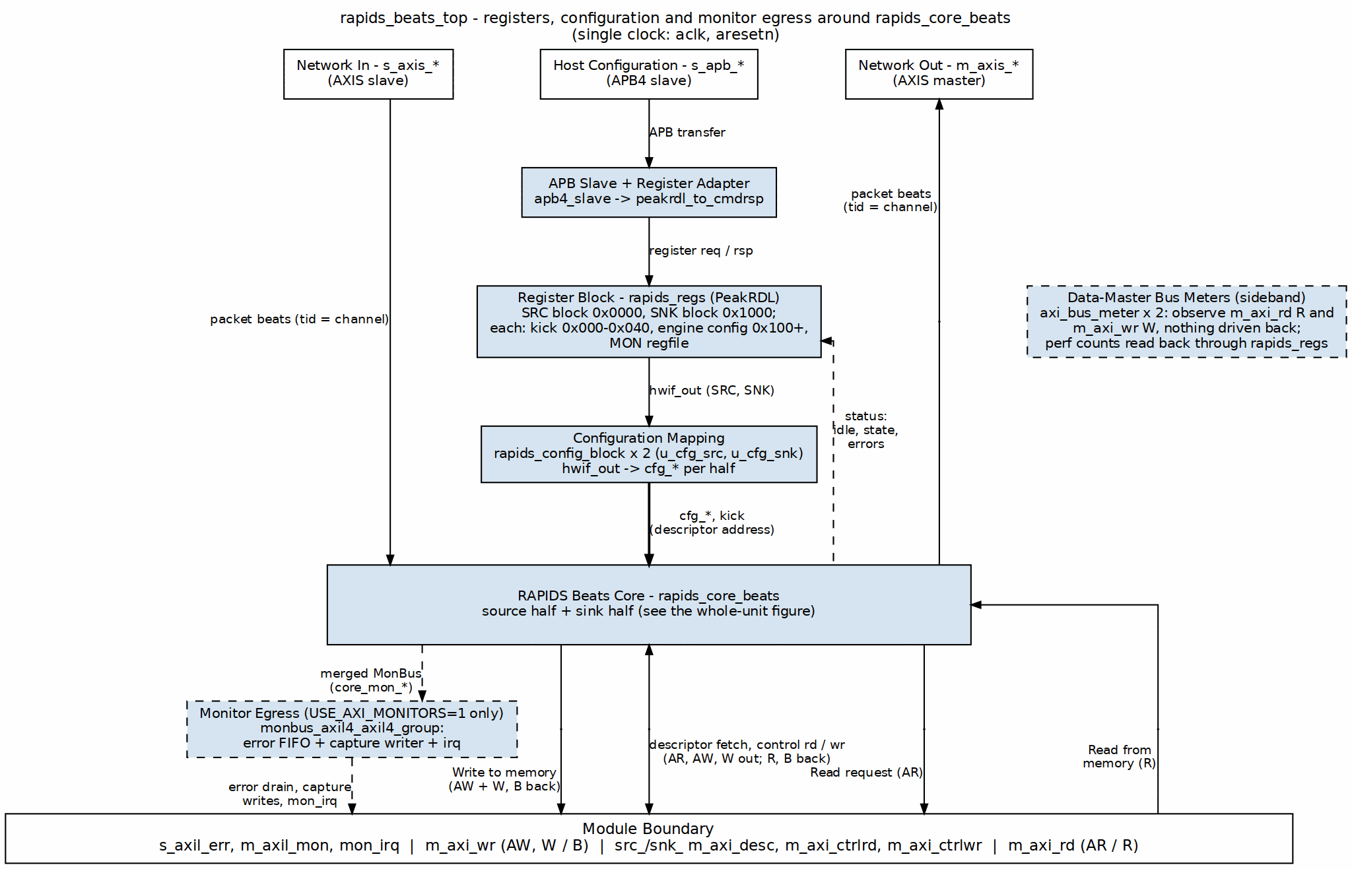
rapids_beats_top Integration
Source: ch02_top_integration.dot

8.3 Component Summary

8.3.1 Scheduler Group Array
The scheduler group array manages 8 independent channels:
Scheduler Array Components
Component | Instance Count | Purpose
scheduler_beats | 8 | Transfer coordination per channel
descriptor_engine_beats | 8 | Descriptor fetch and parse
Descriptor AXI Arbiter | 1 | Shared AXI4 for descriptor fetch

8.3.2 Sink Data Path
Network-to-memory data flow:
Sink Path Components
Component | Purpose
snk_sram_controller_beats | Multi-channel SRAM management
axi_write_engine_beats | AXI4 burst write generation
alloc_ctrl_beats | Space allocation tracking
drain_ctrl_beats | Data availability tracking

8.3.3 Source Data Path
Memory-to-network data flow:
Source Path Components
Component | Purpose
axi_read_engine_beats | AXI4 burst read generation
src_sram_controller_beats | Multi-channel SRAM management
alloc_ctrl_beats | Space allocation tracking
drain_ctrl_beats | Data availability tracking

8.4 Hierarchy
rapids_core_beats
├── monbus_arbiter
├── rapids_src_beats
│ ├── scheduler_group_array_beats
│ │ ├── scheduler_group_beats [0..7]
│ │ │ ├── scheduler_beats
│ │ │ ├── descriptor_engine_beats
│ │ │ ├── ctrlrd_engine
│ │ │ └── ctrlwr_engine
│ │ ├── arbiter_round_robin [x3]
│ │ ├── axi4_master_rd_monlite
│ │ └── axi_bus_meter
│ ├── monbus_arbiter (3:1)
│ ├── axis4_master_monlite (source-egress AXIS monitor-lite)
│ └── src_data_path_axis_beats
│ └── src_data_path_beats
│ ├── axi_read_engine_beats
│ └── src_sram_controller_beats
│ └── sram_controller (STREAM)
│ └── sram_controller_unit [0..7]
│ ├── stream_alloc_ctrl
│ ├── gaxi_fifo_sync
│ ├── stream_drain_ctrl
│ └── stream_latency_bridge
└── rapids_snk_beats
├── scheduler_group_array_beats (same shape)
├── monbus_arbiter (3:1)
├── axis4_slave_monlite (sink-ingress AXIS monitor-lite)
└── snk_data_path_axis_beats
└── snk_data_path_beats
├── axi_write_engine_beats
└── snk_sram_controller_beats
└── sram_controller (STREAM)
└── sram_controller_unit [0..7]

8.5 Internal Buses
Internal Bus Summary
Bus | Width | Description
Descriptor Bus | 256-bit | Parsed descriptor to scheduler
Scheduler Command | Variable | Transfer parameters to data paths
SRAM Data | 512-bit | Data to/from SRAM buffers
MonBus | 64-bit | Monitor packets (aggregated)

RTL Design Sherpa · Learning Hardware Design Through Practice GitHub · Documentation Index · MIT License

9 Data Flow

9.1 Overview
RAPIDS Beats implements two independent data paths that can operate concurrently:
- Sink Path: Network to Memory (AXIS Slave -> AXI Write)
- Source Path: Memory to Network (AXI Read -> AXIS Master)

9.2 Sink Path Data Flow
The sink accepts a beat for channel tid only while that channel holds an SRAM reservation. snk_data_path_axis_beats drives
s_axis_tready = fill_ready && (r_pending_alloc[tid] > 0 || fill_alloc_req)
where r_pending_alloc[tid] is the number of reserved beats the channel has not yet filled. When the head beat arrives for a channel that holds no reservation, the wrapper raises fill_alloc_req in the same cycle. The request is for AXI_XFER_CONFIG.ALLOC_SIZE beats, or for whatever remains when less than that is free, and the beat is accepted on that cycle. A channel whose partition is full, or whose last allocation is still settling into fill_space_free (three cycles), gets no reservation, and tready stays low.
The reservation does not depend on the descriptor. Data can therefore reach a channel’s SRAM partition before its descriptor has been fetched, but only up to the space the partition has free. After that the channel stops accepting until the write engine drains. The write engine drains only after the scheduler has a descriptor in CH_XFER_DATA and presents sched_wr_valid, so a channel that is never kicked fills its partition once and then stalls. tready is evaluated for the tid of the beat at the head of the single s_axis port, so a stalled channel also blocks beats for every other channel behind it (head-of-line blocking). The AXIS monitor-lite’s skid stage in front of the wrapper absorbs a few beats before the stall reaches the network.
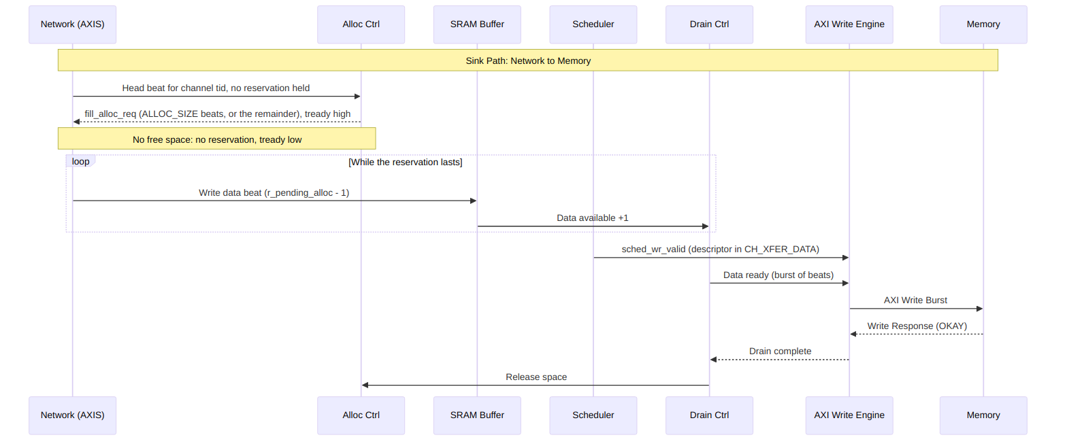
Diagram 2
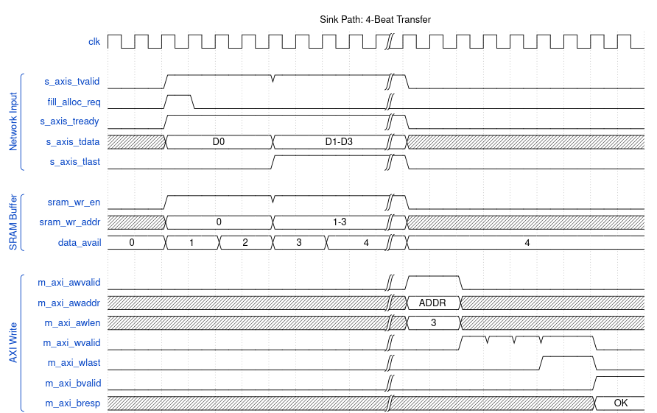
Sink Path Timing
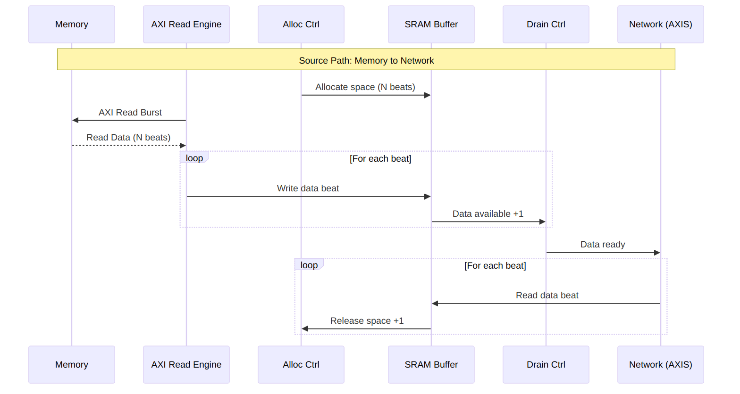
Source Path Data Flow
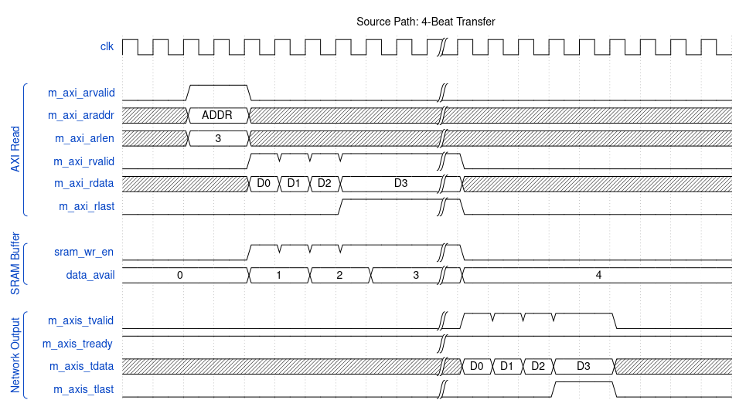
Source Path Timing

9.3 Concurrent Operation
Both data paths operate independently and can run simultaneously:
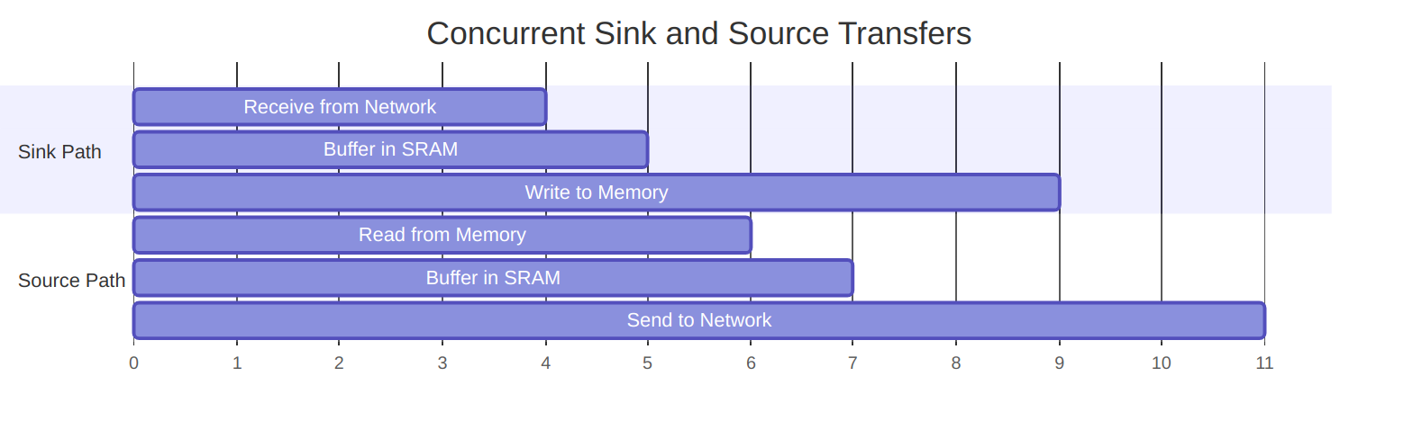
Diagram 4

9.3.1 Deadlock Prevention
RAPIDS prevents deadlock through independent resource allocation:
Resource Isolation
Resource | Sink Path | Source Path | Shared
SRAM Buffer | Dedicated | Dedicated | No
AXI Port | Write only | Read only | No
Scheduler | Per-channel | Per-channel | No

RTL Design Sherpa · Learning Hardware Design Through Practice GitHub · Documentation Index · MIT License

10 Channel Architecture

10.1 Multi-Channel Design
RAPIDS Beats supports 8 independent DMA channels, each with dedicated resources for concurrent operation.

10.2 Channel Resource Allocation

10.2.1 Figure 2.3.1: Per-Channel and Shared Resources
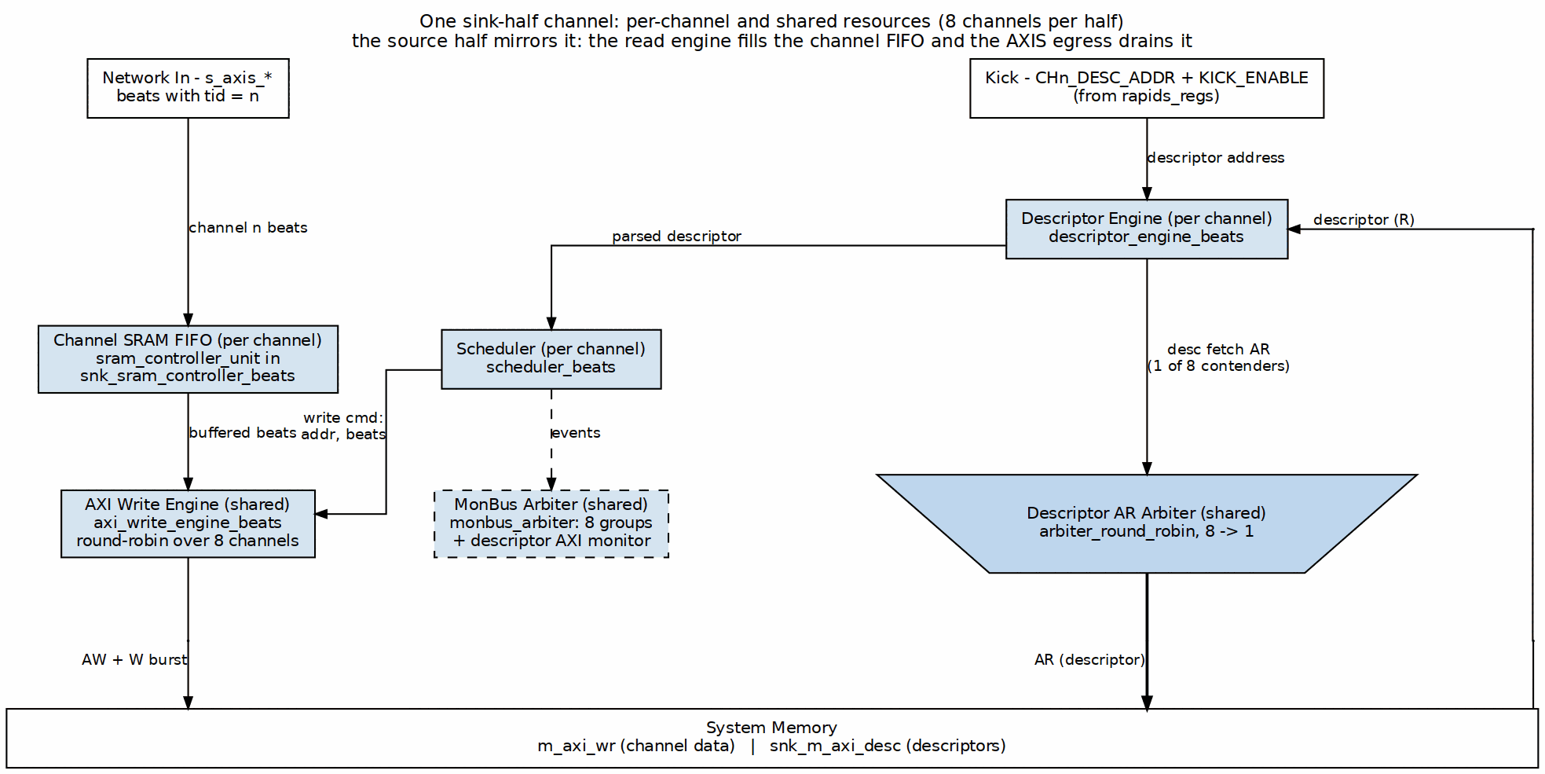
Per-Channel and Shared Resources
Source: ch02_channel_resources.dot

10.3 Per-Channel Resources
Each channel has dedicated:
Per-Channel Resources
Resource | Description | Size/Capacity
Scheduler | Transfer coordination FSM | 1 instance
Descriptor Engine | Descriptor fetch/parse | 8-deep FIFO
Sink SRAM Unit | Sink buffer, its own sram_controller | SRAM_DEPTH beats
Source SRAM Unit | Source buffer, its own sram_controller | SRAM_DEPTH beats
Configuration Registers | Per-channel config | ~16 registers

10.4 Shared Resources
Resources shared across all channels:
Shared Resources
Resource | Arbitration | Max Outstanding
Descriptor AXI | Round-robin | 8 (1 per channel)
Sink AXI Write | Round-robin | 8 configurable
Source AXI Read | Round-robin | 8 configurable
MonBus Output | Round-robin (monbus_arbiter tree) | 1 (serialized)

10.5 Channel Scheduling

10.5.1 Arbitration Policy

10.5.2 Figure 2.3.2: Channel Arbitration onto a Shared AXI Port
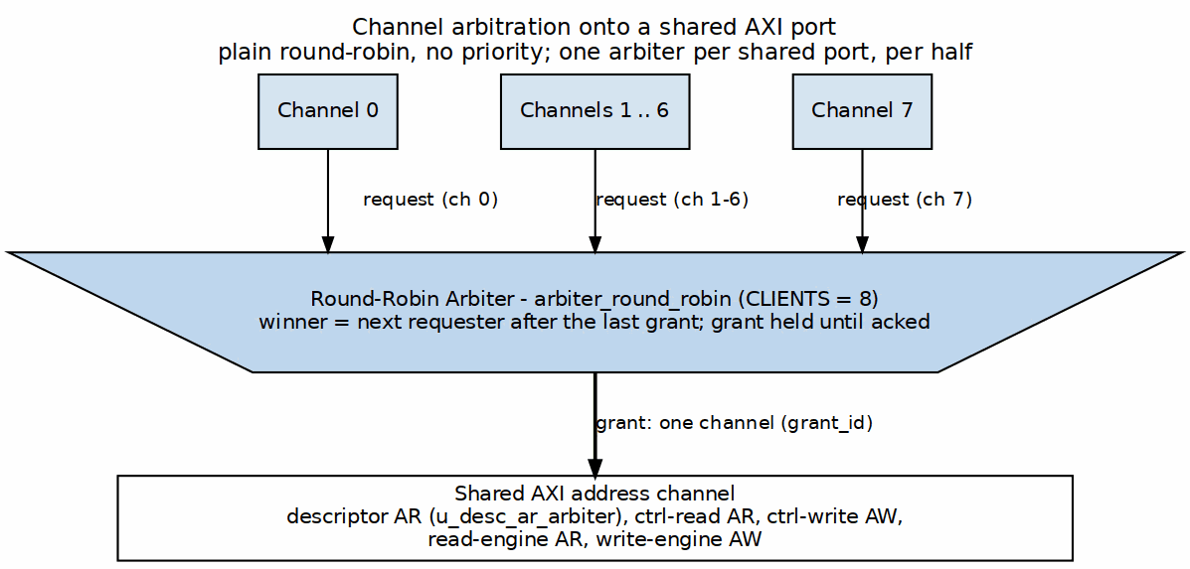
Channel Arbitration onto a Shared AXI Port
Source: ch02_channel_arbitration.dot
Arbitration Timing:

Waveform 3

10.6 Channel State Machine
Each channel scheduler follows this state machine:
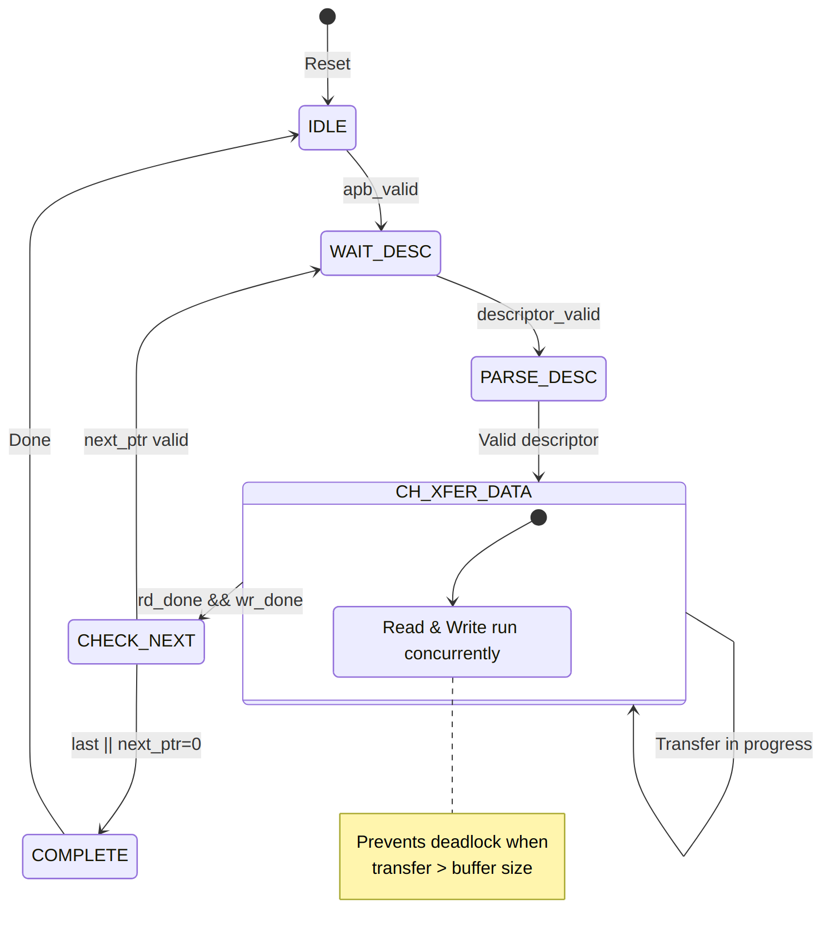
Diagram 5

Channel State Timing

10.7 Channel Isolation
Channels are isolated to prevent interference:
Channel Isolation Features
Isolation Type | Implementation
State Isolation | Separate FSM per channel
Buffer Isolation | Partitioned SRAM per channel
Error Isolation | Per-channel error flags
Reset Isolation | Per-channel soft reset

10.7.1 Per-Channel Error Handling
Each channel maintains independent error state:

Waveform 5
Channel 1 error does not affect Channel 0 or Channel 2 operation.

RTL Design Sherpa · Learning Hardware Design Through Practice GitHub · Documentation Index · MIT License

11 Interface Summary

11.1 External Interface Overview
RAPIDS Beats exposes the following external interfaces:

11.1.1 Figure 3.1.1: External Interfaces
External Interfaces
Source: ch01_system_integration.dot

11.2 Interface Port Summary
External Interface Summary
Interface | Type | Direction | Data Width | Address Width
Descriptor AXI | AXI4 Master | Read | 256-bit | 64-bit
Sink AXI | AXI4 Master | Write | 512-bit | 64-bit
Source AXI | AXI4 Master | Read | 512-bit | 64-bit
Sink AXIS | AXIS Slave | Input | 512-bit | -
Source AXIS | AXIS Master | Output | 512-bit | -
APB Config | APB-like | Input | 32-bit | 12-bit
MonBus | Custom | Output | 64-bit | -

11.3 Clock and Reset
All interfaces operate in the same clock domain:
Clock and Reset Signals
Signal | Type | Description
aclk | input | System clock (100-500 MHz typical)
aresetn | input | Active-low reset (async assert, sync deassert)

11.4 Interface Feature Matrix
Interface Feature Matrix
Feature | Desc AXI | Sink AXI | Src AXI | Sink AXIS | Src AXIS
Protocol | AXI4 | AXI4 | AXI4 | AXIS | AXIS
Direction | Read | Write | Read | Slave | Master
Burst Support | INCR | INCR | INCR | N/A | N/A
Max Burst | 1 | 256 | 256 | N/A | N/A
Outstanding | 8 | 8 | 8 | N/A | N/A
ID Width | 8-bit | 8-bit | 8-bit | Optional | Optional

11.5 Signal Count Summary
Signal Count Summary
Interface | Input Signals | Output Signals | Total
Descriptor AXI | ~20 | ~30 | ~50
Sink AXI | ~15 | ~40 | ~55
Source AXI | ~25 | ~25 | ~50
Sink AXIS | ~20 | ~5 | ~25
Source AXIS | ~5 | ~20 | ~25
APB Config | ~15 | ~5 | ~20
MonBus | ~2 | ~5 | ~7
Total | ~102 | ~130 | ~232
Note: Signal counts are approximate and vary with configuration parameters.

RTL Design Sherpa · Learning Hardware Design Through Practice GitHub · Documentation Index · MIT License

12 AXI4 Interface Specification

12.1 Overview
RAPIDS Beats uses three AXI4 master interfaces for memory access:
- Descriptor AXI - Fetches 256-bit descriptors (read-only)
- Sink AXI - Writes data to memory (write-only)
- Source AXI - Reads data from memory (read-only)

12.2 Descriptor AXI Master

12.2.1 Purpose
Fetches descriptor structures from system memory for all 8 channels.

12.2.2 Configuration
Descriptor AXI Configuration
Parameter | Value | Description
Data Width | 256-bit | Fixed descriptor size
Address Width | 64-bit | Configurable
ID Width | 8-bit | Configurable
Burst Length | 1 | Single-beat only
Burst Type | INCR | Fixed

12.2.3 Signal List
Descriptor AXI Signals
Signal | Width | Direction | Description
m_axi_desc_aclk | 1 | input | Clock
m_axi_desc_aresetn | 1 | input | Reset (active-low)
m_axi_desc_arid | 8 | output | Read ID (channel ID)
m_axi_desc_araddr | 64 | output | Read address
m_axi_desc_arlen | 8 | output | Burst length (always 0)
m_axi_desc_arsize | 3 | output | Beat size (5 = 32 bytes)
m_axi_desc_arburst | 2 | output | Burst type (INCR)
m_axi_desc_arvalid | 1 | output | Address valid
m_axi_desc_arready | 1 | input | Address ready
m_axi_desc_rid | 8 | input | Response ID
m_axi_desc_rdata | 256 | input | Read data
m_axi_desc_rresp | 2 | input | Read response
m_axi_desc_rlast | 1 | input | Last beat
m_axi_desc_rvalid | 1 | input | Data valid
m_axi_desc_rready | 1 | output | Data ready
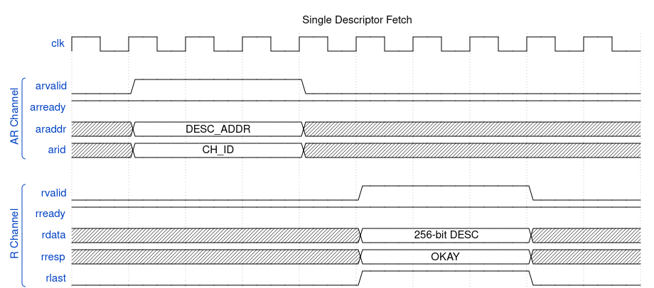
Timing Diagram

12.3 Sink AXI Master (Write)

12.3.1 Purpose
Writes data from SRAM buffer to system memory.

12.3.2 Configuration
Sink AXI Configuration
Parameter | Default | Range | Description
Data Width | 512-bit | Configurable | Match SRAM width
Address Width | 64-bit | Configurable | System address space
ID Width | 8-bit | Configurable | Transaction tracking
Max Burst | 256 | 1-256 | AXI4 maximum
Outstanding | 8 | 1-16 | Concurrent AW requests

12.3.3 Signal List
Sink AXI Signals
Signal | Width | Direction | Description
m_axi_sink_awid | 8 | output | Write ID
m_axi_sink_awaddr | 64 | output | Write address
m_axi_sink_awlen | 8 | output | Burst length - 1
m_axi_sink_awsize | 3 | output | Beat size (6 = 64 bytes)
m_axi_sink_awburst | 2 | output | Burst type (INCR)
m_axi_sink_awvalid | 1 | output | Address valid
m_axi_sink_awready | 1 | input | Address ready
m_axi_sink_wdata | 512 | output | Write data
m_axi_sink_wstrb | 64 | output | Write strobes
m_axi_sink_wlast | 1 | output | Last beat
m_axi_sink_wvalid | 1 | output | Data valid
m_axi_sink_wready | 1 | input | Data ready
m_axi_sink_bid | 8 | input | Response ID
m_axi_sink_bresp | 2 | input | Write response
m_axi_sink_bvalid | 1 | input | Response valid
m_axi_sink_bready | 1 | output | Response ready
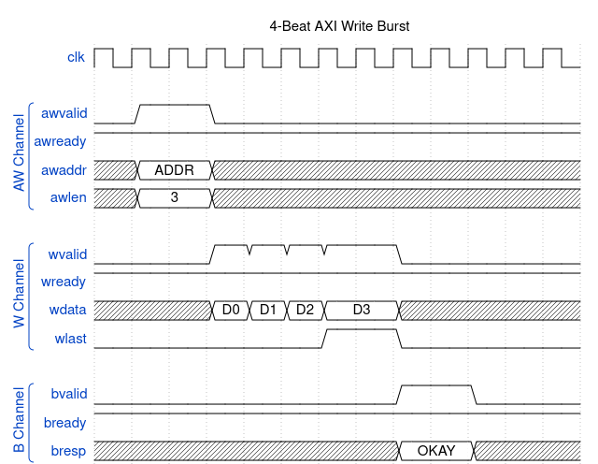
Timing Diagram

12.4 Source AXI Master (Read)

12.4.1 Purpose
Reads data from system memory to SRAM buffer.

12.4.2 Configuration
Source AXI Configuration
Parameter | Default | Range | Description
Data Width | 512-bit | Configurable | Match SRAM width
Address Width | 64-bit | Configurable | System address space
ID Width | 8-bit | Configurable | Transaction tracking
Max Burst | 256 | 1-256 | AXI4 maximum
Outstanding | 8 | 1-16 | Concurrent AR requests

12.4.3 Signal List
Source AXI Signals
Signal | Width | Direction | Description
m_axi_src_arid | 8 | output | Read ID
m_axi_src_araddr | 64 | output | Read address
m_axi_src_arlen | 8 | output | Burst length - 1
m_axi_src_arsize | 3 | output | Beat size (6 = 64 bytes)
m_axi_src_arburst | 2 | output | Burst type (INCR)
m_axi_src_arvalid | 1 | output | Address valid
m_axi_src_arready | 1 | input | Address ready
m_axi_src_rid | 8 | input | Response ID
m_axi_src_rdata | 512 | input | Read data
m_axi_src_rresp | 2 | input | Read response
m_axi_src_rlast | 1 | input | Last beat
m_axi_src_rvalid | 1 | input | Data valid
m_axi_src_rready | 1 | output | Data ready
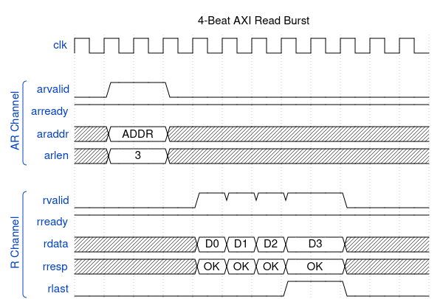
Timing Diagram

12.5 AXI Protocol Constraints

12.5.1 Address Alignment
Address Alignment Requirements
Transfer Type | Alignment Requirement
Descriptor | 32-byte aligned
Sink Data | 64-byte aligned
Source Data | 64-byte aligned

12.5.2 4KB Boundary Handling
AXI4 requires burst transactions not to cross 4KB boundaries. RAPIDS automatically splits bursts at 4KB boundaries:
Example: 8-beat burst starting at 0x0FE0 (64 bytes/beat)
Beat 0-1: 0x0FE0 - 0x0FFF (to 4KB boundary)
Beat 2-7: 0x1000 - 0x117F (after boundary)
Split into two bursts:
Burst 1: ARLEN=1, ARADDR=0x0FE0
Burst 2: ARLEN=5, ARADDR=0x1000

12.5.3 Response Handling
AXI Response Handling
Response | Code | RAPIDS Behavior
OKAY | 2’b00 | Normal completion
EXOKAY | 2’b01 | Treated as OKAY
SLVERR | 2’b10 | Error, transfer aborted
DECERR | 2’b11 | Error, transfer aborted

RTL Design Sherpa · Learning Hardware Design Through Practice GitHub · Documentation Index · MIT License

13 AXIS Interface Specification

13.1 Overview
RAPIDS Beats uses AXI-Stream interfaces for network data transfer:
- Sink AXIS Slave - Receives data from network (ingress)
- Source AXIS Master - Sends data to network (egress)

13.2 Sink AXIS Slave

13.2.1 Purpose
Receives streaming data from external network interface and writes to SRAM buffer.

13.2.2 Configuration
Sink AXIS Configuration
Parameter | Default | Range | Description
Data Width | 512-bit | Configurable | TDATA width
ID Width | 8-bit | 0-8 | TID width (optional)
DEST Width | 8-bit | 0-8 | TDEST width (optional)
USER Width | 1-bit | 0-16 | TUSER width (optional)

13.2.3 Signal List
Sink AXIS Signals
Signal | Width | Direction | Description
s_axis_sink_tdata | 512 | input | Data payload
s_axis_sink_tkeep | 64 | input | Byte valid mask
s_axis_sink_tstrb | 64 | input | Byte position (optional)
s_axis_sink_tlast | 1 | input | End of packet
s_axis_sink_tid | 8 | input | Transaction ID (channel select)
s_axis_sink_tdest | 8 | input | Destination (optional)
s_axis_sink_tuser | 1 | input | User sideband (optional)
s_axis_sink_tvalid | 1 | input | Data valid
s_axis_sink_tready | 1 | output | Ready to accept
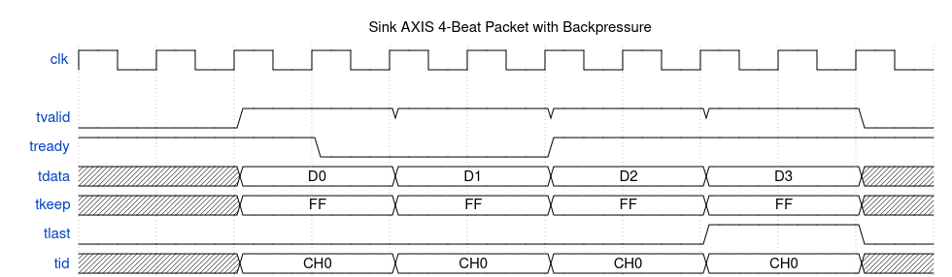
Timing Diagram

13.2.4 Backpressure Behavior
When SRAM buffer is full, tready deasserts:
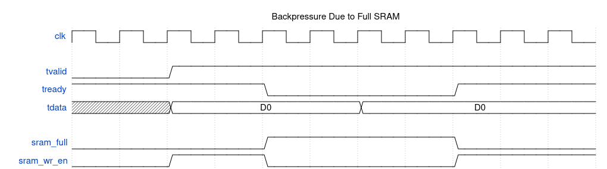
Waveform 10

13.3 Source AXIS Master

13.3.1 Purpose
Sends streaming data from SRAM buffer to external network interface.

13.3.2 Configuration
Source AXIS Configuration
Parameter | Default | Range | Description
Data Width | 512-bit | Configurable | TDATA width
ID Width | 8-bit | 0-8 | TID width (optional)
DEST Width | 8-bit | 0-8 | TDEST width (optional)
USER Width | 1-bit | 0-16 | TUSER width (optional)

13.3.3 Signal List
Source AXIS Signals
Signal | Width | Direction | Description
m_axis_src_tdata | 512 | output | Data payload
m_axis_src_tkeep | 64 | output | Byte valid mask
m_axis_src_tstrb | 64 | output | Byte position (optional)
m_axis_src_tlast | 1 | output | End of packet
m_axis_src_tid | 8 | output | Transaction ID (channel)
m_axis_src_tdest | 8 | output | Destination (optional)
m_axis_src_tuser | 1 | output | User sideband (optional)
m_axis_src_tvalid | 1 | output | Data valid
m_axis_src_tready | 1 | input | Downstream ready
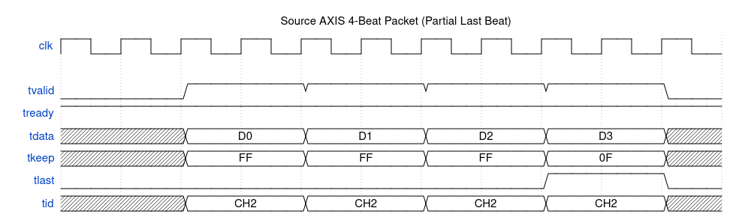
Timing Diagram

13.3.4 Data Availability
Source AXIS only asserts tvalid when data is available in SRAM:
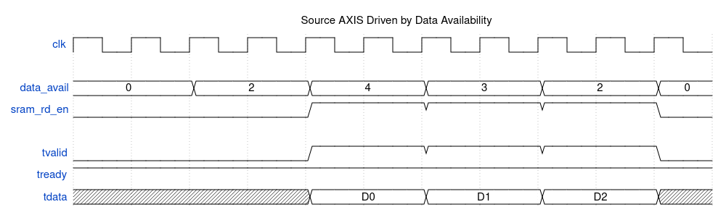
Waveform 12

13.4 AXIS Protocol Notes

13.4.1 Handshake Rules
Standard AXI-Stream handshake applies:
- tvalid asserts when data is available
- tready asserts when receiver can accept
- Transfer occurs on clock edge when both are high
- tvalid SHALL NOT depend on tready
- tready MAY depend on tvalid

13.4.2 TLAST Semantics
TLAST Usage
Scenario | TLAST Behavior
Descriptor transfer complete | Assert on last beat
Packet boundary | Assert on last beat of packet
Continuous stream | Not used (always 0)

13.4.3 TKEEP Usage
TKEEP indicates valid bytes within each beat:
TKEEP Examples
TKEEP Value | Meaning
64’hFFFF_FFFF_FFFF_FFFF | All 64 bytes valid
64’h0000_FFFF_FFFF_FFFF | Upper 16 bytes invalid
64’h0000_0000_0000_000F | Only lower 4 bytes valid

13.4.4 Channel Multiplexing via TID
Multiple channels can share a single AXIS interface using TID:
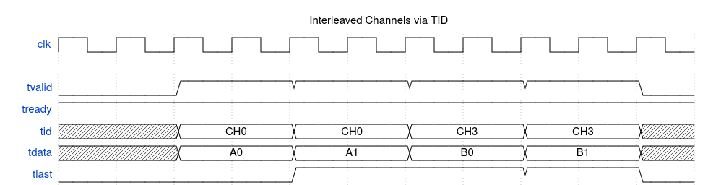
Waveform 13

RTL Design Sherpa · Learning Hardware Design Through Practice GitHub · Documentation Index · MIT License

14 APB Configuration Interface

14.1 Overview
At the top level (rapids_beats_top), RAPIDS Beats exposes a single APB4 slave (s_apb_*) for all software access. This interface allows software to:
- Configure channel and monitor parameters (via the register block)
- Initiate descriptor processing (kick-off)
- Read status and error information

14.2 APB Slave and Address Routing
The APB slave is converted to an internal command/response transaction and routed by address to two targets:
APB Address Routing
Address Range | Target | Purpose
0x000-0x03F | rapids_regs (staged descriptor addresses) | Per-channel CH*_DESC_ADDR_{LOW,HIGH}, stride 0x8
0x040 | rapids_regs (KICK_ENABLE) | Per-channel launch bits (singlepulse)
0x100-0x3FF | rapids_regs (base regfile) | Channel/scheduler/descriptor configuration and status
0x1000+ | rapids_regs (monitor regfile) | AXI-monitor configuration and performance counters
Because the monitor regfile is located at 0x1000, the APB address bus must be at least 13 bits wide to reach it. Configuration that was formerly imagined as discrete cfg_* ports is now driven internally by the register block through rapids_config_block; see the Register Map for the full address map, and the descriptor address ranges (DESCENG_ADDR0/1_* at 0x224-0x230).

14.2.1 APB Slave Signal List
APB Slave Signals
Signal | Width | Direction | Description
s_apb_paddr | APB_ADDR_WIDTH (>=13) | input | Address
s_apb_psel | 1 | input | Select
s_apb_penable | 1 | input | Enable phase
s_apb_pwrite | 1 | input | Write / read
s_apb_pwdata | 32 | input | Write data
s_apb_pstrb | 4 | input | Write byte strobes
s_apb_prdata | 32 | output | Read data
s_apb_pready | 1 | output | Ready
s_apb_pslverr | 1 | output | Slave error

14.2.2 Descriptor Kick-Off
To start descriptor processing on a channel:
- Write descriptor to memory
- Assert apb_valid[ch] with descriptor address on apb_addr
- Wait for apb_ready[ch] assertion
- Deassert apb_valid[ch]

Timing Diagram

14.3 Status Interface

14.3.1 Per-Channel Status Signals
Status Signals
Signal | Width | Direction | Description
channel_idle | NC | output | Channel idle status
channel_error | NC | output | Channel error flag
scheduler_state | 4*NC | output | FSM state per channel

14.3.2 Channel State Encoding
Scheduler State Encoding
State | Value | Description
IDLE | 4’h0 | Waiting for kick-off
WAIT_DESC | 4’h1 | Waiting for descriptor
PARSE_DESC | 4’h2 | Parsing descriptor
CH_XFER_DATA | 4’h3 | Transfer in progress
CHECK_NEXT | 4’h4 | Checking next descriptor
COMPLETE | 4’h5 | Transfer complete
ERROR | 4’hF | Error state

14.4 Configuration Registers

14.4.1 Address Range Validation
RAPIDS validates descriptor addresses against configurable ranges:
Valid if:
(addr >= cfg_addr0_base && addr < cfg_addr0_limit) ||
(addr >= cfg_addr1_base && addr < cfg_addr1_limit)

14.4.2 Configuration Registers
Configuration and status registers are provided by the rapids_regs register block. See the Register Map for the complete, RTL-accurate address map. The registers most relevant to bring-up are:
Key Configuration Registers
Register | Offset | Description
GLOBAL_CTRL | 0x100 | GLOBAL_EN, GLOBAL_RST (level; write 0 to release)
CHANNEL_ENABLE | 0x120 | Per-channel enable bitmap
SCHED_TIMEOUT_CYCLES | 0x200 | Write-progress timeout window
SCHED_TIMEOUT_LIMIT | 0x208 | Consecutive-timeout escalation limit (0 = never)
DESCENG_CONFIG | 0x220 | Descriptor-engine enable / prefetch / FIFO threshold
DESCENG_ADDR0_BASE/_LIMIT | 0x224/0x228 | Descriptor address range 0

14.5 Programming Sequence

14.5.1 Initialization
// 1. Optional global reset: GLOBAL_RST is a level, not self-clearing
GLOBAL_CTRL = 0x2; // assert
GLOBAL_CTRL = 0x0; // release
// 2. Configure descriptor address range(s)
DESCENG_ADDR0_BASE = 0x8000_0000;
DESCENG_ADDR0_LIMIT = 0x9000_0000;
// 3. Scheduler timeout policy
SCHED_TIMEOUT_CYCLES = 1000;
SCHED_TIMEOUT_LIMIT = 4; // escalate after 4 stalled windows; 0 = never
// 4. Enable channels and global enable
CHANNEL_ENABLE = 0xFF; // enable all 8 channels
GLOBAL_CTRL = 0x1; // GLOBAL_EN

14.5.2 Descriptor Kick-Off
// Prepare descriptor in memory
desc->src_addr = src;
desc->dst_addr = dst;
desc->length = beats;
desc->last = 1;
desc->valid = 1;
// Kick off channel 0: stage the address, then launch
CH0_DESC_ADDR_LOW = (uint32_t)desc_addr;
CH0_DESC_ADDR_HIGH = (uint32_t)(desc_addr >> 32);
KICK_ENABLE = 0x01; // KICK0, self-clearing
// Wait for completion: idle, or faulted (CH_ERROR is never idle)
while (!(SCHEDULER_IDLE & 0x01) && !(SCHED_ERROR & 0x01));
// Check for errors
if (SCHED_ERROR & 0x01) {
handle_error(0);
}

RTL Design Sherpa · Learning Hardware Design Through Practice GitHub · Documentation Index · MIT License

15 Monitor Bus Interface

15.1 Overview
RAPIDS Beats outputs a 64-bit Monitor Bus (MonBus) for real-time event reporting. The MonBus provides visibility into:
- State machine transitions
- Descriptor processing events
- Error conditions
- Performance metrics

15.2 MonBus Packet Format

15.2.1 64-bit Packet Structure
Bit Field Width Description
───────────────────────────────────────────────────────
[63:60] 4-bit packet_type (error, completion, etc.)
[59:57] 3-bit protocol (CORE for RAPIDS)
[56:53] 4-bit event_code (specific event)
[52:47] 6-bit channel_id
[46:43] 4-bit unit_id (subsystem)
[42:35] 8-bit agent_id (module)
[34:0] 35-bit event_data (event-specific)

15.2.2 Signal List
MonBus Signals
Signal | Width | Direction | Description
monbus_pkt_valid | 1 | output | Packet valid
monbus_pkt_data | 64 | output | Packet data
monbus_pkt_ready | 1 | input | Downstream ready

15.3 Packet Types
MonBus Packet Types
Type | Code | Description
ERROR | 4’h0 | Error event
COMPLETION | 4’h1 | Transfer/operation complete
THRESHOLD | 4’h2 | Threshold crossed
TIMEOUT | 4’h3 | Timeout event
PERF | 4’h4 | Performance metric
DEBUG | 4’hF | Debug/trace event

15.4 Agent IDs
RAPIDS modules use the following Agent IDs:
RAPIDS Agent IDs
Agent ID | Module | Description
0x08 | Descriptor AXI monitor | axi4_master_rd_monlite on the descriptor read master (per half, USE_AXI_MONITORS)
0x09 | Sink-ingress AXIS monitor | axis4_slave_monlite on s_axis_* in rapids_snk_beats (USE_AXI_MONITORS; config SNK.MON.WRMON_*)
0x0A | Source-egress AXIS monitor | axis4_master_monlite on m_axis_* in rapids_src_beats (USE_AXI_MONITORS; config SRC.MON.RDMON_*)
0x10-0x17 | Descriptor Engine | Channels 0-7
0x20 | Control Read Engine | ctrlrd (one per half)
0x21 | Control Write Engine | ctrlwr (one per half)
0x30-0x37 | Scheduler | Channels 0-7
These are the values the scheduler group array and the halves pass down (DESC_AXI_MON_AGENT_ID, DESC_MON_BASE_AGENT_ID, CTRLRD_MON_AGENT_ID, CTRLWR_MON_AGENT_ID, SCHED_MON_BASE_AGENT_ID); the module defaults inside the engines differ and are overridden at instantiation. An earlier revision of this table listed data-path agents at 0x40-0x57, which nothing emits: the data paths carry no MonBus emitters, and the AXIS ports are monitored only by the characterization harness’s instruments until TASK-015 lands.

15.5 Event Codes

15.5.1 Scheduler Events (Agent 0x30-0x37)
Scheduler Event Codes
Event Code | Type | Description
0x0 | COMPLETION | Descriptor complete
0x1 | COMPLETION | Chain complete
0x2 | ERROR | Timeout
0x3 | ERROR | AXI error
0x4 | DEBUG | State transition
The scheduler’s and the descriptor engine’s COMPLETION packets are reported only while the half’s SCHED_CONFIG.COMPL_EN is set (reset value 1). With the bit clear the scheduler group drops them before its monitor-bus arbiter and still acknowledges the emitters, so a channel runs identically either way; ERROR packets are reported regardless of ERR_EN.

15.5.2 Descriptor Engine Events (Agent 0x10-0x17)
Descriptor Engine Event Codes
Event Code | Type | Description
0x0 | COMPLETION | Descriptor fetched
0x1 | ERROR | Address range error
0x2 | ERROR | AXI read error
0x3 | DEBUG | Fetch started

Timing Diagram

15.6 Event Data Encoding

15.6.1 Completion Event Data
[34:32] - Reserved
[31:0] - Transfer length (beats completed)

15.6.2 Error Event Data
[34:32] - Error type
[31:16] - Reserved
[15:0] - Error details

15.6.3 State Transition Event Data
[34:32] - Reserved
[31:28] - Previous state
[27:24] - New state
[23:0] - Timestamp (lower bits)

15.7 MonBus Arbitration
Multiple RAPIDS modules generate MonBus packets. Internal arbitration ensures ordered delivery:

15.7.1 Figure 3.5.1: MonBus Arbitration Tree
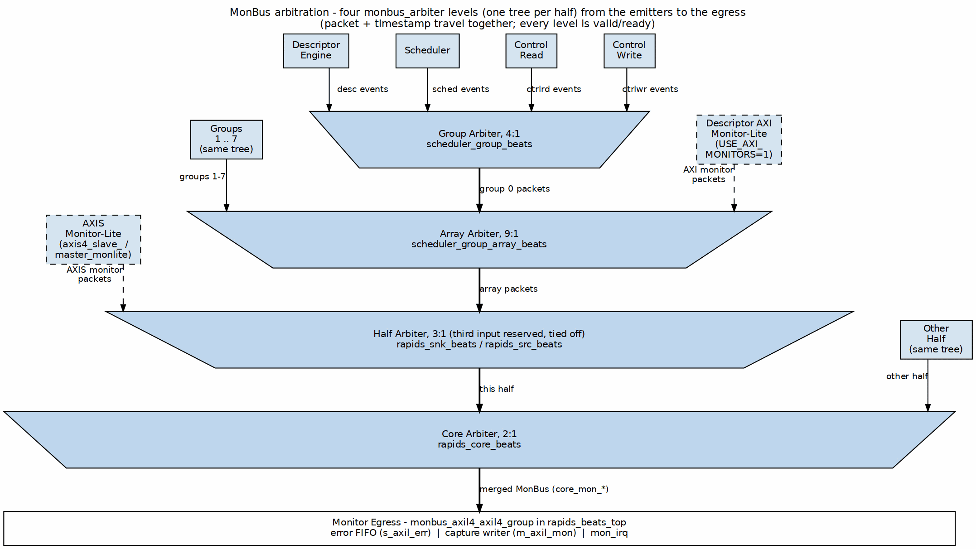
MonBus Arbitration Tree
Source: ch03_monbus_arbitration.dot

15.7.2 Arbitration Policy
- Round-robin across modules
- No packet loss (backpressure if output blocked)
- Priority boosting for ERROR packets

15.8 Top-Level MonBus Delivery (monbus_axil4_axil4_group)
At the top level (rapids_beats_top), the internal MonBus is not exposed as a raw 64-bit port. Instead, when USE_AXI_MONITORS = 1, packets are combined and delivered through a monbus_axil4_axil4_group:
- AXI monitors: axi4_master_rd_monlite and axi4_master_wr_monlite (axi_monitor_lite: error, timeout, completion, threshold and the optional address-range checker; no perf or debug class) observe the read (m_axi_rd) and write (m_axi_wr) data masters and emit monitor packets. When USE_AXI_MONITORS = 0, these taps are bypassed and the MonBus outputs below are tied off (mon_irq = 0).
- Arbitration: a 3-input monbus_arbiter merges the read-monitor packet, the write-monitor packet, and the core’s descriptor-monitor packet.
- Delivery: the combined stream feeds monbus_axil4_axil4_group, which presents three external interfaces:
Top-Level MonBus AXI-Lite Group
Interface | Signals | Purpose
Error-drain slave | s_axil_err_ar*, s_axil_err_r* (AXI-Lite, 32-bit read) | CPU reads captured error events from the error FIFO
Capture master | m_axil_mon_aw*, m_axil_mon_w* (64-bit wdata), m_axil_mon_b* | Bulk-writes the MonBus trace to system memory
Interrupt | mon_irq | Asserts on error/threshold events
The capture region and flush behavior are configured by cfg_mon_base_addr, cfg_mon_limit_addr, and cfg_mon_flush_watermark.

15.9 Integration Notes

15.9.1 Downstream Connection
Internally, MonBus output connects to:
- MonBus Arbiter - Combines core + rd/wr monitor sources
- monbus_axil4_axil4_group - Error-drain slave, capture master, and mon_irq
- Debug FIFO - Buffered access for debug tools

15.9.2 Packet Rate
MonBus Packet Rates
Scenario | Approximate Rate
Idle | 0 packets/cycle
Single channel active | ~1 packet/100 cycles
All channels active | ~1 packet/20 cycles
Error storm | Up to 1 packet/cycle

RTL Design Sherpa · Learning Hardware Design Through Practice GitHub · Documentation Index · MIT License

16 Use Case: Network to Memory (Sink Path)

16.1 Overview
The Sink Path transfers data from a network interface (AXI-Stream slave) to system memory (AXI4 write master). This is the primary receive data path for network applications.
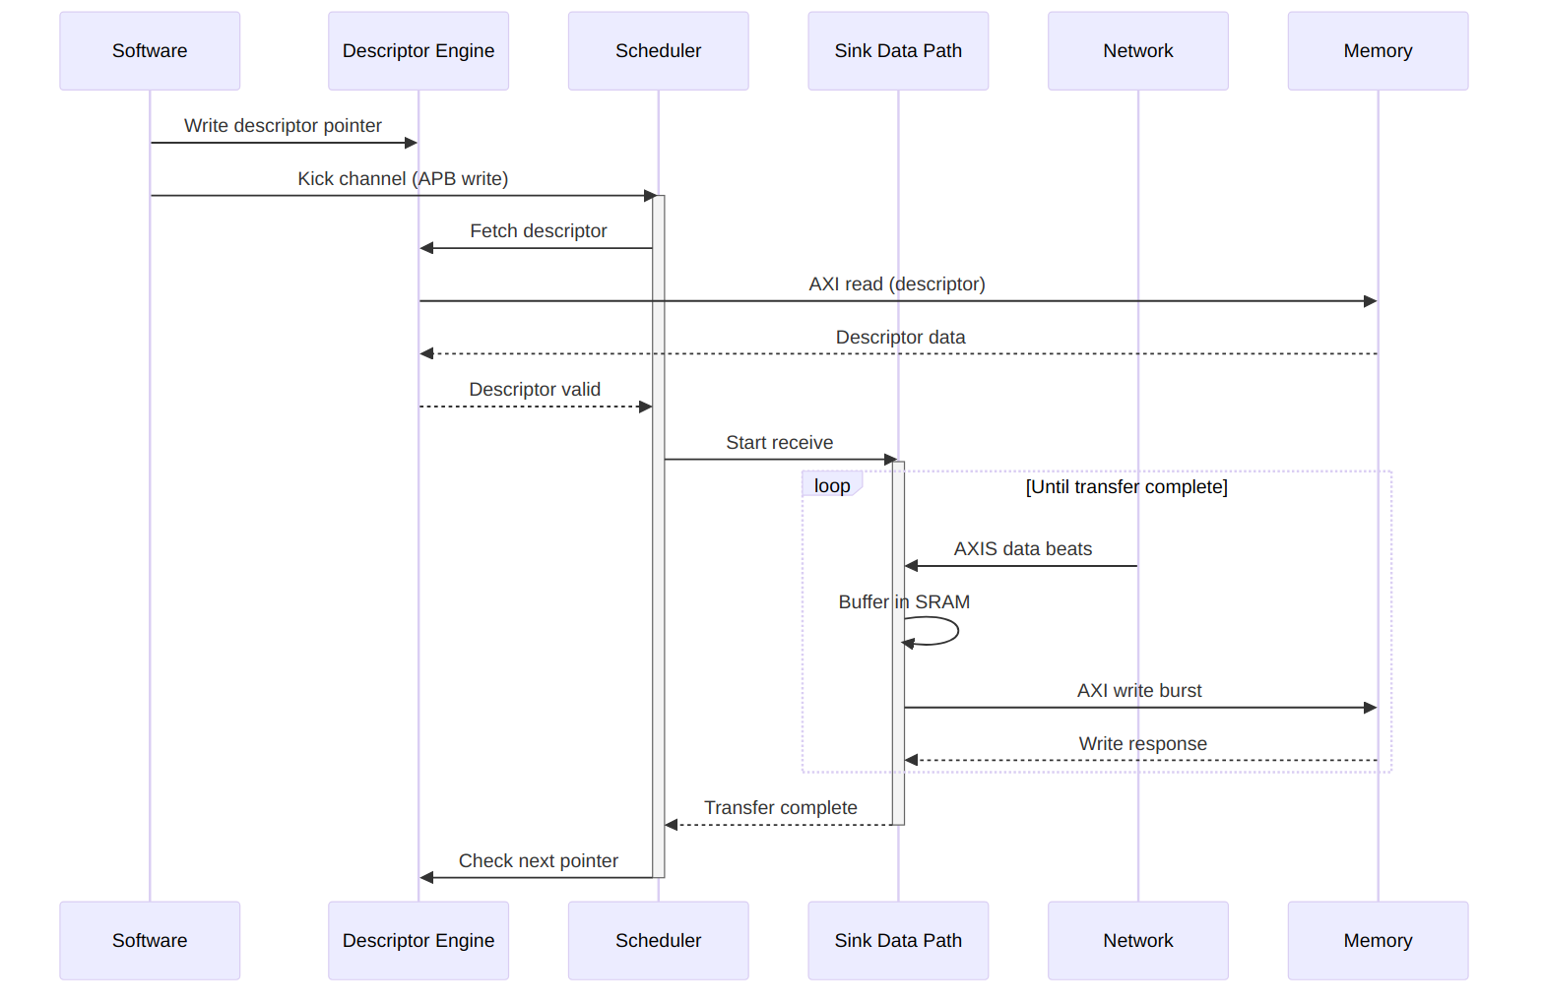
Operation Flow
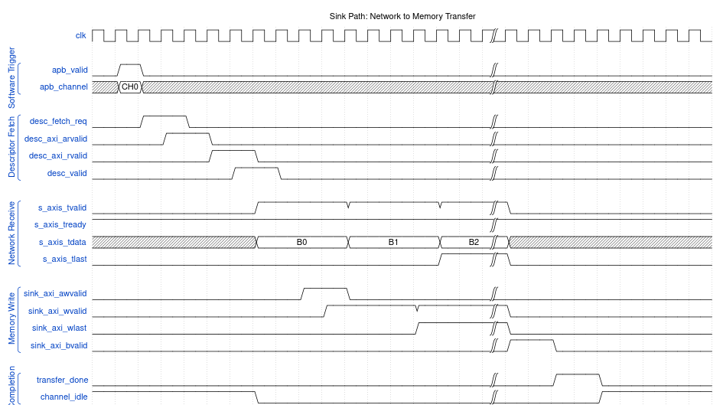
Timing Diagram

16.2 Buffer Management

16.2.1 SRAM Buffering Strategy
The sink path uses internal SRAM to decouple network timing from memory timing:

16.2.2 Figure 4.1.1: Sink Channel Buffer
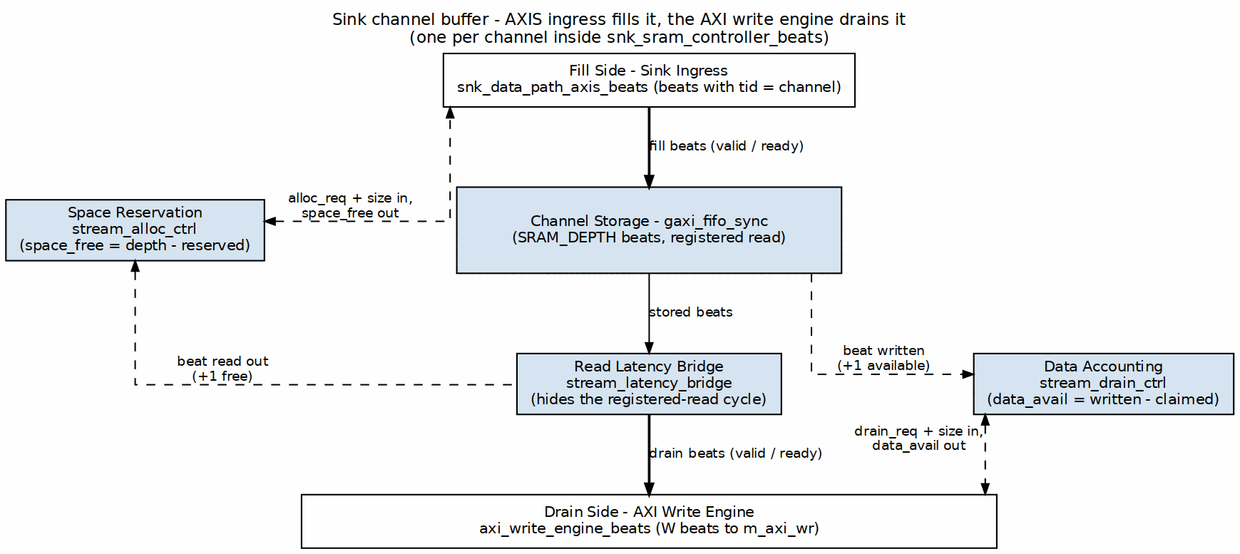
Sink Channel Buffer
Source: ch04_sink_buffering.dot

16.2.3 Flow Control
Sink Path Flow Control
Condition | Behavior
SRAM full | Backpressure network (TREADY=0)
SRAM empty | Pause AXI writes
SRAM threshold | Optional early write start
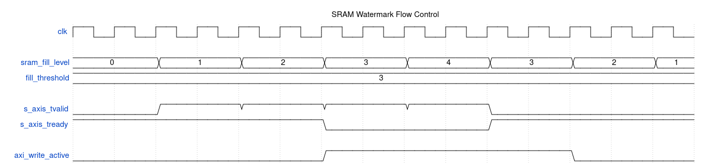
Watermark Timing

16.3 Performance Considerations

16.3.1 Throughput
Sink Path Throughput Factors
Factor | Impact
Network bandwidth | Upper bound on receive rate
Memory bandwidth | Must match or exceed network
SRAM depth | Burst absorption capability
AXI outstanding | Overlapped write latency hiding

16.3.2 Latency
Sink Path Latency Breakdown
Phase | Typical Cycles
Descriptor fetch | 10-50 (memory dependent)
First beat to SRAM | 1
SRAM to AXI write | 2-4
AXI write completion | 10-100 (memory dependent)

16.4 Error Handling

16.4.1 Error Sources
Sink Path Error Handling
Error | Detection | Response
AXI write error | BRESP != OKAY | Stop transfer, report via MonBus
SRAM overflow | Fill pointer catches drain | Should never occur (TREADY control)
Timeout | Watchdog timer | Abort transfer, report error
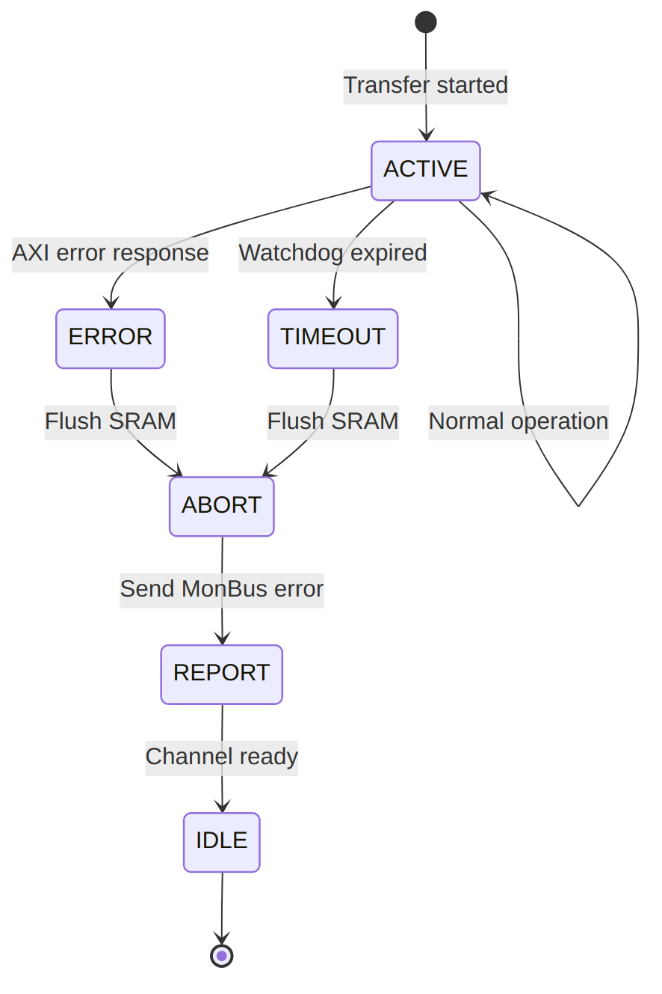
Error Recovery Sequence

RTL Design Sherpa · Learning Hardware Design Through Practice GitHub · Documentation Index · MIT License

17 Use Case: Memory to Network (Source Path)

17.1 Overview
The Source Path transfers data from system memory (AXI4 read master) to a network interface (AXI-Stream master). This is the primary transmit data path for network applications.
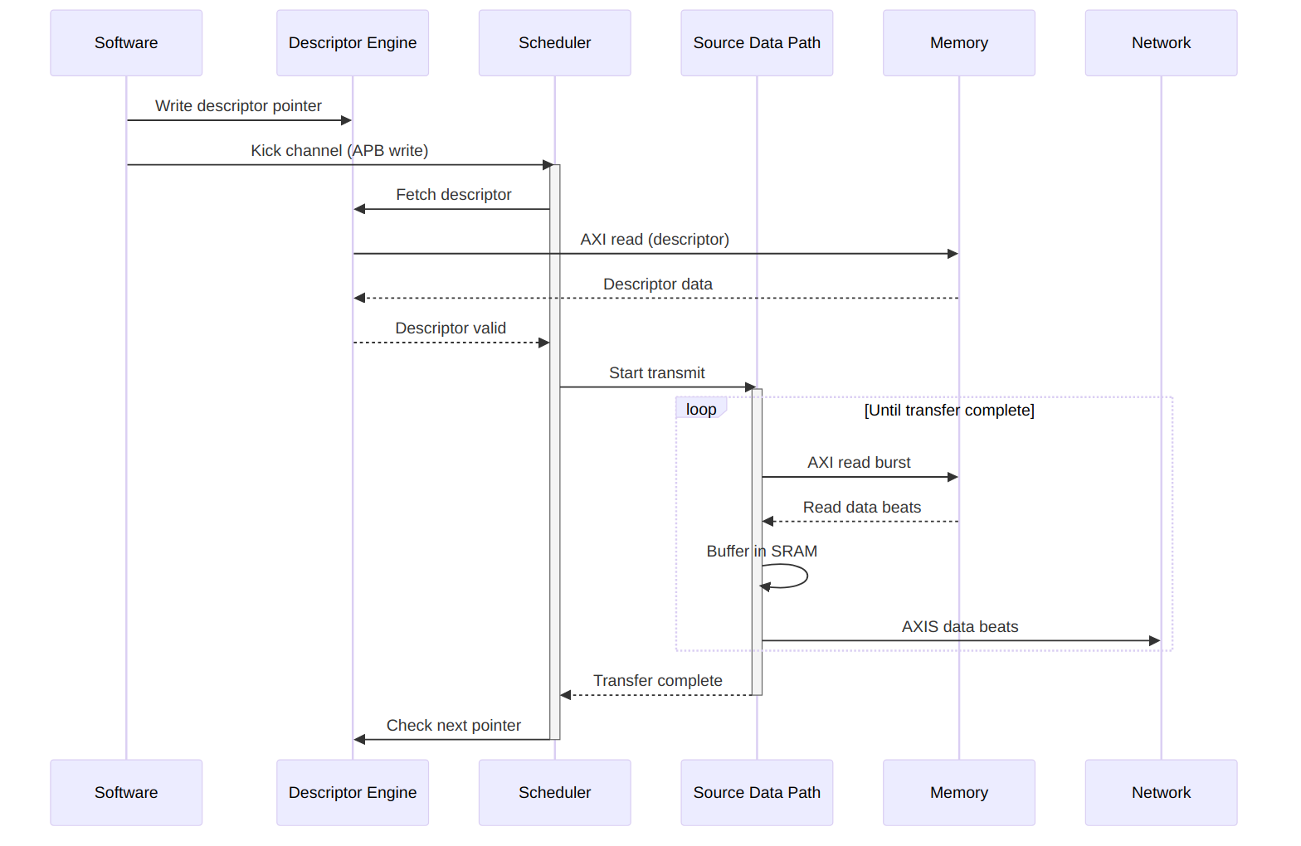
Operation Flow
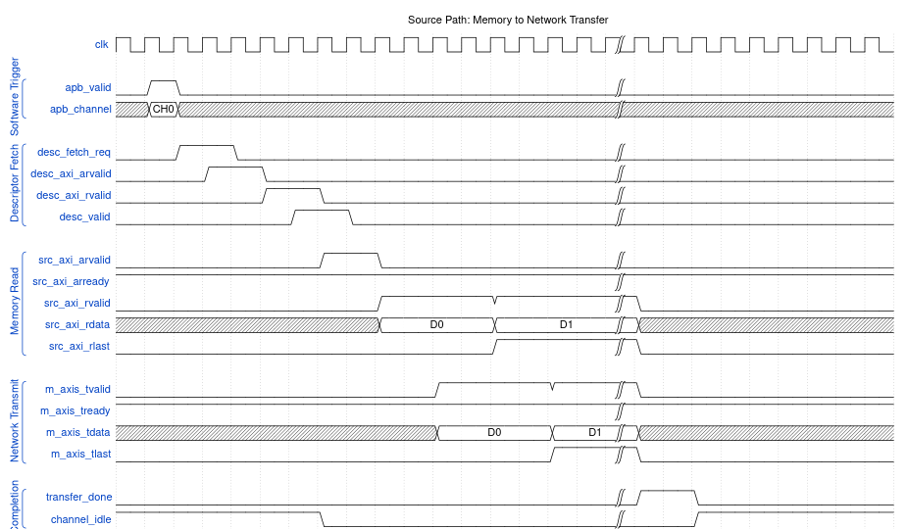
Timing Diagram

17.2 Buffer Management

17.2.1 SRAM Buffering Strategy
The source path uses internal SRAM to prefetch data and maintain network throughput:

17.2.2 Figure 4.2.1: Source Channel Buffer
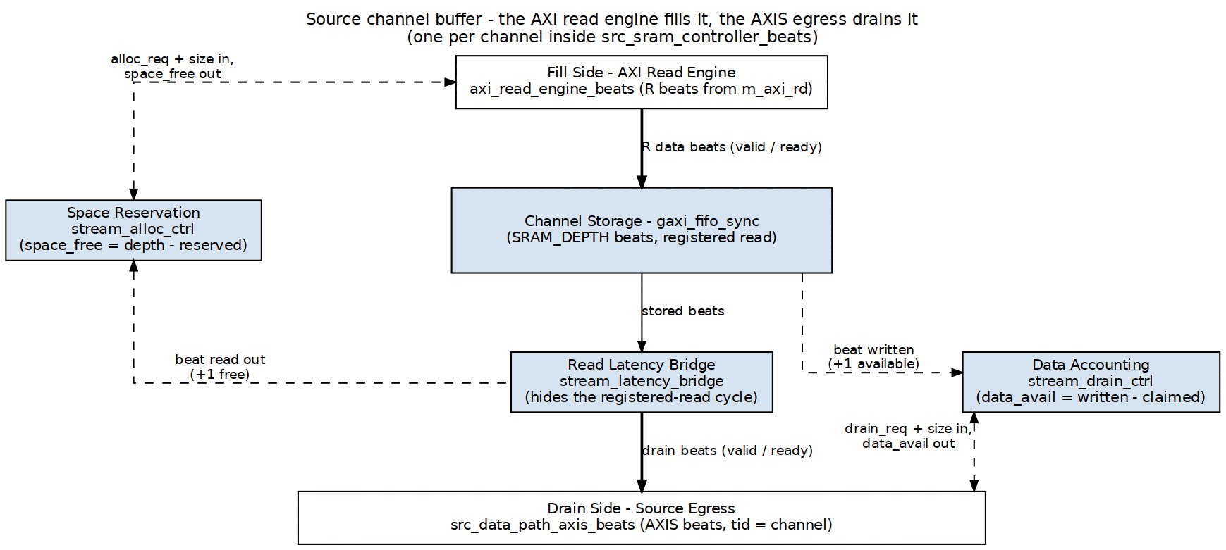
Source Channel Buffer
Source: ch04_source_buffering.dot

17.2.3 Flow Control
Source Path Flow Control
Condition | Behavior
SRAM full | Pause AXI reads
SRAM empty | Hold TVALID low
Network backpressure | Stop draining SRAM
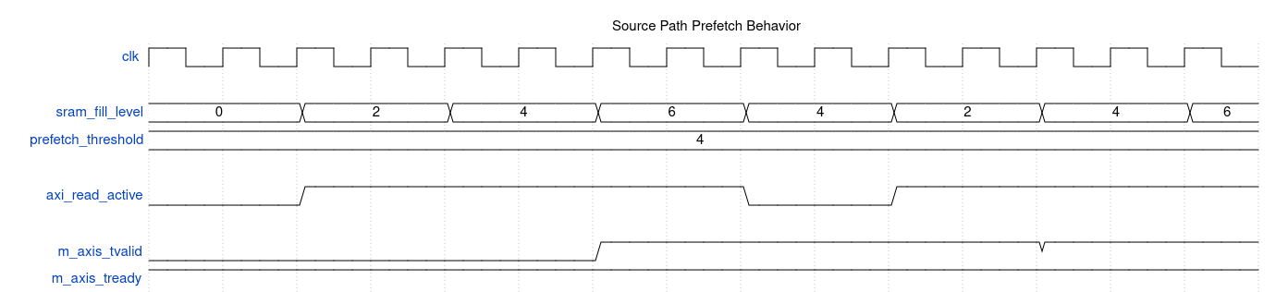
Prefetch Strategy

17.3 Concurrent Operation

17.3.1 Read-Ahead Pipeline
The source path can issue AXI reads ahead of network consumption:
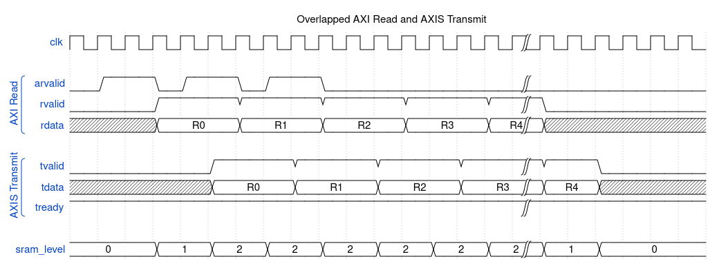
Waveform 20

17.4 Performance Considerations

17.4.1 Throughput
Source Path Throughput Factors
Factor | Impact
Memory bandwidth | Upper bound on transmit rate
Network acceptance | Must keep pace with reads
SRAM depth | Read-ahead capability
AXI outstanding | Overlapped read latency hiding

17.4.2 Latency
Source Path Latency Breakdown
Phase | Typical Cycles
Descriptor fetch | 10-50 (memory dependent)
AXI read issue | 1-2
Memory read latency | 10-100 (memory dependent)
SRAM to network | 1-2

17.5 Error Handling

17.5.1 Error Sources
Source Path Error Handling
Error | Detection | Response
AXI read error | RRESP != OKAY | Stop transfer, report via MonBus
Network timeout | Watchdog timer | Abort transfer, report error
Address range | Descriptor validation | Reject descriptor
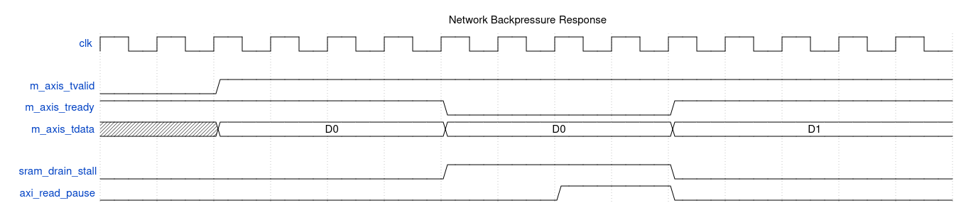
Backpressure Handling
When the network deasserts TREADY: 1. SRAM drain stalls immediately 2. SRAM continues filling until threshold 3. AXI reads pause when SRAM approaches full 4. Resume automatically when TREADY returns

RTL Design Sherpa · Learning Hardware Design Through Practice GitHub · Documentation Index · MIT License

18 Use Case: Descriptor Chaining

18.1 Overview
Descriptor chaining enables multiple transfers to execute sequentially without software intervention. Each descriptor contains a pointer to the next descriptor, forming a linked list that RAPIDS processes automatically.

18.2 Chain Structure

18.2.1 Figure 4.3.1: Descriptor Chain Structure
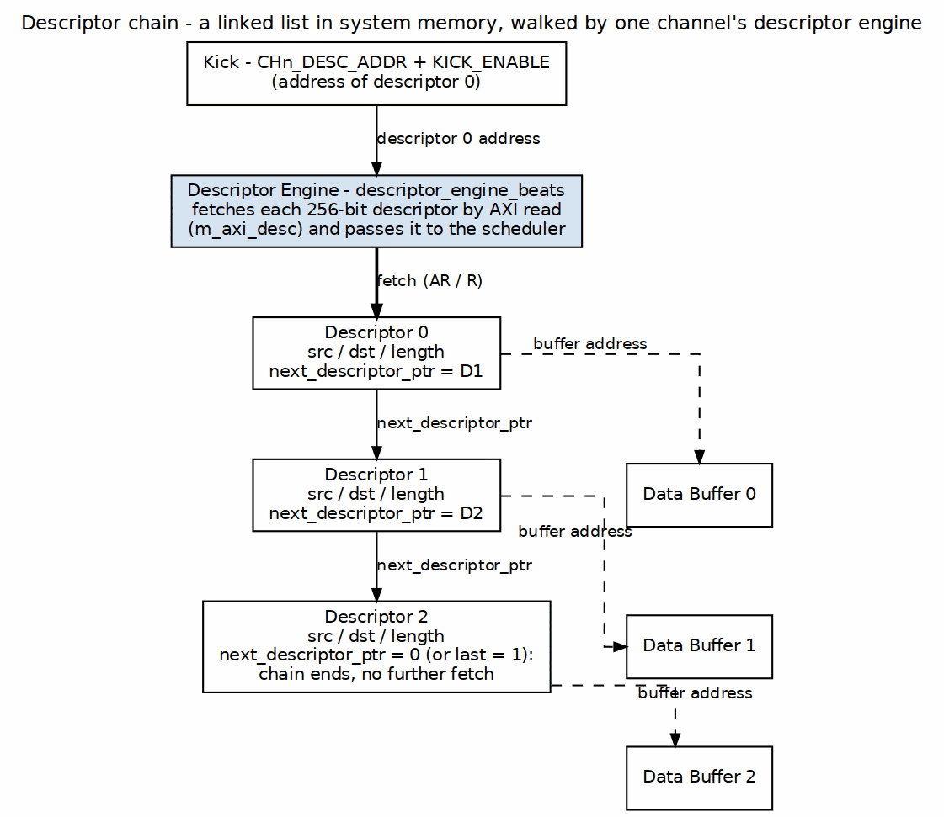
Descriptor Chain Structure
Source: ch04_chain_structure.dot

Chain Execution Flow

Timing Diagram

18.3 Descriptor Fields for Chaining

18.3.1 Relevant Fields
Chaining-Related Descriptor Fields
Field | Bits | Description
next_ptr | [191:128] | 64-bit pointer to next descriptor
last | [255] | Last descriptor in chain flag
irq_en | [254] | Generate interrupt on completion

18.3.2 Chain Termination
A chain terminates when ANY of these conditions is true:
- next_ptr == 0 (null pointer)
- last == 1 (explicit last flag)
- Error during transfer
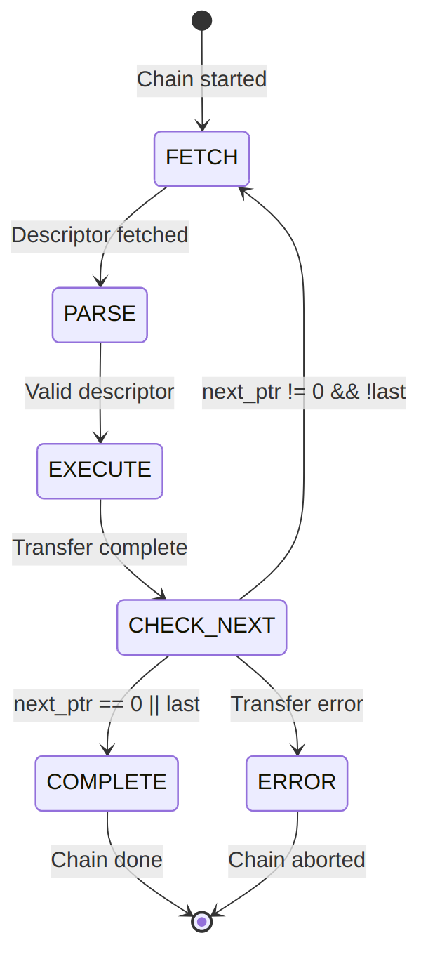
Diagram 10

18.4 Prefetch Optimization

18.4.1 Descriptor Prefetching
RAPIDS can prefetch the next descriptor while the current transfer executes:

Waveform 23
Benefit: Zero-cycle gap between chained transfers when prefetch completes before current transfer.
Prefetch depth is controlled by DESCENG_CONFIG.PREFETCH_EN and DESCENG_CONFIG.FIFO_THRESH (register block, offset 0x220). With prefetch disabled the descriptor engine fetches on demand (roughly one descriptor ahead of the scheduler); with prefetch enabled it buffers up to FIFO_THRESH descriptors ahead. A chain fetch that is throttled (output FIFO at the threshold) is deferred and reissued automatically once the FIFO drains, so no chain link is lost.

18.5 Multi-Channel Chaining
Each channel maintains independent chains:

18.5.1 Figure 4.3.2: Independent Per-Channel Chains

Independent Per-Channel Chains
Source: ch04_multichannel_chains.dot
Channels execute their chains concurrently and independently.

18.6 Error During Chain

18.6.1 Error Handling
When an error occurs mid-chain:

Waveform 24
Error Response: 1. Current transfer aborts 2. Chain processing stops 3. Error status captures failing descriptor index 4. MonBus reports error event 5. Interrupt generated (if enabled)

18.6.2 Recovery
Software must: 1. Read error status to identify failing descriptor 2. Fix the issue (descriptor content, memory mapping, etc.) 3. Restart chain from failing descriptor or beginning

RTL Design Sherpa · Learning Hardware Design Through Practice GitHub · Documentation Index · MIT License

19 Use Case: Multi-Channel Operation

19.1 Overview
RAPIDS Beats supports 8 independent DMA channels that can operate concurrently. This enables parallel data transfers for multiple network connections, priority-based scheduling, and efficient resource utilization.

19.2 Channel Independence

19.2.1 Figure 4.4.1: Independent Channels
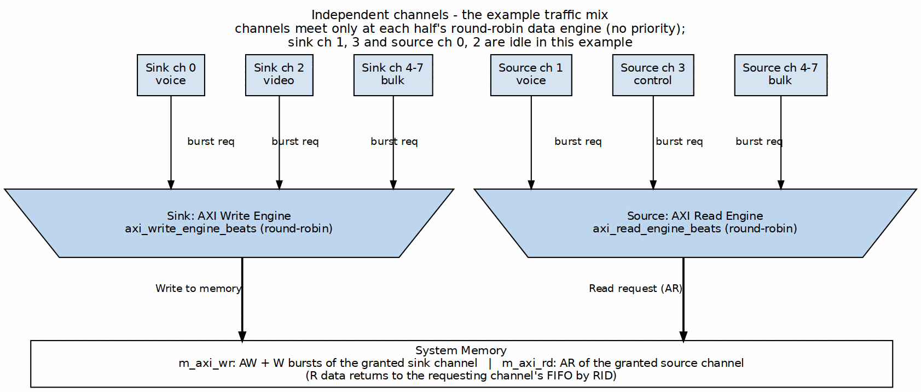
Independent Channels
Source: ch04_channel_independence.dot

Concurrent Operation Timing

19.3 Resource Arbitration

19.3.1 Descriptor Port Arbitration
All channels share a single AXI port for descriptor fetches:

Waveform 26

19.3.2 Sink/Source Arbitration
Data path AXI ports use plain round-robin arbitration (arbiter_round_robin inside each engine). There is no priority boost: the descriptor’s priority field is carried but not used for arbitration.

19.3.3 Figure 4.4.2: Data-Path AXI Arbitration
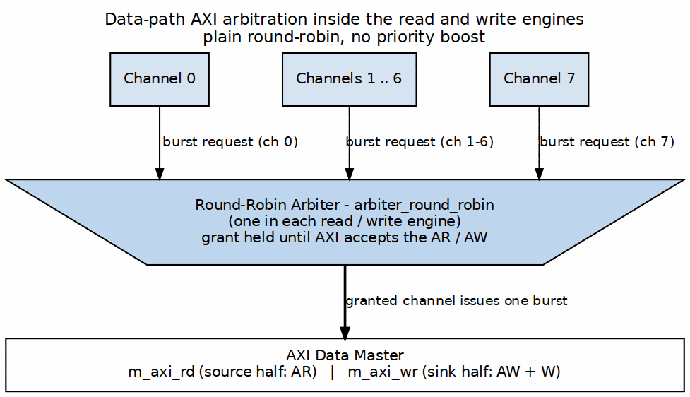
Data-Path AXI Arbitration
Source: ch04_datapath_arbitration.dot

19.4 Channel Isolation

19.4.1 Error Isolation
Errors in one channel do not affect other channels:

Waveform 27

19.4.2 Per-Channel Soft Reset
Individual channels can be reset without affecting others:

Waveform 28

19.5 Use Case Examples

19.5.1 Mixed Traffic Pattern
Typical network application with different traffic types:
Mixed Traffic Channel Assignment
Channel | Traffic Type | Direction | Priority | Notes
0 | Voice/RTP | Sink | High | Low latency required
1 | Voice/RTP | Source | High | Low latency required
2 | Video | Sink | Medium | High bandwidth
3 | Control | Source | Medium | Small packets
4-7 | Bulk data | Both | Low | Background transfers

19.5.2 Bidirectional Transfer
Single network connection using paired channels:

19.5.3 Figure 4.4.3: Bidirectional Transfer
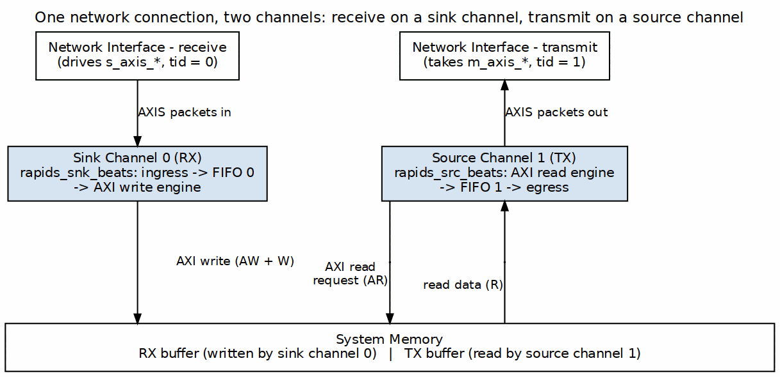
Bidirectional Transfer
Source: ch04_bidirectional.dot

19.5.4 Load Balancing
Multiple channels processing same traffic type:

19.5.5 Figure 4.4.4: Load Balancing by tid
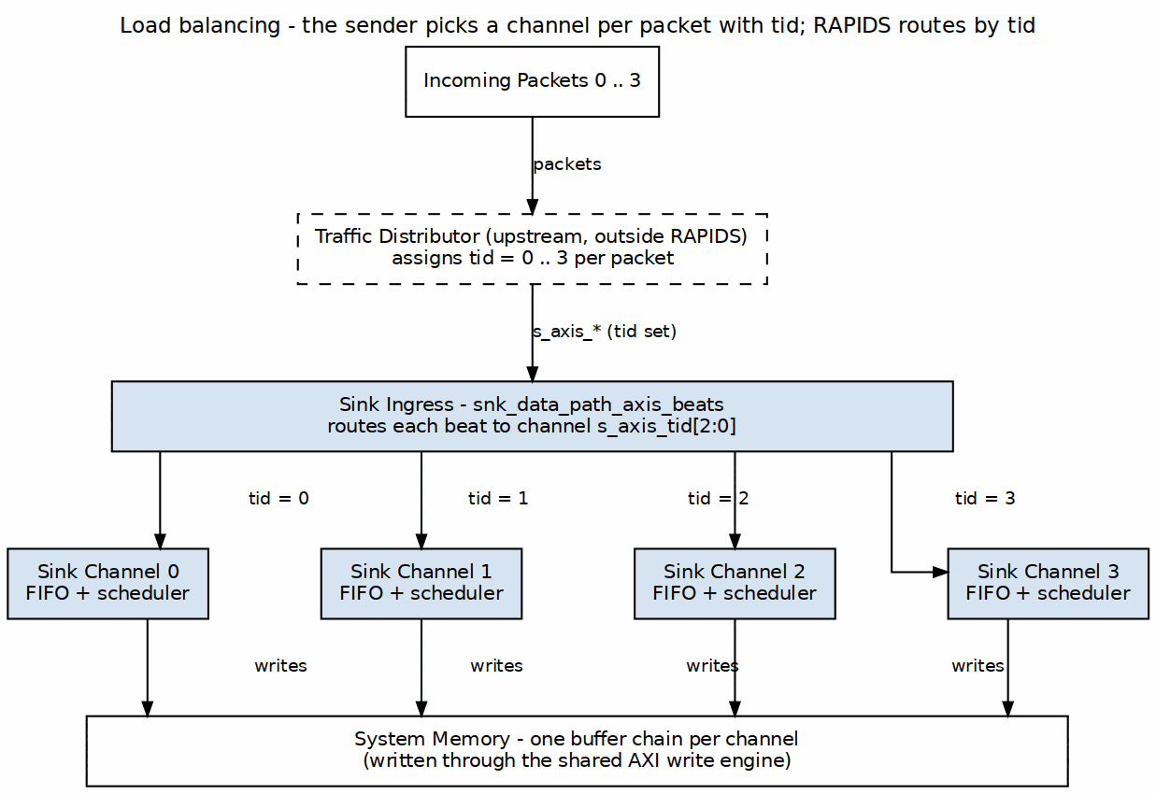
Load Balancing by tid
Source: ch04_load_balancing.dot

19.6 Performance Considerations

19.6.1 Bandwidth Sharing
Bandwidth Distribution
Active Channels | Per-Channel BW (% of max) | Notes
1 | 100% | Full bandwidth available
2 | ~50% each | Round-robin sharing
4 | ~25% each | Fair distribution
8 | ~12.5% each | All channels active
Note: Actual distribution depends on transfer sizes and memory latency.

19.6.2 Latency Impact
Multi-channel operation adds arbitration latency:
Arbitration Latency
Scenario | Additional Latency
Single channel | 0 cycles
2 channels contending | 1-2 cycles
8 channels contending | Up to 7 cycles

19.7 MonBus Events
Each channel generates independent MonBus events:

Waveform 29
Events are arbitrated and serialized on the shared MonBus output.

RTL Design Sherpa · Learning Hardware Design Through Practice GitHub · Documentation Index · MIT License

20 Descriptor Format

20.1 Overview
RAPIDS Beats uses 256-bit (32-byte) descriptors to define DMA transfers. Descriptors are stored in system memory and fetched by the Descriptor Engine when a channel is kicked.

20.2 Descriptor Layout

20.2.1 256-Bit Structure
Bit Range Field Name Width Description
────────────────────────────────────────────────────────────────────────
[255:213] reserved 43 Reserved (write 0)
[212:210] desc_type 3 0 = LEGACY, 1 = EXTENDED (see below)
[209:208] opcode 2 0 = DATA, 1 = CTRL_READ, 2 = CTRL_WRITE
[207:200] priority 8 Transfer priority (informational)
[199:196] channel_id 4 Channel ID (informational)
[195] error 1 Error flag (written by hardware)
[194] last 1 Last descriptor in chain
[193] gen_irq 1 Generate interrupt on completion
[192] valid 1 Descriptor valid flag
[191:160] next_descriptor_ptr 32 Address of next descriptor (0 = last)
[159:128] length 32 Transfer length in BEATS (not bytes)
[127:64] dst_addr 64 Destination address
[63:0] src_addr 64 Source address
: 256-Bit Descriptor Layout (rapids_pkg::descriptor_t)
The authoritative definition is rapids_pkg::descriptor_t in rtl/includes/rapids_pkg.sv; the same layout is restated in the scheduler’s header comment. Note the struct is declared 272 bits wide with a 16-bit pad above bit 255 – only [255:0] is fetched and used.
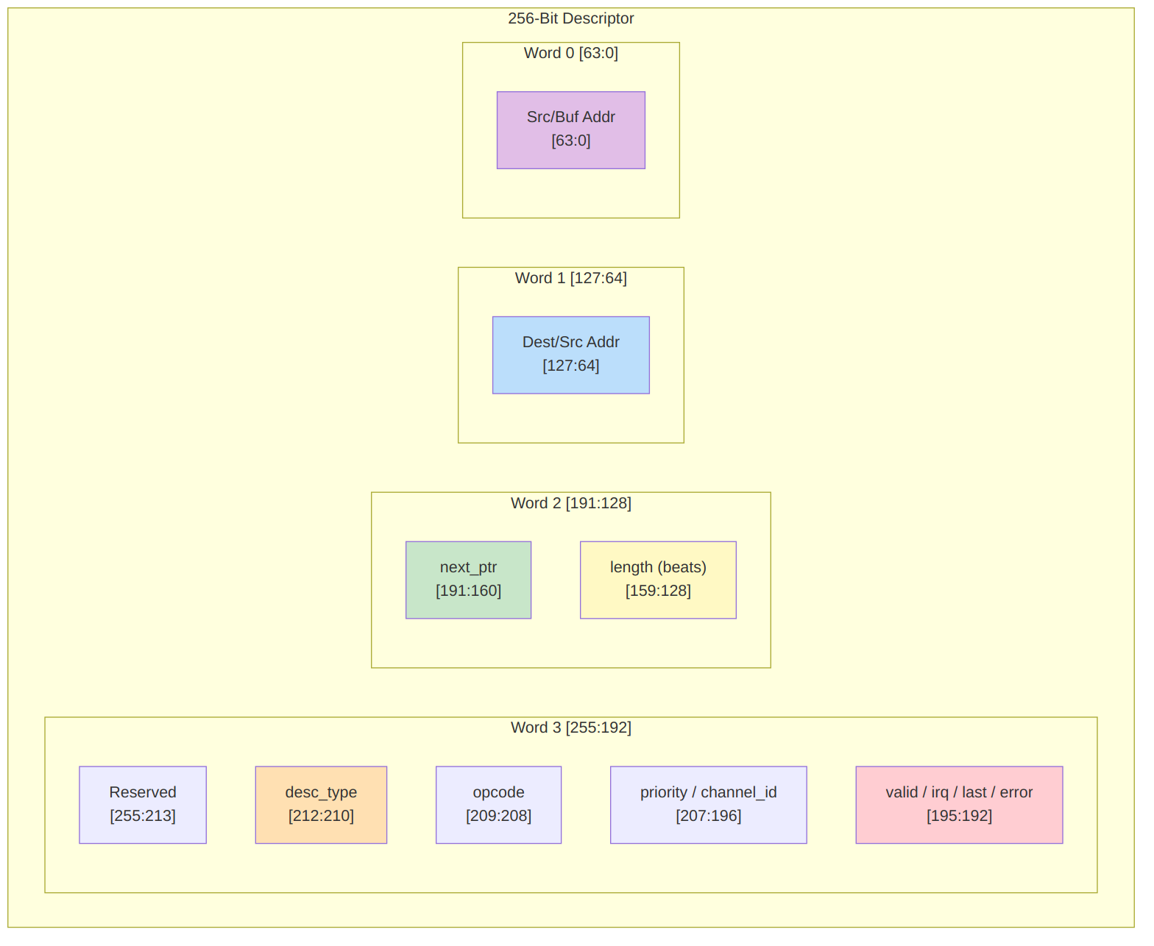
Visual Layout

20.3 Field Descriptions

20.3.1 Control Bits [195:192]
Control Bits
Bit | Field | Description
192 | valid | Must be 1; a descriptor with valid=0 raises a descriptor error
193 | gen_irq | Set to 1 to generate a completion interrupt
194 | last | Set to 1 for the last descriptor in a chain
195 | error | Error flag; written by hardware, write 0

20.3.2 Direction
There is no direction field in the descriptor. Direction is a property of the half that owns the channel: the SOURCE half (memory -> AXIS) reads from src_addr, the SINK half (AXIS -> memory) writes to dst_addr. A descriptor is delivered to one half’s descriptor engine by the address it was staged at, so the same layout serves both.

20.3.3 Transfer Length [159:128]
- 32-bit field specifying transfer size in BEATS, not bytes
- 1 beat = DATA_WIDTH bits (512 bits = 64 bytes in the default build)
- Length of 0 is reserved (no operation)

20.3.4 Next Pointer [191:160]
- 32-bit address of the next descriptor (zero-extended to the engine’s 64-bit address width)
- Value of 0 terminates the chain, as does last = 1
- Autonomous chaining also requires the address to fall inside one of the two configured descriptor address ranges

20.3.5 Address Fields [127:0]
For SINK transfers (network to memory): | Field | Usage | |——-|——-| | dst_addr [127:64] | Memory write destination address | | src_addr [63:0] | Not used (write 0) |
For SOURCE transfers (memory to network): | Field | Usage | |——-|——-| | dst_addr [127:64] | Not used (write 0) | | src_addr [63:0] | Memory read source address |
: Address Field Usage

20.4 Descriptor Opcodes (DATA / CTRL_READ / CTRL_WRITE)
Beyond plain DATA transfers, a descriptor carries a 2-bit opcode (rapids_pkg desc_op_e) that selects one of three behaviors. DATA descriptors move payload through the concurrent read/write engines (above); the two control opcodes let a channel synchronize with a producer/consumer in memory without moving payload – the basis of the RAPIDS producer/consumer flow.
Opcode | Value | Behavior
DATA | 2'b00 | Concurrent read/write payload transfer (fields as above)
CTRL_READ | 2'b01 | Consumer gate – poll a memory location until (read & mask) == expected, then release the descriptor/chain
CTRL_WRITE | 2'b10 | Producer doorbell – single 32-bit write of a value to a memory location, then continue
CTRL_READ (consumer gate) re-interprets the descriptor fields as a poll specification. The scheduler drives the per-channel control-read engine, which reads the gate address once per retry and compares the masked value; the descriptor completes when the gate is satisfied. The retry budget is bounded by CTRL_CONFIG.CTRLRD_MAX_TRY (0-511, reset 16) so a never-satisfied gate cannot hang the channel – exhaustion raises an error instead.
Field | Bits | Usage
poll_addr | [63:0] | Gate address to poll
expected | [95:64] | Expected value after masking
mask | [127:96] | Compare mask ((read & mask) == expected)
max_try | [143:128] | Per-descriptor retry hint (capped by CTRLRD_MAX_TRY)
CTRL_WRITE (producer doorbell) performs one single-beat 32-bit AXI write, after which the chain continues. It has no poll/retry – it is an unconditional write used to signal a consumer.
Field | Bits | Usage
wr_addr | [63:0] | Doorbell address
wr_data | [95:64] | 32-bit value to write
The control opcodes are handled by dedicated engines (control-read / control-write), one pair per channel, driven by the scheduler’s control interface. See the MAS Scheduler (Section 2.1) and Control-Read / Control-Write Engine specifications (Sections 2.8 / 2.9).

20.5 Extended Descriptors (row/col-major addressing)
desc_type = 1 (EXTENDED) selects strided / 2-D / circular addressing instead of linear accumulation. It is gated at build time by USE_ROW_COL_MAJOR_ADDRESSING; when that parameter is 0 the second-chunk fetch is unreachable and synthesizes away, and an EXT descriptor is treated as legacy.
An extended descriptor is 512 bits in two 256-bit chunks. Chunk 0 is the layout above with desc_type = 1. Chunk 1 holds the address-generator configuration and is fetched by a second single-beat read at descriptor_addr + 0x20, so the two chunks must be contiguous in memory.
Chunk 1 (at descriptor_addr + 0x20)
Bit Range Field Name Width Description
──────────────────────────────────────────────────────────────────────
[255:192] reserved_hi 64 Reserved (future 3rd dimension)
[191:188] wr_reserved 4 Reserved
[187:182] wr_wrap1_log2 6 Write outer wrap window, log2 (0 = off)
[181:176] wr_wrap0_log2 6 Write inner wrap window, log2 (0 = off)
[175:160] wr_inner_count 16 Write beats per contiguous run
[159:128] wr_stride_1 32 Write outer stride, SIGNED bytes
[127:96] wr_stride_0 32 Write inner stride, SIGNED bytes
[95:92] rd_reserved 4 Reserved
[91:86] rd_wrap1_log2 6 Read outer wrap window, log2 (0 = off)
[85:80] rd_wrap0_log2 6 Read inner wrap window, log2 (0 = off)
[79:64] rd_inner_count 16 Read beats per contiguous run
[63:32] rd_stride_1 32 Read outer stride, SIGNED bytes
[31:0] rd_stride_0 32 Read inner stride, SIGNED bytes
: Extended Descriptor Chunk 1 (rapids_pkg::descriptor_ext_t)
Read and write are configured independently, which is what makes transpose possible: one side bursts while the other issues single beats.
Mode selection is implicit. The hardware compares stride_0 against the beat size (DATA_WIDTH/8):
Condition | Mode | Behaviour
stride_0 == beat_size | run-contiguous | bursts inner_count beats, then jumps to the next run base
stride_0 != beat_size | per-beat 2-D | one beat per address; transpose, gather, scatter
Addresses follow addr = base + (i0 * stride_0) + (i1 * stride_1), with each offset masked by (1 << wrap_log2) - 1 when that wrap field is non-zero, giving circular buffers. i0 is the fast index and runs to inner_count. Strides are signed, so negative values walk backwards.
The layout is byte-compatible with STREAM’s descriptor_ext_t, so one descriptor builder serves both engines.
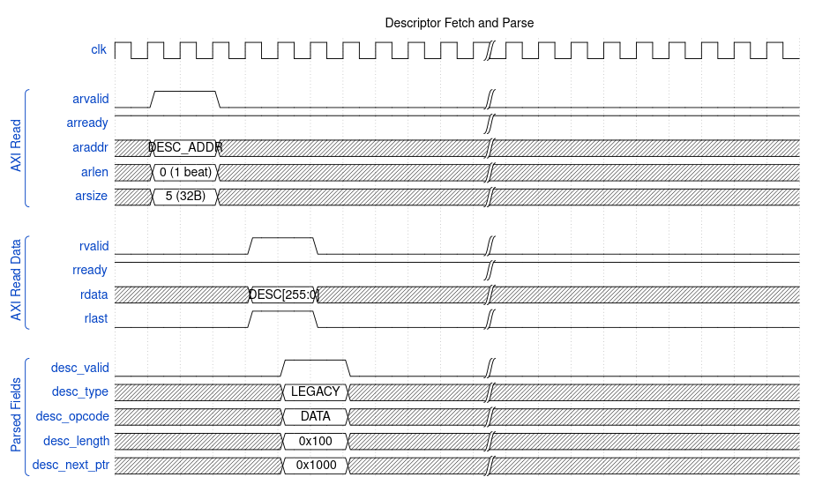
Descriptor Fetch Timing

20.6 Alignment Requirements
Address Alignment Requirements
Field | Alignment | Notes
Descriptor address | 32-byte | One descriptor is 32 bytes; an EXTENDED descriptor’s chunk 1 is fetched at +0x20
next_ptr [191:160] | 32-byte | 32-bit descriptor address, zero-extended by the engine
dst_addr [127:64] | DATA_WIDTH/8 | 64-byte for 512-bit data
src_addr [63:0] | DATA_WIDTH/8 | 64-byte for 512-bit data
Note: Unaligned addresses may cause unpredictable behavior or AXI protocol violations.

20.7 Descriptor Examples

20.7.1 Sink Descriptor (Network to Memory)
A 256-beat sink transfer to 0x1_0000_0000, chained to a descriptor at 0x2000, raising an interrupt on completion.
64-bit words, LSB word first:
[63:0] = 0x0000_0000_0000_0000 // src_addr (unused by the SINK half)
[127:64] = 0x0000_0001_0000_0000 // dst_addr = 0x1_0000_0000
[191:128] = 0x0000_2000_0000_0100 // next_ptr[191:160]=0x2000, length[159:128]=256
[255:192] = 0x0000_0000_0000_0007 // valid=1, gen_irq=1, last=1
Word 3 detail:
[192] = 1 // valid
[193] = 1 // gen_irq
[194] = 1 // last
[195] = 0 // error (hardware-written)
[199:196] = 0 // channel_id (informational)
[207:200] = 0 // priority
[209:208] = 00 // opcode = DATA
[212:210] = 000 // desc_type = LEGACY

20.7.2 Source Descriptor (Memory to Network)
A 128-beat source transfer from 0x2_0000_0000, terminated by next_ptr = 0.
64-bit words, LSB word first:
[63:0] = 0x0000_0002_0000_0000 // src_addr = 0x2_0000_0000
[127:64] = 0x0000_0000_0000_0000 // dst_addr (unused by the SOURCE half)
[191:128] = 0x0000_0000_0000_0080 // next_ptr = 0 (terminates), length = 128
[255:192] = 0x0000_0000_0000_0003 // valid=1, gen_irq=1, last=0
Word 3 detail:
[192] = 1 // valid
[193] = 1 // gen_irq
[194] = 0 // not last -- next_ptr = 0 terminates the chain
[209:208] = 00 // opcode = DATA
[212:210] = 000 // desc_type = LEGACY

20.8 Software Construction

20.8.1 C Structure Example
typedef struct __attribute__((packed, aligned(32))) {
uint64_t src_addr; // [63:0]
uint64_t dst_addr; // [127:64]
uint32_t length; // [159:128] transfer length in BEATS
uint32_t next_ptr; // [191:160] 32-bit, 0 terminates the chain
uint32_t flags; // [223:192] see macros below
uint32_t reserved[2]; // [255:224]
} rapids_descriptor_t;
// flags bit positions are relative to descriptor bit 192
#define DESC_VALID (1u << 0) // [192]
#define DESC_GEN_IRQ (1u << 1) // [193]
#define DESC_LAST (1u << 2) // [194]
#define DESC_ERROR (1u << 3) // [195] hardware-written
#define DESC_CHANNEL_ID(n) (((n) & 0xFu) << 4) // [199:196]
#define DESC_PRIORITY(n) (((n) & 0xFFu) << 8) // [207:200]
#define DESC_OPCODE(n) (((n) & 0x3u) << 16) // [209:208]
#define DESC_TYPE(n) (((n) & 0x7u) << 18) // [212:210]
#define DESC_OP_DATA 0x0
#define DESC_OP_CTRL_READ 0x1
#define DESC_OP_CTRL_WRITE 0x2
#define DESC_TYPE_LEGACY 0x0
#define DESC_TYPE_EXT 0x1

20.8.2 Descriptor Ring Setup
// Allocate descriptor ring (must be 32-byte aligned)
rapids_descriptor_t *desc_ring = aligned_alloc(32, NUM_DESC * sizeof(rapids_descriptor_t));
// Initialize chain
for (int i = 0; i < NUM_DESC - 1; i++) {
desc_ring[i].next_ptr = (uint64_t)&desc_ring[i + 1];
desc_ring[i].control = DESC_CTRL_IRQ_EN;
}
// Last descriptor
desc_ring[NUM_DESC - 1].next_ptr = 0;
desc_ring[NUM_DESC - 1].control = DESC_CTRL_LAST | DESC_CTRL_IRQ_EN;

RTL Design Sherpa · Learning Hardware Design Through Practice GitHub · Documentation Index · MIT License

21 Register Map

21.1 Overview
RAPIDS Beats provides a memory-mapped register interface for configuration and status. All registers are accessed through the single top-level APB slave (s_apb_*) and are implemented by the PeakRDL-generated rapids_regs register block. One addrmap holds two independent halves of the same layout (rapids_engine_regs): SRC at 0x0000 and SNK at 0x1000, 4 KB each. Within a half, the staged descriptor addresses occupy +0x000-0x03F, the launch register KICK_ENABLE sits at +0x040, configuration and status at +0x100-0x3FF, and the nested monitor regfile (rapids_mon_regs) at +0x800. Every offset below is relative to its half; add 0x1000 for the SNK copy.
Because the SNK half lives at 0x1000, the APB address bus must be at least 13 bits wide; paddr[12] selects the half and paddr[11] the monitor window.

21.2 Address Space Layout
Range (per half) | Target | Purpose
+0x000-0x03F | rapids_engine_regs | Per-channel staged descriptor addresses
+0x040 | rapids_engine_regs | KICK_ENABLE per-channel launch bits
+0x100-0x3FF | rapids_engine_regs | Configuration and status
+0x800-0x9FF | rapids_mon_regs | AXI-monitor config and performance
0x0000 / 0x1000 | half base | SRC half / SNK half
The three *_PKT_MASK registers are masks: bit[type] = 1 masks (drops) that packet type, at the monitor-lite and again at the monbus group. They reset to all-masked (0xFFFF), so nothing reaches the group until the host clears the bits of the classes it wants to see. (rapids BUG-008: the description used to read “1 = enable”; the polarity and the reset are as intended.) *_TIMEOUT counts MICROSECONDS in its low 16 bits.
On a build with USE_MON_REGS = 0 (the default when USE_AXI_MONITORS = 0) the two monitor windows keep their addresses but answer every access with PSLVERR and zero read data: the config blocks drive nothing from them, and a read-back that succeeded would tell the host a monitor is configured that does not exist.
: Address Space Layout

21.3 Base Registers (0x100-0x3FF)
Base Registers
Offset | Name | Access | Description
0x100 | GLOBAL_CTRL | RW | GLOBAL_EN[0], GLOBAL_RST[1] (level; write 0 to release)
0x104 | GLOBAL_STATUS | RO | SYSTEM_IDLE[0]
0x108 | VERSION | RO | MINOR[7:0], MAJOR[15:8], NUM_CHANNELS[23:16]=8
0x120 | CHANNEL_ENABLE | RW | CH_EN[7:0] per-channel enable
0x124 | CHANNEL_RESET | RW | CH_RST[7:0] per-channel reset (level; write 0 to release)
0x140 | CHANNEL_IDLE | RO | CH_IDLE[7:0] – not driven at the top level, reads 0; use SCHEDULER_IDLE
0x144 | DESC_ENGINE_IDLE | RO | Per-channel descriptor-engine idle
0x148 | SCHEDULER_IDLE | RO | Per-channel scheduler idle (excludes CH_ERROR)
0x150-0x16C | CH_STATE[0..7] | RO | Per-channel FSM state (stride 0x4)
0x170 | SCHED_ERROR | RO | Per-channel sticky scheduler error
0x174 | AXI_RD_COMPLETE | RO | Per-channel read-complete (SRC half only; reads 0 in SNK)
0x178 | AXI_WR_COMPLETE | RO | Per-channel write-complete – not driven, reads 0
0x200 | SCHED_TIMEOUT_CYCLES | RW | Write-progress timeout window (cycles, reset 1000)
0x204 | SCHED_CONFIG | RW | SCHED_EN, TIMEOUT_EN, ERR_EN, COMPL_EN, PERF_EN
0x208 | SCHED_TIMEOUT_LIMIT | RW | LIMIT[7:0] escalation limit (reset 4, 0 = never)
0x220 | DESCENG_CONFIG | RW | DESCENG_EN[0], PREFETCH_EN[1], FIFO_THRESH[5:2] (reset 8)
0x224 | DESCENG_ADDR0_BASE | RW | Descriptor address range 0 base [31:0]
0x228 | DESCENG_ADDR0_LIMIT | RW | Descriptor address range 0 limit [31:0]
0x22C | DESCENG_ADDR1_BASE | RW | Descriptor address range 1 base [31:0]
0x230 | DESCENG_ADDR1_LIMIT | RW | Descriptor address range 1 limit [31:0]
0x240 | CTRL_CONFIG | RW | CTRLRD_MAX_TRY[8:0] control-read poll retry budget (0-511, reset 16)
0x2A0 | AXI_XFER_CONFIG | RW | AXI transfer sizing configuration
0x2B0 | PERF_CONFIG | RW | Performance profiler configuration
0x2C0-0x2CC | OBS_CTRL/OBS_FLAGS/OBS_DATA0/OBS_DATA1 | RW/RO | Observation mux
0x35C | PERF_CH_SEL | RW | Performance channel select
0x378-0x380 | HIST_SEL/HIST_DATA/HIST_TOTAL | RW/RO | Latency histogram

21.4 Monitor Registers (+0x800 within each half)
Monitor Registers (+0x800 within each half; SRC at 0x0800, SNK at 0x1800)
Offset | Name | Access | Description
+0x800 | MON_FIFO_STATUS | RO | MonBus capture/error FIFO status
+0x804 | MON_FIFO_COUNT | RO | MonBus FIFO occupancy
+0x8C0-0x8DC | DAXMON_* | RW | Descriptor-monitor config (enable/timeout/latency/masks)
+0x8E0-0x8FC | RDMON_* | RW | Source-egress AXIS monitor-lite config (same layout; live in the SRC half, rapids TASK-015)
+0x900-0x91C | WRMON_* | RW | Sink-ingress AXIS monitor-lite config (same layout; live in the SNK half, rapids TASK-015; the SRC copy’s COMPRESS_EN drives the group)
+0x950-0x978 | DAXMON_PERF_* | RO/RW | Descriptor-monitor performance counters
+0x980-0x9A8 | RDMON_PERF_* | RO/RW | Read-monitor performance counters
+0x9B0-0x9D8 | WRMON_PERF_* | RO/RW | Write-monitor performance counters
+0x9E0-0x9F4 | {RD,WR}MON_PERF_CH_* | RO | Per-channel producer/backpressure/starve/idle/overflow

21.5 Key Register Fields

21.5.1 GLOBAL_CTRL (0x100) - Read/Write
GLOBAL_CTRL Register
Bits | Field | Reset | Description
[0] | GLOBAL_EN | 0 | Master enable for the entire engine
[1] | GLOBAL_RST | 0 | Global reset: holds every channel of the half in reset while 1. Not self-clearing – write 0 to release
[31:2] | Reserved | 0 | Reserved

21.5.2 SCHED_TIMEOUT_LIMIT (0x208) - Read/Write
SCHED_TIMEOUT_LIMIT Register
Bits | Field | Reset | Description
[7:0] | LIMIT | 4 | Consecutive write-progress timeout windows before escalating to a fatal, sticky CH_ERROR. 0 = never escalate. Total escalation time ~= LIMIT x SCHED_TIMEOUT_CYCLES.

21.5.3 DESCENG_CONFIG (0x220) - Read/Write
DESCENG_CONFIG Register
Bits | Field | Reset | Description
[0] | DESCENG_EN | 1 | Descriptor engine master enable
[1] | PREFETCH_EN | 0 | Prefetch chaining (0 = on-demand, ~1 ahead)
[5:2] | FIFO_THRESH | 8 | Descriptors buffered ahead when prefetch enabled
[31:6] | Reserved | 0 | Reserved

Register Access Timing

Waveform 32

21.6 Channel Kick Sequence
Staging a channel’s descriptor address, then writing that channel’s bit in KICK_ENABLE, triggers descriptor processing:

Waveform 33

21.7 Address Decoding
Registers are global (not per-channel windows); per-channel fields are packed as bit lanes within a single 32-bit register (e.g. CHANNEL_ENABLE.CH_EN[7:0], SCHEDULER_IDLE.SCHED_IDLE[7:0]). The only per-channel array is CH_STATE[0..7] at 0x150-0x16C (stride 0x4). Descriptor kick-off is part of this register block: staged addresses at 0x000-0x03F (CH*_DESC_ADDR_{LOW,HIGH}, stride 0x8) and the KICK_ENABLE launch register at 0x040.
+0x000 - 0x03F: Staged descriptor addresses (CH*_DESC_ADDR_{LOW,HIGH})
+0x040 : KICK_ENABLE (per-channel launch, singlepulse)
+0x100 - 0x3FF: Base configuration / status registers
+0x800 - 0x9FF: Monitor configuration / performance registers
SRC half at 0x0000, SNK half at 0x1000 (paddr[12]); PSLVERR on the monitor
window when USE_MON_REGS = 0.

RTL Design Sherpa · Learning Hardware Design Through Practice GitHub · Documentation Index · MIT License

22 Initialization Sequence

22.1 Overview
This section describes how software brings up RAPIDS Beats and starts a transfer. Every register named here is a register of the PeakRDL rapids_engine_regs register file (rtl/macro_beats/rapids_engine_regs.rdl), using the names in the generated per-instance map rapids_regmap.py. The two halves share one layout: SRC at 0x0000 and SNK at 0x1000. Each half is initialized on its own, and the offsets in the Register Map are relative to the half.
The code below uses reg_wr(half, NAME, value) and reg_rd(half, NAME) as shorthand for an APB access to register NAME in the SRC or SNK half. Resolve the names through the generated map instead of hard-coding offsets.

22.2 Boot Sequence

22.2.1 Figure 5.3.1: Bring-Up Sequence

Bring-Up Sequence
Source: ch05_boot_sequence.dot

22.3 What the Hardware Requires
A channel runs a descriptor only when every one of these terms is true. They are ANDed in rapids_config_block, so a missing one leaves the channel idle without raising an error:
Conditions for a Channel to Run
Term | Register.field | Reset | Effect when 0
Global enable | GLOBAL_CTRL.GLOBAL_EN | 0 | Masks CH_EN, SCHED_EN, DESCENG_EN and every monitor enable in the half
Channel enable | CHANNEL_ENABLE.CH_EN[n] | 0 | The scheduler stays in CH_IDLE with a descriptor waiting
Scheduler enable | SCHED_CONFIG.SCHED_EN | 1 | All schedulers in the half are disabled
Descriptor engine enable | DESCENG_CONFIG.DESCENG_EN | 1 | No descriptor is fetched
Descriptor window | DESCENG_ADDR0_BASE/_LIMIT, DESCENG_ADDR1_BASE/_LIMIT | 0 / 0xFFFFFFFF | A descriptor address outside both windows is refused and the channel errors
Kick | KICK_ENABLE.KICKn | – | Nothing is fetched until the bit is written
GLOBAL_EN and CH_EN both reset to 0. The other enables reset to 1, and both descriptor windows reset to the full 32-bit range, so a minimal bring-up only has to write CHANNEL_ENABLE, GLOBAL_CTRL, the staged address and KICK_ENABLE.

22.4 Detailed Steps

22.4.1 Step 1: Verify Hardware Presence
// VERSION (0x108): MINOR[7:0], MAJOR[15:8], NUM_CHANNELS[23:16]
uint32_t version = reg_rd(SRC, VERSION);
uint8_t minor = (version >> 0) & 0xFF; // 0x5A (90) in this release
uint8_t major = (version >> 8) & 0xFF; // 0x00: pre-release, version 0.90
uint8_t num_ch = (version >> 16) & 0xFF; // 8
if (num_ch == 0) {
printf("ERROR: RAPIDS not detected\n");
return -1;
}
There is no separate configuration register. The channel count is the only build parameter that software can read back. Data width and SRAM depth are not readable from the register file.

22.4.2 Step 2: Optional Reset
GLOBAL_CTRL.GLOBAL_RST and CHANNEL_RESET.CH_RST[n] are ordinary read/write bits. They do not self-clear. A channel is held in reset (scheduler forced to CH_IDLE, descriptor engine reset) for as long as its bit, or GLOBAL_RST, reads 1. Software must write the bit back to 0 to release it.
// Pulse the global reset: set, then clear. Keep GLOBAL_EN at 0 meanwhile.
reg_wr(half, GLOBAL_CTRL, GLOBAL_CTRL_GLOBAL_RST); // bit 1
reg_wr(half, GLOBAL_CTRL, 0);
// Every scheduler should now report idle (SYSTEM_IDLE = AND of SCHED_IDLE).
while (!(reg_rd(half, GLOBAL_STATUS) & 1)) { }

22.4.3 Step 3: Configure the Engine
// Scheduler: SCHED_EN[0] TIMEOUT_EN[1] ERR_EN[2] COMPL_EN[3] PERF_EN[4]
reg_wr(half, SCHED_TIMEOUT_CYCLES, 1000); // write-progress window, in clocks
reg_wr(half, SCHED_TIMEOUT_LIMIT, 4); // fatal after 4 stalled windows; 0 = never
reg_wr(half, SCHED_CONFIG, SCHED_EN | TIMEOUT_EN | ERR_EN | COMPL_EN);
// Descriptor engine: DESCENG_EN[0] PREFETCH_EN[1] FIFO_THRESH[5:2]
reg_wr(half, DESCENG_CONFIG, DESCENG_EN | PREFETCH_EN | (4 << 2));
// Descriptor address windows (lower 32 bits). A fetch address outside
// both windows is refused and the channel enters CH_ERROR.
reg_wr(half, DESCENG_ADDR0_BASE, desc_region_base);
reg_wr(half, DESCENG_ADDR0_LIMIT, desc_region_base + desc_region_size - 1);
// Burst sizing: RD_XFER_BEATS[7:0] WR_XFER_BEATS[15:8]
// ALLOC_SIZE[23:16] DRAIN_SIZE[31:24]
reg_wr(half, AXI_XFER_CONFIG, (16 << 24) | (16 << 16) | (8 << 8) | 8);
The SRC half uses the read-side fields and the SNK half uses the write-side fields. Writing the whole word in both halves does no harm.

22.4.4 Step 4: Optional Monitor and Interrupt Egress
The only interrupt output is mon_irq. It comes from the top-level monbus_axil4_axil4_group and is asserted while that group’s error FIFO is not empty. The scheduler error and completion packets travel on the CORE protocol. For both halves, the group takes its CORE filter from the SRC half’s WRMON_* registers:
// CORE packets: PKT_MASK bit[type] = 1 DROPS that type; reset is 0xFFFF.
reg_wr(SRC, WRMON_PKT_MASK, ~((1u << 0) | (1u << 1)) & 0xFFFF); // pass Error, Completion
// ERR_SELECT[3:0] bit[type] = 1 routes that type to the error FIFO (-> mon_irq).
// Bit 0 = Error. Bit 1 = Completion, which includes the gen_irq descriptor event.
reg_wr(SRC, WRMON_ERR_CFG, (0xFF << 8) | (1u << 0)); // keep ERR_MASK reset value
Packets that are passed but not selected for the error FIFO go to the capture path (m_axil_mon_*). The group, mon_irq and the s_axil_err_* drain exist only when USE_AXI_MONITORS = 1. With USE_AXI_MONITORS = 0, mon_irq is tied to 0, and software must poll SCHED_ERROR and SCHEDULER_IDLE instead.

22.4.5 Step 5: Build Descriptors
// rapids_pkg::descriptor_t, 256 bits (see Descriptor Format)
for (int i = 0; i < NUM_RX_DESC; i++) {
desc[i].src_addr = 0; // unused by a sink transfer
desc[i].dst_addr = rx_buffer + i * FRAME_SIZE;
desc[i].length = FRAME_LEN; // BEATS in RAPIDS Beats, BYTES in byte-granular RAPIDS
desc[i].next_descriptor_ptr = (i < NUM_RX_DESC - 1) ? (uint32_t)&desc[i + 1] : 0;
desc[i].valid = 1; // 0 -> CH_ERROR
desc[i].last = (i == NUM_RX_DESC - 1);
desc[i].gen_irq = 1; // completion event RAPIDS_EVENT_IRQ
}
__sync_synchronize(); // descriptors visible before the kick
The descriptors must lie inside a DESCENG_ADDR0/DESCENG_ADDR1 window.

22.4.6 Step 6: Enable
reg_wr(half, CHANNEL_ENABLE, 1u << ch); // CH_EN[n]
reg_wr(half, GLOBAL_CTRL, GLOBAL_CTRL_GLOBAL_EN); // bit 0; GLOBAL_RST stays 0

Initialization Timing
cfg_channel_enable[n] is CH_EN[n] & GLOBAL_EN, so it asserts only after the last of the two writes.

22.5 Starting Transfers

22.5.1 Kick a Channel
Stage the descriptor address, then launch it with a single write to KICK_ENABLE. The address registers only store the value, so writing them does not start anything. Each KICKn bit is a singlepulse field and clears itself. One 32-bit write can launch several channels on the same clock.
reg_wr(half, CH0_DESC_ADDR_LOW, (uint32_t)((uint64_t)&desc[0]));
reg_wr(half, CH0_DESC_ADDR_HIGH, (uint32_t)((uint64_t)&desc[0] >> 32));
reg_wr(half, KICK_ENABLE, 1u << 0); // KICK0
The APB write completes as soon as the request is raised. The RTL holds the request until the descriptor engine accepts it, so a completed write does not mean the engine has accepted the kick.

Waveform 35

22.6 Completion and Interrupt Handling
There is no interrupt status register and no per-channel interrupt clear. Software sees completion in one of two ways:
- Polling. SCHEDULER_IDLE.SCHED_IDLE[n] returns to 1 when the scheduler is back in CH_IDLE after the last descriptor of a chain. A channel in CH_ERROR never reports idle, and SCHED_ERROR.SCHED_ERR[n] reads 1 for it instead. Poll both registers, or the loop will hang on a faulted channel. Do not poll CHANNEL_IDLE, AXI_WR_COMPLETE, or the SNK half’s AXI_RD_COMPLETE. Those fields are not driven at the top level and always read 0 (see the Register Map).
- mon_irq. If Step 4 routed Completion packets to the error FIFO, every descriptor completion lands there, and so does every error. A completion is reported as RAPIDS_EVENT_DESC_COMPLETE, or as RAPIDS_EVENT_IRQ when the descriptor’s gen_irq is set. The descriptor engine’s descriptor-loaded completions land there too. mon_irq stays high until the records are drained over s_axil_err_*.
void rapids_irq_handler(void) {
// mon_irq == error FIFO not empty: drain every record
while (mon_irq_pending()) {
mon_record_t r = err_fifo_read(); // s_axil_err_* reads
if (r.pkt_type == PKT_TYPE_ERROR) {
handle_channel_error(r.half, r.channel_id); // see Error Handling
} else if (r.pkt_type == PKT_TYPE_COMPLETION) {
process_completed_buffer(r.half, r.channel_id, r.event_data);
}
}
}
To run the channel again, stage the next chain’s first descriptor address and write its KICK_ENABLE bit. No re-enable is needed, because CH_EN stays set.

22.7 Reset and Recovery

22.7.1 Per-Channel Reset
void reset_channel(int half, int ch) {
// Assert, then release: CH_RST is NOT self-clearing.
reg_wr(half, CHANNEL_RESET, 1u << ch);
reg_wr(half, CHANNEL_RESET, 0);
while (!(reg_rd(half, SCHEDULER_IDLE) & (1u << ch))) { }
// SCHED_ERROR[ch] is the CH_ERROR state, so it reads 0 again here.
}
The scheduler’s error state is sticky. The only ways out of CH_ERROR are a channel reset (CH_RST[n]) or a global reset (GLOBAL_RST). The reset leaves CH_EN[n] and the staged descriptor address unchanged. After the reset, re-stage the address if it should change, then kick.

22.7.2 Global Reset
void reset_rapids_half(int half) {
reg_wr(half, GLOBAL_CTRL, GLOBAL_CTRL_GLOBAL_RST); // GLOBAL_EN = 0, RST = 1
reg_wr(half, GLOBAL_CTRL, 0); // release
while (!(reg_rd(half, GLOBAL_STATUS) & 1)) { } // SYSTEM_IDLE
rapids_init_half(half); // Steps 3-6 again
}
GLOBAL_RST drives every channel’s reset in that half only. The other half, and the shared monitor group’s error FIFO, are not affected.

RTL Design Sherpa · Learning Hardware Design Through Practice GitHub · Documentation Index · MIT License

23 Error Handling

23.1 Overview
This section covers how RAPIDS Beats detects an error, how it reports one, and how software recovers. Every fatal error in a channel ends the same way. The channel’s scheduler latches it and moves to the sticky CH_ERROR state, and it stays there until software resets the channel. No per-channel error-status register holds an error code. Software has three sources of information: the SCHED_ERROR bit, the CH_STATE readback, and the MonBus error packet.

23.2 Error Categories

23.2.1 Figure 5.4.1: Error Sources
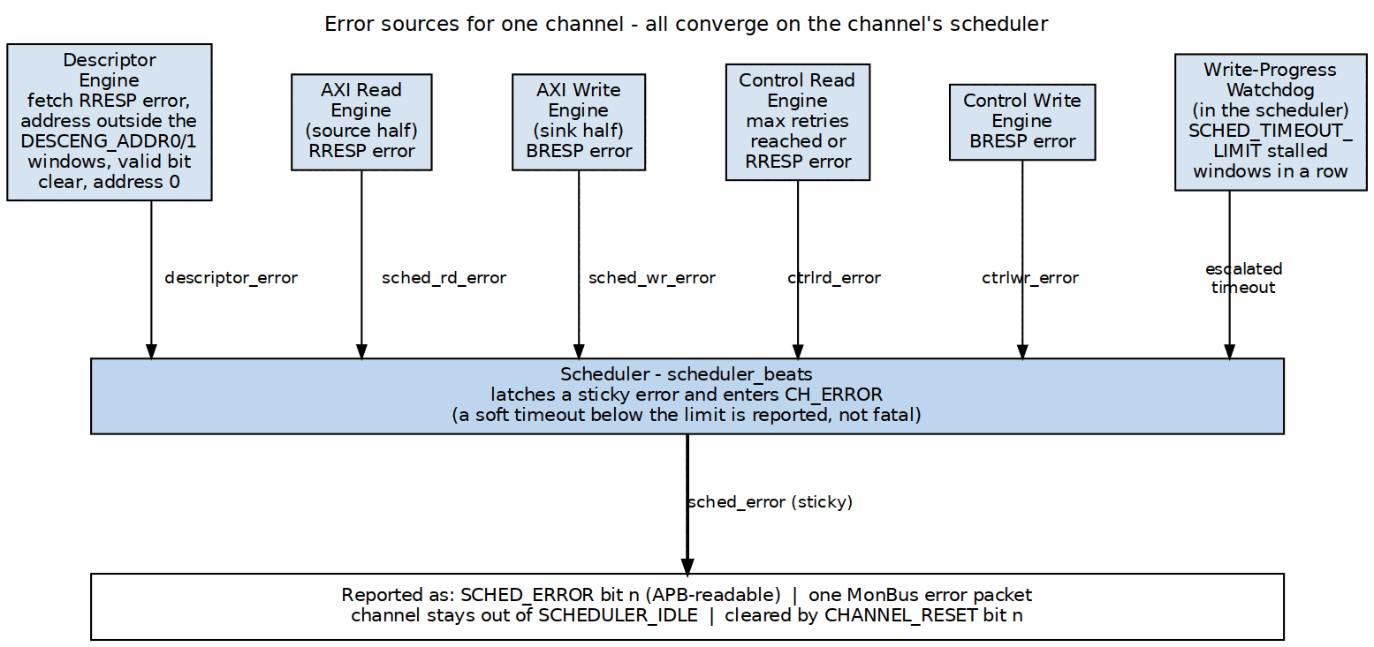
Error Sources
Source: ch05_error_sources.dot

23.3 Error Detection

23.3.1 AXI Response Errors
RAPIDS checks the response on every AXI transaction it issues: descriptor fetches, source-half data reads, sink-half data writes, and the control read/write engines.
AXI Response Codes
Response | Code | Description | Typical Cause
OKAY | 2’b00 | Normal success | –
EXOKAY | 2’b01 | Exclusive OK | –
SLVERR | 2’b10 | Slave error | Memory protection, invalid access
DECERR | 2’b11 | Decode error | Address not mapped
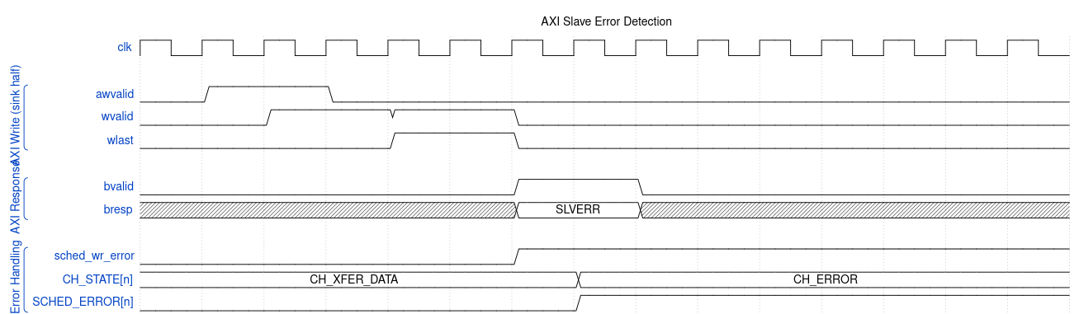
Waveform 36

23.3.2 Descriptor Errors
The descriptor engine and the scheduler apply a small, fixed set of checks. None of them has its own status code. Each one sets the channel’s SCHED_ERROR bit, and the descriptor-engine checks also emit a MonBus error packet.
Descriptor Checks
Check | Where | Error condition
Address window | Descriptor engine | The fetch address is outside both DESCENG_ADDR0_BASE..DESCENG_ADDR0_LIMIT and DESCENG_ADDR1_BASE..DESCENG_ADDR1_LIMIT. The fetch is refused and never issued.
Null pointer | Descriptor engine | The descriptor address is 0
Fetch response | Descriptor engine | RRESP is not OKAY on the descriptor read
Valid bit | Scheduler (CH_FETCH_DESC) | The descriptor’s valid bit is 0
The hardware does not check length, alignment, or direction. A descriptor with a zero or oversized length is software’s responsibility. The software validation example at the end of this section shows one way to catch it.
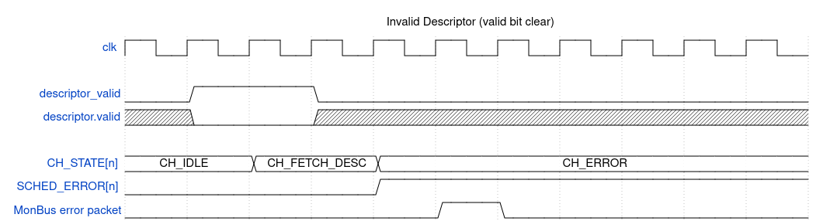
Waveform 37

23.3.3 Timeout Detection
Only the scheduler’s write-progress watchdog can put a channel into CH_ERROR by itself. The control-read retry budget has a similar effect. The AXI monitors’ timeouts only report.
Timeout Mechanisms
Mechanism | Register | Reset value | Result
Write-progress watchdog | SCHED_TIMEOUT_CYCLES.TIMEOUT_CYCLES (clocks per window), SCHED_TIMEOUT_LIMIT.LIMIT (windows) | 1000, 4 | Fatal CH_ERROR after LIMIT consecutive stalled windows. With LIMIT = 0 it never escalates. Enabled by SCHED_CONFIG.TIMEOUT_EN.
Control-read poll budget | CTRL_CONFIG.CTRLRD_MAX_TRY | 16 | A CTRL_READ descriptor that does not match within the budget raises ctrlrd_error, and the channel goes to CH_ERROR
Monitor transaction timeout | DAXMON_TIMEOUT, RDMON_TIMEOUT, WRMON_TIMEOUT | – | Emits a MonBus Timeout packet when the monitor’s TIMEOUT_EN is set. The channel state does not change.
Recoverable write-progress timeout. Each window of SCHED_TIMEOUT_CYCLES clocks that expires without write progress adds one strike to a counter. The channel goes to the fatal, sticky CH_ERROR only after SCHED_TIMEOUT_LIMIT (register 0x208) consecutive stalled windows. Any write progress, either an AW issue or a B-response commit, clears the strike counter. A limit of 0 disables escalation entirely, which makes the timeout soft. A channel in CH_ERROR is reported through SCHED_ERROR and is deliberately left out of SCHEDULER_IDLE.
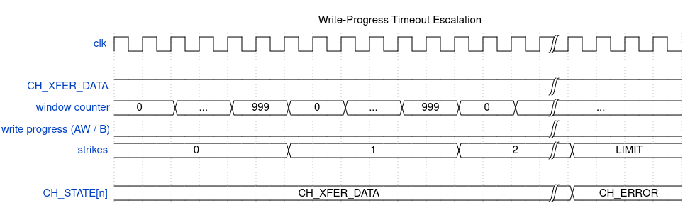
Waveform 38

23.4 Error Reporting

23.4.1 Status Registers
Error-Related Status Registers
Register | Meaning on error
SCHED_ERROR.SCHED_ERR[n] | 1 while channel n is in CH_ERROR. The bit reads the state directly and clears only on channel reset.
CH_STATE[n].STATE | One-hot scheduler state. CH_ERROR = 7’b0100000.
SCHEDULER_IDLE.SCHED_IDLE[n] | 0 for a faulted channel, because CH_ERROR is not idle
GLOBAL_STATUS.SYSTEM_IDLE | 0 while any channel in the half is faulted
The register file does not record which response code or which descriptor caused the error. That detail travels only in the MonBus error packet.

23.4.2 MonBus Error Events
Each error episode emits one error packet (PktTypeError, CORE protocol). The packet carries the half’s agent ID and the channel ID:
MonBus Error Packets
Emitter | Event code | Event data
Scheduler (on entering CH_ERROR) | RAPIDS_EVENT_ERROR (0x0F) | Read-side and write-side sticky error flags. Both clear means the cause was the descriptor engine, a control engine, or the timeout.
Descriptor engine | CORE_ERR_DESCRIPTOR_ENGINE | The descriptor fetch RRESP
SCHED_CONFIG.ERR_EN and COMPL_EN do not gate error packets. The scheduler re-arms its one-shot error packet when the channel returns to CH_IDLE.
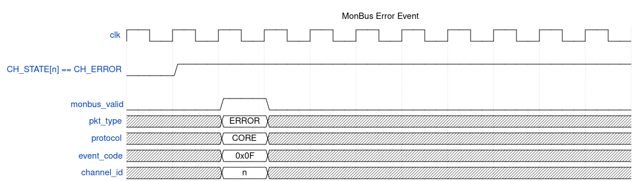
Waveform 39

23.4.3 Interrupt Generation
There is no separate interrupt status register. A channel error sets that channel’s sticky SCHED_ERROR bit and emits one MonBus error packet. The top-level monitor group routes the packet types that its err_select configuration selects into its error FIFO. For CORE packets that configuration is SRC.MON.WRMON_ERR_CFG.ERR_SELECT, and bit 0 selects Error. SRC.MON.WRMON_PKT_MASK bit 0 must also be clear, because the reset value masks every type. mon_irq is asserted while the error FIFO is not empty. Software reads the records out over s_axil_err:

23.4.4 Figure 5.4.2: Error Reporting
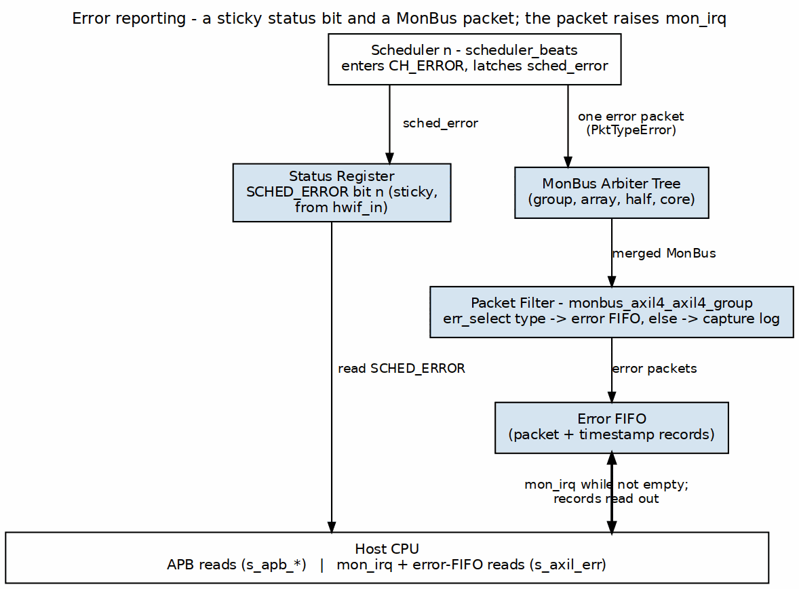
Error Reporting
Source: ch05_error_reporting.dot

23.5 Error Recovery

23.5.1 Recovery Flow

23.5.2 Figure 5.4.3: Error Recovery
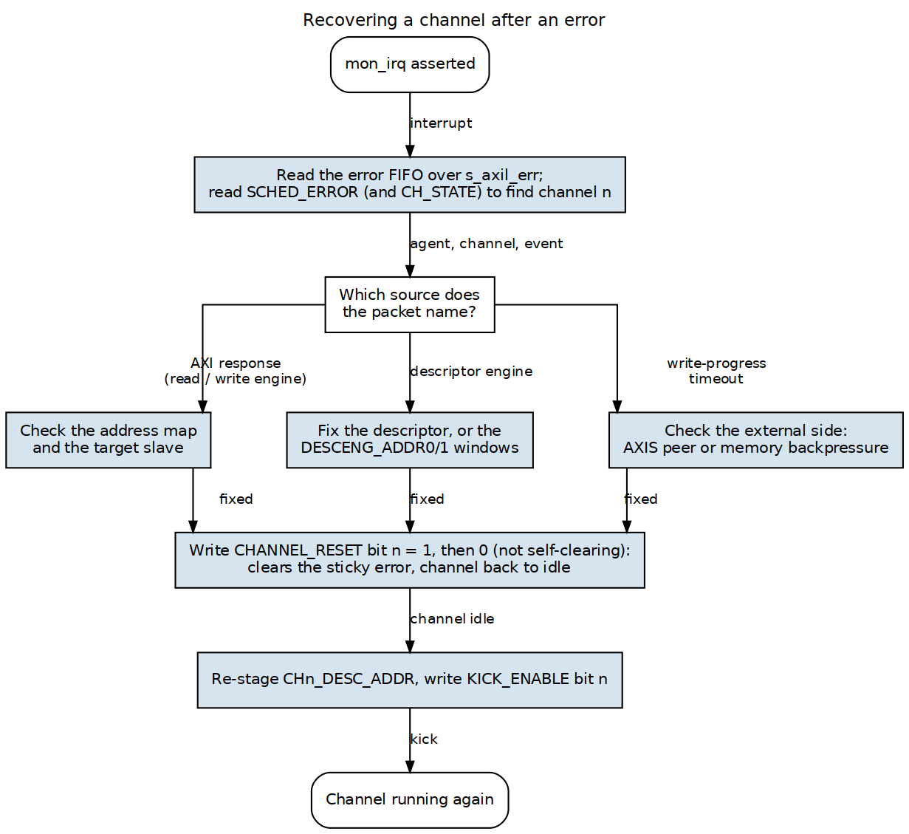
Error Recovery
Source: ch05_error_recovery.dot
Every recovery ends the same way. Fix the cause, then reset the channel. Set its CHANNEL_RESET bit and clear it again, because the bit is not self-clearing. Re-stage the descriptor address and kick. reset_channel() is defined in Initialization.

23.5.3 Finding the Faulted Channel
void handle_errors(int half) {
uint32_t faulted = reg_rd(half, SCHED_ERROR) & 0xFF; // SCHED_ERR[7:0]
for (int ch = 0; ch < 8; ch++) {
if (!(faulted & (1u << ch)))
continue;
mon_record_t r = find_error_record(half, ch); // from the s_axil_err drain
recover_channel(half, ch, &r);
}
}

23.5.4 AXI Error Recovery
void recover_axi_error(int half, int ch, const mon_record_t *r) {
// The scheduler packet says which side failed; the address is not latched.
if (r->rd_err)
printf("%s ch%d: read-side AXI error\n", half_name(half), ch);
if (r->wr_err)
printf("%s ch%d: write-side AXI error\n", half_name(half), ch);
// Check the address map and the target slave, then:
reset_channel(half, ch);
restage_and_kick(half, ch, first_desc_addr[half][ch]);
}

23.5.5 Descriptor Error Recovery
void recover_desc_error(int half, int ch, uint64_t bad_desc) {
// Window refusal, null pointer, fetch RRESP error, or valid bit clear.
// Fix the descriptor (or widen DESCENG_ADDR0/1) before re-kicking.
fix_descriptor(bad_desc);
reset_channel(half, ch);
restage_and_kick(half, ch, bad_desc);
}
void restage_and_kick(int half, int ch, uint64_t addr) {
reg_wr(half, CH_DESC_ADDR_LOW(ch), (uint32_t)addr); // CHn_DESC_ADDR_LOW
reg_wr(half, CH_DESC_ADDR_HIGH(ch), (uint32_t)(addr >> 32)); // CHn_DESC_ADDR_HIGH
reg_wr(half, KICK_ENABLE, 1u << ch); // KICKn
}

23.5.6 Timeout Recovery
void recover_timeout(int half, int ch) {
// Escalated write-progress timeout: the write side stopped making progress
// for SCHED_TIMEOUT_LIMIT windows. In the SNK half that usually means the
// AXIS peer stopped sending or memory stopped accepting writes. In the SRC
// half, check m_axis_tready.
printf("%s ch%d: write-progress timeout\n", half_name(half), ch);
reset_channel(half, ch);
restage_and_kick(half, ch, first_desc_addr[half][ch]);
}
To ride out long stalls without a fatal error, raise SCHED_TIMEOUT_CYCLES or SCHED_TIMEOUT_LIMIT, or set the limit to 0. The timeout is then reported but never escalates.

23.6 Error Prevention

23.6.1 Best Practices
Error Prevention Best Practices
Practice | Rationale
Validate descriptors before submission | The hardware checks only the window, a null pointer, and the valid bit
Set DESCENG_ADDR0/1 to the real descriptor region | A stray next_descriptor_ptr is refused rather than fetched
Size SCHED_TIMEOUT_CYCLES x SCHED_TIMEOUT_LIMIT above the worst legitimate stall | Avoids false fatal timeouts
Route Error packets to the error FIFO | mon_irq reports errors without polling

23.6.2 Descriptor Validation Example
int validate_descriptor(const rapids_descriptor_t *desc) {
if (!desc->valid)
return ERR_NOT_VALID; // the scheduler would fault the channel
if (desc->length == 0 || desc->length > MAX_BEATS)
return ERR_LENGTH; // not checked by hardware
if (desc->next_descriptor_ptr &&
!in_desc_window(desc->next_descriptor_ptr))
return ERR_ADDRESS; // the descriptor engine would refuse it
return 0;
}

RTL Design Sherpa · Learning Hardware Design Through Practice GitHub · Documentation Index · MIT License

24 Throughput Targets
RAPIDS Beats is a network-to-memory accelerator: the sink path moves an AXIS ingress stream into system memory, and the source path reads system memory and drives an AXIS egress stream. The two paths are independent engines (with their own SRAM buffers, schedulers, and AXI masters), so a sink transfer and a source transfer run concurrently and their bandwidths add.

24.1 Theoretical Maximum
A beat is DATA_WIDTH = 512 bits = 64 bytes. Per-direction bandwidth is DATA_WIDTH x f_aclk / 8.

24.1.1 Per-Interface Bandwidth
Interface | Data Width | Frequency | Bandwidth
Descriptor Fetch | 256 bits | 100 MHz | 3.2 GB/s
Sink AXI Write (to memory) | 512 bits | 100 MHz | 6.4 GB/s
Source AXI Read (from memory) | 512 bits | 100 MHz | 6.4 GB/s
AXIS ingress / egress (network) | 512 bits/beat | 100 MHz | 6.4 GB/s
The table uses the Nexys A7 characterization clock (CLK100MHZ, 100 MHz). The design targets 100-500 MHz; scale linearly (e.g. 12.8 GB/s per direction at 200 MHz, 32 GB/s at 500 MHz).

24.1.2 Aggregate Bandwidth
- Concurrent sink + source: 12.8 GB/s at 100 MHz (6.4 sink + 6.4 source), since the two directions are separate engines against separate AXI masters.
- Descriptor Overhead: ~0.1% for large transfers; the descriptor engine prefetches (DESCENG_CONFIG.PREFETCH_EN) so chained fetches overlap the current transfer.

24.2 Practical Throughput
A transfer is bounded by the slower of its two ends: a sink transfer by min(AXIS ingress, AXI write), a source transfer by min(AXI read, AXIS egress). The SRAM buffer decouples the two ends so a transient stall on one side does not immediately stall the other.

24.2.1 Single-Channel Performance
Scenario | Expected Efficiency | Effective Bandwidth (100 MHz)
Large sequential (>1MB) | >95% | >6.1 GB/s per direction
Medium sequential (64KB-1MB) | 85-95% | 5.4-6.1 GB/s
Small sequential (4KB-64KB) | 70-85% | 4.5-5.4 GB/s
Very small (<4KB) | 40-70% | 2.6-4.5 GB/s

24.2.2 Multi-Channel Performance
All channels of one direction share that direction’s AXI master, so aggregate is bounded by the shared master while per-channel throughput scales inversely with active channel count.
Active Channels (per direction) | Per-Channel BW | Aggregate BW (per direction)
1 | 6.4 GB/s | 6.4 GB/s
2 | 3.2 GB/s | 6.4 GB/s
4 | 1.6 GB/s | 6.4 GB/s
8 | 0.8 GB/s | 6.4 GB/s
Note: figures are at 100 MHz for a single direction. Sink and source run concurrently, so full-duplex aggregate is twice the per-direction column.

24.3 Throughput Limiting Factors

24.3.1 Memory / Network System Factors
Factor | Impact | Mitigation
Memory latency | Reduces efficiency for small transfers | Deeper outstanding / larger SRAM
Memory or network bandwidth | Hard limit on the slower end | Match RAPIDS to the memory/network capability
AXIS backpressure | Stalls the network end (s_axis_tready/m_axis_tready) | SRAM buffering absorbs transient stalls
Interconnect contention | Variable impact | Priority / channel configuration

24.3.2 RAPIDS Internal Factors
Factor | Impact | Mitigation
Descriptor fetch overhead | Fixed per descriptor | Longer transfers; descriptor prefetch (PREFETCH_EN)
SRAM depth | Limits outstanding beats | Configure adequate SRAM_DEPTH
Arbitration overhead | Multi-channel penalty on the shared AXI master | Reduce active channels per direction
AXI transfer sizing | Small bursts lose efficiency | AXI_XFER_CONFIG RD/WR beats, ALLOC/DRAIN sizing
Control descriptors | CTRL_READ/CTRL_WRITE are synchronization, not payload | Use only for producer/consumer handshakes; see below
Control descriptors do not carry throughput. A CTRL_READ (consumer gate) polls a memory location until it matches; a CTRL_WRITE (producer doorbell) issues one 32-bit write. They synchronize a channel with a producer/consumer and occupy the channel while active, but move no payload – budget them as latency, not bandwidth (see Latency, Section 6.2).

24.4 Performance Targets

24.4.1 Design Targets
Metric | Target | Condition
Peak throughput (per direction) | 6.4 GB/s | Single channel, 100 MHz, ideal
Full-duplex aggregate | 12.8 GB/s | Sink + source concurrent, 100 MHz
Sustained throughput | >6.1 GB/s | Large transfers, single channel
Small transfer efficiency | >50% | 4KB transfers

24.4.2 Verification Criteria
Scenario | Pass Criteria
Sink stream (large) | >95% of AXI write bandwidth
Source stream (large) | >95% of AXI read bandwidth
Multi-channel (per direction) | Aggregate within 5% of the shared master limit
Data integrity (all cases) | wr_crc/rd_crc/chk_crc == golden model

24.5 On-Silicon Validation
The characterization harness (rapids_char_top on the Nexys A7-100T, 100 MHz) validates data integrity end to end via golden-CRC self-checks on both paths: sink wr_crc == golden, source rd_crc == chk_crc == golden. The current harness measures correctness and beat counts.
Per-direction bus utilization is measured IN THE DESIGN, not by an external observer. rapids_beats_top instantiates the shared axi_bus_meter (rtl/amba/shared/) twice – u_rd_bus_meter on the read master and u_wr_bus_meter on the write master – giving the true per-direction split (STREAM’s shared master is aggregate-only). Aggregate PROD/BP/STARV/IDLE plus beat/byte/burst counts surface through the RDMON_PERF_* / WRMON_PERF_* CSRs, and per-channel buckets through SRC.PERF_CH_SEL / SNK.PERF_CH_SEL with RDMON_PERF_CH_* / WRMON_PERF_CH_*.
Adopting axi4_intf_master_observer here was considered and rejected (RAPIDS TASK-001, 2026-09-24). The observer is a packaging of that same axi_bus_meter plus a latency histogram and monbus taps; since the meters are already the shared primitive, it buys no measurement RAPIDS lacks while costing +208% LUTs at its smallest legal config – the same measured ground on which pumice rejected it (PUMICE-016). The one thing it would add is axi_perf_latency_hist, which RAPIDS does not instantiate; that is a separate question from this one.
As of 2026-08-05 the observer carries its OWN APB config regblock (obs_regs) instead of exporting 29 cfg_* ports for the instantiating harness to tie off, and it moved to projects/components/utility-ip/misc/rtl/ so any board flow can reach it:
-f $MISC_ROOT/rtl/filelists/axi4_intf_master_observer.f
It was renamed from axi4_dma_observer at the same time – the header always said “DMA-agnostic”, and the DMA in the name read wrong for a block a memory controller or a beats DMA would share. dma_slave_monitors is retired: module, filelist and its slvmon_regs regblock were deleted 2026-09-20 (STREAM TASK-073). The slave-side equivalent is axi4_intf_slave_observer + obs_regs.
Latest on-silicon result (full characterization suite): 48 / 48 configurations pass across channels {1, 2, 4} x beats {1, 4, 8, 16} x backpressure {off, on} x seeds {default, alternate}, sink and source, all golden-validated – including under injected AXIS backpressure.

Last Updated: 2026-07-13

RTL Design Sherpa · Learning Hardware Design Through Practice GitHub · Documentation Index · MIT License

25 Latency Characteristics
Latency is dominated by the one-time pipeline fill from a channel kick to the first data beat. Once running, both paths sustain the throughput of Section 6.1; control descriptors add a bounded synchronization delay.

25.1 Latency Components

25.1.1 Kick-to-First-Beat Breakdown
Stage | Typical Cycles (100 MHz) | Notes
Kick decode (APB write to KICK_ENABLE) | TBD – re-measure | Address is staged beforehand; the launch request is then held until the descriptor engine accepts it
Descriptor fetch (AXI read, 256-bit) | AXI read latency + 1 | Overlapped by prefetch on chains
Descriptor parse | 1-2 | Opcode + fields decoded
SRAM fill (sink) / AXI read issue (source) | AXI/AXIS latency | First beat into the buffer
First beat out | 1-2 | Drain to memory (sink) / AXIS (source)

25.1.2 Total Latency Formula
L_first_beat = L_kick + L_desc_fetch + L_parse + L_pipeline_fill
Note: L_kick predates the staged-address/KICK_ENABLE kick and has not been re-measured. The previous figure came from a path that stalled APB until the descriptor engine accepted the kick; acceptance is now asynchronous, so the term is no longer bounded by an APB stall.
L_desc_fetch is hidden on chained descriptors when the descriptor engine has prefetched the next descriptor (DESCENG_CONFIG.PREFETCH_EN).

25.2 First-Beat Latency
The dominant term is the memory/network round trip to fill the pipeline. For a sink transfer the first AXIS beat must arrive and be buffered before the first AXI write can drain; for a source transfer the first AXI read must return before the first AXIS egress beat. After the first beat the pipeline is full and throughput is bandwidth-bound, not latency-bound.

25.3 Control-Descriptor Latency
Control descriptors are latency, not throughput (Section 6.1):
Opcode | Latency
CTRL_WRITE (doorbell) | One single-beat AXI write: AW->W->B round trip
CTRL_READ (gate) | One poll per retry (AXI read + compare); retries paced by tick_1us, up to CTRL_CONFIG.CTRLRD_MAX_TRY (default 16, max 511)
A CTRL_READ gate blocks its descriptor (and the chain) until the polled value matches. The retry budget bounds the worst case: an unsatisfied gate cannot hang the channel – after CTRLRD_MAX_TRY polls the engine raises ctrlrd_error instead of waiting forever.

25.4 Latency Variability

25.4.1 Sources of Variability
- Memory read latency (descriptor fetch, source reads) and write-response timing.
- AXIS backpressure (s_axis_tready / m_axis_tready) on the network end.
- Multi-channel arbitration for the shared AXI master.
- CTRL_READ retry count when a gate is not yet satisfied.

25.4.2 Worst-Case Latency
Bounded by: memory timeout (SCHED_TIMEOUT_CYCLES / SCHED_TIMEOUT_LIMIT escalation on the scheduler side) and the control-read retry budget (CTRL_CONFIG.CTRLRD_MAX_TRY). Both convert an otherwise-unbounded wait into a reported error so a channel is never permanently stalled.

25.5 Latency Optimization

25.5.1 Software Recommendations
- Chain descriptors so the descriptor engine prefetches the next while the current transfers (hides L_desc_fetch).
- Keep the AXIS consumer/producer ready to avoid backpressure stalls.
- Size CTRL_READ gates so the expected value is already (or soon) present to minimize poll retries.

25.5.2 Hardware Configuration
- Adequate SRAM_DEPTH so the buffer covers memory/network latency without stalling.
- Tune AXI_XFER_CONFIG (RD/WR beats, ALLOC/DRAIN) so bursts amortize AXI setup.

Last Updated: 2026-07-13

RTL Design Sherpa · Learning Hardware Design Through Practice GitHub · Documentation Index · MIT License

26 Resource Estimates
Unlike the theoretical throughput and latency numbers above, the resource figures here are measured from the actual place-and-route of the characterization build (rapids_char_harness wrapping rapids_beats_top) on the Nexys A7-100T.

26.1 FPGA Resource Summary
Measured, post-implementation (Vivado 2025.1, xc7a100t-csg324-1, 100 MHz, characterization build: NUM_CHANNELS = 4, DATA_WIDTH = 512, ADDR_WIDTH = 64, APB_ADDR_WIDTH = 13):
Resource | Used | Available | Utilization
Slice LUTs | 37,555 | 63,400 | 59.24%
– LUT as Logic | 30,205 | 63,400 | 47.64%
– LUT as Memory | 7,350 | 19,000 | 38.68%
Slice Registers (FF) | 28,683 | 126,800 | 22.62%
Block RAM Tile | 22 | 135 | 16.30%
– RAMB36 | 20 | 135 | –
– RAMB18 | 4 | 270 | –
DSP48E1 | 0 | 240 | 0%
Timing: all user-specified timing constraints met at 100 MHz (positive slack) – the harness plus DUT close cleanly on the -1 speed grade part.
The characterization build uses 4 channels (sink + source) to fit the harness (BRAM SRAM buffers, golden-CRC checkers, UART bridge) comfortably on the 100T. The design parameter default is NUM_CHANNELS = 8; an 8-channel build roughly scales the per-channel SRAM/scheduler logic and would target a larger part.

26.2 Resource Breakdown by Block
Approximate distribution of the DUT logic (excludes the char harness’s UART/CRC scaffolding). Both a sink and a source instance are present; they do not share logic.

26.2.1 APB Configuration Slave + Register Block
- LUTs: ~1.5K
- FFs: ~2K
- Function: APB decode, PeakRDL rapids_regs block (config + monitor regfile @ 0x1000), rapids_config_block hwif fan-out.

26.2.2 Scheduler Group (per direction)
- LUTs: ~3-4K per direction
- FFs: ~3K per direction
- Function: scheduler_beats (three-opcode: DATA / CTRL_READ / CTRL_WRITE), descriptor_engine_beats (256-bit fetch/parse + prefetch), channel arbitration.

26.2.3 Control Engines (per direction)
- LUTs: ~0.5K per direction
- FFs: ~0.5K per direction
- Function: ctrlrd_engine (poll-until-match, retry budget) and ctrlwr_engine (single-beat doorbell write). Small – one AXI read/write state machine each.

26.2.4 AXI Read / Write Engines
- LUTs: ~2-3K each
- FFs: ~2-3K each
- Function: 512-bit streaming AXI masters (source read, sink write) with beat-level completion.

26.2.5 SRAM Buffers (sink + source)
- BRAM: dominant BRAM consumer (20x RAMB36 + 4x RAMB18)
- Function: per-channel sink and source data buffers decoupling network and memory ends. BRAM scales with SRAM_DEPTH x NUM_CHANNELS x 2 directions.

26.2.6 MonBus / AXI Monitors (USE_AXI_MONITORS)
- LUTs: ~1-2K
- FFs: ~1-2K
- Function: rd/wr AXI monitors feeding the MonBus AXI-Lite group (error-drain + capture master), monitor perf windows @ 0x1000.

26.3 SRAM Sizing
BRAM is the primary scaling resource. Each direction has its own per-channel buffer, so total BRAM ~= 2 x NUM_CHANNELS x ceil(SRAM_DEPTH x DATA_WIDTH / BRAM_bits). For the 4-channel char build this lands at 22 BRAM tiles (16.30% of the 100T). Deeper buffers improve small-transfer efficiency (Section 6.1) at the cost of BRAM; wider NUM_CHANNELS multiplies both scheduler logic and BRAM.

26.4 Scaling Notes
Change | LUT/FF impact | BRAM impact
NUM_CHANNELS 4 -> 8 | ~+scheduler/arbiter per channel | ~2x buffer tiles
SRAM_DEPTH deeper | minimal | +tiles per direction
USE_AXI_MONITORS off | -1-2K LUT/FF | none
DATA_WIDTH 512 -> 256 | ~half datapath LUT/FF | ~half buffer width
DSP usage is zero – RAPIDS Beats is pure control + datapath movement, no arithmetic multiply/accumulate.

Last Updated: 2026-07-13

RTL Design Sherpa · Learning Hardware Design Through Practice GitHub · Documentation Index · MIT License

27 RAPIDS Beats Architecture MAS
Version: 0.7 Date: 2026-07-13 Purpose: Module Architecture Specification for RAPIDS Phase 1 “Beats” Architecture

27.1 Document Organization
Note: All chapters linked below for automated document generation.

27.1.1 Front Matter
- Document Information

27.1.2 Chapter 1: Overview
- Architecture Overview
- Top-Level Port List
- Clocks and Reset

27.1.3 Chapter 2: FUB (Functional Unit Blocks)
Control Path: - Scheduler - Descriptor Engine
AXI Engines: - AXI Read Engine - AXI Write Engine
Flow Control: - Beats Alloc Control - Beats Drain Control - Beats Latency Bridge
Control Engines: - Control-Read Engine - Control-Write Engine

27.1.4 Chapter 3: Macro (Integration Blocks)
Scheduler Integration: - Beats Scheduler Group - Beats Scheduler Group Array
Sink Data Path (Network to Memory): - Sink Data Path - Sink Data Path AXIS - Sink SRAM Controller
Source Data Path (Memory to Network): - Source Data Path - Source Data Path AXIS - Source SRAM Controller
Top-Level Integration: - RAPIDS Core Beats - RAPIDS Registers - RAPIDS Config Block - RAPIDS Beats Top

27.1.5 Chapter 4: Interfaces
- Interface Overview
- AXI4 Interface Specification
- AXIS Interface Specification
- MonBus Interface Specification

27.2 Quick Reference

27.2.1 FUB Modules (fub_beats/)
FUB Module Summary
Module | File | Purpose | Status
scheduler_beats | scheduler_beats.sv | Transfer coordinator, descriptor processing | Implemented
descriptor_engine_beats | descriptor_engine_beats.sv | Descriptor fetch/parse (256-bit) | Implemented
axi_read_engine_beats | axi_read_engine_beats.sv | AXI read master, streaming pipeline | Implemented
axi_write_engine_beats | axi_write_engine_beats.sv | AXI write master, streaming pipeline | Implemented
alloc_ctrl_beats | alloc_ctrl_beats.sv | Space allocation tracking (virtual FIFO); kept and tested, no longer in the SRAM path since bdf4e0dff | Implemented
drain_ctrl_beats | drain_ctrl_beats.sv | Data availability tracking (virtual FIFO); kept and tested, no longer in the SRAM path | Implemented
latency_bridge_beats | latency_bridge_beats.sv | Registered-FIFO to valid/ready skid bridge; kept and tested, no longer in the SRAM path | Implemented
ctrlrd_engine | ctrlrd_engine.sv | Control-read consumer gate (poll-until-match, retry budget) | Implemented
ctrlwr_engine | ctrlwr_engine.sv | Control-write producer doorbell (single-beat write) | Implemented

27.2.2 Macro Modules (macro_beats/)
Macro Module Summary
Module | File | Purpose | Status
scheduler_group_beats | scheduler_group_beats.sv | Scheduler + Descriptor Engine wrapper | Implemented
scheduler_group_array_beats | scheduler_group_array_beats.sv | 8-channel scheduler array with arbitration | Implemented
snk_data_path_beats | snk_data_path_beats.sv | Network-to-memory path integration | Implemented
snk_data_path_axis_beats | snk_data_path_axis_beats.sv | AXIS variant of sink path | Implemented
src_data_path_beats | src_data_path_beats.sv | Memory-to-network path integration | Implemented
src_data_path_axis_beats | src_data_path_axis_beats.sv | AXIS variant of source path | Implemented
snk_sram_controller_beats | snk_sram_controller_beats.sv | Sink SRAM: naming wrapper around STREAM’s sram_controller (one instance, per-channel FIFOs inside it) | Implemented
src_sram_controller_beats | src_sram_controller_beats.sv | Source SRAM: naming wrapper around STREAM’s sram_controller | Implemented
rapids_src_beats / rapids_snk_beats | rapids_src_beats.sv, rapids_snk_beats.sv | One half each: scheduler array + data path + monbus merge | Implemented
rapids_core_beats | rapids_core_beats.sv | Both halves + the core monbus arbiter | Implemented
rapids_regs | regs/generated/rtl/rapids_regs.sv (generated from rtl/macro_beats/rapids_regs.rdl) | PeakRDL register block (base + MON regfile @ 0x1000) | Implemented
rapids_config_block | rapids_config_block.sv | Maps register hwif_out to core/monitor cfg_* | Implemented
rapids_beats_top | rapids_beats_top.sv | Top-level: APB slave, kickoff, monitors, MonBus AXI-Lite group | Implemented

27.3 Architecture Comparison: RAPIDS vs STREAM
The “beats” architecture is a Phase 1 implementation of RAPIDS that shares concepts with STREAM but targets network-to-memory (and vice versa) transfers rather than memory-to-memory.
RAPIDS Beats vs STREAM Comparison
Feature | STREAM | RAPIDS Beats
Primary Use | Memory-to-memory DMA | Network-to-memory accelerator
Data Paths | Single bidirectional | Separate sink/source paths
Network Interface | None | AXIS master/slave
SRAM Buffering | Shared buffer | Separate sink/source buffers
Descriptor Format | 256-bit | 256-bit (compatible)
Channel Count | 8 | 8
Flow Control | alloc_ctrl/drain_ctrl | STREAM stream_alloc_ctrl/stream_drain_ctrl inside the shared sram_controller (alloc_ctrl_beats/drain_ctrl_beats kept, out of the path)

27.4 Clock and Reset Summary

27.4.1 Clock Domains
Clock Domains
Clock | Frequency | Usage
aclk | 100-500 MHz | Primary - all RAPIDS logic, AXI/AXIS interfaces

27.4.2 Reset Signals
Reset Signals
Reset | Polarity | Type | Usage
aresetn | Active-low | Async assert, sync deassert | Primary - all RAPIDS logic
See: Clocks and Reset for complete timing specifications

27.5 Interface Summary

27.5.1 External Interfaces
External Interfaces
Interface | Type | Width | Purpose
AXI4 (Descriptor) | Master | 256-bit | Descriptor fetch
AXI4 (Sink Write) | Master | 512-bit (param) | Sink data write to memory
AXI4 (Source Read) | Master | 512-bit (param) | Source data read from memory
AXIS (Sink) | Slave | 512-bit (param) | Network data ingress
AXIS (Source) | Master | 512-bit (param) | Network data egress
MonBus | Master | 64-bit | Monitor packet output

27.5.2 Internal Buses
Internal Buses
Interface | Width | Purpose
MonBus | 64-bit | Internal monitoring bus
Descriptor Bus | 256-bit | Descriptor distribution
SRAM Data Bus | 512-bit | SRAM read/write data

27.6 Related Documentation
- PRD.md - Product requirements and overview
- CLAUDE.md - AI development guide
- RAPIDS Beats HAS - Architecture specification (the original pre-beats rapids_spec/ tree was retired)

27.7 Specification Conventions

27.7.1 Signal Naming
- Clock: aclk
- Reset: aresetn (active-low)
- Valid/Ready: Standard AXI/AXIS handshake
- Registers: r_ prefix (e.g., r_state, r_counter)
- Wires: w_ prefix (e.g., w_next_state, w_grant)

27.7.2 Parameter Naming
- Uppercase: NUM_CHANNELS, DATA_WIDTH, ADDR_WIDTH
- Derived: CHAN_WIDTH = $clog2(NUM_CHANNELS)

27.7.3 Figure and Table Numbering
- Figures: Figure X.Y.Z: Title where X=chapter, Y=section, Z=figure number
- Tables: Caption line : Table Title after table markdown

Last Updated: 2026-07-13 Maintained By: RAPIDS Architecture Team

RTL Design Sherpa · Learning Hardware Design Through Practice GitHub · Documentation Index · MIT License

28 Product Requirements Document (PRD)

28.1 RAPIDS - Rapid AXI Programmable In-band Descriptor System
Version: 1.0 Date: 2025-09-30 Status: Active Development - Validation in Progress Owner: RTL Design Sherpa Project Parent Document: /PRD.md

28.2 1. Executive Summary
The Rapid AXI Programmable In-band Descriptor System (RAPIDS) is a custom hardware accelerator designed for efficient memory-to-memory data movement with network interface integration. It demonstrates complex FSM coordination, descriptor-based DMA operations, and comprehensive monitoring capabilities.
Status (2026-07-22): RAPIDS was rearchitected to the “beats” design. Current RTL is in rtl/fub_beats/, rtl/macro_beats/, rtl/top_beats/ (control engines in rtl/fub/); current specs are docs/rapids_beats_has/ and docs/rapids_beats_mas/. The old rapids_fub//rapids_macro/ RTL, the docs/rapids_spec/ tree, and the program engine / network master / network slave blocks described in parts of this PRD were retired (network interfaces are now AXIS; control is APB). Sections describing the pre-beats design are kept as history and marked where practical.
Status (2026-09-29, rapids TASK-019): RAPIDS is byte-granular. The product RTL is the un-suffixed tree rtl/fub/, rtl/macro/, rtl/top/rapids_top.sv: descriptor length in BYTES, byte-granular addresses, WSTRB/TSTRB carry partial beats, one AXIS packet per descriptor. The *_beats tree is the beat-granular stepping stone, kept runnable and green as the characterized Genesys 2 design. Tests: dv/tests/fub, macro, top.

28.2.1 1.1 Quick Stats
- Modules: ~20 SystemVerilog files (beats architecture)
- Architecture: 3 major groups (Scheduler group, Sink path, Source path)
- Interfaces: AXI4 (memory), AXIS (network), APB (control), MonBus (monitoring)
- Test Coverage: see dv/tests/ beats suites (fub_beats/macro_beats/top_beats)
- Status: Active validation, known issues documented

28.2.2 1.2 Subsystem Goals
- Primary: Demonstrate complex accelerator design patterns
- Secondary: Provide DMA-style memory transfer capability
- Tertiary: Educational reference for descriptor-based engines

28.3 2. Documentation Structure
This PRD provides a high-level overview. Detailed specifications are maintained separately:

28.3.1 Complete RAPIDS Specification
Status (2026-07-22): The old docs/rapids_spec/ tree was replaced by two beats spec trees.
Byte-granular RAPIDS books (the product design): HAS Index, MAS Index. Chapters that are identical for both designs are linked from the Beats books below.
Architecture Spec (HAS), RAPIDS Beats: docs/rapids_beats_has/
- HAS Index - Complete HAS structure
- Product Overview
- Block Diagram / Data Flow / Channel Architecture
- Interfaces: Summary, AXI4, AXIS, APB, MonBus
- Use cases: docs/rapids_beats_has/ch04_use_cases/
- Programming: Descriptor Format, Register Map, Initialization, Error Handling
- Performance: docs/rapids_beats_has/ch06_performance/
Micro-Architecture Spec (MAS): docs/rapids_beats_mas/
- MAS Index - Complete MAS structure
- Overview: Architecture, Port List, Clocks and Reset
FUB blocks (docs/rapids_beats_mas/ch02_fub_blocks/): - Scheduler - Per-channel scheduler FSM - Descriptor Engine - Descriptor fetch/parsing - AXI Read Engine / AXI Write Engine - Alloc Ctrl / Drain Ctrl / Latency Bridge - CtrlRd Engine / CtrlWr Engine
Macro blocks (docs/rapids_beats_mas/ch03_macro_blocks/): - Scheduler Group / Scheduler Group Array - Sink Data Path + AXIS wrapper, SRAM controllers - Source Data Path + AXIS wrapper, SRAM controllers - RAPIDS Core / Registers / Top
Interfaces (docs/rapids_beats_mas/ch04_interfaces/): - AXI4 Interface - AXIS Interface - MonBus Interface

28.3.2 Known Issues
Location: projects/components/dma-ip/rapids/known_issues/
- Index - Issue tracking overview (the old scheduler.md credit-counter write-up was retired with the pre-beats RTL)
- Sink Data Path - RESOLVED 2026-09-25 (write-error flag wired; timeouts are the monitor’s job by design)
- Sink SRAM Control - RESOLVED (moved to resolved/ in d587852c2)
- Plus known_issues/active/ for current beats issues

28.3.3 Other Documentation
- CLAUDE - AI assistance guide for this subsystem
- TASKS - Work items (largely pre-beats history)
- Validation Report - Test results (pre-beats snapshot)

28.4 2.4 Organizational Standards - RAPIDS Code Location
MANDATORY: All RAPIDS-specific code must be in the project area

28.4.1 Code Organization Principle
“All RAPIDS-specific verification code MUST reside in projects/components/dma-ip/rapids/dv/ for easy discovery.”
This subsystem follows the repository-wide organizational standard (see /PRD.md Section 2.3) requiring all project-specific code to be located in the project area, NOT the framework area.

28.4.2 RAPIDS Directory Structure
projects/components/dma-ip/rapids/
├── rtl/ # RTL source code
│ ├── includes/ # RAPIDS packages
│ ├── fub/ # Control engines (ctrlrd/ctrlwr)
│ ├── fub_beats/ # Beats functional unit blocks
│ ├── macro_beats/ # Beats assemblies + registers
│ ├── macro/ # MonBus group
│ └── top_beats/ # rapids_beats_top.sv
│
└── dv/ # Design verification (all RAPIDS-specific)
├── tbclasses/ # RAPIDS TB classes HERE (not framework!)
│ ├── scheduler_tb.py # Scheduler testbench class
│ ├── descriptor_engine_tb.py
│ └── rapids_core_beats_tb.py
│
├── components/ # RAPIDS-specific BFMs
│ └── data_mover_bfm.py
│
└── tests/ # Test runners (import TB classes)
├── fub/ # Control engine tests
├── fub_beats/ # Beats FUB tests (test_scheduler_beats.py, ...)
├── macro/ # MonBus group test
├── macro_beats/ # Multi-block scenarios
└── top_beats/ # Full RAPIDS operation

28.4.3 What Goes Where?
Code Type | CORRECT Location | WRONG Location
RAPIDS TB Classes | projects/components/dma-ip/rapids/dv/tbclasses/ | bin/TBClasses/ (framework area)
RAPIDS-Specific BFMs | projects/components/dma-ip/rapids/dv/components/ | bin/TBClasses/ (framework area)
RAPIDS Scoreboards | projects/components/dma-ip/rapids/dv/ (project area) | bin/TBClasses/scoreboards/
Test Runners | projects/components/dma-ip/rapids/dv/tests/ | Anywhere else
Shared AXI4/APB BFMs | bin/TBClasses/{protocol}/ | Project area

28.4.4 Import Pattern for RAPIDS Tests
CORRECT - Import from Project Area:
# Import framework utilities (PYTHONPATH includes bin/)
import os, sys
from TBClasses.shared.utilities import get_repo_root
from TBClasses.shared.tbbase import TBBase
# Add repo root to Python path using robust git-based method
repo_root = get_repo_root()
sys.path.insert(0, repo_root)
# Import RAPIDS TB classes from PROJECT AREA
from projects.components.dma_ip.rapids.dv.tbclasses.scheduler_tb import SchedulerTB
from projects.components.dma_ip.rapids.dv.tbclasses.descriptor_engine_tb import DescriptorEngineTB
# Shared framework components
from CocoTBFramework.components.axi4.axi4_master import AXI4Master
WRONG - Don’t Import from Framework:
# DON'T DO THIS!
from TBClasses.rapids.scheduler_tb import SchedulerTB # WRONG!

28.4.5 Benefits of This Organization
- Easy Discovery - All RAPIDS code in ONE place: projects/components/dma-ip/rapids/
- Clear Ownership - RAPIDS team owns their dv/ area completely
- No Confusion - Never wonder “where does this TB class live?”
- Maintainability - Changes isolated to RAPIDS area don’t affect other projects
- Framework Stays Clean - Only truly shared cross-project code in framework

28.4.6 Compliance Status
RAPIDS is now compliant - All TB classes moved to project area as of 2025-10-18
Migration History: - Before: TB classes incorrectly in bin/TBClasses/rapids/ - After: TB classes correctly in projects/components/dma-ip/rapids/dv/tbclasses/ - Test Imports: Updated to import from project area
Complete Documentation: See /PRD.md Section 2.3 for repository-wide organizational standards.

28.5 3. Architecture Overview

28.5.1 3.1 Top-Level Block Diagram
RAPIDS Beats (Rapid AXI Programmable In-band Descriptor System)
├── Scheduler Group (scheduler_group_beats / scheduler_group_array_beats)
│ ├── Scheduler (Per-channel FSM, scheduler_beats.sv)
│ ├── Descriptor Engine (Descriptor fetch/parsing, descriptor_engine_beats.sv)
│ └── Control Engines (ctrlrd_engine.sv / ctrlwr_engine.sv)
│
├── Sink Data Path (AXIS Network → SRAM → System Memory)
│ ├── AXIS Slave ingress (snk_data_path_axis_beats.sv)
│ ├── Sink SRAM Controller (snk_sram_controller_beats.sv + alloc/drain ctrl)
│ └── AXI Write Engine (axi_write_engine_beats.sv)
│
├── Source Data Path (System Memory → SRAM → AXIS Network)
│ ├── AXI Read Engine (axi_read_engine_beats.sv)
│ ├── Source SRAM Controller (src_sram_controller_beats.sv + alloc/drain ctrl)
│ └── AXIS Master egress (src_data_path_axis_beats.sv)
│
└── Control and Monitoring
├── APB CSRs (rapids_config_block.sv, PeakRDL rapids_regs.rdl)
└── MonBus Group (macro/monbus_axil_group_2in.sv)
See: docs/rapids_beats_mas/ch01_overview/01_architecture.md for detailed architecture

28.5.2 3.2 Data Flow
Sink Path (Receive): 1. Network packets arrive via Network Slave 2. Buffered in Sink SRAM 3. DMA’d to system memory via AXI4 Write Engine 4. Completion reported via MonBus
Source Path (Transmit): 1. Descriptor specifies data location in system memory 2. Source AXI Reader fetches data to Source SRAM 3. Network Master transmits to network 4. Completion reported via MonBus
Scheduler Coordination: - Parses descriptors from Descriptor Engine - Manages credit-based flow control - Sequences program engine operations - Coordinates sink/source data paths

28.6 4. Key Features

28.6.1 4.1 Descriptor-Based Operation
Feature | Status | Description
Descriptor FIFO | yes | Queued descriptor processing
Multi-field parsing | yes | Address, length, control fields
Chained descriptors | ⏳ | Future enhancement
Completion reporting | yes | Via MonBus packets

28.6.2 4.2 Data Path Features
Feature | Status | Description
SRAM buffering | yes | Decouple network from memory
AXI4 burst support | yes | Efficient memory transfers
Backpressure handling | yes | Flow control on all interfaces
Data alignment | yes | Handle unaligned transfers

28.6.3 4.3 Scheduler Features
Feature | Status | Description
Task FSM | yes | Multi-state coordination
Credit management | ⏳ | Pre-beats scheduler had exponential encoding (0→1, 1→2, …, 15→∞); scheduler_beats.sv has no credit management yet (planned later phase)
Program sequencing | yes | Coordinated operations
Error detection | yes | Timeout, overflow detection
Credit Management Details (pre-beats, historical): - Uses exponential credit encoding for compact configuration - 4-bit cfg_initial_credit decodes to actual credit counts: - 0 → 1 credit (2^0), 4 → 16 credits (2^4), 8 → 256 credits (2^8) - 15 → ∞ (unlimited credits, 0xFFFFFFFF) - Encoding applied at initialization; runtime operations are linear (increment/decrement by 1) - Provides wide range (1 to 16384) with minimal configuration overhead
See: docs/rapids_beats_mas/ch02_fub_blocks/01_scheduler.md for the current scheduler specification

28.6.4 4.4 Monitoring Integration
Feature | Status | Description
MonBus packets | yes | StandardAMBA 64-bit format
Descriptor events | yes | Start/complete reporting
Error events | yes | Timeout, overflow, underflow
Performance metrics | ⏳ | Future enhancement

28.7 5. Interfaces

28.7.1 5.1 External Interfaces
Interface | Type | Width | Purpose
APB | Slave | 32-bit | Control/status registers
AXI4 (Sink) | Master | Configurable | Write to system memory
AXI4 (Source) | Master | Configurable | Read from system memory
AXIS (Sink) | Slave | Configurable | Network ingress (tid = channel)
AXIS (Source) | Master | Configurable | Network egress (tid = channel)
MonBus | Master | 64-bit | Monitor packet output
See: docs/rapids_beats_mas/ch04_interfaces/ and docs/rapids_beats_has/ch03_interfaces/ for complete interface specs

28.7.2 5.2 Configuration Parameters
// Example RAPIDS instantiation sketch (see rtl/top_beats/rapids_beats_top.sv for the
// full parameter/port list)
rapids_beats_top #(
.ADDR_WIDTH(64),
.DATA_WIDTH(512),
.NUM_CHANNELS(8)
) u_rapids (
.clk (clk),
.rst_n (rst_n),
// APB control interface
.s_apb_* (...),
// AXI4 memory interfaces (read + write masters)
.m_axi_* (...),
// AXIS network interfaces (tid = channel)
.s_axis_* (...),
.m_axis_* (...),
// MonBus / monitor group egress
.mon_* (...)
);

28.8 6. Use Cases

28.8.1 6.1 DMA-Style Transfers
Scenario: Move data from network to system memory
Flow: 1. Software writes descriptor to Descriptor Engine 2. Scheduler parses descriptor, activates Sink path 3. Network packets arrive via Network Slave 4. Data buffered in Sink SRAM 5. AXI4 Write Engine DMAs to system memory 6. Completion packet on MonBus

28.8.2 6.2 Network Packet Processing
Scenario: Read data from memory, transmit to network
Flow: 1. Descriptor specifies source address, length 2. Source AXI Reader fetches data to SRAM 3. Network Master transmits to network 4. Completion/error reporting via MonBus

28.8.3 6.3 Custom Data Path Acceleration
Educational value: Shows how to build custom accelerators - Descriptor-based control - Multi-block FSM coordination - Buffering strategies - Error handling - Performance monitoring

28.9 7. Test Coverage

28.9.1 7.1 Current Status
Status (2026-07-22): The numbers below are a pre-beats snapshot (they include the retired program engine). Current beats regression: fub 232+ and macro 182 tests passing; run the beats suites for live numbers.
Overall (pre-beats snapshot): ~85% functional coverage (basic scenarios validated, descriptor engine complete)
Component | Test Coverage | Status
Scheduler | ~95% | Credit encoding fixed and verified (43/43 tests passing)
Descriptor Engine | 100% | All tests passing (14/14 tests, 100% success rate)
Program Engine | ~85% | Alignment tested
Sink Data Path | ~75% | Basic flows working
Source Data Path | ~70% | Basic flows working
SRAM Controllers | ~80% | Buffer management tested
Integration | ~60% | More stress testing needed
Test Location: projects/components/dma-ip/rapids/dv/tests/fub_beats/ and projects/components/dma-ip/rapids/dv/tests/macro_beats/ (plus fub/, macro/, top_beats/)
Recent Achievements: - Descriptor Engine (2025-10-13): Achieved 100% test pass rate using continuous background monitoring pattern - 14/14 tests passing across all test levels (basic, medium, full) - All test classes passing (APB_ONLY, MIXED) - All delay profiles passing (fast_producer, fast_consumer, fixed_delay, minimal_delay) - Applied continuous monitoring methodology for asynchronous output capture
See: vault/Tasks/projects/components/dma-ip/rapids/RAPIDS_Validation_Status_Report.md for detailed results

28.9.2 7.2 Test Strategy
FUB (Functional Unit Block) Tests: - Individual block testing - Located in projects/components/dma-ip/rapids/dv/tests/fub_beats/ (+ fub/ for control engines) - Focus on module-level functionality
Macro Tests: - Multi-block scenarios - Located in projects/components/dma-ip/rapids/dv/tests/macro_beats/ (+ macro/ for the monbus group) - End-to-end data flow validation
Top Tests: - Full RAPIDS operation - Located in projects/components/dma-ip/rapids/dv/tests/top_beats/ - Realistic traffic patterns

28.10 8. Known Issues Summary

28.10.1 8.1 Critical Issues
Scheduler Credit Counter Initialization - FIXED (2025-10-11, pre-beats) - File: the retired pre-beats scheduler.sv (replaced by rtl/fub_beats/scheduler_beats.sv, which currently has no credit management - planned for a later phase) - Issue: Credit counter was initializing to 0 instead of using exponential encoding - Fix Applied: Implemented exponential credit encoding - Status: Fixed and verified pre-beats; the known_issues/scheduler.md write-up was retired with that RTL (see known_issues/README.md)
Fix Details:
// Previous (wrong):
r_descriptor_credit_counter <= 32'h0;
// Fixed - Exponential encoding:
// 0→1, 1→2, 2→4, 3→8, ..., 14→16384, 15→∞
r_descriptor_credit_counter <= (cfg_initial_credit == 4'hF) ? 32'hFFFFFFFF :
(cfg_initial_credit == 4'h0) ? 32'h00000001 :
(32'h1 << cfg_initial_credit);
Encoding Rationale: - Compact 4-bit configuration covers 1 to 16384 credits - Fine-grained control for low traffic (1, 2, 4, 8) - High-throughput support (256, 1024, 16384) - Special unlimited mode (15 → ∞) - Exponential encoding applied at initialization only; runtime operations are linear

28.10.2 8.2 Medium Priority Issues
Descriptor Engine Edge Cases: - Some stress test failures under high load - Edge case handling needs improvement - Priority: P2
SRAM Control Timing: - Rare timing issues in back-to-back operations - Priority: P2
See: known_issues/ directory for complete issue tracking

28.11 9. Integration Guidelines

28.11.1 9.1 Quick Start
rapids_beats_top #(
.ADDR_WIDTH(64),
.DATA_WIDTH(512),
.NUM_CHANNELS(8)
) u_rapids (
// Clocking & Reset
.clk (system_clk),
.rst_n (system_rst_n),
// APB Control (connect to control fabric)
.s_apb_paddr (ctrl_paddr),
.s_apb_psel (ctrl_psel),
.s_apb_penable (ctrl_penable),
// ... other APB signals
// AXI4 Memory (connect to memory controller)
// ... AXI write channels (sink), AXI read channels (source)
// AXIS Network (connect to network fabric; tid = channel)
.s_axis_tdata (net_rx_data),
.s_axis_tvalid (net_rx_valid),
// ... AXIS slave (receive), AXIS master (transmit)
// Monitor group egress (AXI-Lite drain / IRQ)
// ... mon_* signals
);
See rtl/top_beats/rapids_beats_top.sv for the complete, authoritative port list.

28.11.2 9.2 Configuration Steps
- Initialize via APB registers (use the generated regmap, access registers by name):
  - Configure channel enables and thresholds
  - Set timeout thresholds
- Load Descriptors:
  - Write descriptors to Descriptor Engine FIFO
  - Each descriptor specifies: address, length, control bits
- Enable Operation:
  - Set enable bits via APB registers
  - Monitor MonBus for completion/error packets
See: docs/rapids_beats_has/ch05_programming/ for register and programming details

28.12 10. Development Status

28.12.1 10.1 Current Phase
Phase: Validation and Bug Fixing (In Progress)
- Core architecture implemented
- Basic functionality verified
- Scheduler credit counter bug fixed (exponential encoding implemented)
- ⏳ Credit management tests need verification (remove workarounds)
- ⏳ Stress testing ongoing
- ⏳ Edge case refinement
See: TASKS.md for detailed work items

28.12.2 10.2 Roadmap
Near-Term (Q4 2025): - Fix scheduler credit counter bug (completed 2025-10-11) - ⏳ Verify credit management tests (remove workarounds) - ⏳ Complete descriptor engine stress testing - ⏳ Integration test suite expansion - ⏳ Performance benchmarking
Long-Term (2026+): - Chained descriptor support - Advanced error recovery - Performance optimizations - Multi-channel support

28.13 11. Performance Characteristics

28.13.1 11.1 Throughput
Target: Match network/memory interface bandwidth
Bottlenecks: - SRAM buffer size - AXI4 burst efficiency - Scheduler overhead
Optimization: - Increase SRAM depth for larger packets - Tune AXI4 burst parameters - Pipeline scheduler operations

28.13.2 11.2 Latency
Components: - Descriptor parsing: ~10 cycles - SRAM buffering: Configurable depth - AXI4 memory access: System dependent - End-to-end: Typically <100 cycles for small packets

28.13.3 11.3 Resource Utilization
Area: - Scheduler: ~2K LUTs - Each data path: ~3K LUTs - SRAM buffers: Configurable (dominant area) - Total: ~10K LUTs + SRAM
Power: - Clock gating opportunities in idle blocks - SRAM power depends on depth/width

28.14 12. Verification Infrastructure

28.14.1 12.1 Test Organization
Location: projects/components/dma-ip/rapids/dv/tests/
Structure:
projects/components/dma-ip/rapids/dv/tests/
├── fub/ # Control engine tests (ctrlrd/ctrlwr)
├── fub_beats/ # Beats FUB tests (scheduler, descriptor engine,
│ # alloc/drain ctrl, latency bridge)
├── macro/ # MonBus group test
├── macro_beats/ # Multi-block scenarios (scheduler group, data paths,
│ # SRAM controllers)
└── top_beats/ # Full RAPIDS operation

28.14.2 12.2 CocoTB Framework
Location: projects/components/dma-ip/rapids/dv/tbclasses/ (RAPIDS-specific) plus shared BFMs in bin/TBClasses/
Components: - RAPIDS-specific drivers - Descriptor generators - Traffic patterns - Monitor checkers
See: ../RTLDesignSherpa-DV/docs/components/<family>/ for shared framework docs

28.14.3 12.2.1 MANDATORY: BFM Usage for FUB Tests
CRITICAL DESIGN REQUIREMENT
All RAPIDS FUB (Functional Unit Block) level tests MUST use CocoTB Framework BFMs. Manual handshake driving is NOT allowed.
Required BFM Components:
Interface Type | Framework Location | BFM Component
Custom valid/ready | bin/TBClasses/gaxi/ | GAXI Master/Slave
AXI4 | bin/TBClasses/axi4/ | AXI4 Master/Slave
AXI4-Lite (AXIL) | bin/TBClasses/axil4/ | AXIL Master/Slave
APB | bin/TBClasses/apb/ | APB Master/Slave
AXI-Stream (AXIS) | bin/TBClasses/axis4/ | AXIS Master/Slave (RAPIDS network interfaces are AXIS)
MonBus | bin/TBClasses/monbus/ | MonBus drivers
Rationale: 1. Consistency: All tests use standardized handshake protocols 2. Correctness: BFMs handle complex timing scenarios (backpressure, randomization) 3. Reusability: Same BFM across all RAPIDS tests 4. Maintainability: Fix once in BFM, all tests benefit 5. Coverage: BFMs include comprehensive timing profiles
Example - Program Engine:
# WRONG: Manual handshake (violates design requirement)
async def send_request(self, addr, data):
self.dut.program_valid.value = 1
self.dut.program_pkt_addr.value = addr
# ... manual handshaking logic ...
# CORRECT: Use GAXI Master BFM
from CocoTBFramework.components.gaxi.gaxi_master import GAXIMaster
class ProgramEngineTB(TBBase):
def __init__(self, dut):
super().__init__(dut)
self.program_master = GAXIMaster(
dut=dut,
clock=dut.clk,
valid_signal='program_valid',
ready_signal='program_ready',
data_signals=['program_pkt_addr', 'program_pkt_data'],
data_widths=[64, 32]
)
async def send_request(self, addr, data):
await self.program_master.write({'program_pkt_addr': addr, 'program_pkt_data': data})
See: - projects/components/dma-ip/rapids/CLAUDE.md - Rule #1 for complete BFM usage guidelines - ../RTLDesignSherpa-DV/docs/components/gaxi/ - GAXI BFM documentation - bin/TBClasses/axi4/ - AXI4 BFM sources (full framework docs in the RTLDesignSherpa-DV repo)

28.14.4 12.3 Test File Structure (Standard Pattern)
MANDATORY: All RAPIDS tests must follow this structure
RAPIDS tests follow the same pattern as AMBA tests for consistency across the repository:
# Example: projects/components/dma-ip/rapids/dv/tests/fub_beats/test_scheduler_beats.py
import os
import pytest
import cocotb
from cocotb_test.simulator import run
# Import REUSABLE testbench class (NOT defined in this file!)
from projects.components.dma_ip.rapids.dv.tbclasses.scheduler_tb import SchedulerTB
from TBClasses.shared.utilities import get_paths, create_view_cmd
from TBClasses.shared.tbbase import TBBase
# ===========================================================================
# COCOTB TEST FUNCTIONS - prefix with "cocotb_" to prevent pytest collection
# ===========================================================================
@cocotb.test(timeout_time=100, timeout_unit="ms")
async def cocotb_test_basic_flow(dut):
"""Test basic descriptor flow."""
tb = SchedulerTB(dut)
await tb.setup_clocks_and_reset() # Mandatory init method
await tb.initialize_test()
result = await tb.test_basic_descriptor_flow()
assert result, "Basic descriptor flow test failed"
@cocotb.test(timeout_time=100, timeout_unit="ms")
async def cocotb_test_credit_encoding(dut):
"""Test exponential credit encoding."""
tb = SchedulerTB(dut)
await tb.setup_clocks_and_reset() # Mandatory init method
await tb.initialize_test()
result = await tb.test_exponential_encoding_all_values()
assert result, "Credit encoding test failed"
# ===========================================================================
# PARAMETER GENERATION - at bottom of file
# ===========================================================================
def generate_scheduler_test_params():
"""Generate test parameters for scheduler tests."""
return [
# (channel_id, num_channels, data_width, credit_width)
(0, 8, 512, 8), # Standard configuration
# Add more parameter sets as needed
]
scheduler_params = generate_scheduler_test_params()
# ===========================================================================
# PYTEST WRAPPER FUNCTIONS - at bottom of file
# ===========================================================================
@pytest.mark.parametrize("channel_id, num_channels, data_width, credit_width", scheduler_params)
def test_basic_flow(request, channel_id, num_channels, data_width, credit_width):
"""
Scheduler basic flow test.
Run with: pytest projects/components/dma-ip/rapids/dv/tests/fub_beats/test_scheduler_beats.py::test_basic_flow -v
"""
module, repo_root, tests_dir, log_dir, rtl_dict = get_paths({
'rtl_fub_beats': '../../rtl/fub_beats'
})
dut_name = "scheduler_beats"
toplevel = dut_name
verilog_sources = [
os.path.join(repo_root, 'rtl', 'amba', 'includes', 'monitor_pkg.sv'),
# RAPIDS package(s) from the project includes area
# (prefer get_sources_from_filelist() with rtl/filelists/ in real tests)
os.path.join(rtl_dict['rtl_fub_beats'], '..', 'includes', 'rapids_pkg.sv'),
os.path.join(rtl_dict['rtl_fub_beats'], f'{dut_name}.sv'),
]
# Format parameters for unique test name
cid_str = TBBase.format_dec(channel_id, 2)
nc_str = TBBase.format_dec(num_channels, 2)
dw_str = TBBase.format_dec(data_width, 4)
cw_str = TBBase.format_dec(credit_width, 2)
test_name_plus_params = f"test_{dut_name}_cid{cid_str}_nc{nc_str}_dw{dw_str}_cw{cw_str}"
# Add worker ID for pytest-xdist parallel execution
worker_id = os.environ.get('PYTEST_XDIST_WORKER', '')
if worker_id:
test_name_plus_params = f"{test_name_plus_params}_{worker_id}"
log_path = os.path.join(log_dir, f'{test_name_plus_params}.log')
sim_build = os.path.join(tests_dir, 'local_sim_build', test_name_plus_params)
os.makedirs(sim_build, exist_ok=True)
os.makedirs(log_dir, exist_ok=True)
rtl_parameters = {
'CHANNEL_ID': channel_id,
'NUM_CHANNELS': num_channels,
'DATA_WIDTH': data_width,
'CREDIT_WIDTH': credit_width,
# Add other RTL parameters as needed
}
extra_env = {
'LOG_PATH': log_path,
'TEST_CHANNEL_ID': str(channel_id),
'TEST_NUM_CHANNELS': str(num_channels),
'TEST_DATA_WIDTH': str(data_width),
}
compile_args = ["-Wno-TIMESCALEMOD"]
sim_args = []
plusargs = []
cmd_filename = create_view_cmd(log_dir, log_path, sim_build, module, test_name_plus_params)
try:
run(
python_search=[tests_dir],
verilog_sources=verilog_sources,
includes=[
os.path.join(repo_root, 'projects', 'components', 'dma-ip', 'rapids', 'rtl', 'includes'),
os.path.join(repo_root, 'rtl', 'amba', 'includes'),
],
toplevel=toplevel,
module=module,
testcase="cocotb_test_basic_flow", # ← cocotb test function name
parameters=rtl_parameters,
sim_build=sim_build,
extra_env=extra_env,
waves=False,
keep_files=True,
compile_args=compile_args,
sim_args=sim_args,
plusargs=plusargs,
)
print(f"Scheduler basic flow test completed!")
print(f"Logs: {log_path}")
except Exception as e:
print(f"Scheduler basic flow test failed: {str(e)}")
print(f"Logs preserved at: {log_path}")
raise
Key Structure Requirements:
- Testbench Class Location:
  - ALWAYS in projects/components/dma-ip/rapids/dv/tbclasses/
  - NEVER inline in test file
  - Reusable across multiple test files
- CocoTB Test Functions:
  - Prefix with cocotb_ to prevent pytest collection
  - Located at top of test file
  - Use @cocotb.test() decorator
  - Call testbench methods
- Parameter Generation:
  - Function returns list of parameter tuples
  - Located near bottom of file (before pytest wrappers)
  - Stored in variable (e.g., scheduler_params)
- Pytest Wrapper Functions:
  - Located at bottom of file
  - Use @pytest.mark.parametrize() with parameter variable
  - Build unique test names with TBBase.format_dec()
  - Call run() with testcase="cocotb_test_function_name"
  - Handle parallel execution (PYTEST_XDIST_WORKER)
- Mandatory TB Methods:
  - async def setup_clocks_and_reset(self) - Complete initialization
  - async def assert_reset(self) - Assert reset signal(s)
  - async def deassert_reset(self) - Deassert reset signal(s)
See: - val/amba/test_apb4_slave.py - Reference example - projects/components/dma-ip/rapids/CLAUDE.md - Detailed TB requirements

28.15 13. Quick Reference

28.15.1 13.1 Key Files
File | Purpose
projects/components/dma-ip/rapids/PRD.md | This document (overview)
projects/components/dma-ip/rapids/CLAUDE.md | AI assistance guide
projects/components/dma-ip/rapids/TASKS.md | Work items (largely pre-beats history)
projects/components/dma-ip/rapids/docs/rapids_beats_has/ | Architecture specification
projects/components/dma-ip/rapids/docs/rapids_beats_mas/ | Micro-architecture specification
projects/components/dma-ip/rapids/known_issues/ | Bug tracking
vault/Tasks/projects/components/dma-ip/rapids/RAPIDS_Validation_Status_Report.md | Test results (pre-beats snapshot)

28.15.2 13.2 Commands
# Run RAPIDS tests
pytest projects/components/dma-ip/rapids/dv/tests/fub_beats/ -v # Individual blocks
pytest projects/components/dma-ip/rapids/dv/tests/macro_beats/ -v # Multi-block
pytest projects/components/dma-ip/rapids/dv/tests/top_beats/ -v # Full system
# Run specific FUB test
pytest projects/components/dma-ip/rapids/dv/tests/fub_beats/test_scheduler_beats.py -v
# Lint RAPIDS RTL
verilator --lint-only projects/components/dma-ip/rapids/rtl/fub_beats/scheduler_beats.sv
# View specifications
cat projects/components/dma-ip/rapids/docs/rapids_beats_mas/rapids_beats_mas_index.md
cat projects/components/dma-ip/rapids/docs/rapids_beats_mas/ch02_fub_blocks/01_scheduler.md

28.16 14. Success Criteria

28.16.1 14.1 Functional
- All major blocks implemented
- Basic data flows working
- Scheduler credit bug fixed (exponential encoding implemented)
- ⏳ Credit management tests verified (remove workarounds, run full suite)
- ⏳ 100% descriptor test pass rate (currently ~80%)
- ⏳ Stress tests passing

28.16.2 14.2 Quality
- ⏳ >90% functional coverage (currently ~80%)
- ⏳ >85% code coverage
- All FSMs documented
- ⏳ Integration guide complete

28.16.3 14.3 Documentation
- Complete specification in docs/rapids_beats_has/ + docs/rapids_beats_mas/
- Known issues documented
- ⏳ Integration examples
- ⏳ Performance characterization

28.17 15. Educational Value
RAPIDS demonstrates: - Complex FSM coordination (scheduler ↔ data paths) - Descriptor-based DMA design patterns - Buffer management strategies - Credit-based flow control with exponential encoding - Multi-interface integration - Comprehensive monitoring - Error detection and reporting - Compact configuration encoding strategies
Target Audience: - Advanced RTL designers - Accelerator architects - DMA engine developers - System integration engineers

28.18 16. Documentation Generation

28.18.1 16.1 Generating PDF/DOCX from Specification
Tool: bin/md_to_docx.py (driven by the wrapper scripts in docs/ - preferred)
Use the wrapper scripts to convert the linked HAS/MAS spec indexes into single all-inclusive PDF/DOCX files:
Basic Usage:
# Preferred: wrapper scripts (they call md_to_docx.py with the house style)
cd projects/components/dma-ip/rapids/docs
./generate_has_pdf.sh --rev 0.8 # builds RAPIDS_Beats_HAS_v0.8.docx/.pdf
./generate_mas_pdf.sh --rev 0.7 # builds RAPIDS_Beats_MAS_v0.7.docx/.pdf
# Direct tool invocation (from repo root), if you need custom options
python bin/md_to_docx.py \
projects/components/dma-ip/rapids/docs/rapids_beats_mas/rapids_beats_mas_index.md \
-o projects/components/dma-ip/rapids/docs/RAPIDS_Beats_MAS_draft.docx \
--toc \
--title-page \
--pdf
Key Features: - Recursive Collection: Follows all markdown links in the index file - Heading Demotion: Automatically adjusts heading levels for included files - Table of Contents: --toc flag generates automatic ToC - Title Page: --title-page flag creates title page from first heading - PDF Export: --pdf flag generates both DOCX and PDF - Image Support: Resolves images relative to source directory - Template Support: Optional custom DOCX/DOTX template via -t flag
Common Workflow:
# 1. Update spec content under rapids_beats_has/ or rapids_beats_mas/
# 2. Generate documentation with a bumped revision
cd projects/components/dma-ip/rapids/docs
./generate_mas_pdf.sh --rev 0.8
# 3. Output files created in docs/:
# - RAPIDS_Beats_MAS_v0.8.docx
# - RAPIDS_Beats_MAS_v0.8.pdf
Debug Mode:
# Generate debug markdown to see combined output
python bin/md_to_docx.py \
projects/components/dma-ip/rapids/docs/rapids_beats_mas/rapids_beats_mas_index.md \
-o output.docx \
--debug-md
# This creates debug.md showing the complete merged content
Tool Requirements: - Python 3.6+ - Pandoc installed and in PATH - For PDF generation: LaTeX (e.g., texlive) or use Pandoc’s built-in PDF writer
See: bin/md_to_docx.py for complete implementation details

28.19 16.2 PDF Generation Location
IMPORTANT: PDF files should be generated in the docs directory:
projects/components/dma-ip/rapids/docs/
Quick Command: Use the provided shell scripts:
cd projects/components/dma-ip/rapids/docs
./generate_has_pdf.sh # Architecture spec (HAS)
./generate_mas_pdf.sh # Micro-architecture spec (MAS)
The shell scripts will automatically: 1. Use the md_to_docx.py tool from bin/ 2. Process the rapids_beats_has / rapids_beats_mas index files 3. Generate both DOCX and PDF files in the docs/ directory 4. Create table of contents and title page
See: bin/md_to_docx.py for complete implementation details

28.20 17. References

28.20.1 16.1 Internal Documentation
- Complete Spec: docs/rapids_beats_has/ + docs/rapids_beats_mas/ ← Primary technical reference
- Validation: vault/Tasks/projects/components/dma-ip/rapids/RAPIDS_Validation_Status_Report.md (pre-beats snapshot)
- Master PRD: /PRD.md
- Repository Guide: /CLAUDE.md

28.20.2 16.2 Related Subsystems
- AMBA: rtl/amba/ - Monitor infrastructure used in RAPIDS (monitors in rtl/amba/ocelus/)
- Common: rtl/common/ - Building blocks (counters, FIFOs, etc.)
- CocoTB Framework: bin/TBClasses/ (shared) + projects/components/dma-ip/rapids/dv/tbclasses/ (RAPIDS)

28.20.3 16.3 External References
- AXI4 Specification: ARM IHI0022E
- AXIL4 Specification: ARM IHI0022E (subset)
- Network interface specs (custom Network protocol)

Document Version: 1.0 Last Updated: 2025-09-30 Review Cycle: Monthly during active development Next Review: 2025-10-30 Owner: RTL Design Sherpa Project

28.21 Navigation
- ← Back to Root: /PRD.md
- Complete Specification: docs/rapids_beats_has/rapids_beats_has_index.md + docs/rapids_beats_mas/rapids_beats_mas_index.md
- AI Guidance: CLAUDE.md
- Tasks: TASKS.md
- Issues: known_issues/

RTL Design Sherpa · Learning Hardware Design Through Practice GitHub · Documentation Index · MIT License

29 Address Increment Patterns for DMA and Descriptor-Based Data Movement
Document Version: 1.0 Last Updated: 2026-01-13 Scope: Comprehensive analysis of address increment patterns for descriptor-based systems Reference Implementation: RAPIDS (Rapid AXI Programmable In-band Descriptor System)

29.1 Table of Contents
- Executive Summary
- RAPIDS Current Implementation
- AXI Protocol Burst Modes
- Linear Address Increment Patterns
- 2D Transfer Patterns (Stride-Based)
- 3D Transfer Patterns
- Scatter-Gather Patterns
- Circular and Ring Buffer Patterns
- Tensor Memory Access Patterns
- Implementation Comparison Matrix
- RAPIDS Extension Recommendations
- References

29.2 1. Executive Summary
Address increment patterns determine how DMA engines and descriptor-based data movement systems calculate memory addresses during transfers. The choice of pattern significantly impacts:
- Bandwidth efficiency: Alignment and burst optimization
- Application fit: Different workloads require different patterns
- Hardware complexity: More patterns = more control logic
- Software flexibility: Richer patterns = simpler programming model

29.2.1 Pattern Categories
Category | Description | Use Cases
Linear/Contiguous | Sequential address increment | Block copy, streaming data
2D Stride | Row-major with inter-row gaps | Image processing, video frames
3D Volume | Multi-plane with inter-plane gaps | 3D imaging, tensor operations
Scatter-Gather | Non-contiguous fragment list | Protocol buffers, fragmented memory
Circular | Wrap-around at boundary | Audio streaming, network buffers
Tensor | Multi-dimensional with strides | Neural network accelerators

29.3 2. RAPIDS Current Implementation

29.3.1 2.1 Descriptor Format (256-bit)
RAPIDS uses a fixed 256-bit descriptor structure defined in rapids_pkg.sv:
Bit Field Width Description
─────────────────────────────────────────────────────────
[63:0] 64-bit src_addr - Source address (byte-aligned)
[127:64] 64-bit dst_addr - Destination address (byte-aligned)
[159:128] 32-bit length - Transfer length in BEATS (not bytes)
[191:160] 32-bit next_descriptor_ptr - Next descriptor address
[207:200] 8-bit desc_priority - Transfer priority
[199:196] 4-bit channel_id - Channel ID
[195] 1-bit error - Error flag
[194] 1-bit last - Last descriptor in chain
[193] 1-bit gen_irq - Generate interrupt
[192] 1-bit valid - Valid descriptor
[255:208] 48-bit reserved - Future use

29.3.2 2.2 Current Address Increment Modes
Mode 1: Beat-Based Linear (Default)
Address Calculation:
next_addr = current_addr + (beat_count × 64 bytes)
Where: RAPIDS_BYTES_PER_BEAT = 64 bytes (512-bit data width)
- All transfers aligned to 64-byte boundaries for optimal throughput
- Descriptor length field specifies count in beats
- Software converts byte count to beats: beats = (bytes + 63) >> 6
Mode 2: Chunk-Based Alignment (Sub-Beat Transfers)
For alignment/final phases handling partial beats:
Address Calculation for Alignment Phase:
offset = address[5:0] // 6-bit offset (0-63)
bytes_to_boundary = (offset == 0) ? 0 : 64 - offset
Transfer Phases:
Phase 1 (Alignment): Transfer bytes_to_boundary to reach 64B boundary
Phase 2 (Streaming): Transfer full 64B beats
Phase 3 (Final): Transfer remaining < 64 bytes

29.3.3 2.3 Alignment Information Structure
typedef struct packed {
logic [15:0] first_chunk_enables; // Phase 1 chunk mask
logic [15:0] streaming_chunk_enables; // Phase 2 (always 0xFFFF)
logic [15:0] final_chunk_enables; // Phase 3 chunk mask
logic [31:0] first_transfer_bytes; // Phase 1 size
logic [31:0] streaming_bytes; // Phase 2 size
logic [31:0] final_transfer_bytes; // Phase 3 size
logic [3:0] first_start_chunk; // Starting chunk (0-15)
logic [3:0] first_valid_chunks; // Chunks in phase 1
logic [3:0] final_valid_chunks; // Chunks in phase 3
} alignment_info_t;

29.3.4 2.4 AXI Translation
Transfer Phase AxSIZE AxBURST Address Increment
────────────────────────────────────────────────────────
Alignment 3'b010 INCR 4 bytes × (AxLEN+1)
Streaming 3'b110 INCR 64 bytes × (AxLEN+1)
Final 3'b010 INCR 4 bytes × (AxLEN+1)

29.4 3. AXI Protocol Burst Modes
The AXI protocol defines three burst types that constrain address generation:

29.4.1 3.1 FIXED Burst (AxBURST = 2’b00)
Address Formula:
beat[n].addr = AxADDR (constant for all beats)
Use Cases: - FIFO access (single address register) - Memory-mapped I/O ports - Audio codec sample registers
Constraints: - All beats transfer to same address - Cannot cross 4KB boundary (trivially satisfied)

29.4.2 3.2 INCREMENT Burst (AxBURST = 2’b01)
Address Formula:
beat[n].addr = AxADDR + n × (1 << AxSIZE)
Example (AxSIZE=6, 64-byte):
beat[0] = 0x1000
beat[1] = 0x1040
beat[2] = 0x1080
...
Use Cases: - Linear memory access - Block copy operations - Stream data to/from memory
Constraints: - Cannot cross 4KB boundary - Maximum burst length varies by protocol version

29.4.3 3.3 WRAP Burst (AxBURST = 2’b10)
Address Formula:
wrap_boundary = AxADDR & ~((AxLEN+1) × (1<<AxSIZE) - 1)
wrap_size = (AxLEN+1) × (1 << AxSIZE)
beat[n].addr = wrap_boundary + ((AxADDR + n×(1<<AxSIZE)) mod wrap_size)
Example (AxADDR=0x1020, AxLEN=3, AxSIZE=4):
Wrap boundary: 0x1000
Wrap size: 64 bytes (4 × 16)
beat[0] = 0x1020
beat[1] = 0x1030
beat[2] = 0x1000 (wrapped)
beat[3] = 0x1010
Use Cases: - Cache line fills (critical-word-first) - Circular buffer access
Constraints: - AxLEN must be 1, 3, 7, or 15 - Starting address must be aligned to transfer size

29.5 4. Linear Address Increment Patterns

29.5.1 4.1 Simple Contiguous
The most basic pattern - sequential addresses:
Descriptor Fields:
src_addr: Starting source address
dst_addr: Starting destination address
length: Total transfer size
Address Calculation:
for each beat b in [0, length/beat_size):
src = src_addr + b × beat_size
dst = dst_addr + b × beat_size
RAPIDS Implementation: Native support via beat-based transfers.

29.5.2 4.2 Unaligned Start/End
Handling transfers that don’t start or end on natural boundaries:
Example: Transfer 200 bytes from 0x1040
Phase 1 (Align): Transfer 64 bytes (0x1040-0x107F) to reach 0x1080
Phase 2 (Stream): Transfer 128 bytes (0x1080-0x10FF) in 2 full beats
Phase 3 (Final): Transfer 8 bytes (0x1100-0x1107)
RAPIDS Implementation: Native support via alignment_info_t structure.

29.5.3 4.3 Size-Constrained Bursts
Breaking large transfers into AXI-compliant bursts:
Constraints:
- AXI4: Max 256 beats per burst
- No 4KB boundary crossing
Address Calculation:
remaining = total_length
current_addr = start_addr
while (remaining > 0):
burst_len = min(remaining, 256×beat_size)
burst_len = min(burst_len, next_4kb_boundary - current_addr)
issue_burst(current_addr, burst_len)
current_addr += burst_len
remaining -= burst_len
RAPIDS Implementation: Handled by AXI engine burst splitting.

29.6 5. 2D Transfer Patterns (Stride-Based)

29.6.1 5.1 Concept
2D transfers move rectangular regions where source and destination may have different memory layouts (pitches/strides).
Memory Layout:
┌─────────────────────────────────────┐
│ █ █ █ █ . . . . . . . . . . . . . . │ Row 0: Transfer 4 elements
│ █ █ █ █ . . . . . . . . . . . . . . │ Row 1: Transfer 4 elements
│ █ █ █ █ . . . . . . . . . . . . . . │ Row 2: Transfer 4 elements
│ . . . . . . . . . . . . . . . . . . │
└─────────────────────────────────────┘
←─────── src_stride (pitch) ────────→
←─ width ─→

29.6.2 5.2 Descriptor Fields (Extended)
2D Descriptor Format:
src_addr: Starting source address (top-left corner)
dst_addr: Starting destination address
x_length: Bytes per row (width of transfer region)
y_length: Number of rows
src_stride: Source bytes between row starts
dst_stride: Destination bytes between row starts

29.6.3 5.3 Address Calculation
for row in [0, y_length):
row_src = src_addr + row × src_stride
row_dst = dst_addr + row × dst_stride
transfer(row_src, row_dst, x_length)

29.6.4 5.4 Use Cases
Image Processing:
Example: Extract 640×480 ROI from 1920×1080 frame (32-bit pixels)
src_addr: frame_base + (y_offset × 1920 + x_offset) × 4
dst_addr: roi_buffer
x_length: 640 × 4 = 2560 bytes
y_length: 480
src_stride: 1920 × 4 = 7680 bytes
dst_stride: 640 × 4 = 2560 bytes (packed destination)
Video Frame Tiling:
Example: Copy 16×16 macroblock
x_length: 16 × bytes_per_pixel
y_length: 16
src_stride: frame_width × bytes_per_pixel
dst_stride: 16 × bytes_per_pixel

29.6.5 5.5 Analog Devices AXI DMAC Implementation
Reference implementation from ADI’s high-speed DMA controller:
Registers:
X_LENGTH (0x418): Row width - 1
Y_LENGTH (0x41C): Row count - 1
SRC_STRIDE (0x424): Source row spacing
DEST_STRIDE (0x420): Destination row spacing
Address Formulas:
ROW_SRC_ADDRESS = SRC_ADDRESS + SRC_STRIDE × N
ROW_DEST_ADDRESS = DEST_ADDRESS + DEST_STRIDE × N

29.7 6. 3D Transfer Patterns

29.7.1 6.1 Concept
3D transfers extend 2D with an additional depth/plane dimension:
Memory Layout (Z planes stacked):
Plane 0: Plane 1: Plane 2:
┌───────┐ ┌───────┐ ┌───────┐
│ █ █ █ │ │ █ █ █ │ │ █ █ █ │
│ █ █ █ │ │ █ █ █ │ │ █ █ █ │
└───────┘ └───────┘ └───────┘

29.7.2 6.2 Descriptor Fields (Extended)
3D Descriptor Format:
src_addr: Starting address (origin corner)
dst_addr: Destination address
x_length: Width in bytes
y_length: Height in rows
z_length: Depth in planes
src_stride_x: Source row stride (unused, implicit x_length)
src_stride_y: Source row-to-row stride
src_stride_z: Source plane-to-plane stride
dst_stride_y: Destination row stride
dst_stride_z: Destination plane stride

29.7.3 6.3 Address Calculation
for plane in [0, z_length):
for row in [0, y_length):
src = src_addr + plane×src_stride_z + row×src_stride_y
dst = dst_addr + plane×dst_stride_z + row×dst_stride_y
transfer(src, dst, x_length)

29.7.4 6.4 Use Cases
3D Medical Imaging:
Example: Extract 64×64×64 VOI from 512×512×256 CT volume
src_addr: volume_base + z_off×512×512 + y_off×512 + x_off
x_length: 64 bytes
y_length: 64
z_length: 64
src_stride_y: 512
src_stride_z: 512 × 512
Neural Network Tensors:
Example: Move 4D tensor slice [batch, channel, H, W]
Requires nested 3D operations or generalized tensor addressing

29.8 7. Scatter-Gather Patterns

29.8.1 7.1 Concept
Scatter-Gather (SG) handles non-contiguous memory regions using linked lists of descriptors:
Descriptor Chain:
┌──────────┐ ┌──────────┐ ┌──────────┐
│ Desc 0 │────→│ Desc 1 │────→│ Desc 2 │────→ NULL
│ addr=A0 │ │ addr=A1 │ │ addr=A2 │
│ len=L0 │ │ len=L1 │ │ len=L2 │
└──────────┘ └──────────┘ └──────────┘

29.8.2 7.2 SG Descriptor Fields
Scatter-Gather Descriptor:
buffer_addr: Address of this fragment
buffer_length: Size of this fragment
next_desc_ptr: Address of next descriptor (0 = last)
control_flags: Completion interrupt, error handling, etc.
status: Completion status (written by DMA)

29.8.3 7.3 Operation Modes
Gather (Multiple Source -> Single Destination):
Source fragments: [A0:L0], [A1:L1], [A2:L2]
Destination: Contiguous buffer B
Result: B = concat(mem[A0:A0+L0], mem[A1:A1+L1], mem[A2:A2+L2])
Scatter (Single Source -> Multiple Destinations):
Source: Contiguous buffer B of length L0+L1+L2
Destination fragments: [A0:L0], [A1:L1], [A2:L2]
Result: mem[A0:A0+L0] = B[0:L0]
mem[A1:A1+L1] = B[L0:L0+L1]
mem[A2:A2+L2] = B[L0+L1:end]

29.8.4 7.4 AMD/Xilinx AXI DMA SG Descriptor Format
Standard Descriptor (32-bit addressing):
Offset Field Description
──────────────────────────────────────────────
0x00 NXTDESC Next descriptor pointer
0x04 Reserved
0x08 BUFFER_ADDRESS Data buffer pointer
0x0C Reserved
0x10 Reserved
0x14 Reserved
0x18 CONTROL Transfer length, SOF, EOF
0x1C STATUS Completion status

29.8.5 7.5 Use Cases
Network Packet Assembly:
Example: Assemble TCP packet from scattered headers and payload
Desc 0: Ethernet header (14 bytes at addr_eth)
Desc 1: IP header (20 bytes at addr_ip)
Desc 2: TCP header (20 bytes at addr_tcp)
Desc 3: Payload (1460 bytes at addr_payload)
RAPIDS Implementation: Native support via next_descriptor_ptr chaining.

29.9 8. Circular and Ring Buffer Patterns

29.9.1 8.1 Concept
Circular buffers wrap addresses at a boundary, enabling continuous streaming without descriptor reload:
Memory Layout:
┌─────────────────────────────────────┐
│ 7 │ 0 │ 1 │ 2 │ 3 │ 4 │ 5 │ 6 │ 7 │ (wraps)
└─────────────────────────────────────┘
↑ ↑
write read

29.9.2 8.2 Descriptor Fields (Extended)
Circular Buffer Descriptor:
base_addr: Buffer base address
buffer_size: Total buffer size (must be power of 2 for efficient wrap)
current_ptr: Current read/write position
wrap_enable: Enable address wrapping

29.9.3 8.3 Address Calculation
Efficient wrap (power-of-2 size):
next_addr = base_addr + ((current_ptr + increment) & (buffer_size - 1))
General wrap:
offset = (current_ptr + increment) % buffer_size
next_addr = base_addr + offset

29.9.4 8.4 Ping-Pong Double Buffering
Common implementation using two descriptors pointing to each other:
Descriptor A: Descriptor B:
buffer_addr = BUF_A buffer_addr = BUF_B
next_desc = &Desc_B next_desc = &Desc_A
Operation:
While DMA processes BUF_A, CPU fills BUF_B
On completion, DMA auto-loads Desc_B, starts BUF_B
CPU processes BUF_A while DMA runs BUF_B
(repeat)

29.9.5 8.5 Use Cases
Audio Streaming:
Example: 48kHz stereo audio, 20ms buffers
buffer_size: 48000 × 2 channels × 2 bytes × 0.02s = 3840 bytes
Ring with 4 buffers: 15360 bytes total
Wrap at: base + 15360
Network RX Ring:
Example: Ethernet receive ring
descriptor_count: 256 (power of 2)
Each descriptor points to packet buffer
Last descriptor.next points to first descriptor
Hardware auto-advances through ring

29.10 9. Tensor Accelerator Memory Access Patterns (PRIORITY 0)
Tensor accelerators for neural network inference represent the most demanding and sophisticated address generation requirements. This section provides comprehensive coverage of industry-standard approaches.

29.10.1 9.1 Systolic Array Dataflow Fundamentals
Systolic arrays (used in Google TPU, NVIDIA Tensor Cores, etc.) require coordinated data movement across three matrices: inputs (activations), weights, and outputs (partial sums).
Three Primary Dataflows:
Dataflow | Stationary Data | Moving Data | Best For
Weight Stationary (WS) | Weights preloaded in PEs | Inputs + partial sums flow | Weight reuse (many inputs)
Input Stationary (IS) | Inputs held in PEs | Weights + partial sums flow | Input reuse (many kernels)
Output Stationary (OS) | Partial sums accumulate in PEs | Inputs + weights flow | Output accumulation
Address Pattern Implications:
Weight Stationary:
- Weights: Load once per layer, stream through array
- Inputs: Stream row-by-row, reuse across weight tiles
- Address pattern: 2D tiled with weight-tile-aligned boundaries
Output Stationary:
- Outputs: Accumulate in place
- Inputs/Weights: Double-buffered streaming
- Address pattern: Output-tile-centric addressing

29.10.2 9.2 Data Cube Model (NVDLA Reference)
NVIDIA’s Deep Learning Accelerator (NVDLA) defines tensor addressing using a “data cube” model with three key stride parameters:
Data Cube Structure:
Dimensions: Width (W) × Height (H) × Channels (C)
Memory Layout:
- Data divided into 1×1×32byte "atom cubes"
- Scanning order: C'(32B) → W → H → C (surfaces)
- C' changes fastest (innermost loop)
Address Calculation:
element_addr = base_addr
+ surface_index × surface_stride
+ line_index × line_stride
+ element_offset_within_line
Stride Parameters:
Parameter | Description | Alignment
line_stride | Bytes from line N to line N+1 | 32 bytes
surface_stride | Bytes from surface N to surface N+1 | 32 bytes
base_addr | Starting address | 32 bytes
NVDLA Register Configuration:
D_DATAIN_FORMAT : Data format selection
D_DATAIN_SIZE_0 : Width × Height
D_DATAIN_SIZE_1 : Channels
D_LINE_STRIDE : Line-to-line spacing (0x5040)
D_SURF_STRIDE : Surface-to-surface spacing
Example:
Width=26, Height=32, Channels=3
line_stride = 0x1A0 (aligned width)
surface_stride = 0x1520 (line_stride × height)

29.10.3 9.3 Tensor Memory Accelerator (TMA) - NVIDIA Hopper
NVIDIA’s Hopper architecture introduces hardware TMA for efficient multi-dimensional tensor transfers:
TMA Descriptor Format:
CUtensorMap structure (64-bit packed descriptor):
- Global memory base address
- Tensor rank (1D to 5D supported)
- Dimension sizes and strides
- Swizzle pattern for bank conflict avoidance
- Box dimensions (tile size for transfer)
Key Constraints:
Alignment Requirements:
- Contiguous dimension must have stride=1
- All other strides must be multiples of 16 bytes
- For float tensors [M,N] with stride [N,1]: N % 4 == 0
Tile Quantization:
- TPU/GPU systolic arrays process 128×128 or 128×8 tiles
- Tensors must align to tile boundaries to avoid padding waste
- Performance penalty for partial tiles (idle MACs)
Address Generation (Hardware):
TMA eliminates per-thread address calculation:
Traditional: Each thread computes addr = base + thread_id × stride
TMA: Single descriptor, hardware generates all addresses
Coordinate-based access:
ArithTuple(row, col) → Hardware translates to physical address
Automatic out-of-bounds predication (no manual boundary checks)

29.10.4 9.4 Convolution Address Patterns

29.10.4.1 9.4.1 Direct Convolution
Input Feature Map: [N, C_in, H_in, W_in]
Weight Kernel: [C_out, C_in, K_h, K_w]
Output Feature Map: [N, C_out, H_out, W_out]
Output position (n, c_out, h_out, w_out):
For each (c_in, k_h, k_w):
input_addr = base_in + n×(C_in×H_in×W_in)
+ c_in×(H_in×W_in)
+ (h_out×stride_h + k_h)×W_in
+ (w_out×stride_w + k_w)
weight_addr = base_w + c_out×(C_in×K_h×K_w)
+ c_in×(K_h×K_w)
+ k_h×K_w
+ k_w

29.10.4.2 9.4.2 Im2Col Transformation
Converts convolution to GEMM for systolic array efficiency:
Original Convolution:
Output[h,w] = sum(Input[h+kh, w+kw] × Weight[kh, kw])
Im2Col Transformation:
- Unroll each receptive field into a column
- Weight kernels become rows
- Convolution becomes matrix multiplication
Address Pattern for Im2Col:
For output position (h_out, w_out):
col_index = h_out × W_out + w_out
For kernel position (c_in, k_h, k_w):
row_index = c_in × K_h × K_w + k_h × K_w + k_w
src_addr = base + c_in×(H×W) + (h_out×s_h+k_h)×W + (w_out×s_w+k_w)
dst_addr = im2col_base + row_index × num_output_positions + col_index
Data Expansion Factor:
Naive: K_h × K_w × data replication
Hardware Im2Col: Generate addresses on-the-fly, no physical expansion

29.10.4.3 9.4.3 Strided and Dilated Convolution
Strided Convolution (stride > 1):
input_h = output_h × stride + kernel_h
input_w = output_w × stride + kernel_w
Reduces output spatial dimensions
Dilated/Atrous Convolution:
input_h = output_h + kernel_h × dilation
input_w = output_w + kernel_w × dilation
Expands receptive field without increasing parameters
Address Modification:
base_addr + (h × stride + kh × dilation) × line_stride
+ (w × stride + kw × dilation) × element_size

29.10.4.4 9.4.4 Depthwise Separable Convolution
Standard Convolution: C_in × C_out × K × K multiplications
Depthwise Separable: C_in × K × K + C_in × C_out multiplications
Phase 1 - Depthwise (per-channel):
For each channel c:
output[c, h, w] = conv2d(input[c], kernel[c])
Address Pattern:
Each channel processes independently
No cross-channel data movement
input_addr = base + c × H × W + h × W + w
Phase 2 - Pointwise (1×1 convolution):
Standard GEMM across channels
input_addr = base + c × (H × W) + position

29.10.5 9.5 Gemmini Accelerator Architecture (UC Berkeley Reference)
Open-source systolic array generator with well-documented DMA and addressing:
Memory Hierarchy:
┌─────────────────────────────────────────────┐
│ Main Memory │
│ (Virtual Addresses) │
└────────────────────┬────────────────────────┘
│ DMA (TileLink)
▼
┌─────────────────────────────────────────────┐
│ Scratchpad SRAM │
│ (Banked, Row-Addressed, Explicit Mgmt) │
│ Default: 256KB, 16 elements/row │
└────────────────────┬────────────────────────┘
│
▼
┌─────────────────────────────────────────────┐
│ Systolic Array (16×16 PEs) │
│ Weight Stationary or Output Stationary │
└────────────────────┬────────────────────────┘
│
▼
┌─────────────────────────────────────────────┐
│ Accumulator SRAM │
│ (32-bit accumulators, in-place addition) │
└─────────────────────────────────────────────┘
Scratchpad Address Format (32-bit):
Bit 31: 0=Scratchpad, 1=Accumulator
Bit 30: Accumulator mode (0=overwrite, 1=accumulate)
Bit 29: Read format (0=scaled inputType, 1=raw accType)
Bits 28:0: Row address within selected memory
Row Width:
Scratchpad: DIM × inputType bits (default: 16 × 8 = 128 bits)
Accumulator: DIM × accType bits (default: 16 × 32 = 512 bits)
DMA Operations:
// mvin: Move data from DRAM to scratchpad
// Configuration registers set stride
mvin(
dram_addr, // Virtual address (64-bit)
sp_addr, // Scratchpad row address
rows, // Number of rows to transfer
cols // Elements per row (≤ DIM)
);
// mvout: Move data from accumulator to DRAM
// Supports integrated max-pooling
mvout(
dram_addr, // Destination address
acc_addr, // Accumulator row address
rows, cols,
pool_size, // Optional pooling window
pool_stride
);
Stride Configuration:
config_mvin:
stride[0]: Source memory stride for mvin_A
stride[1]: Source memory stride for mvin_B
stride[2]: Source memory stride for mvin_D
config_mvout:
stride: Destination memory stride
pool_params: Pooling window and stride

29.10.6 9.6 Tiling for Large Matrices
When matrices exceed on-chip memory, tiling is essential:
Hierarchical Tiling (CUTLASS Model):
Level 1 - Thread Block Tile:
Load tile from global memory to shared memory
Tile size: M_tile × K_tile (A), K_tile × N_tile (B)
Level 2 - Warp Tile:
Load from shared memory to registers
Tile size: Warp_M × Warp_K (A), Warp_K × Warp_N (B)
Level 3 - Thread Tile:
Individual thread's computation
Register-to-register operations
Address Generation per Level:
Global: base + block_id × block_tile_size
Shared: smem_base + warp_id × warp_tile_size
Register: Direct indexing within tile
Double-Buffering for Latency Hiding:
Buffer Structure:
tile_buffer[2][TILE_ROWS][TILE_COLS]
Pipeline:
Cycle N: Compute on buffer[0], Load to buffer[1]
Cycle N+1: Compute on buffer[1], Load to buffer[0]
Address Pattern:
compute_addr = base + (cycle % 2) × tile_size + element_offset
load_addr = base + ((cycle + 1) % 2) × tile_size + element_offset

29.10.7 9.7 Sparse Tensor Patterns
Sparse accelerators require index-based indirect addressing:
Compressed Sparse Row (CSR) Format:
Dense: [a 0 b] CSR: values = [a, b, c, d]
[0 c 0] col_idx = [0, 2, 1, 0]
[d 0 0] row_ptr = [0, 2, 3, 4]
Address Calculation:
For row r, iterate col_idx[row_ptr[r]] to col_idx[row_ptr[r+1]-1]
value_addr = values_base + idx
col_addr = col_idx_base + idx
Indirect Access:
actual_col = memory[col_addr]
dense_addr = base + r × stride + actual_col × element_size
Hardware Implications:
Dense Accelerator (TPU): Initiation interval = 1 (fully pipelined)
Sparse Accelerator (EIE): Initiation interval = 17 (metadata overhead)
Trade-off:
- Sparse saves memory bandwidth (skip zeros)
- But adds index indirection latency
- Effective for >90% sparsity

29.10.8 9.8 Transformer/Attention Patterns
Modern LLM accelerators require specialized patterns:
Q, K, V Matrix Generation:
Input: X [seq_len, d_model]
Weights: W_Q, W_K, W_V [d_model, d_k]
Q = X × W_Q → [seq_len, d_k]
K = X × W_K → [seq_len, d_k]
V = X × W_V → [seq_len, d_k]
Address Pattern: Standard GEMM with different weight matrices
q_addr = q_base + seq_idx × d_k + head_idx
k_addr = k_base + seq_idx × d_k + head_idx
v_addr = v_base + seq_idx × d_k + head_idx
Attention Score Computation:
Attention = softmax(Q × K^T / sqrt(d_k)) × V
Memory Challenge:
Q × K^T produces [seq_len × seq_len] matrix
O(n^2) memory for sequence length n
FlashAttention Tiling:
Tile Q, K, V into blocks that fit in SRAM
Compute attention incrementally without materializing full matrix
Tile Address Pattern:
q_tile_addr = q_base + tile_row × tile_size × d_k
k_tile_addr = k_base + tile_col × tile_size × d_k
Online Softmax:
Track running max and sum across tiles
No need to store intermediate attention matrix

29.10.9 9.9 Programmable Address Generation Unit (PAGU)
Academic reference for flexible tensor addressing:
PAGU Instruction Set:
Operations Supported:
- Standard Convolution
- Padded Convolution
- Strided Convolution
- Dilated (Atrous) Convolution
- Pooling (Max, Average)
- Upsampled Convolution
- Transposed Convolution
Performance: 1.7 cycles per address for convolution
Area Overhead: ~4.6× vs fixed datapath (justified by flexibility)
Configuration Registers:
tensor_config_t:
base_addr[63:0] // Tensor base address
dim_sizes[4][31:0] // Size of each dimension
dim_strides[4][31:0] // Stride of each dimension
kernel_size[15:0] // Convolution kernel size
conv_stride[7:0] // Convolution stride
dilation[7:0] // Dilation factor
padding[7:0] // Padding amount
operation_mode[3:0] // Select operation type
Address Generation FSM:
always_ff @(posedge clk) begin
case (state)
IDLE: begin
if (start) begin
dim_counters <= '0;
state <= GENERATE;
end
end
GENERATE: begin
// Multi-dimensional address calculation
addr <= base_addr;
for (int d = 0; d < num_dims; d++) begin
case (operation_mode)
CONV_STANDARD:
addr <= addr + dim_counters[d] * dim_strides[d];
CONV_STRIDED:
addr <= addr + (dim_counters[d] * conv_stride) * dim_strides[d];
CONV_DILATED:
addr <= addr + (dim_counters[d] * dilation) * dim_strides[d];
endcase
end
// Increment counters (innermost first)
increment_counters();
if (done) state <= IDLE;
end
endcase
end

29.11 10. Implementation Comparison Matrix

29.11.1 10.1 Pattern Complexity vs. Capability
Pattern | Descriptor Fields | Address Logic | Hardware Cost | SW Flexibility
Linear | 3 (src, dst, len) | Simple add | Low | Limited
2D Stride | 6 (+x_len, y_len, strides) | Nested loop | Medium | Good
3D Volume | 9 (+z_len, z_strides) | Triple nested | Medium-High | Very Good
Scatter-Gather | 4 per fragment | List traversal | Medium | Excellent
Circular | 4 (+size, wrap) | Modulo/mask | Low-Medium | Good
Tensor | N (variable stride) | Sum-of-products | High | Excellent

29.11.2 10.2 Use Case Mapping
Application Domain | Primary Pattern | Secondary Pattern
Block memory copy | Linear | -
Network packets | Scatter-Gather | Linear
Audio streaming | Circular | Linear
Image processing | 2D Stride | Linear
Video encode/decode | 2D Stride | Scatter-Gather
3D graphics | 3D Volume | 2D Stride
Neural networks | Tensor | 2D Stride
Database operations | Scatter-Gather | Linear

29.11.3 10.3 RAPIDS Current vs. Extended Capability
Capability | Current RAPIDS | Industry Standard
Linear contiguous | YES | YES
Unaligned transfers | YES (3-phase) | Varies
Descriptor chaining | YES | YES
2D stride | NO | Common
3D volume | NO | Rare
Scatter-Gather | Partial (chain) | Full SG
Circular wrap | NO | Common
Tensor addressing | NO | Emerging

29.12 11. RAPIDS Extension Recommendations

29.12.1 11.0 PRIORITY 0: Tensor Accelerator Addressing (CRITICAL)
Rationale: Essential for AI/ML workloads. Tensor accelerators represent the highest-growth market for DMA engines. Without tensor addressing, RAPIDS cannot serve neural network inference applications.
Implementation Approach: Data Cube Model (NVDLA-style)
This approach provides the best balance of flexibility and hardware complexity, supporting convolution, pooling, and GEMM operations.
Extended Descriptor Format:
typedef struct packed {
// === Base Fields (existing, 256 bits) ===
logic [63:0] src_addr; // Base source address
logic [63:0] dst_addr; // Base destination address
logic [31:0] length; // For linear mode: beats
logic [31:0] next_descriptor_ptr;
logic [7:0] desc_priority;
logic [3:0] channel_id;
logic error;
logic last;
logic gen_irq;
logic valid;
// === Tensor Extension (repurpose reserved bits + add 2nd descriptor word) ===
// Mode selection
logic [3:0] transfer_mode; // 0=linear, 1=2D, 2=3D/tensor, 3=conv, 4=pool
// Data cube dimensions
logic [15:0] width; // W dimension (elements)
logic [15:0] height; // H dimension (lines)
logic [15:0] channels; // C dimension (surfaces)
// Stride parameters (32-byte aligned)
logic [31:0] line_stride; // Bytes between lines
logic [31:0] surface_stride; // Bytes between surfaces
// Convolution parameters (when transfer_mode == CONV)
logic [7:0] kernel_width; // Kw
logic [7:0] kernel_height; // Kh
logic [7:0] conv_stride_x; // Horizontal stride
logic [7:0] conv_stride_y; // Vertical stride
logic [7:0] dilation_x; // Horizontal dilation
logic [7:0] dilation_y; // Vertical dilation
logic [7:0] pad_left; // Left padding
logic [7:0] pad_right; // Right padding
logic [7:0] pad_top; // Top padding
logic [7:0] pad_bottom; // Bottom padding
// Pooling parameters (when transfer_mode == POOL)
logic [7:0] pool_width;
logic [7:0] pool_height;
logic [7:0] pool_stride_x;
logic [7:0] pool_stride_y;
logic [1:0] pool_type; // 0=max, 1=avg, 2=min
// Data type and precision
logic [3:0] data_type; // 0=int8, 1=int16, 2=fp16, 3=bf16, 4=fp32
logic [3:0] element_size; // Bytes per element (1, 2, 4)
} descriptor_tensor_t;
Address Generation Unit (AGU) Architecture:
module tensor_address_generator #(
parameter int PIPE_STAGES = 3 // Pipeline for multiply-accumulate
) (
input logic clk,
input logic rst_n,
// Configuration from descriptor
input descriptor_tensor_t desc,
input logic start,
// Address output stream
output logic [63:0] addr,
output logic addr_valid,
input logic addr_ready,
// Status
output logic done
);
// Dimension counters
logic [15:0] w_cnt, h_cnt, c_cnt;
logic [7:0] kw_cnt, kh_cnt; // Kernel position (for conv)
// Pipeline registers for address calculation
logic [63:0] addr_stage[PIPE_STAGES];
// FSM states
typedef enum logic [2:0] {
IDLE,
CALC_BASE,
CALC_LINE,
CALC_SURFACE,
OUTPUT
} state_t;
state_t state;
// Address calculation based on mode
always_ff @(posedge clk or negedge rst_n) begin
if (!rst_n) begin
state <= IDLE;
w_cnt <= '0;
h_cnt <= '0;
c_cnt <= '0;
end else begin
case (state)
IDLE: begin
if (start) begin
w_cnt <= '0;
h_cnt <= '0;
c_cnt <= '0;
state <= CALC_BASE;
end
end
CALC_BASE: begin
// Stage 1: Base address
addr_stage[0] <= desc.src_addr;
state <= CALC_LINE;
end
CALC_LINE: begin
// Stage 2: Add line offset
case (desc.transfer_mode)
MODE_LINEAR:
addr_stage[1] <= addr_stage[0] + (w_cnt * desc.element_size);
MODE_2D, MODE_3D:
addr_stage[1] <= addr_stage[0]
+ (h_cnt * desc.line_stride)
+ (w_cnt * desc.element_size);
MODE_CONV:
// Convolution: account for stride and kernel position
addr_stage[1] <= addr_stage[0]
+ ((h_cnt * desc.conv_stride_y + kh_cnt * desc.dilation_y) * desc.line_stride)
+ ((w_cnt * desc.conv_stride_x + kw_cnt * desc.dilation_x) * desc.element_size);
MODE_POOL:
addr_stage[1] <= addr_stage[0]
+ ((h_cnt * desc.pool_stride_y) * desc.line_stride)
+ ((w_cnt * desc.pool_stride_x) * desc.element_size);
endcase
state <= CALC_SURFACE;
end
CALC_SURFACE: begin
// Stage 3: Add surface offset (for 3D/tensor)
if (desc.transfer_mode inside {MODE_3D, MODE_CONV}) begin
addr_stage[2] <= addr_stage[1] + (c_cnt * desc.surface_stride);
end else begin
addr_stage[2] <= addr_stage[1];
end
state <= OUTPUT;
end
OUTPUT: begin
if (addr_ready) begin
// Increment counters (innermost first)
if (desc.transfer_mode == MODE_CONV) begin
// Convolution: iterate kernel, then spatial, then channels
if (kw_cnt < desc.kernel_width - 1) begin
kw_cnt <= kw_cnt + 1;
end else begin
kw_cnt <= '0;
if (kh_cnt < desc.kernel_height - 1) begin
kh_cnt <= kh_cnt + 1;
end else begin
kh_cnt <= '0;
// Continue to spatial/channel iteration
increment_spatial_counters();
end
end
end else begin
increment_spatial_counters();
end
if (transfer_complete())
state <= IDLE;
else
state <= CALC_BASE;
end
end
endcase
end
end
assign addr = addr_stage[PIPE_STAGES-1];
assign addr_valid = (state == OUTPUT);
assign done = (state == IDLE) && !start;
endmodule
Scratchpad Integration (Gemmini-style):
// Memory address format for tensor scratchpad
typedef struct packed {
logic mem_select; // 0=scratchpad, 1=accumulator
logic acc_mode; // 0=overwrite, 1=accumulate
logic read_format; // 0=scaled, 1=raw
logic [28:0] row_addr; // Row address within memory
} scratchpad_addr_t;
// DMA configuration for tensor loads
typedef struct packed {
logic [63:0] dram_addr; // Virtual address in main memory
scratchpad_addr_t sp_addr; // Scratchpad destination
logic [15:0] rows; // Number of rows to transfer
logic [15:0] cols; // Elements per row
logic [31:0] dram_stride; // Source memory stride
logic [15:0] sp_stride; // Scratchpad row stride (usually 1)
} tensor_dma_config_t;
Alignment Requirements:
All tensor addresses must satisfy:
- base_addr aligned to 32 bytes (NVDLA requirement)
- line_stride aligned to 32 bytes
- surface_stride aligned to 32 bytes
- For optimal performance: align to 64 bytes (RAPIDS beat size)
Verification:
assert((desc.src_addr & 32'h1F) == 0);
assert((desc.line_stride & 32'h1F) == 0);
assert((desc.surface_stride & 32'h1F) == 0);
Performance Considerations:
Address Generation Rate:
- Target: 1 address per cycle (pipelined)
- Convolution: 1.7 cycles/address typical (due to kernel iteration)
Memory Bandwidth:
- TPU-class: 600+ GB/s (HBM)
- FPGA-class: 20-80 GB/s (DDR4/5)
- RAPIDS target: Match AXI interface bandwidth
Tiling Support:
- Hardware computes tile boundaries
- Double-buffering via ping-pong descriptors
- Software provides tile dimensions, hardware handles addressing

29.12.2 11.1 Priority 1: 2D Stride Support
Rationale: High value for image/video processing with moderate complexity. Also serves as foundation for tensor addressing.
Descriptor Extension:
typedef struct packed {
// Existing fields (256 bits)...
// 2D extension (96 bits in reserved space)
logic [31:0] x_length; // Bytes per row
logic [15:0] y_length; // Number of rows
logic [31:0] src_stride; // Source row stride
logic [31:0] dst_stride; // Destination row stride
logic mode_2d; // Enable 2D mode
} descriptor_2d_t;
Address Generation:
always_comb begin
if (mode_2d) begin
row_src_addr = src_addr + current_row * src_stride;
row_dst_addr = dst_addr + current_row * dst_stride;
row_length = x_length;
end else begin
row_src_addr = src_addr;
row_dst_addr = dst_addr;
row_length = length * BYTES_PER_BEAT;
end
end

29.12.3 11.2 Priority 2: Circular Buffer Mode
Rationale: Essential for streaming applications, low complexity addition.
Descriptor Extension:
typedef struct packed {
// Existing fields...
// Circular buffer extension
logic [31:0] buffer_size; // Total buffer size
logic [31:0] buffer_mask; // Size-1 for power-of-2
logic circular_mode; // Enable wrap-around
logic src_circular; // Apply to source
logic dst_circular; // Apply to destination
} descriptor_circular_t;
Address Generation:
function automatic logic [63:0] wrap_address(
logic [63:0] base,
logic [63:0] offset,
logic [31:0] mask,
logic enable
);
if (enable)
return base + (offset & {32'b0, mask});
else
return base + offset;
endfunction

29.12.4 11.3 Priority 3: Enhanced Scatter-Gather
Rationale: Full SG capability for network and fragmented memory use cases.
Current Limitation: Chain-only SG requires one descriptor per fragment.
Enhancement: Add fragment list support within single descriptor:
typedef struct packed {
logic [63:0] fragment_list_ptr; // Pointer to fragment array
logic [15:0] fragment_count; // Number of fragments
logic sg_mode; // Enable SG mode
// Fragment entry format (in memory):
// [63:0] address
// [31:0] length
// [31:0] flags
} descriptor_sg_t;

29.13 12. References

29.13.1 Industry Documentation
- AMD AXI DMA Product Guide (PG021) - Scatter-Gather descriptor format
- Analog Devices AXI DMAC - 2D transfer implementation
- Understanding AXI Addressing (ZipCPU) - Burst mode analysis
- WRAP Address Calculation (Verification Guide) - Wrap burst formulas

29.13.2 GPU and Accelerator Patterns
- NVIDIA CUDA Memory Coalescing - Coalesced access patterns
- CUDA Pitch Linear Memory - 2D array allocation
- NVIDIA TMA Tutorial (CUTLASS) - Tensor Memory Accelerator
- Efficient GEMM in CUDA (CUTLASS) - Hierarchical tiling

29.13.3 DMA Architecture
- DMA330 Microcode - Linked-list implementation

29.13.4 Neural Network Accelerators
- NVDLA Hardware Architecture - Data cube model, CDMA
- NVDLA In-Memory Data Formats - Line stride, surface stride
- NVDLA Unit Description - Convolution DMA details
- Gemmini Accelerator (UC Berkeley) - Open-source systolic array
- Gemmini Documentation (Chipyard) - DMA and scratchpad
- Google TPU Architecture - Systolic array overview
- TPU System Architecture - Memory hierarchy
- Programmable AGU for DNNs - Flexible address generation

29.13.5 Convolution and Tensor Operations
- Im2Col Characterization - Convolution memory patterns
- ST Neural-ART Programming Model - NPU descriptor concepts
- Systolic Array Dataflows Survey - Weight/input/output stationary
- FlashAttention Analysis - Attention tiling patterns
- Depthwise Separable Convolutions - Channel-wise addressing

29.13.6 Sparse Tensor Formats
- FLAASH Sparse Tensor Accelerator - CSR/CSF formats
- SparTen CNN Accelerator - Sparse tensor addressing
- Indirection Stream Architecture - Hardware indirect addressing

29.14 Document History
Version | Date | Author | Changes
1.0 | 2026-01-13 | RTL Design Sherpa | Initial comprehensive analysis

This document is part of the RAPIDS (Rapid AXI Programmable In-band Descriptor System) design documentation.

